Supporting Information
Population structure, not special connections: a dependence-aware baseline for archaic-segment sharing across 66 human populations
Figure S1. Complete 66-population Neanderthal and Denisovan profile-similarity matrices.
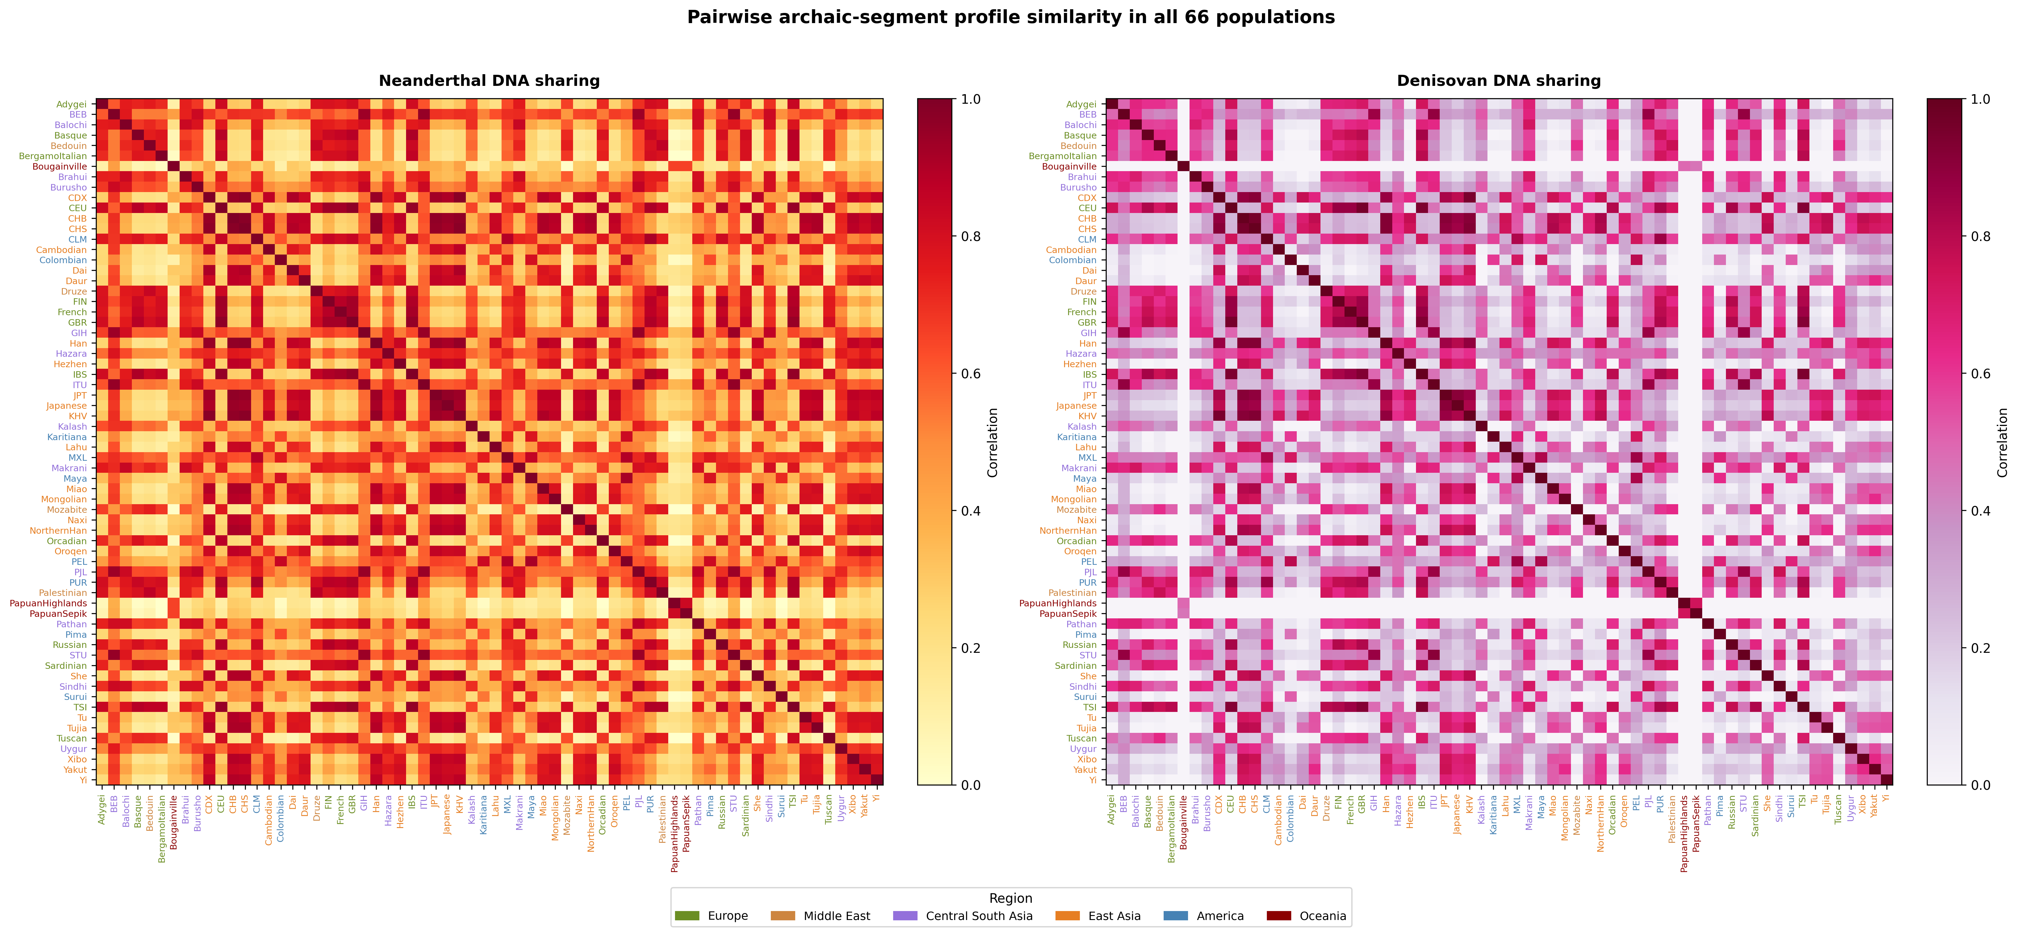

Figure S2. Minard-style schematic of human dispersal and archaic introgression. Band widths, branch positions, and event placement are illustrative and do not estimate migration magnitude or a route supported by the present analysis. The ABO sub-lineage compositions shown are computed in this study from data/abo_sublineage_summary.csv (segments, not individuals; ties excluded from the percentages) and the South Asian Denisovan-segment count from data/abo_denisovan_segments.csv; broad archaic-ancestry ranges are attributed on the figure to Prüfer et al. (2014), Vernot and Akey (2014), Reich et al. (2011), and Meyer et al. (2012).
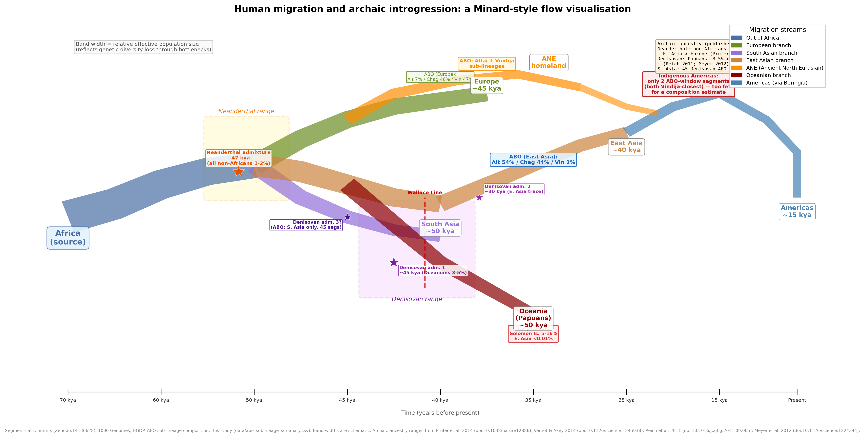

Figure S3. O2 blood-group subtype-defining allele frequencies and ABO-window segment-carrier frequencies. The panels use different sources and are not an association analysis; proximity does not establish that the O2 allele is Neanderthal-derived.
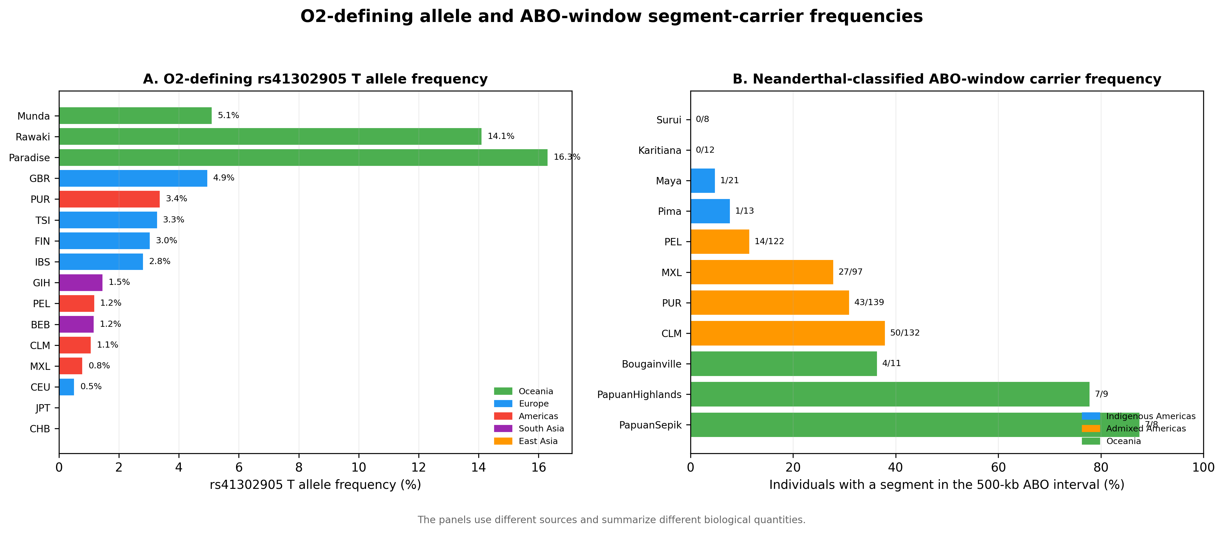

Figure S4. Ancient North Eurasian contextual hypothesis. Dashed arrows represent a testable narrative, not evidence that either observed segment followed the illustrated route.
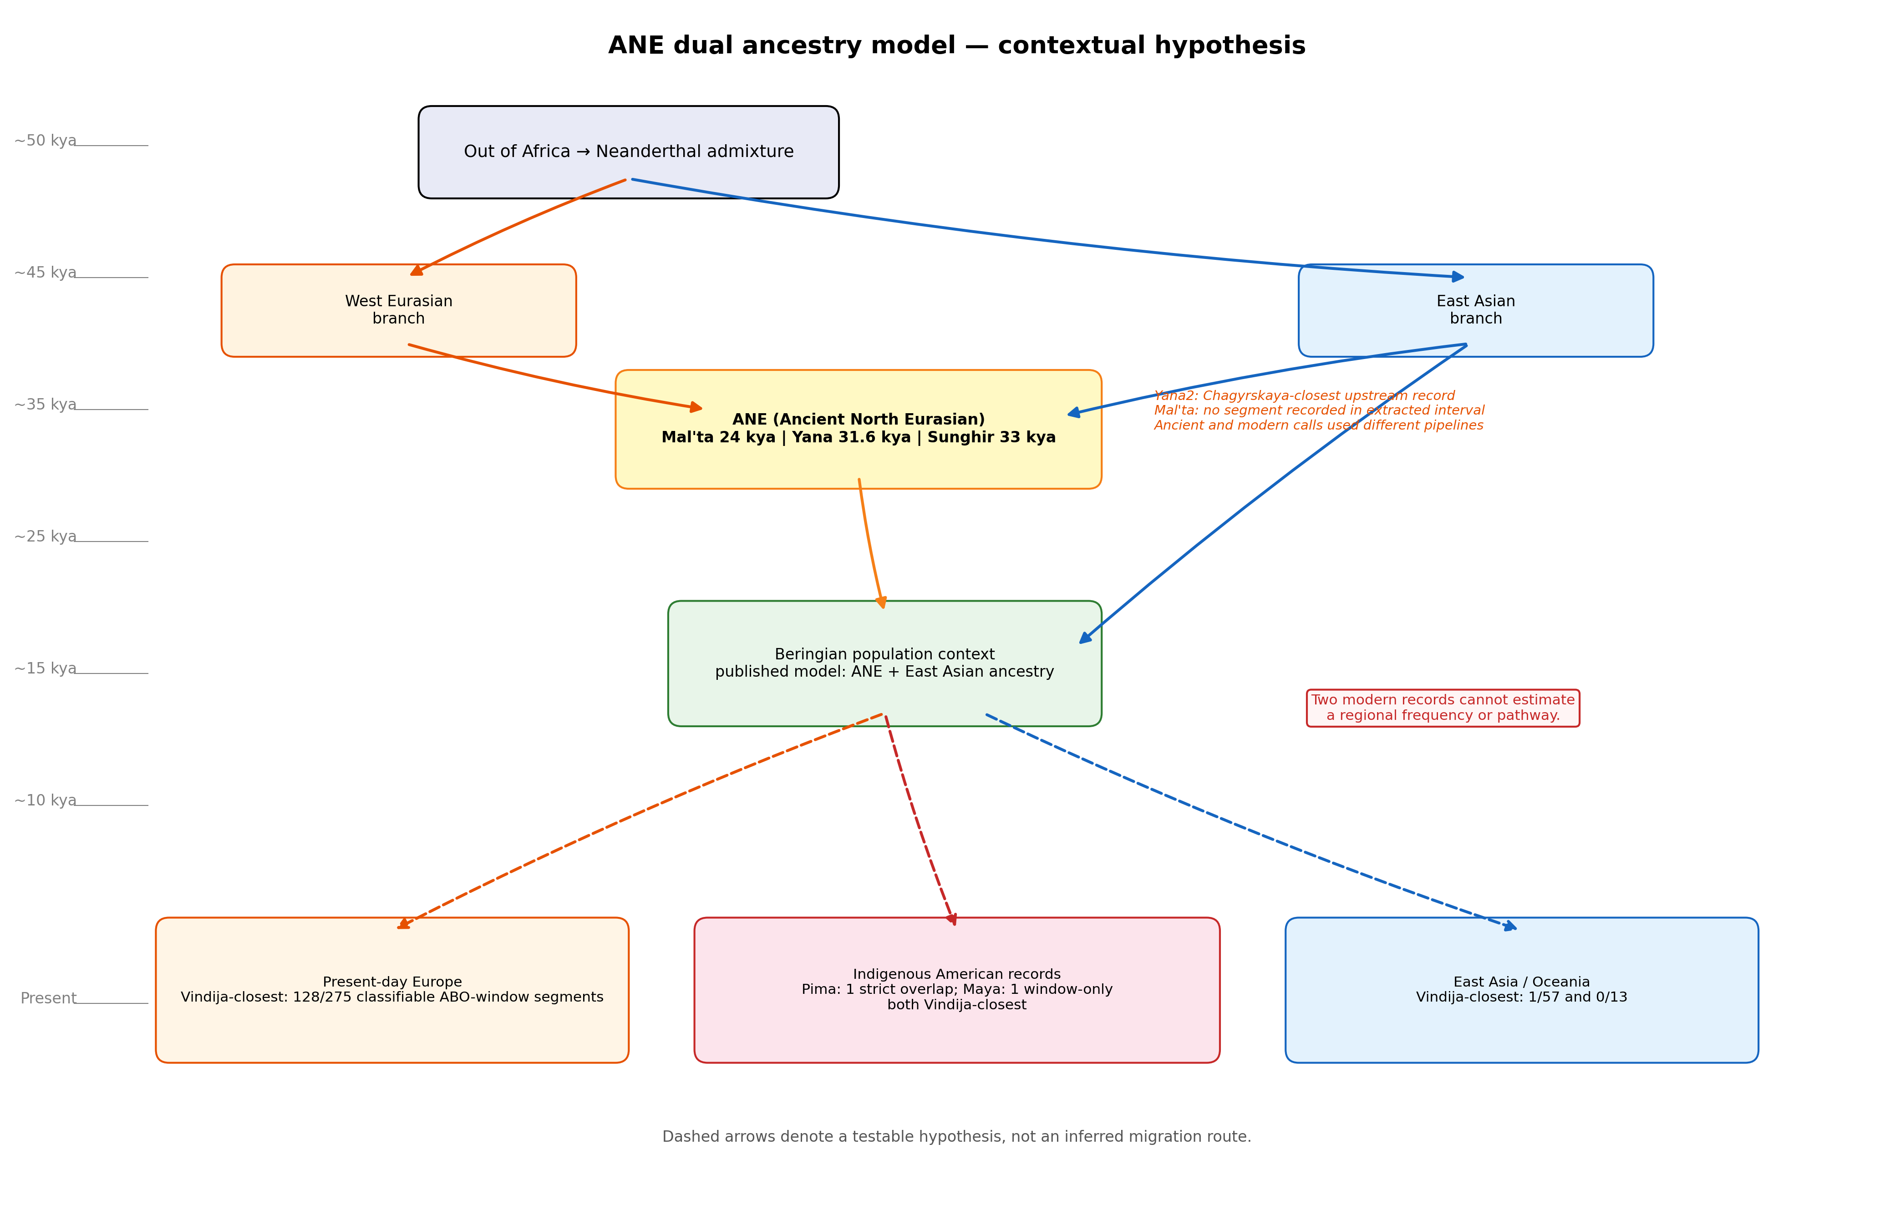

Figure S5. Descriptive ancient and modern ABO-window summaries generated by different pipelines; no formal temporal comparison is made.
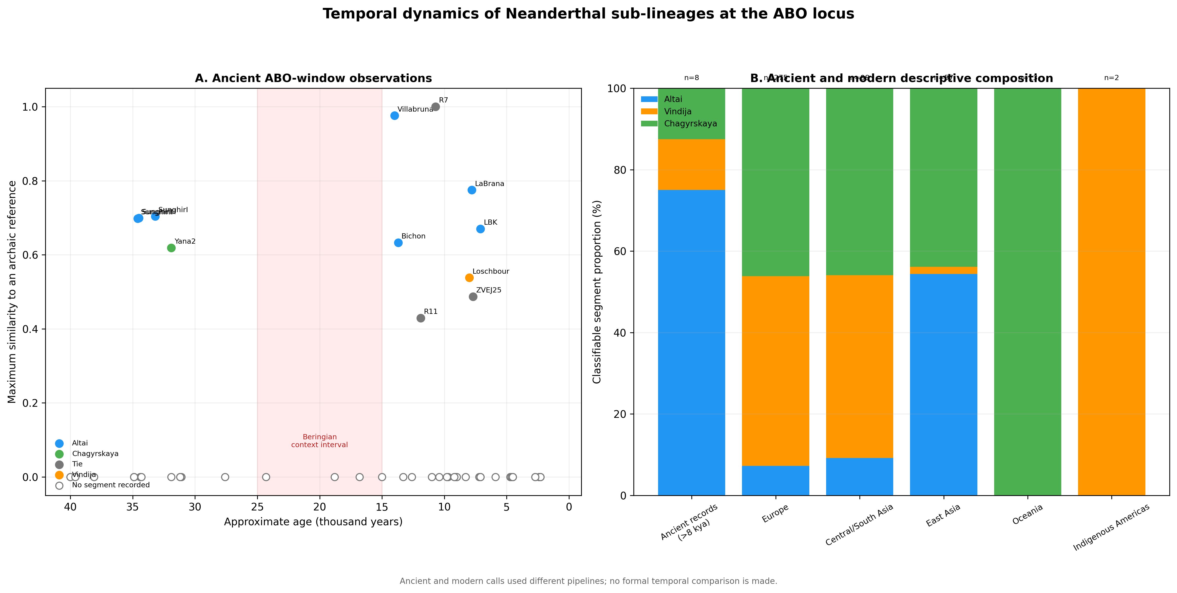

Figure S6. Bivariate global context computed in this study. Circle area encodes the mean per-bin Neanderthal-segment coverage and colour encodes the mean per-bin Denisovan-segment coverage for each population, both from data/population_profiles_500kb.npz; coordinates are approximate sampling locations from data/population_metadata.csv. These descriptive summaries were not used in the pairwise statistical models.
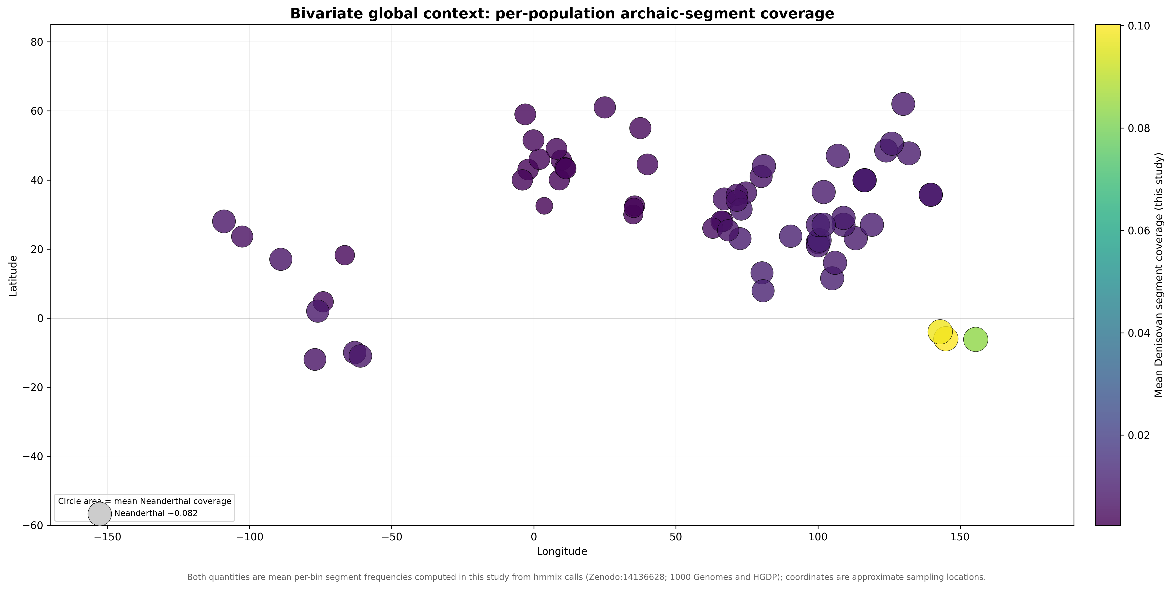

Supplementary Data Files
Supplementary Data 1: population_metadata.csv. Population, project, sample size, coordinates, continent assignment, and analysis inclusion.
Supplementary Data 2: pairwise_sharing_corrected.csv. Complete pairwise similarity, geographic, covariate, residual, permutation, and false discovery rate results.
Supplementary Data 3: model_summary.csv. Quadratic assignment procedure coefficients, permutation P values, descriptive R-squared values, and population-deletion intervals.
Supplementary Data 4: sensitivity_analysis.csv and window_size_sensitivity.csv. Metric, population-subset, and window-size robustness summaries.

