Journal of Medical Screening - Original Article
False-positive cascade from direct-to-consumer multi-cancer early detection blood tests in Japan: a scenario modelling study of health-system burden
Short title: False-positive cascade from direct-to-consumer MCED tests
[Author 1 Name]¹, [Author 2 Name]², [Author 3 Name]¹
¹[Affiliation 1, department, institution, city, country] ²[Affiliation 2, department, institution, city, country]

Corresponding author
[Corresponding author name], [department, institution], [full postal address], [country]. Email: [email address]. Telephone: [telephone number].

Word counts
Abstract: 250 words (limit 250).
Main text (Introduction to Conclusions, excluding abstract, tables, figure legends and references): 2519 words (limit 4000).
Tables: 2; Figures: 2; References: 14; Supplementary tables: 5; Supplementary figures: 5.

Declarations
Funding: The authors received no financial support for the research, authorship and/or publication of this article.
Declaration of conflicting interests: The authors declared no potential conflicts of interest with respect to the research, authorship and/or publication of this article.
Ethical considerations: Publicly available aggregate data and a deterministic simulation only; ethics committee approval and informed consent were not required.
Data availability: Code, parameters and outputs are openly available at https://github.com/bougtoir/cancer-screening-burden-data-driven.
Use of AI-assisted technology: An AI-assisted research assistant (Devin, Cognition AI) was used for drafting and code generation; the authors reviewed and edited all content.

False-positive cascade from direct-to-consumer multi-cancer early detection blood tests in Japan: a scenario modelling study of health-system burden

Abstract
Objectives: To quantify the false-positive cascade and health-system burden generated by direct-to-consumer (DTC) blood-based multi-cancer early detection (MCED) testing as a function of follow-up behaviour, test specificity and age structure.
Setting: Japan. A hypothetical cohort of 100,000 asymptomatic adults aged 20 years and over was parameterised with 2023 national cancer incidence and population data, 2023 national diagnostic volumes, and primary care and specialist capacity derived from NDB Open Data outpatient counts and specialist-board counts.
Methods: A deterministic expected-value cohort model estimated true positives, false positives, downstream visits, capacity utilisation and per-specialist caseload across follow-up rates of 0-100% and specificities of 95.0-99.9%.
Results: At 50% follow-up and 0.990 specificity, the model estimated 383.5 true positives and 7,994.5 false positives per 100,000 screened (positive predictive value 4.58%; 20.8 false positives per true positive). Total downstream visits reached 19,873.4, including 4,189.0 primary care visits (35.0% of the illustrative primary-care capacity). Maximum capacity utilisation was 163.2% (specialist visits), and the illustrative capacity ceiling was exceeded at a follow-up rate of 40% (specialist total visits). False-positive specialist visits added 168.8 visits per relevant specialist, raising the effective cases per specialist from 35.1 to 204.0 (481% increase). Positive predictive value was strongly age-dependent and lowest for low-prevalence cancers; capacity results were insensitive to a two-fold change in prevalence.
Conclusions: In this scenario model, even at 99% specificity a DTC MCED wave can exceed available diagnostic and specialist capacity. Transparent age-specific positive predictive value reporting, pre-market performance thresholds and defined follow-up obligations are needed before routine adoption.
Keywords: multi-cancer early detection, false positive, positive predictive value, healthcare capacity, direct-to-consumer testing, scenario model, Japan

Introduction
Blood-based multi-cancer early detection (MCED) tests are marketed directly to consumers in high-income countries as a convenient single-blood-draw cancer screen.^{1,2} In asymptomatic populations most positive results are false positives, and each positive result can trigger a cascade of confirmatory imaging, endoscopy and specialist visits.^{1,2} Classical screening principles require that facilities for diagnosis and treatment be available before a screening programme is offered,³ yet direct-to-consumer (DTC) testing bypasses programme governance entirely: the purchaser, not the health system, decides who is screened, and the health system inherits the confirmatory work-up. National diagnostic volumes are already substantial,⁴ so unregulated DTC use could displace routine care and place additional pressure on primary care.
Prospective MCED studies have so far enrolled older, risk-enriched populations within organised follow-up pathways,⁵ and the capacity consequences of unselected consumer uptake have not been quantified. Japan is a useful setting for this question because national incidence, population, diagnostic-volume and workforce data are publicly available in detail and DTC cancer screening tests are already commercially available there.⁶ Although the empirical inputs are Japanese, the model structure can be parameterised for other high-income settings. This study quantifies the health-system burden of a DTC MCED screening wave as a function of follow-up behaviour, test specificity and age structure, and identifies the follow-up rate at which illustrative diagnostic and specialist capacity is exceeded.

Methods

Setting and study design
We built a deterministic expected-value cohort model of a hypothetical screening wave in which 100,000 asymptomatic adults aged 20 years and over in Japan purchase a blood-based MCED test. Outcomes were expressed per 100,000 screened and compared with the annual diagnostic and specialist capacity available per 100,000 population.

Data sources
Cancer incidence by site, age, sex and calendar year (2023) and the corresponding 2023 population by age and sex were taken from the National Cancer Center Japan.⁷ Annual volumes of CT, MRI and upper/lower gastrointestinal endoscopy were derived from the 2023 Ministry of Health, Labour and Welfare (MHLW) Medical Facility Survey.⁴ Test sensitivity and specificity ranges were informed by two recent systematic reviews of blood-based MCED tests,^{1,2} and real-world evidence on the downstream diagnostic yield after a positive DTC cancer-screening result came from a nationwide PET/CT facility survey of N-NOSE-triggered examinations.⁶
Specialist capacity was defined using NDB Open Data first/revisit outpatient patient counts and Japanese Board of Medical Specialties (JMSB) specialist counts.^{8,9} Disease-specific baseline patient numbers for the case-per-specialist ratio were taken from the MHLW 2023 Patient Survey.¹⁰

Model
For each cancer type the expected numbers of cases and test results were:
$Actual cases=\frac{screened population×prevalence per 100,000}{100000}$
$True positives=actual cases×sensitivity$
$False positives=(screened population−actual cases)×(1−specificity)$
$Capacity utilisation=\frac{total visits}{annual capacity per 100,000 population}$
Sensitivity and specificity were applied per cancer, so each cancer contributed its own true and false positives and the aggregate counts are sums across the eight cancers; a single MCED assay reporting one overall result at the same specificity would generate roughly one-eighth as many false-positive individuals, each still requiring a multi-site work-up. Each positive result that was followed up (follow-up rate, 0-100%, applied equally to true and false positives) generated a primary care visit plus visits to CT, MRI, endoscopy and specialist care according to cancer-specific pathway probabilities. Additional visits per true and false positive were added. Capacity utilisation for each resource was calculated as total visits divided by the annual capacity per 100,000 population. The complete set of equations is documented in the analysis code (simulate.py) and parameter file (parameters.yaml) in the public repository.
Prevalence was approximated by adult (20+) incidence because point prevalence of undiagnosed, screen-detectable cancers is not publicly reported. Point prevalence of detectable but undiagnosed cancers is likely lower than annual incidence (preclinical sojourn time is usually well under one year), so this proxy probably overstates the number of true positives. It therefore produces upper-bound positive predictive value estimates and lower-bound false-positive to true-positive ratios. Because the direction of this bias is known but its size is not, the prevalence proxy was scaled from 0.25 to 2.0 times the incidence-based value in a dedicated sensitivity analysis. Pathway probabilities and the share of facility capacity available for a new DTC-related wave were scenario assumptions documented in the parameter file.

Specialist and primary care capacity definition
Baseline specialist capacity was defined as the annual outpatient caseload per cancer-relevant specialist. NDB Open Data unique first/revisit outpatient patient counts (April 2024 to March 2025) were divided by the total number of basic JMSB specialists, giving an average annual caseload per specialist.^{8,9} This value was multiplied by the number of cancer-relevant specialists per 100,000 population and reduced by the same 20% share assumed available for a DTC wave. The resulting value is an illustrative specialist capacity ceiling for a 100,000-person cohort. The same approach was applied to primary care (internal medicine and general practice) specialists to derive the illustrative primary-care capacity.

Scenarios and sensitivity analyses
Base-case sensitivity and specificity were 0.70 and 0.990. Follow-up rate was varied from 0 to 100% and specificity from 0.950 to 0.999 in a sensitivity sweep. The available-for-cancer-workup share of national diagnostic capacity was set to 20%. One-way sensitivity analyses varied specificity, follow-up rate, available capacity share and sensitivity, and alternative age distributions of DTC purchasers were examined. The model is deterministic; results are expected values and no confidence intervals are reported, with parameter uncertainty explored through these scenario and one-way analyses.

Ethics and reporting
The study used only publicly available aggregate data and a deterministic simulation; ethics approval and informed consent were not required. Model structure, parameter sourcing and transparency follow the ISPOR-SMDM modelling good research practices.¹¹ Because no dedicated EQUATOR checklist exists for deterministic scenario models, the study is reported in accordance with the Strengthening the Reporting of Observational Studies in Epidemiology (STROBE) statement where applicable, and the completed checklist is provided as a supplementary file.

Results

Scenario parameters
Table 1 summarises the data sources and base-case parameter values, distinguishing empirical inputs from scenario assumptions.
Table 1. Data sources and scenario parameters.
Parameter | Base-case value | Source / assumption
Screened population | 100,000 | Hypothetical single screening wave of adults aged 20+ years
Test sensitivity (all cancers) | 0.70 | Systematic review of blood-based MCED tests;¹ scenario value within reported range
Test specificity (all cancers) | 0.990 | Systematic review of blood-based MCED tests;¹ scenario value within reported range
Follow-up rate after a positive result | 50% (varied 0-100%) | Scenario assumption
CT capacity per 100,000 per year | 5,676 | MHLW 2023 Medical Facility Survey; annualised national volume per 100,000 population;⁴ 20% share assumed available for new cancer work-ups (scenario assumption)
MRI capacity per 100,000 per year | 2,678 | MHLW 2023 Medical Facility Survey; annualised national volume per 100,000 population;⁴ 20% share assumed available for new cancer work-ups (scenario assumption)
Endoscopy capacity per 100,000 per year | 2,583 | MHLW 2023 Medical Facility Survey; annualised national volume per 100,000 population;⁴ 20% share assumed available for new cancer work-ups (scenario assumption)
Specialist capacity per 100,000 per year | 7,183 | NDB Open Data first/revisit outpatient counts⁸ divided by JMSB cancer-relevant specialist counts;⁹ 20% share assumed available for new cancer work-ups (scenario assumption)
Primary care capacity per 100,000 per year | 11,983 | NDB Open Data first/revisit outpatient counts⁸ divided by JMSB internal medicine and general practice specialist counts;⁹ 20% share assumed available for new cancer work-ups (scenario assumption)
Gastric prevalence proxy (per 100,000) | 84.3 | 2023 adult (20+) incidence, National Cancer Center Japan⁷
Colorectal prevalence proxy (per 100,000) | 123.8 | 2023 adult (20+) incidence, National Cancer Center Japan⁷
Lung prevalence proxy (per 100,000) | 99.7 | 2023 adult (20+) incidence, National Cancer Center Japan⁷
Breast prevalence proxy (per 100,000) | 83.2 | 2023 adult (20+) incidence, National Cancer Center Japan⁷
Prostate prevalence proxy (per 100,000) | 82.1 | 2023 adult (20+) incidence, National Cancer Center Japan⁷
Liver prevalence proxy (per 100,000) | 26.2 | 2023 adult (20+) incidence, National Cancer Center Japan⁷
Pancreatic prevalence proxy (per 100,000) | 38.2 | 2023 adult (20+) incidence, National Cancer Center Japan⁷
Ovarian prevalence proxy (per 100,000) | 10.3 | 2023 adult (20+) incidence, National Cancer Center Japan⁷

Per-cancer burden at 50% follow-up
At a 50% follow-up rate, the model estimated 383.5 true positives and 7,994.5 false positives across all eight cancers (aggregate positive predictive value 4.58%; 20.8 false positives per true positive). Colorectal cancer had the highest age-distribution-weighted positive predictive value (7.99%) and ovarian cancer the lowest (0.72%). Full per-cancer results are provided in Supplementary Table S1.

Capacity impact
Total downstream visits rose linearly with follow-up to 39,746.8 at 100% follow-up. At 50% follow-up, the wave generated 4,189.0 primary care visits (35.0% of the illustrative primary-care capacity) and 19,873.4 total visits. Resource utilisation by modality is shown in Figure 1. The first illustrative capacity ceiling was exceeded at a follow-up rate of 40% (specialist total visits); at 50% follow-up, maximum utilisation was 163.2% (specialist visits), whereas CT, MRI and endoscopy remained below their ceilings and the illustrative primary-care ceiling was not exceeded even at 100% follow-up (69.9% utilisation).
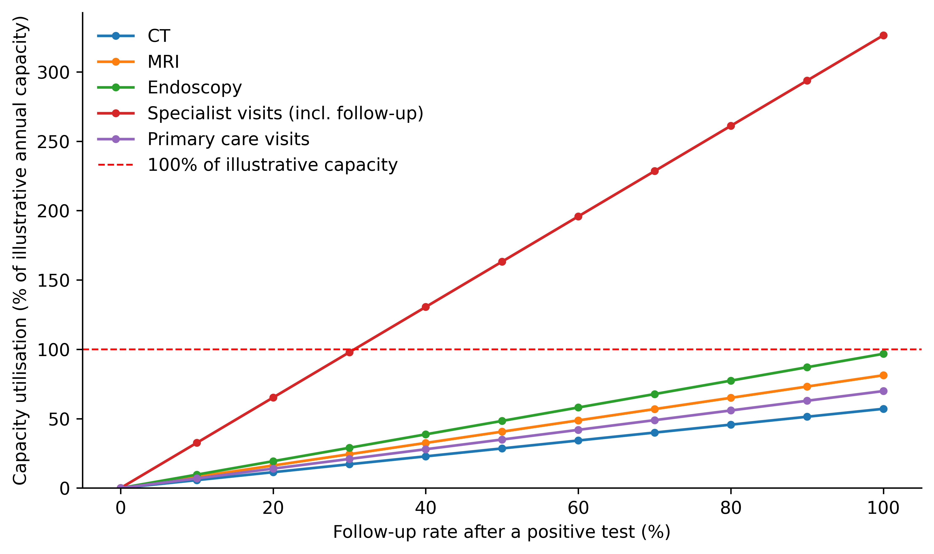
Figure 1. Capacity utilisation (%) for CT, MRI, endoscopy, specialist and primary care visits as the follow-up rate increases. Values above 100% indicate demand exceeding the illustrative annual capacity available for a direct-to-consumer screening wave.

Age-specific positive predictive value
Positive predictive value was strongly age-dependent (Figure 2). Below 40 years of age it was under 2.4% for every cancer, and it exceeded 20% only from 75 years onwards, for colorectal and lung cancer. If DTC MCED users are younger than the general screening population, aggregate positive predictive value would be lower and the false-positive burden larger than the base-case estimate.
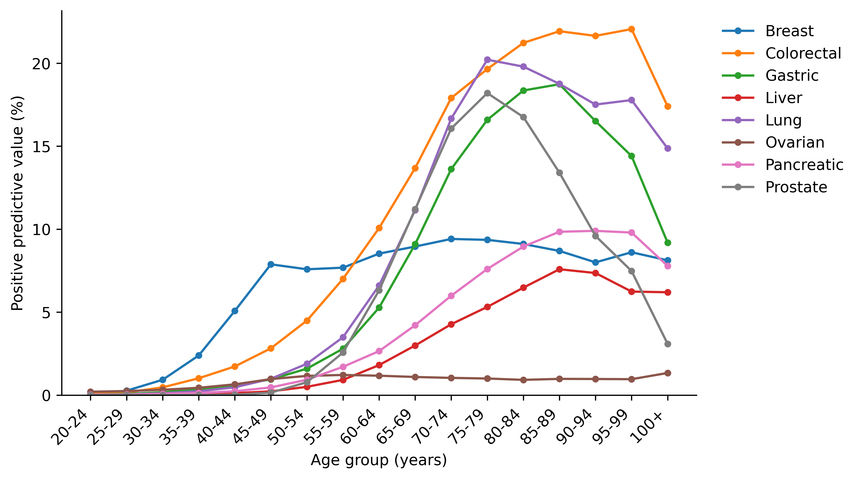
Figure 2. Age-specific positive predictive value for each cancer among adults aged 20 years and over, assuming sensitivity 0.70 and specificity 0.990 and using 2023 age-specific incidence as the prevalence proxy.

Specialist capacity and the false-positive cascade
Table 2 compares the MHLW Patient Survey 2023 baseline cancer caseload per specialist with the additional false-positive specialist visits generated by a 100,000-person DTC wave at 50% follow-up. Across all cancer-relevant specialties, the baseline caseload is about 35.1 patients per specialist; the DTC wave adds about 168.8 false-positive specialist visits per specialist, an increase of 481%. Relative increases are largest for specialties whose baseline cancer caseload per specialist is small (hepatology, gastroenterology for pancreatic cancer, and obstetrics and gynaecology), where the denominator is a few cases per specialist per year.
Table 2. Baseline cases per specialist and incremental false-positive burden at 50% follow-up.
Cancer | Relevant specialty | Baseline cases per specialist | False-positive specialist visits per specialist | Cases per specialist with FP | Increase (%)
Gastric | Gastroenterology | 11.9 | 65.5 | 77.4 | 552.7
Colorectal | Gastrointestinal Surgery | 63.4 | 174.9 | 238.3 | 275.7
Lung | Respiratory Medicine | 43.9 | 245.4 | 289.2 | 559.6
Breast | Breast Surgery | 403.5 | 799.3 | 1202.8 | 198.1
Prostate | Urology | 85.5 | 221.4 | 306.9 | 258.9
Liver | Hepatology | 10.1 | 194.2 | 204.4 | 1918.5
Pancreatic | Gastroenterology | 3.8 | 78.7 | 82.4 | 2095.0
Ovarian | Obstetrics and Gynaecology | 2.2 | 84.8 | 87.0 | 3885.6

Sensitivity and scenario analyses
Per-cancer outcomes at base-case follow-up are detailed in Supplementary Table S1. Supplementary Table S2 reports aggregate positive predictive value under alternative age-distribution scenarios, Supplementary Table S3 shows the one-way sensitivity analysis for the four key parameters, and aggregate outcomes by follow-up rate are in Supplementary Table S4. Test specificity and follow-up behaviour were the dominant drivers of capacity pressure (Supplementary Table S3). At 50% follow-up, lowering specificity from 99.9% to 95.0% reduced aggregate positive predictive value from 32.42% to 0.95% and raised maximum capacity utilisation from 28.6% to 761.4%. With 99% specificity, maximum utilisation ranged from 32.6% at 10% follow-up to 293.8% at 90% follow-up. If only 5% of the illustrative national capacity could be reallocated, the bottleneck reached 653%; with a 50% share it stayed at 65%. Scaling the incidence-based prevalence proxy from 0.25 to 2.0 times its base value changed aggregate positive predictive value from 1.18% to 8.76% and the false-positive to true-positive ratio from 83.4 to 10.4, but maximum capacity utilisation moved only from 153.0% to 176.8% (Supplementary Table S5), because the visit cascade is driven by false positives whose number depends on specificity rather than prevalence. Supplementary Figure S1 shows total downstream visits by follow-up rate, Supplementary Figure S2 the specificity sweep, Supplementary Figure S3 the tornado sensitivity analysis for maximum capacity utilisation, Supplementary Figure S4 the corresponding analysis for positive predictive value, and Supplementary Figure S5 the age-distribution scenarios.

Discussion
Under the base-case assumptions, a DTC blood-based MCED screening wave generates roughly 21 false-positive workups for each true cancer detected. The illustrative capacity ceiling is already exceeded once follow-up reaches 40% (specialist total visits); Supplementary Table S4 shows the corresponding follow-up trajectory. At 50% follow-up, the ceiling is exceeded by 63.2 percentage points, and the effective caseload per cancer-relevant specialist rises by about 481% after adding false-positive follow-up visits. This pattern is consistent with real-world Japanese experience of another DTC cancer-screening test: the N-NOSE PET/CT survey found a low cancer discovery rate after a high-risk result.⁶
The modelled aggregate positive predictive value (4.6%) is far below the 38% reported in the PATHFINDER cohort.⁵ The two figures are not in conflict: PATHFINDER enrolled adults aged 50 years and over, many with elevated risk, within a protocolised follow-up pathway, whereas the present model assumes unselected adult purchasers aged 20 years and over and a per-cancer specificity of 0.990. The age-specific results (Figure 2) show that restricting uptake to older adults would move positive predictive value toward the trial estimate, while marketing to younger consumers would move it further away. The capacity results are much less sensitive to this uncertainty: halving or doubling the prevalence proxy shifted maximum utilisation by at most 13.6 percentage points (Supplementary Table S5), because the cascade is dominated by false positives.

Implications for screening practice and policy
A positive MCED result is likely to be handled first by primary care before any specialist is involved. Clinicians must explain an uncertain signal, weigh it against guideline-recommended screening and coordinate confirmatory tests. People considering a DTC blood test need clear information on the low positive predictive value in asymptomatic populations and the likely cascade of follow-up visits.¹² Primary care providers are concerned about responsibility for interpreting results, costs and managing subsequent evaluations,¹³ and health-technology reviews identify anxiety, false reassurance and displacement of guideline-based screening as potential harms.¹⁴
The workload is not evenly distributed: cancers with the lowest prevalence produce the highest false-positive ratios, and younger users, who may be preferentially targeted by DTC advertising, have the lowest positive predictive values. Regulators and payers could reduce this burden by requiring pre-market performance thresholds, transparent positive predictive value reporting by age and sex, and a clear follow-up pathway that prevents primary care from becoming the default safety net for unregulated screening. High-income countries with constrained primary and specialty care capacity should account for these externalities when deciding whether to allow or reimburse DTC MCED testing.

Benefit to individuals and referral status of a positive result
A consumer-facing blood test offers convenience and the prospect of detecting cancers for which organised screening is unavailable.^{1,2} For a small minority of users, earlier detection could shift stage at diagnosis, but in an asymptomatic cohort a positive result is unlikely to represent cancer (Figure 2; Supplementary Table S1). Most positive results therefore generate anxiety, additional testing and opportunity costs rather than useful early diagnosis, and systematic reviews report downstream harms including false reassurance, overdiagnosis and displacement of guideline-based screening.¹⁴
Treating a DTC positive result as equivalent to a physician's referral letter has direct capacity implications. A referral-letter model gives individuals insured access to confirmatory care and may improve follow-up completion, but it also signals medical legitimacy and channels the false-positive cascade into the publicly funded system. In the present model the illustrative specialist ceiling was breached once follow-up reached 40% (specialist total visits) with 20% of national capacity assumed available; insuring confirmatory workups would be expected to raise follow-up completion and push utilisation higher still. Conversely, keeping DTC testing outside the referral pathway leaves individuals to self-fund follow-up, which may reduce public-sector pressure but also fragments care, delays diagnosis for the small true-positive minority and creates inequity.
An intermediate arrangement would allow DTC access but require the test to meet pre-market performance thresholds, and require clinician review of positive results before any publicly funded workup is authorised. Only evidence-based confirmatory investigations would be covered, and the responsible clinician would be able to decline inappropriate cascades. This preserves individual choice without shifting the full cost of unregulated screening onto primary and specialty care.¹²

Strengths and limitations
The model is fully reproducible from public national data and open code, and it separates the effects of follow-up behaviour, specificity, capacity share, prevalence and age structure. Its simple structure also brings several limitations. First, the analysis uses scenario assumptions for test performance, diagnostic pathways and the age distribution of DTC users, because these data are not publicly reported; a single sensitivity and specificity were applied to all eight cancers, whereas real assays differ by cancer and by stage. Second, prevalence was approximated by adult incidence, which likely overstates true positives; the direction of the bias is known and its effect on capacity results was shown to be small. Third, positives were summed across cancers, so an assay reporting one overall result and a cancer signal origin would generate fewer positive individuals but a comparable number of confirmatory investigations per positive. Fourth, the model represents a single screening wave of 100,000 purchasers; repeated annual testing, incidental findings, overdiagnosis, costs and the downstream benefit of any true positive were not modelled. Fifth, diagnostic capacity was annualised from a one-month facility survey and specialist capacity from NDB outpatient patient counts, both reduced by an assumed available-for-cancer-workup share that is itself a scenario parameter. Finally, the model is deterministic and does not capture stochastic variation, geographic maldistribution, waiting-time dynamics or queueing effects; the follow-up rate was applied equally to true and false positives.

Conclusions
In a fully reproducible scenario model parameterised with Japanese national data, a single DTC MCED screening wave of 100,000 adults generated about 21 false positives per detected cancer and exceeded illustrative specialist capacity once 40% of positive results were followed up, a conclusion that was robust to a two-fold uncertainty in prevalence. In the absence of clear regulatory guardrails, including pre-market performance thresholds, transparent age-specific positive predictive value reporting and defined follow-up obligations, DTC MCED tests risk generating a large-scale false-positive cascade that stresses primary care, specialty care and diagnostic capacity in high-income settings.

Acknowledgements
During the preparation of this work the authors used an AI-assisted research assistant (Devin, Cognition AI) to draft and revise sections of the manuscript and to generate simulation code. The authors reviewed and edited all content and take full responsibility for the content of the article.

Author contributions
[Author 1 Name]: conceptualisation, methodology, software, writing - original draft. [Author 2 Name]: data curation, formal analysis, visualisation, writing - review and editing. [Author 3 Name]: supervision, writing - review and editing. All authors approved the final manuscript.

Declaration of conflicting interests
The authors declared no potential conflicts of interest with respect to the research, authorship and/or publication of this article.

Funding
The authors received no financial support for the research, authorship and/or publication of this article.

Ethical considerations
This study used only publicly available aggregate data and a deterministic simulation; ethics committee approval was not required.

Consent to participate
Not applicable; no human participants were involved.

Data availability statement
All data sources are publicly available and listed in Table 1. The analysis code, parameters and outputs are openly available at https://github.com/bougtoir/cancer-screening-burden-data-driven.

References
1. Kahwati LC, Avenarius M, Brouwer L, et al. Blood-based tests for multiple cancer screening: a systematic review. AHRQ Publication No. 25-EHC033. Rockville, MD: Agency for Healthcare Research and Quality, 2025. DOI: 10.23970/AHRQEPCSRMULTIPLE.
2. LeeVan E and Pinsky P. Predictive performance of cell-free nucleic acid-based multi-cancer early detection tests: a systematic review. Clin Chem 2024; 70: 90-101. DOI: 10.1093/clinchem/hvad134.
3. Wilson JMG and Jungner G. Principles and practice of screening for disease. Public Health Papers No. 34. Geneva: World Health Organization, 1968.
4. Ministry of Health, Labour and Welfare. 2023 Medical Facility Survey (static and dynamic), table 05sisetu05, https://www.mhlw.go.jp/toukei/saikin/hw/iryosd/23/ (2024, accessed 11 September 2026).
5. Schrag D, Beer TM, McDonnell CH, et al. Blood-based tests for multicancer early detection (PATHFINDER): a prospective cohort study. Lancet 2023; 402: 1251-1260. DOI: 10.1016/S0140-6736(23)01700-2.
6. Nagamachi S, Jinnouchi S, Tashiro K, et al. Multicentre survey of PET cancer screening and nematode (N-NOSE) testing (in Japanese). Rinsho Kaku Igaku 2024; 57(5). Summary: PET Nuclear Medicine Subcommittee, Japanese Society of Nuclear Medicine, https://jcpet.jp/2024/10/senchu-chosa.html (2024, accessed 11 September 2026).
7. National Cancer Center Japan. Cancer statistics in Japan: cancer registry and statistics, incidence 2016-2023 and population, https://ganjoho.jp/reg_stat/statistics/data/dl/en.html (2025, accessed 11 September 2026).
8. Ministry of Health, Labour and Welfare. NDB Open Data, 11th release (April 2024 to March 2025), https://www.mhlw.go.jp/stf/seisakunitsuite/bunya/0000177221_00017.html (2025, accessed 11 September 2026).
9. Japanese Board of Medical Specialties. Overview of the Japanese specialist system 2025 (in Japanese), https://jmsb.or.jp/wp-content/uploads/2026/03/gaiho_2025.pdf (2026, accessed 11 September 2026).
10. Ministry of Health, Labour and Welfare. Patient Survey 2023, https://www.mhlw.go.jp/toukei/saikin/hw/kanja/10syoubyo/ (2025, accessed 11 September 2026).
11. Caro JJ, Briggs AH, Siebert U, et al. Modeling good research practices - overview: a report of the ISPOR-SMDM Modeling Good Research Practices Task Force-1. Med Decis Making 2012; 32: 667-677. DOI: 10.1177/0272989X12454577.
12. Hoffman RM, Wolf AMD, Raoof S, et al. Multicancer early detection testing: guidance for primary care discussions with patients. Cancer 2025; 131: e35823. DOI: 10.1002/cncr.35823.
13. Ueberroth BE, Presutti RJ, McGary A, et al. Perspectives of primary care providers regarding multicancer early detection panels. Einstein (Sao Paulo) 2024; 22: eAO0771. DOI: 10.31744/einstein_journal/2024AO0771.
14. Wade R, Nevitt S, Liu Y, et al. Multi-cancer early detection tests for general population screening: a systematic literature review. Health Technol Assess 2025; 29(2): 1-105. DOI: 10.3310/DLMT1294.

