Supplementary material
False-positive cascade from direct-to-consumer MCED tests

Supplementary tables
Supplementary Table S1. Per-cancer outcomes at 50% follow-up (per 100,000 screened).
Cancer | Prevalence per 100k | True positives | False positives | PPV (%) | FP/TP ratio | Primary care visits | Total visits | Max resource utilisation (%)
Gastric | 84.3 | 59.0 | 999.2 | 5.58 | 16.9 | 529.1 | 2613.4 | 19.4
Colorectal | 123.9 | 86.7 | 998.8 | 7.99 | 11.5 | 542.7 | 2713.5 | 20.4
Lung | 99.7 | 69.8 | 999.0 | 6.53 | 14.3 | 534.4 | 2830.1 | 23.8
Breast | 83.2 | 58.2 | 999.2 | 5.51 | 17.2 | 528.7 | 2161.1 | 19.4
Prostate | 82.1 | 57.5 | 999.2 | 5.44 | 17.4 | 528.3 | 2182.8 | 19.0
Liver | 26.3 | 18.4 | 999.7 | 1.81 | 54.4 | 509.1 | 2211.9 | 18.0
Pancreatic | 38.2 | 26.8 | 999.6 | 2.61 | 37.4 | 513.2 | 2657.4 | 22.0
Ovarian | 10.4 | 7.3 | 999.9 | 0.72 | 137.4 | 503.6 | 2503.5 | 21.2

Supplementary Table S2. Aggregate positive predictive value under alternative age-distribution scenarios.
Age-distribution scenario | Aggregate PPV (%) | FP/TP ratio
DTC bimodal (23andMe-like) | 1.94 | 50.5
DTC screening-age purchasers | 4.05 | 23.7
DTC younger purchasers | 0.56 | 176.3
Adults 20+ | 5.39 | 17.5
2023 total population | 4.58 | 20.8

Supplementary Table S3. One-way sensitivity analysis.
Parameter | Value | Aggregate PPV (%) | Max capacity utilisation (%) | Total visits
specificity | 0.950 | 0.95 | 761.4 | 93922.9
specificity | 0.980 | 2.34 | 312.8 | 38385.8
specificity | 0.990 | 4.58 | 163.2 | 19873.4
specificity | 0.995 | 8.75 | 88.4 | 10617.2
specificity | 0.999 | 32.42 | 28.6 | 3212.3
follow_up_rate | 0.100 | 4.58 | 32.6 | 3974.7
follow_up_rate | 0.300 | 4.58 | 97.9 | 11924.0
follow_up_rate | 0.500 | 4.58 | 163.2 | 19873.4
follow_up_rate | 0.700 | 4.58 | 228.5 | 27822.8
follow_up_rate | 0.900 | 4.58 | 293.8 | 35772.1
available_share | 0.050 | 4.58 | 652.9 | 19873.4
available_share | 0.100 | 4.58 | 326.4 | 19873.4
available_share | 0.200 | 4.58 | 163.2 | 19873.4
available_share | 0.300 | 4.58 | 108.8 | 19873.4
available_share | 0.500 | 4.58 | 65.3 | 19873.4
sensitivity | 0.500 | 3.31 | 159.3 | 19484.5
sensitivity | 0.600 | 3.95 | 161.3 | 19679.0
sensitivity | 0.700 | 4.58 | 163.2 | 19873.4
sensitivity | 0.800 | 5.20 | 165.2 | 20067.8
sensitivity | 0.900 | 5.81 | 167.1 | 20262.3

Supplementary Table S4. Aggregate outcomes by follow-up rate (base-case specificity).
Follow-up rate | True positives | False positives | Total positives | PPV (%) | FP/TP ratio | Primary care visits | Total visits | Max capacity utilisation (%)
0% | 383.5 | 7994.5 | 8378.0 | 4.58 | 20.8 | 0.0 | 0.0 | 0.0
10% | 383.5 | 7994.5 | 8378.0 | 4.58 | 20.8 | 837.8 | 3974.7 | 32.6
20% | 383.5 | 7994.5 | 8378.0 | 4.58 | 20.8 | 1675.6 | 7949.4 | 65.3
30% | 383.5 | 7994.5 | 8378.0 | 4.58 | 20.8 | 2513.4 | 11924.0 | 97.9
40% | 383.5 | 7994.5 | 8378.0 | 4.58 | 20.8 | 3351.2 | 15898.7 | 130.6
50% | 383.5 | 7994.5 | 8378.0 | 4.58 | 20.8 | 4189.0 | 19873.4 | 163.2
60% | 383.5 | 7994.5 | 8378.0 | 4.58 | 20.8 | 5026.8 | 23848.1 | 195.9
70% | 383.5 | 7994.5 | 8378.0 | 4.58 | 20.8 | 5864.6 | 27822.8 | 228.5
80% | 383.5 | 7994.5 | 8378.0 | 4.58 | 20.8 | 6702.4 | 31797.5 | 261.2
90% | 383.5 | 7994.5 | 8378.0 | 4.58 | 20.8 | 7540.2 | 35772.1 | 293.8
100% | 383.5 | 7994.5 | 8378.0 | 4.58 | 20.8 | 8378.0 | 39746.8 | 326.4

Supplementary Table S5. Sensitivity of base-case results (50% follow-up, specificity 0.990, sensitivity 0.70) to scaling the incidence-based prevalence proxy.
Prevalence multiplier | True positives | False positives | PPV (%) | FP/TP ratio | Max capacity utilisation (%)
0.25 | 95.9 | 7,998.6 | 1.18 | 83.4 | 153.0
0.50 | 191.7 | 7,997.3 | 2.34 | 41.7 | 156.4
1.00 | 383.5 | 7,994.5 | 4.58 | 20.8 | 163.2
1.50 | 575.2 | 7,991.8 | 6.71 | 13.9 | 170.0
2.00 | 767.0 | 7,989.0 | 8.76 | 10.4 | 176.8

Supplementary figures
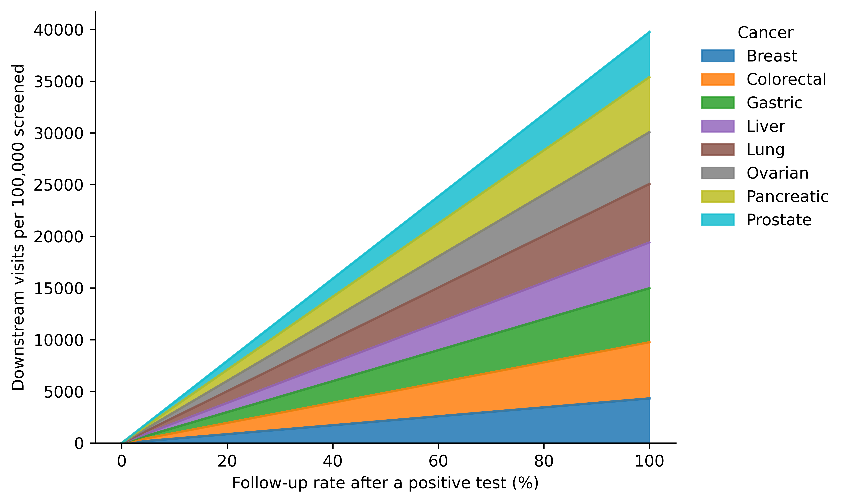
Supplementary Figure S1. Total downstream diagnostic, primary care and specialist visits generated by a blood-based MCED screening wave of 100,000 persons, by follow-up rate.
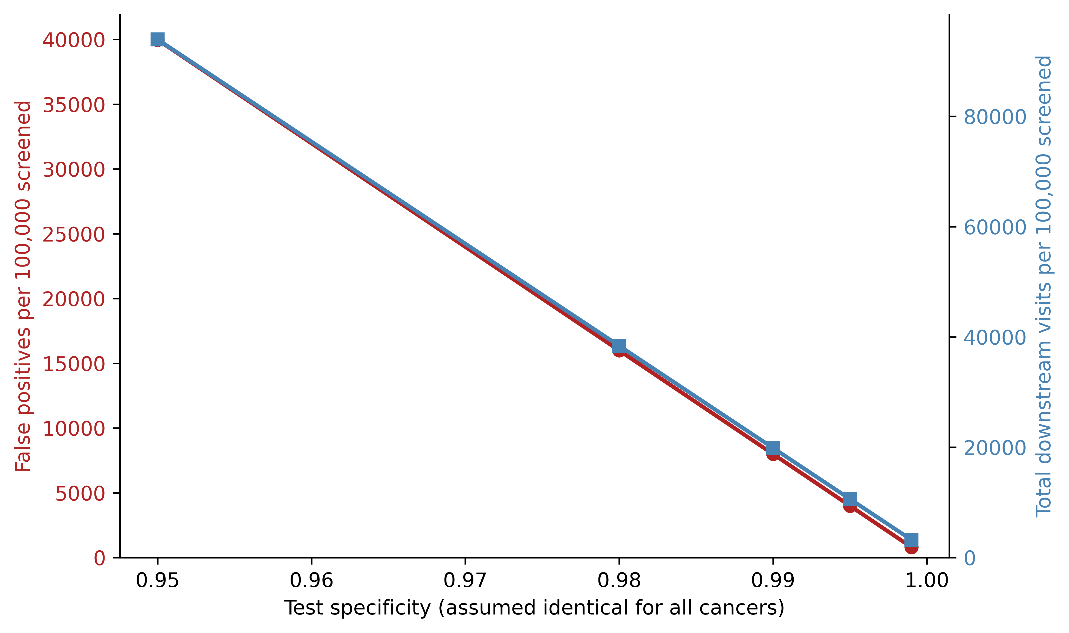
Supplementary Figure S2. False positives and total downstream visits per 100,000 screened across test specificity values (0.950-0.999) at a 50% follow-up rate.
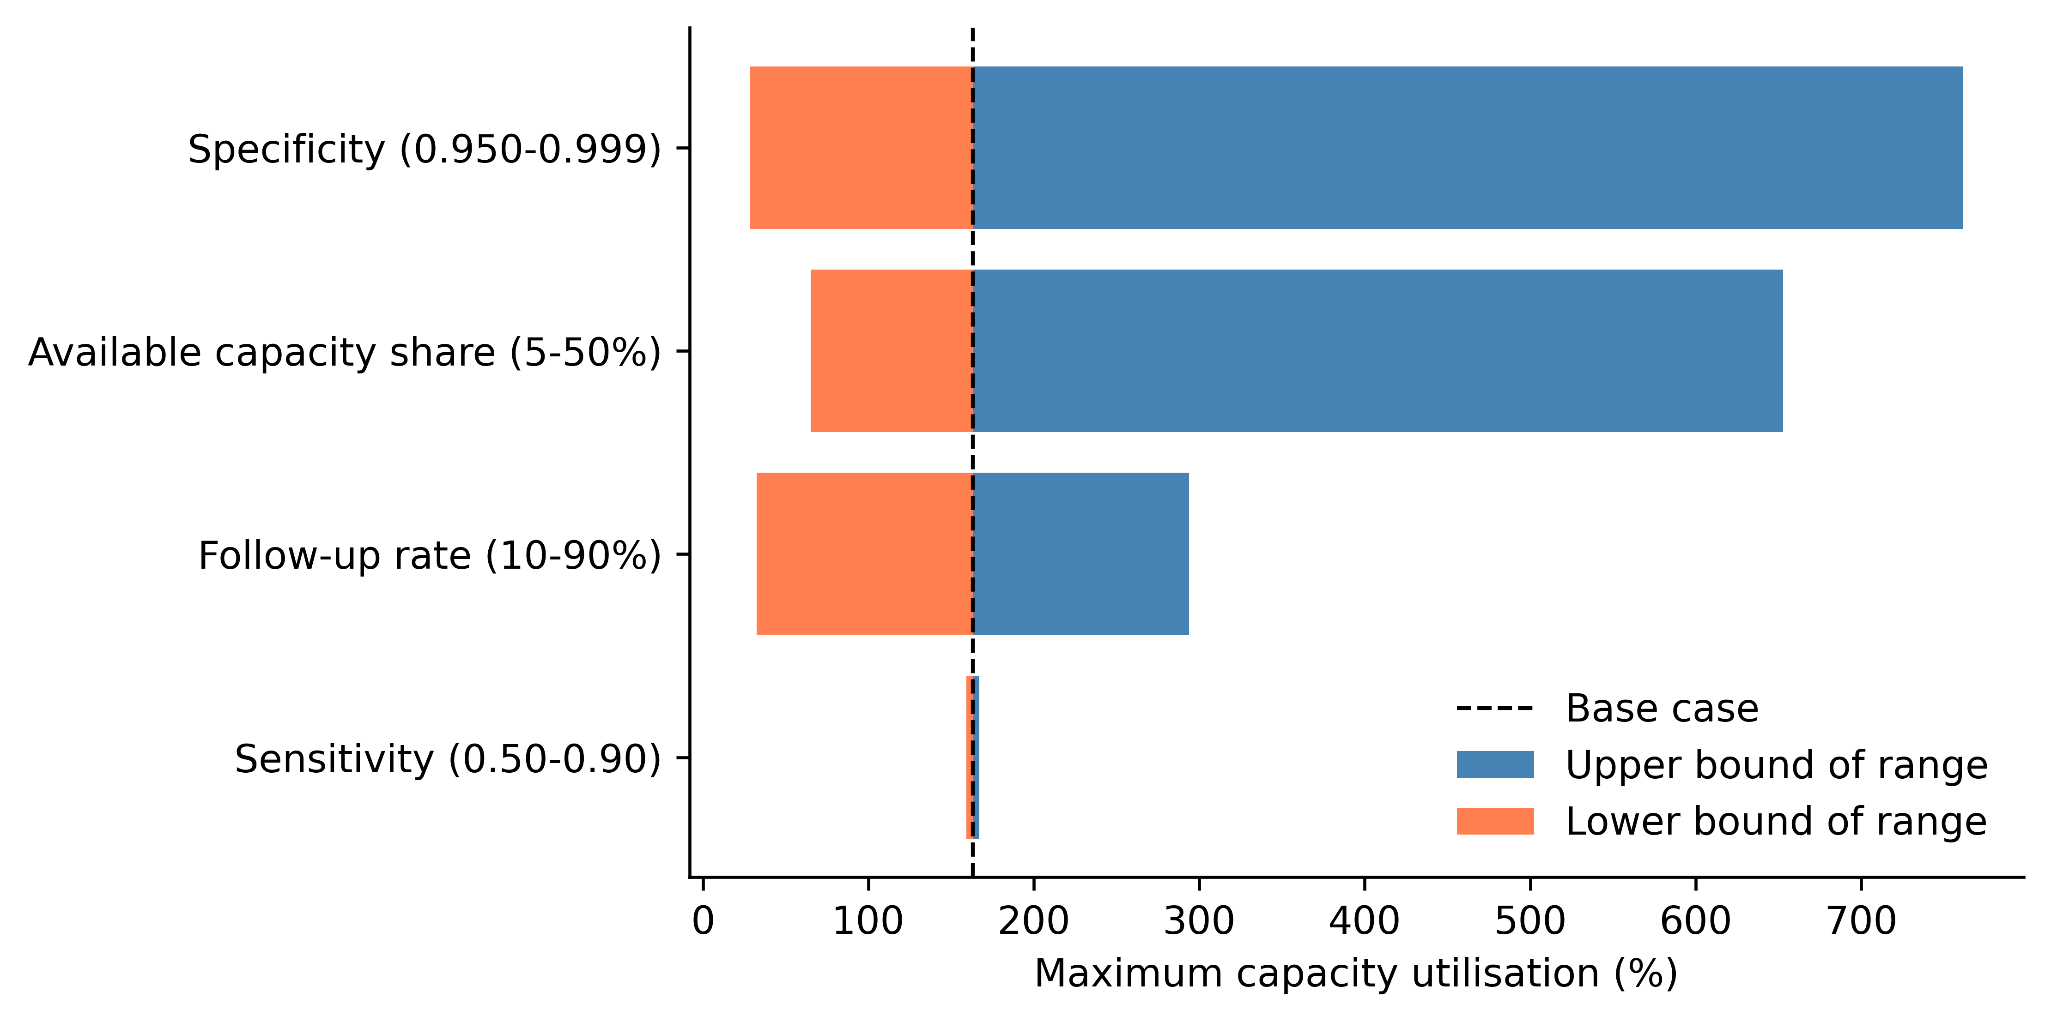
Supplementary Figure S3. Tornado diagram showing the effect of varying specificity, follow-up rate, available capacity share and sensitivity on maximum capacity utilisation (base case = 50% follow-up, 0.990 specificity, 0.70 sensitivity, 20% capacity share). Parameters are ordered by the width of their effect.
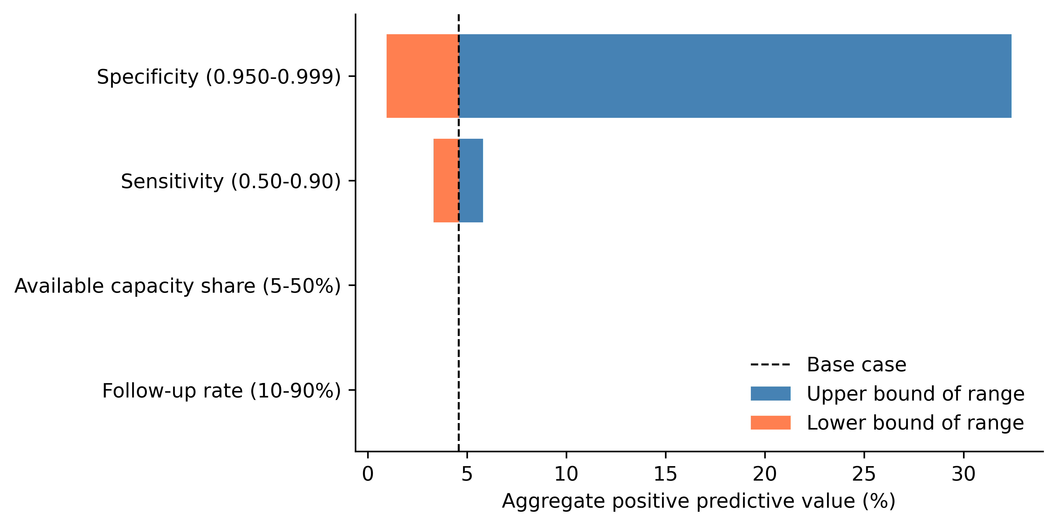
Supplementary Figure S4. Tornado diagram showing the effect of the same four parameters on aggregate positive predictive value.
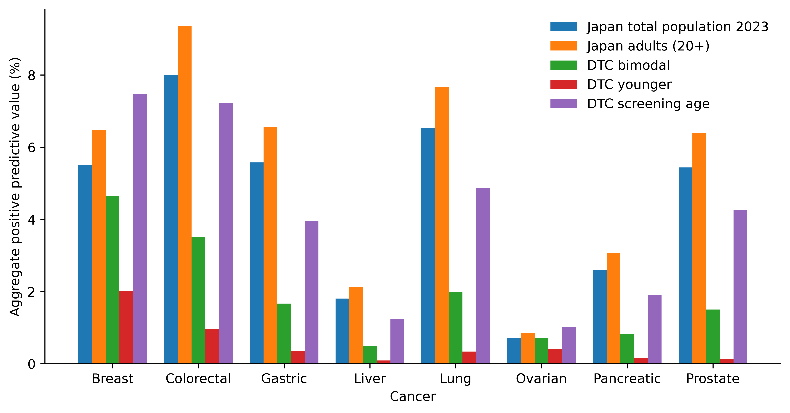
Supplementary Figure S5. Aggregate positive predictive value for each cancer type under the 2023 national total-population distribution and four hypothetical direct-to-consumer purchaser age profiles.

