Structural asymmetries distort guild-level beta-diversity contrasts
Blinded main text (double-anonymous). Structured abstract in GEB_structured_abstract.md; all values traceable to results/manuscript_values.csv.

Abstract
See GEB_structured_abstract.md (structured, ≤300 words).

Introduction
Beta diversity — the compositional variation of assemblages across space — is a foundational currency of macroecology and biogeography (Whittaker, 1960; Tuomisto, 2010a; Anderson et al., 2011). Pairwise dissimilarity, multiple-site metrics and the decay of similarity with distance are used to infer connectivity, dispersal limitation, environmental filtering and biogeographic differentiation (Nekola & White, 1999; Soininen et al., 2007; Morlon et al., 2008; Baselga, 2010). Comparative studies increasingly apply these measures across taxonomic or functional groups — asking, for example, whether one guild is more spatially homogeneous than another — because such contrasts promise inference about group-specific spatial ecology (Heino et al., 2015). All of these applications are scale-dependent: turnover varies with the spatial grain and extent of the data (Wiens, 1989; Barton et al., 2013). When such measures are compared between guilds, clades or functional groups, the comparison carries an implicit assumption: that the two assemblages are structurally comparable — that differences in their regional pool size, dominance structure, taxonomic resolution, temporal span and sampling intensity do not themselves alter measured turnover.
In practice, however, guilds and assemblages differ routinely in exactly these properties. A predator guild and its prey guild typically differ in pool size; a dominant species can occupy most of the sampled sites while its comparison guild has none; one group may be identifiable to species while another is only resolvable to genus; one dataset may integrate a decade of sampling while another pools centuries; and the two sides may have been collected under different effort regimes. Each of these structural properties is individually known to affect diversity metrics. Measured beta diversity depends on the size and composition of the regional species pool (Kraft et al., 2011; Chase et al., 2011; Pärtel et al., 2011; Zobel, 2016), and comparisons across assemblages of unequal richness are a known source of scale-dependent distortion (Chase et al., 2018). Dominant species and the shape of the occupancy–frequency distribution can drive dissimilarity values regardless of underlying spatial processes (Lennon et al., 2004; McGeoch & Gaston, 2002; McGill et al., 2007; Hillebrand et al., 2008). The taxonomic grain at which data are recorded alters diversity patterns (Bertrand et al., 2006; Bevilacqua et al., 2012), temporal aggregation reshapes apparent community change (Olszewski, 1999; Korhonen et al., 2010; Blowes et al., 2019), and unequal sampling effort and incomplete detection bias comparisons when they are not standardized (Gotelli & Colwell, 2001; MacKenzie et al., 2002; Colwell et al., 2012; Chao et al., 2014). Because these mechanisms co-occur in real data and interact, treating them as independent additive corrections is itself an untested assumption. Each mechanism is established; what is missing is a quantitative account of how large their separate and joint effects on guild-level turnover contrasts can be.
This is not merely a fossil problem. Much of the biodiversity evidence now used in macroecology is historically aggregated: museum and herbarium collections, long-term monitoring compilations, archaeological faunas, pollen and sedimentary records are all assembled over uneven taxonomic, temporal and sampling structure (Shaffer et al., 1998; Graham et al., 2004; Pyke & Ehrlich, 2010; Lavoie, 2013). Palaeoecological assemblages are the extreme end of the same spectrum — they push every structural asymmetry further, with small and uneven taxon pools, strong dominance, coarse taxonomic resolution and temporal averaging over thousands to millions of years (Kidwell & Behrensmeyer, 1991; Olszewski, 1999; Behrensmeyer et al., 2000; Badgley, 2010; Smith & McGowan, 2007; Vilhena & Smith, 2013). If structural bias in guild-level turnover comparisons is consequential anywhere, it should be consequential there. The fossil record therefore serves as an informative stress test for a general inferential problem rather than a special case with its own rules (Uhen et al., 2013; Peters & McClennen, 2015).
What is missing from the literature is not awareness that these biases exist but their magnitudes under controlled conditions: how large can a structurally generated guild contrast become when no true ecological difference exists? Can structural asymmetry reverse the sign of a contrast? And does it alter only the mean of dissimilarity, or also the shape of spatial turnover — the distance-decay relationship that underlies biogeographic inference? Answering these questions requires ground truth, which empirical assemblages cannot provide; it requires simulation.
Here we combine (i) controlled simulations in which the true guild contrast is zero by construction, on a one-dimensional spatial axis and, as a robustness check, a two-dimensional lattice; (ii) a factorial map identifying joint conditions that produce false differences and sign reversals; (iii) an analysis of how structural asymmetry distorts distance-decay slopes, not just mean dissimilarity; and (iv) an empirical fossil stress test — dinosaur assemblages of the Late Jurassic Morrison Formation (Maidment et al., 2024) — in which an initially strong guild-level turnover contrast is decomposed stepwise under structural controls, with the Nemegt Formation as an external comparator. Our central equation is Δβ_observed ≠ Δβ_ecological whenever the compared guilds differ in assemblage structure. Our objectives are to quantify the magnitude of structural bias under controlled conditions, to identify conditions causing false differentiation, lost differentiation and sign reversal, to decompose the Morrison signal empirically, and to derive a practical diagnostic workflow for guild-level beta-diversity inference in structurally heterogeneous data.
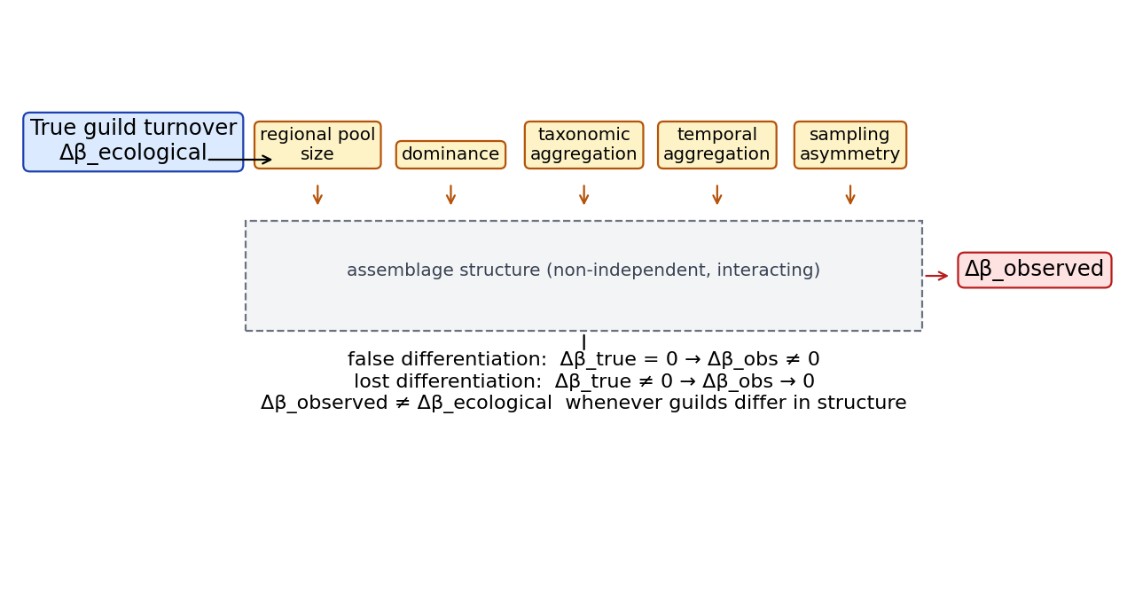
Figure 1. Conceptual framework. True guild turnover is filtered
through assemblage structure — regional pool size, dominance,
taxonomic and temporal aggregation, sampling asymmetry — before
Δβ_observed is measured; observed contrasts therefore need not equal
ecological contrasts. Schematic (to be drawn).

Methods

Overview
We combine (i) controlled simulation of fossil guild assemblages, in which the true ecological turnover contrast is known, with (ii) a sequential empirical decomposition of a real guild-level beta-diversity contrast in the Upper Jurassic Morrison Formation, and (iii) a negative external comparator from the Nemegt Formation. All estimators, null models, seeds and output files are frozen and versioned; every number cited in the manuscript is traced in `results/manuscript_values.csv`.

Terminology and estimand
Throughout, beta diversity is measured between assemblages as the mean pairwise Jaccard dissimilarity computed on incidence matrices, equivalently one minus the mean pairwise Jaccard index. The focal contrast is
Δβ = β_P − β_H
where β_P and β_H are mean pairwise Jaccard beta diversities of the predator and herbivore guilds. The estimand is the mean of pairwise dissimilarities, identical for the point estimate and the bootstrap distribution (collection resampling with replacement on incidence rows). Under a simulated scenario, bias is defined as
Bias = Δβ_obs − Δβ_true.
Sign conventions: Δβ < 0 indicates predators are *more* spatially homogeneous than herbivores; Δβ > 0 indicates greater predator turnover. A lumping manipulation that lowers predator beta raises β_H − β_P and therefore produces Δβ < 0 (apparent predator continuity); we report lumping effects as B_lumping = β_species − β_genus of the manipulated guild and as Δβ shifts with explicit sign annotation.

Simulation design
Artificial fossil assemblages are generated on a 1-D spatial axis of N = 200 localities (analysis/sim_core.py). Each taxon occupies a contiguous range of width `breadth` (fraction of the axis) centred at a uniform random location; within its range it is recorded with probability `occ_p` per locality. Guild incidence matrices are built independently for herbivores (26 taxa) and predators from identical per-taxon parameters, so the two guilds share the same underlying spatial process — contiguous random ranges, equal occupancy probability — and Δβ_true = 0 in expectation; the guilds differ only in pool size. The simulator is deliberately one-dimensional (contiguous 1-D ranges): bias magnitudes are demonstrations of sufficiency, not calibrated estimates for real palaeolandscapes. The conceptual decomposition Δβ_obs = Δβ_eco + B_γ + B_D + B_T + B_L + B_S + ε is a scaffold, not a fitted causal partition; the five terms can interact, which is why Simulation 6 is factorial. Default parameters: breadth = 0.45, occ_p = 0.35, N_H = 26, N_P = 12. All sweeps use 100–200 replicates per cell with frozen seeds (20260922–20260923).

Two-dimensional robustness and distance decay
A confirmatory simulator generates assemblages on a 40×40 square lattice: each taxon occupies a disc of radius 0.225·L centred at a uniform-random location, recording with occ_p = 0.35 per lattice cell (analysis/13_2d_robustness.py, seed 20260924, 100 replicates). Beyond mean pairwise β, we compute distance-decay slopes as the linear regression slope of pairwise Jaccard dissimilarity on pairwise Euclidean distance (lattice units) per replicate and guild; slope comparisons report small-pool versus comparison-guild apparent decay under identical true spatial processes.

Simulation 1 — gamma-diversity imbalance
Herbivore richness fixed at 26; predator richness swept 2–26. Δβ_true = 0 by construction. Output: mean Δβ_obs, 95% quantile interval, proportion of replicates with Δβ_obs < 0 and with |Δβ_obs| > 0.1 (false-contrast rate).

Simulation 2 — dominant taxon
One predator taxon is elevated to a dominant that occurs in proportion p_D of all localities, independent of range; p_D swept 0–0.9.

Simulation 3 — taxonomic lumping
k geographically partitioned species (disjoint sub-ranges, joint occupancy ~0.6) are collapsed into a single genus column. Bias is reported as β_species − β_genus for the predator guild and as the change in Δβ between species- and genus-level matrices.

Simulation 4 — temporal averaging
Each taxon's occurrence pattern is re-drawn independently across 8 time slices (true within-slice contrast = 0 across slices but guild turnover exists per slice); locality rows are then pooled into bins of 8, 4, 2, or 1 slice(s) (pooled presence = slice-wise OR).

Simulation 5 — asymmetric sampling
The spatial axis is divided into alternating 20-locality environment blocks; predator occurrences in environment A are retained with a sampling multiplier of 1–8× relative to environment B (truncated at 1).

Simulation 6 — factorial
Full grid of n_pred_taxa (2–26) × p_dominant (0–0.9) × n_lumped (1, 3, 6 partitioned species), 100 replicates per cell, to map sign-reversal (Δβ_obs sign opposite Δβ_true) and false-difference (|Δβ_obs| > 0.1) regions; the five bias terms are not assumed independent — the factorial design is the primary evidence on interaction.

Empirical worked example — Morrison Formation
Occurrence data derive from the Maidment et al. (2024) Dryad dataset (DOI 10.5061/dryad.6m905qg77; CC0), hashed with sha256 and listed in `metadata/sources.csv`: 651 dinosaur occurrences, 239 collections, 38 resolved genera. Guilds follow the published taxonomy; predators = theropod taxa, herbivores = ornithischian + sauropodomorph taxa. Analyses use the collection (assemblage) as the spatial unit, genus resolution, Jaccard metric, and a 999-replicate collection bootstrap (seed 20260920).
The sequential decomposition applies, in fixed order: 1. naive genus-level Δβ; 2. gamma-matched null (B = 10,000 replicates reassigning guild labels across genera while preserving pool sizes); 3. frequency-matched null (occupancy-frequency matched); 4. exclusion of the dominant predator (Allosaurus); 5. species-level resolution (Allosaurus split into named species); 6. stratigraphic-duration + occurrence-count OLS on geographic extent (extent ~ duration + n_occurrences), reporting the Allosaurus residual and z-score; 7. an exploratory collection-covariate logistic model of Allosaurus presence (environment, lithology, collection type, count type), reported only as pseudo-R². The unpenalized fit showed quasi-separation (state coefficients ≈ 17, MLE non-convergence); an L2-penalized logistic refit (sklearn, C = 1, 0.1, 10) converged and is reported as a robustness check alongside it. Both remain exploratory and carry no inferential weight.

External comparator — Nemegt Formation
Nemegt dinosaur occurrences were pulled from the Paleobiology Database (Paleodata API; collections filtered to Nemegt-bearing collections in Mongolia, Maastrichtian), with sha256 provenance: 319 dinosaur occurrences, 124 collections; body-fossil genus-resolved subset: 89 collections, predator 116 occurrences / 26 genera, herbivore 34 occurrences / 8 genera. The identical locked pipeline (Jaccard, collection level, genus, 999 bootstrap, seed 20260920) yields the comparator Δβ. The gamma-matched null degenerates here because herbivore gamma (8 genera) is smaller than predator gamma — Nemegt is used strictly as a comparator of opposite structure, not as a biological replication test.

Independent evidence audit
A bounded literature scan (stable isotopes, trackways, feeding traces, ontogenetic structure, palaeobiogeography) classifies each evidence class on a five-point scale from "supports exceptional mobility" to "contradictory"; the full classification is in INDEPENDENT_EVIDENCE_AUDIT.md.

Reproducibility
All random seeds are frozen; scripts 01–11 under `methodological_beta_bias/analysis/` regenerate every table and figure. `results/manuscript_values.csv` maps each cited number to its source script, output file, figure panel and manuscript location.

Results

Results 1 — Gamma-diversity imbalance alone creates strong apparent guild contrasts
With the true guild contrast fixed at zero, reducing one guild's regional taxon pool generated substantial apparent turnover bias despite identical true guild turnover: at a predator pool of 4 taxa (against 26 herbivore taxa — a realistic Morrison-like asymmetry) mean Δβ_obs was −0.170 (95% replicate interval −0.187, −0.157), and under the most extreme tested condition, a two-taxon pool, bias reached −0.412 (−0.443, −0.398) (Fig. 2a). A "false contrast" is defined here as |Δβ_obs| > 0.1 on the mean-pairwise Jaccard contrast (a magnitude-and-sign threshold on the point estimate — not a CI or p-value criterion; replicate spread supplies the interval): the false-contrast rate was 100% at predator pools of both 2 and 4 taxa (200 replicates each, seed 20260922), and the all-negative-sign rate persisted through pools of 20. Only at equal pools (26 vs 26) did Δβ_obs centre on zero (−0.0001; −0.008, +0.008).
A lightweight two-dimensional replication (40×40 lattice, disc-shaped ranges, identical pool asymmetry; 100 replicates, seed 20260924) reproduced the qualitative pattern: bias ≈ −0.21 at a four-taxon pool and ≈ −0.47 at the extreme two-taxon pool, confirming the phenomenon is not an artefact of one-dimensional range geometry. Pool asymmetry also inflated the small-pool guild's apparent distance-decay slope (≈0.028 lattice-units⁻¹ versus ≈0.006 for the comparison guild under identical true spatial processes): the bias distorts the spatial form of turnover, not only its mean (Fig. 3).
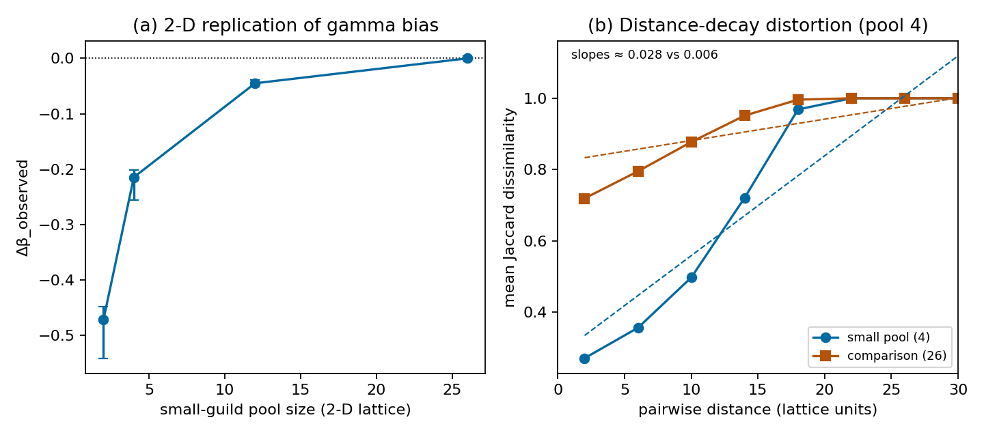
Figure 3. Two-dimensional robustness and distance-decay
distortion. (a) Δβ_obs under pool asymmetry on a 40×40 lattice with
disc-shaped ranges (pool 4: −0.21; pool 2: −0.47; 100 replicates,
seed 20260924), replicating the 1-D pattern. (b) Mean pairwise Jaccard
dissimilarity vs pairwise geographic distance (β(d)) for small-pool
vs comparison guilds; fitted decay slopes ≈0.028 vs ≈0.006 — the
bias inflates the apparent rate of spatial turnover, not just its
mean. Dependent variable: pairwise Jaccard; distance in lattice
units; slope sign positive = increasing dissimilarity with distance.

Results 2 — Dominance, taxonomic lumping, temporal averaging and sampling
**Dominant taxon.** A single dominant predator lowered Δβ_obs monotonically with its prevalence: bias ≈ −0.07 at p_D = 0.5 — the cell bracketing Allosaurus's observed 45.6% occupancy — and ≈ −0.21 at p_D = 0.9 (Fig. 2b).
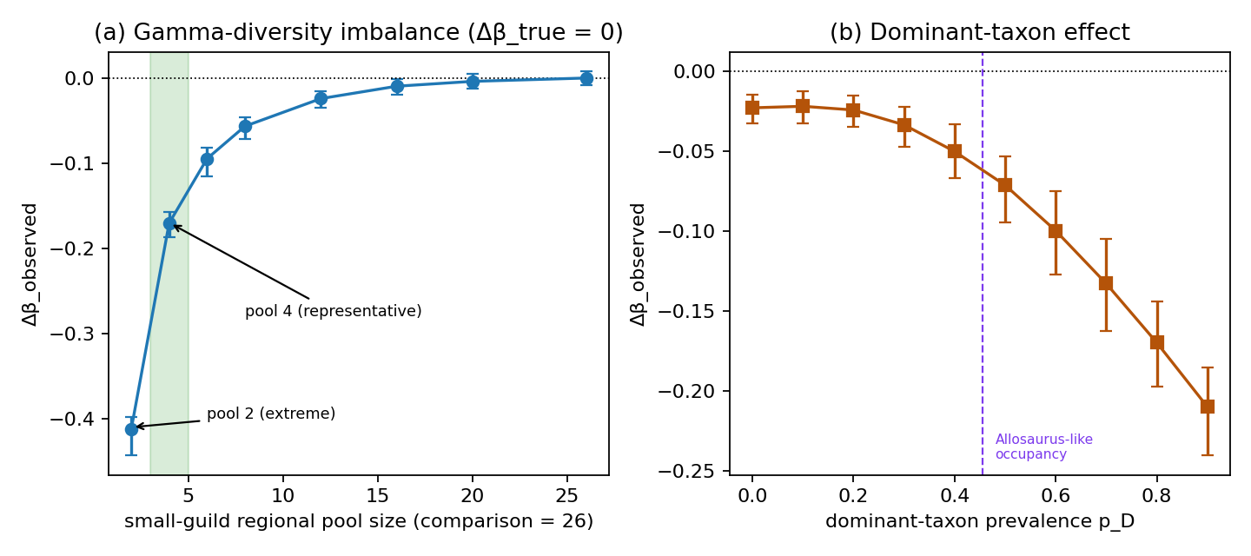
Figure 2. Structural asymmetry creates false differentiation
(Δβ_true = 0). (a) Δβ_obs vs small-guild regional pool size
(comparison guild = 26 taxa); four-taxon pool is the representative
case (−0.17) and the two-taxon pool the extreme tested condition
(−0.41); points are means over 200 replicates with 95% replicate
intervals. (b) Δβ_obs vs dominant-taxon prevalence p_D; negative
Δβ = apparent spatial continuity of the small/dominant-structured
guild. Frozen seed set 20260922.
**Taxonomic lumping.** We define B_lumping = β_species − β_genus of the manipulated guild; positive values mean genus pooling makes the guild appear *more* spatially continuous. Collapsing k geographically partitioned species into one genus produced B_lumping up to +0.099 at k = 6, shifting Δβ_obs from −0.001 (species-resolved) to −0.101 (genus-pooled; Fig. 4a) — i.e., lumping fabricated apparent predator continuity.
**Temporal averaging.** Pooling 8 thin time slices into progressively wider bins attenuated the observed guild contrast from −0.031 (single-slice bins) to −0.001 (full pooling; Fig. 4b) — pooling drives Δβ toward zero whether the contrast is structural or ecological, because union-pooling inflates within-bin occupancy and mechanically deflates per-guild beta diversity. Temporal averaging can therefore erase structure, not only create it.
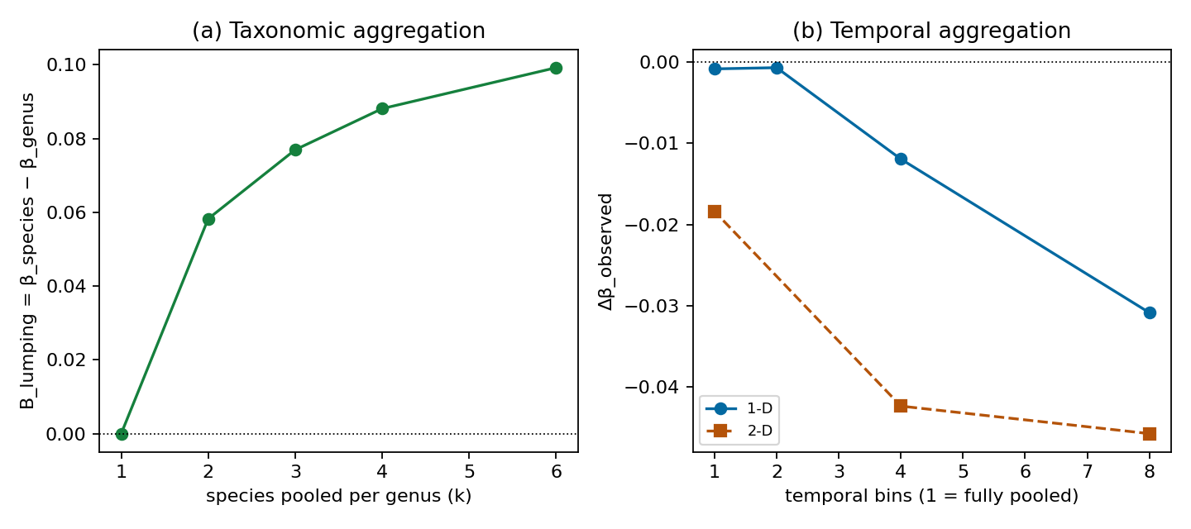
Figure 4. Taxonomic aggregation and temporal aggregation. (a) Pooling k geographically partitioned species into one genus adds
apparent continuity; B_lumping = β_species − β_genus (positive = more
continuity), up to +0.099 at k = 6. (b) Temporal pooling attenuates
observed guild contrasts toward zero (1-D −0.031 → −0.001; 2-D
confirmatory −0.045 → −0.018), a false-negative mechanism.
**Sampling asymmetry.** An 8-fold predator-sampling asymmetry between environmental blocks produced comparatively small bias under the parameter range examined (Δβ_obs between −0.024 and −0.023; Fig. S#); we do not claim sampling bias is unimportant in general.

Results 3 — Factorial simulation: sign-reversal and false-difference regions
The five structural terms are not independent. In the factorial grid (n_pred_taxa × p_dominant × n_lumped), biases compound non-additively: the most extreme cell reached Bias = −0.91 and the false-difference rate (|Δβ_obs| > 0.1 under Δβ_true = 0) reached 100% in the low-gamma, high-dominance, high-lumping region (Fig. 5). Because interactions dominate the corner cases, no single-bias correction is sufficient.
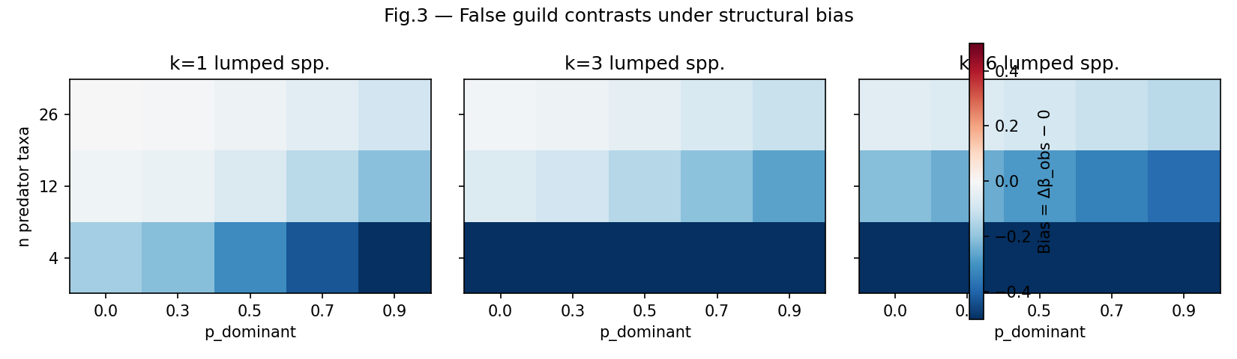
Figure 5. Factorial bias map. Bias = Δβ_obs − Δβ_true across
pool size × dominance, one panel per lumping level; sign-reversal and
false-difference regions occupy the low-gamma/high-dominance corner
(max |Bias| −0.91, 100% false-difference rate). The additive
decomposition is conceptual only; this map is the estimable summary.

Results 4 — Morrison worked example: the naive guild contrast
On the primary specification (collection assemblages, genus level, Jaccard), Morrison predators were much more spatially homogeneous than herbivores: Δβ = −0.550 (bootstrap 95% CI −0.630, −0.457). Read naively this would imply exceptional predator spatial continuity — exactly the class of signal Simulations 1–3 show can arise structurally.

Results 5 — Sequential empirical decomposition
Applying the diagnostic cascade (Fig. 6):
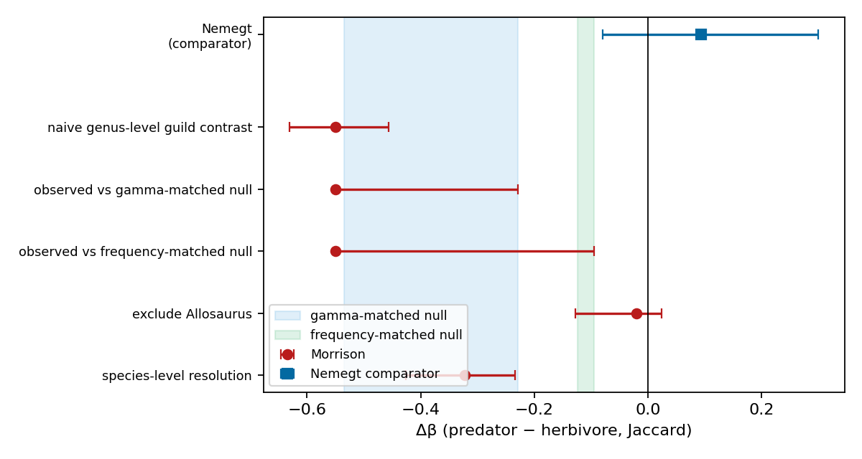
Figure 6. Empirical stress test (Morrison Formation). Sequential
attenuation: naive Δβ = −0.550 (−0.630, −0.457); gamma- and
frequency-matched null intervals shown shaded (distinct from
bootstrap CIs); dominant-taxon exclusion Δβ = −0.020; species
resolution Δβ = −0.322; dominant-taxon extent residual −36.6 km
(z = −0.16). Inset: Nemegt comparator Δβ = +0.094 (−0.079, +0.300).
If space is constrained, the Nemegt inset moves to Supporting
Information.
1. **Gamma-matched null.** Δβ = −0.550 lies inside the pool-matched null interval (−0.534 to −0.229): unequal taxon pools account for much of the magnitude. 2. **Frequency-matched null.** The observed value is more negative than the frequency-matched null interval (−0.124 to −0.095): occupancy-frequency structure alone does not produce the signal. 3. **Dominant-taxon exclusion.** Removing Allosaurus collapses Δβ to −0.020 (−0.128, +0.024). 4. **Taxonomic resolution.** At species level Δβ attenuates to −0.322 (−0.426, −0.234), direction consistent with Simulation 3. 5. **Duration + sampling adjustment.** After regressing geographic extent on stratigraphic duration and occurrence count, Allosaurus's extent residual is −36.6 km (z = −0.16): not geographically exceptional for its sampling footprint. 6. **Preservation/collection model (exploratory).** The unpenalized model reached pseudo-R² = 0.46 but did not fully converge (quasi-separation; state coefficients ≈ 17). An L2-penalized logistic refit converged and yielded pseudo-R² = 0.34 — the same qualitative conclusion that collection covariates carry substantial presence structure. Both are retained as exploratory diagnostics only.

Results 6 — Nemegt comparator
Under the identical locked pipeline, Nemegt (herbivore gamma 8 < predator gamma 26 — the reverse asymmetry) yields Δβ = +0.094 (95% CI −0.079, +0.300): the Morrison direction is not reproduced. Nemegt functions here as a structural comparator showing the pattern is not a universal predator-guild phenomenon; extended Tarbosaurus diagnostics appear in the Supplementary Material.

Results 7 — Independent evidence audit
A bounded review of isotopic, ichnological and feeding-trace evidence identified nothing contradicting the methodological interpretation; the strongest independent evidence supports dietary generalism rather than exceptional mobility, and no direct test of Allosaurus movement was identified (Supplementary Material).

Discussion

Main conceptual result
Our simulations demonstrate two symmetric inferential failures. Under a true guild contrast of zero (Δβ_true = 0), structural asymmetry alone — unequal regional pools, dominance, taxonomic lumping — generated observed contrasts as large as |Δβ_obs| ≈ 0.17 for a realistic four-taxon pool and ≈ 0.41 under the most extreme two-taxon pool, a false-positive mechanism. Conversely, temporal aggregation attenuated observed contrasts toward zero (2-D: −0.045 → −0.018), a false-negative mechanism. Assemblage construction can thus both create and erase apparent ecological spatial structure. These magnitudes are scenario-specific demonstrations of sufficiency, not universal constants, but the two failure directions are qualitative properties of guild-level comparisons rather than artifacts of any single parameterization. The two failure directions are also asymmetric in where they hide: false differentiation is invisible to naive replication — repeating the same contrast on structurally similar data reproduces the same bias — whereas lost differentiation is invisible precisely because nothing is seen. A diagnostic workflow must therefore test both directions rather than searching only for spurious signal.

Gamma diversity
The largest single bias source was gamma-diversity imbalance. Richness effects on dissimilarity metrics are recognized (Kraft et al., 2011; Chase et al., 2011), but the magnitudes observed here — a four-taxon pool yielding a fully reproducible apparent contrast of −0.17 against a 26-taxon pool under Δβ_true = 0 — show that pool-size-matched nulls are not optional refinements but a minimal requirement. The qualitative result replicated across spatial geometries: on a 2-D lattice the same conditions produced −0.21 (pool 4) and −0.47 (pool 2), indicating the phenomenon is not an artifact of one-dimensional range geometry. Comparisons among guilds or regions with different pool structures remain vulnerable even after standard diversity partitioning (Chase et al., 2018).

Distance-decay distortion
A result of particular relevance to biogeographic inference is that structural asymmetry distorts the *shape* of turnover, not only its mean. In the 2-D simulations, the small-pool guild showed an inflated apparent distance-decay slope (≈0.028) relative to the comparison guild (≈0.006) under identical true spatial processes. Distance decay is a core tool for diagnosing dispersal limitation and environmental filtering (Nekola & White, 1999; Soininen et al., 2007; Morlon et al., 2008); our result implies that guild or regional differences in pool size alone can mimic steeper turnover gradients, so decay comparisons require the same structural controls as mean dissimilarity. Practically, a reported difference in distance-decay slopes between groups may reflect differential sensitivity to pool size rather than differential dispersal; pool-matched or richness-standardized decay curves are the analogue of the matched-null requirement for mean Δβ.

Dominance and taxonomic aggregation
A single dominant taxon shifted Δβ by ≈−0.07 at realistic prevalence and ≈−0.21 at extreme dominance — consistent with the known sensitivity of assemblage dissimilarity to common species (Lennon et al., 2004; Hillebrand et al., 2008; McGeoch & Gaston, 2002). Genus-level pooling of geographically differentiated species produced an apparent continuity shift of +0.099 (B_lumping = β_species − β_genus; positive = more apparent continuity), mirroring taxonomic-sufficiency effects documented for assemblage analyses (Bertrand et al., 2006; Bevilacqua et al., 2012; Lane et al., 2003). In the Morrison case, dominant-taxon exclusion and species-level resolution each collapsed or attenuated the naive contrast — an empirical illustration, not a general estimate. The two mechanisms are usefully distinguished: dominance changes which *sites* are occupied (fewer occupied sites than the pool implies, biasing β downward in the dominant guild), whereas lumping changes which *entities* are counted (multiple spatially segregated species fused into one widespread genus, erasing turnover at the finer taxonomic grain). Both inflate apparent spatial continuity but through different data construction paths, so the diagnostics differ: occupancy-frequency inspection for the former, resolution sensitivity for the latter.

Temporal aggregation
Pooling eight temporal slices into one bin attenuated the observed contrast toward zero (1-D: −0.031 → −0.001; 2-D: −0.045 → −0.018). Time averaging is expected to homogenize assemblages (Kidwell & Behrensmeyer, 1991; Olszewski, 1999; Kowalewski, 1996; Tomašových & Kidwell, 2010), but the symmetric framing matters: temporal aggregation is primarily a *false-negative* mechanism, erasing genuine structure rather than manufacturing it, whereas gamma imbalance, dominance and lumping chiefly generate *false-positive* differentiation.

Sampling
An eight-fold sampling asymmetry produced comparatively small bias (≈−0.024) within the tested parameter range. We do not infer that sampling is unimportant — fossil databases are demonstrably sampling-structured (Smith & McGowan, 2007; Vilhena & Smith, 2013) — only that under our parameterization its isolated effect was smaller than pool-size, dominance and lumping effects.

Empirical stress test
In the Morrison Formation, a naive predator–herbivore Δβ of −0.550 fell within the gamma-matched null interval, exceeded the frequency-matched null, and collapsed to −0.020 after exclusion of the single dominant taxon; species-level resolution gave −0.322, and the dominant taxon was not geographically exceptional after duration and occurrence adjustment (extent residual −36.6 km, z = −0.16). Collection covariates explained substantial presence structure (pseudo-R² 0.46 unpenalized, 0.34 under L2 penalization — exploratory, with an MLE convergence warning; the penalized fit reaches the same qualitative conclusion). The correct interpretation is not that the ecological account was disproven, but that structural explanations became sufficient — a biologically compelling narrative was no longer required. Nemegt, run through the identical locked pipeline, showed Δβ = +0.094 (−0.079, +0.300): the Morrison direction is not a universal predator-guild property.

Factorial interaction
Because gamma diversity, dominance, taxonomic resolution and sampling co-vary in real assemblages, the bias terms cannot be treated as independent additive corrections. The factorial simulation — the appropriate summary for applied inference — shows interactions large enough to reverse sign (the extreme corner reached −0.91). This is why single-mechanism corrections under-protect: fixing only pool size leaves dominance and lumping free to generate a contrast; the diagnostic workflow must therefore be sequential and cross-checked rather than a single covariate adjustment.

General applicability
The mechanisms quantified here apply wherever comparisons are made between assemblages differing in pool size, dominance, taxonomic grain, temporal span or sampling structure — museum and herbarium records, multi-year monitoring compilations, archaeological faunas, and sedimentary records (Shaffer et al., 1998; Pyke & Ehrlich, 2010; Lavoie, 2013; Graham et al., 2004). These are conceptual analogues; direct tests in each domain are needed, and our magnitudes should not be transported quantitatively. The growing reliance on aggregated occurrence datasets for biodiversity-change inference (Blowes et al., 2019) makes the asymmetry between the two failure modes especially consequential: structurally generated contrasts are likely to be interpreted as ecological signal, while temporally erased contrasts are invisible and therefore never tested for. Among the candidate biases we isolated, the pool-size mechanism has the clearest parallel outside palaeontology — cross-guild and cross-region richness asymmetries are ubiquitous in modern occurrence data — whereas temporal averaging is most acute in archives that integrate time, and taxonomic lumping sits between the two wherever identification effort varies across groups.

Practical workflow
Before interpreting guild-level beta-diversity contrasts: (1) compare guild gamma diversity; (2) run pool-size-matched nulls; (3) inspect dominance and run leave-one-dominant-taxon analyses; (4) harmonize taxonomic resolution and test sensitivity across levels; (5) test temporal aggregation; (6) inspect sampling asymmetry and detection structure; (7) examine distance-decay slopes, not only mean dissimilarity; (8) map interactions across these factors; (9) only then infer ecological connectivity, mobility or filtering. The same discipline applies to non-fossil assemblage comparisons (Socolar et al., 2016).

Limitations
Our simulators use simplified ecology and synthetic guild construction; parameter ranges were chosen to bracket plausible assemblage structures but the reported magnitudes are not calibrated estimates for real landscapes. The bias mechanisms are non-independent — the factorial map, not the additive decomposition, is the appropriate summary. The 2-D replication improves but does not reproduce real landscape complexity. Morrison is one worked example and species-resolution analyses depend on identification completeness. Structural sufficiency is not causal attribution: demonstrating that a contrast *can* be generated structurally does not prove it *was*.

References
See bibliography.md (52 DOI-verified entries; reference_audit.csv).

Figures (as placed)
Figure 1: fig_geb1_conceptual.png
Figure 2: fig_geb2_gamma_dominance.png
Figure 3: fig_geb3_2d_decay.png
Figure 4: fig_geb4_lumping_temporal.png
Figure 5: fig3_bias_heatmap.png
Figure 6: fig_geb6_empirical.png

