A shared core protocol for cross-system tests of trophic spatial coupling: six-system refactor and a Cenozoic mammal strict replication

Abstract
We refactored a multi-system ecology program (Late Jurassic dinosaurs, Cenozoic mammals, Quaternary mammals, ancient marine fossils, modern terrestrial surveys, modern marine observations) onto a shared Core Protocol with per-system adapters. Fixed items — the primary lower-vs-higher trophic contrast, effect-direction convention, sampling-pool test, time-aggregation test, distance-decay test, negative control, and a common A–D robustness classification — are identical across systems, while database, spatial unit, temporal resolution, observation-process corrections, and guild definitions are system-specific and declared in adapter documents. We then implemented a strict replication of the dinosaur reference protocol on Cenozoic (23–5 Ma) North American mammals from the Paleobiology Database. The predator-minus-herbivore Simpson turnover contrast replicated in sign (Delta-beta = -0.028, 95% CI [-0.040, -0.018]) but its magnitude falls within genus-pool null expectations — a partial replication (class B).

1. Introduction
Comparability across ecological systems requires that each system measures an analogue of the same construct rather than identical preprocessing. The Core Protocol (docs/CORE_PROTOCOL_V1.md) fixes what is measured; adapters (protocols/<system>/) translate each system's observation model. Tier 1 systems (dinosaur, Cenozoic, Quaternary) replicate strictly; Tier 2 systems (ancient marine, modern terrestrial, modern marine) export translated metrics into a common schema; Tier 3 synthesis consumes only standardized exports.

2. Methods
Cenozoic input: PBDB 1.2 occurrences (base_name=Mammalia, cc=NOA, 23–5 Ma); 12,248 terrestrial-environment occurrences, 2,102 collections, 378 herbivore-order and 131 Carnivora (non-pinniped) genera. Estimand identical to the dinosaur reference: Delta-beta = mean pairwise Simpson turnover (predator minus herbivore), collection bootstrap (n=999), Mantel test (Spearman, 9,999 permutations), 100 km distance bins, and the five-correction sampling battery (raw, dominant-quarry exclusion, singleton exclusion, equalized collections, 1-degree spatial thinning). Genus-pool size-matched and label-shuffle nulls are mandatory negative controls. Deviations are enumerated in protocols/cenozoic_mammals/PROTOCOL_DEVIATIONS.md.

3. Results
The Delta-beta contrast is negative (Simpson -0.028; Sorensen -0.026), the same direction as the dinosaur reference (−0.543) but an order of magnitude smaller. Weak but significant distance decay appears in both guilds (Mantel r: herbivore 0.087, predator 0.103; both p<0.001), unlike the Morrison null decay. Figure 1 shows the occurrence map and turnover-by-distance curves.
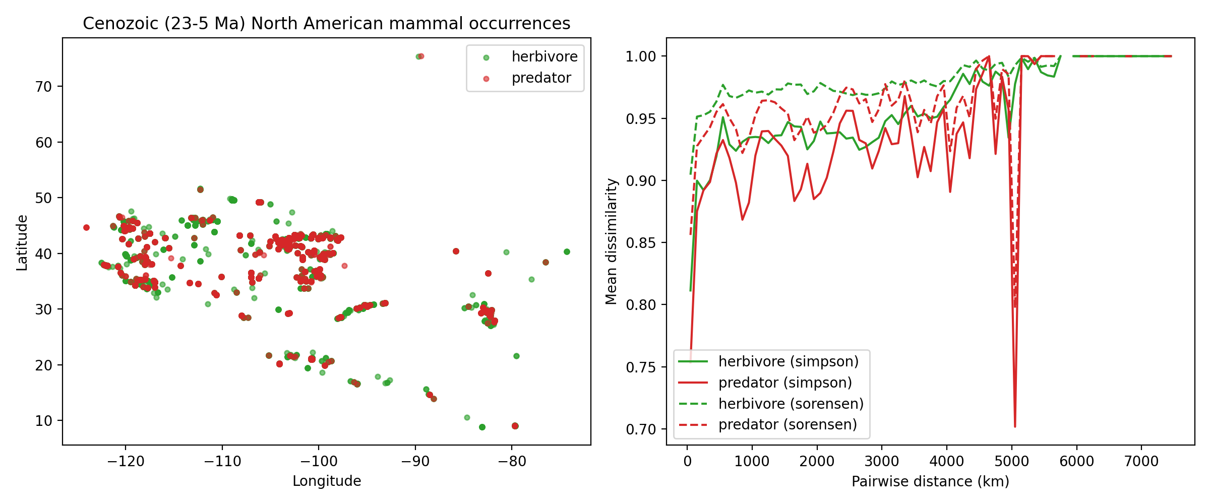
Figure 1. Cenozoic North American mammal occurrences (23–5 Ma) and guild turnover vs pairwise distance (Simpson solid, Sorensen dashed).
Table 1 gives the sampling-pool sensitivity; the sign is preserved under all five corrections. Table 2 shows the temporal aggregation ladder; finer bins strengthen the negative contrast (to ~−0.08). Table 3 shows the genus-pool nulls: the observed Delta-beta sits at quantile ~0.34 of size-matched null splits — the direction replicates but the magnitude is consistent with guild-pool asymmetry alone.
Table 1. Sampling-pool sensitivity of Delta-beta (Simpson).
correction | delta_beta_mean | lo95 | hi95 | prop_gt0 | n_rep
raw | -0.0284 | -0.0284 | -0.0284 | 0.0 | 1
no_dominant_quarries | -0.0252 | -0.0252 | -0.0252 | 0.0 | 1
no_singletons | -0.0104 | -0.0104 | -0.0104 | 0.0 | 1
equalized_collections | -0.0283 | -0.0338 | -0.0225 | 0.0 | 999
spatial_thinning_1deg | -0.0263 | -0.0504 | -0.0045 | 0.001 | 999

Table 2. Temporal aggregation sensitivity (Delta-beta by binning).
binning | delta_beta | delta_vs_pooled
pooled | -0.0284 | 0.0
epoch | -0.0873 | -0.059
ma5 | -0.0807 | -0.0524
ma1 | -0.0784 | -0.05

Table 3. Genus-pool null models vs observed Delta-beta.
null | observed | null_mean | null_lo | null_hi | quantile | n_rep | notes
size_matched_split | -0.0284 | -0.0288 | -0.0805 | 0.0037 | 0.3413 | 999 | random 131/378 genus splits
label_shuffle | -0.0284 | -0.0278 | -0.0805 | 0.003 | 0.3273 | 999 | permute guild labels across genera, keep pool sizes

4. Discussion
The Cenozoic result is a partial replication (class B): the direction matches the dinosaur pattern, but the effect size is null-consistent. The observation-model matrix (Table 4) documents per-system bias regimes so synthesis can separate ecological generality from shared methodological artifacts. The essential harmonization step for v1.1 is mandatory export of a pool-matched null quantile alongside every Delta-beta.
Table 4. Observation-model matrix (condensed).
system | fossil_or_modern | temporal_resolution | preservation_bias | observer_bias | major_correction_method
dinosaur | fossil | formation-pooled (~10 Myr) | high (taphonomic filter; monodominant bone beds) | collector/quarry bias | dominant-quarry + singleton exclusion; equalized collections; 1deg thinning; pool-matched nulls
cenozoic | fossil | interval-pooled 23-5 Ma (subepoch sensitivity) | high (mass-death beds; cave/tarpit accumulations) | collector bias (screen-wash vs quarry) | same five-correction battery + aggregation ladder
quaternary | fossil | fine (100-20 kyr secondary; coarse primary) | high (cave/tarpit predator-accumulated) | collector bias | same battery + fine-resolution ladder
ancient_marine | fossil | stage/subepoch (condensation) | very high (mineralization; facies tracking; condensation) | collection-intensity bias | facies-stratified turnover + intensity normalization + Lagerstaette exclusion
modern_terrestrial | modern | annual (multi-decade) | none | high (observer turnover/identity) | route demeaning; prevalence inclusion; matched-environment contrast; observer control (pending)
modern_marine | modern | event-based (3-14 d) | none | platform/effort bias | tow-anchored matching; LOEO; placebos/reverse-time; capelin positive control

5. Conclusions
A fixed conceptual contract plus system-specific adapters enables cross-era, cross-environment comparison without forcing identical pipelines. Cenozoic mammals replicate the sign but not the magnitude of the dinosaur trophic-turnover contrast.

