A training-free, event-driven Poisson likelihood-ratio detector for faint object events in sparse neuromorphic space-imaging streams
[Author names]
[Affiliations, addresses]
Abstract. In event-camera space surveillance, faint objects must be separated from background-activity noise. We describe a detector that works on the event stream without frames, voxel grids or labels: each pixel's background rate is estimated from its inter-event intervals, and the Poisson tail probability of the count in a causal neighbourhood is the noise probability. On all 43 labelled recordings of the Event-Based Space Situational Awareness dataset, with every comparator tuned by the same grouped cross-validation, it reaches a mean area under the receiver operating characteristic curve (ROC-AUC) of 0.753, indistinguishable from the event bilateral filter (0.801) and 0.09 below YNoise. Its cost falls with the number of events (exponent 0.81), whereas the voxelised form of the same test stays constant (0.02). The operating point follows a false-alarm budget without labels: a requested 0.01 yields a median 0.0088. In a zero-knowledge test, a window set from the estimated background rate transfers between sensor models with an AUC loss of at most 0.02, against 0.08 for a fixed window; handed to YNoise as its time constant, it raises that filter from 0.74 to 0.84 without labels. The method follows from the pixel physics of the sensor and suits surveys of new fields.
Keywords: event camera; dynamic vision sensor; space situational awareness; Poisson process; likelihood ratio; denoising.
*Corresponding author: [e-mail]
1 Introduction
Event cameras, or dynamic vision sensors (DVS), emit an asynchronous event whenever the log-intensity at a pixel changes by more than a contrast threshold, giving microsecond timing and a dynamic range above 120 dB without a global exposure.^{1,2} These properties have motivated their use for optical space situational awareness (SSA), where resident space objects (RSOs) appear as faint, slowly moving point sources against a static star field, and where the data volume of conventional framing cameras is dominated by empty sky.³⁻⁵ In such observations the event stream is extremely sparse: in the recordings analysed here the median rate is 12 kilo-events per second over a 180 x 240-pixel or 240 x 304-pixel array, and only 0.8% of events (median) fall inside the annotated object boxes.
The dominant contaminant is background activity (BA): spontaneous events produced by junction leakage and shot noise in the pixel front end, whose rate depends on temperature and illumination and varies from pixel to pixel.^{6,7} Event-denoising filters are therefore a mature topic. Spatiotemporal correlation filters pass an event only if a neighbour fired recently,^{8,9} density filters count neighbours within a window,¹⁰ the double-window filter compares an event against the most recent signal and noise events,⁷ and supervised networks learn the decision from labelled streams.^{7,11} These methods share two properties that matter for astronomy. First, they output a heuristic score (a neighbour count or a network logit) whose threshold must be tuned on labelled data for each sensor and observing condition. Second, several high-performing variants are implemented, or are most naturally described, on a voxel grid of time bins and pixels, so their cost is set by the size of the array and the length of the recording rather than by the number of events; as the stream becomes sparser, most of the work is spent on empty voxels.
We take a different starting point. Under the null hypothesis that a pixel produces only BA, its events form an approximately Poisson point process with a pixel-specific rate that can be estimated from the stream itself. A faint moving object adds events that are clustered in space and time relative to that rate. The optimal test for such a hypothesis, by the Neyman-Pearson lemma, is a likelihood ratio,^{12,13} and for a Poisson count it reduces to a tail probability that is monotone in the observed neighbourhood count given the expected count. This gives an event-driven detector with three properties: (i) it requires no labels because the background model is fitted to the same stream it filters; (ii) its output is a probability on a common scale, so a false-alarm budget can be converted directly into a threshold; and (iii) it touches each event once with a small neighbourhood lookup, so its cost scales with the number of events rather than with the voxel grid.
These properties follow from the physics of the sensor rather than being imposed on it. A DVS pixel is an independent, asynchronous circuit whose output is a sequence of timestamps, and its background activity arises from leakage and shot noise in that circuit,^{2,6} so a per-pixel Poisson point process is the natural null model, and the pixel-to-pixel variation of the noise rate is a reason to estimate the rate per pixel rather than a nuisance. Converting the stream to frames or voxels discards the microsecond timing the sensor provides and replaces a data volume proportional to the number of events with one proportional to the array and the exposure, undoing the two advantages that motivate the use of event cameras in astronomy. A detector that touches each event once, in arrival order, with state proportional to the number of pixels, preserves both and maps directly onto the streaming, near-sensor processing for which the sensor was designed. Finally, because the operating point is derived from a false-alarm budget on the same stream, the detector needs neither labelled data nor manual re-tuning when it is pointed at a new field, a new sensor or a new observing condition; this is the situation of survey and discovery observations, where no catalogue of what should be detected exists.
This paper makes the following contributions. (1) We formulate the event-driven Poisson likelihood-ratio (LR) detector and describe an implementation whose per-event cost is logarithmic in the stream length. (2) We evaluate it against 17 unsupervised comparators and two supervised networks on all 43 labelled recordings of the Event-Based Space Situational Awareness (EBSSA) dataset,⁴ using the published object annotations as ground truth and grouped cross-validation for every tuned parameter. (3) We measure how the cost of event-driven and voxel-based formulations changes when the real streams are thinned by up to two orders of magnitude. (4) We show that the probability output can be self-calibrated to a requested false-alarm rate without labels, and quantify the detection rate obtained at that budget. (5) We test a zero-knowledge deployment, in which the configuration is fixed on one sensor model and the detector is pointed, unchanged, at the other, with a temporal window that is set from the estimated background rate rather than in milliseconds. (6) We show that this rate-derived window, handed to the strongest comparator as its time constant, recovers most of the accuracy that labelled tuning gives that comparator, and we measure a two-stage front end in which the proposal screens and the comparator confirms. The claim is one of equivalence with added properties, not of superiority: the detector is comparable in accuracy to most published unsupervised event filters when those filters are given the same cross-validated tuning, while it alone needs no labels, no per-sensor tuning and no manually chosen threshold in operation, and it is much cheaper than frame- or voxel-based processing as the stream becomes sparse. We do not claim to exceed supervised networks trained on labelled data from the same sensors.
2 Methods
2.1 Event stream and hypotheses
An event camera produces a time-ordered stream of events e_i = (x_i, y_i, t_i, p_i), where (x_i, y_i) is the pixel address, t_i the timestamp in microseconds and p_i the polarity. We ignore polarity in the detector. For every event we test the null hypothesis H0 that the events in a small causal neighbourhood of e_i were produced by the pixel-wise BA process alone, against the alternative H1 that an additional source contributed to them. Under H0 we model the BA of pixel (x, y) as a homogeneous Poisson process with rate λ_xy;¹⁴ the rates differ between pixels because leakage and hot-pixel behaviour do.⁶ Figure 1 summarises the pipeline.
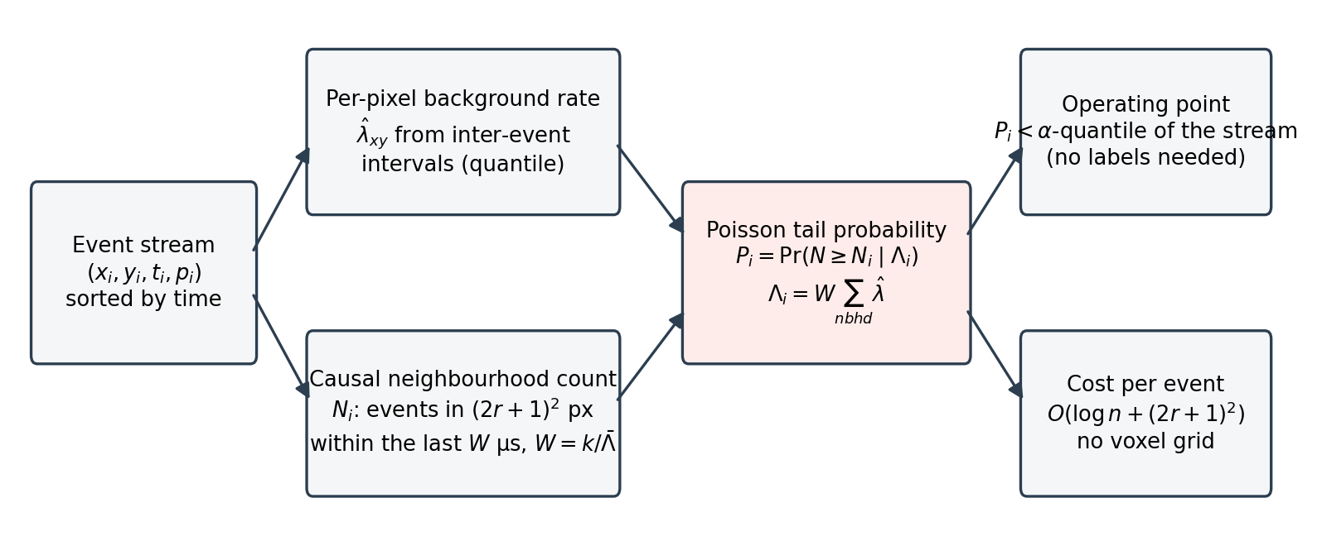
Fig. 1 Event-driven Poisson likelihood-ratio detector. Each event is scored from the estimated background rate of its neighbourhood and the number of events that arrived in that neighbourhood during the preceding window; the tail probability is used directly as the noise probability, so the operating point can be set from a false-alarm budget without labels and no voxel grid is constructed.
2.2 Per-pixel background-rate estimation
The rate of each pixel is estimated from its own inter-event intervals. Let Δ_xy(q) be the q-quantile of the intervals between successive events at pixel (x, y). For an exponential interval distribution with rate λ, the q-quantile is -ln(1 - q)/λ, so
$$\hat{λ}{}_{xy} = \frac{−ln\left(1 − q\right)}{Δ_{xy}(q)}$$ (1)
is a consistent estimate of the BA rate. A high quantile is deliberately used: object events shorten a minority of the intervals at the pixels they cross, and a high quantile of the interval distribution is insensitive to that minority, whereas the mean interval is not. Pixels with fewer than four events receive the median rate of the array. The quantile q, the window W and the radius r introduced below are the only tuned parameters and were selected by cross-validation (Sec. 2.8).
2.3 Event-driven Poisson tail test
For event i let N_i be the number of events, including e_i itself, that arrived at most W microseconds earlier within the (2r + 1) x (2r + 1) pixel neighbourhood centred on (x_i, y_i):
$$N_{i} = \#\left\{j : t_{i} − W ≤ t_{j} < t_{i}, ‖\left(x_{j} − x_{i}, y_{j} − y_{i}\right)‖{}_{∞} ≤ r\right\}$$ (2)
Under H0 the count is Poisson with mean
$$Λ_{i} = W \sum_{|u|,|v| ≤ r}{\hat{λ}{}_{x_i+u, y_i+v}}$$ (3)
The likelihood ratio of H1 against H0 for a Poisson count with a larger alternative rate is monotone increasing in N_i, so by the Neyman-Pearson lemma thresholding N_i given Λ_i is the most powerful test at any size, and the size attained by observing N_i is the upper tail probability¹³
$$P_{i} = Pr\left(N ≥ N_{i} | Λ_{i}\right) = \sum_{k = N_{i}}^{∞}{e^{−Λ_i}\frac{Λ^{k}}{k!}}$$ (4)
P_i is reported as the noise probability of event i; small values indicate an event that is unlikely under the background model. Because Λ_i differs between events, the comparison is made on the probability scale rather than on the raw count, which is what allows one threshold to serve the whole array. The count includes e_i, so an isolated event in a quiet region has N_i = 1 and P_i close to one.
The stream is processed in time order. A per-pixel ring of recent timestamps and a running pointer into the sorted stream give N_i in O((2r + 1)^2 + log n) operations per event, and the neighbourhood rate sum in Eq. (3) is a box filter over the rate map computed once. No voxel grid or dense frame is allocated, so memory is proportional to the number of pixels plus the number of events. The implementation uses NumPy and Numba.¹⁵
2.4 Self-calibrated operating point
A tracker downstream of the detector typically tolerates a stated false-alarm rate α rather than a stated threshold. Because P_i is a probability, a label-free operating point is obtained by asking the detector to pass exactly a fraction α of the stream:
$$τ_{α} = Q{}_{α}\left(\{P_{i}\}\right), flag event i if P_{i} ≤ τ_{α}$$ (5)
where Q_α denotes the empirical α-quantile. If the object fraction is small and the background model is adequate, the achieved false-alarm rate on true noise events is close to α. The same rule can be applied to any score, so we also apply it to the comparators; the difference is that an integer neighbour count has few distinct values and cannot be cut at an arbitrary quantile, whereas a continuous probability can. The inequality is strict, so that when the quantile falls inside a run of tied scores the tied events are not passed and the achieved rate stays at or below α; a tie of this kind arises for the proposed detector itself when Λ_i is so large that P_i rounds to one, and the fraction of such saturated scores is a label-free diagnostic that the window is too long for the background rate.
2.5 Rate-adaptive window for zero-knowledge deployment
A window stated in milliseconds is a sensor-specific choice: the same W gives a background expectation Λ_i that is several times larger on a sensor with a higher BA rate, and the tail probability saturates. The window is therefore also specified in a dimensionless form, as the expected number k of background events in the neighbourhood: W is set so that the median of Λ_i / W over the events of the stream, multiplied by W, equals k, i.e. W = k / median(Σλ̂) with the sum over the (2r + 1)^2 neighbourhood, clipped to [1 ms, 2 s]. The rate estimate is the label-free one of Sec. 2.2, so the rule uses nothing but the target stream. The deployment configuration used in the zero-knowledge analysis is r = 3, k = 16, q = 0.99. The value of k was fixed once, from the trade-off between ranking accuracy and saturation over k ∈ {2, 4, 8, 16, 32, 64} on the EBSSA data (Sec. 3.6); it is therefore a constant of the method chosen on this dataset, not a per-sensor setting, and the cross-sensor protocol below tests whether it carries over.
2.6 Data
We used the labelled split of the EBSSA dataset,⁴ downloaded through the Tonic library.¹⁶ It contains recordings of RSOs and stars made with two event-camera models: 29 recordings from a 180 x 240-pixel sensor and 14 from a 240 x 304-pixel sensor. Ground truth is the published object annotation: an event is labelled as object if it lies within a 10 x 10-pixel box around an annotated position and within 10 ms of its timestamp; all other events are labelled as background. For each recording the analysis window was restricted to the annotated interval (plus 0.5 s on each side) and the central 200,000 events of that window were kept, giving 8,267,149 events in total. Recordings with fewer than 50 events in either class were excluded, leaving all 43 labelled recordings. Median event rate was 12.2 k events/s (range 3.3-85.7); the object fraction ranged from 0.12% to 15.6% (median 0.85%). No synthetic data were used anywhere in the evaluation.
2.7 Comparators and ablations
Published unsupervised filters were re-implemented from their descriptions, and their parameters were selected by the same grouped cross-validation as those of the proposed detector (Sec. 2.8), so that no comparator is handicapped by author defaults chosen for other sensors: the background-activity filter (temporal correlation with a neighbour),⁸ a nearest-neighbour filter, an event bilateral filter (weighted spatiotemporal neighbour count), a motion-compensated proxy, kNoise,⁹ the double-window filter (DWF)⁷ and YNoise (event-density filter).¹⁰ Two supervised references were trained with the object labels: a multilayer-perceptron filter (MLPF)⁷ and an event-denoising convolutional neural network (EDnCNN)¹¹ operating on 98-dimensional time-surface patches of radius 3 pixels and time constant 50 ms. They were trained only on recordings outside the test fold, with 8,000 events sampled per training recording, and are reported to locate the proposed unsupervised detector relative to what labels can buy.
Ablations isolate the two design choices of the proposal. A voxelised Poisson LR filter applies the same tail test to counts on a fixed time-bin x pixel grid, differing only in being frame-based. Event-driven forms of the bilateral and double-window filters use the same causal neighbourhood machinery as the proposal but replace the Poisson probability with the original heuristic score. Further event-driven alternatives (a gamma waiting-time test, a k-nearest-neighbour point-process test, a recursive rate tracker and a velocity-adaptive matched filter) are reported for completeness. A multiscale variant combines the tail probabilities of three (r, W) scales with Fisher's method¹⁷ and is used only in the operating-point analysis.
Two further label-free comparators test the Poisson assumption from the other side, by asking whether a pixel is overdispersed rather than whether a window is improbable. The Fano-factor score¹⁸ bins each recording into 30 equal time bins, forms the per-pixel count series, and computes the Fano factor F = Var(N) / E[N], which is 1 for a Poisson process. Pixels with F > 2 are treated as containing a source and their background rate is set to the minimum bin count of that pixel, all other pixels keep their mean count; the score of an event is then the ratio of this background rate to the total rate of its pixel, so events at overdispersed pixels receive a low noise probability. Because the Fano factor is a statistic of the whole recording, this score is not causal and is retained only as an ablation of the overdispersion idea. The physics-informed network (PI-DC-DVS) takes the same rate cube, with 40 time bins, and refines the Fano-derived background-rate map with a small convolutional network trained for 50 epochs per recording on a loss that pulls the prediction towards the mean count at Poisson-like pixels (0 < F < 2), towards the minimum count at overdispersed pixels, and penalises spatial roughness and rates above the observed mean; no object labels enter the loss. Both run at one fixed configuration, as do the motion proxy and the four further event-driven alternatives, since none of them has a published default and their grids would be ours; the configurations are listed in the code repository.
2.8 Evaluation protocol
The unit of analysis is the recording. Event-level ROC-AUC against the object labels was computed per recording and summarised as mean and standard deviation (SD) over recordings; F1, noise-removal rate (NRR; fraction of background events with P_i of at least 0.5) and signal-preservation rate (SPR) are also reported. Tunable parameters of the proposed detector (r ∈ {2, 3}, W ∈ {100, 150, 300} ms, q ∈ {0.95, 0.99}; 12 combinations), of the voxelised ablation, of every published comparator and of the two event-driven ablations that share their form (time constants, spatial radii, bin counts and window lengths; grids of 6 to 12 combinations, listed in the code repository) were selected by grouped 4-fold cross-validation over recordings: the configuration with the highest mean AUC on the training folds was applied to the held-out fold, so every reported number for these methods is out of fold. The supervised networks used the same folds. The cross-validation is an evaluation device that gives every comparator its best fair configuration; in operation the proposed detector runs with one fixed configuration and sets its threshold from the false-alarm budget (Sec. 2.4). Paired differences between the proposed detector and each comparator were tested with the two-sided Wilcoxon signed-rank test over recordings,¹⁹ with Holm adjustment for the 19 comparisons.²⁰ Results are also stratified by sensor model and by event rate (below or above the median). Partial AUC restricted to false-positive rates below 0.01 and 0.001 is reported in the standardised form of McClish,²¹ in which 0.5 is chance, using scikit-learn.²² The random seed was fixed at 42.
2.9 Cost versus sparsity
To measure how cost depends on sparsity, a real EBSSA recording (200,000 events) was thinned by keeping a uniformly random fraction f of its events, f ∈ {1, 0.5, 0.25, 0.1, 0.05, 0.02, 0.01}, while leaving the sensor array and the recording interval unchanged, so the voxel grid of the frame-based methods keeps its size. Thinning a Poisson process yields a Poisson process,¹⁴ so the thinned streams remain realistic sparse backgrounds. Wall-clock time and peak Python-level memory were recorded over 3 repeats after a warm-up call, and a cost exponent β was fitted by least squares on log-log axes:
$$T\left(f\right) ∝ f^{β}, β = \frac{d log T}{d log f}$$ (6)
An exponent near one means cost proportional to the number of events; an exponent near zero means cost fixed by the grid. Timings were taken on a single processor core and are indicative of scaling, not of absolute throughput on dedicated hardware. The zero-knowledge form of the proposed detector (Sec. 2.5) was timed in the same way, with the rate estimate and the window choice included in its cost.
2.10 Zero-knowledge protocol
The cross-validation of Sec. 2.8 still lets each method see labelled recordings from both sensor models. To emulate a new instrument, the two models were treated as source and target (29 and 14 recordings) in both directions, and three questions were asked. (A) Configuration transfer: the configuration with the highest mean AUC on the source sensor was applied unchanged to the target sensor, and the AUC lost relative to the best configuration on the target itself was recorded for every method. The reference is optimistic, since it is selected with the target labels, so the loss is an upper bound on what a per-sensor tuning could recover. (B) No tuning: every method was run at one fixed configuration (the publication default of each comparator; the fixed-window and rate-adaptive forms of the proposal) on all recordings. (C) Threshold transfer: for a requested budget α ∈ {0.001, 0.01, 0.05} a numerical threshold was fixed on the source sensor (median over source recordings of the α-quantile of the score) and applied to the target recordings, and compared with the label-free recalibration of Eq. (5) on each target stream. Achieved false-positive and detection rates are medians over target recordings. With only two sensor models the transfer directions are two case studies, not a sample of sensors, and are interpreted as such.
2.11 Parameter hand-over and two-stage front end
The zero-knowledge form of the proposal produces two label-free by-products that a second filter can use: the per-pixel rate map and the rate-adaptive window W of Sec. 2.5. We tested whether they can replace the tuning that the strongest comparator, YNoise, otherwise needs. YNoise counts the neighbours of an event that fired within a time constant dt; its published default is dt = 30 ms with radius 2, and the cross-validation of Sec. 2.8 selected it from a grid with labels. In the hand-over, dt was set equal to W and the radius to that of the proposal (r = 3), per recording and without labels, and YNoise was run on the whole stream. In the two-stage form, the proposal first passed the fraction f ∈ {0.02, 0.05, 0.1, 0.2, 0.5} of the stream with the smallest noise probability (a quantile of the stream, Eq. (5); when the strict quantile would pass fewer than half the requested number because it falls inside a block of tied probabilities, the whole block is passed and the achieved fraction is reported); YNoise was then run on the passed events alone, so that its recent-event map and its cost saw only that fraction, with three parameter sources: the hand-over (dt = W), the published default, and a pseudo-label choice in which the grid point of Sec. 2.8 that best separated the passed from the rejected events was taken (labels were not used; the screening decision served as the target). The two-stage score ranks rejected events below passed ones, the former by the stage-1 probability and the latter by the stage-2 density, and its operating point is again a quantile of the stream. We report the AUC of every variant, the achieved false-positive and detection rates at the budgets of Sec. 2.4, and the wall-clock time of each stage relative to YNoise on the whole stream (for the pseudo-label variant the grid search is charged to stage 2), on all recordings, with Wilcoxon signed-rank tests on paired per-recording AUC. For a visual check of what each stage passes, one recording per sensor model was selected by a fixed rule, the one whose stage-1 AUC lies closest to the median of that sensor, and the events that each method passed at a requested false-alarm rate of 0.01 (its own quantile, Eq. (5), no labels, with the same tied-block rule as the screening stage) were accumulated into a per-pixel count image over the whole analysed interval.
3 Results
3.1 Detection performance
Table 1 lists the mean AUC of every method over the 43 recordings, and Fig. 2 shows the same values with their spread. The proposed detector reached an AUC of 0.753 ± 0.157. With every published filter tuned by the same grouped cross-validation, 3 of the 7 were statistically indistinguishable from it (mean paired difference of the proposal minus the comparator and Holm-adjusted p: event bilateral filter 0.801 (-0.049, p = 0.308), motion-compensated proxy 0.735 (+0.017, p = 1.000), DWF 0.758 (-0.006, p = 1.000)), 1 was significantly higher (YNoise 0.844 (-0.091, p < 0.001)) and 3 were significantly lower (background-activity filter 0.693 (+0.060, p < 0.001), nearest-neighbour filter 0.655 (+0.098, p = 0.003), kNoise 0.623 (+0.130, p < 0.001)). The supervised networks were higher still: MLPF 0.813 and EDnCNN-style 0.823 (differences -0.061 and -0.070; Holm-adjusted p = 0.002 and p < 0.001). The proposed detector is therefore in the group of the stronger unsupervised filters rather than above it: when the comparators are given labels to tune their time constants and radii, the best of them, the density filter YNoise, exceeds it, and the label-trained networks exceed both. The comparison in this section gives every comparator a label-tuned configuration that the proposed detector does not need (Sec. 3.5).
Table 1 Event-level detection performance on the 43 labelled EBSSA recordings (mean over recordings; AUC also with standard deviation). ΔAUC is the mean paired difference of the proposed detector minus the comparator; p is the Holm-adjusted two-sided Wilcoxon signed-rank p-value. NRR: noise-removal rate; SPR: signal-preservation rate at a probability threshold of 0.5. Rows are grouped as proposed (fixed window; rate-adaptive window of Sec. 2.5), published unsupervised filters, event-driven ablations, frame-based and label-free learned ablations, and supervised references.
Method | Labels | AUC (mean ± SD) | F1 | NRR | SPR | ΔAUC | p (Holm)
Event-driven Poisson LR filter (proposed) | no | 0.753 ± 0.157 | 0.204 | 0.979 | 0.269 | - | -
Event-driven Poisson LR filter, rate-adaptive window (proposed) | no | 0.774 ± 0.175 | 0.205 | 0.990 | 0.211 | -0.022 | 0.041
Event bilateral filter | no | 0.801 ± 0.158 | 0.069 | 0.568 | 0.843 | -0.049 | 0.308
YNoise | no | 0.844 ± 0.124 | 0.075 | 0.631 | 0.823 | -0.091 | <0.001
Motion-compensated proxy | no | 0.735 ± 0.179 | 0.064 | 0.561 | 0.773 | +0.017 | 1.000
Background-activity filter | no | 0.693 ± 0.121 | 0.102 | 0.798 | 0.588 | +0.060 | <0.001
Double-window filter | no | 0.758 ± 0.162 | 0.080 | 0.686 | 0.716 | -0.006 | 1.000
Nearest-neighbour filter | no | 0.655 ± 0.169 | 0.088 | 0.735 | 0.476 | +0.098 | 0.003
kNoise | no | 0.623 ± 0.120 | 0.092 | 0.880 | 0.287 | +0.130 | <0.001
Event bilateral filter (event-driven form) | no | 0.774 ± 0.184 | 0.060 | 0.513 | 0.816 | -0.021 | 1.000
kNN point-process test (event-driven) | no | 0.694 ± 0.137 | 0.104 | 0.817 | 0.373 | +0.059 | 0.006
Gamma waiting-time test (event-driven) | no | 0.685 ± 0.147 | 0.103 | 0.837 | 0.365 | +0.068 | 0.003
Velocity-adaptive matched filter (event-driven) | no | 0.555 ± 0.162 | 0.031 | 0.391 | 0.628 | +0.197 | <0.001
Double-window filter (event-driven form) | no | 0.563 ± 0.099 | 0.044 | 0.606 | 0.531 | +0.190 | <0.001
Recursive rate tracker (event-driven) | no | 0.523 ± 0.157 | 0.094 | 0.845 | 0.328 | +0.229 | <0.001
Voxelised Poisson LR filter (frame-based ablation) | no | 0.683 ± 0.178 | 0.033 | 0.009 | 0.997 | +0.069 | 0.006
PI-DC-DVS CNN | no | 0.702 ± 0.183 | 0.033 | 0.002 | 0.998 | +0.051 | 0.523
Fano-factor score (ablation) | no | 0.553 ± 0.146 | 0.105 | 0.888 | 0.222 | +0.200 | <0.001
EDnCNN-style CNN (supervised) | yes | 0.823 ± 0.138 | 0.238 | 0.922 | 0.551 | -0.070 | <0.001
MLPF (supervised) | yes | 0.813 ± 0.140 | 0.211 | 0.918 | 0.535 | -0.061 | 0.002

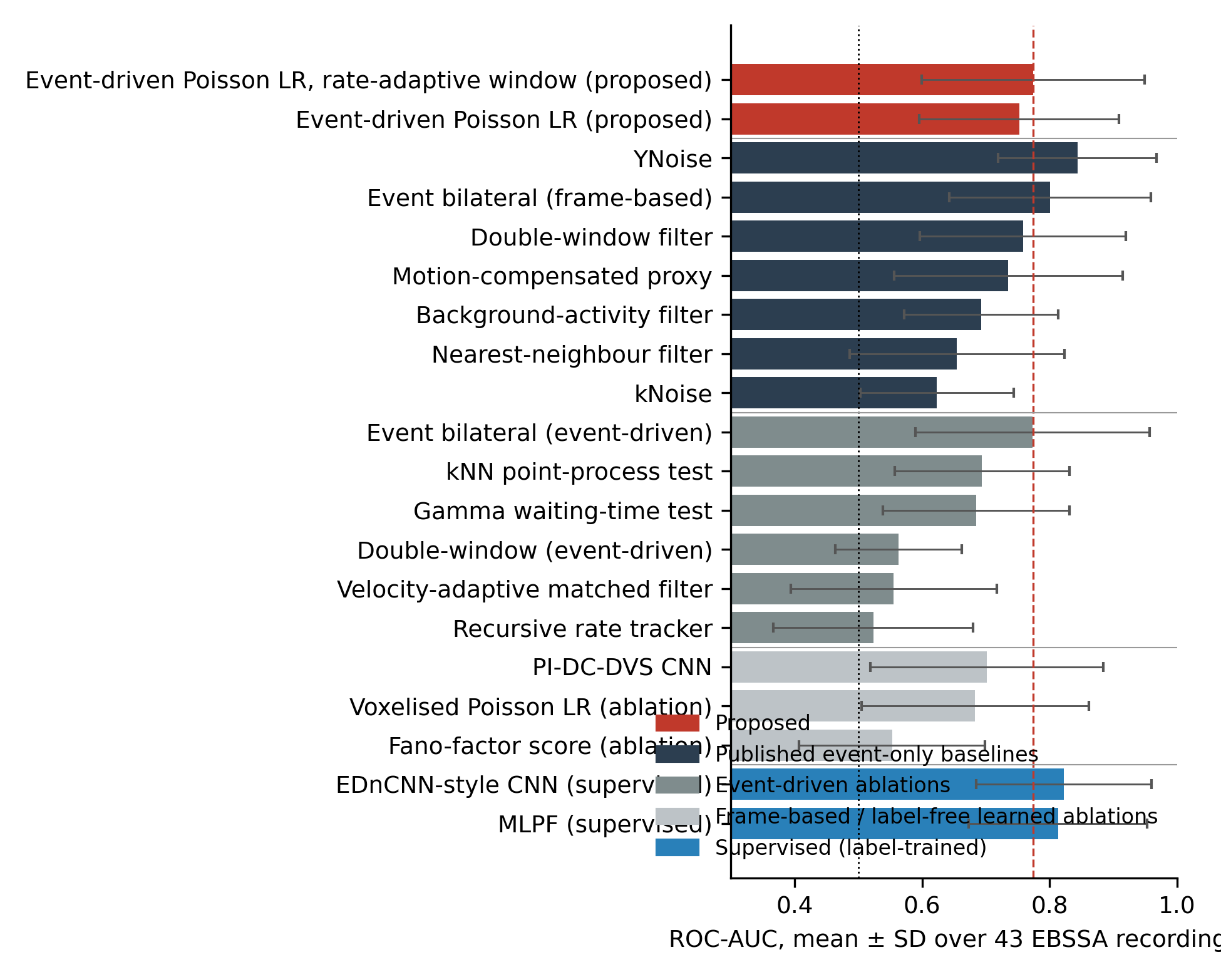
Fig. 2 Mean ROC-AUC with standard deviation over the 43 EBSSA recordings for all methods in Table 1. The dashed line marks the proposed detector; the dotted line marks chance. Colours group the proposed method (fixed and rate-adaptive window), published unsupervised event filters, event-driven ablations, frame-based and label-free learned ablations, and label-trained supervised networks.
Figure 3 shows the paired per-recording comparison. The proposed detector was above the tuned event bilateral filter on 18 of 43 recordings, above tuned YNoise on 7, and above its own voxelised form on 31. Recording-to-recording variation was large for every method (Table 1), and the two sensor models behaved differently (Sec. 3.3), which is why the recording rather than the event was used as the statistical unit.
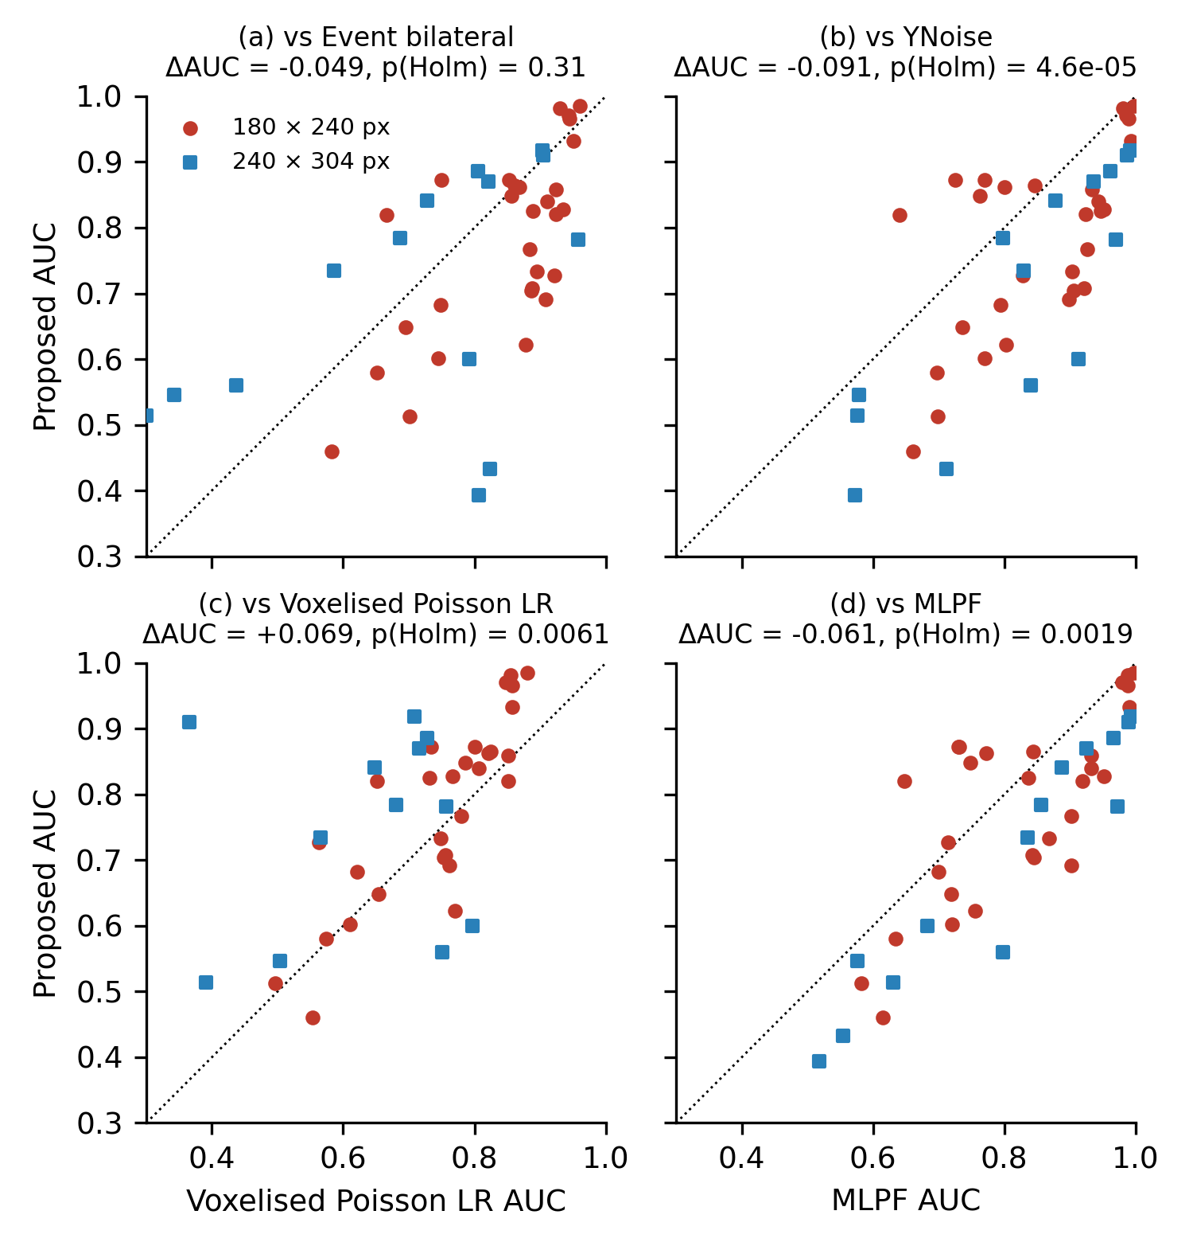
Fig. 3 Per-recording ROC-AUC of the proposed detector against (a) the event bilateral filter, (b) YNoise, (c) its voxelised, frame-based form and (d) the supervised MLPF. Circles: 180 x 240-pixel sensor; squares: 240 x 304-pixel sensor. Points above the diagonal favour the proposed detector. ΔAUC and Holm-adjusted p refer to the paired Wilcoxon test over 43 recordings.
3.2 Ablations
Replacing the event-driven neighbourhood with a voxel grid lowered AUC from 0.753 to 0.683 (difference +0.069, Holm-adjusted p = 0.0061), because the fixed time bins split object tracks across bin boundaries and because the cross-validated bin count is a compromise across recordings with very different event rates. Replacing the Poisson probability with a heuristic score while keeping the event-driven neighbourhood made no significant difference for the bilateral weight (0.774, p = 1.00) but degraded the double-window rule (0.563). The other event-driven alternatives were significantly worse than the proposed detector (0.694 to 0.523). The Fano-factor score reached 0.553, close to chance, and the physics-informed network 0.702 at about 15 times the runtime. The probability output therefore matters mainly for calibration (Sec. 3.5); the event-driven neighbourhood matters for both accuracy and cost. The rate-adaptive window (Sec. 2.5), cross-validated over k, reached 0.774 (difference from the fixed window -0.022, Holm-adjusted p = 0.041).
3.3 Stratified results
Table 2 stratifies the main comparison. On the 180 x 240-pixel sensor the proposed detector (0.779) was -0.068 from the event bilateral filter and -0.074 from YNoise; on the 240 x 304-pixel sensor (0.698) the gaps were -0.009 and -0.127. Across the event-rate split the proposed detector moved by 0.011 AUC (0.747 to 0.758), the bilateral filter by 0.051 and YNoise by 0.039. These strata are exploratory: they contain 14 to 29 recordings each and were not pre-specified.
Table 2 Mean ROC-AUC by sensor model and by event-rate stratum (split at the median rate of 12.2 k events/s). Supervised networks are shown for reference.
Stratum | n | Proposed | Bilateral | YNoise | Voxelised LR | MLPF | EDnCNN-style
180 x 240-pixel sensor | 29 | 0.779 | 0.847 | 0.853 | 0.744 | 0.820 | 0.830
240 x 304-pixel sensor | 14 | 0.698 | 0.707 | 0.825 | 0.558 | 0.799 | 0.808
Event rate below median | 22 | 0.747 | 0.826 | 0.825 | 0.718 | 0.784 | 0.794
Event rate above median | 21 | 0.758 | 0.775 | 0.863 | 0.647 | 0.844 | 0.852

3.4 Cost versus sparsity
Figure 4 and Table 3 show the second claim. The wall-clock time of the proposed detector fell with the number of events with an exponent of 0.81: from 53 ms on the full stream to 1.4 ms at one percent of the events, with peak memory falling from 12.9 to 1.9 MB. The voxelised form of the same test had an exponent of 0.02: its time stayed at about 0.5 s and its memory at 170 MB regardless of sparsity, so that at one percent of the events it was 322 times slower and spent 224 μs per event against 0.70 μs. The frame-based bilateral and background-activity filters showed the same plateau (exponents 0.01 and 0.12), while the event-driven comparators scaled like the proposal (YNoise 1.00, event-driven bilateral 0.96). The per-event cost of the proposed detector rose from 264 to 696 ns at the sparsest setting because the per-pixel rate map is still computed over the full array; this fixed term is small compared with the grid cost of the frame-based methods but explains the exponent below one. The zero-knowledge form, which additionally estimates the rate map and chooses its own window, cost 276 ns per event on the full stream and 2.0 ms at one percent of the events (exponent 0.74): the window choice is a median over the events and adds no term that grows with the array.
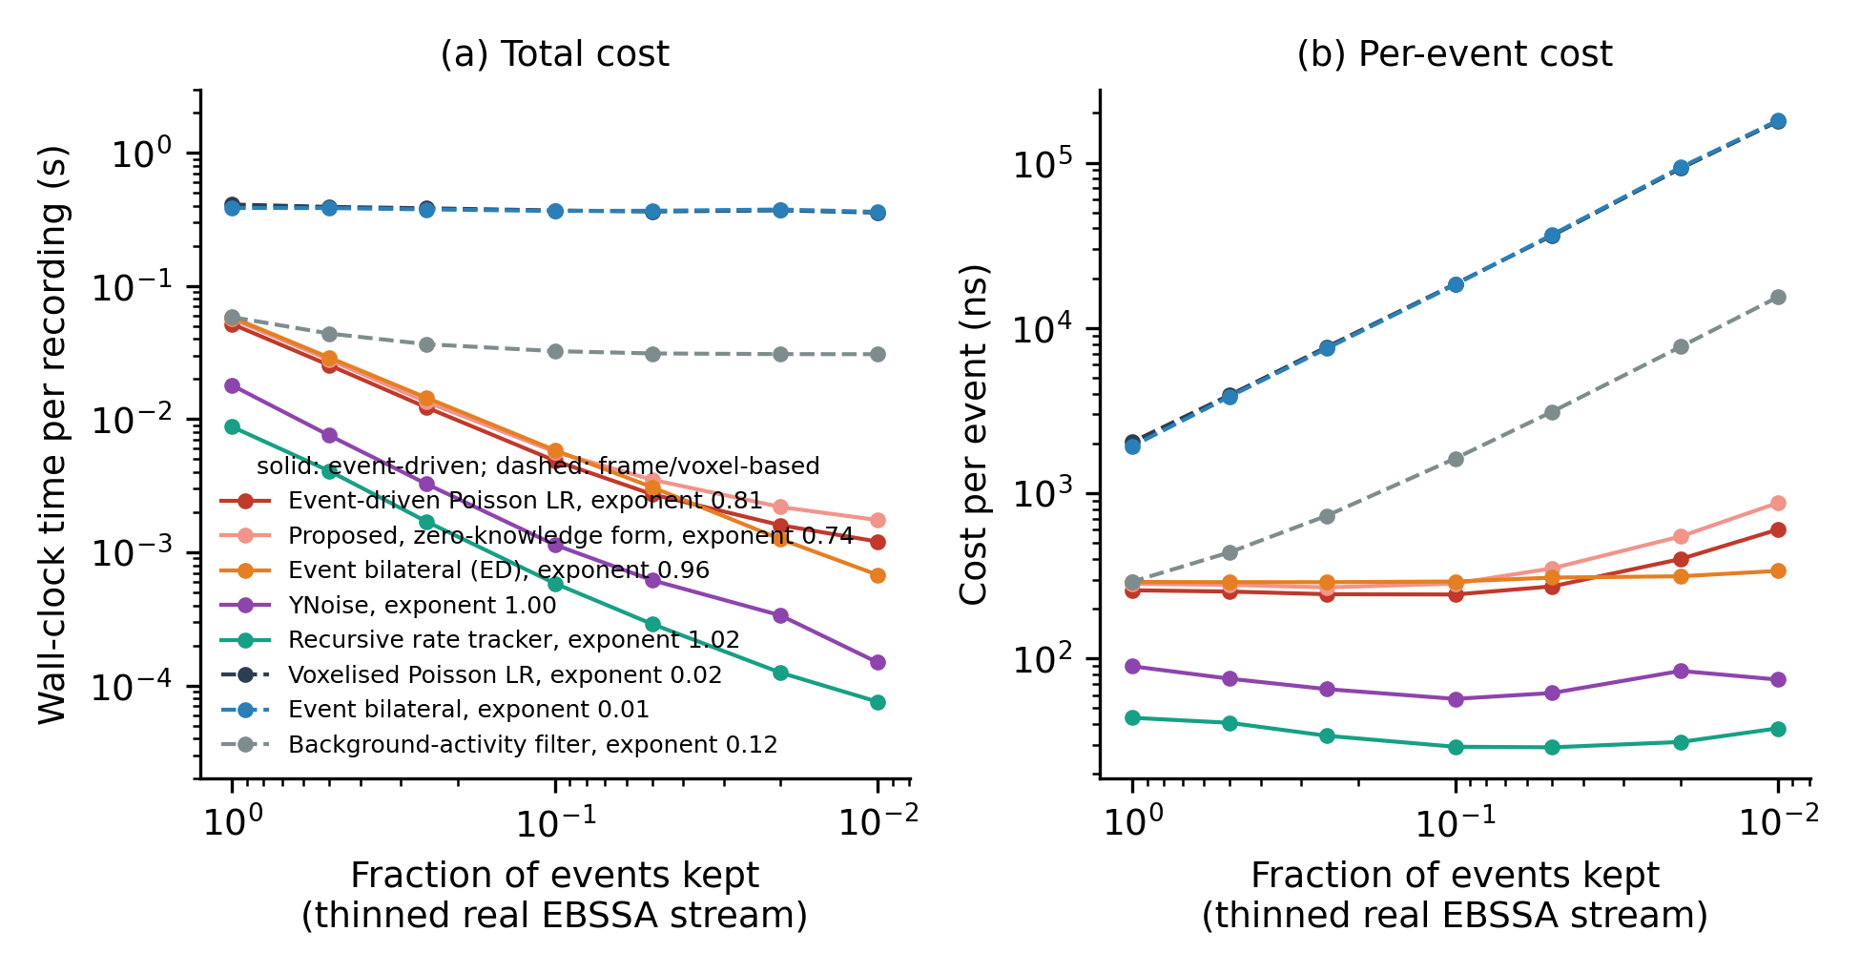
Fig. 4 Computational cost as the real EBSSA stream is thinned. (a) Wall-clock time per recording and (b) time per event, medians over 3 repeats, against the fraction of events kept (the array and the recording interval are unchanged). Solid lines: event-driven methods; dashed lines: frame- or voxel-based methods. Legend entries give the fitted cost exponent β of Eq. (6).
Table 3 Cost-scaling summary from Fig. 4. Exponent: mean ± SD of β over repeats. Dense: all events; sparse: one percent of events. Memory is the peak Python-level allocation.
Method | Family | Exponent β | Time dense (ms) | Time sparse (ms) | ns/event dense | ns/event sparse | Memory dense (MB) | Memory sparse (MB)
Event-driven Poisson LR filter | event-driven | 0.81 ± 0.05 | 52.8 | 1.39 | 264 | 696 | 12.9 | 1.90
Event-driven Poisson LR filter, zero-knowledge form | event-driven | 0.74 ± 0.06 | 55.1 | 2.02 | 276 | 1008 | 14.9 | 2.34
Event bilateral filter (event-driven form) | event-driven | 0.96 ± 0.01 | 58.2 | 0.68 | 291 | 341 | 7.0 | 0.49
YNoise | event-driven | 1.00 ± 0.04 | 16.3 | 0.15 | 82 | 77 | 6.8 | 0.49
Recursive rate tracker (event-driven) | event-driven | 1.02 ± 0.07 | 8.1 | 0.08 | 41 | 39 | 7.3 | 0.97
Voxelised Poisson LR filter | frame-based | 0.02 ± 0.01 | 500.0 | 448.77 | 2500 | 224383 | 170.2 | 170.20
Event bilateral filter | frame-based | 0.01 ± 0.00 | 461.4 | 444.95 | 2307 | 222477 | 48.1 | 42.56
Background-activity filter | frame-based | 0.12 ± 0.01 | 55.5 | 29.81 | 278 | 14905 | 4.0 | 0.78

3.5 Self-calibrated operating points
Figure 5 and Table 4 report the label-free operating points of Eq. (5), with every comparator at its cross-validated configuration. For requested false-alarm budgets of 0.001, 0.01, 0.05 the proposed detector achieved median false-positive rates of 0.0007, 0.0088, 0.0474 on the true background events, i.e. it stayed within budget at every level, as did the multiscale variant (0.0006, 0.0085, 0.0476). YNoise, whose score is an integer density, gave 0.0001, 0.0040, 0.0242: the quantile falls inside a tie and every tied event is passed, so the budget is met or exceeded depending on where the ties fall. The event-driven bilateral score gave 0.0010, 0.0100 (0% over), 0.0492 but detected 0.000 of the object events at a requested 0.01. For completeness the detection rates at the same nominal budgets and the standardised partial AUC in the two low-false-positive regions (false-positive rate below 0.01 and below 0.001) are also reported: at a requested 0.01 the median detection rate was 0.148 for the proposed detector and 0.237 for YNoise, and the partial AUC below 0.01 was 0.601 for the proposed detector, 0.696 for YNoise and 0.527, 0.540 and 0.568 for the frame-based bilateral filter, kNoise and DWF (below 0.001: 0.551 against 0.633). Where YNoise is tuned on labels it detects more object events at these budgets. The point of this section is different: with one fixed configuration and no labels, the proposed detector met the requested budget at every level, because its score is a continuous probability without the ties of a density count, and it retained a non-zero detection rate at the tightest budget where the calibrated bilateral score detected nothing. An operator with no labelled stream, no catalogue of the field and no experience of the sensor can therefore state the false-alarm rate in advance and obtain it, together with a usable detection rate.
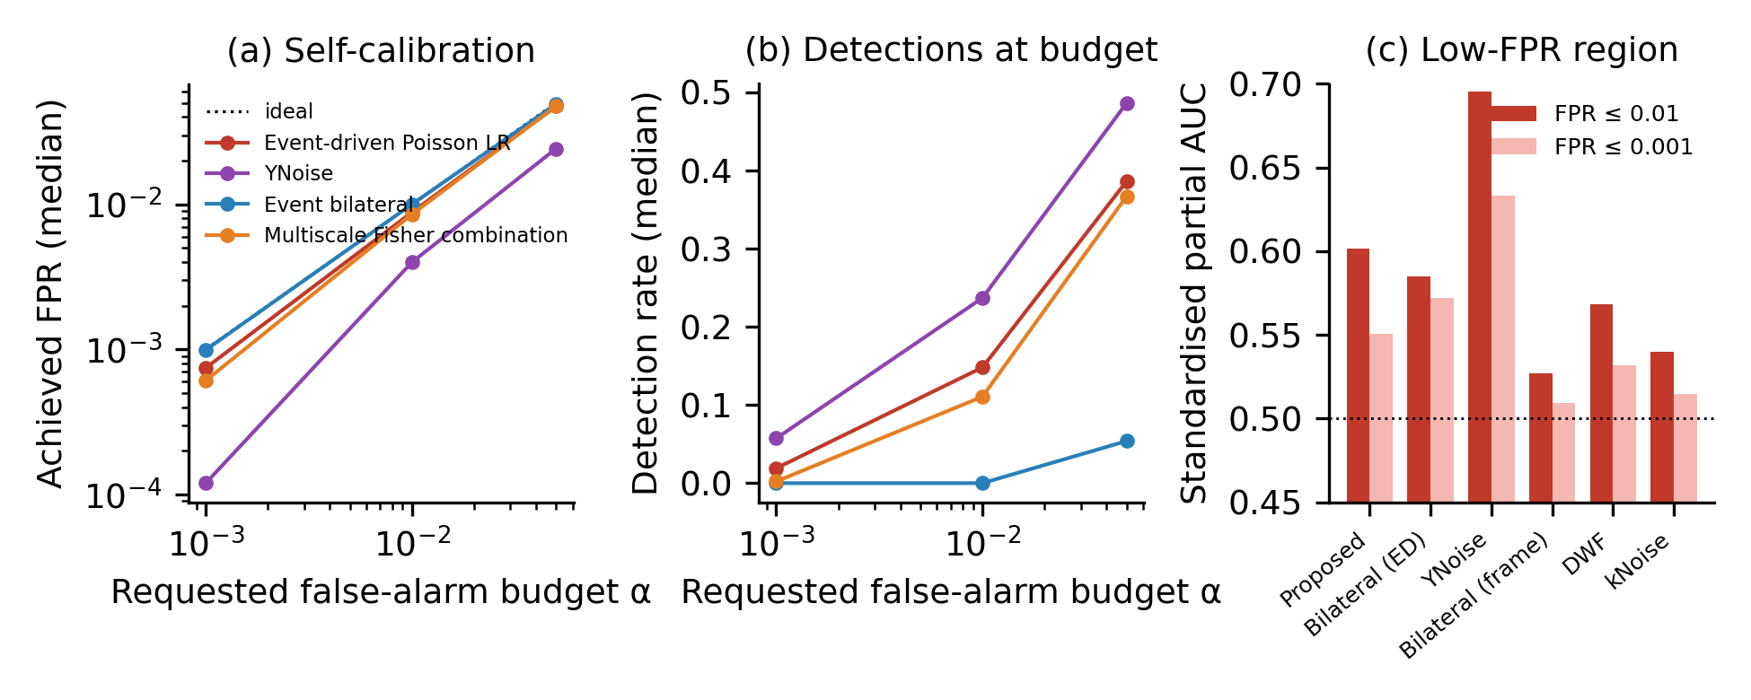
Fig. 5 Self-calibrated operating points and low-false-positive performance. (a) Median achieved false-positive rate on background events against the requested budget α when each score is cut at its own α-quantile (Eq. (5)); the dotted line is ideal calibration. (b) Median detection rate of object events at the same budgets. (c) Standardised partial AUC below false-positive rates of 0.01 and 0.001 (0.5 is chance).
Table 4 Median achieved false-positive rate (FPR) and detection rate (TPR) over recordings when each detector is cut at the α-quantile of its own score, without labels.
Method | FPR (α = 0.001) | TPR (α = 0.001) | FPR (α = 0.01) | TPR (α = 0.01) | FPR (α = 0.05) | TPR (α = 0.05)
Event-driven Poisson LR filter (proposed) | 0.0007 | 0.019 | 0.0088 | 0.148 | 0.0474 | 0.386
Multiscale Fisher combination (proposed, 3 scales) | 0.0006 | 0.002 | 0.0085 | 0.111 | 0.0476 | 0.367
YNoise | 0.0001 | 0.057 | 0.0040 | 0.237 | 0.0242 | 0.487
Event bilateral filter (event-driven form) | 0.0010 | 0.000 | 0.0100 | 0.000 | 0.0492 | 0.054

3.6 Zero-knowledge deployment
Table 5 and Fig. 6 report the zero-knowledge protocol of Sec. 2.10. Without any tuning (protocol B), the fixed-window proposal reached 0.754 and the rate-adaptive form 0.781, against 0.738 for YNoise at its published defaults and 0.774 for the bilateral filter; the advantage of YNoise in Table 1 (0.844) therefore rests on its labelled tuning and was not present at its published defaults on these recordings. Configuration transfer (protocol A) exposed the weakness of a window stated in milliseconds: the configuration selected on the 180 x 240-pixel sensor (W = 300 ms) lost 0.081 AUC on the other sensor, and the reverse transfer lost 0.057, because the denser sensor drives the tail probability into saturation (median fraction of scores equal to one 60% for the fixed deployment configuration on the 240 x 304-pixel sensor, against 0.1% on the other). The rate-adaptive window lost 0.009 and 0.022 (source-selected k = 16 and 32): stated as a count, the window carried over to a sensor with a different background rate. The density and bilateral filters, whose parameters are also spatial and temporal extents, transferred with losses of 0.000 to 0.028. Fig. 6(a) shows the trade-off behind the choice of k: mean AUC peaked at k = 16 on the 180 x 240-pixel sensor and at k = 32 on the 240 x 304-pixel sensor, while the median saturated fraction on the denser sensor was 23% at k = 16 and 69% at k = 32, so k = 16 is the longest window that keeps the probability scale usable on both sensors.
Table 5 Zero-knowledge evaluation. No tuning: mean AUC over all 43 recordings at one fixed configuration (publication defaults for the comparators). Transfer: mean AUC on the target sensor with the configuration selected on the source sensor, and in parentheses the AUC lost relative to the best configuration on the target itself (an optimistic, label-selected reference; negative values are losses).
Method | No tuning (all recordings) | Transfer 180 x 240 to 240 x 304 | Transfer 240 x 304 to 180 x 240
Proposed, fixed window | 0.754 | 0.632 (-0.081) | 0.744 (-0.057)
Proposed, rate-adaptive window | 0.781 | 0.685 (-0.009) | 0.805 (-0.022)
YNoise | 0.738 | 0.825 (-0.000) | 0.853 (-0.000)
Event bilateral (frame-based) | 0.774 | 0.721 (-0.000) | 0.851 (-0.000)
Event bilateral (event-driven) | 0.728 | 0.689 (-0.011) | 0.787 (-0.028)
Double-window filter | 0.667 | 0.700 (-0.000) | 0.787 (-0.000)
kNoise | 0.619 | 0.589 (-0.000) | 0.633 (-0.006)
Background-activity filter | 0.696 | 0.678 (-0.020) | 0.694 (-0.012)
Voxelised Poisson LR | 0.723 | 0.618 (-0.017) | 0.794 (-0.003)

Threshold transfer (protocol C, Fig. 6(c)) shows why the operating point must be recalibrated on the target stream rather than carried over as a number. A threshold fixed on the 240 x 304-pixel sensor for a requested 0.01 and applied to the other gave a median false-positive rate of 0.328 for the fixed-window proposal, 0.048 for the rate-adaptive form and 0.0018 for YNoise; in the opposite direction the transferred thresholds passed almost nothing (0.0023 and 0.0115). Recalibrating on the target stream with Eq. (5), which uses no labels, brought the rate-adaptive proposal to 0.0094 and 0.0068 in the two directions at a requested 0.01, with detection rates of 0.107 and 0.209; the same recalibration applied to YNoise gave 0.0035 and 0.0042, the excess again coming from ties in the integer density. Taken together, the three protocols separate what is and is not knowledge-free in the proposal: the threshold is, on the target stream; the temporal window is, once it is stated as an expected count rather than a time; the radius and the constant k are choices made once on this dataset whose transfer to a third sensor is untested.
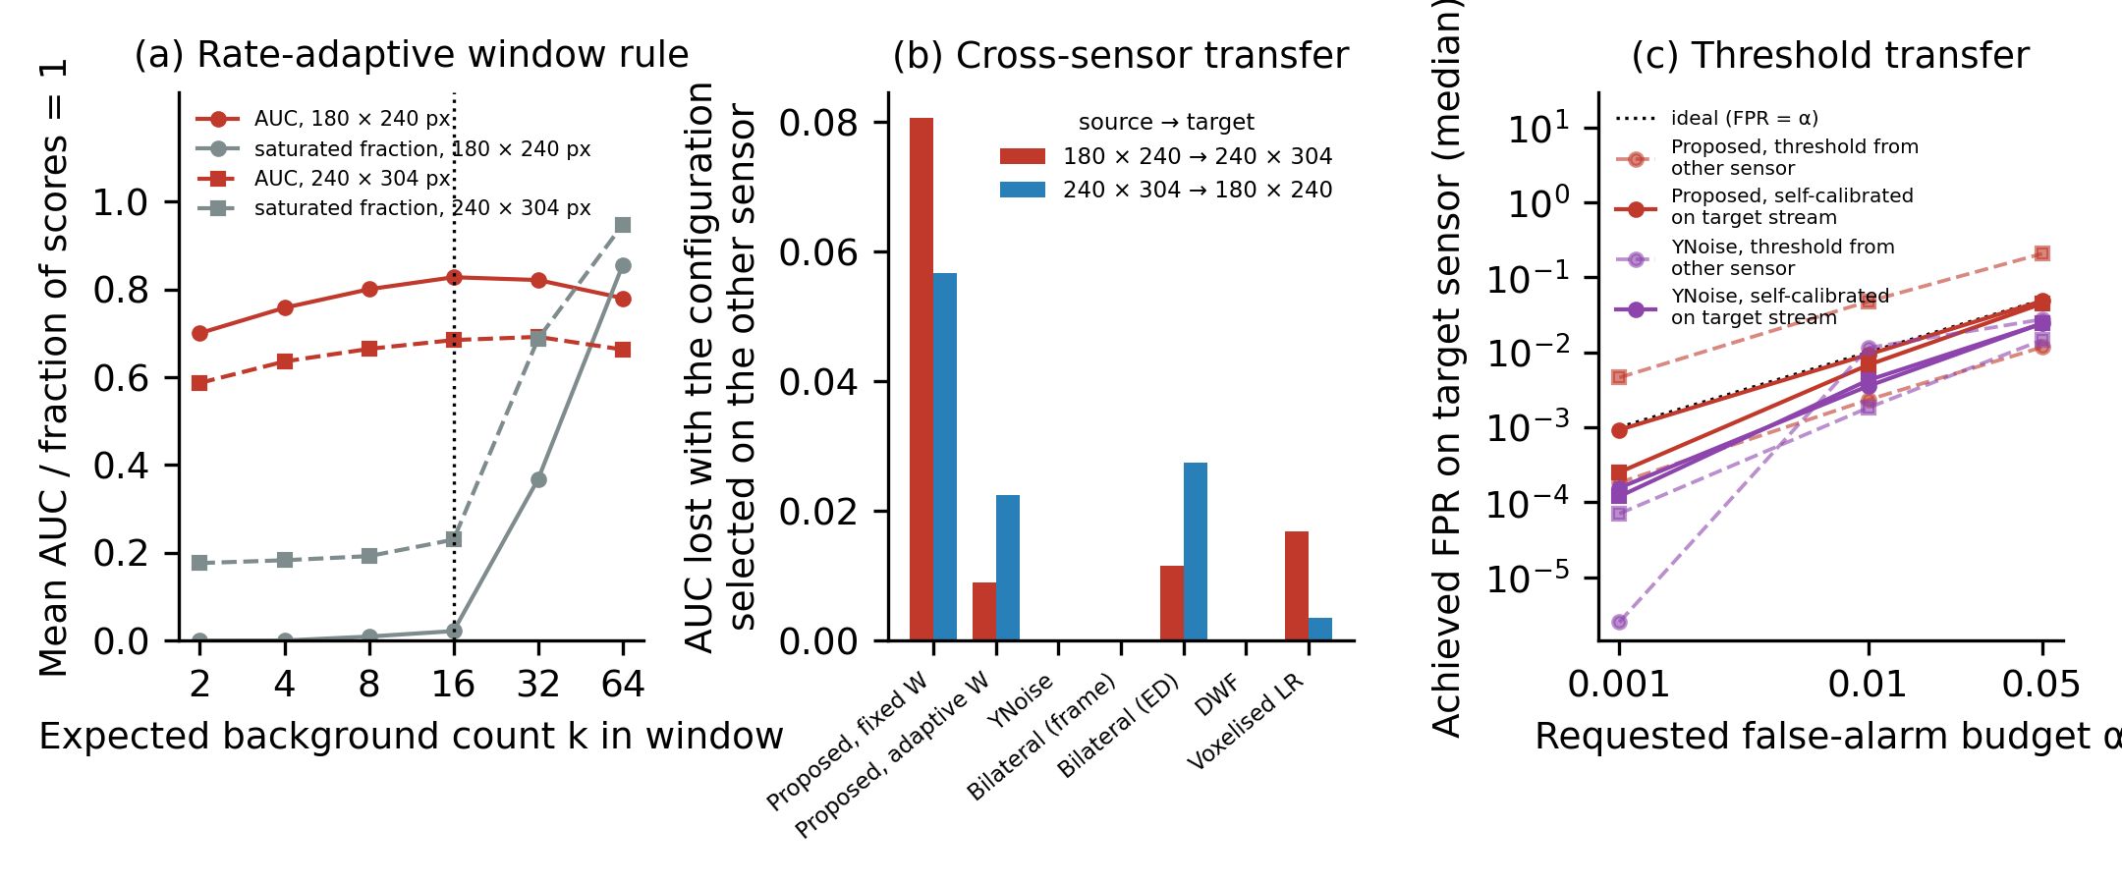
Fig. 6 Zero-knowledge deployment. (a) Mean AUC (red) and median fraction of saturated scores (grey) of the rate-adaptive proposal against the dimensionless window k on the two sensor models (circles, solid: 180 x 240 px; squares, dashed: 240 x 304 px); the dotted line marks the deployment value. (b) AUC lost when the configuration selected on one sensor is applied to the other, for both directions. (c) Median achieved false-positive rate on the target sensor when a numerical threshold fixed on the other sensor is carried over (dashed) and when the threshold is recalibrated on the target stream without labels (solid), for the rate-adaptive proposal and YNoise; the dotted line is ideal calibration.
3.7 Parameter hand-over and two-stage front end
Table 6 and Fig. 7 report the hand-over protocol of Sec. 2.11. Setting the YNoise time constant to the rate-adaptive window of the proposal, per recording and without labels, raised its AUC over all 43 recordings from 0.738 at the published default to 0.841 (Wilcoxon p = 2.0e-11), within 0.003 of the 0.844 that label-tuned cross-validation reached in Table 1, and above the zero-knowledge proposal itself (0.781, p = 2.3e-04). The gain held on both sensor models (0.732 to 0.865 on the 180 x 240-pixel sensor, 0.750 to 0.790 on the 240 x 304-pixel sensor), where the handed-over windows had medians of 383 and 59 ms. On these recordings, then, the tuning that YNoise needed to reach its Table 1 value did not have to come from labels: a time constant read from the background rate of the target stream closed most of the gap.
Table 6 Parameter hand-over and two-stage front end on all 43 recordings. AUC: mean over recordings (pooled and per sensor model). Recall: fraction of object events passed by stage 1. Stage-2 time: median wall-clock time of YNoise on the passed events relative to YNoise on the whole stream. No labels are used by any row except the label-tuned reference.
Configuration | AUC, all | AUC, 180 x 240 | AUC, 240 x 304 | Recall of stage 1 | Stage-2 time
Proposed, zero-knowledge form (stage 1 alone) | 0.781 | 0.828 | 0.685 | n/a | n/a
YNoise, published default | 0.738 | 0.732 | 0.750 | n/a | 1.00
YNoise, dt = W handed over | 0.841 | 0.865 | 0.790 | n/a | 1.00
YNoise, label-tuned CV (Table 1) | 0.844 | n/a | n/a | n/a | 1.00
Two-stage, f = 0.02, stage 2 dt = W | 0.782 | n/a | n/a | 0.32 | 0.05
Two-stage, f = 0.05, stage 2 dt = W | 0.784 | n/a | n/a | 0.45 | 0.11
Two-stage, f = 0.1, stage 2 dt = W | 0.787 | n/a | n/a | 0.55 | 0.22
Two-stage, f = 0.2, stage 2 dt = W | 0.794 | n/a | n/a | 0.66 | 0.45
Two-stage, f = 0.5, stage 2 dt = W | 0.810 | n/a | n/a | 0.81 | 1.20

The two-stage form (Fig. 7(b)) improved on stage 1 alone by a smaller margin that grew with the passed fraction: from 0.781 to 0.787 at f = 0.1 (p = 9.8e-10) and 0.810 at f = 0.5 (p = 5.9e-07), because the score can only reorder the events that stage 1 passed. With the published default in stage 2 the two-stage score did not improve on stage 1 (p = 0.53 at f = 0.1), and the pseudo-label choice tracked the hand-over (0.786 at f = 0.1), so the improvement comes from the handed-over time constant rather than from the second density count as such. Stage 1 passed 0.55 of the object events at f = 0.1 and 0.81 at f = 0.5, which bounds the detection rate of the cascade. Its quantile operating point remained calibrated: at a requested 0.01 the two-stage score gave a median false-positive rate of 0.0039 (f = 0.1), below the budget because of ties in the integer density. The stage-2 workload fell in proportion to f (0.22 of the full-stream YNoise time at f = 0.1, with the hand-over; the pseudo-label choice, which must run the whole YNoise grid on the passed events, cost 117 times the full-stream time from a single timing and is not a practical alternative); in this implementation, however, stage 1 itself (48 ms per recording, median) costs more than YNoise on the whole stream (7 ms), so the cascade does not lower the total cost when the second stage is as cheap as YNoise. The cost argument for a cascade applies when the confirmation stage is expensive, such as a network, or when the screened stream must leave the sensor; the argument from the data is that the proposal supplies, without labels, the parameter that the confirmation stage otherwise needs labels to find.
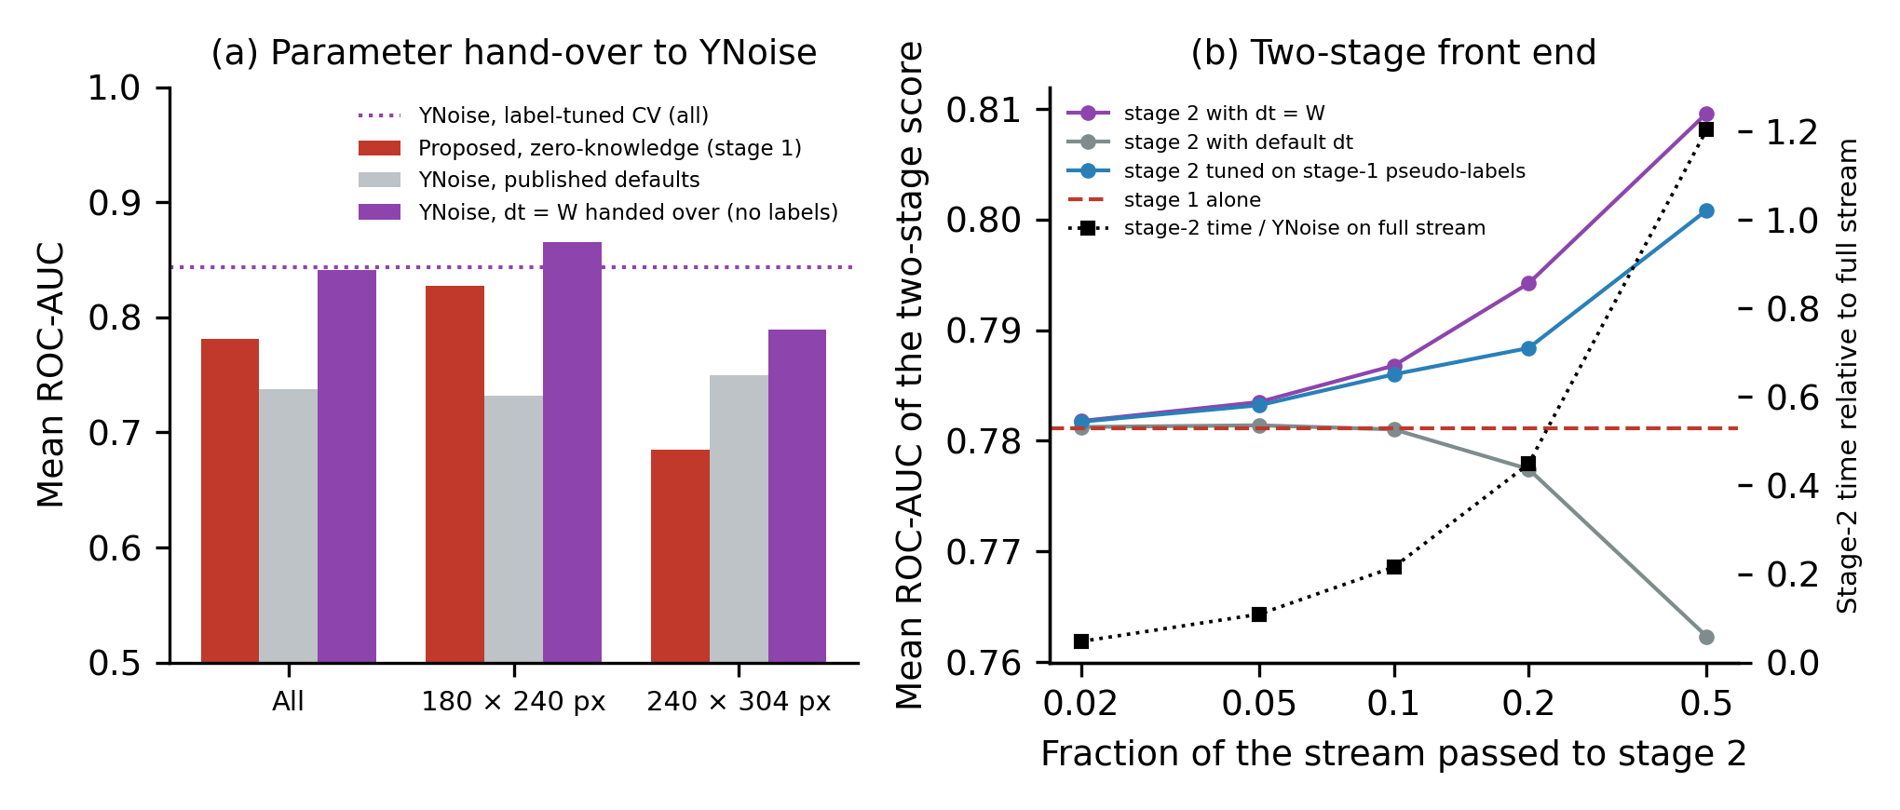
Fig. 7 Parameter hand-over and two-stage front end. (a) Mean AUC of the zero-knowledge proposal, of YNoise at its published default and of YNoise with its time constant set to the rate-adaptive window W handed over from the proposal, pooled and per sensor model; the dotted line is YNoise with label-tuned cross-validation (Table 1). (b) Mean AUC of the two-stage score against the fraction of the stream passed by stage 1, with stage 2 parameterised by the hand-over, by the published default and by a pseudo-label choice; the dashed line is stage 1 alone and the black squares (right axis) the median stage-2 time relative to YNoise on the whole stream.
Fig. 8 shows the same two recordings, one per sensor model, after each stage at a requested false-alarm rate of 0.01. The achieved false-positive rates of the four event-window scores lay between 0.0028 and 0.0170; the budget was exceeded where the quantile fell inside a block of tied scores (180 × 240, ynoise default: 0.017; 240 × 304, two stage: 0.012), and the object is visible in every output, but the detection rates differ in the direction of Table 6: on the 180 × 240 recording the zero-knowledge proposal passed 0.10 of the object events, YNoise at its default 0.17, YNoise with the handed-over W 0.49 and the two-stage score at f = 0.1 0.27; on the 240 × 304 recording the corresponding values were 0.11, 0.21, 0.27 and 0.33. The Fano-factor score is shown for contrast: its per-pixel ratio takes the same value for every event of a pixel and is exactly zero wherever the minimum bin count is zero, so the alpha-quantile falls inside a block of tied scores and the smallest block that can be passed already has a false-positive rate of 0.096 and 0.131, with 0.01 and 0.07 of the object events; a score with few distinct values cannot be set to a false-alarm budget by a quantile. For every method the quantile fixes how many events pass, not where they fall, and the surviving background is scattered over the frame. These are two recordings chosen by rule, not a summary; the pooled figures are those of Table 6.
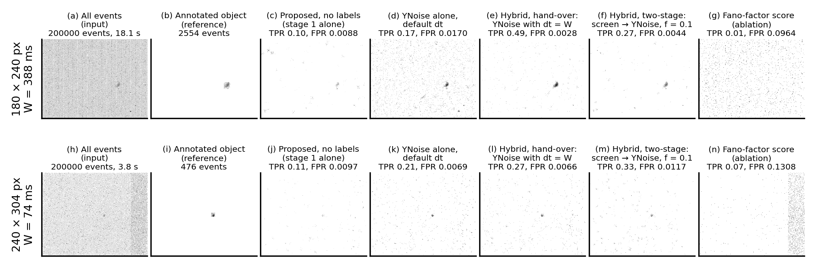
Fig. 8 The same two recordings processed by every stage. Rows: one recording per sensor model (SL8RB_1957_davis_td, canopus_leos_11_26_atis_td), selected as the recording whose stage-1 AUC is closest to the median of that sensor, with its rate-adaptive window W. Columns: all events; events inside the annotated object boxes; events passed at a requested false-alarm rate of 0.01 by the zero-knowledge proposal alone (stage 1), by YNoise alone at its published default, by the hybrid in its hand-over form (YNoise with dt = W taken from the proposal), by the hybrid in its two-stage form (proposal screens, YNoise confirms) with f = 0.1, and by the Fano-factor score (Sec. 2.7). Each panel is the per-pixel count of passed events over the whole analysed interval on a logarithmic grey scale; the achieved detection and false-positive rates against the annotation are given above each panel.
4 Discussion
The results support a modest but useful position for the event-driven Poisson LR detector. On the only public labelled event-camera SSA dataset its ROC-AUC is statistically indistinguishable from most of the published unsupervised event filters when those filters are given cross-validated tuning, and below the best of them, YNoise, by 0.09; without labels that gap closes (0.781 against 0.738 at fixed configurations, Table 5); unlike all of them it can be operated without labels and without a manually chosen threshold, because its threshold follows from a false-alarm budget and is recalibrated on whatever stream it is given; and its cost is proportional to the number of events. The zero-knowledge analysis qualifies the phrase "without per-sensor tuning": a window stated in milliseconds did not transfer between the two sensor models, whereas a window stated as an expected background count did, so the property is one of the rate-adaptive form and of the recalibrated threshold, and is demonstrated on two sensor models only. The combination matters most where no reference exists: in a survey of a new field, a blind search for uncatalogued objects, or the first light of a new sensor, there is no labelled stream on which to tune a neighbour-count threshold or train a network, whereas a false-alarm budget can always be stated in advance and, as Sec. 3.5 shows, is honoured on the data. The cost property is the one that distinguishes the detector for astronomy: in a sparse regime the voxelised form of the same statistic spent 224 μs per event, almost all of it on empty voxels, whereas the event-driven form spent under a microsecond. The same contrast applies to any frame-based filter and grows as sensors become larger and observing conditions darker.
Relative to supervised networks, the detector is 0.06 to 0.07 AUC lower. We regard this as the price of not requiring labels rather than a deficiency to be hidden: the networks were trained on annotated recordings from the same two sensors and would need new annotations for a new sensor, site or observing mode, whereas the proposed detector fits its background model to whatever stream it is given. For surveys of unexplored regimes, and for on-sensor or on-board processing where a training pipeline is not available, that trade is often the right one. The synergy with the sensor is also worth stating: the detector uses the DVS output in the form the pixel circuit produces it, as per-pixel timestamp sequences, models the noise where it originates, in the pixel, and needs only per-pixel state. Because it touches each event once, in arrival order, with a few arithmetic operations, no training phase and a memory footprint set by the array rather than by the data, its structure suits the streaming, near-sensor and edge-processing setting for which event cameras are intended, where a label-free front end could pass a calibrated fraction of the stream downstream; we have not measured an embedded implementation, so this is a statement about structure, not about throughput. Where the highest detection rate at a very stringent budget is the goal and labelled data for threshold tuning exist, the density filter YNoise remains a strong choice. Sec. 3.7 shows that the two are not alternatives so much as stages of one pipeline: the rate-adaptive window that the proposal derives from the target stream served as the time constant of YNoise, and handing it over without labels recovered 0.841 of the 0.844 that label-tuned cross-validation reached. Hand-tuned defaults are, in this light, priors formed on other sensors and other skies; on an unknown field they have no more authority than the stream itself, from which the rate, the window and the threshold can all be taken. The cascade in which the proposal screens at a stated budget and YNoise confirms on the passed events improved the ranking further, but did not lower the total cost when the confirmation stage is as cheap as YNoise; its cost case is a network or an off-sensor link as the second stage, which we have not measured. The cost comparison is also one-sided in favour of the comparators: the timings of Sec. 3.4 and Table 6 cover inference only, and the labelled recordings and grid search that the tuned comparators needed before inference are not charged to them. The one label-free tuning we did time, the pseudo-label grid search on the passed events, cost 117 times a full-stream YNoise pass, whereas the hand-over involves no search at all; with the cost of acquiring the parameters included, the case for taking them from the stream is stronger than the inference timings alone suggest.
Several limitations bound these conclusions. First, the ground truth is the EBSSA object annotation, a 10 x 10-pixel box around a tracked position over 10 ms; background events inside the box are counted as object and object events outside it as background, which compresses the AUC of every method and may affect them unequally. Second, the recordings come from two sensor models at one site, and the strata in Table 2 show that the ranking of unsupervised methods differs between sensors; the comparability claim is made over the pooled sample and should be re-tested on new hardware, and the zero-knowledge transfer of Sec. 3.6 consists of two directions between two sensors, with the constant k chosen once on the same data; the parameter hand-over of Sec. 3.7 was tested for one comparator, and the two-stage front end was not shown to lower total cost with that comparator. Third, the homogeneous-Poisson null ignores refractory behaviour and burst noise in the pixel circuit, so the achieved false-alarm rate is close to but not exactly the requested one, and persistent sources such as tracked stars are treated as background only because their pixels acquire a high estimated rate. Fourth, the cost measurements are single-core Python and Numba timings; absolute numbers will differ on other hardware, though the scaling exponents should not. Fifth, the published comparators were re-implemented from their descriptions rather than run from the authors' code; they were given the same cross-validated tuning as the proposed detector, which removes the usual bias in favour of the proposal but means the reported comparator accuracies are upper bounds that an operator without labels could not reach. Finally, the analysis is retrospective and the strata were not pre-specified.
5 Conclusion
A per-event Poisson tail test, with the background rate of each pixel estimated from its own inter-event intervals, detects faint object events in neuromorphic space-imaging streams with an accuracy comparable to most label-tuned unsupervised event filters, without labels, on all 43 labelled EBSSA recordings. Because it never builds a frame or a voxel grid, its cost falls in proportion to the number of events while that of frame-based processing does not, and because its output is a probability, the false-alarm rate can be specified in advance and honoured without labelled data. When its window is stated as an expected background count, the configuration chosen on one sensor model carried over to the other with an AUC loss of at most 0.02, and the threshold was recovered on the new stream without labels. The same window, handed to the density filter YNoise as its time constant, brought that filter from 0.738 to 0.841 AUC without labels, close to its label-tuned 0.844. These properties make it a practical front end for sparse, unexplored observing regimes. All code, the exact data-access procedure and every number in this paper are reproducible from the public repository.
Disclosures
The authors declare that there are no financial interests, commercial affiliations, or other potential conflicts of interest that could have influenced the objectivity of this research or the writing of this paper. The manuscript has not been published in a conference proceedings and is not under consideration elsewhere. An artificial-intelligence coding assistant (Devin, Cognition AI) was used to write the analysis code, generate the figures from the result files and draft and edit the text under the authors' direction; the authors take full responsibility for the content.
Code and Data Availability
The EBSSA dataset is publicly available and was accessed through the Tonic library (version 1.6.0), which downloads the labelled split from the authors' repository. All analysis and manuscript-generation code, the result files and a one-command build that regenerates every number, table and figure in this paper are available at https://github.com/bougtoir/dvs-jatis-submission. No additional data were created.
Acknowledgments
[Funding and acknowledgments to be added by the authors.]
References
1. G. Gallego, T. Delbruck, G. Orchard, et al., "Event-based vision: a survey," IEEE Trans. Pattern Anal. Mach. Intell. 44(1), 154-180 (2022).
2. P. Lichtsteiner, C. Posch, and T. Delbruck, "A 128 x 128 120 dB 15 us latency asynchronous temporal contrast vision sensor," IEEE J. Solid-State Circuits 43(2), 566-576 (2008).
3. G. Cohen, S. Afshar, B. Morreale, et al., "Event-based sensing for space situational awareness," J. Astronaut. Sci. 66, 125-141 (2019).
4. S. Afshar, A. P. Nicholson, A. van Schaik, and G. Cohen, "Event-based object detection and tracking for space situational awareness," IEEE Sens. J. 20(24), 15117-15132 (2020).
5. N. O. Ralph, A. Marcireau, S. Afshar, et al., "Astrometric calibration and source characterisation of the latest generation neuromorphic event-based cameras for space imaging," Astrodynamics 7(4), 415-443 (2023).
6. Y. Nozaki and T. Delbruck, "Temperature and parasitic photocurrent effects in dynamic vision sensors," IEEE Trans. Electron Devices 64(8), 3239-3245 (2017).
7. S. Guo and T. Delbruck, "Low cost and latency event camera background activity denoising," IEEE Trans. Pattern Anal. Mach. Intell. 45(1), 785-795 (2023).
8. T. Delbruck, "Frame-free dynamic digital vision," in Proc. Int. Symp. Secure-Life Electronics, Advanced Electronics for Quality Life and Society, 21-26, University of Tokyo (2008).
9. A. Khodamoradi and R. Kastner, "O(N)-space spatiotemporal filter for reducing noise in neuromorphic vision sensors," IEEE Trans. Emerg. Top. Comput. 9(1), 15-23 (2021).
10. Y. Feng, H. Lv, H. Liu, et al., "Event density based denoising method for dynamic vision sensor," Appl. Sci. 10(6), 2024 (2020).
11. R. W. Baldwin, M. Almatrafi, V. Asari, and K. Hirakawa, "Event probability mask (EPM) and event denoising convolutional neural network (EDnCNN) for neuromorphic cameras," in Proc. IEEE/CVF Conf. Computer Vision and Pattern Recognition, 1701-1710 (2020).
12. J. Neyman and E. S. Pearson, "On the problem of the most efficient tests of statistical hypotheses," Philos. Trans. R. Soc. A 231, 289-337 (1933).
13. S. M. Kay, Fundamentals of Statistical Signal Processing, Volume II: Detection Theory, Prentice Hall, Upper Saddle River (1998).
14. J. F. C. Kingman, Poisson Processes, Oxford University Press, Oxford (1993).
15. S. K. Lam, A. Pitrou, and S. Seibert, "Numba: a LLVM-based Python JIT compiler," in Proc. Second Workshop on the LLVM Compiler Infrastructure in HPC, 1-6 (2015).
16. G. Lenz, K. Chaney, S. B. Shrestha, et al., "Tonic: event-based datasets and transformations," Zenodo, doi:10.5281/zenodo.5079802 (2021).
17. R. A. Fisher, Statistical Methods for Research Workers, Oliver and Boyd, Edinburgh (1925).
18. U. Fano, "Ionization yield of radiations. II. The fluctuations of the number of ions," Phys. Rev. 72(1), 26-29 (1947).
19. F. Wilcoxon, "Individual comparisons by ranking methods," Biometrics Bull. 1(6), 80-83 (1945).
20. S. Holm, "A simple sequentially rejective multiple test procedure," Scand. J. Stat. 6(2), 65-70 (1979).
21. D. K. McClish, "Analyzing a portion of the ROC curve," Med. Decis. Making 9(3), 190-195 (1989).
22. F. Pedregosa, G. Varoquaux, A. Gramfort, et al., "Scikit-learn: machine learning in Python," J. Mach. Learn. Res. 12, 2825-2830 (2011).

