Supplementary material
Self-calibrating unsupervised anomaly detection in sparse event streams: replacing designer-chosen time scales with data-native scales
Tatsuki Onishi; Data Science and AI Innovation Research Promotion Center, Shiga University, Hikone, Japan; bougtoir@gmail.com
This file contains the comparator feasibility table, the effect-size tables, the exploratory stratified results, the cost-scaling figure and table, the zero-knowledge transfer table, the qualitative example and the AEDNet transfer table referred to in the main text as Supplementary Fig. S1-S2 and Table S1-S7. All values are generated from the same result files as the main text.
AEDNet transfer protocol (Section 4.3 of the main text). The released weights were applied on the CPU with the sensor frame set to that of each recording (180 x 240 or 240 x 304 pixels for EBSSA, 346 x 260 for DND21), the released neighbourhood (25 x 15 pixels, 50 events), the softmax noise probability as a ranking score and a stratified random subset of at most 1,500 signal and 1,500 background events per recording, since the CPU throughput of the network is tens of events per second. ROC-AUC does not depend on the class prior, so the subset AUC estimates the full-stream AUC. On the authors' released sample the re-implemented patch construction matched the official loader to a maximum absolute difference of 0 in the patches and 0 in the output probabilities (400 events).

Table S1. Comparator feasibility under the common protocol (event-only input, exact or annotated labels, grouped cross-validation). "Executed here" states whether the method was scored in this paper and on which dataset; caveats are given in the text and in results/comparator_feasibility.json.
Method | Type | Input | Training labels | Extra sensors | Public code | Executed here
MLPF (multilayer-perceptron filter) | supervised, event-driven | local time-surface patch (age and polarity of recent events) around each event | per-event signal/noise labels (published training used DND21-style mixes of clean recordings with measured noise) | none | jAER (Java); C++ re-implementation in E-MLB (cuke-emlb, CUDA) | yes: MLPF-style MLP on the same patch features, trained inside each grouped-CV fold (sp_evaluation.MLPF); EBSSA and DND21
EDnCNN (event denoising CNN) | supervised, patch-based CNN | spatio-temporal feature volume built from events around each event (event-only at inference) | Event Probability Mask (EPM): per-event probabilities computed from co-registered APS intensity frames and IMU motion (DVSNOISE20) | APS frames + IMU for label generation only | MATLAB (bald6354/edncnn); C++/CUDA re-implementation in E-MLB | yes: EDnCNN-style 2-channel time-surface CNN trained inside each grouped-CV fold on the exact labels available (bounding boxes on EBSSA, origin labels on DND21) instead of EPM labels (sp_evaluation.EDnCNNStyle)
AEDNet (asynchronous event denoising network) | supervised, point-set network on raw asynchronous events | (x, y) offsets of the 50 nearest-in-time events inside a 25 x 15 px neighbourhood of each event, treated as an irregular point set | per-event labels from DVSCLEAN (simulated + real-world; 1280x720 sensor) | none | PyTorch (github.com/Fanghuachen/AEDNet, commit 4fca5c5) with one set of released weights (GitHub release "AEDNet", AEDNet_model.pth, SHA-256 e20c3da6...583e30; DVSCLEAN background-activity model, 1280x720); official inference script is CUDA-only | yes: released weights applied unchanged (zero-shot transfer, CPU) to the EBSSA recordings and the DND21 mixtures on a stratified event subset (aednet_transfer.py); no re-training
WedNet (window-based event denoising network) | supervised, window-based deep network (temporal window + learned sparse coding) | stack of events in a spatio-temporal window; labels the whole stack at once | per-event labels; trained on 39 simulated DVSCLEAN scenes, tested on DVSCLEAN, DVSNOISE20 and ED-KoGTL (per the paper) | none | none located (checked 2026-09-12): the paper (arXiv 2402.09270) gives no code link; the first author's GitHub account (Fanghuachen) exposes only AEDNet; GitHub repository search for "WedNet" and "window-based event denoising" returns no implementation, and GitHub code search for "WedNet event denoising" returns only third-party paper summaries | no
PFD-A (polarity-focused denoising) | hand-crafted two-stage filter (no learning), event-driven | timestamps and polarities of the 8-neighbourhood; polarity-change FIFO per pixel | none | none | C++ (shicy17/PFD), GPL-3.0 | yes: re-implemented in numba (sp_evaluation.pfd_filter) with the reference thresholds; DND21 only (added after the EBSSA runs were frozen)

Table S2. Effect sizes of the paired comparison on EBSSA (43 recordings): mean and median paired ΔAUC of the proposed fixed-window detector minus each method, 95% percentile bootstrap CI (10,000 resamples of recordings), number of recordings on which the proposal is ahead, and matched-pairs rank-biserial correlation r (−1 to +1; positive favours the proposal).
Method | Mean ΔAUC | Median ΔAUC | 95% CI | Proposal ahead | r
Event-driven Poisson LR filter, rate-adaptive window (proposed) | -0.022 | -0.020 | [-0.044, +0.002] | 12/43 | -0.47
Event bilateral filter | -0.049 | -0.046 | [-0.093, -0.007] | 18/43 | -0.33
YNoise | -0.091 | -0.095 | [-0.123, -0.058] | 7/43 | -0.76
Motion-compensated proxy | +0.017 | +0.008 | [-0.034, +0.068] | 22/43 | +0.08
Background-activity filter | +0.060 | +0.058 | [+0.032, +0.086] | 36/43 | +0.70
Double-window filter | -0.006 | -0.008 | [-0.049, +0.034] | 18/43 | +0.01
Nearest-neighbour filter | +0.098 | +0.064 | [+0.049, +0.147] | 32/43 | +0.60
kNoise | +0.130 | +0.139 | [+0.091, +0.165] | 37/43 | +0.82
Event bilateral filter (event-driven form) | -0.021 | -0.024 | [-0.071, +0.028] | 15/43 | -0.15
kNN point-process test (event-driven) | +0.059 | +0.066 | [+0.010, +0.103] | 33/43 | +0.57
Gamma waiting-time test (event-driven) | +0.068 | +0.073 | [+0.017, +0.113] | 32/43 | +0.61
Velocity-adaptive matched filter (event-driven) | +0.197 | +0.172 | [+0.131, +0.267] | 37/43 | +0.79
Double-window filter (event-driven form) | +0.190 | +0.218 | [+0.135, +0.242] | 39/43 | +0.86
Recursive rate tracker (event-driven) | +0.229 | +0.238 | [+0.189, +0.267] | 42/43 | +0.97
Voxelised Poisson LR filter (frame-based ablation) | +0.069 | +0.062 | [+0.030, +0.110] | 31/43 | +0.57
PI-DC-DVS CNN | +0.051 | +0.024 | [+0.001, +0.102] | 25/43 | +0.27
Fano-factor score (ablation) | +0.200 | +0.191 | [+0.155, +0.243] | 41/43 | +0.95
EDnCNN-style CNN (supervised) | -0.070 | -0.081 | [-0.096, -0.043] | 8/43 | -0.69
MLPF (supervised) | -0.061 | -0.074 | [-0.086, -0.033] | 7/43 | -0.63

Table S3. Mean ROC-AUC on EBSSA by sensor model and by event-rate stratum (split at the median rate of 12.2 k events/s). Supervised networks for reference.
Stratum | n | Proposed | Bilateral | YNoise | Voxelised LR | MLPF-style | EDnCNN-style
180 x 240-pixel sensor | 29 | 0.779 | 0.847 | 0.853 | 0.744 | 0.820 | 0.830
240 x 304-pixel sensor | 14 | 0.698 | 0.707 | 0.825 | 0.558 | 0.799 | 0.808
Event rate below median | 22 | 0.747 | 0.826 | 0.825 | 0.718 | 0.784 | 0.794
Event rate above median | 21 | 0.758 | 0.775 | 0.863 | 0.647 | 0.844 | 0.852

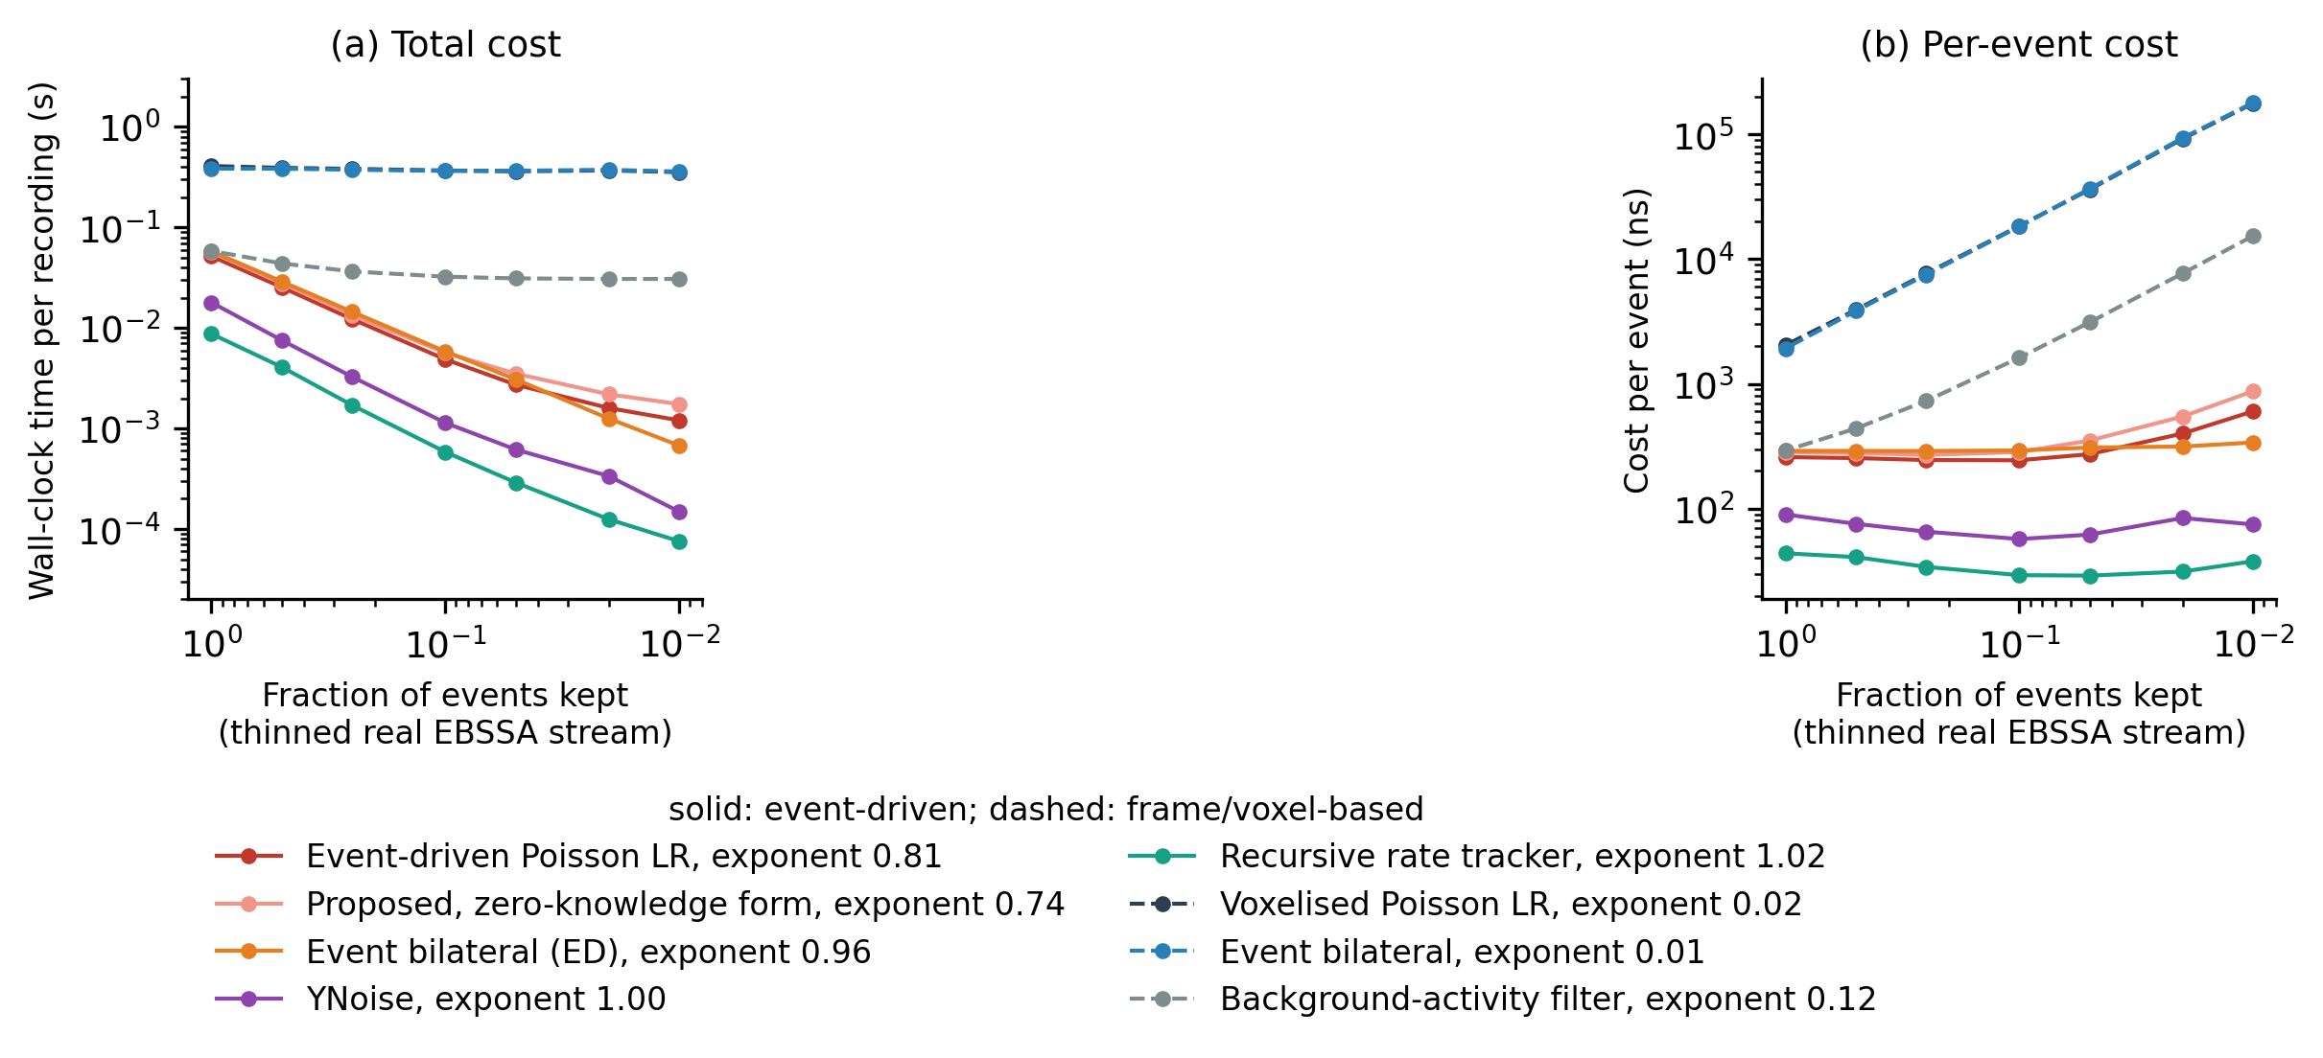
Fig. S1. Computational cost as the real EBSSA stream is thinned. (a) Wall-clock time per recording and (b) time per event, medians over 3 repeats, against the fraction of events kept (array and recording interval unchanged). Solid lines: event-driven methods; dashed lines: frame- or voxel-based methods. Legend entries give the fitted cost exponent β of Eq. (7).

Table S4. Cost-scaling summary from Fig. S1. Exponent: mean ± SD of β over repeats. Dense: all events; sparse: one percent of events. Memory is the peak Python-level allocation.
Method | Family | Exponent β | Time dense (ms) | Time sparse (ms) | ns/event dense | ns/event sparse | Memory dense (MB) | Memory sparse (MB)
Event-driven Poisson LR filter | event-driven | 0.81 ± 0.05 | 52.8 | 1.39 | 264 | 696 | 12.9 | 1.90
Event-driven Poisson LR, zero-knowledge form | event-driven | 0.74 ± 0.06 | 55.1 | 2.02 | 276 | 1008 | 14.9 | 2.34
Event bilateral filter (event-driven form) | event-driven | 0.96 ± 0.01 | 58.2 | 0.68 | 291 | 341 | 7.0 | 0.49
YNoise | event-driven | 1.00 ± 0.04 | 16.3 | 0.15 | 82 | 77 | 6.8 | 0.49
Recursive rate tracker (event-driven) | event-driven | 1.02 ± 0.07 | 8.1 | 0.08 | 41 | 39 | 7.3 | 0.97
Voxelised Poisson LR filter | frame-based | 0.02 ± 0.01 | 500.0 | 448.77 | 2500 | 224383 | 170.2 | 170.20
Event bilateral filter | frame-based | 0.01 ± 0.00 | 461.4 | 444.95 | 2307 | 222477 | 48.1 | 42.56
Background-activity filter | frame-based | 0.12 ± 0.01 | 55.5 | 29.81 | 278 | 14905 | 4.0 | 0.78

Table S5. Zero-knowledge evaluation on EBSSA. No tuning: mean AUC over all 43 recordings at one fixed configuration (publication defaults for the comparators). Transfer: mean AUC on the target sensor with the configuration selected on the source sensor, and in parentheses the AUC lost relative to the best configuration on the target itself (negative values are losses).
Method | No tuning (all recordings) | Transfer 180 x 240 to 240 x 304 | Transfer 240 x 304 to 180 x 240
Proposed, fixed window | 0.754 | 0.632 (-0.081) | 0.744 (-0.057)
Proposed, rate-adaptive window | 0.781 | 0.685 (-0.009) | 0.805 (-0.022)
YNoise | 0.738 | 0.825 (-0.000) | 0.853 (-0.000)
Event bilateral (frame-based) | 0.774 | 0.721 (-0.000) | 0.851 (-0.000)
Event bilateral (event-driven) | 0.728 | 0.689 (-0.011) | 0.787 (-0.028)
Double-window filter | 0.667 | 0.700 (-0.000) | 0.787 (-0.000)
kNoise | 0.619 | 0.589 (-0.000) | 0.633 (-0.006)
Background-activity filter | 0.696 | 0.678 (-0.020) | 0.694 (-0.012)
Voxelised Poisson LR | 0.723 | 0.618 (-0.017) | 0.794 (-0.003)

Fig. S2 shows the same two recordings, one per sensor model, after each stage at a requested false-alarm rate of 0.01. On the 180 x 240 recording the zero-knowledge proposal passed 0.10 of the object events, YNoise at its default 0.17, YNoise with the handed-over W 0.49 and the two-stage score at f = 0.1 0.27; on the 240 x 304 recording the corresponding values were 0.11, 0.21, 0.27 and 0.33. The Fano-factor score is shown for contrast: its per-pixel ratio takes few distinct values, so the α-quantile falls inside a block of tied scores and the smallest block that can be passed already has a false-positive rate of 0.096 and 0.131; a score with few distinct values cannot be set to a false-alarm budget by a quantile. The two recordings were chosen by a fixed rule (stage-1 AUC closest to the sensor median) and the events each method passed were accumulated into per-pixel count images; the pooled figures are those of Table 3 of the main text.
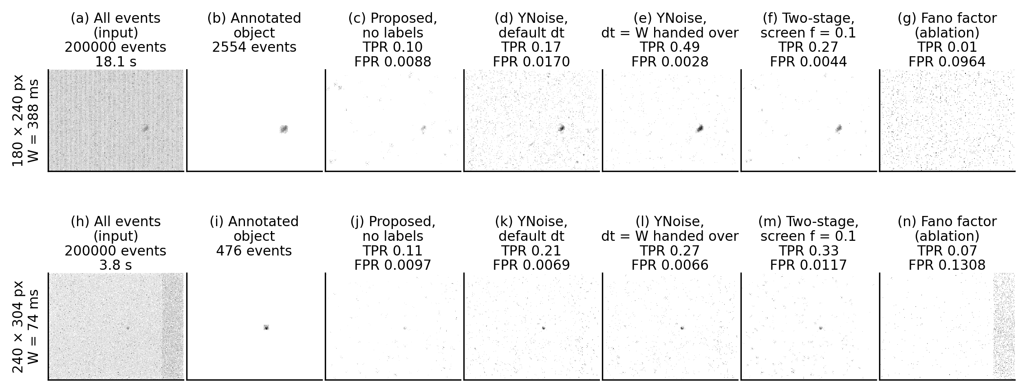
Fig. S2. The same two EBSSA recordings processed by every stage. Rows: one recording per sensor model (SL8RB_1957_davis_td, canopus_leos_11_26_atis_td), the recording whose stage-1 AUC is closest to the median of that sensor, with its rate-adaptive window W. Columns: all events; events inside the annotated object boxes; events passed at a requested false-alarm rate of 0.01 by the zero-knowledge proposal alone, by YNoise at its published default, by the hand-over (YNoise with dt = W), by the two-stage cascade with f = 0.1, and by the Fano-factor score. Each panel is the per-pixel count of passed events over the analysed interval on a logarithmic grey scale; achieved detection and false-positive rates are given above each panel.

Table S6. Dependence-aware sensitivity analysis on DND21. Mixture level: 80 mixtures, paired difference A minus B with cluster-bootstrap 95% CI over signal segments, unadjusted Wilcoxon p and rank-biserial r. Segment level: mean AUC over the noise conditions of each of the 16 signal segments, paired difference, Wilcoxon p and number of segments with A ahead. Source level: number of the 4 signal sources with A ahead (no test). Method keys as in the result files: edlr, nested-CV fixed-window proposal; edlr adaptive, nested-CV rate-adaptive proposal; zero knowledge, fixed-deployment proposal; ebssa suffix, configuration selected on EBSSA; hybrid f, two-stage cascade passing fraction f.
A | B | Mix. Δ | Mix. 95% CI | Mix. p | r | Seg. Δ | Seg. p | Seg. A ahead | Sources A ahead
edlr | edlr adaptive | -0.127 | [-0.178, -0.062] | < 0.001 | -0.80 | -0.127 | = 0.003 | 1/16 | 1/4
edlr | ynoise | -0.291 | [-0.316, -0.267] | < 0.001 | -1.00 | -0.291 | < 0.001 | 0/16 | 0/4
edlr | bilateral | -0.270 | [-0.303, -0.241] | < 0.001 | -1.00 | -0.270 | < 0.001 | 0/16 | 0/4
edlr | pfd | -0.269 | [-0.306, -0.230] | < 0.001 | -1.00 | -0.269 | < 0.001 | 0/16 | 0/4
edlr | dwf | -0.250 | [-0.277, -0.229] | < 0.001 | -1.00 | -0.250 | < 0.001 | 0/16 | 0/4
edlr | knoise | -0.094 | [-0.149, -0.042] | < 0.001 | -0.70 | -0.094 | = 0.003 | 3/16 | 1/4
edlr | temporal | -0.222 | [-0.251, -0.193] | < 0.001 | -1.00 | -0.222 | < 0.001 | 0/16 | 0/4
edlr | plr | -0.239 | [-0.266, -0.215] | < 0.001 | -0.99 | -0.239 | < 0.001 | 0/16 | 0/4
edlr | mlpf | -0.284 | [-0.317, -0.250] | < 0.001 | -1.00 | -0.284 | < 0.001 | 0/16 | 0/4
edlr | edncnn | -0.300 | [-0.334, -0.266] | < 0.001 | -1.00 | -0.300 | < 0.001 | 0/16 | 0/4
zero knowledge | edlr adaptive ebssa | +0.035 | [-0.008, +0.078] | < 0.001 | +0.53 | +0.035 | = 0.144 | 11/16 | 3/4
zero knowledge | ynoise default | -0.132 | [-0.165, -0.098] | < 0.001 | -0.87 | -0.132 | < 0.001 | 1/16 | 1/4
zero knowledge | ynoise ebssa | -0.062 | [-0.092, -0.031] | < 0.001 | -0.55 | -0.062 | = 0.002 | 3/16 | 1/4
zero knowledge | ynoise handoff | -0.130 | [-0.166, -0.098] | < 0.001 | -0.95 | -0.130 | < 0.001 | 0/16 | 0/4
zero knowledge | hybrid 0.1 | +0.000 | [-0.000, +0.001] | = 0.017 | -0.31 | +0.000 | = 0.375 | 4/16 | 2/4
zero knowledge | hybrid 0.2 | -0.003 | [-0.008, +0.000] | < 0.001 | -0.58 | -0.003 | = 0.016 | 3/16 | 1/4
ynoise handoff | ynoise default | -0.003 | [-0.024, +0.020] | = 0.034 | -0.27 | -0.003 | = 0.706 | 6/16 | 2/4
edlr adaptive | edlr | +0.127 | [+0.063, +0.178] | < 0.001 | +0.80 | +0.127 | = 0.003 | 15/16 | 3/4

Table S7. Zero-shot transfer of the released AEDNet weights to EBSSA and DND21 (Section 4.3): mean ROC-AUC on stratified subsets of at most 1,500 signal and 1,500 background events per recording, next to the untuned proposal and YNoise at its published default on the same subsets and on the full streams. Rows: EBSSA by sensor and overall; DND21 by signal scene, by noise condition and overall. Events: mean number of scored events per recording. n: number of recordings or mixtures. Adaptations from the published protocol: CPU inference (official test_net.py is CUDA-only); sensor frame set to the recording sensor; 25x15 px neighbourhood kept; whole recording as one shape (official: 100000-event chunks); softmax noise probability used as a ranking score for ROC-AUC; stratified subset of <= 1500 signal + 1500 noise events per recording. Environment: PyTorch 2.13.0+cpu, CUDA not available. Code https://github.com/Fanghuachen/AEDNet at commit 4fca5c5; weights SHA-256 e20c3da6c43345b8905380b62bc7f9ce4535fc2b135eb0f60096701651583e30.
Stratum | AEDNet (subset) | Proposal (subset) | YNoise default (subset) | Proposal (full) | YNoise default (full) | Events | n
EBSSA, 180 x 240-pixel sensor | 0.697 | 0.830 | 0.734 | 0.828 | 0.732 | 2777 | 29
EBSSA, 240 x 304-pixel sensor | 0.664 | 0.688 | 0.749 | 0.685 | 0.750 | 2540 | 14
EBSSA, all recordings | 0.686 | 0.783 | 0.739 | 0.781 | 0.738 | 2700 | 43
DND21 scene: hotel_bar | 0.855 | 0.827 | 0.968 | 0.828 | 0.969 | 3000 | 25
DND21 scene: driving | 0.789 | 0.718 | 0.847 | 0.718 | 0.846 | 2978 | 25
DND21 scene: dots5 | 0.784 | 0.693 | 0.689 | 0.692 | 0.688 | 2612 | 10
DND21 scene: accel_dot | 0.941 | 0.742 | 0.938 | 0.742 | 0.937 | 2826 | 20
DND21 condition: light native | 0.883 | 0.794 | 0.919 | 0.792 | 0.918 | 2965 | 16
DND21 condition: dark 0.5 Hz | 0.863 | 0.782 | 0.911 | 0.781 | 0.910 | 3000 | 16
DND21 condition: dark 1 Hz | 0.848 | 0.786 | 0.902 | 0.787 | 0.902 | 3000 | 16
DND21 condition: dark 3 Hz | 0.825 | 0.714 | 0.868 | 0.718 | 0.869 | 2808 | 16
DND21 condition: dark 5 Hz | 0.815 | 0.698 | 0.840 | 0.698 | 0.839 | 2732 | 16
DND21, all mixtures | 0.847 | 0.755 | 0.888 | 0.755 | 0.888 | 2901 | 80

