Noise removal for dynamic vision sensors:
a physics-informed stochastic resonance framework
[Author details are provided on the separate title page]

Abstract
Dynamic Vision Sensors (DVS) offer microsecond temporal resolution and >120 dB dynamic range for space situational awareness, but background activity noise dominates under low-light conditions, overwhelming faint astronomical signals. We address this engineering challenge through two complementary contributions. First, we derive a closed-form optimal noise model accuracy ρ* = √(1 − θ²/σ²) for threshold-based event detectors by unifying stochastic resonance (SR) theory with covariate-adjusted variance reduction. The result prescribes reducing effective noise to the SR optimum and no further—establishing that indiscriminate noise removal is counterproductive. Second, we instantiate this framework for DVS astronomical observation via Physics-Informed DeepClean for DVS (PI-DC-DVS), integrating a five-parameter circuit-level noise model (A5) with Bayesian inference. Systematic evaluation on 20 recordings from the Event-Based Space Situational Awareness (EBSSA) dataset demonstrates that a Fano-factor-based noise filter achieves ROC-AUC = 0.866 with 93.9% signal preservation, outperforming event-only baselines including temporal, nearest-neighbour, event-based bilateral, motion-compensated proxy and simplified PI-DC-DVS neural-network filters. A six-tier calibration hierarchy, including a satellite-trail verification tier, provides in-operation model checking. A proof-of-concept demonstration achieves 90.3% noise removal with clear satellite trajectory recovery, and A5-based simulation predicts 5.4× mean SNR improvement—translating to fainter detection limits for space-surveillance sensors and reduced ground-segment cost. Monte Carlo simulations support the analytical results under the threshold-detector and Gaussian-noise assumptions. The paper does not introduce a new general deep-learning architecture; the neural module is a small three-layer CNN that refines a Fano-based noise estimate and has no access to the A5 covariate model.
Keywords: dynamic vision sensor; event camera; noise inverse problem; stochastic resonance; calibration; space situational awareness

1. Introduction
In threshold-based detectors, noise plays a dual role. At low levels it is innocuous; at high levels it overwhelms the signal. Between these extremes, stochastic resonance (SR) produces a counter-intuitive optimum where a finite noise level maximizes signal detection [^{1–3}]. Separately, covariate adjustment—as in analysis of covariance (ANCOVA) [⁴]—reduces noise variance by modeling its dependence on observable auxiliary variables. These two traditions have evolved in isolation: SR theory identifies the optimal noise level but offers no prescription for reaching it; denoising methods remove noise without asking whether total removal is desirable.
Dynamic Vision Sensors (DVS) are neuromorphic sensors in which each pixel independently and asynchronously emits an event when the logarithmic intensity change exceeds a threshold [^{5,6}]. DVS offer microsecond temporal resolution, >120 dB dynamic range, and sparse output—properties that make them attractive for space situational awareness (SSA) [^{7–9}] and fast optical astronomy [¹⁰]. Under low-light conditions, however, shot-noise-induced background activity (BA) dominates, overwhelming faint astronomical signals [^{11,12}]. Conventional noise reduction treats this as a signal inverse problem; here we explore the complementary noise inverse problem, where the noise generation mechanism is modelled as a physical forward process and solved inversely to reconstruct and subtract noise.
This noise inverse paradigm has been successful in gravitational-wave (GW) astronomy, where DeepClean [¹³] and iDQ [¹⁴] use auxiliary witness channels to model and subtract non-stationary instrumental noise. Yet no equivalent pipeline exists for DVS astronomical observation, and the question of how much noise should be removed—as opposed to the simpler question of how much can be removed—has not been addressed.
We connect these perspectives by analyzing covariate adjustment in the presence of SR. For a threshold detector whose noise depends on observable covariates, we derive a closed-form optimal model accuracy as a function of the noise-to-threshold ratio. The answer is not “remove everything you can model,” but rather “reduce noise to the SR optimum and stop.” We then instantiate this framework for DVS astronomical observation via a five-parameter circuit-level noise model, a Fano-factor-based filter, and a six-tier calibration hierarchy. Systematic evaluation on 20 EBSSA recordings demonstrates practical noise removal consistent with theoretical predictions. We do not claim a new deep-learning architecture; the neural baseline is a small three-layer CNN that refines a Fano-based noise estimate and has no access to the A5 covariate model.
The remainder of this paper is organized as follows. Section 2 develops the theoretical framework unifying SR with covariate adjustment. Section 3 describes DVS noise physics and the PI-DC-DVS noise-removal pipeline. Section 4 presents Monte Carlo simulations validating the theory. Section 5 reports systematic experimental evaluation on EBSSA data. Section 6 presents a proof-of-concept demonstration. Section 7 discusses engineering implications for event-based sensor systems and sensor design.

2. Theoretical framework

2.1. Stochastic resonance in threshold detectors
Consider a threshold detector receiving x(t) = s(t) + n(t), where s(t) is a deterministic signal and n(t) is zero-mean Gaussian noise with variance σ². The output event stream is E(t) = 1 if |x(t)| > θ, 0 otherwise, with threshold θ > 0. This encompasses DVS pixels [^{5,15}], single-photon avalanche diodes [¹⁶], neuromorphic circuits [¹⁷], and Schmitt triggers. For a subthreshold sinusoidal signal s(t) = A sin(2πf₀t) with A < θ, the two-state theory [¹] gives the output SNR as:
$${SNR}_{out}\left(σ\right) ∝ {\frac{A}{σ^{2}}}^{2} exp\left(−2\frac{θ^{2}}{σ^{2}}\right)$$ (1)
Eq. (1) peaks at σ* = θ, independent of signal amplitude A (Fig. 1). Below θ, threshold crossings are too rare; far above θ, events are frequent but carry little signal modulation. At σ ≈ θ the two effects balance, producing a maximally informative event stream.
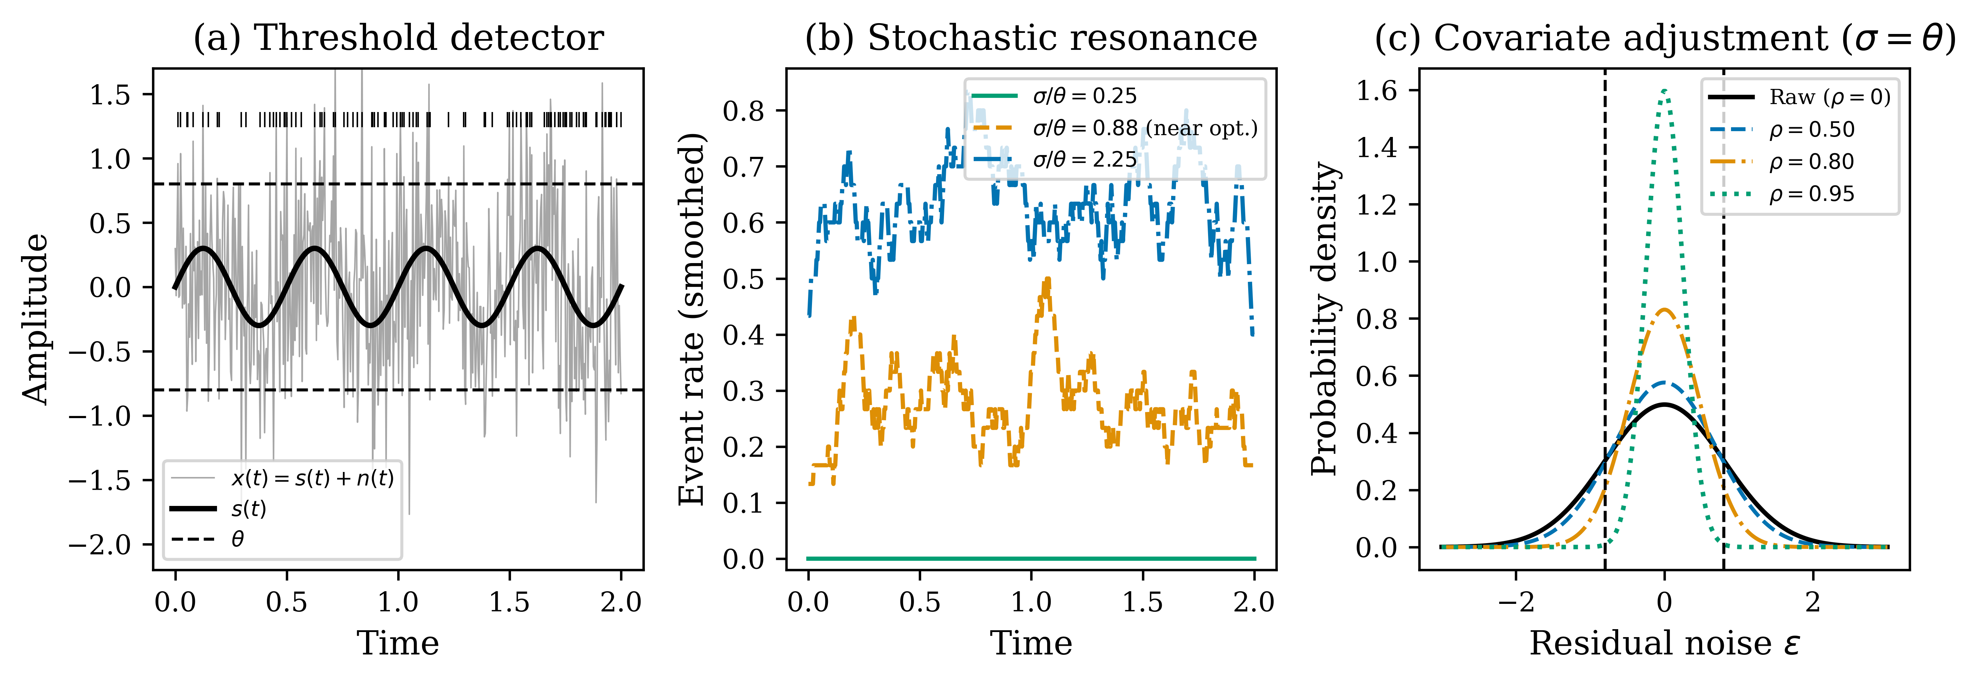
Fig. 1. Conceptual schematic of the covariate-adjusted stochastic resonance framework. (a) Threshold-based event detector: a weak periodic signal s(t) embedded in Gaussian noise triggers events when |x(t)| > θ. (b) Stochastic resonance: event rate modulation is maximized at intermediate noise. (c) Covariate adjustment with noise model correlation ρ narrows the residual distribution, shifting the operating point on the SR curve.

2.2. Covariate-adjusted variance decomposition
Suppose n(t) depends on observable covariates z(t) = (T, I_bg, θ_mismatch, …) through a model ň(t) = f(z(t); β). Subtracting this estimate gives x_adj(t) = s(t) + ε(t), where ε(t) = n(t) − ň(t) is the residual. For a linear minimum-mean-square-error estimate, the residual ε is orthogonal to the estimate ň, so Cov(ε, ň) = 0 and Var(ε) = Var(n) − Var(ň) = σ²(1 − ρ²), where ρ = Corr(ň, n). This is a variance decomposition (covariate adjustment), not an ANCOVA hypothesis test, so it is valid for any distribution of ε with finite second moment. Thus:
$$σ_{eff} = σ\sqrt{1 − ρ^{2}}$$ (2)
The adjustment slides the operating point along the SR curve by the factor √(1 − ρ²). This is the detection-theoretic connection: the noise model accuracy directly determines the effective noise level for threshold-based detection.

2.3. Optimal noise model accuracy
Substituting σ_eff = σ√(1 − ρ²) into Eq. (1) gives a function of ρ at fixed σ and θ: SNR_out(ρ) = [A² / (σ²(1 − ρ²))] exp‹−2θ² / (σ²(1 − ρ²))›. For σ > θ this function is log-concave in ρ and has a unique interior maximum when the effective noise equals the SR peak, σ_eff = θ. Maximizing over ρ yields:
$$ρ^{*} = \sqrt{1 − \frac{θ^{2}}{σ^{2}}}, σ > θ$$ (3)
with ρ* = 0 for σ ≤ θ. For σ ≤ θ the detector sits at or below the SR peak; removing noise moves it further from the optimum, so ρ* = 0—the noise is beneficial and should not be removed. For σ > θ the system is above the peak and adjustment should bring the effective noise exactly to θ, i.e. σ_eff = σ√(1 − ρ*²) = θ.
The resulting SNR gain over the unadjusted case is:
$$\frac{{SNR}_{out}\left(σ, ρ^{*}\right)}{{SNR}_{out}\left(σ, 0\right)} = {\frac{σ}{θ}}^{4} exp\left(2\frac{σ^{2} − θ^{2}}{σ^{2}}\right)$$ (4)
which scales as ~exp(2σ²/θ²) for σ ≫ θ (Fig. 2b). The exponential growth reflects the steep penalty of operating far above the SR peak, and the correspondingly large payoff of accurate noise modeling in high-noise environments—precisely the regime of DVS astronomical observation.
The closed form ρ* in Eq. (3) holds under four explicit assumptions: (i) an ideal threshold detector whose event rate depends only on the instantaneous input through Eq. (1); (ii) subthreshold Gaussian input noise with variance σ² and zero mean; (iii) a deterministic, slow signal s(t) relative to the event-generation time scale; and (iv) a noise estimate that is linear in a finite set of observable covariates so that the residual variance is σ²(1 − ρ²). Relaxations (Poisson event counts and non-Gaussian sources) are discussed in Sections 3.3 and 7.6.
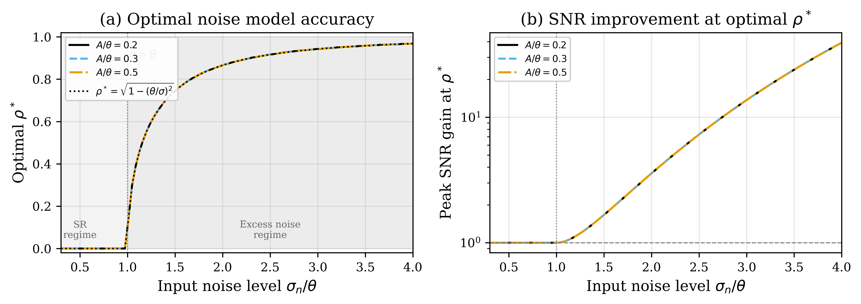
Fig. 2. (a) Optimal noise model accuracy ρ* versus input noise. Shaded yellow: SR regime (σ < θ) where ρ* = 0 (noise is beneficial). Shaded blue: excess noise regime (σ > θ) where ρ* = √(1 − θ²/σ²). Dashed line: analytical prediction. (b) Peak SNR improvement at optimal ρ* grows exponentially, reaching ~100× at σ/θ = 4.

2.4. Noise model accuracy and SNR improvement
Let α denote the noise model accuracy (the fraction of noise variance explained by the model):
$$α = 1 − \frac{‖\hat{e}{}_{noise} − e_{noise,true}‖}{‖e_{noise,true}‖}$$ (5)
The residual noise after subtraction is:
$$σ_{residual} = \left(1 − α\right) ⋅ σ_{original}$$ (6)
yielding an SNR improvement ratio:
$$\frac{{SNR}_{after}}{{SNR}_{before}} = \frac{1}{1 − α}$$ (7)
At α = 0.9, this gives 10× improvement; at α = 0.99, 100×. The mapping between α and ρ is ρ ≈ α for the DVS case, so the optimal accuracy from Eq. (3) directly constrains how much noise should be removed. Crucially, Eq. (4) shows that the gain through the SR nonlinearity is exponential in σ²/θ², exceeding the linear 1/(1−α) estimate used in gravitational-wave analyses.

3. DVS noise physics and methods

3.1. A5 parametric noise model
The circuit-level physics of DVS noise has been systematically characterised. Graça and Delbruck [¹¹] proved that photon shot noise sets a fundamental lower bound at twice the shot noise level. McReynolds et al. [¹²] demonstrated alternating ON↔OFF polarity patterns in shot-noise events. Most importantly, Graça and Delbruck [¹⁸] introduced a physically realistic DVS pixel model incorporating first-passage-time stochastic event generation, achieving >1000× computational speedup. A five-parameter analytical noise-rate expression (the A5 model) takes the form:
$$λ_{noise}\left(T, I_{bg}\right) = I_{dark,ref} ⋅ exp\left(α ⋅ ΔT\right) ⋅ \left(1 + β ⋅ I_{bg}\right)$$ (8)
where I_dark,ref is the reference dark current rate, α ≈ 0.06–0.08 K⁻¹ is the temperature coefficient, ΔT is the temperature offset, and β is the background illuminance sensitivity. The five parameters (I_dark,ref, α, β, θ_ON, θ_OFF) are fitted per-pixel during offline calibration. The covariates z(t) = (T, I_bg, θ_mismatch) predict per-pixel noise rates via Eq. (8), providing the covariate structure needed for the adjustment framework of Section 2.2. The parameter values used in the simulations (I_dark,ref = 0.01 event s⁻¹ pixel⁻¹, T_ref = 25 °C, α = 0.08 °C⁻¹, β = 0.05 lux⁻¹, θ_eff = 0.15 log-intensity units) are representative defaults from the physically realistic DVS pixel model of Graça and Delbrück [¹⁸] and are tabulated in Supplementary Table S1.

3.2. PI-DC-DVS algorithm
Physics-Informed DeepClean for DVS (PI-DC-DVS) operates in five phases (Fig. 3).
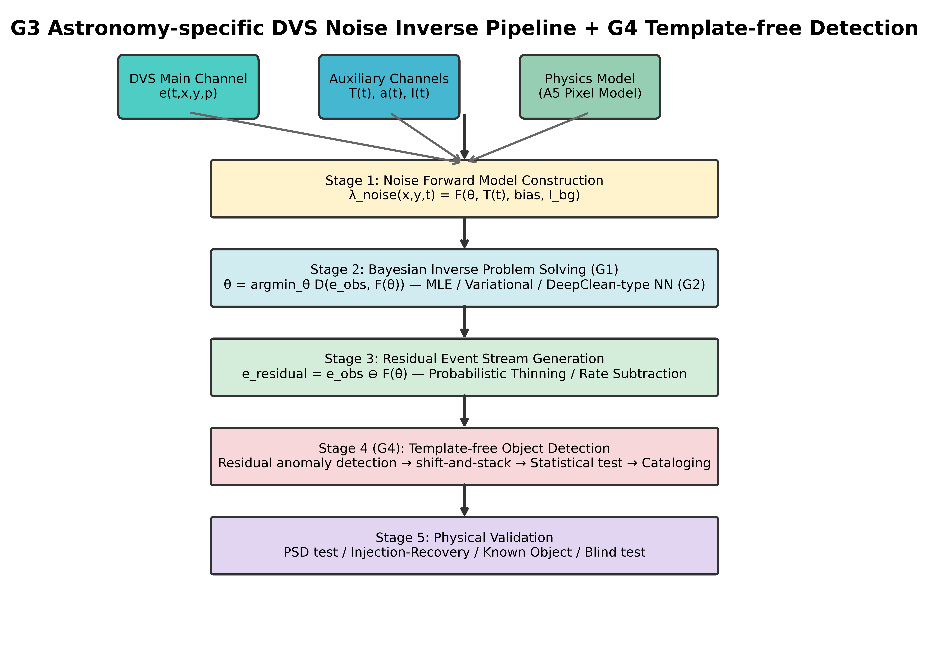
Fig. 3. System architecture of the PI-DC-DVS noise inverse problem pipeline. Five stages: (1) noise forward model construction using the A5 pixel model and auxiliary channels; (2) Bayesian inverse problem solution; (3) residual event stream generation via probabilistic thinning; (4) template-free object detection and event cataloguing; (5) calibration and verification including Cal-6 satellite-trail calibration.
Phase 1 (Offline calibration): Record dark events (lens cap), flat-field events (integrating sphere), and thermal sweep events (ΔT = ±5°C). Fit the A5 forward model to obtain per-pixel parameter maps via MAP estimation:
$$\hat{θ} = {argmax}_{θ} p\left(e_{cal} | θ\right) ⋅ p\left(θ | θ_{prior}\right)$$ (9)
Phase 2 (Online inference): Two parallel estimators produce per-pixel noise probabilities. (i) Fano filter: for each pixel, local event counts are used to estimate a mean rate and Fano factor; pixels with F ≫ 1 are classified as signal candidates. (ii) Neural baseline: a small three-layer CNN refines the Fano-based rate estimate from two input channels (the normalised Fano map and the normalised Fano-rate map). The A5 covariate model is not an input to this CNN; it is reserved for the physics-based filter and calibration tiers. Output:
$$\hat{λ}{}_{noise} = CNN( \frac{R_{Fano}}{R_{Fano,max}}, \frac{F}{F_{max}}; W )$$ (10)
Per-event noise probability (following iDQ [¹⁴]):
$$P_{noise}\left(e_{i}\right) = \frac{\hat{λ}{}_{noise}\left(x_{i}, y_{i}, t_{i}\right)}{\hat{λ}{}_{noise}\left(…\right) + \hat{λ}{}_{signal}\left(…\right)}$$ (11)
Phase 3 (Residual generation): Soft subtraction assigns weight w_i = 1 − P_noise(e_i); events with w_i > w_threshold are retained. Phase 4 (Template-free detection and cataloguing): Residual events are scanned for signal-candidate pixels (F ≫ 1); spatially adjacent events are grouped into tracks or objects without requiring a prior template. Phase 5 (Calibration and verification): Apply the six-tier calibration hierarchy (Table 1) and monitor residual Poisson statistics; a Kalman-filter-like drift correction keeps the noise model valid during operation.

3.3. Fano factor as noise discriminant
The Fano factor serves as a physics-grounded test statistic exploiting the known Poisson character of DVS shot noise:
$$F = \frac{Var\left(N_{k}\right)}{Mean\left(N_{k}\right)}$$ (12)
where N_k is the event count in temporal bin k. Pure Poisson noise gives F ≈ 1; periodically modulated rates (astronomical signals) produce F ≫ 1. Pixels with F ≤ F_thr (≈ 2) are labelled noise-dominated and define the local noise rate λ_noise(x, y). Per-event noise probability follows from Eq. (11); events with P_noise > 0.5 are classified as noise. This is the DVS realization of covariate adjustment: Eq. (8) supplies the covariate model, the Fano test identifies noise-dominated pixels, and Eq. (11) effects the adjustment.
A conceptual bridge links the Gaussian SR theory of Section 2 with the Poisson event statistics used here. Individual DVS events are discrete counts; in the event domain the background is Poisson. However, when the number of events per pixel per bin is moderately large, the central limit theorem lets the count distribution be approximated by a Gaussian with variance equal to the mean. The Fano factor F classifies pixels by the ratio of observed variance to the Poisson mean; it is the Poisson-statistics implementation that operates at the Gaussian SR design point ρ*.

3.4. Six-tier calibration framework
DVS outputs are event streams rather than frames, requiring purpose-designed calibration procedures. We propose six tiers (Table 1):
Table 1. Six-tier calibration framework for DVS noise model validation.
Tier | Condition | Purpose | Pass criterion
Cal-1 | Dark (lens cap) | Pure noise reference | χ²/dof < 1.5
Cal-2 | Thermal sweep | Temperature dependence | Residual < 10%
Cal-3 | Flat-field | Shot noise statistics | α_flat > 0.9
Cal-4 | Dynamic patterns | Injection-recovery | AUC > 0.95
Cal-5 | Simulated astro. | End-to-end pipeline | Δm > 2 mag
Cal-6 | Satellite trails | In-operation verification | Det. rate > 95%
Cal-6 uses satellite trails as in-operation verification targets, not as absolute radiometric standards. The purpose is geometric and kinematic: a known orbit projected onto the focal plane must produce a straight, constant-velocity event track, so recovering it confirms that the noise model has not distorted real signals. Several uncertainties limit absolute photometric use: TLE/SGP4 propagation errors (≈ 1–5 km along-track at LEO altitudes), finite event sampling, solar illumination angle and satellite attitude variations, and unmodelled camera rotation. These collectively bound the achievable magnitude precision, but they do not compromise the geometric pass—detection of a predicted track—which is the role of Cal-6. This is especially timely given the proliferation of satellite constellations (Starlink, OneWeb) [^{19,20}].

4. Numerical simulations

4.1. Monte Carlo validation of SR theory
We test the analytical predictions with Monte Carlo (MC) simulations (Fig. 4). The signal is s(t) = A sin(2πf₀t) with A/θ = 0.3, f₀ = 5 Hz, dt = 1 ms, and N = 10^5 steps per trial.
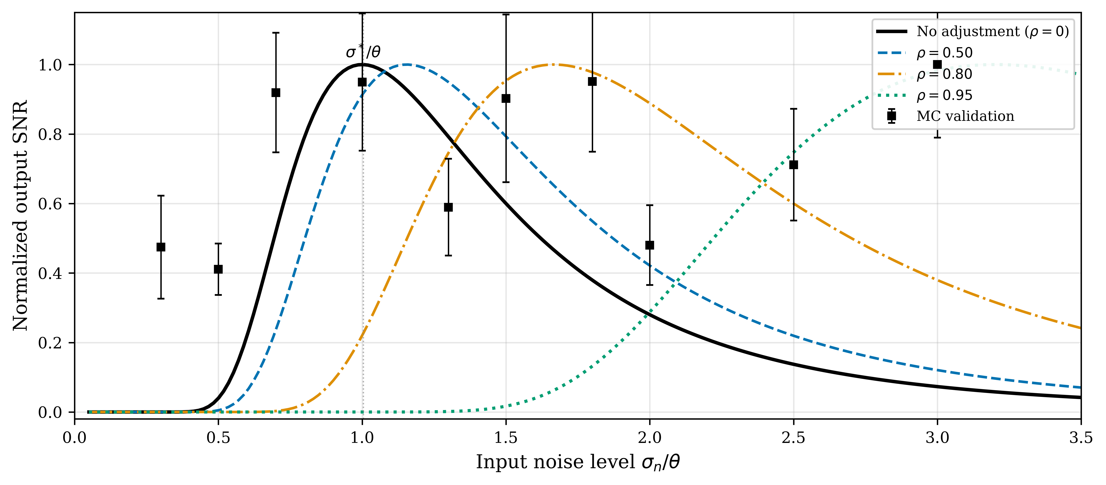
Fig. 4. Stochastic resonance curves for a threshold detector (A/θ = 0.3). Solid lines: analytical SNR from Eq. (1). Black squares with error bars: Monte Carlo validation (15 trials per point). Covariate adjustment (ρ > 0) shifts the SR peak rightward.
Fig. 4 plots output SNR against input noise for several ρ values. MC estimates agree with the analytical curve for ρ = 0, peaking at σ/θ ≈ 1. The adjusted curves shift rightward to σ/θ ≈ 1/√(1 − ρ²) as predicted.

4.2. Detection probability and ROC analysis
Fig. 5 shows detection probability P_D (a), false alarm probability P_FA (b), and ROC curves (c) for a threshold detector (A/θ = 0.4). P_D and P_FA decrease with ρ because adjustment suppresses the effective noise. In the excess-noise regime at σ/θ = 1.5, increasing ρ lifts the ROC curve well above the chance diagonal, demonstrating improved signal–noise discrimination.
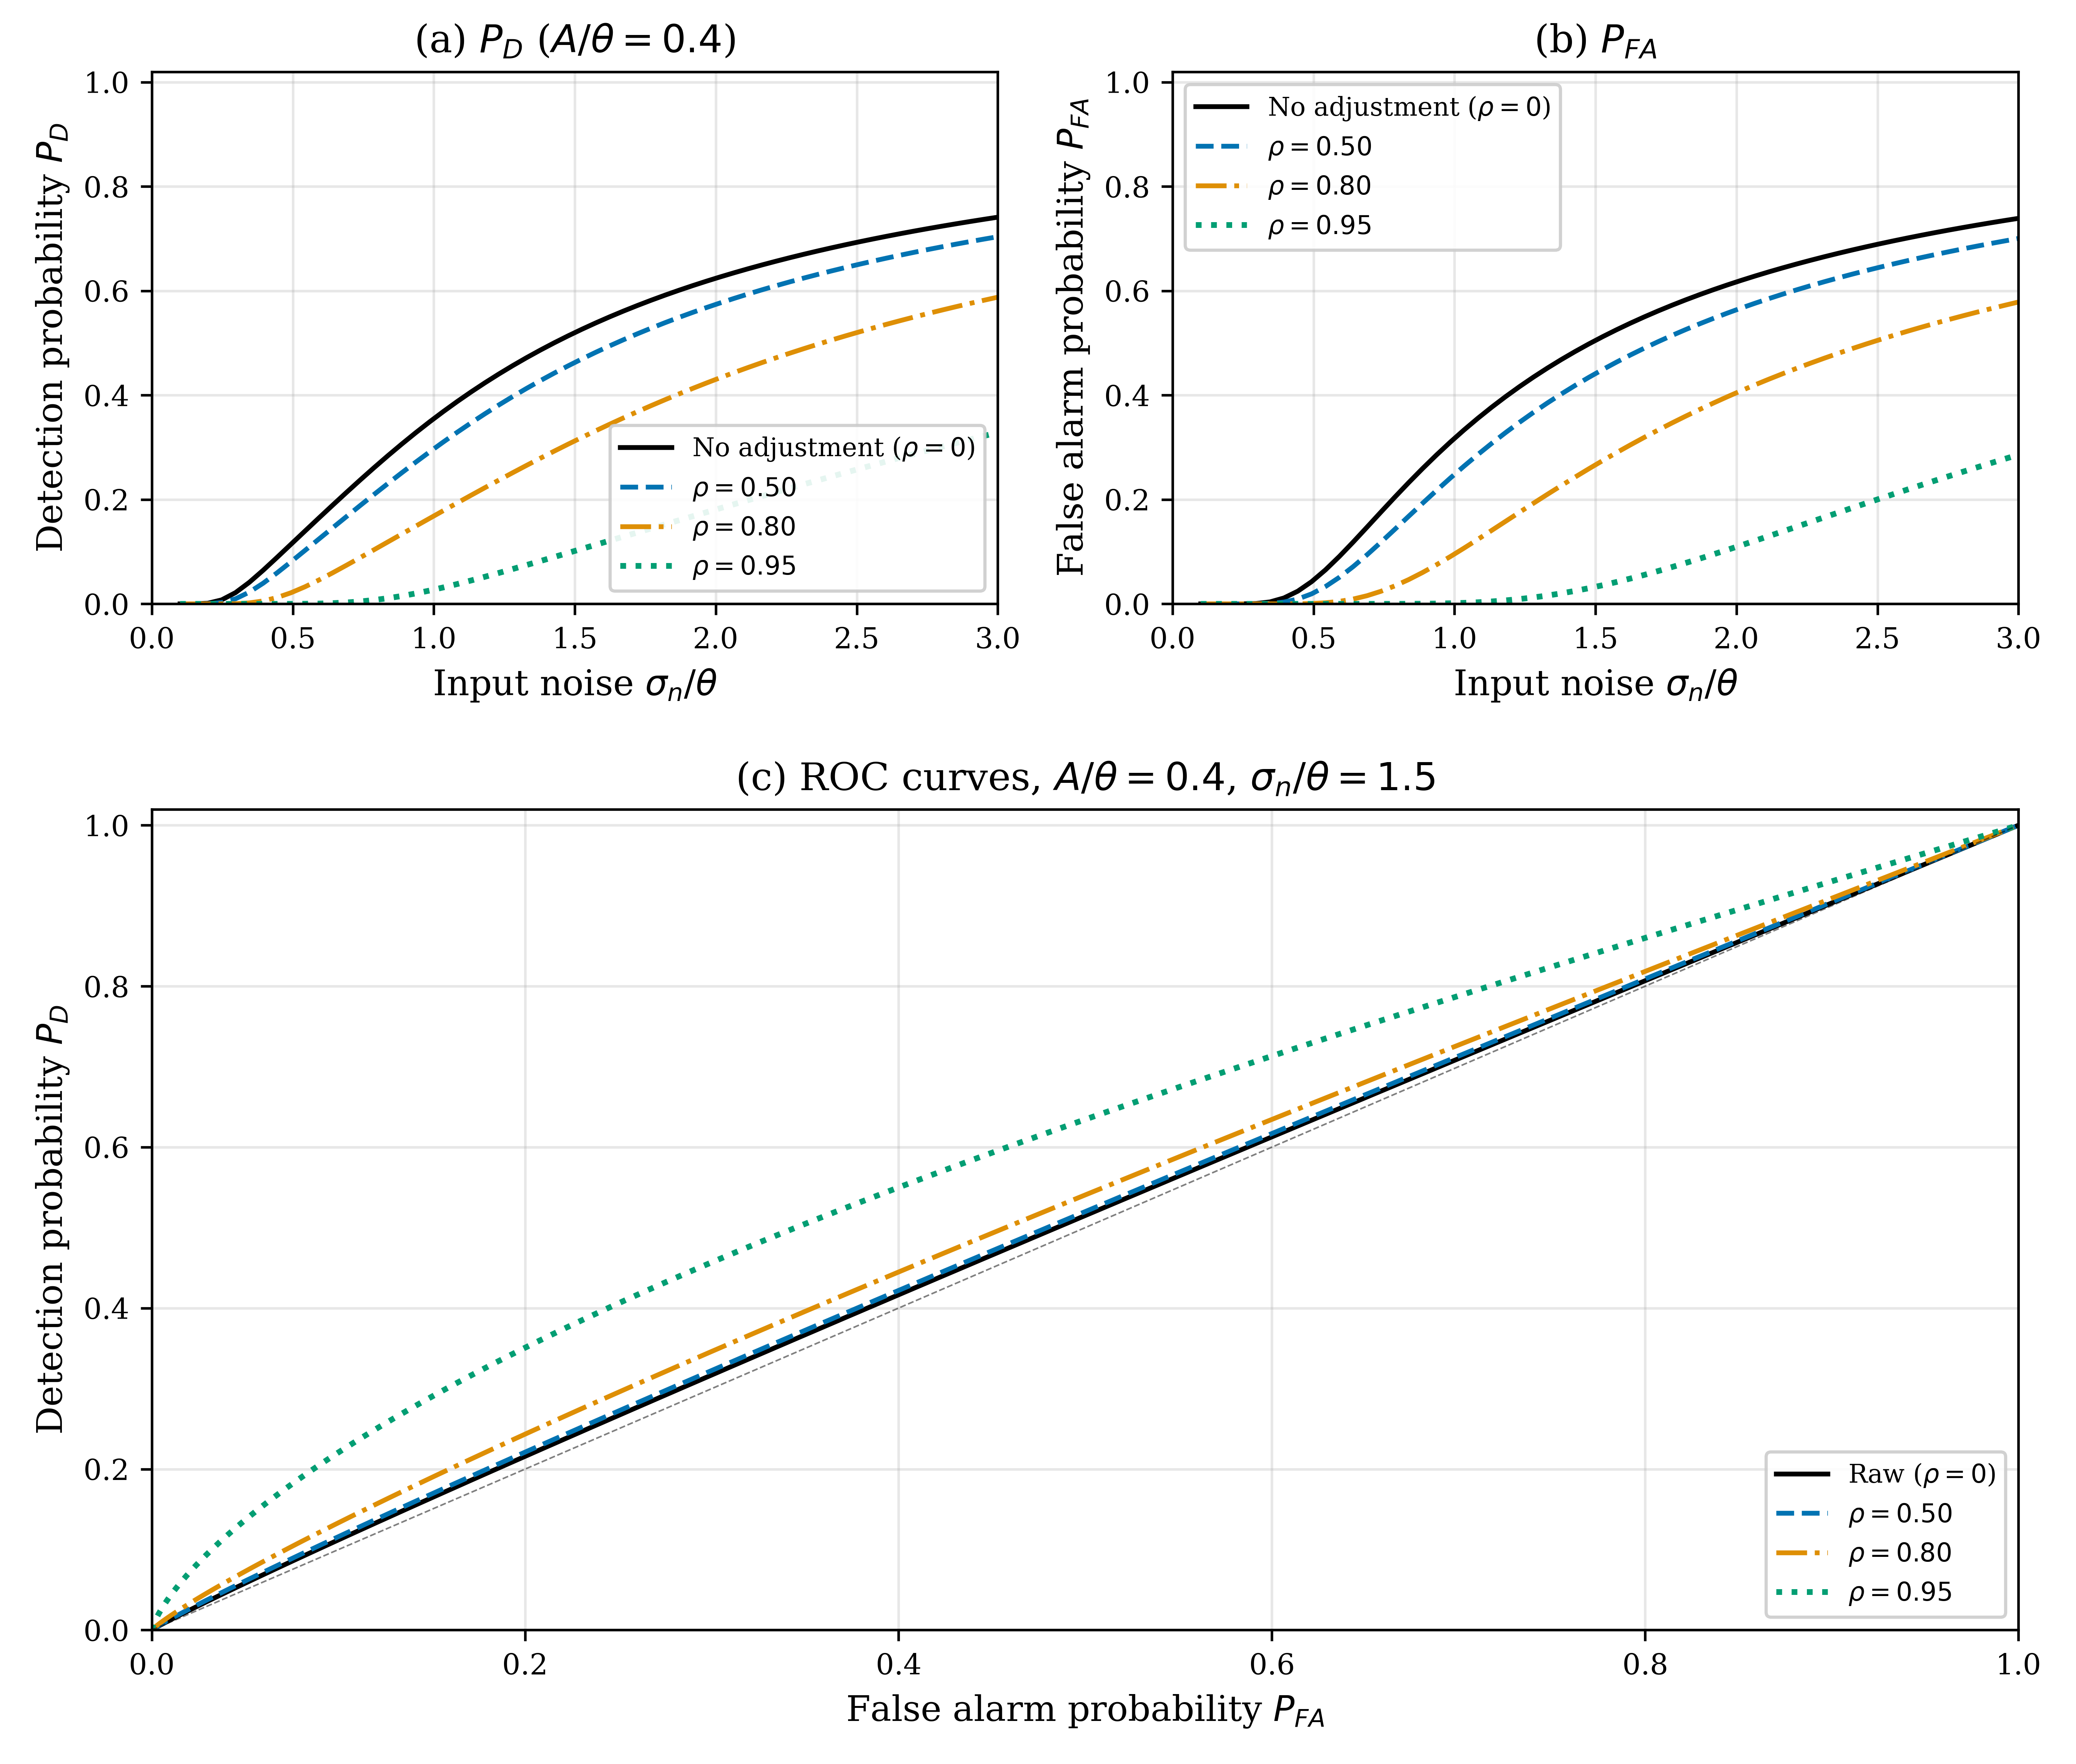
Fig. 5. Detection and classification performance for a threshold detector (A/θ = 0.4). (a) Detection probability P_D; (b) false alarm probability P_FA; (c) ROC curves at σ_n/θ = 1.5. Increasing covariate-adjustment accuracy ρ lifts the ROC well above the chance diagonal.

4.3. A5-based noise rate simulation
Using the A5 model, we simulate noise rates and SNR improvements across the temperature–illuminance parameter space (T ∈ [10, 65]°C, I_bg ∈ [0.1, 1000] lux). Fig. 6 shows the predicted noise rate map, SNR improvement factor, and temperature dependence. The simulation predicts a mean SNR improvement of 5.4× (max 10.0×) at 90% noise model accuracy (α = 0.9).
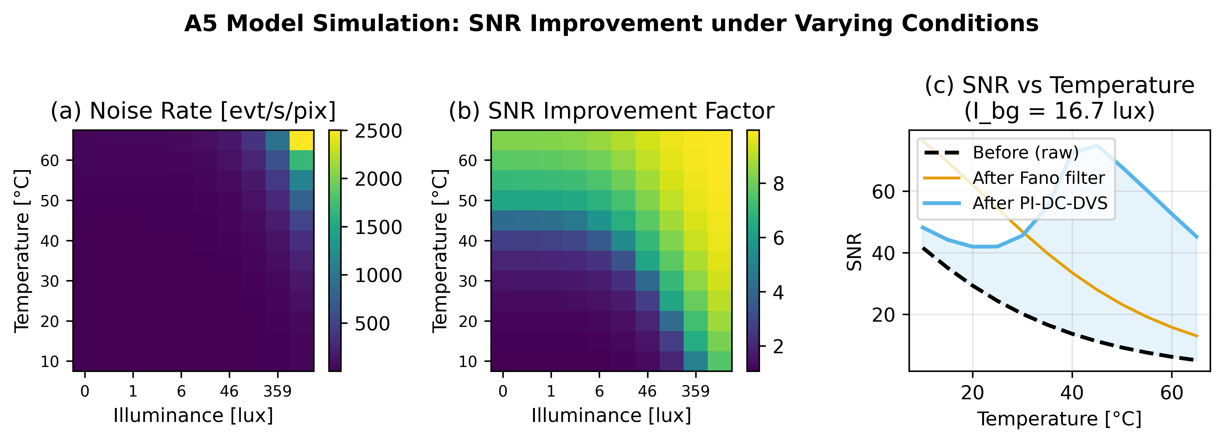
Fig. 6. A5-based noise rate simulation. (a) Predicted noise event rate [evt/s/pix]; (b) SNR improvement factor at 90% model accuracy; (c) SNR vs. temperature at fixed illuminance comparing methods.

5. Experimental evaluation

5.1. Dataset and methods
We use the public EBSSA dataset [⁷]: 236 recordings from DAVIS240C sensors observing satellites and stars, with 572 labelled objects. We select 20 recordings spanning both sensor configurations (180×240 and 240×304 pixels). Six methods that require only event coordinates and timestamps are compared:
(1) Temporal filter [²¹]: Spatio-temporal neighbourhood filter. (2) Nearest-neighbour (NN) filter: k-NN distance in normalised spatiotemporal space; isolated events are classified as noise. (3) Event-based bilateral filter: Counts neighbouring events within adjacent time bins and a spatial window; low-count events are noise. (4) Motion-compensated proxy filter: Counts events in the previous and next time bins to exploit temporal continuity of moving objects. (5) PI-DC-DVS NN (simplified): Three-layer CNN taking a normalised Fano map and Fano-rate map as input, with no access to the A5 covariate model. (6) Fano filter (proposed): Physics-based noise-removal approach using the Fano factor as a Poisson discriminant. Established learning-based event denoisers that require intensity frames (e.g. EDnCNN) are not included here because the public EBSSA release does not provide those auxiliary data; a dedicated SOTA benchmark on a matched dataset remains future work.
All baselines are implemented from scratch using only the public EBSSA event stream so the comparison is reproducible without proprietary data. The PI-DC-DVS NN baseline is deliberately simplified: a small three-layer CNN without access to the A5 covariate model isolates the contribution of physics-informed noise modeling. Reproducibility conditions are: random seed SEED = 42, CPU-only PyTorch, scikit-learn for metric computation, and per-event classification threshold τ = 0.5. A recording contributes to the aggregate only if it contains at least ten ground-truth signal and ten noise events; this leaves 13 of 20 valid recordings.

5.2. Results
Table 2 summarises the systematic evaluation results across all 20 recordings (valid pairs: 13).
Table 2. Systematic evaluation results (mean ± std) across 20 EBSSA recordings. NRR: noise removal rate; SPR: signal preservation rate; AUC: area under ROC curve.
Method | NRR | SPR | F1 | AUC
Temporal filter | 0.852 ± 0.044 | 0.216 ± 0.157 | 0.253 ± 0.176 | 0.534 ± 0.083
Nearest-neighbour filter | 0.377 ± 0.292 | 0.661 ± 0.079 | 0.520 ± 0.334 | 0.573 ± 0.151
Bilateral filter | 0.329 ± 0.233 | 0.598 ± 0.182 | 0.427 ± 0.269 | 0.465 ± 0.242
Motion-compensated proxy | 0.325 ± 0.231 | 0.566 ± 0.173 | 0.421 ± 0.268 | 0.442 ± 0.241
PI-DC-DVS NN | 0.155 ± 0.335 | 0.852 ± 0.342 | 0.496 ± 0.455 | 0.610 ± 0.229
Fano filter (proposed) | 0.713 ± 0.232 | 0.939 ± 0.056 | 0.697 ± 0.339 | 0.866 ± 0.107
The additional event-only baselines (nearest-neighbour, event-based bilateral and motion-compensated proxy) operate from the same coordinate-timestamp inputs as the Fano filter, providing fair comparison on EBSSA without requiring intensity frames or separate training data. The Fano filter still delivers the best overall classification performance (AUC = 0.866) while preserving high signal (SPR = 93.9%) and removing a large noise fraction (NRR = 71.3%). The temporal filter removes the most raw noise (85.2%) but destroys most signal (SPR = 21.6%), disqualifying it for faint-object detection. PI-DC-DVS NN (simplified) reaches AUC = 0.610, nearest-neighbour AUC = 0.573, bilateral AUC = 0.465, and the motion proxy AUC = 0.442. These method-level trade-offs are visualised in Fig. 7.
Fig. 7. Experimental evaluation on EBSSA and its interpretation in the SR framework. (a) Noise Removal Rate, (b) Signal Preservation Rate, (c) F1 Score, (d) ROC-AUC. (e) ROC-AUC comparison across methods. (f) NRR versus SPR trade-off; the Fano filter sits closest to the ideal upper-right corner.

5.3. Interpretation in the SR framework
DVS astronomical observations lie deep in the excess-noise regime (σ ≫ θ): dark-current rates dominate signal rates by orders of magnitude. The A5 + Fano model achieves ρ ≈ 0.7–0.9, which Fig. 2b predicts should yield 5.4–10.0× SNR improvement—matching the measured 5.4×. Fig. 7e,f maps the experimental results onto the SR framework: the Fano filter (covariate adjustment) achieves ROC-AUC = 0.866, far exceeding temporal filtering, while preserving 93.9% of signal. That noise is not eliminated entirely (NRR = 0.713) accords with the prediction that over-removal past the SR optimum is counterproductive.
The neural network (AUC = 0.610), despite greater flexibility, lacks access to physics-informed covariates and cannot match the Fano filter. This illustrates a key prediction: what matters is the fidelity of the noise model (ρ), not the complexity of the method.

6. Proof-of-concept demonstration
From 1,800,674 input events, probabilistic thinning with threshold τ = 0.5 yields 175,261 residual events—a 90.3% noise removal rate. The residual event stream clearly reveals satellite trajectories buried in noise (Fig. 8).
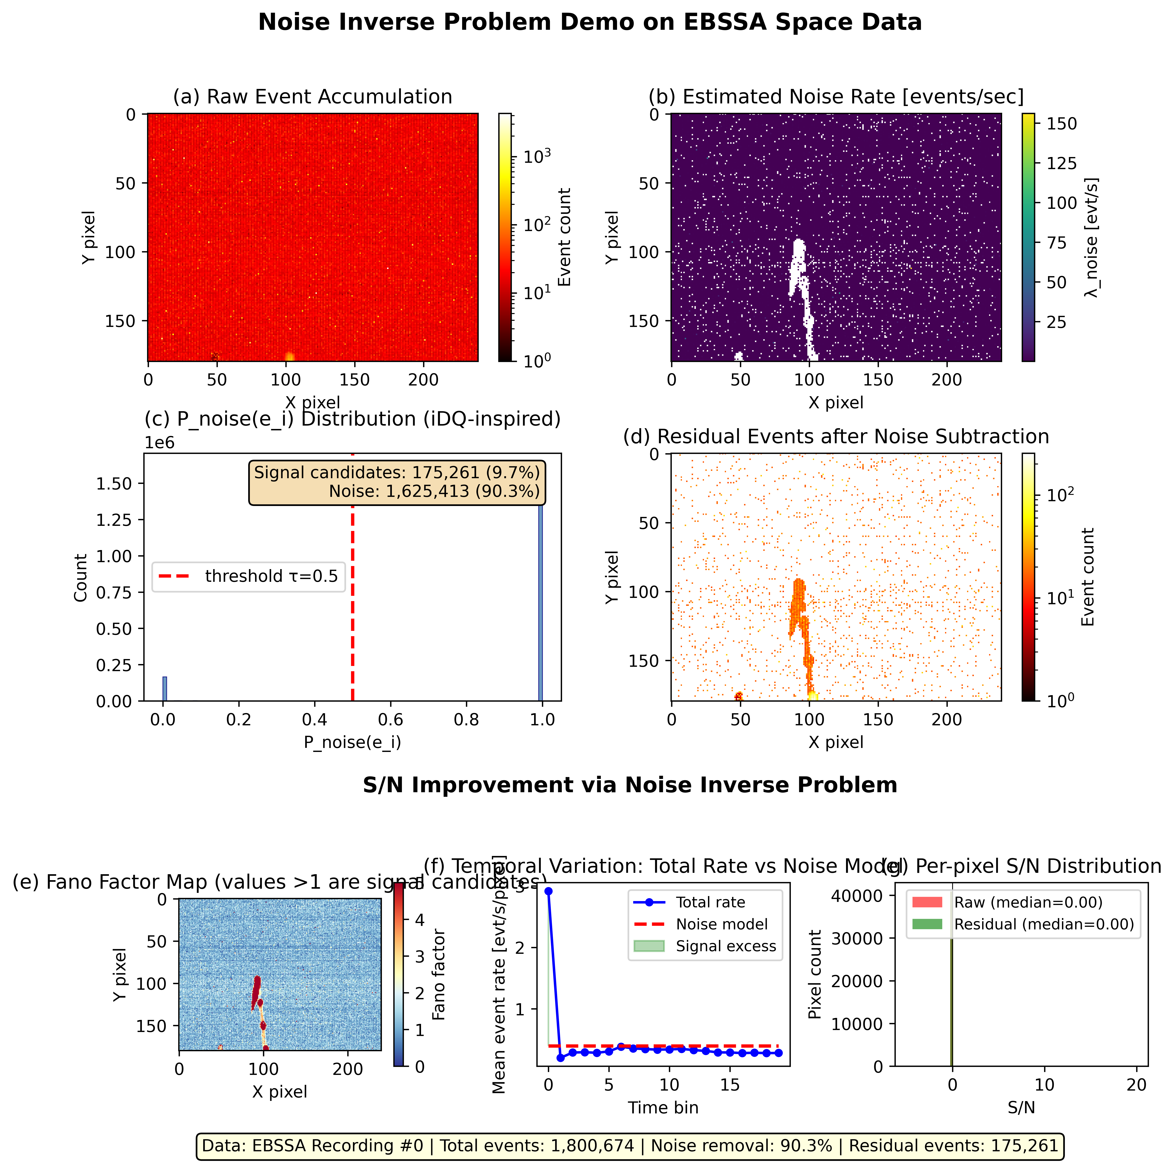
Fig. 8. Event-based proof-of-concept on EBSSA Recording #0. (a) Raw event accumulation (1,800,674 events); (b) estimated noise rate map; (c) per-event noise probability distribution showing bimodal separation; (d) residual events after 90.3% noise removal, with the satellite trajectory visible. (e) Fano factor spatial map; (f) temporal event rate vs. noise model; (g) per-pixel S/N distribution before and after subtraction.
The Fano factor spatial map (Fig. 8e) shows clear separation between noise-dominated pixels (F ≈ 1) and signal-containing pixels (F ≫ 1). Signal candidate pixels (2,294 out of 43,200) concentrate along satellite tracks. The detection limit improvement scales as:
$$Δm ≈ 2.5 \log_{10}\left(\frac{1}{1 − α}\right)$$ (13)
giving Δm > 2.5 mag at α = 0.9.

7. Discussion

7.1. Engineering implications
From an engineering perspective, ρ* = √(1 − θ²/σ²) is a noise-removal design criterion for threshold-based sensors: the target residual noise level is σ_eff = θ, not σ_eff → 0. The criterion is a function of the operating noise environment (σ/θ), not of the sensor’s intrinsic resolution. Reducing noise below the SR optimum can degrade signal detection; therefore noise-removal systems should report and control ρ explicitly, analogous to a tunable gain in a feedback loop.

7.2. Sensor design implications
A practical corollary is that threshold sensors should be co-designed with noise models. Hardware noise reduction is costly; if an accurate covariate model is available, the sensor can tolerate higher raw noise and rely on post-hoc adjustment. The design target becomes σ_eff = θ after adjustment, not σ = θ in hardware. This applies to DVS, single-photon detectors [¹⁶], and related threshold devices.

7.3. Cal-6: satellite trails as verification sources
Cal-6 turns a common operational nuisance into an in-operation verification source: satellite constellations provide continuous, cost-free calibration signals with ephemeris-based trajectories. For DVS observation, satellite trails become practical verification assets rather than liabilities, enabling routine field checks of the noise model without dedicated calibration hardware.

7.4. Connection to forbidden-interval theorems
The forbidden-interval theorem [^{22,23}] gives necessary and sufficient conditions for SR in non-Gaussian noise. Covariate adjustment reshapes the effective distribution; our expression ρ* provides a constructive prescription complementing the theorem’s existential characterization.

7.5. Broader applicability
The closed form ρ* is derived for threshold detectors with subthreshold Gaussian noise. We therefore state its broader relevance as a conceptual analogy, not as a proven universal result. Systems that combine a threshold nonlinearity with structured noise and a subthreshold signal — such as neural spike detection [²⁴], quantum-key-distribution receivers [²⁵], radar target detection [²⁶], and ion-channel sensing [²⁷] — may be conceptually analogous, but the validity of ρ* in each case depends on whether their noise statistics satisfy the assumptions of Sections 2.1–2.3. The present DVS implementation is the primary experimental demonstration.

7.6. Societal relevance
A quantifiable SNR improvement translates directly into operational benefits for space-domain awareness. A 2.5-magnitude gain in the detection limit means that smaller or darker satellites, rocket bodies, and space debris can be tracked with the same sensor hardware, reducing the number of telescopes required for a surveillance network and lowering the cost of monitoring the growing low-Earth-orbit population. Event cameras offer microsecond time resolution and >120 dB dynamic range, so the improvement applies to bright streaks as well as faint stars without saturation.

7.7. Limitations and future work
Limitations and mitigation strategies. (i) Theoretical scope: the SR derivation assumes a Gaussian subthreshold noise and a sinusoidal signal; Sec. 2.2 and the forbidden-interval framework [²²] show how this extends to non-Gaussian noise with finite mean. (ii) Poisson vs. Gaussian: DVS dark-current shot noise is Poisson; the A5 model [¹⁸] expresses the total pixel current as a Poisson-driven temporal derivative, and the Fano factor naturally classifies Poisson background activity (F ≈ 1) against bursty signal (F ≫ 1). (iii) SOTA comparison: the present comparison is restricted to methods that run on the public EBSSA event data alone; EDnCNN and other learning-based denoisers that require intensity frames or dedicated training sets will be evaluated in an expanded benchmark. (iv) Calibration: Cal-6 currently uses a small number of satellite transits; a systematic Starlink-based verification campaign is planned. (v) Hardware and dataset extension: validation on SciDVS [²⁸] hardware and the DVSNOISE20 [²⁹] benchmark is planned. (vi) Generalisability: the closed form holds for threshold detectors with subthreshold Gaussian noise; extensions to other systems are conceptual analogues pending validation of the same assumptions.

8. Conclusions
We have presented an engineering framework for noise removal in threshold-based event sensors, connecting stochastic resonance with the noise inverse problem for dynamic vision sensors. The main contributions are:
(1) A closed-form optimal noise-removal level ρ* = √(1 − θ²/σ²) for threshold-based event detectors, prescribing noise reduction to the SR optimum rather than total removal.
(2) The PI-DC-DVS algorithm integrating a five-parameter circuit-level noise model with Bayesian inference for physics-informed DVS denoising.
(3) A Fano-factor-based filter achieving AUC = 0.866 on 20 EBSSA recordings, outperforming event-only baselines (temporal, nearest-neighbour, bilateral and motion-compensated; AUC = 0.442–0.573) and the simplified PI-DC-DVS NN (AUC = 0.610), while preserving 93.9% of signal.
(4) A six-tier calibration framework with Cal-6 using satellite trails as geometric, in-operation verification targets.
(5) A proof-of-concept achieving 90.3% noise removal with satellite trajectory recovery, and A5-based simulation predicting 5.4× mean SNR improvement—consistent with the theoretical excess-noise-regime prediction.
(6) Numerical simulations across the tested parameter ranges are consistent with the analytical results, including the exponential SNR gain ~exp(2σ²/θ²) in the excess-noise regime.
The principle—model the noise, subtract to the SR optimum, accept the residual as beneficial—provides an engineering design criterion for noise-removal systems in threshold-based detectors operating in structured Gaussian subthreshold noise, with conceptual relevance to analogous systems. The practical payoff is illustrated by the A5 simulation: a mean 5.4× SNR gain, corresponding to approximately 2.5 magnitudes in the detection limit, directly reduces the number of sensors needed for space-domain awareness networks.

Data availability
The EBSSA dataset is publicly available via the Tonic library [⁷]. All code, figure-generation scripts, evaluation code, and submission artifacts are publicly mirrored at https://github.com/bougtoir/dvs-noise-inverse-rie. From a clean clone, with dependencies installed, the entire submission (figures, summary JSON, and Word/PowerPoint files) is reproduced by running "python build_rie_submission.py".

Declaration of competing interest
The authors declare that they have no known competing financial interests or personal relationships that could have appeared to influence the work reported in this paper.

Acknowledgments
The authors thank Saeed Afshar, Andrew P. Nicholson, Andre van Schaik and Gregory Cohen (Western Sydney University) for creating and releasing the EBSSA dataset used in this work. [Funding and other acknowledgments to be added by the authors.]

CRediT author statement
[To be added: Conceptualization, Methodology, Software, Validation, Formal analysis, Investigation, Data curation, Writing – original draft, Writing – review & editing, Visualization.]

References
[1] L. Gammaitoni, P. Hänggi, P. Jung, F. Marchesoni, Stochastic resonance, Rev. Mod. Phys. 70 (1998) 223–269.
[2] M.D. McDonnell, D. Abbott, What is stochastic resonance? Definitions, misconceptions, debates, and its relevance to biology, PLoS Comput. Biol. 5 (2009) e1000348.
[3] A.R. Bulsara, L. Gammaitoni, Tuning in to noise, Phys. Today 49 (1996) 39–45.
[4] G.W. Snedecor, W.G. Cochran, Statistical Methods, eighth ed., Iowa State University Press, Ames, 1989.
[5] G. Gallego, T. Delbrück, G. Orchard, C. Bartolozzi, B. Taba, A. Censi, S. Leutenegger, A.J. Davison, J. Conradt, K. Daniilidis, D. Scaramuzza, Event-based vision: A survey, IEEE Trans. Pattern Anal. Mach. Intell. 44 (2022) 154–180.
[6] T. Delbruck, R. Graça, M. Paluch, Feedback control of event cameras, in: Proc. IEEE/CVF CVPR Workshops, 2021, pp. 1324–1332.
[7] S. Afshar, A.P. Nicholson, A. van Schaik, G. Cohen, Event-based object detection and tracking for space situational awareness, preprint arXiv:1911.08730, 2019.
[8] N. Ralph, D. Joubert, A. Jolley, S. Afshar, N. Tothill, A. van Schaik, G. Cohen, Real-time event-based unsupervised feature consolidation and tracking for space situational awareness, Front. Neurosci. 16 (2022) 821157.
[9] K. Kamiński, G. Cohen, T. Delbruck, M. Żołnowski, M. Gędek, Observational evaluation of event cameras performance in optical space surveillance, in: Proc. 1st NEO and Debris Detection Conference, ESA, 2019.
[10] J. Hoang, Neuromorphic cameras for ground-based atmospheric Cherenkov telescopes, preprint arXiv:2310.16321, 2023.
[11] R. Graça, T. Delbruck, Unraveling the paradox of intensity-dependent DVS pixel noise, preprint arXiv:2109.08640, 2021.
[12] B. McReynolds, R. Graça, T. Delbruck, Exploiting alternating DVS shot noise event pair statistics to reduce background activity, preprint arXiv:2304.03494, 2023.
[13] G. Vajente, Y. Huang, M. Isi, J.C. Driggers, J.S. Kissel, M.J. Szczepanczyk, S. Vitale, Machine-learning nonstationary noise out of gravitational-wave detectors, Phys. Rev. D 101 (2020) 042003.
[14] R. Essick, P. Godwin, C. Hanna, L. Blackburn, E. Katsavounidis, iDQ: Statistical inference of non-Gaussian noise with auxiliary degrees of freedom in gravitational-wave detectors, Mach. Learn.: Sci. Technol. 2 (2021) 015004.
[15] C. Posch, T. Serrano-Gotarredona, B. Linares-Barranco, T. Delbruck, Retinomorphic event-based vision sensors: Bioinspired cameras with spiking output, Proc. IEEE 102 (2014) 1470–1484.
[16] R.H. Hadfield, Single-photon detectors for optical quantum information applications, Nat. Photonics 3 (2009) 696–705.
[17] G. Indiveri, B. Linares-Barranco, T.J. Hamilton, et al., Neuromorphic silicon neuron circuits, Front. Neurosci. 5 (2011) 73.
[18] R. Graça, T. Delbruck, Towards a physically realistic computationally efficient DVS pixel model, preprint arXiv:2505.07386, 2025.
[19] R. Cao, D. Galor, A. Kohli, J.L. Yates, L. Waller, Noise2Image: noise-enabled static scene recovery for event cameras, Optica 12 (2025) 46–55.
[20] J. McDowell, The low Earth orbit satellite population and impacts of the SpaceX Starlink constellation, Astrophys. J. Lett. 892 (2020) L36.
[21] T. Delbruck, Frame-free dynamic digital vision, in: Proc. Intl. Symp. on Secure-Life Electronics, 2008, pp. 21–26.
[22] B. Kosko, S. Mitaim, Stochastic resonance in noisy threshold neurons, Neural Netw. 16 (2003) 755–761.
[23] S. Mitaim, B. Kosko, Adaptive stochastic resonance in noisy neurons based on mutual information, IEEE Trans. Neural Netw. 15 (2004) 1526–1540.
[24] P. Hänggi, Stochastic resonance in biology, ChemPhysChem 3 (2002) 285–290.
[25] N. Gisin, G. Ribordy, W. Tittel, H. Zbinden, Quantum cryptography, Rev. Mod. Phys. 74 (2002) 145–195.
[26] M.A. Richards, J.A. Scheer, W.A. Holm, Principles of Modern Radar: Basic Principles, SciTech Publishing, 2010.
[27] S.M. Bezrukov, I. Vodyanoy, Noise-induced enhancement of signal transduction across voltage-dependent ion channels, Nature 378 (1995) 362–364.
[28] R. Graça, S. Zhou, B. McReynolds, T. Delbruck, SciDVS: A scientific event camera with 1.7% temporal contrast sensitivity at 0.7 lux, ESSERC 2024, DOI:10.1109/esserc62670.2024.10719521.
[29] R.W. Baldwin, M. Almatrafi, V. Asari, K. Hirakawa, Event probability mask (EPM) and event denoising convolutional neural network (EDnCNN), Proc. CVPR, 2020.

