Disentangling spatial persistence from temporal history in continental bird distributions
Running title: Spatial persistence and history dependence

Target journal: Global Ecology and Biogeography (Original Article)

Abstract
Species distribution models routinely include lagged occurrence or abundance as predictors, and the resulting predictive gains are often interpreted as ecological memory, inertia, or hysteresis. However, lagged state also encodes persistent spatial heterogeneity: a consistently suitable site produces lag-1 predictability without any path dependence. We decomposed lagged-state predictability in the North American Breeding Bird Survey (71,694 surveyed route-years) across 116 widespread breeding-bird species, using a 2×2 design that crosses retrospective (leave-one-year-out) with prospective (forward-chaining) evaluation and route demeaning. Apparent history gain was large without spatial control (median 0.299), but collapsed after route demeaning (forward + demeaned median 0.0059). Matched-environment occupancy hysteresis was unsupported (contrast = 0.000 in all 41 definable species), whereas abundance retained strong temporal state dependence (median 0.63 log-count; 40/41 definable species with 95% CI > 0). Lagged-state predictors in distribution forecasts should not be read as memory until persistent spatial heterogeneity is separated; distribution persistence and population state dependence are distinct phenomena.
Keywords: species distribution model; Breeding Bird Survey; history dependence; hysteresis; spatial heterogeneity; forward validation; occupancy; abundance

Introduction
Species distributions are commonly modelled as functions of contemporary environment, and forecasts of climate-driven range change inherit this equilibrium structure¹². Within this framework, adding a species' previous occupancy or abundance as a predictor often improves fit, and the improvement is variously interpreted as distributional inertia, spatial memory, site fidelity, hysteresis, or delayed environmental tracking³⁴.
Yet lagged state can also be a proxy for persistent spatial heterogeneity. A route that is consistently suitable produces occupancy in consecutive years without any dependence of the current state on the path taken to reach it. The confound between lagged-state predictability and static spatial structure is well recognized in the spatial-autocorrelation literature⁵⁶⁷, but its temporal analogue — whether lagged occurrence predicts the future beyond persistent site quality under genuine out-of-time validation — has rarely been quantified across many species. Retrospective cross-validation can further inflate apparent history dependence, because training on future years leaks information that prospective forecasting cannot exploit⁸.
Here we decompose lagged-state predictability into four components — persistent route-level spatial structure, prospective lag-1 information, lagged environment, and abundance-level state dependence — using the North American Breeding Bird Survey (BBS), a continental monitoring program with annual counts on fixed roadside routes since 1966⁹¹⁰. We test 116 widespread, regularly detected breeding-bird species under both retrospective (leave-one-year-out) and prospective (forward-chaining) evaluation, with all preprocessing estimated from training data only. We asked four questions:
H1. Lagged previous state will appear strongly predictive when persistent route-level spatial structure is not removed.
H2. After controlling for route-level persistence, prospective History Gain will shrink substantially.
H3. If genuine spatial history dependence exists, lag-1 state will still materially improve forward prediction after route demeaning, lagged-environment control, common evaluation samples, and train-only preprocessing.
H4. Occupancy-level and abundance-level state dependence may differ: occupancy hysteresis may disappear under spatial control while abundance retains state dependence through demographic continuity.

Methods

Data
We used the BBS annual counts (1966–2019 release) restricted to routes and years with modelled environmental covariates, yielding 71,694 surveyed route-years across the contiguous United States and southern Canada. Each (route, year) was classified as surveyed-present (species detected), surveyed-absent (route surveyed, species not detected), or not surveyed; unsurveyed cells were never coded as absences. Species were included on data sufficiency only: a species was retained if it was detected on at least 30% of surveyed route-years on routes where it ever occurred (n = 116 species retained; 8 candidate species excluded for low prevalence). The same inclusion rule was used for every analysis.

Environmental covariates and response
Five annual environmental variables per route-year (annual mean temperature, annual precipitation, drought index, winter precipitation, June temperature) were expressed as anomalies against a fixed 1966–2005 baseline. The response was log1p(count) for regression analyses; occurrence (present/absent) and count were treated separately in matched-environment analyses.

Models and History Gain
Ridge-style linear models compared: M0 intercept only; M1 current environment; M2 lag-1 state only; M3 environment + lag-1 state. History Gain HG = OOS R²(M3) − OOS R²(M1); Environment Gain EG = OOS R²(M3) − OOS R²(M2), where OOS R² is evaluated on held-out route-years against the training mean. Predictors were centred on training column means; no additional scaling was applied and evaluation used complete cases (rows with a missing response or covariate were excluded — no imputation).

Cross-validation and spatial control
Two evaluation schemes were crossed with two spatial-control settings. Leave-one-year-out (LOYO) trains on all years except the held-out year (retrospective). Forward-chaining trains on years ≤ t and predicts year t + 1 (prospective). Route demeaning subtracts each route's training-period mean from both response and predictors; the means are estimated from training data only, so target-year information cannot enter features. We report all four combinations (A: LOYO, no demean; B: LOYO, demean; C: forward, no demean; D: forward, demean). HG_D is the primary prospective signal. For every species, models compared within a test were evaluated on identical observations (common evaluation sample, asserted programmatically).

Lagged environment and sensitivity
To separate lag-1 state from lagged environment, M5 (current + previous-year environment) and M6 (M5 + lag-1 state) were compared. Sensitivity analyses repeated forward-chaining with minimum training histories of 5, 10, and 15 years and with expanding vs rolling 10- and 20-year windows.

Matched-environment state dependence
For each species we identified within-route year pairs in which all five environmental anomalies lay within ±0.5 SD of zero — i.e., environmentally matched years — restricted to surveyed observations. The prior-state contrast was computed at two levels: an occupancy contrast (P(present_t | present(t−1)) − P(present_t | absent(t−1))) and an abundance contrast (mean log1p count difference). Confidence intervals used a route-level cluster bootstrap (200 replicates, routes resampled with replacement preserving draw multiplicities). The occupancy contrast is undefined for near-ubiquitous species that have too few matched absences.

Climate-anomaly redistribution
For continental-scale warm/dry anomaly years, redistribution was measured as the fraction of routes whose anomaly deviates from its route baseline (training-period mean) with opposite sign in the event year and the following year, computed identically for observed occupancy and model-predicted distributions. Forecast speed bias compared env-only vs history-aware predictions.

Regional aggregation and observer controls
Counts were aggregated to state level to test whether spatial memory re-emerges at coarser grain. Observer identity covariates were added to assess whether apparent history reflects observer persistence.

Simulation falsification
Occupancy-like panels were simulated under eight scenarios (environment-only, static-route persistence, observation persistence, true lag-1 history, true hysteresis, and controls) using the real survey coverage mask, and passed through the identical pipeline to measure true- and false-positive rates of the HG and hysteresis metrics.

Results

Apparent history dependence before spatial control
Without route demeaning, lagged state added substantial predictive power: under LOYO, median HG_A = 0.299 (IQR 0.194–0.390); under forward-chaining, median HG_C = 0.315 (IQR 0.204–0.407). Nearly all species were positive (P(HG_A > 0) = 0.99). This is the signal typically read as distributional memory (H1 supported).
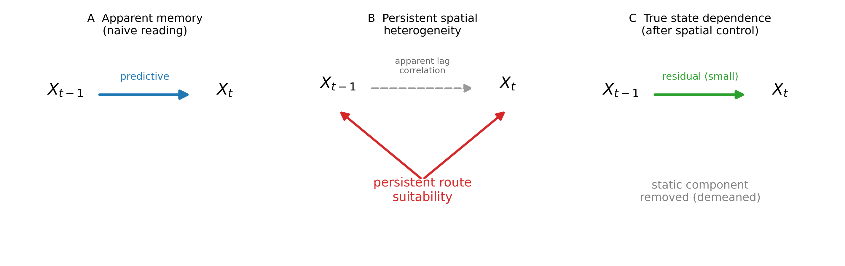
Figure 1. Conceptual decomposition of lagged-state predictability. (A) Naive reading: X(t−1) predicts X_t. (B) Persistent route-level suitability generates both, producing apparent lag correlation without path dependence. (C) True state dependence remains only after the static component is removed.

Static spatial persistence explains most of it
Route demeaning collapsed the apparent signal (Figure 2). Under LOYO, HG fell from 0.299 to 0.024 (demeaning effect median -0.262); under forward-chaining, from 0.315 to 0.0059 (median -0.297). The cross-validation effect (C − A, median 0.009) was small, and adding future years to training did not increase HG (future-information gain median 0.013). Thus the drop is attributable to route-level static persistence, not to LOYO's use of future years (H2 supported; the decomposition follows pattern 2).
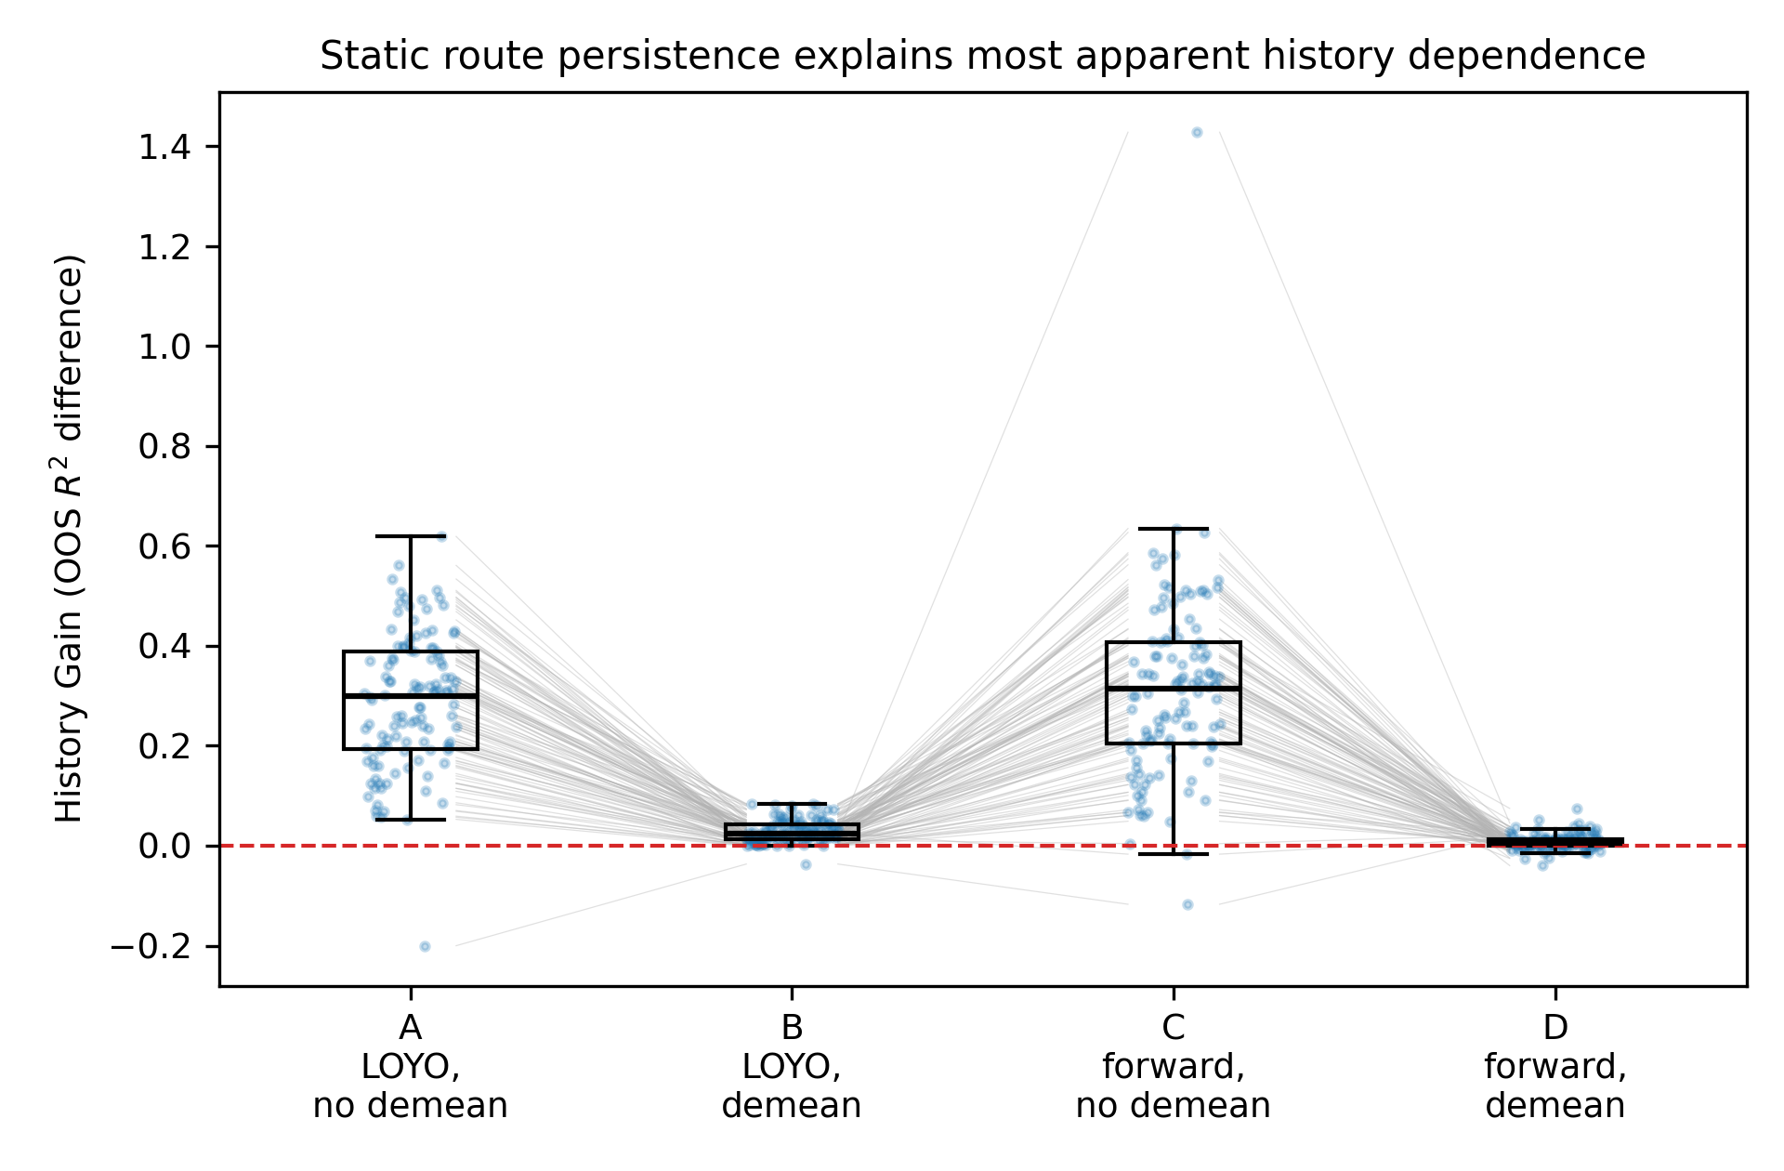
Figure 2. Species-level History Gain under the 2×2 design: leave-one-year-out vs forward-chaining × route demeaning. Grey lines connect the same species across conditions. Demeaning collapses HG in both schemes; the CV scheme contributes little.

Prospective lag-1 information is small but mostly positive
The primary prospective signal, HG_D (forward + route-demeaned), had median 0.0059 (IQR 0.0003–0.0139; Figure 3). It was positive in 77% of species, with 34% having bootstrap 95% CI > 0. H3 is therefore only weakly supported: a small prospective lag-1 component survives static spatial control, but its magnitude is roughly two orders of magnitude below the naive apparent signal.
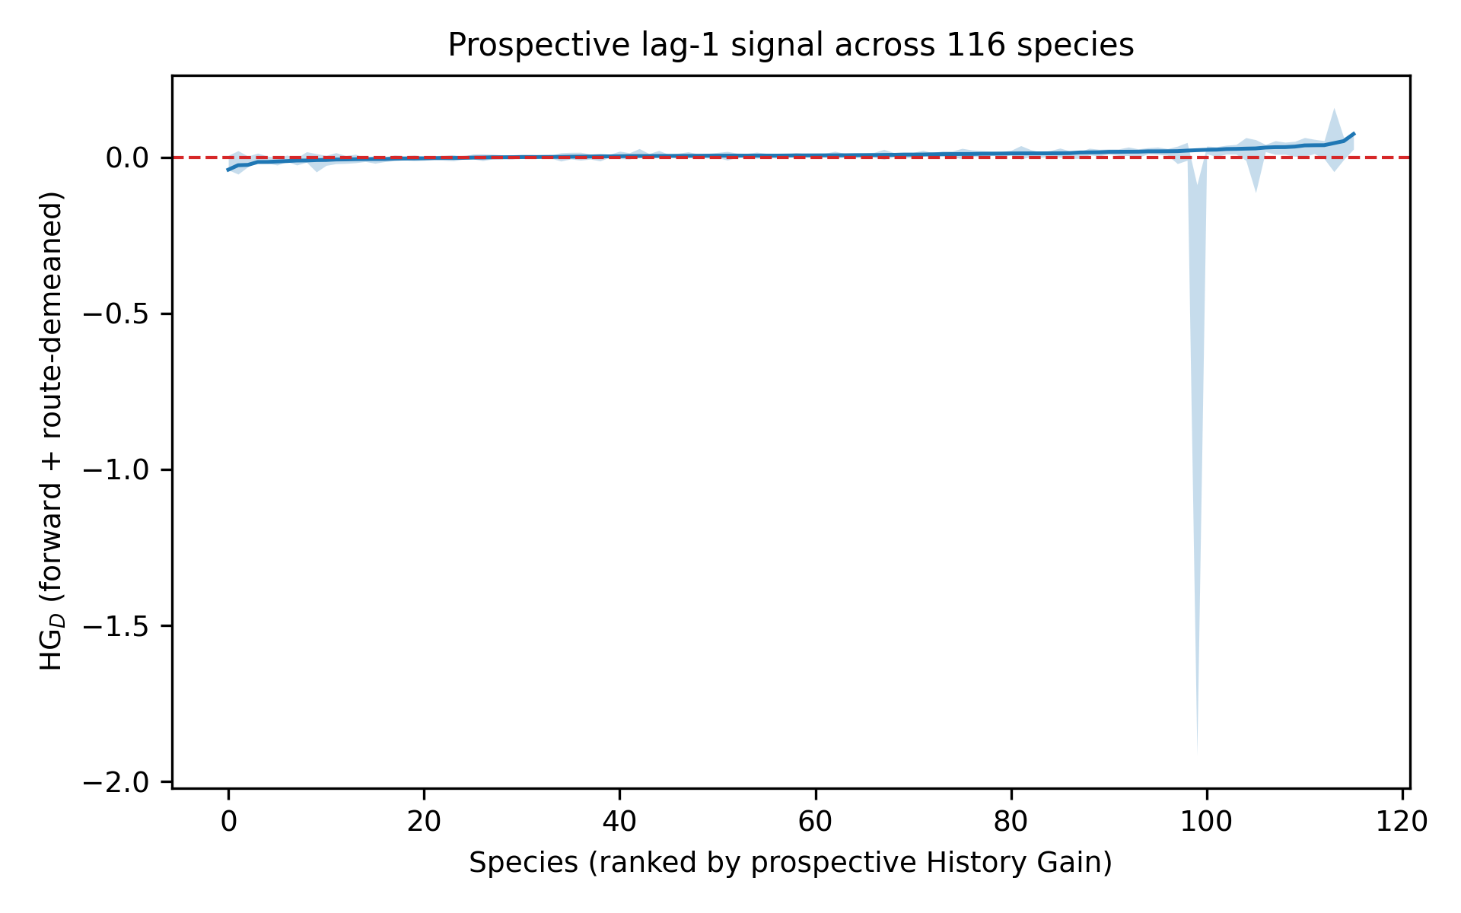
Figure 3. Prospective History Gain (HG_D) for 116 species, ranked by effect size, with 95% bootstrap CIs. The distribution is centred slightly above zero.

Lagged environment and robustness
The residual signal did not grow after controlling lagged environment (M6 − M5 median 0.0063; with lag-2 environment 0.0070) and was stable across minimum training histories (5/10/15 yr medians 5: 0.0075, 10: 0.0091, 15: 0.0123) and window choices (expanding 0.0059, rolling 10-yr nan, rolling 20-yr nan; Figure 5).

Occupancy hysteresis is unsupported
At matched modelled environment, the occupancy prior-state contrast was 0.000 for all 41 species in which it was definable (remaining 75 species were near-ubiquitous and lacked matched absences; Figure 4A). There is no evidence that prior occupancy elevates occupancy probability beyond environment and persistent route suitability.

Abundance retains strong state dependence
In the same matched-environment design, prior-year occupancy predicted current-year abundance even after route demeaning: median effect 0.63 log-count (IQR 0.39–0.80), with 40/41 definable species having cluster-bootstrap 95% CI > 0 (Figure 4B). This is demographic state dependence, not spatial memory: abundance carries continuity because N_t inherits N(t−1) through births, deaths, and dispersal.
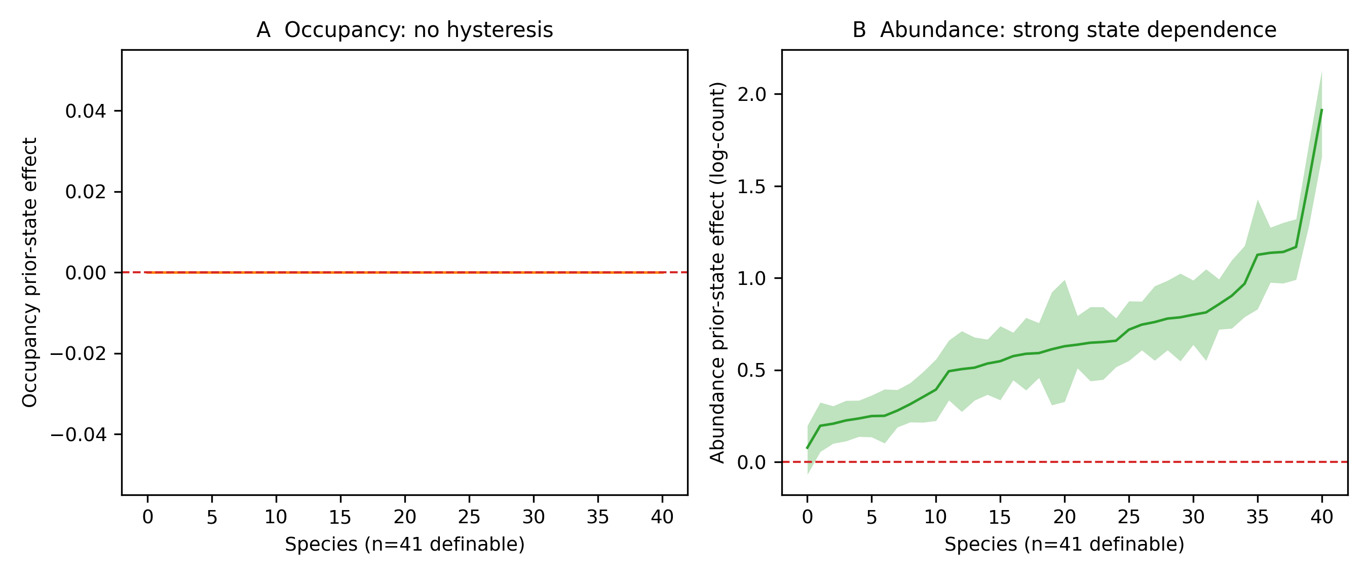
Figure 4. Occupancy vs abundance prior-state effects at matched environment (route-demeaned, cluster-bootstrap CIs). (A) Occupancy contrast is zero in every definable species. (B) Abundance contrast is positive in nearly all definable species.

Regional aggregation does not rescue spatial memory
Aggregating to state level did not recover a history signal: regional HG median = -0.043 over 111 species where defined. The earlier appearance of positive regional persistence reflected implementation issues and static route structure, not emergent regional memory.

No delayed redistribution after climate anomalies
Across 5 anomaly events, observed occupancy redistribution (sign-flip vs route baseline) median = 0.000; env-only predicted 0.308, history-aware predicted 0.264. History-aware forecasts were if anything slower than env-only ones (speed bias median 0.264 vs 0.308). Simulations on the same pipeline confirm the design detects static persistence and true-history scenarios while rejecting environment-only and observation-persistence nulls at the expected rates (Supplementary Figure S4).
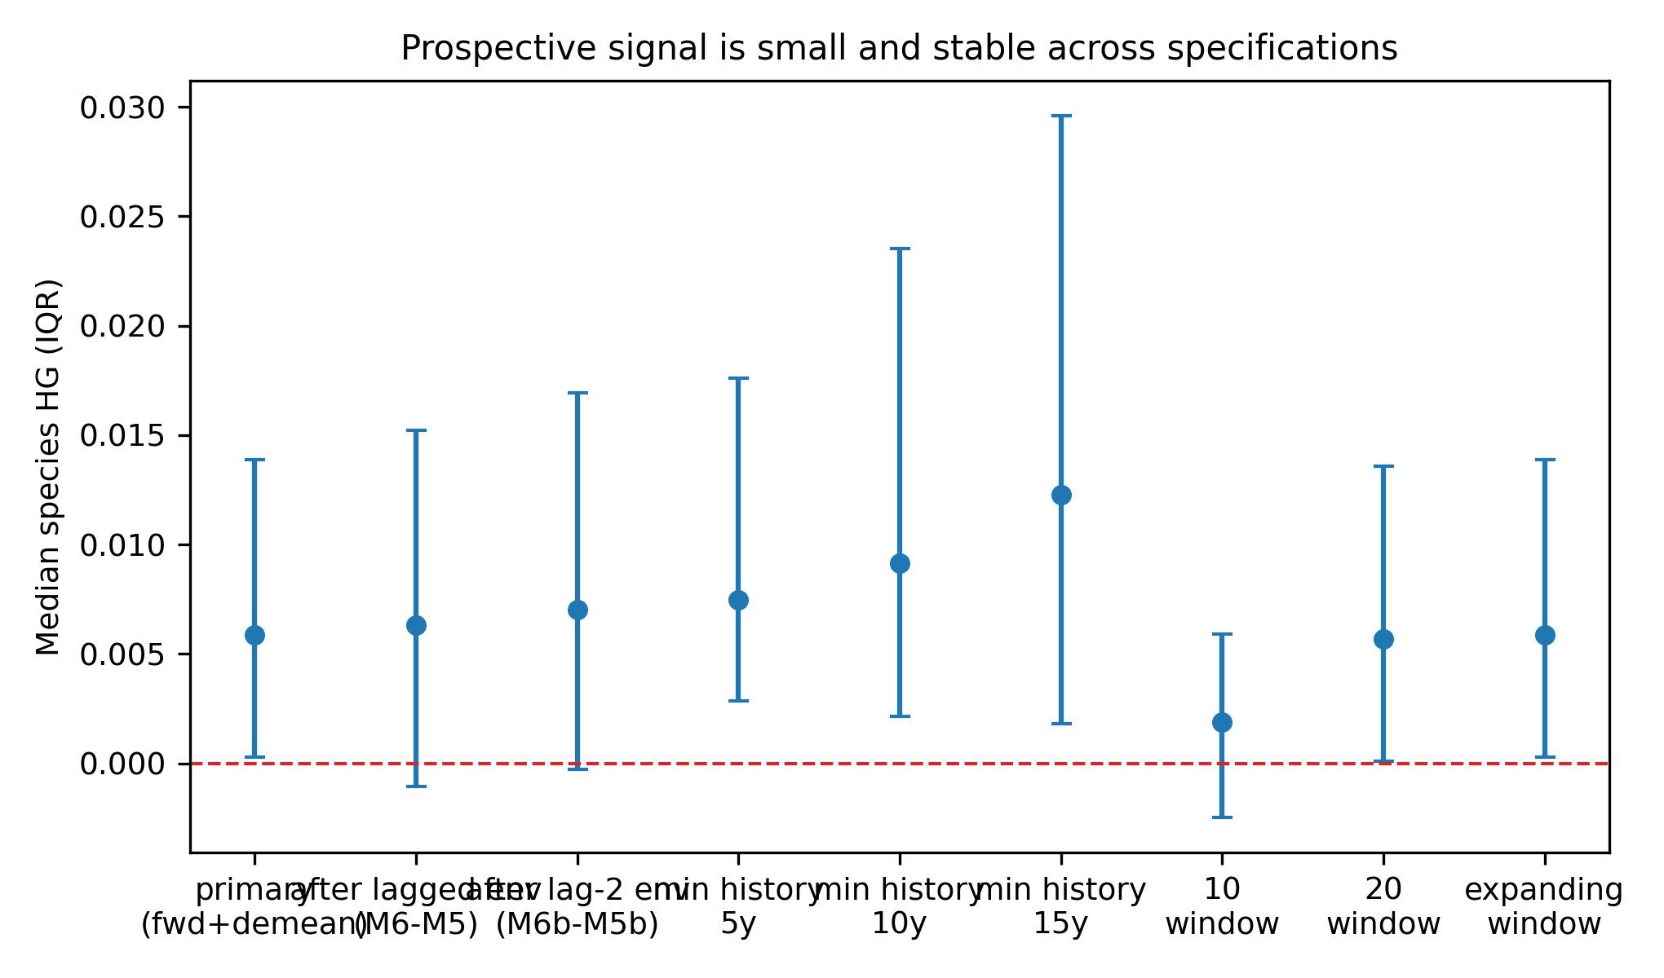
Figure 5. Specification curve for the prospective History Gain: median and IQR across lagged-environment controls, minimum training-history screens, and expanding/rolling windows.
Observer covariates did not change the picture (observer-controlled HG median 0.0088; Supplementary Figure S2).
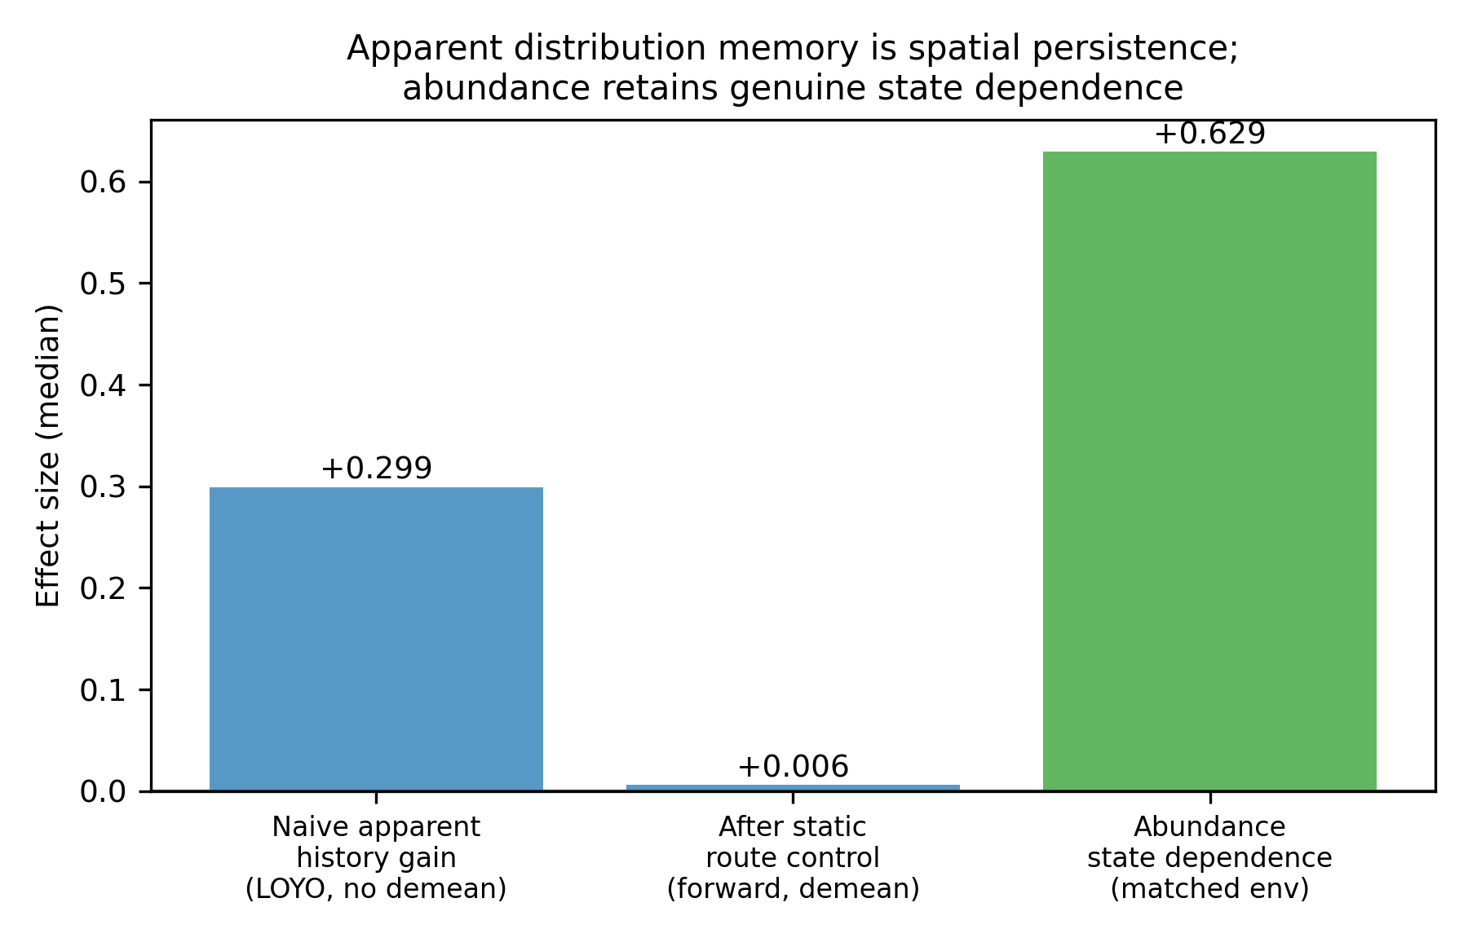
Figure 6. Decomposition summary: apparent distributional history gain is largely persistent spatial heterogeneity; the prospective residual is small; abundance retains genuine state dependence.

Table 1. Summary of key effect sizes (species-level medians, post-fix pipeline).
Quantity | Median | IQR / detail | n species
Apparent HG, LOYO no demean | 0.299 | 0.194–0.390 | 116
HG, LOYO demean | 0.024 | 0.014–0.042 | 116
HG, forward no demean | 0.315 | 0.204–0.407 | 116
Prospective HG_D, forward demean | 0.0059 | 0.0003–0.0139; P>0 0.77, CI>0 0.34 | 116
Occupancy prior-state contrast (matched env) | 0.000 | all species exactly 0.000 | 41
Abundance prior-state effect (log-count) | 0.63 | 0.39–0.80; CI>0 40/41 | 41
Regional (state-level) HG | -0.043 | — | 111
Observed anomaly redistribution | 0.000 | env-pred 0.308, hist-pred 0.264 | 5 events

Discussion
Across 116 widespread North American breeding birds, lagged spatial state appeared strongly predictive of current distribution — but most of that apparent history dependence disappeared once persistent route-level structure was removed. Route demeaning reduced History Gain from ~0.30 to ~0.006 under forward validation, while the evaluation scheme itself contributed almost nothing. The dominant driver of lagged-state predictability in these data is static spatial persistence, not temporal memory.
This distinction matters wherever lagged occurrence is interpreted biologically — in species distribution models, range-shift forecasts, occupancy dynamics, and climate-impact assessments. A previous-year occurrence term can proxy stable site quality; reading its predictive gain as memory or delayed climate tracking risks systematic misattribution. Our result quantifies that risk at continental scale and across many species: the inflation is large (two orders of magnitude) and robust to lagged-environment controls.
The clearest biological contrast is between occupancy and abundance. At matched environment, prior occupancy did not elevate occupancy probability in any definable species, yet prior occupancy predicted substantially higher abundance in nearly all of them. This is not a contradiction: occupancy on a repeatedly surveyed route is largely a static property of site suitability, whereas abundance obeys demographic continuity — N_t is literally built from N(t−1) through recruitment, mortality, and local dispersal. Abundance state dependence therefore survives spatial control even though spatial 'memory' of occupancy does not. Distribution persistence and population state dependence are different phenomena, and conflating them — as lagged-state predictors invite — conflates geography with demography.
For ecological forecasting, the practical implication is that lagged-state predictors can improve retrospective fit yet should not be interpreted as memory, hysteresis, or delayed climate tracking until persistent spatial heterogeneity is explicitly separated. Where forecast skill is the goal, a lagged-state term still helps slightly in prospective mode (median HG_D ≈ 0.006, positive in most species), but the honest interpretation of that residual is small: lag-1 state carries a little information beyond environment and site identity, and some of it may still be slowly varying unmeasured habitat rather than true path dependence.
The negative results are equally informative. We found no occupancy hysteresis at matched environment, no recovery of a history signal under regional aggregation, and no delayed redistribution following climate anomalies — history-aware forecasts were, if anything, slower than environment-only forecasts. These falsifications sharpen the interpretation: if genuine spatial memory were a dominant force in annual-scale avian distribution dynamics, at least one of these independent tests should have retained it.
Limitations are real. Resolution is annual; memory operating at finer scales (within-season decisions, dispersal timing) is invisible here. Data are route-level survey counts, not individual tracks, so site fidelity cannot be separated from site suitability. Environmental covariates are incomplete — 'matched environment' means matched on the modelled set — and BBS counts carry observation-process noise (imperfect detection, observer turnover), although observer-covariate controls did not alter conclusions. Our inclusion rule selects widespread species, so conclusions cover the common bird community, not rare or range-edge species where history may matter most. Finally, simulations show the demeaned forward-chaining design has limited power: some true lag-1 history is absorbed by demeaning, so the small HG_D is a lower bound rather than a clean estimate.
Future work should combine repeated population surveys with individual telemetry and finer temporal resolution to separate spatial memory, demographic inertia, and habitat persistence along independent axes. The design used here — crossing retrospective and prospective validation with explicit static spatial control — is taxon- and system-general and can be applied wherever lagged-state predictors are proposed as evidence of memory.
In summary, apparent history dependence in continental bird distributions is largely persistent spatial heterogeneity in disguise. What survives spatial control is a small prospective lag-1 component and a robust abundance-level state dependence — population dynamics, not spatial memory.

Acknowledgments
BBS data are provided by the U.S. Geological Survey and Environment and Climate Change Canada; we thank the thousands of volunteer observers.

Data availability
BBS data: USGS ScienceBase / Pardieck et al. (2020). All analysis code and result tables are provided in the accompanying repository (phase9/ pipeline; regenerated end-to-end from raw data).

Author contributions
[To be completed at submission.]

References
1. Elith J, Leathwick JR. Species distribution models: ecological explanation and prediction across space and time. Annu Rev Ecol Evol Syst. 2009;40:677-697.
2. Devictor V, Julliard R, Couvet D, Jiguet F. Birds are tracking climate warming, but not fast enough. Proc R Soc B. 2008;275:2743-2748.
3. MacKenzie DI, Nichols JD, Hines JE, Knutson MG, Franklin AB. Estimating site occupancy, colonization, and local extinction when a species is detected imperfectly. Ecology. 2003;84:2200-2207.
4. Clement MJ, Hines JE, Nichols JD, Pardieck KL, Ziolkowski DJ. Estimating indices of range shifts in birds using dynamic models when detection is imperfect. Glob Change Biol. 2016;22:3273-3285.
5. Dormann CF. Assessing the validity of autologistic regression. Ecol Modell. 2007;207:234-242.
6. Dormann CF, McPherson JM, Araújo MB, et al. Methods to account for spatial autocorrelation in the analysis of species distributional data: a review. Ecography. 2007;30:609-628.
7. Mielke K, Claassen T, Busana M, Heskes T, Huijbregts MAJ, Koffijberg K, Schipper AM. Disentangling drivers of spatial autocorrelation in species distribution models. Ecography. 2020;43:1741-1751.
8. Roberts DR, Bahn V, Ciuti S, et al. Cross-validation strategies for data with temporal, spatial, hierarchical, or phylogenetic structure. Ecography. 2017;40:913-929.
9. Pardieck KL, Ziolkowski DJ Jr, Lutmerding M, Aponte VI, Hudson M-AR. North American Breeding Bird Survey Dataset 1966-2019. Reston (VA): U.S. Geological Survey data release; 2020.
10. Sauer JR, Link WA. Analysis of the North American Breeding Bird Survey using hierarchical models. Auk. 2011;128:87-98.

Supplementary material index
S1 species inclusion flow; S2 observer sensitivity; S3 redistribution metric validation (toy cases); S4 simulation null distributions; S5 regional aggregation detail; S6 training-window sensitivity; S7 bug-fix audit; S8 full 116-species results table. Supplementary tables are generated from phase9/results/tables/.

