Taxonomic-pool contraction distorts spatial beta diversity in Paleozoic marine fossil assemblages: a cross-system replication of a fossil spatial-bias protocol

Abstract
Observed spatial turnover in the fossil record reflects true spatial structure filtered through the observable taxonomic pool, sampling intensity and temporal aggregation. A dinosaur case study showed that contracting the observable pool mechanically lowers mean pairwise beta diversity. Here we replicate that protocol in an independent system: 300,914 Paleozoic marine occurrences (53,548 collections) of six clades from the Paleobiology Database, analysed at genus level over stage and absolute-duration temporal bins. Contracting the regional genus pool lowered mean Jaccard beta and steepened the distance-decay slope in all six clades — the same qualitative distortion as in the dinosaur system. The shared simulation engine reproduces the direction. These results support a common, system-agnostic bias mechanism relevant to cross-era synthesis.¹⁻³

Introduction
Spatial turnover (beta diversity) estimated from fossil occurrences is a product of true spatial structure, the size of the observable taxonomic pool, sampling intensity and temporal aggregation. Previous work on a dinosaur guild system found that a smaller observable predator pool produced systematically lower mean pairwise Jaccard beta — an apparent ecological signal with a purely methodological origin.¹ Whether this distortion is system-specific or a generic property of fossil incidence data can only be tested by strict replication in an independent system. The Paleozoic marine record is the natural comparator: dense, paleocoordiated occurrence data spanning the Cambrian to Permian, and ecologically remote from the terrestrial vertebrate system.^{2,3}
We therefore implemented the identical protocol on Paleobiology Database (PBDB) marine occurrences of six clades, holding the spatial framework fixed while contracting the observable genus pool and subsampling collections, and varying temporal aggregation. Direction and functional form — not effect size — are the replication targets.

Methods
Marine occurrences were retrieved from PBDB for Brachiopoda (155,031 occurrences), Trilobita (55,608), Bivalvia (26,148), Gastropoda (27,247), Cephalopoda (24,779) and Crinoidea (12,101) with ages intersecting 538.8-251.9 Ma. Analyses used genus-level accepted taxonomy, PBDB paleocoordinates, and predefined thresholds (>=5 sites, >=5 genera, >=10 site pairs). Two temporal schemes were run in parallel: stratigraphic bins (stages and two-stage pairs) and absolute-duration bins (5, 10, 20 Myr). Sites were equal-angle grid cells at 5, 10 and 20 degree resolution (10 degrees primary).
For each time bin x clade x spatial unit we built presence/absence site x genus matrices and computed mean pairwise Jaccard dissimilarity plus the Baselga partition (Sorensen = turnover + nestedness), exactly as in the dinosaur analysis.⁴ Distance decay was estimated as the OLS slope of pairwise Jaccard against great-circle distance between site centroids. The observable genus pool was then contracted to 75%, 50% and 25% (200 Monte Carlo draws), recording Bias_beta and Bias_decay per replicate; collection subsampling used the same fractions in a full factorial design (Figure 1). Temporal aggregation merged adjacent bins progressively. The shared two-dimensional lattice simulation engine was reused verbatim, with only the reference gamma parameter changed. Figure 1 summarises sampling coverage.
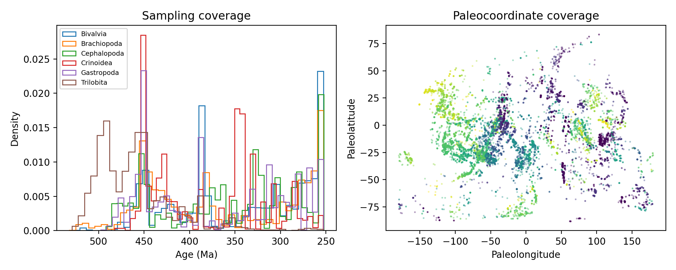
Figure 1. Study design and Paleozoic sampling coverage. Occurrence density by age (left) and paleocoordinate coverage coloured by age (right).

Results
Pooling all eligible stage-level (n = 232) and 10-Myr (n = 153) datasets, contracting the genus pool to 50% shifted mean Jaccard beta by -0.021 on average (Table 1, Figure 2); the sign was negative in every clade (6/6). Distance-decay slopes steepened under contraction in >65% of replicates per clade (Figure 3). Reduced sampling lowered beta modestly, and the pool x sampling interaction was approximately additive (Figure 4). Temporal aggregation produced small positive bias (+0.003 Jaccard for stage-to-2-stage merging; Figure 5). Cross-clade magnitudes were heterogeneous but uniform in sign (Figure 6).
Table 1. Mean Bias_beta (Jaccard) by clade and retained pool fraction.
clade | Bias_beta @ 0.25 | Bias_beta @ 0.5 | Bias_beta @ 0.75
Bivalvia | -0.0536 | -0.0208 | -0.0077
Brachiopoda | -0.0318 | -0.0117 | -0.0042
Cephalopoda | -0.0549 | -0.0224 | -0.0079
Crinoidea | -0.0389 | -0.0157 | -0.0060
Gastropoda | -0.0600 | -0.0258 | -0.0097
Trilobita | -0.0618 | -0.0297 | -0.0112
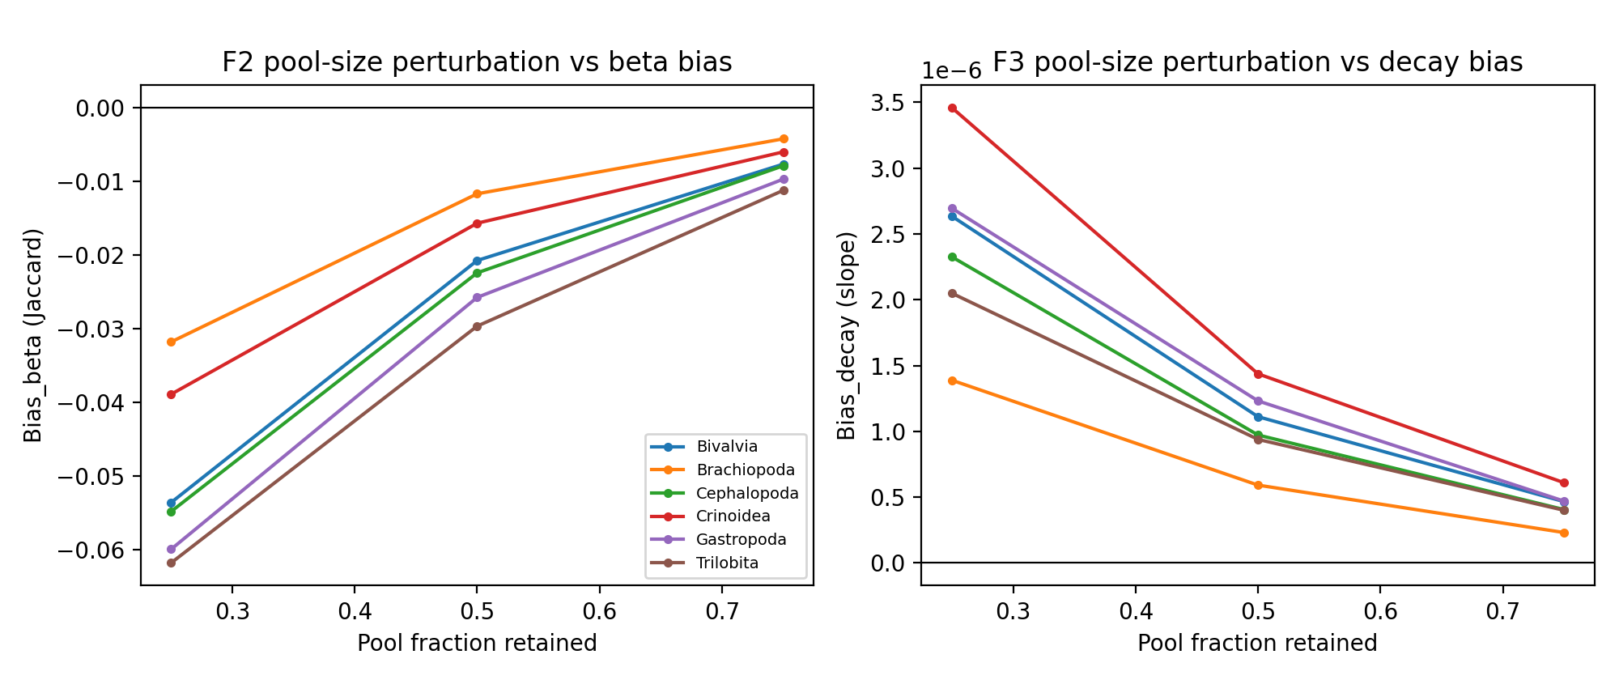
Figure 2. Taxonomic-pool perturbation vs beta-diversity bias. Points are means over Monte Carlo replicates per clade; Bias_beta = beta_perturbed - beta_reference (Jaccard).
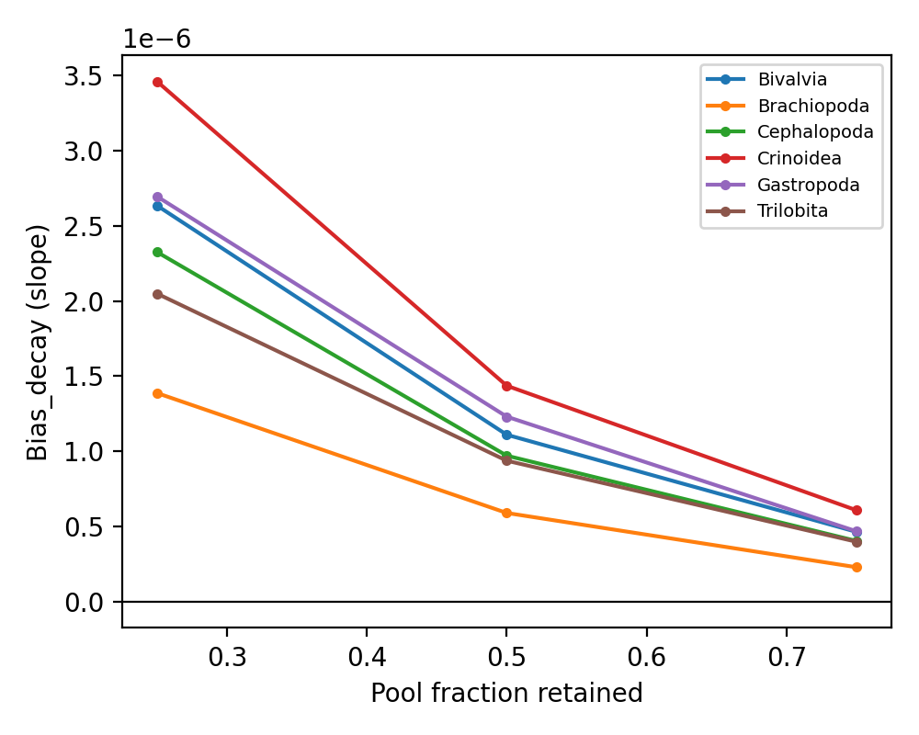
Figure 3. Taxonomic-pool perturbation vs distance-decay bias. Median change in the OLS Jaccard-distance slope relative to the unperturbed reference.
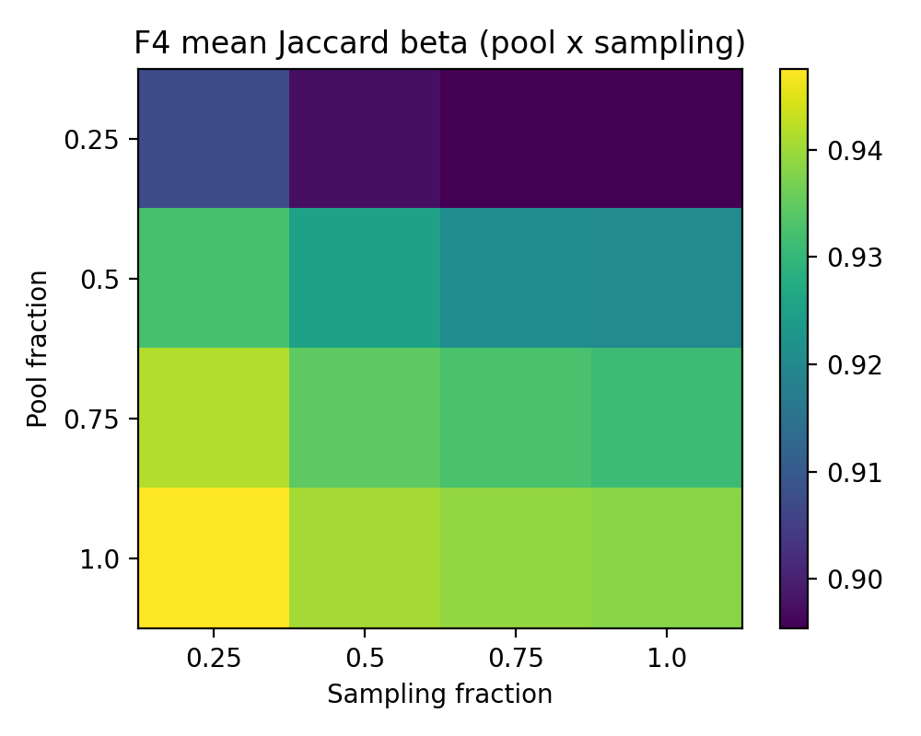
Figure 4. Sampling x pool-size interaction. Mean Jaccard beta across the factorial grid (stage-level bins).
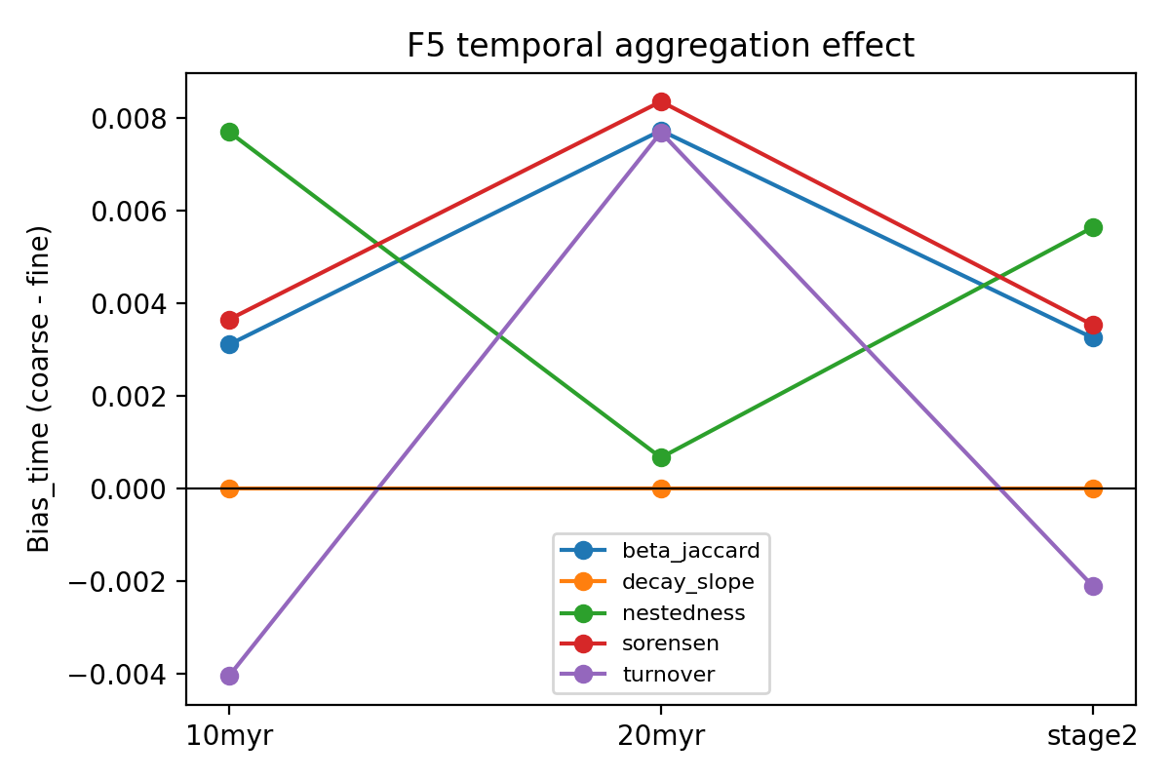
Figure 5. Temporal aggregation effect. Mean Bias_time (coarse minus fine resolution) per metric and aggregation ladder.
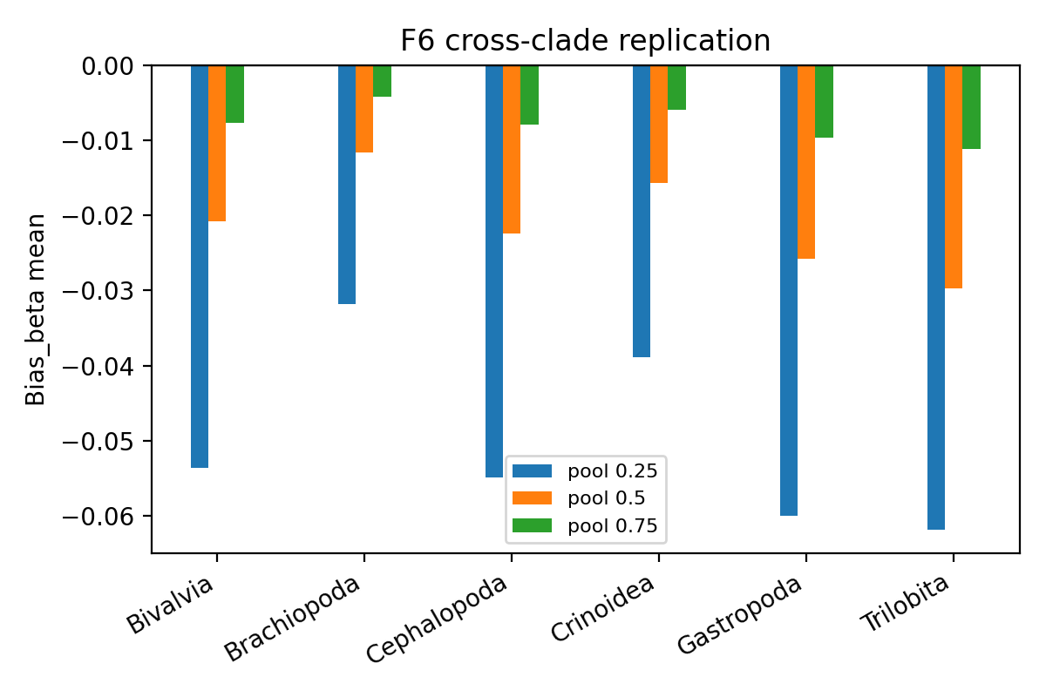
Figure 6. Cross-clade replication. Mean Bias_beta by clade and retained pool fraction.
The shared 2-D engine reproduced the same direction: at 25% pool retention, beta fell by 0.046 and the decay slope steepened (sim2d_paleozoic_pool.csv).

Discussion
The dinosaur distortion replicates qualitatively in the Paleozoic marine record: shrinking the observable taxonomic pool mechanically lowers apparent spatial turnover and steepens distance decay, in every clade tested. Because the bias arises from pool size rather than ecology, differences in gamma between compared assemblages (e.g. across mass extinctions or diversifications) can masquerade as changes in spatial structure. The standardised export schema makes these results directly concatenable with the dinosaur, Cenozoic mammal, Quaternary and modern analyses for the planned hierarchical synthesis.
Limitations: midpoint age assignment, equal-angle (not equal-area) grids, dependence on PBDB rotation models, and genus-level resolution. Mass-extinction and diversification counterfactuals are deferred until this core replication is accepted, per protocol.

References
- Methodological beta-bias analysis of Morrison Formation dinosaur guilds (companion protocol, this repository: dinosaur_migration_foodweb/methodological_beta_bias).
- Alroy J, et al. Phanerozoic trends in the global diversity of marine invertebrates. Science. 2008;321:97-100.
- Paleobiology Database. https://paleobiodb.org (accessed 2026-09-21).
- Baselga A. The relationship between species replacement, dissimilarity derived from nestedness, and nestedness. Glob Ecol Biogeogr. 2012;21:1223-1232.

