Supplementary Material
AI researchers as the next coal: transition rates, minimum viable research communities and the preservation of variety in global AI/ML
This supplement provides the country mapping, the exploratory annual estimation layer, robustness checks on the PI proxy and on the minimum viable scale, and detailed tables that support the main manuscript. Values are reproduced from the same result CSVs used to generate the main tables and figures; no numbers are hard-coded.

S1. Country-to-macro-region mapping
Supplementary Table S1 lists every country with at least one AI/ML work in 2022-2023 under its macro-region. The partition starts from Huntington's taxonomy and is adjusted for AI/ML sample size (Latin American, Orthodox and sub-Saharan African countries merged into Other regions; the United States separated from the rest of the Anglosphere). The labels are operational aggregations of publication-affiliation patterns and carry no claim about cultural identity. The complete machine-readable mapping, including countries with zero works, is data/country_civilization_mapping.json in the public repository.
Macro-region | Countries | Works
Anglosphere ex-US | United Kingdom of Great Britain and Northern Ireland, Canada, Australia, Ireland, New Zealand | 66221
China-centred | China, Korea, Republic of, Hong Kong, Singapore, Taiwan, Province of China, Viet Nam, Macao | 175918
Continental Europe | Germany, France, Italy, Spain, Netherlands, Kingdom of the, Switzerland, Poland, Sweden, Austria, Belgium, Portugal, Denmark, Greece, Norway, Czechia, Finland, Romania, Hungary, Bulgaria, Slovenia, Slovakia, Croatia, Cyprus, Luxembourg, Estonia, Lithuania, Latvia, Iceland, Malta | 156002
Islamic world | Indonesia, Saudi Arabia, $T$ürkiye, Malaysia, Iran, Islamic Republic of, Pakistan, Egypt, Iraq, United Arab Emirates, Bangladesh, Jordan, Morocco, Algeria, Tunisia, Qatar, Lebanon, Kazakhstan, Oman, Uzbekistan, Yemen, Kuwait, Bahrain, Azerbaijan, Palestine, State of, Sudan, Brunei Darussalam, Libya | 114388
Japan | Japan | 16929
Other Western (Israel) | Israel | 3847
Other regions | Russian Federation, Brazil, Mexico, Nigeria, South Africa, Ukraine, Thailand, Chile, Philippines, Colombia, Argentina, Serbia, Ethiopia, Ghana, Peru, Ecuador, Kenya, Cameroon, Belarus, Tanzania, United Republic of, Mongolia, Bosnia and Herzegovina, North Macedonia, Armenia, Uganda, Uruguay | 46466
South Asia | India, Nepal, Sri Lanka | 53745
United States | United States of America | 100154
Supplementary Table S1. Country membership of the research macro-regions (countries with at least one AI/ML work in 2022-2023).

S2. Annual estimation and projection layer (exploratory extension)
This section is an exploratory extension of the steady-state analysis: it asks whether the fitted rates can be updated year by year, not whether the projection forecasts stocks. The annual layer re-estimates each transition rate for every calendar year 2000-2016 from the reconstructed compartment state of the cohort. Rates are estimated as transitions divided by exposure with a Laplace pseudocount and projected with a linear trend fitted to the 2000-2016 series, regularised in two ways: (i) projected rates are clipped to the [0, 1] interval (inflows are projected on a log1p scale and clipped to be non-negative), and (ii) where fewer than four annual observations are available or the linear fit explains less than 10% of the variance (R² < 0.10), the macro-region's own 2000-2016 mean is carried forward instead of the trend; and (iii) projected dropout is capped at 1.5 times its 90th percentile over the training period. No PI-reproduction stability cap is imposed in the annual layer; that cap applies only to the steady-state model. Projected rates for 2017-2026 are applied to the 2016 compartment state with a one-year time step, and the projected 2017-2023 compartment counts are compared with the observed reconstruction. Accuracy is reported as RMSE, MAPE, direction agreement (whether the projected and observed year-to-year change have the same sign) and threshold-alarm metrics (whether the projection correctly flags years in which the observed active pool $T = D + H_{D} + P_{D}$ falls below $M$, its group-specific minimum viable coauthor scale; Supplementary Table S2 reports the number of observed and projected alarm years alongside accuracy, sensitivity, specificity and precision). Stock-level errors are larger than rate-level errors because the cohort is fixed at 2016 and cannot contain the new entrants that the projection adds; the layer is therefore a drift-and-threshold alarm, not a population forecast.
Supplementary Figure S1 plots observed 2000-2016 and projected 2017-2026 transition rates by macro-region, Supplementary Figure S2 the accumulated cross-region abroad author-years by origin and destination (a lower-bound proxy for inter-regional pipelines, used as the host distribution of the talent-concentration scenario in the main text), and Supplementary Figure S3 compares the 2017-2023 projection with observed compartment counts. Rate-level projections have RMSE 0.0892 and a skill ratio (baseline RMSE / model RMSE) of 0.99 against a historical-mean baseline, so they do not improve on simply carrying the historical mean forward; stock-level errors are larger (RMSE 10,190). Year-to-year direction agreement is 21.6%. The observed compartment series of the closed cohort falls below $M$ in 5 macro-region-years (Other Western (Israel); Supplementary Table S2), whereas the projection flags 0. These observed alarms are an artefact of cohort closure, not evidence that the system is below its threshold: the observed series excludes everyone who entered after 2016, so it declines by construction, while the equilibrium $T$ of the main text includes continuing entry. The alarm metrics are reported for completeness only.
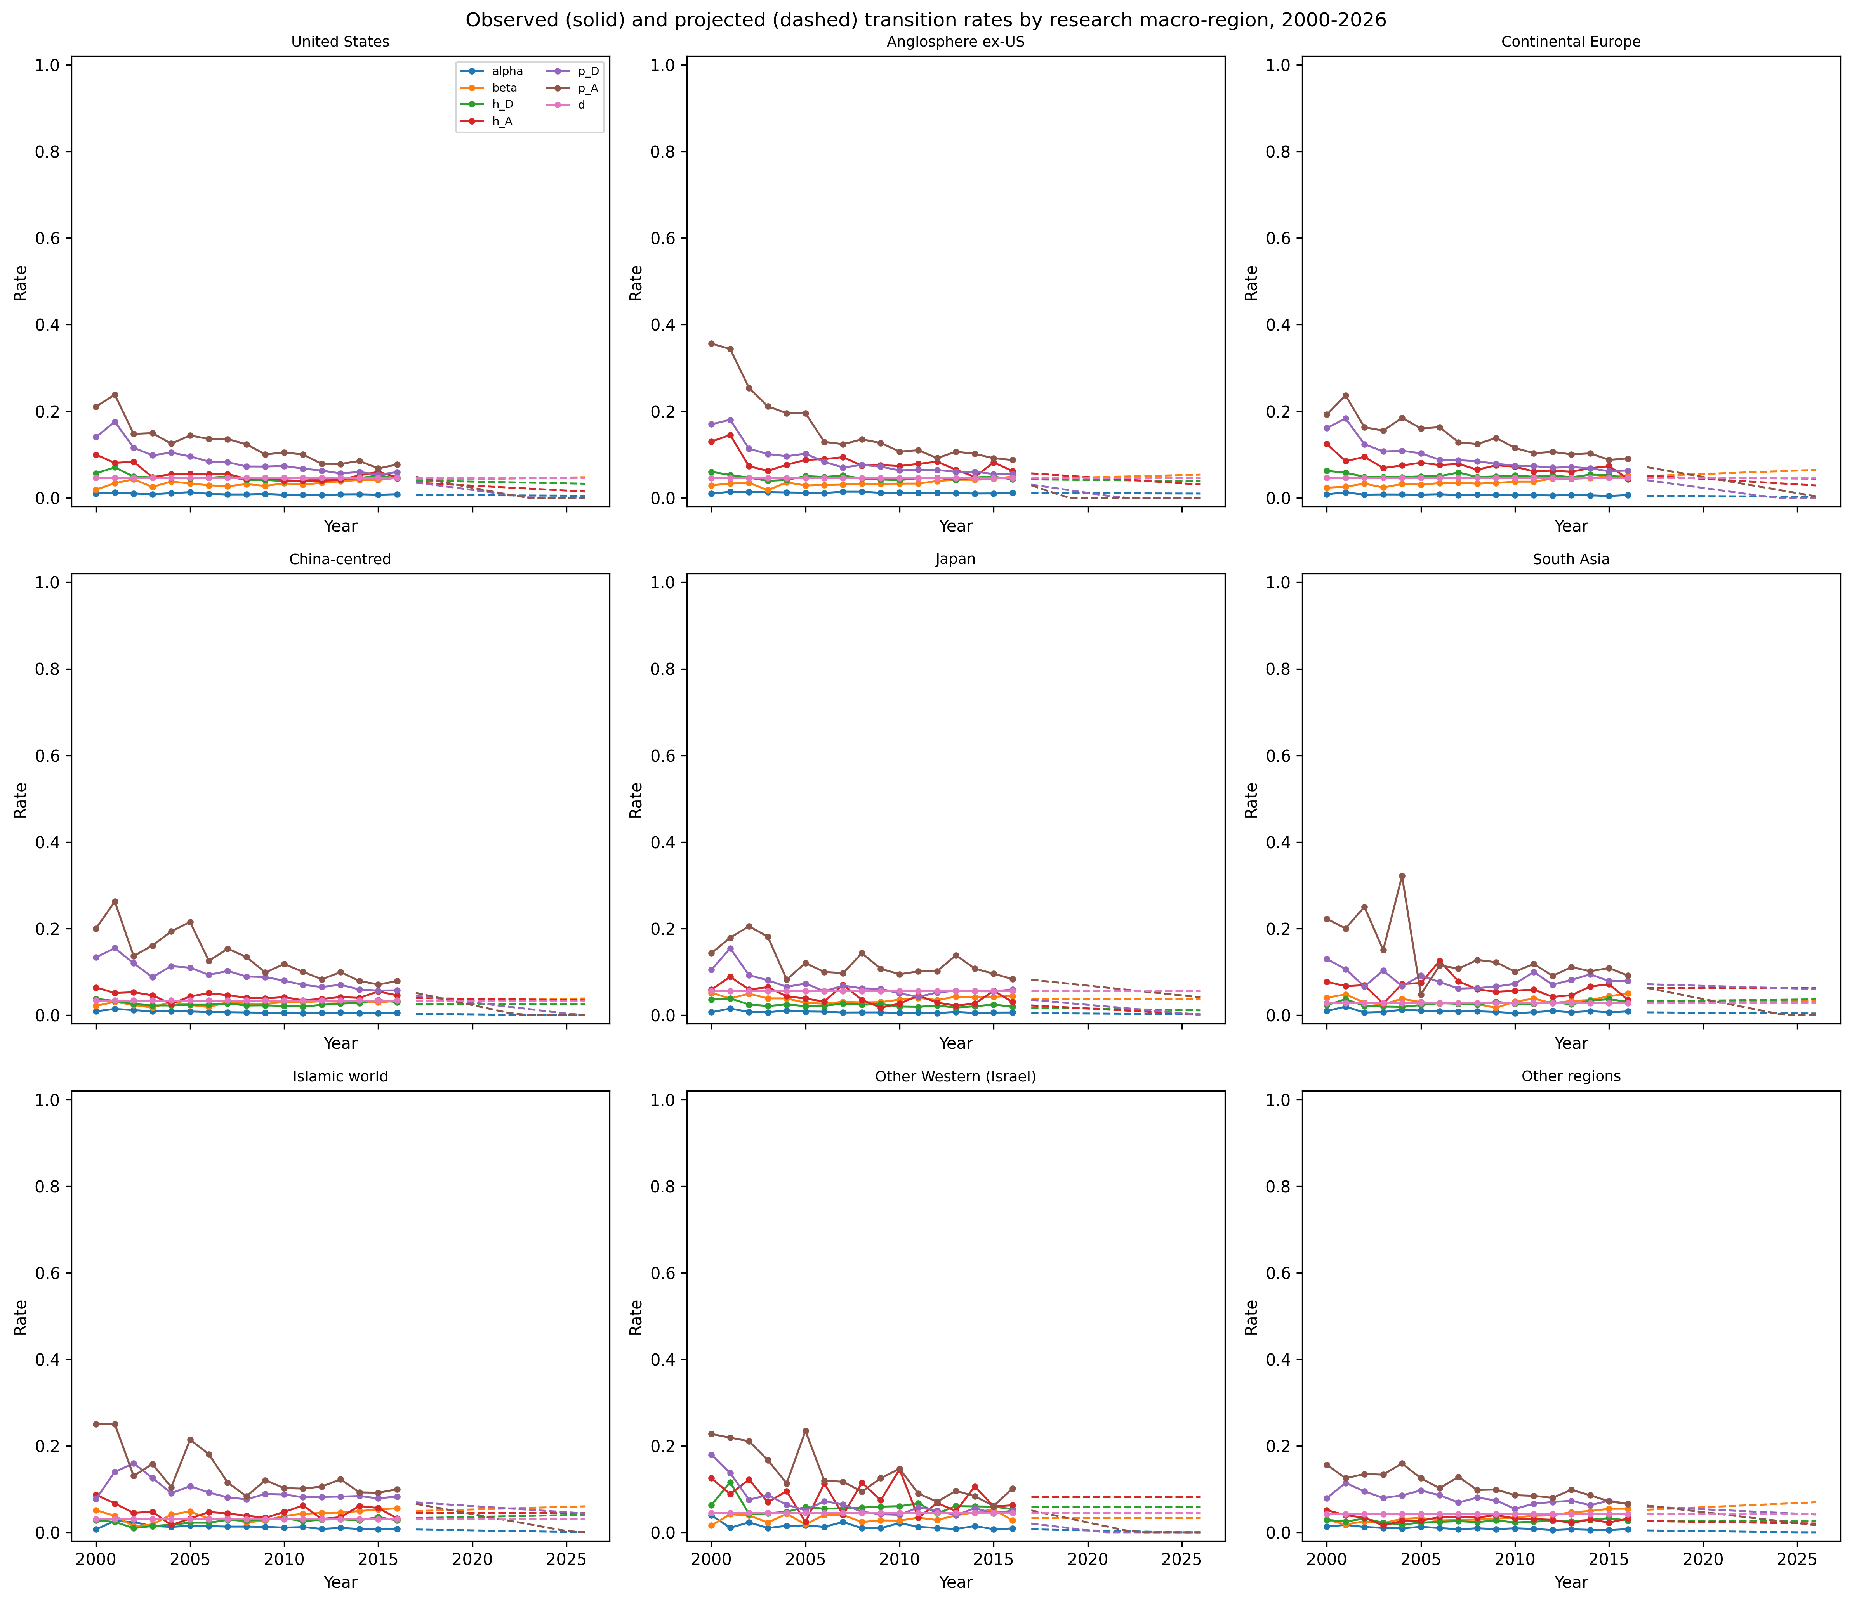
Supplementary Figure S1. Observed (solid) and projected (dashed) transition rates by research macro-region, 2000-2026.
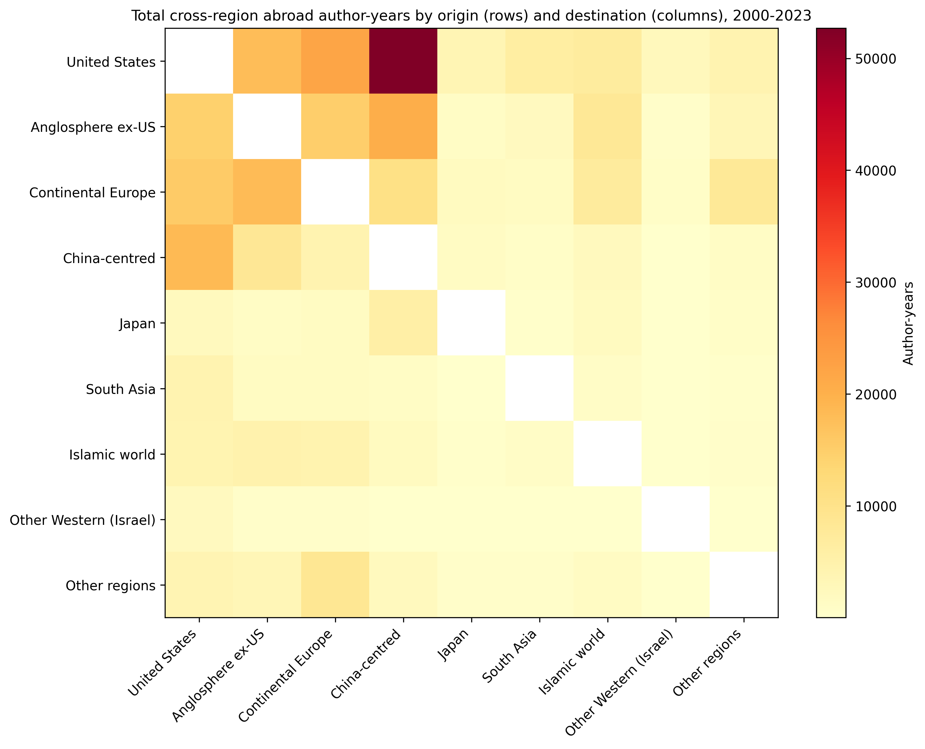
Supplementary Figure S2. Cross-region abroad author-year accumulation by origin (rows) and destination (columns); same-region cells and Unknown destinations excluded (lower-bound proxy).
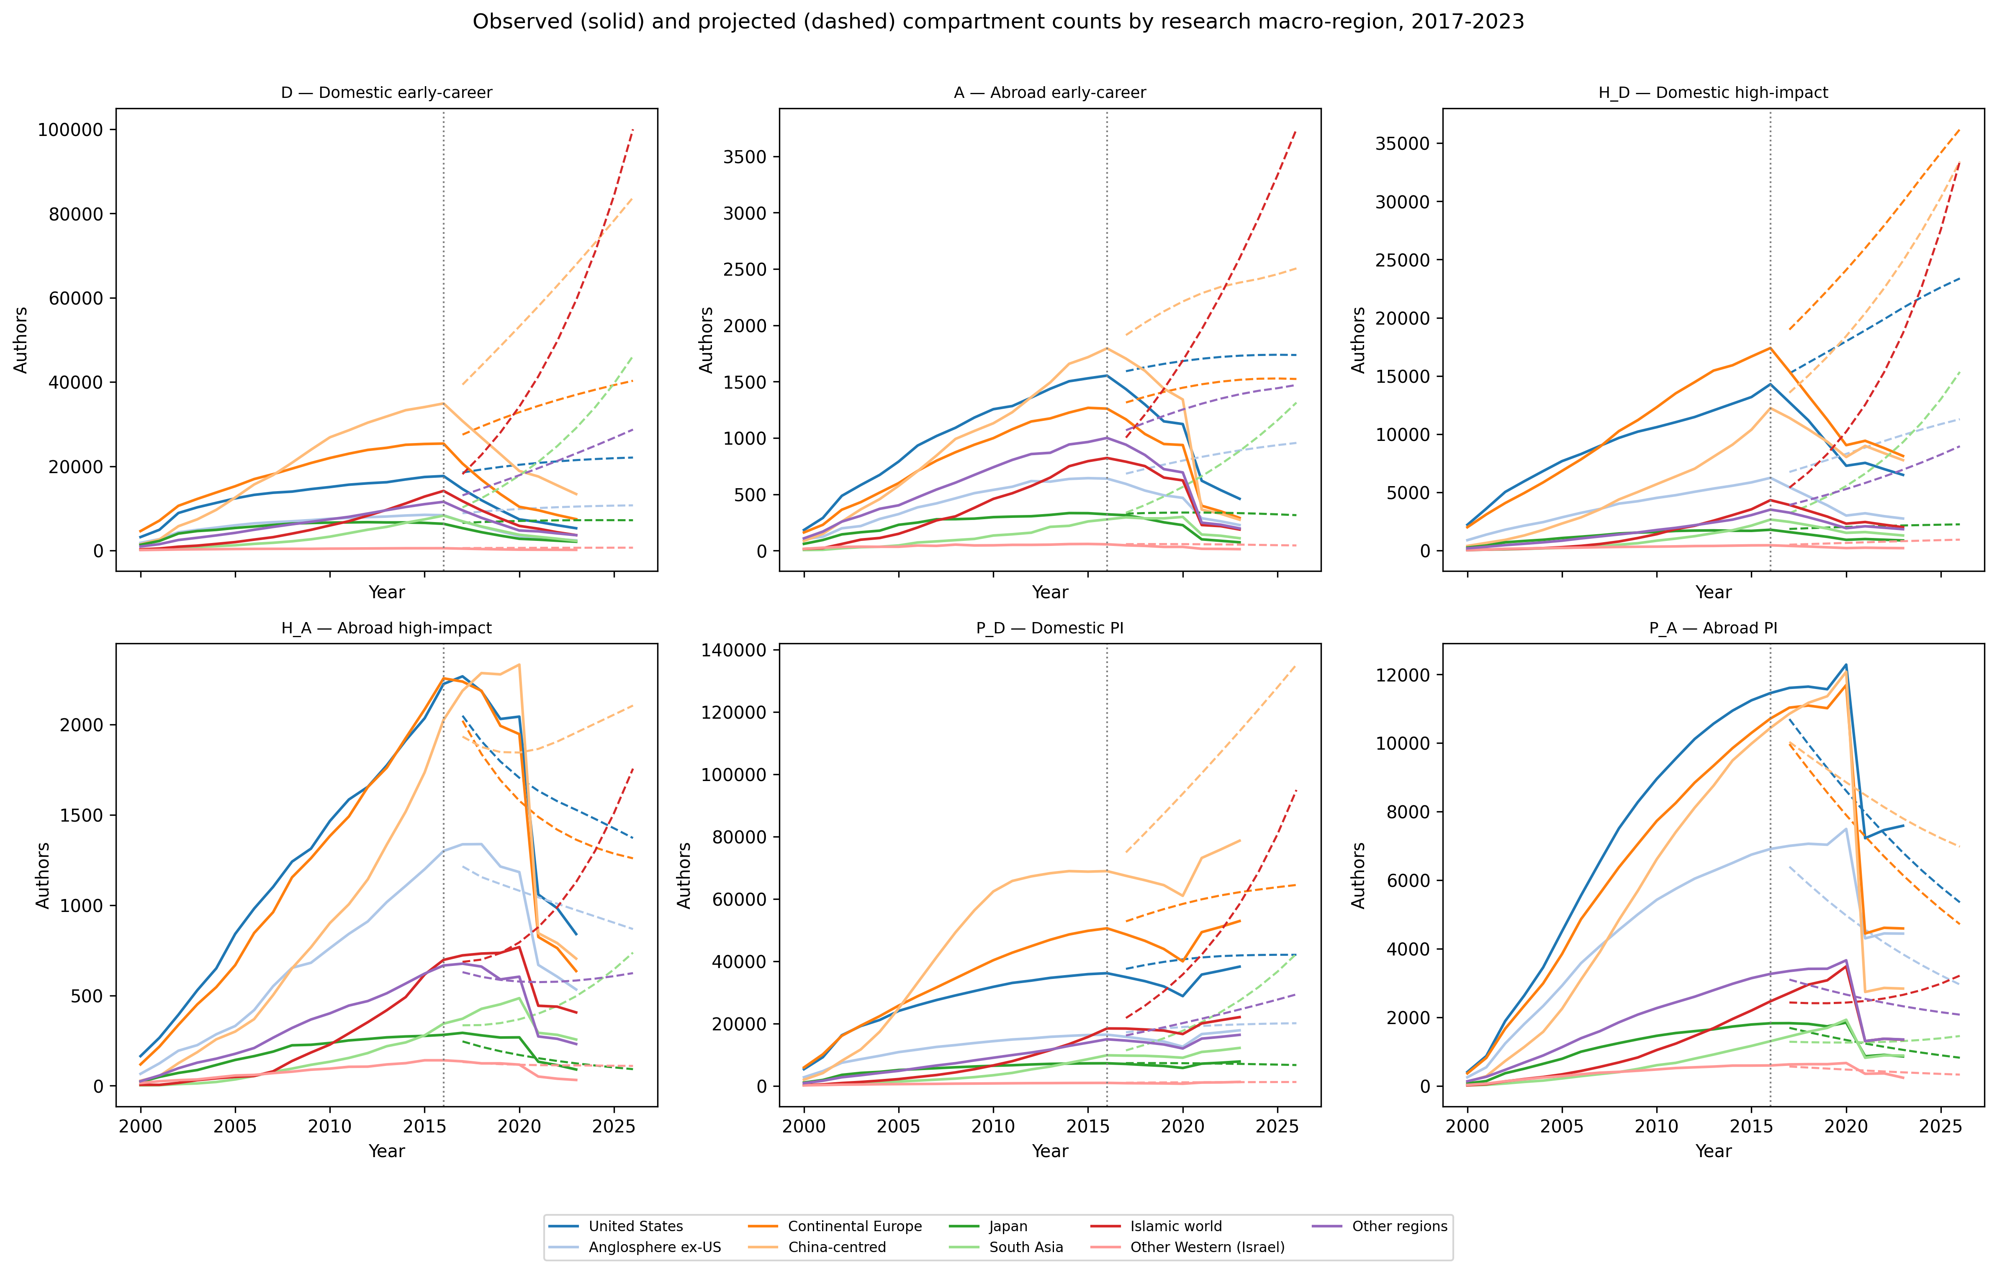
Supplementary Figure S3. Observed (solid) and projected (dashed) compartment counts by research macro-region, 2017-2023. The dotted line marks the end of the training period (2016).

Supplementary Table S2. Projection accuracy by research macro-region, 2017-2023
Group | RMSE | MAPE | Direction agreement | Alarm Accuracy | Alarm Sensitivity | Alarm Specificity | Alarm Precision | Alarm years (observed) | Alarm years (projected)
Anglosphere ex-US | 3544.26 | 86.2% | 19.4% | 100.0% | — | 100.0% | — | 0.00 | 0.00
Continental Europe | 11674.84 | 103.1% | 19.4% | 100.0% | — | 100.0% | — | 0.00 | 0.00
South Asia | 7915.72 | 188.4% | 16.7% | 100.0% | — | 100.0% | — | 0.00 | 0.00
Islamic world | 16757.46 | 273.0% | 22.2% | 100.0% | — | 100.0% | — | 0.00 | 0.00
Japan | 1677.63 | 69.9% | 27.8% | 100.0% | — | 100.0% | — | 0.00 | 0.00
Other regions | 6149.73 | 132.4% | 16.7% | 100.0% | — | 100.0% | — | 0.00 | 0.00
Other Western (Israel) | 256.88 | 98.7% | 27.8% | 28.6% | 0.0% | 100.0% | — | 5.00 | 0.00
China-centred | 18771.59 | 132.3% | 19.4% | 100.0% | — | 100.0% | — | 0.00 | 0.00
United States | 7013.54 | 77.4% | 25.0% | 100.0% | — | 100.0% | — | 0.00 | 0.00
Supplementary Table S2. Projection accuracy by research macro-region, 2017-2023.

Supplementary Table S3. Projection accuracy by compartment, 2017-2023
Compartment | RMSE | MAPE | Direction agreement
A | 849.47 | 215.1% | 7.4%
$D$ | 19801.25 | 263.3% | 1.9%
$H_{A}$ | 394.83 | 50.1% | 38.9%
$H_{D}$ | 8094.10 | 171.6% | 9.3%
$P_{A}$ | 1744.50 | 36.4% | 25.9%
$P_{D}$ | 12709.83 | 37.7% | 46.3%
Supplementary Table S3. Projection accuracy by compartment, 2017-2023.

Supplementary Table S4. Mean observed annual transition rates by research macro-region, 2000-2016
Group | $α$ | $β$ | $h_{D}$ | $p_{D}$ | $d$ | $I_{total}$
Anglosphere ex-US | 0.012 | 0.034 | 0.046 | 0.087 | 0.046 | 3771.88
China-centred | 0.007 | 0.027 | 0.026 | 0.091 | 0.034 | 11179.47
Continental Europe | 0.007 | 0.036 | 0.051 | 0.094 | 0.046 | 9935.94
Islamic world | 0.013 | 0.038 | 0.025 | 0.095 | 0.030 | 3002.53
Japan | 0.007 | 0.038 | 0.024 | 0.070 | 0.055 | 1882.76
Other Western (Israel) | 0.015 | 0.033 | 0.059 | 0.068 | 0.044 | 258.65
Other regions | 0.009 | 0.035 | 0.026 | 0.078 | 0.042 | 2955.29
South Asia | 0.009 | 0.033 | 0.027 | 0.082 | 0.028 | 1651.12
United States | 0.009 | 0.033 | 0.047 | 0.086 | 0.046 | 7929.82
Supplementary Table S4. Mean observed annual transition rates by research macro-region, 2000-2016.

Supplementary Table S5. Top cross-region origin-destination abroad author-year pairs
Origin | Destination | Author-years
United States | China-centred | 52689
United States | Continental Europe | 21968
Anglosphere ex-US | China-centred | 20534
China-centred | United States | 18505
Continental Europe | Anglosphere ex-US | 18156
United States | Anglosphere ex-US | 17719
Continental Europe | United States | 15459
Anglosphere ex-US | Continental Europe | 15003
Anglosphere ex-US | United States | 14422
Continental Europe | China-centred | 10535
Supplementary Table S5. Top cross-region origin-destination abroad author-year pairs.

Supplementary Table S6. Bootstrap 95% confidence intervals for equilibrium $T$ and domestic PI pool $P_{D}$
Group | $T$ median | $T$ 95% CI | $P_{D}$ mean | $P_{D}$ 95% CI
Anglosphere ex-US | 67546 | [66728, 68334] | 29814 | [29158, 30486]
Continental Europe | 195077 | [193718, 196316] | 83476 | [82421, 84527]
South Asia | 53407 | [52402, 54515] | 30277 | [29348, 31258]
Islamic world | 88428 | [87356, 89880] | 47264 | [46155, 48511]
Japan | 29372 | [28932, 29757] | 7387 | [7128, 7662]
Other regions | 59396 | [58590, 60178] | 22326 | [21715, 22975]
Other Western (Israel) | 4829 | [4602, 5077] | 2163 | [1981, 2370]
China-centred | 303843 | [301809, 305720] | 133015 | [131418, 134567]
United States | 146991 | [145947, 148235] | 63906 | [62994, 64906]
Supplementary Table S6. Bootstrap 95% confidence intervals for equilibrium $T$ and domestic PI pool $P_{D}$.

Supplementary Table S7. Closest point of no return under linear versus saturating inflow
Group | Linear lever | Linear factor | Linear proximity | Saturating lever | Saturating factor | Saturating proximity
United States | $I_{0}$ | 0.013 | 0.988 | $I_{0}$ | 0.011 | 0.989
Anglosphere ex-US | $I_{0}$ | 0.047 | 0.953 | $I_{0}$ | 0.042 | 0.958
Continental Europe | $I_{0}$ | 0.020 | 0.980 | $I_{0}$ | 0.018 | 0.982
China-centred | $I_{0}$ | 0.010 | 0.990 | $I_{0}$ | 0.009 | 0.991
Japan | $I_{0}$ | 0.061 | 0.939 | $I_{0}$ | 0.059 | 0.942
South Asia | $I_{0}$ | 0.042 | 0.958 | $I_{0}$ | 0.034 | 0.966
Islamic world | $I_{0}$ | 0.025 | 0.975 | $I_{0}$ | 0.021 | 0.979
Other Western (Israel) | $I_{0}$ | 0.332 | 0.668 | $I_{0}$ | 0.307 | 0.693
Other regions | $I_{0}$ | 0.035 | 0.965 | $I_{0}$ | 0.031 | 0.969
Supplementary Table S7. Closest point-of-no-return lever, critical factor and proximity for the active pool under linear and saturating PI-driven inflow.

Supplementary Table S8. Talent-concentration scenario: inputs and their status
Parameter | Value | Status
phi_grid | 0.0,0.5,1.0,2.0,4.0,8.0 | stylised
gamma_grid | 0.0,1.0,2.0 | stylised
horizon_years | 100.00 | stylised
tau_years | 24.31 | fitted (1 / mean $d$)
horizon_in_tau | 4.11 | derived
pull_rule | additional outflow alpha_i phi from $D_{i}$ to separate compartments hosted by the focal region (i != focal); pre-existing abroad stock keeps observed host shares W | stylised
retention_rule | beta_i/(1+phi) for researchers pulled to the focal region | stylised
host_recruitment_rule | each host recruits $r_{j}$ x hosted abroad PIs; I0_j reduced so the fitted equilibrium is unchanged | stylised
collapse_rule | $r_{i}$ -> 0 permanently once $T_{i} < M_{i}$ (integrator terminal event at the crossing) | stylised
variety_rule | $h_{D}$, $h_{A}$ scaled by ($N_{eff}/N_{eff0}$)^gamma; gamma = 0 is the fitted model | stylised
initial_state | baseline equilibrium from results/endogenous/equilibrium_summary.csv | fitted
transition_rates | data/cohort/transition_rates.csv | fitted
recruitment_split | $I_{0}$, $r$ from results/endogenous/equilibrium_summary.csv (exogenous_share=fitted); 0.25 as sensitivity | fitted / stylised
host_shares | results/annual/annual_interciv_stock.csv, all years, off-diagonal | fitted
Supplementary Table S8. Inputs to the talent-concentration scenario (Section 4.5). 'Fitted' inputs come from the estimated model and observed mobility data; 'stylised' inputs are modelling assumptions without an empirical estimate.

S3. Robustness to the PI proxy definition
The baseline defines a PI by the first last-author paper. To test this choice, the full AI/ML author population was re-extracted from OpenAlex with the corresponding-author flag of every authorship retained, and each author was classified under three definitions on the same snapshot: (a) first last-author paper (baseline); (b) first paper on which the author is flagged as corresponding author (OpenAlex authorships.is_corresponding); (c) second last-author paper, i.e. last author on at least two papers. The re-extracted snapshot contains 719,173 authors against 723,647 in the published cohort; the difference reflects OpenAlex updates between extractions, so definitions are compared with each other on the same snapshot (Supplementary Table S10) and the baseline definition is also compared with the published results. For each definition the transition rates were re-estimated, the endogenous-inflow equilibrium, the elasticities and the closest point of no return were recomputed with the same $M$, and the nine-region rankings were compared by Spearman rank correlation. Two quantities are invariant to the proxy by construction and are reported only for completeness: because $I_{0}$ is calibrated so that total equilibrium entry equals observed entry (Section 4.2), the equilibrium active pool $T$ (hence $T/M$) and the proximity of the entry lever $I_{0}$ do not depend on how PIs are identified. The proxy does change the promotion rates $p_{D}$ and $p_{A}$, the equilibrium PI pool $P_{D}$, the exogenous/PI-driven split of entry ($I_{0}$, $r$), the elasticity of $T$ to $p_{D}$ and the point of no return of the PI pool relative to its own threshold $k$. Supplementary Table S9 reports the region-level results and Supplementary Table S10 the rank agreement on these proxy-dependent quantities.
PI proxy | Group | Share of authors who are PIs | $p_{D}$ | $T/M$ | Closest lever ($T$) | Proximity ($T$) | $P_{D}$ | Closest lever ($P_{D}$) | Proximity ($P_{D}$) | Elasticity of $T$ to $p_{D}$
First last-author paper (baseline) | Anglosphere ex-US | 0.667 | 0.073 | 21.57 | exogenous entry rate ($I_{0}$) | 0.954 | 30773 | exogenous entry rate ($I_{0}$) | 0.980 | 0.338
First last-author paper (baseline) | Continental Europe | 0.666 | 0.073 | 49.68 | exogenous entry rate ($I_{0}$) | 0.980 | 83975 | exogenous entry rate ($I_{0}$) | 0.991 | 0.355
First last-author paper (baseline) | South Asia | 0.734 | 0.088 | 23.93 | exogenous entry rate ($I_{0}$) | 0.958 | 30608 | exogenous entry rate ($I_{0}$) | 0.982 | 0.211
First last-author paper (baseline) | Islamic world | 0.744 | 0.091 | 39.33 | exogenous entry rate ($I_{0}$) | 0.975 | 47906 | exogenous entry rate ($I_{0}$) | 0.988 | 0.220
First last-author paper (baseline) | Japan | 0.618 | 0.064 | 16.88 | exogenous entry rate ($I_{0}$) | 0.941 | 7642 | exogenous entry rate ($I_{0}$) | 0.945 | 0.265
First last-author paper (baseline) | Other regions | 0.672 | 0.074 | 28.67 | exogenous entry rate ($I_{0}$) | 0.965 | 22513 | exogenous entry rate ($I_{0}$) | 0.978 | 0.315
First last-author paper (baseline) | Other Western (Israel) | 0.597 | 0.060 | 2.94 | exogenous entry rate ($I_{0}$) | 0.660 | 2099 | exogenous entry rate ($I_{0}$) | 0.823 | 0.355
First last-author paper (baseline) | China-centred | 0.707 | 0.082 | 96.96 | exogenous entry rate ($I_{0}$) | 0.990 | 136375 | exogenous entry rate ($I_{0}$) | 0.995 | 0.256
First last-author paper (baseline) | United States | 0.662 | 0.072 | 80.16 | exogenous entry rate ($I_{0}$) | 0.988 | 64884 | exogenous entry rate ($I_{0}$) | 0.995 | 0.356
First corresponding-author paper | Anglosphere ex-US | 0.515 | 0.048 | 21.57 | exogenous entry rate ($I_{0}$) | 0.954 | 26050 | exogenous entry rate ($I_{0}$) | 0.976 | 0.428
First corresponding-author paper | Continental Europe | 0.544 | 0.052 | 49.68 | exogenous entry rate ($I_{0}$) | 0.980 | 73375 | exogenous entry rate ($I_{0}$) | 0.989 | 0.430
First corresponding-author paper | South Asia | 0.549 | 0.053 | 23.93 | exogenous entry rate ($I_{0}$) | 0.958 | 26708 | exogenous entry rate ($I_{0}$) | 0.980 | 0.305
First corresponding-author paper | Islamic world | 0.543 | 0.052 | 39.33 | exogenous entry rate ($I_{0}$) | 0.975 | 41082 | exogenous entry rate ($I_{0}$) | 0.986 | 0.322
First corresponding-author paper | Japan | 0.451 | 0.040 | 16.88 | exogenous entry rate ($I_{0}$) | 0.941 | 6083 | exogenous entry rate ($I_{0}$) | 0.930 | 0.513
First corresponding-author paper | Other regions | 0.514 | 0.048 | 28.67 | exogenous entry rate ($I_{0}$) | 0.965 | 19126 | exogenous entry rate ($I_{0}$) | 0.974 | 0.405
First corresponding-author paper | Other Western (Israel) | 0.482 | 0.044 | 2.94 | exogenous entry rate ($I_{0}$) | 0.660 | 1824 | dropout rate ($d$) | 0.728 | 0.427
First corresponding-author paper | China-centred | 0.559 | 0.055 | 96.96 | exogenous entry rate ($I_{0}$) | 0.990 | 120427 | exogenous entry rate ($I_{0}$) | 0.995 | 0.337
First corresponding-author paper | United States | 0.461 | 0.041 | 80.16 | exogenous entry rate ($I_{0}$) | 0.988 | 50906 | exogenous entry rate ($I_{0}$) | 0.993 | 0.482
Second last-author paper (recurrent last author) | Anglosphere ex-US | 0.472 | 0.043 | 21.57 | exogenous entry rate ($I_{0}$) | 0.954 | 24564 | exogenous entry rate ($I_{0}$) | 0.975 | 0.456
Second last-author paper (recurrent last author) | Continental Europe | 0.481 | 0.044 | 49.68 | exogenous entry rate ($I_{0}$) | 0.980 | 67407 | exogenous entry rate ($I_{0}$) | 0.988 | 0.472
Second last-author paper (recurrent last author) | South Asia | 0.536 | 0.051 | 23.93 | exogenous entry rate ($I_{0}$) | 0.958 | 26351 | exogenous entry rate ($I_{0}$) | 0.980 | 0.314
Second last-author paper (recurrent last author) | Islamic world | 0.535 | 0.051 | 39.33 | exogenous entry rate ($I_{0}$) | 0.975 | 40550 | exogenous entry rate ($I_{0}$) | 0.986 | 0.332
Second last-author paper (recurrent last author) | Japan | 0.460 | 0.041 | 16.88 | exogenous entry rate ($I_{0}$) | 0.941 | 6151 | exogenous entry rate ($I_{0}$) | 0.931 | 0.478
Second last-author paper (recurrent last author) | Other regions | 0.471 | 0.042 | 28.67 | exogenous entry rate ($I_{0}$) | 0.965 | 17994 | exogenous entry rate ($I_{0}$) | 0.973 | 0.437
Second last-author paper (recurrent last author) | Other Western (Israel) | 0.440 | 0.039 | 2.94 | exogenous entry rate ($I_{0}$) | 0.660 | 1731 | dropout rate ($d$) | 0.680 | 0.447
Second last-author paper (recurrent last author) | China-centred | 0.479 | 0.044 | 96.96 | exogenous entry rate ($I_{0}$) | 0.990 | 110377 | exogenous entry rate ($I_{0}$) | 0.994 | 0.388
Second last-author paper (recurrent last author) | United States | 0.460 | 0.041 | 80.16 | exogenous entry rate ($I_{0}$) | 0.988 | 50768 | exogenous entry rate ($I_{0}$) | 0.993 | 0.484
Supplementary Table S9. Equilibrium active pool, $T/M$, rank and closest point-of-no-return lever by research macro-region under three PI proxy definitions (same OpenAlex snapshot; $M$ held at its baseline value).
PI proxy | Spearman rho ($T/M$) | Spearman rho (PNR proximity, $T$) | Spearman rho ($p_{D}$) | Spearman rho ($P_{D}$) | Spearman rho (PNR proximity, $P_{D}$) | Same closest lever (regions) | Regions | Same lowest-$T/M$ region
First corresponding-author paper | 1.00 | 1.00 | 0.73 | 0.98 | 1.00 | 9.00 | 9.00 | yes
Second last-author paper (recurrent last author) | 1.00 | 1.00 | 0.87 | 0.98 | 1.00 | 9.00 | 9.00 | yes
Supplementary Table S10. Rank agreement between alternative PI proxies and the baseline definition across the nine research macro-regions (Spearman rho). $T/M$ and the $T$ proximity are invariant by construction (see text).

S4. Sensitivity to the minimum viable scale $M$
$M = k$ x c-bar is an operational threshold, so we multiply it by 0.50, 0.75, 1.00, 1.25, 1.50, 2.00 and recompute, for every macro-region, $T/M$, the rank by $T/M$, the closest point-of-no-return lever and its proximity, and the elasticities of $T$ to dropout ($d$) and early-career outflow (alpha). Supplementary Table S11 summarises the results. No macro-region falls below $M$ at any multiplier (minimum $T/M$ 1.51 at the largest multiplier); the rankings by $T/M$ and by proximity are unchanged (Spearman rho = 1.00 and 1.00 against the baseline at every multiplier); and |elasticity to $d$| exceeds |elasticity to alpha| in every macro-region at every multiplier. The closest lever changes only where a larger $M$ brings the dropout lever closer than exogenous entry: Other Western (Israel) at multiplier 1.25 (dropout rate ($d$), proximity 0.533); Other Western (Israel) at multiplier 1.50 (dropout rate ($d$), proximity 0.374); Other Western (Israel) at multiplier 2.00 (dropout rate ($d$), proximity 0.184).
$M$ multiplier | Regions below $M$ | Minimum $T/M$ | Lowest-$T/M$ region | Closest region | Spearman rho ($T/M$ vs baseline) | Spearman rho (proximity vs baseline) | Closest lever unchanged (regions) | Regions with $|e_{d}|$ > |$e_{alpha}$|
0.50 | 0.00 | 6.03 | Other Western (Israel) | Other Western (Israel) | 1.00 | 1.00 | 9.00 | 9.00
0.75 | 0.00 | 4.02 | Other Western (Israel) | Other Western (Israel) | 1.00 | 1.00 | 9.00 | 9.00
1.00 | 0.00 | 3.01 | Other Western (Israel) | Other Western (Israel) | 1.00 | 1.00 | 9.00 | 9.00
1.25 | 0.00 | 2.41 | Other Western (Israel) | Other Western (Israel) | 1.00 | 1.00 | 8.00 | 9.00
1.50 | 0.00 | 2.01 | Other Western (Israel) | Other Western (Israel) | 1.00 | 1.00 | 8.00 | 9.00
2.00 | 0.00 | 1.51 | Other Western (Israel) | Other Western (Israel) | 1.00 | 1.00 | 8.00 | 9.00
Supplementary Table S11. Sensitivity of the steady-state results to the level of the minimum viable coauthor scale $M$ (multipliers applied to every macro-region).
Group | $M$ multiplier | $T/M$ | $T/M$ rank | Closest lever | Proximity | Elasticity ($d$) | Elasticity (alpha)
Anglosphere ex-US | 0.50 | 42.43 | 3.00 | exogenous entry rate ($I_{0}$) | 0.976 | -2.680 | -0.267
Anglosphere ex-US | 0.75 | 28.28 | 3.00 | exogenous entry rate ($I_{0}$) | 0.965 | -2.680 | -0.267
Anglosphere ex-US | 1.00 | 21.21 | 3.00 | exogenous entry rate ($I_{0}$) | 0.953 | -2.680 | -0.267
Anglosphere ex-US | 1.25 | 16.97 | 3.00 | exogenous entry rate ($I_{0}$) | 0.941 | -2.680 | -0.267
Anglosphere ex-US | 1.50 | 14.14 | 3.00 | exogenous entry rate ($I_{0}$) | 0.929 | -2.680 | -0.267
Anglosphere ex-US | 2.00 | 10.61 | 3.00 | exogenous entry rate ($I_{0}$) | 0.906 | -2.680 | -0.267
Continental Europe | 0.50 | 99.45 | 7.00 | exogenous entry rate ($I_{0}$) | 0.990 | -2.681 | -0.134
Continental Europe | 0.75 | 66.30 | 7.00 | exogenous entry rate ($I_{0}$) | 0.985 | -2.681 | -0.134
Continental Europe | 1.00 | 49.72 | 7.00 | exogenous entry rate ($I_{0}$) | 0.980 | -2.681 | -0.134
Continental Europe | 1.25 | 39.78 | 7.00 | exogenous entry rate ($I_{0}$) | 0.975 | -2.681 | -0.134
Continental Europe | 1.50 | 33.15 | 7.00 | exogenous entry rate ($I_{0}$) | 0.970 | -2.681 | -0.134
Continental Europe | 2.00 | 24.86 | 7.00 | exogenous entry rate ($I_{0}$) | 0.960 | -2.681 | -0.134
South Asia | 0.50 | 47.52 | 4.00 | exogenous entry rate ($I_{0}$) | 0.979 | -2.535 | -0.123
South Asia | 0.75 | 31.68 | 4.00 | exogenous entry rate ($I_{0}$) | 0.968 | -2.535 | -0.123
South Asia | 1.00 | 23.76 | 4.00 | exogenous entry rate ($I_{0}$) | 0.958 | -2.535 | -0.123
South Asia | 1.25 | 19.01 | 4.00 | exogenous entry rate ($I_{0}$) | 0.947 | -2.535 | -0.123
South Asia | 1.50 | 15.84 | 4.00 | exogenous entry rate ($I_{0}$) | 0.937 | -2.535 | -0.123
South Asia | 2.00 | 11.88 | 4.00 | exogenous entry rate ($I_{0}$) | 0.916 | -2.535 | -0.123
Islamic world | 0.50 | 78.52 | 6.00 | exogenous entry rate ($I_{0}$) | 0.987 | -2.579 | -0.134
Islamic world | 0.75 | 52.35 | 6.00 | exogenous entry rate ($I_{0}$) | 0.981 | -2.579 | -0.134
Islamic world | 1.00 | 39.26 | 6.00 | exogenous entry rate ($I_{0}$) | 0.975 | -2.579 | -0.134
Islamic world | 1.25 | 31.41 | 6.00 | exogenous entry rate ($I_{0}$) | 0.968 | -2.579 | -0.134
Islamic world | 1.50 | 26.17 | 6.00 | exogenous entry rate ($I_{0}$) | 0.962 | -2.579 | -0.134
Islamic world | 2.00 | 19.63 | 6.00 | exogenous entry rate ($I_{0}$) | 0.949 | -2.579 | -0.134
Japan | 0.50 | 32.72 | 2.00 | exogenous entry rate ($I_{0}$) | 0.969 | -2.274 | -0.156
Japan | 0.75 | 21.82 | 2.00 | exogenous entry rate ($I_{0}$) | 0.954 | -2.274 | -0.156
Japan | 1.00 | 16.36 | 2.00 | exogenous entry rate ($I_{0}$) | 0.939 | -2.274 | -0.156
Japan | 1.25 | 13.09 | 2.00 | exogenous entry rate ($I_{0}$) | 0.924 | -2.274 | -0.156
Japan | 1.50 | 10.91 | 2.00 | exogenous entry rate ($I_{0}$) | 0.908 | -2.274 | -0.156
Japan | 2.00 | 8.18 | 2.00 | exogenous entry rate ($I_{0}$) | 0.878 | -2.274 | -0.156
Other regions | 0.50 | 57.38 | 5.00 | exogenous entry rate ($I_{0}$) | 0.983 | -2.790 | -0.187
Other regions | 0.75 | 38.25 | 5.00 | exogenous entry rate ($I_{0}$) | 0.974 | -2.790 | -0.187
Other regions | 1.00 | 28.69 | 5.00 | exogenous entry rate ($I_{0}$) | 0.965 | -2.790 | -0.187
Other regions | 1.25 | 22.95 | 5.00 | exogenous entry rate ($I_{0}$) | 0.956 | -2.790 | -0.187
Other regions | 1.50 | 19.13 | 5.00 | exogenous entry rate ($I_{0}$) | 0.948 | -2.790 | -0.187
Other regions | 2.00 | 14.34 | 5.00 | exogenous entry rate ($I_{0}$) | 0.930 | -2.790 | -0.187
Other Western (Israel) | 0.50 | 6.03 | 1.00 | exogenous entry rate ($I_{0}$) | 0.834 | -2.744 | -0.191
Other Western (Israel) | 0.75 | 4.02 | 1.00 | exogenous entry rate ($I_{0}$) | 0.751 | -2.744 | -0.191
Other Western (Israel) | 1.00 | 3.01 | 1.00 | exogenous entry rate ($I_{0}$) | 0.668 | -2.744 | -0.191
Other Western (Israel) | 1.25 | 2.41 | 1.00 | dropout rate ($d$) | 0.533 | -2.744 | -0.191
Other Western (Israel) | 1.50 | 2.01 | 1.00 | dropout rate ($d$) | 0.374 | -2.744 | -0.191
Other Western (Israel) | 2.00 | 1.51 | 1.00 | dropout rate ($d$) | 0.184 | -2.744 | -0.191
China-centred | 0.50 | 194.24 | 9.00 | exogenous entry rate ($I_{0}$) | 0.995 | -2.685 | -0.063
China-centred | 0.75 | 129.50 | 9.00 | exogenous entry rate ($I_{0}$) | 0.992 | -2.685 | -0.063
China-centred | 1.00 | 97.12 | 9.00 | exogenous entry rate ($I_{0}$) | 0.990 | -2.685 | -0.063
China-centred | 1.25 | 77.70 | 9.00 | exogenous entry rate ($I_{0}$) | 0.987 | -2.685 | -0.063
China-centred | 1.50 | 64.75 | 9.00 | exogenous entry rate ($I_{0}$) | 0.985 | -2.685 | -0.063
China-centred | 2.00 | 48.56 | 9.00 | exogenous entry rate ($I_{0}$) | 0.979 | -2.685 | -0.063
United States | 0.50 | 159.50 | 8.00 | exogenous entry rate ($I_{0}$) | 0.994 | -2.665 | -0.227
United States | 0.75 | 106.34 | 8.00 | exogenous entry rate ($I_{0}$) | 0.991 | -2.665 | -0.227
United States | 1.00 | 79.75 | 8.00 | exogenous entry rate ($I_{0}$) | 0.987 | -2.665 | -0.227
United States | 1.25 | 63.80 | 8.00 | exogenous entry rate ($I_{0}$) | 0.984 | -2.665 | -0.227
United States | 1.50 | 53.17 | 8.00 | exogenous entry rate ($I_{0}$) | 0.981 | -2.665 | -0.227
United States | 2.00 | 39.88 | 8.00 | exogenous entry rate ($I_{0}$) | 0.975 | -2.665 | -0.227
Supplementary Table S12. Region-level results underlying Supplementary Table S11.

