Comment
The Invisible Variables: Why Clonal Systems Are Not Immune to Environmental Confounding
Tatsuki Onishi^{1,*}
¹[Affiliation to be added]
*Correspondence: bougtoir@gmail.com

The clonal complacency trap
Genetically identical pluripotent stem cell (PSC) lines are often treated as if they cancel out all systematic variance. The reasoning is intuitive: if every cell carries the same genome, then residual differences must be stochastic or technical. We argue that this 'clonal complacency trap' conflates removing genetic variance with removing environmental variance. Clonality reduces the first, but not the second.
The problem is empirical, not philosophical. Volpato and colleagues showed that laboratory-of-origin explains more transcriptomic variance in iPSC-derived neurons than genetic background or differentiation batch.¹ Operator technique, reagent lots, and passage number account for part of that variance, yet a large residual remains unexplained. We propose that unmeasured environmental exposure is a missing explanatory variable.
The crucial distinction is between genetic identity and environmental identity. Two aliquots of the same clone grown in different rooms, seasons, or buildings do not receive the same environmental input unless that input is measured and controlled. Treating unmeasured environmental exposure as a constant is an assumption, not a fact, and it weakens the scientific basis for comparing protocols, lines, and laboratories.

Why PSCs are environmentally exposed
Pluripotent cells are unusually sensitive to physical parameters. Mechano-osmotic perturbations alter nuclear morphology, chromatin state, and fate transitions in human iPSCs, with implications for routine biosafety-cabinet work where evaporation changes medium osmolarity.² Ambient fine particulate matter reduces pluripotency and proliferation in human embryonic stem cells through ROS-mediated signalling, showing that ordinary air quality directly affects pluripotency.³ In embryology laboratories, continuous monitoring has demonstrated that low concentrations of volatile organic compounds correlate with compromised embryo quality, yet comparable monitoring is rarely reported in PSC studies.⁴ Together, these observations are consistent with a shallow energetic landscape in which small environmental shifts can tip the balance between self-renewal and lineage commitment. Although many published protocols still assume environmental homogeneity, the evidence above suggests that assumption is frequently violated.
Good Manufacturing Practice (GMP) facilities already treat temperature, humidity, particulate counts, microbial contamination, and operator flow as critical process variables, logging them continuously for regulatory audit. Most academic research laboratories control only incubator temperature and CO2. Humidity, ambient light, electromagnetic fields, barometric pressure, and vibration are typically unlogged. This disparity in monitoring discipline creates a reproducibility gap between clinical-grade manufacturing and discovery research.
This gap is no longer only academic. As PSC-derived products move toward clinical translation, manufacturing guidelines increasingly treat environmental parameters as process variables that should be logged continuously. Recording the same variables in discovery research would narrow the reproducibility gap between clinical-grade manufacturing and academic laboratories.

Why public databases cannot settle the question
Figure 1A and 1C schematize the conceptual distinction between narrow genetic variance and broad environmental variance; Figure 1B tests the same idea with public data. An exploratory analysis of 6,101 PSC differentiation-related GEO Series shows why retrospective metadata are more cautionary than probative. Overall submissions peaked in Mar (561 datasets). Grouping submissions by academic-year start shows that the Mar signal was concentrated in the Japan/Korea group (n=250, p=0.0006), while the larger September-start group (n=2825) had its highest count in Jan and showed no significant seasonality (p=0.1542). The small Southern Hemisphere group (n=83) also peaked in Mar, consistent with institutional rather than hemisphere-inverted biological timing, although the deviation from uniformity was not significant (p=0.1749). These mixed patterns suggest that GEO submission dates cannot separate institutional and biological seasonality.⁵
This limitation is structural. GEO submission dates are a convolution of experiment timing, analysis duration, manuscript preparation, peer review, revision, and institutional reporting deadlines, with typical lags of six to eighteen months from bench to deposition. Even if PSC differentiation were strongly seasonal, that signal would be obscured. Retrospective database mining can generate hypotheses, but it cannot test them.

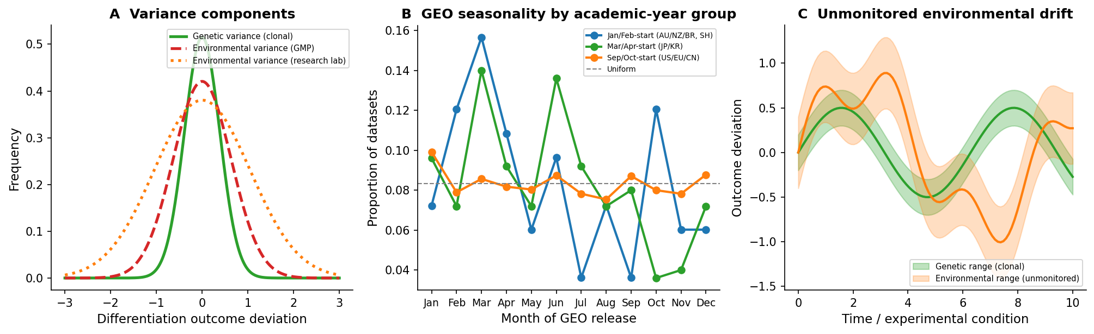
Figure 1. Clonality does not eliminate environmental variance. (A) A clonal population has narrow genetic variance (green) but can still experience wide environmental variance (orange), especially in research laboratories that do not monitor environmental parameters. (B) Monthly distribution of PSC-related GEO Series by academic-year start group (Jan/Feb-start Southern Hemisphere, Mar/Apr-start Japan/Korea, Sep/Oct-start US/EU/CN). Lines show the proportion of datasets released per month; the dashed grey line is uniform expectation. Data source: NCBI GEO.⁵ (C) Over time, unmonitored environmental drift can produce outcome variation comparable to — or larger than — genetic effects, even when all cells are isogenic.

A path forward
What is missing is systematic environmental monitoring. Inexpensive modern Internet-of-Things sensors can record temperature, humidity, illuminance, volatile organic compounds, electromagnetic fields, barometric pressure, and vibration at one-minute intervals over months. The statistical challenge is to separate these signals from batch, operator, reagent lot, and genetic effects.
A practical framework has three stages. First, a baseline variance-budgeting phase of at least twelve months deploys multi-parameter sensors alongside routine differentiation outcomes and estimates the magnitude and autocorrelation of environmental fluctuations. This phase is exploratory, not a formal hypothesis test. Second, a retrospective screen uses time-lagged regression with false-discovery-rate control to identify candidate variables linked to historical batch outcomes. Third, an experimental perturbation phase uses blocked factorial or crossover designs with mixed-effects models and equivalence testing for negative findings.
Analytical choices matter. Differentiation outcomes are usually proportions or counts, so generalized linear mixed models with appropriate link functions are preferable to ordinary linear regression. Seasonal components should be modeled with circular or harmonic terms, not arbitrary month labels. Cross-validation and holdout laboratories should assess external validity, and null findings should be reported with equivalence bounds so that absence of evidence is not mistaken for evidence of absence.
We are not claiming that uncontrolled environments dominate PSC variability. We are claiming that they remain largely unmeasured, that measuring them is feasible, and that the PSC field should stop assuming that isogenic cells grown in different rooms, seasons, or buildings receive the same environmental exposure. Even well-powered null results would be valuable: a decisive absence of association for a particular variable would tell the field it can stop worrying about that variable. The clonal complacency trap will persist until environmental exposure is measured, not assumed.

Declarations
Ethics approval and consent to participate: Not applicable.
Availability of data and materials: All GEO dataset metadata were downloaded from NCBI GEO⁵ using the Entrez E-utilities search interface. Processed metadata and reproducibility code are available at https://github.com/bougtoir/stem-cell-seasonality.
Competing interests: The author declares no competing interests.
Funding: This work received no specific funding.

References
1. Volpato V, Smith J, Sandor C, et al. Reproducibility of molecular phenotypes after long-term differentiation to human iPSC-derived neurons: a multi-site omics study. Stem Cell Reports. 2018;11(4):897-911.
2. McCreery KP, Stubb A, Stephens R, et al. Mechano-osmotic signals control chromatin state and fate transitions in pluripotent stem cells. Nat Cell Biol. 2025;27(10):1757-1770.
3. Bi S, Tang J, Zhang L, et al. Fine particulate matter reduces the pluripotency and proliferation of human embryonic stem cells through ROS induced AKT and ERK signaling pathway. Reprod Toxicol. 2020;96:231-240.
4. Cai J, Zhou L, Liu L, et al. Real-time monitoring reveals the effects of low concentrations of volatile organic compounds in the embryology laboratory. Hum Reprod. 2025;40(4):601-611.
5. Barrett T, Wilhite SE, Ledoux P, et al. NCBI GEO: archive for functional genomics data sets-update. Nucleic Acids Res. 2013;41(D):D991-D995.

