What Zeroing Cannot Fix: Detecting Residual Gain and Dynamic-Response Errors After Zero Calibration in Invasive Arterial Pressure Monitoring

[Author names to be completed]
[Affiliations to be completed]

Corresponding author:
[Name, address, email, ORCID]

EDICS: Metrology and Measurement Fundamentals / Measurement and estimation uncertainty; Medical, Biomedical, and Healthcare Instrumentation and Measurement / Medical measurements.

Index Terms—Arterial pressure monitoring, zero calibration, concordance correlation coefficient, Bland–Altman analysis, proportional bias, dynamic response, fast-flush test, method comparison, measurement uncertainty, biomedical instrumentation, pressure sensors, sensor calibration

Conflicts of Interest and Source of Funding:
[To be completed by the authors. State each author’s financial, consultant, institutional and other relationships and all sources of funding; if there are none, state “none declared”.]

Abstract—Zero calibration removes the direct-current (DC) offset of an invasive arterial pressure transducer but not the sensor-gain (scale) error or dynamic-response (damping) distortion. We used seeded simulations ( paired systolic pressures) and VitalDB beat-by-beat waveforms ( cases, paired beats per scenario) to test which analyses detect a residual gain error after zeroing. Four static cases—offset only, ideal zeroing, 10% gain error, and gain masked by a compensating offset—plus optimal, under-damped and over-damped systems were assessed with the Bland–Altman summary, Bland–Altman regression, Deming and Passing–Bablok regression, and Lin’s concordance correlation coefficient (CCC) with scale shift . The masked gain produced a mean bias of only +0.3 mmHg, yet the regression slopes and CCC scale shift () detected it. Under-damping inflated and over-damping attenuated pulse pressure by 24% and 8% respectively; these frequency-dependent gains persist after zeroing and are diagnosed by the fast-flush test. CCC rose with sampled pressure range (0.60 to 0.96), whereas approached the true gain ratio. Real waveforms reproduced the masked-gain pattern (-0.0 mmHg, ). A mean-bias summary alone can miss a clinically relevant gain error; reports should add proportional-bias-aware analyses, the CCC decomposition with pressure range, a dynamic-response check, and define without calibration as a design target for self-calibrating sensors.

I. INTRODUCTION
Accurate pressure measurement is a central problem in biomedical instrumentation and measurement. Invasive arterial blood pressure (ABP) monitoring, performed millions of times peri-operatively and in critical care, links a pressure transducer, a fluid-filled catheter system and a calibration protocol that defines atmospheric pressure as the zero reference [1-2]. The first part of that protocol, zeroing, removes the direct-current (DC) offset created by the hydrostatic column, the gauge-pressure reference and slow drift; clinicians zero before monitoring [3-4] and repeat whenever the height relationship between transducer and catheter changes [5]. What zeroing cannot do is verify the sensor gain (sensitivity), i.e. the scale factor that converts a true pressure change into the displayed value [6-7]. If the gain is wrong, the waveform is scaled and the error persists after zeroing. Our first question is therefore whether, after correct zeroing, a residual gain (scale) error can remain undetected.
A second, frequency-dependent gain error arises from the dynamic response of the catheter–transducer system. Under- or over-damping distorts the pulsatile signal and therefore pulse pressure [8]. This pulsatile gain error also survives zeroing and, unlike a static scale error, varies with heart rate; our second question is how it behaves and how it should be checked at the bedside.
How agreement is judged is the third issue. Validation studies for ABP and derived haemodynamic monitors overwhelmingly report the Bland–Altman summary (mean bias and 95% limits of agreement) [9] and the Critchley percentage error [10], with attention to the precision of the reference method [11]. In practice, clinicians and manufacturers often read this minimal summary as a complete statement of agreement. Yet the original Bland–Altman method also includes regression of the differences on the mean to detect proportional bias [12], a step that is frequently omitted; when an offset and a gain error partially cancel, the mean-bias summary alone is misleading. Using a reproducible simulation, and without claiming that gain error is invisible to a properly conducted Bland–Altman analysis, we ask which analyses actually reported in the literature detect a residual gain error after zeroing, and we position Lin’s concordance correlation coefficient (CCC) and its scale-shift component [13-14], together with Deming [15] and Passing–Bablok [16] regression, as complementary diagnostics, noting that the CCC depends on the sampled pressure range [17-18].
These choices matter beyond the individual study. Regulatory evaluation of a new monitor rests on the same method-comparison statistics, so if the reported summary cannot separate offset-corrected agreement from genuine gain accuracy, the approval decision inherits that blind spot. We therefore use the simulation to define a compact reporting framework—a proportional-bias–aware slope, the CCC decomposition, the sampled pressure range and an explicit dynamic-response check—that is usable in validation papers and in device-approval review. This framework is not an alternative to measurement-uncertainty analysis [19]; it is a way to make the systematic part of that uncertainty visible when only paired device-reference measurements are available.
Zeroing nevertheless remains indispensable at the bedside because these offsets are installation- and time-dependent physics rather than a factory-fixable device defect. The hydrostatic column depends on the height of the transducer relative to the phlebostatic axis (about 7.5 mmHg per 10 cm) and changes whenever the patient or transducer is repositioned [5]; the atmospheric gauge reference drifts with weather and altitude; and electrical or thermal drift accumulates over time [6-7]. Detection is not the same as correction: method-comparison analyses are retrospective and need paired reference measurements that are not available in real time, whereas zeroing removes a known, setup-specific offset a priori and without a reference. This also points to the design horizon: if the offset sources are engineered out of the hardware the need to zero disappears, leaving gain and dynamic response as the residual design and validation targets—the same quantities our framework isolates.
The contribution is therefore not a new blood pressure estimation algorithm. It is an instrumentation-and-measurement result about an existing calibration protocol: which error terms of a fluid-filled invasive pressure measurement chain zeroing can and cannot identify, which of the analyses used to accept such instruments recover the remaining terms, and what should consequently be reported. Section II places this question in the I&M literature, Section III gives the measurement model and the simulated and real-waveform experiments, Section IV reports the results, and Section V derives the reporting framework and the implications for sensor design.

II. RELATED WORK IN INSTRUMENTATION AND MEASUREMENT
Blood pressure instrumentation has a substantial literature in this journal, and it is against that work that our contribution should be placed. Balestrieri and Rapuano surveyed the instruments and methods used to calibrate oscillometric blood pressure devices and showed that calibration practice is dominated by static pressure references, with dynamic behaviour largely unaddressed [20]. Later work in the same venue has concentrated on estimation from the oscillometric or cuff signal: model-based mean arterial pressure estimation from simultaneous electrocardiogram and cuff measurements [21], a metrologically characterised arterial lumen-area model [22], and an experimental characterisation of the cuff itself as a transducer [23]. Alvarez Vazquez et al. quantified the uncertainty of consecutive auscultatory measurements [24], and Cosoli et al. showed for pressure-wave therapy devices that a full metrological characterisation has to include the waveform, not only scalar amplitude [25]. What this body of work does not cover is the invasive, fluid-filled measurement chain and the specific consequence of its calibration protocol: zeroing corrects the offset term only, so the sensitivity and the dynamic transfer function remain unverified.
Separating an offset error from a gain error is a standing problem in instrumentation, and the solutions differ by error type. Offset is typically handled at the interface: on-chip autocalibration cancels sensor offset in capacitive front ends [26], and bias estimation with temperature compensation does the same for piezoresistive pressure sensors [27]. Gain, in contrast, requires a traceable reference: the histogram test for analogue-to-digital converters, for example, estimates gain and offset errors as separate parameters with separate precisions [28]. Bedside zeroing is functionally an offset-only autocalibration with no pressure reference attached, which is why the gain term is structurally unidentifiable from the zeroing procedure itself. Our study makes that asymmetry explicit and quantifies which reported analyses recover the gain term afterwards.
For the frequency-dependent part of the error, dynamic calibration of pressure sensors has been addressed directly in this journal: Zakrzewski and Wróbel calibrated low-range silicon pressure sensors dynamically rather than statically [29], and dynamic sensor compensation has been implemented with analogue adaptive filters [30] and analysed as an uncertainty-versus-complexity tradeoff [31]. The catheter–transducer system is the clinical instance of exactly this problem, with the added constraint that the compensating element (tubing, bubbles, clots) is assembled at the bedside and changes during use, so the dynamic response must be re-checked in situ rather than calibrated once at manufacture. Finally, because acceptance in this field is a decision made under measurement uncertainty [19], [32], the reporting framework we derive is aimed at the quantity that such decisions currently omit: the systematic scale term.

III. METHODS

A. Arterial pressure as DC plus AC components
An arterial pressure waveform can be decomposed into a slowly varying DC level (mean arterial pressure plus any external offset) and a pulsatile alternating-current (AC) component driven by cardiac ejection. Pulse pressure () is a pure AC quantity and is therefore independent of any additive DC offset but proportional to sensor gain (see Fig. 1, which decomposes the arterial pressure signal into its DC and AC components). An offset shifts the baseline without changing , whereas a gain error scales the whole waveform and changes .
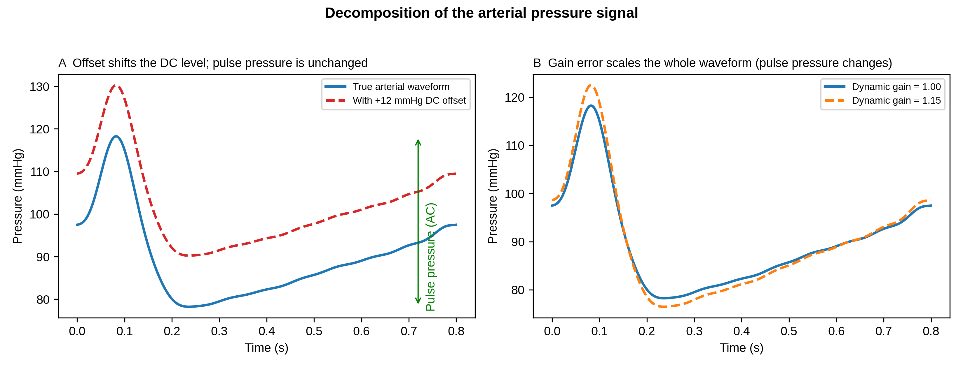
Fig. 1. Decomposition of the arterial pressure signal. (A) A DC offset shifts the baseline but leaves pulse pressure unchanged. (B) A gain error scales the entire waveform, so pulse pressure changes in proportion to the gain. Zeroing corrects the offset in (A) but cannot correct the gain error in (B).

B. Statistical methods
For each paired dataset we computed: (i) the minimal Bland–Altman summary, comprising mean bias, 95% limits of agreement (mean bias ± 1.96 SD) and percentage error [10]; (ii) the Bland–Altman regression of the differences on the mean, whose slope tests for proportional bias [12]; (iii) Deming regression, which allows for error in both methods, with jackknife confidence intervals [15]; (iv) Passing–Bablok non-parametric regression [16]; and (v) Lin’s CCC [13].
Lin’s CCC (ρc) decomposes as ρc = r × C_b, where r is Pearson’s correlation (precision) and C_b is the bias-correction factor (accuracy) [14]. C_b further decomposes as:
(1)
where is the scale shift (the gain ratio) and is the location shift (offset). Zeroing drives toward zero but leaves unchanged; a residual gain error keeps even after perfect zeroing.
We used fixed a-priori detection rules, reported here so they cannot be chosen post hoc: the mean-bias summary flags an error if mmHg; the Bland-Altman regression flags if the slope 95% confidence interval (CI) excludes 0; Deming and Passing-Bablok flag if the slope 95% CI excludes 1; and the CCC scale shift flags if . Strength of agreement was interpreted using published CCC criteria [33].

C. Dynamic response and the fast-flush test
The fluid-filled catheter-transducer system behaves as a second-order system characterised by a natural frequency and a damping coefficient [8]. We modelled its transfer function and applied it to the Fourier harmonics of synthetic arterial waveforms. Under-damping (low , resonance near the arterial harmonics) causes systolic overshoot and over-estimation; over-damping attenuates . Both are gain errors on the pulsatile signal that zeroing cannot correct, and both are quantified at the bedside by the fast-flush (square-wave) test [34-35].

D. Simulation design and reproducibility
Static scenarios comprised paired systolic pressures drawn uniformly over 80.0-180.0 mmHg with Gaussian measurement noise (SD = 3.0 mmHg): S1 offset only (+12.0 mmHg, gain 1.0); S2 ideal zeroing (offset removed, gain 1.0); S3 uncompensated gain error (gain 1.10); and S4 the same gain error with a compensating negative offset chosen so the mean difference is approximately zero. S4 is intentionally artificial: it is a worst-case contrivance that asks whether a mean-bias summary can be fooled by a chance cancellation of offset and gain, not a claim that real devices typically fail in this way. Dynamic scenarios passed synthetic waveforms through optimal, under-damped and over-damped systems (25 Hz, 0.65; 10 Hz, 0.15; 8 Hz, 0.80). A range-dependence experiment sampled one fixed device (5% gain error) over pressure ranges of increasing width. The random seed, all parameters and the full pipeline (simulate -> analyse -> figures -> manuscript) are available in the public repository (https://github.com/bougtoir/abp_zero_calibration) so that a third party can regenerate every number, table and figure from a clean clone.

E. Measurement uncertainty and sensitivity analysis
Measurement uncertainty was treated following the Guide to the Expression of Uncertainty in Measurement [19]. Random uncertainty comes from the Gaussian measurement noise (SD = 3.0 mmHg) and from finite sample size; systematic uncertainty comes from the choice of dynamic-response parameters, the beat-detection algorithm on real waveforms and the a-priori detection thresholds. Bootstrap 95% confidence intervals are reported for all regression slopes. To test robustness we ran a threshold sweep on the masked-gain scenario and an (offset, gain) grid search. With mean-bias thresholds of 3, 5 and 10 mmHg the S4 mean bias remained inside the acceptance band, while the CCC scale shift flagged a gain error at all thresholds; with thresholds of 0.02, 0.05 and 0.10, S4 was flagged in every case. Across a grid of offsets (–20 to +20 mmHg) and gains (1.00 to 1.20), the mean-bias summary passed while flagged a gain error in 12.1% of combinations, defining the mean-bias blind spot quantitatively.

F. Real-waveform validation with VitalDB
To test whether the same gain/offset masking occurs in real waveforms, we selected a reproducible sample of cases with an invasive arterial pressure (SNUADC/ART) waveform from the VitalDB Open Dataset [36]. Beat-by-beat systolic and diastolic pressures were extracted from a 60-s intra-operative segment of each case, and the same four error models (offset only, ideal zeroing, uncompensated gain, and compensated gain) were applied to the real beat SBP values. The compensating offset in the gain-masked scenario (R4) was a single constant across all cases so that the overall mean bias was near zero while the gain-induced proportional bias survived; like S4, this is an intentional, artificial contrivance used to test whether the mean-bias summary can be masked. This real-data experiment is denoted R1-R4 and parallels the synthetic S1-S4 scenarios.
The VitalDB dataset is publicly available and fully anonymised; no additional ethics approval was required for this secondary analysis. Use of artificial-intelligence tools: the simulation and analysis code, the figures, and drafts of the text were prepared with the assistance of an AI coding assistant (Devin; Cognition AI, San Francisco, California, USA). The authors reviewed and verified all code, numerical results and statements, and take full responsibility for the content of the article.

IV. RESULTS

A. Static scenarios
Concordance plots for the four static scenarios are shown in Fig. 2 and the full metrics in Table 1. Ideal zeroing (S2) gave near-perfect agreement (mean bias +0.1 mmHg, CCC 0.995, 0.990). An uncompensated 10% gain error (S3) was obvious on every analysis, including the mean bias (+12.7 mmHg): gain error is not invisible to a Bland–Altman analysis.
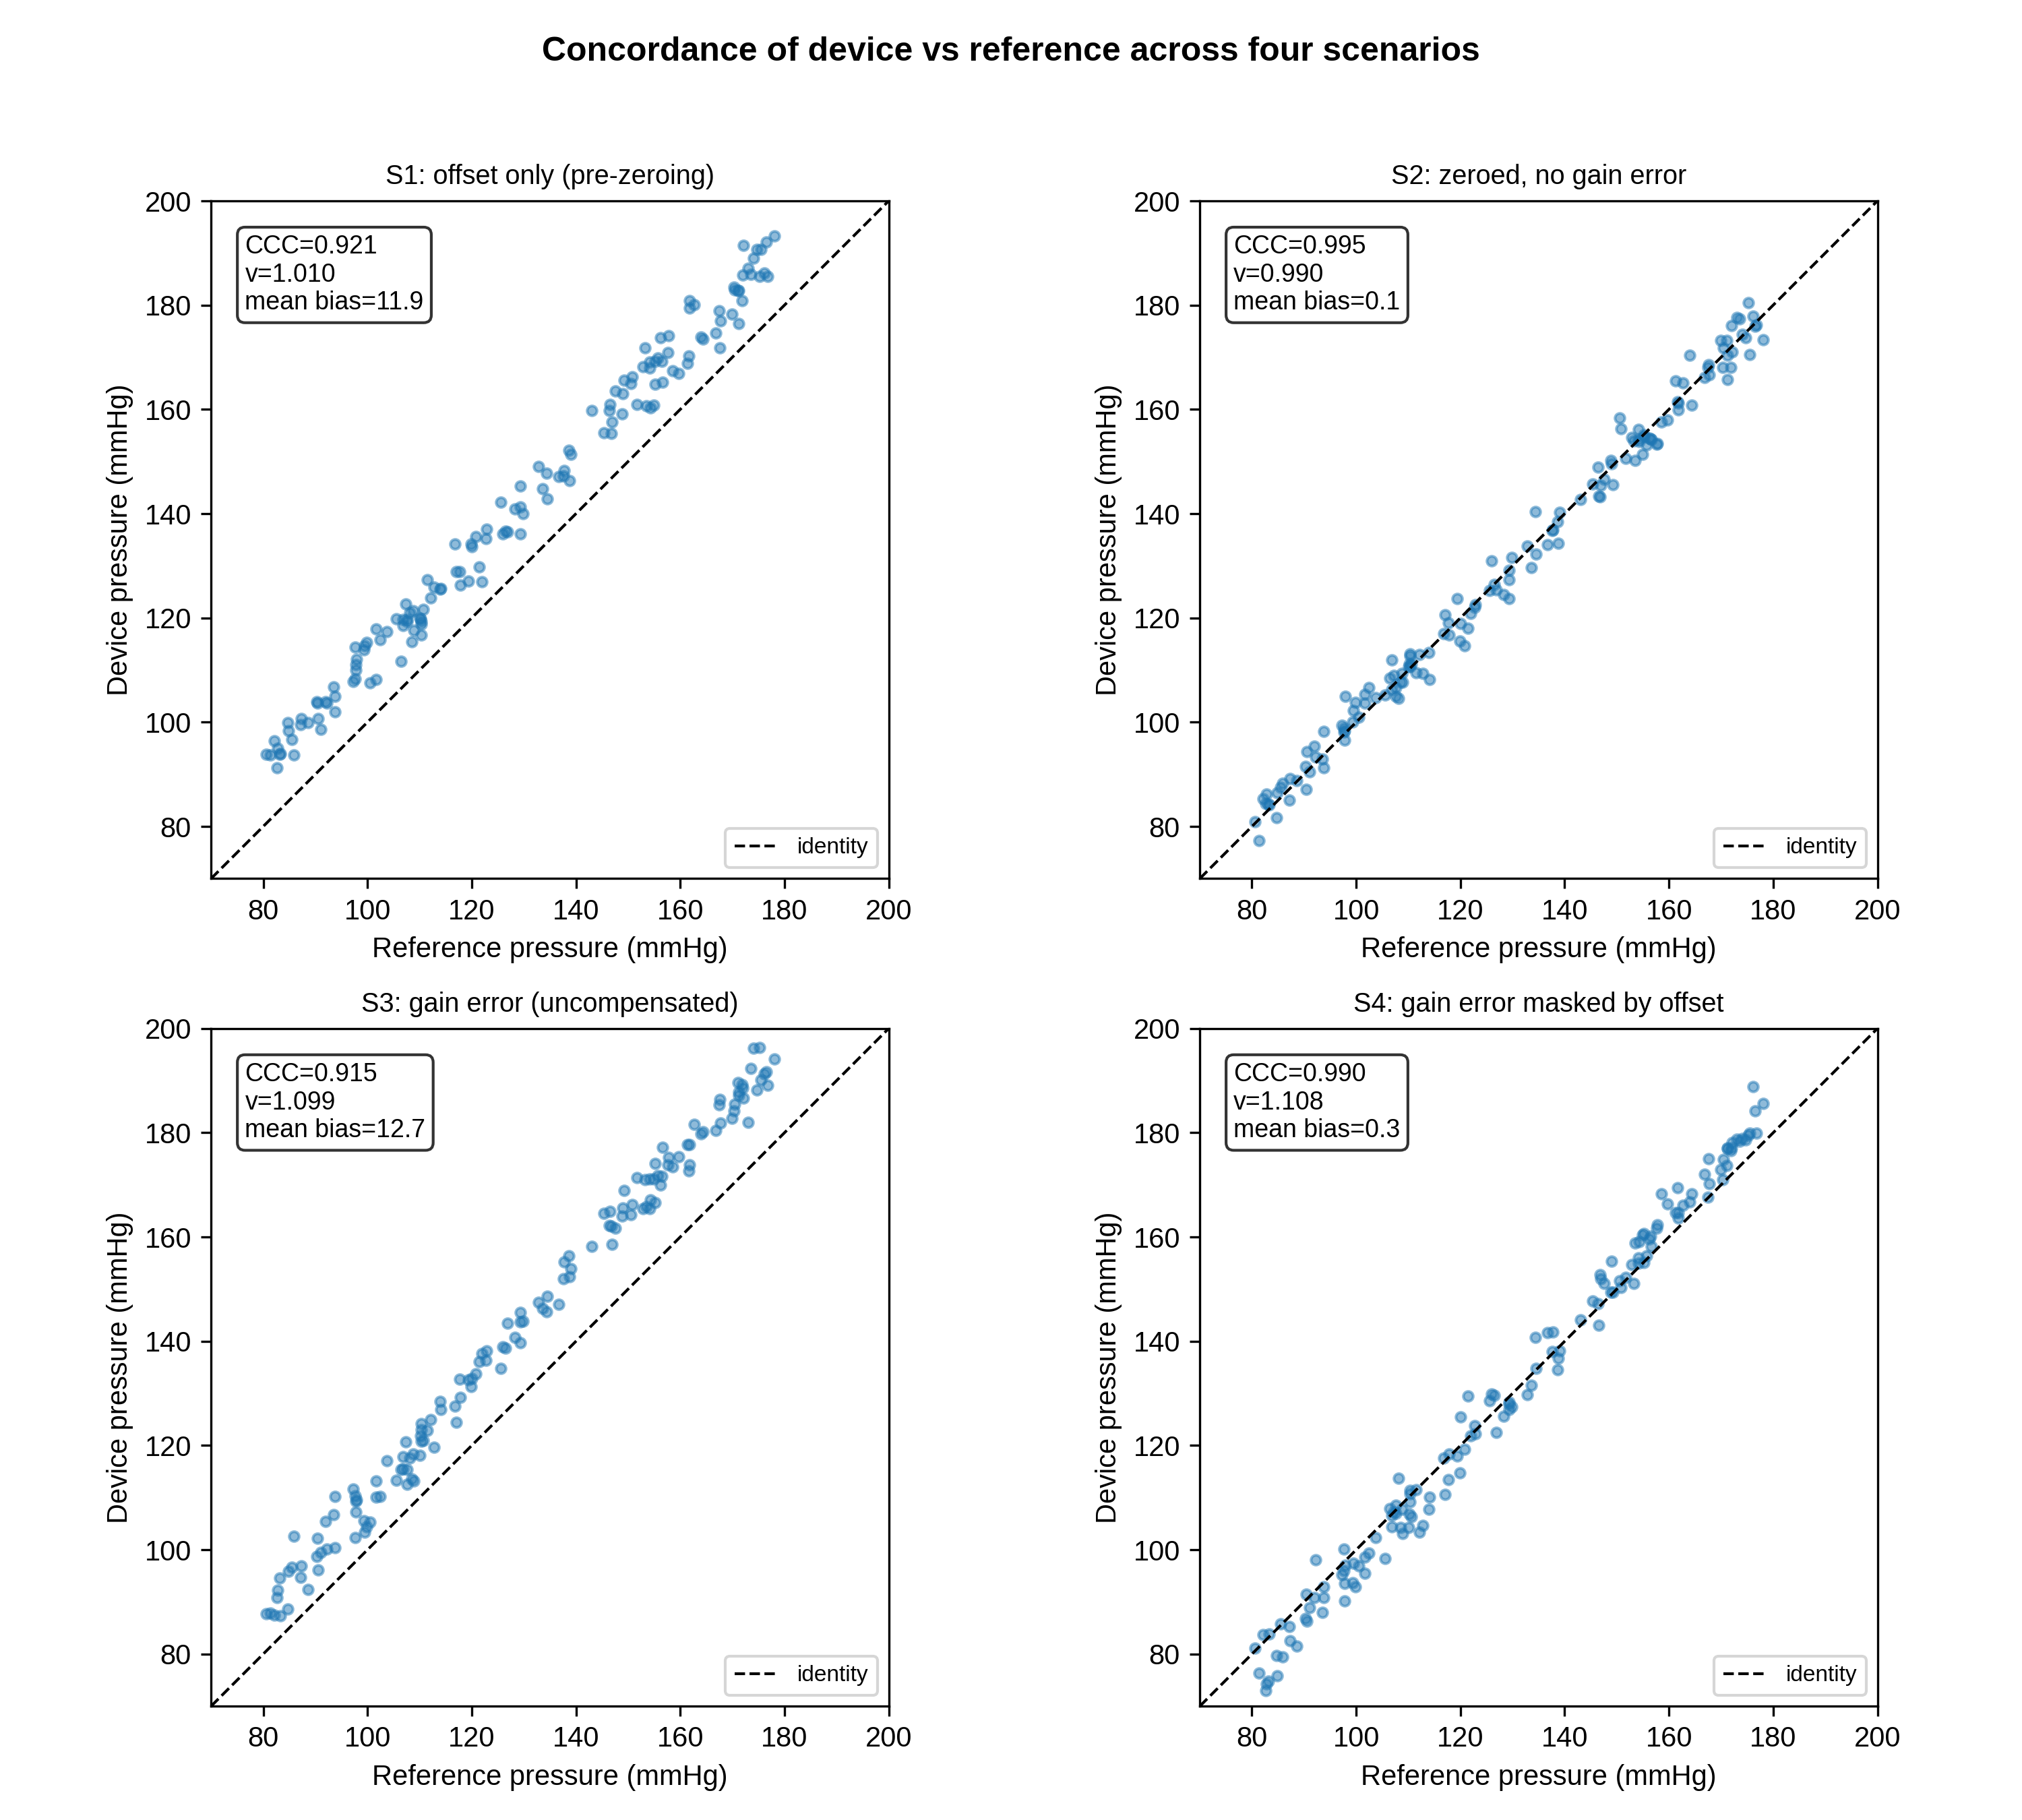
Fig. 2. Device-versus-reference concordance for the four static scenarios (dashed line = identity). Each panel shows the CCC, the CCC scale shift , and the Bland–Altman mean bias. S4 has a near-zero mean bias despite a 10% gain error.
Table 1. Method-comparison metrics for the four static scenarios (n = 150 paired measurements each).
Scenario | Mean bias  (mmHg) | 95% LoA  (mmHg) | PE (%) | BA reg. slope  (95% CI) | Deming slope  (95% CI) | P–B slope  (95% CI) | CCC | C_b | v
S1 offset only | +11.9 | 5.6 to 18.2 | 4.6 | 0.010  (-0.007, 0.028) | 1.010  (0.993, 1.028) | 1.010  (0.990, 1.029) | 0.921 | 0.926 | 1.010
S2 zeroed (ideal) | +0.1 | -5.4 to 5.5 | 4.2 | -0.010  (-0.025, 0.006) | 0.990  (0.975, 1.006) | 0.985  (0.971, 1.001) | 0.995 | 1.000 | 0.990
S3 gain error | +12.7 | 4.7 to 20.7 | 5.9 | 0.094  (0.080, 0.109) | 1.099  (1.082, 1.117) | 1.100  (1.081, 1.117) | 0.915 | 0.919 | 1.099
S4 gain masked | +0.3 | -8.4 to 8.9 | 6.7 | 0.103  (0.087, 0.119) | 1.109  (1.091, 1.126) | 1.111  (1.092, 1.130) | 0.990 | 0.995 | 1.108
BA = Bland–Altman; CI = confidence interval; LoA = limits of agreement; PE = percentage error; P–B = Passing–Bablok; CCC = concordance correlation coefficient; C_b = bias-correction factor; v = scale shift. S4 has a near-zero mean bias yet a clearly non-zero regression, Deming and Passing–Bablok slope and v > 1, i.e. a gain error hidden from the mean-bias summary.
The decisive case is S4, where a compensating offset makes the mean bias only +0.3 mmHg, within the ±5.0 mmHg acceptance band, so the minimal Bland–Altman summary does not flag any problem. Every proportional-bias–aware analysis nonetheless detects the hidden gain error: the Bland–Altman regression slope is 0.103 (95% CI 0.087 to 0.119), the Deming slope 1.109 (95% CI 1.091 to 1.126), the Passing–Bablok slope 1.111 (95% CI 1.092 to 1.130), and the CCC scale shift = 1.108. The detection pattern across all scenarios is summarised in Fig. 3, and the difference-versus-mean plots for S2 and S4 in Fig. 4.
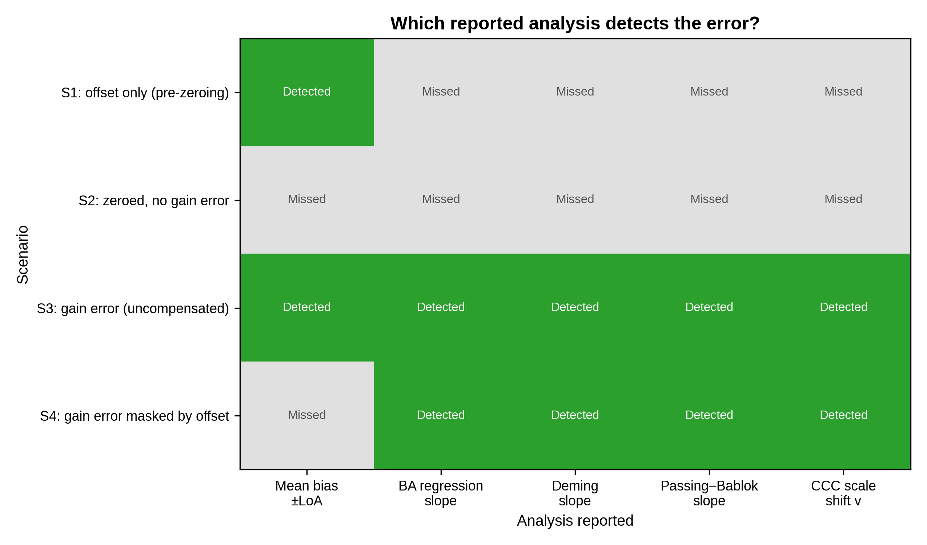
Fig. 3. Which reported analysis detects the error in each scenario (green = detected, grey = missed). In S4 the mean-bias summary misses the gain error that every proportional-bias–aware analysis detects.
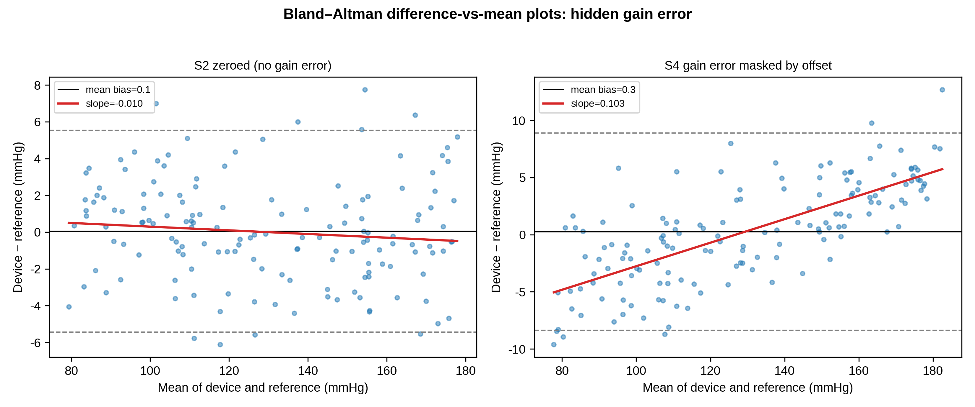
Fig. 4. Bland–Altman difference-versus-mean plots. In S2 the regression slope is flat; in S4 the slope is clearly positive despite a near-zero mean bias, revealing the masked proportional (gain) error.

B. Dynamic-response scenarios
Dynamic-response metrics are given in Table 2 and illustrated in Fig. 5. The optimal system reproduced PP faithfully (PP ratio 1.01). Under-damping produced systolic overshoot and inflated PP by 24% (PP ratio 1.24, CCC scale shift = 1.28); over-damping attenuated PP by 8% (PP ratio 0.92). These are gain errors on the pulsatile signal that survive zeroing. Because the distortion is frequency-dependent (it varies with heart rate rather than with pressure amplitude), it maps only partially onto the amplitude-proportional model underlying the static regression statistics, which is why it is best characterised directly by the fast-flush test parameters (, ζ).
Table 2. Dynamic-response metrics for pulse pressure (PP) and systolic pressure (SBP).
System (f_n, ζ) | PP ratio | PP mean bias  (mmHg) | CCC (PP) | v (PP) | SBP mean bias  (mmHg)
Optimal (25.0 Hz, 0.65) | 1.01 | +0.3 | 0.973 | 1.030 | +0.2
Underdamped (10.0 Hz, 0.15) | 1.24 | +10.7 | 0.588 | 1.277 | +7.6
Overdamped (8.0 Hz, 0.80) | 0.92 | -3.4 | 0.891 | 0.989 | -3.4
PP ratio = mean(measured PP / true PP); f_n = natural frequency; ζ = damping coefficient. Under-damping inflates and over-damping attenuates pulse pressure; the mean arterial (DC) level is preserved, so zeroing does not correct these errors.
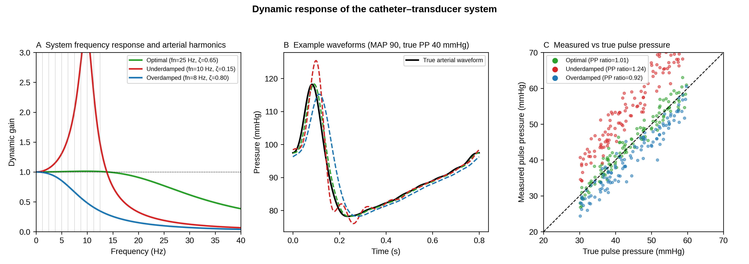
Fig. 5. Dynamic response of the catheter–transducer system. (A) Frequency response of optimal, under-damped and over-damped systems with the arterial harmonics overlaid. (B) Example waveforms. (C) Measured versus true pulse pressure, with the mean PP ratio per system.

C. Range-dependence of the CCC
For a single device with a fixed 5% gain error, the CCC rose from 0.60 when sampled over a narrow pressure range (20 mmHg wide) to 0.96 over a wide range (100 mmHg). The scale shift was far less range-dependent than CCC and approached the true gain ratio as the sampled range widened (Fig. 6). The CCC therefore should be reported together with the sampled pressure range; the structural components (, ) are more transportable across studies [17].
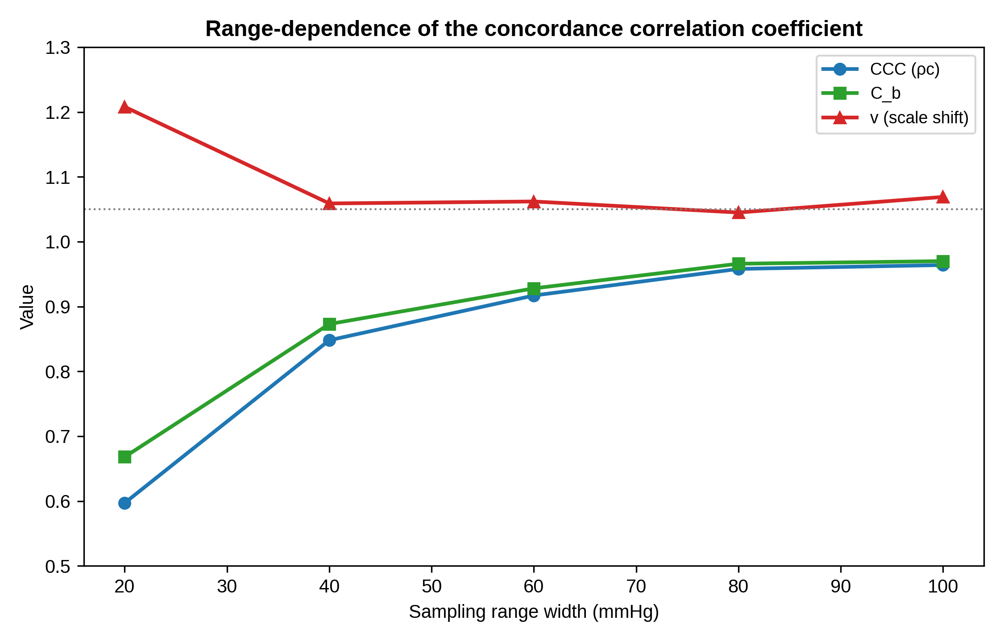
Fig. 6. Range-dependence of the CCC. For one fixed device, the CCC and increase as the sampled pressure range widens, whereas the scale shift is less range-dependent and approaches the true gain ratio (dotted line) at wider ranges.

D. Real-waveform validation
The same four error models were applied to beat-by-beat invasive arterial pressures from the VitalDB Open Dataset ( cases, paired beats per scenario). The pattern matched the synthetic data: a compensating offset made the mean bias effectively zero (-0.0 mmHg), while the proportional-bias indicators remained elevated (CCC scale shift = 1.106, Deming slope 1.106, Passing–Bablok slope 1.105). Table 3 gives the metrics for all four real-data scenarios; Fig. 7 shows a representative 10-s waveform and the Bland–Altman plot for R4.
Table 3. Real-waveform method-comparison metrics from the VitalDB Open Dataset (29 cases; n = 1,874 paired beats per scenario).
Scenario | n | Mean bias  (mmHg) | 95% LoA  (mmHg) | PE (%) | BA reg. slope  (95% CI) | Deming slope  (95% CI) | P–B slope  (95% CI) | CCC | C_b | v
R1 offset only | 1874 | +12.0 | 6.1 to 17.9 | 4.5 | 0.006  (0.001, 0.012) | 1.006  (1.001, 1.012) | 1.006  (1.000, 1.011) | 0.894 | 0.900 | 1.006
R2 zeroed (ideal) | 1874 | -0.0 | -5.9 to 5.9 | 4.7 | 0.006  (0.001, 0.012) | 1.006  (1.001, 1.012) | 1.006  (1.000, 1.011) | 0.993 | 1.000 | 1.006
R3 gain error | 1874 | +12.6 | 4.9 to 20.3 | 5.8 | 0.101  (0.096, 0.106) | 1.106  (1.101, 1.112) | 1.105  (1.100, 1.111) | 0.890 | 0.896 | 1.106
R4 gain masked | 1874 | -0.0 | -7.7 to 7.7 | 6.1 | 0.101  (0.096, 0.106) | 1.106  (1.101, 1.112) | 1.105  (1.100, 1.111) | 0.989 | 0.995 | 1.106
BA = Bland–Altman; CI = confidence interval; LoA = limits of agreement; PE = percentage error; P–B = Passing–Bablok; CCC = concordance correlation coefficient; C_b = bias-correction factor; v = scale shift. R4 has a near-zero mean bias with elevated v and regression slopes, reproducing the masked-gain pattern found in synthetic scenario S4.
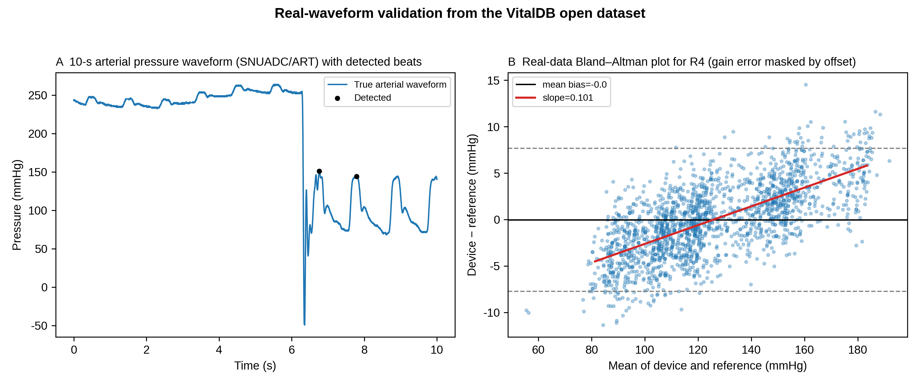
Fig. 7. Real-waveform validation from the VitalDB Open Dataset. (A) A 10-s segment of the arterial pressure waveform (SNUADC/ART) with detected beats. (B) Bland–Altman plot for the gain-masked scenario (R4) on real data, showing a near-zero mean bias with a clear proportional bias.

E. Sensitivity and uncertainty
A threshold sweep on the masked-gain scenario showed that the mean-bias summary passed every a-priori acceptance band (3, 5 and 10 mmHg), while the CCC scale shift and all regression-based proportional-bias tests flagged the gain error at every tested threshold (0.02, 0.05, 0.10). An (offset, gain) grid search over offsets –20 to +20 mmHg and gains 1.00 to 1.20 confirmed a broad mean-bias blind spot: the mean-bias test passed while flagged the gain error in 12.1% of the (offset, gain) combinations. This defines the numerical size of the reporting hazard and gives an uncertainty-aware context for the detection rule.

V. DISCUSSION
Our central finding is narrow and directly supported by the data: the mean-bias–plus–limits-of-agreement summary that dominates device-validation reporting can miss a clinically relevant gain error when a coincidental offset cancels its effect on the mean, whereas the Bland–Altman difference-versus-mean regression [12], Deming [15] and Passing–Bablok [16] regression, and the CCC scale shift [14] all detect it. This is a critique of common reporting practice, not of the Bland–Altman method itself.

A. Recommendations for validation reporting
Validation studies of arterial pressure and derived monitors [37-38] should therefore report, in addition to mean bias and limits of agreement: (i) the Bland–Altman regression slope with its CI (or, equivalently, a Deming or Passing–Bablok slope); (ii) the CCC with its decomposition into r, C_b, u and v; and (iii) the sampled pressure range, because the CCC is range-dependent [17-18]. Notably, C_b alone is relatively insensitive to a pure gain error (in S4, C_b was 0.995 despite v = 1.108); the scale shift v should be reported explicitly. These additions require only standard regression output and make the systematic part of the measurement uncertainty visible to regulators and clinicians [39], distinguishing offset-corrected agreement from genuine gain accuracy.
Relative to the uncertainty budgets reported for non-invasive blood pressure measurement [24], which characterise the repeatability of a measurement procedure, the quantity we recommend adding is systematic rather than random: v is a scale term that does not shrink with repetition and that a limits-of-agreement statement can hide when an offset partially cancels it. Reporting it explicitly keeps the accept/reject decision consistent with the uncertainty on which it is based [19], [32].

B. Dynamic response is a distinct, clinical gain error
The dynamic-response error is specific to fluid-filled systems and is routinely encountered at the bedside as under-damping (air bubbles, long compliant tubing) or over-damping (clots, kinks) [8], [35]. Because it is frequency-dependent, it is not fully captured by static method-comparison statistics and is best assessed directly with the fast-flush test, from which f_n and ζ are read [34]. We therefore recommend that a fast-flush dynamic-response check accompany any accuracy statement for a fluid-filled arterial line; pulse pressure is the sensitive readout, because it is proportional to gain but independent of offset.
In instrumentation terms this is the in-situ counterpart of dynamic sensor calibration and compensation [29-31]. Those methods characterise or invert a transfer function that is fixed by the device; here the second-order system is completed by tubing, fluid and air that are assembled at the bedside and change during use, so f_n and ζ have to be re-estimated from the measurement chain in place. The fast-flush test is attractive precisely because it supplies that estimate from a step response without a pressure reference, and Cosoli et al. make the same point for therapeutic pressure devices: waveform-level characterisation is not optional once the quantity of interest is pulsatile [25].

C. Implications for sensor design
The reason zeroing is still performed today is that it corrects a setup-specific offset in real time, a role that no retrospective method-comparison statistic can fill. This also points to the way forward: because zeroing addresses only the operational offset problem, designing the offset sources out of the hardware removes the need to zero at all, leaving gain and dynamic response as the residual design and validation problems. The same division of labour is visible in sensor interface design, where offset is cancelled on chip [26] or estimated jointly with temperature effects [27], while gain accuracy still has to be established against a reference, as in ADC gain and offset error testing [28]. Zeroing occupies the first role only.
The offset that zeroing corrects can also be removed by design. Catheter-tip micro-electro-mechanical systems (MEMS) sensors abolish the hydrostatic column [40-41]; absolute sensors with barometric compensation remove the atmospheric reference; and self-calibrating MEMS references limit drift [42]. High-fidelity pressure wires already demonstrate accurate catheter-based pressure measurement [43]. With offset removed by design and gain verified by accurate PP reproduction, the residual systematic error is expressed entirely in v, giving a concrete design target (v ≈ 1, C_b ≥ 0.99 without calibration) [33]. Modern piezoresistive MEMS sensors achieve non-linearity well below 0.1% of full scale [44], supporting the assumption that gain verified over the pulsatile range generalises across the physiological range.

D. Extension to derived haemodynamic monitors
The offset-versus-gain distinction extends to derived monitors whose auto-calibration routines re-optimise a setpoint (an offset correction) without correcting the gain of the pressure- or impedance-to-flow conversion [45-48]. Reporting the scale shift v for these devices would make their dependence on calibration explicit.

E. Limitations
This is a simulation study; the data are synthetic and chosen to isolate specific error structures, and they are not a substitute for a prospective clinical comparison against an invasive reference of stated precision [11]. The masked-gain scenarios (S4 and R4) are intentionally artificial: they test whether a summary metric can be fooled by a cancellation of offset and gain, not whether devices typically fail in this way. The static model assumes sensor linearity, the dynamic model is a single second-order approximation, and the measurement-uncertainty budget is limited to the components we could propagate from the stated simulation parameters. The value of the work is to make explicit, and reproducibly quantify, which reported analyses detect a residual gain error, a prelude to rather than a replacement for empirical validation.

VI. CONCLUSION
Zero calibration corrects offset but not gain, and a residual scale error can persist after perfect zeroing.
Dynamic-response error is a distinct, frequency-dependent gain error that also survives zeroing and is diagnosed at the bedside by the fast-flush test.
Read on its own, a mean-bias–plus–limits-of-agreement summary can miss such a gain error when an offset masks it, whereas Bland–Altman regression, Deming and Passing–Bablok regression, and the CCC scale shift all detect it. The message for clinicians and manufacturers is not to abandon Bland–Altman but to use it with its regression step and these complementary analyses.
We recommend that arterial pressure validation studies, and device-approval evaluations, report a proportional-bias–aware analysis, the CCC decomposition with the sampled pressure range, and an explicit dynamic-response check, so that offset-corrected agreement is not mistaken for gain accuracy.
Because zeroing addresses only the operational offset, designing the offset sources out of the hardware would make zeroing unnecessary and leave gain and dynamic response as the residual targets; expressing the remaining systematic error as the scale shift v gives a concrete design goal (v ≈ 1 without calibration) for the next generation of self-calibrating arterial pressure sensors.

VII. ACKNOWLEDGEMENTS
[To be completed by the authors, or state “none”.]

VIII. DATA AVAILABILITY
Replication code, parameter files, and the generated data used to produce every number, table and figure are available in the public repository https://github.com/bougtoir/abp_zero_calibration. The real-waveform validation uses the VitalDB Open Dataset, which is publicly available at https://api.vitaldb.net/.

REFERENCES
[1] ANSI/AAMI BP22:1994 (R2016), Blood Pressure Transducers. Arlington, VA, USA: AAMI, 2016.
[2] S. Shirmohammadi, K. Barbé, D. Grimaldi, S. Rapuano, and S. Grassini, "Instrumentation and measurement in medical, biomedical, and healthcare systems," IEEE Instrum. Meas. Mag., vol. 19, no. 5, pp. 6-12, Oct. 2016.
[3] B. Saugel, K. Kouz, A. S. Meidert, L. Schulte-Uentrop, and S. Romagnoli, "How to measure blood pressure using an arterial catheter: A systematic 5-step approach," Crit. Care, vol. 24, p. 172, 2020.
[4] B. Saugel and D. I. Sessler, "Perioperative blood pressure management," Anesthesiology, vol. 134, pp. 250-261, 2021.
[5] D. Gupta, A. Jain, and M. Ismaeil, "Zero arterial catheters with every change in the height difference of pressure transducer and catheter insertion site," Ann. Card. Anaesth., vol. 28, p. 205, 2025.
[6] J. B. Mark, Atlas of Cardiovascular Monitoring. New York, NY, USA: Churchill Livingstone, 1998.
[7] B. H. McGhee and M. E. J. Bridges, "Monitoring arterial blood pressure: What you may not know," Crit. Care Nurse, vol. 22, pp. 60-79, 2002.
[8] R. M. Gardner, "Direct blood pressure measurement—dynamic response requirements," Anesthesiology, vol. 54, pp. 227-236, 1981.
[9] J. M. Bland and D. G. Altman, "Statistical methods for assessing agreement between two methods of clinical measurement," Lancet, vol. 327, pp. 307-310, 1986.
[10] L. A. H. Critchley and J. A. J. H. Critchley, "A meta-analysis of studies using bias and precision statistics to compare cardiac output measurement techniques," J. Clin. Monit. Comput., vol. 15, pp. 85-91, 1999.
[11] M. Cecconi, A. Rhodes, J. Poloniecki, G. Della Rocca, and R. M. Grounds, "Bench-to-bedside review: The importance of the precision of the reference technique in method comparison studies," Crit. Care, vol. 13, p. 201, 2009.
[12] J. M. Bland and D. G. Altman, "Measuring agreement in method comparison studies," Stat. Methods Med. Res., vol. 8, pp. 135-160, 1999.
[13] L. I. Lin, "A concordance correlation coefficient to evaluate reproducibility," Biometrics, vol. 45, pp. 255-268, 1989.
[14] L. I. Lin, "A note on the concordance correlation coefficient," Biometrics, vol. 56, pp. 324-325, 2000.
[15] K. Linnet, "Estimation of the linear relationship between the measurements of two methods with proportional errors," Stat. Med., vol. 9, pp. 1463-1473, 1990.
[16] H. Passing and W. Bablok, "A new biometrical procedure for testing the equality of measurements from two different analytical methods," J. Clin. Chem. Clin. Biochem., vol. 21, pp. 709-720, 1983.
[17] C. A. Nickerson, "A note on 'A concordance correlation coefficient to evaluate reproducibility'," Biometrics, vol. 53, pp. 1503-1507, 1997.
[18] H. X. Barnhart, M. J. Haber, and L. I. Lin, "An overview on assessing agreement with continuous measurements," J. Biopharm. Stat., vol. 17, pp. 529-569, 2007.
[19] JCGM 100:2008, Evaluation of Measurement Data—Guide to the Expression of Uncertainty in Measurement. Sèvres, France: BIPM, 2008.
[20] E. Balestrieri and S. Rapuano, "Instruments and methods for calibration of oscillometric blood pressure measurement devices," IEEE Trans. Instrum. Meas., vol. 59, no. 9, pp. 2391-2404, Sep. 2010.
[21] M. Forouzanfar, S. Ahmad, I. Batkin, H. R. Dajani, V. Z. Groza, and M. Bolic, "Model-based mean arterial pressure estimation using simultaneous electrocardiogram and oscillometric blood pressure measurements," IEEE Trans. Instrum. Meas., vol. 64, no. 9, pp. 2443-2452, Sep. 2015.
[22] I. Koohi, I. Batkin, V. Z. Groza, S. Shirmohammadi, H. R. Dajani, and S. Ahmad, "Metrological characterization of a method for blood pressure estimation based on arterial lumen area model," IEEE Trans. Instrum. Meas., vol. 66, no. 4, pp. 734-745, Apr. 2017.
[23] L. I. Bogatu, S. Turco, M. Mischi, J. Muehlsteff, and P. Woerlee, "An experimental study on the blood pressure cuff as a transducer for oscillometric blood pressure measurements," IEEE Trans. Instrum. Meas., vol. 70, pp. 1-11, 2021.
[24] E. Alvarez Vazquez, D. Ewert, D. Jorgenson, and M. Sand, "Assessment of the uncertainty associated with two consecutive blood pressure measurements using the auscultatory method," IEEE Trans. Instrum. Meas., vol. 71, pp. 1-11, 2022.
[25] G. Cosoli, L. Verdenelli, and L. Scalise, "Metrological characterization of therapeutic devices for pressure wave therapy: Force, energy density, and waveform evaluation," IEEE Trans. Instrum. Meas., vol. 70, pp. 1-8, 2021.
[26] R. Tirupathi and S. K. Kar, "On-chip implementable autocalibration of sensor offset for differential capacitive sensor interfaces," IEEE Trans. Instrum. Meas., vol. 70, pp. 1-9, 2021.
[27] Y. Ruan, L. Yuan, W. Yuan, Y. He, and L. Lu, "Temperature compensation and pressure bias estimation for piezoresistive pressure sensor based on machine learning approach," IEEE Trans. Instrum. Meas., vol. 70, pp. 1-10, 2021.
[28] F. Correa Alegria and A. Cruz Serra, "Standard histogram test precision of ADC gain and offset error estimation," IEEE Trans. Instrum. Meas., vol. 56, no. 5, pp. 1527-1531, Oct. 2007.
[29] J. Zakrzewski and K. Wrobel, "Dynamic calibration of low-range silicon pressure sensors," IEEE Trans. Instrum. Meas., vol. 51, no. 6, pp. 1358-1362, Dec. 2002.
[30] M. Jafaripanah, B. M. Al-Hashimi, and N. M. White, "Application of analog adaptive filters for dynamic sensor compensation," IEEE Trans. Instrum. Meas., vol. 54, no. 1, pp. 245-251, Feb. 2005.
[31] M. Gubian, A. Marconato, A. Boni, and D. Petri, "A study on uncertainty-complexity tradeoffs for dynamic nonlinear sensor compensation," IEEE Trans. Instrum. Meas., vol. 58, no. 1, pp. 26-32, Jan. 2009.
[32] R. Morello, "GUM-based decisional criteria to make decisions in presence of measurement uncertainty," IEEE Trans. Instrum. Meas., vol. 69, no. 8, pp. 5511-5522, Aug. 2020.
[33] G. B. McBride, "A proposal for strength-of-agreement criteria for Lin's concordance correlation coefficient," NIWA, Hamilton, New Zealand, Client Rep. HAM2005-062, 2005.
[34] B. Kleinman, S. Powell, P. Kumar, and R. M. Gardner, "The fast flush test measures the dynamic response of the entire blood pressure monitoring system," Anesthesiology, vol. 77, pp. 1215-1220, 1992.
[35] S. Romagnoli et al., "Accuracy of invasive arterial pressure monitoring in cardiovascular patients: An observational study," Crit. Care, vol. 18, p. 644, 2014.
[36] H. C. Lee, Y. Park, S. B. Yoon, S. M. Yang, D. Park, and C. W. Jung, "VitalDB, a high-fidelity multi-parameter vital signs database in surgical patients," Sci. Data, vol. 9, p. 279, 2022.
[37] S. H. Kim et al., "Accuracy and precision of continuous noninvasive arterial pressure monitoring compared with invasive arterial pressure: A systematic review and meta-analysis," Anesthesiology, vol. 120, pp. 1080-1097, 2014.
[38] A. Joosten et al., "Accuracy and precision of non-invasive cardiac output monitoring devices in perioperative medicine: A systematic review and meta-analysis," Br. J. Anaesth., vol. 118, pp. 298-310, 2017.
[39] P. M. Odor, S. Bampoe, and M. Cecconi, "Cardiac output monitoring: Validation studies—how results should be presented," Curr. Anesthesiol. Rep., vol. 7, pp. 410-415, 2017.
[40] W. Hasenkamp et al., "Polyimide/SU-8 catheter-tip MEMS gauge pressure sensor," Biomed. Microdevices, vol. 14, pp. 819-828, 2012.
[41] P. Song et al., "Recent progress of miniature MEMS pressure sensors," Micromachines, vol. 11, no. 1, p. 56, 2020.
[42] Y. Kang et al., "Development of a flexible integrated self-calibrating MEMS pressure sensor using a liquid-to-vapor phase change," Sensors, vol. 22, no. 24, p. 9737, 2022.
[43] A. Scalia et al., "High fidelity pressure wires provide accurate validation of non-invasive central blood pressure and pulse wave velocity measurements," Biomedicines, vol. 11, no. 4, p. 1235, 2023.
[44] A. A. Barlian, W. T. Park, J. R. Mallon, A. J. Rastegar, and B. L. Pruitt, "Review: Semiconductor piezoresistance for microsystems," Proc. IEEE, vol. 97, no. 3, pp. 513-552, Mar. 2009.
[45] K. Chatterjee, "The Swan–Ganz catheters: Past, present, and future," Circulation, vol. 119, pp. 147-152, 2009.
[46] K. Ameloot, P. J. Palmers, and M. L. N. G. Malbrain, "The accuracy of noninvasive cardiac output and pressure measurements with finger cuff: A concise review," Curr. Opin. Crit. Care, vol. 21, pp. 232-239, 2015.
[47] P. Squara, D. Denjean, P. Estagnasie, A. Brusset, J. C. Dib, and C. Dubois, "Noninvasive cardiac output monitoring (NICOM): A clinical validation," Intensive Care Med., vol. 33, pp. 1191-1194, 2007.
[48] G. R. Manecke, "Edwards FloTrac sensor and Vigileo monitor: Easy, accurate, reliable cardiac output assessment using the arterial pulse wave," Expert Rev. Med. Devices, vol. 2, pp. 523-527, 2005.

Tatsuki Onishi (Member, IEEE) was born in Japan. He received the M.D. degree from Tohoku University, Sendai, Japan, in 2005, and the Ph.D. degree in medical informatics from Kyoto University, Kyoto, Japan, in 2021. His major field of study was clinical measurement and biomedical data science.
He is currently a Project Assistant Professor with the Data Science and AI Innovation Research Promotion Center, Shiga University, Hikone, Japan. He was previously a Clinical Researcher with Juntendo University Shizuoka Hospital and a Visiting Researcher with Healthcare Finland Oy, focusing on perioperative monitoring and clinical data analysis. His current research interests include biomedical instrumentation, measurement uncertainty, clinical data science, and reproducible analysis of physiological waveforms.
Dr. Onishi is a member of the IEEE and the Japanese Society of Anesthesiologists. He has served as a reviewer for journals in measurement and perioperative medicine and received research support from Shiga University.

