Where could rice cultivation systems be transferred beyond traditional growing regions? A multi-scale gate analysis of thermal transfer, water access and food-supply risk on European arable land

Abstract
Proposals to grow rice outside its traditional regions often treat a climatic threshold as evidence of suitability. We test that inference geographically for 106.9 Mha of incumbent arable land in Europe (SPAM 2010 harvested area of wheat, maize, barley and potato, 5′ grid) using five sequential, non-compensatory gates: thermal transfer of a cold-region japonica system, irrigation infrastructure, rainfed water balance, economic parity and food-supply risk. Calibrating the Hokkaido cold bound on the same WorldClim grid gives 589 GDD10 (5th percentile of Hokkaido rice area), not the ~900 GDD10 obtained from NASA POWER point cells; the thermal gate is therefore met by 94.2% of incumbent arable land, whereas a transplanted 900 threshold would retain 65.4% and almost exclude Germany (96.6% vs 3.2%). Water, not temperature, is the binding constraint: 17.6% of incumbent arable land combines thermal compatibility with irrigation infrastructure (area equipped ≥10%), while 76.5% faces a positive Jun–Sep rainfed deficit. Point-scale daily water balances agree with the grid deficit (Spearman ρ = 0.73). On the Lower Danube, a 250,000 ha paddy scenario would require ~241 m³/s, 22% of Q99 low flow, so allocation rather than channel discharge decides feasibility. Correcting an analog-yield inconsistency and adding block-bootstrap intervals, modeled shortfall-probability reductions remain robust for Kazakhstan but are uncertain for Romania (95% CI −0.172 to 0.000) and fragile elsewhere. The results identify a small set of irrigated-infrastructure regions for next-stage feasibility assessment, not land allocations or implemented irrigation.
Keywords: rice; land suitability; cultivation-system transfer; irrigation infrastructure; modifiable areal unit problem; food-supply risk; Europe

1. Introduction
Diversifying staple crops is promoted as a response to correlated harvest failures, because temperature and precipitation anomalies co-move across breadbaskets and the probability of simultaneous failure is changing (Gaupp et al., 2020; Mehrabi & Ramankutty, 2019; Ray et al., 2015). Diversity can stabilise national production (Renard & Tilman, 2019), but adding a crop reduces risk only where the crop can actually be grown, where its resource demands can be met, and where its failures are not synchronous with those of incumbent crops. Each of these conditions has a geography, and each depends on scale.
Rice is a demanding test case. It is the most irrigated staple, it carries high caloric yields per hectare where it succeeds, and its cultivation has expanded at cold margins. In Northeast China, paddy expansion under warming has been documented and attributed in part to climate change (Gao & Liu, 2011; Liu et al., 2022), and the potential northern limits of particular rice systems have been mapped from heat-accumulation thresholds (Yang et al., 2023). Global suitability assessments also map where rice could be grown (Zabel et al., 2014). Applied land-suitability work, however, shows that suitability maps are sensitive to criteria, weights and thresholds (Xu & Zhang, 2013; Tenerelli & Carver, 2012). It also shows that irrigation-led expansion can conflict with basin water sustainability (Nouri et al., 2017; Saiko & Zonn, 2000). Water governance, rather than climate, often shapes how rice systems adapt (Burchfield & Gilligan, 2016).
Three inferential shortcuts recur when rice transfer is discussed outside traditional regions. First, a thermal threshold taken from one data source and one place is applied to another, as if it were a property of the crop rather than of a cultivation system measured at a particular scale. Second, abundant river discharge is read as available irrigation water. Third, modeled reductions in a scenario's shortfall probability are read as resilience gains. This study treats all three as geographic questions and asks a narrower question than suitability mapping: on existing arable land in Europe, where does a transferable rice cultivation system pass successive biophysical and infrastructural gates? Where does it fail? And how do these answers change with data source, seasonal window, spatial resolution and aggregation? A further question is whether rice substitution changes modeled food-supply risk differently from a non-rice comparator in the countries that pass.
We make three contributions. (i) We separate thermal transfer, irrigation infrastructure and rainfed water balance as non-compensatory gates and map them with an explicit land denominator, the harvested area of incumbent arable crops. Results are therefore exposures of existing land use to each gate, not convertible areas. (ii) We show that the commonly quoted cold-region bound is source- and scale-specific. Calibrated consistently on one grid, it stops being the binding constraint, and the binding constraint moves to water and infrastructure. (iii) We re-evaluate the mainstem water and portfolio-risk arguments for the Lower Danube and other candidates with corrected calculations and uncertainty intervals. The framework is summarised in Figure 1.
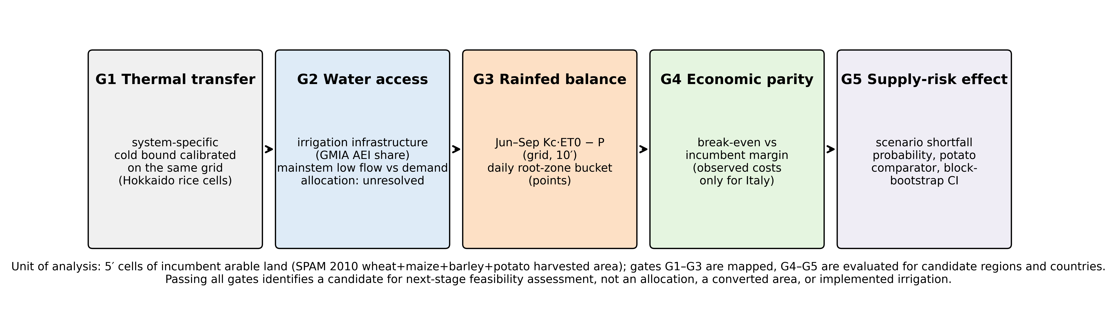
Figure 1. Gate framework. Five sequential, non-compensatory gates evaluated for a transferable cold-region japonica rice system on incumbent arable land. Passing all gates identifies a candidate for next-stage feasibility assessment, not an allocation or converted area.

2. Data and methods

2.1 Study region, spatial unit and denominator
The analysis window covers 11°W–45°E and 34°N–71.5°N. The spatial unit is the 5′ grid cell (about 9.3 km at the equator). The denominator is the 2010 harvested area of wheat, maize, barley and potato in the Spatial Production Allocation Model, all technologies combined (IFPRI, 2019; Yu et al., 2020). We call this incumbent arable land. It totals 106.9 Mha in the window. It is a measure of where arable cropping already occurs and where rice would compete with incumbent crops; it is not an estimate of land that could or should be converted. Countries are assigned by rasterising Natural Earth 1:50 m boundaries (Natural Earth, 2024). The data sources are listed in Table 1.
Table 1. Data sources and their role.
Dataset | Version / period | Resolution | Role | Licence
NASA POWER daily (T2M_MAX, T2M_MIN, PRECTOTCORR) | v2, 2000–2024 | 0.5° point cells (43) | Point GDD10, daily bucket | Public domain (NASA)
WorldClim 2.1 tavg, tmin, tmax, prec | 1970–2000 monthly | 2.5′, 5′, 10′ | Grid GDD10, ET0, deficit D | Free for research; redistribution restricted
MapSPAM 2010 v2.0 harvested area (all technologies) | circa 2010 | 5′ | Incumbent arable denominator, rice validation, Hokkaido calibration | CC BY 4.0
FAO GMIA v5 area equipped for irrigation | circa 2005–2008 | 5′ | Irrigation-infrastructure gate | CC BY-NC-SA 3.0 IGO
FAOSTAT QCL yields | 1961–2024 | national | Portfolio risk scenarios | CC BY 4.0
Natural Earth admin-0 | 1:50m v5.1 | vector | Country assignment | Public domain
Iron Gates discharge statistics; WEAP allocation | literature | reach | Lower Danube mainstem check | cited sources

2.2 Thermal transfer gate
Commercial rice production in Hokkaido relies on ultra-early japonica cultivars, heated nurseries, transplanting and warm-water irrigation (MAFF, 2024). We use Hokkaido as the reference for the transferable cold-region system, not as a universal physiological threshold. Thermal accumulation is GDD10, the sum of the daily mean temperature above 10 °C. In the point analysis, NASA POWER daily data for 2000–2024 (NASA POWER Project, 2025; evaluated by Bai et al., 2010) give GDD10 over the season window used by the original pipeline. Because that window was computed from a pseudo day-of-year (month × 30.4 + day), it actually runs from about 29 April to 11 September rather than June to September; we report both windows and a May–September window. On the grid, GDD10 is computed from WorldClim 2.1 monthly means for 1970–2000 (Fick & Hijmans, 2017) at 2.5′, 5′ and 10′ resolution, weighting each month by the number of its days that fall in the window. The grid threshold T* is calibrated on the same grid: it is the 5th percentile of GDD10 across Hokkaido rice cells, weighted by SPAM 2010 rice harvested area (114 thousand ha). It is reported alongside the 1st, 10th and 50th percentiles and the 1st and 5th percentiles of all rice north of 35°N.

2.3 Water gates
Irrigation infrastructure is represented by the area equipped for irrigation in the Global Map of Irrigation Areas version 5 (Siebert et al., 2013), expressed as a share of cell area. Cells with a share of at least 10% are classed as having existing infrastructure. This is a conservative indicator of infrastructure presence, not of water allocated to rice. For rainfed systems we compute a climatic balance on the grid, D = Σ (Kc·ET0 − P) over June–September, using Hargreaves–Samani reference evapotranspiration (Hargreaves & Samani, 1985) from WorldClim 10′ monthly minimum and maximum temperature, extraterrestrial radiation, and the Kc schedule of the point model (1.05–1.20; Allen et al., 1998). At the point cells, a daily single-layer root-zone water balance (total available water 100 mm, stress at 30% depletion, 120-day season) gives the share of years with more than ten deficit days during flowering. The two measures are compared by rank correlation.
For the Lower Danube, the continuous-equivalent demand Q = A·D/T of a paddy scenario is compared with low-flow statistics for the Iron Gates reach (mean discharge 5,420 m³/s; Q90/Q95/Q99 1,460/1,320/1,100 m³/s; CT-UPT, 2014). We use seasonal depths of 800–1,200 mm and seasons of 120–150 days (Bouman et al., 2007). We also draw on a water-allocation model of the Iron Gates–Zimnicea reach (Salam et al., 2022). This is a mainstem comparison only; it does not establish water rights, conveyance or farm-level access.

2.4 Gate cascade and validation
Cells with incumbent arable area are assigned to one of four classes: (1) thermal gate not met; (2) thermal gate met, no infrastructure, and D > 0; (3) thermal gate met, no infrastructure, and D ≤ 0; (4) thermal gate met with infrastructure. Areas are summed by country. As an observational check, we overlay the same classes on the SPAM 2010 rice harvested area that already exists in Europe (776 thousand ha).

2.5 Scale, window and source sensitivity
To assess the modifiable areal unit problem (Jelinski & Wu, 1996), the share of incumbent arable land passing thresholds T ∈ {T*, 800, 900, 1,000, 1,100} is computed at native 2.5′, 5′ and 10′ resolution and after aggregating the 5′ GDD10 field to 30′ and 60′ block means. For each configuration we report the area disagreement with the 2.5′ result. We also compare NASA POWER point values with the WorldClim 5′ cell that contains each point.

2.6 Economic parity
Observed temperate paddy costs exist in the audited sources only for Italy: total costs 1470–2430 €/ha and gross margins 1499–4379 €/ha for conventional systems (Guglielmo et al., 2025; Monaco et al., 2016). Rice-specific costs for Romania, Bulgaria, Croatia and Serbia were not found in public sources. Economics is therefore treated as a break-even condition: rice must match the incumbent margin per hectare. It is not treated as an observed regional profitability.

2.7 Food-supply risk scenarios
For each country, FAOSTAT yields (FAO, 2024) of wheat, barley, maize, rice and potato are log-detrended, and the residuals are used as yearly shocks to recent yield levels. The incumbent portfolio (A) is compared with a substitution of 20% of the incumbent area by rice (B) and by potato (D). The outcome is the modeled probability that portfolio calories fall below 90% of their mean. Where a country has fewer than 15 years of rice yields, rice shocks and the rice yield level are both taken from an analog country. The original implementation combined analog shocks with a missing own-country rice level, which set the rice contribution to zero; we correct this and label such countries as analog evidence. Uncertainty in B − A is estimated by a moving-block bootstrap with 3-year blocks and 2,000 resamples (Künsch, 1989). Robustness is assessed over 24 configurations: substitution shares of 0.1, 0.2 and 0.3; linear or quadratic detrending; a rice yield scale of 1.0 or 0.75; and own-mean or baseline-mean thresholds. These are scenario statistics about modeled calorie variability, not estimates of observed food crises.

3. Results

3.1 The cold-region bound is source- and window-specific
At the NASA POWER point cell, Hokkaido accumulates 903 GDD10 in the pipeline window, 941 in calendar June–September and 991 in May–September. The ranking of European candidates against Hokkaido depends on the window. Under the pipeline window, Rhine (957) and Saxony (969) exceed the Hokkaido value. Under calendar June–September they fall just below it (931 and 935 vs 941), because Hokkaido's late season is relatively warm. Alsace, Loire and Berlin remain above Hokkaido in all three windows.
On the WorldClim grid, rice-area-weighted GDD10 across Hokkaido rice cells has a 5th percentile of 589 and a median of 859 (1st and 10th percentiles 487 and 637). The point-derived ~900 bound therefore lies near the median of the grid distribution, not at its cold tail. Across 33 European point cells, NASA POWER (2000–2024) exceeds the containing WorldClim cell (1970–2000) by a median of 135 GDD10 (range -129 to 463). The difference reflects the warmer recent period and also the coarse 0.5° POWER grid, which smooths terrain. The Alsace point, for example, falls in a Vosges cell at 5′ (617 vs 1,080). A threshold is thus meaningful only when it is calibrated in the data and at the scale where it is applied.

3.2 Gate cascade on incumbent arable land
With the grid-consistent threshold, the thermal gate is met on 94.2% of incumbent arable land (100.8 Mha) (Figure 2a; Table 2). Thermal failure is concentrated in Ireland, Scotland, Fennoscandia, the Baltic states and uplands. Most thermally compatible land, 81.8 Mha (76.5%), lacks irrigation infrastructure and faces a positive rainfed deficit. Only 114 thousand ha combine no infrastructure with a non-positive deficit. Thermal compatibility combined with existing infrastructure covers 18.8 Mha (17.6%) and is concentrated in Spain, Italy, Romania, France, Ukraine, Bulgaria and Hungary (Figure 2b). Serbia and Croatia have almost no incumbent arable land in this class. The infrastructure class depends on the equipped-area cut-off: with cut-offs of 5% and 20%, it covers 24.4% and 10.9% of incumbent arable land, and 81.4% and 67.6% of existing rice.
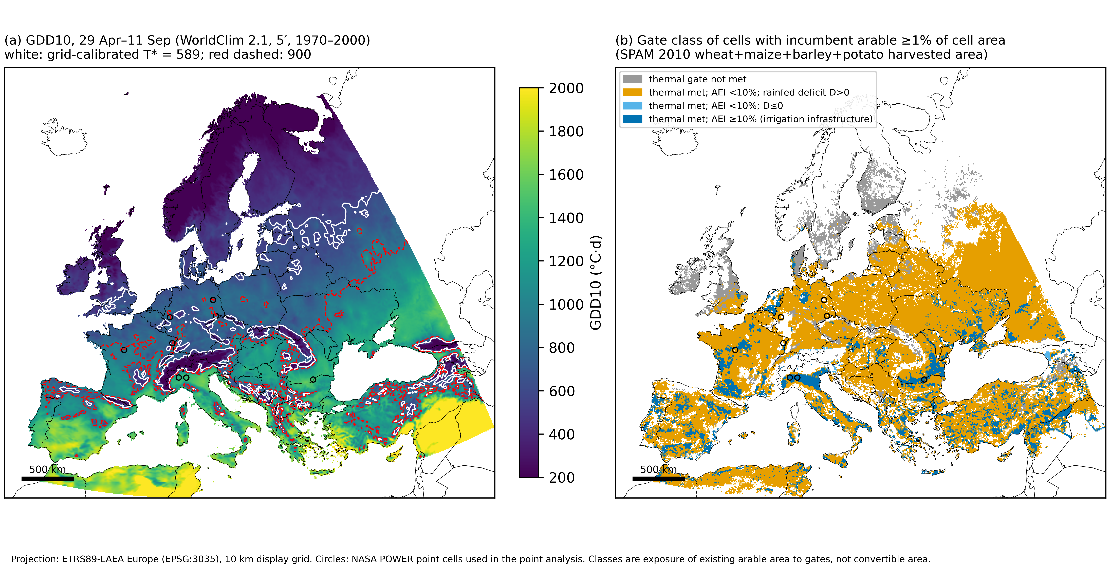
Figure 2. (a) GDD10 for 29 April–11 September from WorldClim 2.1 (5′, 1970–2000), with the grid-calibrated Hokkaido bound T* = 589 (white) and the point-derived 900 GDD10 (red, dashed). (b) Gate class of 5′ cells with incumbent arable land ≥1% of cell area. AEI, area equipped for irrigation (GMIA v5). Circles mark NASA POWER point cells. ETRS89-LAEA projection; the analysis window includes parts of North Africa and Anatolia.
Table 2. Exposure of incumbent arable land to the gate cascade by country (T* = 589 GDD10; AEI ≥10%). Percentages of incumbent arable area; the remainder (thermal gate met, no infrastructure, D ≤ 0) is <1% everywhere.
Country | Incumbent arable (Mha) | Thermal not met (%) | Thermal met, no AEI, D>0 (%) | Thermal met, AEI ≥10% (%) | Rice 2010 (kha)
Spain | 5.2 | 0.2 | 72.1 | 27.8 | 121
Italy | 3.1 | 0.1 | 45.6 | 54.0 | 244
France | 9.1 | 0.3 | 76.2 | 23.5 | 22
Romania | 5.1 | 0.7 | 62.9 | 36.5 | 13
Bulgaria | 1.8 | 0.3 | 71.6 | 28.1 | 10
Hungary | 2.5 | 0.0 | 82.7 | 17.3 | 2
Ukraine | 14.4 | 0.2 | 91.6 | 8.2 | 24
Serbia | 1.9 | 1.8 | 98.2 | 0.0 | 0
Croatia | 0.5 | 0.1 | 99.9 | 0.0 | 0
Germany | 5.7 | 3.4 | 92.3 | 4.0 | 0
Poland | 4.2 | 2.2 | 97.5 | 0.2 | 0
United Kingdom | 3.0 | 61.5 | 33.9 | 4.6 | 0
Analysis window total | 106.9 | 5.7 | 76.5 | 17.6 | 771

The cascade reproduces the geography of existing rice. Of the 776 thousand ha of rice in the window, 99.3% lies in cells that meet the thermal gate and 75.7% lies in cells with infrastructure. Most of the remainder lies in thermally compatible cells whose equipped-area share is below 10%. This mainly reflects the coarseness of the equipped-area indicator at 5′ rather than rainfed rice.

3.3 Threshold, window and resolution sensitivity
The share of incumbent arable land passing the thermal gate falls steeply with the threshold (Figure 3a): from 94.2% at T to 65.4% at 900 and 56.1% at 1,000 GDD10. The national implications are larger than the Europe-wide totals suggest. Germany passes on 96.6% of its incumbent arable land at T but on only 3.2% at 900. Using the calendar June–September window and its own calibrated threshold (664) gives 89.3%, and the two windows classify 95.0% of the area identically. Changing the resolution from 2.5′ to 10′, or aggregating to 30′ or 60′, changes the Europe-wide share by at most about 4 percentage points (Figure 3b). The area that changes class is nevertheless substantial: 7.2 Mha at 900 GDD10 when 60′ is compared with 2.5′. Nationally, Romania's passing share at 900 falls from 93.6% at 2.5′ to 78.5% at 60′. Classification near the bound is therefore resolution-dependent even where continental totals are stable. The source cross-walk (Figure 3c) shows the systematic offset between point and grid data.
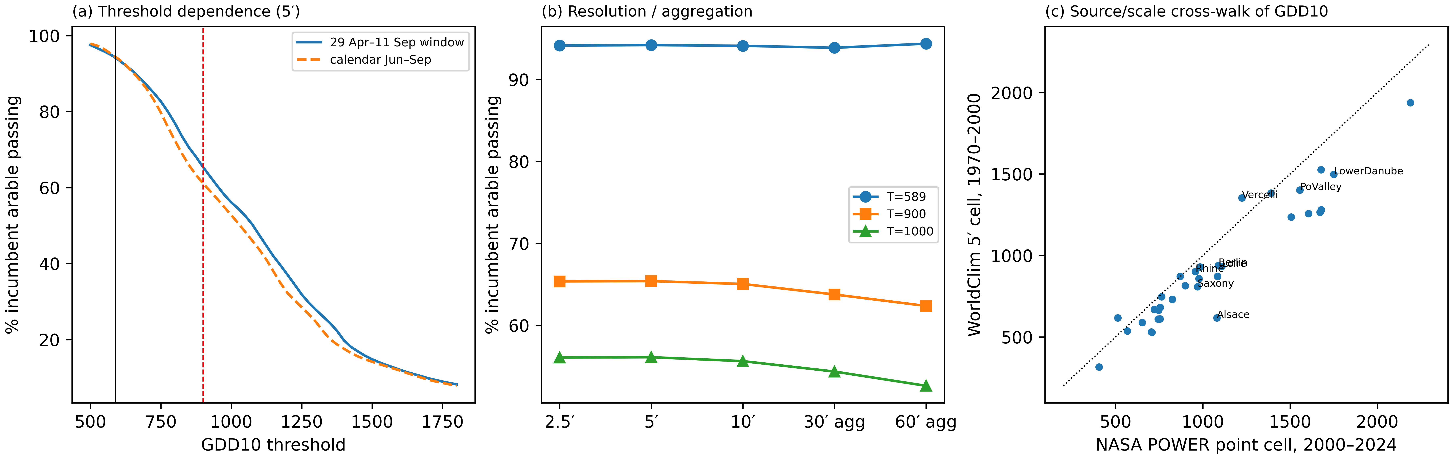
Figure 3. Sensitivity of the thermal gate. (a) Share of incumbent arable land passing as a function of the GDD10 threshold for two seasonal windows (vertical lines: T* and 900). (b) Share passing by native resolution (2.5′, 5′, 10′) and after aggregation of 5′ GDD10 to 30′ and 60′. (c) NASA POWER point-cell GDD10 (2000–2024) versus the containing WorldClim 5′ cell (1970–2000); dotted line 1:1.

3.4 Water geography
The rainfed deficit is the gate that rice cannot bypass in continental Europe. The grid deficit D and the point-scale frequency of flowering-stage deficits are concordant (Spearman ρ = 0.73, p = 0.0013, n = 16; Figure 4a). Flowering deficits occur in 88–100% of years at continental cells and in 64–84% at Nordic and Baltic cells, compared with 48% in Hokkaido. A rainfed upland system would therefore share the drought exposure of incumbent cereals where diversification is most needed.
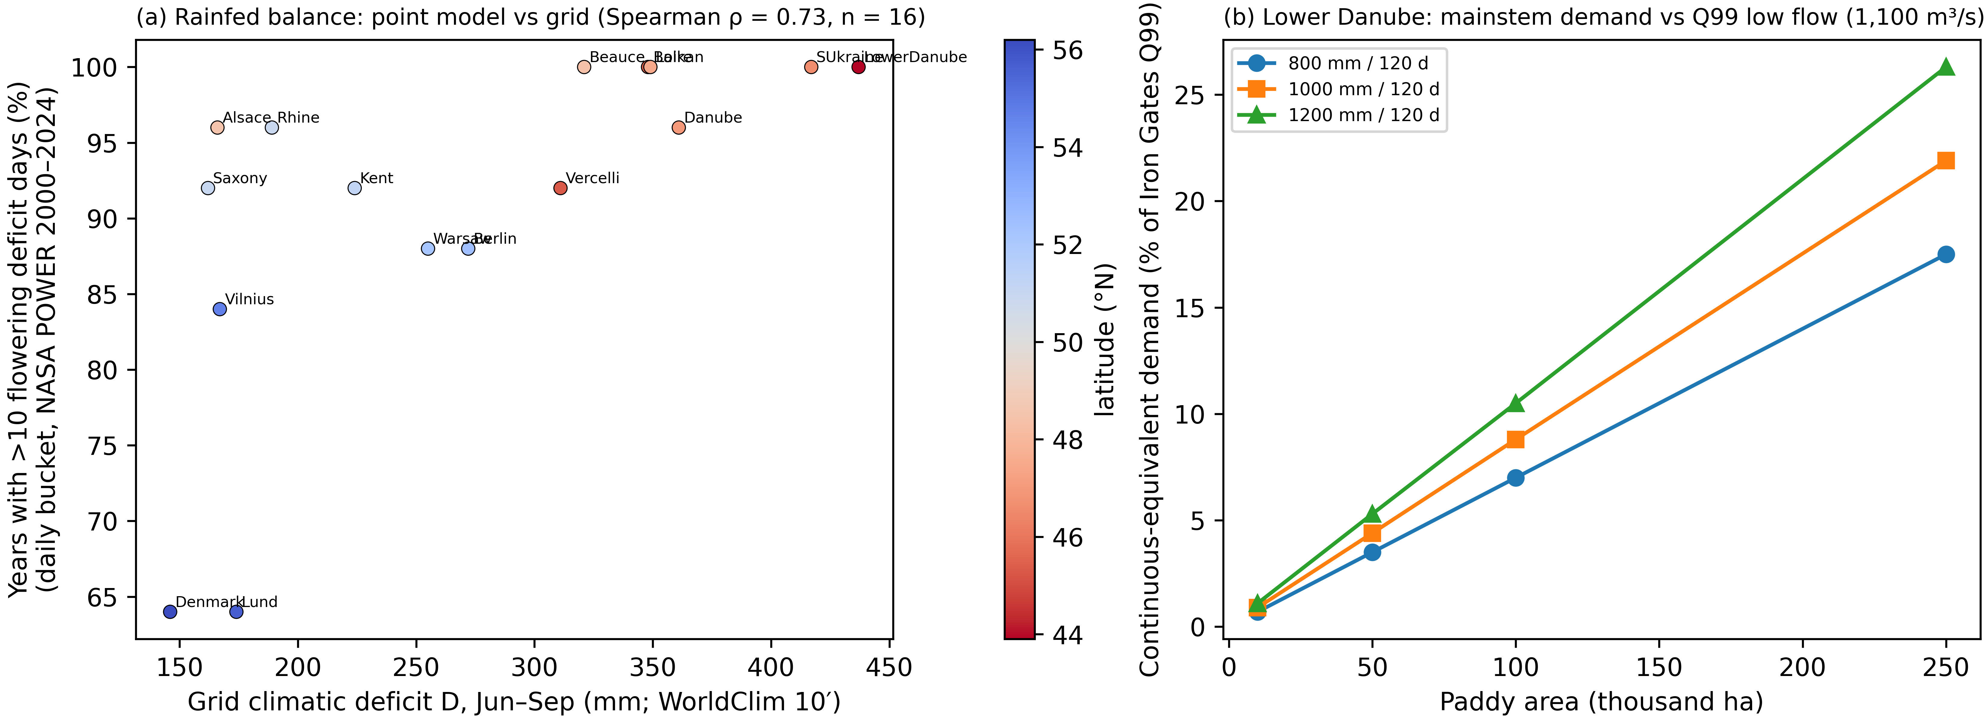
Figure 4. Water geography. (a) Grid Jun–Sep climatic deficit D (WorldClim 10′) versus the share of years with >10 flowering-stage deficit days from the daily bucket model at NASA POWER point cells (Spearman ρ = 0.73, n = 16); colour shows latitude. (b) Continuous-equivalent paddy water demand on the Lower Danube as a percentage of Iron Gates Q99 low flow (1,100 m³/s) for three seasonal depths over 120 days; mainstem comparison only.
For irrigated lowland rice on the Lower Danube, the mainstem comparison scales with area (Figure 4b). A 100,000 ha scenario at 1,000 mm over 120 days requires 96 m³/s (8.8% of Q99). A 250,000 ha scenario requires 241 m³/s (22% of Q99; 4.5% of mean discharge). These are not negligible fractions of a drought low flow on an international river that also serves navigation, hydropower, ecological flows and other users. The allocation model for the Iron Gates–Zimnicea reach reports no agricultural deficit under its scenarios (Salam et al., 2022), but it does not represent a new paddy sector of this size. Conveyance, pumping, water rights and transboundary arrangements therefore remain the decisive unknowns.

3.5 Food-supply risk
After correction (Figure 5; Table 3), substituting 20% of the incumbent area with rice lowers the modeled shortfall probability in Romania from 0.203 to 0.109 (potato comparator 0.172). The 95% block-bootstrap interval of the change is −0.172 to 0.000. B is below A in 100% of the 24 configurations, but the interval excludes zero in only 42%. In Kazakhstan the reduction (0.212 to 0.030) has an interval that excludes zero (−0.273 to −0.030) in 79% of configurations. For Serbia, the earlier contrast between rice (0.211) and potato (0.053) was an artifact of the analog-yield inconsistency. The corrected estimate (0.000 vs potato 0.053) rests on Hungarian rice shocks and is analog evidence only. In Bulgaria, Hungary and France, the direction of the effect is not robust across configurations (B < A in 71%, 38% and 21% of configurations, respectively).
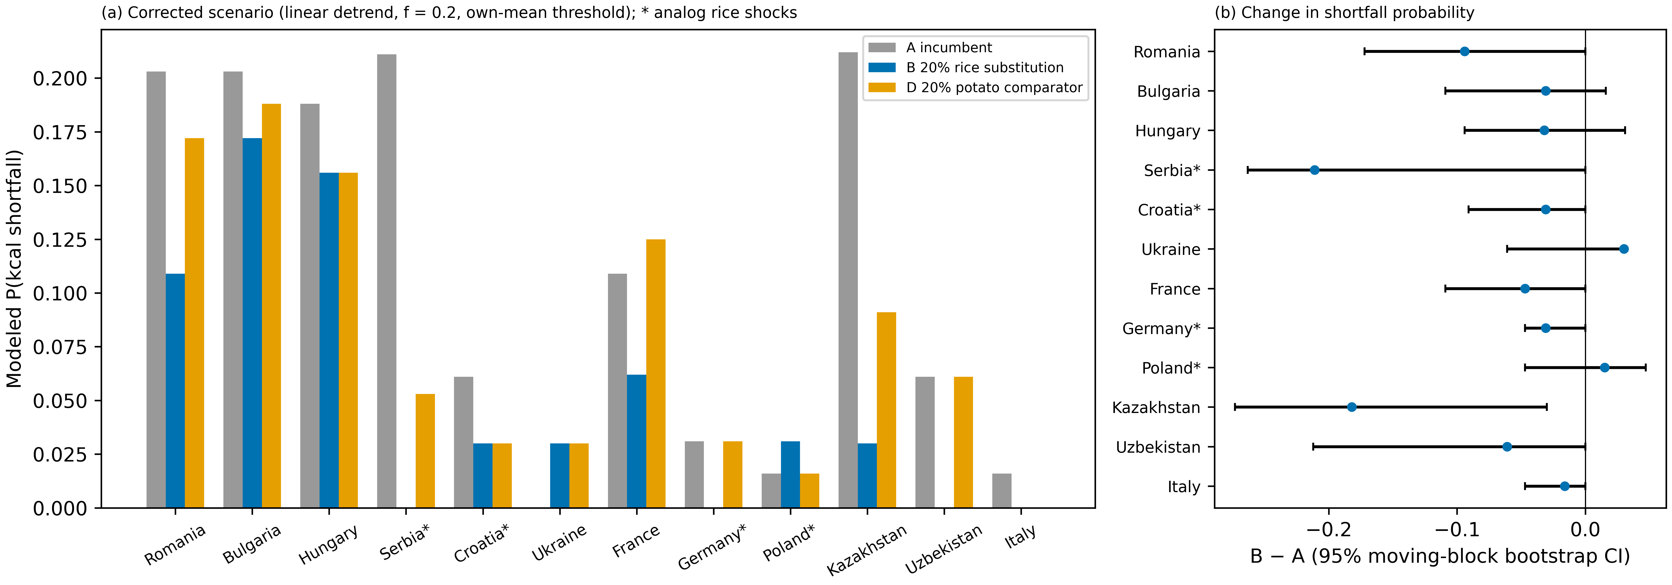
Figure 5. Corrected food-supply portfolio scenarios. (a) Modeled probability that portfolio calories fall below 90% of their mean for the incumbent portfolio (A), 20% rice substitution (B) and 20% potato comparator (D). (b) Change B − A with 95% moving-block bootstrap intervals (3-year blocks, 2,000 resamples). * Rice shocks and yield level from an analog country.
Table 3. Corrected portfolio scenarios and robustness over 24 configurations. P, modeled shortfall probability; CI, 95% moving-block bootstrap interval of B − A.
Country | Rice evidence | Years | P(A) | P(B) rice | P(D) potato | B − A (95% CI) | B < A (% configs) | CI excludes 0 (% configs)
Romania | Romania | 64 | 0.203 | 0.109 | 0.172 | −0.094 (−0.172, 0.000) | 100 | 42
Bulgaria | Bulgaria | 64 | 0.203 | 0.172 | 0.188 | −0.031 (−0.109, 0.016) | 71 | 4
Hungary | Hungary | 64 | 0.188 | 0.156 | 0.156 | −0.032 (−0.094, 0.031) | 38 | 0
Serbia | analog: Hungary | 19 | 0.211 | 0.000 | 0.053 | −0.211 (−0.263, 0.000) | 42 | 0
Croatia | analog: Greece | 33 | 0.061 | 0.030 | 0.030 | −0.031 (−0.091, 0.000) | 79 | 0
France | France | 64 | 0.109 | 0.062 | 0.125 | −0.047 (−0.109, 0.000) | 21 | 0
Kazakhstan | Kazakhstan | 33 | 0.212 | 0.030 | 0.091 | −0.182 (−0.273, −0.030) | 100 | 79

3.6 Economic parity
Observed Italian costs and margins bound what a temperate paddy system must earn. Without observed costs in the candidate countries, the analysis can state only the parity condition. Rice is economically comparable where its gross margin per hectare, net of irrigation and drying costs, at least matches that of the wheat or maize it would replace. This condition is evaluated nowhere in this study and must be measured in field trials.

4. Discussion

4.1 What changes with geography, scale and constraint
The main result concerns the location of the binding constraint. When a cold-region bound measured at point cells is transplanted to a gridded climatology, temperature appears to exclude much of central and northern Europe. When the bound is calibrated on the grid where it is applied, temperature is binding only at the Atlantic and northern margins and in uplands, and the geography of feasibility follows irrigation infrastructure. This reversal is a scale and data-source effect of the kind that land-suitability studies warn about (Jelinski & Wu, 1996; Xu & Zhang, 2013). It matters here because it changes which regions merit attention. Rhine, Saxony, Berlin and Alsace were previously advanced as cold-region transfer candidates. They are thermally compatible, but almost all of their incumbent arable land lacks infrastructure and faces rainfed deficits. Conversely, the regions where thermal compatibility and infrastructure coincide are those that already grow rice or have irrigated cropping: northern Italy, Spain, southern France, the Lower Danube in Romania and Bulgaria, and Hungary. The screen is consistent with the observed distribution of European rice.

4.2 Relation to previous work
Compared with threshold-based mapping of rice limits (Yang et al., 2023) and global suitability (Zabel et al., 2014), the present analysis contributes three things: a land denominator, separation of non-compensatory gates, and explicit sensitivity to source, window and resolution. Compared with observed cold-margin expansion in Northeast China (Gao & Liu, 2011; Liu et al., 2022), it does not claim that Europe will follow a similar trajectory. That expansion occurred within an existing paddy culture and with water development. Evidence from the Aral basin and Lake Urmia (Saiko & Zonn, 2000; Nouri et al., 2017) is a reminder that irrigation expansion can be the problem rather than the solution, so the water gate cannot be treated as a formality. The portfolio results agree with studies showing that diversification stabilises production on average (Renard & Tilman, 2019), but they also show how fragile country-specific scenario gains are once implementation and resampling uncertainty are included.

4.3 Candidates for next-stage feasibility assessment
Only cells that meet the thermal gate and have existing irrigation infrastructure are candidates for further assessment. Among the countries examined, the Lower Danube in Romania combines thermal compatibility, infrastructure, a large mainstem flow and the most robust modeled risk reduction among European candidates. It is therefore a candidate for targeted feasibility assessment or field trials, and not an implementation-ready region. Such an assessment would need to establish allocable water at the farm level, conveyance and pumping costs, local rice production costs and margins, cultivar performance, and the methane and nitrogen implications of flooded rice. Bulgaria and Hungary have infrastructure but non-robust risk effects. Serbia and Croatia lack infrastructure on incumbent arable land and rest on analog risk evidence.

4.4 Limitations
The climate layers differ in period (WorldClim 1970–2000; POWER 2000–2024), and monthly GDD underestimates daily accumulation near the 10 °C base. Calibrating within each source addresses this but does not remove it. SPAM 2010 and GMIA v5 are circa-2010 products and are subject to their own disaggregation errors. The equipped-area share indicates the presence of infrastructure, not water allocated to rice. The thermal bound represents one cultivation system and does not address cold-water damage at booting or the availability of cultivars. Gate classes describe the exposure of existing arable land and are not an optimisation of land allocation. They imply no converted area, observed land-use change or causal policy effect. Costs outside Italy are unobserved. The risk analysis is national and calorie-based, ignores trade and storage, and treats rice shocks from short or analog series as weak evidence. Future climate was not modeled.

5. Conclusions
Whether rice can be transferred beyond its traditional regions is a geographic question whose answer depends on the data source, window and resolution used to define a cultivation-system bound. Calibrated consistently, the thermal requirement of a cold-region japonica system is met on most European arable land. Irrigation infrastructure and allocable water are the binding constraints. Mainstem flow arguments understate the scale of the allocation problem, and modeled supply-risk gains are robust in few places. Land-use assessment should therefore move from asking whether rice can grow to asking where infrastructure, water rights and costs allow a functioning rice system, and it should begin with targeted feasibility studies in the few irrigated regions that pass every mapped gate.

Data and code availability
All code, derived outputs and figure scripts are openly available in a public repository (link withheld for double-anonymized review; provided on the title page). Raw inputs are public and are re-downloadable from the cited sources; the repository includes an acquisition ledger with source URLs, retrieval times, file sizes and SHA-256 checksums. Inputs with non-commercial or share-alike licences (GMIA) are not redistributed.

Declaration of generative AI and AI-assisted technologies in the manuscript preparation process
During the preparation of this work the author used an AI-assisted coding and writing agent (Devin, Cognition AI) to write analysis scripts, reproduce calculations and draft and edit text. After using this tool, the author reviewed and edited the content as needed and takes full responsibility for the content of the publication. No figures were generated by generative AI; all figures are plotted by scripts from the cited data.

Funding
This research did not receive any specific grant from funding agencies in the public, commercial, or not-for-profit sectors.

References
Allen, R. G., Pereira, L. S., Raes, D., & Smith, M. (1998). Crop evapotranspiration: Guidelines for computing crop water requirements (FAO Irrigation and Drainage Paper 56). FAO.
Bai, J., Chen, X., Dobermann, A., Yang, H., Cassman, K. G., & Zhang, F. (2010). Evaluation of NASA satellite- and model-derived weather data for simulation of maize yield potential in China. Agronomy Journal, 102(1), 9–16. https://doi.org/10.2134/agronj2009.0085
Bouman, B. A. M., Lampayan, R. M., & Tuong, T. P. (2007). Water management in irrigated rice: Coping with water scarcity. International Rice Research Institute.
Burchfield, E. K., & Gilligan, J. (2016). Agricultural adaptation to drought in the Sri Lankan dry zone. Applied Geography, 77, 92–100. https://doi.org/10.1016/j.apgeog.2016.10.003
CT-UPT. (2014). Eco-hydrological assessment of the Iron Gates reservoir, Lower Danube. Center for Technology, University Politehnica of Timisoara.
FAO. (2024). FAOSTAT: Crops and livestock products [dataset]. Food and Agriculture Organization of the United Nations. https://www.fao.org/faostat/
Fick, S. E., & Hijmans, R. J. (2017). WorldClim 2: New 1-km spatial resolution climate surfaces for global land areas. International Journal of Climatology, 37(12), 4302–4315. https://doi.org/10.1002/joc.5086
Gao, J., & Liu, Y. (2011). Climate warming and land use change in Heilongjiang Province, Northeast China. Applied Geography, 31(2), 476–482. https://doi.org/10.1016/j.apgeog.2010.11.005
Gaupp, F., Hall, J., Hochrainer-Stigler, S., & Dadson, S. (2020). Changing risks of simultaneous global breadbasket failure. Nature Climate Change, 10, 54–57. https://doi.org/10.1038/s41558-019-0600-z
Guglielmo, S., Pietro, D. M., Andrea, C., Narote, A. D., Guidetti, R., Bocchi, S., & Vaglia, V. (2025). Sustainability assessment of rice farming: Insights from four Italian farms under climate stress. Agriculture, 15(17), 1797. https://doi.org/10.3390/agriculture15171797
Hargreaves, G. H., & Samani, Z. A. (1985). Reference crop evapotranspiration from temperature. Applied Engineering in Agriculture, 1(2), 96–99.
IFPRI. (2019). Global spatially-disaggregated crop production statistics data for 2010 version 2.0 [dataset]. Harvard Dataverse. https://doi.org/10.7910/DVN/PRFF8V
Jelinski, D. E., & Wu, J. (1996). The modifiable areal unit problem and implications for landscape ecology. Landscape Ecology, 11(3), 129–140. https://doi.org/10.1007/BF02447512
Künsch, H. R. (1989). The jackknife and the bootstrap for general stationary observations. The Annals of Statistics, 17(3), 1217–1241. https://doi.org/10.1214/aos/1176347265
Liu, Y., Liu, X., & Liu, Z. (2022). Effects of climate change on paddy expansion and potential adaption strategies for sustainable agriculture development across Northeast China. Applied Geography, 141, 102667. https://doi.org/10.1016/j.apgeog.2022.102667
MAFF. (2024). Crop statistics: Rice (Hokkaido and Japan) [dataset]. Ministry of Agriculture, Forestry and Fisheries of Japan. https://www.maff.go.jp/
Mehrabi, Z., & Ramankutty, N. (2019). Synchronized failure of global crop production. Nature Ecology & Evolution, 3, 780–786. https://doi.org/10.1038/s41559-019-0862-x
Monaco, F., Sali, G., Ben Hassen, M., Facchi, A., Romani, M., & Valè, G. (2016). Water management options for rice cultivation in a temperate area: A multi-objective model to explore economic and water saving results. Water, 8(8), 336. https://doi.org/10.3390/w8080336
NASA POWER Project. (2025). Prediction Of Worldwide Energy Resources (POWER), daily point API, version 2 [dataset]. NASA Langley Research Center. https://power.larc.nasa.gov/
Natural Earth. (2024). Admin 0 – Countries, 1:50m, version 5.1 [dataset]. https://www.naturalearthdata.com/
Nouri, H., Mason, R. J., & Moradi, N. (2017). Land suitability evaluation for changing spatial organization in Urmia County towards conservation of Urmia Lake. Applied Geography, 81, 1–12. https://doi.org/10.1016/j.apgeog.2017.02.006
Ray, D. K., Gerber, J. S., MacDonald, G. K., & West, P. C. (2015). Climate variation explains a third of global crop yield variability. Nature Communications, 6, 5989. https://doi.org/10.1038/ncomms6989
Renard, D., & Tilman, D. (2019). National food production stabilized by crop diversity. Nature, 571, 257–260. https://doi.org/10.1038/s41586-019-1316-y
Saiko, T. A., & Zonn, I. S. (2000). Irrigation expansion and dynamics of desertification in the Circum-Aral region of Central Asia. Applied Geography, 20(4), 349–367. https://doi.org/10.1016/S0143-6228(00)00014-X
Salam, S., Popescu, I., & Scrieciu, A. (2022). Defining a water–energy–food nexus framework for water allocation in the lower Danube between Iron Gates and Zimnicea. Geo-Eco-Marina, 28. https://doi.org/10.5281/zenodo.7491458
Siebert, S., Henrich, V., Frenken, K., & Burke, J. (2013). Global map of irrigation areas version 5 [dataset]. Rheinische Friedrich-Wilhelms-University and FAO. https://www.fao.org/aquastat/en/geospatial-information/global-maps-irrigated-areas/
Tenerelli, P., & Carver, S. (2012). Multi-criteria, multi-objective and uncertainty analysis for agro-energy spatial modelling. Applied Geography, 32(2), 724–736. https://doi.org/10.1016/j.apgeog.2011.08.013
Xu, E., & Zhang, H. (2013). Spatially-explicit sensitivity analysis for land suitability evaluation. Applied Geography, 45, 1–9. https://doi.org/10.1016/j.apgeog.2013.08.005
Yang, J., Hu, Q., You, L., Cai, Z., Chen, Y., & Wei, H. (2023). Mapping the potential northern limits and promotion extent of ratoon rice in China. Applied Geography, 150, 102822. https://doi.org/10.1016/j.apgeog.2022.102822
Yu, Q., You, L., Wood-Sichra, U., Ru, Y., Joglekar, A. K. B., Fritz, S., Xiong, W., Lu, M., Wu, W., & Yang, P. (2020). A cultivated planet in 2010 – Part 2: The global gridded agricultural-production maps. Earth System Science Data, 12(4), 3545–3572. https://doi.org/10.5194/essd-12-3545-2020
Zabel, F., Putzenlechner, B., & Mauser, W. (2014). Global agricultural land resources – A high resolution suitability evaluation and its perspectives until 2100 under climate change conditions. PLoS ONE, 9(9), e107522. https://doi.org/10.1371/journal.pone.0107522

