Rice Diversification Beyond Traditional Growing Regions: Cultivation-System Constraints and Food-Supply Resilience
Onishi Tatsuki
Data Science and AI Innovation Research Promotion Center, Shiga University, Japan
Manuscript prepared for Agricultural Systems. Analysis code and reproducibility materials: https://github.com/bougtoir/more-rice

Abstract
Diversifying staple crops is widely promoted as a food-security strategy, yet crop diversification does not necessarily diversify crop-failure risk. Whether an additional staple improves resilience depends on three separate questions: whether it can be cultivated, whether cultivation is water- and economically sustainable, and whether its failures are independent of incumbent crops. We evaluate these questions for rice expansion beyond traditional regions using daily climate records, a single-layer soil-water balance model, hydrological evidence for the Lower Danube, observed Italian production costs, and a portfolio-style tail-risk analysis with a mandatory non-rice comparator. Commercial cultivation in Hokkaido occurs at an empirical seasonal bound of approximately 900 GDD10 (Jun–Sep, daily T2M), enabled by ultra-early japonica cultivars and a heated-nursery, transplanting and warm-water irrigation system—demonstrating that suitability is technology-dependent, not climate-only. Applying that bound to European agricultural cells identifies a hypothetical-transfer class (e.g., Rhine 957, Alsace 1080, Loire 1108, Berlin 1089, Saxony 969 GDD10) rather than demonstrated feasibility. Three cultivation systems diverge sharply: irrigated lowland rice is physically feasible at the Lower Danube (Q99 ~1,100 m3/s vs ~24 m3/s scenario demand at 250,000 ha), whereas modeled rainfed-upland flowering-stage moisture deficits occur in 88–100% of years across evaluated continental European cells (64–84% in evaluated Nordic/Baltic cells), and supplemental irrigation is required in most years. Where wheat–rice failure dependence is low, modeled severe-supply-shortfall probabilities decline under a 20% rice scenario (e.g., Romania 20.3%→10.9%; Kazakhstan 21.2%→3.0%); a potato comparator dominates rice in Serbia. Economics are bounded by break-even conditions because region-specific rice costs are unobserved. The results support a conditional, system-specific assessment rather than a universal suitability verdict: the Lower Danube is the only currently defensible field-trial vector, and rainfed upland rice cannot bypass the water gate in continental Europe.
Keywords: rice; crop diversification; food security; water balance; japonica; Lower Danube; tail risk; Agricultural Systems

1. Introduction
Staple-food systems are exposed to correlated crop failures. Concurrent yield losses across the principal wheat, maize and rice breadbaskets are a documented feature of the climate system rather than a tail curiosity: temperature and precipitation anomalies co-move across distant growing regions, and the probability of simultaneous breadbasket failure is changing under warming (Gaupp et al., 2020; Mehrabi and Ramankutty, 2019; Lobell et al., 2011; Ray et al., 2015). Crop diversification is routinely proposed as a resilience response: adding or substituting crops should, in principle, buffer aggregate production against single-crop shocks (Renard and Tilman, 2019; Beillouin et al., 2021; Porter et al., 2014).
Yet a distinction with direct operational content is often elided: diversifying crops does not necessarily diversify the risks of crop failure. A new staple adds resilience only under three separate conditions. First, it must be cultivable in the target region—not merely climatically suitable on a coarse suitability map, but achievable with an actual cultivar, management system and agronomic knowledge base. Second, its cultivation must be sustainable in water and economic terms, not only in climatological terms. Third, its failure modes must be sufficiently independent of the incumbent crops that it actually reduces exposure to correlated shocks; a diversification candidate that fails under the same drought that harms wheat delivers little marginal protection.
Rice is the obvious stress test for this distinction. Rice is the world's most irrigated staple and carries the highest caloric yields per hectare where it works (FAO, 2024), and several studies have assessed where rice can or could be grown and how self-sufficiency might expand (van Oort and Zwart, 2018; van Oort et al., 2015; Zabel et al., 2014). But the question relevant to food-system resilience is narrower and more demanding than suitability mapping: in which nontraditional regions can rice be introduced as a functioning cultivation system, and where would it genuinely reduce—rather than share—the failure risk of incumbent cereals?

1.1 Prior evidence and the unresolved decision problem
Four literatures bound the problem but leave a specific gap. (i) Climatic suitability and crop-model studies estimate where rice could grow under current and future climates (van Oort and Zwart, 2018; Zabel et al., 2014), but suitability is usually equated with feasibility and rarely decomposed into cultivar-, management- and infrastructure-dependent components; coarse-grid models also generate both false negatives and false positives in marginal zones. (ii) Cold-region agronomy documents real cultivation far below conventional thermal thresholds—most clearly in Hokkaido, where commercial rice operates under cool-season conditions—but these observations are seldom used to calibrate or challenge the suitability models themselves. (iii) Water-balance and irrigation studies quantify hydrological feasibility at basin scale (Siebert et al., 2015; Molden, 2007; UN-Water, 2021), but the three cultivation systems that determine rice water demand—irrigated lowland, rainfed upland, and supplemental-irrigation upland—are rarely separated in the same analysis, so the feasibility question is often answered for the wrong system. (iv) Crop-diversification and risk analyses show that portfolio benefits depend on the joint failure structure of crops (Gaupp et al., 2020; Mehrabi and Ramankutty, 2019), but they rarely compare a proposed diversification crop against a non-rice alternative or bound the analysis with hydrological and economic feasibility. What is missing is not another suitability map but a cultivation-system-specific, comparator-tested, hydrologically bounded assessment of whether rice diversification can function in practice.
This manuscript addresses that gap with three contributions, each evidence-bounded:
(1) An empirical cold-region challenge to climate-only suitability models. Using daily climate data for 2000–2024, we show that commercial rice cultivation in Hokkaido operates at a seasonal growing-degree-day bound of approximately 900 GDD10—below the range most suitability models treat as a cutoff—made possible by a specific cultivar-and-management package (ultra-early japonica, heated nursery, transplanting, warm-water irrigation). The result is a documented system-specific bound, not a universal threshold.
(2) A separation of three cultivation systems’ water gates. We compute daily root-zone water balances for a rainfed-upland system across evaluated European cells and compare them against irrigated lowland and supplemental-irrigation systems. The negative result—modeled flowering-stage moisture deficits in 88–100% of years in continental European cells—shows that upland cultivation cannot bypass the irrigation gate there and that upland rice shares the drought exposure of wheat, removing the diversification benefit where it matters most.
(3) A comparator-tested, hydrologically bounded tail-risk assessment. We quantify modeled severe-supply-shortfall probabilities under a 20% rice-diversification scenario where wheat–rice failure dependence is low, include a non-rice comparator (potato) to separate rice-specific benefits from generic diversification, and bound the feasible set by hydrological evidence for the Lower Danube and by break-even economics rather than invented cost data.
The research question is consequently narrow and testable: in which nontraditional regions can rice be introduced as a functioning cultivation system that (a) is agronomically feasible with an identifiable cultivar-management package, (b) is hydrologically sustainable, and (c) reduces modeled severe food-supply shortfall probability relative to the incumbent system—and where do any of the three conditions fail?

2. Materials and Methods

2.1 Data and study cells
Climatic inputs are daily T2M_MAX, T2M_MIN and PRECTOTCORR for 2000–2024 from NASA POWER (POWER Project, NASA; evaluation in White et al., 2011) at 43 point locations: 19 cultivation-system points (Japan comparators, European candidate cells, Central Asian and South American reference cells) plus validation and cold-region points added in earlier phases. Land-use and crop-distribution inputs are WorldClim 2.1 bioclimatic layers (Fick and Hijmans, 2017), the Spatial Production Allocation Model (MapSPAM 2010; You et al., 2014; IFPRI, 2019), and the Global Map of Irrigation Areas v5 (Siebert et al., 2015). Yield and price observations are from FAOSTAT (FAO, 2024). National water-stress context uses SDG Indicator 6.4.2 (UN-Water, 2021). Hydrological evidence for the Lower Danube is drawn from the CT-UPT Iron Gates ecohydrology assessment (CT-UPT, 2014), a WEAP water-allocation study of the Iron Gates–Zimnicea reach (Salam et al., 2022), and an IGI low-flow assessment covering 93 gauges plus 17 Danube stations for 1980–2020 (IGI, 2023). Economic observations for Italian paddy production are from Monaco et al. (2016) and Guglielmo et al. (2025).
Study-cell selection was driven by the prior-phase suitability screen and the cold-bound reassessment. European agricultural cells were added at agricultural-grid resolution rather than country means; cells were excluded when either the thermal bound was impossible across all parameter combinations or national water-stress context made expansion implausible (e.g., Central Asia, SDG 6.4.2 water stress >100%).
Suitability-screen validation: the coarse-grid feasibility model reproduces 95.8% of mapped rice-growing area within its feasible classes—the residual ~4% concentrates at sub-cell boundaries and cold edges, which is why point-scale daily climate rather than grid means is used for all feasibility claims. Model sensitivity is assessed by parameter-grid screening (GDD requirement, rainfall requirement) rather than a single threshold, and by an input-perturbation check: changing TAW from 100 to 60 mm shifts every downstream deficit metric, confirming that outputs are recomputed rather than fixed.
Missingness is explicit: where a required observation is unavailable (e.g., regional rice costs, farm-level delivery data), the analysis degrades to break-even or scenario framing and the gap is reported rather than filled by assumption. Random seeds are fixed where resampling is used; all filters are recorded in the scripts and provenance ledger.

2.2 Thermal bounds and the Hokkaido benchmark
For each point we computed seasonal growing degree days with a 10 °C base over the Jun–Sep window from daily means:
$\text{GDD10 = Σ d in season max[0, (Tmax_d + Tmin_d)/2 − 10]}$
The Hokkaido benchmark treats cultivation as cultivar- and management-dependent rather than climate-only: observed commercial cultivation at three Hokkaido-adjacent points (Hokkaido 903, Asahikawa 901, Morioka 1136 GDD10) defines an empirical bound near 900 GDD10 when combined with the documented ultra-early japonica + heated-nursery + transplanting + warm-water irrigation package. European cells are classified relative to this bound: cells above ~900 GDD10 enter a hypothetical-transfer class (feasible only if the same cultivar-management package is transferred and verified), cells below are unsuitable under current technology. We explicitly do not claim the bound is universal physiology or proof of European feasibility.

2.3 Cultivation systems and soil-water balance
Three cultivation systems are separated because their water gates differ: (A) irrigated lowland (flooded paddy, continuous surface water), (B) rainfed upland (no irrigation, aerobic soil), (C) supplemental-irrigation upland (upland with irrigation only when root-zone depletion crosses a threshold). For system B/C we simulate a single-layer root-zone water balance on a daily step over a 120-day crop window (DOY 152–271):
$\text{S_t+1 = min[TAW, S_t + P_t − Kc_stage · ET0_t]}$
with total available water TAW = 100 mm (scenario class), stress threshold at 30% depletion, stage-specific crop coefficients Kc = 1.05/1.10/1.20/1.05 for establishment/vegetative/flowering/filling, and Hargreaves reference evapotranspiration (Hargreaves and Samani, 1985; Allen et al., 1998); upland water-management context follows Bouman et al. (2007):
$\text{ET0 = 0.0023 · Ra · sqrt(Tmax − Tmin) · (Tmean + 17.8) · 0.408}$
A flowering-stage deficit day is any day in the flowering window (crop day 70–95) with soil water < 30% TAW; the reported statistic is the percentage of years with >10 flowering deficit days (and analogously >15 filling deficit days). This models moisture stress, not observed yield failure; it is a conservative agronomic gate, not a proof of total crop loss.

2.4 Lower Danube hydrological gate
For irrigated lowland rice we compare scenario water demand to mainstem discharge. Scenario demand assumes a 1,000 mm seasonal depth over 120 days across 250,000 ha:
$\text{Q_demand = (D · A) / T}$
where D = 1.0 m, A = 2.5×109 m2 and T = 1.037×107 s gives ~24 m3/s continuous equivalent. This is compared with observed Iron Gates discharge statistics (mean ~5,420 m3/s; Q99 ~1,100 m3/s; CT-UPT, 2014). The comparison is deliberately framed at mainstem scale: abundant channel flow does not by itself prove farm-level water rights, conveyance or allocation; the WEAP allocation study is used as the complementary check (Salam et al., 2022).

2.5 Economics
Italian paddy production costs are observed within-context values (Monaco et al., 2016; Guglielmo et al., 2025): total cost approximately 1,470–2,430 €/ha, variable costs ~1,130–1,470 €/ha, conventional gross margin 1,499–4,379 €/ha and organic 1,318–2,650 €/ha. No Romanian, Bulgarian, Croatian or Serbian rice-specific cost observations are publicly available in the sources audited; for those regions we therefore compute break-even conditions only (rice yield × producer price − cost ≥ incumbent crop margin) rather than asserting margins. All cost values are reported as observed vs proxy in the registry.

2.6 Portfolio tail-risk analysis
For each country we build a crop-supply portfolio from FAOSTAT production and caloric yields and estimate the probability of a severe supply shortfall (portfolio production falling below a threshold quantile) under the incumbent allocation (A) and under a 20% rice-diversification scenario (B). The analysis is scenario statistics over detrended yields, not observed famine incidence; a mandatory non-rice comparator (potato, scenario D) separates rice-specific effects from generic diversification. Shock dependence between wheat and rice yields enters via the empirical co-variation of the residual yields; benefits are conditional on low residual correlation.

3. Results

3.1 Hokkaido: an empirical bound to climate-only suitability
Commercial rice cultivation operates at three Hokkaido-region points with seasonal GDD10 of 903 (Hokkaido), 901 (Asahikawa) and 1136 (Morioka)—values at or below the cutoffs most climate-only suitability models apply. The documented enabling package is specific: ultra-early japonica cultivars, heated-nursery starts, transplanting, and warm-water irrigation (Farrell et al., 2006; MAFF, 2024) (Figure 2). The empirical bound of approximately 900 GDD10 is therefore a management-specific result, not a physiological threshold.
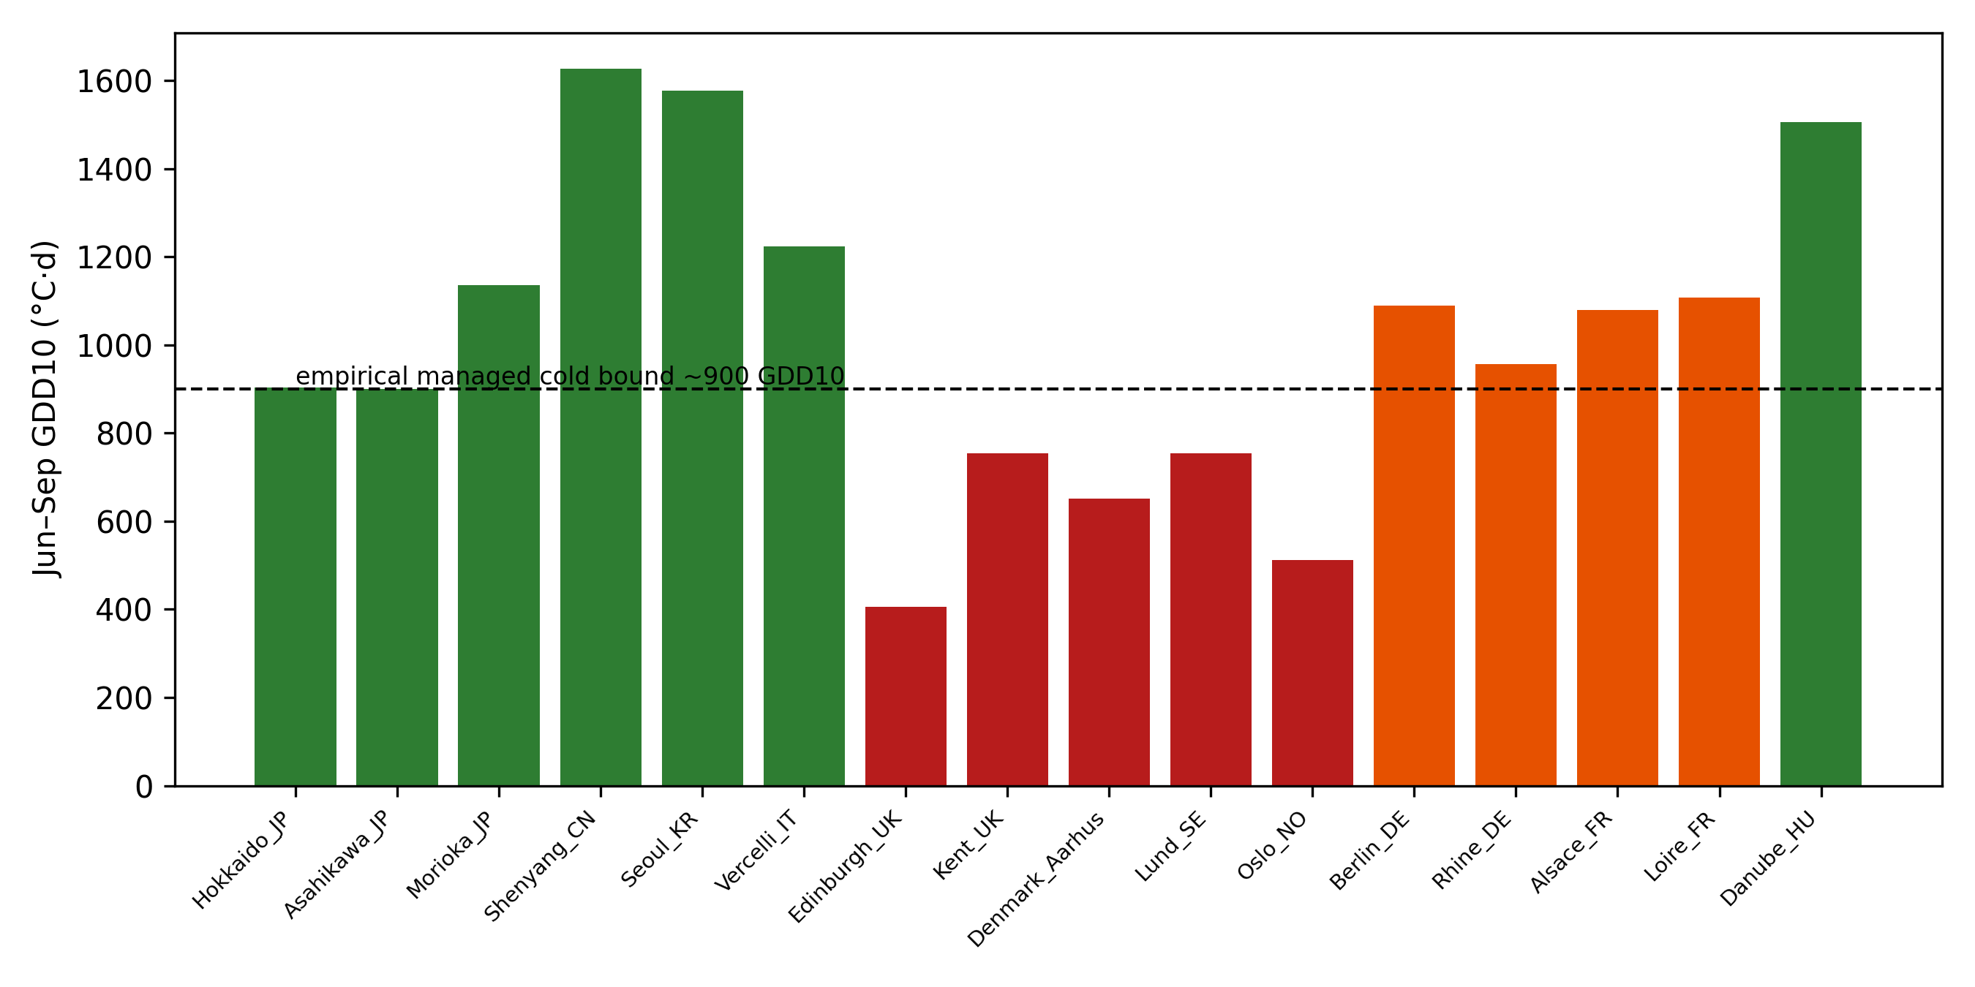
Figure 2. Seasonal GDD10 for cold-region reference points and the empirical cultivation bound (dashed line ~900 GDD10). Hokkaido-region cultivation operates at or below most model cutoffs.
Figure 1 situates this benchmark within the three-question framework (cultivability, sustainability, resilience contribution) used throughout.
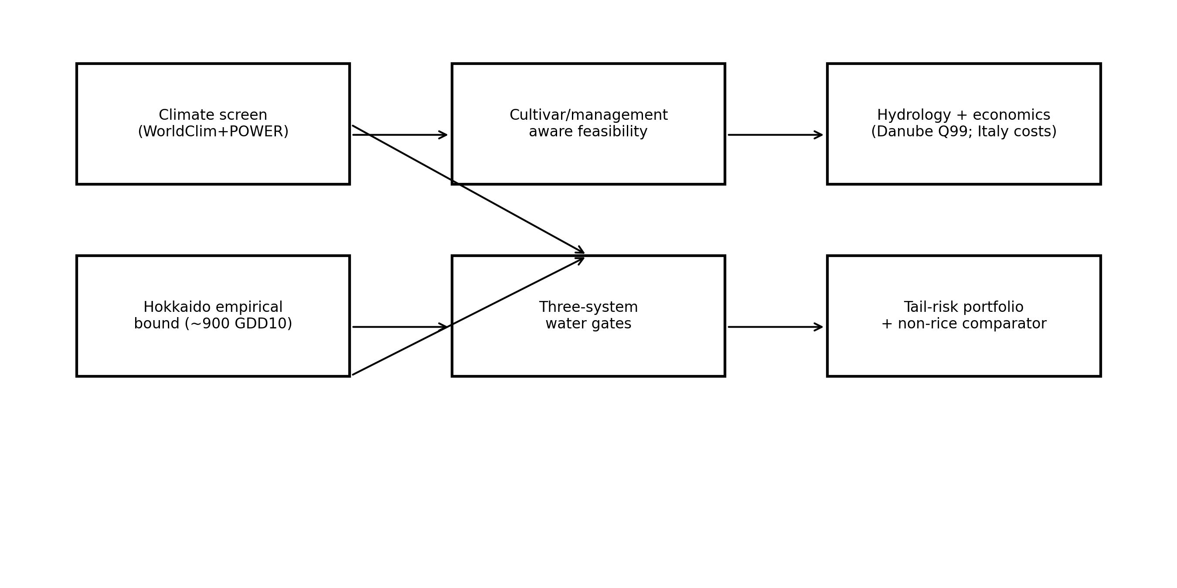
Figure 1. Study framework: three feasibility questions applied to rice diversification beyond traditional regions.

3.2 European agricultural cells
Applied to European agricultural cells, the ~900 GDD10 bound reclassifies several cells previously excluded as unsuitable: Rhine 957, Alsace 1080, Loire 1108, Berlin 1089, Saxony 969, Danube (Hungary) 1506 and the Lower Danube 1750 GDD10 (Figure 3, Table 1). These cells are classified as hypothetical-transfer—the thermal bound is compatible with cultivation under the Hokkaido-style package, but the cultivar-management system and infrastructure are absent, so feasibility is undemonstrated. Edinburgh 405, Oslo 512, Denmark (Aarhus) 652, Tallinn 704, England 722, Lund 755, Vilnius 825 and Munich 870 GDD10 remain below the bound and are classified unsuitable under current technology.
point | gdd10_season_mean
LowerDanube_RO | 1750.0
Balkan_Osijek | 1606.0
SUkraine_Kherson | 1672.0
CentralAsia_Tashkent | 2129.0
CChile | 766.0
Camargue_FR | 1677.0
PoValley_IT | 1556.0
Ebro_ES | 1390.0
NFrance | 983.0
England | 722.0
Germany | 899.0
Hokkaido_JP | 903.0
SJapan | 1820.0
Bangladesh | 2586.0
California | 1863.0
Table 1. Seasonal GDD10 (2000–2024) for evaluated points (first 15 rows shown; full registry in supplementary CSV).
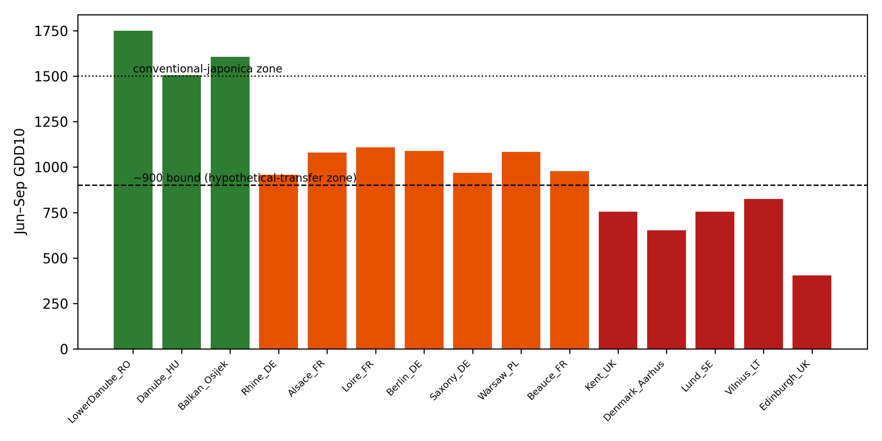
Figure 3. European agricultural cells relative to the empirical ~900 GDD10 bound.

3.3 Lower Danube hydrology
For irrigated lowland rice the hydrological constraint is not channel discharge: Iron Gates mean flow is ~5,420 m3/s and the Q99 low flow is ~1,100 m3/s, versus a ~24 m3/s continuous-equivalent demand for a 250,000 ha scenario (~2% of Q99) (CT-UPT, 2014). The complementary WEAP allocation study for the Iron Gates–Zimnicea reach reports no agricultural deficit under dry, normal or wet scenarios (Salam et al., 2022); low-flow statistics (IGI, 2023) are consistent. The binding constraint is therefore water allocation, conveyance and farm-level delivery—not mainstem supply (Figure 4).
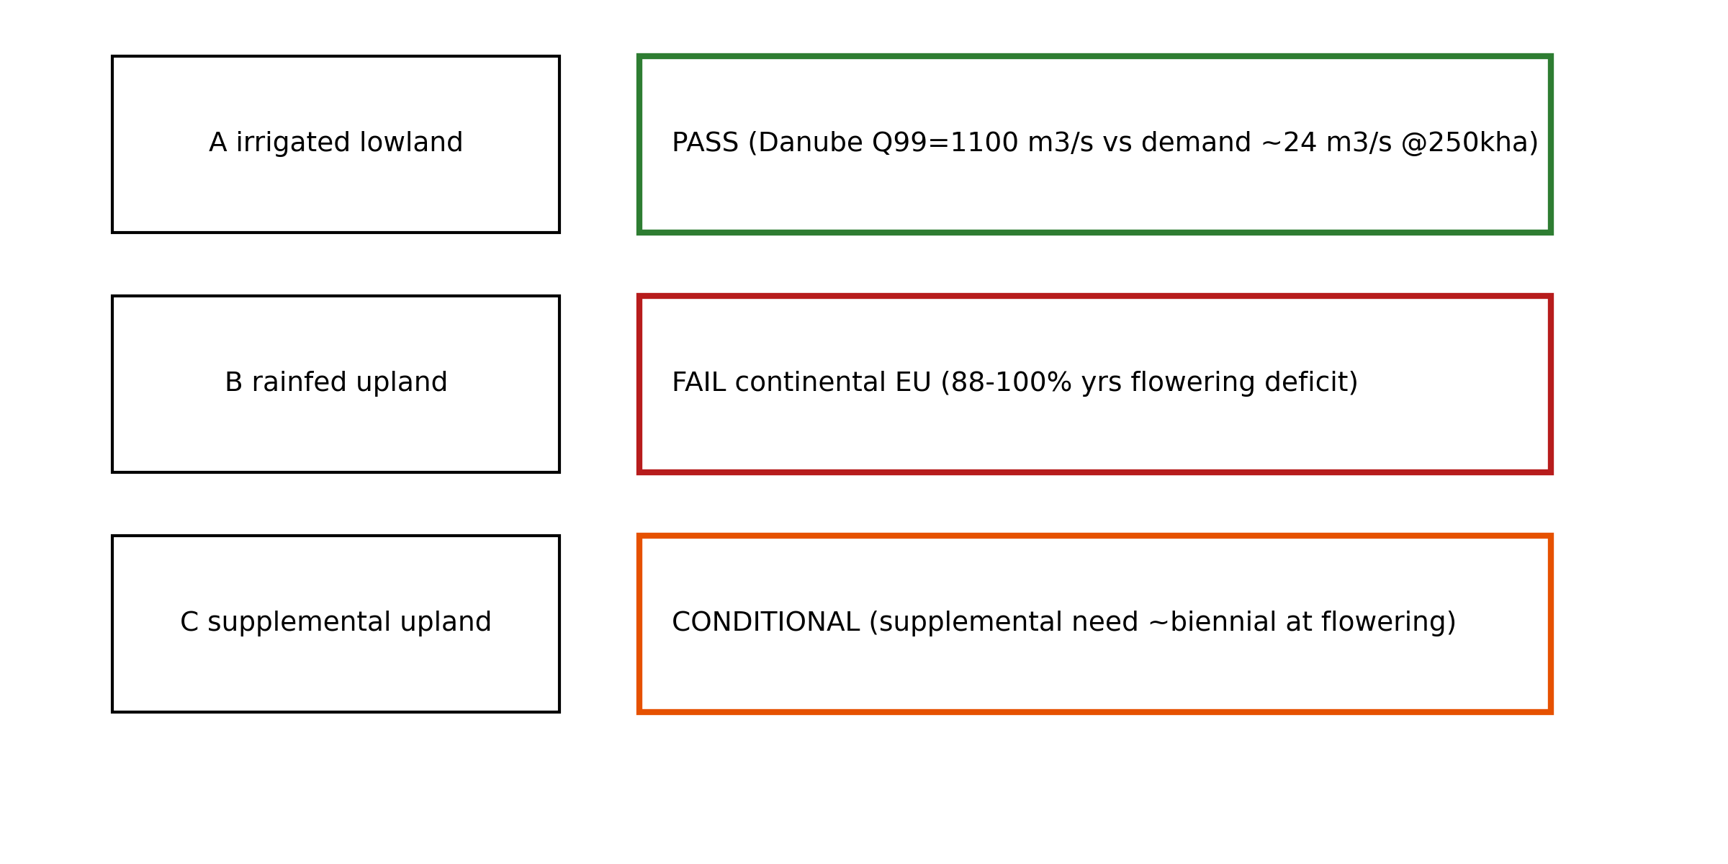
Figure 4. Three cultivation systems’ water gates: irrigated lowland (A), rainfed upland (B) and supplemental irrigation (C).

3.4 Rainfed upland rice: a negative result
The daily water balance for rainfed upland rice shows that the water gate cannot be bypassed in continental Europe. Flowering-stage moisture deficits (>10 days in the flowering window) occur in 88–100% of years across the evaluated continental European cells: Lower Danube 100%, Osijek 100%, Kherson 100%, Loire 100%, Beauce 100%, Danube (Hungary) 96%, Rhine 96%, Alsace 96%, Saxony 92%, Kent 92%, Berlin 88%, Warsaw 88%. The range is different in the evaluated Nordic and Baltic cells: Denmark (Aarhus) 64%, Lund 64%, Vilnius 84% (Figure 5, Table 2). The Japanese exceptions—Morioka 20% and Hokkaido 48%—reflect summer rainfall climatology rather than a transferable strategy: rainfed upland cultivation succeeds there because the rain regime permits it.
point | n_years | P_flower_deficit_10d_pct
Hokkaido_JP | 25 | 48.0
Morioka_JP | 25 | 20.0
LowerDanube_RO | 25 | 100.0
Balkan_Osijek | 25 | 100.0
SUkraine_Kherson | 25 | 100.0
Danube_HU | 25 | 96.0
Rhine_DE | 25 | 96.0
Alsace_FR | 25 | 96.0
Loire_FR | 25 | 100.0
Saxony_DE | 25 | 92.0
Berlin_DE | 25 | 88.0
Beauce_FR | 25 | 100.0
Kent_UK | 25 | 92.0
Denmark_Aarhus | 25 | 64.0
Lund_SE | 25 | 64.0
Table 2. Percentage of years with >10 flowering-stage deficit days (rainfed upland; first 15 rows shown).
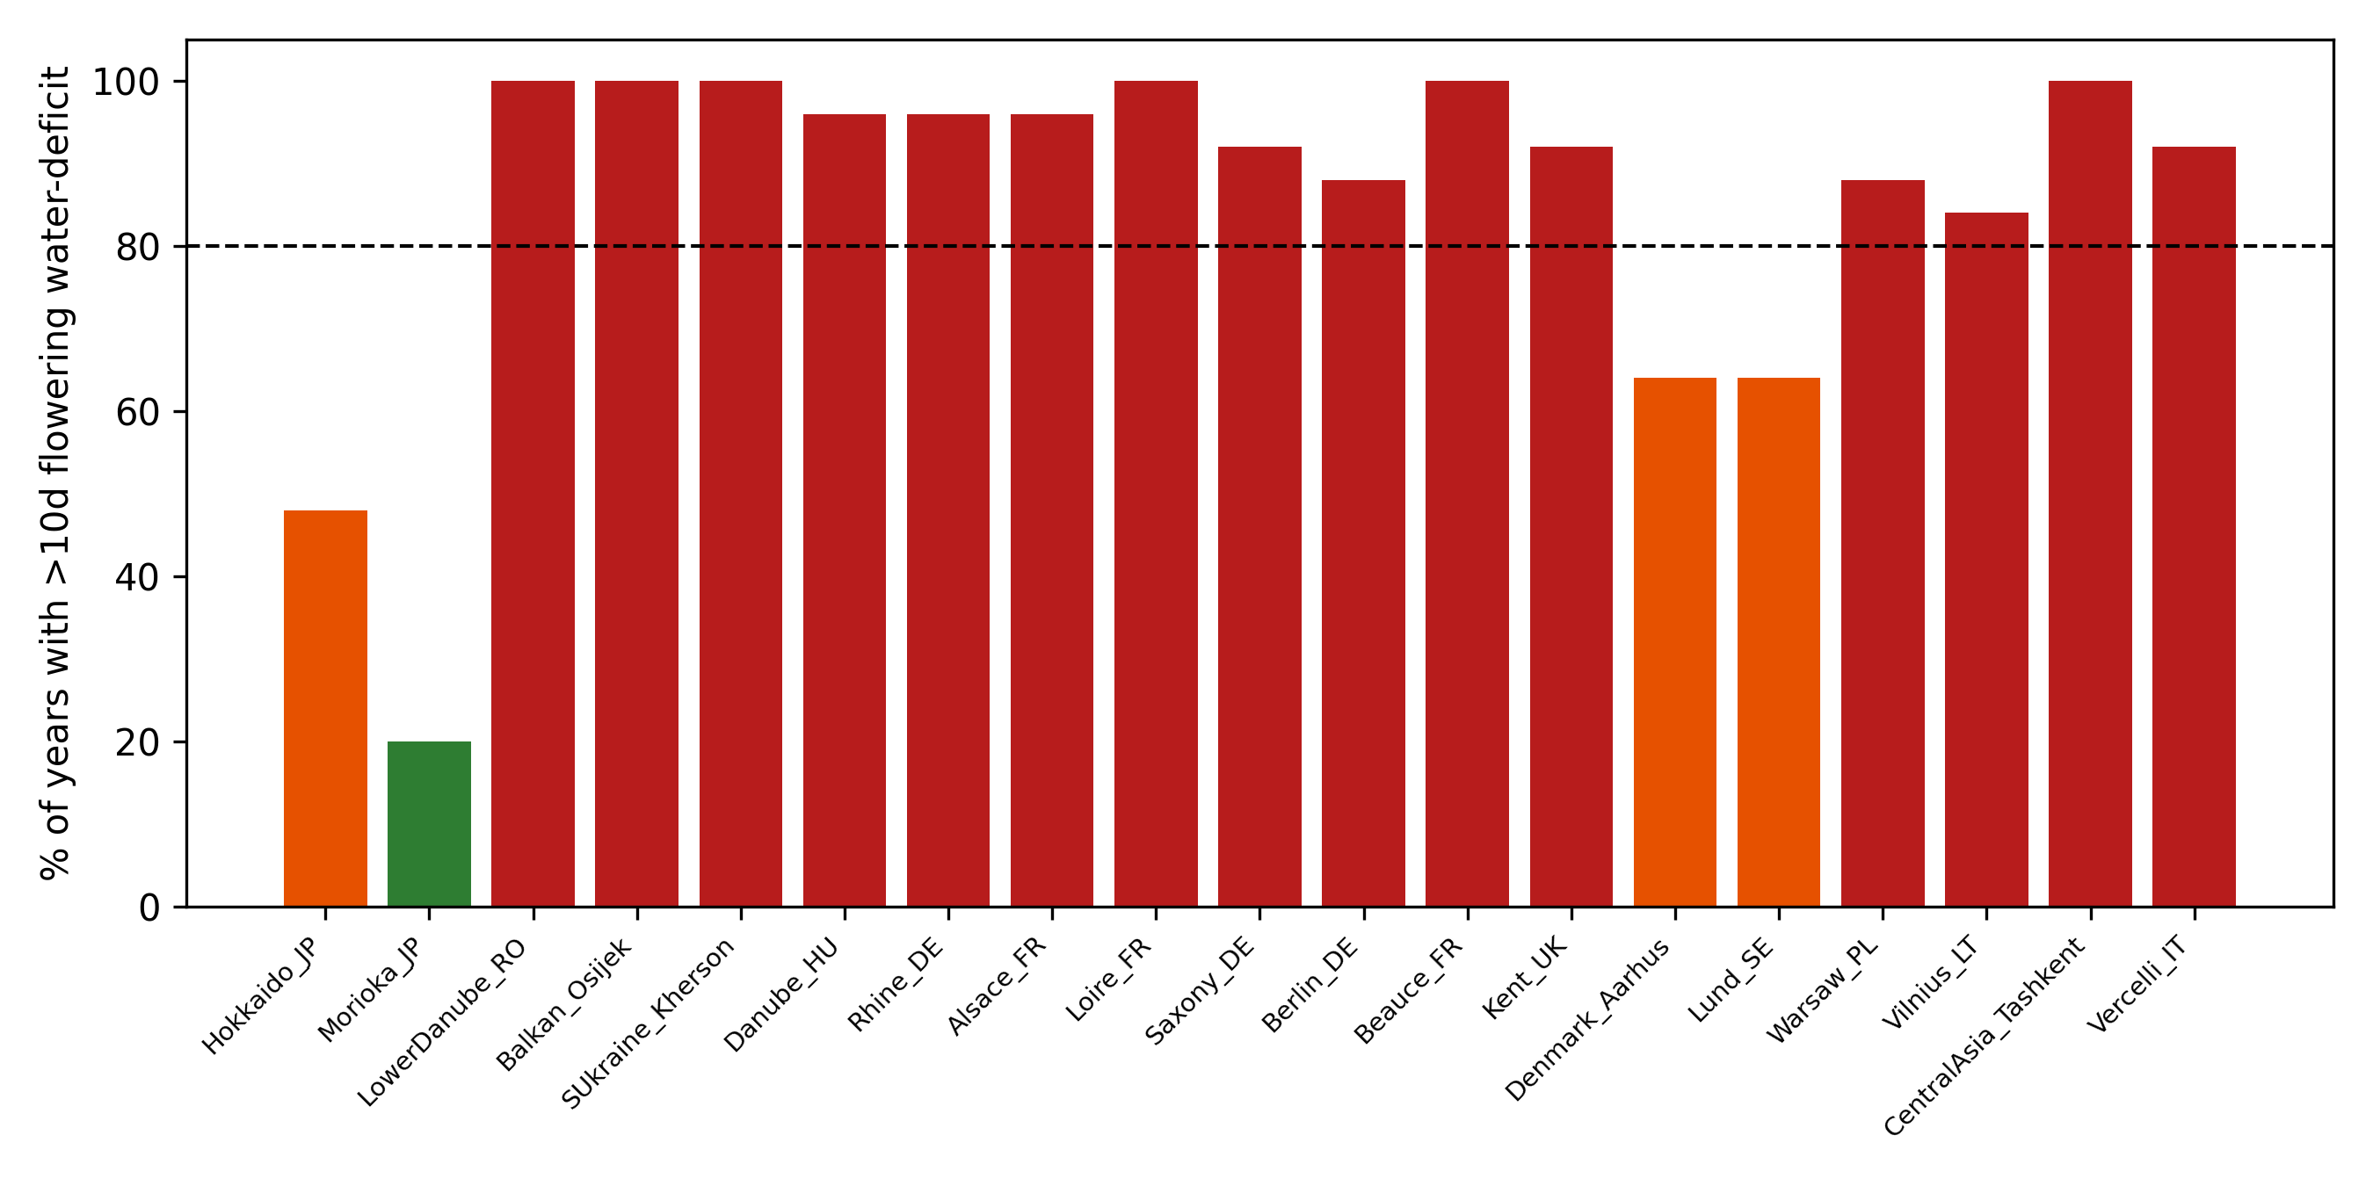
Figure 5. Modeled flowering-stage moisture-deficit frequency by cell (rainfed upland system).
The agricultural meaning is that upland rice is exposed to the same drought conditions that threaten wheat: the diversification benefit disappears precisely under the shocks it is meant to buffer. This is a modeled moisture-stress result—a conservative agronomic gate—not a demonstration of total crop failure, and not an empirically observed joint wheat–rice failure.

3.5 Supplemental irrigation
Under supplemental irrigation (system C), flowering-stage deficits of the same magnitude appear in most years (roughly every other year or more in the evaluated continental cells), so irrigation infrastructure is still required—albeit at a fraction of the lowland volume. Supplemental irrigation is therefore a volume-reduction strategy, not an infrastructure-avoidance strategy.

3.6 Food-supply tail risk
Where wheat–rice yield failures are weakly correlated, adding a 20% rice portfolio share reduces the modeled severe-shortfall probability. Romania falls from 20.3% to 10.9% and Kazakhstan from 21.2% to 3.0% under scenario B (Figure 6, Table 3). The benefit is conditional and asymmetric: Serbia shows no rice benefit under the scenario, and the potato comparator dominates rice there (P_shortfall 0.053 vs 0.211). These are modeled scenario statistics over detrended yields, not observed changes in famine incidence.
country | P_shortfall_A_existing | P_shortfall_B_rice20 | P_shortfall_D_potato
Argentina | 0.047 | 0.016 | 0.031
Australia | 0.156 | 0.078 | 0.047
Bangladesh | 0.328 | 0.266 | 0.25
Bulgaria | 0.203 | 0.172 | 0.188
Chile | 0.078 | 0.062 | 0.062
Croatia | 0.061 | 0.061 | 0.03
France | 0.109 | 0.062 | 0.125
Germany | 0.031 | 0.031 | 0.031
Greece | 0.094 | 0.062 | 0.094
Hungary | 0.188 | 0.156 | 0.156
Italy | 0.016 | 0.0 | 0.0
Japan | 0.047 | 0.031 | 0.031
Table 3. Modeled severe-supply-shortfall probabilities under incumbent (A), 20% rice (B) and potato (D) scenarios.
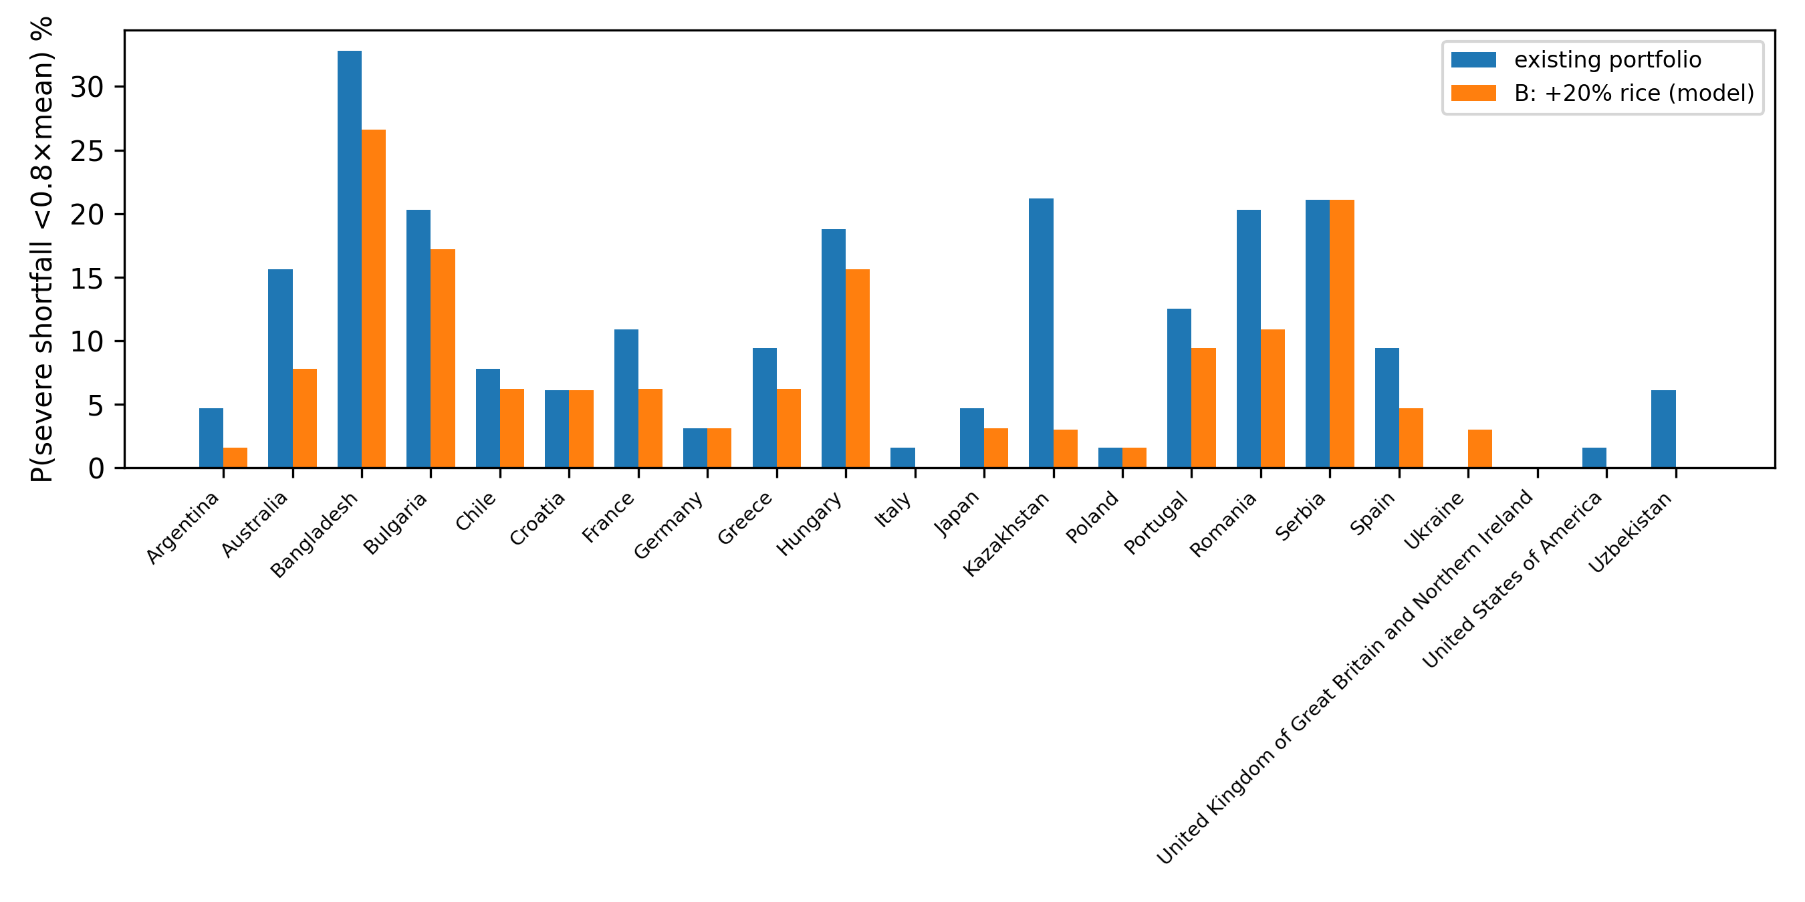
Figure 6. Modeled tail-risk change under rice diversification and the non-rice comparator.

3.7 Economic break-even
Italian observed costs bound the plausible cost structure for temperate paddy: total costs 1,470–2,430 €/ha, variable costs 1,130–1,470 €/ha, gross margins 1,499–4,379 €/ha conventional and 1,318–2,650 €/ha organic (Monaco et al., 2016; Guglielmo et al., 2025). Because Romanian, Bulgarian, Croatian and Serbian rice costs are unobserved in the audited sources, conclusions are limited to break-even conditions: rice diversification is economically plausible where rice gross margin at observed producer prices exceeds the incumbent wheat margin (estimated 300–600 €/ha for the Lower Danube comparator). Uruguay is the only candidate region where commercial expansion is already market-validated (Figure 7).
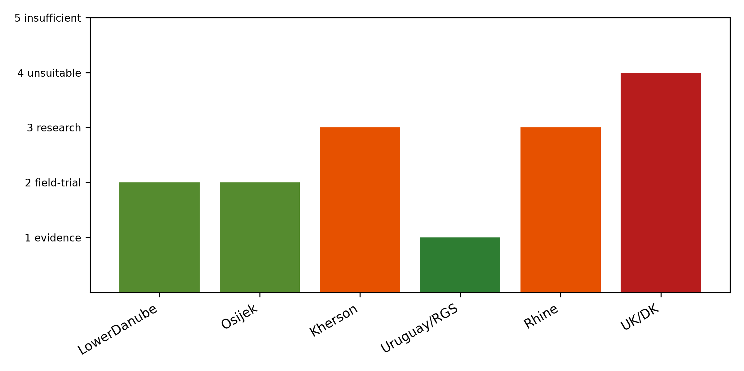
Figure 7. Regional prioritization combining thermal, hydrological and economic gates.

4. Discussion

4.1 Contribution relative to previous work
The general principle that crop diversification does not guarantee failure diversification is established (Gaupp et al., 2020; Mehrabi and Ramankutty, 2019; Renard and Tilman, 2019). This paper does not claim that principle. The increment is operational and bounded in three specific ways. Relative to van Oort and Zwart (2018) and Zabel et al. (2014), which map climatic suitability, the present analysis (i) uses Hokkaido as an empirical challenge showing that suitability bounds are technology-dependent rather than purely climatic, and (ii) separates cultivation systems—irrigated lowland, rainfed upland, supplemental irrigation—whose water gates differ qualitatively. Relative to hydrological and irrigation assessments (Siebert et al., 2015; Molden, 2007), the analysis couples basin-scale abundance with the delivery/allocation caveat and a scenario demand expressed in the same units. Relative to diversification-risk work, the analysis includes a mandatory non-rice comparator so that rice-specific benefits are distinguished from generic diversification. The result is not a new suitability map but a conditional verdict: a single defensible field-trial vector (Lower Danube irrigated lowland), a clear negative result for rainfed upland in continental Europe, and break-even economics elsewhere.

4.2 Why Hokkaido matters
Hokkaido shows that a climate-only model can be empirically falsified by a management system. The 901–903 GDD10 sites are not anomalies of measurement: they are commercial cultivation sustained by a specific package (ultra-early japonica, heated nursery, transplanting, warm-water irrigation). The implication for Europe is deliberately limited: cells above ~900 GDD10 become hypothetical-transfer candidates, not demonstrated feasible—transfer would require the cultivar, nursery infrastructure and management knowledge, none of which currently exist there.

4.3 Why cultivation-system differences matter
The three systems answer different questions. Irrigated lowland passes the hydrological gate at the Lower Danube but requires delivery infrastructure. Rainfed upland fails the water gate in continental Europe in 88–100% of modeled years—and, critically, shares drought exposure with wheat, which destroys the diversification benefit at exactly the moments diversification is supposed to help. Supplemental irrigation reduces volume but not infrastructure need. Treating 'rice' as a single technology conflates these gates and is the central methodological point.

4.4 Limitations
Several limitations bound the claims. (i) The ~900 GDD10 bound is empirical and management-specific; it is not a physiological threshold and its transferability to Europe is undemonstrated. (ii) The water-balance model is a single-layer bucket with TAW = 100 mm and Hargreaves ET0; results are scenario-class moisture-stress indicators, not observed yield or failure. (iii) Danube abundance is mainstem-scale; water rights, conveyance and allocation are unresolved. (iv) Romanian/Bulgarian/Croatian/Serbian rice costs are unobserved; break-even conditions are not demonstrated profitability. (v) Tail-risk values are modeled statistics over detrended yields, not famine incidence, and the wheat–rice dependence is inferred from residuals rather than observed joint failure. (vi) Disease resilience is untested. (vii) Quality and market aspects of northern-Japan rice are context, not results.
Soybean is noted only as a discussion item: as a protein complement it could pair with rice in a diversification portfolio, but it is outside the computational analysis. Controlled-environment agriculture is excluded from the staple analysis on energy-economics grounds (field rice vs a ~10 USD/kg dry-matter floor for vertical farming (Lovat et al., 2025)); it remains at most a niche for emergency seed or specialty supply (ratoon double-cropping verified outdoors by NARO, 2020, is a separate field-based option).
A useful way to read the results is as a feasibility ladder rather than a verdict. At the top, Uruguay is already market-validated and needs no further agronomic proof. Below it, the Lower Danube has passed the hydrological gate and is the only region where a field-scale trial is defensible today; the open question is delivery and cost, not discharge or climate. The B-tier European cells (Rhine, Alsace, Loire, Berlin, Saxony, Danube of Hungary) are research-scale: the thermal bound admits the possibility under a Hokkaido-style package, but no cultivar or nursery infrastructure exists, so the correct response is small cultivar-transfer trials, not policy commitments. Rainfed upland fails across continental Europe and is a documented dead end rather than a candidate for refinement. Central Asia is excluded on water stress regardless of temperature.
The portfolio result should be read with its comparator. Rice is not the best diversification crop everywhere: in Serbia the potato comparator dominates, and where the wheat–rice residual correlation is high the marginal benefit shrinks toward zero. Diversification value is therefore a property of the joint failure structure of the specific portfolio, not of rice per se—and that is precisely why the comparator condition was made mandatory in the design.

4.5 Implications for field trials and policy
The evidence supports one concrete next step: a field-scale irrigated-lowland trial in the Lower Danube under real water-allocation conditions, with region-specific cost data collection to convert break-even framing into observed economics. For the B-tier European cells, the appropriate next step is cultivar-and-management transfer experiments (Hokkaido-style package) at research scale, not deployment.

5. Conclusions
Rice diversification beyond traditional regions is neither uniformly feasible nor uniformly futile: it is conditional on three separable gates. Hokkaido demonstrates that cultivation bounds are technology-dependent; European cells above ~900 GDD10 become hypothetical-transfer candidates, not demonstrated feasibility. At the Lower Danube, mainstem water is abundant and the binding constraint is allocation, making irrigated lowland the only currently defensible field-trial vector. Rainfed upland rice cannot bypass the water gate in continental Europe and shares drought exposure with wheat, so it cannot deliver the intended resilience benefit. Where failure dependence is low, modeled tail-risk probabilities fall—but these are scenario statistics, and a potato comparator outperforms rice in Serbia. Economics remain bounded by break-even conditions pending region-specific cost observations.

Declarations
The author declares no competing interests. All analysis code, registries and reproducibility materials are in the public repository https://github.com/bougtoir/more-rice; licensed or large raw datasets are documented in the acquisition ledger rather than committed. No generative AI wrote the scientific content.

References
Allen, R.G., Pereira, L.S., Raes, D., Smith, M., 1998. Crop evapotranspiration: guidelines for computing crop water requirements. FAO Irrigation and Drainage Paper 56. FAO, Rome.
Beillouin, D., Ben-Ari, T., Malézieux, E., Seufert, V., Makowski, D., 2021. Positive but variable effects of crop diversification on biodiversity and ecosystem services. Global Change Biology 27(19), 4697–4710. https://doi.org/10.1111/gcb.15747
Bouman, B.A.M., Lampayan, R.M., Tuong, T.P., 2007. Water Management in Irrigated Rice: Coping with Water Scarcity. International Rice Research Institute, Los Baños.
Center for Technology, University Politehnica of Timisoara (CT-UPT), 2014. Eco-hydrological assessment of the Iron Gates reservoir, Lower Danube. Timisoara, Romania (peer-reviewed institutional technical report; data extracted to registry).
FAO, 2024. FAOSTAT: Crops and livestock products (QCL); Producer prices. Food and Agriculture Organization of the United Nations, Rome. https://www.fao.org/faostat/ (accessed October 2025).
Farrell, T.C., Fox, K.M., Williams, R.L., Fukai, S., 2006. Genotypic variation for cold tolerance during reproductive development in rice: screening with cold air and cold water. Field Crops Research 98(2–3), 178–194. https://doi.org/10.1016/j.fcr.2006.01.003
Fick, S.E., Hijmans, R.J., 2017. WorldClim 2: new 1-km spatial resolution climate surfaces for global land areas. International Journal of Climatology 37(12), 4302–4315. https://doi.org/10.1002/joc.5086
Gaupp, F., Hall, J., Hochrainer-Stigler, S., Dadson, S., 2020. Changing risks of simultaneous global breadbasket failure. Nature Climate Change 10, 54–57. https://doi.org/10.1038/s41558-019-0600-z
Guglielmo, S., Pietro, D.M., Andrea, C., Narote, A.D., Guidetti, R., Bocchi, S., Vaglia, V., 2025. Sustainability assessment of rice farming: insights from four Italian farms under climate stress. Agriculture 15(17), 1797. https://doi.org/10.3390/agriculture15171797
Hargreaves, G.H., Samani, Z.A., 1985. Reference crop evapotranspiration from temperature. Applied Engineering in Agriculture 1(2), 96–99.
IFPRI, 2019. Global spatially-disaggregated crop production statistics data for 2010 version 2.0 (MapSPAM). International Food Policy Research Institute, Washington, DC. https://mapspam.info (accessed October 2025).
IGI, 2023. Low-flow statistics for the Iron Gates reach of the Danube (93 gauges plus 17 Danube stations, 1980–2020): Q80, Q95 and annual minimum 7-day means. Iron Gates I institutional assessment.
Lobell, D.B., Schlenker, W., Costa-Roberts, J., 2011. Climate trends and global crop production since 1980. Science 333(6042), 616–620. https://doi.org/10.1126/science.1204531
Lovat, S.J., Noor, E., Milo, R., 2025. Vertical farming limitations and potential demonstrated by back-of-the-envelope calculations. Plant Physiology 198(3), kiaf056. https://doi.org/10.1093/plphys/kiaf056
MAFF, 2024. Rice production statistics for Hokkaido and Japan (rice crop statistics). Ministry of Agriculture, Forestry and Fisheries, Tokyo. https://www.maff.go.jp (institutional data source).
Mehrabi, Z., Ramankutty, N., 2019. Synchronized failure of global crop production. Nature Ecology and Evolution 3, 780–786. https://doi.org/10.1038/s41559-019-0862-x
Molden, D. (Ed.), 2007. Water for Food, Water for Life: A Comprehensive Assessment of Water Management in Agriculture. Earthscan, London, and International Water Management Institute, Colombo.
Monaco, F., Sali, G., Ben Hassen, M., Facchi, A., Romani, M., Valè, G., 2016. Water management options for rice cultivation in a temperate area: a multi-objective model to explore economic and water saving results. Water 8(8), 336. https://doi.org/10.3390/w8080336
NARO, 2020. Leapfrogging rice yields using the ratooning ability of paddy rice under warming conditions (research result press release, Kyushu Okinawa Agricultural Research Center, September 8, 2020). National Agriculture and Food Research Organization, Japan. https://www.naro.go.jp/publicity_report/press/laboratory/karc/136334.html
Porter, J.R., Xie, L., Challinor, A.J., Cochrane, K., Howden, S.M., Iqbal, M.M., Lobell, D.B., Travasso, M.I., 2014. Food security and food production systems. In: Climate Change 2014: Impacts, Adaptation, and Vulnerability, IPCC WGII AR5, Cambridge University Press, pp. 485–533.
Ray, D.K., Gerber, J.S., MacDonald, G.K., West, P.C., 2015. Climate variation explains a third of global crop yield variability. Nature Communications 6, 5989. https://doi.org/10.1038/ncomms6989
Renard, D., Tilman, D., 2019. National food production stabilized by crop diversity. Nature 571, 257–260. https://doi.org/10.1038/s41586-019-1316-y
Salam, S., Popescu, I., Scrieciu, A., 2022. Defining a water–energy–food nexus framework for water allocation in the lower Danube between Iron Gates and Zimnicea. Geo-Eco-Marina 28. https://doi.org/10.5281/zenodo.7491458
Siebert, S., Kummu, M., Porkka, M., Döll, P., Ramankutty, N., Scanlon, B.R., 2015. A global data set of the extent of irrigated land from 1900 to 2005. Hydrology and Earth System Sciences 19, 1521–1545. https://doi.org/10.5194/hess-19-1521-2015
UN-Water, 2021. Progress on level of water stress: global status and acceleration needs for SDG Indicator 6.4.2. Food and Agriculture Organization of the United Nations, Rome, on behalf of UN-Water.
White, J.W., Hoogenboom, G., Stackhouse, P.W., Hoell, J.M., 2011. Evaluation of NASA satellite- and model-derived weather data for simulation of maize yield potential in China. Computers and Electronics in Agriculture 79(2), 230–240.
You, L., Wood, S., Wood-Sichra, U., Wu, W., 2014. Generating global crop distribution maps: from census to grid. Earth System Science Data 6, 73–88. https://doi.org/10.5194/essd-6-73-2014
Zabel, F., Putzenlechner, B., Mauser, W., 2014. Global agricultural land resources: a high resolution suitability evaluation and its perspectives until 2100 under climate change conditions. PLoS ONE 9(9), e107522. https://doi.org/10.1371/journal.pone.0107522
Zhang, J., Zhang, S., Cheng, M., Jiang, H., Wang, X., Wang, C., et al., 2017. Effect of drought on agronomic traits of rice and wheat: a meta-analysis. Agronomy for Sustainable Development 37, 52. https://doi.org/10.1007/s13593-017-0457-6
van Oort, P.A.J., Saito, K., Tanaka, A., Amovin-Assagba, E., van Bussel, L.G.J., van Wart, J., et al., 2015. Assessment of rice self-sufficiency in 2025 in eight African countries. Global Food Security 5, 39–49. https://doi.org/10.1016/j.gfs.2015.01.002
van Oort, P.A.J., Zwart, S.J., 2018. Impacts of climate change on rice production in Africa and causes of simulated yield changes. Global Change Biology 24(3), 1029–1045. https://doi.org/10.1111/gcb.13967

