Rapid nationwide transition from interferon-based to interferon-free hepatitis C therapy in Japan: treatment dynamics after reimbursement and their relevance to Asia-Pacific elimination programs
Article type: Original Article
Short title: Interferon-to-DAA transition in Japan
Authors: [To be completed by the authors; given name(s) and family name(s), with affiliation letters as superscripts and 16-digit ORCID iDs]
Affiliations: [To be completed by the authors; institution, department, city, country for each affiliation]
Corresponding author: [Name], [Affiliation], [Full postal address including country], Tel: [telephone], Fax: [fax], Email: [email]
Word count: Abstract: 234 words; main text: 3332 words (the journal's limit of 4,000 words includes the references)
Tables and figures: 3 tables, 3 figures, and 1 graphical abstract (display items within the journal's limit of 6 tables/figures combined)
Conflict of interest: The authors declare that they have no conflict of interest.
Ethics approval: This study used only publicly available, aggregated national open data (NDB Open Data) containing no individual-level or identifiable information; ethics-committee approval was therefore not required. All procedures followed were in accordance with the ethical standards of the Helsinki Declaration.
Informed consent: Not applicable: no individual participants were included in the study.
Consent for publication: Not applicable: the manuscript contains no individual person's data.

Abstract
Background and Aims: Hepatitis C elimination depends on how quickly health systems move people to curative interferon-free therapy once it is reimbursed, yet national treatment dynamics after reimbursement are rarely measured. We describe the nationwide transition from interferon-based to interferon-free hepatitis C therapy in Japan, an Asia-Pacific country with universal insurance and early listing of interferon-free regimens. Methods: Using the national open-data release of Japan's health insurance claims database (fiscal years 2014-2024), we extracted national dispensed quantities of peginterferon, first-generation protease inhibitors given with peginterferon, conventional interferon, ribavirin, and nine interferon-free direct-acting antiviral products. Quantities were converted to estimated treatment courses using documented regimen durations and described with segmented log-linear and exponential trend models. Results: Peginterferon dispensing fell 99.3% from fiscal year 2014 to 2024 (34% per year, 95% confidence interval 22-44%), and protease inhibitors fell below the publication threshold from fiscal year 2016. Estimated total treatment volume rose from 26,307 to a fiscal year 2015 peak of 92,589 courses, then fell 91.4% to 7,950 by fiscal year 2024; the interferon-free share of estimated courses moved from 50.9% to 97.0% within one fiscal year and stayed above 97%. Conclusions: Once interferon-free regimens were listed and subsidized, national hepatitis C treatment switched almost entirely within a year, and total volume surged then declined, a pattern consistent with progressive treatment of the prevalent pool, the dynamic Asia-Pacific elimination programs must plan for after reimbursement.
Graphical Abstract
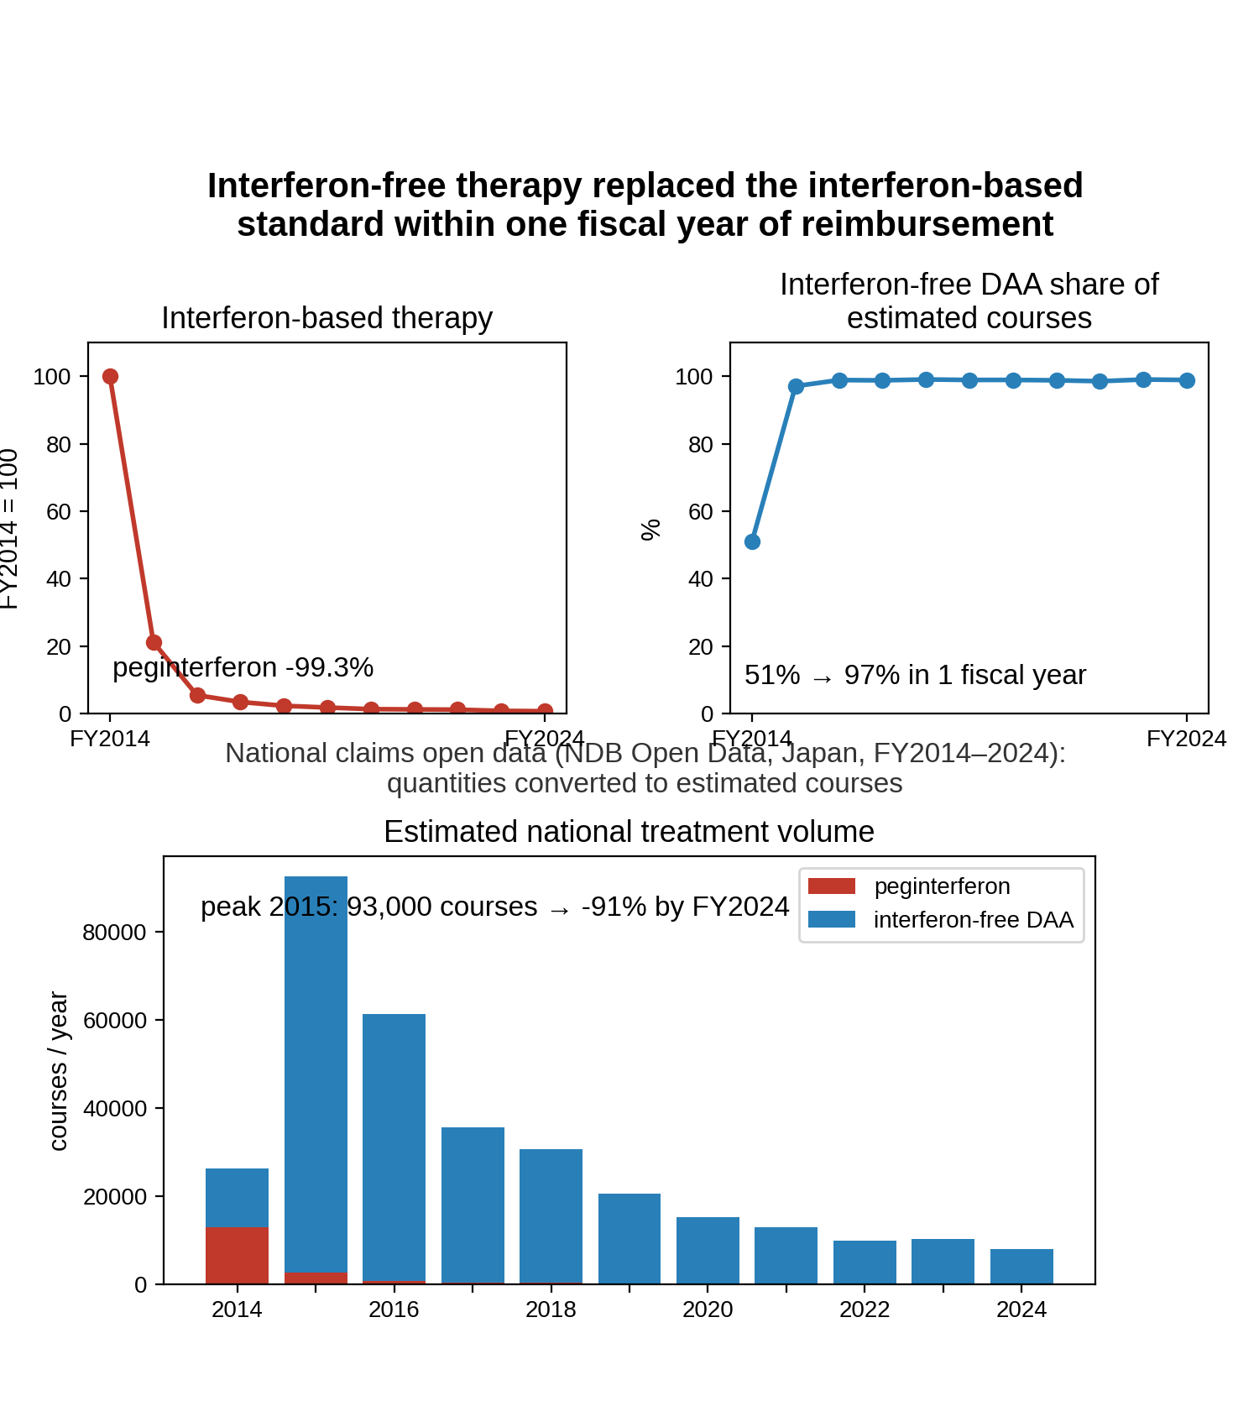
Keywords: hepatitis C; antiviral agents; interferons; direct-acting antivirals; drug utilization; health insurance claims; Japan; treatment switching; pharmacoepidemiology; healthcare policy

Introduction
The World Health Organization has set targets to eliminate hepatitis C virus (HCV) infection as a public health threat by 2030, and treatment initiation is the step most directly under the control of health systems. Globally, an estimated 56.8 million people had viremic infection at the start of 2020 and about 641,000 started treatment that year, a pace that is not on track to meet the targets[1]. The Asia-Pacific region carries a large share of this burden, and although regional guidance has endorsed interferon-free direct-acting antivirals (DAAs) since 2016, access to them has been uneven across the region[1,2]. Where national programs have reimbursed DAAs broadly, uptake has been rapid: Australia, which introduced government-funded DAA treatment prescribable by specialists and general practitioners in March 2016, treated an estimated 32,400 people, about 14% of its chronically infected population, in the remainder of 2016[3], and Taiwan combined public financing with relaxed reimbursement rules toward a target of 250,000 treated patients by 2025[4]. Modeling of 45 high-income countries placed Japan among the 9 on track for the 2030 targets at 2017 levels of diagnosis and treatment and among the 11 on track at 2019 levels, whereas the standing of some other Asia-Pacific economies changed between the two assessments[5,6].
Japan's position rests on a mature national hepatitis policy that combines publicly funded hepatitis testing with a subsidy program that caps out-of-pocket payments for antiviral therapy on top of universal insurance[7-9]. Until 2014, treatment was built around interferon, given for 24-48 weeks with ribavirin and, from 2011, with a first-generation non-structural protein 3/4A (NS3/4A) protease inhibitor; it was poorly tolerated and did not cure everyone[10]. Interferon-free all-oral regimens then arrived in quick succession: daclatasvir plus asunaprevir, approved in July 2014, was the first regimen worldwide to dispense with both interferon and ribavirin[11,12], followed by sofosbuvir-based and pangenotypic regimens with cure rates above 90% and treatment durations of 8-12 weeks[13,14]. Japan has historically approved new drugs later than the United States or Europe[15], but each DAA was listed on National Health Insurance (NHI) within months of approval and brought into the subsidy program as it was listed[9,16].
National analyses of Japan's claims and subsidy-program records have already quantified how many patients were treated with DAAs, at what cost, and where[17,18]. What they do not isolate is the dynamic replacement of an incumbent treatment standard by a new one: how quickly the older therapy is displaced once the new option is reimbursed, and what happens to total treatment volume once the switch is complete. If reimbursement removes the main barrier, national use of the older therapy should collapse and total treatment volume should surge as the diagnosed prevalent pool is treated, then fall toward the flow of new diagnoses; if practical friction—referral pathways, treatment capacity, or clinical caution—dominates, the switch should be gradual. The shape of that trajectory determines how much treatment capacity a program must mobilize and how soon its principal programmatic constraint may shift from treatment delivery toward case-finding. We therefore used NDB Open Data, the national open-data release of Japan's claims database[19], to extend prior national utilization work by describing how national dispensing of interferon-based therapy and of interferon-free DAAs changed around the approval and NHI-listing milestones of 2014-2017, how fast the two exchanged places on a common estimated-course scale, and how much total hepatitis C treatment volume the transition generated.

Materials and Methods
Data. NDB Open Data editions 1-11 cover fiscal years 2014-2024[19]. From the sex- and age-stratified prescription-drug quantity tables (oral, topical, injectable) we extracted the national total dispensed quantity of every product of interest, identified by its marketed product name. Dispensed quantity is counted in tablets or capsules for oral drugs and in syringes or vials for injections; it is not a patient count and is not comparable across products with different dosage units. Japanese fiscal years run from April to March. In each formulation and care-setting table, NDB Open Data lists only the highest-ranked products of each therapeutic class (top 30 or 100, by edition) and shows cells below 1,000 as a dash, so an absent or dashed product is below the publication threshold, not necessarily unused. Such cells are zero in the primary (lower-bound) series; an upper-bound sensitivity series sets every unpublished cell from a product's first listing onward to the largest quantity it could conceal (the smallest published total of its class in that table when the listing cap was reached, otherwise 999). From the 11th edition (FY2024) the listing expands to every product in each class rather than a top-N cap, so low-volume products invisible earlier can reappear; this is a listing-scope change, not resumed use. Of 417 extracted rows, 113 were dashed.
Drug groups. Peginterferon (peginterferon alfa-2a and alfa-2b) is the hepatitis-C-specific marker of interferon-based therapy. The three first-generation NS3/4A protease inhibitors (telaprevir, simeprevir, vaniprevir) were always added to peginterferon plus ribavirin, so they are treated as markers of interferon-based triple therapy and are kept out of the DAA group. Conventional (non-pegylated) interferon is a non-specific background series, being also used for other indications. Ribavirin is also reported separately because it accompanied both peginterferon and the interferon-free sofosbuvir plus ribavirin regimen for genotype 2[13]; its series therefore mixes established and new treatments. The remaining 9 products form the interferon-free DAA group. Official approval and NHI drug-price listing dates, taken from package inserts, Central Social Insurance Medical Council (Chuikyo) records, and company releases, are used as dated milestones at fiscal-year resolution (Table 1)[11,16]. No measure of media coverage or of exposure to it was available, so media effects were not modeled.
Table 1. Official approval and NHI drug-price listing milestones for interferon-free direct-acting antivirals in Japan.
FY | Date | Drug | Milestone | Source
2014 | 2014-07-04 | daclatasvir + asunaprevir | approval | Approval date 2014-07-04 (asunaprevir and daclatasvir package inserts); Bristol-Myers Squibb K.K. press release, 2014-07-04
2014 | 2014-09-02 | daclatasvir + asunaprevir | NHI listing | NHI drug-price listing date 2014-09-02 (asunaprevir and daclatasvir package inserts); market launch 2014-09-03 (Bristol-Myers Squibb K.K. press release)
2015 | 2015-03-26 | sofosbuvir | approval | Sofosbuvir approval date 2015-03-26 (package insert / interview form)
2015 | 2015-05-20 | sofosbuvir | NHI listing | NHI listing 2015-05-20 (Chuikyo plenary decision 2015-05-13; MHLW Health Insurance Bureau notification Ho-i-hatsu 0519 No. 1)
2015 | 2015-07-03 | ledipasvir/sofosbuvir | approval | MHLW marketing approval 2015-07-03 (package insert; reported by Asahi Shimbun, 2015-07-04)
2015 | 2015-08-31 | ledipasvir/sofosbuvir | NHI listing | Ledipasvir/sofosbuvir NHI drug-price listing date 2015-08-31 (package insert)
2017 | 2017-09-27 | glecaprevir/pibrentasvir | approval | Marketing approval 2017-09-27 (PMDA/MHLW; AbbVie GK)
2017 | 2017-11-22 | glecaprevir/pibrentasvir | NHI listing | Glecaprevir/pibrentasvir NHI drug-price listing date 2017-11-22 (Chuikyo plenary decision 2017-11-15; package insert); market launch 2017-11-27
Common scale. Because dispensed quantities of an 8-week tablet regimen and of a 48-week weekly injection are not comparable, we converted quantities to estimated treatment courses using documented daily doses and standard durations from Japanese package inserts and the Japan Society of Hepatology (JSH) guideline[10]. For each interferon-free regimen only one anchor component is counted, so a two-drug regimen is not counted twice; for peginterferon one syringe is one weekly dose, giving 48 syringes for a 48-week course and 24 for a 24-week course as a sensitivity assumption. Peginterferon courses also stand in for the patients who additionally received a protease inhibitor, since those drugs were always added to peginterferon; counting the inhibitors separately would double-count the same treatment episodes. Ribavirin is excluded from course estimates because it does not identify a single regimen. Adding interferon-free DAA courses to peginterferon courses gives an approximate national hepatitis C antiviral treatment volume, and the DAA share of it measures substitution on one scale. These are estimates that depend on the regimen assumptions, not observed patient counts.
Statistical analysis. NDB Open Data begins in FY2014, the period in which interferon-free DAAs became available, so there is no pre-intervention baseline and a conventional interrupted time series is not identifiable. With 11 annual national observations we fitted descriptive trend models. Total DAA dispensing and the combined estimated treatment volume were each fitted with a continuous segmented (broken-stick) log-linear model with a knot at the observed peak fiscal year (Equation 1), giving separate pre- and post-peak annual multiplicative rates. Each interferon-based drug was fitted with an exponential (log-linear) decay over the fiscal years with positive dispensing (Equation 2). Because the knot was fixed at the observed peak rather than estimated independently, and because only two annual observations preceded it, inference for the slope-change term was considered model-based and exploratory.
$$\text{ln }Q_{t} = β_{0} + β_{1}(t − t_{0}) + β_{2}{(t − t_{0})}^{\text{+}} + ε_{t}$$ (1)
$$\text{ln }Q_{t} = α + γt + ε_{t}, \text{annual change = }e^{γ} − 1$$ (2)
where $Q_{t}$ is the national dispensed quantity in fiscal year $t$, $t_{0}$ the peak fiscal year, ${(t − t_{0})}^{\text{+}} = \text{max}(0, t − t_{0})$; $β_{1}$ and $β_{2}$ are the pre- and post-knot slope coefficients in Equation (1), $γ$ is the slope in Equation (2), and the annual multiplicative change is $e^{β_{1}} − 1$ before the knot and $e^{(β_{1} + β_{2})} − 1$ after the knot in Equation (1), and $e^{γ} − 1$ in Equation (2).
Uncertainty is summarized with heteroskedasticity- and autocorrelation-consistent (Newey-West, maxlags = 1) 95% intervals[20], cross-checked against a residual bootstrap (10,000 resamples)[21]. They describe how fast dispensing changed and how precisely that rate can be pinned down; they are not causal estimates, and no comparison condition is available. Because the DAA peak falls in the second fiscal year of the series, the pre-peak segment rests on 2 observations and is reported for completeness rather than as an estimated rate. Analyses used Python with statsmodels, and the pipeline regenerates every reported number, figure, and table from the public data.

Results
Interferon-based therapy fell away quickly (Figure 1, Table 2). Peginterferon dispensing dropped 99.3% between FY2014 and FY2024, from 619,333 to 4,240 syringes, a decline of 34% per year (95% CI 22-44%; P < 0.001). The first-generation protease inhibitors, given only with peginterferon, went from 826,748 published units in FY2014 to below the publication threshold in every table from FY2016 (at most 8,991 units in FY2024). Conventional interferon, which is not hepatitis-C-specific, fell more gradually (94.9% overall; 25% per year, 95% CI 24-26%; P < 0.001), a background comparison: the much steeper fall in peginterferon is not explained by a general drift in interferon use.
Ribavirin, shared by older and newer regimens, fell from 10,166,159 units in FY2014 to 3,124 published units in FY2018 and was below the publication threshold in every table from FY2020 to FY2023. In FY2024, when the listing expanded to every product in each class, a small total (28,508 units) is published again—a visibility change under the widened listing, not resumed use. The FY2018-FY2019 values come only from tables still listing ribavirin, and their movement lies within what unlisted cells could conceal, so it is not interpreted. Fitted over the fiscal years with published dispensing (FY2014-FY2024), its decline was 50% per year (95% CI 30-65%; P < 0.001). Because ribavirin was used with peginterferon and with interferon-free sofosbuvir, this rate describes the combined retreat of both regimens and is not evidence about interferon-based therapy alone.
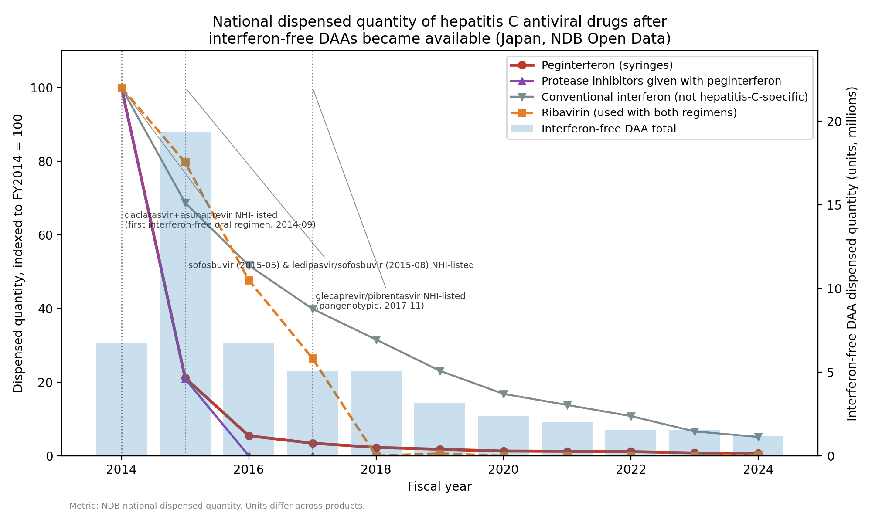
Figure 1. National dispensed quantity of hepatitis C antiviral drugs, indexed to FY2014 = 100, with total interferon-free DAA dispensing on the right axis and dated approval and NHI-listing milestones. Ribavirin and conventional interferon are shown separately because they do not mark interferon-based hepatitis C therapy uniquely.
Table 2. National dispensed quantity by drug group and fiscal year (NDB Open Data). Units differ across groups and are not additive. Values are the published totals and are lower bounds; NP, not published in any table (below the top-ranked listing cap of the class or shown as a dash for values below 1,000), with the maximum quantity the unpublished cells could conceal in parentheses.
Fiscal year | Peginterferon (syringes) | First-generation protease inhibitors (with peginterferon) | Conventional interferon (not hepatitis-C-specific) | Ribavirin (both regimens) | Interferon-free DAA total
2014 | 619,333 | 826,748 | 326,802 | 10,166,159 | 6,736,616
2015 | 131,081 | 173,122 | 224,563 | 8,100,850 | 19,374,861
2016 | 33,688 | NP (≤284,823) | 168,967 | 4,849,660 | 6,783,118
2017 | 21,176 | NP (≤444,730) | 130,383 | 2,687,890 | 5,062,848
2018 | 14,162 | NP (≤530,758) | 103,120 | 3,124 | 5,051,120
2019 | 10,961 | NP (≤506,393) | 75,458 | 62,956 | 3,165,028
2020 | 8,013 | NP (≤336,918) | 54,982 | NP (≤112,306) | 2,356,769
2021 | 7,534 | NP (≤241,864) | 45,147 | NP (≤80,622) | 1,994,076
2022 | 7,073 | NP (≤233,392) | 35,298 | NP (≤77,798) | 1,545,191
2023 | 4,836 | NP (≤187,965) | 21,673 | NP (≤62,561) | 1,527,987
2024 | 4,240 | NP (≤8,991) | 16,816 | 28,508 | 1,164,534
Interferon-free DAA dispensing rose and then receded (Figure 2). Total DAA dispensing peaked in FY2015 at 19.4 million units, 188% above FY2014, and then fell 94% to 1.2 million units by FY2024, with each generation of product giving way to the next. In the segmented model, dispensing declined 23.8% per year after the FY2015 peak (95% CI 19.9-27.5%; P < 0.001), and the slope-change term was -0.77 log units per year (95% CI -1.21 to -0.32; P < 0.001), a model-based estimate given the fixed knot. With later low-volume cells unpublished, that decline is an upper limit: in the upper-bound series (unpublished cells at most 34% of the published DAA total in any year) the peak-to-FY2024 fall is 94% and the post-peak decline 22.2% per year (95% CI 18.6-25.6%). The pre-peak segment corresponds to 64% per year but rests on only 2 observations (bootstrap -13.5% to 154.5%, including zero); it is a single year-on-year increment, not an estimated trend.
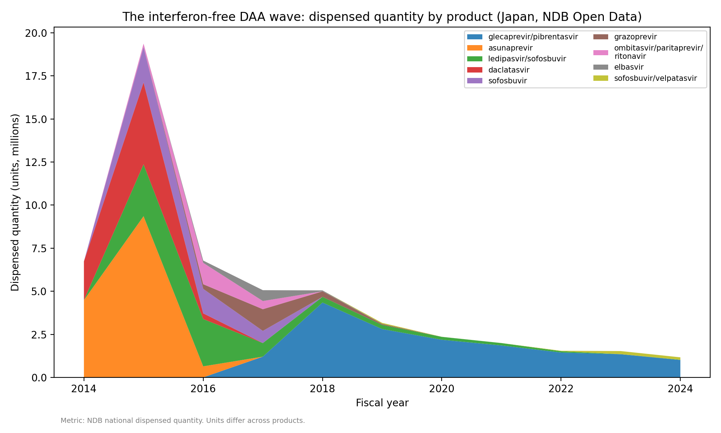
Figure 2. Interferon-free DAA dispensed quantity by product, fiscal years 2014-2024.
Placing both therapies on the estimated-course scale shows the exchange directly (Figure 3, Table 3). Estimated peginterferon courses fell from about 12,903 in FY2014 to about 88 in FY2024, while estimated interferon-free DAA courses peaked at about 89,858 in FY2015. The combined estimated treatment volume rose from 26,307 courses in FY2014 to 92,589 in FY2015 and then declined 91.4% to 7,950 by FY2024 (23.4% per year after the peak, 95% CI 20.7-26.0%; P < 0.001; slope change -1.26 log units per year, 95% CI -1.55 to -0.97, P < 0.001). The DAA share of estimated courses went from 50.9% in FY2014 to 97.0% in FY2015 and remained at 98.9% in FY2024. Over FY2014-FY2024 the estimated cumulative interferon-free DAA volume was 270,939-305,499 courses depending on the duration assumption. These are estimates derived from regimen durations, not counts of treated people.
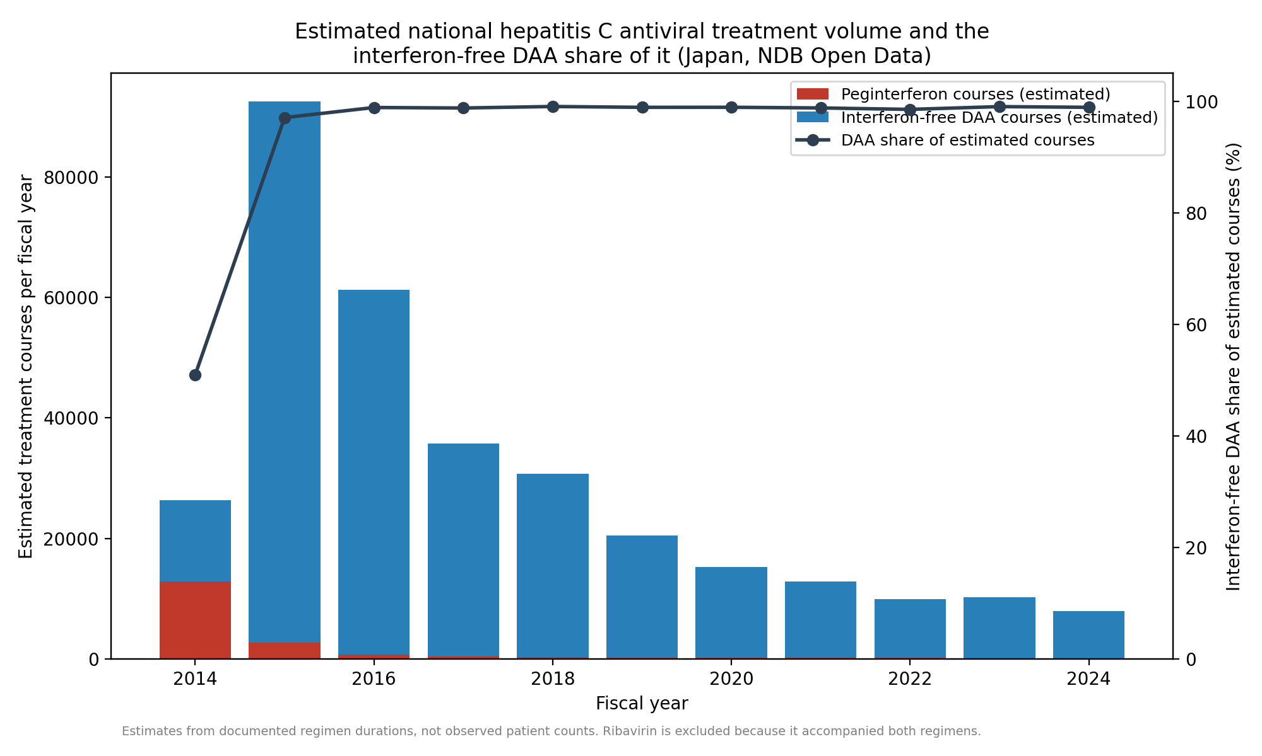
Figure 3. Estimated national hepatitis C antiviral treatment volume (interferon-free DAA courses plus peginterferon courses) and the DAA share of it. Ribavirin is excluded because it accompanied both interferon-based and interferon-free regimens.
Table 3. Estimated treatment courses by fiscal year (estimates from documented regimen durations, one anchor product per regimen; not observed patient counts).
Fiscal year | Interferon-free DAA courses | Interferon-free DAA courses (longer-duration assumption) | Peginterferon courses | Combined treatment volume | DAA share (%)
2014 | 13,404 | 13,404 | 12,903 | 26,307 | 50.9
2015 | 89,858 | 89,858 | 2,731 | 92,589 | 97.0
2016 | 60,598 | 60,598 | 702 | 61,300 | 98.9
2017 | 35,292 | 32,903 | 441 | 35,733 | 98.8
2018 | 30,473 | 21,853 | 295 | 30,768 | 99.0
2019 | 20,275 | 14,354 | 228 | 20,503 | 98.9
2020 | 15,052 | 10,700 | 167 | 15,219 | 98.9
2021 | 12,712 | 9,027 | 157 | 12,868 | 98.8
2022 | 9,799 | 6,793 | 147 | 9,947 | 98.5
2023 | 10,174 | 6,423 | 101 | 10,275 | 99.0
2024 | 7,862 | 5,026 | 88 | 7,950 | 98.9

Discussion
We asked whether national use of an established standard therapy falls steeply once a new option is approved and reimbursed, or whether it changes slowly enough to indicate practical friction. In hepatitis C the first pattern is unambiguous. Dispensing shifted so fast that interferon-free regimens accounted for almost all estimated treatment courses within one fiscal year of the first interferon-free listing, and the interferon-based drugs had fallen to negligible levels or below the publication threshold within about two years. This rapid displacement is consistent with limited aggregate friction between reimbursement and treatment on an annual scale, although the data do not isolate any specific barrier.
The surge and decline in total treatment volume needs careful interpretation. A curative therapy given to people who already have the infection will produce exactly this shape without invoking anticipation effects: the prevalent pool is treated over a few years and annual demand then approaches the much smaller flow of newly diagnosed patients. The pattern is therefore consistent with, but not evidence for, a backlog of patients who had been waiting for a tolerable option. Its magnitude does suggest that a large pool was available to treat: the estimated 270,939-305,499 interferon-free DAA courses over 11 fiscal years are of the same order as the hepatitis C population known to be in care in Japan before DAAs, estimated at about 520,000 patients receiving care in 2011 with a further 167,000-767,000 diagnosed but untreated[22]. A national claims study covering more than 98% of Japanese healthcare reported 357,877 patients treated with DAAs between fiscal years 2013 and 2022, a 40% fall in the prevalence of care for chronic hepatitis C, and hepatitis C healthcare costs peaking in 2015[17]. A subsequent evaluation adding subsidy-program records estimated about 300,000 treated patients and a cumulative cost above 1.23 trillion yen over FY2014-2023, with prefecture-level detail[18]. Those studies quantify who was treated and at what cost; we extend them on a different axis, quantifying the replacement dynamics themselves on a course-equivalent scale that includes the interferon era. Our course estimates are somewhat lower, as expected when one anchor product per regimen is converted with fixed durations, and the peak timing agrees; together they suggest the dispensing-based estimates track the treated population reasonably well.
Several factors besides a treatment backlog plausibly contributed, and the data cannot separate them. The new regimens were shorter, all-oral, and far better tolerated, with cure rates above 90% in Japanese phase 3 studies[10,12-14], so both clinicians and patients had strong reasons to switch as soon as the option existed. Japan also removes the cost barrier: on top of universal insurance, the national program for the promotion of hepatitis treatment subsidizes antiviral therapy so that most patients pay a capped monthly amount, and hepatitis C DAAs were brought into that program as they were listed[8,9]. Comparison with settings that lack such a scheme is instructive: among insured United States adults diagnosed in 2019-2020, only 23-35% started DAA treatment within a year, varying by payer[23]. Availability alone does not produce this pattern; the observed speed most likely reflects a decisively better therapy, prompt NHI listing, and subsidized affordability against a large diagnosed backlog. We measured none of the mechanisms individually, and no measure of media coverage or of exposure to it entered the analysis.
The Japanese trajectory bears directly on elimination planning elsewhere in the Asia-Pacific region. Australia, which began government-funded DAA treatment in March 2016, likewise recorded a large initial wave of treatment initiation[3], and Taiwan built its national program around a time-limited treatment target backed by public financing and progressively relaxed reimbursement rules[4]. In each case the operational question is the one our data address: after reimbursement, how quickly is the diagnosed pool treated, and how soon might the principal programmatic constraint move from treatment access toward diagnosis and linkage to care? In Japan the switch itself took about one fiscal year and the bulk of the volume was dispensed within roughly five years, after which estimated courses declined by about 23% per year. Sustaining progress in that later phase depends on case-finding rather than on treatment supply: in Japan the groups now explicitly targeted by national countermeasures are undiagnosed carriers and diagnosed carriers who have never consulted, or have dropped out of, medical care[7]. Elimination forecasts that hold diagnosis and treatment at recent levels[5,6] should therefore be read against where a country sits on this curve: a falling treatment count after a completed switch is the expected signature of a treated pool, not necessarily of a failing program. Conversely, where DAAs are approved but reimbursement is restricted or out-of-pocket costs remain high[1,23], the same therapy will not produce this pattern. Japan's experience shows what prompt listing combined with subsidy can achieve in a population with a large diagnosed pool; it does not show what approval alone achieves, and it does not identify which of the contributing mechanisms mattered most.

Limitations
NDB Open Data begins in FY2014, the period in which interferon-free DAAs launched, so no pre-DAA interferon baseline exists within it and the FY2014 value already reflects decline from an earlier peak; the analysis speaks to the speed of the observed displacement rather than its full extent. Dispensed quantity is not a patient count, units are not comparable across products, and the course figures are estimates that inherit their regimen assumptions; the shorter-duration sensitivity analysis indicates the size of that dependence. Because NDB Open Data omits lower-ranked products and masks small cells, low-volume products and declining tails are underestimated, apparent disappearance means only that a drug fell below the publication threshold, and the later protease-inhibitor and ribavirin values are lower bounds. The upper-bound analysis is a bound derived from the publication rules, not an observed total; within it these omissions change the post-peak decline of combined treatment volume from 23.4% to 21.7% per year and the interferon-free share by less than 0.5 percentage points, and alter neither the peak year nor any trend's direction, because the large early quantities carrying the main findings lie far above the threshold. Ribavirin cannot be assigned to either therapy, which is why it is reported separately and excluded from course estimates, and conventional interferon is not hepatitis-C-specific. The data are annual, so within-year timing around a listing date is invisible; with 11 observations, no control condition, and no pre-period, the trend models are descriptive and the pre-peak DAA segment in particular rests on two observations; accordingly the slope-change P values are reported for completeness but are model-based and should not be interpreted as formal change-point evidence. Secular changes from FY2020, including the effect of the COVID-19 pandemic on outpatient care, cannot be separated from the continuing decline. Finally, no measure of media coverage or of exposure to it was available, and the aggregate data cannot be stratified by genotype, fibrosis stage, treatment history, or region.

Conclusions
National hepatitis C treatment in Japan moved almost entirely from interferon-based to interferon-free regimens within a year of the first interferon-free reimbursement, and interferon-based dispensing was negligible within about two years. Total estimated treatment volume rose and then fell steeply, a pattern consistent with progressive treatment of a prevalent population. For Asia-Pacific elimination programs the trajectory is a planning template: once a decisively better therapy is listed promptly and made affordable, the principal programmatic constraint may shift within a few years from treatment delivery toward case-finding and linkage to care. It does not follow that the same therapy would be adopted as quickly in systems without comparable coverage and subsidy.

Declarations
Acknowledgements: None.
Funding: This research did not receive any specific grant from funding agencies in the public, commercial, or not-for-profit sectors.
Conflict of interest: The authors declare that they have no conflict of interest.
Ethics approval: This study used only publicly available, aggregated national open data and involved no individual-level or identifiable information; ethics-committee approval was therefore not required.
Consent to participate: Not applicable.
Consent for publication: Not applicable.
Availability of data and material: Data derived from a source in the public domain: the raw NDB Open Data workbooks are published by the Ministry of Health, Labour and Welfare and can be re-downloaded with the provided script (scripts/download_ndb.py). All derived datasets are openly available at https://github.com/bougtoir/ndb-dea-drug-lag.
Code availability: All analysis code and the figure and manuscript generators are openly available at https://github.com/bougtoir/ndb-dea-drug-lag, so the full pipeline (download, build, analyze, figures, manuscript) reproduces every reported number, figure, and table from the public data.
Authors' contributions: [To be completed by the authors using the CRediT taxonomy. All authors read and approved the final manuscript.]

References
1. Polaris Observatory HCV Collaborators. Global change in hepatitis C virus prevalence and cascade of care between 2015 and 2020: a modelling study. Lancet Gastroenterol Hepatol. 2022;7(5):396-415. doi:10.1016/S2468-1253(21)00472-6
2. Omata M, Kanda T, Wei L, et al. APASL consensus statements and recommendation on treatment of hepatitis C. Hepatol Int. 2016;10(5):702-726. doi:10.1007/s12072-016-9717-6
3. Hajarizadeh B, Grebely J, Matthews GV, Martinello M, Dore GJ. Uptake of direct-acting antiviral treatment for chronic hepatitis C in Australia. J Viral Hepat. 2018;25(6):640-648. doi:10.1111/jvh.12852
4. Chien RN, Lu SN, Pwu RF, Wu GH, Yang WW, Liu CL. Taiwan accelerates its efforts to eliminate hepatitis C. Glob Health Med. 2021;3(5):293-300. doi:10.35772/ghm.2021.01064
5. Razavi H, Sanchez Gonzalez Y, Yuen C, Cornberg M. Global timing of hepatitis C virus elimination in high-income countries. Liver Int. 2020;40(3):522-529. doi:10.1111/liv.14324
6. Gamkrelidze I, Pawlotsky JM, Lazarus JV, et al. Progress towards hepatitis C virus elimination in high-income countries: an updated analysis. Liver Int. 2021;41(3):456-463. doi:10.1111/liv.14779
7. Tanaka J, Akita T, Ko K, Miura Y, Satake M; Epidemiological Research Group on Viral Hepatitis and its Long-term Course, Ministry of Health, Labour and Welfare of Japan. Countermeasures against viral hepatitis B and C in Japan: an epidemiological point of view. Hepatol Res. 2019;49(9):990-1002. doi:10.1111/hepr.13417
8. Setoyama H, Tanaka Y, Kanto T. Seamless support from screening to anti-HCV treatment and HCC/decompensated cirrhosis: subsidy programs for HCV elimination. Glob Health Med. 2021;3(5):335-342. doi:10.35772/ghm.2021.01079
9. Ministry of Health, Labour and Welfare (Japan). Special program for the promotion of hepatitis treatment (medical-expense subsidy for antiviral treatment of viral hepatitis). https://www.mhlw.go.jp/stf/seisakunitsuite/bunya/kenkou_iryou/kenkou/kekkaku-kansenshou/kanen/kangan/iryouhijyosei.html. Accessed September 27, 2026.
10. Drafting Committee for Hepatitis Management Guidelines, the Japan Society of Hepatology. Japan Society of Hepatology guidelines for the management of hepatitis C virus infection: 2019 update. Hepatol Res. 2020;50(7):791-816. doi:10.1111/hepr.13503
11. Bristol-Myers Squibb K.K. Press release: approval in Japan of Daklinza (daclatasvir) and Sunvepra (asunaprevir), the world's first all-oral, interferon- and ribavirin-free treatment for chronic hepatitis C. 4 July 2014. https://www.bms.com/jp/media/press-release-listing/press-release-listing-2014/20140704.html. Accessed September 27, 2026.
12. Kumada H, Suzuki Y, Ikeda K, et al. Daclatasvir plus asunaprevir for chronic HCV genotype 1b infection. Hepatology. 2014;59(6):2083-2091. doi:10.1002/hep.27113
13. Omata M, Nishiguchi S, Ueno Y, et al. Sofosbuvir plus ribavirin in Japanese patients with chronic genotype 2 HCV infection: an open-label, phase 3 trial. J Viral Hepat. 2014;21(11):762-768. doi:10.1111/jvh.12312
14. Mizokami M, Yokosuka O, Takehara T, et al. Ledipasvir and sofosbuvir fixed-dose combination with and without ribavirin for 12 weeks in treatment-naive and previously treated Japanese patients with genotype 1 hepatitis C: an open-label, randomised, phase 3 trial. Lancet Infect Dis. 2015;15(6):645-653. doi:10.1016/S1473-3099(15)70099-X
15. Tanaka M, Idei M, Sakaguchi H, et al. Evolving landscape of new drug approval in Japan and lags from international birth dates: retrospective regulatory analysis. Clin Pharmacol Ther. 2021;109(5):1265-1273. doi:10.1002/cpt.2080
16. Ministry of Health, Labour and Welfare (Japan), Central Social Insurance Medical Council (Chuikyo). Records of National Health Insurance drug-price listings of direct-acting antivirals for hepatitis C, 2014-2017 (Chuikyo plenary minutes and Health Insurance Bureau notifications; the document cited for each date is listed in the study repository, https://github.com/bougtoir/ndb-dea-drug-lag). https://www.mhlw.go.jp/stf/shingi/shingi-chuo_128154.html. Accessed September 27, 2026.
17. Yamashita S, Kanda N, Hashimoto H, et al. Trends in the healthcare burden of hepatitis C after the introduction of direct-acting antivirals in Japan, 2013-2022: a national claims database study in Japan. Int J Infect Dis. 2025;160:108043. doi:10.1016/j.ijid.2025.108043
18. Suoh M, Esmaili S, Eslam M, George J. Nationwide socioeconomic evaluation of direct-acting antivirals for chronic hepatitis C virus infection in Japan between 2014 and 2023. J Viral Hepat. 2026;33(8):e70206. doi:10.1111/jvh.70206
19. Ministry of Health, Labour and Welfare (Japan). NDB Open Data (1st-11th editions). https://www.mhlw.go.jp/stf/seisakunitsuite/bunya/0000177182.html. Accessed September 27, 2026.
20. Newey WK, West KD. A simple, positive semi-definite, heteroskedasticity and autocorrelation consistent covariance matrix. Econometrica. 1987;55(3):703-708. doi:10.2307/1913610
21. Efron B, Tibshirani RJ. An Introduction to the Bootstrap. New York: Chapman & Hall; 1993.
22. Tanaka J, Akita T, Ohisa M, et al. Trends in the total numbers of HBV and HCV carriers in Japan from 2000 to 2011. J Viral Hepat. 2018;25(4):363-372. doi:10.1111/jvh.12828
23. Thompson WW, Symum H, Sandul A, et al. Vital signs: hepatitis C treatment among insured adults - United States, 2019-2020. MMWR Morb Mortal Wkly Rep. 2022;71(32):1011-1017. doi:10.15585/mmwr.mm7132e1

