Nationwide transition from interferon-based to interferon-free hepatitis C therapy in Japan: a descriptive study of national claims open data
Article type: Original Article
Short title: Interferon-to-DAA transition in Japan
Authors: [To be completed by the authors; given name(s) and family name(s), with affiliation letters as superscripts; first author ORCID iD linked in the submission system]
Affiliations: [To be completed by the authors; full postal address including country for each affiliation]
Corresponding author: [Name], [Affiliation], [Full postal address including country], Tel: [telephone], Email: [email]
Word count: Abstract: 211 words; main text: 2861 words (Introduction to Discussion)
Numbers of tables, figures, and supplementary materials: 3 tables, 3 figures, 1 supplementary file (completed STROBE checklist)

Abstract
Background: How quickly a national population leaves an established treatment once a better option is approved and reimbursed is rarely measured from routine data. Using Japan's national claims open data, we described the countrywide transition from interferon-based to interferon-free hepatitis C therapy. Methods: From the National Database of Health Insurance Claims and Specific Health Checkups of Japan (NDB) Open Data (fiscal years 2014-2023), we extracted national dispensed quantities of peginterferon, first-generation protease inhibitors given with peginterferon, conventional interferon, ribavirin, and nine interferon-free direct-acting antiviral products, respecting the database's publication thresholds. Quantities were converted to estimated treatment courses using documented regimen durations and described with segmented log-linear and exponential trend models. Results: Peginterferon dispensing fell 99.2% from fiscal year 2014 to 2023 (36% per year, 95% confidence interval 24-47%). Estimated total treatment volume rose from 26,307 to a fiscal year 2015 peak of 92,589 courses, then fell 88.9% to 10,275 by fiscal year 2023; the interferon-free share of estimated courses moved from 50.9% to 97.0% within one fiscal year. Conclusions: National hepatitis C treatment switched almost entirely to interferon-free regimens within a year of reimbursement, and total volume surged then declined as the prevalent pool was treated. National open claims data can measure such transitions, provided their publication rules are handled explicitly.
Keywords: hepatitis C; antiviral agents; interferons; drug utilization; Japan

Introduction
National claims databases have become a standard instrument of descriptive epidemiology for following how medical care is actually delivered¹, and Japan's National Database of Health Insurance Claims and Specific Health Checkups of Japan (NDB) Open Data release puts part of that instrument in the public domain: annual, nationwide dispensed quantities of prescription drugs by sex- and age-stratified table. Using it for epidemiology means accepting its publication rules as part of the measurement instrument—each table lists only the highest-ranked products of a therapeutic class and masks cells below a fixed threshold—so series built from it are bounded rather than exact, and the rules can be used to derive explicit bounds¹. Whether such data can capture a population-level treatment transition is a methodological question worth answering on a transition that actually happened.
Chronic hepatitis C provides such a transition. Until 2014, treatment in Japan was built around interferon, given for 24-48 weeks with ribavirin and, from 2011, with a first-generation non-structural protein 3/4A (NS3/4A) protease inhibitor; it was poorly tolerated and did not cure everyone². Interferon-free all-oral regimens then arrived in quick succession: daclatasvir plus asunaprevir, approved in July 2014, was the first regimen worldwide to dispense with both interferon and ribavirin^{3,4}, followed by sofosbuvir-based and pangenotypic regimens with cure rates above 90% and treatment durations of 8-12 weeks^{5,6}. Japan combines universal health insurance with publicly funded hepatitis testing and a national subsidy program that caps out-of-pocket payments for antiviral therapy, and each direct-acting antiviral (DAA) was listed on National Health Insurance (NHI) within months of approval and brought into the subsidy program as it was listed⁷⁻⁹.
Once such a therapy is approved and reimbursed, two population-level trajectories are possible. Use of the prior standard may fall steeply—if it was being used for want of an alternative—and total treatment volume may surge as the diagnosed prevalent pool is treated, then decline toward the flow of new diagnoses; alternatively, practical friction in referral pathways, treatment capacity, or clinical caution would slow both. Distinguishing between them matters because the shape of the trajectory determines how much treatment capacity a program must mobilize and how soon its binding constraint shifts from treatment to case-finding. Japan has historically approved new drugs later than the United States or Europe¹⁰, which makes the speed of this switch additionally informative. We therefore used NDB Open Data (fiscal years 2014-2023) to describe how national dispensing of interferon-based therapy and of interferon-free DAAs changed around the approval and NHI-listing milestones of 2014-2017, how fast the two exchanged places on a common estimated-course scale, and how much total hepatitis C treatment volume the transition generated.

Methods
Data. NDB Open Data editions 1-10 cover fiscal years 2014-2023¹. From the sex- and age-stratified prescription-drug quantity tables (oral, topical, injectable) we extracted the national total dispensed quantity of every product of interest, identified by its marketed product name. Dispensed quantity is counted in tablets or capsules for oral drugs and in syringes or vials for injections; it is not a patient count and is not comparable across products with different dosage units. Japanese fiscal years run from April to March. In each formulation and care-setting table, NDB Open Data lists only the highest-ranked products of each therapeutic class (top 30 or 100, by edition) and shows cells below 1,000 as a dash, so an absent or dashed product is below the publication threshold, not necessarily unused. Such cells are zero in the primary (lower-bound) series; an upper-bound sensitivity series sets every unpublished cell from a product's first listing onward to the largest quantity it could conceal (the smallest published total of its class in that table when the listing cap was reached, otherwise 999). Of 391 extracted rows, 105 were dashed.
Drug groups. Peginterferon (peginterferon alfa-2a and alfa-2b) is the hepatitis-C-specific marker of interferon-based therapy. The three first-generation NS3/4A protease inhibitors (telaprevir, simeprevir, vaniprevir) were always added to peginterferon plus ribavirin, so they are treated as markers of interferon-based triple therapy and are kept out of the DAA group. Conventional (non-pegylated) interferon is reported separately as a background series because it is also used for other indications and is not hepatitis-C-specific. Ribavirin is also reported separately, and deliberately not as part of interferon-based therapy, because it accompanied both peginterferon and the interferon-free sofosbuvir plus ribavirin regimen for genotype 2⁵; its series therefore mixes established and new treatment. The remaining 9 products form the interferon-free DAA group. Official approval and NHI drug-price listing dates, taken from package inserts, Central Social Insurance Medical Council (Chuikyo) records, and company releases, are used as dated milestones at fiscal-year resolution (Table 1)^{3,9}. No measure of news or social-media coverage, or of patient or prescriber exposure to it, was available, so media effects were not included as an exposure in this study.
Table 1. Official approval and NHI drug-price listing milestones for interferon-free direct-acting antivirals in Japan.
FY | Date | Drug | Milestone | Source
2014 | 2014-07-04 | daclatasvir + asunaprevir | approval | Approval date 2014-07-04 (asunaprevir and daclatasvir package inserts); Bristol-Myers Squibb K.K. press release, 2014-07-04
2014 | 2014-09-02 | daclatasvir + asunaprevir | NHI listing | NHI drug-price listing date 2014-09-02 (asunaprevir and daclatasvir package inserts); market launch 2014-09-03 (Bristol-Myers Squibb K.K. press release)
2015 | 2015-03-26 | sofosbuvir | approval | Sofosbuvir approval date 2015-03-26 (package insert / interview form)
2015 | 2015-05-20 | sofosbuvir | NHI listing | NHI listing 2015-05-20 (Chuikyo plenary decision 2015-05-13; MHLW Health Insurance Bureau notification Ho-i-hatsu 0519 No. 1)
2015 | 2015-07-03 | ledipasvir/sofosbuvir | approval | MHLW marketing approval 2015-07-03 (package insert; reported by Asahi Shimbun, 2015-07-04)
2015 | 2015-08-31 | ledipasvir/sofosbuvir | NHI listing | Ledipasvir/sofosbuvir NHI drug-price listing date 2015-08-31 (package insert)
2017 | 2017-09-27 | glecaprevir/pibrentasvir | approval | Marketing approval 2017-09-27 (PMDA/MHLW; AbbVie GK)
2017 | 2017-11-22 | glecaprevir/pibrentasvir | NHI listing | Glecaprevir/pibrentasvir NHI drug-price listing date 2017-11-22 (Chuikyo plenary decision 2017-11-15; package insert); market launch 2017-11-27
Common scale. Because dispensed quantities of an 8-week tablet regimen and of a 48-week weekly injection are not comparable, we converted quantities to estimated treatment courses using documented daily doses and standard durations from Japanese package inserts and the Japan Society of Hepatology (JSH) guideline². For each interferon-free regimen only one anchor component is counted, so a two-drug regimen is not counted twice; for peginterferon one syringe is one weekly dose, giving 48 syringes for a 48-week course and 24 for a 24-week course as a sensitivity assumption. Peginterferon courses also stand in for the patients who additionally received a protease inhibitor, since those drugs were always added to peginterferon; counting the inhibitors separately would double-count the same treatment episodes. Ribavirin is excluded from course estimates because it does not identify a single regimen. Adding interferon-free DAA courses to peginterferon courses gives an approximate national hepatitis C antiviral treatment volume, and the DAA share of it measures substitution on one scale. These are estimates that depend on the regimen assumptions, not observed patient counts.
Statistical analysis. NDB Open Data begins in FY2014, the period in which interferon-free DAAs became available, so there is no pre-intervention baseline and a conventional interrupted time series is not identifiable. With 10 annual national observations we fitted descriptive trend models. Total DAA dispensing and the combined estimated treatment volume were each fitted with a continuous segmented (broken-stick) log-linear model with a knot at the observed peak fiscal year (Equation 1), giving separate pre- and post-peak annual multiplicative rates. Each interferon-based drug was fitted with an exponential (log-linear) decay over the fiscal years with positive dispensing (Equation 2).
$$\text{ln }Q_{t} = β_{0} + β_{1}(t − t_{0}) + β_{2}{(t − t_{0})}^{+} + ε_{t}$$ (1)
$$\text{ln }Q_{t} = α + γt + ε_{t}, \text{annual change = }e^{γ} − 1$$ (2)
where $Q_{t}$ is the national dispensed quantity in fiscal year $t$, $t_{0}$ the peak fiscal year, ${(t − t_{0})}^{+} = \text{max}(0, t − t_{0})$; $β_{1}$ and $β_{2}$ are the pre- and post-knot slope coefficients in Equation (1), $γ$ is the slope in Equation (2), and the annual multiplicative change is $e^{β_{1}} − 1$ before the knot and $e^{(β_{1} + β_{2})} − 1$ after the knot in Equation (1), and $e^{γ} − 1$ in Equation (2).
Uncertainty is summarized with heteroskedasticity- and autocorrelation-consistent (Newey-West, maxlags = 1) 95% intervals¹¹, cross-checked against a residual bootstrap (10,000 resamples)¹². They describe how fast dispensing changed and how precisely that rate can be pinned down; they are not causal estimates, and no comparison condition is available. Because the DAA peak falls in the second fiscal year of the series, the pre-peak segment rests on 2 observations and is reported for completeness rather than as an estimated rate. Analyses used Python with statsmodels, and the pipeline regenerates every reported number, figure, and table from the public data.

Results
Interferon-based therapy fell away quickly (Figure 1, Table 2). Peginterferon dispensing dropped 99.2% between FY2014 and FY2023, from 619,333 to 4,836 syringes, a decline of 36% per year (95% CI 24-47%). The first-generation protease inhibitors, which were only ever given with peginterferon, went from 826,748 published units in FY2014 to below the publication threshold in every table from FY2016 onward (at most 187,965 units in FY2023). Conventional interferon, which is not hepatitis-C-specific, fell more gradually (93.4% overall; 25% per year, 95% CI 24-26%), providing a background comparison; the much steeper fall in peginterferon suggests that most of the hepatitis-C-specific decline is not explained by a general drift in interferon use.
Ribavirin, shared by older and newer regimens, fell from 10,166,159 units in FY2014 to 3,124 published units in FY2018 and was below the publication threshold in every table from FY2020 onward (at most 62,561 units in FY2023). The FY2018-FY2019 values come only from tables in which ribavirin remained listed, and their year-on-year movement lies within what the unlisted tables could conceal, so it is not interpreted. Fitted over the fiscal years with published dispensing (FY2014-FY2019), its decline was 76% per year (95% CI 60-85%). Because ribavirin was used with peginterferon and with interferon-free sofosbuvir, this rate describes the combined retreat of both regimens and is not evidence about interferon-based therapy alone.
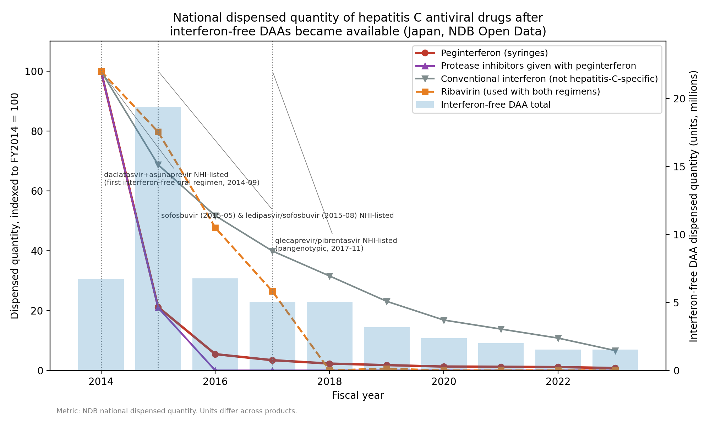
Figure 1. National dispensed quantity of hepatitis C antiviral drugs, indexed to FY2014 = 100, with total interferon-free DAA dispensing on the right axis and dated approval and NHI-listing milestones. Ribavirin and conventional interferon are shown separately because they do not mark interferon-based hepatitis C therapy uniquely.
Table 2. National dispensed quantity by drug group and fiscal year (NDB Open Data). Units differ across groups and are not additive. Values are the published totals and are lower bounds; NP, not published in any table (below the top-ranked listing cap of the class or shown as a dash for values below 1,000), with the maximum quantity the unpublished cells could conceal in parentheses.
Fiscal year | Peginterferon (syringes) | First-generation protease inhibitors (with peginterferon) | Conventional interferon (not hepatitis-C-specific) | Ribavirin (both regimens) | Interferon-free DAA total
2014 | 619,333 | 826,748 | 326,802 | 10,166,159 | 6,736,616
2015 | 131,081 | 173,122 | 224,563 | 8,100,850 | 19,374,861
2016 | 33,688 | NP (≤284,823) | 168,967 | 4,849,660 | 6,783,118
2017 | 21,176 | NP (≤444,730) | 130,383 | 2,687,890 | 5,062,848
2018 | 14,162 | NP (≤530,758) | 103,120 | 3,124 | 5,051,120
2019 | 10,961 | NP (≤506,393) | 75,458 | 62,956 | 3,165,028
2020 | 8,013 | NP (≤336,918) | 54,982 | NP (≤112,306) | 2,356,769
2021 | 7,534 | NP (≤241,864) | 45,147 | NP (≤80,622) | 1,994,076
2022 | 7,073 | NP (≤233,392) | 35,298 | NP (≤77,798) | 1,545,191
2023 | 4,836 | NP (≤187,965) | 21,673 | NP (≤62,561) | 1,527,987
Interferon-free DAA dispensing rose and then receded (Figure 2). Total DAA dispensing peaked in FY2015 at 19.4 million units, 188% above FY2014, and then fell 92% to 1.5 million units by FY2023, with each generation of product giving way to the next. In the segmented model, dispensing declined 25.0% per year after the FY2015 peak (95% CI 20.5-29.2%) and the post-peak slope differed from the pre-peak slope (P < 0.001). Because some later low-volume cells are unpublished, the observed decline is an upper limit: in the upper-bound series (unpublished cells at most 34% of the published DAA total in any year), the peak-to-FY2023 fall is 90% and the post-peak decline 21.9% per year (95% CI 17.4-26.1%). The pre-peak segment corresponds to 71% per year but rests on only 2 observations, and its bootstrap interval (-8.6% to 166.8%) includes zero; it is a single year-on-year increment rather than an estimated trend and we do not interpret it as a rate.
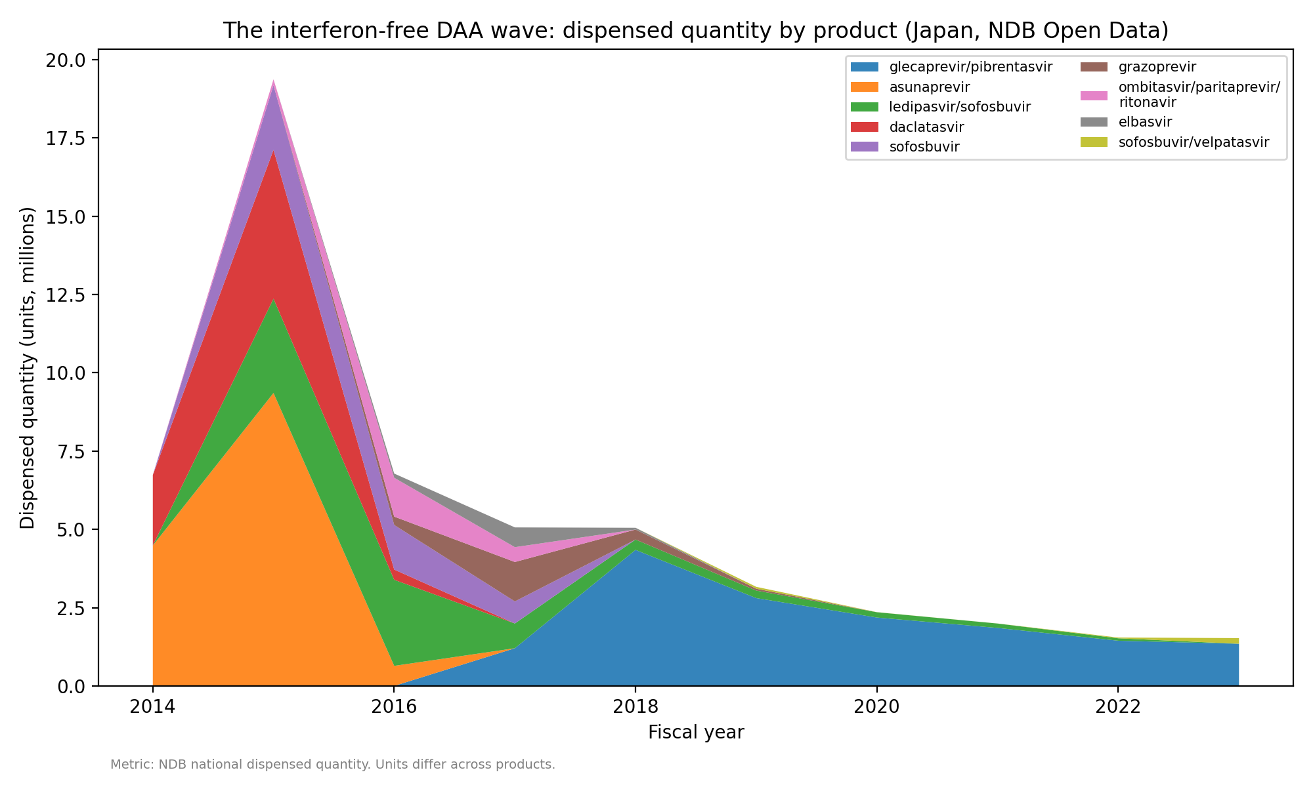
Figure 2. Interferon-free DAA dispensed quantity by product, fiscal years 2014-2023.
Placing both therapies on the estimated-course scale shows the exchange directly (Figure 3, Table 3). Estimated peginterferon courses fell from about 12,903 in FY2014 to about 101 in FY2023, while estimated interferon-free DAA courses peaked at about 89,858 in FY2015. The combined estimated treatment volume rose from 26,307 courses in FY2014 to 92,589 in FY2015 and then declined 88.9% to 10,275 by FY2023 (24.7% per year after the peak, 95% CI 21.8-27.5%; slope change P < 0.001). The DAA share of estimated courses went from 50.9% in FY2014 to 97.0% in FY2015 and remained at 99.0% in FY2023. Over FY2014-FY2023 the estimated cumulative interferon-free DAA volume was 265,914-297,637 courses depending on the duration assumption. These are estimates derived from regimen durations, not counts of treated people.
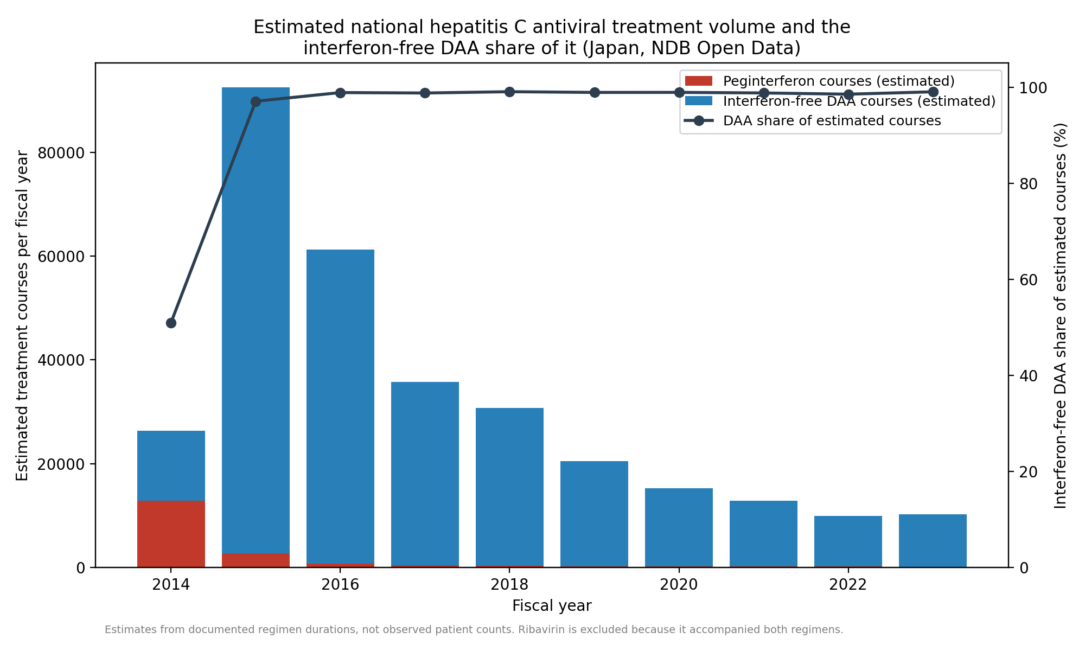
Figure 3. Estimated national hepatitis C antiviral treatment volume (interferon-free DAA courses plus peginterferon courses) and the DAA share of it. Ribavirin is excluded because it accompanied both interferon-based and interferon-free regimens.
Table 3. Estimated treatment courses by fiscal year (estimates from documented regimen durations, one anchor product per regimen; not observed patient counts).
Fiscal year | Interferon-free DAA courses | Interferon-free DAA courses (longer-duration assumption) | Peginterferon courses | Combined treatment volume | DAA share (%)
2014 | 13,404 | 13,404 | 12,903 | 26,307 | 50.9
2015 | 89,858 | 89,858 | 2,731 | 92,589 | 97.0
2016 | 60,598 | 60,598 | 702 | 61,300 | 98.9
2017 | 35,292 | 32,903 | 441 | 35,733 | 98.8
2018 | 30,473 | 21,853 | 295 | 30,768 | 99.0
2019 | 20,275 | 14,354 | 228 | 20,503 | 98.9
2020 | 15,052 | 10,700 | 167 | 15,219 | 98.9
2021 | 12,712 | 9,027 | 157 | 12,868 | 98.8
2022 | 9,799 | 6,793 | 147 | 9,947 | 98.5
2023 | 10,174 | 6,423 | 101 | 10,275 | 99.0

Discussion
We asked whether national use of an established standard therapy falls steeply once a new option is approved and reimbursed, or whether it changes slowly enough to indicate practical friction. In hepatitis C the first pattern is unambiguous. Dispensing shifted so fast that interferon-free regimens accounted for almost all estimated treatment courses within one fiscal year of the first interferon-free listing, and the interferon-based drugs had fallen to negligible levels or below the publication threshold within about two years. This rapid displacement suggests that any friction between reimbursement and treatment was small on an annual scale, although the data do not isolate it.
The surge and decline in total treatment volume needs careful interpretation. A curative therapy given to people who already have the infection will produce exactly this shape without invoking anticipation effects: the prevalent pool is treated over a few years and annual demand then approaches the much smaller flow of newly diagnosed patients. The pattern is therefore consistent with, but not evidence for, a backlog of patients who had been waiting for a tolerable option. Its magnitude does suggest that a large pool was available to treat: the estimated 265,914-297,637 interferon-free DAA courses over ten years are of the same order as the hepatitis C population known to be in care in Japan before DAAs, estimated at about 520,000 patients receiving care in 2011 with a further 167,000-767,000 diagnosed but untreated¹³. A national claims study covering more than 98% of Japanese healthcare reported 357,877 patients treated with DAAs between fiscal years 2013 and 2022, a 40% fall in the prevalence of care for chronic hepatitis C, and hepatitis C healthcare costs peaking in 2015¹⁴. Our course estimates are somewhat lower, as expected when one anchor component per regimen is converted with fixed durations, and the timing of the peak agrees; together they suggest the dispensing-based estimates track the treated population reasonably well.
Several factors besides a treatment backlog plausibly contributed to how fast this happened, and the data cannot separate them. The new regimens were shorter, all-oral, and far better tolerated, with cure rates above 90% in Japanese phase 3 studies^{2,4-6}, so both clinicians and patients had strong reasons to switch as soon as the option existed. Japan also removes the cost barrier: on top of universal insurance, the national program for the promotion of hepatitis treatment subsidizes antiviral therapy so that most patients pay a capped monthly amount, and hepatitis C DAAs were brought into that program as they were listed^{8,15}. Comparison with settings that lack such a scheme is instructive: among insured United States adults diagnosed in 2019-2020, only 23-35% started DAA treatment within a year, varying by payer¹⁶. Availability alone therefore does not produce the Japanese pattern; the observed speed is most likely the combined effect of a decisively better therapy, prompt NHI listing, and subsidized affordability in a population with a large diagnosed backlog. We measured none of the mechanisms individually, and no measure of news coverage or of exposure to it entered the analysis, so we make no claim about how information reached patients or prescribers.
The episode also illustrates what national open claims data can and cannot measure. The NDB Open Data release is complete in coverage—the underlying database captures essentially all insurance claims in Japan—but deliberately partial in publication: each table lists only the highest-ranked products of a class and shows small cells as a dash¹. The dominant features of this transition (the collapse of interferon-based therapy, the surge in DAA dispensing, and the subsequent decline) involve quantities far above the threshold, so they survive those rules intact; the rules mattered only at the margins, where we treated unpublished cells as zero in the primary series and bounded them in the upper-bound sensitivity series, which moved the post-peak decline by less than 3.3 percentage points per year and changed no qualitative conclusion. The same construction—extracting complete products, flagging masked cells, and publishing bounds rather than point values—is applicable to any drug class tracked through the same data release, and makes the analysis reproducible end to end from public sources. The limits are equally instructive: dispensed quantity is not a patient count, annual resolution hides within-year timing around a listing date, and without individual-level linkage the data cannot show who started treatment, who deferred it, or why.

Limitations
NDB Open Data begins in FY2014, the period in which interferon-free DAAs launched, so no pre-DAA interferon baseline exists within it and the FY2014 value already reflects decline from an earlier peak; the analysis speaks to the speed of the observed displacement rather than its full extent. Dispensed quantity is not a patient count, units are not comparable across products, and the course figures are estimates that inherit their regimen assumptions; the shorter-duration sensitivity analysis indicates the size of that dependence. Because NDB Open Data omits lower-ranked products and masks small cells, low-volume products and the tail of a declining drug are underestimated, apparent disappearance means only that a drug fell below the publication threshold, and the later protease-inhibitor and ribavirin values are lower bounds. The upper-bound analysis is a bound derived from the publication rules, not an observed total; within it these omissions change the post-peak decline of combined treatment volume from 24.7% to 21.4% per year and the interferon-free share by less than 0.1 percentage points, and alter neither the peak year nor the direction of any trend, because the large early quantities that carry the main findings lie far above the threshold. Ribavirin cannot be assigned to either therapy, which is why it is reported separately and excluded from course estimates, and conventional interferon is not hepatitis-C-specific. The data are annual, so within-year timing around a listing date is invisible; with 10 observations, no control condition, and no pre-period, the trend models are descriptive and the pre-peak DAA segment in particular rests on two observations. Secular changes from FY2020, including the effect of the COVID-19 pandemic on outpatient care, cannot be separated from the continuing decline. Finally, no measure of media coverage or of exposure to it was available, and the aggregate data cannot be stratified by genotype, fibrosis stage, treatment history, or region, so nothing here identifies why any individual was treated when they were.
In conclusion, national dispensing data show that hepatitis C treatment in Japan moved almost entirely from interferon-based to interferon-free regimens within one fiscal year of the first interferon-free listing, and that total estimated treatment volume surged then declined as the diagnosed prevalent pool was treated. For health systems and for researchers using the same open data, the episode demonstrates both what prompt listing plus subsidy can achieve and how much of that trajectory can be measured despite the NDB publication thresholds. Whether the same speed is attainable for other therapies, or in systems without comparable coverage and subsidy, cannot be inferred from these data.

Acknowledgments
Funding: This research did not receive any specific grant from funding agencies in the public, commercial, or not-for-profit sectors. During the preparation of this manuscript the authors used ChatGPT/GPT-4 for language editing and formatting assistance; after using this tool, the authors reviewed and edited the content and take full responsibility for the final manuscript.
Ethics approval. This study used only publicly available, aggregated national open data and involved no individual-level or identifiable information; ethics-committee approval was therefore not required.
Conflicts of interest. The authors declare they have no conflict of interest with respect to this research study and paper.

Data Availability
Data derived from a source in the public domain: the raw NDB Open Data workbooks are published by the Ministry of Health, Labour and Welfare and can be re-downloaded with the provided script (scripts/download_ndb.py). All analysis code, derived datasets, and the figure and manuscript generators are openly available at https://github.com/bougtoir/ndb-dea-drug-lag, so the full pipeline (download, build, analyze, figures, manuscript) reproduces every reported number, figure, and table from the public data.

References
1. Ministry of Health, Labour and Welfare (Japan). NDB Open Data (1st-10th editions). https://www.mhlw.go.jp/stf/seisakunitsuite/bunya/0000177182.html. Accessed September 21, 2026.
2. Drafting Committee for Hepatitis Management Guidelines, the Japan Society of Hepatology. Japan Society of Hepatology guidelines for the management of hepatitis C virus infection: 2019 update. Hepatol Res. 2020;50(7):791-816. doi:10.1111/hepr.13503
3. Bristol-Myers Squibb K.K. Press release: approval in Japan of Daklinza (daclatasvir) and Sunvepra (asunaprevir), the world's first all-oral, interferon- and ribavirin-free treatment for chronic hepatitis C. 4 July 2014. https://www.bms.com/jp/media/press-release-listing/press-release-listing-2014/20140704.html. Accessed September 21, 2026.
4. Kumada H, Suzuki Y, Ikeda K, et al. Daclatasvir plus asunaprevir for chronic HCV genotype 1b infection. Hepatology. 2014;59(6):2083-2091. doi:10.1002/hep.27113
5. Omata M, Nishiguchi S, Ueno Y, et al. Sofosbuvir plus ribavirin in Japanese patients with chronic genotype 2 HCV infection: an open-label, phase 3 trial. J Viral Hepat. 2014;21(11):762-768. doi:10.1111/jvh.12312
6. Mizokami M, Yokosuka O, Takehara T, et al. Ledipasvir and sofosbuvir fixed-dose combination with and without ribavirin for 12 weeks in treatment-naive and previously treated Japanese patients with genotype 1 hepatitis C: an open-label, randomised, phase 3 trial. Lancet Infect Dis. 2015;15(6):645-653. doi:10.1016/S1473-3099(15)70099-X
7. Tanaka J, Akita T, Ko K, Miura Y, Satake M; Epidemiological Research Group on Viral Hepatitis and its Long-term Course, Ministry of Health, Labour and Welfare of Japan. Countermeasures against viral hepatitis B and C in Japan: an epidemiological point of view. Hepatol Res. 2019;49(9):990-1002. doi:10.1111/hepr.13417
8. Ministry of Health, Labour and Welfare (Japan). Special program for the promotion of hepatitis treatment (medical-expense subsidy for antiviral treatment of viral hepatitis). https://www.mhlw.go.jp/stf/seisakunitsuite/bunya/kenkou_iryou/kenkou/kekkaku-kansenshou/kanen/kangan/iryouhijyosei.html. Accessed September 21, 2026.
9. Ministry of Health, Labour and Welfare (Japan), Central Social Insurance Medical Council (Chuikyo). Records of National Health Insurance drug-price listings of direct-acting antivirals for hepatitis C, 2014-2017 (Chuikyo plenary minutes and Health Insurance Bureau notifications; the document cited for each date is listed in the study repository, https://github.com/bougtoir/ndb-dea-drug-lag). https://www.mhlw.go.jp/stf/shingi/shingi-chuo_128154.html. Accessed September 21, 2026.
10. Tanaka M, Idei M, Sakaguchi H, et al. Evolving landscape of new drug approval in Japan and lags from international birth dates: retrospective regulatory analysis. Clin Pharmacol Ther. 2021;109(5):1265-1273. doi:10.1002/cpt.2080
11. Newey WK, West KD. A simple, positive semi-definite, heteroskedasticity and autocorrelation consistent covariance matrix. Econometrica. 1987;55(3):703-708. doi:10.2307/1913610
12. Efron B, Tibshirani RJ. An Introduction to the Bootstrap. New York: Chapman & Hall; 1993.
13. Tanaka J, Akita T, Ohisa M, et al. Trends in the total numbers of HBV and HCV carriers in Japan from 2000 to 2011. J Viral Hepat. 2018;25(4):363-372. doi:10.1111/jvh.12828
14. Yamashita S, Kanda N, Hashimoto H, et al. Trends in the healthcare burden of hepatitis C after the introduction of direct-acting antivirals in Japan, 2013-2022: a national claims database study in Japan. Int J Infect Dis. 2025;160:108043. doi:10.1016/j.ijid.2025.108043
15. Setoyama H, Tanaka Y, Kanto T. Seamless support from screening to anti-HCV treatment and HCC/decompensated cirrhosis: subsidy programs for HCV elimination. Glob Health Med. 2021;3(5):335-342. doi:10.35772/ghm.2021.01079
16. Thompson WW, Symum H, Sandul A, et al. Vital signs: hepatitis C treatment among insured adults - United States, 2019-2020. MMWR Morb Mortal Wkly Rep. 2022;71(32):1011-1017. doi:10.15585/mmwr.mm7132e1

