Therapeutic substitution of interferon-based hepatitis C therapy by interferon-free direct-acting antivirals in Japan: national drug-utilization dynamics, 2014-2024
Article type: Original Article (national repeated cross-sectional drug-utilization study of aggregate open data)
Running head: Therapeutic substitution of hepatitis C therapy in Japan
Corresponding author: [Name], [Affiliation], [Address], [Email], [ORCID]
Authors / affiliations / ORCID: [To be completed by the authors]

Abstract
Purpose: Uptake of a new medicine does not by itself show whether it replaced the incumbent treatment standard. We quantified the speed and structure of nationwide therapeutic substitution from interferon-based therapy to interferon-free direct-acting antivirals (DAAs) for hepatitis C in Japan, and the treatment-throughput trajectory after near-complete replacement. Methods: Repeated cross-sectional drug-utilization analysis of Japan's National Database of Health Insurance Claims and Specific Health Checkups (NDB) Open Data, fiscal years (FY) 2014-2024. National dispensed quantities of peginterferon, first-generation NS3/4A protease inhibitors (given with peginterferon), conventional interferon, ribavirin, and 9 interferon-free DAA products were converted to estimated treatment courses, placing incumbent and successor regimens on one course-equivalent scale, and described with segmented log-linear and exponential trend models plus a publication-threshold upper-bound analysis. Results: Peginterferon dispensing fell 99.3% from FY2014 to FY2024 (34% per year, 95% confidence interval (CI) 22-44%; P < 0.001) and protease inhibitors fell below the publication threshold from FY2016. The DAA share of estimated courses moved from 50.9% to 97.0% within one fiscal year. Combined estimated treatment volume rose from 26,307 courses in FY2014 to a FY2015 peak of 92,589, then fell 91.4% to 7,950 by FY2024 (23.4% per year after the peak, 95% CI 20.7-26.0%; P < 0.001). Conclusions: National dispensing data distinguished uptake from replacement: the incumbent therapy disappeared within about two years and, after near-complete substitution, throughput entered a lower-volume phase consistent with progressive treatment of a prevalent population.
Keywords: hepatitis C; direct-acting antivirals; interferon; pharmacoepidemiology; prescription trends; drug utilization; NDB Open Data; Japan

Key Points
- National drug-utilization open data can distinguish simple uptake of a new medicine from true therapeutic substitution—the replacement of an incumbent treatment standard.
- In Japan, peginterferon dispensing for hepatitis C fell 99.3% between FY2014 and FY2024 and the first-generation protease inhibitors given with it disappeared from FY2016.
- On an estimated-course scale, interferon-free direct-acting antivirals accounted for 97.0% of hepatitis C antiviral treatment within one fiscal year of the first interferon-free reimbursement, up from 50.9%.
- Estimated total treatment volume peaked in FY2015 and then fell 91.4%, the shape expected when a curative therapy works through a prevalent population.
- Findings describe national dispensed quantities, not patient counts; no measure of media coverage or of individual treatment decisions was available.

Plain Language Summary
Hepatitis C is a long-lasting liver infection that can lead to cirrhosis and liver cancer. For years, treatment in Japan relied on interferon injections, which caused hard side effects and cured only some people. In 2014 and 2015, Japan approved tablet-only treatments that work without interferon and began paying for them through public insurance. We asked how quickly the country actually moved from the old treatment to the new one. Using national open records of medicines supplied across Japan from the 2014 to the 2024 fiscal year, we followed the yearly amount of each drug and converted those amounts into approximate numbers of treatment courses. Interferon injections almost vanished, falling 99% over the ten years, and the drugs given alongside them stopped being used altogether. Within a single year of insurance coverage, the new tablets made up about 97% of estimated treatment. Total treatment rose sharply, peaked in 2015, and then fell by about 91% — the pattern expected when a curative treatment works through a large group of people already living with an infection. These records count medicines rather than people, so they describe national trends, not individual decisions.

Introduction
How well a new medicine sells is not the same question as how completely it replaces the treatment standard it succeeds. Uptake measures the new therapy alone; a successor can show rapid uptake while the incumbent continues in parallel, so utilization of the new product by itself cannot quantify displacement. Whether and how fast a clinically superior therapy removes the previous standard from routine use is a distinct pharmacoepidemiologic question, and answering it requires following both therapies at once.
Measuring replacement requires a common scale. Dispensed quantities of the old and new regimens are rarely comparable directly—an eight-week tablet course and a year of weekly injections have nothing in common unit for unit—so drug-utilization research converts them to a shared metric such as the defined daily dose or, where treatments have finite durations, a course-equivalent count¹. Once both therapies sit on the same scale, the speed of the incumbent's disappearance, the successor's share of treatment, and the level of total throughput before and after substitution all become measurable quantities rather than impressions.
The transition from interferon-based therapy to interferon-free direct-acting antivirals (DAAs) for hepatitis C offers an unusually clear empirical case. Until 2014, treatment in Japan was built around interferon, given for 24-48 weeks with ribavirin and, from 2011, with a first-generation NS3/4A protease inhibitor; it was poorly tolerated and did not cure everyone². Interferon-free all-oral regimens then arrived in quick succession: daclatasvir plus asunaprevir, approved in July 2014, was the first regimen worldwide to dispense with both interferon and ribavirin^{3,4}, followed by sofosbuvir-based and pangenotypic regimens with cure rates above 90% and treatment durations of 8-12 weeks^{5,6}.
The Japanese national data covering this transition are already partly described. A national claims study covering more than 98% of Japanese healthcare reported 357,877 patients treated with DAAs between fiscal years 2013 and 2022 and a 40% fall in the prevalence of care for chronic hepatitis C⁷, and a subsequent evaluation adding subsidy-program records estimated about 300,000 treated patients and a cumulative cost above 1.23 trillion yen over FY2014-2023, with prefecture-level detail⁸. These studies quantify who was treated, where, and at what cost; they do not place the incumbent and successor therapies on a common scale, so the replacement dynamics themselves—the speed of substitution and the throughput trajectory after it—remain unmeasured.
We therefore used NDB Open Data, the national open-data release of Japan's claims database⁹, to quantify therapeutic substitution across fiscal years 2014-2024: how quickly dispensing of interferon-based therapy disappeared after the interferon-free regimens were approved and listed for National Health Insurance (NHI) reimbursement, how quickly the successor therapy dominated on a course-equivalent scale, and how total treatment throughput evolved once substitution was nearly complete.

Methods
Data. NDB Open Data editions 1-11 cover fiscal years 2014-2024⁹. From the sex- and age-stratified prescription-drug quantity tables (oral, topical, injectable) we extracted the national total dispensed quantity of every product of interest, identified by its marketed product name. Dispensed quantity is counted in tablets or capsules for oral drugs and in syringes or vials for injections; it is not a patient count and is not comparable across products with different dosage units. Japanese fiscal years run from April to March. In each formulation and care-setting table, NDB Open Data lists only the highest-ranked products of each therapeutic class (top 30 or 100, by edition) and shows cells below 1,000 as a dash, so an absent or dashed product is below the publication threshold, not necessarily unused. Such cells are zero in the primary (lower-bound) series; an upper-bound sensitivity series sets every unpublished cell from a product's first listing onward to the largest quantity it could conceal (the smallest published total of its class in that table when the listing cap was reached, otherwise 999). From the 11th edition (FY2024) the listing expands to every product in each class rather than a top-N cap, so low-volume products invisible earlier can reappear; this is a listing-scope change, not resumed use. Of 417 extracted rows, 113 were dashed.
Drug groups. Peginterferon (peginterferon alfa-2a and alfa-2b) is the hepatitis-C-specific marker of interferon-based therapy. The three first-generation NS3/4A protease inhibitors (telaprevir, simeprevir, vaniprevir) were always added to peginterferon plus ribavirin, so they are treated as markers of interferon-based triple therapy and are kept out of the DAA group. Conventional (non-pegylated) interferon is a non-specific background series, being also used for other indications. Ribavirin is also reported separately because it accompanied both peginterferon and the interferon-free sofosbuvir plus ribavirin regimen for genotype 2⁵; its series therefore mixes established and new treatments. The remaining 9 products form the interferon-free DAA group. Official approval and NHI drug-price listing dates, taken from package inserts, Central Social Insurance Medical Council (Chuikyo) records, and company releases, are used as dated milestones at fiscal-year resolution (Table 1)^{3,10}. No measure of media coverage or of exposure to it was available, so media effects were not modeled.
Table 1. Official approval and NHI drug-price listing milestones for interferon-free direct-acting antivirals in Japan.
FY | Date | Drug | Milestone | Source
2014 | 2014-07-04 | daclatasvir + asunaprevir | approval | Approval date 2014-07-04 (asunaprevir and daclatasvir package inserts); Bristol-Myers Squibb K.K. press release, 2014-07-04
2014 | 2014-09-02 | daclatasvir + asunaprevir | NHI listing | NHI drug-price listing date 2014-09-02 (asunaprevir and daclatasvir package inserts); market launch 2014-09-03 (Bristol-Myers Squibb K.K. press release)
2015 | 2015-03-26 | sofosbuvir | approval | Sofosbuvir approval date 2015-03-26 (package insert / interview form)
2015 | 2015-05-20 | sofosbuvir | NHI listing | NHI listing 2015-05-20 (Chuikyo plenary decision 2015-05-13; MHLW Health Insurance Bureau notification Ho-i-hatsu 0519 No. 1)
2015 | 2015-07-03 | ledipasvir/sofosbuvir | approval | MHLW marketing approval 2015-07-03 (package insert; reported by Asahi Shimbun, 2015-07-04)
2015 | 2015-08-31 | ledipasvir/sofosbuvir | NHI listing | Ledipasvir/sofosbuvir NHI drug-price listing date 2015-08-31 (package insert)
2017 | 2017-09-27 | glecaprevir/pibrentasvir | approval | Marketing approval 2017-09-27 (PMDA/MHLW; AbbVie GK)
2017 | 2017-11-22 | glecaprevir/pibrentasvir | NHI listing | Glecaprevir/pibrentasvir NHI drug-price listing date 2017-11-22 (Chuikyo plenary decision 2017-11-15; package insert); market launch 2017-11-27
Common scale. Because dispensed quantities of an 8-week tablet regimen and of a 48-week weekly injection are not comparable, we converted quantities to estimated treatment courses using documented daily doses and standard durations from Japanese package inserts and the Japan Society of Hepatology (JSH) guideline². For each interferon-free regimen only one anchor component is counted, so a two-drug regimen is not counted twice; for peginterferon one syringe is one weekly dose, giving 48 syringes for a 48-week course and 24 for a 24-week course as a sensitivity assumption. Peginterferon courses also stand in for the patients who additionally received a protease inhibitor, since those drugs were always added to peginterferon; counting the inhibitors separately would double-count the same treatment episodes. Ribavirin is excluded from course estimates because it does not identify a single regimen. Adding interferon-free DAA courses to peginterferon courses gives an approximate national hepatitis C antiviral treatment volume, and the DAA share of it measures substitution on one scale. These are estimates that depend on the regimen assumptions, not observed patient counts. A course-equivalent scale follows the same logic as the WHO defined daily dose, the standard common-unit metric of drug-utilization research, while measuring completed treatment courses rather than daily doses¹.
Statistical analysis. NDB Open Data begins in FY2014, the period in which interferon-free DAAs became available, so there is no pre-intervention baseline and a conventional interrupted time series is not identifiable. With 11 annual national observations we fitted descriptive trend models. Total DAA dispensing and the combined estimated treatment volume were each fitted with a continuous segmented (broken-stick) log-linear model with a knot at the observed peak fiscal year (Equation 1), giving separate pre- and post-peak annual multiplicative rates. Each interferon-based drug was fitted with an exponential (log-linear) decay over the fiscal years with positive dispensing (Equation 2). Because the knot was fixed at the observed peak rather than estimated independently, and because only two annual observations preceded it, inference for the slope-change term was considered model-based and exploratory. Segmented log-linear models are a standard descriptive tool of drug-utilization research^{11,12}.
$$\text{ln }Q_{t} = β_{0} + β_{1}(t − t_{0}) + β_{2}{(t − t_{0})}^{\text{+}} + ε_{t}$$ (1)
$$\text{ln }Q_{t} = α + γt + ε_{t}, \text{annual change = }e^{γ} − 1$$ (2)
where $Q_{t}$ is the national dispensed quantity in fiscal year $t$, $t_{0}$ the peak fiscal year, ${(t − t_{0})}^{\text{+}} = \text{max}(0, t − t_{0})$; $β_{1}$ and $β_{2}$ are the pre- and post-knot slope coefficients in Equation (1), $γ$ is the slope in Equation (2), and the annual multiplicative change is $e^{β_{1}} − 1$ before the knot and $e^{(β_{1} + β_{2})} − 1$ after the knot in Equation (1), and $e^{γ} − 1$ in Equation (2).
Uncertainty is summarized with heteroskedasticity- and autocorrelation-consistent (Newey-West, maxlags = 1) 95% intervals¹³, cross-checked against a residual bootstrap (10,000 resamples)¹⁴. They describe how fast dispensing changed and how precisely that rate can be pinned down; they are not causal estimates, and no comparison condition is available. Because the DAA peak falls in the second fiscal year of the series, the pre-peak segment rests on 2 observations and is reported for completeness rather than as an estimated rate. Analyses used Python with statsmodels, and the pipeline regenerates every reported number, figure, and table from the public data.

Results
Interferon-based therapy fell away quickly (Figure 1, Table 2). Peginterferon dispensing dropped 99.3% between FY2014 and FY2024, from 619,333 to 4,240 syringes, a decline of 34% per year (95% CI 22-44%; P < 0.001). The first-generation protease inhibitors, given only with peginterferon, went from 826,748 published units in FY2014 to below the publication threshold in every table from FY2016 (at most 8,991 units in FY2024). Conventional interferon, which is not hepatitis-C-specific, fell more gradually (94.9% overall; 25% per year, 95% CI 24-26%; P < 0.001), a background comparison: the much steeper fall in peginterferon is not explained by a general drift in interferon use.
Ribavirin, shared by older and newer regimens, fell from 10,166,159 units in FY2014 to 3,124 published units in FY2018 and was below the publication threshold in every table from FY2020 to FY2023. In FY2024, when the listing expanded to every product in each class, a small total (28,508 units) is published again—a visibility change under the widened listing, not resumed use. The FY2018-FY2019 values come only from tables still listing ribavirin, and their movement lies within what unlisted cells could conceal, so it is not interpreted. Fitted over the fiscal years with published dispensing (FY2014-FY2024), its decline was 50% per year (95% CI 30-65%; P < 0.001). Because ribavirin was used with peginterferon and with interferon-free sofosbuvir, this rate describes the combined retreat of both regimens and is not evidence about interferon-based therapy alone.
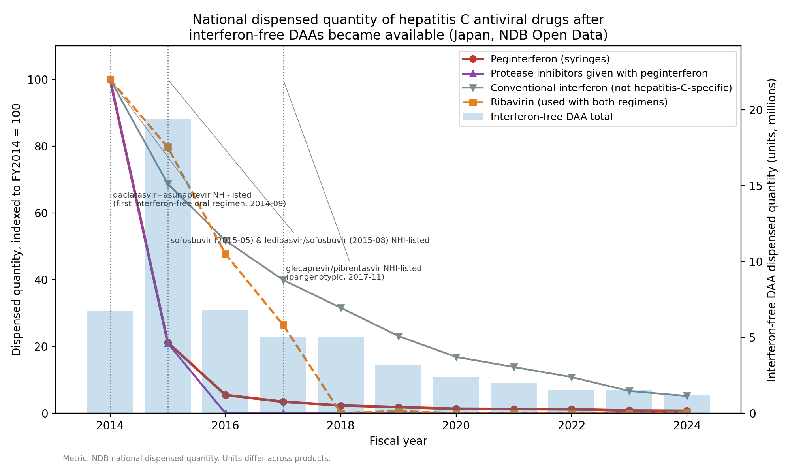
Figure 1. National dispensed quantity of hepatitis C antiviral drugs, indexed to FY2014 = 100, with total interferon-free DAA dispensing on the right axis and dated approval and NHI-listing milestones. Ribavirin and conventional interferon are shown separately because they do not mark interferon-based hepatitis C therapy uniquely.
Table 2. National dispensed quantity by drug group and fiscal year (NDB Open Data). Units differ across groups and are not additive. Values are the published totals and are lower bounds; NP, not published in any table (below the top-ranked listing cap of the class or shown as a dash for values below 1,000), with the maximum quantity the unpublished cells could conceal in parentheses.
Fiscal year | Peginterferon (syringes) | First-generation protease inhibitors (with peginterferon) | Conventional interferon (not hepatitis-C-specific) | Ribavirin (both regimens) | Interferon-free DAA total
2014 | 619,333 | 826,748 | 326,802 | 10,166,159 | 6,736,616
2015 | 131,081 | 173,122 | 224,563 | 8,100,850 | 19,374,861
2016 | 33,688 | NP (≤284,823) | 168,967 | 4,849,660 | 6,783,118
2017 | 21,176 | NP (≤444,730) | 130,383 | 2,687,890 | 5,062,848
2018 | 14,162 | NP (≤530,758) | 103,120 | 3,124 | 5,051,120
2019 | 10,961 | NP (≤506,393) | 75,458 | 62,956 | 3,165,028
2020 | 8,013 | NP (≤336,918) | 54,982 | NP (≤112,306) | 2,356,769
2021 | 7,534 | NP (≤241,864) | 45,147 | NP (≤80,622) | 1,994,076
2022 | 7,073 | NP (≤233,392) | 35,298 | NP (≤77,798) | 1,545,191
2023 | 4,836 | NP (≤187,965) | 21,673 | NP (≤62,561) | 1,527,987
2024 | 4,240 | NP (≤8,991) | 16,816 | 28,508 | 1,164,534
Interferon-free DAA dispensing rose and then receded (Figure 2). Total DAA dispensing peaked in FY2015 at 19.4 million units, 188% above FY2014, and then fell 94% to 1.2 million units by FY2024, with each generation of product giving way to the next. In the segmented model, dispensing declined 23.8% per year after the FY2015 peak (95% CI 19.9-27.5%; P < 0.001), and the slope-change term was -0.77 log units per year (95% CI -1.21 to -0.32; P < 0.001), a model-based estimate given the fixed knot. With later low-volume cells unpublished, that decline is an upper limit: in the upper-bound series (unpublished cells at most 34% of the published DAA total in any year) the peak-to-FY2024 fall is 94% and the post-peak decline 22.2% per year (95% CI 18.6-25.6%). The pre-peak segment corresponds to 64% per year but rests on only 2 observations (bootstrap -13.5% to 154.5%, including zero); it is a single year-on-year increment, not an estimated trend.
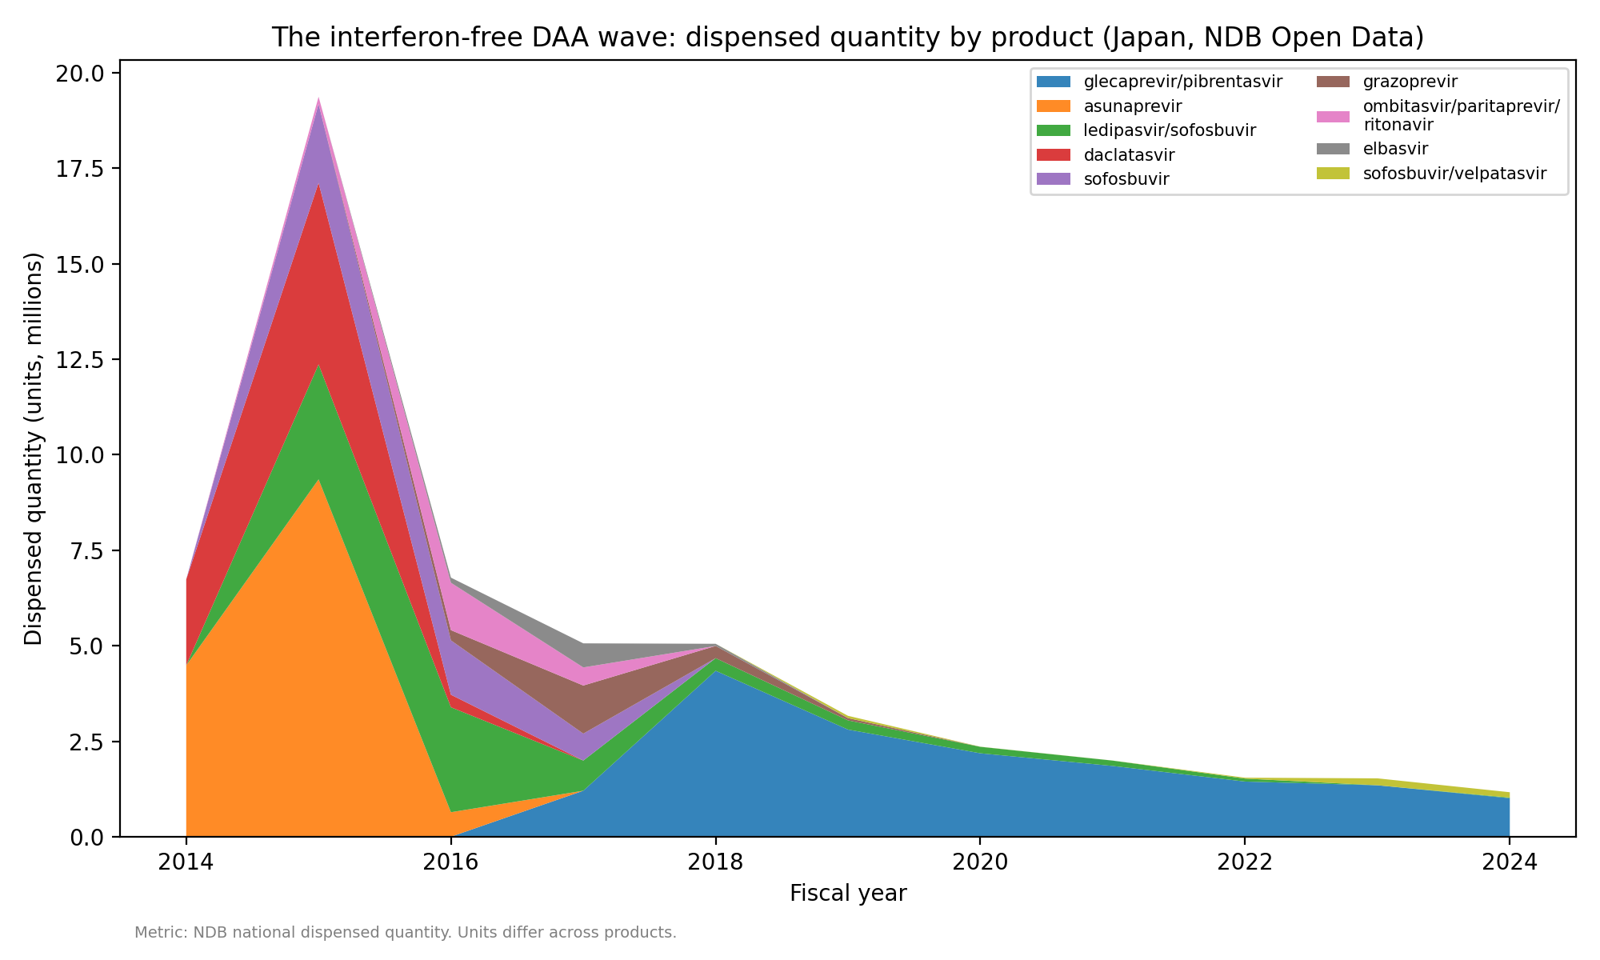
Figure 2. Interferon-free DAA dispensed quantity by product, fiscal years 2014-2024.
Placing both therapies on the estimated-course scale shows the exchange directly (Figure 3, Table 3). Estimated peginterferon courses fell from about 12,903 in FY2014 to about 88 in FY2024, while estimated interferon-free DAA courses peaked at about 89,858 in FY2015. The combined estimated treatment volume rose from 26,307 courses in FY2014 to 92,589 in FY2015 and then declined 91.4% to 7,950 by FY2024 (23.4% per year after the peak, 95% CI 20.7-26.0%; P < 0.001; slope change -1.26 log units per year, 95% CI -1.55 to -0.97, P < 0.001). The DAA share of estimated courses went from 50.9% in FY2014 to 97.0% in FY2015 and remained at 98.9% in FY2024. Over FY2014-FY2024 the estimated cumulative interferon-free DAA volume was 270,939-305,499 courses depending on the duration assumption. These are estimates derived from regimen durations, not counts of treated people.
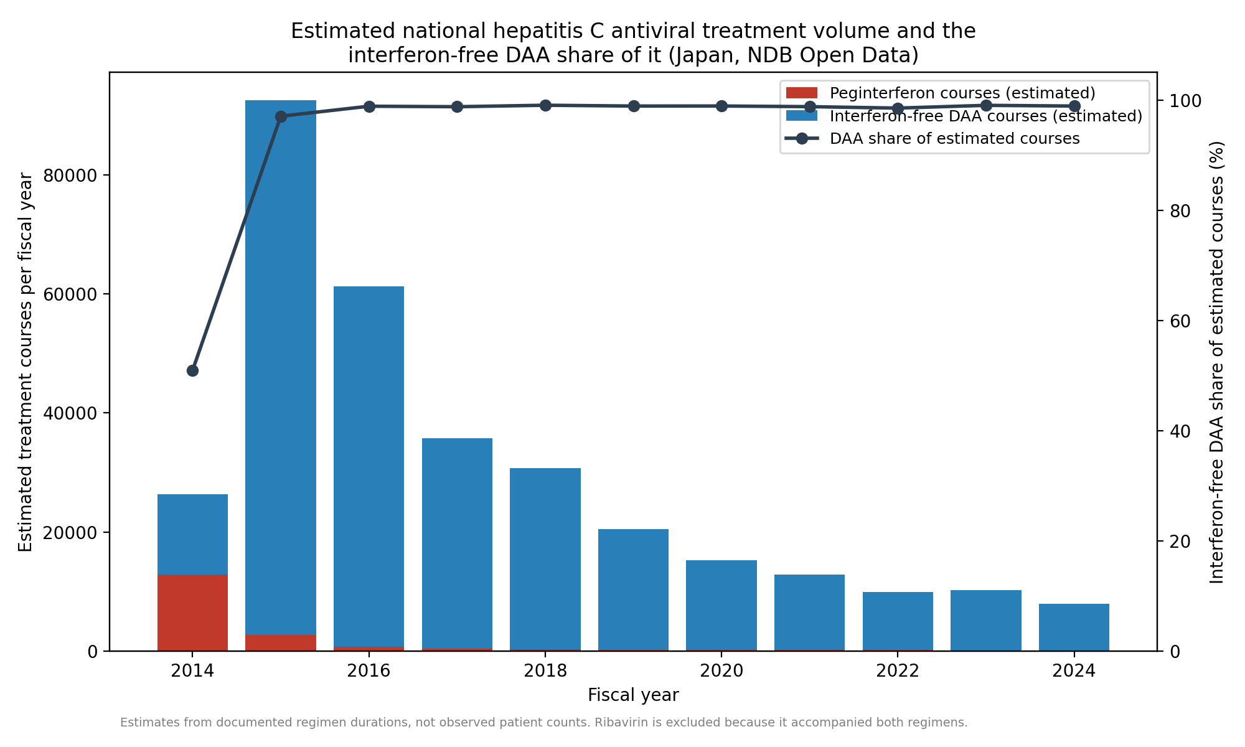
Figure 3. Estimated national hepatitis C antiviral treatment volume (interferon-free DAA courses plus peginterferon courses) and the DAA share of it. Ribavirin is excluded because it accompanied both interferon-based and interferon-free regimens.
Table 3. Estimated treatment courses by fiscal year (estimates from documented regimen durations, one anchor product per regimen; not observed patient counts).
Fiscal year | Interferon-free DAA courses | Interferon-free DAA courses (longer-duration assumption) | Peginterferon courses | Combined treatment volume | DAA share (%)
2014 | 13,404 | 13,404 | 12,903 | 26,307 | 50.9
2015 | 89,858 | 89,858 | 2,731 | 92,589 | 97.0
2016 | 60,598 | 60,598 | 702 | 61,300 | 98.9
2017 | 35,292 | 32,903 | 441 | 35,733 | 98.8
2018 | 30,473 | 21,853 | 295 | 30,768 | 99.0
2019 | 20,275 | 14,354 | 228 | 20,503 | 98.9
2020 | 15,052 | 10,700 | 167 | 15,219 | 98.9
2021 | 12,712 | 9,027 | 157 | 12,868 | 98.8
2022 | 9,799 | 6,793 | 147 | 9,947 | 98.5
2023 | 10,174 | 6,423 | 101 | 10,275 | 99.0
2024 | 7,862 | 5,026 | 88 | 7,950 | 98.9

Discussion

This national drug-utilization analysis shows that therapeutic innovation can be decomposed into at least two distinct population-level processes: replacement of an incumbent therapy and the subsequent evolution of treatment throughput after replacement is nearly complete. The first was essentially instantaneous on an annual scale—interferon-free regimens accounted for almost all estimated treatment courses within one fiscal year of the first interferon-free listing, and the interferon-based drugs had fallen to negligible levels or below the publication threshold within about two years. This is a measurement of substitution, not merely uptake: the incumbent series disappears on the same course-equivalent scale on which the successor appears, so the share calculations are direct evidence of replacement rather than parallel use.
The course-equivalent scale is what makes that decomposition possible. Quantities of an eight-week tablet regimen and of a 48-week weekly injection cannot be compared as dispensed units; converting both to estimated treatment courses puts the incumbent and the successor on one axis, in the same spirit as the defined daily dose convention of drug-utilization research¹. On that scale the DAA share of estimated treatment moved from 50.9% to 97.0% in a single fiscal year—an ordering that no raw-quantity comparison could express. The estimates inherit their regimen assumptions and are not counts of treated people, but they are consistent in scale and direction with independent claims-based counts.
Prior national studies of the same transition answer a different question. The claims-database analyses^{7,8} quantify who was treated, where treatment occurred, and what it cost—357,877 treated patients over 2013-2022 and about 300,000 patients with cumulative cost above 1.23 trillion yen over FY2014-2023—and our course-equivalent estimates, somewhat lower as expected when one anchor product per regimen is converted with fixed durations, track those counts in scale and peak timing. We extend that record on a different axis: the interferon-era baseline is included, so the replacement dynamics themselves—the incumbent's exit speed and the post-substitution throughput—are measured rather than inferred from the successor series alone.
The throughput pattern after near-complete substitution also needs careful interpretation. Total estimated treatment volume surged to a FY2015 peak and then fell 91.4%. A curative therapy given to people who already have the infection produces exactly this shape without invoking anticipation effects: the accumulated prevalent population is treated over a few years and annual demand then approaches the smaller flow of newly diagnosed patients. The observed pattern is therefore consistent with progressive treatment of a prevalent population, though the aggregate data cannot establish that mechanism. Its magnitude does suggest a large treatable pool: the estimated 270,939-305,499 interferon-free DAA courses over 11 fiscal years are of the same order as the hepatitis C population known to be in care in Japan before DAAs—about 520,000 patients receiving care in 2011 with a further 167,000-767,000 diagnosed but untreated¹⁵.
Several factors besides a treatment backlog plausibly contributed, and the data cannot separate them. The new regimens were shorter, all-oral, and far better tolerated, with cure rates above 90% in Japanese phase 3 studies^{2,4,5,6}, so both clinicians and patients had strong reasons to switch as soon as the option existed. Japan also removes the cost barrier: on top of universal insurance, the national program for the promotion of hepatitis treatment subsidizes antiviral therapy so that most patients pay a capped monthly amount, and hepatitis C DAAs were brought into that program as they were listed^{16,17}. Comparison with settings lacking such a scheme is instructive: among insured United States adults diagnosed in 2019-2020, only 23-35% started DAA treatment within a year, varying by payer¹⁸. Availability alone does not produce this pattern; the observed speed most likely reflects a decisively better therapy, prompt NHI listing, and subsidized affordability against a large diagnosed backlog; we measured none of the mechanisms individually.
Two implications carry beyond hepatitis C. First, a declining medicine-use count after near-complete substitution describes a fundamentally different system state from low adoption: falling DAA dispensing after FY2015 marks the depletion of an accumulated treatment need, not therapeutic failure, and readers of utilization trends should not conflate the two. Second, the framework transfers to other therapeutic transitions in which a new treatment displaces an incumbent and treatment courses are finite—curative or disease-modifying therapies facing an accumulated demand that can be treated down. Where treatment is chronic, the post-substitution phase will differ, but the same course-equivalent decomposition still applies.

Limitations
NDB Open Data begins in FY2014, the period in which interferon-free DAAs launched, so no pre-DAA interferon baseline exists within it and the FY2014 value already reflects decline from an earlier peak; the analysis speaks to the speed of the observed displacement rather than its full extent. Dispensed quantity is not a patient count, units are not comparable across products, and the course figures are estimates that inherit their regimen assumptions; the shorter-duration sensitivity analysis indicates the size of that dependence. Because NDB Open Data omits lower-ranked products and masks small cells, low-volume products and declining tails are underestimated, apparent disappearance means only that a drug fell below the publication threshold, and the later protease-inhibitor and ribavirin values are lower bounds. The upper-bound analysis is a bound derived from the publication rules, not an observed total; within it these omissions change the post-peak decline of combined treatment volume from 23.4% to 21.7% per year and the interferon-free share by less than 0.5 percentage points, and alter neither the peak year nor any trend's direction, because the large early quantities carrying the main findings lie far above the threshold. Ribavirin cannot be assigned to either therapy and is excluded from course estimates, and conventional interferon is not hepatitis-C-specific. The data are annual and the series has 11 observations, no control condition, and no pre-period, so the trend models are descriptive, the pre-peak DAA segment rests on two observations, and the slope-change P values are model-based rather than formal change-point evidence. Secular changes from FY2020, including the effect of the COVID-19 pandemic on outpatient care, cannot be separated from the continuing decline. Finally, no measure of media coverage was available, and the data cannot be stratified by genotype, fibrosis stage, treatment history, or region.

Conclusions
National drug-utilization data can quantify therapeutic substitution itself, not only uptake of the new therapy. In Japan's hepatitis C transition, the incumbent interferon-based regimens were replaced almost completely within about two years of reimbursement, and the course-equivalent record then showed the lower-throughput phase expected once a curative therapy has worked through much of the accumulated prevalent population. Where a new therapy displaces a finite incumbent treatment, the same framework separates the replacement phase from the steady state that follows it.
Ethics approval and consent. This study used only publicly available, aggregated national open data (NDB Open Data) containing no individual-level or identifiable information; ethics-committee approval and informed consent were therefore not required.
Conflict of interest. The authors declare no conflicts of interest.
Funding. This research received no specific grant from any funding agency.
Reporting guideline. This observational study is reported in line with the STROBE guideline for cross-sectional/ecological analyses of routinely collected aggregate data; a completed STROBE checklist is provided as Supplementary Material.
Transparency and reproducibility. No study protocol was preregistered. All analysis code, derived datasets, and the figure/manuscript generators are openly available at https://github.com/bougtoir/ndb-dea-drug-lag; the raw NDB Open Data workbooks are re-downloadable from the Ministry of Health, Labour and Welfare, so every reported number, figure, and table can be regenerated from the public data.

Data and code availability
All analysis code, derived datasets, and the figure/manuscript generators are openly available at https://github.com/bougtoir/ndb-dea-drug-lag. The raw NDB Open Data workbooks are published by the Ministry of Health, Labour and Welfare and are re-downloadable with scripts/download_ndb.py, so the full pipeline (download, build, analyze, figures, manuscript) reproduces every reported number, figure, and table from the public data.

References
1. WHO Collaborating Centre for Drug Statistics Methodology. Guidelines for ATC classification and DDD assignment 2025, 28th edition. Oslo: Norwegian Institute of Public Health; 2024. https://atcddd.fhi.no (accessed 06 October 2026).
2. Drafting Committee for Hepatitis Management Guidelines, the Japan Society of Hepatology. Japan Society of Hepatology guidelines for the management of hepatitis C virus infection: 2019 update. Hepatol Res. 2020;50(7):791-816. https://doi.org/10.1111/hepr.13503
3. Bristol-Myers Squibb K.K. Press release: approval in Japan of Daklinza (daclatasvir) and Sunvepra (asunaprevir), the world's first all-oral, interferon- and ribavirin-free treatment for chronic hepatitis C. 4 July 2014. https://www.bms.com/jp/media/press-release-listing/press-release-listing-2014/20140704.html (accessed 06 October 2026).
4. Kumada H, Suzuki Y, Ikeda K, Toyota J, Karino Y, Chayama K, et al. Daclatasvir plus asunaprevir for chronic HCV genotype 1b infection. Hepatology. 2014;59(6):2083-2091. https://doi.org/10.1002/hep.27113
5. Omata M, Nishiguchi S, Ueno Y, Mochizuki H, Izumi N, Ikeda F, et al. Sofosbuvir plus ribavirin in Japanese patients with chronic genotype 2 HCV infection: an open-label, phase 3 trial. J Viral Hepat. 2014;21(11):762-768. https://doi.org/10.1111/jvh.12312
6. Mizokami M, Yokosuka O, Takehara T, Sakamoto N, Korenaga M, Mochizuki H, et al. Ledipasvir and sofosbuvir fixed-dose combination with and without ribavirin for 12 weeks in treatment-naive and previously treated Japanese patients with genotype 1 hepatitis C: an open-label, randomised, phase 3 trial. Lancet Infect Dis. 2015;15(6):645-653. https://doi.org/10.1016/S1473-3099(15)70099-X
7. Yamashita S, Kanda N, Hashimoto H, Yoshimoto H, Goda K, Mitsutake N, et al. Trends in the healthcare burden of hepatitis C after the introduction of direct-acting antivirals in Japan, 2013-2022: a national claims database study in Japan. Int J Infect Dis. 2025;160:108043. https://doi.org/10.1016/j.ijid.2025.108043
8. Suoh M, Esmaili S, Eslam M, George J. Nationwide socioeconomic evaluation of direct-acting antivirals for chronic hepatitis C virus infection in Japan between 2014 and 2023. J Viral Hepat. 2026;33(8):e70206. https://doi.org/10.1111/jvh.70206
9. Ministry of Health, Labour and Welfare (Japan). NDB Open Data (1st-11th editions). https://www.mhlw.go.jp/stf/seisakunitsuite/bunya/0000177182.html (accessed 06 October 2026).
10. Ministry of Health, Labour and Welfare (Japan), Central Social Insurance Medical Council (Chuikyo). Records of National Health Insurance drug-price listings of direct-acting antivirals for hepatitis C, 2014-2017 (Chuikyo plenary minutes and Health Insurance Bureau notifications; the document cited for each date is listed in the study repository, https://github.com/bougtoir/ndb-dea-drug-lag). https://www.mhlw.go.jp/stf/shingi/shingi-chuo_128154.html (accessed 06 October 2026).
11. Wagner AK, Soumerai SB, Zhang F, Ross-Degnan D. Segmented regression analysis of interrupted time series studies in medication use research. J Clin Pharm Ther. 2002;27(4):299-309. https://doi.org/10.1046/j.1365-2710.2002.00430.x
12. Bernal JL, Cummins S, Gasparrini A. Interrupted time series regression for the evaluation of public health interventions: a tutorial. Int J Epidemiol. 2017;46(1):348-355. https://doi.org/10.1093/ije/dyw098
13. Newey WK, West KD. A simple, positive semi-definite, heteroskedasticity and autocorrelation consistent covariance matrix. Econometrica. 1987;55(3):703-708. https://doi.org/10.2307/1913610
14. Efron B, Tibshirani RJ. An Introduction to the Bootstrap. New York: Chapman & Hall; 1993.
15. Tanaka J, Akita T, Ohisa M, Sakamune K, Ko K, Uchida S, et al. Trends in the total numbers of HBV and HCV carriers in Japan from 2000 to 2011. J Viral Hepat. 2018;25(4):363-372. https://doi.org/10.1111/jvh.12828
16. Ministry of Health, Labour and Welfare (Japan). Special program for the promotion of hepatitis treatment (medical-expense subsidy for antiviral treatment of viral hepatitis). https://www.mhlw.go.jp/stf/seisakunitsuite/bunya/kenkou_iryou/kenkou/kekkaku-kansenshou/kanen/kangan/iryouhijyosei.html (accessed 06 October 2026).
17. Setoyama H, Tanaka Y, Kanto T. Seamless support from screening to anti-HCV treatment and HCC/decompensated cirrhosis: subsidy programs for HCV elimination. Glob Health Med. 2021;3(5):335-342. https://doi.org/10.35772/ghm.2021.01079
18. Thompson WW, Symum H, Sandul A, Gupta N, Patel P, Nelson N, et al. Vital signs: hepatitis C treatment among insured adults - United States, 2019-2020. MMWR Morb Mortal Wkly Rep. 2022;71(32):1011-1017. https://doi.org/10.15585/mmwr.mm7132e1

