How quickly did interferon-based therapy for hepatitis C give way to interferon-free direct-acting antivirals? A national dispensing analysis of Japan's NDB Open Data, fiscal years 2014-2023
Article type: Original Report (observational, national open-data study)
Running head: Speed of the interferon-to-DAA switch in Japan
Corresponding author: [Name], [Affiliation], [Address], [Email]
Authors / affiliations: [To be completed by the authors]

Abstract
Background/Objectives: Interferon-free direct-acting antivirals (DAAs) for hepatitis C virus (HCV) were approved and covered by National Health Insurance (NHI) in Japan in 2014-2015. How quickly an entire population moves away from an established standard once a better option is approved and reimbursed is rarely measured directly. We describe national antiviral use across this transition. Methods: Using the National Database of Health Insurance Claims and Specific Health Checkups of Japan (NDB) Open Data (fiscal years (FY) 2014-2023), we extracted national dispensed quantities of peginterferon, first-generation non-structural protein 3/4A (NS3/4A) protease inhibitors (given with peginterferon), conventional interferon, ribavirin, and 9 interferon-free DAA products. Quantities were converted to estimated treatment courses using documented regimen durations, placing established and new therapy on a common scale, and described with segmented log-linear and exponential trend models. Results: Peginterferon dispensing fell 99.2% from FY2014 to FY2023 (36% per year, 95% confidence interval (CI) 24-47%), and protease inhibitors were absent from FY2016. Estimated total treatment volume rose from 26,307 to a FY2015 peak of 92,589 courses, then fell 88.9% to 10,275 by FY2023; the DAA share of estimated courses moved from 50.9% to 97.0% within one fiscal year and stayed above 97%. Ribavirin, used in both interferon-based and interferon-free regimens, fell, rebounded 20-fold in FY2019, and was zero from FY2020 onward. Conclusions: National hepatitis C treatment switched almost entirely to interferon-free regimens within a year of reimbursement, with a surge and decline in total volume of the kind expected when a curative therapy works through a prevalent pool.
Keywords: hepatitis C; direct-acting antivirals; interferon; pharmacoepidemiology; prescription trends; drug utilization; NDB Open Data; Japan

Key Points
- National drug-utilization open data can show how quickly a population leaves an established standard therapy after a new option is approved and reimbursed.
- In Japan, peginterferon dispensing for hepatitis C fell 99.2% between FY2014 and FY2023 and the first-generation protease inhibitors given with it disappeared from FY2016.
- On an estimated-course scale, interferon-free direct-acting antivirals accounted for 97.0% of hepatitis C antiviral treatment within one fiscal year of the first interferon-free reimbursement, up from 50.9%.
- Estimated total treatment volume peaked in FY2015 and then fell 88.9%, the shape expected when a curative therapy works through a prevalent population.
- Findings describe national dispensed quantities, not patient counts; no measure of media coverage or of individual treatment decisions was available.

Plain Language Summary
Hepatitis C is a long-lasting liver infection that can lead to cirrhosis and liver cancer. For years, treatment in Japan relied on interferon injections, which caused hard side effects and cured only some people. In 2014 and 2015, Japan approved tablet-only treatments that work without interferon and began paying for them through public insurance. We asked how quickly the country actually moved from the old treatment to the new one. Using national open records of medicines supplied across Japan from the 2014 to the 2023 fiscal year, we followed the yearly amount of each drug and converted those amounts into approximate numbers of treatment courses. Interferon injections almost vanished, falling 99% over the ten years, and the drugs given alongside them stopped being used altogether. Within a single year of insurance coverage, the new tablets made up about 97% of estimated treatment. Total treatment rose sharply, peaked in 2015, and then fell by about 89% — the pattern expected when a curative treatment works through a large group of people already living with an infection. These records count medicines rather than people, so they describe national trends, not individual decisions.

Introduction
Whether a newly approved therapy actually displaces the established standard of care, and how fast, is a practical question for regulators and payers as well as for patients waiting for a better option. Japan has historically approved new drugs later than the United States or Europe, although that gap narrowed over the 2010s¹, and approval is only the first step: a therapy also has to be reimbursed, affordable, and taken up by clinicians and patients before national utilization moves. Chronic hepatitis C provides an unusually clear setting in which to observe that movement. Until 2014, treatment in Japan was built around interferon, given for 24-48 weeks with ribavirin and, from 2011, with a first-generation NS3/4A protease inhibitor; it was poorly tolerated and did not cure everyone². Interferon-free all-oral regimens then arrived in quick succession: daclatasvir plus asunaprevir, approved in July 2014, was the first regimen worldwide to dispense with both interferon and ribavirin^{3,4}, followed by sofosbuvir-based and pangenotypic regimens with cure rates above 90% and treatment durations of 8-12 weeks^{5,6}.
Two outcomes are possible at the population level once such a therapy is approved and reimbursed. National use of the prior standard may fall steeply, indicating that the older therapy was being used for want of an alternative and that little stands between reimbursement and treatment. Alternatively, use may change slowly, which would point to real practical friction—cost, referral pathways, capacity, or clinical caution—between a therapy becoming available and a population receiving it. Nationwide dispensing data can distinguish these, and the answer is informative because the same question recurs with every new class of therapy. We therefore used NDB Open Data, the national open-data release of Japan's claims database⁷, to describe how national dispensing of interferon-based therapy and of interferon-free direct-acting antivirals (DAAs) changed around the approval and NHI-listing milestones of 2014-2017, how fast the two exchanged places on a common estimated-course scale, and how much total hepatitis C treatment volume the transition generated.

Methods
Data. NDB Open Data editions 1-10 cover fiscal years 2014-2023⁷. From the sex- and age-stratified prescription-drug quantity tables (oral, topical, injectable) we extracted the national total dispensed quantity of every product of interest, identified by its marketed product name. Dispensed quantity is counted in tablets or capsules for oral drugs and in syringes or vials for injections; it is not a patient count and is not comparable across products with different dosage units.
Drug groups. Peginterferon (peginterferon alfa-2a and alfa-2b) is the hepatitis-C-specific marker of interferon-based therapy. The three first-generation NS3/4A protease inhibitors (telaprevir, simeprevir, vaniprevir) were always added to peginterferon plus ribavirin, so they are treated as markers of interferon-based triple therapy and are kept out of the DAA group. Conventional (non-pegylated) interferon is reported separately as a background series because it is also used for other indications and is not hepatitis-C-specific. Ribavirin is also reported separately, and deliberately not as part of interferon-based therapy, because it accompanied both peginterferon and the interferon-free sofosbuvir plus ribavirin regimen for genotype 2⁵; its series therefore mixes established and new treatment. The remaining 9 products form the interferon-free DAA group. Official approval and NHI drug-price listing dates, taken from package inserts, Central Social Insurance Medical Council (Chuikyo) records, and company releases, are used as dated milestones at fiscal-year resolution (Table 1)^{3,8}. No measure of news or social-media coverage, or of patient or prescriber exposure to it, was available, so media effects were not included as an exposure in this study.
Table 1. Official approval and NHI drug-price listing milestones for interferon-free direct-acting antivirals in Japan.
FY | Date | Drug | Milestone | Source
2014 | 2014-07-04 | daclatasvir + asunaprevir | approval | Approval date 2014-07-04 (asunaprevir and daclatasvir package inserts); Bristol-Myers Squibb K.K. press release, 2014-07-04
2014 | 2014-09-02 | daclatasvir + asunaprevir | NHI listing | NHI drug-price listing date 2014-09-02 (asunaprevir and daclatasvir package inserts); market launch 2014-09-03 (Bristol-Myers Squibb K.K. press release)
2015 | 2015-03-26 | sofosbuvir | approval | Sofosbuvir approval date 2015-03-26 (package insert / interview form)
2015 | 2015-05-20 | sofosbuvir | NHI listing | NHI listing 2015-05-20 (Chuikyo plenary decision 2015-05-13; MHLW Health Insurance Bureau notification Ho-i-hatsu 0519 No. 1)
2015 | 2015-07-03 | ledipasvir/sofosbuvir | approval | MHLW marketing approval 2015-07-03 (package insert; reported by Asahi Shimbun, 2015-07-04)
2015 | 2015-08-31 | ledipasvir/sofosbuvir | NHI listing | Ledipasvir/sofosbuvir NHI drug-price listing date 2015-08-31 (package insert)
2017 | 2017-09-27 | glecaprevir/pibrentasvir | approval | Marketing approval 2017-09-27 (PMDA/MHLW; AbbVie GK)
2017 | 2017-11-22 | glecaprevir/pibrentasvir | NHI listing | Glecaprevir/pibrentasvir NHI drug-price listing date 2017-11-22 (Chuikyo plenary decision 2017-11-15; package insert); market launch 2017-11-27
Common scale. Because dispensed quantities of an 8-week tablet regimen and of a 48-week weekly injection are not comparable, we converted quantities to estimated treatment courses using documented daily doses and standard durations from Japanese package inserts and the Japan Society of Hepatology (JSH) guideline². For each interferon-free regimen only one anchor component is counted, so a two-drug regimen is not counted twice; for peginterferon one syringe is one weekly dose, giving 48 syringes for a 48-week course and 24 for a 24-week course as a sensitivity assumption. Peginterferon courses also stand in for the patients who additionally received a protease inhibitor, since those drugs were always added to peginterferon; counting the inhibitors separately would double-count the same treatment episodes. Ribavirin is excluded from course estimates because it does not identify a single regimen. Adding interferon-free DAA courses to peginterferon courses gives an approximate national hepatitis C antiviral treatment volume, and the DAA share of it measures substitution on one scale. These are estimates that depend on the regimen assumptions, not observed patient counts.
Statistical analysis. NDB Open Data begins in FY2014, the period in which interferon-free DAAs became available, so there is no pre-intervention baseline and a conventional interrupted time series is not identifiable. With 10 annual national observations we fitted descriptive trend models. Total DAA dispensing and the combined estimated treatment volume were each fitted with a continuous segmented (broken-stick) log-linear model with a knot at the observed peak fiscal year (Equation 1), giving separate pre- and post-peak annual multiplicative rates. Each interferon-based drug was fitted with an exponential (log-linear) decay over the fiscal years with positive dispensing (Equation 2).
$$\text{ln }Q_{t} = β_{0} + β_{1}(t − t_{0}) + β_{2}{(t − t_{0})}^{+} + ε_{t}$$ (1)
$$\text{ln }Q_{t} = α + γt + ε_{t}, \text{annual change = }e^{γ} − 1$$ (2)
where $Q_{t}$ is the national dispensed quantity in fiscal year $t$, $t_{0}$ the peak fiscal year, ${(t − t_{0})}^{+} = \text{max}(0, t − t_{0})$; $β_{1}$ and $β_{2}$ are the pre- and post-knot slope coefficients in Equation (1), $γ$ is the slope in Equation (2), and the annual multiplicative change is $e^{β_{1}} − 1$ before the knot and $e^{(β_{1} + β_{2})} − 1$ after the knot in Equation (1), and $e^{γ} − 1$ in Equation (2).
Uncertainty is summarized with heteroskedasticity- and autocorrelation-consistent (Newey-West, maxlags = 1) 95% intervals⁹, cross-checked against a residual bootstrap (10,000 resamples)¹⁰. They describe how fast dispensing changed and how precisely that rate can be pinned down; they are not causal estimates, and no comparison condition is available. Because the DAA peak falls in the second fiscal year of the series, the pre-peak segment rests on 2 observations and is reported for completeness rather than as an estimated rate. Analyses used Python with statsmodels, and the pipeline regenerates every reported number, figure, and table from the public data.

Results
Interferon-based therapy fell away quickly (Figure 1, Table 2). Peginterferon dispensing dropped 99.2% between FY2014 and FY2023, from 619,333 to 4,836 syringes, a decline of 36% per year (95% CI 24-47%). The first-generation protease inhibitors, which were only ever given with peginterferon, went from 826,748 units in FY2014 to none from FY2016 onward. Conventional interferon, which is not hepatitis-C-specific, fell more gradually (93.4% overall; 25% per year, 95% CI 24-26%), providing a background comparison; the much steeper fall in peginterferon suggests that most of the hepatitis-C-specific decline is not explained by a general drift in interferon use.
Ribavirin behaved differently, as expected for a drug shared by older and newer regimens: it fell from 10,166,159 to 3,124 units in FY2018, then rose 20-fold to 62,956 in FY2019, and was zero from FY2020 onward. Fitted over the fiscal years with positive dispensing (FY2014-FY2019, which include the FY2019 increase), its decline was 76% per year (95% CI 60-85%). Because ribavirin was used with peginterferon and with interferon-free sofosbuvir, this rate describes the combined retreat of both regimens and is not evidence about interferon-based therapy alone.
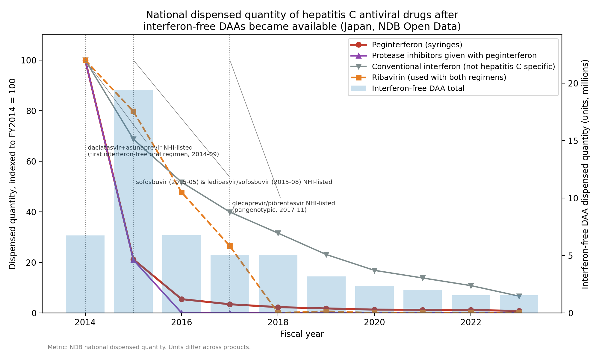
Figure 1. National dispensed quantity of hepatitis C antiviral drugs, indexed to FY2014 = 100, with total interferon-free DAA dispensing on the right axis and dated approval and NHI-listing milestones. Ribavirin and conventional interferon are shown separately because they do not mark interferon-based hepatitis C therapy uniquely.
Table 2. National dispensed quantity by drug group and fiscal year (NDB Open Data). Units differ across groups and are not additive.
Fiscal year | Peginterferon (syringes) | First-generation protease inhibitors (with peginterferon) | Conventional interferon (not hepatitis-C-specific) | Ribavirin (both regimens) | Interferon-free DAA total
2014 | 619,333 | 826,748 | 326,802 | 10,166,159 | 6,736,616
2015 | 131,081 | 173,122 | 224,563 | 8,100,850 | 19,374,861
2016 | 33,688 | 0 | 168,967 | 4,849,660 | 6,783,118
2017 | 21,176 | 0 | 130,383 | 2,687,890 | 5,062,848
2018 | 14,162 | 0 | 103,120 | 3,124 | 5,051,120
2019 | 10,961 | 0 | 75,458 | 62,956 | 3,165,028
2020 | 8,013 | 0 | 54,982 | 0 | 2,356,769
2021 | 7,534 | 0 | 45,147 | 0 | 1,994,076
2022 | 7,073 | 0 | 35,298 | 0 | 1,545,191
2023 | 4,836 | 0 | 21,673 | 0 | 1,527,987
Interferon-free DAA dispensing rose and then receded (Figure 2). Total DAA dispensing peaked in FY2015 at 19.4 million units, 188% above FY2014, and then fell 92% to 1.5 million units by FY2023, with each generation of product giving way to the next. In the segmented model, dispensing declined 25.0% per year after the FY2015 peak (95% CI 20.5-29.2%) and the post-peak slope differed from the pre-peak slope (P < 0.001). The pre-peak segment corresponds to 71% per year but rests on only 2 observations, and its bootstrap interval (-8.6% to 166.8%) includes zero; it is a single year-on-year increment rather than an estimated trend and we do not interpret it as a rate.
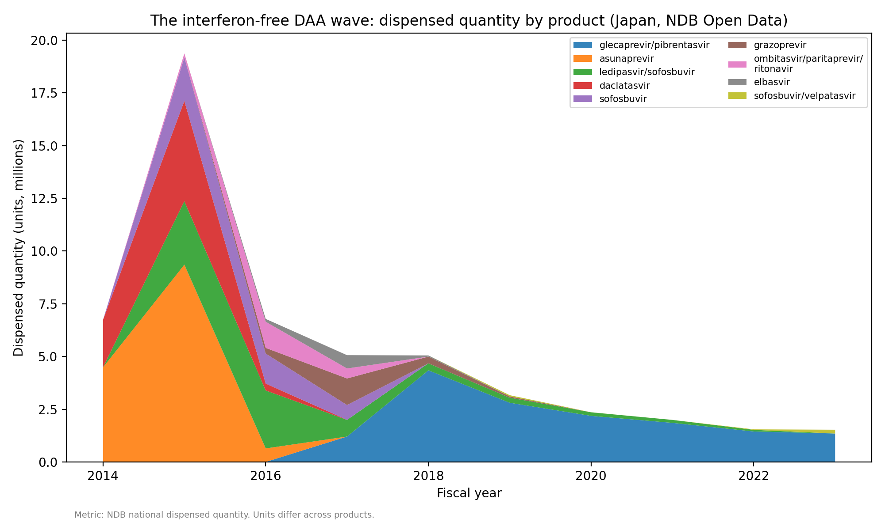
Figure 2. Interferon-free DAA dispensed quantity by product, fiscal years 2014-2023.
Placing both therapies on the estimated-course scale shows the exchange directly (Figure 3, Table 3). Estimated peginterferon courses fell from about 12,903 in FY2014 to about 101 in FY2023, while estimated interferon-free DAA courses peaked at about 89,858 in FY2015. The combined estimated treatment volume rose from 26,307 courses in FY2014 to 92,589 in FY2015 and then declined 88.9% to 10,275 by FY2023 (24.7% per year after the peak, 95% CI 21.8-27.5%; slope change P < 0.001). The DAA share of estimated courses went from 50.9% in FY2014 to 97.0% in FY2015 and remained at 99.0% in FY2023. Over FY2014-FY2023 the estimated cumulative interferon-free DAA volume was 265,914-297,637 courses depending on the duration assumption. These are estimates derived from regimen durations, not counts of treated people.
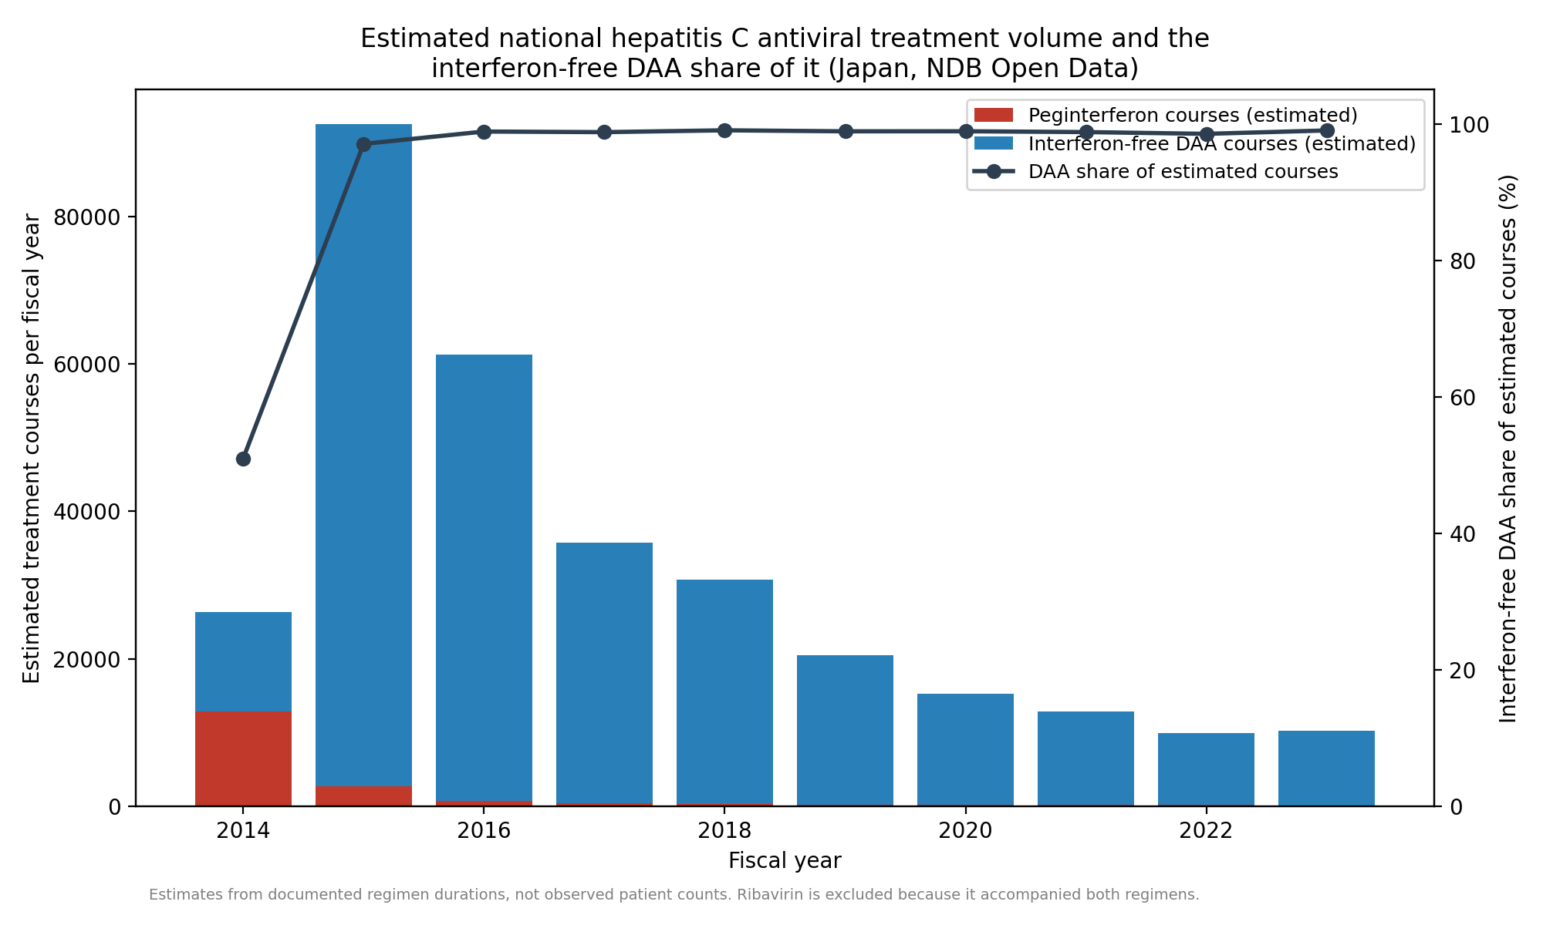
Figure 3. Estimated national hepatitis C antiviral treatment volume (interferon-free DAA courses plus peginterferon courses) and the DAA share of it. Ribavirin is excluded because it accompanied both interferon-based and interferon-free regimens.
Table 3. Estimated treatment courses by fiscal year (estimates from documented regimen durations, one anchor product per regimen; not observed patient counts).
Fiscal year | Interferon-free DAA courses | Interferon-free DAA courses (longer-duration assumption) | Peginterferon courses | Combined treatment volume | DAA share (%)
2014 | 13,404 | 13,404 | 12,903 | 26,307 | 50.9
2015 | 89,858 | 89,858 | 2,731 | 92,589 | 97.0
2016 | 60,598 | 60,598 | 702 | 61,300 | 98.9
2017 | 35,292 | 32,903 | 441 | 35,733 | 98.8
2018 | 30,473 | 21,853 | 295 | 30,768 | 99.0
2019 | 20,275 | 14,354 | 228 | 20,503 | 98.9
2020 | 15,052 | 10,700 | 167 | 15,219 | 98.9
2021 | 12,712 | 9,027 | 157 | 12,868 | 98.8
2022 | 9,799 | 6,793 | 147 | 9,947 | 98.5
2023 | 10,174 | 6,423 | 101 | 10,275 | 99.0

Discussion
We asked whether national use of an established standard therapy falls steeply once a new option is approved and reimbursed, or whether it changes slowly enough to indicate practical friction. In hepatitis C the first pattern is unambiguous. Dispensing shifted so fast that interferon-free regimens accounted for almost all estimated treatment courses within one fiscal year of the first interferon-free listing, and the interferon-based drugs were negligible or absent within about two years. This rapid displacement suggests that any friction between reimbursement and treatment was small on an annual scale, although the data do not isolate it.
The surge and decline in total treatment volume needs careful interpretation. A curative therapy given to people who already have the infection will produce exactly this shape without invoking anticipation effects: the prevalent pool is treated over a few years and annual demand then approaches the much smaller flow of newly diagnosed patients. The pattern is therefore consistent with, but not evidence for, a backlog of patients who had been waiting for a tolerable option. Its magnitude does suggest that a large pool was available to treat: the estimated 265,914-297,637 interferon-free DAA courses over ten years are of the same order as the hepatitis C population known to be in care in Japan before DAAs, estimated at about 520,000 patients receiving care in 2011 with a further 167,000-767,000 diagnosed but untreated¹¹. A national claims study covering more than 98% of Japanese healthcare reported 357,877 patients treated with DAAs between fiscal years 2013 and 2022, a 40% fall in the prevalence of care for chronic hepatitis C, and hepatitis C healthcare costs peaking in 2015¹². Our course estimates are somewhat lower, as expected when one anchor component per regimen is converted with fixed durations, and the timing of the peak agrees; together they suggest the dispensing-based estimates track the treated population reasonably well.
Several factors besides a treatment backlog plausibly contributed to how fast this happened, and the data cannot separate them. The new regimens were shorter, all-oral, and far better tolerated, with cure rates above 90% in Japanese phase 3 studies^{2,4,5,6}, so both clinicians and patients had strong reasons to switch as soon as the option existed. Japan also removes the cost barrier: on top of universal insurance, the national program for the promotion of hepatitis treatment subsidizes antiviral therapy so that most patients pay a capped monthly amount, and hepatitis C DAAs were brought into that program as they were listed^{13,14}. Comparison with settings that lack such a scheme is instructive: among insured United States adults diagnosed in 2019-2020, only 23-35% started DAA treatment within a year, varying by payer¹⁵. Availability alone therefore does not produce the Japanese pattern; the observed speed is most likely the combined effect of a decisively better therapy, prompt NHI listing, and subsidized affordability in a population with a large diagnosed backlog. We measured none of the mechanisms individually, and no measure of news coverage or of exposure to it entered the analysis, so we make no claim about how information reached patients or prescribers.

Limitations
NDB Open Data begins in FY2014, the period in which interferon-free DAAs launched, so no pre-DAA interferon baseline exists within it and the FY2014 value already reflects decline from an earlier peak; the analysis speaks to the speed of the observed displacement rather than its full extent. Dispensed quantity is not a patient count, units are not comparable across products, and the course figures are estimates that inherit their regimen assumptions; the shorter-duration sensitivity analysis indicates the size of that dependence. Ribavirin cannot be assigned to either therapy, which is why it is reported separately and excluded from course estimates, and conventional interferon is not hepatitis-C-specific. The data are annual, so within-year timing around a listing date is invisible; with 10 observations, no control condition, and no pre-period, the trend models are descriptive and the pre-peak DAA segment in particular rests on two observations. Secular changes from FY2020, including the effect of the COVID-19 pandemic on outpatient care, cannot be separated from the continuing decline. Finally, no measure of media coverage or of exposure to it was available, and the aggregate data cannot be stratified by genotype, fibrosis stage, treatment history, or region, so nothing here identifies why any individual was treated when they were.

Conclusions
National hepatitis C treatment in Japan moved almost entirely from interferon-based to interferon-free regimens within a year of the first interferon-free reimbursement, and interferon-based dispensing was negligible within about two years. Total estimated treatment volume rose and then fell steeply, as expected when a curative therapy works through a prevalent population. The speed of the switch shows what is possible when a decisively better therapy is listed promptly and made affordable; it does not follow that other therapies, or the same therapy in systems without comparable coverage and subsidy, would be adopted as quickly.
Ethics approval and consent. This study used only publicly available, aggregated national open data (NDB Open Data) containing no individual-level or identifiable information; ethics-committee approval and informed consent were therefore not required.
Conflict of interest. The authors declare no conflicts of interest.
Funding. This research received no specific grant from any funding agency.
Reporting guideline. This observational study is reported in line with the STROBE guideline for cross-sectional/ecological analyses of routinely collected aggregate data; a completed STROBE checklist is provided as Supplementary Material.

Data and code availability
All analysis code, derived datasets, and the figure/manuscript generators are openly available at https://github.com/bougtoir/ndb-dea-drug-lag. The raw NDB Open Data workbooks are published by the Ministry of Health, Labour and Welfare and are re-downloadable with scripts/download_ndb.py, so the full pipeline (download, build, analyze, figures, manuscript) reproduces every reported number, figure, and table from the public data.

References
1. Tanaka M, Idei M, Sakaguchi H, Kato R, Sato D, Sawanobori K, et al. Evolving landscape of new drug approval in Japan and lags from international birth dates: retrospective regulatory analysis. Clin Pharmacol Ther. 2021;109(5):1265-1273. https://doi.org/10.1002/cpt.2080
2. Drafting Committee for Hepatitis Management Guidelines, the Japan Society of Hepatology. Japan Society of Hepatology guidelines for the management of hepatitis C virus infection: 2019 update. Hepatol Res. 2020;50(7):791-816. https://doi.org/10.1111/hepr.13503
3. Bristol-Myers Squibb K.K. Press release: approval in Japan of Daklinza (daclatasvir) and Sunvepra (asunaprevir), the world's first all-oral, interferon- and ribavirin-free treatment for chronic hepatitis C. 4 July 2014. https://www.bms.com/jp/media/press-release-listing/press-release-listing-2014/20140704.html (accessed 12 September 2026).
4. Kumada H, Suzuki Y, Ikeda K, Toyota J, Karino Y, Chayama K, et al. Daclatasvir plus asunaprevir for chronic HCV genotype 1b infection. Hepatology. 2014;59(6):2083-2091. https://doi.org/10.1002/hep.27113
5. Omata M, Nishiguchi S, Ueno Y, Mochizuki H, Izumi N, Ikeda F, et al. Sofosbuvir plus ribavirin in Japanese patients with chronic genotype 2 HCV infection: an open-label, phase 3 trial. J Viral Hepat. 2014;21(11):762-768. https://doi.org/10.1111/jvh.12312
6. Mizokami M, Yokosuka O, Takehara T, Sakamoto N, Korenaga M, Mochizuki H, et al. Ledipasvir and sofosbuvir fixed-dose combination with and without ribavirin for 12 weeks in treatment-naive and previously treated Japanese patients with genotype 1 hepatitis C: an open-label, randomised, phase 3 trial. Lancet Infect Dis. 2015;15(6):645-653. https://doi.org/10.1016/S1473-3099(15)70099-X
7. Ministry of Health, Labour and Welfare (Japan). NDB Open Data (1st-10th editions). https://www.mhlw.go.jp/stf/seisakunitsuite/bunya/0000177182.html (accessed 12 September 2026).
8. Ministry of Health, Labour and Welfare (Japan), Central Social Insurance Medical Council (Chuikyo). Records of National Health Insurance drug-price listings of direct-acting antivirals for hepatitis C, 2014-2017 (Chuikyo plenary minutes and Health Insurance Bureau notifications; see data/announcement_events.csv for the document cited for each date). https://www.mhlw.go.jp/stf/shingi/shingi-chuo_128154.html (accessed 12 September 2026).
9. Newey WK, West KD. A simple, positive semi-definite, heteroskedasticity and autocorrelation consistent covariance matrix. Econometrica. 1987;55(3):703-708. https://doi.org/10.2307/1913610
10. Efron B, Tibshirani RJ. An Introduction to the Bootstrap. New York: Chapman & Hall; 1993.
11. Tanaka J, Akita T, Ohisa M, Sakamune K, Ko K, Uchida S, et al. Trends in the total numbers of HBV and HCV carriers in Japan from 2000 to 2011. J Viral Hepat. 2018;25(4):363-372. https://doi.org/10.1111/jvh.12828
12. Yamashita S, Kanda N, Hashimoto H, Yoshimoto H, Goda K, Mitsutake N, et al. Trends in the healthcare burden of hepatitis C after the introduction of direct-acting antivirals in Japan, 2013-2022: a national claims database study in Japan. Int J Infect Dis. 2025;160:108043. https://doi.org/10.1016/j.ijid.2025.108043
13. Ministry of Health, Labour and Welfare (Japan). Special program for the promotion of hepatitis treatment (medical-expense subsidy for antiviral treatment of viral hepatitis). https://www.mhlw.go.jp/stf/seisakunitsuite/bunya/kenkou_iryou/kenkou/kekkaku-kansenshou/kanen/kangan/iryouhijyosei.html (accessed 12 September 2026).
14. Setoyama H, Tanaka Y, Kanto T. Seamless support from screening to anti-HCV treatment and HCC/decompensated cirrhosis: subsidy programs for HCV elimination. Glob Health Med. 2021;3(5):335-342. https://doi.org/10.35772/ghm.2021.01079
15. Thompson WW, Symum H, Sandul A, Gupta N, Patel P, Nelson N, et al. Vital signs: hepatitis C treatment among insured adults - United States, 2019-2020. MMWR Morb Mortal Wkly Rep. 2022;71(32):1011-1017. https://doi.org/10.15585/mmwr.mm7132e1

