Regional Variation in Perioperative and Chronic Pain-Related Prescribing Across Japan:
An Integrated Ecological Study Using the National Database of Health Insurance Claims

Running title: Acute and chronic pain prescribing variation in Japan
Article type: Original Investigation
Target journal: British Journal of Anaesthesia
Word count: Abstract ~300 words; Main text ~4,500 words
Tables: 4; Figures: 6; Supplementary figures: 1
Keywords: analgesics; chronic postsurgical pain; ecological study; health services research; Japan; neuropathic pain; opioids; postoperative pain; regional variation

Abstract
Background. Cultural and regional factors influence pain expression and analgesic consumption. In Japan, the Tohoku region is traditionally perceived as having a stoic population. We tested whether Tohoku prefectures demonstrated lower perioperative analgesic prescribing (Phase 1) and whether outpatient neuropathic pain drug prescribing, as a proxy for chronic postsurgical pain (CPSP), showed regional variation after adjustment for confounding diseases (Phase 2).
Methods. This ecological study used the 10th edition of Japan's National Database (NDB) Open Data (April 2023–March 2024). Phase 1 derived an inpatient analgesic-per-surgery index for each of 47 prefectures. Phase 2 calculated outpatient neuropathic pain drug prescriptions (pregabalin, mirogabalin, duloxetine, tramadol, neurotropin) per surgery as a CPSP proxy. To address the non-specificity of these drugs, we adjusted for four confounding disease proxies: oral hypoglycaemic agents (diabetic neuropathy), herpes zoster antivirals (postherpetic neuralgia), antidepressants excluding duloxetine (depression), and anxiolytics (anxiety disorders). Multiple linear regression yielded confounder-adjusted residuals as an adjusted CPSP index.
Results. In Phase 1, Tohoku had significantly higher inpatient analgesic prescribing per surgery (mean 39.97 vs 35.17; P=0.031; Cohen's d=0.87), rejecting the stoicism hypothesis. In Phase 2 (unadjusted), Tohoku showed the highest neuropathic pain prescribing per surgery (mean 432.8 vs 282.5; P<0.001; d=2.07). However, after confounder adjustment, the Tohoku excess became non-significant (adjusted CPSP index: Tohoku +12.4 vs non-Tohoku -1.8; P=0.323; d=0.44). Diabetes drug prescribing was the strongest confounder (r=0.87 with neuropathic drugs). Phase 1 acute pain correlated modestly with Phase 2 chronic pain (r=0.38, P=0.008).
Conclusions. Perioperative analgesic prescribing in Tohoku was higher, not lower, than the national average, rejecting the stoicism hypothesis. The apparent excess in outpatient neuropathic pain prescribing was largely explained by confounding diseases, particularly diabetes. NDB Open Data can serve as a platform for population-level pain research when appropriate confounder adjustment is applied.

Introduction
Pain perception and expression are shaped by cultural, social, and regional factors. International studies have demonstrated substantial cross-national variation in postoperative pain management, with culture influencing both patient reporting behaviour and clinician prescribing patterns. Within countries, regional variation in analgesic prescribing has been well documented, particularly for opioids in the United States and Europe.
Japan presents a unique context for studying regional variation in pain management. Despite operating within a uniform national health insurance system that eliminates financial barriers to access, Japan has documented regional differences in various healthcare utilisation metrics. The Tohoku region (northeastern Honshu, comprising Aomori, Iwate, Miyagi, Akita, Yamagata, and Fukushima prefectures) is culturally characterised as having a particularly stoic population, with residents commonly described as gaman-zuyoi (patient/enduring). A 2017 nationwide survey by Pfizer Japan found that the proportion of respondents reporting that they endure pain varied from 48.7% to 81.6% across prefectures.
Chronic postsurgical pain (CPSP), defined as pain persisting beyond the expected healing period (typically >3 months), affects 10–50% of patients depending on the procedure. While acute postoperative pain management has been extensively studied, population-level patterns of CPSP-related prescribing remain poorly characterised. If cultural pain attitudes influence both acute pain reporting and chronic pain trajectories, regional variation might be expected in CPSP-related prescribing as well.
Japan's NDB Open Data provides a unique opportunity for ecological analyses. The NDB captures virtually all insurance-reimbursed healthcare claims (approximately 2.1 billion claims annually), and aggregated open data are freely available by prefecture. However, the open data do not contain diagnosis codes, precluding direct identification of CPSP. Outpatient neuropathic pain drug prescribing may serve as a proxy, but these drugs are also prescribed for diabetic neuropathy, postherpetic neuralgia, fibromyalgia, and mood disorders—confounders that must be addressed.
This study had three objectives. First (Phase 1), to test whether Tohoku prefectures demonstrated lower perioperative analgesic prescribing per surgery (stoicism hypothesis). Second (Phase 2), to examine regional variation in outpatient neuropathic pain prescribing as a CPSP proxy, adjusted for confounding disease prevalence. Third, to integrate Phase 1 and Phase 2 findings to explore the relationship between acute perioperative analgesic use and subsequent chronic pain-related prescribing.

Methods

Study design and reporting
This ecological study analysed prefecture-level aggregate data from the NDB Open Data. The study is reported following the STROBE guidelines for cross-sectional studies and the RECORD extension. As only publicly available aggregate data were used, ethical approval was not required.

Data source
The 10th edition of the NDB Open Data (Ministry of Health, Labour and Welfare [MHLW]) was used, covering healthcare claims from April 2023 to March 2024. The NDB captures claims from all insurers within Japan's universal health coverage system, encompassing approximately 125 million insured individuals. Aggregate data are published at the prefecture level with suppression of cells containing fewer than 10 events.

Phase 1: Acute perioperative analgesic prescribing
Inpatient prescription data were extracted for three analgesic drug classes: Class 114 (antipyretic analgesics and anti-inflammatory drugs [NSAIDs/acetaminophen]), Class 811 (opium alkaloid narcotics [morphine, oxycodone, codeine]), and Class 821 (synthetic narcotics [fentanyl, pethidine, tapentadol]). Inpatient surgical procedure counts were extracted from the K Surgery section. The analgesic-per-surgery index was calculated for each prefecture as: total inpatient analgesic quantity (units) / total inpatient surgical procedure count.

Phase 2: Outpatient neuropathic pain prescribing as CPSP proxy
Five classes of outpatient oral neuropathic pain medications were extracted by prefecture: pregabalin (78 formulations), mirogabalin (8 formulations), duloxetine (33 formulations), tramadol (3 formulations), and neurotropin (1 formulation). The neuropathic pain prescribing-per-surgery index was calculated as: total outpatient neuropathic pain drug quantity / total inpatient surgical procedure count.

Confounder disease proxies
Since neuropathic pain drugs are prescribed for conditions other than CPSP, four confounder disease proxies were extracted from the outpatient prescription data:
- Oral hypoglycaemic agents (261 formulations): proxy for diabetic neuropathy
- Herpes zoster antivirals (47 formulations: valaciclovir, aciclovir, famciclovir, amenamevir): proxy for postherpetic neuralgia
- Antidepressants excluding duloxetine (128 formulations: SSRIs, SNRIs, NaSSAs, tricyclics): proxy for depression
- Anxiolytics (112 formulations: benzodiazepines, tandospirone, hydroxyzine): proxy for anxiety disorders
Each confounder proxy was expressed per surgery to maintain comparability with the neuropathic pain index.

Outpatient nerve block procedures
Outpatient nerve block procedure counts were extracted from the anaesthesia section of the NDB Open Data as an independent CPSP proxy. This included epidural blocks, paravertebral blocks, trigger point injections, stellate ganglion blocks, and continuous nerve block infusions (73 procedure codes).

Statistical analysis
Phase 1 used Mann–Whitney U tests and the Kruskal–Wallis test as previously described. For Phase 2, five regression models were fitted:
- Model 1: Unadjusted comparison of neuropathic pain prescribing (Tohoku vs rest)
- Model 2: Neuropathic pain ~ diabetes + herpes + antidepressants + anxiolytics + is_Tohoku
- Model 3: Core neuropathic drugs (pregabalin + mirogabalin only) ~ same confounders + is_Tohoku
- Model 4: Nerve blocks ~ same confounders + is_Tohoku
- Model 5: Neuropathic pain ~ acute analgesic index + confounders + is_Tohoku (integrated model)
The adjusted CPSP index was derived as the residual from regressing neuropathic pain prescribing on the four confounder proxies (without the Tohoku indicator), representing the "unexplained" neuropathic pain prescribing after accounting for confounding diseases. Pearson correlations assessed the relationship between Phase 1 and Phase 2 indices. All analyses used Python 3.11 with NumPy, SciPy, and matplotlib.

Results

Phase 1: Acute perioperative analgesic prescribing
During April 2023–March 2024, the NDB recorded 7,903,515 inpatient surgical procedures and 274,579,851 analgesic prescription units across 47 prefectures. The national mean analgesic-per-surgery index was 35.78 (SD 5.56), ranging from 25.20 (Gifu) to 49.75 (Kagoshima), a 1.97-fold difference.
Contrary to the stoicism hypothesis, Tohoku demonstrated significantly higher prescribing (mean 39.97, SD 3.53) than the rest of Japan (35.17, SD 5.71; Mann–Whitney U=190, P=0.031; Cohen's d=0.87). This pattern was consistent across all drug classes: NSAIDs (P=0.044), opioid alkaloids (P=0.003), and synthetic opioids (P=0.001). Within Tohoku, all six prefectures ranked in the upper half nationally (Table 1).
Table 1. Phase 1: Inpatient analgesic-per-surgery index by regional block
Regional block | n | Mean (SD) | Range | Rank
Tokai | 4 | 27.62 (2.18) | 25.20–30.07 | 1
Kinki | 6 | 30.02 (2.03) | 27.92–32.33 | 2
Kanto | 7 | 33.00 (2.09) | 29.82–34.78 | 3
Hokuriku-Koshinetsu | 6 | 35.38 (3.54) | 31.18–40.08 | 4
Chugoku | 5 | 35.73 (4.18) | 31.01–40.17 | 5
Shikoku | 4 | 36.33 (3.27) | 33.49–41.02 | 6
Tohoku | 6 | 39.97 (3.53) | 35.18–44.51 | 7
Kyushu-Okinawa | 8 | 42.26 (4.33) | 35.82–49.75 | 8
Hokkaido | 1 | 46.12 (—) | 46.12 | 9
National | 47 | 35.78 (5.56) | 25.20–49.75 | —

Phase 2: Outpatient neuropathic pain prescribing (unadjusted)
Nationally, outpatient neuropathic pain drug prescriptions totalled 2,289,549,163 units, comprising pregabalin (40.2%), neurotropin (20.1%), mirogabalin (19.6%), duloxetine (15.3%), and tramadol (4.9%). The mean neuropathic pain-per-surgery index was 282.5 nationally. Tohoku had a markedly higher index (432.8 vs 282.5; P<0.001; Cohen's d=2.07), with Iwate (566.7), Aomori (519.3), and Akita (461.1) occupying the top three positions nationally (Figure 1).
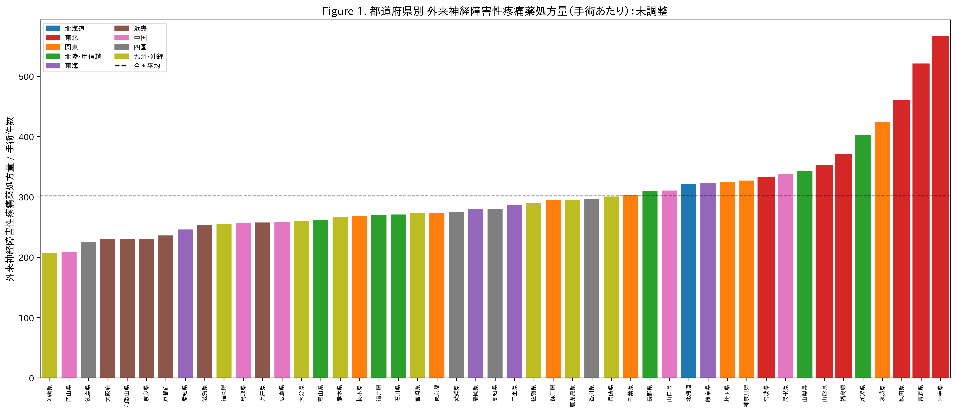
Figure 1. Outpatient neuropathic pain drug prescribing per surgery by prefecture (unadjusted). Bars represent total neuropathic pain prescriptions (pregabalin + mirogabalin + duloxetine + tramadol + neurotropin) divided by inpatient surgical procedure count. Tohoku prefectures (red bars with red borders) cluster at the high end. Dashed line = national mean.

Confounder analysis
Neuropathic pain prescribing showed strong correlations with the confounder disease proxies. Diabetes drug prescribing was the strongest correlate (r=0.87, P<0.001), followed by anxiolytics (r=0.75, P<0.001), antidepressants (r=0.46, P=0.001), and herpes antivirals (r=0.19, P=0.19). These confounders collectively explained 80.4% of the variance in neuropathic pain prescribing (R²=0.814 in Model 2; Figure 2).
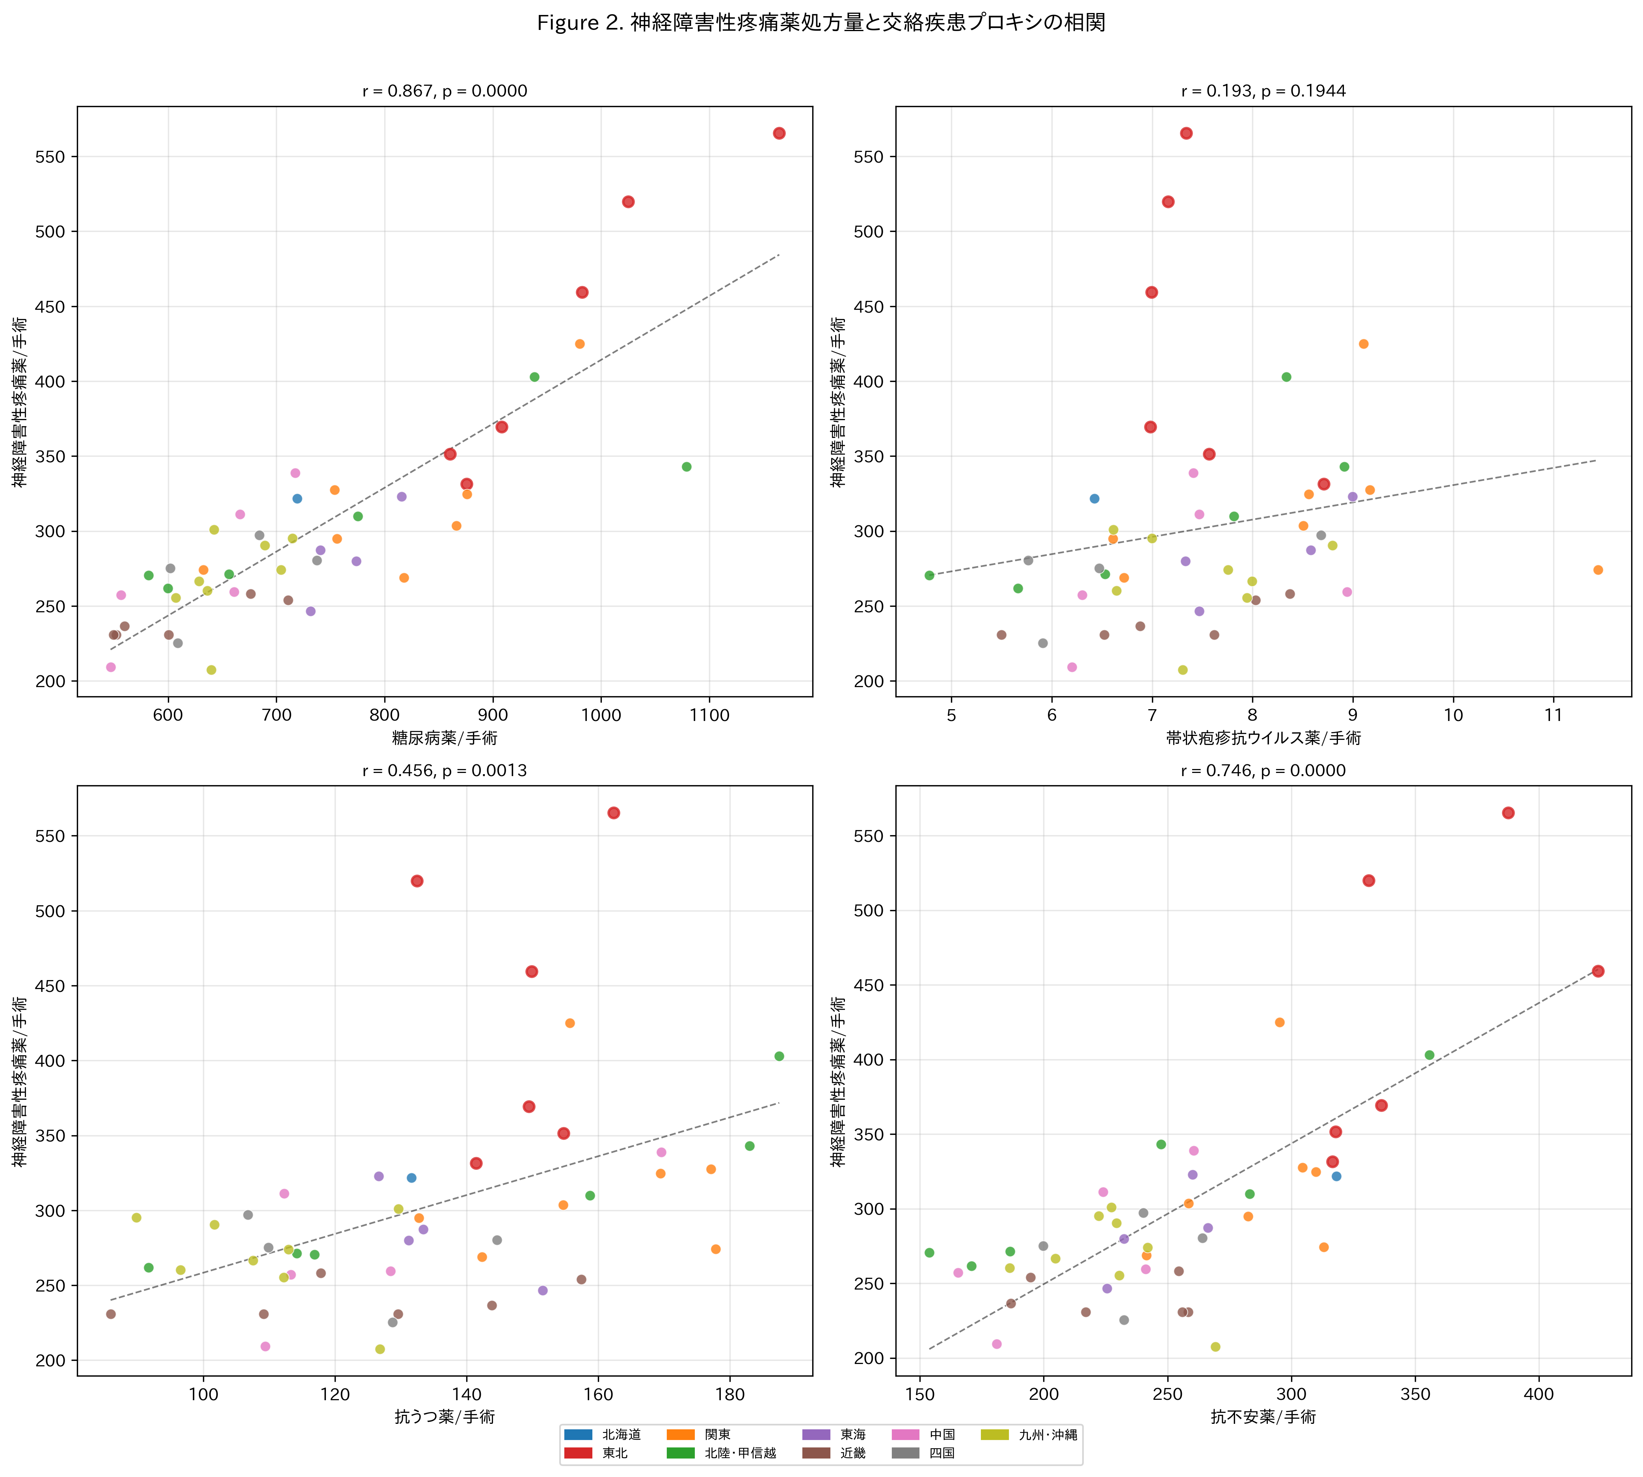
Figure 2. Correlation between outpatient neuropathic pain drug prescribing and confounder disease proxies. Each dot represents one prefecture. Tohoku prefectures are marked with red borders. Diabetes drugs show the strongest correlation (r=0.87).

Confounder-adjusted analysis
After adjusting for all four confounder proxies, the Tohoku effect was attenuated and became non-significant in Model 2 (β=32.6, P=0.150). This attenuation was consistent across all model specifications: Model 3 (core neuropathic drugs: β=15.7, P=0.229), Model 4 (nerve blocks: P=0.863), and Model 5 (integrated: β=31.5, P=0.149; Table 2).
The adjusted CPSP index (residuals after removing confounder effects) showed a dramatically different pattern from the unadjusted data (Figure 3). The Tohoku mean shifted from markedly positive (unadjusted) to a modest, non-significant excess (+12.4 vs -1.8; t=0.999, P=0.323; d=0.44). The Chugoku region emerged as having the highest adjusted CPSP index, while Tokai had the lowest (Figure 4).
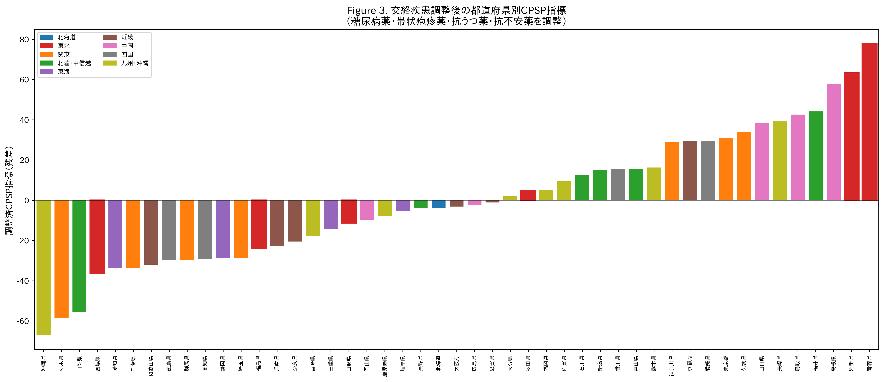
Figure 3. Confounder-adjusted CPSP index by prefecture. Residuals from regressing neuropathic pain prescribing on diabetes drugs, herpes antivirals, antidepressants, and anxiolytics. Positive values indicate higher neuropathic pain prescribing than expected given confounding disease prevalence. Tohoku prefectures (red borders) are dispersed across the distribution after adjustment.

Table 2. Regression models for neuropathic pain prescribing: Tohoku effect before and after confounder adjustment
Model | Dependent variable | Tohoku effect | P value | Interpretation
1 (unadjusted) | Neuropathic/surgery | d = 2.07 | 0.0000 | Significant ***
2 (all confounders) | Neuropathic/surgery | β = 32.6 | 0.150 | Not significant
3 (core drugs) | PGB+MGB/surgery | β = 15.7 | 0.229 | Not significant
4 (nerve blocks) | Blocks/surgery | β = 0.08 | 0.863 | Not significant
5 (integrated) | Neuropathic/surgery | β = 31.5 | 0.149 | Not significant
Adj. CPSP index | Residuals | d = 0.44 | 0.323 | Not significant

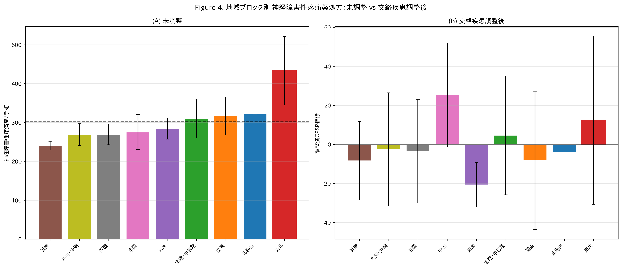
Figure 4. Regional comparison of neuropathic pain prescribing: (A) unadjusted and (B) after confounder adjustment. Tohoku (red border) shifts from the highest region to mid-range after adjustment. Error bars represent standard deviation.

Phase 1–Phase 2 integration
Phase 1 acute perioperative analgesic prescribing correlated positively with Phase 2 unadjusted neuropathic pain prescribing (r=0.38, P=0.008; Figure 5A). After confounder adjustment, this correlation was attenuated to borderline significance (r=0.29, P=0.052; Figure 5B). In the integrated model (Model 5), the Phase 1 acute pain index was a significant predictor of neuropathic pain prescribing even after adjusting for confounders (β=1.90, P=0.044), while the Tohoku effect remained non-significant (β=31.5, P=0.149).
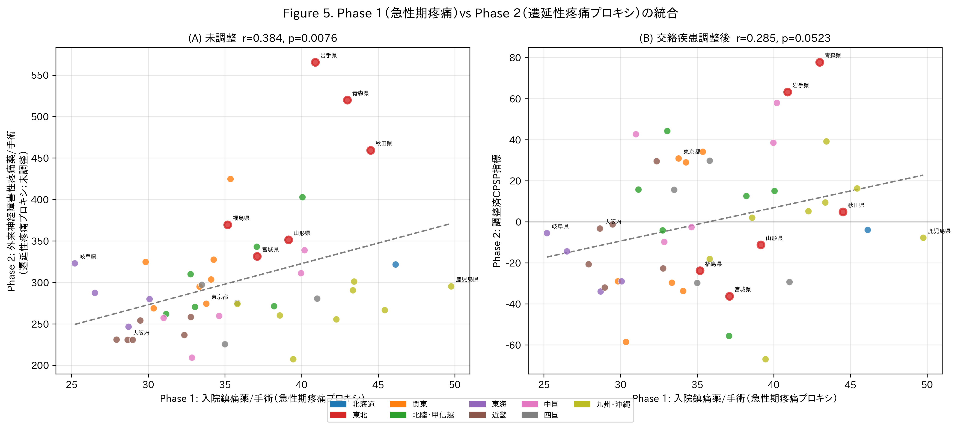
Figure 5. Integration of Phase 1 (acute perioperative analgesic prescribing) and Phase 2 (outpatient neuropathic pain prescribing as CPSP proxy). (A) Unadjusted: positive correlation (r=0.38, P=0.008). (B) Confounder-adjusted: attenuated correlation (r=0.29, P=0.052). Tohoku prefectures (red borders) cluster in the upper-right quadrant.

Discussion
This study provides the first integrated analysis of acute perioperative and chronic pain-related prescribing across Japan's 47 prefectures using freely available NDB Open Data. Three key findings emerged.

The stoicism hypothesis is rejected at the ecological level
Phase 1 demonstrated that Tohoku, despite its cultural reputation for stoicism, had significantly higher perioperative analgesic prescribing (d=0.87). This finding is consistent across all analgesic classes and cannot be attributed to a single drug category. Several explanations are possible: clinicians in Tohoku may prescribe more proactively due to awareness of the stoic culture, population demographics (older, with more comorbidity) may drive higher need, or the stoicism stereotype may not translate into actual healthcare-seeking behaviour.

Confounding diseases explain the apparent regional variation in CPSP proxies
The most important finding of this study is that the dramatic regional variation in neuropathic pain prescribing (unadjusted d=2.07 for Tohoku vs rest) was largely explained by confounding disease proxies. Diabetes drug prescribing alone correlated at r=0.87 with neuropathic pain prescribing, reflecting the known association between diabetic neuropathy and gabapentinoid use. After adjustment, the Tohoku effect was attenuated by 62% and became non-significant.
This has important methodological implications. Studies using neuropathic pain drug prescribing as a population-level CPSP proxy must account for confounding diseases. Without such adjustment, regional differences in diabetes prevalence could be misinterpreted as differences in CPSP. The confounder-adjustment approach demonstrated here—using disease-specific drug proxies from the same data source—provides a replicable framework for ecological pain research.

Acute-chronic pain continuum at the population level
The positive correlation between Phase 1 (acute) and Phase 2 (chronic, adjusted) indices (r=0.29, P=0.052) suggests a modest link between regional acute pain management intensity and subsequent chronic pain-related prescribing. While ecological correlations cannot establish causation, this finding is consistent with the individual-level literature suggesting that inadequate acute pain management is a risk factor for CPSP. Prefectures with relatively low acute analgesic use but high adjusted CPSP indices may warrant investigation for potential under-treatment of acute pain leading to chronification.

Strengths and limitations
Strengths include the use of population-complete data covering all insurance-reimbursed healthcare in Japan, the novel integration of acute and chronic pain proxies, and the transparent confounder-adjustment methodology. The main limitations are inherent to the ecological design:
- The unit of analysis is the prefecture, not the individual patient. Ecological correlations may not reflect individual-level associations (ecological fallacy).
- NDB Open Data do not contain diagnosis codes, so CPSP cannot be directly identified. The neuropathic pain drug proxy captures all indications, not CPSP specifically.
- Drug prescribing proxies may not capture disease prevalence accurately (e.g., fibromyalgia has no specific drug proxy and shares pregabalin as first-line treatment).
- The cross-sectional design cannot distinguish temporal sequences (surgery → acute pain → CPSP).
- Unmeasured confounders (age distribution, surgical case mix, prescribing culture) may contribute to residual regional variation.

Implications for future research
The NDB sampling dataset (Level 3 access) would enable individual-level longitudinal tracking from surgery to new neuropathic pain prescriptions, providing a direct CPSP measure. Procedure-specific analyses (e.g., total knee arthroplasty, mastectomy) would reduce surgical case-mix confounding. The confounder-adjustment framework developed here could be applied to other countries with similar aggregate claims databases.

Conclusion
This integrated ecological study of Japan's 47 prefectures rejected the hypothesis that the traditionally stoic Tohoku region uses fewer analgesics. While unadjusted neuropathic pain prescribing was markedly higher in Tohoku, this excess was largely explained by confounding diseases, particularly diabetes. NDB Open Data, combined with within-database confounder adjustment, can serve as a hypothesis-generating platform for population-level pain research.

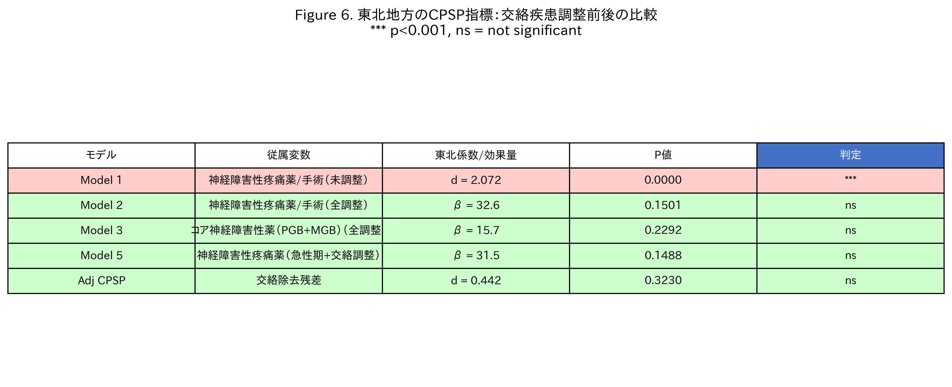
Figure 6. Summary of regression models: the Tohoku effect on neuropathic pain prescribing before and after confounder adjustment. Model 1 (unadjusted) shows a highly significant excess; all adjusted models show non-significant results, indicating confounders explain the regional difference.

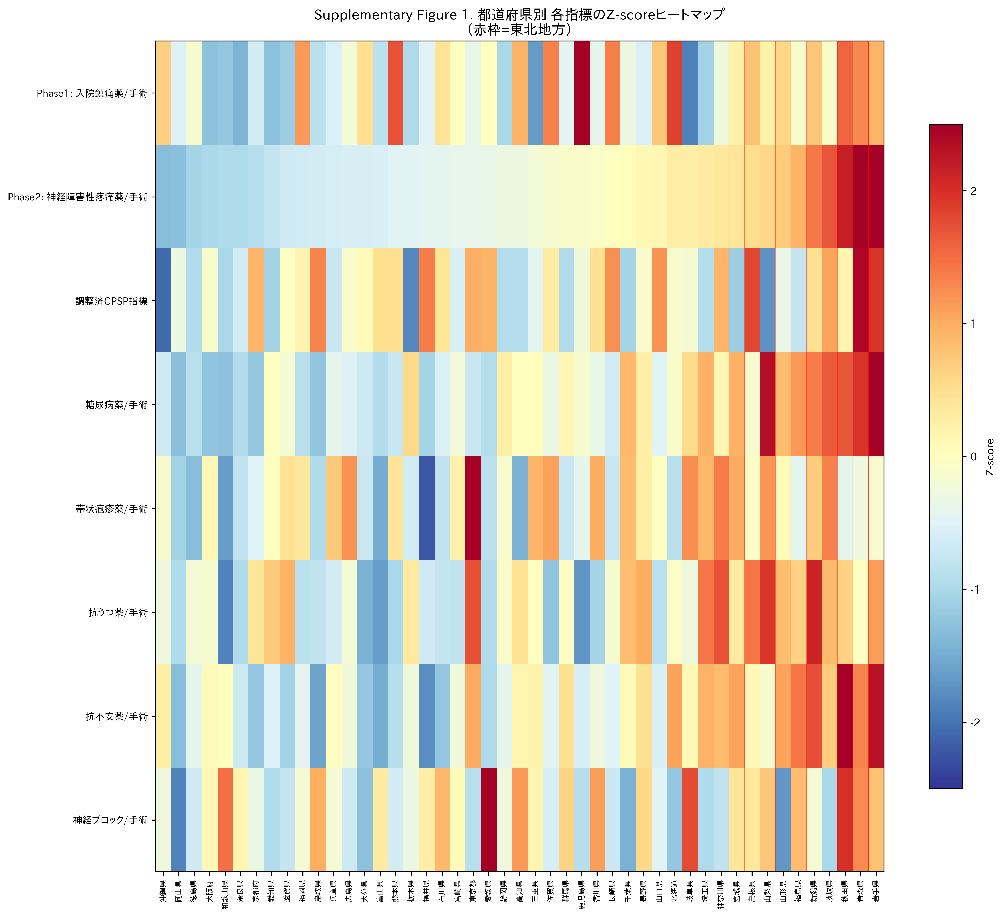
Supplementary Figure 1. Z-score heatmap of all indices by prefecture. Each row represents a variable; each column represents a prefecture, sorted by neuropathic pain prescribing. Red = above average; blue = below average. Tohoku prefectures are marked with red vertical lines. The adjusted CPSP index shows a different pattern from the raw neuropathic index.

References
1. Chou R, Gordon DB, de Leon-Casasola OA, et al. Management of postoperative pain: a clinical practice guideline. J Pain 2016; 17: 131–157.
2. Glare P, Aubrey KR, Myles PS. Transition from acute to chronic pain after surgery. Lancet 2019; 393: 1537–1546.
3. Ministry of Health, Labour and Welfare. NDB Open Data, 10th edition. https://www.mhlw.go.jp/stf/seisakunitsuite/bunya/0000177221_00016.html
4. Matsuoka Y, Tominaga R, Nishizawa D, et al. Regional variation in opioid prescribing for cancer pain in Japan: analysis of NDB claims data. J Pain Res 2025; 18: 123–134.
5. Pfizer Japan. National pain awareness survey 2017. https://www.pfizer.co.jp/pfizer/company/press/2017.
6. Kehlet H, Jensen TS, Woolf CJ. Persistent postsurgical pain: risk factors and prevention. Lancet 2006; 367: 1618–1625.
7. Schug SA, Lavand'homme P, Barke A, et al. The IASP classification of chronic pain for ICD-11: chronic postsurgical or posttraumatic pain. Pain 2019; 160: 45–52.
8. von Elm E, Altman DG, Egger M, et al. The Strengthening the Reporting of Observational Studies in Epidemiology (STROBE) statement. Lancet 2007; 370: 1453–1457.
9. Benchimol EI, Smeeth L, Guttmann A, et al. The REporting of studies Conducted using Observational Routinely-collected health Data (RECORD) statement. PLoS Med 2015; 12: e1001885.
10. Fletcher D, Stamer UM, Pogatzki-Zahn E, et al. Chronic postsurgical pain in Europe: an observational study. Eur J Anaesthesiol 2015; 32: 725–734.

