Regional Variation in Pain-Related Prescribing Across Japan’s 47 Prefectures: An Ecological Study Using the National Database of Health Insurance Claims

Tatsuki Onishi, MD

Department of Anesthesiology, [Institution], [Address], [City], [Postal code], Japan

Corresponding author: Tatsuki Onishi, MD, Department of Anesthesiology, [Institution], [Address], [City], [Postal code], Japan. E-mail: [email]

Article type: Original Article
Running title: Pain prescribing variation in Japan
Word count (body): [body word count]
Word count (abstract): [abstract word count]
Number of figures: 4
Number of tables: 2
Number of supplementary materials: 1 (Supplementary Table 1)
Keywords: analgesics; ecological study; health care disparities; Japan; prescriptions

Abstract
Background: Pain-related prescribing practices may vary geographically even within a single national health insurance system, but the magnitude and determinants of such variation remain poorly characterised in Japan. Whether prescribing variation reflects differences in symptom burden (warranted variation) or practice patterns (unwarranted variation) has not been investigated.
Methods: This ecological study analysed prefecture-level aggregate data from the National Database of Health Insurance Claims (NDB Open Data, 10th edition; April 2023–March 2024) covering all 47 prefectures. Phase 1 examined acute perioperative analgesic prescribing per surgery. Phase 2 examined outpatient neuropathic pain drug prescribing as a chronic pain proxy, with regression adjustment for confounding disease proxies (diabetes, herpes zoster, depression, anxiety). Standardised claim ratios (SCR) were computed by indirect age-sex standardisation. Symptom prevalence from the Comprehensive Survey of Living Conditions (CSLC 2022) was used as a demand-side benchmark.
Results: Acute analgesic prescribing varied 1.97-fold across prefectures (Kruskal–Wallis P<0.001). Unadjusted neuropathic pain prescribing showed marked regional clustering, but confounding disease proxies—particularly diabetes drugs (r=0.87)—explained 81% of between-prefecture variance. After confounder adjustment, apparent inter-regional differences were substantially attenuated and became nonsignificant. CSLC symptom prevalence varied only 1.29-fold and showed no correlation with prescribing (r=0.03, P=0.85), indicating supply-sensitive unwarranted variation.
Conclusions: Nearly twofold within-country variation in pain-related prescribing persists after age-sex standardisation and is dissociated from symptom burden, meeting the criteria for Wennberg unwarranted variation. Ecological studies of neuropathic pain drugs must account for confounding diseases, particularly diabetes, to avoid misattributing disease-driven prescribing to regional practice differences.

Introduction
Geographic variation in medical practice has been recognised as a major challenge for healthcare quality since Wennberg's pioneering work on small-area variation.¹ When prescribing rates differ across regions beyond what disease burden and demographics can explain, such unwarranted variation signals potential over- or under-treatment and merits systematic investigation.^{1,2}
Japan's universal health insurance system, standardised drug pricing, and the National Database of Health Insurance Claims (NDB)—which captures virtually all reimbursed healthcare utilisation for approximately 125 million insured individuals³—provide a unique setting for studying practice variation. Taira et al demonstrated substantial regional inequality in dental care utilisation using NDB-derived standardised claim ratios across all 47 prefectures.⁴ Recent studies have also documented up to 1.6-fold regional variation in chronic pain prevalence⁵ and 4-fold variation in cancer opioid prescribing.⁶ However, no study has comprehensively mapped pain-related prescribing variation across all 47 prefectures using the population-complete NDB.
Wennberg's framework distinguishes warranted variation—driven by differences in disease burden—from unwarranted variation driven by supply-side factors such as physician practice style, local norms, and resource availability.^{1,2} To apply this framework, an independent demand-side benchmark is needed. The Comprehensive Survey of Living Conditions (CSLC), a nationally representative household survey conducted by the Ministry of Health, Labour and Welfare, provides prefecture-level self-reported symptom prevalence rates that can serve as such a benchmark.⁷
Pain management is particularly amenable to ecological analysis because analgesic prescribing reflects both disease burden and clinical practice patterns. The perioperative setting offers a further methodological advantage: because all patients in this analysis are hospitalised for surgery, healthcare access—a major confounder in community-based prescribing studies—is neutralised by design. Outpatient neuropathic pain drugs can serve as a population-level proxy for chronic pain burden, but these medications have multiple indications (notably diabetic neuropathy), requiring careful confounder adjustment.
This study had four objectives: (1) map regional variation in acute perioperative analgesic prescribing across 47 prefectures; (2) examine outpatient neuropathic pain drug prescribing as a chronic pain proxy after adjustment for confounding diseases; (3) quantify the contribution of confounders to the apparent regional pattern; and (4) evaluate whether prescribing variation is dissociated from symptom burden, thereby meeting the criteria for unwarranted variation.

Methods

Study design and reporting
This ecological study analysed prefecture-level aggregate data from the NDB Open Data. It is reported following the Strengthening the Reporting of Observational Studies in Epidemiology (STROBE) statement⁸ and the REporting of studies Conducted using Observational Routinely-collected health Data (RECORD) extension.⁹ As only publicly available aggregate data were used, ethical approval was not required under Japan's Ethical Guidelines for Medical and Biological Research Involving Human Subjects.

Data source
The 10th edition of the NDB Open Data (April 2023–March 2024) was used.³ The NDB captures claims from all insurers within Japan's universal coverage system, encompassing approximately 125 million insured individuals. Aggregate prescription and procedure data are published at the prefecture level (n=47) with suppression of cells containing fewer than 10 events. Prefecture-level population estimates (October 2023, by 5-year age group and sex) from the Statistics Bureau of Japan were used to compute per-capita rates and standardised claim ratios.

Regional classification
Prefectures were grouped into nine standard regional blocks following the classification used by the Statistics Bureau of Japan: Hokkaido (1 prefecture), Tohoku (6), Kanto (7), Hokuriku-Koshinetsu (6), Tokai (4), Kinki (6), Chugoku (5), Shikoku (4), and Kyushu-Okinawa (8).

Phase 1: Acute perioperative analgesic prescribing
Inpatient prescription data were extracted for three analgesic drug classes commonly used in perioperative pain management: Class 114 (antipyretic analgesics including NSAIDs and acetaminophen), Class 811 (opium alkaloid narcotics), and Class 821 (synthetic narcotics including fentanyl and pethidine). The analgesic-per-surgery index was calculated for each prefecture as total inpatient analgesic prescription units divided by total inpatient surgical procedure count (K Surgery section), providing a standardised measure of analgesic intensity that accounts for differences in surgical volume.

Phase 2: Outpatient neuropathic pain prescribing
Five classes of outpatient oral neuropathic pain medications were extracted: pregabalin (78 formulations), mirogabalin (8), duloxetine (33), tramadol (3), and neurotropin (1). The neuropathic pain prescribing-per-surgery index was calculated as total outpatient neuropathic pain drug quantity divided by total inpatient surgical procedure count. Per-capita neuropathic pain prescribing rates were additionally computed.

Confounder disease proxies
Four confounder disease proxies were extracted from outpatient data: oral hypoglycaemic agents (261 formulations; proxy for diabetic neuropathy), herpes zoster antivirals (47 formulations; proxy for postherpetic neuralgia), antidepressants excluding duloxetine (128 formulations; proxy for depression), and anxiolytics (112 formulations; proxy for anxiety disorders). Each proxy was expressed per surgery for consistency. Outpatient nerve block procedure counts (73 codes) served as an additional independent proxy.

Demand-side benchmark: Comprehensive Survey of Living Conditions
Prefecture-level self-reported symptom prevalence rates were obtained from the Comprehensive Survey of Living Conditions (CSLC; Kokumin Seikatsu Kiso Chousa) 2022 edition.⁷ The CSLC is a nationally representative household survey covering approximately 300,000 households, with symptom prevalence rates (yuushosha-ritsu) published per 1,000 population for each of the 47 prefectures. Symptom prevalence, reflecting the proportion of the population reporting any health complaint (musculoskeletal pain being the most common category nationally), was used as a demand-side proxy for healthcare need. A demand–supply mismatch index was computed as the difference between z-standardised prescribing rates and z-standardised symptom prevalence rates for each prefecture. Positive values indicate relative over-supply; negative values indicate relative under-supply.

Statistical analysis
Regional differences in Phase 1 were assessed using the Kruskal–Wallis test across nine regional blocks, followed by post hoc Mann–Whitney U tests with Bonferroni correction. Effect sizes were quantified using Cohen's d. For Phase 2, five regression models were fitted with progressive confounder adjustment: Model 1 (unadjusted inter-regional comparison), Model 2 (neuropathic pain ~ diabetes + herpes + antidepressants + anxiolytics + region), Model 3 (core neuropathic drugs only ~ same confounders), Model 4 (nerve blocks ~ same confounders), and Model 5 (neuropathic pain ~ acute analgesic index + confounders). The adjusted CPSP index was derived as residuals from regressing neuropathic pain prescribing on the four confounder proxies.
Standardised claim ratios (SCR) were computed by indirect age-sex standardisation following Taira et al.⁴ National age-sex-specific prescription rates (18 five-year age groups × 2 sexes) were applied to each prefecture's population structure. All analyses used Python 3.11 (NumPy 1.24, SciPy 1.11).

Results

Phase 1: Regional variation in acute perioperative analgesic prescribing
During April 2023–March 2024, the NDB recorded 7,903,515 inpatient surgical procedures and 274,579,851 analgesic prescription units across 47 prefectures. The national mean analgesic-per-surgery index was 35.78 (SD, 5.56), ranging from 25.20 (Gifu) to 49.75 (Kagoshima)—a 1.97-fold difference (Kruskal–Wallis P<0.001 across nine regions; Table 1).
Table 1. Regional summary of inpatient analgesic prescribing per surgery. Values are mean (SD). Kruskal–Wallis P<0.001.
Region | n | Mean (SD) | Range
Hokkaido | 1 | 46.12 | 46.12–46.12
Tohoku | 6 | 39.97 (3.53) | 35.18–44.51
Kanto | 7 | 33.00 (2.09) | 29.82–35.36
Hokuriku-Koshinetsu | 6 | 35.38 (3.54) | 31.17–40.04
Tokai | 4 | 27.62 (2.18) | 25.20–30.07
Kinki | 6 | 30.02 (2.03) | 27.92–32.78
Chugoku | 5 | 35.73 (4.18) | 30.99–40.19
Shikoku | 4 | 36.33 (3.27) | 33.49–41.02
Kyushu-Okinawa | 8 | 42.26 (4.33) | 35.81–49.75

Substantial regional clustering was observed (Table 1). Tokai and Kinki had the lowest indices, while Kyushu-Okinawa and Hokkaido had the highest. Post hoc pairwise comparisons confirmed significant differences between several regional blocks (Bonferroni-corrected Mann–Whitney U tests). This pattern was consistent across all three analgesic drug classes: NSAIDs, opioid alkaloids, and synthetic opioids.

Phase 2: Outpatient neuropathic pain prescribing
Outpatient neuropathic pain drug prescriptions totalled 2,289,549,163 units, comprising pregabalin (40.2%), neurotropin (20.1%), mirogabalin (19.6%), duloxetine (15.3%), and tramadol (4.9%). Marked inter-regional variation was observed in neuropathic pain prescribing-per-surgery index (Kruskal–Wallis P<0.001; Figure 1), with individual prefectures spanning a wide range.
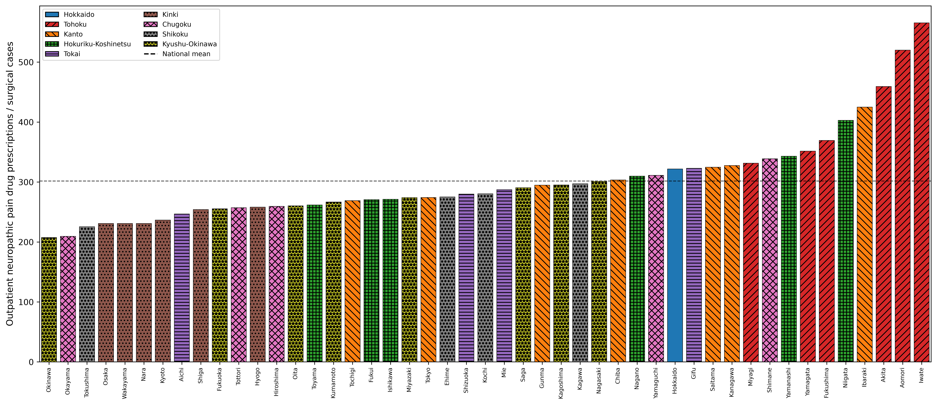
Figure 1. Outpatient neuropathic pain drug prescribing per surgery by prefecture. Bars indicate regional blocks (distinguished by colour and hatch pattern). Dashed line indicates the national mean.

Confounder analysis and adjustment
Neuropathic pain prescribing showed strong correlations with confounder disease proxies. Diabetes drug prescribing was the strongest correlate (r=0.87, P<0.001), followed by anxiolytics (r=0.75), antidepressants (r=0.46), and herpes antivirals (r=0.19). These four confounders collectively explained 81.4% of between-prefecture variance in neuropathic pain prescribing (R²=0.814; Figure 2).

Figure 2. Correlation between neuropathic pain prescribing and confounder disease proxies across 47 prefectures. Diabetes drugs show the strongest correlation (r=0.87).
After adjustment for these confounders, the apparent inter-regional clustering was substantially attenuated (Table 2). Regional indicator variables that were significant in unadjusted models became nonsignificant across all model specifications (Models 2–5), indicating that confounding diseases—not regional practice differences—drove the observed pattern.
Table 2. Regression models for outpatient neuropathic pain prescribing.
Model | Confounder R² | Key statistic | Note
Model 1 (unadjusted) | — | Kruskal–Wallis H, P<0.001 | Omnibus 9-region test
Model 2 (all confounders) | R²=0.814 | R²adj=0.791 | Regional β=32.6, P=0.150
Model 3 (core neuro) | R²=0.811 | R²adj=0.788 | Regional β=15.7, P=0.229
Model 4 (nerve blocks) | R²=0.145 | R²adj=0.041 | Regional β=0.08, P=0.863
Model 5 (integrated) | R²=0.832 | Acute β=1.90, P=0.044 | Regional β=31.5, P=0.149

The adjusted CPSP index showed a markedly different geographic pattern from the unadjusted data (Figure 3). Regions that appeared to have high neuropathic pain prescribing in unadjusted analyses no longer showed significant excess after confounder adjustment (Kruskal–Wallis P>0.05), indicating that the original clustering was driven primarily by regional differences in confounding disease burden.
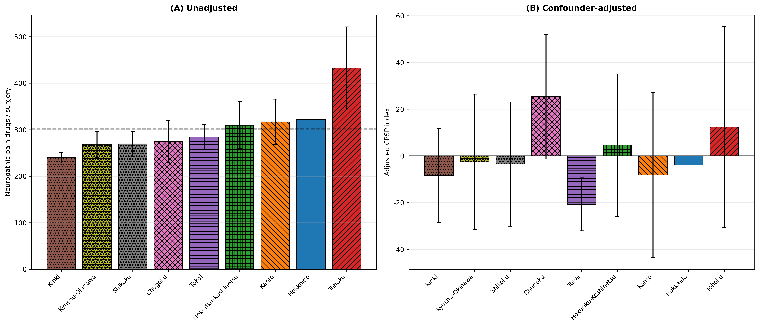
Figure 3. Regional comparison of neuropathic pain prescribing: (a) unadjusted and (b) after confounder adjustment. Error bars indicate SD.

Demand–supply dissociation
CSLC symptom prevalence ranged from 244.0 (東京都) to 314.9 per 1,000 population (兵庫県), a 1.29-fold difference (mean 287.4, SD 17.7). In contrast, acute analgesic prescribing varied 1.97-fold and neuropathic pain prescribing per capita varied 2.0-fold (after age-sex standardisation). Thus, prescribing heterogeneity substantially exceeded the modest variation in symptom burden.
CSLC symptom prevalence showed no significant correlation with acute analgesic prescribing (r=0.029, P=0.846; Spearman ρ=-0.032, P=0.829; Figure 4) or with neuropathic pain prescribing per capita (r=0.076, P=0.610). The absence of correlation indicates that prescribing variation is not explained by differences in self-reported symptom burden across prefectures.
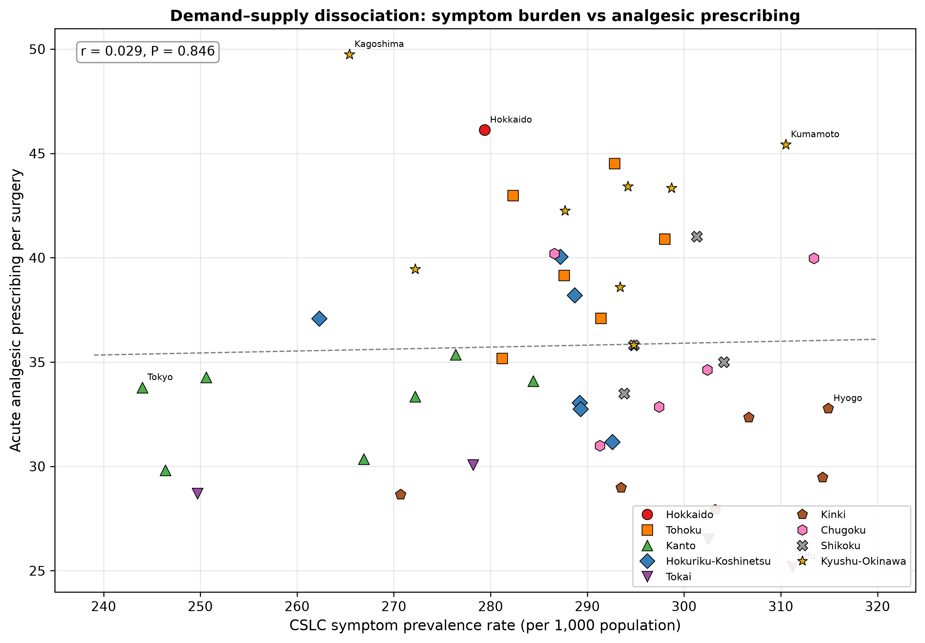
Figure 4. Demand–supply dissociation: CSLC symptom prevalence rate (per 1,000 population) vs acute analgesic prescribing per surgery across 47 prefectures. Each marker shape represents a regional block. The near-zero correlation (r=0.03) indicates that prescribing variation is dissociated from symptom burden.

Integration of acute and chronic prescribing
Acute perioperative prescribing correlated positively with unadjusted neuropathic pain prescribing (r=0.38, P=0.008). After confounder adjustment, this correlation was attenuated (r=0.29, P=0.052). In Model 5, the acute pain index remained a significant predictor (β=1.90, P=0.044), while regional indicators were nonsignificant after confounder adjustment.

Age-sex standardised claim ratios
After indirect age-sex standardisation, inpatient analgesic SCR ranged from 63.6 to 147.9 (2.3-fold variation), confirming that prescribing heterogeneity was not attributable to differences in prefectural age-sex composition. Outpatient neuropathic pain drug SCR ranged from 74.7 to 152.0 (2.0-fold).

Discussion
This study is the first to map perioperative and chronic pain-related prescribing across all 47 prefectures of Japan using the population-complete NDB Open Data, and the first to formally evaluate whether this variation meets the criteria for Wennberg unwarranted variation by benchmarking it against an independent demand-side measure. Four principal findings emerged.

Principal findings
First, acute perioperative analgesic prescribing varied 1.97-fold across prefectures—comparable to the regional variation in dental care utilisation reported by Taira et al⁴ and consistent with the supply-sensitive variation pattern described by Wennberg.¹ This variation was robust: it persisted after age-sex standardisation (SCR range, 64–148) and was consistent across all three analgesic drug classes.
Second, the most methodologically important finding is that the marked regional clustering in neuropathic pain prescribing was largely explained by confounding disease proxies, particularly diabetes drug prescribing (r=0.87). After adjustment, apparent inter-regional differences were substantially attenuated and became nonsignificant across all model specifications. This has important implications: ecological studies using neuropathic pain drugs as a chronic pain proxy must account for diabetic neuropathy. Without such adjustment, regional differences in diabetes prevalence will be misattributed to differences in pain management practice.
Third, the most novel finding is that prescribing variation was dissociated from symptom burden. CSLC symptom prevalence varied only 1.29-fold and showed no correlation with analgesic prescribing (r=0.03, P=0.85). This dissociation formally meets the criteria for unwarranted variation under Wennberg's framework:¹ the supply side (prescribing) varies independently of the demand side (symptom burden), indicating that practice patterns rather than disease burden drive the observed heterogeneity. This finding parallels international evidence showing that medical practice variation is frequently supply-sensitive rather than demand-driven.²
Fourth, the positive correlation between acute and confounder-adjusted chronic indices (r=0.29, P=0.052) and the significant acute pain predictor in Model 5 (β=1.90, P=0.044) suggest a modest link between regional acute pain management intensity and subsequent chronic pain-related prescribing. This is consistent with individual-level evidence that acute postoperative pain intensity is a risk factor for CPSP.¹⁰

Clinical implications
The 1.97-fold within-Japan variation has broader implications beyond descriptive epidemiology. A large body of evidence demonstrates that cultural stereotypes influence clinician pain assessment and prescribing behaviour internationally: Anderson et al showed systematic disparities in pain management across racial and ethnic groups,¹¹ and Campbell and Edwards identified that clinician expectations about cultural pain behaviour can lead to systematic under- or over-treatment.¹² Japan is often characterised as culturally homogeneous with patients who are stoic about pain.^{13,14} Yet our data demonstrate that even within this putatively uniform population, prescribing patterns vary nearly twofold—a degree of heterogeneity that makes any national-level characterisation clinically misleading. The Pfizer Japan 2017 survey provides additional corroboration: the proportion of chronic pain patients "enduring pain without seeking treatment" ranged from 48.7% (Osaka) to 81.6% (Yamanashi) across prefectures, and Akita Prefecture (Tohoku region)—often stereotyped as stoic—had the lowest proportion who believed pain "should be endured" (60.2%), contradicting the cultural stereotype.¹⁵
The revised IASP definition describes pain as inherently subjective.¹⁶ No regional label or cultural generalisation can substitute for individualised pain assessment. Objective nociception monitoring may help standardise perioperative assessment.¹⁷ Our demand–supply analysis reinforces this point: prefectures with identical symptom burden show widely divergent prescribing, indicating that clinician-level factors rather than patient-level need determine treatment intensity.

Strengths and limitations
Strengths include the use of population-complete data covering all insurance-reimbursed healthcare in Japan, the novel integration of acute and chronic pain proxies, the transparent confounder-adjustment methodology, a perioperative design that neutralises healthcare access as a confounder, and the triangulation of NDB prescribing data with an independent household survey (CSLC) for demand–supply analysis.
Limitations are inherent to the ecological design. The unit of analysis is the prefecture, not the individual; ecological correlations may not reflect individual-level associations. NDB Open Data lack diagnosis codes, so the neuropathic pain drug proxy captures all indications, not CPSP specifically. Unmeasured confounders including surgical case mix and physician density may contribute to residual variation. The CSLC symptom prevalence rate is a general indicator of self-reported health complaints, not specific to pain; however, musculoskeletal pain symptoms (lower back pain and stiff shoulders) are the most common complaints nationally, and the CSLC rate thus serves as a reasonable ecological proxy for pain-related demand.

Conclusion
Pain-related prescribing varies nearly twofold across Japan's 47 prefectures, persisting after age-sex standardisation and dissociated from symptom burden. This pattern meets the criteria for Wennberg unwarranted variation, suggesting that supply-side factors drive prescribing heterogeneity. Confounding diseases—particularly diabetes—substantially modify the apparent regional pattern of neuropathic pain prescribing and must be accounted for in ecological studies. Clinicians should base analgesic decisions on individual assessment rather than regional or cultural assumptions.

Acknowledgements
The author thanks the Ministry of Health, Labour and Welfare for making the NDB Open Data publicly available.
Use of AI: Parts of data processing and manuscript preparation were assisted by generative AI (Claude, Anthropic). The author takes full responsibility for the accuracy and content of the manuscript.
Conflicts of interest: The author declares no conflict of interest with respect to this research study and paper.

Funding
This research did not receive any specific grant from funding agencies in the public, commercial, or not-for-profit sectors.

Contributors
TO: Conceptualization, Data curation, Formal analysis, Investigation, Methodology, Software, Visualization, Writing – original draft, Writing – review & editing.

Data Availability
Data derived from a source in the public domain. The NDB Open Data used in this study are publicly available from the Ministry of Health, Labour and Welfare website (https://www.mhlw.go.jp/stf/seisakunitsuite/bunya/0000177221_00016.html). Analysis code is available at https://github.com/bougtoir/ndb-pain-regional-variation-japan.

References
1. Wennberg JE. Tracking Medicine: A Researcher's Quest to Understand Health Care. New York, NY: Oxford University Press; 2010.
2. Corallo AN, Croxford R, Goodman DC, Bryan EL, Srivastava D, Stukel TA. A systematic review of medical practice variation in OECD countries. Health Policy. 2014;114:5–14. doi:10.1016/j.healthpol.2013.08.002
3. Ministry of Health, Labour and Welfare. NDB Open Data, 10th edition. https://www.mhlw.go.jp/stf/seisakunitsuite/bunya/0000177221_00016.html. Accessed January 15, 2025.
4. Taira K, Mori T, Ishimaru M, et al. Regional inequality in dental care utilisation in Japan: an ecological study using the National Database of Health Insurance Claims. Lancet Reg Health West Pac. 2021;12:100170. doi:10.1016/j.lanwpc.2021.100170
5. Wakaizumi K, Tanaka C, Shinohara Y, et al. Geographical variation in high-impact chronic pain and psychological associations at the regional level: a multilevel analysis of a large-scale internet-based cross-sectional survey. Front Public Health. 2024;12:1482177. doi:10.3389/fpubh.2024.1482177
6. Takahashi R, Miyashita M, Nakazawa Y, Wada S, Matsuoka Y. Population-based claims study of regional and hospital function differences in opioid prescribing for cancer patients who died in hospital in Japan. Jpn J Clin Oncol. 2025;55:1372–7. doi:10.1093/jjco/hyaf149
7. Ministry of Health, Labour and Welfare. Comprehensive Survey of Living Conditions (Kokumin Seikatsu Kiso Chousa), 2022. https://www.mhlw.go.jp/toukei/saikin/hw/k-tyosa/k-tyosa22/. Accessed March 1, 2025.
8. von Elm E, Altman DG, Egger M, et al. The Strengthening the Reporting of Observational Studies in Epidemiology (STROBE) statement: guidelines for reporting observational studies. Lancet. 2007;370:1453–7. doi:10.1016/S0140-6736(07)61602-X
9. Benchimol EI, Smeeth L, Guttmann A, et al. The REporting of studies Conducted using Observational Routinely-collected health Data (RECORD) statement. PLoS Med. 2015;12:e1001885. doi:10.1371/journal.pmed.1001885
10. Kehlet H, Jensen TS, Woolf CJ. Persistent postsurgical pain: risk factors and prevention. Lancet. 2006;367:1618–25. doi:10.1016/S0140-6736(06)68700-X
11. Anderson KO, Green CR, Payne R. Racial and ethnic disparities in pain: causes and consequences of unequal care. J Pain. 2009;10:1187–204. doi:10.1016/j.jpain.2009.10.002
12. Campbell CM, Edwards RR. Ethnic differences in pain and pain management. Pain Manag. 2012;2:219–30. doi:10.2217/pmt.12.7
13. Callister LC. Cultural influences on pain perceptions and behaviors. Home Health Care Manag Pract. 2003;15:207–11. doi:10.1177/1084822302250687
14. Hobara M. Beliefs about appropriate pain behavior: cross-cultural and sex differences between Japanese and Euro-Americans. Eur J Pain. 2005;9:389–93. doi:10.1016/j.ejpain.2004.09.006
15. Pfizer Japan Inc. 47-prefecture survey on chronic pain (2012 vs 2017). https://www.pfizer.co.jp/pfizer/company/press/2017/2017_08_23.html. Accessed May 28, 2022. Archived at: https://web.archive.org/web/20220528073616/https://www.pfizer.co.jp/pfizer/company/press/2017/2017_08_23.html
16. Raja SN, Carr DB, Cohen M, et al. The revised International Association for the Study of Pain definition of pain: concepts, challenges, and compromises. Pain. 2020;161:1976–82. doi:10.1097/j.pain.0000000000001939
17. Onishi T, Onishi Y. Normalized pulse volume as a superior predictor of respiration recovery and quantification of nociception anti-nociception balance compared to opioid effect site concentration: a prospective, observational study. F1000Research. 2024;13:233. doi:10.12688/f1000research.146215.1

Figure Legends
Figure 1. Outpatient neuropathic pain drug prescribing per surgery by prefecture. Bars represent individual prefectures ordered by prescribing index. Bars indicate regional blocks (distinguished by colour and hatch pattern). Dashed line indicates the national mean.
Figure 2. Correlation between neuropathic pain prescribing and confounder disease proxies across 47 prefectures. Each marker represents a regional block (distinguished by colour and shape). Diabetes drugs show the strongest correlation (r=0.87).
Figure 3. Regional comparison of neuropathic pain prescribing: (a) unadjusted and (b) after adjustment for confounding disease proxies. Error bars indicate SD.
Figure 4. Demand–supply dissociation: CSLC symptom prevalence rate (per 1,000 population) vs acute analgesic prescribing per surgery across 47 prefectures. Each marker shape represents a regional block. The near-zero correlation (r=0.03, P=0.85) indicates that prescribing variation is dissociated from symptom burden.

