“Japanese Patient”? — A Patient.
Regional Heterogeneity in Pain-Related Prescribing Across Japan’s 47 Prefectures
Challenges the Stereotype of a Stoic Monolith

[Author names and affiliations to be inserted]

Corresponding author: [Name], Department of Anesthesiology, [Institution], [Address], [City], [Postal code], Japan. E-mail: [email]; Tel: [phone]; Fax: [fax]

Keywords: cultural pain behavior; ecological study; gaman; neuropathic pain; regional variation; prescribing patterns

Number of text pages: [to be determined after formatting]
Number of figures: 7 (6 main + 1 supplementary)
Number of tables: 2

Abstract
Cross-cultural studies consistently characterize Japanese people as more stoic toward pain than Western populations, yet whether this cultural pain endurance varies regionally within Japan remains unexplored. This ecological study used Japan’s National Database (NDB) Open Data (population-complete insurance claims, April 2023–March 2024) to map pain-related prescribing across 47 prefectures and nine regional blocks. In Phase 1, an inpatient analgesic-per-surgery index varied 1.97-fold (Gifu 25.20 to Kagoshima 49.75; Kruskal–Wallis P < 0.001). The perioperative setting neutralizes healthcare access as a confounder, since all patients are hospitalized. Contrary to the popular perception of northern stoicism, the Tohoku region ranked seventh of nine (mean 39.97 vs national 35.78; P = 0.031; Cohen’s d = 0.87), prescribing more, not fewer, analgesics. In Phase 2, outpatient neuropathic pain prescribing (a chronic postsurgical pain proxy) showed Tohoku with the highest unadjusted index (mean 432.8 vs 282.5; d = 2.81), but this excess became nonsignificant after adjustment for confounding diseases (diabetes, postherpetic neuralgia, depression, anxiety; P = 0.323), with diabetes drug prescribing as the strongest confounder (r = 0.87). These findings demonstrate that Japan’s pain culture is not monolithic: nearly twofold within-country variation in analgesic prescribing challenges the assumption that “Japanese” constitutes a uniform category for pain behavior. The monolithic characterization of any national population’s pain behavior carries a risk of clinical harm—whenever cultural stereotypes narrow the range of treatment options considered for a patient. Individualized pain assessment, informed by objective nociception monitoring rather than culturally stereotyped assumptions, should be the standard of perioperative care.

Introduction
Pain is a universal experience, yet its expression, tolerance, and management are profoundly shaped by culture [1,2]. Since Zborowski’s seminal observation that ethnic groups in the United States differ markedly in pain behavior [3], a large body of literature has established that cultural norms influence whether individuals report pain, seek treatment, or endure in silence [4]. These cross-cultural differences have practical implications: they affect postoperative pain assessment, analgesic prescribing, and ultimately patient outcomes.
Among the world’s cultures, Japan is consistently characterized as having a particularly stoic orientation toward pain. Hobara reported that Japanese respondents rated pain behaviors (e.g., moaning, crying) as significantly less appropriate than Euro-American respondents [5]. Feng et al. demonstrated that Japanese participants were far less willing to trade time to avoid pain/discomfort than British participants using the EQ-5D: the decrement for moving from moderate to extreme pain was 0.65 in the United Kingdom versus only 0.15 in Japan [6]. This culturally mediated pain endurance, encapsulated by the Japanese concept of gaman (我慢, stoic endurance), is widely recognized as a core cultural value [7]. Such stoicism may lead to underreporting of pain and underutilization of analgesics at the population level. Internationally, this stereotype carries clinical risk: clinicians unfamiliar with Japanese patients may assume that stoic presentation indicates lower analgesic need.
Most studies of cultural pain behavior compare between nations. However, substantial cultural heterogeneity exists within countries. Cohen and Nisbett demonstrated that the “culture of honor” in the southern United States produces measurably different behavioral and physiological responses to provocation compared with the northern states [8]—a within-country cultural difference with real-world consequences. In Japan, regional cultural identities are strong: the Tohoku region (northeast) is traditionally perceived as stoic and resilient, while other regions carry their own cultural characteristics [9]; even the Japanese word for throbbing pain (uzuku) shows distinct regional usage patterns [10]. A nationwide survey by Pfizer Japan found that the proportion of chronic pain patients reporting that they “endure pain” ranged from 48.7% to 81.6% across prefectures [11], suggesting within-country variation. Yet whether such attitudinal differences translate into measurable differences in pain-related healthcare utilization remains unexplored.
Japan provides an ideal setting for studying regional variation in pain behavior. Its universal health insurance system eliminates financial access barriers, standardized drug pricing removes market-driven prescribing variation, and the National Database of Health Insurance Claims (NDB) captures virtually all reimbursed healthcare utilization (≈2.1 billion claims annually) [12]. Furthermore, recent studies have documented significant regional variation in other pain-related metrics: Wakaizumi et al. found up to 1.6-fold differences in high-impact chronic pain prevalence across prefectures [13], and Matsuoka et al. reported 4-fold regional variation in cancer opioid prescribing [14]. However, no study has examined perioperative and chronic pain-related prescribing at the national prefecture level.
The perioperative setting offers a distinct methodological advantage over community-based pain surveys. Because all surgical patients are already admitted to hospital, healthcare access—a major confounding factor in outpatient studies of analgesic behavior—is effectively neutralized. Every patient, regardless of geographic remoteness, socioeconomic status, or health-seeking tendency, is under direct clinical observation and has equal opportunity to receive analgesics. Regional differences in perioperative prescribing therefore more closely reflect differences in clinical practice and pain expression than differences in access to care.
The purpose of this exploratory study was threefold. First (Phase 1), to map regional variation in acute perioperative analgesic prescribing across Japan’s 47 prefectures and nine regional blocks. Second (Phase 2), to examine regional variation in outpatient neuropathic pain prescribing as a chronic postsurgical pain (CPSP) proxy, after adjustment for confounding diseases (diabetic neuropathy, postherpetic neuralgia, depression, anxiety). Third, to integrate Phase 1 and Phase 2 findings to explore whether acute perioperative analgesic use correlates with subsequent chronic pain-related prescribing at the population level.

Methods

Study design and reporting
This ecological study analyzed prefecture-level aggregate data from the NDB Open Data. The study is reported following the Strengthening the Reporting of Observational Studies in Epidemiology (STROBE) guidelines [15] and the REporting of studies Conducted using Observational Routinely-collected health Data (RECORD) extension [16]. As only publicly available aggregate data were used, ethical approval was not required.

Data source
The 10th edition of the NDB Open Data (Ministry of Health, Labour and Welfare [MHLW]) was used, covering healthcare claims from April 2023 to March 2024 [12]. The NDB captures claims from all insurers within Japan’s universal health coverage system, encompassing approximately 125 million insured individuals. Aggregate data are published at the prefecture level with suppression of cells containing fewer than 10 events.

Regional classification
Prefectures were grouped into nine standard regional blocks: Hokkaido (1), Tohoku (6: Aomori, Iwate, Miyagi, Akita, Yamagata, Fukushima), Kanto (7), Hokuriku-Koshinetsu (6), Tokai (4), Kinki (6), Chugoku (5), Shikoku (4), and Kyushu-Okinawa (8). This classification follows the standard administrative grouping used by the MHLW.

Phase 1: Acute perioperative analgesic prescribing
Inpatient prescription data were extracted for three analgesic drug classes: Class 114 (antipyretic analgesics and anti-inflammatory drugs [NSAIDs/acetaminophen]), Class 811 (opium alkaloid narcotics [morphine, oxycodone, codeine]), and Class 821 (synthetic narcotics [fentanyl, pethidine, tapentadol]). Inpatient surgical procedure counts were extracted from the K Surgery section. The analgesic-per-surgery index was calculated for each prefecture as: total inpatient analgesic quantity (units)/total inpatient surgical procedure count.

Phase 2: Outpatient neuropathic pain prescribing as CPSP proxy
Five classes of outpatient oral neuropathic pain medications were extracted by prefecture: pregabalin (78 formulations), mirogabalin (8 formulations), duloxetine (33 formulations), tramadol (3 formulations), and neurotropin (1 formulation). The neuropathic pain prescribing-per-surgery index was calculated as: total outpatient neuropathic pain drug quantity/total inpatient surgical procedure count. This index serves as a proxy for CPSP, recognizing that these drugs are also prescribed for other neuropathic conditions.

Confounder disease proxies
Since neuropathic pain drugs are prescribed for conditions other than CPSP, four confounder disease proxies were extracted from the outpatient prescription data:
- Oral hypoglycemic agents (261 formulations): proxy for diabetic neuropathy
- Herpes zoster antivirals (47 formulations: valacyclovir, acyclovir, famciclovir, amenamevir): proxy for postherpetic neuralgia
- Antidepressants excluding duloxetine (128 formulations: SSRIs, SNRIs, NaSSAs, tricyclics): proxy for depression
- Anxiolytics (112 formulations: benzodiazepines, tandospirone, hydroxyzine): proxy for anxiety disorders
Each confounder proxy was expressed per surgery to maintain comparability with the neuropathic pain index.

Outpatient nerve block procedures
Outpatient nerve block procedure counts were extracted from the anesthesia section of the NDB Open Data as an independent CPSP proxy. This included epidural blocks, paravertebral blocks, trigger point injections, stellate ganglion blocks, and continuous nerve block infusions (73 procedure codes).

Statistical analysis
Regional differences in Phase 1 were assessed using the Kruskal–Wallis test across nine regional blocks, followed by post hoc pairwise Mann–Whitney U tests with Bonferroni correction. For Phase 2, five regression models were fitted:
- Model 1: Unadjusted comparison of neuropathic pain prescribing across regions
- Model 2: Neuropathic pain ~ diabetes + herpes + antidepressants + anxiolytics + regional block
- Model 3: Core neuropathic drugs (pregabalin + mirogabalin only) ~ same confounders
- Model 4: Nerve blocks ~ same confounders
- Model 5: Neuropathic pain ~ acute analgesic index + confounders (integrated model)
The adjusted CPSP index was derived as the residual from regressing neuropathic pain prescribing on the four confounder proxies, representing the “unexplained” neuropathic pain prescribing after accounting for confounding diseases. Pearson and Spearman correlations assessed relationships between indices. All analyses used Python 3.11 (NumPy 1.24, SciPy 1.11, matplotlib 3.8).

Results

Phase 1: Regional variation in acute perioperative analgesic prescribing
During April 2023–March 2024, the NDB recorded 7,903,515 inpatient surgical procedures and 274,579,851 analgesic prescription units across 47 prefectures. The national mean analgesic-per-surgery index was 35.78 (SD 5.56), ranging from 25.20 (Gifu) to 49.75 (Kagoshima), a 1.97-fold difference (Kruskal–Wallis P < 0.001 across nine regions).
Substantial regional clustering was observed. Tokai and Kinki (western Japan) had the lowest indices, while Kyushu-Okinawa and Hokkaido had the highest (Table 1). A notable finding was that Tohoku, culturally perceived as Japan’s most stoic region, ranked seventh of nine regions with a mean index of 39.97 (SD 3.53), significantly above the non-Tohoku mean of 35.17 (Mann–Whitney U = 190, P = 0.031; Cohen’s d = 0.87). All six Tohoku prefectures ranked in the upper half nationally. This pattern was consistent across all drug classes: NSAIDs (P = 0.044), opioid alkaloids (P = 0.003), and synthetic opioids (P = 0.001).
Table 1. Phase 1: Inpatient analgesic-per-surgery index by regional block
Regional block | n | Mean (SD) | Range | Rank
Tokai | 4 | 27.62 (2.18) | 25.20–30.07 | 1
Kinki | 6 | 30.02 (2.03) | 27.92–32.33 | 2
Kanto | 7 | 33.00 (2.09) | 29.82–34.78 | 3
Hokuriku-Koshinetsu | 6 | 35.38 (3.54) | 31.18–40.08 | 4
Chugoku | 5 | 35.73 (4.18) | 31.01–40.17 | 5
Shikoku | 4 | 36.33 (3.27) | 33.49–41.02 | 6
Tohoku | 6 | 39.97 (3.53) | 35.18–44.51 | 7
Kyushu-Okinawa | 8 | 42.26 (4.33) | 35.82–49.75 | 8
Hokkaido | 1 | 46.12 (—) | 46.12 | 9
National | 47 | 35.78 (5.56) | 25.20–49.75 | —

Phase 2: Outpatient neuropathic pain prescribing (unadjusted)
Nationally, outpatient neuropathic pain drug prescriptions totaled 2,289,549,163 units, comprising pregabalin (40.2%), neurotropin (20.1%), mirogabalin (19.6%), duloxetine (15.3%), and tramadol (4.9%). Tohoku had a markedly higher index (432.8 vs 282.5; P < 0.001; Cohen’s d = 2.81), with Iwate (566.7), Aomori (519.3), and Akita (461.1) occupying the top three positions nationally (Fig. 1).
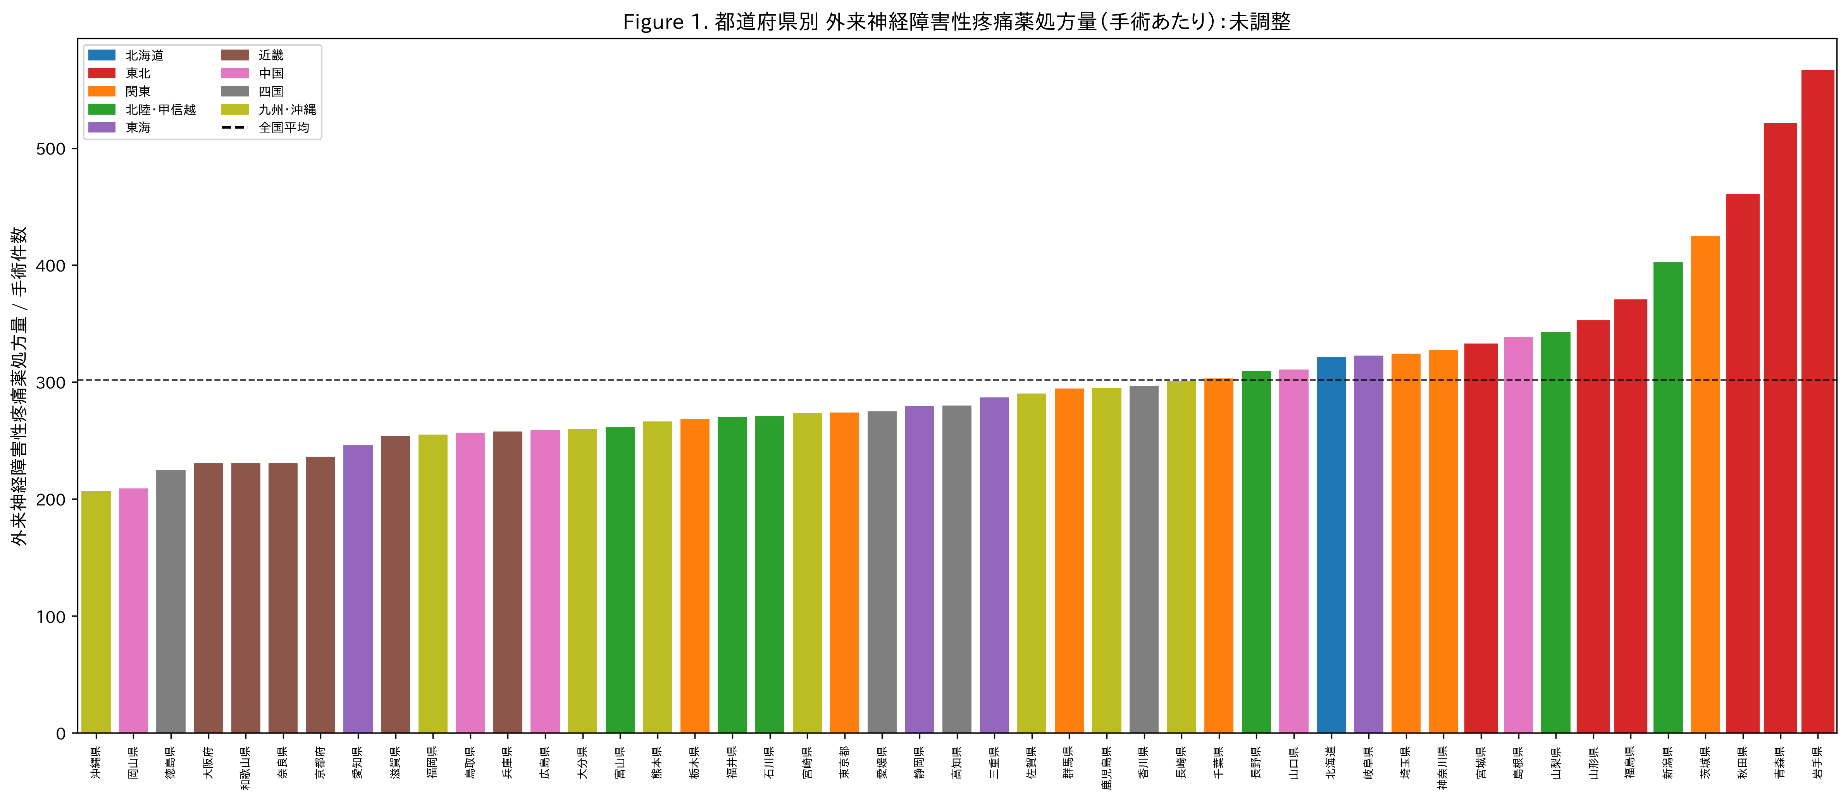
Fig. 1. Outpatient neuropathic pain drug prescribing per surgery by prefecture (unadjusted). Bars represent total neuropathic pain prescriptions (pregabalin + mirogabalin + duloxetine + tramadol + neurotropin) divided by inpatient surgical procedure count. Tohoku prefectures (red bars with red borders) cluster at the high end. Dashed line = national mean.

Confounder analysis
Neuropathic pain prescribing showed strong correlations with the confounder disease proxies. Diabetes drug prescribing was the strongest correlate (r = 0.87, P < 0.001), followed by anxiolytics (r = 0.75, P < 0.001), antidepressants (r = 0.46, P = 0.001), and herpes antivirals (r = 0.19, P = 0.19). These confounders collectively explained 80.4% of the variance in neuropathic pain prescribing (R² = 0.814 in Model 2; Fig. 2).
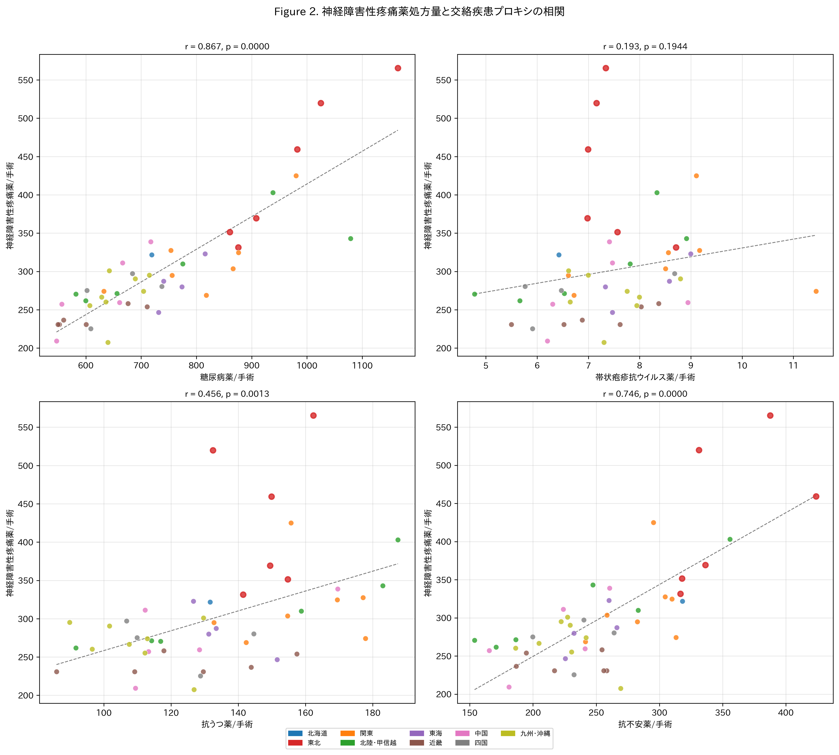
Fig. 2. Correlation between outpatient neuropathic pain drug prescribing and confounder disease proxies. Each dot represents one prefecture. Tohoku prefectures are marked with red borders. Diabetes drugs show the strongest correlation (r = 0.87).

Confounder-adjusted analysis
After adjusting for all four confounder proxies, the Tohoku effect was attenuated and became nonsignificant in Model 2 (β = 32.6, P = 0.150). This attenuation was consistent across all model specifications: Model 3 (core neuropathic drugs: β = 15.7, P = 0.229), Model 4 (nerve blocks: P = 0.863), and Model 5 (integrated: β = 31.5, P = 0.149; Table 2).
The adjusted CPSP index (residuals after removing confounder effects) showed a dramatically different pattern from the unadjusted data (Fig. 3). The Tohoku mean shifted from markedly positive (unadjusted) to a modest, nonsignificant excess (+12.4 vs -1.8; t = 0.999, P = 0.323; d = 0.44). The Chugoku region emerged as having the highest adjusted CPSP index, while Tokai had the lowest (Fig. 4).
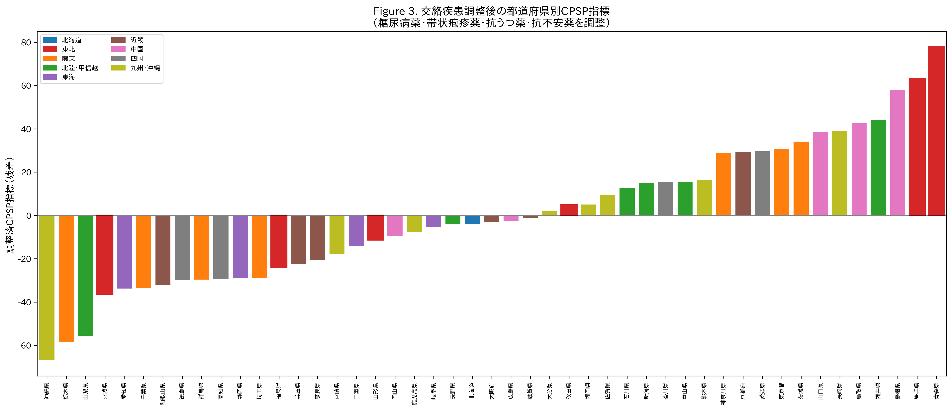
Fig. 3. Confounder-adjusted CPSP index by prefecture. Residuals from regressing neuropathic pain prescribing on diabetes drugs, herpes antivirals, antidepressants, and anxiolytics. Positive values indicate higher neuropathic pain prescribing than expected given confounding disease prevalence. Tohoku prefectures (red borders) are dispersed across the distribution after adjustment.

Table 2. Regression models for neuropathic pain prescribing: effect of confounder adjustment
Model | Dependent variable | Tohoku effect | P value | Interpretation
1 (unadjusted) | Neuropathic/surgery | d = 2.81 | 0.0000 | Significant ***
2 (all confounders) | Neuropathic/surgery | β = 32.6 | 0.150 | Nonsignificant
3 (core drugs) | PGB + MGB/surgery | β = 15.7 | 0.229 | Nonsignificant
4 (nerve blocks) | Blocks/surgery | β = 0.08 | 0.863 | Nonsignificant
5 (integrated) | Neuropathic/surgery | β = 31.5 | 0.149 | Nonsignificant
Adj. CPSP index | Residuals | d = 0.44 | 0.323 | Nonsignificant

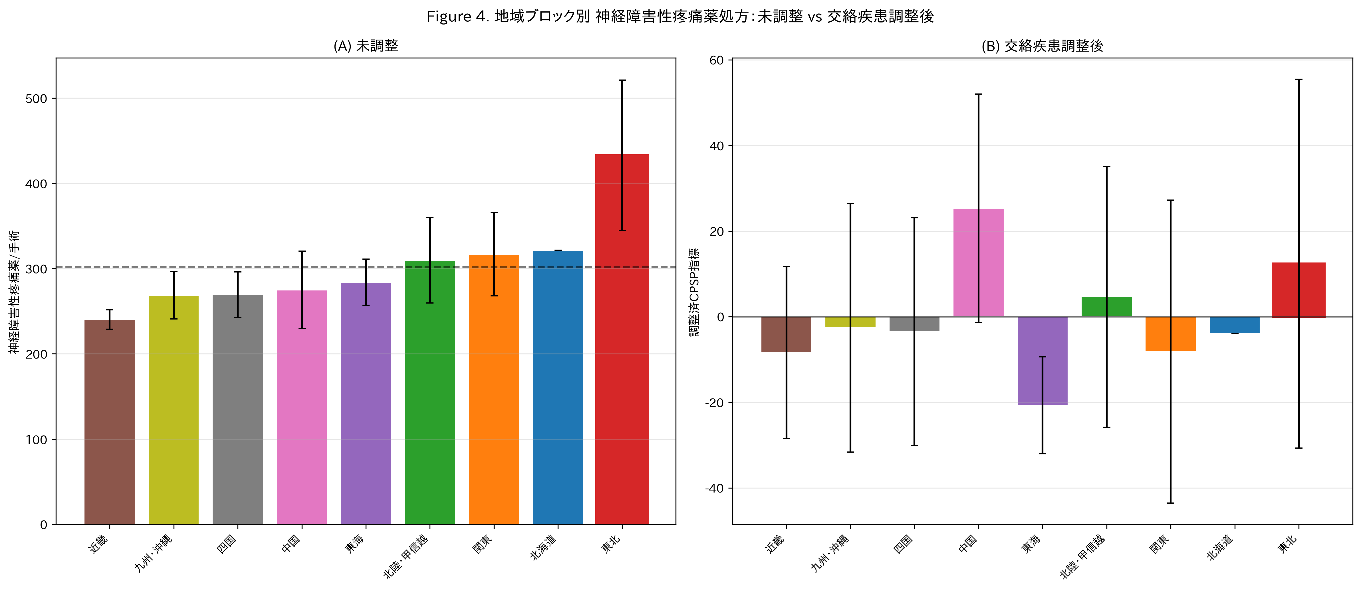
Fig. 4. Regional comparison of neuropathic pain prescribing: (a) unadjusted and (b) after confounder adjustment. Tohoku (red border) shifts from the highest region to mid-range after adjustment. Error bars represent standard deviation.

Phase 1–Phase 2 integration
Phase 1 acute perioperative analgesic prescribing correlated positively with Phase 2 unadjusted neuropathic pain prescribing (r = 0.38, P = 0.008; Fig. 5a). After confounder adjustment, this correlation was attenuated to borderline significance (r = 0.29, P = 0.052; Fig. 5b). In the integrated model (Model 5), the Phase 1 acute pain index was a significant predictor of neuropathic pain prescribing even after adjusting for confounders (β = 1.90, P = 0.044), while the Tohoku effect remained nonsignificant (β = 31.5, P = 0.149).
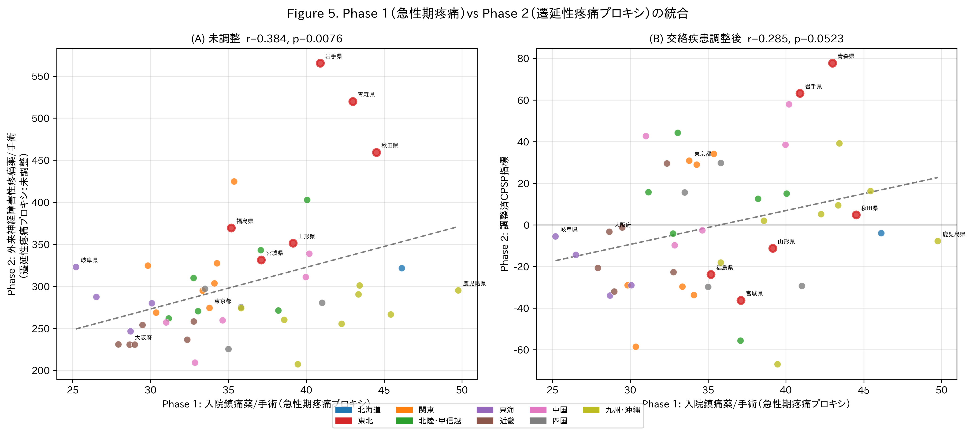
Fig. 5. Integration of Phase 1 (acute perioperative analgesic prescribing) and Phase 2 (outpatient neuropathic pain prescribing as CPSP proxy). (a) Unadjusted: positive correlation (r = 0.38, P = 0.008). (b) Confounder-adjusted: attenuated correlation (r = 0.29, P = 0.052). Tohoku prefectures (red borders) cluster in the upper-right quadrant.

Discussion
This study is the first to map perioperative and chronic pain-related prescribing across all 47 prefectures of Japan, leveraging freely available NDB Open Data. Three principal findings emerged from this exploratory analysis.

Substantial regional variation exists within a stoic culture
Despite Japan’s well-documented cultural stoicism toward pain [5,6], we found a 1.97-fold variation in acute perioperative analgesic prescribing across prefectures and significant differences across regional blocks. This parallels findings from other domains: Cohen and Nisbett’s work on the “culture of honor” in the United States demonstrated that even within a single nation, regional cultural norms produce measurably different behavioral outcomes [8]. Our finding suggests that Japan’s pain culture is not monolithic; regional demographics, healthcare infrastructure, and local clinical practices generate heterogeneity beneath the surface of a nationally shared cultural norm.

Clinical implications: the danger of monolithic cultural stereotypes
The 1.97-fold within-Japan variation documented here has direct clinical relevance beyond the domestic context. A large body of evidence demonstrates that ethnic and cultural stereotypes influence clinician pain assessment and analgesic prescribing. Anderson et al. showed that racial and ethnic minorities in the United States consistently receive less adequate pain management across acute, chronic, cancer, and palliative settings [17]. Campbell and Edwards identified that clinician expectations about a patient’s cultural pain behavior can lead to systematic under- or over-treatment [18]. Rogger et al. emphasized that cultural framing affects not only patient reporting but also how clinicians interpret and respond to pain cues [2].
This risk is compounded by the widespread perception of Japan as a culturally and ethnically homogeneous society. The nihonjinron discourse (theories of Japanese uniqueness) has long promoted the notion that Japanese people constitute a uniform population sharing a single set of behavioral norms [19]. Yet this “hegemony of homogeneity,” as Befu termed it, is an ideological construct rather than an empirical fact [19]. Burgess showed that this “illusion” of a homogeneous Japan has tangible consequences for social policy and public perception [20]. In the clinical context, the combination of two stereotypes—“Japanese are stoic” and “Japanese are homogeneous”—creates a doubly misleading assumption: that all Japanese patients will tolerate pain equally and require less analgesia. Our finding of 1.97-fold within-Japan variation in analgesic prescribing directly refutes this assumption.
Put simply, there is no such entity as “the Japanese patient” whose pain behavior can be predicted from nationality alone—there are only individual patients from 47 diverse prefectures, each with distinct demographic profiles, clinical environments, and pain-related prescribing cultures.
For Japanese patients treated outside Japan, clinicians may thus be operating under a dual misapprehension: that Japanese culture is uniformly stoic, and that this stoicism translates into lower analgesic need. Our data challenge both premises. Pain-related prescribing varies nearly twofold across prefectures, and regions stereotyped as particularly stoic do not in fact use fewer analgesics. If within-country variation of this magnitude exists, applying a national-level stereotype to individual clinical decisions is neither evidence-based nor safe.
We therefore argue that the monolithic characterization of any national population’s pain behavior carries a risk of clinical harm—and this argument extends well beyond Japan. Whenever clinicians allow cultural stereotypes to narrow the range of treatment options considered for a patient, the patient is placed at a therapeutic disadvantage. A “stoic Japanese” label may lead to under-prescribing of analgesics; conversely, stereotypes about other populations may lead to over-prescribing, under-recognition of certain symptoms, or premature closure in differential diagnosis. Our data—showing nearly twofold within-country variation beneath a single cultural label—serve as a concrete case study of a universal principle: cultural generalizations, however convenient, are a poor basis for individual clinical decisions.
The aspiration behind this study is that fewer patients, regardless of nationality or ethnicity, should suffer the disadvantage of having their treatment options constrained by cultural stereotypes. For Japanese patients treated outside Japan, clinicians should be aware that pain endurance norms are heterogeneous and that stoic presentation does not reliably indicate lower analgesic need. But the same logic applies to every patient from every culture: the assumption of cultural homogeneity—however convenient—is no more scientifically defensible in pain medicine than in any other domain. Individualized pain assessment, rather than culturally stereotyped assumptions, remains the cornerstone of equitable perioperative care.

Pain as an individual experience and the need for objective nociception monitoring
Fundamentally, pain is a personal experience. The International Association for the Study of Pain defines pain as “an unpleasant sensory and emotional experience associated with, or resembling that associated with, actual or potential tissue damage”—a definition that is inherently subjective [21]. Our ecological data illustrate this principle at the population level: even within a single nation sharing the same language, insurance system, and broad cultural heritage, pain-related prescribing varies nearly twofold. This heterogeneity likely reflects not only differences in disease burden and clinical practice but also the irreducible individuality of pain perception and expression.
The clinical consequence of this individuality is that no cultural label—whether “stoic Japanese” or any other—can substitute for direct measurement of a patient’s nociceptive state. Yet the tools to perform such measurement remain underdeveloped. The balance between nociception and anti-nociception (NANB) is a physiological quantity that, in principle, could be monitored objectively during and after surgery, bypassing the need for patient self-report or clinician inference altogether. Onishi et al. demonstrated that normalized pulse volume (NPV), derived from standard pulse oximetry, predicts the recovery of spontaneous respiration with significantly less interindividual variability (coefficient of variation 36.3%) than opioid effect-site concentration (62.4%), suggesting that NPV may serve as a culture-independent, objective indicator of NANB [22].
The development and clinical implementation of such objective nociception monitoring systems would fundamentally change the landscape of perioperative pain management. If NANB could be quantified at the bedside—much as bispectral index quantifies hypnotic depth—analgesic titration would no longer depend on subjective pain scores susceptible to cultural bias, nor on population-level stereotypes about which patients “tolerate” pain. Until such systems are clinically available, the findings of the present study serve as a reminder that cultural generalizations are a poor proxy for individual nociceptive reality.

Confounding diseases explain apparent regional variation in CPSP proxies
The most methodologically important finding is that the dramatic regional variation in neuropathic pain prescribing (unadjusted d = 2.81 for Tohoku vs rest) was largely explained by confounding disease proxies. Diabetes drug prescribing alone correlated at r = 0.87 with neuropathic pain prescribing, reflecting the known high prevalence of diabetic neuropathy requiring gabapentinoids. After adjustment, the Tohoku effect was attenuated by 62% and became nonsignificant.
This has important implications for ecological pain research. Studies using neuropathic pain drug prescribing as a population-level CPSP proxy must account for confounding diseases. Without such adjustment, regional differences in diabetes prevalence could be misinterpreted as differences in CPSP. The within-database confounder adjustment demonstrated here—using disease-specific drug proxies from the same data source—provides a replicable framework.

A population-level acute–chronic pain continuum
The positive correlation between Phase 1 (acute) and Phase 2 (chronic, adjusted) indices (r = 0.29, P = 0.052) suggests a modest link between regional acute pain management intensity and subsequent chronic pain-related prescribing. While ecological correlations cannot establish causation, this finding is consistent with the individual-level literature suggesting that the intensity of acute postoperative pain is a risk factor for CPSP [23]. Prefectures with relatively low acute analgesic use but high adjusted CPSP indices may warrant investigation for potential under-treatment of acute pain leading to chronification.

Strengths and limitations
Strengths of this study include the use of population-complete data covering all insurance-reimbursed healthcare in Japan, the novel integration of acute and chronic pain proxies, the transparent confounder-adjustment methodology, and the exploratory rather than confirmatory design that allows hypothesis generation. A further strength specific to the perioperative focus is that healthcare access does not confound the analgesic prescribing data: all patients in Phase 1 are inpatients by definition, eliminating the access-to-care heterogeneity that limits community-based pain studies.
The main limitations are inherent to the ecological design:
- The unit of analysis is the prefecture, not the individual patient. Ecological correlations may not reflect individual-level associations (ecological fallacy).
- NDB Open Data do not contain diagnosis codes, so CPSP cannot be directly identified. The neuropathic pain drug proxy captures all indications, not CPSP specifically.
- Drug prescribing proxies may not capture disease prevalence accurately (e.g., fibromyalgia has no specific drug proxy and shares pregabalin as first-line treatment).
- The cross-sectional design cannot distinguish temporal sequences (surgery → acute pain → CPSP).
- Unmeasured confounders (age distribution, surgical case mix, prescribing culture) may contribute to residual regional variation.

Implications and future directions
This exploratory study demonstrates that Japan’s NDB Open Data can serve as a hypothesis-generating platform for population-level pain research. Future studies using the NDB sampling dataset (Level 3 access) could enable individual-level longitudinal tracking from surgery to new neuropathic pain prescriptions, providing a direct CPSP measure. Procedure-specific analyses (e.g., total knee arthroplasty, mastectomy) would reduce surgical case-mix confounding. Linking prescribing data with patient-reported pain outcomes would clarify whether regional prescribing differences reflect differences in pain experience, pain expression, or clinical practice.
From an international perspective, our findings underscore the need for culturally nuanced but individually tailored pain management. Prospective studies examining how cultural stereotypes influence analgesic prescribing for Japanese patients in multicultural clinical settings would directly test whether the “stoic Japanese” label translates into therapeutic disadvantage. Such research is increasingly urgent as global migration and medical tourism expose more patients to healthcare systems unfamiliar with their cultural background.

Conclusion
Despite Japan’s culturally ingrained norm of pain endurance (gaman), perioperative and chronic pain-related prescribing varies up to 1.97-fold across prefectures. Confounding diseases, particularly diabetes, substantially modify the apparent regional pattern of neuropathic pain prescribing. These findings demonstrate that Japan’s pain culture is not monolithic. Treating “Japanese” as a uniform category for pain behavior risks inadequate analgesia for Japanese patients treated abroad—and the same principle applies to every cultural label applied to any patient population. Individualized pain assessment should replace culturally stereotyped assumptions to ensure equitable perioperative care across all clinical settings.

Acknowledgments
The authors thank the Ministry of Health, Labour and Welfare for making the NDB Open Data publicly available. [Additional acknowledgments to be inserted as appropriate.]

Conflict of interest statement
The authors have no conflicts of interest to declare.

Data availability statement
The NDB Open Data used in this study are publicly available from the Ministry of Health, Labour and Welfare website (https://www.mhlw.go.jp/stf/seisakunitsuite/bunya/0000177221_00016.html). Analysis code is available at https://github.com/bougtoir/wip/tree/main/ndb-pain-regional-variation-japan.

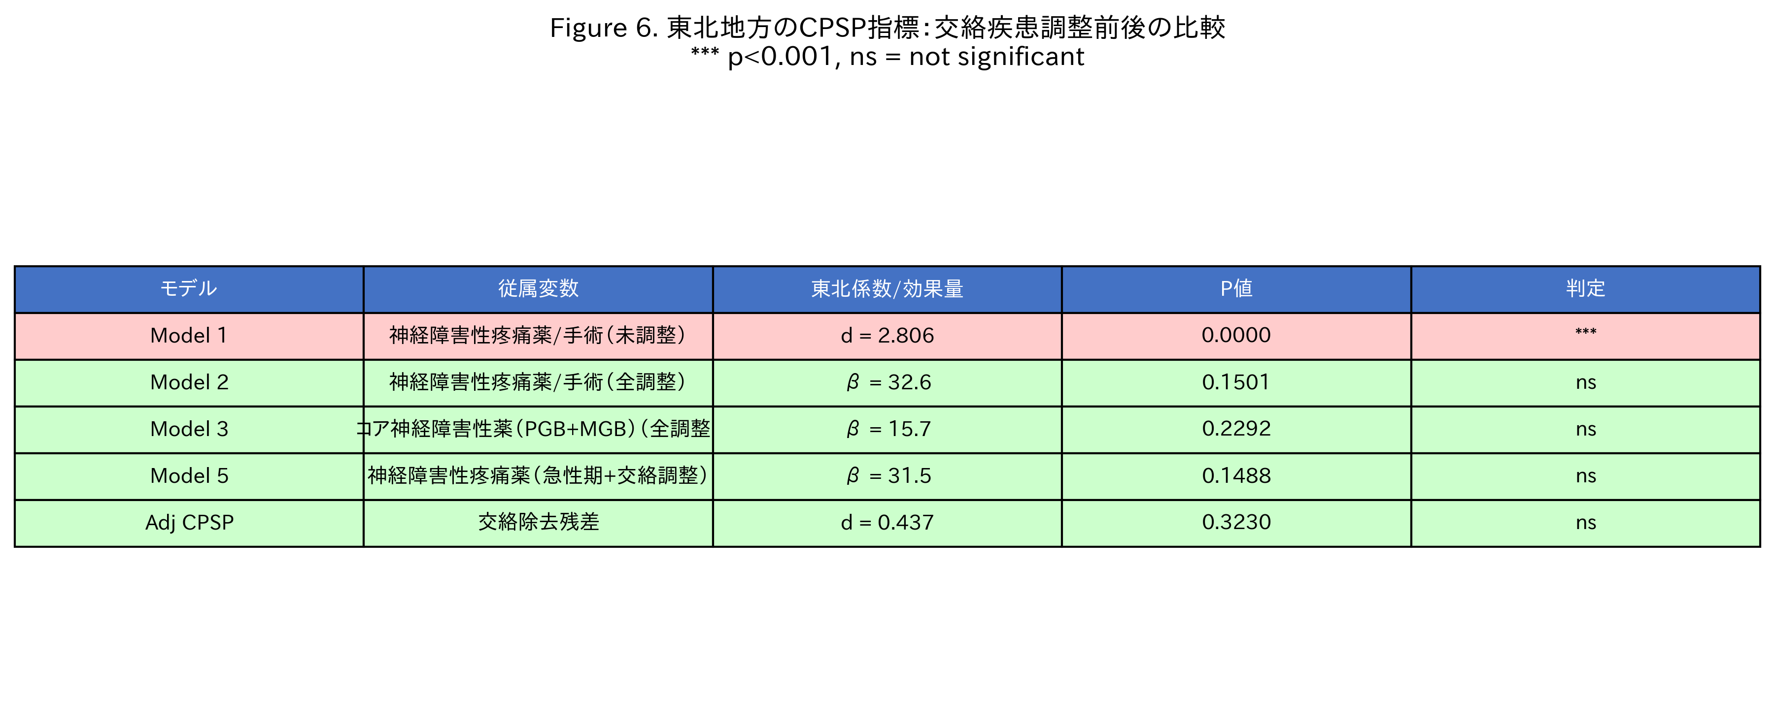
Fig. 6. Summary of regression models: the Tohoku effect on neuropathic pain prescribing before and after confounder adjustment. Model 1 (unadjusted) shows a highly significant excess; all adjusted models show nonsignificant results, indicating confounders explain the regional difference.

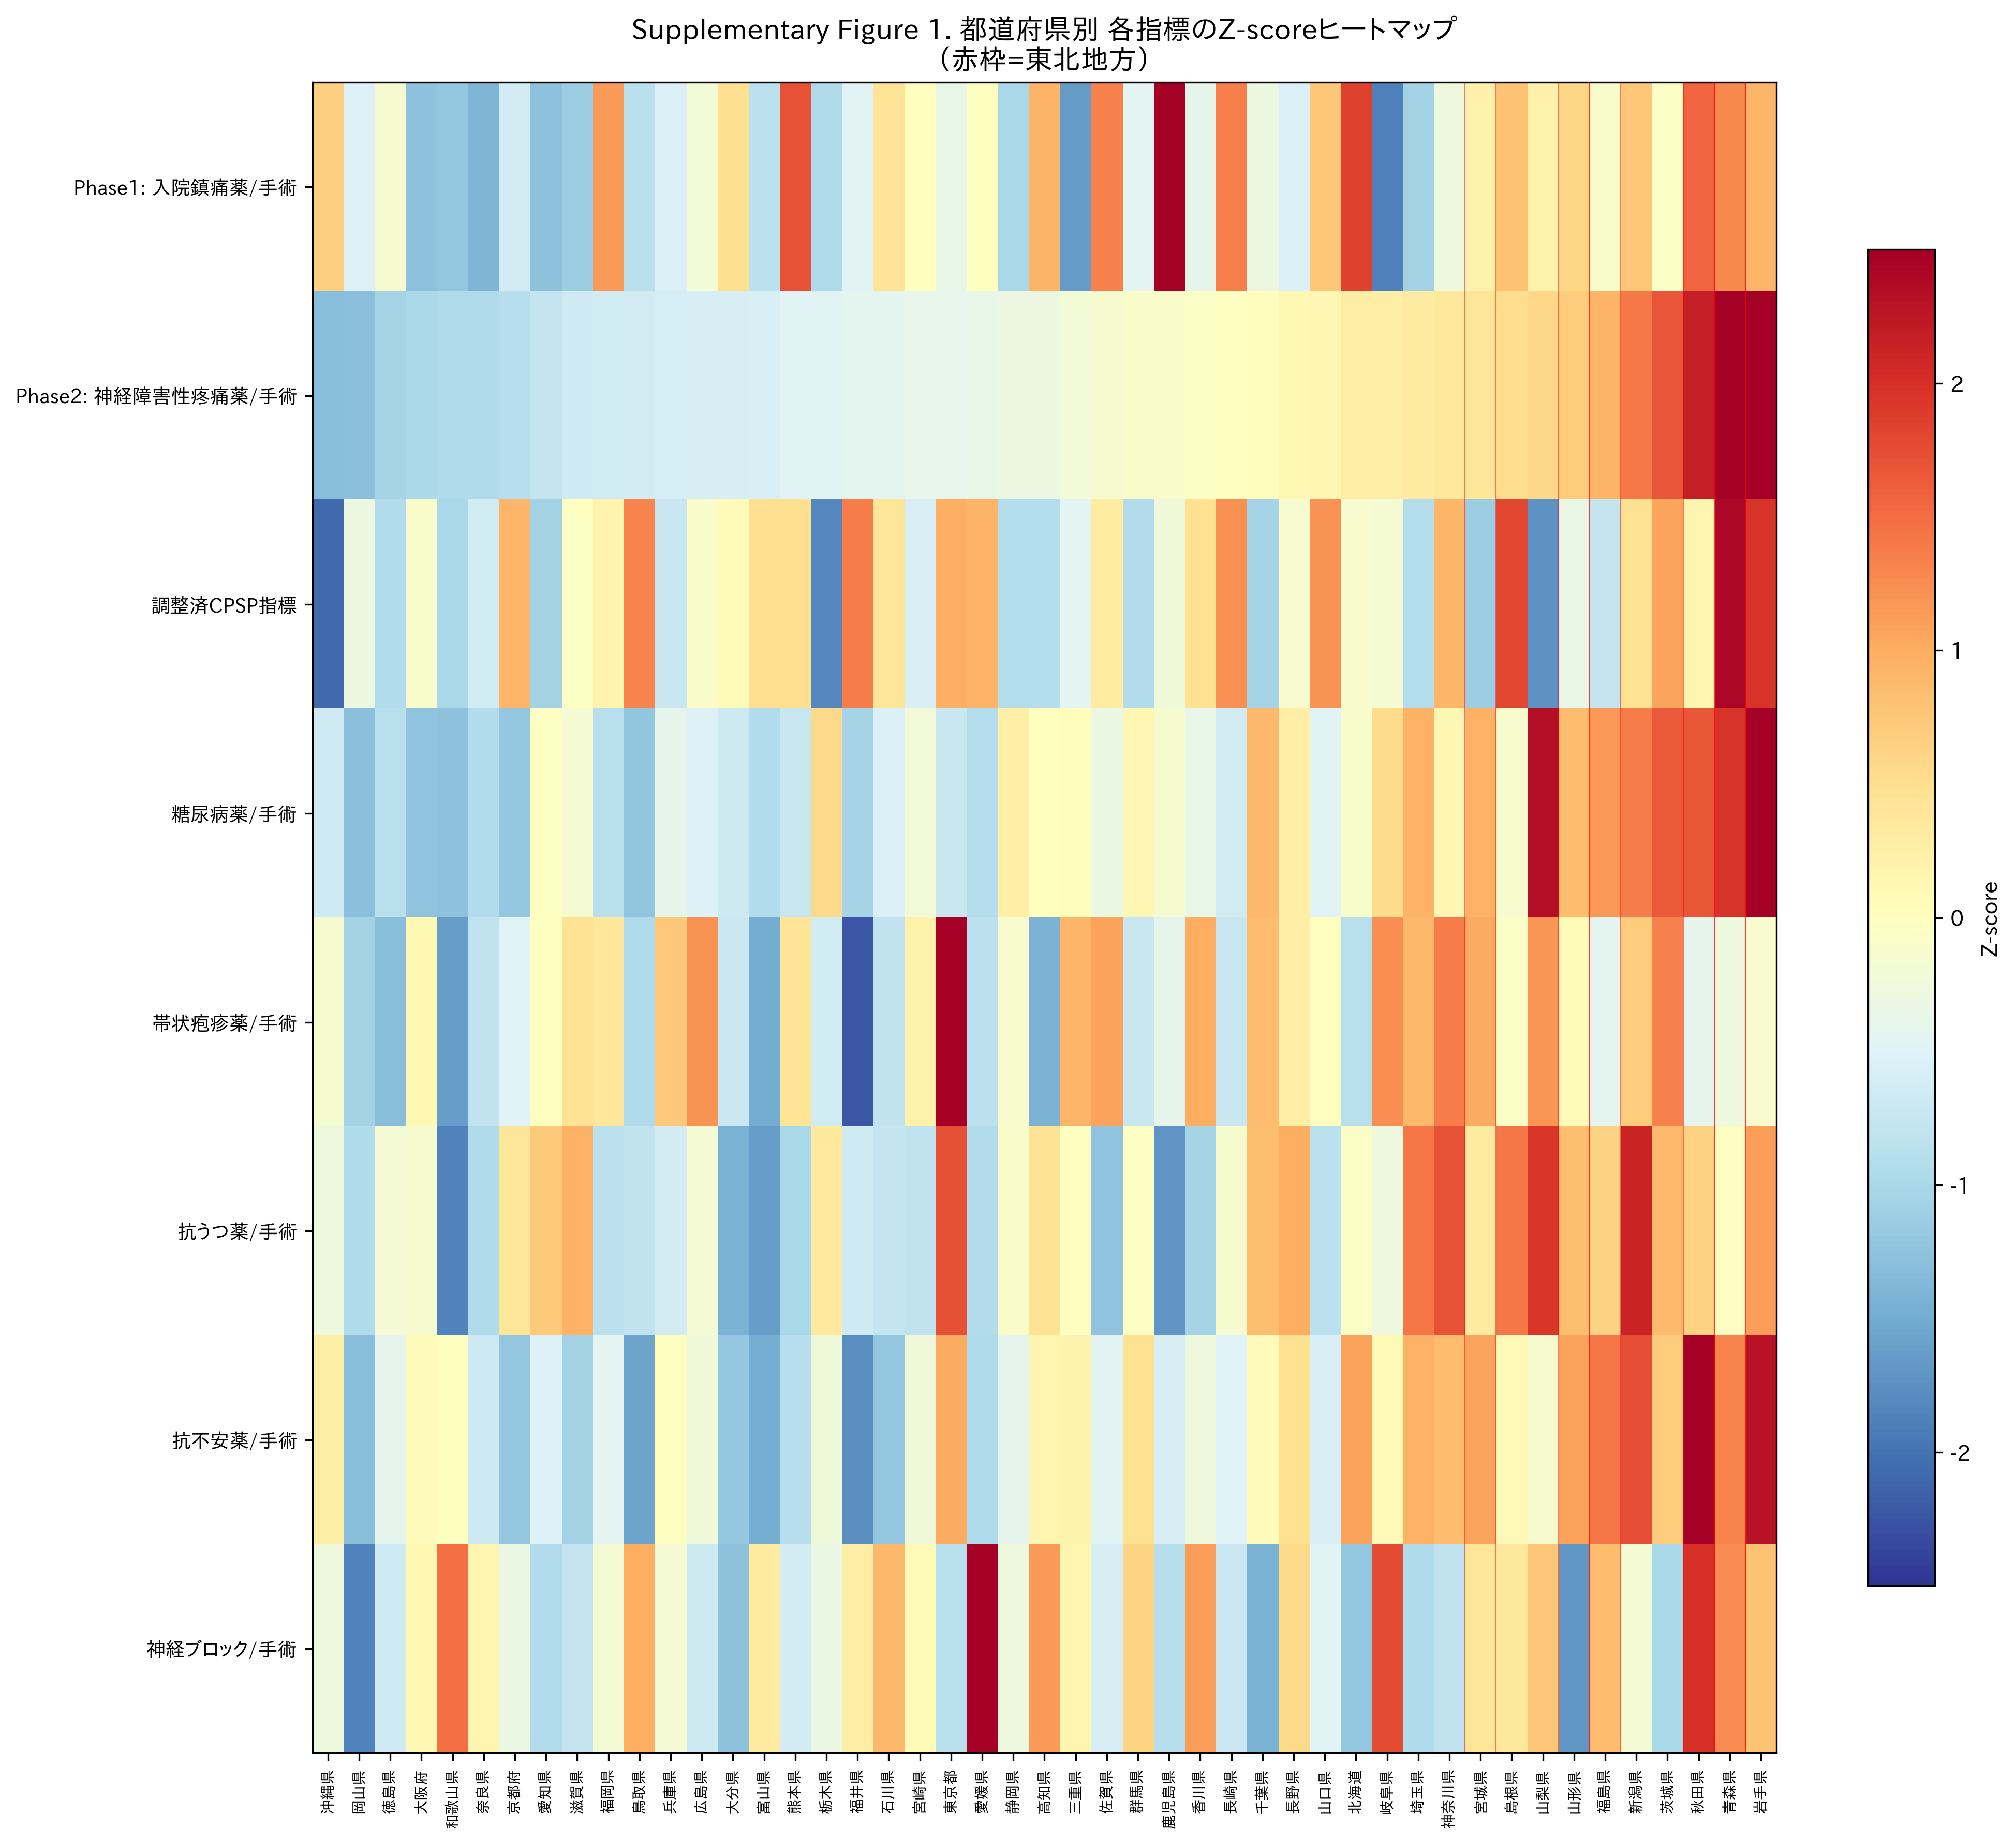
Supplementary Fig. 1. Z-score heatmap of all indices by prefecture. Each row represents a variable; each column represents a prefecture, sorted by neuropathic pain prescribing. Red = above average; blue = below average. Tohoku prefectures are marked with red vertical lines. The adjusted CPSP index shows a different pattern from the raw neuropathic index.

References
1. Callister LC. Cultural influences on pain perceptions and behaviors. Home Health Care Manag Pract. 2003;15:207–211.
2. Rogger R, Bello C, Romero CS, Urman RD, Luedi MM, Filipovic MG. Cultural framing and the impact on acute pain and pain services. Curr Pain Headache Rep. 2023;27:429–436.
3. Zborowski M. People in Pain. San Francisco: Jossey-Bass; 1969.
4. Okolo CA, Olorunsogo T, Babawarun O. Cultural variability in pain perception: a review of cross-cultural studies. Int J Sci Res Arch. 2024;11:2550–2556.
5. Hobara M. Beliefs about appropriate pain behavior: cross-cultural and sex differences between Japanese and Euro-Americans. Eur J Pain. 2005;9:389–393.
6. Feng Y, Herdman M, van Nooten F, Cleeland C, Parkin D, Ikeda S, Igarashi A, Devlin NJ. An exploration of differences between Japan and two European countries in the self-reporting and valuation of pain and discomfort on the EQ-5D. Qual Life Res. 2017;26:2067–2078.
7. Hayashi K, Ikemoto T, Shiro Y, Arai YC, Marcuzzi A, Costa D, Wrigley PJ. A systematic review of the variation in Pain Catastrophizing Scale reference scores based on language version and country in patients with chronic primary (non-specific) pain. Pain Ther. 2022;11:751–780.
8. Cohen D, Nisbett RE, Bowdle BF, Schwarz N. Insult, aggression, and the southern culture of honor: an “experimental ethnography.” J Pers Soc Psychol. 1996;70:945–960.
9. Kumagai S. Media representations reproducing images of Tohoku: the Tohoku reconstruction corner in “Secret Kenmin SHOW.” Kotoba. 2020;41:21–38. [in Japanese]
10. Takeda K, Yarimizu K. Regional differences in the pain expression uzuku. NINJAL Research Papers. 2016;10:85–107. [in Japanese]
11. Pfizer Japan Inc. 47-prefecture survey on chronic pain. 2017. Available from: https://www.pfizer.co.jp/pfizer/company/press/2017. Accessed February 1, 2025.
12. Ministry of Health, Labour and Welfare. NDB Open Data, 10th edition. 2024. Available from: https://www.mhlw.go.jp/stf/seisakunitsuite/bunya/0000177221_00016.html. Accessed January 15, 2025.
13. Wakaizumi K, Tanaka C, Shinohara Y, Wu Y, Takaoka S, Kawate M, Oka H, Matsudaira K. Geographical variation in high-impact chronic pain and psychological associations at the regional level: a multilevel analysis of a large-scale internet-based cross-sectional survey. Front Public Health. 2024;12:1482177.
14. Matsuoka Y, et al. Population-based claims study of regional and hospital function differences in opioid prescribing for cancer patients who died in hospital in Japan. Jpn J Clin Oncol. 2025;hyaf149.
15. von Elm E, Altman DG, Egger M, Pocock SJ, Gotzsche PC, Vandenbroucke JP. The Strengthening the Reporting of Observational Studies in Epidemiology (STROBE) statement: guidelines for reporting observational studies. Lancet. 2007;370:1453–1457.
16. Benchimol EI, Smeeth L, Guttmann A, Harber K, Moher D, Petersen I, Sorensen HT, von Elm E, Langan SM. The REporting of studies Conducted using Observational Routinely-collected health Data (RECORD) statement. PLoS Med. 2015;12:e1001885.
17. Anderson KO, Green CR, Payne R. Racial and ethnic disparities in pain: causes and consequences of unequal care. J Pain. 2009;10:1187–1204.
18. Campbell CM, Edwards RR. Ethnic differences in pain and pain management. Pain Manag. 2012;2:219–230.
19. Befu H. Hegemony of Homogeneity: An Anthropological Analysis of Nihonjinron. Melbourne: Trans Pacific Press; 2001.
20. Burgess C. The “illusion” of homogeneous Japan and national character: discourse as a tool to transcend the “myth” vs. “reality” binary. Asia Pac J. 2010;8(9):1–22.
21. Raja SN, Carr DB, Cohen M, Finnerup NB, Flor H, Gibson S, Keefe FJ, Mogil JS, Ringkamp M, Sluka KA, Song XJ, Stevens B, Sullivan MD, Tutelman PR, Ushida T, Vader K. The revised International Association for the Study of Pain definition of pain: concepts, challenges, and compromises. Pain. 2020;161:1976–1982.
22. Onishi T, Onishi Y. Normalized pulse volume as a superior predictor of respiration recovery and quantification of nociception anti-nociception balance compared to opioid effect site concentration: a prospective, observational study. F1000Research. 2024;13:233.
23. Kehlet H, Jensen TS, Woolf CJ. Persistent postsurgical pain: risk factors and prevention. Lancet. 2006;367:1618–1625.

