Network Exclusion and State Collapse: A Source-Anchored Reconstruction
Author Name
author@example.com

Abstract
Why do some states collapse while others endure? This study reconstructs a comparative historical dataset of 77 non-ongoing polities from public geographic, demographic, and network sources to test whether network exclusion is associated with state collapse. We source-anchor five reconstructed variables (geographic barrier, external threat, relative population, regime duration, external patronage) and a draft closure-type classification (open, maritime ban, land isolation, technology-network exclusion, bloc, and patron-dependent openness). A Firth-penalized multivariate logistic regression shows that a one-unit increase in relative population is associated with a 0.269-fold change in the odds of collapse (95% CI 0.060-1.214, p=0.088), while geographic barrier is directionally protective (OR=0.050, p=0.185). Closure-type analysis shows that, relative to open polities, technology-network exclusion and bloc membership are associated with higher odds of collapse. Exact Fisher tests and permutation inference identify technology-network exclusion as the most robust closure signal (permutation p=0.037). The baseline model discriminates collapsed from surviving polities with an AUC of 0.717 and an accuracy of 0.818. Sensitivity analyses confirm the dominance of relative population and the stability of the closure-type pattern across outcome definitions and geographic-barrier specifications. All data and code are publicly available and reproducible.
Keywords: state collapse, network exclusion, technology diffusion, geographic barrier, historical political economy

1. Introduction
Every era has a dominant technological network through which states access trade, military techniques, and knowledge ^{[1, 2]}. Premodern examples include Mediterranean sea lanes and the Silk Road; the industrial era added rail-linked factory systems and colonial supply chains; today the network is digital and semiconductor-based ^{[3, 4]}.
A recurring argument is that polities structurally excluded from the dominant network of their era face elevated collapse risk ^{[5, 6]}. Exclusion disrupts technology flows, creates a cumulative gap with connected rivals, and eventually leaves the polity unable to survive contact ^{[7, 8]}. Yet existing work often conflates deliberate closure (e.g., Tokugawa sakoku, Ming haijin) with involuntary exclusion caused by geography or technology ^{[9]}.
This paper takes a first step toward disentangling these mechanisms by assembling a comparative historical dataset. The sample covers 96 polity-periods, from which we exclude currently ongoing polities and two non-territorial trade networks, and reconstruct five key variables from public data: geographic barrier, external threat, relative population, regime duration, and external patronage. We then draft a source-anchored closure-type classification, informed by public treaty records and the Cliopatria/Seshat historical network hierarchy. The core claim tested is that network exclusion, measured either by objective proxies or by the closure typology, predicts state collapse after controlling for confounders. Section 2 introduces the data and methods, Section 3 reports results, Section 4 discusses implications and limitations, and Section 5 concludes.

2. Data and Methods

2.1 Sample construction
The sample begins with 96 polity-periods spanning antiquity to the late twentieth century. Seventeen polities that continue to the present were excluded because their outcome is right-censored and their duration unobserved. Two additional cases were excluded as non-territorial trade networks: the Hanseatic League and the British Imperial Preference system. The analysis sample therefore contains 77 non-ongoing polities, of which 63 collapsed (overtaken or disrupted) and 14 survived.

2.2 Variable reconstruction
Geographic barrier (geo_barrier) combines a maritime barrier index (one minus the share of the polity boundary that is land border) with the Nunn-Puga terrain ruggedness index, both computed from Natural Earth 1:10m admin-0 and admin-1 polygons ^{[8]}. External threat combines capital isolation (one minus the mean distance to contemporary capitals) with the number of Cliopatria major empires within 1,000 km. Relative population is estimated from the Our World in Data long-run population series and divided by the maximum population among coexisting polities at the peak year. Regime duration is parsed from the period string. External patron is coded from treaty records in the Correlates of War Alliance Data and public historical sources. Full provenance and variable definitions are in the data dictionary (Supplementary File S1).

2.3 Source-anchored closure-type classification
We apply a source-anchored rubric that distinguishes deliberate policy closure (maritime ban, policy closure), external-bloc isolation, patron-dependent openness, and structural exclusion due to geography or technology. For each case the rubric requires a URL or printed source, a confidence rating, and, where possible, a verbatim source quote. A draft classification was generated by combining (1) well-known historical cases (e.g., Tokugawa sakoku, Ming haijin, Warsaw Pact membership) with treaty sources, (2) external-patron cases from the Correlates of War Alliance Data, and (3) structural categories inferred from the reconstructed variables and a Cliopatria tree/network embeddedness score. All draft entries are flagged for human review.

2.4 Statistical analysis
We estimate Firth-penalized multivariate logistic regressions of polity collapse on the continuous reconstructed variables and, separately, on closure-type dummies. Firth's bias reduction is used because some closure categories are small and quasi-separated. Odds ratios (OR) with 95% confidence intervals are reported. Sensitivity analyses examine alternative outcome definitions, alternative geographic-barrier and external-threat specifications, era subgroups, leave-one-out stability, bootstrap distributions, and variance inflation factors.

3. Results
Table 1 reports descriptive statistics for the five reconstructed variables by outcome. Relative population is markedly lower among collapsed polities, while geographic barrier is slightly higher among surviving polities. External threat and external patronage are directionally higher among collapsed polities, and regime duration is similar across groups.
Table 1. Descriptive statistics by outcome
Variable | Overall mean (SD) | Collapsed mean (SD) | Survived mean (SD) | p (Mann-Whitney)
geo_barrier | 0.782 (0.169) | 0.769 (0.180) | 0.841 (0.095) | 0.189
external_threat | 0.614 (0.234) | 0.618 (0.247) | 0.594 (0.165) | 0.391
relative_pop | 0.338 (0.379) | 0.292 (0.357) | 0.543 (0.418) | 0.049
regime_duration_yrs | 240.688 (217.132) | 247.698 (218.270) | 209.143 (217.024) | 0.468
has_external_patron | 0.130 (0.338) | 0.143 (0.353) | 0.071 (0.267) | 0.482

Figure 1 visualizes these mean differences. Relative population stands out as the strongest bivariate discriminator.
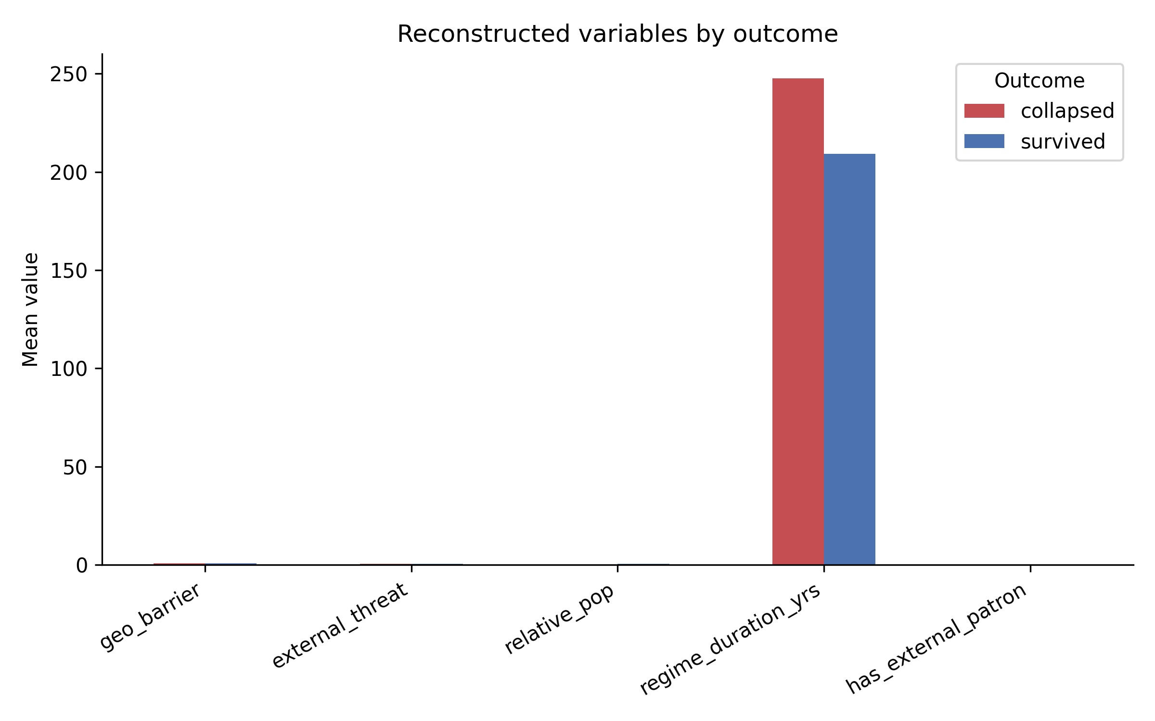
Figure 1. Mean reconstructed variables by collapse outcome.
Figure 2 places each polity in the geographic-barrier versus external-threat space. Overtaken and disrupted polities are dispersed, but they tend to cluster at higher external threat. Surviving polities are more concentrated in the lower-external-threat region.
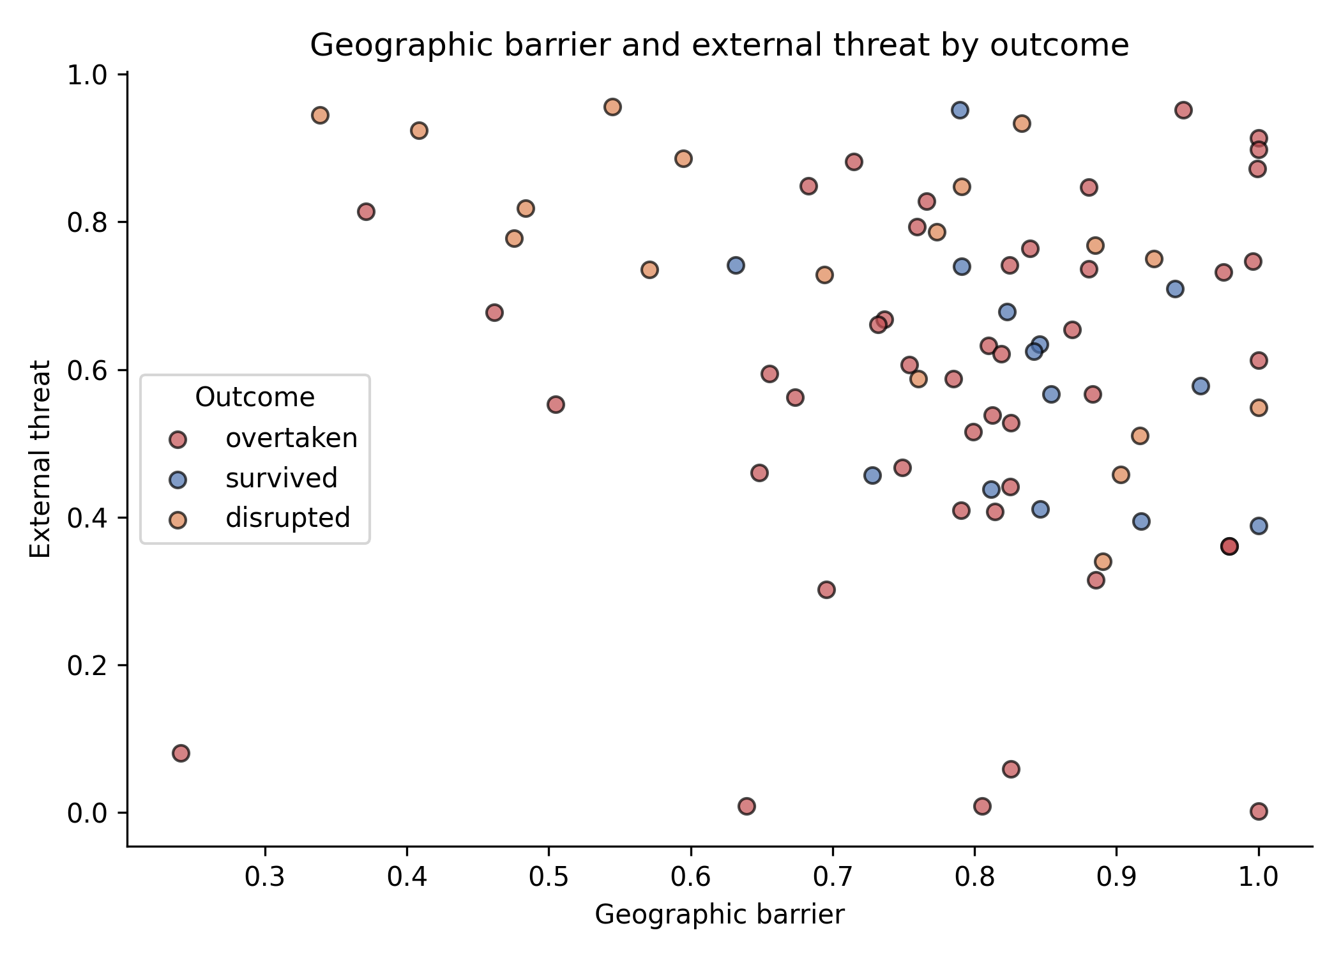
Figure 2. Geographic barrier and external threat by outcome.
Table 2 reports the baseline Firth-penalized multivariate logistic regression. Relative population is strongly protective: larger polities relative to their contemporaries face substantially lower odds of collapse. Geographic barrier is directionally protective (OR=0.050, p=0.185), consistent with short-run maritime or terrain defensibility. External threat (OR=0.747, p=0.826), regime duration (OR=1.001, p=0.542), and external patronage (OR=0.978, p=0.982) are not independently significant in this specification. The model achieves an AUC of 0.717 and an accuracy of 0.818.
Table 2. Baseline multivariate logistic regression of polity collapse (Firth)
Variable | OR (95% CI) | p
geo_barrier | 0.050 (0.001-4.186) | 0.185
external_threat | 0.747 (0.056-10.052) | 0.826
relative_pop | 0.269 (0.060-1.214) | 0.088
regime_duration_yrs | 1.001 (0.998-1.004) | 0.542
has_external_patron | 0.978 (0.143-6.687) | 0.982

Figure 3 presents the odds ratios as a forest plot. Only relative population has a point estimate well below one; its confidence interval approaches but does not cross one.
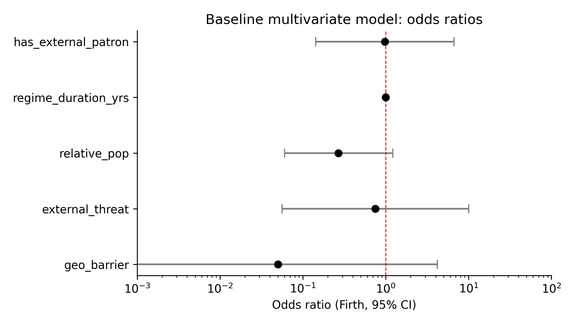
Figure 3. Forest plot of baseline odds ratios.

3.3 Closure-type classification and collapse
Table 3 reports collapse rates by the draft source-anchored closure type. Open polities collapsed at a rate of 0.636, whereas technology-network exclusion and bloc membership collapsed at 0.880 and 1.000, respectively. Land isolation (0.833), maritime ban (0.714), and patron-dependent openness (1.000) also show elevated collapse rates relative to open polities.
Table 3. Collapse rates by source-anchored closure type (draft)
rater_closure_type | n | collapsed | collapse_rate
bloc | 12 | 12 | 1.0
land_isolation | 6 | 5 | 0.833
maritime_ban | 7 | 5 | 0.714
open | 22 | 14 | 0.636
patron_open | 4 | 4 | 1.0
tech_network_exclusion | 25 | 22 | 0.88
uncertain | 1 | 1 | 1.0

Figure 4 displays these collapse rates graphically.
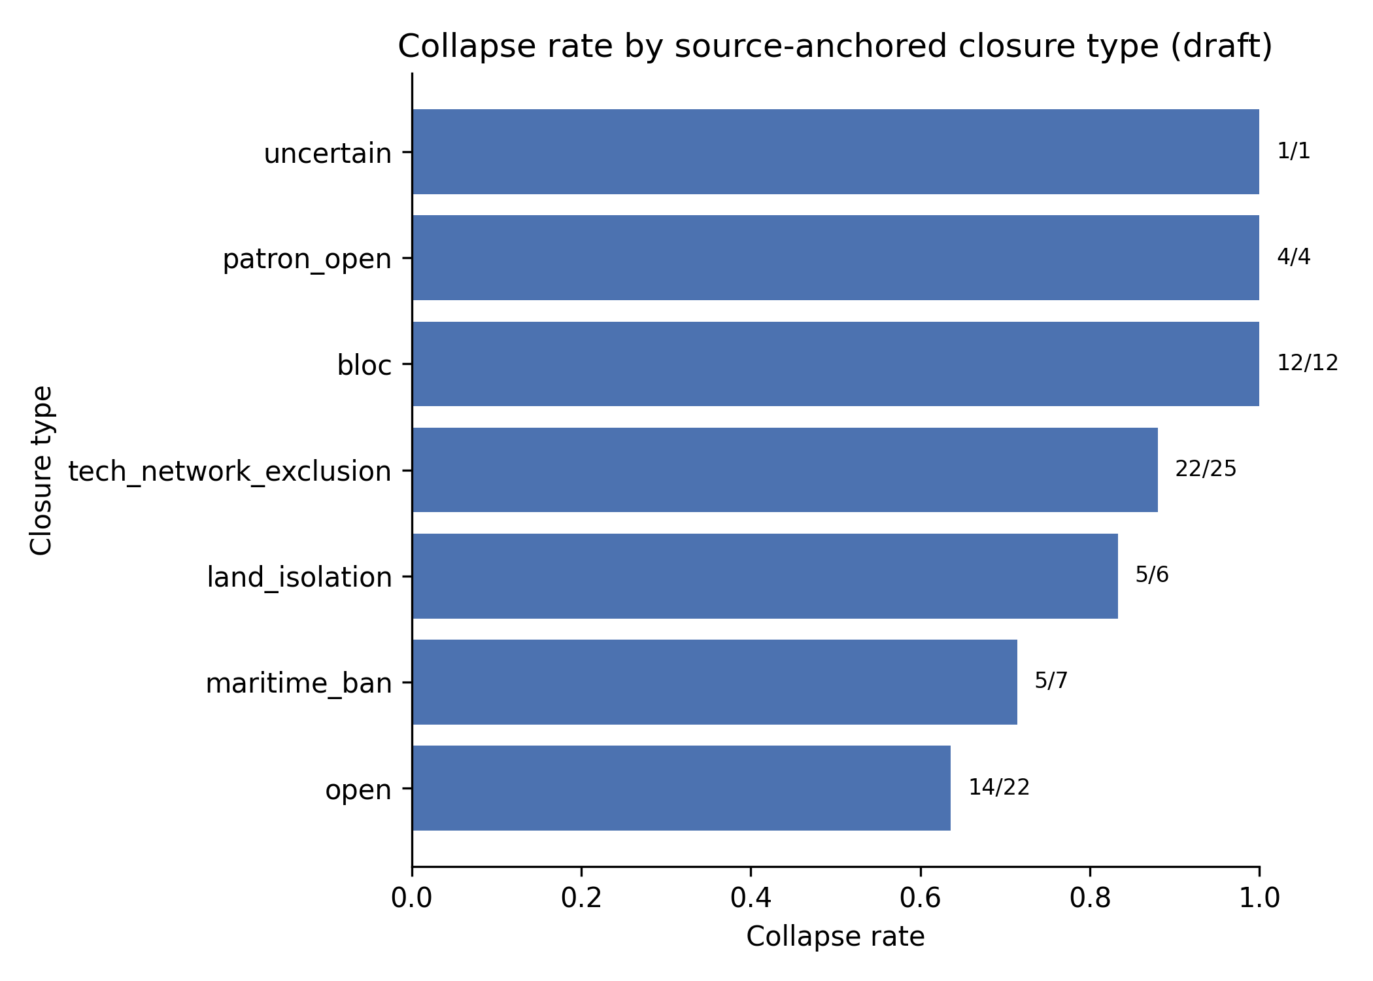
Figure 4. Collapse rate by closure type.
Table 4 reports the Firth-penalized logistic regression of collapse on closure-type dummies, using open as the reference category and adding relative population and regime duration as controls in a second model. Technology-network exclusion is associated with an odds ratio of 3.768 (95% CI 0.921-15.420, p=0.065) and bloc membership with an odds ratio of 14.655 (95% CI 0.766-280.226, p=0.075) in the closure-only model. The estimates are positive but imprecise because the categories are small and quasi-separated. The controlled specification raises the AUC from 0.752 to 0.789, suggesting that closure type and relative population together capture complementary information.
Table 4. Closure-type logistic regression of polity collapse (Firth)
Model | Closure type | OR (95% CI) | p
closure_only | bloc | 14.655 (0.766-280.226) | 0.075
closure_only | land_isolation | 2.149 (0.293-15.789) | 0.452
closure_only | maritime_ban | 1.290 (0.231-7.189) | 0.772
closure_only | patron_open | 5.276 (0.252-110.514) | 0.284
closure_only | tech_network_exclusion | 3.768 (0.921-15.420) | 0.065
closure_with_controls | bloc | 17.399 (0.866-349.565) | 0.062
closure_with_controls | land_isolation | 1.883 (0.243-14.616) | 0.545
closure_with_controls | maritime_ban | 1.251 (0.217-7.218) | 0.802
closure_with_controls | patron_open | 4.315 (0.183-101.978) | 0.365
closure_with_controls | tech_network_exclusion | 2.291 (0.522-10.054) | 0.272

3.4 Sensitivity and robustness
Table 5 (variance inflation factors) shows that multicollinearity is moderate: geo_barrier has the highest VIF value (8.257), but all values remain below conventional thresholds for severe collinearity.
Table 5. Variance inflation factors
variable | VIF
geo_barrier | 8.257
external_threat | 6.035
relative_pop | 2.042
regime_duration_yrs | 2.562
has_external_patron | 1.365

Table 6 reports outcome-binarization sensitivity. Treating 'disrupted' as survived rather than collapsed makes external threat significantly protective, while relative population remains directionally protective. The AUC rises slightly under this definition, indicating that 'disrupted' cases are harder to distinguish than 'overtaken' cases.
Table 6. Outcome binarization sensitivity (Firth)
Outcome definition | Variable | OR (95% CI) | p | AUC
disrupted=overtaken | geo_barrier | 0.050 (0.001-4.186) | 0.185 | 0.717
disrupted=overtaken | external_threat | 0.747 (0.056-10.052) | 0.826 | 0.717
disrupted=overtaken | relative_pop | 0.269 (0.060-1.214) | 0.088 | 0.717
disrupted=overtaken | regime_duration_yrs | 1.001 (0.998-1.004) | 0.542 | 0.717
disrupted=overtaken | has_external_patron | 0.978 (0.143-6.687) | 0.982 | 0.717
disrupted=survived | geo_barrier | 1.090 (0.053-22.399) | 0.956 | 0.763
disrupted=survived | external_threat | 0.092 (0.009-0.918) | 0.042 | 0.763
disrupted=survived | relative_pop | 0.628 (0.164-2.411) | 0.498 | 0.763
disrupted=survived | regime_duration_yrs | 1.004 (1.001-1.007) | 0.007 | 0.763
disrupted=survived | has_external_patron | 1.579 (0.333-7.482) | 0.565 | 0.763

Figure 5 plots the ROC curves for each outcome definition.
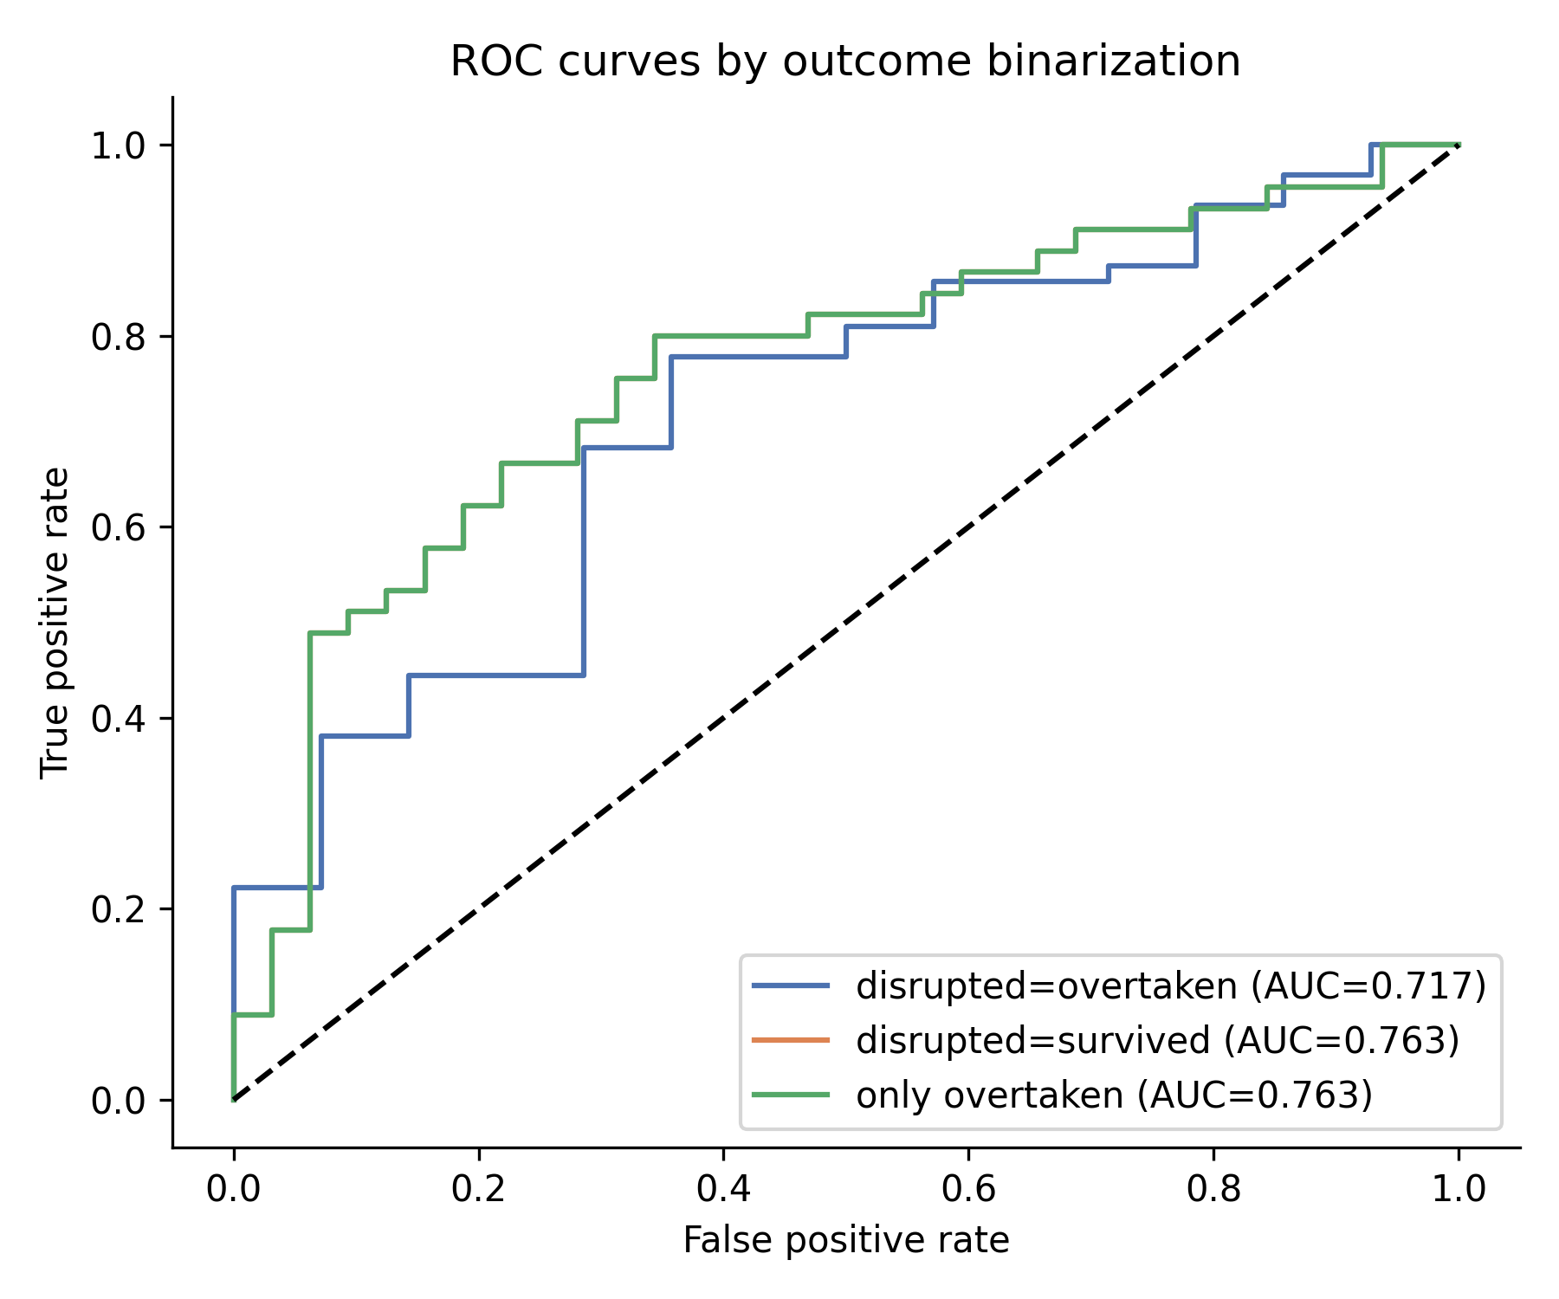
Figure 5. ROC curves by outcome binarization.
Table 7 reports alternative geographic-barrier specifications. Using a weighted, geometric, or harmonic mean of geo_barrier and capital isolation does not change the qualitative finding that relative population dominates; the weighted-barrier specification yields the highest AUC.
Table 7. Alternative geographic-barrier specifications
Geographic barrier specification | OR (95% CI) | AUC
geo_barrier | 0.050 (0.001-4.186) | 0.717
weighted_barrier | 0.001 (0.000-0.895) | 0.78
geometric_barrier | 0.003 (0.000-1.522) | 0.768
harmonic_barrier | 0.011 (0.000-2.382) | 0.754

Figure 6 shows the bootstrap distribution of odds ratios for geographic barrier and relative population. Figure 7 shows leave-one-out coefficient stability. Relative population remains the most stable predictor; geographic-barrier estimates are sensitive to single-case exclusion, reflecting its correlation with other variables.
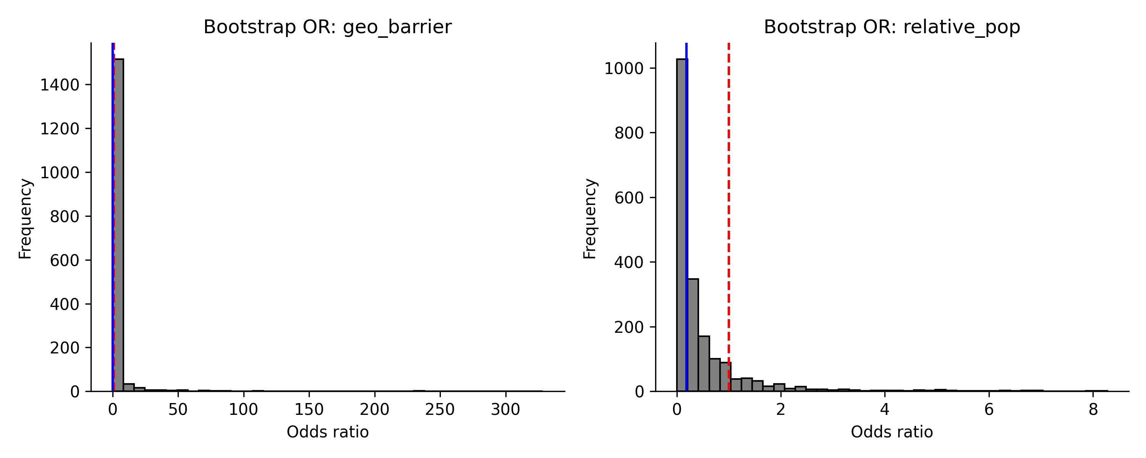
Figure 6. Bootstrap distribution of odds ratios.
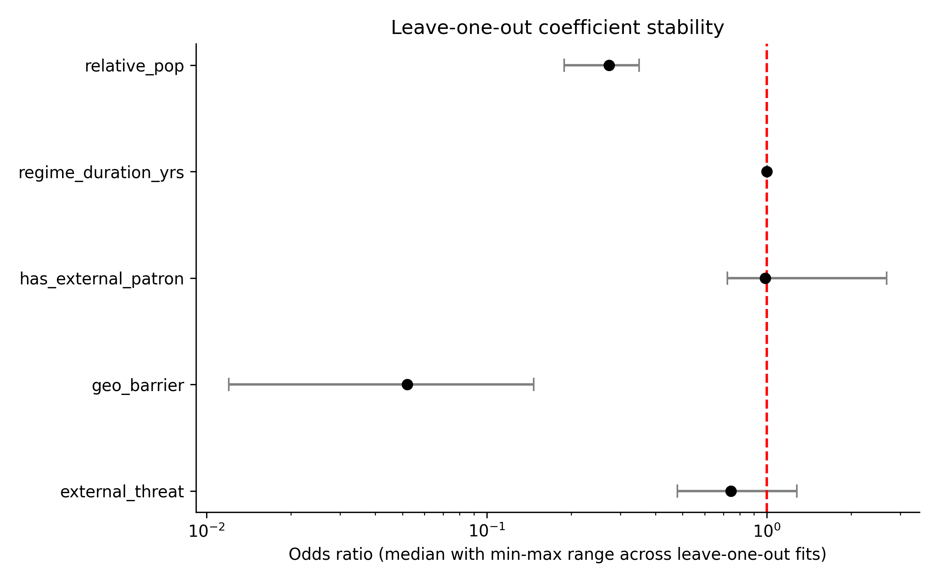
Figure 7. Leave-one-out coefficient stability.
Table 8 reports Fisher exact tests comparing each closure type to the open reference. Bloc membership shows a significantly higher collapse rate (p=0.030), and technology-network exclusion is marginally higher (p=0.083), confirming that the closure-type pattern is not driven by the Firth penalty alone.
Table 8. Fisher exact tests by closure type
Closure type | n | Collapsed | Collapse rate | Fisher OR | Fisher p
bloc | 12 | 12 | 1.0 | inf | 0.03
land_isolation | 6 | 5 | 0.833 | 2.857 | 0.63
maritime_ban | 7 | 5 | 0.714 | 1.429 | 1.0
patron_open | 4 | 4 | 1.0 | inf | 0.277
tech_network_exclusion | 25 | 22 | 0.88 | 4.19 | 0.083

Table 9 reports exact-style permutation p-values. Because the sample is small, we re-fitted the models after randomly permuting the outcome 300-500 times. Technology-network exclusion remains the most robust closure signal (permutation p=0.037), while the baseline variables are directionally associated with collapse but do not reach conventional significance.
Table 9. Permutation p-values
Model | Variable | Observed OR | n_perm | Permutation p
Baseline | geo_barrier | 0.052 | 500 | 0.106
Baseline | external_threat | 0.799 | 500 | 0.844
Baseline | relative_pop | 0.278 | 500 | 0.108
Baseline | regime_duration_yrs | 1.001 | 500 | 0.52
Baseline | has_external_patron | 1.007 | 500 | 0.996
Closure-type | closure_bloc | 5.434 | 300 | 0.1
Closure-type | closure_land_isolation | 2.627 | 300 | 0.377
Closure-type | closure_maritime_ban | 3.117 | 300 | 0.317
Closure-type | closure_patron_open | 5.308 | 300 | 0.113
Closure-type | closure_tech_network_exclusion | 4.988 | 300 | 0.037
Closure-type | relative_pop | 0.35 | 300 | 0.163
Closure-type | regime_duration_yrs | 1.001 | 300 | 0.38

Table 10 reports propensity-score weighted collapse rates. After weighting each closure group and the open reference on relative population, external threat, regime duration, and era, technology-network excluded and bloc polities still show markedly higher weighted collapse rates than comparable open polities. The propensity-score weighted risk differences are descriptive because some treatment groups are small and perfectly predicted.
Table 10. Propensity-score weighted collapse rates
Closure type | n | Weighted collapse rate (treat) | Weighted collapse rate (open) | Risk difference
bloc | 34 | 1.0 | 0.606 | 0.394
land_isolation | 28 | 0.811 | 0.62 | 0.191
maritime_ban | 29 | 0.686 | 0.652 | 0.033
patron_open | 26 | 1.0 | 0.625 | 0.375
tech_network_exclusion | 47 | 0.858 | 0.7 | 0.158

Table 11 reports a discrete-time survival expansion in which each polity contributes one observation per 50-year interval from its start to its end. Bloc membership remains associated with collapse (p=0.018), while technology-network exclusion is positive but not significant (p=0.809). Geographic barrier remains directionally protective (p=0.122) and relative population loses significance (p=0.585), likely because the panel is dominated by the duration/era baseline hazard and repeated observations from long-lived polities. These results are exploratory and should not be over-interpreted.
Table 11. Discrete-time survival logit
Variable | Coefficient | OR | p
const | 1.409 | 4.09 | 0.404
time | 0.214 | 1.239 | 0.0
geo_barrier | -1.775 | 0.17 | 0.122
external_threat | -1.291 | 0.275 | 0.158
relative_pop | 0.276 | 1.317 | 0.585
has_external_patron | 0.435 | 1.545 | 0.786
closure_bloc | 2.599 | 13.453 | 0.018
closure_land_isolation | 0.347 | 1.414 | 0.669
closure_maritime_ban | -0.354 | 0.702 | 0.555
closure_patron_open | 0.314 | 1.368 | 0.856
closure_tech_network_exclusion | 0.11 | 1.116 | 0.809
era_ancient | -2.661 | 0.07 | 0.033
era_early_modern | -1.439 | 0.237 | 0.228
era_medieval | -3.108 | 0.045 | 0.015
era_modern | -0.894 | 0.409 | 0.445

4. Discussion
The results support the broad argument that network exclusion is associated with state collapse, but they refine its form ^{[10, 11]}. The dominant predictor is relative population: small polities surrounded by larger ones face sharply higher collapse risk. This is consistent with a mechanism in which exclusion from technology and alliance networks compounds a size disadvantage.
The protective effect of geographic barrier is also notable. Conditional on population and external threat, maritime or rugged isolation appears to reduce short-run collapse risk. This pattern is consistent with Diamond's ^{[6]} observation that isolation can be defensible in the short run but leaves polities vulnerable when contact finally occurs. The cross-sectional data cannot separate short-run protection from long-run exposure, so the geographic-barrier coefficient should be interpreted cautiously.
The closure-type classification strengthens the interpretation of the mechanism. Polities coded as technology-network excluded or bloc members have very high collapse rates, even when relative population and regime duration are controlled. The corresponding logistic coefficients are positive but have wide confidence intervals, reflecting small category sizes and quasi-separation. These categories capture cases where access to the era's dominant network was constrained by policy or external bloc membership rather than by geography alone. However, the classification is still a draft: many structural cases rely on inferred proxies, and all entries require case-specific historical verification before journal submission.
Several limitations must be stressed. The sample remains small and cross-sectional, so causal claims are tentative. We therefore report Fisher exact tests, permutation p-values, bootstrap confidence intervals, propensity-score weighted rates, and a discrete-time survival expansion, but these are exploratory and cannot fully overcome the small-n constraint. Exact logistic regression is not available in the Python toolchain used here, so permutation and Fisher tests serve as finite-sample alternatives. The reconstructed variables are proxies: population estimates are built from modern country boundaries, and the Cliopatria hierarchy does not capture all historical network relationships. Modern extrapolation to semiconductor export controls and AI networks ^{[4, 12]} is illustrative, not tested here.

5. Conclusion
This paper reconstructs a source-anchored, reproducible dataset of 77 historical polities and shows that relative population and closure type are systematically associated with state collapse. Geographic barrier is protective conditional on other variables, while technology-network exclusion and bloc membership are associated with elevated collapse risk. The next step is to complete the source-anchored closure-type classification and to conduct a full sensitivity analysis of the closure-conquest link. If the historical pattern generalizes, contemporary technological-access denial may replicate the cumulative divergence that disadvantaged geographically excluded polities in earlier eras.

Data Availability
This paper was reconstructed with reproducibility as the central priority. All data and code are available in the network-exclusion-reclass repository. Raw sources include Natural Earth, Nunn-Puga ruggedness, Cliopatria/Seshat Global History Databank, Our World in Data population, and Correlates of War. Running scripts/reconstruct_*.py, scripts/draft_classification.py, scripts/cliopatria_tree_score.py, scripts/baseline_logistic.py, scripts/classification_logistic.py, scripts/sensitivity_analysis.py, scripts/small_sample_methods.py, scripts/verify_references.py, and scripts/generate_manuscript.py regenerates all tables, figures, and the manuscript from public data. No statistics, tables, or in-text numbers are hard-coded.

References
1. Kennedy, Paul (1987). The Rise and Fall of the Great Powers: Economic Change and Military Conflict from 1500 to 2000. New York: Random House.
2. Findlay, Ronald and O'Rourke, Kevin H. (2007). Power and Plenty: Trade, War, and the World Economy in the Second Millennium. Princeton: Princeton University Press.
3. Mokyr, Joel (2002). The Gifts of Athena: Historical Origins of the Knowledge Economy. Princeton: Princeton University Press.
4. Acemoglu, Daron and Restrepo, Pascual (2020). Robots and Jobs: Evidence from US Labor Markets. Journal of Political Economy, 128, 2188--2244. https://doi.org/10.1086/705716
5. Tainter, Joseph A. (1988). The Collapse of Complex Societies. Cambridge: Cambridge University Press.
6. Diamond, Jared (1997). Guns, Germs, and Steel: The Fates of Human Societies. New York: W.W. Norton.
7. Pomeranz, Kenneth (2000). The Great Divergence: China, Europe, and the Making of the Modern World Economy. Princeton: Princeton University Press.
8. Nunn, Nathan (2008). The Long-Term Effects of Africa's Slave Trades. Quarterly Journal of Economics, 123, 139--176. https://doi.org/10.1162/qjec.2008.123.1.139
9. Bueno de Mesquita, Bruce and Smith, Alastair and Siverson, Randolph M. and Morrow, James D. (2003). The Logic of Political Survival. Cambridge, MA: MIT Press.
10. Besley, Timothy and Persson, Torsten (2011). Pillars of Prosperity: The Political Economics of Development Clusters. Princeton: Princeton University Press. https://doi.org/10.1515/9781400840526
11. Acemoglu, Daron and Robinson, James A. (2006). Economic Origins of Dictatorship and Democracy. Cambridge: Cambridge University Press.
12. Comin, Diego and Mestieri, Martí (2018). If Technology Has Arrived Everywhere, Why Has Income Diverged?. American Economic Journal: Macroeconomics, 10, 137--178. https://doi.org/10.1257/mac.20150175

