Carry It Without Me: A Cyclical Theory of Normative Internalisation, Normative Release, and Religious Renewal
[Author name and affiliation omitted]
Abstract
Existing research has extensively examined how religious representations help transmit and enforce social norms and how externally supported norms become internalised. Less attention has been given to the subsequent fate of the religious representation itself. This article introduces normative release: the process by which a norm becomes sufficiently embedded in ordinary social life that its reproduction becomes progressively independent of the continued explicit salience of the religious, supernatural, or personified representation through which it was previously transmitted. Normative release is distinguished from four accounts of post-religious persistence—Anscombe's surviving "law conception of ethics," Nietzsche's shadows of God, the individual-level "religion residue" effect, and Talmont-Kaminski and Shults's theory of religion as vestigial structure—by an inversion in what is taken to survive. In normative release, the religious scaffold recedes while the norm remains and continues to reproduce. The concept yields a "self-effacement paradox": a tradition may become least visible precisely where one of its transmissive functions has succeeded most completely. Embedding release in a norm-specific cyclical model—problem, norm, religious scaffold, narrative and ritual, recursive incorporation, internalisation, release, contextual change, new problem—reframes religious decline and revival without reducing either to failure or restoration. Revival is reconceived as the critical retrieval and selective reintegration of dormant normative repertoires under changed conditions. The article specifies falsification conditions and asks whether normative adaptability differs between traditions that permit sacred representations to complete particular transmissive roles and traditions that require the same divine authority to adjudicate indefinitely.
Keywords: normative release; norm internalisation; religious transmission; secularisation; religious revival; vestigial structure; religious scaffolding
1. Introduction
Religious decline is commonly described at the level of traditions: affiliation falls, attendance contracts, institutions lose authority. Yet at the level of individual norms, the picture is more puzzling. A norm may remain socially active long after the religious representation that once carried it has become less salient. Children who have never heard of a water deity still learn not to play unsupervised at the river's edge; heirs of a Christian moral vocabulary continue to speak of duty and obligation without any belief in a divine legislator. What should we call this condition, and how should we interpret it?
Three existing literatures each explain part of the phenomenon. Cognitive and evolutionary accounts of religion explain how supernatural agents, rituals, and narratives transmit and stabilise norms (Norenzayan et al., 2016; Purzycki et al., 2016). Theories of norm dynamics explain how externally supported norms become internalised until compliance no longer requires external enforcement (Finnemore & Sikkink, 1998; Gintis, 2003). Empirical work on disaffiliation documents a "religion residue" in which the values and moral dispositions of the formerly religious persist after identification ends (Van Tongeren et al., 2021a, 2021b). Each literature explains persistence; none asks what follows for the religious representation itself once a norm it helped transmit no longer requires it.
This article proposes normative release to fill that gap: the process by which a norm becomes sufficiently embedded in ordinary social life that its reproduction becomes progressively independent of the continued explicit salience of the religious, supernatural, or personified representation through which it was previously transmitted. Release is not secularisation by another name, nor a claim that the deity has been defeated, disproved, or abandoned. It names a possibility that existing accounts leave untheorised: that the diminishing necessity of a religious carrier may sometimes register the completion of a transmissive function rather than its failure.
This possibility complicates a familiar interpretive reflex. Where a norm's religious scaffold fades while the norm persists, observers typically reach for one of three readings: the norm is a problematic survival (Anscombe, 1958), it is residue of a faded commitment (Van Tongeren et al., 2021a), or the remaining religious structure is vestigial (Talmont-Kaminski & Shults, 2024). We argue there is a fourth reading—successful transmission—and that keeping it available changes how religious recession, persistence, and revival should be described.
The cyclical model that results (Figure 1) and its bearing on renewal are developed in Sections 6–7. The argument proceeds as follows. Section 2 reviews how religious and supernatural representations can serve as scaffolds for norm transmission, without reducing religion to that function. Section 3 traces the path from transmission to internalisation, drawing on norm life-cycle models and residue research. Section 4 defines normative release and distinguishes it from secularisation, residue, deus otiosus, and vestigialisation. Section 5 derives the self-effacement paradox. Section 6 embeds release in a cyclical, norm-specific model of renewal. Section 7 reconceives religious revival as selective reintegration rather than restoration. Section 8 discusses the release and perpetual-authority pathways, limits, and falsification conditions. Section 9 concludes.
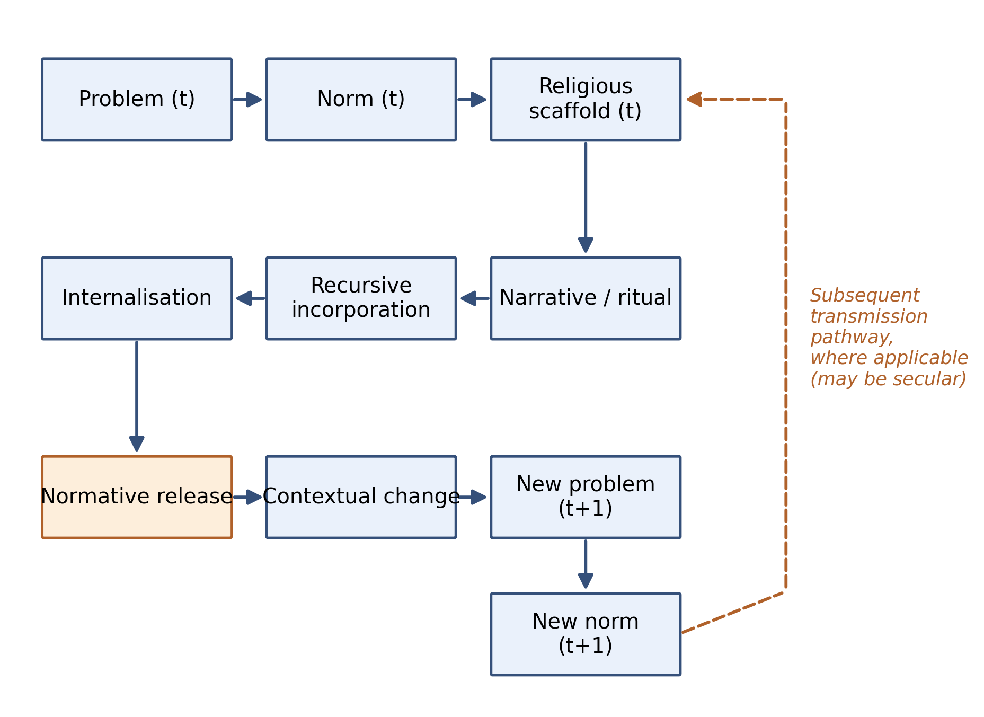
Figure 1. The normative release cycle.
2. Religious representations as normative scaffolds
We do not claim that gods exist to carry norms, or that every deity is a personified rule. Supernatural representations have multiple origins—natural forces, ecological danger, ancestors, fertility, death, political authority, existential uncertainty, cosmological explanation—and no single genealogy covers them. Our claim is deliberately limited: some religious and supernatural representations may function, among other things, as personified carriers of norms, environmental constraints, or socially valued conduct.
There is good reason to take this limited functionalism seriously. Experimental and ethnographic work shows that beliefs in watchful, morally interested supernatural agents are associated with increased prosocial conduct toward strangers (Purzycki et al., 2016), and that people across fifteen field sites tend to attribute moral concern to local deities even when those deities are not explicitly moralised—a "moralization bias of gods' minds" (Purzycki et al., 2022). Singh, Kaptchuk, and Henrich (2021) document the Mentawai water spirit Sikameinan, believed to punish those who violate meat-sharing norms; the public healing rituals that follow a violation retransmit the underlying norm to onlookers. The scope and powers of deities may have expanded historically as their norm-enforcement role deepened (Norenzayan et al., 2016; Watts et al., 2015; cf. Watts et al., 2016), though the causal ordering remains debated (Beheim et al., 2021).
What does personification add to transmission? Candidate effects include memorability, emotional salience, agency attribution, causal intelligibility, and behavioural consequence made vivid. The contrast is intuitive: "do not approach dangerous water" is an abstract rule; "the kappa will pull you in" is an agent with a story and a consequence. The kappa is a documented example of a danger-bearing supernatural figure used to warn children about rivers (Foster, 1998; Ishikawa, 1985), and importantly, Foster (1998) traces its subsequent transformation through folklorism into a benign mascot—the warning persists in signage and parental instruction while the frightening agent has been defanged. We use such cases illustratively, not as proof: the causal claim that personification outperforms equivalent abstract instruction has suggestive support in narrative cognition and cultural transmission research (Boyer, 2001; Gervais et al., 2011) but no clean demonstration, and we do not assert more than the literature supports.
Ritual reinforces the same architecture. Rituals are costly, public, and repetitive; they re-broadcast the norm-relevant content of a tradition to participants and onlookers (Singh et al., 2021; Whitehouse, 2004). Narrative supplies causal intelligibility: an agent who notices, punishes, or rewards makes the norm memorable as a story rather than a rule (Boyer, 2001). Place anchors both: sacred geography ties transmitted meanings to recurrent encounters. Religion, in this view, is not only scripture, doctrine, belief, confession, and membership; it is also place, ritual, narrative, participation, and transmission—a practice-centered conception continuous with the lived-religion and vernacular-religion traditions (McGuire, 2008; Ammerman, 2007; Primiano, 1995) and with Luckmann's (1967) account of the modern relocation of the sacred.
Three cautions discipline this section. First, functionalism is bounded: saying a representation can carry a norm does not entail that it only does so, or that its other functions are eliminable. Second, correlation is not causation: the experimental literature on supernatural monitoring shows modest and contested effects, and we rely on it for plausibility, not proof (cf. Beheim et al., 2021). Third, not every norm has a god, and not every god carries a norm; the scaffold claim is existential, not universal.
Four illustrative cases anchor the abstraction without pretending to test it. (i) The kappa case: a dangerous water figure encoding river-safety instruction, later softened through folklorism into a mascot while the warning detached and persisted in ordinary parental practice and signage (Foster, 1998; Ishikawa, 1985). We do not claim the kappa was invented for instruction; the point is that a figure could carry the warning and that the warning survived the figure's de-fanging. (ii) The Mentawai case: Sikameinan's norm-enforcement role is still live—transmission has not completed—and the healing ritual publicly re-broadcasts the sharing norm after each violation (Singh et al., 2021). The pair—one figure's warning function completed and defused, another still enforced—shows the variable our model tracks: the norm's continued dependence on the representation. (iii) The Church–kinship case: Schulz et al. (2019) document durable psychological and normative change produced by a religious institution's restructuring of kinship—embedding at civilisational scale. Whether the resulting individualism now reproduces independently of its Christian carrier is precisely the diagnostic question release poses; we cite it as scope, not as established release. (iv) Shinto offers a contrasting baseline for the whole discussion: a tradition with weak creed and overlapping membership that nonetheless sustains ritual, place, and seasonal practice (Reader, 1991; Nelson, 2000)—evidence that transmission does not require confessional structure.
3. From transmission to internalisation
Norm research provides the second plank. Finnemore and Sikkink's (1998) norm life-cycle runs from emergence through cascade to internalisation, where norms acquire a "taken-for-granted" quality and compliance approaches the automatic. Subsequent scholarship has complicated the terminal stage—internalised norms remain contestable (Wiener, 2014) and can regress—but the core insight stands: enforcement migrates from external sanctions to habit, identity, and social expectation (Gintis, 2003).
The religion residue literature supplies empirical traction at the individual level. People who leave religion ("religious dones") retain values and moral emphases intermediate between the consistently religious and the never religious—a stairstep pattern across moral foundations (Van Tongeren et al., 2021b) and Schwartz values (Schwadel et al., 2021), with cross-cultural replication (Van Tongeren et al., 2021a). At the institutional scale, Schulz et al. (2019) argue that the medieval Western Church's restructuring of kinship produced psychological and normative shifts—toward individualism and impersonal prosociality—that outlasted the institutions that generated them.
Two observations motivate what follows. First, residue research describes that norms persist after religiosity recedes; it is largely silent on when the carrier's continued salience becomes unnecessary, and on whether the recession can be read as anything other than attenuation. Second, internalisation models end where our question begins. Once the external scaffold's enforcement function has been absorbed into ordinary social reproduction, what is the scaffold's status? The literature offers no named process for this transition. We propose one.
A transitional concept is needed between transmission and internalisation: the recursive incorporation of inherited ritual, narrative, place, and normative meaning into ordinary life. Religious meaning does not merely persist; it is folded back into everyday practice, where transformed experience in turn reshapes the meaning transmitted to the next generation. Recursive incorporation is a process, distinct from lived religion understood as an empirical orientation or field (McGuire, 2008; Ammerman, 2007). Where lived religion describes religion as it is lived, recursive incorporation describes how transmitted content becomes ordinary.
4. Normative release
Definition. Normative release is the process by which a norm becomes sufficiently embedded in ordinary social life that its reproduction becomes progressively independent of the continued explicit salience of the religious, supernatural, or personified representation through which it was previously transmitted.
Several qualifications are essential.
Release is norm-specific, not tradition-wide. A deity, spirit, or sacred representation may carry many functions. If G = {f₁, f₂, …, fₙ}, release concerns the transfer of a particular transmissive function fᵢ from G to ordinary social reproduction: G → N becomes Society → N for that function, while other functions of G may remain active, migrate, or lapse independently. Release does not require the deity's exit.
Release is not denial, defeat, or disproof. The representation is not falsified; its role in the reproduction of a particular norm has been completed or transferred. Nor is release equivalent to secularisation: secularisation describes declining religious authority and participation; release describes a change in the dependency structure of one norm.
Release is gradual and potentially partial. Salience can diminish across generations without disappearing; a norm may remain weakly coupled to a dormant representation that can be reactivated.
To fix the concept, it helps to set it against the four nearest accounts of post-religious persistence—an inversion our comparison makes visible (Figure 2; Table 1).
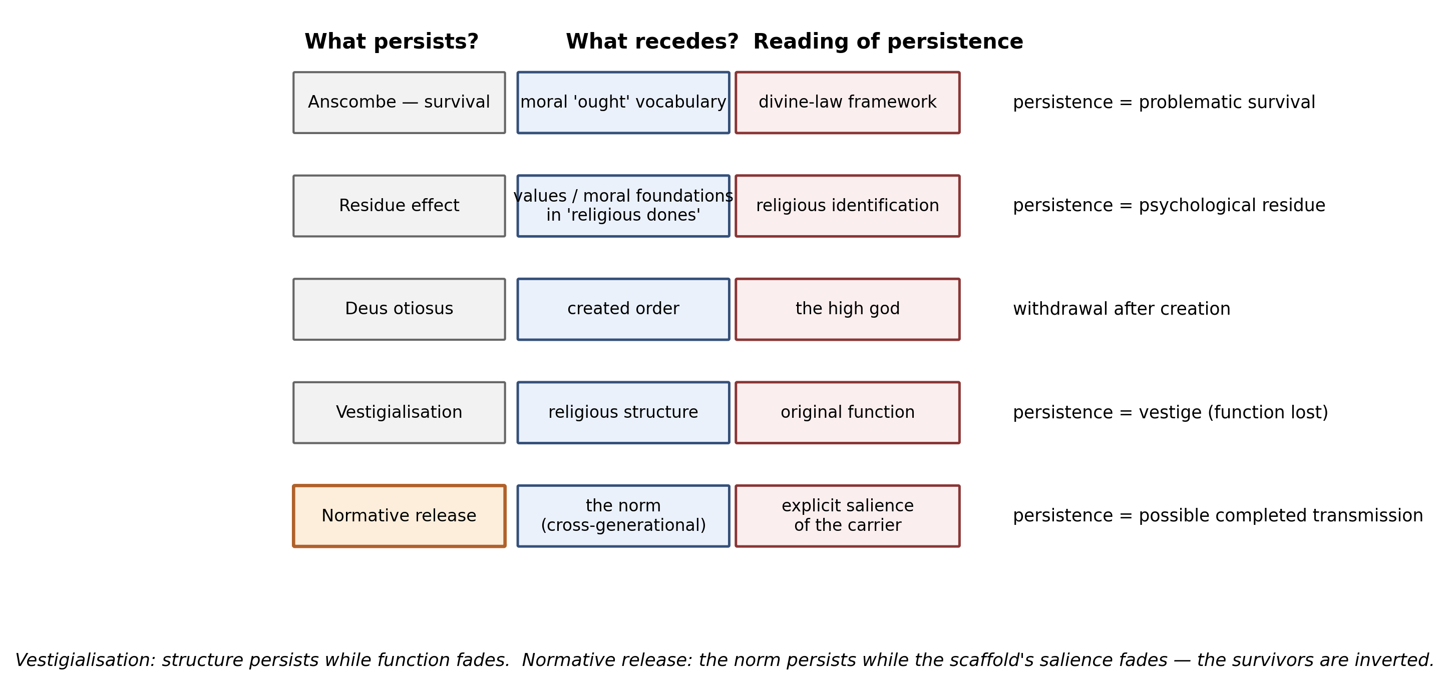
Figure 2. Four accounts of persistence after religious recession, and normative release.
Table 1. Accounts of persistence after religious recession: what persists, what recedes, and how persistence is interpreted.
Framework | What persists? | What recedes? | Interpretation | Scale | Relation to normative release
Anscombe (1958): survival | Moral "ought" vocabulary | Divine-law framework | Problematic survival — concepts lost their root | Conceptual / civilisational | Same structure; release offers a completion reading Anscombe does not consider
Nietzsche (1974/1882): shadow of God | Moral/metaphysical structures | Belief in God | Lingering dependence on an absent source | Cultural / civilisational | Asks whether some "shadows" are self-sustaining, not shadows
Religion residue (Van Tongeren et al., 2021a, 2021b; Schwadel et al., 2021) | Values, moral foundations in "dones" | Religious identification/practice | Persistence of psychological residue after disaffiliation | Individual | Individual-level analogue; release adds mechanism + cultural level
Deus otiosus (Eliade, 1959) | Created order | The high god's governance | Mythological withdrawal after creation | Mythological / god-level | God-level withdrawal; release is norm-level, function-specific
Vestigial structure (Talmont-Kaminski & Shults, 2024) | Religious structure | Original function | Loss of function; trait persists as vestige | Trait / tradition-level | Inverted: in release the norm persists, the scaffold recedes
Norm life-cycle (Finnemore & Sikkink, 1998) | Internalised norm | External enforcement | Taken-for-granted compliance | Norm-level | Shares the endpoint; release theorises what happens to the carrier
Normative release (this article) | The norm (cross-generational) | Explicit salience of the carrier | Possible completion of a transmissive function | Norm-specific, cultural | —
Anscombe's survival. In Modern Moral Philosophy, Anscombe (1958) argues that the moral "ought"—obligation, duty, being bound as by law—is a survival of a divine-law framework that "no longer generally survives," rendered incoherent by the legislator's departure: the concepts "remain though they had lost their root." The structure is ours: carrier recedes, norm persists. The interpretation differs. Anscombe reads persistence as a conceptual residue that corrupts moral philosophy without its theological root. Normative release keeps a second reading open: survival after theological recession need not have a single interpretation, and the continued work of a norm may register completed transmission rather than orphaned vocabulary. We do not resolve Anscombe's worry—she may be right that some survivals are incoherent—we deny that incoherence is the only diagnosis.
Nietzsche's shadows. God is dead, but "given the way of men, there may still be caves for thousands of years in which his shadow will be shown" (Nietzsche, 1974/1882, §108): moral and metaphysical structures persist after belief has withdrawn. Again the structure matches; again the valence differs. The shadow is cast by the absent god and is expected to fade. We ask instead: could some apparent shadows be not residual dependencies but norms that have become culturally self-sustaining—no longer shadows at all, but independent inhabitants of the cave?
Religion residue. Residue is measured at the individual level, in the disaffiliated person's retained values. Release is a claim about norm-level, cultural, potentially intergenerational reproduction: not "religious people who left still carry the values" but "the norm's reproduction no longer routes through the representation." The difference matters diagnostically: residue decays as cohorts turn over (indeed the residue literature documents decay alongside persistence—Van Tongeren et al., 2021b), whereas a norm in release should reproduce stably across generations without the scaffold.
Deus otiosus. The mythological figure of the withdrawn high god—a creator who retires from governing the world after establishing its order—is well attested (Eliade, 1959; see also Deist and Nyāya-Vaiśeṣika analogues). Deus otiosus is a god-level withdrawal from world-governance; normative release is function-specific independence of a norm from its carrier. A deity may be released from one transmissive role while remaining, in principle, active in others; conversely an otiosus god who never carried the norm at all exhibits no release. The concepts are orthogonal and must not be conflated.
Vestigialisation. Talmont-Kaminski and Shults (2024) argue that modern religious traits increasingly exhibit the marks of biological vestiges—increasing variability, decreasing costliness, novel functions—as the structures' original functions decay. The survivors are inverted between the two models: in vestigialisation, function fades while the religious structure remains; in normative release, the religious scaffold recedes while the norm remains and continues to reproduce. The models are not rivals. Within a single tradition, one function may vestigialise (a rite whose point is forgotten persists as pageantry) while another is released (a water-safety norm that no longer needs its kappa). Whether a given case is vestige or release is an empirical question about what still reproduces.
Distinguishing conditions. Release requires: (i) the norm was historically transmitted in significant part through the representation; (ii) the norm continues to reproduce robustly, including across generations; (iii) continued reproduction no longer depends on the representation's salience. Absent (ii), we have ordinary decay; absent (iii), ordinary embedded religiosity; absent (i), a norm that never needed gods at all.
5. The self-effacement paradox
Normative release yields a general interpretive consequence. Religious success is conventionally gauged by adherents, worship frequency, explicit belief, institutional persistence—all measures of visible religion. But if a norm's transmission succeeds completely, its reproduction requires no explicit religious mediation: successful transmission reduces the need for explicit enforcement. A religious tradition may therefore become least visible precisely where one of its transmissive functions has succeeded most completely. We call this the self-effacement paradox of religious transmission.
The paradox has bite because measurement conflates salience with function. Declining explicit religiosity is routinely read as functional loss; the paradox says the same observation is compatible, in some cases, with completed transmission. This does not rescue religion from decline, nor does it make decline illusory: many recessions are plainly losses—norms lapse, rituals die unpractised, traditions are uprooted. The point is narrower and diagnostic. Wherever explicit religion has receded and a historically associated norm continues to reproduce, two hypotheses compete—failure of the carrier, or completion of the function—and they are distinguishable in principle by testing whether the norm still reproduces independently.
The paradox also warns against over-reading. "Decline might be success" is not a licence to count every empty church as a triumph; the falsification conditions in Section 8 exist precisely to keep the interpretation disciplined.
6. A cyclical model of normative renewal
Internalisation is not an endpoint, because the environment that generated the norm keeps moving. Norm life-cycle models conventionally stop at internalisation: emergence, cascade, then taken-for-granted compliance (Finnemore & Sikkink, 1998). But nothing in social life guarantees that the conditions under which a norm was formed will persist. After Internalisation(t) → Normative Release(t), the context itself changes—Context(t+1) ≠ Context(t)—and once the context changes, there is no presumption that the inherited norm remains adequate: Norm(t+1) may differ from Norm(t). The endpoint of the received model is thus a waypoint in ours.
Nor is release preservation. Normative release is not the freezing of an old norm in place; it is closer to the opposite. Where a norm remains explicitly bound to a divine command, revision may also have to contend with the authority attributed to that command. Once the norm reproduces on its own, the command that fixed it no longer has to be renegotiated for the norm to be reconsidered. Release therefore can enable normative updating: Norm(t) → internalisation → release → contextual change → normative reconsideration → Norm(t+1). What was carried without the carrier can also be carried differently.
The model we propose is accordingly cyclical and norm-specific (Figure 1):
Problem(t) → Norm(t) → Religious scaffold(t) → Narrative/ritual(t) → recursive incorporation → internalisation → normative release → contextual change → Problem(t+1) → Norm(t+1)
Contextual change—technology, ecology, climate, urbanisation, medicine, communication, political institutions, warfare, family forms, artificial intelligence—generates new problems for which the inherited norm may be maladapted. Then Norm(t+1) ≠ Norm(t), and the cycle begins again, with or without a new scaffold. Because the cycle is norm-specific rather than tradition-level, it differs from revival-cycle accounts in which whole traditions surge and recede (cf. Fogel's awakenings, in which technological change outpaces ethical capacity; Fogel, 2000), and from cyclical or dialectical models of secularisation at the civilisational scale (cf. Martin, 1978). A tradition is, on this view, not a fixed doctrine but a historically situated process of transmission, completion, and renewal—Recover → Reflect → Internalise → Release → Renew—iterated over norms rather than over the tradition as a whole.
Conceptually, one may write the historical embeddedness of a tradition as $H_{r}=∫_{T}∫_{A}N(x,t) E_{r}(x,t) dx dt$—a gesture only, meant to visualise that a currently marginal tradition may nonetheless have shaped very many lives across long periods and wide regions. We deliberately impose no completeness constraint (∑ᵣ Eᵣ = 1): the same person's conduct may simultaneously carry several traditions' norms. Current prevalence is not equivalent to historical significance.
7. Religious renewal without restoration
This brings the argument back to its starting point: a religious tradition that is now largely forgotten need not be valued at zero merely because its present adherent count is near zero. Present religious affiliation is a temporal snapshot, not a measure of the cumulative historical significance of a tradition. A tradition that today retains few explicit adherents may nonetheless have organised birth, marriage, death, seasonal life, agriculture, ecological conduct, kinship, reciprocity, and relations to place over long periods and wide regions; such a record constitutes a historical normative repertoire that remains a legitimate object of reconsideration. Nor should the snapshot be read through a one-person-one-religion assumption: a single person may participate simultaneously in several festivals, ancestral practices, and religious traditions, so affiliation-style bookkeeping understates distributed engagement in the first place.
If revival is defined as the exact restoration of an earlier religious form under its original social conditions, it is an unrealistic standard: those conditions are no longer recoverable in full. We define revival instead as the recovery and selective reintegration of dormant normative repertoires:
Historical repertoire → Retrieval → Critical reflection → Selective reintegration → Renewed living practice (Figure 3)
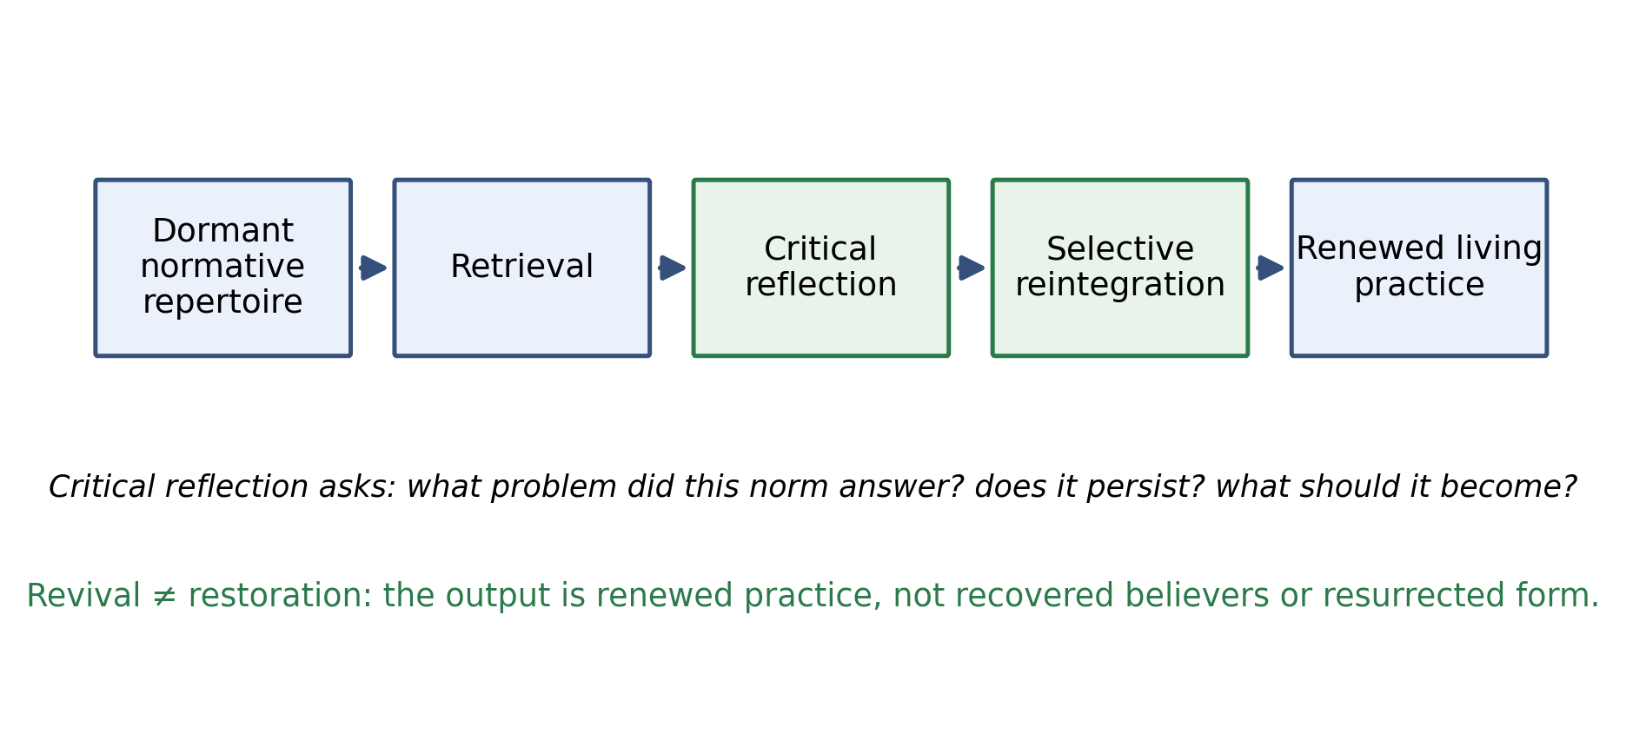
Figure 3. Revival without restoration.
What is recovered is not believers but relations—people–place, people–ancestors, people–season, people–ritual, people–narrative, people–community, generation–generation—and the normative repertoires encoded in them. Retrieval without reflection is antiquarianism; reflection without selection is nostalgia. Selection must answer four questions: what problem did this norm answer? What was it protecting? Does the problem persist in modified form? What should the norm become now? Antiquarian authority confers no warrant: discriminatory, dangerous, or unintelligible survivals are to be rejected.
Two warnings from adjacent literatures discipline this account. First, revival reconstructs: Wallace's (1956) revitalization movements and Hobsbawm and Ranger's (1983) invented traditions show that "returns" fabricate as much as they recover—renewed practice is a new cultural product wearing inherited materials, which our model accepts rather than denies. Second, revival can misfire by scripturalization: attempts to revive diffuse, local, overlapping, or contradictory traditions may inadvertently reconstruct them in the image of bounded, doctrinal, canon-centred religion—fragmented tradition → reconstruction → systematisation → doctrinalisation → canonisation → orthodoxy—destroying the plurality that made the tradition vital. Scripturalization is an established term for the process by which texts and traditions acquire scriptural status (Cantwell Smith, 1993; Wimbush, 2015); the trap we name is the deformation of practice-centered traditions by canon-centred reconstruction, overlapping but not identical with heritageisation and invention-of-tradition critiques. We flag it as a hazard of revival, not the centre of this paper.
Shinto illustrates the practice-centered pole without exemplifying it: weak formal creed and non-exclusive membership coexist with durable ritual continuity across place, season, and household (Reader, 1991; Nelson, 2000)—practice without strong exclusive confession. We treat it as an illustration of what can be transmitted and renewed, not as an ideal type or a claim about Japanese uniqueness.
8. Discussion
Release vs. perpetual authority. Two pathways organize a tradition's relation to novel problems, and they may differ in normative adaptability. In the release pathway, Religious Representation(t) → Norm(t) → internalisation → normative release: a particular representation completes a particular transmissive role, and when Problem(t+1) arrives there is room to form Norm(t+1) without routing the answer back through the original carrier. The representation's silence on the new problem is not a failure of authority; it is the expected consequence of a completed function.
In the perpetual-authority pathway, Religious Authority(t) → Norm(t) is retained as a standing relation: when Problem(t+1) arises, an answer consistent with Religious Authority(t) → Norm(t+1) may be required—the same sacred authority is expected to adjudicate indefinitely across historically novel conditions. Whether this produces stricter, slower, or simply different normative updating is not obvious a priori: perpetual authority may constrain adaptation, or it may supply a stable frame within which adaptation is negotiated.
We therefore pose the comparison strictly as a question: does normative adaptability differ between traditions that permit particular sacred representations to complete specific transmissive roles and traditions in which the same sacred authority is expected to adjudicate indefinitely across historically novel conditions? To our knowledge the question is untheorised, and we offer it as a comparative research hypothesis rather than a conclusion. Its doctrinal mechanics—how authority is interpreted, enforced, and aggregated—belong to a separate analysis and are deliberately left to future work.
Complementarity with vestigialisation. A tradition is a bundle of functions. Some may vestigialise—structure persists, function decays—while others release—function transferred, scaffold recedes—and still others remain actively enforced. Decline narratives that track only visibility miss this decomposition; the interesting empirical programme is differential diagnosis function by function.
Limits of functional interpretation. Normative release is a hypothesis about one function—normative transmission—among many. Representations also console, sacralise, legitimise, mark identity, orient cosmologically; release of a transmissive function says nothing about the others. Nor does release claim that norms need gods to persist—many norms plainly do not—or that gods are invented for norms. The claim is conditional: where a representation did carry a norm, its later dispensability admits a completion reading.
Falsification. The concept weakens if: (1) norm persistence after carrier recession is sufficiently explained by non-religious pathways; (2) putatively released norms turn out not to reproduce without continued covert dependence on the representation; (3) post-recession persistence is short-lived residue rather than cross-generational reproduction; (4) release cannot be distinguished empirically from ordinary secularisation; (5) norm renewal needs no reference to the religious scaffold's history; or (6) the revival account collapses into existing heritage or lived-religion theory. These are stated so the concept cannot absorb every case of religious recession.
Implications for measurement. If the most thoroughly internalised norms are precisely those least visible to affiliation and practice measures, current religious statistics systematically under-register completed transmission. That implication—about legibility and observability bias—we flag but defer: it belongs to a companion analysis of how religion is counted.
A closing metaphor, marked as such. Not an empirical claim but an interpretive image: a deity released from a particular transmissive role need not be imagined as defeated or forgotten. A deity may be imagined to step back and watch quietly while humans carry on what once required a divine voice. Silence, on this reading, can mark completion rather than absence.
9. Conclusion
The take-away is not that gods are unnecessary, nor that old religions should be restored. Religious representations may sometimes serve as temporary cultural scaffolds through which norms, relationships, and meanings become embedded in ordinary life; when those norms can reproduce without continuous divine enforcement, the fading of explicit representation need not signify failure. It may sometimes mark normative release—the point at which a tradition can, metaphorically, say: carry it without me. And because environments change, release is not a terminus: new problems call forth new norms, and traditions that endure may do so less by keeping their gods permanently active than by allowing what the gods once carried to be taken up, reworked, and carried forward in human life.
Acknowledgements
[To be completed.]
Disclosure statement
No potential conflict of interest was reported by the author.
References
Ammerman, N. T. (2007). Everyday religion: Observing modern religious lives. Oxford University Press.
Anscombe, G. E. M. (1958). Modern moral philosophy. Philosophy, 33(124), 1–19. https://doi.org/10.1017/S0031819100037943
Beheim, B., Atkinson, Q. D., Bulbulia, J., Gervais, W., Gray, R. D., Henrich, J., Lang, M., Monroe, M. W., Muthukrishna, M., Norenzayan, A., Purzycki, B. G., Shariff, A., Slingerland, E., Spicer, R., & Willard, A. K. (2021). Treatment of missing data determines conclusions regarding moralizing gods. Nature, 595(7866), E29–E34. https://doi.org/10.1038/s41586-021-03655-4
Boyer, P. (2001). Religion explained: The evolutionary origins of religious thought. Basic Books.
Cantwell Smith, W. (1993). What is scripture? A comparative approach. Fortress Press.
Davie, G. (1994). Religion in Britain since 1945: Believing without belonging. Blackwell.
Eliade, M. (1959). The sacred and the profane: The nature of religion (W. R. Trask, Trans.). Harcourt, Brace & World. (Original work published 1957)
Finnemore, M., & Sikkink, K. (1998). International norm dynamics and political change. International Organization, 52(4), 887–917. https://doi.org/10.1162/002081898550789
Fogel, R. W. (2000). The fourth great awakening and the future of egalitarianism. University of Chicago Press.
Foster, M. D. (1998). The metamorphosis of the kappa: Transformation of folklore to folklorism in Japan. Asian Folklore Studies, 57(1), 1–24. https://doi.org/10.2307/1178994
Gervais, W. M., Willard, A. K., Norenzayan, A., & Henrich, J. (2011). The cultural transmission of faith: Why innate intuitions are necessary, but insufficient, to explain religious belief. Religion, 41(3), 389–410. https://doi.org/10.1080/0048721X.2011.604510
Gintis, H. (2003). The hitchhiker's guide to altruism: Gene–culture coevolution, and the internalization of norms. Journal of Theoretical Biology, 220(4), 407–418. https://doi.org/10.1006/jtbi.2003.3104
Hobsbawm, E., & Ranger, T. (Eds.). (1983). The invention of tradition. Cambridge University Press.
Ishikawa, J. (1985). The kappa legend: A comparative ethnological study on the Japanese water-spirit kappa and its habit of trying to lure horses into ponds. Folklore Studies, 44, 1–6. https://doi.org/10.2307/1177988
Luckmann, T. (1967). The invisible religion: The problem of religion in modern society. Macmillan.
Martin, D. (1978). A general theory of secularization. Blackwell.
McGuire, M. B. (2008). Lived religion: Faith and practice in everyday life. Oxford University Press.
Nelson, J. K. (2000). Enduring identities: The guise of Shinto in contemporary Japan. University of Hawai'i Press.
Nietzsche, F. (1974). The gay science (W. Kaufmann, Trans.). Vintage Books. (Original work published 1882)
Norenzayan, A., Shariff, A. F., Gervais, W. M., Willard, A. K., McNamara, R. A., Slingerland, E., & Henrich, J. (2016). The cultural evolution of prosocial religions. Behavioral and Brain Sciences, 39, e1. https://doi.org/10.1017/S0140525X14001356
Primiano, L. N. (1995). Vernacular religion and the search for method in religious folklife. Western Folklore, 54(1), 37–56. https://doi.org/10.2307/1499910
Purzycki, B. G., Apicella, C., Atkinson, Q. D., Cohen, E., McNamara, R. A., Willard, A. K., Xygalatas, D., Norenzayan, A., & Henrich, J. (2016). Moralistic gods, supernatural punishment and the expansion of human sociality. Nature, 530(7590), 327–330. https://doi.org/10.1038/nature16980
Purzycki, B. G., Willard, A. K., Klocová, E. K., Apicella, C., Atkinson, Q., Baimel, A., Cohen, E., Handley, C., Kundtová Klocová, E., Lesorogol, C., Mathew, S., McNamara, R. A., Moya, C., Norenzayan, A., Placek, C., Soler, M., Vardy, T., Weigel, J., Wildman, W., Xygalatas, D., & Henrich, J. (2022). The moralization bias of gods' minds: A cross-cultural test. Religion, Brain & Behavior, 12(1–2), 38–60. https://doi.org/10.1080/2153599X.2021.2006291
Reader, I. (1991). Religion in contemporary Japan. University of Hawai'i Press.
Schulz, J. F., Bahrami-Rad, D., Beauchamp, J. P., & Henrich, J. (2019). The Church, intensive kinship, and global psychological variation. Science, 366(6466), eaau5141. https://doi.org/10.1126/science.aau5141
Schwadel, P., Hardy, S. A., Van Tongeren, D. R., & DeWall, C. N. (2021). The values of religious nones, dones, and sacralized Americans: Links between changes in religious affiliation and Schwartz values. Journal of Personality, 89(5), 867–882. https://doi.org/10.1111/jopy.12620
Singh, M., Kaptchuk, T. J., & Henrich, J. (2021). Small gods, rituals, and cooperation: The Mentawai water spirit Sikameinan. Evolution and Human Behavior, 42(1), 61–72. https://doi.org/10.1016/j.evolhumbehav.2020.07.008
Talmont-Kaminski, K., & Shults, F. L. (2024). Modern religion as vestigial structure: An evolutionary account of secularisation. Religion, 54(2), 320–332. https://doi.org/10.1080/0048721X.2023.2289421
Van Tongeren, D. R., DeWall, C. N., Chen, Z., Sibley, C. G., & Bulbulia, J. (2021a). Religious residue: Cross-cultural evidence that religious psychology and behavior persist following deidentification. Journal of Personality and Social Psychology, 120(2), 484–503. https://doi.org/10.1037/pspp0000288
Van Tongeren, D. R., DeWall, C. N., Hardy, S. A., & Schwadel, P. (2021b). Religious identity and morality: Evidence for religious residue and decay in moral foundations. Personality and Social Psychology Bulletin, 47(6), 1033–1049. https://doi.org/10.1177/0146167220940810
Voas, D. (2009). The rise and fall of fuzzy fidelity in Europe. European Sociological Review, 25(2), 155–168. https://doi.org/10.1093/esr/jcn044
Wallace, A. F. C. (1956). Revitalization movements. American Anthropologist, 58(2), 264–281. https://doi.org/10.1525/aa.1956.58.2.02a00040
Watts, J., Greenhill, S. J., Atkinson, Q. D., Currie, T. E., Bulbulia, J., & Gray, R. D. (2015). Broad supernatural punishment but not moralizing high gods precede the evolution of political complexity in Austronesia. Proceedings of the Royal Society B, 282(1804), 20142556. https://doi.org/10.1098/rspb.2014.2556
Watts, J., Sheehan, O., Atkinson, Q. D., Bulbulia, J., & Gray, R. D. (2016). Ritual human sacrifice promoted and sustained the evolution of stratified societies. Nature, 532(7598), 228–231. https://doi.org/10.1038/nature17159
Whitehouse, H. (2004). Modes of religiosity: A cognitive theory of religious transmission. AltaMira Press.
Wiener, A. (2014). A theory of contestation. Springer.
Wimbush, V. L. (Ed.). (2015). Scripturalizing the human: The written as the political. Routledge.

