The Reincarnation of the Divine: The Vortex of One and Many in Ever-Changing Worlds
Abstract
The classification of religions by deity count carries a persistent developmental shadow: the aggregation of many gods into one has been read as progress, refinement, or maturation, while the reverse dispersal has been read as fragmentation or decline. This article subjects that directional reading to a formal reversal test and finds it unsupported. It then develops a model in which One and Many are not successive stages but two configurations of a representational architecture — a partition of divine attributes, functions, narratives, and normative authority across agents and interpreters. Aggregation and differentiation are modeled as symmetric operators on this architecture; a directional symmetry test requires that no transformation be called development unless an independent evaluative criterion survives reversal of direction. The model's temporal engine is historical novelty: when a changing problem environment generates questions that a stabilized normative repertoire does not answer, ontological unity can produce interpretive plurality through authorized interpretation, and institutions then accommodate, compress, or reintegrate that plurality. Because each transition deposits texts, precedents, and institutions, the process does not close into a cycle; it traces a path-dependent vortex. Finally, the article introduces authority-scope release — the relinquishment of completed regulatory functions by an authority that remains sacred — as a theoretically distinct alternative to the indefinite extension of divine jurisdiction, and derives testable hypotheses and falsification conditions from the complete framework.
Introduction
Why should Many-to-One be interpreted as religious development if One-to-Many can be described, with equal formal plausibility, as differentiation, narrative articulation, specialization, or renewed interpretive plurality? The question is older than the academic study of religion, but it has never quite been asked in operational form. Nineteenth-century evolutionism placed polytheism before monotheism on a ladder (Tylor 1871); counter-traditions placed an original monotheism before degeneration into plurality (Schmidt 1931); both parties agreed that direction was meaningful while disagreeing only about its sign. The twentieth century largely abandoned the ladder without abandoning its grammar: differentiation remains the default verb for development in models descended from Bellah's "Religious Evolution" (1964), and unity continues to imply closure, maturity, or finality in much comparative description.
This article argues that the mistake is not choosing the wrong direction of religious evolution. The mistake is inferring development from the direction of aggregation itself. To make that claim precise, the paper constructs a minimal formal apparatus. Divine representation is treated as a multidimensional architecture — a way of distributing semantic features, functions, narratives, and normative authority over a set of divine agents and their authorized interpreters. On this view, the number of gods is an insufficient statistic for the architecture of divine representation: two traditions with the same deity count may partition a partially overlapping space of attributes and jurisdictions at very different resolutions, and one tradition may present incompatible counts at different registers without contradiction (Versnel 2011).
Three questions organize the argument. First, the directional question just stated. Second, an ontological-classificatory question: are monotheism and polytheism always distinct religious ontologies, or can they sometimes reflect different representational resolutions applied to partially overlapping spaces of divine attributes, functions, norms, forces, and narratives? Third, a temporal question: what happens when a divine authority whose normative repertoire was stabilized under an earlier social, ecological, political, or technological environment is expected to adjudicate problems that did not exist when that repertoire emerged? The paper's wager is that the third question supplies the mechanism the first two need. Historical novelty is what keeps the architecture moving: under ontological unity, new problems underdetermine interpretation, authorized interpreters multiply defensible readings, and institutions must then accommodate or recompress the resulting plurality. The same engine can then restart. The result is not a cycle — each return deposits memory and structure — but a vortex.
The argument proceeds as follows. Section 1 reviews the historiography of the monotheism/polytheism pair and locates the teleology problem precisely. Section 2 replaces deity count with representational architecture and establishes the vocabulary the rest of the paper uses. Section 3 defines the aggregation and differentiation operators and states the directional symmetry test. Section 4 presents the vortex model of path-dependent recurrence. Section 5 introduces representational inversion — the transition from a norm carried by a divine representation to a norm authorized by it — which links representation to normative authority. Section 6 develops the temporal module: historical novelty, interpretive distance, and the normative carryover problem. Section 7 connects novelty to authorized interpretation and institutional multiplication. Section 8 analyzes interpretive accumulation and its dual effect on stability and plurality. Section 9 develops authority-scope release as an alternative pathway, distinguishable from secularization and from the deus otiosus motif. Section 10 works through four comparative cases. Section 11 states hypotheses, falsification conditions, and an empirical research agenda. The Discussion addresses classification, emic/etic asymmetry, and the limits of the model; the Conclusion states what the framework claims and what it refuses to claim.
Two boundary commitments govern everything below. The analysis is etic and structural: it describes representational dynamics and does not adjudicate the truth of any theology, and it respects emic self-classification — a tradition that understands itself as monotheistic is not reclassified as polytheist by an analyst's feature count; instead, the analyst distinguishes emic classification from etic structural description and keeps both on the table. And "reincarnation" in the title is an analytical metaphor: the return of divine representation, authority, and function in transformed states, not a doctrine of rebirth.
1. The teleology of the count
The monotheism/polytheism distinction entered scholarship already carrying a direction. Tylor's animist sequence implied that plurality was earlier and simpler (Tylor 1871); Lang's "high gods" and Schmidt's Urmonotheismus answered that the original form was unitary and that multiplication was decay (Schmidt 1931). The debate's participants shared more than they contested: all assumed that the count of divine agents mapped onto an axis of development, so that establishing the direction of historical change settled the direction of development. Evans-Pritchard's critique (1965) dismantled the evidential base of both schools, but the grammatical form — transformation read as progression or regression along the One–Many axis — survived in softened forms.
Bellah's evolutionary sociology gave that grammar its most influential modern statement: religious symbol systems evolve from compact to differentiated (Bellah 1964). The axial-age literature retained the asymmetry even where it rejected the word "evolution" (Jaspers 1953; Bellah and Joas 2012). Meanwhile the "world religions" paradigm reified religions as countable wholes with stable essences, against which Masuzawa (2005), W. C. Smith (1962), and Josephson (2012) have shown the categories themselves to be historically manufactured. Within the category specifically at issue here, a recent wave of scholarship has attacked the binary directly: Versnel's demonstration that Greek religiosity operated simultaneously on incompatible registers (1990; 2011); the pagan-monotheism literature showing that "one god" language in late antiquity marked neither doctrine nor exclusivity (Athanassiadi and Frede 1999; Mitchell and Van Nuffelen 2010); philosophical decompositions of deity, god, and ultimate showing the count underdetermined (Steinhart 2012); and the proposal to replace the pair with mono-/multi-devotionalism (Hedges 2024; Schneider 2008). Assmann's Mosaic distinction relocated the real boundary from number to truth: what monotheism introduced was not one god but the true/false partition of religion (Assmann 1996; 2010). Table 1 summarizes this prior landscape and marks the novelty boundary the present argument must respect.
Table 1. Nearest prior concepts and the novelty boundary.
Concept | Nearest prior literature | Novelty boundary
Directional Symmetry Test | Teleology critique: Tylor, Schmidt, Bellah, Evans-Pritchard, Masuzawa | The reversal test itself, as an operational device
Aggregation/Differentiation operators | Bellah (unidirectional differentiation); Luhmannian differentiation | Symmetric operator pair over a representational architecture
Representational granularity | Hornung; Versnel; Floridi (levels of abstraction) | Deity number as partition resolution of a feature space (W)
Vortex | Religious-cycle models; Sorokin-style oscillation; Bellah stages | Path-dependent recurrence driven by historical novelty; non-closed
Representational inversion | Feuerbach; Big Gods (Norenzayan); Durkheim | Direction-of-warrant reversal, not an origin claim
Temporal authority extension | Newman; usul al-fiqh (Hallaq); magisterial instructions | Named mechanism linking novelty to differentiation
Interpretive distance / load | Hard cases in law; responsa literatures | Distance from stabilization environment, not age
Interpretive accumulation | Newman's development notes; legal accretion | Dual effect: stabilization + plurality generation
Authority-scope release | deus otiosus; Casanova's differentiation sub-thesis | Jurisdiction relinquished while sacred standing persists
Divine retirement | deus otiosus (Eliade) | Metaphor only; the operator is authority-scope release

What survives this demolition is an interesting residue. Nobody defends the ladder; yet the directional vocabulary persists in practice — "emergence of monotheism," "development toward unity," "fragmentation" of traditions — because the critique supplied no alternative instrument for reading directional claims. The absence of such an instrument is the gap this paper addresses. The needed tool is not another prohibition but a test: a way of checking whether a given directional description encodes an actual evaluative judgment or merely redescribes the transformation.
2. From deity count to representational architecture
Let a tradition's divine representation be modeled as an assignment of semantic material to agents. Define a semantic feature space $F=\{f_{1},…,f_{m}\}$ whose elements are the capacities, domains, and values a tradition predicates of the divine — creation, death, fertility, justice, mercy, warfare, knowledge, healing, protection, danger, social obligation, cosmological order, existential uncertainty, and the like. Define a set of divine agents $G=\{g_{1},…,g_{n}\}$ and a feature–agent assignment structure $W=(w_{ij})$, where $w_{ij}$ records the strength with which feature $f_{i}$ is associated with agent $g_{j}$ in that tradition's texts, rituals, and institutions. Two features of this apparatus matter. First, $F$ is tradition-relative: no claim is made that all religions share one semantic space, only that within any analysis some feature vocabulary must be fixed before agents can be compared. Second, $W$ describes representation, not ontology: it models how a tradition's discourses distribute the divine across agents, and entails nothing about what exists.
On this apparatus, the one/many distinction in a tradition is partly a fact about the partition of $F$ across $G$: how finely the shared space is resolved into distinct agents. Figure 1 illustrates three configurations of the same schematic feature space — a single highly bundled agent, a hierarchical architecture, and multiple specialized agents — which differ in $A_{eff}$ (effective agent diversity), bundling $B$, and functional differentiation $D$ even before any question of ontology arises. The number of gods is an insufficient statistic for the architecture of divine representation: a tradition with one supreme agent may exhibit enormous internal differentiation of names, attributes, persons, and intermediaries; a tradition with a crowded pantheon may coordinate its agents under a unified implicit order (Hornung 1996; Versnel 2011). Table 2 defines the vocabulary used throughout.
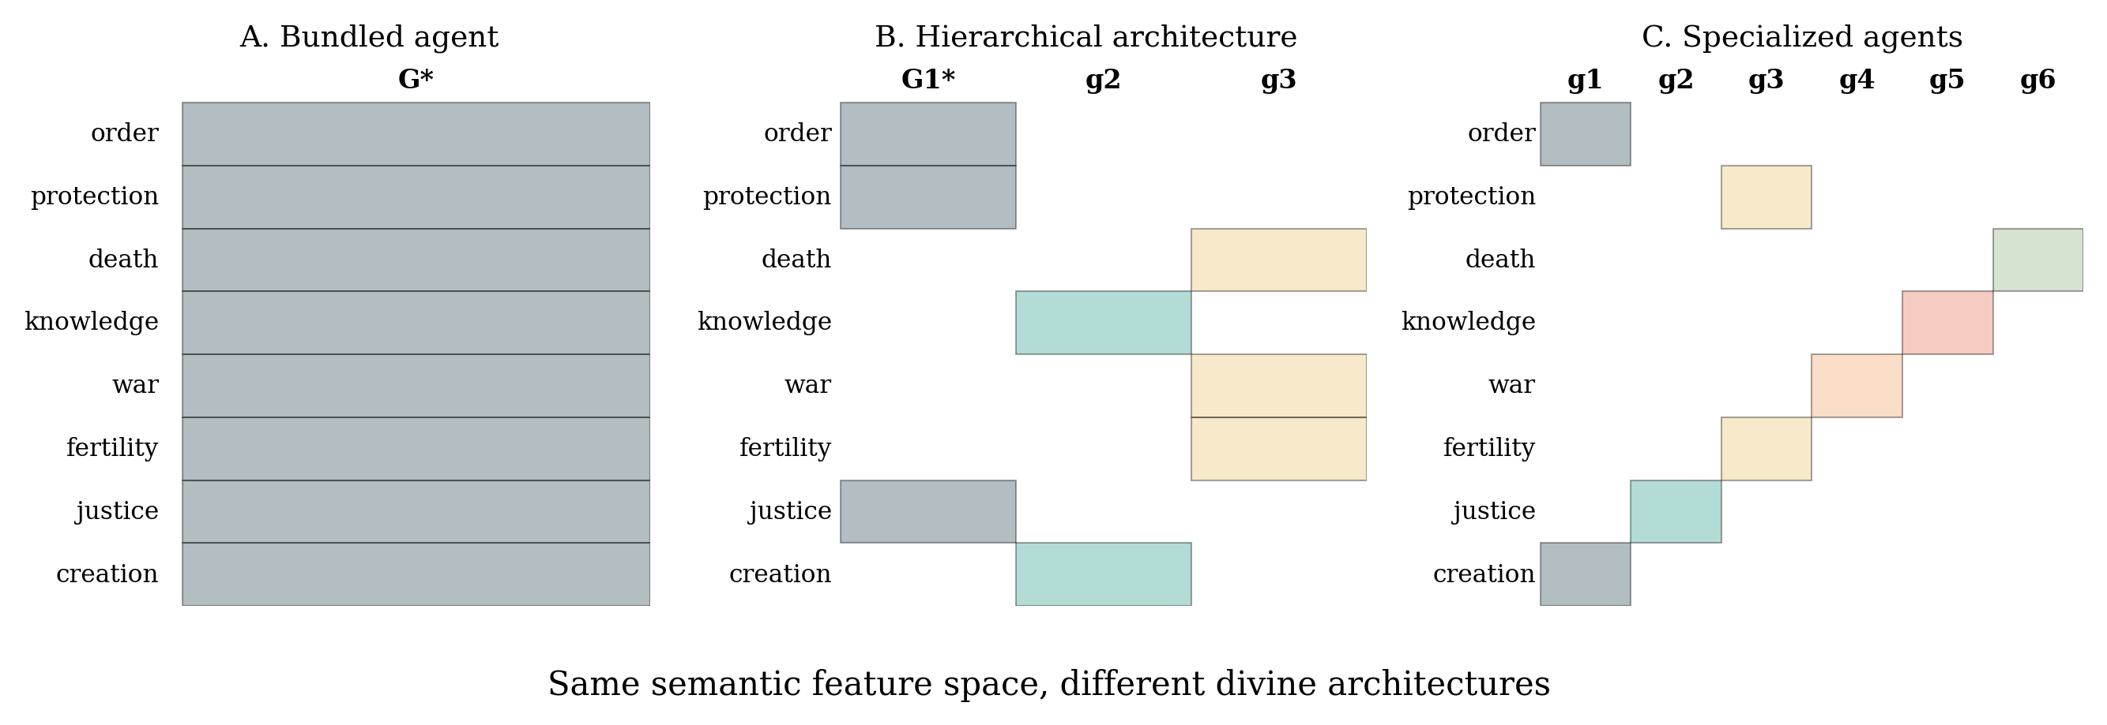
Figure 1. Three partitions of the same schematic semantic feature space across divine agents. Shaded cells mark a nonzero feature-agent association: (A) one bundled agent; (B) a hierarchical architecture; (C) multiple specialized agents.
Table 2. Definitions of central concepts.
Term | Definition
Semantic feature space (F) | The set of attributes, functions, domains, and values a tradition predicates of the divine
Divine agents (G) | The agents to which features are assigned in a tradition's texts, rituals, and institutions
Feature–agent matrix (W) | Assignment weights w_ij linking each feature to each agent; the representational architecture
Aggregation (A) | Operator bundling a family of agents into a compressed representation
Differentiation (D) | Operator re-distributing features across agents, aspects, or interpretive lineages
Representational inversion | Shift from a norm carried by a divine representation to a norm authorized by divine will
Historical novelty | A change in the context vector generating problems outside the repertoire's stabilization environment
Normative carryover problem | Application of a stabilized norm to a materially different problem environment with no determined mapping
Interpretive distance | Distance between a novel problem and the repertoire's stabilization environment (not chronological age)
Interpretive load | Total interpretive work required to sustain continuity across an environmental shift
Authorized interpretation | Institutionally sanctioned derivation of binding norms from non-self-applying sources
Interpretive accumulation | The growing deposit of precedents, distinctions, commentaries, and rulings (ΔI per period)
Authority-scope release | Relinquishment of regulatory jurisdiction by an authority that retains sacred standing
Vortex | Path-dependent recurrence of aggregation and differentiation in which successive states are non-identical
Directional Symmetry Test | Audit requiring that directional descriptions support developmental claims only via direction-independent criteria

This reframing is deliberately modest. It does not claim that monotheism and polytheism are "the same"; it claims that some differences between them are differences of representational resolution over partially overlapping material, and that these are the differences the framework can analyze. Nor does it collapse many dimensions into one index: the state of a representation is a vector, not a scalar, and no single axis — including deity count — is allowed to summarize it.
3. Operators and the directional symmetry test
Define two operators on the space of representations. Aggregation $A:\{g_{1},…,g_{n}\}→G^{*}$ maps a family of agents to a bundled agent $G^{*}$ that carries the union (or a dominant subset) of their feature columns, typically accompanied by hierarchization, syncretic naming, or doctrinal unification. Differentiation $D:G^{*}→\{g_{1},…,g_{n}\}$ maps a bundled or unified representation to a family of agents, aspects, persons, or interpretive lineages between which features are re-distributed. Historically, $A$ appears as convergence and syncretism — the absorption of El's epithets and Baal's domains into Yahweh (Smith 2001) — and $D$ appears as articulation: the emergence of distinct divine names, persons, schools, or intermediaries that partition what unity had held.
The operators are formal, not causal. Formally, $A$ and $D$ are mutually invertible directions on the state space; this is precisely what licenses the suspicion that direction of transformation is not equivalent to direction of development. But formal reversibility does not imply historical reversibility: a tradition that has aggregated and canonized cannot simply re-instantiate a pre-aggregation state, because texts, institutions, and memories have accumulated (Section 4). The formal symmetry is a diagnostic instrument, not a historical claim.
Directional Symmetry Test. Given any historical description in which a transformation toward One is characterized as development (integration, maturation, refinement, rationalization), rewrite the description with the direction reversed: characterize the corresponding transformation toward Many as development (articulation, specialization, functional differentiation, liberation of suppressed distinctions). Perform the symmetric operation on descriptions of development toward Many. If both rewritings are formally coherent — if each direction admits a developmental vocabulary and a degenerative vocabulary with equal descriptive fit — then the original description encoded direction, not development. Development may only be asserted where an independent evaluative criterion is supplied that does not itself presuppose the direction: for example, an independently motivated measure of problem-solving capacity, or a tradition-internal criterion of coherence, stated before the transformation is assessed.
The test does not prohibit all developmental claims. It relocates their burden. A claim that second-Temple Judaism "developed" must specify what increased — interpretive reach, institutional capacity, textual coherence — and show that the specification does not reduce to "became more unitary." Where such a criterion exists and survives the reversal check, developmental language stands. Where it does not, the language describes transformation while wearing the costume of evaluation. The test also applies in reverse to romantic primitivism: a claim that differentiation recovered an "original richness" fails symmetrically unless it names an independent value.
Applied to the historiography of Section 1, the test classifies Tylor's ladder and Schmidt's degeneration scheme symmetrically: both are directional descriptions equipped with an evaluative vocabulary ("higher," "purer") whose independence was never demonstrated. Bellah's differentiation criterion is more interesting: differentiation is a candidate independent value only if it is decoupled from the One–Many axis — but in Bellah's usage, differentiation toward unity (a single transcendent symbol system) still counted as advance, so the criterion smuggles the direction back in. The test does not refute Bellah; it forces the question his framework suppresses.
4. The Vortex
If aggregation and differentiation are both recurrent and neither is intrinsically developmental, what does the history of divine representation look like? Not a pendulum, and not a cycle. The evidence reviewed in Section 10 suggests a recurrent sequence — differentiation, hierarchization, aggregation, authoritative unity, internal differentiation, interpretive multiplication, reintegration, renewed differentiation — in which the later state is never identical to the earlier. Formally, $X(t+n)≠X(t)$ for the state vector $X_{t}=(A_{eff}, B, D, N, I, U, E, R_{eff}, L, J)$ — effective agent diversity, attribute bundling, functional and narrative differentiation, interpretive centralization, universality of jurisdiction, exclusivity of truth claims, effective interpreter diversity, interpretive load, and the scope of divine jurisdiction — because each transition deposits an accumulation: texts, commentaries, precedents, institutions, sectarian histories, and interpretive conventions become part of the next state. Post-exilic Yahwism is not a return to pre-exilic Yahwism with fewer gods; post-Amarna Amun is not pre-Amarna Amun restored. The process is path-dependent: the possibility space of each recurrence is shaped by the deposits of the previous ones. For this reason the model is named a vortex rather than a cycle: the motion is recurrent, but the trajectory spirals through an expanding state space rather than tracing a closed orbit (Figure 2).
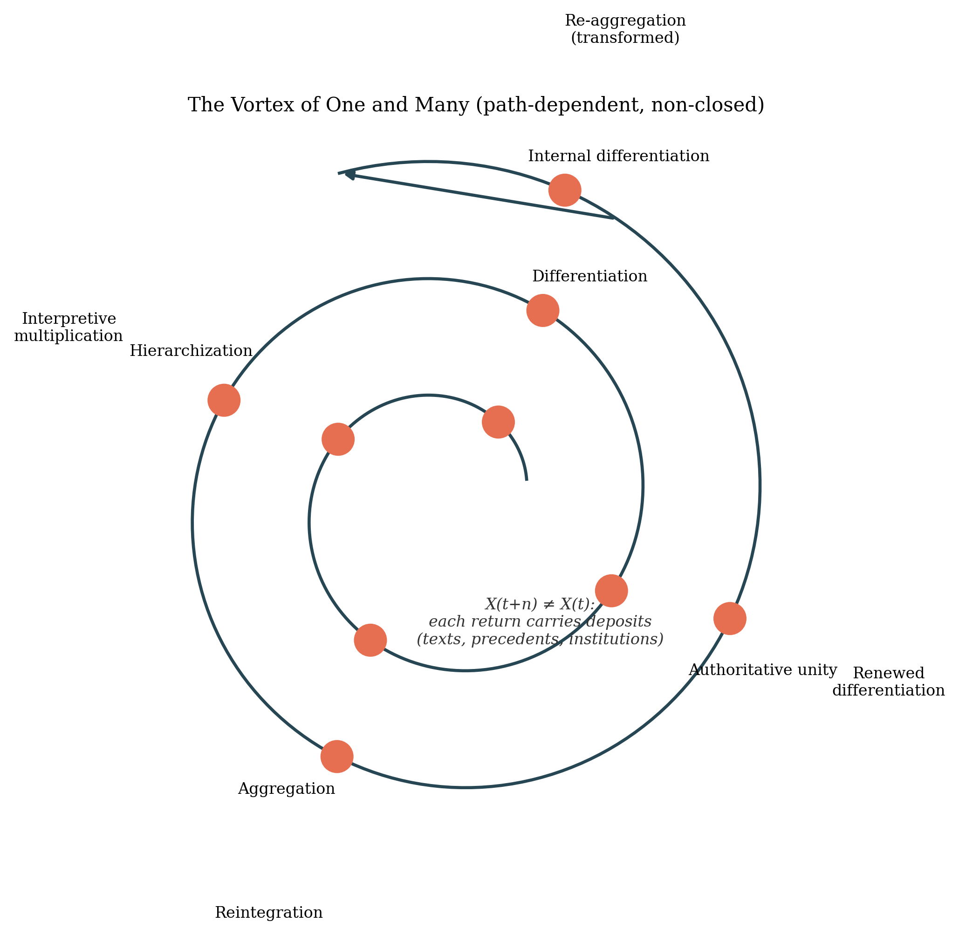
Figure 2. The Vortex of One and Many. Recurrent movement through differentiation, aggregation, authoritative unity, internal differentiation, interpretive multiplication, and reintegration; the spiral indicates path dependence — later states are never identical to earlier ones — since each return deposits texts, precedents, and institutions.
Three features distinguish this from prior recurrence models. Cyclic theories of religion (stage-cycle models of the Sergeev type; confessional R/S/SP cycles; Sorokin-style oscillation) posit return to comparable states and thus inherit the falsification problem of closed cycles: history does not repeat. Stage theories (Bellah 1964) posit direction. The vortex posits recurrence without return and without rank order — transformations revisit regions of the space (more or less bundled, more or less centralized) under changed constraints. Second, the vortex is driven, not free: its crank is historical novelty acting on underdetermined authority (Sections 6–7). Third, it can weaken or decouple: where divine authority can relinquish completed regulatory functions, the reintegration branch need not fire (Section 9). A vortex that has released enough jurisdiction may run slowly or stall — a prediction, not a defect.
Path dependence also explains why the model is not symmetric in time even though its operators are formally symmetric. The asymmetry is historical, not evaluative: deposits bias subsequent transitions. Aggregation performed with scripture and councils produces different re-differentiation options than differentiation performed before them existed. The directional symmetry test thus has a precise scope: it applies to descriptions of transformations, not to transition probabilities, which may legitimately be asymmetric.
5. Representational inversion
The link between divine representation and normative authority is itself a transformation. Consider the schematic sequence $Norm→God→Norm$. In the first movement, a divine representation expresses or carries a norm: a law, custom, or social requirement is predicated of, narrated through, or attributed to a divine agent — Hammurabi receives the law from Šamaš; ma'at is carried by the gods. In the second movement, the dependency inverts: the norm is authoritative because it expresses divine will. What changed is not the norm's content but the direction of the warrant: after inversion, the norm's authority does not survive the removal of its divine underwriting, whereas before, the divine representation was one carrier among others of a norm with independent standing. Feuerbach (1841) described projection from human predicates to the divine; Norenzayan's Big Gods account (2013) describes norms assigned to supernatural monitors; representational inversion is the representational converse of both — a shift in the direction of authorization within a functioning representation, not a claim about origins. It is not asserted as the origin of religion, not confined to monotheism, and not a stage; it is a re-wiring operation that histories can instantiate partially and reversibly (Figure 3).
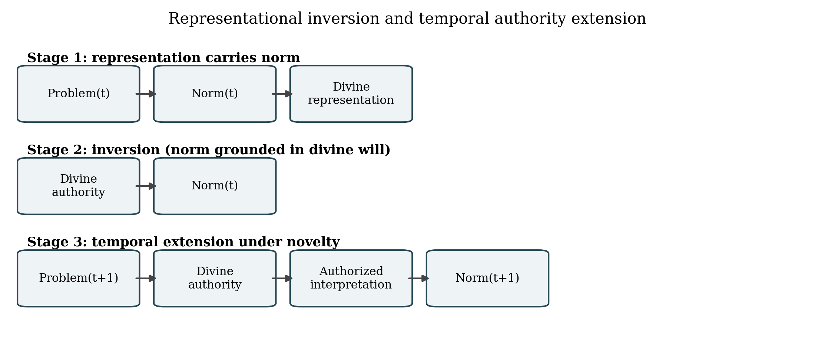
Figure 3. Representational inversion and temporal authority extension. A norm first carried by a divine representation becomes grounded in divine will (inversion); novel problems then route interpretation through the same authority.
Inversion matters to the vortex because it determines what is at stake when the environment changes. Where norms retain autonomous grounding, environmental novelty demands normative work but not necessarily divine reinterpretation. Where inversion has occurred — where norms are binding because they express divine will — novelty routes directly through divine authority: every novel problem that falls under the jurisdiction becomes a question about what the divine authority wills. Inversion thereby sets up the temporal engine analyzed next.
6. Historical novelty and the normative carryover problem
Model the external environment as a context vector $C_{t}=(T_{t}, {Eco}_{t}, {Pol}_{t}, K_{t}, S_{t})$ — technology, ecology, political structure, available knowledge, and social structure — such that historical change gives $C_{t+1}≠C_{t}$ and, critically, generates problems $P_{t+1}$ not contained in the problem space under which the normative repertoire $N_{t}$ was stabilized. Reproductive technologies, genetic intervention, organ transplantation, machine intelligence, industrial warfare, communication infrastructures, urbanization, and altered family structures are contemporary instances; imperial administration, alphabetic canon, and monetized exchange were ancient ones. The list is illustrative, not definitional: novelty is relativized to the repertoire, not to a period.
A normative carryover problem occurs when a norm, interpretive rule, or authority relation stabilized under one problem environment is invoked in a materially different one, without an automatically determined mapping between old and new problems. The needed variable is not chronological age. Define interpretive distance $d(P_{t+1},N_{t})$ between the novel problem and the repertoire's stabilization environment: a chronologically ancient norm may have low interpretive distance from a new problem (a rule about killing maps readily onto new weapons), while a recent, highly specified norm may have high distance (a ruling tied to a superseded technology). Age is a proxy that fails; distance is the variable that works.
On distance rests interpretive load $L_{t+1}=f(d, jurisdiction, sacralization, revision constraint, interpretive structure)$: the total interpretive work a tradition must perform to sustain continuity across the environmental shift. High interpretive load is not pathology; it can index sophisticated adaptive reasoning, as the responsa literatures of Judaism, the fatwa and qiyas apparatuses of Islamic law (Hallaq 2001), and the magisterial instructions of Catholic bioethics (Donum Vitae 1987; Dignitas Personae 2008) each demonstrate in their own idiom. The neutral claim is that continuity across changing environments requires interpretive work, and that the quantity and institutional form of that work are measurable properties of a tradition, not symptoms of failure.
7. Authorized interpretation: unity as a plurality engine
After representational inversion, an inherited divine authority continues to govern new problem domains: ${Problem}_{t+1}→{God}_{t}→{Interpretation}_{t+1}→{Norm}_{t+1}$. The critical mechanism is underdetermination. For a novel problem $p^{*}$, distinct authorized readings may hold simultaneously: $I_{1}(G,p^{*})≠I_{2}(G,p^{*})≠I_{3}(G,p^{*})$, even where every interpreter recognizes the same divine authority and submits to the same sources. Nothing in the sources settles the mapping, because the sources were stabilized before the problem existed. Ontological One thus generates interpretive Many — not by failure of unity but by its exercise: the more domains fall under a single sacred jurisdiction, the more novel problems route into a single interpretive pipeline whose outputs are non-unique.
This is why authorized interpretation is an institutional structure, not an accident of exegesis. Theologians, jurists, muftis, councils, scriptural specialists, and commentarial communities exist wherever a tradition must produce binding answers from non-self-applying sources (Hallaq 2001; Weber 1922/1978). The Fundamentalism Project's comparative finding — that "strong religion" emerges where inherited authority must confront a perceived hostile novelty — is one register of this machinery under strain (Almond, Appleby, and Sivan 2003). No cynical intent is required: authorized interpretation is what the combination of continuing sacred authority, new problems, non-unique mappings, and demand for binding decisions institutionally produces.
The multiplication is double. Each novel problem admits multiple defensible interpretations; and each issued interpretation — each precedent, distinction, exception, ruling, analogy — becomes part of the material from which subsequent interpretations differ. Interpretive outputs are also inputs. The vortex's differentiating stroke is thereby supplied endogenously by unity itself, given novelty: Figure 4 traces the two pathways an authority under novelty can take.
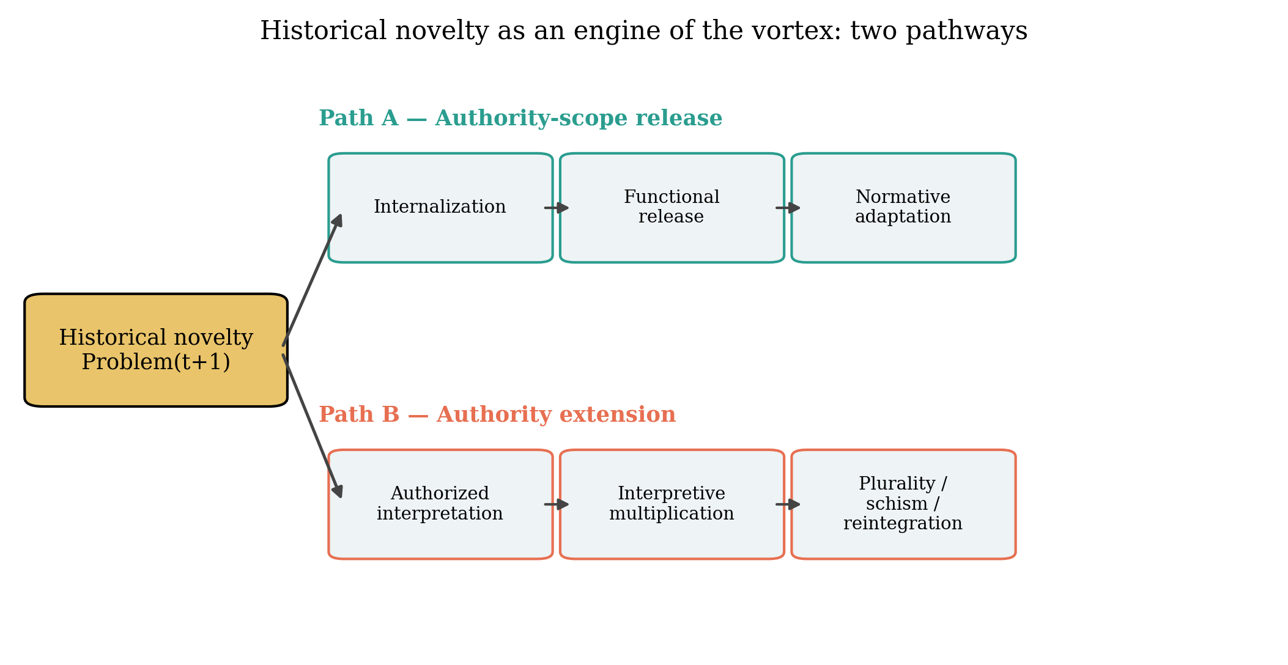
Figure 4. Historical novelty as the engine of the vortex. Path A: authority-scope release through internalization and functional release; Path B: authority extension through authorized interpretation and interpretive multiplication.
8. Interpretive accumulation
Let $D_{t}$ denote the doctrinal-interpretive deposit of a tradition at $t$, with $D_{t+1}=D_{t}+ΔI_{t+1}$, where $ΔI$ comprises the precedents, distinctions, exceptions, commentaries, rulings, analogies, and interpretive rules generated by the previous period's interpretive work. Newman (1845) posed the normative version of this problem — how to distinguish genuine development from corruption — and answered it with notes of continuity, logical sequence, and conservative action on the past; the present framework brackets his confessional question but retains the structural insight that a growing deposit is governed by criteria a tradition articulates for itself. MacIntyre's account of tradition as an extended argument (1988) and the usul al-fiqh architecture of qiyas and ijtihad (Hallaq 2001) describe the same phenomenon from inside other communities of practice: a deposit is not clutter but the medium in which future reasoning operates.
The governing hypothesis is dual-edged. Interpretive accumulation simultaneously stabilizes a tradition and increases its plurality-generating capacity: every added distinction multiplies the stock of internally defensible interpretive pathways. A tradition with a rich deposit has more ways to say yes, no, and distinguish; adjudication between them becomes correspondingly harder. Complexity is not decay — the deposit is also adaptive capacity — but the price of adaptability is a larger space of licit disagreement. Trade-offs among adaptability, consistency, accessibility, specialist dependence, interpretive centralization, and institutional continuity follow from the stock's growth, and different traditions purchase different points on that frontier: centralized magisterium trades accessibility for uniformity; distributed ijazah systems trade uniformity for local resilience.
9. Authority-scope release
The engine of Sections 6–8 assumes that divine authority retains jurisdiction over each new domain. That assumption can fail — and its failure is not secularization. Distinguish continued sacred significance from continued regulatory jurisdiction: a divine authority may remain sacred while no longer being expected to supply case-specific adjudication for every historically novel problem. Define authority-scope release as the transition ${God}_{t}→{Norm}_{t}→Internalization→authority-scope release$: norms originally warranted by divine authority are stabilized, internalized by institutions or conscience, and thereafter maintained without requiring fresh divine interpretation for each new case; novel problems $P_{t+1}$ are then met by normative adaptation whose warrant does not route through the divine authority's interpretive pipeline.
The nearest prior figure is the deus otiosus, the creator who withdraws after creation (Eliade 1978; Doniger and Eliade 1999) — present in African high gods, Greek succession myth, Vaiśeṣika Īśvara read as watchmaker (Klostermaier 2007), and deist reception. But the deus otiosus retires from the cosmos; authority-scope release is narrower and institutional: a jurisdiction-level relinquishment of completed functions inside a living tradition, while the authority's sacred standing, worship, and symbolic centrality persist. It is also not Casanova's privatization (1994): release can leave the authority publicly and politically potent while narrowing its case-law domain. "Divine retirement" survives only as a metaphor for this operator: the question it names — whether a divine authority can finish a historical function without ceasing to be divine — is the question the operator makes precise.
Paths A and B (Figure 4) can now be contrasted without ranking. Authority extension preserves identity continuity, sacred continuity, moral coherence, legitimacy, and transgenerational stability, at the price of rising interpretive load and the plurality dynamics of Section 7. Authority-scope release purchases local adaptability, lower interpretive dependency, and easier revision under novel conditions, at the price of weakened pipeline coherence and the risk that released domains drift from the tradition's self-understanding. Both costs are real; the framework assigns neither a score. What the distinction adds analytically is a third falsifiable hypothesis space: where release is structurally available, novelty need not generate interpretive multiplication — a boundary condition on the vortex engine itself.
10. Four cases
The cases below were selected for analytical function, not representativeness; each is documented in specialist literature and none is forced into more than the operators it instantiates (Table 3).
Table 3. Comparative cases mapped to vortex operators.
Case | Operators instantiated | Key documentation
Ancient Egypt (Amun-Re; Amarna; restoration) | Aggregation, imposed compression, re-differentiation under memory | Hornung 1996; Assmann 1996, 2008; Baines 2000
Israel/Judah (convergence–differentiation of Yahweh) | Aggregation, differentiation, representational inversion, jurisdiction boundary | Smith 2001, 2002; Assmann 1996
Greco-Roman late antiquity (henotheism, theos hypsistos, Neoplatonism) | Register coexistence of One and Many without synthesis | Versnel 1990, 2011; Athanassiadi & Frede 1999; Mitchell & Van Nuffelen 2010
Hindu traditions (Brahman/devas; sectarian theisms) | Ontological unity as interpretive resource; recurrent re-specification | Klostermaier 2007; genealogical critiques
Structural illustrations (Islamic names & ijtihad; Christian doctrinal development) | Authorized interpretation under novelty; interpretive accumulation | Hallaq 2001; Newman 1845; Donum Vitae 1987; Dignitas Personae 2008

Egypt: aggregation and re-differentiation under memory. Egyptian theology presents the One/Many question in its most extreme documented form: Hornung (1996) showed that Egyptians predicated unity and multiplicity of the divine in complementary registers, with many-valued logic rather than contradiction. Syncretic aggregation is well attested — Amun-Re's bundling of hidden and solar functions — and Amarna is the limiting case of imposed aggregation: Aten as sole effective agent, other names suppressed (Assmann 1996, 2008). Post-Amarna restoration re-differentiated the pantheon, but into a state altered by the episode itself; the "return" deposited new theological reflexivity (Baines 2000). Egypt instantiates $A$, $D$, coexistence registers, and path-dependent re-differentiation.
Israel/Judah: convergence, differentiation, and the boundary operation. Smith's analysis (2001; 2002) documents both directions inside one corpus: convergence — El's epithets, Asherah's associations, Baal's storm functions accruing to Yahweh — and differentiation — the subsequent separation and polemical expulsion of what had been converged, alongside inner-Yahwistic differentiations (the divine council's transformation into angelic hierarchies). Assmann's Mosaic distinction (1996) identifies the mechanism that made Israel's aggregation unlike Egypt's: the true/false partition of religion, a boundary operation that turned representational aggregation into exclusive jurisdiction. Israel thus illustrates aggregation and differentiation plus the inversion of Section 5 and the jurisdiction variable $J$, including its boundary-policing correlate.
Greco-Roman late antiquity: register coexistence without synthesis. The pagan-monotheism record shows "one god" language (theos hypsistos acclamations, heis theos inscriptions, Neoplatonic One) flourishing within functioning plural cults — megatheistic elevation and competition among cults rather than replacement (Athanassiadi and Frede 1999; Mitchell and Van Nuffelen 2010; Versnel 1990, 2011). The case demonstrates that One-language and Many-practice can occupy different registers of a single representational system for centuries without driving to a synthesis — a standing refutation of any model in which aggregation, once begun, runs to completion.
India: unity as interpretive resource, sectarianism as re-differentiation. Brahman/deva relations, the viśvarūpa of Gītā 11, and sectarian theisms that specify the supreme as Śiva, Viṣṇu, or Devī exhibit a pattern in which ontological unity functions as an interpretive resource repeatedly re-specified rather than as a settled state (Klostermaier 2007). Genealogical work shows the movement between unity and plurality there is driven by sectarian and doctrinal shifts, not by evolutionary teleology (Sophia 2024 critique of Zaehner). India supplies the clearest case of recurrent specification — the Many re-emerging inside a One that was never abandoned.
Across the four, every vortex phase is instantiated at least once, and no case exhibits all phases in sequence — consistent with the model's claim that trajectories are path-dependent samples, not a fixed sequence.
11. Predictions, falsification, and research agenda
The framework generates hypotheses (H1–H7) and falsification conditions (Table 4). H1 (interpretive distance): greater distance between novel problem domains and a repertoire's stabilization environment increases interpretive load, other things equal. H2 (authority extension): the broader the range of novel domains under one divine jurisdiction, the greater the institutional importance of authorized interpretation. H3 (novelty-induced differentiation): where inherited authority underdetermines responses to novel problems, interpretive multiplication increases even under ontological unity. H4 (conditional reintegration): interpretive multiplication more likely elicits formal reintegration where exclusivity, interpretive centralization, and incentives for doctrinal uniformity are jointly high. H5 (authority-scope release): where norms remain binding while less dependent on case-specific divine adjudication, novel domains permit wider normative adaptation without equivalent expansion of authorized interpretation. H6 (accretion–plurality): interpretive accumulation simultaneously stabilizes tradition and increases internally defensible interpretive pathways. H7 (vortex recurrence): historical sequences show recurrent aggregation and differentiation with historically non-identical successive states.
The theory is weakened to the extent that: aggregation/differentiation recurrence is rare or absent across suitable historical cases; apparent One↔Many transformations involve complete semantic replacement rather than partial continuity; interpretive multiplication does not increase under new problem environments; divine jurisdiction is unrelated to interpretive institutionalization; ontological unity consistently predicts interpretive unity; authority-scope release cannot be identified in evidence; formal reverse descriptions exist but transition probabilities are overwhelmingly directional; developmental outcomes align with one direction after teleological vocabulary is removed; or semantic-partition modeling adds no explanatory value beyond existing categories. Figure 5 maps the multidimensional state space on which these propositions are defined.
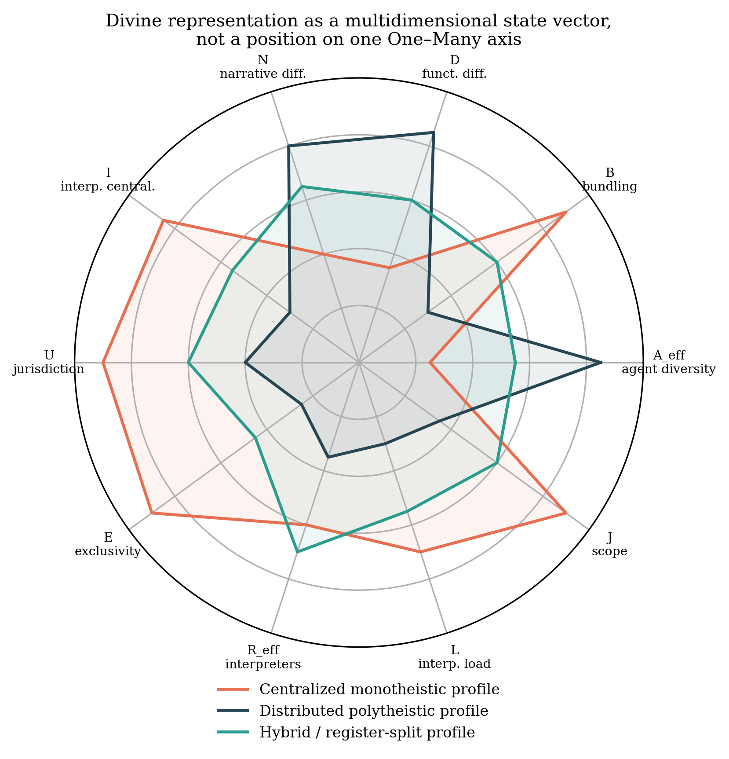
Figure 5. Divine representation as a multidimensional state vector. Monotheism and polytheism are not positions on a single axis but different vectors over analytically separable dimensions (illustrative profiles).
Table 4. Hypotheses and falsification conditions.
# | Hypothesis | Falsified if
H1 | Greater distance between novel problems and a repertoire's stabilization environment increases interpretive load | Interpretive load does not covary with problem-environment distance
H2 | Broader novel-domain jurisdiction of one divine authority increases the institutional importance of authorized interpretation | Jurisdiction scope unrelated to interpretive institutionalization
H3 | Underdetermination of inherited authority produces interpretive multiplication under ontological unity | Unity consistently predicts interpretive unity under novelty
H4 | Multiplication elicits reintegration where exclusivity, centralization, and uniformity incentives are jointly high | Reintegration occurs independently of those three conditions
H5 | Authority-scope release permits normative adaptation without equivalent growth of authorized interpretation | Release cannot be identified, or adaptation always requires interpretation growth
H6 | Interpretive accumulation both stabilizes tradition and increases defensible interpretive pathways | Accumulation reduces plurality or destabilizes in all observed cases
H7 | Sequences show recurrent aggregation and differentiation with non-identical successive states | Recurrence is absent, or successive states prove identical

Empirically, the agenda has three arms. First, corpus-linguistic coding of attested divine epithets and function lists into feature–agent matrices $W$ for bounded domains (Egyptian temple corpora, Ugaritic and biblical lists, hymnic corpora), with inter-coder reliability; the Database of Religious History (Slingerland et al. 2023), Seshat (Turchin et al. 2015), and Pulotu (Watts et al. 2015) supply partial coverage but require new coding at feature-agent resolution. Second, institutional-history measurement of interpretive output (responsa volume, council acts, fatwa corpora) against dated problem-environment changes, testing H1–H3. Third, comparative historiography applying the directional symmetry test to a sample of published developmental descriptions, testing whether independent evaluative criteria are present. Candidate quantifications for the first arm are deliberately conservative: effective agent diversity as perplexity, $A_{eff}=exp(−∑_{g}q_{g}lnq_{g})$, where $q_{g}$ is an agent's share of semantic or functional weight; bundling as concentration, $B=∑_{g}q_{g}^{2}$; and functional differentiation as normalized association, $D=I(F;G)/H(F)$. None of these arms is performed here; the model is presented as theory with worked historical illustrations, and the hypotheses are stated precisely so that the agenda can be executed or refuted.
Discussion
Four implications follow. For classification: the mono/poly pair fails not because traditions are fuzzy but because the pair reports one coordinate of a vector; classification should report the vector — bundling, effective diversity, jurisdiction scope, interpretive centralization — or stay silent. For religious evolution debates: the directional symmetry test supplies the missing audit; developmental claims survive it only when they import an evaluative criterion independent of direction. For the sociology of religious authority: authorized interpretation is modeled as the institutional answer to underdetermination under continuing jurisdiction — Weberian routinization (1922/1978) with the innovation direction made explicit — and interpretive accumulation is the medium that makes each recurrence historically new. For the study of religion and change: authority-scope release separates "sacred significance" from "regulatory jurisdiction," permitting a fine-grained vocabulary for secularization debates that neither requires decline nor forbids it (Casanova 1994).
The insider/outsider asymmetry deserves explicit statement because the framework could be misread as a diagnosis of believers' blindness. It is instead a cost model: the cost of normative revision is endogenous to religious belonging — a function of identity linkage, sacredness, ancestral continuity, community dependence, salvation relevance, and institutional commitment — so a revision that is cheap for an analyst can be existentially expensive for an adherent (Ginges et al. 2007; Atran and Ginges 2012). Interpretive strain plus identity threat plus sacred values plus exclusive truth claims plus competition plus interpretive monopoly may, under some conditions, raise the probability of defensive literalism, doctrinal hardening, exclusion, or schism; these are conditional empirical claims (Almond, Appleby, and Sivan 2003), not necessities, and no violence is attributed to monotheism as such.
Limits must be stated plainly. The framework is a model of literate, institutionally staffed traditions; its application to non-textual traditions is untested. The $W$-matrix formalism is a conceptual instrument whose measurement program is future work. The model's own vocabulary risks the disease it cures: "aggregation" and "differentiation" are themselves directional words, and the paper's defense is that it subjects them to the same test — they describe transformations, and any evaluative use of them must import an external criterion. Finally, the "divine retirement" metaphor, retained in the discussion of Section 9, is an aid to intuition subordinate to authority-scope release; where the metaphor strains — retirements are usually permanent and personal, releases need be neither — the operator, not the metaphor, governs.
Conclusion
The One–Many distinction is better treated, in part, as a dynamic problem of representational architecture than as a developmental ladder. Divine functions, attributes, narratives, and interpretive authority can be aggregated, differentiated, and reaggregated across historical time, and the direction of any such transformation carries no development until an independent criterion supplies one. Because changing worlds continually generate problems that earlier normative environments did not contain, ontological unity can produce interpretive plurality, which institutions accommodate or recompress; because each transition deposits texts and institutions, the system never returns to its origin but traces a path-dependent vortex. And because perpetual authority extension is not the only possibility — a divine authority may remain sacred while relinquishing regulatory functions whose historical work is complete — the vortex can slow, weaken, or release its jurisdiction without the sacred dying. Neither One nor Many is the endpoint. The capacity to finish a normative function may be as important to a tradition's continuation as the capacity to extend authority into new domains. The question the framework leaves open, for the traditions as much as for the theory, is the one with which this paper began: what happens when the One is never allowed to stop speaking — and what happens when, having finished a work, it may?
References
Almond, Gabriel A., R. Scott Appleby, and Emmanuel Sivan. 2003. Strong Religion: The Rise of Fundamentalisms around the World. Chicago: University of Chicago Press.
Assmann, Jan. 1996. "The Mosaic Distinction: Israel, Egypt, and the Invention of Paganism." Representations 56: 48–67.
Assmann, Jan. 2010. The Price of Monotheism. Stanford: Stanford University Press.
Athanassiadi, Polymnia, and Michael Frede, eds. 1999. Pagan Monotheism in Late Antiquity. Oxford: Clarendon Press.
Atran, Scott, and Jeremy Ginges. 2012. "Religious and Sacred Imperatives in Human Conflict." Science 336: 855–857.
Barrett, Justin L. 1999. "Theological Correctness: Cognitive Constraint and the Study of Religion." Method & Theory in the Study of Religion 11: 325–339.
Barrett, Justin L., and Frank C. Keil. 1996. "Conceptualizing a Nonnatural Entity: Anthropomorphism in God Concepts." Cognitive Psychology 31: 219–247.
Beheim, Bret, et al. 2021. "Treatment of Missing Data Determined Conclusions Regarding Moralizing Gods." Nature 595: E29–E34.
Bellah, Robert N. 1964. "Religious Evolution." American Sociological Review 29: 358–374.
Bellah, Robert N., and Hans Joas, eds. 2012. The Axial Age and Its Consequences. Cambridge, MA: Harvard University Press.
Berger, Peter L., and Thomas Luckmann. 1966. The Social Construction of Reality. New York: Doubleday.
Boyer, Pascal. 2001. Religion Explained. New York: Basic Books.
Casanova, José. 1994. Public Religions in the Modern World. Chicago: University of Chicago Press.
Congregation for the Doctrine of the Faith. 1987. Donum Vitae: Instruction on Respect for Human Life in Its Origin. Vatican City.
Congregation for the Doctrine of the Faith. 2008. Dignitas Personae: Instruction on Certain Bioethical Questions. Vatican City.
Eliade, Mircea. 1978. A History of Religious Ideas, vol. 1. Chicago: University of Chicago Press. (deus otiosus tradition)
Evans-Pritchard, E. E. 1965. Theories of Primitive Religion. Oxford: Clarendon Press.
Feuerbach, Ludwig. 1841/1989. The Essence of Christianity. Trans. George Eliot. Buffalo: Prometheus.
Floridi, Luciano. 2008. "The Method of Levels of Abstraction." Minds and Machines 18: 303–329.
Guthrie, Stewart. 1993. Faces in the Clouds: A New Theory of Religion. New York: Oxford University Press.
Hallaq, Wael B. 2001. Authority, Continuity and Change in Islamic Law. Cambridge: Cambridge University Press.
Hornung, Erik. 1996. Conceptions of God in Ancient Egypt: The One and the Many. Trans. John Baines. Ithaca: Cornell University Press.
Jaspers, Karl. 1953. The Origin and Goal of History. London: Routledge.
Josephson, Jason Ānanda. 2012. The Invention of Religion in Japan. Chicago: University of Chicago Press.
Klostermaier, Klaus. 2007. A Survey of Hinduism, 3rd ed. Albany: SUNY Press. (Ishvara as deus otiosus parallel)
MacIntyre, Alasdair. 1988. Whose Justice? Which Rationality? Notre Dame: University of Notre Dame Press.
Masuzawa, Tomoko. 2005. The Invention of World Religions. Chicago: University of Chicago Press.
Mitchell, Stephen, and Peter Van Nuffelen, eds. 2010. One God: Pagan Monotheism in the Roman Empire. Cambridge: Cambridge University Press.
Newman, John Henry. 1845/1989. An Essay on the Development of Christian Doctrine. Notre Dame: University of Notre Dame Press.
Norenzayan, Ara. 2013. Big Gods: How Religion Transformed Cooperation and Conflict. Princeton: Princeton University Press.
Schmidt, Wilhelm. 1931. The Origin and Growth of Religion. London: Methuen. (primitive monotheism)
Slingerland, Edward, et al. 2023. "The Database of Religious History: Ontology, Coding Strategies and the Future of Cultural Evolution." Journal of the American Academy of Religion 91.
Smith, Jonathan Z. 1982. Imagining Religion. Chicago: University of Chicago Press.
Smith, Mark S. 2001. The Origins of Biblical Monotheism. New York: Oxford University Press.
Smith, Mark S. 2002. The Early History of God, 2nd ed. Grand Rapids: Eerdmans. (convergence/differentiation)
Smith, Wilfred Cantwell. 1962. The Meaning and End of Religion. New York: Macmillan.
Tylor, Edward Burnett. 1871. Primitive Culture. London: John Murray.
Turchin, Peter, et al. 2015. "Seshat: The Global History Databank." Cliodynamics 6: 77–107.
Versnel, Henk S. 1990. Ter Unus: Isis, Dionysos, Hermes—Three Studies in Henotheism. Leiden: Brill.
Versnel, Henk S. 2011. Coping with the Gods: Wayward Readings in Greek Theology. Leiden: Brill.
Watts, Joseph, et al. 2015. "Broad Supernatural Punishment but Not Moralizing High Gods Precede the Evolution of Political Complexity in Austronesia." Proceedings of the Royal Society B 282.
Weber, Max. 1922/1978. Economy and Society. Berkeley: University of California Press. (routinization of charisma)
Whitehouse, Harvey, et al. 2019. "Complex Societies Precede Moralizing Gods throughout World History." Nature 568: 226–229. (retracted 2021; see Whitehouse et al. 2021 Retake)
Whitehouse, Harvey, et al. 2021. "Testing the Big Gods Hypothesis with Global Historical Data: A Review and 'Retake'." Religion, Brain & Behavior 12.
Ginges, Jeremy, Scott Atran, Douglas Medin, and Khalil Shikaki. 2007. "Sacred Bounds on Rational Resolution of Violent Political Conflict." PNAS 104: 7357–7360.
Steinhart, Eric. 2012. "On the Plurality of Gods." Religious Studies 49.
Hedges, Paul. 2024. "Multi-Devotionalism and Mono-Devotionalism: Beyond the Problems of Polytheism and Monotheism." Journal of the American Academy of Religion.
Schneider, Laurel C. 2008. Beyond Monotheism: A Theology of Multiplicity. London: Routledge.
Assmann, Jan. 2008. Of God and Gods: Egypt, Israel, and the Rise of Monotheism. Madison: University of Wisconsin Press.
Baines, John. 2000. "Egyptian Deities in Context: Multiplicity, Unity, and the Problem of Change." In One God or Many?, ed. Barbara Nevling Porter. Chebeague: Casco Bay Assyriological Institute.
Porter, Barbara Nevling, ed. 2000. One God or Many? Concepts of Divinity in the Ancient World. Chebeague, ME: Casco Bay Assyriological Institute.

