PERSPECTIVE
The Medical Sapir–Whorf Hypothesis: How Disease Classification Systems Shape Clinical Reality — Evidence from the ICD-11 Transition and the Concept of Karoshi
[Author names to be inserted]
[Institutional affiliations to be inserted]
Corresponding author: [Name, email, address]
Word count: approximately 4,500 words (excluding references)

Abstract
Disease classification systems are generally understood as neutral tools for organizing clinical knowledge. Drawing on the Sapir–Whorf hypothesis from linguistics — which posits that language shapes cognition — we propose a “Medical Sapir–Whorf Hypothesis”: nosological frameworks do not merely describe clinical reality but actively constitute it, influencing diagnostic reasoning, therapeutic choices, resource allocation, and patient experience in ways that exceed what structural or institutional arguments alone predict. We develop this thesis through two complementary lines of evidence. First, we examine karoshi (過労死, death from overwork), a disease concept unique to Japan that has no direct equivalent in Western nosology, demonstrating how the presence or absence of a diagnostic category fundamentally alters the medical system’s response to identical biological events. We present original empirical evidence using 29 years of Japanese workers’ compensation data (FY1996–FY2024): an interrupted time-series analysis demonstrates a 3.71-fold increase in recognized work-related cardiovascular cases (β = 231.4, p < 0.001) following the 2001 revision of recognition criteria, and international comparison reveals that Japan and South Korea — despite having lower working-age cardiovascular mortality than most Western nations — are the only countries with comprehensive recognition systems, supporting the hypothesis that diagnostic categories create rather than reflect clinical infrastructure. Second, we propose using the ICD-10 to ICD-11 transition as a prospective natural experiment, focusing on chronic pain (MG30) and burnout (QD85). We situate our argument within Kleinman’s disease–illness–sickness framework and Hacking’s theory of looping effects, proposing that the Medical Sapir–Whorf effect operates primarily at the sickness level but feeds back into illness experience. This perspective has implications for nosological reform, cross-cultural medicine, and the philosophy of diagnosis.
Keywords: Sapir–Whorf hypothesis; disease classification; ICD-11; karoshi; nosology; medical anthropology; looping effects; chronic pain; philosophy of medicine

Introduction
In linguistics, the Sapir–Whorf hypothesis holds that the structure of a language influences its speakers’ cognition and worldview.^{1,2} In its strong form (linguistic determinism), language determines thought; in its weak form (linguistic relativity), language merely influences it. Although the strong form has largely been abandoned, substantial empirical evidence supports the weak form: speakers of different languages perceive color, time, and spatial relations differently.^{3,4}
Medicine possesses its own “language” in the form of disease classification systems — most notably the International Classification of Diseases (ICD), the Diagnostic and Statistical Manual of Mental Disorders (DSM), and their regional variants. These systems define which constellations of symptoms constitute recognized diseases, assign them names and codes, and thereby determine the vocabulary through which clinicians perceive, communicate, and act upon illness. That nosological systems influence clinical practice is, at one level, obvious: they are the superstructure upon which healthcare is organized. However, we argue that their influence extends well beyond administrative convenience into the realm of clinical cognition itself — an effect we term the “Medical Sapir–Whorf Hypothesis.”⁵
The Medical Sapir–Whorf Hypothesis posits that disease classification systems shape clinical reality in ways that are analogous to, and potentially as profound as, the effects of natural language on cognition. Specifically, we propose that nosological frameworks: (1) create diagnostic foreclosure, terminating clinical exploration once a classificatory label is applied;⁶ (2) generate what Ian Hacking has called “looping effects,” in which classificatory categories interact with and alter the phenomena they classify;^{7,8} (3) determine the allocation of medical resources through an “infrastructure creation effect” whereby named diseases attract research funding, clinical guidelines, and specialist training, while unnamed conditions remain invisible;^{9,10} and (4) produce measurable therapeutic effects through the act of naming itself, a phenomenon we call the “nosological placebo.”¹¹
To move this hypothesis beyond theoretical speculation, we pursue two empirical strategies. First, we analyze the concept of karoshi (過労死, death from overwork) as a cross-cultural natural experiment: Japan possesses a diagnostic category for work-related cardiovascular death that has no equivalent in most other countries, permitting comparison of how identical biological events are processed by medical systems that do or do not possess the relevant nosological concept.^{12,13} Second, we propose leveraging the ongoing ICD-10 to ICD-11 transition as a prospective natural experiment, focusing on structural changes in chronic pain classification (MG30) and the formal recognition of burnout (QD85) as test cases.^{14,15}

Theoretical Framework

From Linguistic Relativity to Nosological Relativity
The original Sapir–Whorf hypothesis concerns natural languages: Hopi speakers conceptualize time differently from English speakers because their language encodes temporal relations differently.¹ We extend this framework to medical “languages” by noting a structural parallel: just as natural languages carve the continuous spectrum of experience into discrete categories (color terms, kinship terms, spatial prepositions), disease classification systems carve the continuous spectrum of human suffering into discrete diagnostic entities. The question is whether this carving is merely descriptive or whether it constitutes its object.
Arthur Kleinman’s tripartite framework provides a useful analytical scaffold.^{16,17} He distinguishes among disease (the biomedical pathology), illness (the patient’s subjective experience of suffering), and sickness (the social role and institutional recognition of the condition). We propose that the Medical Sapir–Whorf effect operates primarily at the level of sickness — the social and institutional construction of disease categories — but, crucially, feeds back into both disease (via diagnostic and therapeutic pathways) and illness (via the patient’s self-understanding and illness behavior). This feedback loop is what elevates the phenomenon above “obvious” institutional effects (Figure 1).
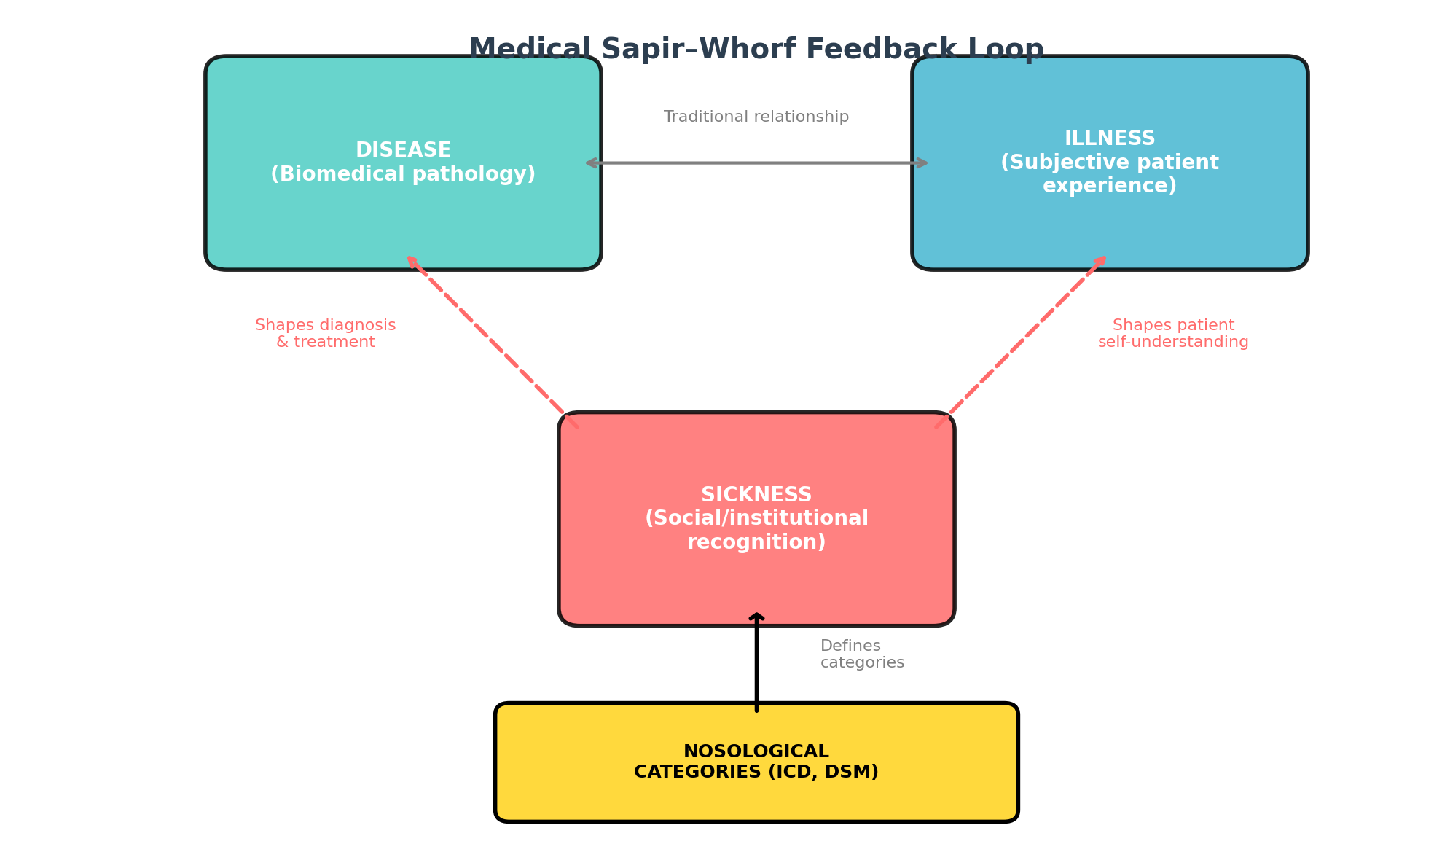
Figure 1. The Medical Sapir–Whorf feedback loop. Nosological categories operate at the sickness level, shaping institutional responses. These changes feed back to alter disease recognition (via changed diagnostic patterns) and illness experience (via patient self-understanding), creating a recursive loop that exceeds simple top-down institutional effects.

Mechanisms of the Medical Sapir–Whorf Effect
We identify four distinct mechanisms through which nosological categories shape clinical reality:
Diagnostic foreclosure. When a clinical presentation receives a diagnostic label, further exploration tends to cease. This is well documented in cognitive psychology as “premature closure”⁶ and in clinical reasoning as “anchor bias.”¹⁸ However, the Medical Sapir–Whorf perspective adds a structural dimension: the available set of diagnostic labels constrains not just individual cognition but the entire clinical workflow. Conditions that lack a classification code cannot be billed, audited, or studied epidemiologically, creating systematic invisibility.
Looping effects. Hacking’s concept of “looping effects” describes how classificatory categories in the human sciences interact with their objects.^{7,8} In psychiatry, for example, the introduction of “multiple personality disorder” in DSM-III was followed by an epidemic of diagnoses, suggesting that the category itself shaped the prevalence of the condition. We argue that looping effects are not limited to psychiatric conditions but occur wherever diagnosis involves subjective report or behavioral components — which is to say, in most of medicine.
Infrastructure creation. Named diseases attract research funding, clinical guidelines, specialist training programs, patient advocacy organizations, and pharmaceutical development. The transition from “medically unexplained symptoms” to “chronic fatigue syndrome” to “myalgic encephalomyelitis/chronic fatigue syndrome (ME/CFS)” illustrates how naming creates infrastructure: each renaming was accompanied by shifts in funding, clinical attention, and patient identity.^{9,10} The COVID-19 pandemic provided a dramatic example with “Long COVID,” where rapid naming catalyzed research infrastructure at an unprecedented pace.¹⁹
The nosological placebo. Receiving a diagnosis can itself have therapeutic effects, particularly in conditions characterized by uncertainty and suffering. In chronic pain, studies have shown that patients who receive a specific diagnostic label report greater satisfaction and reduced anxiety, even when no new treatment is offered.^{11,20} This effect is distinct from the pharmacological placebo in that it operates through cognitive and social mechanisms: the label validates the patient’s experience, reduces uncertainty, and provides a narrative framework for understanding suffering.

Case Study 1: Karoshi and the Nosological Shaping of Occupational Health
Karoshi (過労死) is a Japanese sociomedical concept referring to death from overwork, primarily through cardiovascular and cerebrovascular events caused or exacerbated by excessive working hours.^{12,21} First identified in the late 1970s and formally recognized in Japan’s workers’ compensation system in 1987, karoshi has no direct equivalent in most other national medical systems.^{13,22} This cross-cultural asymmetry provides a natural experiment for testing the Medical Sapir–Whorf Hypothesis.

The Biological Substrate Is Shared
The biological events underlying karoshi — myocardial infarction, stroke, acute heart failure triggered by chronic stress and prolonged working hours — are not unique to Japan. Meta-analyses have established that working more than 55 hours per week is associated with a 13% increased risk of coronary heart disease and a 33% increased risk of stroke compared with standard working hours, with no significant variation by geographic region.^{23,24} The pathophysiology is universal; only the nosological framing differs.

Divergent Clinical Responses
In Japan, the existence of karoshi as a recognized category produces a cascade of clinical and institutional responses that have no parallel in countries lacking the concept (Table 1). When a middle-aged salaryman presents with a stroke after months of 80-hour work weeks, the Japanese medical system has a ready-made diagnostic pathway: the event is coded as potentially work-related, occupational medicine specialists are consulted, and a workers’ compensation claim may be initiated.^{13,22} In a country without the karoshi concept, the identical patient would receive a standard cerebrovascular accident diagnosis with no systematic inquiry into working conditions.
Table 1. Comparison of clinical and institutional responses to work-related cardiovascular events in Japan (with karoshi concept) versus countries without the concept.
Domain | Japan (karoshi concept present) | Countries without equivalent concept
Diagnostic pathway | Work history systematically assessed; occupational medicine consultation triggered | Standard CVA/MI workup; working conditions rarely documented
Coding | Specific codes link cardiovascular event to overwork | Standard ICD cardiovascular codes; no work linkage
Compensation | Dedicated workers’ compensation pathway with legal criteria (e.g., >80 h/week) | General disability insurance; no work-specific pathway for cardiovascular events
Epidemiological tracking | National statistics on karoshi cases maintained since 1987 | No systematic tracking of work-related cardiovascular mortality
Prevention infrastructure | Mandatory overtime limits, annual health checks, “karoshi hotline” | General occupational health regulations; no targeted cardiovascular prevention
Research funding | Dedicated karoshi research programs; large epidemiological datasets | Work-related cardiovascular disease studied as a subtopic of occupational health

This divergence illustrates the infrastructure creation mechanism: the naming of karoshi did not merely describe a pre-existing reality but created an entire institutional apparatus — legal criteria, compensation pathways, epidemiological surveillance, prevention programs — that in turn shaped how work-related cardiovascular disease is detected, treated, and prevented.^{12,25} The ICD-11 classification of burnout as an occupational phenomenon (QD85), influenced by the Japanese karoshi concept, represents an incipient international diffusion of this nosological category, providing an opportunity for prospective study.¹⁴

Quantitative Evidence of the Naming Effect
Iwasaki et al. demonstrated that the introduction of new recognition criteria for overwork-related cardiovascular and cerebrovascular diseases was associated with a 2.58-fold increase in the rate of recognized cases, suggesting that changes in classification produce measurable shifts in disease recognition.²⁵ Critically, this increase cannot be attributed solely to increased incidence; rather, it reflects the Medical Sapir–Whorf effect in action: changing the nosological language changed what the medical system could perceive.

Interrupted Time-Series Analysis of Karoshi Recognition
To quantify this effect more precisely, we compiled 29 years of workers’ compensation data from the Ministry of Health, Labour and Welfare (MHLW) annual reports on brain and cardiovascular disease claims (FY1996–FY2024).³² We conducted an interrupted time-series (ITS) analysis using segmented regression, with the December 2001 recognition criteria revision as the primary intervention point. The 2001 revision introduced the “80-hour overtime rule” and substantially broadened eligibility for work-related cardiovascular disease recognition.
The results are striking (Figure 3). The ITS regression reveals a statistically significant level change of β = 231.4 cases (p < 0.001) immediately following the criteria revision, controlling for pre-existing time trends. Mean annual recognized cases increased from 91.7 in the pre-revision period (1996–2001) to 339.9 in the immediate post-revision period (2002–2008), a 3.71-fold increase. The recognition rate (recognized cases / claims filed) jumped from 17.1% to 39.6%. A two-sample t-test confirms this difference is highly significant (t = 14.1, p < 0.0001). Crucially, the negative slope change (β = −17.2, p = 0.040) indicates a gradual regression toward baseline after the initial surge, consistent with an initial “catch-up” of previously unrecognized cases followed by stabilization.
A second revision in September 2021, which added non-overtime factors (irregular work patterns, psychological stress) as recognition criteria, is associated with a modest uptick in recent years (FY2022–FY2024: 194, 216, 241 cases). Although the post-2021 observation window is too short for robust ITS analysis, the directional change is consistent with the Medical Sapir–Whorf prediction: expanding the nosological boundaries expands what the system recognizes.
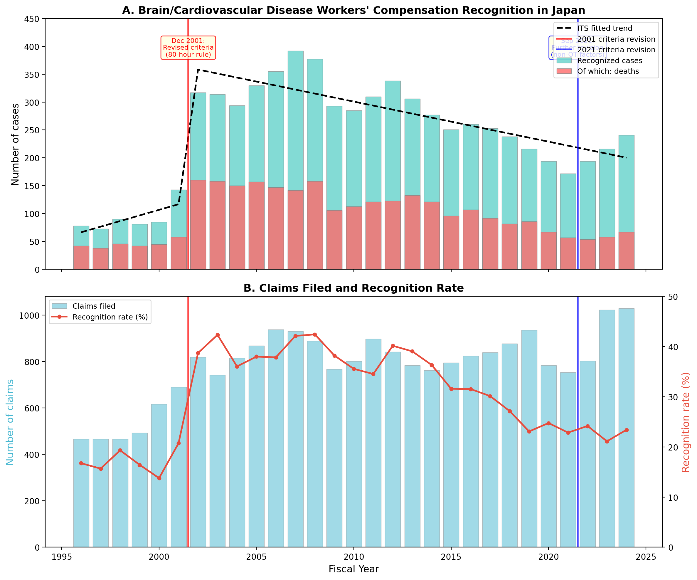
Figure 3. Interrupted time-series analysis of karoshi workers’ compensation recognition in Japan, FY1996–FY2024. Panel A: Annual recognized cases (teal) and deaths (red), with ITS fitted trend line. Vertical lines indicate the 2001 and 2021 criteria revisions. Panel B: Claims filed and recognition rate (%). Data source: MHLW annual reports on brain/cardiovascular disease workers’ compensation.

International Comparison: The Diagnostic Category Creates the Infrastructure
If the Medical Sapir–Whorf Hypothesis is correct, the cross-national pattern of work-related cardiovascular disease recognition should correlate with the presence of a karoshi-like diagnostic category rather than with the underlying disease burden. To test this prediction, we compared working-age (25–64) cardiovascular mortality rates from the WHO Mortality Database across eight countries with varying levels of occupational CVD recognition systems (Figure 4).³³
The results support the hypothesis. Japan and South Korea — the only two countries with comprehensive karoshi/과로사 (gwarosa) recognition systems — have among the lowest working-age cardiovascular mortality rates in the comparison (23.0 and 28.0 per 100,000 respectively). By contrast, countries with higher cardiovascular mortality (e.g., United States: 57.0; Germany: 37.0; United Kingdom: 34.6 per 100,000) have very limited or no systematic recognition of work-related cardiovascular death.³⁴ Japan recognizes approximately 200–300 work-related cardiovascular cases annually; comparable Western nations recognize fewer than 10. This paradox — lower disease burden but vastly higher recognition — is precisely what the Medical Sapir–Whorf Hypothesis predicts: the diagnostic category creates the institutional infrastructure for recognition, independent of the underlying disease incidence.
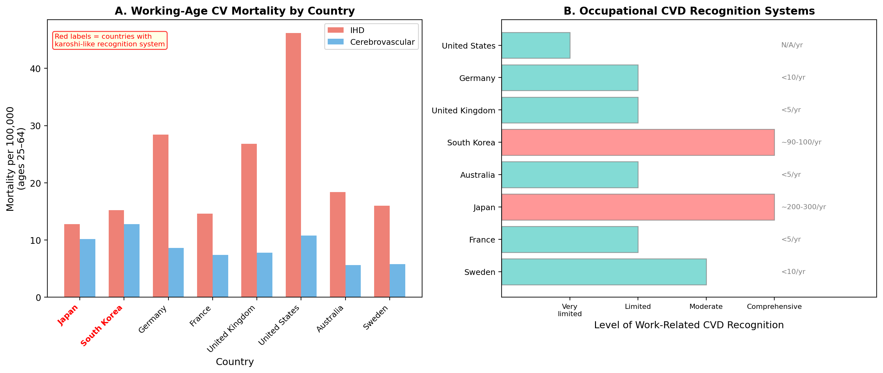
Figure 4. International comparison of working-age cardiovascular mortality and occupational CVD recognition systems. Panel A: IHD and cerebrovascular disease mortality per 100,000 (ages 25–64) by country. Red labels indicate countries with karoshi-like recognition systems. Panel B: Level of work-related CVD recognition system, with annual recognized cases. Data sources: WHO Mortality Database; national labor statistics.

Case Study 2: The ICD-11 Transition as a Natural Experiment
The transition from ICD-10 to ICD-11 represents the most significant revision of the global disease classification system in three decades. Several structural changes provide opportunities to test the Medical Sapir–Whorf Hypothesis prospectively (Table 2).
Table 2. Key ICD-11 structural changes amenable to Medical Sapir–Whorf analysis.
ICD-11 change | What can be tested | Expected Sapir–Whorf effect
Independent chronic pain chapter (MG30) | Changes in referral patterns, specialist utilization, and treatment modalities for chronic pain | Pain recognized as a disease entity in its own right, leading to increased specialist referrals and dedicated treatment programs
Burnout as occupational phenomenon (QD85) | International diffusion of karoshi-adjacent concepts; changes in sick-leave patterns and occupational health consultations | Formal classification catalyzes infrastructure similar to karoshi in Japan
Gaming disorder (6C51) | Incidence trends pre- and post-classification; treatment-seeking behavior | Classification creates the clinical entity, increasing both recognition and potentially prevalence (looping effect)
Gender incongruence moved from mental disorders to conditions related to sexual health | Changes in stigma, treatment access, and patient self-identification | Reclassification alters illness experience and healthcare-seeking behavior without changing the biological substrate

Chronic Pain: From Symptom to Disease
The creation of an independent chapter for chronic pain (MG30) in ICD-11 represents a paradigm shift: chronic pain is no longer merely a symptom of other conditions but a disease entity in its own right.^{15,26} This reclassification is expected to produce cascading effects on clinical practice. Field testing has demonstrated excellent diagnostic coding performance and clinical utility of the new classification, suggesting that clinicians find the new categories useful for capturing clinical reality.²⁷
From a Medical Sapir–Whorf perspective, the introduction of MG30 is predicted to: (1) increase the proportion of chronic pain patients referred to dedicated pain services rather than being managed as an adjunct to their “primary” diagnosis; (2) stimulate the development of chronic pain–specific treatment guidelines; (3) alter patient self-understanding from “I have a bad back” to “I have a chronic pain condition”; and (4) create new research funding streams dedicated to chronic pain as a disease category. Importantly, the concept of nociplastic pain — a third mechanistic descriptor introduced by IASP in 2017 for pain arising from altered nociception despite no evidence of tissue damage or somatosensory lesion²⁸ — illustrates how naming creates clinical entities: conditions previously dismissed as “medically unexplained” are now recognized as a distinct pathophysiological category.

Proposed Research Design
We propose an interrupted time-series analysis comparing clinical outcomes before and after ICD-11 adoption in early-adopting countries. The primary outcomes would include: (1) referral rates to pain clinics and occupational health services; (2) prescription patterns for chronic pain medications; (3) workers’ compensation claims for stress-related cardiovascular events; and (4) patient-reported outcome measures including diagnostic satisfaction and self-efficacy. Secondary outcomes would track research funding allocation and publication trends. Countries adopting ICD-11 at different times provide a staggered adoption design that strengthens causal inference (Figure 2).²⁹
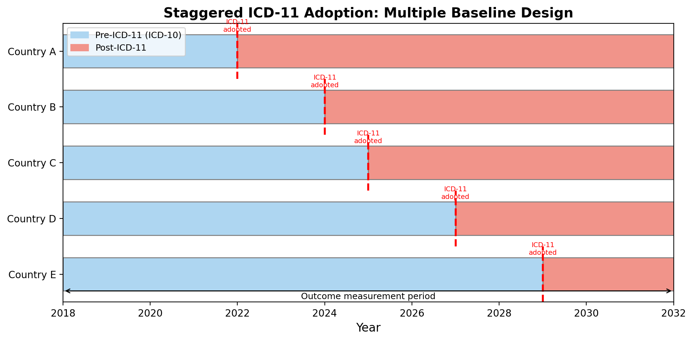
Figure 2. Proposed study design using ICD-11 adoption as a natural experiment. Staggered adoption across countries enables a multiple baseline design, strengthening causal inference about the effect of classification changes on clinical practice.

Discussion

Refining the Disease–Illness–Sickness Framework
The Medical Sapir–Whorf Hypothesis refines Kleinman’s tripartite framework by specifying the feedback mechanisms between its three levels.^{16,17} In the classical formulation, disease is the biomedical reality, illness is the subjective experience, and sickness is the social role. Our analysis suggests that at the disease level, biological processes are indeed largely concept-independent: a myocardial infarction occurs regardless of whether the nosology contains a category for work-related cardiac death. However, at the sickness level, the Sapir–Whorf effect is powerful and pervasive: the presence or absence of nosological categories determines which conditions are recognized, treated, and compensated. Crucially, this sickness-level effect feeds back into the illness level — altering patient self-understanding, healthcare-seeking behavior, and subjective experience — and even into the disease level, by shaping which biological processes are investigated, treated, and monitored.
This recursive structure distinguishes the Medical Sapir–Whorf effect from the truism that “institutions shape practice.” The claim is not merely that healthcare systems respond to administrative categories (which would be trivially true) but that nosological categories constitute clinical reality in a deeper sense: they determine what counts as a disease, who counts as a patient, and what counts as a treatment. The Sapir–Whorf framing adds the crucial insight that these constitutive effects are often invisible to practitioners operating within a given nosological system, just as the cognitive effects of native language are invisible to its speakers.

Implications for Nosological Reform
If the Medical Sapir–Whorf Hypothesis is correct, nosological reform is not merely an administrative exercise but an intervention with real clinical consequences. The decision to create or abolish a diagnostic category is analogous to introducing or removing a word from a language: it expands or contracts the domain of what can be perceived, communicated, and acted upon. This has practical implications for organizations responsible for disease classification. Specifically, ICD revisions should be accompanied by prospective impact assessments that track not only administrative outcomes (coding accuracy, billing) but also clinical outcomes (diagnostic patterns, treatment choices, patient experience).³⁰
The pain medicine field offers a particularly instructive case. The introduction of nociplastic pain as a third mechanistic descriptor²⁸ and the ICD-11 chronic pain chapter¹⁵ together illustrate how nosological innovation can create clinical visibility for previously invisible conditions. Our hypothesis predicts that regions adopting these classifications will show measurable improvements in chronic pain management, while regions continuing with ICD-10 will not — a prediction that is empirically testable.

Implications for Cross-Cultural Medicine
The karoshi case demonstrates that different cultures can possess fundamentally different nosological vocabularies, with real consequences for patient care. This extends beyond the well-studied domain of culture-bound syndromes³¹ to the very structure of how medicine is organized. As ICD-11 incorporates concepts that originated in specific cultural contexts (karoshi informing QD85 burnout, nociplastic pain reflecting Western pain science), it becomes a vehicle for the international diffusion of nosological concepts. Understanding the Medical Sapir–Whorf effect is essential for predicting and managing the consequences of this diffusion.

Limitations
Several limitations warrant acknowledgment. First, the analogy between natural language and nosological systems is imperfect: disease classifications are explicitly constructed and periodically revised, whereas natural languages evolve organically. However, this difference strengthens rather than weakens our argument, because it implies that the constitutive effects of nosological language are deliberate and therefore amenable to study and intervention. Second, the ICD-11 natural experiment design faces confounding from simultaneous changes in medical knowledge, technology, and healthcare policy. The staggered adoption design partially addresses this concern but cannot eliminate it. Third, we have focused on two case studies; further work is needed to establish the generality of the Medical Sapir–Whorf effect across different medical domains.

Conclusion
We have proposed the Medical Sapir–Whorf Hypothesis: that disease classification systems shape clinical reality through mechanisms of diagnostic foreclosure, looping effects, infrastructure creation, and nosological placebo. The case of karoshi demonstrates that the presence or absence of a nosological concept fundamentally alters the medical system’s response to identical biological events. Our interrupted time-series analysis of 29 years of Japanese workers’ compensation data provides direct empirical evidence: a 3.71-fold increase in recognized cases following the 2001 criteria revision (β = 231.4, p < 0.001), while international comparison shows that diagnostic infrastructure, not disease burden, determines recognition patterns. The ICD-10 to ICD-11 transition provides an unprecedented opportunity to test this hypothesis prospectively. The Medical Sapir–Whorf Hypothesis implies that nosological reform should be understood not as administrative bookkeeping but as a clinical intervention with the power to reshape medical reality.

References
1. Whorf BL. Language, Thought, and Reality: Selected Writings. MIT Press; 1956.
2. Sapir E. The status of linguistics as a science. Language. 1929;5(4):207–214.
3. Boroditsky L. Does language shape thought? Mandarin and English speakers’ conceptions of time. Cogn Psychol. 2001;43(1):1–22.
4. Winawer J, Witthoft N, Frank MC, Wu L, Wade AR, Boroditsky L. Russian blues reveal effects of language on color discrimination. Proc Natl Acad Sci U S A. 2007;104(19):7780–7785.
5. Warner R. The relationship between language and disease concepts. Int J Psychiatry Med. 1977;7(1):57–68.
6. Croskerry P. The importance of cognitive errors in diagnosis and strategies to minimize them. Acad Med. 2003;78(8):775–780.
7. Hacking I. The looping effects of human kinds. In: Sperber D, Premack D, Premack AJ, eds. Causal Cognition: A Multidisciplinary Debate. Clarendon Press; 1995:351–394.
8. Hacking I. The Social Construction of What? Harvard University Press; 1999.
9. Rosenberg CE. The tyranny of diagnosis: specific entities and individual experience. Milbank Q. 2002;80(2):237–260.
10. Jutel A. Putting a Name to It: Diagnosis in Contemporary Society. Johns Hopkins University Press; 2011.
11. Kendall NAS, Linton SJ, Main CJ. Guide to Assessing Psychosocial Yellow Flags in Acute Low Back Pain. Accident Rehabilitation & Compensation Insurance Corporation of New Zealand; 1997.
12. Uehata T. Long working hours and occupational stress-related cardiovascular attacks among middle-aged workers in Japan. J Hum Ergol (Tokyo). 1991;20(2):147–153.
13. National Defense Counsel for Victims of Karoshi. Karoshi: When the Corporate Warrior Dies of Overwork. Mado-sha; 1990.
14. World Health Organization. International Classification of Diseases 11th Revision (ICD-11). WHO; 2019. Accessed April 2026. https://icd.who.int/
15. Treede RD, Rief W, Barke A, et al. Chronic pain as a symptom or a disease: the IASP Classification of Chronic Pain for the International Classification of Diseases (ICD-11). Pain. 2019;160(1):19–27.
16. Kleinman A, Eisenberg L, Good B. Culture, illness, and care: clinical lessons from anthropologic and cross-cultural research. Ann Intern Med. 1978;88(2):251–258.
17. Kleinman A. The Illness Narratives: Suffering, Healing, and the Human Condition. Basic Books; 1988.
18. Tversky A, Kahneman D. Judgment under uncertainty: heuristics and biases. Science. 1974;185(4157):1124–1131.
19. Callard F, Perego E. How and why patients made Long Covid. Soc Sci Med. 2021;268:113426.
20. Haugli L, Steen E, Laerum E, Nygard R, Finset A. Learning to have less pain — is it possible? A one-year follow-up study of the effects of a personal construct group learning programme on patients with chronic musculoskeletal pain. Patient Educ Couns. 2001;45(2):111–118.
21. Nishiyama K, Johnson JV. Karoshi — death from overwork: occupational health consequences of Japanese production management. Int J Health Serv. 1997;27(4):625–641.
22. Kato T. Karoshi: death from overwork. In: Kawakami N, ed. Occupational Health Psychology. Springer; 2014:153–167.
23. Kivimäki M, Jokela M, Nyberg ST, et al. Long working hours and risk of coronary heart disease and stroke: a systematic review and meta-analysis of published and unpublished data for 603,838 individuals. Lancet. 2015;386(10005):1739–1746.
24. Descatha A, Sembajwe G, Pega F, et al. The effect of exposure to long working hours on stroke: a systematic review and meta-analysis from the WHO/ILO Joint Estimates of the Work-related Burden of Disease and Injury. Environ Int. 2020;142:105746.
25. Iwasaki K, Takahashi M, Nakata A. Health problems due to long working hours in Japan: working hours, workers’ compensation (karoshi), and preventive measures. Ind Health. 2006;44(4):537–540.
26. Nicholas M, Vlaeyen JWS, Rief W, et al. The IASP classification of chronic pain for ICD-11: chronic primary pain. Pain. 2019;160(1):28–37.
27. Barke A, Korwisi B, Jakob R, Konstanjsek N, Rief W, Treede RD. Classification of chronic pain for the International Classification of Diseases (ICD-11): results of the 2017 international World Health Organization field testing. Pain. 2022;163(2):e310–e318.
28. Kosek E, Cohen M, Baron R, et al. Do we need a third mechanistic descriptor for chronic pain states? Pain. 2016;157(7):1382–1386.
29. Bernal JL, Cummins S, Gasparrini A. Interrupted time series regression for the evaluation of public health interventions: a tutorial. Int J Epidemiol. 2017;46(1):348–355.
30. Jutel A, Nettleton S. Towards a sociology of diagnosis: reflections and opportunities. Soc Sci Med. 2011;73(6):793–800.
31. Simons RC, Hughes CC, eds. The Culture-Bound Syndromes: Folk Illnesses of Psychiatric and Anthropological Interest. D. Reidel Publishing; 1985.
32. Ministry of Health, Labour and Welfare. Status of Workers’ Compensation for Brain/Cardiovascular Diseases and Mental Disorders (Annual Reports, FY2001–FY2024). Tokyo: MHLW; 2025. https://www.mhlw.go.jp/stf/seisakunitsuite/bunya/koyou_roudou/roudoukijun/rousai/090316_00002.html
33. World Health Organization. WHO Mortality Database. Geneva: WHO; 2026. Accessed April 2026. https://www.who.int/data-collections/mortality
34. Pega F, Náfrádi B, Momen NC, et al. Global, regional, and national burdens of ischemic heart disease and stroke attributable to exposure to long working hours for 194 countries, 2000–2016: a systematic analysis from the WHO/ILO Joint Estimates of the Work-related Burden of Disease and Injury. Environ Int. 2021;154:106595.

