ONISHI: an integrated framework for diagnosing the validity of evidence synthesis across three levels
Review copy with figures and tables placed inline (not the submission-format file).
ABSTRACT
Evidence synthesis can fail in at least three independent ways: the studies pooled may carry unequal amounts of information (between studies), a study population may hide coherent subgroups with different behaviour (within studies), and randomized and observational evidence may disagree or an inconclusive result may be misread as showing no effect (between study types). Existing tools address these problems separately. We describe ONISHI (Optimal Normalization, Incoherence Stratification, and Harmonized Integration), a framework that assigns one previously reported method to each level—LINKO between studies, IONE within studies, and KOTHA between study types—and chains them into a single pipeline on shared data with defined hand-offs between methods. We specify the interfaces, describe the analytic capabilities that emerge from combining methods, and give a worked example on public individual patient data from the International Stroke Trial (18,451 patients). The pipeline shows the aspirin effect on 14-day mortality to be coherent across risk strata yet informationally insufficient rather than null (53% of the optimal information size), and it quantifies the additional evidence needed. ONISHI offers a structured way to interrogate a synthesis before trusting it.
INTRODUCTION
Evidence synthesis—combining results across studies to estimate an effect—underlies much of clinical epidemiology and guideline development. It usually proceeds by pooling a small number of summary quantities under the assumption that those summaries are commensurable and that a single pooled estimate is meaningful. That assumption can break in more than one way, and the ways are not interchangeable.
We distinguish three levels at which a synthesis can be compromised. Between studies, the outcome measured in each study may carry unequal amounts of information about the effect, so that nominally comparable studies contribute unequally; the LINKO method (Latent Information Normalization for Key Outcomes) quantifies this through an information contribution ratio (ICR).¹ Within a study, an apparently homogeneous population may contain coherent subgroups whose effects differ, so that a single average misrepresents every subgroup; the IONE method (Incoherence-Oriented Neutralisation and Extraction) detects such structure through an incoherence indicator, C1, and a within-stratum homogeneity measure, W.² Between study types, randomized and observational evidence may diverge and an inconclusive result may be mistaken for evidence of no effect; the KOTHA method (Knowledge-driven Observational-Trial Harmonisation Approach) addresses this with counterfactual power analysis and Bayesian harmonization.³
Each level already has established tools. Heterogeneity statistics such as the I² statistic and the between-study variance τ² quantify inconsistency between studies but do not attribute it to a level or a mechanism.⁴ Propensity-score methods adjust observational comparisons for measured confounding.⁵ The Grading of Recommendations Assessment, Development and Evaluation (GRADE) approach codifies how certainty in a body of evidence should be rated.⁶ Target-trial emulation disciplines observational analyses by specifying the randomized trial they approximate.⁷ These tools are powerful within their domains, but each targets one level, and none provides a way to move systematically across levels on the same data.
We describe ONISHI (Optimal Normalization, Incoherence Stratification, and Harmonized Integration), a framework that pairs each level with one of the three methods above and connects them into a single pipeline. Our contribution is threefold: a conceptual account of why the three methods are complementary rather than redundant; the analytic capabilities that arise from combining them; and explicit hand-off interfaces that let the output of one method parameterize the next. We give an overview of the framework, summarize the component methods, describe their pairwise and joint combinations, specify the integrated pipeline, and illustrate the whole pipeline on a single public dataset.
THE ONISHI FRAMEWORK
ONISHI is organized around a simple correspondence: three levels of potential failure, three methods, and one shared data basis (Figure 1). LINKO operates between studies, IONE within studies, and KOTHA between study types (Table 1). The three components map onto the framework name—Normalization (LINKO), Incoherence Stratification (IONE), and Harmonized Integration (KOTHA).
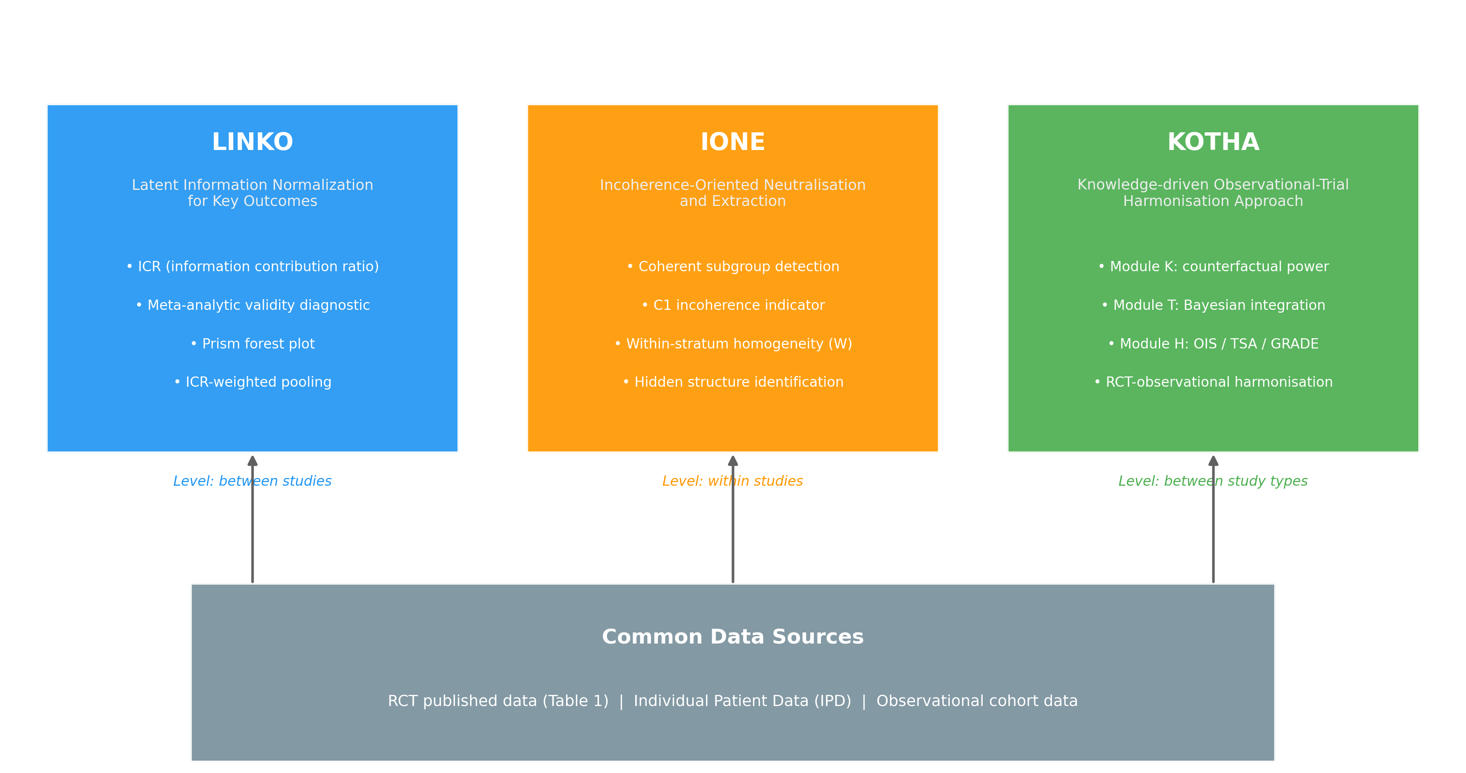
Figure 1. Overview of the ONISHI framework. Three levels at which an evidence synthesis can be compromised are matched to three component methods operating on a common data basis: LINKO between studies, IONE within studies, and KOTHA between study types. ICR, information contribution ratio; IPD, individual patient data; OIS, optimal information size; TSA, trial sequential analysis; GRADE, Grading of Recommendations Assessment, Development and Evaluation.
The methods draw on a common set of inputs rather than incompatible data structures. LINKO can operate on published trial summaries or on individual patient data (IPD); IONE requires IPD or an observational cohort; KOTHA combines randomized and observational effect estimates and, where available, IPD. Because these inputs overlap, a single dataset with IPD can feed all three methods, which is what makes a sequential pipeline possible.
Each method is reported in full in a separate manuscript;¹⁻³ here we treat them as components with defined inputs and outputs and focus on their integration. Table 1 summarizes each method's target level, core metric, primary input, and what it verifies.
Table 1. The three component methods of the ONISHI framework.
Method | Target level | Core metric | Primary input | What it verifies | Ref.
LINKO  (Latent Information Normalization for Key Outcomes) | Between studies | Information contribution ratio (ICR) | Published RCT summaries or IPD | Which studies/endpoints carry the informative signal | 1
IONE  (Incoherence-Oriented Neutralisation and Extraction) | Within studies | Incoherence indicator C1 (= 1 − I²); within-stratum homogeneity W | IPD or observational cohort | Whether a population hides coherent subgroups (effect modification) | 2
KOTHA  (Knowledge-driven Observational-Trial Harmonisation Approach) | Between study types | Counterfactual power; harmonized estimate; OIS/TSA | RCT + observational effect estimates; IPD | How to harmonize randomized and observational evidence; “no effect” vs “no information” | 3
ICR, information contribution ratio; IPD, individual patient data; OIS, optimal information size; TSA, trial sequential analysis; I², heterogeneity statistic; C1, incoherence indicator (one minus I²); W, within-stratum homogeneity.
COMPONENT METHODS
LINKO quantifies how much information each study or endpoint contributes to a pooled estimate through the ICR, computed either from a variance decomposition or from a principal-component-analysis (PCA)-based estimator.¹ A low ICR flags a study or endpoint whose nominal weight in the synthesis is not matched by its informational content, so that it can be down-weighted or reported explicitly rather than pooled uncritically.
IONE asks whether a single population conceals coherent subgroups with distinct behaviour.² It proceeds in two steps: the incoherence indicator C1, defined as one minus the I² statistic on the relevant partition, detects departure from a single coherent effect, and coherent subgroups are then extracted, with within-stratum homogeneity summarized by W. IONE is explicitly an exploratory, model-dependent diagnostic, in keeping with the distinction between risk-based and effect-based approaches to treatment-effect heterogeneity.⁸
KOTHA harmonizes randomized and observational evidence and separates “evidence of no effect” from “no evidence of effect”.³ It comprises three modules: Module K (counterfactual power simulation), Module T (hierarchical Bayesian integration), and Module H, which links the analysis to reporting standards by supplying an optimal information size (OIS), trial sequential analysis (TSA),⁹ and the GRADE imprecision domain.¹⁰ Detailed derivations and validation of each method are given in the respective reports;¹⁻³ we summarize only what the pipeline consumes.
COMBINATIONS AND SYNERGIES
Because the three methods target non-overlapping levels, pairing them yields capabilities that none has alone. We describe the three pairwise combinations and the full triple, illustrating each on the shared dataset introduced below.
LINKO with IONE separates two sources of apparent heterogeneity that are easily confused: differences in information content (LINKO) and genuine subgroup incoherence (IONE). Applying LINKO within IONE-defined subgroups shows that a subgroup can carry little information yet a coherent effect, or a large information share yet a divergent effect; the pair distinguishes these cases and thereby supports root-cause identification of heterogeneity rather than its mere quantification.
LINKO with KOTHA makes the information content of the evidence explicit in both pooling and certainty assessment. The ICR enters KOTHA directly: as an input to the Module K power calculation and as a prior weight in the Module T Bayesian integration, while Module H reports the ICR alongside the OIS and TSA.
IONE with KOTHA links population structure to external validity. IONE's subgroup risk profiles feed KOTHA's counterfactual power module, so that power is evaluated per risk stratum rather than for an undifferentiated population, and the C1 indicator informs how representative the evidence is judged to be.
Chaining all three methods—incoherence detection, information quantification, and harmonized integration—produces a comprehensive assessment in which heterogeneity is first localized, then weighted by information, then integrated into a single decision-grade read-out. The next section specifies this pipeline.
INTEGRATED PIPELINE
The pipeline runs IONE → LINKO → KOTHA on shared data (Figure 2). Phase 1 (IONE) decomposes the population into coherent subgroups and computes C1 and W. Phase 2 (LINKO) recomputes the ICR within each subgroup and generates the information-weighted summaries. Phase 3 (KOTHA) integrates the evidence and produces the decision-support output.
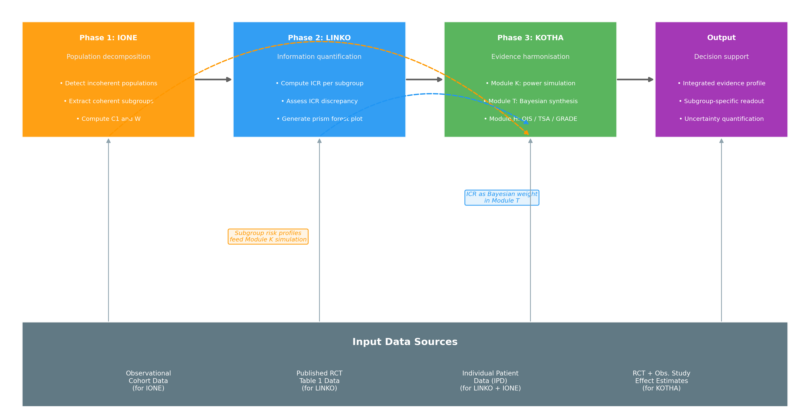
Figure 2. The integrated ONISHI pipeline. Data flow runs IONE → LINKO → KOTHA, with two cross-phase hand-offs shown as dashed arrows: IONE subgroup risk profiles parameterize the KOTHA Module K power simulation, and the LINKO information contribution ratio (ICR) enters the KOTHA Module T Bayesian integration as a prior weight.
The value of the pipeline lies in the defined hand-offs between phases (Table 2). IONE passes its subgroup labels to LINKO, which recomputes the ICR within each subgroup, and its subgroup risk profiles to KOTHA Module K, which uses them to parameterize per-stratum power. LINKO passes the ICR to KOTHA Module T, where it scales the information borrowed in the hierarchical (power-prior) integration,¹¹ and, together with C1, to Module H as reporting items.
Table 2. Hand-off interfaces in the integrated ONISHI pipeline.
Interface | Upstream output | Downstream input | Transformation
IONE → LINKO | Coherent subgroup labels | Subgroup partition | Recompute the ICR within each subgroup
IONE → KOTHA (Module K) | Subgroup risk profiles; C1 | Counterfactual power inputs | Risk profiles parameterize per-stratum power simulation
LINKO → KOTHA (Module T) | Per-study / per-subgroup ICR | Bayesian prior weight | ICR scales the information borrowed in hierarchical integration
LINKO, IONE → KOTHA (Module H) | ICR; C1 | Reporting items | Reported alongside OIS and TSA in the GRADE-linked read-out
ICR, information contribution ratio; C1, incoherence indicator; OIS, optimal information size; TSA, trial sequential analysis; GRADE, Grading of Recommendations Assessment, Development and Evaluation.
Two cross-phase hand-offs (dashed arrows, Figure 2) bypass the strict sequence: IONE risk profiles reach Module K directly, and LINKO's ICR reaches Module T directly. These interfaces are what turn three methods into one analysis rather than three analyses reported side by side.
ILLUSTRATIVE APPLICATION
To show how the three components act as one pipeline rather than three separate tools, we applied ONISHI sequentially—IONE → LINKO → KOTHA—to a single publicly available individual-patient dataset, the International Stroke Trial (IST; open access, Edinburgh DataShare).^{12,13} We analysed the effect of randomized aspirin allocation on 14-day death among the 18,451 of 19,435 randomized patients with complete baseline covariates (complete-case analysis; 25 baseline variables; event rate 22.5%). Pooled across the whole trial, the effect is close to null and inconclusive (odds ratio [OR] 0.94, 95% confidence interval [CI] 0.88–1.01), the kind of “flat” result that is routinely filed as showing no benefit. ONISHI turns this single result into a layered, decision-grade read-out (Figures 3–6; Table 3).
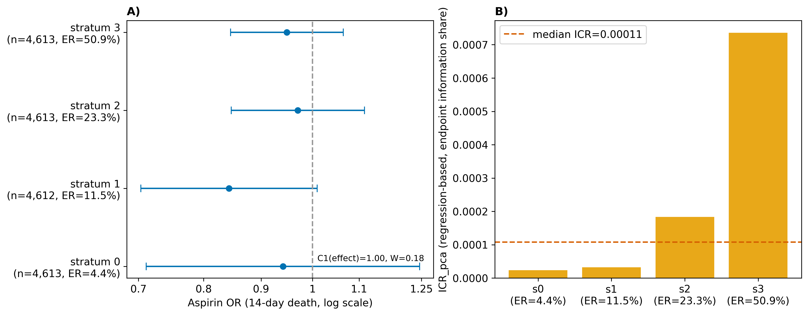
Figure 3. LINKO + IONE on the International Stroke Trial (18,451 patients; randomized aspirin allocation, 14-day death). A) aspirin odds ratios are coherent across four latent risk strata (C1 [effect] = 1.00, W = 0.18); B) the per-stratum information contribution ratio (ICR) increases with baseline risk, so a coherent effect coexists with a risk-dependent information contribution. OR, odds ratio; ICR, information contribution ratio; ER, event rate.
Phase 1—IONE (within-study coherence). We stratified patients into four latent risk groups by their predicted outcome probability. The 14-day mortality rose from 4.4% in stratum 0 to 50.9% in stratum 3, confirming strong latent population structure. Crucially, the aspirin effect was coherent across these strata: the incoherence indicator C1 (effect) = 1.00 (between-stratum I² = 0%) and the within-stratum homogeneity W = 0.18. In other words, IONE finds no hidden effect modification—the treatment effect itself does not differ by risk group (Figure 3A).
Phase 2—LINKO (information weight). For each IONE stratum we recomputed the endpoint ICR via the PCA-based estimator. The ICR increased monotonically with baseline risk (stratum 0 → 3: 2.3×10⁻⁵, 3.2×10⁻⁵, 1.8×10⁻⁴, 7.4×10⁻⁴; median 1.1×10⁻⁴), showing that the outcome carries very different amounts of information across subgroups even though the effect is homogeneous. The two diagnostics are therefore complementary and dissociable: a coherent effect (IONE) coexists with a strongly risk-dependent information contribution (LINKO) (Figure 3B).
We also applied LINKO at the between-study level, treating the 13 IST national sub-studies as studies (Figure 4). Random-effects meta-analysis¹⁴ gave a pooled OR of 0.93 (standard error [SE] 0.056; I² = 37%). Re-weighting each country by its ICR left the point estimate unchanged (OR 0.93). We note explicitly that the accompanying change in the standard error (0.056 → 0.037) is not an effect of information weighting: an equal-weight estimator yields the same standard error (0.037), so the reduction reflects the removal of the random-effects between-country variance (τ²), not the ICR weights, whose values were near-uniform here (0.001–0.002). The correct reading of this step is therefore robustness: the harmonized point estimate is insensitive to information weighting.
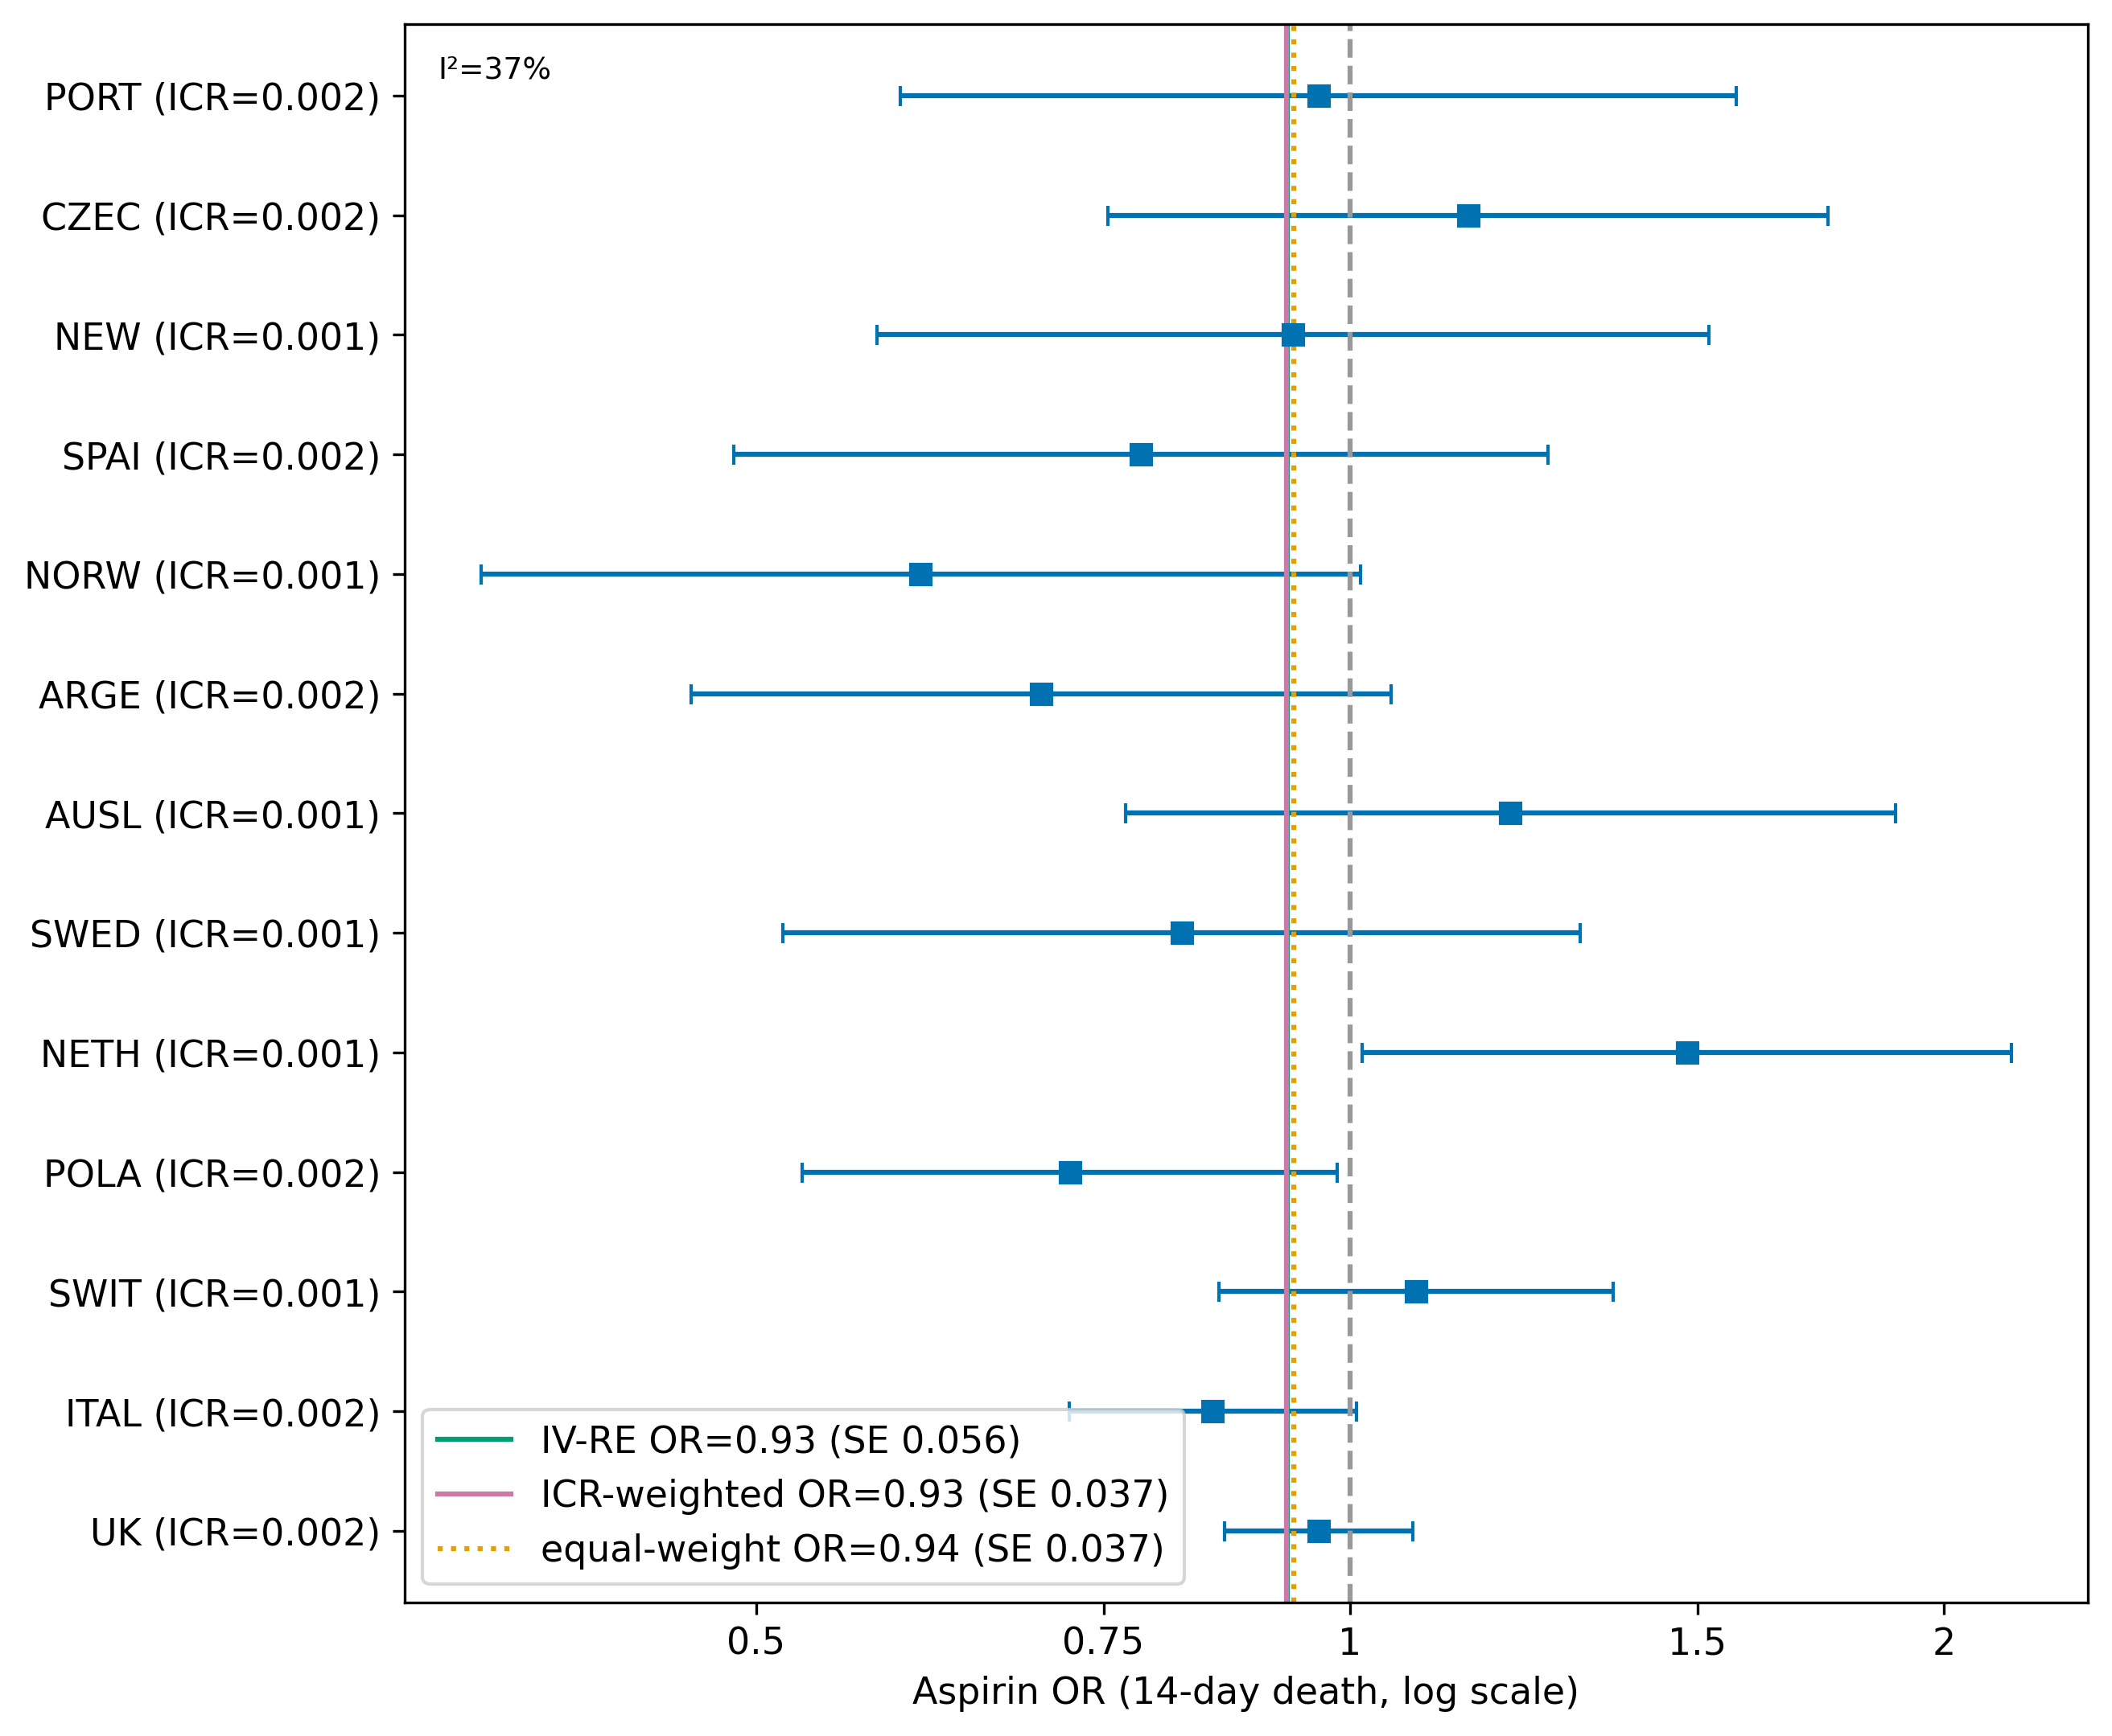
Figure 4. LINKO + KOTHA on the International Stroke Trial: pooling across 13 national sub-studies by inverse-variance random effects, ICR weighting, and equal weighting. The ICR-weighted and equal-weight point estimates coincide, so information weighting demonstrates robustness rather than a change in estimate. OR, odds ratio; ICR, information contribution ratio.
Phase 3—KOTHA (integration and information sizing). We passed the IONE risk profiles into KOTHA's counterfactual-power module (Figure 5). Holding the trial size and the pooled effect fixed, statistical power at the observed effect ranged from 14% in the lowest-risk stratum to 86% in the highest-risk stratum, quantifying how event scarcity—not absence of effect—drives the flat result. Module H formalized this: against an optimal information size of 7,880 events, the trial accrued 4,159 (information fraction 53%), and trial sequential analysis gave a cumulative Z of −1.73, inside the ±1.96 monitoring boundary. Finally, the ICR-guided power-prior integration harmonized the strata into an OR of 0.94–0.95, revising the naive probability of benefit downward from 0.96 to 0.85 (Figure 6).
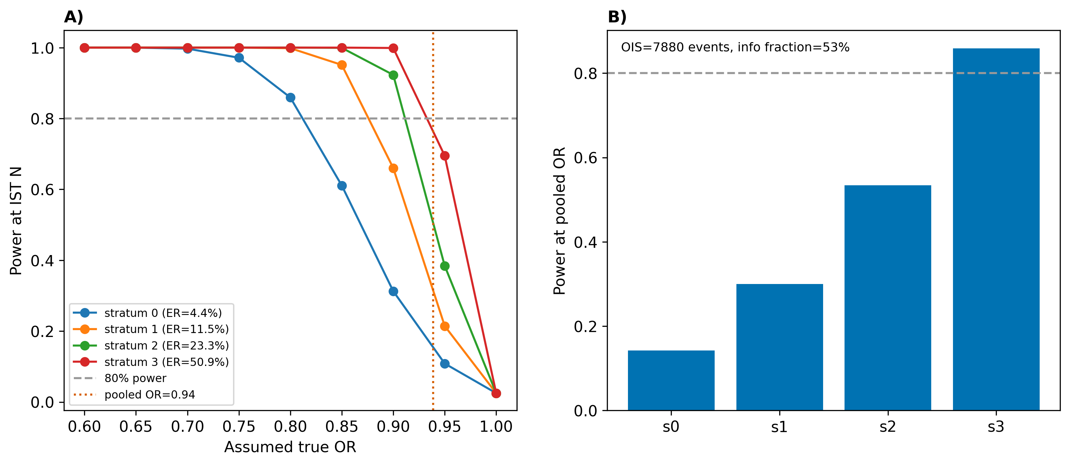
Figure 5. IONE + KOTHA on the International Stroke Trial: A) statistical power at the observed effect against the assumed true odds ratio for each risk stratum; B) power at the trial-wide pooled odds ratio per stratum, quantifying how event scarcity—not absence of effect—drives the flat result. OIS, optimal information size.
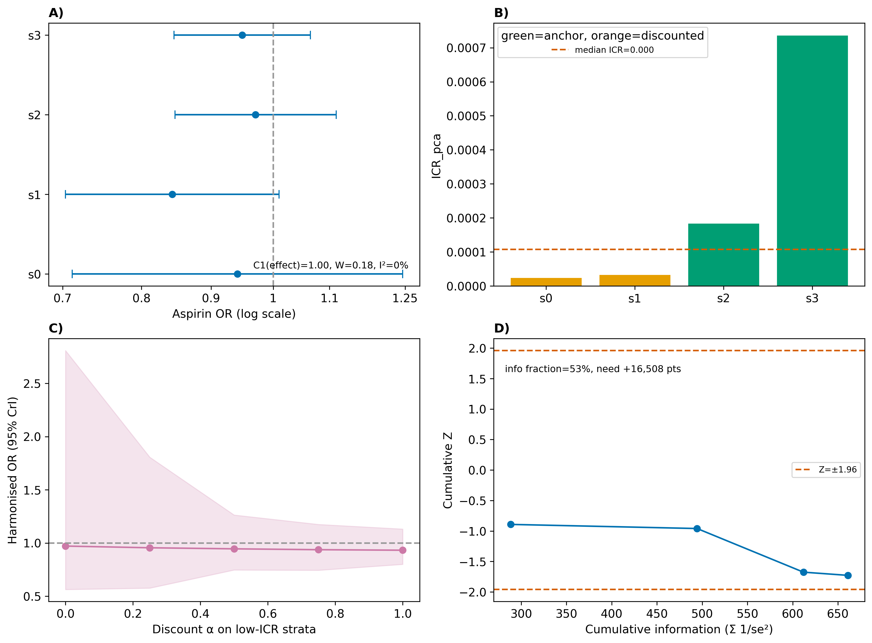
Figure 6. Full ONISHI pipeline on the International Stroke Trial: A) IONE subgroup aspirin odds ratios by stratum; B) LINKO per-stratum information weights; C) KOTHA ICR-guided power-prior harmonization (harmonized odds ratio with 95% credible band across the discount on low-ICR strata); D) trial sequential analysis (cumulative Z = −1.73, within the ±1.96 boundary; information fraction 53%). OR, odds ratio; ICR, information contribution ratio.
Integrated read-out. Read together, the pipeline yields a single conclusion that no component gives alone: the aspirin effect is coherent across the population (no effect modification; C1 = 1.00), but the current evidence is informationally insufficient rather than null (information fraction 53%; cumulative Z = −1.73). Converting the shortfall into a design target, reaching the optimal information size would require 3,721 additional events—about 16,500 additional patients at the trial's overall event rate (roughly doubling enrolment). IONE's risk profiles show this target is reached far more efficiently by enriching for higher-risk patients (about 7,300 additional stratum-3-like patients versus about 83,700 stratum-0-like). ONISHI thus reframes a filed-away “negative” trial as an interim result and outputs the sample size a future study would need—an output available only when the three methods are chained (Table 3).
Table 3. Stratum-wise outputs of the ONISHI pipeline applied to the International Stroke Trial.
Stratum | n | 14-day mortality | Aspirin OR (95% CI) | ICR (PCA) | Power at pooled OR | Additional patients to OIS
0 | 4,613 | 4.4% | 0.94 (0.71–1.25) | 2.3×10⁻⁵ | 14% | 83,734
1 | 4,612 | 11.5% | 0.84 (0.70–1.01) | 3.2×10⁻⁵ | 30% | 32,320
2 | 4,613 | 23.3% | 0.97 (0.85–1.11) | 1.8×10⁻⁴ | 53% | 15,968
3 | 4,613 | 50.9% | 0.95 (0.85–1.06) | 7.4×10⁻⁴ | 86% | 7,311
Overall | 18,451 | 22.5% | 0.94 (0.88–1.01) | — | 53% info. fraction | 16,508
Strata are latent risk groups defined by predicted outcome probability. Odds ratios are for randomized aspirin allocation on 14-day death; confidence intervals are computed on the log-odds scale. The ICR is the principal-component-analysis-based estimate. Power is computed at the trial-wide pooled odds ratio. “Additional patients to OIS” is the number of further patients, at each stratum's event rate, projected to reach the optimal information size; it is a design heuristic, not a formal sample-size calculation. CI, confidence interval; ICR, information contribution ratio; OIS, optimal information size.
DISCUSSION
We have described ONISHI, a framework that diagnoses the validity of evidence synthesis across three independent levels—between studies (which studies carry the informative signal; LINKO), within studies (whether a population hides coherent subgroups; IONE), and between study types (how to harmonize randomized and observational evidence, and how to distinguish “no effect” from “no information”; KOTHA)—and chains the three into a single pipeline on shared data. The IST application shows the practical payoff: individually, each method stops at a partial statement (“the effect is homogeneous”, “the pooled estimate is robust”, “low-risk strata are underpowered”), whereas the sequential pipeline delivers one actionable verdict—coherent effect, insufficient information, and the additional sample size required for resolution.
ONISHI is complementary to, not a replacement for, established tools. Heterogeneity statistics quantify inconsistency but do not attribute it to a level or a mechanism;⁴ ONISHI separates effect incoherence (IONE) from information weight (LINKO). GRADE codifies certainty judgements, and KOTHA's Module H connects directly to the GRADE imprecision domain by supplying the OIS, trial sequential analysis, and an explicit information fraction.^{6,10} Target-trial emulation and individual-patient-data meta-analysis address the between-study-type and between-study levels respectively,^{7,15} but neither provides the within-study coherence diagnosis that IONE contributes, which is aligned with predictive approaches to treatment-effect heterogeneity.⁸ The framework's novelty is thus the cross-level integration and the defined hand-offs between methods (subgroup labels → counterfactual power; ICR → integration weights and the GRADE report), not any single component.
Several limitations follow. First, ONISHI inherits the limitations of its components: IONE's stratification is exploratory and model-dependent, the PCA-based ICR requires individual patient data and is sensitive to the variable set, and KOTHA's Bayesian integration is sensitive to prior and discount specification. Second, the fullest pipeline is data-hungry, requiring IPD; combinations that rely only on published summaries are correspondingly more limited. Third, the IST illustration is deliberately a single, coherent case rather than a validation study: the national ICRs were near-uniform, so the information-weighting step demonstrated robustness rather than a change in estimate—information weighting is expected to matter more when studies differ markedly in information content. Fourth, the IST analysis was complete-case (18,451 of 19,435 randomized patients with complete baseline covariates), so informative missingness could bias the illustration, and the between-study step treats the trial's national sub-studies as if they were independent studies—an illustrative device, since they share a single protocol rather than being separate trials. Fifth, the per-stratum coherence, power, and information analyses are exploratory and not adjusted for multiple comparisons. Finally, the “additional patients” figure is an information-size projection under the observed event rate and effect, intended as a design heuristic, not a formal sample-size calculation for a specific future protocol.
For applied evidence synthesis, ONISHI offers a structured way to interrogate a synthesis before trusting it and, importantly, a way to characterize inconclusive but coherent trials as information-limited while quantifying what further evidence would resolve them. Priorities for future work are a unified software implementation of the pipeline, prospective evaluation on synthesis problems with known ground truth, and extension of the hand-off interfaces to time-to-event and network-meta-analytic settings.
CONCLUSION
Evidence synthesis can be compromised at three distinct levels, and diagnosing one does not diagnose the others. ONISHI pairs each level with a dedicated method and chains the three into a single, reproducible pipeline with explicit interfaces, so that a body of evidence can be interrogated across levels on shared data. Applied to a large public trial, the pipeline reframed an inconclusive result as coherent but information-limited and quantified the evidence needed to resolve it. The framework is complementary to existing appraisal tools and is intended to make the validity of a synthesis an explicit, inspectable property rather than an assumption.
REFERENCES
1. [Author One], [Author Two]. LINKO: Latent Information Normalization for Key Outcomes—quantifying endpoint information contribution in evidence synthesis. Research Square. Preprint (under review). doi:10.21203/rs.3.rs-9338552/v1.
2. [Author One], [Author Two]. IONE: Incoherence-Oriented Neutralisation and Extraction for detecting hidden population structure in observational studies. Research Square. Preprint (under review). doi:10.21203/rs.3.rs-9271445/v1.
3. [Author One], [Author Two]. KOTHA: a Knowledge-driven Observational-Trial Harmonisation Approach for evidence integration. Research Square. Preprint (under review). doi:10.21203/rs.3.rs-9420092/v1.
4. Higgins JPT, Thompson SG. Quantifying heterogeneity in a meta-analysis. Stat Med. 2002;21(11):1539-1558. doi:10.1002/sim.1186.
5. Rosenbaum PR, Rubin DB. The central role of the propensity score in observational studies for causal effects. Biometrika. 1983;70(1):41-55. doi:10.1093/biomet/70.1.41.
6. Guyatt GH, Oxman AD, Vist GE, et al. GRADE: an emerging consensus on rating quality of evidence and strength of recommendations. BMJ. 2008;336(7650):924-926. doi:10.1136/bmj.39489.470347.AD.
7. Hernán MA, Robins JM. Using big data to emulate a target trial when a randomized trial is not available. Am J Epidemiol. 2016;183(8):758-764. doi:10.1093/aje/kwv254.
8. Kent DM, Paulus JK, van Klaveren D, et al. The Predictive Approaches to Treatment effect Heterogeneity (PATH) Statement. Ann Intern Med. 2020;172(1):35-45. doi:10.7326/M18-3667.
9. Wetterslev J, Thorlund K, Brok J, Gluud C. Trial sequential analysis may establish when firm evidence is reached in cumulative meta-analysis. J Clin Epidemiol. 2008;61(1):64-75. doi:10.1016/j.jclinepi.2007.03.013.
10. Guyatt GH, Oxman AD, Kunz R, et al. GRADE guidelines 6. Rating the quality of evidence—imprecision. J Clin Epidemiol. 2011;64(12):1283-1293. doi:10.1016/j.jclinepi.2011.01.012.
11. Ibrahim JG, Chen MH. Power prior distributions for regression models. Stat Sci. 2000;15(1):46-60. doi:10.1214/ss/1009212673.
12. Sandercock PA, Niewada M, Członkowska A; International Stroke Trial Collaborative Group. The International Stroke Trial database. Trials. 2011;12:101. doi:10.1186/1745-6215-12-101.
13. International Stroke Trial Collaborative Group. The International Stroke Trial (IST): a randomised trial of aspirin, subcutaneous heparin, both, or neither among 19435 patients with acute ischaemic stroke. Lancet. 1997;349(9065):1569-1581. doi:10.1016/S0140-6736(97)04011-7.
14. DerSimonian R, Laird N. Meta-analysis in clinical trials. Control Clin Trials. 1986;7(3):177-188. doi:10.1016/0197-2456(86)90046-2.
15. Riley RD, Lambert PC, Abo-Zaid G. Meta-analysis of individual participant data: rationale, conduct, and reporting. BMJ. 2010;340:c221. doi:10.1136/bmj.c221.

