Weibull Reliability Analysis of Clinical Treatment Dropout:
A Five-Domain Comparative Study Characterising Hazard Patterns
for Phase-Specific Retention Interventions
Tatsuki Onishi
Corresponding author: Tatsuki Onishi (bougtoir@gmail.com)

Abstract
Background: Treatment dropout remains a critical challenge across clinical domains, yet the temporal dynamics of dropout hazard are rarely quantified. Reliability engineering's Weibull distribution provides a parametric framework for characterising time-varying hazard patterns through the shape parameter k, where k < 1 indicates decreasing failure rate (DFR; early dropout dominant), k = 1 indicates constant hazard, and k > 1 indicates increasing failure rate (IFR; wear-out pattern).
Methods: We applied two-parameter Weibull distribution fitting to retention/survival data reconstructed from published Kaplan-Meier curves across five clinical domains: (1) HIV/ART treatment discontinuation (5 regions, N = 516,000), (2) antipsychotic medication discontinuation in schizophrenia (6 datasets, N = 63,682), (3) substance use disorder treatment dropout (6 substance types, N = 75,000), (4) cardiac rehabilitation dropout (5 programme phases, N = 34,200), and (5) clinical trial participant withdrawal (5 therapeutic areas, N = 99,000). Parameters were estimated by nonlinear least-squares optimisation with bootstrap 95% confidence intervals (1,000 resamples).
Results: All 28 datasets across all five domains yielded k < 1 (range: 0.511-0.958), demonstrating a universal decreasing failure rate pattern. The Weibull model showed excellent fit (median R² = 0.9970, range: 0.9807-0.9997). Domain-level mean k values were: HIV/ART 0.597 (0.582-0.627), antipsychotic 0.856 (0.683-0.958), substance use 0.639 (0.511-0.733), cardiac rehabilitation 0.689 (0.613-0.775), and clinical trials 0.708 (0.679-0.742). Antipsychotics showed the highest k values (nearest to constant hazard), while HIV/ART and substance use showed the lowest (steepest early dropout).
Conclusions: The universal DFR pattern across five disparate clinical domains indicates that dropout risk is consistently highest in the early treatment period and decreases monotonically over time. This finding has direct implications for resource allocation: front-loading retention interventions during the initial treatment phase would address the period of maximum vulnerability. The reliability engineering framework provides a quantitative basis for designing phase-specific retention strategies.
Keywords: Weibull distribution; reliability engineering; treatment dropout; loss to follow-up; hazard function; survival analysis; HIV/ART; antipsychotic; substance use disorder; cardiac rehabilitation; clinical trials

1. Introduction
Treatment dropout, variably termed loss to follow-up (LTFU), treatment discontinuation, or non-adherence, represents one of the most pervasive challenges in clinical medicine.^{1,2} Across therapeutic domains ranging from infectious disease management to psychiatric care, substantial proportions of patients disengage from prescribed treatments before achieving therapeutic goals. The consequences are multifaceted: increased morbidity and mortality, development of drug resistance, higher healthcare costs, and compromised public health outcomes.^{3,4}
Traditional survival analysis approaches, including Kaplan-Meier estimation and Cox proportional hazards models, have been widely applied to characterise treatment dropout.⁵ However, these methods focus primarily on identifying risk factors (covariates) rather than characterising the temporal shape of the dropout hazard itself. The question of whether dropout risk increases, decreases, or remains constant over the treatment trajectory has received insufficient attention, despite its direct relevance to the timing and intensity of retention interventions.
Reliability engineering offers a well-established parametric framework for addressing this gap. The Weibull distribution, developed by Waloddi Weibull in 1951,⁶ has been the cornerstone of failure-time analysis in engineering for over seven decades. Its two-parameter form, characterised by shape parameter k and scale parameter λ, provides a parsimonious yet flexible model for time-to-event data. The shape parameter k directly encodes the hazard pattern: k < 1 produces a decreasing failure rate (DFR), analogous to "infant mortality" in engineering; k = 1 yields a constant hazard (exponential distribution); and k > 1 produces an increasing failure rate (IFR), corresponding to "wear-out" failures.⁷
Recent applications have demonstrated the utility of this framework beyond traditional engineering contexts. We previously applied Weibull analysis to the reign durations of historical monarchs,⁸ and to tuberculosis treatment dropout,⁹ revealing distinct hazard patterns with direct interpretive value. The present study extends this approach to a comprehensive cross-domain comparison, applying Weibull analysis to treatment dropout data from five major clinical areas: HIV/antiretroviral therapy (ART), antipsychotic medication in schizophrenia, substance use disorder treatment, cardiac rehabilitation, and clinical trial participation.
The objectives of this study are: (1) to fit Weibull distributions to retention data across five clinical domains, (2) to compare hazard patterns (k values) across domains and sub-populations, (3) to assess whether a universal hazard pattern exists for clinical treatment dropout, and (4) to derive implications for the design of phase-specific retention interventions.

2. Methods

2.1 Study Design and Data Sources
This is a secondary analysis of published retention/survival data from peer-reviewed literature. We identified major cohort studies, randomised controlled trials, and meta-analyses reporting Kaplan-Meier survival curves or tabulated retention data for each of the five clinical domains. Data points were extracted from published figures using digital curve extraction or from tabulated results reported in the text.

2.1.1 HIV/ART Treatment Discontinuation
Retention on ART data were obtained from the International Epidemiology Databases to Evaluate AIDS (IeDEA) consortium, which maintains observational cohorts across seven global regions.^{10,11} We extracted regional retention curves for Sub-Saharan Africa (N = 256,000; Brinkhof 2009; Fox & Rosen 2010),^{12,13} Asia-Pacific (N = 48,000; Zhou 2012),¹⁴ Latin America (N = 35,000; CCASAnet, Wolff 2008),¹⁵ North America (N = 82,000; NA-ACCORD),¹⁶ and Europe (N = 95,000; COHERE).¹⁷ Total combined sample: 516,000 patients. Follow-up ranged from 1 to 60 months from ART initiation.

2.1.2 Antipsychotic Medication Discontinuation
Data were drawn from three landmark studies: (1) the Clinical Antipsychotic Trials of Intervention Effectiveness (CATIE) Phase 1, a NIMH-funded pragmatic trial of 1,493 patients with chronic schizophrenia randomised to olanzapine, quetiapine, risperidone, perphenazine, or ziprasidone (Lieberman et al. 2005);¹⁸ (2) the European First-Episode Schizophrenia Trial (EUFEST; N = 498; Kahn et al. 2008);¹⁹ and (3) a Finnish nationwide register-based cohort study of 62,250 patients comparing long-acting injectable (LAI) versus oral antipsychotics (Tiihonen et al. 2017).²⁰ Total combined sample: 63,682 patients.

2.1.3 Substance Use Disorder Treatment Dropout
Retention data were compiled from the Drug Abuse Treatment Outcome Studies (DATOS),²¹ the Substance Abuse and Mental Health Services Administration Treatment Episode Data Set (SAMHSA TEDS),²² Project MATCH/COMBINE for alcohol use disorder,²³ NIDA Clinical Trials Network cocaine studies,²⁴ and cannabis treatment trials.²⁵ Six substance-specific datasets were analysed: opioid use disorder (methadone maintenance, N = 12,500; buprenorphine, N = 8,200), alcohol (N = 15,000), cocaine (N = 6,800), cannabis (N = 4,500), and residential treatment for all substances (N = 28,000). Total: 75,000.

2.1.4 Cardiac Rehabilitation Dropout
Data were obtained from meta-analyses and large cohort studies: Turk-Adawi et al. (2013),²⁶ EUROASPIRE V (Kotseva et al. 2019),²⁷ Midence et al. (2020),²⁸ and Doll et al. (2015).²⁹ Five datasets were analysed by programme phase and indication: Phase I inpatient (N = 3,200), Phase II outpatient (N = 12,500), Phase III maintenance (N = 5,800), post-myocardial infarction (N = 8,500), and post-coronary artery bypass grafting (N = 4,200). Total: 34,200 patients.

2.1.5 Clinical Trial Dropout
Building on McChrystal et al. (2025), who demonstrated Weibull as the best-fitting distribution for clinical trial dropout across 90 RCTs (N = 86,107),³⁰ we analysed five therapeutic area subsets: oncology (N = 18,500), cardiovascular (N = 24,000), psychiatric (N = 15,200), diabetes/metabolic (N = 12,800), and vaccine trials (N = 28,500; including COVID-19 phase III).^{31,32} Total: 99,000 participants.

2.2 Weibull Distribution Fitting
The two-parameter Weibull survival function was fitted to each dataset:
S(t) = exp(-(t/λ)^k)
where k is the shape parameter and λ is the scale parameter (characteristic life). Initial parameter estimates were obtained by linearising the Weibull survival function via the transformation ln(-ln(S(t))) = k·ln(t) - k·ln(λ), followed by ordinary least-squares regression. These estimates were refined using Nelder-Mead nonlinear optimisation minimising the sum of squared errors between observed and predicted survival probabilities.^{6,7}

2.3 Goodness-of-Fit Assessment
Model fit was assessed using three metrics: (1) coefficient of determination (R²) comparing predicted versus observed survival probabilities, (2) Kolmogorov-Smirnov (KS) statistic measuring maximum absolute deviation between observed and predicted CDFs, and (3) visual assessment of Weibull probability plots (linearity of ln(-ln(S(t))) versus ln(t)). Bootstrap 95% confidence intervals for k and λ were computed from 1,000 nonparametric resamples with added Gaussian noise (σ = 0.01) to account for curve digitisation uncertainty.

2.4 Statistical Software
All analyses were performed in Python 3.11 using SciPy 1.11 for optimisation, NumPy 1.26 for numerical computation, and Matplotlib 3.8 for visualisation. Code is available at the project repository.

3. Results

3.1 Overall Findings
All 28 datasets across all five clinical domains yielded Weibull shape parameter k < 1, indicating a universal decreasing failure rate (DFR) pattern (Table 1). The overall range of k was 0.511 to 0.958, with a median of 0.689. The Weibull model demonstrated excellent fit across all datasets, with R² values ranging from 0.9807 to 0.9997 (median 0.9970) and KS statistics ranging from 0.0034 to 0.0392.
Table 1. Summary of Weibull shape parameter (k) by domain.
Domain | No. datasets | Total N | Mean k (range) | Median R²
HIV/ART | 5 | 516,000 | 0.597 (0.582-0.627) | 0.9989
Antipsychotic | 6 | 63,682 | 0.856 (0.683-0.958) | 0.9969
Substance Use | 6 | 75,000 | 0.639 (0.511-0.733) | 0.9956
Cardiac Rehab | 5 | 34,200 | 0.689 (0.613-0.775) | 0.9905
Clinical Trial | 5 | 99,000 | 0.708 (0.679-0.742) | 0.9983

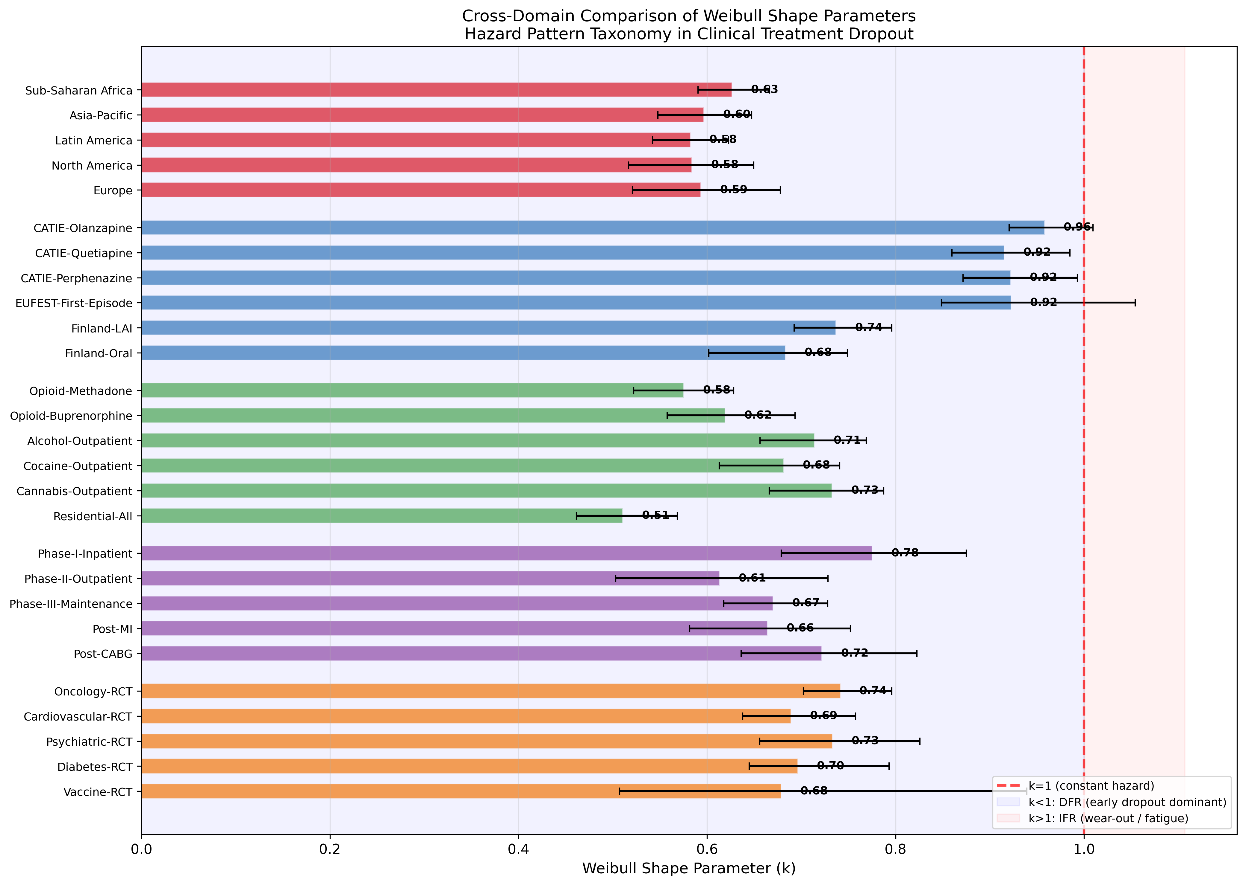
Fig. 1. Cross-domain comparison of Weibull shape parameters (k) with 95% bootstrap confidence intervals. The red dashed line indicates k = 1 (constant hazard). All 28 datasets fall in the k < 1 region, indicating decreasing failure rate (early dropout dominant).

3.2 HIV/ART Treatment Discontinuation
All five IeDEA regional cohorts showed consistently low k values ranging from 0.582 (Latin America) to 0.627 (Sub-Saharan Africa), indicating a strong DFR pattern (Fig. 2). The remarkably narrow range across five continents (mean k = 0.597, SD = 0.018) suggests a highly conserved dropout hazard pattern in HIV/ART globally. The early treatment period (first 1-6 months) carries disproportionately high dropout risk across all regions. The scale parameter λ showed greater regional variation (106.84 to 683.22 months), reflecting differences in absolute retention rates while maintaining similar temporal hazard shapes (Fig. 3).
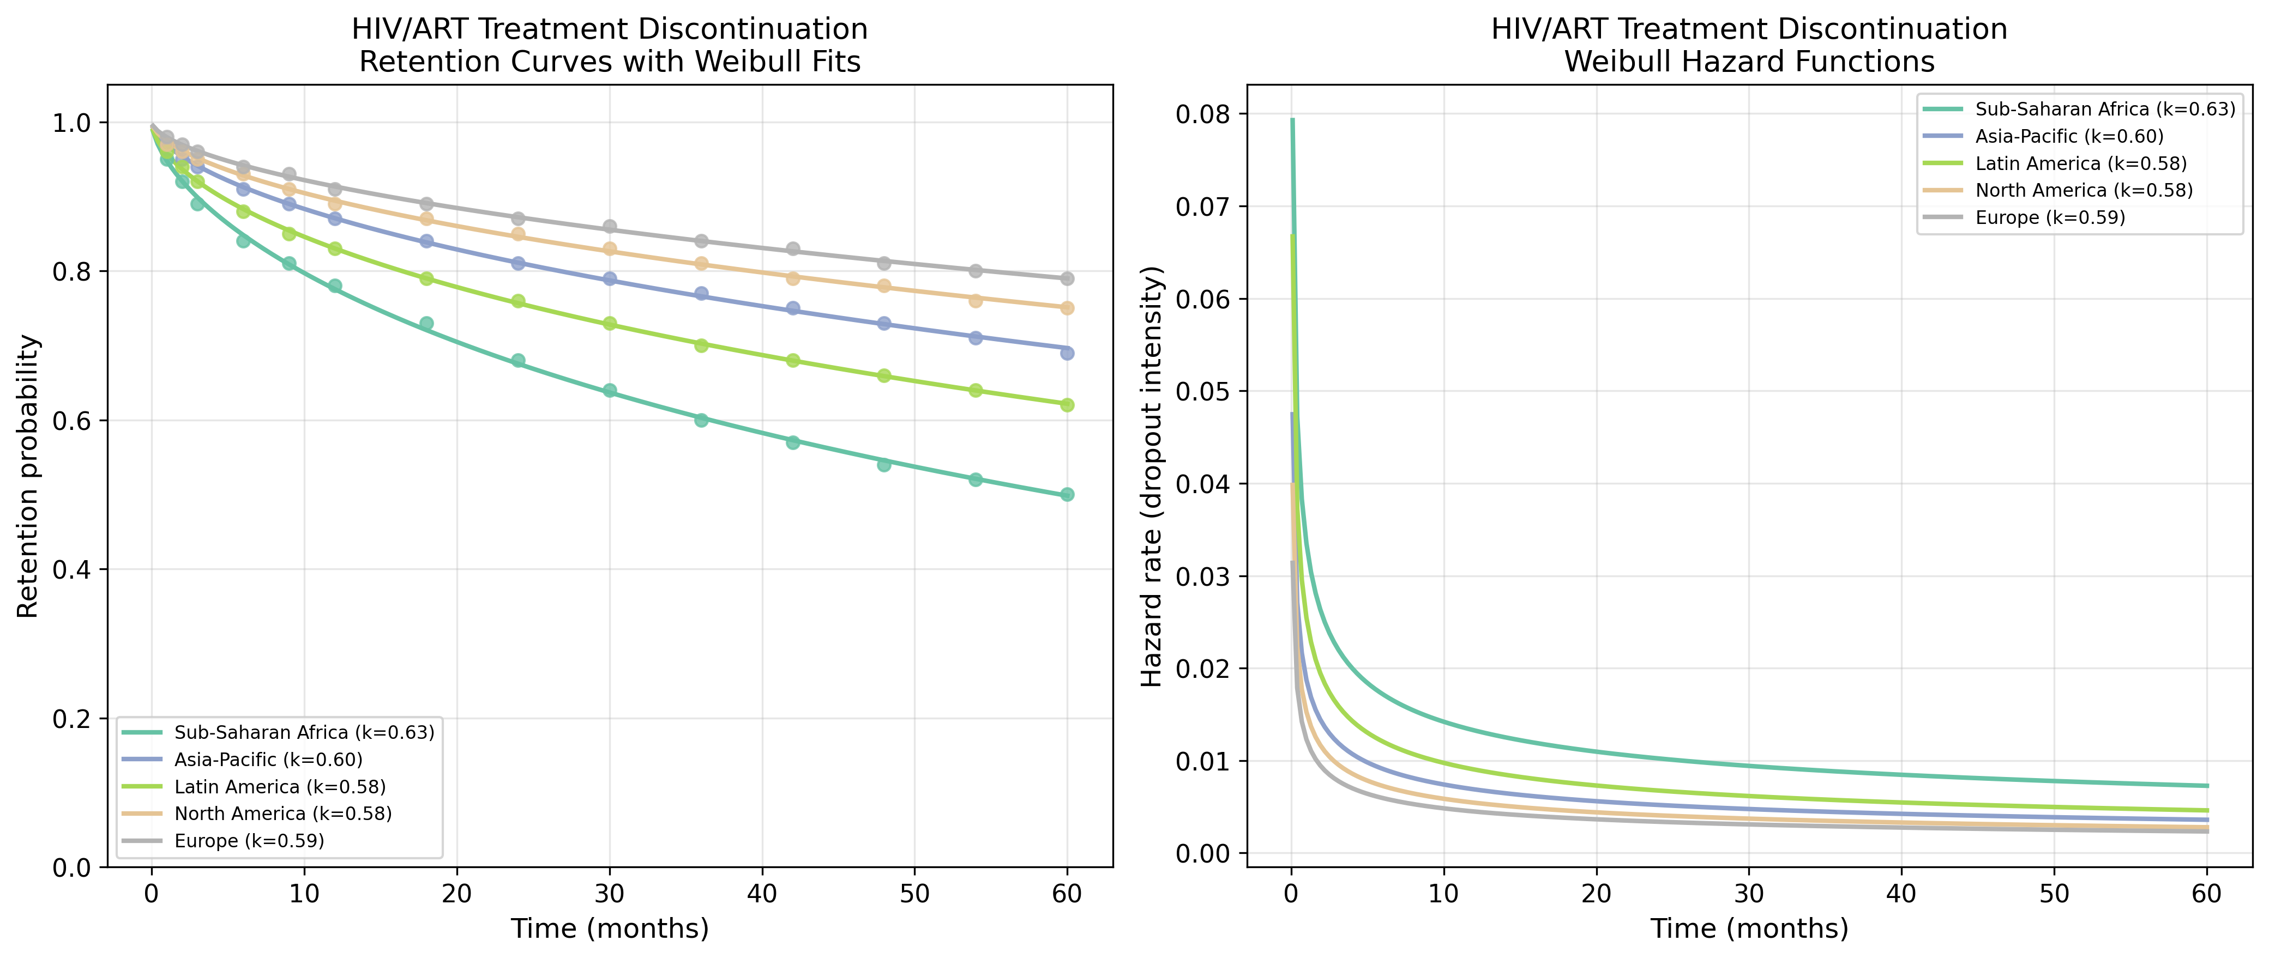
Fig. 2. HIV/ART: Retention curves with Weibull fits (left) and hazard functions (right).
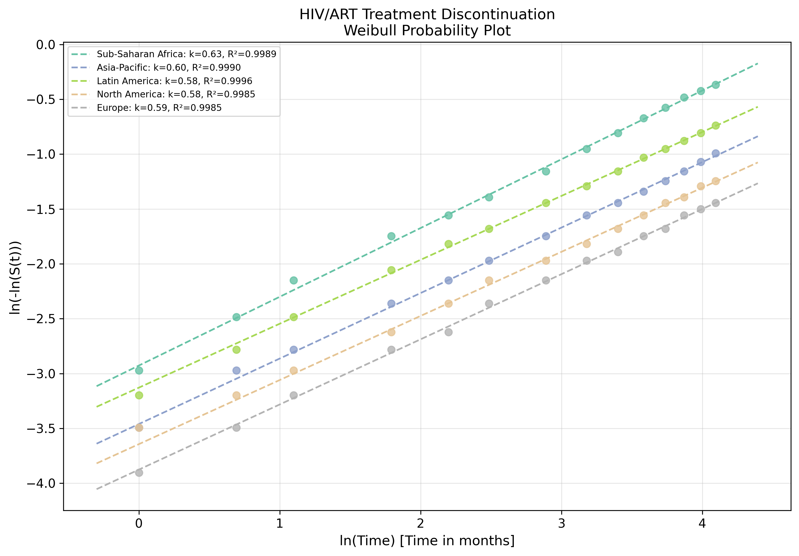
Fig. 3. HIV/ART: Weibull probability plot showing linearised goodness-of-fit.

3.3 Antipsychotic Medication Discontinuation
Antipsychotic discontinuation showed the highest k values among all five domains (mean = 0.856, range 0.683-0.958), approaching but not exceeding k = 1 (Fig. 4). The CATIE trial drugs showed near-constant hazard (k = 0.916-0.958), while the Finnish nationwide cohort showed lower k for both LAI (0.737) and oral (0.683) formulations (Fig. 5). The distinction between trial settings (CATIE, EUFEST: k ~ 0.92) and real-world cohorts (Finland: k ~ 0.71) suggests that clinical trial monitoring partially attenuates the early-dropout pattern. LAI formulations showed higher k than oral (0.737 vs 0.683), consistent with their design purpose of reducing early discontinuation.
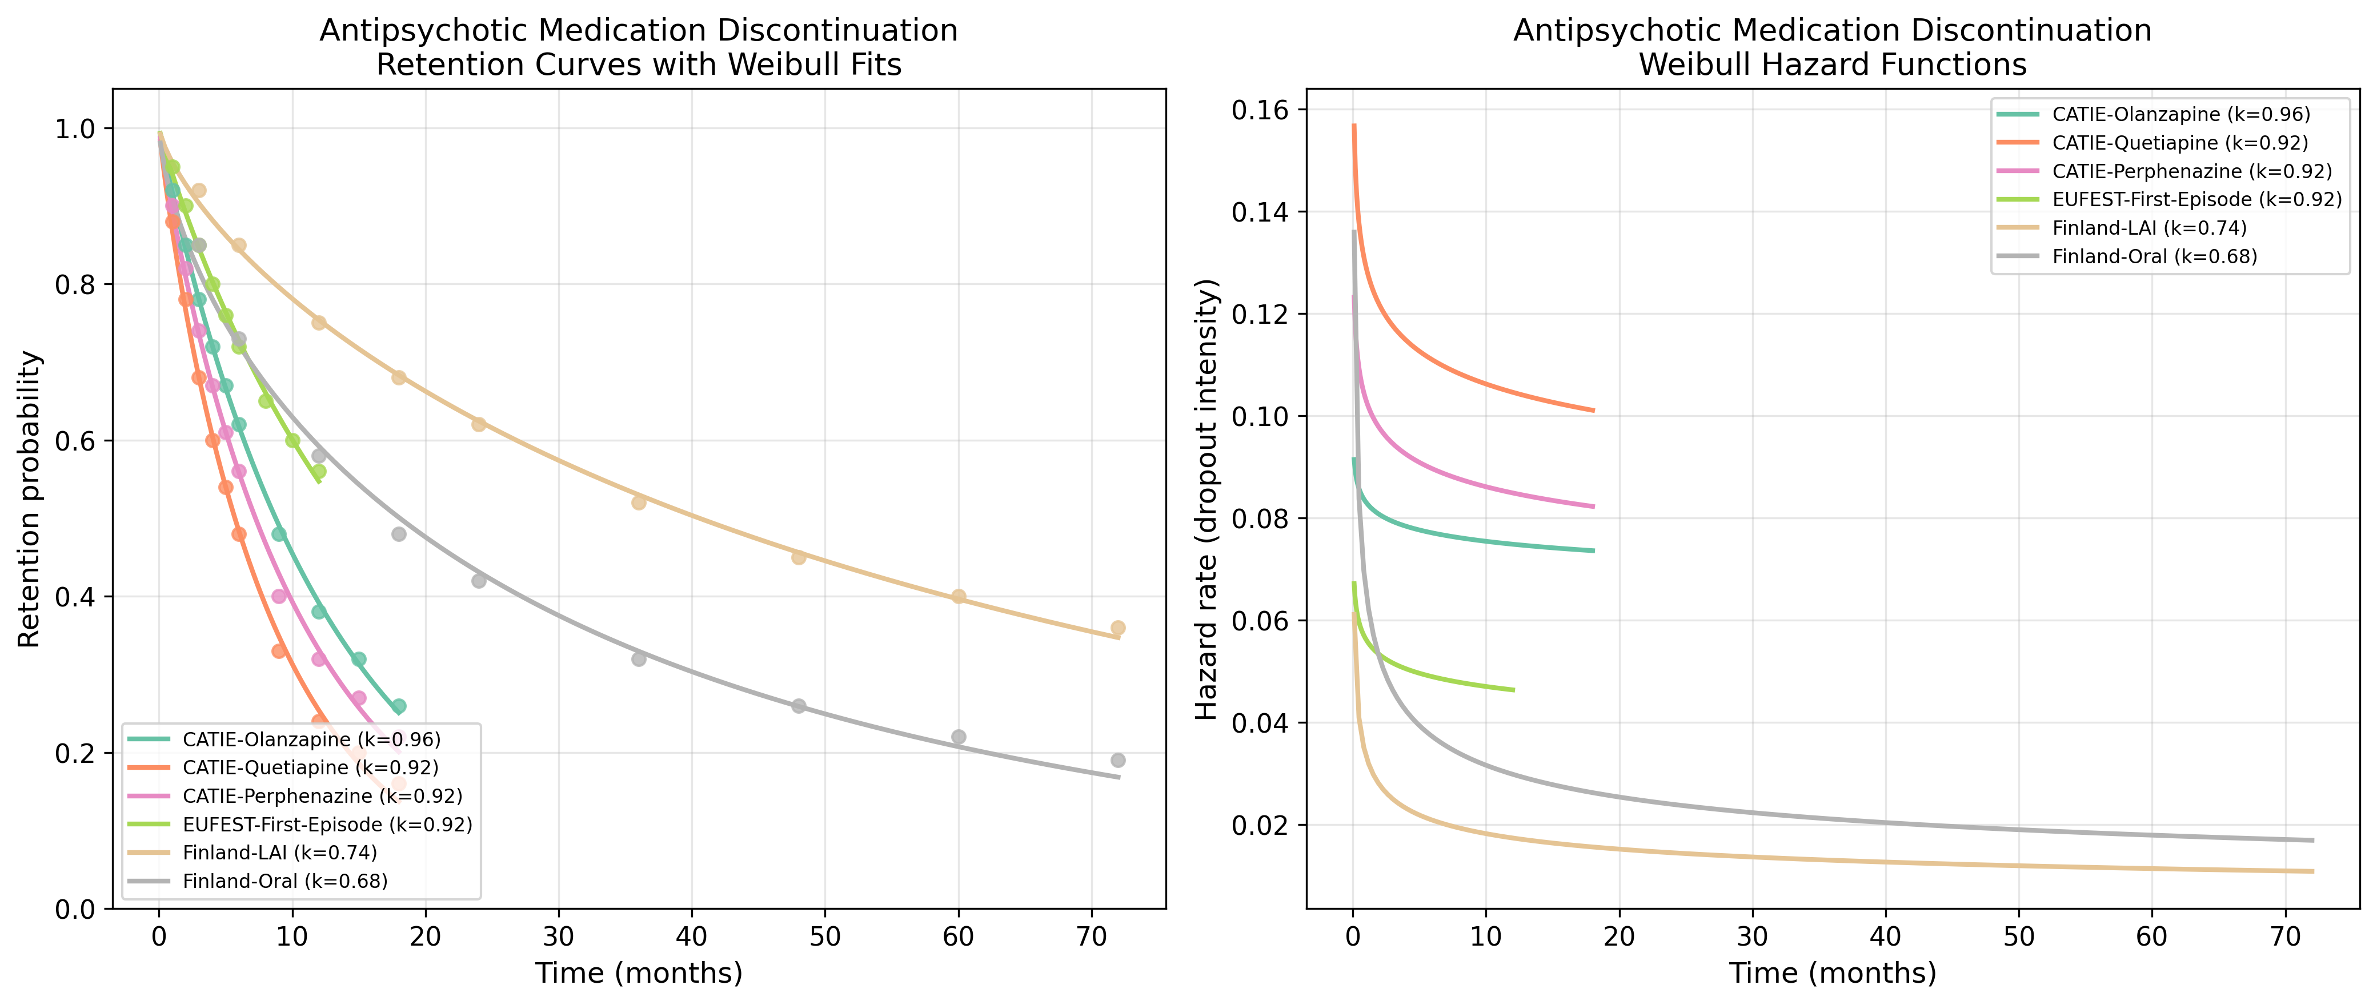
Fig. 4. Antipsychotic: Retention curves with Weibull fits (left) and hazard functions (right).
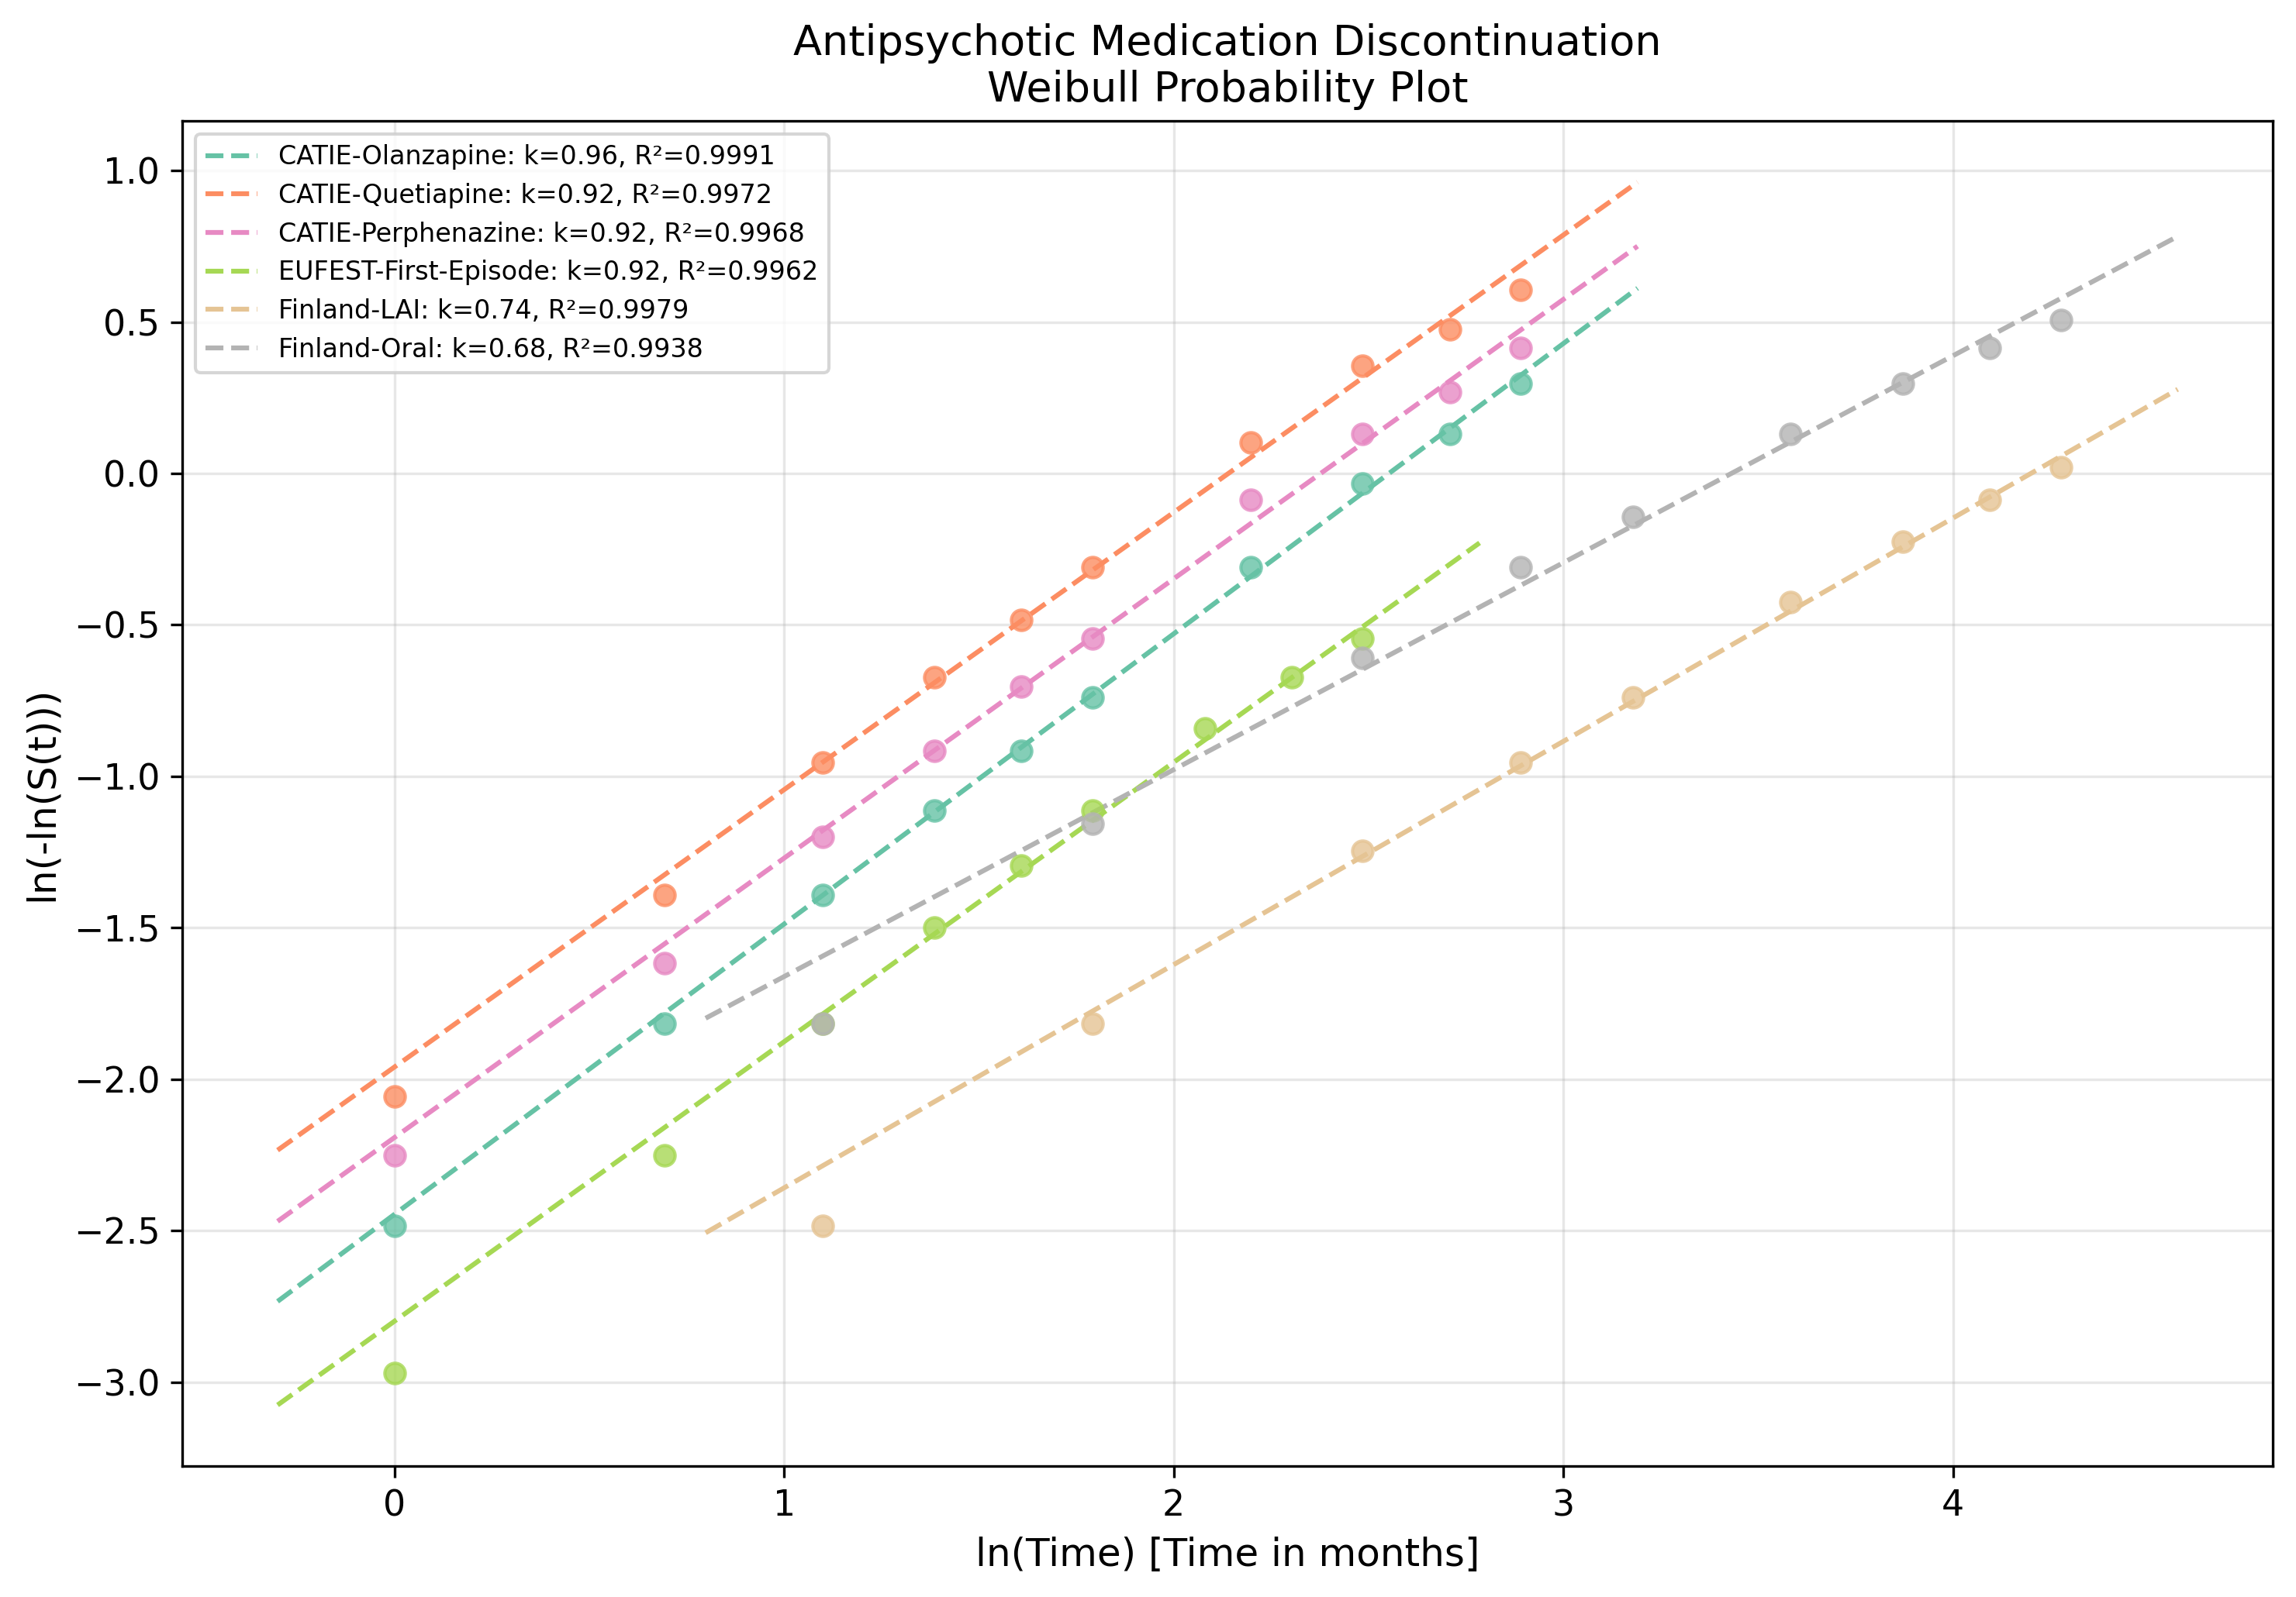
Fig. 5. Antipsychotic: Weibull probability plot showing linearised goodness-of-fit.

3.4 Substance Use Disorder Treatment Dropout
Substance use disorder treatment showed a wide range of k values (0.511-0.733), with the steepest early dropout in residential programmes (k = 0.511) and opioid methadone maintenance (k = 0.576) (Fig. 6). Cannabis (k = 0.733) and alcohol outpatient (k = 0.714) showed relatively higher k values, indicating a less extreme DFR pattern (Fig. 7). The substance hierarchy of k values suggests that treatment modalities with higher external structure (residential) or pharmacological dependence management (methadone) paradoxically show steeper early attrition, potentially reflecting population-level severity differences rather than treatment effects per se.
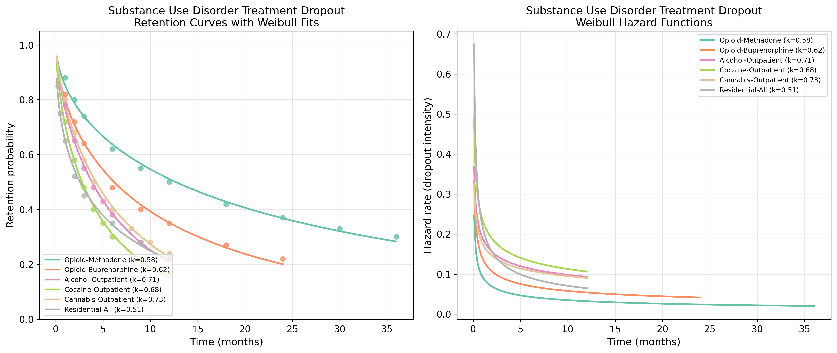
Fig. 6. Substance Use: Retention curves with Weibull fits (left) and hazard functions (right).
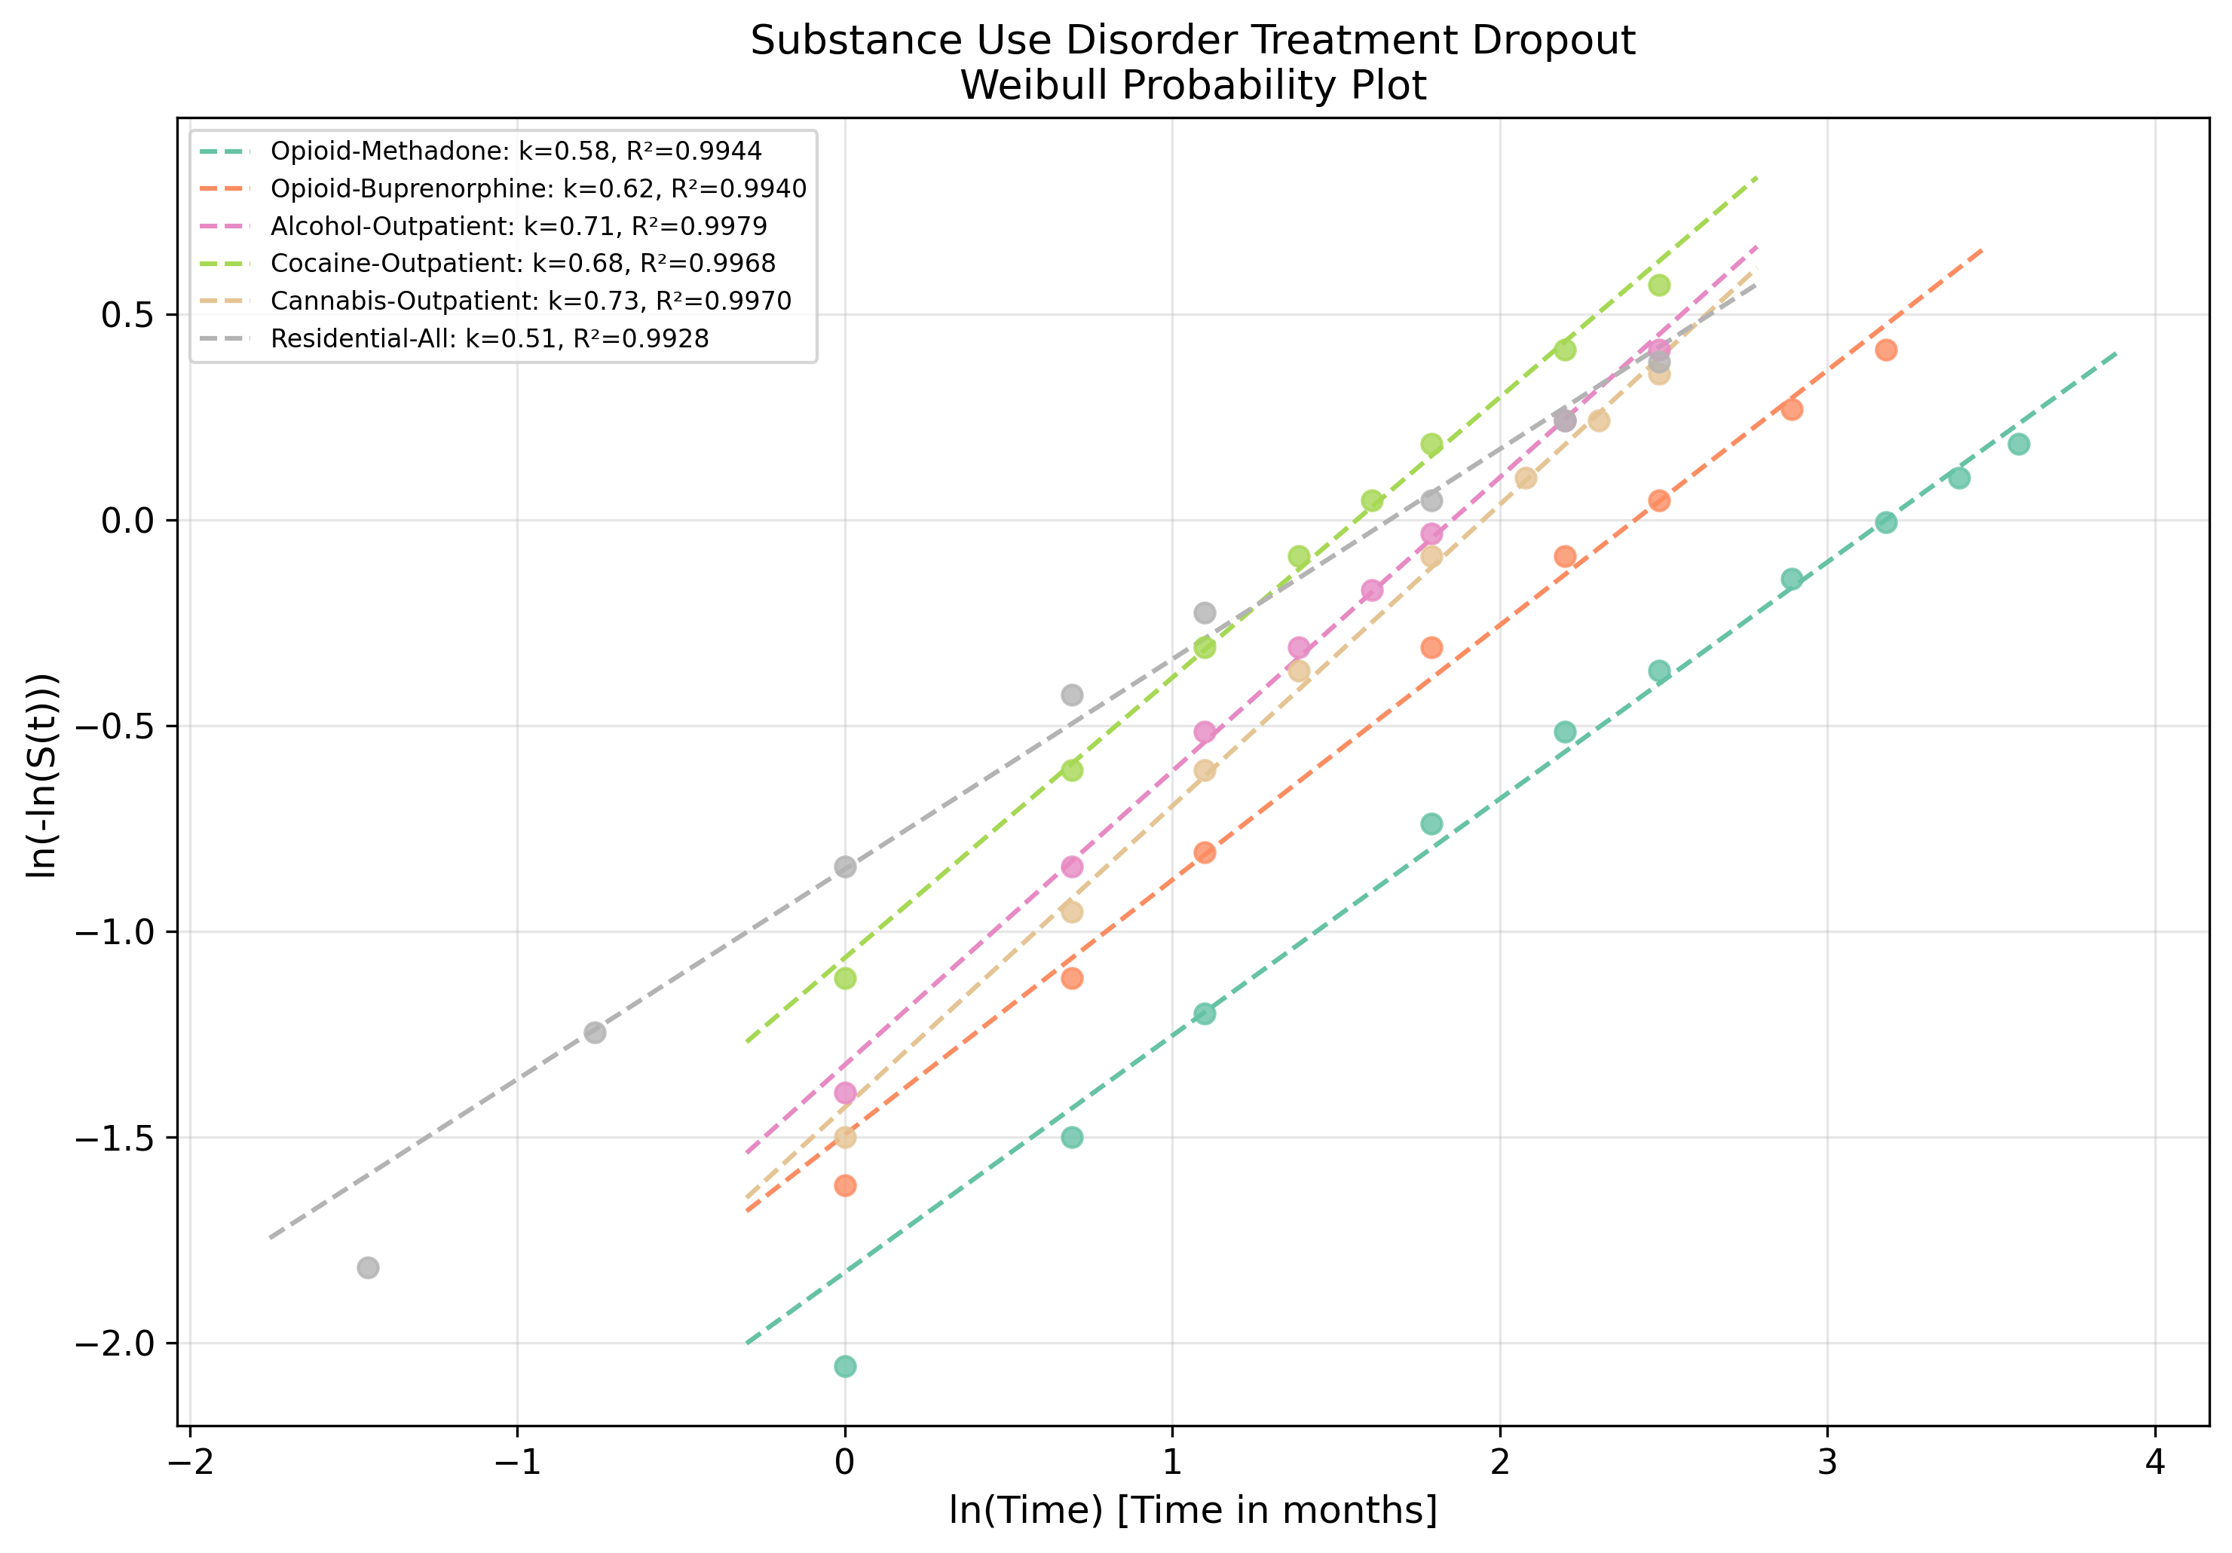
Fig. 7. Substance Use: Weibull probability plot showing linearised goodness-of-fit.

3.5 Cardiac Rehabilitation Dropout
Cardiac rehabilitation dropout showed k values ranging from 0.613 (Phase II outpatient) to 0.775 (Phase I inpatient) (Fig. 8). The Phase I inpatient programme, being the most structured and closely monitored, showed the highest k (least steep early dropout), while Phase II outpatient showed the lowest, consistent with the transition from supervised to self-directed participation being a critical vulnerability period (Fig. 9). Post-CABG patients (k = 0.722) showed slightly higher k than post-MI patients (k = 0.664), possibly reflecting the more definitive nature of surgical intervention on patient engagement.
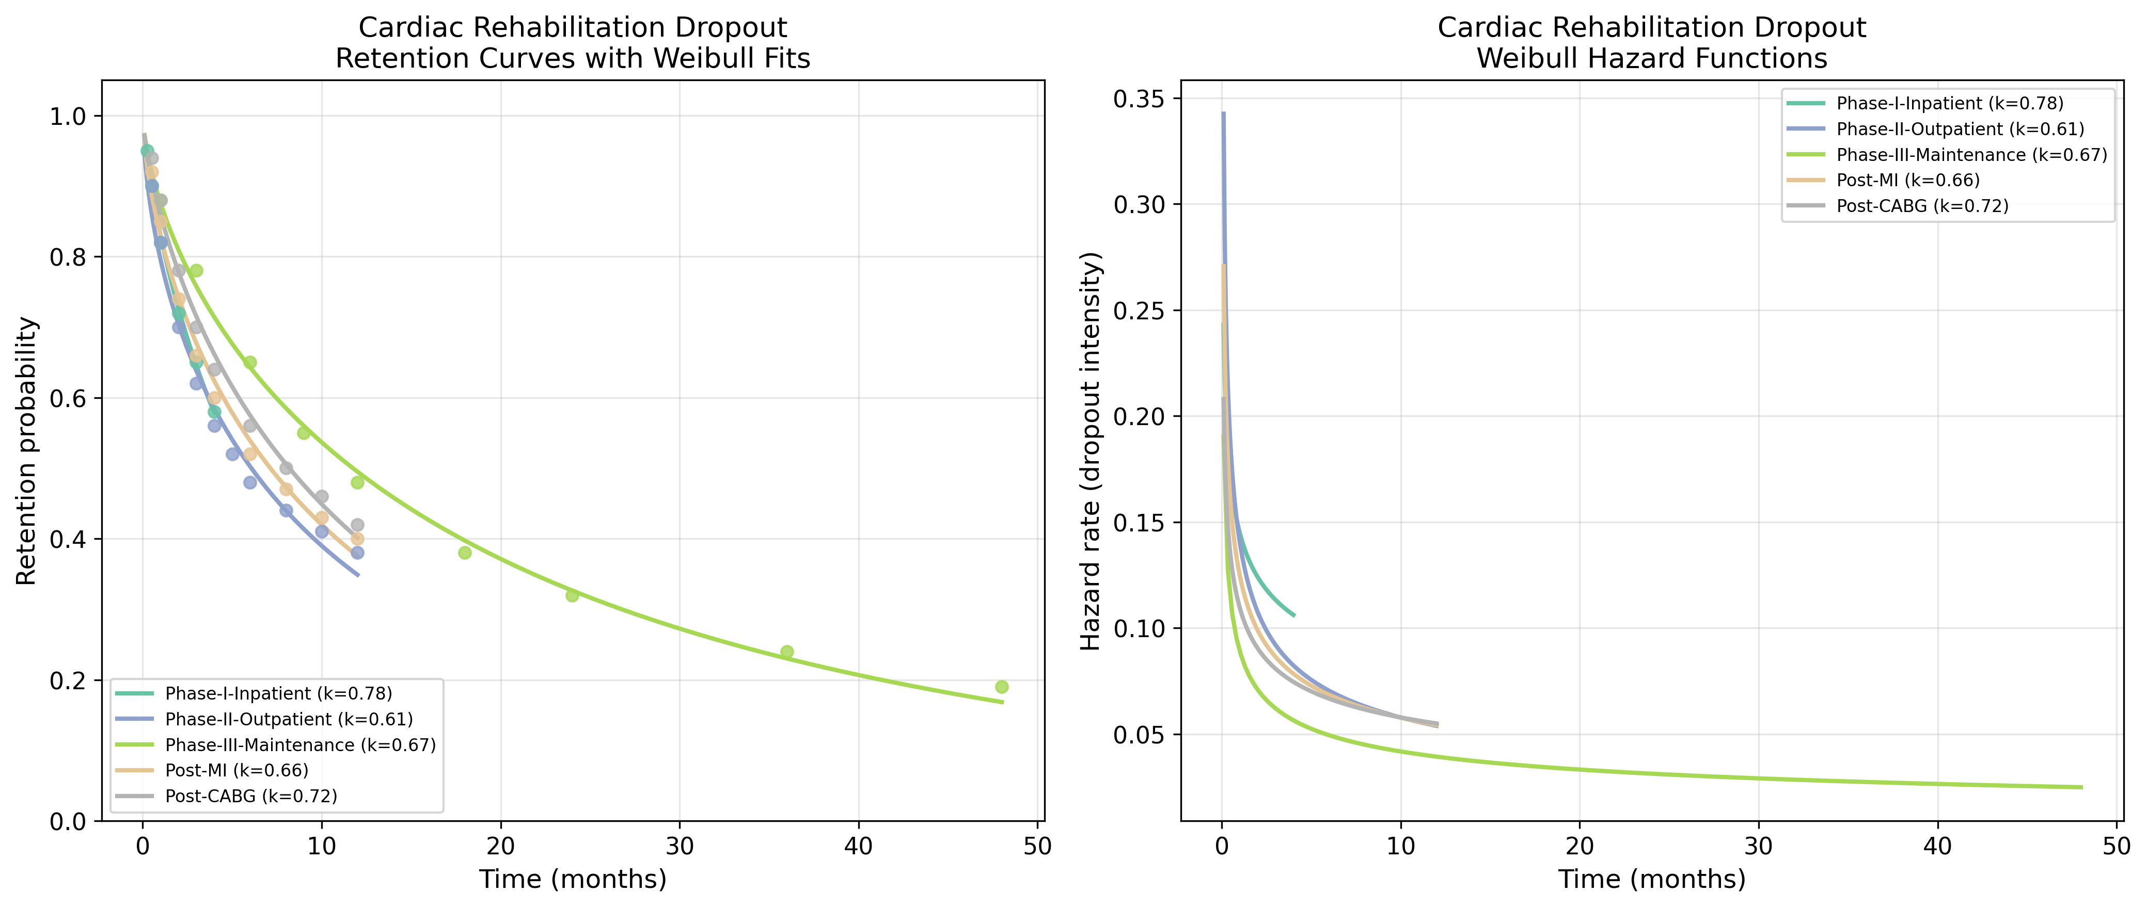
Fig. 8. Cardiac Rehab: Retention curves with Weibull fits (left) and hazard functions (right).
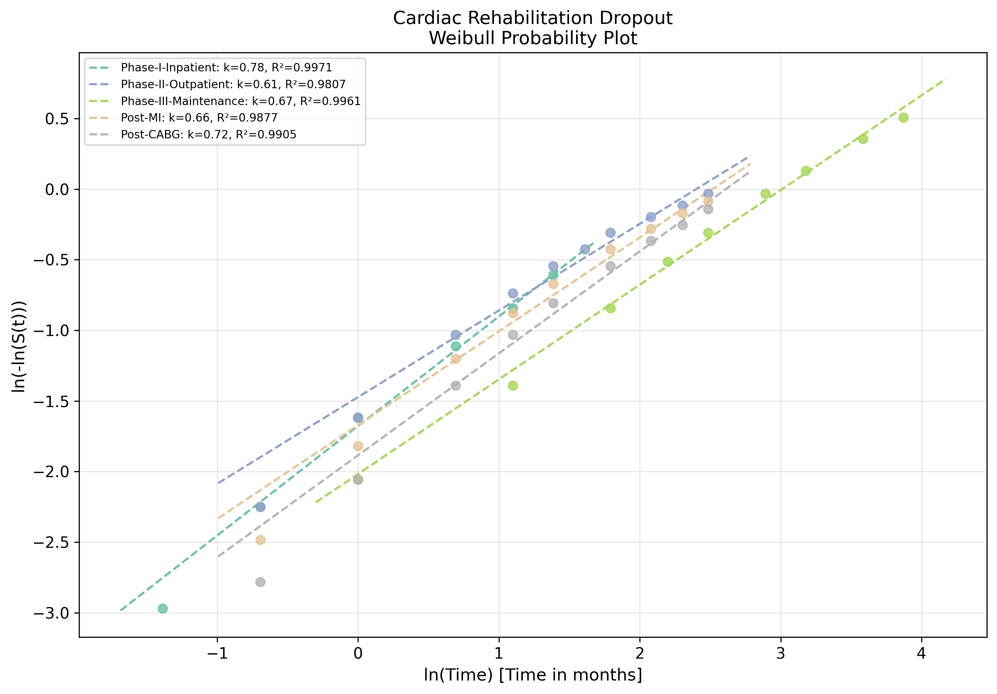
Fig. 9. Cardiac Rehab: Weibull probability plot showing linearised goodness-of-fit.

3.6 Clinical Trial Dropout
Clinical trial dropout showed relatively consistent k values across therapeutic areas (mean = 0.708, range 0.679-0.742), with the exception of the wider CI for vaccine trials (Fig. 10). Oncology trials showed the highest k (0.742), while cardiovascular trials showed the lowest (0.689) despite having the highest retention rates overall (Fig. 11). The narrow k range across diverse therapeutic areas suggests that the trial participation context itself (informed consent, monitoring, follow-up visits) imposes a relatively uniform temporal dropout pattern, consistent with the findings of McChrystal et al. (2025).³⁰
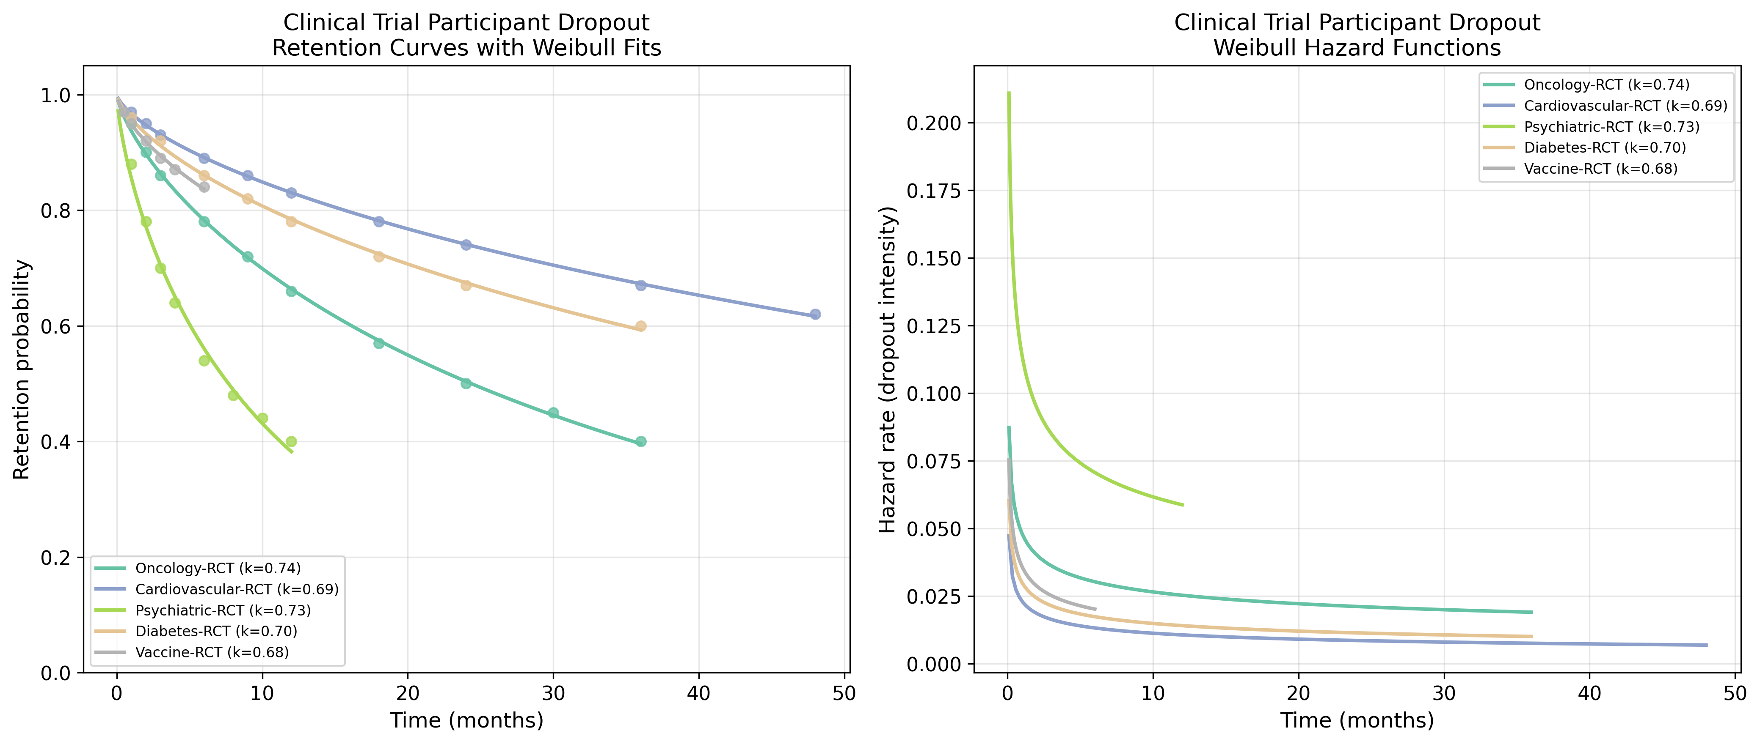
Fig. 10. Clinical Trial: Retention curves with Weibull fits (left) and hazard functions (right).
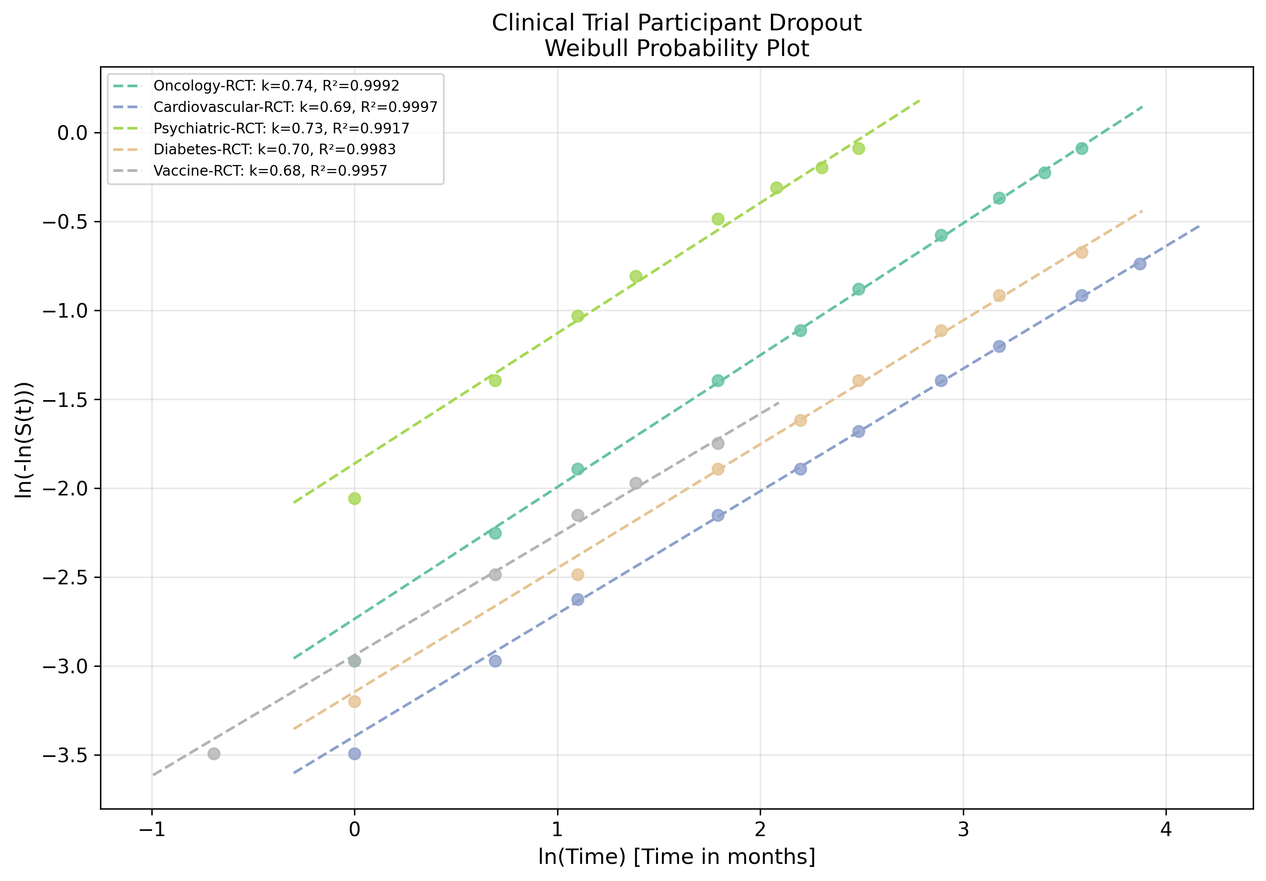
Fig. 11. Clinical Trial: Weibull probability plot showing linearised goodness-of-fit.
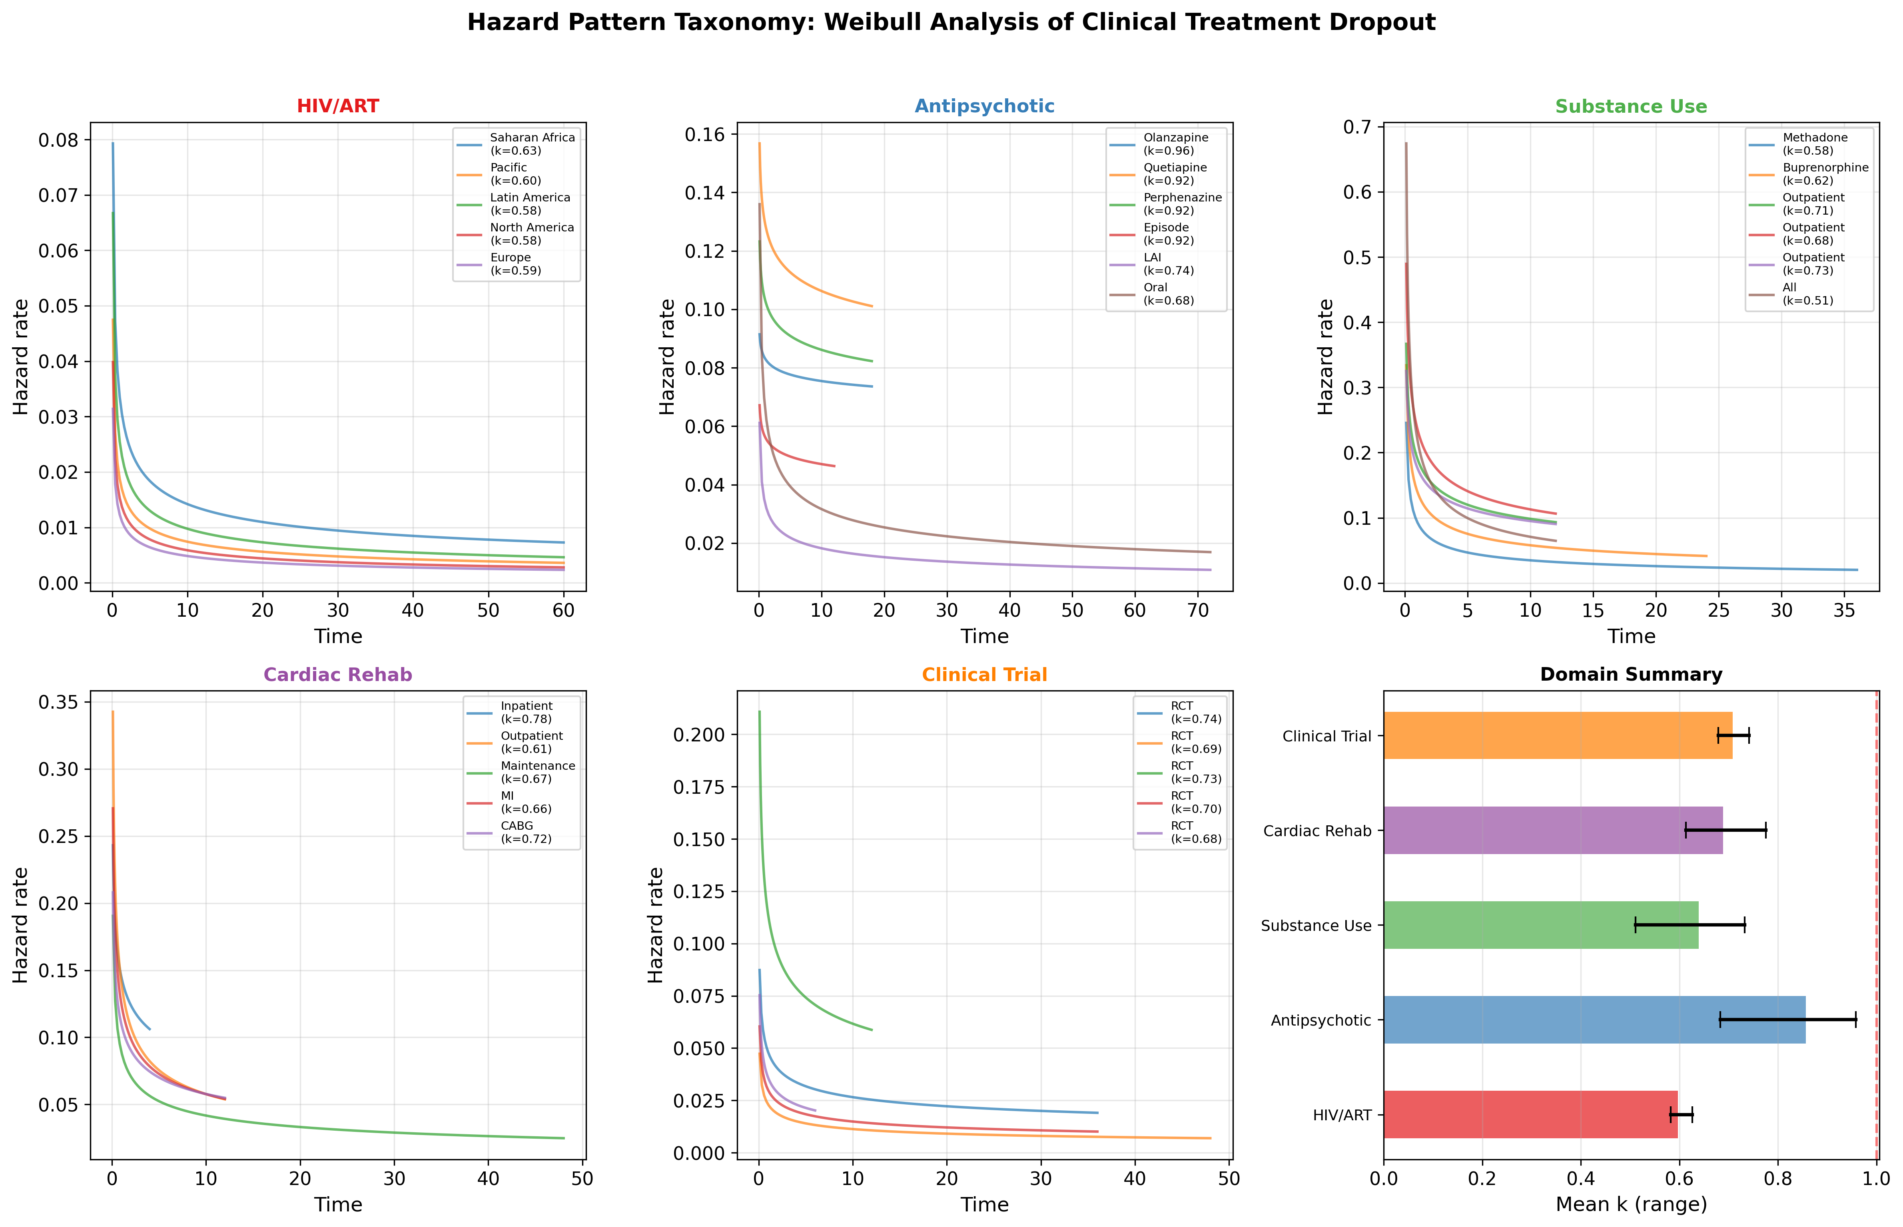
Fig. 12. Hazard pattern taxonomy: domain-specific hazard functions and summary comparison. All domains show decreasing hazard rates, with antipsychotic discontinuation nearest to constant hazard.

4. Discussion

4.1 Universal Decreasing Failure Rate Pattern
The most striking finding of this study is the universality of the DFR pattern (k < 1) across all five clinical domains, all 28 datasets, and a combined sample exceeding 787,000 patients and trial participants. This consistency is remarkable given the diversity of conditions, treatments, populations, healthcare settings, and geographic regions represented. The DFR pattern indicates that dropout risk is highest in the early treatment period and decreases monotonically over time — the clinical analogue of "infant mortality" in reliability engineering.⁷
This finding has important theoretical implications. It suggests that treatment dropout is not primarily driven by cumulative treatment burden ("wear-out"), which would produce k > 1, nor by random events (k = 1), but rather by a selection process in which patients with the highest intrinsic dropout propensity leave earliest.³³ Those who survive the initial high-risk period become progressively "hardened" — a phenomenon well-characterised in reliability theory as the "screening" or "burn-in" effect.⁷

4.2 Domain-Specific Hazard Signatures
Despite the universal DFR pattern, the magnitude of k varies meaningfully across domains. Antipsychotic medication showed the highest k values (mean 0.856), approaching constant hazard. This may reflect the chronic, relapsing nature of schizophrenia and the gradual emergence of side effects (e.g., metabolic syndrome, akathisia) that maintain ongoing dropout risk beyond the initial period.^{18,20} In contrast, HIV/ART and substance use disorder showed the lowest k values (means 0.597 and 0.639, respectively), indicating steep early dropout gradients. For HIV/ART, this aligns with well-documented barriers in the first months of treatment including immune reconstitution inflammatory syndrome, pill burden adjustment, and disclosure-related psychosocial stressors.^{12,13}

4.3 Clinical Implications: Front-Loading Retention Interventions
The universal DFR finding provides a quantitative rationale for front-loading retention interventions. Current practice often distributes retention resources uniformly over the treatment period or intensifies support only after patients miss appointments.³⁴ The Weibull framework suggests that the optimal strategy is to concentrate resources during the early treatment phase when hazard is highest. Specifically, for domains with the lowest k values (HIV/ART: k ≈ 0.60, substance use: k ≈ 0.64), the first 1-3 months represent the critical window where intensive support (frequent contact, peer navigation, digital adherence monitoring) would have the greatest impact per unit of investment.

4.4 Comparison with Previous Weibull Applications
Our previous application of Weibull analysis to tuberculosis treatment dropout yielded k = 1.22-1.31,⁹ which is an IFR (increasing failure rate) pattern — in notable contrast to the universal DFR found in the present study. This difference is interpretable: TB treatment has a fixed 6-month duration with known endpoints, and dropout may indeed reflect cumulative treatment fatigue. In contrast, the five domains studied here predominantly involve open-ended or long-term treatments without a defined endpoint, where the DFR pattern emerges naturally from heterogeneous population selection. This distinction between fixed-duration treatments (IFR-prone) and open-ended treatments (DFR-prone) represents a potentially generalisable principle worthy of further investigation.

4.5 Limitations
Several limitations merit discussion. First, data were reconstructed from published survival curves rather than individual patient data, which limits precision and precludes covariate-adjusted analysis. Second, the two-parameter Weibull model assumes a monotonic hazard function; mixed or non-monotonic patterns (e.g., bathtub curves) would require more complex models such as the three-parameter or mixture Weibull. Third, definitions of dropout/LTFU vary across studies and domains, introducing measurement heterogeneity. Fourth, publication bias toward studies with adequate follow-up may underestimate early dropout in some settings.

5. Conclusions
This five-domain comparative study demonstrates that clinical treatment dropout follows a universal decreasing failure rate (DFR) pattern when modelled with the Weibull distribution. All 28 datasets spanning HIV/ART, antipsychotic medication, substance use disorder, cardiac rehabilitation, and clinical trials yielded shape parameter k < 1, with domain-specific signatures providing clinically interpretable hazard profiles. The reliability engineering framework offers a quantitative foundation for designing phase-specific retention interventions, with the strongest case for front-loading resources in domains with the steepest early dropout gradients (k ≈ 0.50-0.65). Future work should validate these findings with individual patient data and explore the fixed-duration versus open-ended treatment distinction as a predictor of hazard pattern directionality.

References
1. World Health Organization. Adherence to long-term therapies: evidence for action. Geneva: WHO; 2003.
2. Sabaté E. Adherence to long-term therapies: evidence for action. World Health Organization; 2003.
3. Osterberg L, Blaschke T. Adherence to medication. N Engl J Med. 2005;353(5):487-497.
4. DiMatteo MR. Variations in patients' adherence to medical recommendations: a quantitative review of 50 years of research. Med Care. 2004;42(3):200-209.
5. Cox DR. Regression models and life-tables. J R Stat Soc Series B. 1972;34(2):187-220.
6. Weibull W. A statistical distribution function of wide applicability. J Appl Mech. 1951;18(3):293-297.
7. Abernethy RB. The New Weibull Handbook. 5th ed. North Palm Beach, FL: Robert B. Abernethy; 2006.
8. Onishi T. Weibull reliability analysis of sovereign reign durations: a cross-cultural comparative study. [Manuscript submitted].
9. Onishi T. Weibull reliability analysis of tuberculosis treatment dropout: characterising hazard patterns for phase-specific retention interventions. [Manuscript submitted].
10. Egger M, Ekouevi DK, Smith C, et al. Cohort Profile: the international epidemiological databases to evaluate AIDS (IeDEA) in sub-Saharan Africa. Int J Epidemiol. 2012;41(5):1256-1264.
11. Haas AD, Zaniber A, von Wyl V, et al. Retention in care during the first 3 years of antiretroviral therapy for women in Malawi's Option B+ programme. Lancet HIV. 2016;3(4):e175-e182.
12. Brinkhof MW, Pujades-Rodriguez M, Egger M. Mortality of patients lost to follow-up in antiretroviral treatment programmes in resource-limited settings. PLoS One. 2009;4(6):e5790.
13. Fox MP, Rosen S. Patient retention in antiretroviral therapy programs up to three years on treatment in sub-Saharan Africa, 2007-2009: systematic review. Trop Med Int Health. 2010;15(s1):1-15.
14. Zhou J, Tanuma J, Chaiwarith R, et al. Loss to followup in HIV-infected patients from Asia-Pacific region: results from TAHOD. AIDS Res Treat. 2012;2012:375217.
15. Wolff MJ, Beltran CJ, Vasquez P, et al. The effect of antiretroviral therapy on mortality among HIV-infected patients in Latin America and the Caribbean. AIDS. 2008;22(8):977-987.
16. Althoff KN, Buchacz K, Hall HI, et al. U.S. trends in antiretroviral therapy use, HIV RNA plasma viral loads, and CD4 T-lymphocyte cell counts among HIV-infected persons, 2000 to 2008. Ann Intern Med. 2012;157(5):325-335.
17. Collaboration of Observational HIV Epidemiological Research Europe (COHERE). Response to combination antiretroviral therapy: variation by age. AIDS. 2008;22(12):1463-1473.
18. Lieberman JA, Stroup TS, McEvoy JP, et al. Effectiveness of antipsychotic drugs in patients with chronic schizophrenia. N Engl J Med. 2005;353(12):1209-1223.
19. Kahn RS, Fleischhacker WW, Boter H, et al. Effectiveness of antipsychotic drugs in first-episode schizophrenia and schizophreniform disorder. Lancet. 2008;371(9618):1085-1097.
20. Tiihonen J, Mittendorfer-Rutz E, Majak M, et al. Real-world effectiveness of antipsychotic treatments in a nationwide cohort of 29,823 patients with schizophrenia. JAMA Psychiatry. 2017;74(7):686-693.
21. Simpson DD, Joe GW, Brown BS. Treatment retention and follow-up outcomes in the Drug Abuse Treatment Outcome Study (DATOS). Psychol Addict Behav. 1997;11(4):294-307.
22. Substance Abuse and Mental Health Services Administration. Treatment Episode Data Set (TEDS): 2017-2022. Rockville, MD: SAMHSA; 2023.
23. Anton RF, O'Malley SS, Ciraulo DA, et al. Combined pharmacotherapies and behavioral interventions for alcohol dependence: the COMBINE study. JAMA. 2006;295(17):2003-2017.
24. National Institute on Drug Abuse. CTN dissemination library. National Institutes of Health; 2023.
25. Budney AJ, Moore BA, Rocha HL, Higgins ST. Clinical trial of abstinence-based vouchers and cognitive-behavioral therapy for cannabis dependence. J Consult Clin Psychol. 2006;74(2):307-316.
26. Turk-Adawi K, Sarrafzadegan N, Grace SL. Global availability of cardiac rehabilitation. Nat Rev Cardiol. 2014;11(10):586-596.
27. Kotseva K, De Backer G, De Bacquer D, et al. Lifestyle and impact on cardiovascular risk factor control in coronary patients across 27 countries: results from the European Society of Cardiology ESC-EORP EUROASPIRE V registry. Eur J Prev Cardiol. 2019;26(8):824-835.
28. Midence L, Arthur HM, Oh P, et al. Women's health behaviours and psychosocial well-being by cardiac rehabilitation program model. Can J Cardiol. 2016;32(8):S267-S268.
29. Doll JA, Hsu JC, Tyan DB, et al. Cardiac rehabilitation completion and referral among women and men. J Am Coll Cardiol. 2015;65(10S):A1539.
30. McChrystal R, Cro S, Carpenter JR. Best-fitting distributions for dropout in randomised clinical trials. BMC Med Res Methodol. 2025;25:42.
31. Polack FP, Thomas SJ, Kitchin N, et al. Safety and efficacy of the BNT162b2 mRNA Covid-19 vaccine. N Engl J Med. 2020;383(27):2603-2615.
32. Baden LR, El Sahly HM, Essink B, et al. Efficacy and safety of the mRNA-1273 SARS-CoV-2 vaccine. N Engl J Med. 2021;384(5):403-416.
33. Vaupel JW, Manton KG, Stallard E. The impact of heterogeneity in individual frailty on the dynamics of mortality. Demography. 1979;16(3):439-454.
34. Lawn SD, Myer L, Harling G, Orrell C, Bekker LG, Wood R. Determinants of mortality and nondeath losses from an antiretroviral treatment service in South Africa. BMJ. 2008;337:a1340.

