When Should Experience Matter? Path-Invariant Selection and the Credentialisation of Experience in Higher Education

Title page

Author: [AUTHOR NAME — to be completed]
Affiliation: [AFFILIATION — to be completed]
Postal address: [ADDRESS — to be completed]
Email / telephone: [CONTACT — to be completed]
Corresponding author: [YES/NO]

Word count (main text, excl. references, tables, captions): approx. 4346
Acknowledgements: [to be completed by the author]
Funding: [to be completed by the author]
Disclosure statement: No potential conflict of interest was reported by the author(s).

Abstract
Universities increasingly evaluate applicants through experiences, activities and personal narratives as well as through demonstrated attainment. This article distinguishes two roles experience can play in selection: as an input into learning and as a credential rewarded independently of demonstrated capability. It develops the path-invariance principle — where acquisition pathways are substitutable with respect to legitimately valued attributes, equivalent demonstration of those attributes should receive equivalent evaluation unless the pathway itself carries independently legitimate information. Drawing on cultural capital, signaling and credentialist scholarship, the article shows how socially patterned experiences acquire credential value, derives six propositions linking direct assessment, substitutability and residual reliance on biography, and outlines a falsifiable research agenda. Employment selection and political candidacy serve as a structural generalisation and a boundary case.

Keywords
higher education admissions; holistic review; credentialism; cultural capital; selection theory; educational inequality

Introduction
Over the past three decades, selective universities across several systems have widened the evidentiary basis of admission. In high-participation systems, competition for positional advantage increasingly runs through what surrounds formal attainment as much as through attainment itself (Marginson 2016). Alongside examination results and grades, applicants are now routinely assessed on extracurricular involvement, leadership, volunteering, research exposure, internships, travel, awards and personal narratives — a bundle of biographical materials processed through what is usually called holistic review (Karabel 2005; Stevens 2007; Posselt 2016; Warikoo 2016). In the United Kingdom, contextualised admissions similarly ask selectors to read attainment against opportunity (Boliver, Gorard and Siddiqui 2015; Gorard et al. 2019). These developments rest on a defensible intuition: a transcript alone is a thin description of an applicant, and experience can be genuinely developmental.
Yet experience can enter selection in two fundamentally different ways. It can function as an input into learning: a pathway by which an applicant became capable. Or it can function as a credential: a fact about a biography that is rewarded independently of whether it produced, or signals, anything the institution actually values. The distinction matters because access to institutionally prized experiences is socially patterned. Participation in organised activities has grown sharply more stratified by class (Snellman et al. 2015); the content and style of admissions essays correlate with household income more strongly than test scores do (Alvero et al. 2021); and at highly selective private colleges, non-academic credentials account for a substantial share of the admissions advantage enjoyed by applicants from the richest families (Chetty, Deming and Friedman 2026). When experience is rewarded as a credential rather than read as evidence, an equity-motivated expansion of what universities count can quietly convert unequal access to experience into unequal selection outcomes.
This development is not confined to systems built on the United States model. High-participation systems generally intensify positional competition at the margin of entry (Marginson 2016), and the specific instruments differ — aptitude tests, essays, interviews, 'personal statements', portfolios — but the underlying question is the same everywhere: which facts about an applicant's history should count, and why. Examination-dominant systems are not exempt either; where biography is formally excluded, informal channels (coaching, private tuition, school choice) may carry the equivalent inequality outside the selection file. The framework developed here is therefore a general one about selection architecture, even though its primary illustration is holistic and experience-sensitive review.
This article develops a framework for deciding when the pathway through which an applicant acquired a capability should itself matter in selection. Its centrepiece is a conditional normative principle we call path invariance: where acquisition pathways are substitutable with respect to the attributes a selecting institution legitimately values, applicants who demonstrate equivalent attributes should not be evaluated differently merely because they acquired them differently — unless the pathway carries independently legitimate, outcome-relevant information. Path invariance is not biography blindness. It is a demand that any weight placed on the pathway be justified: either the pathway is itself among the attributes the institution values, or the biography is serving as a proxy whose weight should decline as the underlying attribute becomes directly observable.
University admissions is the article's primary case, and it is there that the argument does its main work. Employment selection appears as a structural generalisation — the same architecture in which curricula vitae and employer histories play the role that extracurricular records play in admissions. Political candidate evaluation appears briefly as a boundary case: a selection environment in which the target construct is unusually hard to observe directly, and in which, therefore, residual reliance on biography is unsurprising and partially legitimate. These excursions exist only to clarify the higher-education argument.
The article makes four contributions. First, it separates experience-as-development from experience-as-credential and shows that the two are routinely conflated in admissions practice and debate. Second, it states a defensible criterion — path invariance — for when biographical information should retain independent selection weight, and distinguishes this criterion from measurement invariance, incremental validity, signaling and credentialist accounts to which it is related but not identical. Third, it reframes a documented empirical pattern — the social stratification of experience — as a conditional mechanism, the experience–equality paradox, through which well-intentioned broadening of selection criteria can open new channels for privilege. Fourth, it offers six propositions and a compact empirical agenda connecting the framework to evidence.

Two roles for experience
Consider an applicant who spent a summer conducting field research. That experience may be valued intrinsically; it may have contributed to the applicant's knowledge, discipline and judgement; and it may affect a selector's evaluation simply because the fact of having done it reads well on a form. These are distinct channels, and they deserve distinct names. Let the value of an experience decompose as V(E) = V_intrinsic + V_learning + V_credential: value in itself, value as contribution to competence, and value as a fact rewarded in later selection. The three need not coincide. A demanding rural clinic placement might carry large V_learning and negligible prestige; a short membership in a well-branded society might carry mostly V_credential.
The same distinction applies to the causal structure of selection. Resources and opportunities (R) enable experience (E); experience builds competence (K); competence produces later outcomes (Y). Alongside this developmental pathway runs a second: experience produces a credential signal that enters the evaluation (A) directly (Figure 1). Nothing in this second pathway requires that E changed anything about the applicant that the institution values. Its existence is the phenomenon this article analyses.
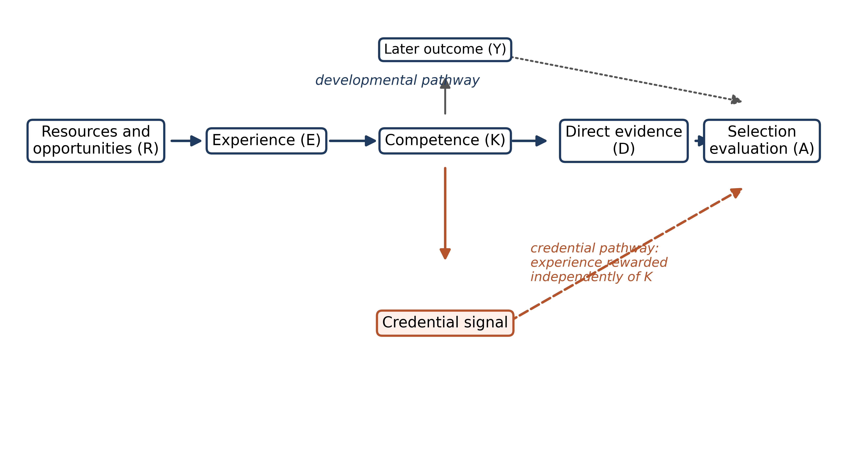
Figure 1. See caption list.
Two clarifications are essential. First, the claim that experience can be educationally valuable without being independently selection-relevant is not a paradox but a category distinction: V_learning concerns what the experience did for the applicant, V_credential what the record of the experience does to the selector. Second, the framework does not presume that selection should maximise prediction alone. Institutions legitimately define the attributes they care about — we denote this set Z — and Z can include qualities (commitment, curiosity, contribution to a cohort) that grades do not capture. The argument turns not on what is in Z but on whether biography earns weight after Z's contents have been observed as directly as practicable.
The distinction has an institutional pedigree worth acknowledging. Admissions offices did not adopt holistic review carelessly: studies of elite admissions show selectors actively construct 'merit' through case-by-case judgement, weighing context, narrative and institutional priorities together (Karabel 2005; Stevens 2007; Posselt 2016). That process is genuinely informative. The problem this article isolates is not the use of biography but the silent equivocation between its two functions, which allows weight to accumulate on the credential pathway without any decision that it should.

The path-invariance principle
We can now state the principle precisely. Let P denote the acquisition pathway of an attribute and A the selection evaluation. Path invariance holds that A should be independent of P conditional on the attributes the institution legitimately values — schematically, A ⊥ P | Z. In its narrowest form: where two applicants demonstrate equivalent relevant competence, K_i = K_j should imply A_i = A_j, provided the pathway itself carries no independently legitimate Z-relevant information (Figure 2).
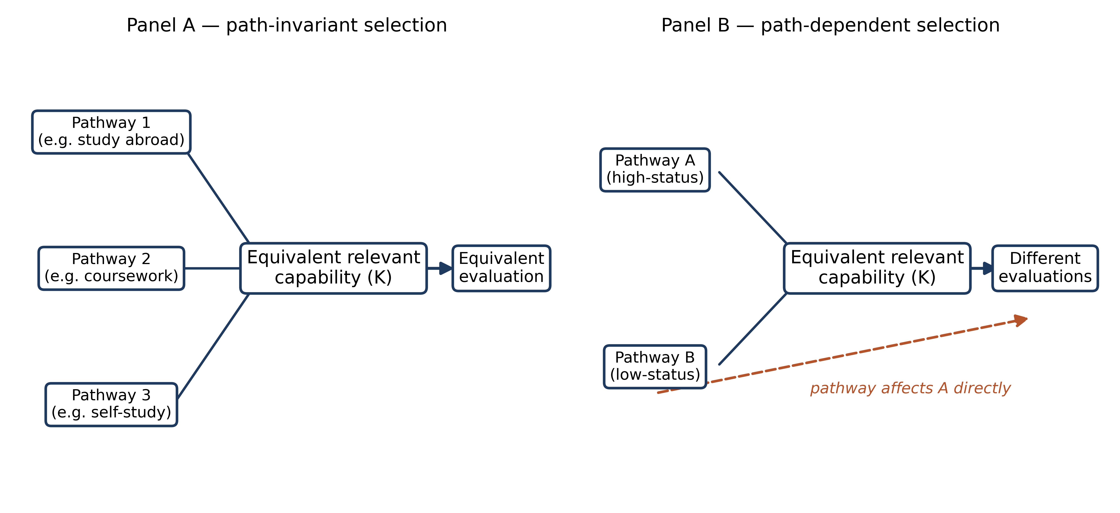
Figure 2. See caption list.
The proviso does substantial work and must not be lost. If a university decides — openly and on defensible grounds — that it values something experience itself supplies, then that something belongs in Z, and differential weight is not a violation of path invariance but a definition of the selection objective. A conservatoire may legitimately value embodied ensemble experience; a university may legitimately value evidence of contribution to a residential community. Path invariance does not adjudicate the contents of Z. It disciplines the residual: biography that operates merely as a proxy for a component of Z should lose weight as that component becomes more directly observable, and should not accumulate weight simply because the proxy is visible, certifiable, or competitively produced.
Two points about Z deserve emphasis. Z is the set of attributes the institution explicitly and legitimately treats as selection-relevant; path invariance does not itself determine Z's contents. What the framework requires is a separation between two kinds of material: attributes the institution intrinsically intends to value, and biographical proxies invoked because those attributes are imperfectly observable. Disagreement over what belongs in Z — how far selection should serve predictive, developmental, or compositional aims — is a distinct normative and institutional question on which the framework takes no position. Its discipline applies after the target is specified: proxies for Z-contents should carry only the residual weight justified by observational limits.
Path invariance is related to, and easily confused with, several established constructs. It is not measurement invariance, which concerns whether an instrument measures the same construct across groups (Millsap 2011); path invariance concerns whether an evaluator should weight the route by which an attribute was acquired once the attribute itself is observed. It is not incremental validity, which is an empirical question about predictive gain (Sackett and Lievens 2008); path invariance is a normative requirement of justification that survives even where incremental prediction is nil. And it is not equality-of-opportunity theory in Roemer's (1998) sense: it does not partition outcomes into circumstance and effort but asks what selectors may legitimately reward. What is common to all three neighbours is a concern with justified inference; what distinguishes path invariance is that its object is the weight placed on the pathway itself.

University admissions: the primary case
Admissions practice institutionalises both pathways of Figure 1 simultaneously. Selective systems request grades and scores — evidence read, at least in intention, as direct indicators of academic capability — alongside biographical material whose function is ambiguous between evidence of development and credential. The ambiguity is not accidental. Holistic review is valuable precisely because it lets institutions decide, file by file, what counts (Stevens 2007; Posselt 2016). But ambiguity has a cost: it allows the credential pathway to expand without any explicit decision that it should.
The empirical record suggests the expansion is consequential. Extracurricular participation, leadership and enrichment activities are stratified by parental resources and school context (Snellman et al. 2015; Covay and Carbonaro 2010). Admissions essays encode social class in content and style (Alvero et al. 2021). Elite employers have been shown to apply a secondary biographical screen on the status of applicants' extracurricular accomplishments, importing admissions logic into hiring (Rivera 2011). And in the most detailed admissions microdata yet analysed, the admissions advantage of top-1% income applicants at Ivy-Plus colleges is driven substantially by non-academic credentials — personal, extracurricular and athletic ratings — rather than by differences in academic indicators (Chetty, Deming and Friedman 2026). The developmental pathway S → E → K is real; but so is the credential pathway S → E → A.
Path invariance implies a diagnostic question admissions offices can ask of any biographical criterion: what in Z is this evidence of, and do we already observe that attribute more directly elsewhere in the file? Volunteering read as evidence of commitment to others is appropriately weighed against other evidence of that attribute; volunteering rewarded because the activity itself is prestigious is credential weight that requires its own justification. The distinction between contextual interpretation — reading attainment relative to opportunity, as in UK contextualised admissions (Boliver, Gorard and Siddiqui 2015) — and independent credential value — rewarding the possession of experience — is crucial here, and the framework protects it deliberately. Contextual information used to interpret K is inside the developmental pathway; independent weight on E is the credential pathway.
Consider the two most common defences of biographical weight. The first is predictive: experiences proxy attributes (persistence, time management, engagement) that grades under-measure. Where that defence holds, the framework is permissive — but it also predicts that the weight should migrate to better direct measures as they become available, and it generates the audit question of what the proxy adds beyond them. The second is expressive: the experience is itself the point, because the institution values a cohort composition or a form of demonstrated commitment. That defence is legitimate but should be owned explicitly, because it can convert selection into a statement about which biographies the institution prices — and that is exactly the channel through which stratified access becomes stratified selection (Snellman et al. 2015; Chetty, Deming and Friedman 2026).

The experience–equality paradox
The stratification of experience motivates a sharpened statement of a tension already visible in the literature. Broadening selection criteria beyond academic metrics is often justified on equity grounds: tests correlate with socioeconomic status (Sackett et al. 2009) and biography can reveal merit that grades obscure. The paradox arises when the broadened criteria themselves carry independent credential value. If resources produce experiences and selectors reward the experiences, then widening what counts can widen the channels through which resources are converted into admission — even while the experiences genuinely develop the applicants who had them.
We state this conditionally and without claiming that holistic admissions necessarily increase inequality, that the net effect of experience-sensitivity is regressive, or that tests are fair. The claim is narrower and, we think, unimpeachable: a selection architecture that assigns independent value to socially patterned experiences can create a conversion mechanism between opportunity inequality and selection inequality. Whether the mechanism operates depends on the residual weight biography carries after direct observation — which is exactly what path invariance governs. Test-optional policy offers a suggestive illustration: adopting colleges improved perceived selectivity more reliably than diversity (Belasco, Rosinger and Hearn 2015), a pattern consistent with weight shifting onto channels (rigour of curriculum, essays, activities) that are themselves socially patterned rather than onto unpatterned assessment.

Residual biographical value and the direct-measurement continuum
To make the residual-weight idea usable, define residual biographical value informally as the outcome-relevant information that biography adds once valid direct evidence is in hand — in information terms, I(Y ; B | D), with the regression analogue R²(D + B) − R²(D). This is illustrative rather than a proposed statistic: residual value is not restricted to linear prediction, and prediction is not the only legitimate institutional objective. The concept matters because it generates a directional expectation: for biography whose relevance operates through a directly assessed construct, better direct measurement should shrink residual biographical value. Quality(D) up, RBV down — conditional on adequate construct coverage, reliability, an appropriate criterion, no important omitted attributes, and sufficient directness of measurement.
The limiting thought experiment clarifies the logic: if an institution could perfectly observe every present attribute it legitimately cares about, which facts about an applicant's past would it still need? Only those that are themselves in Z or that evidence attributes Z includes but observation cannot reach. Any remaining weight would require justification as credential weight rather than as evidence of the attributes directly observed. No institution achieves such observation, and the article claims nothing about its feasibility; the thought experiment functions as an audit standard, not a technology proposal. Figure 3 places the article's three selection environments on a continuum defined by the feasibility and validity of direct measurement: employment selection sits relatively high (work samples and simulations are established and strongly predictive; Schmidt and Hunter 1998), university admissions intermediate, and political candidate evaluation lowest — where residual reliance on biography is correspondingly largest and partially legitimate. Blind orchestral auditions — a celebrated case of deliberately engineered direct assessment that altered selection outcomes (Goldin and Rouse 2000) — illustrate how even partial direct evidence can reorganise an evaluation regime built on biography. Table 1 lays out the three environments; Table 2 summarises the framework's relation to existing theory.
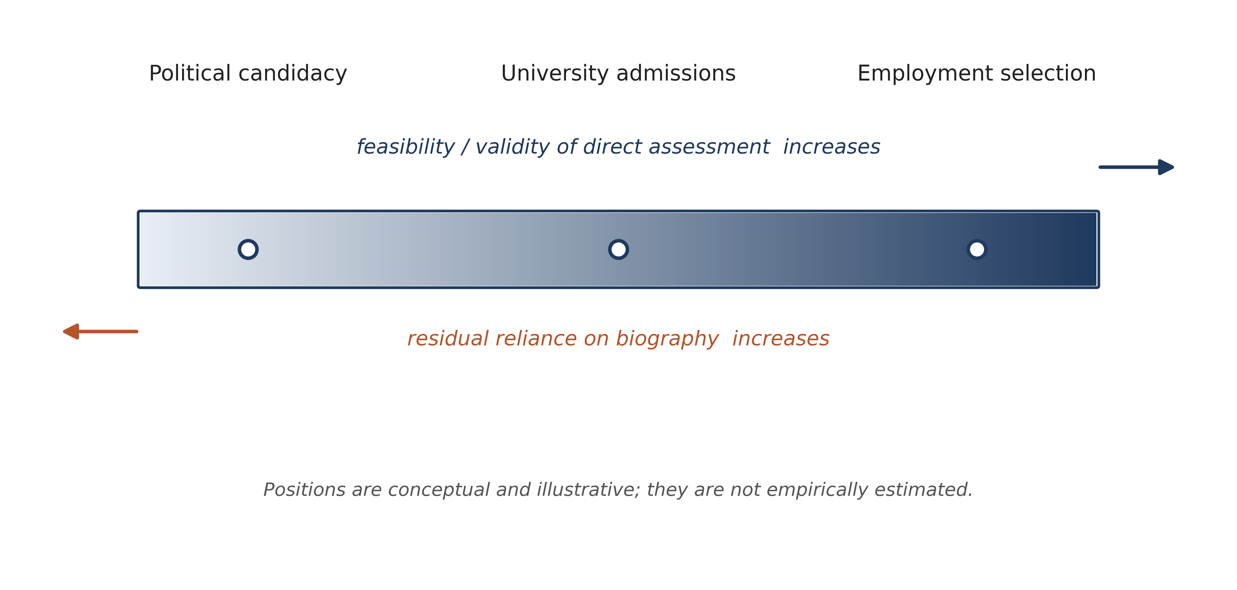
Figure 3. See caption list.

Relations to existing theory
The framework borrows from, but is not reducible to, four traditions. Human-capital and signaling accounts supply the two competing explanations of educational returns (Becker 1993; Weiss 1995); the framework is agnostic between them because it concerns evaluator weighting rather than the source of returns. Signaling theory (Spence 1973; Arrow 1973; Stiglitz 1975) explains why selectors rely on credentials when the target attribute is unobserved. Path invariance asks the question signaling leaves open: what should happen to the signal's independent weight once the attribute becomes observable? The conditional prediction — signal weight should decline with residual uncertainty — is consistent with signaling logic but is not a statement signaling theory itself makes. Cultural capital (Bourdieu 1986; Bourdieu and Passeron 1990; Lareau 2011; Khan 2011) explains why access to valued experiences, and fluency in presenting them, is stratified. The present contribution begins where that literature ends: given stratified production of experience, when should selectors keep rewarding the pathway after its competence consequence is independently observable? Credentialism (Collins 1979; Dore 1976; Collins 2011) documents institutional dependence on credentials and their inflationary dynamics; path invariance supplies an evaluative criterion for when residual credential dependence remains justified rather than a description of that dependence. Finally, the validity and fairness tradition (American Educational Research Association, American Psychological Association and National Council on Measurement in Education 2014; Millsap 2011) supplies the standards direct assessment must meet; the framework depends on it rather than competing with it. Campbell's law and related reactivity dynamics (Campbell 1979; Goodhart 1984; Espeland and Sauder 2007) govern what happens when credential weight becomes public knowledge — a point returned to below.

Substitutable and non-substitutable experience
The strength of the path-invariance case varies with substitutability. For attributes that different pathways plausibly produce equivalently — academic knowledge, conceptual understanding, language competence, analytical reasoning — the case for pathway-blind weighting is strong: a self-taught applicant and a summer-school applicant who demonstrate the same capability should be indistinguishable to the selector qua capability. For attributes that are embodied, interactive or context-bound — clinical skill, laboratory technique, ensemble musicianship, professional judgement — the case is weaker in one respect only: the pathway may itself contain legitimately relevant information, because having genuinely done the practice is partly constitutive of the capability. Even here, however, undergoing the experience must be distinguished from being able to perform the resulting capability; the framework therefore supports performance assessment — auditions, practicals, work samples — rather than experience counting, precisely in the domains where pathway and competence are hardest to separate.

A structural generalisation and a boundary case
Employment selection exhibits the same architecture with the roles relabelled: curriculum vitae, degrees and employer histories stand in for extracurricular records; job performance is the outcome; and work samples, simulations and structured assessments provide comparatively strong direct evidence (Schmidt and Hunter 1998; Sackett and Lievens 2008). The generalisation illustrates two further features of the framework. First, distal credentials should contribute less incremental information as reliable proximal evidence accumulates — a plausible descriptive regularity consistent with the stronger validity of proximal measures. Second, screening improvements need not harm disadvantaged groups: when both the informal screen and the test are roughly unbiased, replacing informal screens with direct testing raised productivity without reducing minority hiring in the best naturalistic study available (Autor and Scarborough 2008). This section deliberately stops short of a personnel-psychology review; its function is to show that the admissions problem is one instance of a wider selection architecture.
Political candidate evaluation occupies the opposite end of the continuum. Governing or representative competence cannot be directly sampled before the fact, so electorates and parties rely on biography — education, occupation, prior office, record — and on imperfect proxies of contemporaneous capability such as debates and policy forums (Popkin 1991). Debates in particular measure not only governing-relevant judgement but verbal fluency, preparation, media skill and strategic performance; they are direct evidence of a partially different construct. Politics therefore marks the boundary condition of the framework: where valid direct measurement is least feasible, residual reliance on biography is largest and its legitimacy least easily displaced. The example is illustrative only — no real candidacies are evaluated — and its function is to delimit, not extend, the higher-education argument.

Propositions and a compact empirical agenda
The framework generates six propositions, three normative and three empirical; all are stated conditionally and none claims more than the argument supports.
- P1 (normative). Path invariance. For acquisition pathways substitutable with respect to legitimately valued attributes, selection evaluation should become increasingly independent of pathway as direct evidence of those attributes improves.
- P2 (empirical). Direct-assessment substitution. For biography operating primarily as a proxy, improvements in the quality of direct assessment reduce residual biographical value.
- P3 (normative). Experience credentialisation. When socially patterned experiences receive independent selection value, they can create a pathway through which opportunity inequality is converted into credential inequality; the strength of that pathway increases with the independent weight placed on the experiences.
- P4 (normative). Substitutability. The stronger the substitutability among acquisition pathways, the stronger the case for path-invariant selection.
- P5 (empirical). Distal-credential attenuation. Distal credentials contribute less incremental information where reliable proximal performance evidence is available.
- P6 (empirical). Measurement boundary. Residual reliance on biography is — and may legitimately remain — greater where direct measurement of the relevant construct is less feasible.
A seventh, empirical, expectation follows from Campbell-type dynamics: the larger the independent credential premium on an experience, the stronger the incentive to produce or present it strategically (Campbell 1979; Espeland and Sauder 2007).
One clarification about the framework's status sharpens the propositions' logic. Path invariance has two connected but distinct components: a normative claim that, for substitutable pathways, equivalent demonstrated attributes should not be weighted differently merely because of acquisition route (P1, P4); and an informational or empirical expectation that biography functioning primarily as a proxy contributes less residual information as valid direct evidence improves (P2, P5, P6). The empirical expectations can be tested independently of whether a reader accepts the normative principle, and vice versa — a reader might accept P2 descriptively while disputing P1's institutional conclusion.
Three designs would test the framework without requiring heroic data. (i) An admissions vignette experiment: hold demonstrated competence constant, randomise the acquisition pathway (study abroad, formal coursework, self-study, online learning, community exposure), and measure admissions recommendations; non-zero pathway effects conditional on demonstrated capability estimate residual credential weight directly (P1, P3). (ii) A direct-evidence experiment: vary the quantity and quality of direct assessment available to evaluators and test whether biographical effects decline as credible direct evidence increases (P2, P5). (iii) An employment analogue: hold work-sample performance constant and randomise distal credentials (institutional prestige, early-career employer), predicting attenuation of credential effects as proximal evidence accumulates (P5). Each design is feasible with selector or proxy-evaluator samples and addresses a propositional component, keeping the agenda proportionate to a conceptual article.

Objections and boundary conditions
Several strong objections deserve direct answers rather than footnotes. Universities do not merely predict grades: correct, and the framework's Z is deliberately broader than any criterion — but this expands what legitimate pathway content can be, not the license for unjustified credential weight. Education has constitutive and developmental purposes: precisely why V_learning and V_intrinsic are separated from V_credential; the article criticises rewarding the record, not having the experience. Standardised tests reproduce inequality: partially true (Sackett et al. 2009), which is why the argument never recommends a testing technology and insists contextual interpretation of attainment is inside the framework, not opposed to it. Direct assessment can be coached: yes — Campbell dynamics apply to D too, which is why P2 is conditional on quality and construct coverage rather than on the mere existence of a measure. Soft skills resist direct measurement: the substitutability section concedes this and derives performance assessment as the appropriate response, not experience counting. Past behaviour predicts beyond present tests: where it does, biography retains genuine residual value and the framework says so — RBV is the space for that claim, not a denial of it. Path invariance ignores unequal opportunities to develop competence: the opposite — the experience–equality paradox exists because opportunities are unequal, and the framework's requirement is only that institutions choose explicitly whether to address that inequality through contextual interpretation or through credential weight. Holistic review contextualises disadvantage rather than rewarding privilege: both mechanisms operate in the same files (Stevens 2007; Chetty, Deming and Friedman 2026), and the framework's purpose is to separate them. Finally, the overlap objections — to signaling, credentialism, incremental validity — are answered in the theory section: the article claims a conditional evaluative criterion, not a new measurement property, a new sociology of credentials, or a new statistic.
Taken together, the objections sharpen rather than undermine the proposal. Every serious counterexample — constitutive purposes, valued experiences, coaching of direct measures, hard-to-observe constructs, residual predictive biography — corresponds to a clause already inside the framework: the breadth of Z, the proviso on independently legitimate pathway information, the quality conditions on P2, the substitutability gradient, and the space RBV reserves for genuine residual value. What the framework adds is not permissiveness or restriction but a location for the argument: any disputed weight must be assigned either to Z, to legitimate pathway information, or to residual proxy value — and the third should shrink as the second's objects become observable.

Conclusion
Higher education increasingly selects on biography on the reasonable grounds that grades and scores are incomplete evidence. This article has argued that the defensibility of that practice turns on a distinction the literature has not made sharp: experience as a means of becoming capable versus experience as something independently rewarded. The path-invariance principle supplies the criterion: reward the pathway only when the pathway is itself legitimately valued or carries information that the institution's valued attributes cannot otherwise reach. The practical implication is not a particular admissions technology but a discipline of institutional self-knowledge: universities should improve their ability to specify and observe the attributes they genuinely value — through whatever mix of evidence serves — rather than assuming that ever richer biographies necessarily yield fairer or more valid selection.

Disclosure statement
No potential conflict of interest was reported by the author(s). [Placeholder — to be completed by the author.]

Funding
[Placeholder — funding statement to be completed by the author, or deleted if none.]

Acknowledgements
[Placeholder — to be completed by the author.]

References
Alvero, A. J., S. Giebel, B. Gebre-Medhin, a. l. antonio, M. L. Stevens and B. W. Domingue. 2021. "Essay Content and Style Are Strongly Related to Household Income and SAT Scores: Evidence from 60,000 Undergraduate Applications." Science Advances 7 (42): eabi9031. doi:10.1126/sciadv.abi9031.
American Educational Research Association, American Psychological Association, and National Council on Measurement in Education. 2014. Standards for Educational and Psychological Testing. Washington, DC: American Educational Research Association.
Arrow, K. J. 1973. "Higher Education as a Filter." Journal of Public Economics 2 (3): 193–216. doi:10.1016/0047-2727(73)90013-3.
Autor, D. H., and D. Scarborough. 2008. "Does Job Testing Harm Minority Workers? Evidence from Retail Establishments." Quarterly Journal of Economics 123 (1): 219–277. doi:10.1162/qjec.2008.123.1.219.
Becker, G. S. 1993. Human Capital. 3rd ed. Chicago: University of Chicago Press. (Original work published 1964.)
Belasco, A. S., K. O. Rosinger and J. C. Hearn. 2015. "The Test-Optional Movement at America's Selective Liberal Arts Colleges: A Boon for Equity or Something Else?" Educational Evaluation and Policy Analysis 37 (2): 206–222. doi:10.3102/0162373714537350.
Bills, D. B. 2003. "Credentials, Signals, and Screens: Explaining the Relationship between Schooling and Job Assignment." Review of Educational Research 73 (4): 441–449. doi:10.3102/00346543073004441.
Boliver, V. 2013. "How Fair Is Access to More Prestigious UK Universities?" British Journal of Sociology of Education 34 (3): 344–364. doi:10.1080/01425692.2013.777774.
Boliver, V., S. Gorard and N. Siddiqui. 2015. "Will the Use of Contextual Indicators Make UK Higher Education Admissions Fairer?" Education Sciences 5 (4): 306–322. doi:10.3390/educsci5040306.
Bourdieu, P. 1986. "The Forms of Capital." In Handbook of Theory and Research for the Sociology of Education, edited by J. Richardson, 241–258. New York: Greenwood.
Bourdieu, P., and J.-C. Passeron. 1990. Reproduction in Education, Society and Culture. 2nd ed. London: Sage.
Campbell, D. T. 1979. "Assessing the Impact of Planned Social Change." Evaluation and Program Planning 2 (1): 67–90. doi:10.1016/0149-7189(79)90048-X.
Chetty, R., D. J. Deming and J. N. Friedman. 2026. "Diversifying Society's Leaders? The Determinants and Causal Effects of Admission to Highly Selective Private Colleges." Quarterly Journal of Economics 141 (1): 51–145. doi:10.1093/qje/qjaf050.
Collins, R. 1979. The Credential Society: An Historical Sociology of Education and Stratification. New York: Academic Press.
Collins, R. 2011. "Credential Inflation and the Future of Universities." Italian Journal of Sociology of Education 3 (2): 228–251. doi:10.14658/PUPJ-IJSE-2011-2-12.
Covay, E., and W. Carbonaro. 2010. "After the Bell: Participation in Extracurricular Activities, Classroom Behavior, and Academic Achievement." Sociology of Education 83 (1): 20–45. doi:10.1177/0038040710385547.
Dore, R. 1976. The Diploma Disease: Education, Qualification and Development. London: Allen & Unwin.
Espeland, W. N., and M. Sauder. 2007. "Rankings and Reactivity: How Public Measures Recreate Social Worlds." American Journal of Sociology 113 (1): 1–40. doi:10.1086/517897.
Espenshade, T. J., and C. Y. Chung. 2005. "The Opportunity Cost of Admission Preferences at Elite Universities." Social Science Quarterly 86 (2): 293–305. doi:10.1111/j.0038-4941.2005.00303.x.
Espenshade, T. J., and A. W. Radford. 2009. No Longer Separate, Not Yet Equal: Race and Class in Elite College Admission and Campus Life. Princeton, NJ: Princeton University Press.
Goldin, C., and C. Rouse. 2000. "Orchestrating Impartiality: The Impact of 'Blind' Auditions on Female Musicians." American Economic Review 90 (4): 715–741. doi:10.1257/aer.90.4.715.
Goodhart, C. A. E. 1984. Monetary Theory and Practice. London: Macmillan.
Gorard, S., V. Boliver, N. Siddiqui and P. Banerjee. 2019. "Which Are the Most Suitable Contextual Indicators for Use in Widening Participation to HE?" Research Papers in Education 34 (1): 99–129. doi:10.1080/02671522.2017.1402083.
Hoxby, C. M., and C. Avery. 2013. "The Missing 'One-Offs': The Hidden Supply of High-Achieving, Low-Income Students." Brookings Papers on Economic Activity Spring: 1–65.
Karabel, J. 2005. The Chosen: The Hidden History of Admission and Exclusion at Harvard, Yale, and Princeton. Boston: Houghton Mifflin.
Khan, S. R. 2011. Privilege: The Making of an Adolescent Elite at St. Paul's School. Princeton, NJ: Princeton University Press.
Kuncel, N. R., and S. A. Hezlett. 2007. "Standardized Tests Predict Graduate Students' Success." Science 315 (5815): 1080–1081. doi:10.1126/science.1136618.
Lareau, A. 2011. Unequal Childhoods: Class, Race, and Family Life. 2nd ed. Berkeley: University of California Press.
Marginson, S. 2016. "High Participation Systems of Higher Education." Journal of Higher Education 87 (2): 243–271. doi:10.1080/00221546.2016.11777416.
Mijs, J. J. B. 2016. "The Unfulfillable Promise of Meritocracy: Three Lessons and Their Implications for Justice in Education." Social Justice Research 29 (1): 14–34. doi:10.1007/s11211-014-0228-0.
Millsap, R. E. 2011. Statistical Approaches to Measurement Invariance. New York: Routledge.
Popkin, S. L. 1991. The Reasoning Voter: Communication and Persuasion in Presidential Campaigns. Chicago: University of Chicago Press.
Posselt, J. R. 2016. Inside Graduate Admissions: Merit, Diversity, and Faculty Gatekeeping. Cambridge, MA: Harvard University Press.
Rivera, L. A. 2011. "Ivies, Extracurriculars, and Exclusion: Elite Employers' Use of Educational Credentials." Research in Social Stratification and Mobility 29 (1): 71–90. doi:10.1016/j.rssm.2010.12.001.
Roemer, J. E. 1998. Equality of Opportunity. Cambridge, MA: Harvard University Press.
Sackett, P. R., N. R. Kuncel, J. J. Arneson, S. R. Cooper and S. D. Waters. 2009. "Does Socioeconomic Status Explain the Relationship between Admissions Tests and Post-Secondary Academic Performance?" Psychological Bulletin 135 (1): 1–22. doi:10.1037/a0013978.
Sackett, P. R., and F. Lievens. 2008. "Personnel Selection." Annual Review of Psychology 59: 419–450. doi:10.1146/annurev.psych.59.103006.093716.
Sandel, M. J. 2020. The Tyranny of Merit: What's Become of the Common Good? New York: Farrar, Straus and Giroux.
Schmidt, F. L., and J. E. Hunter. 1998. "The Validity and Utility of Selection Methods in Personnel Psychology: Practical and Theoretical Implications of 85 Years of Research Findings." Psychological Bulletin 124 (2): 262–274. doi:10.1037/0033-2909.124.2.262.
Snellman, K., J. M. Silva, C. B. Frederick and R. D. Putnam. 2015. "The Engagement Gap: Social Mobility and Extracurricular Participation among American Youth." Annals of the American Academy of Political and Social Science 657 (1): 194–207. doi:10.1177/0002716214548398.
Spence, M. 1973. "Job Market Signaling." Quarterly Journal of Economics 87 (3): 355–374. doi:10.2307/1882010.
Stevens, M. L. 2007. Creating a Class: College Admissions and the Education of Elites. Cambridge, MA: Harvard University Press.
Stiglitz, J. E. 1975. "The Theory of 'Screening,' Education, and the Distribution of Income." American Economic Review 65 (3): 283–300.
Strathern, M., ed. 2000. Audit Cultures: Anthropological Studies in Accountability, Ethics and the Academy. London: Routledge.
Warikoo, N. K. 2016. The Diversity Bargain and Other Dilemmas of Race, Admissions, and Meritocracy at Elite Universities. Chicago: University of Chicago Press.
Weis, L., K. Cipollone and H. Jenkins. 2014. Class Warfare: Class, Race, and College Admissions in Top-Tier Secondary Schools. Chicago: University of Chicago Press.
Weiss, A. 1995. "Human Capital vs. Signalling Explanations of Wages." Journal of Economic Perspectives 9 (4): 133–154. doi:10.1257/jep.9.4.133.
Young, M. 1958. The Rise of the Meritocracy. London: Thames & Hudson.
Zwick, R. 2017. Who Gets In? Strategies for Fair and Effective College Admissions. Cambridge, MA: Harvard University Press.

Table 1. Three selection environments.
Field | Target construct | Common historical proxies | Direct-assessment analogue | Outcome criterion | Direct-measurement feasibility | Expected role of biography | Role in this paper
University admissions | Academic and cohort-relevant capability; contribution | Extracurriculars, leadership, volunteering, research, awards, essays, school context | Entrance/subject examinations, reasoning assessments, validated academic measures, structured performance tasks | Later academic and institutional contribution | Moderate | Contextual interpretation plus debated credential weight | Primary case
Employment selection | Job performance | CV, degrees, employer history, years of experience | Work samples, simulations, structured skill tests, structured interviews | Job performance | Relatively high | Screening proxy; declining weight with proximal evidence | Structural generalisation
Political candidacy | Governing / representative competence | Education, occupation, prior office, public record | Debates, policy forums (partial and confounded) | Governing outcomes (hard to attribute) | Low | Large residual role; partially legitimate | Boundary case
Note. Positions on the direct-measurement continuum are conceptual and illustrative, not empirically estimated.

Table 2. Relation of the path-invariance framework to existing theory.
Perspective | Central question | What it explains | Unresolved issue | Present contribution
Human capital | Does education raise productive capacity? | Returns to learning; experience as development | Does not adjudicate selection weight of the pathway | Separates V_learning from V_credential
Signaling | How do credentials communicate under uncertainty? | Why selectors rely on proxies | Whether the proxy should retain weight once the attribute is observed | Conditional criterion for residual signal weight
Cultural capital | Why is access to valued experiences stratified? | Production and recognition of valued experience | When selectors should keep rewarding the pathway | Links stratified production to credential conversion
Credentialism | Why do institutions depend on credentials? | Credential inflation and stratification | A criterion for justified residual dependence | Path invariance as evaluative standard
Predictive / incremental validity | Does a predictor add predictive power? | Empirical gain of adding B to D | Normative status of residual biographical weight | RBV as conceptual scaffold + justification requirement
Validity / fairness theory | Is a measure valid and fair for its use? | Standards direct assessment must meet | How much weight biography may carry after measurement | Uses the standards; does not replace them
Campbell / Goodhart | What happens when measures become targets? | Strategic production and reactivity | Which weights invite strategic response | Strategic response proposition (P7)
Path invariance | When should the acquisition pathway itself matter? | — (new) | — | A ⊥ P

Figure captions
Figure 1. The two pathways from experience to selection. Upper path: resources enable experience, which builds competence, which produces later outcomes (developmental). Lower path: experience generates a credential signal that enters evaluation directly, independently of competence (credential).
Figure 2. Path-invariant versus path-dependent selection. Panel A: differing acquisition pathways that produce equivalent relevant capability receive equivalent evaluations. Panel B: the pathway itself shifts evaluation despite equivalent capability — a violation requiring justification.
Figure 3. The direct-measurement continuum. Conceptual, illustrative positioning of three selection environments: where valid direct measurement is less feasible, residual reliance on biography is expected to be greater. Positions are not empirically estimated.

