When Should Experience Matter? Path-Invariant Evaluation in Educational Selection

[Author full name: to be completed by the author]
[Affiliation, city, country: to be completed by the author]
[ORCID: to be completed by the author]
Corresponding author: [name, postal address, email: to be completed by the author]

Word count: 4,810 (main text, excluding abstract, references, tables, figure captions, and back matter)
Abstract: 195 words | Tables: 3 | Figures: 3 | References: 50

When Should Experience Matter? Path-Invariant Evaluation in Educational Selection
Abstract
Educational selection decisions combine evidence that differs in how closely it samples the attributes an institution intends to assess. Examination performance, grades, and structured performance tasks sit alongside records of extracurricular activity, personal statements, and other biographical material whose evidentiary role is often left unstated. This article develops a theoretical account of how selection systems should weight relatively direct evidence of valued attributes against distal biographical evidence, with university admissions as the primary high-stakes case. It distinguishes four roles a biographical record can play (developmental, evidential, contextual, and credential) and proposes a path-invariance principle: when different pathways can produce the same target attribute, the pathway by which an applicant acquired it should not independently affect the decision once the attribute is adequately evidenced, unless the pathway is itself part of the target, adds incremental information, or informs the interpretation of other evidence. The principle is positioned as a warrant within argument-based validation and distinguished from incremental validity, construct-irrelevant variance, measurement invariance, and differential prediction. Six normative, empirical, and consequential propositions and three experimental designs make the account testable. The practical implication is an audit of evidence roles, not a preference for any particular testing technology.

Introduction
Selective admission is one of the highest-stakes uses of assessment in education, and it is also one of the least standardized in how evidence is combined. Alongside examination results and grades, applicants are routinely evaluated on extracurricular involvement, leadership, volunteering, research and work experience, awards, essays, and references, usually through some form of holistic review (Bastedo et al., 2018; Posselt, 2016; Stevens, 2007). In the United Kingdom, contextual admissions ask selectors to read attainment against opportunity (Boliver et al., 2015; Gorard et al., 2019), and test-optional policies in the United States have shifted the balance among evidence sources at many selective institutions (Belasco et al., 2015; Bennett, 2022). Each of these developments changes what counts as evidence and how much weight it receives. Yet the assessment literature on admissions has concentrated on the predictive validity and fairness of particular measures, especially admissions tests and grades (Galla et al., 2019; Rothstein, 2004; Sackett et al., 2009; Zwick, 2017, 2019), more than on the logic by which heterogeneous evidence should be combined into a decision.
This article treats that logic as an assessment-design problem. A selection file contains evidence that lies at different distances from the attributes the institution intends to assess. Some evidence is relatively direct: it is generated by sampling performance on tasks that represent the target attribute, as in examinations, practical assessments, auditions, structured interviews, or work samples. Other evidence is distal: it records that an applicant took part in an activity or followed a pathway that may have developed, or may merely be associated with, the target attribute. "Direct" is used here in the relative sense that Frederiksen and Collins (1989) gave it, meaning closer to the performance of interest, and not to imply that such evidence is unbiased, complete, uncoachable, or psychometrically adequate. Whether any piece of evidence is good enough is a validity question in the ordinary sense (Kane, 2013; Messick, 1989).
The specific question this article addresses is when the pathway by which an applicant acquired a valued attribute should itself influence the decision. Access to institutionally prized experiences is socially patterned. Participation in organized activities is stratified by family income (Snellman et al., 2015), admissions essay content and style correlate with household income (Alvero et al., 2021), and in admissions data from highly selective private colleges, weight on non-academic credentials is one of three drivers, alongside alumni preferences and athletic recruitment, of the admissions advantage enjoyed by applicants from the richest families at comparable test scores (Chetty et al., 2026). When an experience is credited because the applicant had it, rather than read as evidence of what the applicant can now do, unequal access to experience can become unequal selection outcomes, even under policies adopted for equity reasons.
The article proposes a path-invariance principle as a warrant for evidence combination: where acquisition pathways are substitutable with respect to the attributes a selecting institution legitimately targets, applicants who demonstrate equivalent attributes should not be evaluated differently because they acquired them differently, unless the pathway is itself part of the target, carries incremental information about it, or informs the interpretation of other evidence. Path invariance is not biography blindness. It is a demand that any weight placed on a biographical record have a stated warrant of a kind that can be checked.
The article makes four contributions to assessment theory. First, it distinguishes four roles a biographical record can play in a selection decision and shows that contextualization and credentialing, which are frequently conflated, are different assessment operations. Second, it states path invariance as a warrant within argument-based validation and specifies its rebuttal conditions, distinguishing it from incremental validity, construct-irrelevant variance, measurement invariance, differential prediction, and consequential validity. Third, it derives a conditional prediction about how the warranted weight of biography should change as direct evidence improves. Fourth, it offers six propositions, classified as normative, empirical, or consequential, together with designs that could disconfirm the empirical ones. University admissions is the primary case throughout; employment selection appears only as a structural analogue.
Four Roles for Biographical Evidence
Consider an applicant who spent a summer conducting field research. The experience may be valuable in itself; it may have developed the applicant's knowledge and judgment; and its record may affect a selector simply because having done it reads well on a form. These are distinct channels. Let the value of an experience decompose as $V(E)=V_{intrinsic}+V_{learning}+V_{credential}$: value in itself, value as a contribution to the attributes the institution targets, and value as a fact rewarded in later selection. The components need not coincide. A demanding rural clinical placement might carry large learning value and little prestige; brief membership in a well-known society might carry mostly credential value.
From the standpoint of assessment, what enters the decision is not the experience but a record of it, which I denote B. That record can play four roles (Figure 1). In a developmental role, the experience built the target attribute, and the attribute itself, if observed, is what matters; the record adds nothing once the attribute is evidenced. In an evidential role, the record is treated as an indicator of an attribute that is not otherwise observed, and its warrant is the strength of the inference from record to attribute. In a contextual role, information about opportunity and circumstance changes how other evidence is interpreted, as when a grade is read relative to the curriculum a school offered. In a credential role, the record receives weight independently of any attribute it evidences.
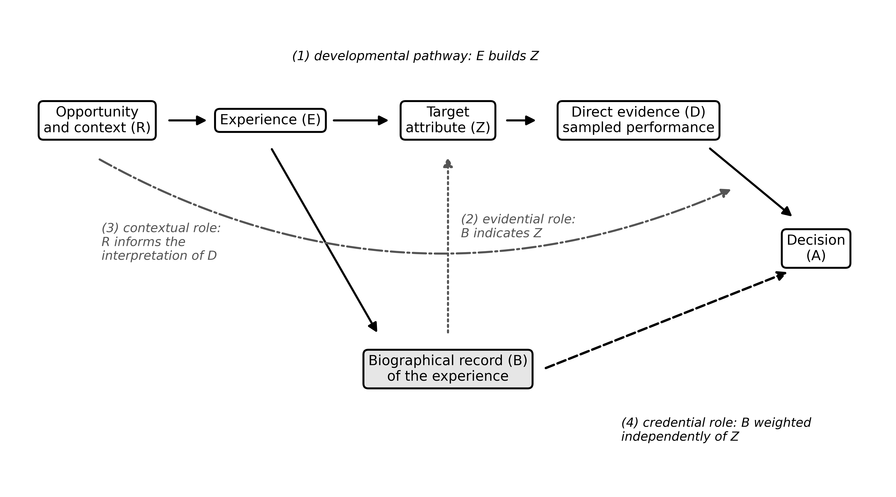
Figure 1. Four roles a biographical record can play in a selection decision. Solid arrows show the developmental pathway from opportunity and experience to the target attribute and its direct evidence. The dotted arrow shows the evidential role (the record as an indicator of the target attribute), the dash-dot arrow the contextual role (opportunity informing the interpretation of direct evidence), and the dashed arrow the credential role (the record weighted independently of the target attribute). The diagram is conceptual and contains no data.
The distinction between the contextual and credential roles matters most for practice. Contextualization modifies the inference drawn from evidence D: it asks what a given level of performance indicates about the target attribute given the opportunities available to the applicant. It is an interpretive operation, consistent with the long-standing concern in the assessment literature with opportunity to learn and with fair interpretation across test takers (American Educational Research Association et al., 2014; Moss et al., 2008). Credentialing assigns weight to B itself. The two can appear in the same file, can involve the same information, and can push in opposite directions: knowing that an applicant attended a school offering few advanced courses can raise the interpretation of a strong transcript, whereas crediting applicants for advanced courses taken can lower the standing of the same applicant. Contextual admissions experiments illustrate the first operation: providing admissions readers with structured information about applicants' high school contexts increased the likelihood that low-income applicants were recommended for admission (Bastedo & Bowman, 2017; Bastedo et al., 2022).
Two clarifications prevent misreading. First, the claim that an experience can be educationally valuable without being independently decision-relevant is a category distinction, not a criticism of the experience: learning value concerns what the experience did for the applicant, whereas credential value concerns what the record does to the selector. Second, the framework does not presume that selection should maximize prediction. Institutions legitimately define the attributes they target, denoted Z, and Z can include qualities such as commitment, curiosity, or contribution to a cohort that grades do not capture. The argument turns not on the contents of Z but on whether biography earns weight after the contents of Z have been evidenced as directly as practicable.
The Path-Invariance Principle
Let P denote the pathway by which an attribute was acquired and A the decision or evaluation. Path invariance holds that, once Z is adequately evidenced, the decision should not depend on the pathway: schematically, $A⟂P∣Z$. In its narrowest form, if two applicants provide equivalent evidence of the target attribute, they should receive equivalent evaluations with respect to that attribute (Figure 2).
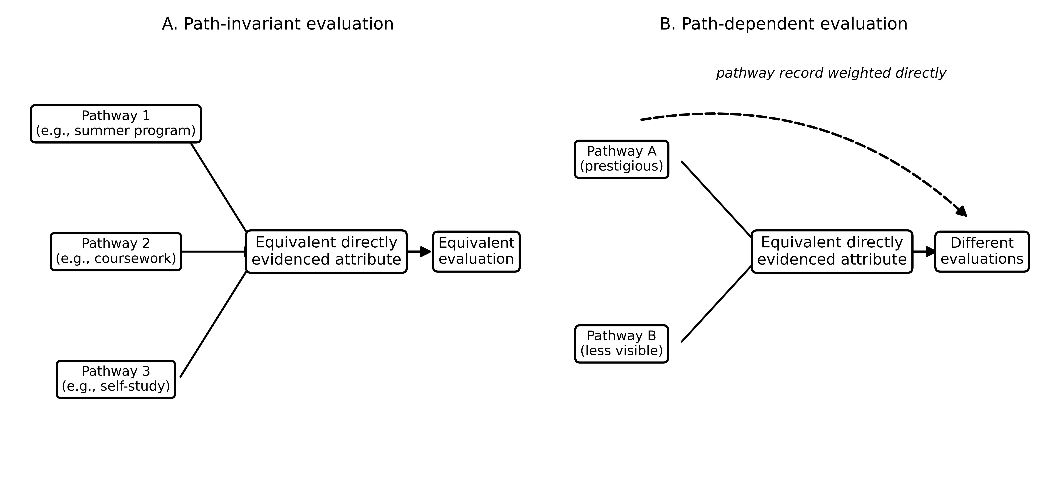
Figure 2. Path-invariant and path-dependent evaluation. In Panel A, equivalent directly evidenced attributes acquired through different pathways receive equivalent evaluations. In Panel B, the record of the pathway affects the evaluation directly (dashed arrow), so equivalent evidence yields different evaluations. The diagram is conceptual and contains no data.
The principle is a default with explicit rebuttal conditions, and the rebuttals do as much work as the default. Weight on the pathway is warranted, first, when the pathway is itself part of Z. A conservatoire may legitimately target ensemble experience, and a medical program may target sustained exposure to clinical settings; in these cases, crediting the pathway is a definition of the selection objective rather than a violation of invariance, provided it is stated as such. Second, weight is warranted when the pathway record carries incremental information about Z that the available direct evidence does not, which is the familiar territory of incremental validity (Hunsley & Meyer, 2003; Sechrest, 1963). Third, information about the pathway and its context is warranted when it changes the interpretation of other evidence, as in contextualization. Weight on the pathway that cannot be assigned to one of these three warrants is credential weight, which I call residual biographical weight.
Path invariance is therefore a requirement of justification, not a prohibition. It allocates the burden of argument: a selection system may credit pathways, but it must say which warrant applies. Because Z is defined by the institution, the principle does not settle which attributes ought to be targeted. It constrains the relation between the stated targets and the weights placed on evidence, and in this respect it operates as an internal consistency condition on a selection system's interpretation and use argument.
The information-side quantity that the second warrant relies on can be written as the conditional mutual information $I(Y;B∣D)$ between a criterion Y and biography B given direct evidence D, or, in a linear-prediction setting, as the familiar incremental $R^{2}$ of B over D. This is not a new quantity; it is incremental validity under another name. The construct the framework adds is on the decision side: residual biographical weight is the weight a decision rule places on B beyond what is warranted by B's membership in Z, its incremental information about Z, or its contextual role. Weight and information can diverge in both directions. A selection rule can place substantial weight on a record that adds little information once direct evidence is available, and it can place weight on a constitutive pathway that adds no predictive information at all, because prediction is not the only legitimate institutional objective.
Relation to Assessment Theory
Path invariance draws on validity theory and is best understood as a component of it. Argument-based validation requires that every inference from evidence to decision be warranted and that the warrant be backed (Kane, 1992, 2013), and Messick's (1989, 1995) unified conception places the value implications and social consequences of score use within validity. What these frameworks do not supply is a default for one inference that recurs in selection: the inference from the route by which an attribute was acquired to the decision, once the attribute itself is evidenced. Path invariance supplies that default and its rebuttal conditions. Table 1 sets out its relation to neighboring concepts.
Table 1
Path Invariance in Relation to Established Assessment Concepts
Concept | Object of evaluation | Central question | Relation to path invariance
Construct validity and argument-based validation (Cronbach & Meehl, 1955; Kane, 2013) | Interpretations and uses of scores | Is each inference from evidence to decision warranted? | Path invariance is a specific warrant within the interpretation/use argument of a selection system, with stated rebuttal conditions
Construct-irrelevant variance (Haladyna & Downing, 2004; Messick, 1989) | Variance in scores | Does score variance reflect sources other than the construct? | Decision-level analogue: weight on the pathway record that is not warranted by the target attribute, even when each record is accurate
Incremental validity (Hunsley & Meyer, 2003; Sechrest, 1963) | Information added by a predictor | Does B improve prediction of a criterion beyond D? | Supplies one of three legitimate warrants for weight on B; path invariance concerns weight, which can exceed or lack predictive gain
Measurement invariance (Millsap, 2011) | Instruments across groups | Does the instrument measure the same construct in each group? | Different object: path invariance concerns how decision makers treat routes of acquisition once an attribute is evidenced
Differential prediction (Cleary, 1968) | Prediction equations across groups | Do the same scores predict the criterion equally across groups? | Different object: pathway is not a group, and a weight can be unwarranted even when prediction is identical across groups
Consequential validity (Messick, 1995; Shepard, 1997) | Consequences of test use | Do the social consequences of use support or undermine the intended interpretation? | Path dependence is a predictable source of adverse consequences when access to pathways is socially patterned (P3)
Evidence-centered design (Mislevy et al., 2003) | Design of assessments | How do student, evidence, and task models connect? | Compatible: a biographical record is an evidence source whose link to the student model must be stated before it is weighted
Fairness and opportunity to learn (AERA et al., 2014; Moss et al., 2008) | Access, treatment, and interpretation across test takers | Have test takers had comparable access and opportunity? | Motivates contextual interpretation of D, which path invariance permits; distinguishes it from credit for possessing an experience
Signaling and credentialism (Collins, 1979; Spence, 1973) | Use of credentials under uncertainty | Why do selectors rely on credentials? | Explains reliance on B when Z is unobserved; path invariance asks what should happen to that reliance as Z becomes evidenced
Note. B = biographical evidence; D = relatively direct evidence of the target attribute; Z = attributes the institution legitimately targets; P3 = Proposition 3 (see Table 3). AERA et al. = American Educational Research Association, American Psychological Association, and National Council on Measurement in Education.

Three distinctions are especially important. First, path invariance differs from incremental validity in its object. Incremental validity is an empirical property of a predictor relative to a criterion. Path invariance concerns the weight a decision rule places on a source, which is subject to normative constraint even where incremental prediction is positive (the weight may exceed the information) or nil (the pathway may be constitutive). Second, it differs from construct-irrelevant variance, which concerns variance in scores arising from sources other than the construct (Haladyna & Downing, 2004; Messick, 1989). Path-dependent weighting can arise even when every record in a file is accurate and every score is construct-valid; it is a property of how a decision rule combines sources, not of any single score. It can, however, be read as a decision-level analogue of the same concern. Third, path invariance is neither measurement invariance, which concerns whether an instrument measures the same construct across groups (Millsap, 2011), nor the absence of differential prediction, which concerns whether a common regression line fits groups equally well (Cleary, 1968). A pathway is not a group, and a weight on a pathway can be unwarranted even where prediction is identical across groups.
Path invariance is also compatible with evidence-centered design (Mislevy et al., 2003). In design terms, a biographical record is an evidence source that was not designed as evidence; before it is weighted, the link between the record and the student model should be stated, and the strength of that link should be assessed. The framework extends this discipline from designed tasks to the undesigned records that make up much of a selection file. Finally, the framework connects to the literature on multiple measures and decision rules. Choices among compensatory, conjunctive, and complementary rules for combining measures have consequences for decision accuracy (Douglas & Mislevy, 2010; Henderson-Montero et al., 2003), and mechanical combination of the same information tends to predict outcomes better than holistic judgment (Dawes, 1979; Kuncel et al., 2013). Path invariance adds a criterion that these literatures leave implicit: which sources should receive weight at all, and on what warrant.
The framework also connects to, without depending on, work in sociology and economics. Signaling accounts explain why selectors rely on credentials when the target attribute is unobserved (Spence, 1973), and credentialist and cultural-capital accounts explain why access to valued credentials, and fluency in presenting them, is stratified (Bourdieu, 1986; Collins, 1979). Path invariance asks the question these accounts leave open for assessment practice: what should happen to the weight on a credential once the attribute it signals can be evidenced directly?
Direct Evidence, Proximity, and the Warrant for Biography
The framework yields a conditional directional prediction. For biographical evidence whose relevance runs through an attribute that can be sampled, improving the quality of direct evidence D should reduce both the incremental information of B and the warranted weight on it. Schematically, as the quality of D increases, residual dependence on B should decrease. Figure 3 represents the idea as a continuum of evidential proximity; the placement of evidence sources is illustrative and construct-specific, because the same source can be proximal for one attribute and distal for another.
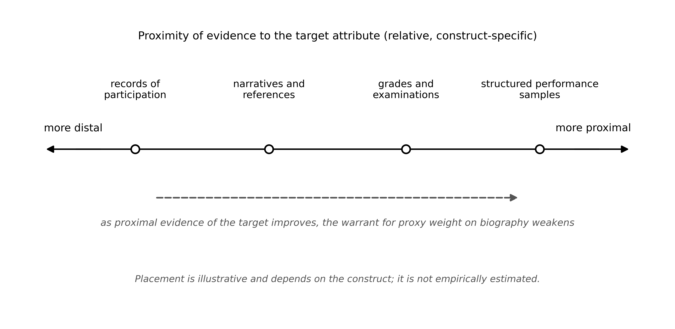
Figure 3. A continuum of evidential proximity. Evidence sources differ in how closely they sample the target attribute, and proximity is relative and construct-specific. As proximal evidence of an attribute that can be sampled improves, the warrant for proxy weight on biography weakens. Placements are illustrative and not empirically estimated.
The prediction is conditional in five ways, each of which corresponds to a familiar threat in validity theory. It requires adequate construct coverage, since direct evidence that samples only part of Z leaves the remainder to be evidenced by other means, including biography (Messick, 1995). It requires adequate reliability and an appropriate criterion; improving the precision of D with respect to a narrow criterion does not reduce the warrant for B with respect to attributes the criterion omits. It requires that D be accessible on comparable terms, since direct evidence that some applicants cannot attempt, or can attempt only with costly preparation, carries its own pathway effects (Moss et al., 2008). It is subject to strategic response: once a source carries weight, applicants and intermediaries have incentives to produce it, a dynamic that applies to direct evidence as well as to biography (Campbell, 1979). And it requires attention to consequences, because the use of any evidence source in high-stakes selection shapes the behavior of schools and applicants (Linn et al., 1991; Shepard, 1997).
Admissions research provides illustrations, though not tests, of the conditional prediction. High school grades predict on-time college graduation better than admissions test scores do, in part because grades capture sustained self-regulation that a single examination does not sample (Galla et al., 2019). In the framework's terms, grades are relatively proximal evidence of a broader attribute than a test samples, which illustrates why proximity is construct-specific. Conversely, part of the apparent predictive power of admissions test scores reflects their association with school demographic characteristics (Rothstein, 2004), although socioeconomic status explains little of the test–performance relationship in large multi-institution data (Sackett et al., 2009); either way, proximity does not imply independence from opportunity. In medical selection, structured formats such as multiple mini-interviews and situational judgment tests show stronger evidence of validity than personal statements and references (Patterson et al., 2016), and a video-based situational judgment test of interpersonal skills used in admission predicted later internship and job performance (Lievens & Sackett, 2012). In these cases, deliberately designed performance samples provide proximal evidence of attributes that were previously inferred largely from biography.
The limiting thought experiment clarifies the logic. If an institution could adequately evidence every present attribute it legitimately targets, which facts about an applicant's past would it still need? Only those that are themselves in Z, that evidence attributes in Z that observation cannot reach, or that are needed to interpret the evidence it has. No institution achieves such observation, and the thought experiment proposes no technology. It functions as an audit standard: weight that would survive perfect observation of Z is either constitutive or contextual; weight that would not survive is proxy weight, and it should be expected to decline as evidence improves.
University Admissions as a High-Stakes Assessment Setting
Admissions is a legitimate and demanding setting for assessment theory. Decisions are consequential for individuals, evidence sources are heterogeneous and partly undesigned, and the decision rule is often implicit. Zwick (2017) describes admissions as a choice among competing goals and evidence sources, each with trade-offs for prediction and equity, and the meaning of holistic review itself varies across institutions, from reading the whole file to reading applicants in the context of their opportunities (Bastedo et al., 2018). The same file can therefore support several different interpretation and use arguments, and path invariance asks which one a given weighting scheme actually instantiates.
Table 2 applies the framework as an evidence-role audit of common admissions evidence sources. For each source, the audit asks what attribute is being claimed, how proximal the evidence is to that attribute, which legitimate roles the source can play, and what question would reveal residual biographical weight. The central audit question for any biographical criterion is whether equivalent evidence of the same attribute, from a less visible pathway, would receive the same weight. Volunteering read as evidence of commitment to others is appropriately weighed against other evidence of that attribute; volunteering credited because the activity is prestigious or costly requires a separate warrant.
Table 2
An Evidence-Role Audit of Common Admissions Evidence Sources
Evidence source | Target attribute typically claimed | Relative proximity | Legitimate roles | Path-invariance audit question
Examination or assessment performance | Subject knowledge, reasoning | Proximal for sampled content; distal for unsampled attributes | Evidential | Which attributes in Z does the task actually sample, and which does it not?
Course grades and transcript | Sustained academic performance, self-regulation | Proximal for course-based attainment; varies with grading standards | Evidential; contextual (curriculum offered) | Is credit given for the performance, or for the prestige of the course or school that offered it?
Structured interview, multiple mini-interview, or situational judgment test | Interpersonal and professional attributes | Intermediate to proximal, depending on design | Evidential | Does the format sample the attribute, or reward fluency acquired through coaching or familiarity?
Portfolio, audition, or practical task | Performance in the domain | Proximal | Evidential; constitutive where practice is part of Z | Is the performance judged, or the setting in which it was developed?
Personal statement or essay | Motivation, reflection, writing | Distal to intermediate | Evidential (weak); contextual | What attribute is being inferred, and could it be evidenced more directly?
Records of activities, leadership, and awards | Commitment, initiative, contribution | Distal | Evidential; contextual; constitutive if explicitly in Z | Would equivalent evidence of the same attribute from a less visible pathway receive the same weight?
Research or work experience | Inquiry or professional skill | Distal unless accompanied by a performance sample | Evidential; constitutive in some professional programs | Is the experience credited, or what the applicant can now do?
School and neighborhood context indicators | Opportunity, not an attribute of the applicant | Not evidence of Z | Contextual only | Is context used to interpret D, or as an independent credit or debit?
Note. Proximity is relative and construct-specific: the same source can be proximal for one attribute and distal for another. Entries are illustrative classifications for audit purposes, not empirical estimates. Z = attributes the institution legitimately targets; D = relatively direct evidence.

The empirical record suggests that the credential role is consequential. Activities, leadership, and enrichment opportunities are stratified by family resources and school context (Covay & Carbonaro, 2010; Snellman et al., 2015). Essays encode family income in content and style (Alvero et al., 2021). In admissions data from highly selective private colleges, the higher admission rates of applicants from the top of the income distribution, at comparable test scores, are driven by alumni preferences, athletic recruitment, and weight placed on non-academic credentials such as extracurricular ratings (Chetty et al., 2026). The developmental pathway from experience to attribute is real; so is the pathway from experience to the decision that bypasses the attribute.
These observations motivate a conditional statement rather than a general claim. A selection system that assigns independent weight to socially patterned experiences creates a channel through which inequality of opportunity can become inequality of selection outcomes. Whether the channel operates, and how strongly, depends on residual biographical weight, which is what path invariance governs. Nothing in this argument implies that holistic review increases inequality overall, that test-based selection is fair, or that contextual information should be excluded; the claim is that the credential channel and the contextual channel are different and should be audited separately. Test-optional policy offers a suggestive illustration of why: removing one evidence source shifts weight to the remaining sources, and whether those sources are socially patterned determines whether the shift advances the policy's equity aims (Belasco et al., 2015; Bennett, 2022).
Substitutability and Its Limits
The strength of the case for path invariance varies with substitutability. For attributes that different pathways plausibly produce equivalently, such as subject knowledge, conceptual understanding, language proficiency, or analytical reasoning, the case for pathway-neutral weighting is strong: a self-taught applicant and a summer-program applicant who demonstrate the same capability should be indistinguishable to the selector with respect to that capability. For attributes that are embodied, interactive, or context-bound, such as clinical skill, laboratory technique, or ensemble musicianship, the case is weaker in one respect only: having engaged in the practice may be partly constitutive of the capability. Even here, undergoing an experience must be distinguished from being able to perform the resulting capability. The framework therefore supports performance assessment, such as auditions, practical tasks, and structured simulations, rather than counting experiences, precisely in the domains where pathway and capability are hardest to separate (Linn et al., 1991).
Employment selection exhibits the same architecture with roles relabeled: degrees and employer histories stand in for activity records, and work samples and structured assessments provide comparatively proximal evidence (Sackett & Lievens, 2008; Schmidt & Hunter, 1998). It illustrates that improvements in direct screening need not disadvantage underrepresented groups: in one naturalistic study, replacing informal screening with a job test raised productivity without reducing minority hiring (Autor & Scarborough, 2008). Blind orchestral auditions, which changed selection outcomes by removing information unrelated to the performance being judged, are a further reminder that the design of direct evidence can reorganize a regime previously built on biography (Goldin & Rouse, 2000). At the other extreme, roles whose target competence cannot be sampled in advance, such as elected office, show the boundary of the framework: where direct evidence is least feasible, reliance on biography is greatest and least easily displaced (Popkin, 1991).
Propositions and Research Designs
The framework yields six propositions (Table 3). Each is stated conditionally and classified by type: normative propositions state warrants and are assessed by argument; empirical propositions predict observable regularities; the consequential proposition predicts effects of assessment use.
Table 3
Propositions, Their Class, and Evidence That Would Count Against Them
Proposition | Class | Manipulated or observed variables | Outcome | Expected pattern | Result inconsistent with the proposition
P1 Path invariance | Normative | Acquisition pathway, holding directly evidenced attribute constant | Evaluation | No pathway effect unless a stated warrant applies | (Normative: assessed by argument; P1 is violated in practice where pathway effects persist without a stated warrant)
P2 Direct-evidence substitution | Empirical | Quality and coverage of D | Weight on and incremental information of B | Both decline as D improves, for B operating as a proxy | Weight on B stable or rising as D improves in quality and coverage of the same attribute
P3 Opportunity-to-credential pathway | Consequential | Independent weight on socially patterned B | Association between opportunity and selection outcomes | Association strengthens with credential weight | No change in the opportunity–outcome association when credential weight is added or removed, holding D constant
P4 Pathway substitutability | Normative | Degree to which pathways produce equivalent attribute | Strength of the case for invariance | Stronger case where pathways are substitutable | (Normative: assessed by argument)
P5 Proximal-evidence attenuation | Empirical | Availability of reliable proximal evidence | Incremental information of distal records | Smaller where proximal evidence is available | Distal records add as much or more information when reliable proximal evidence of the same attribute is present
P6 Measurement boundary | Empirical | Feasibility of sampling the target attribute | Reliance on biography | Greater reliance where the attribute is hard to sample | Reliance on biography unrelated to the feasibility of direct evidence across attributes or programs
Note. B = biographical evidence; D = relatively direct evidence of the target attribute. Normative propositions state warrants and are assessed by argument; empirical and consequential propositions are testable with the designs described in the text.

• P1 (normative). Path invariance. For acquisition pathways that are substitutable with respect to legitimately targeted attributes, evaluation should become independent of pathway once the relevant attributes are adequately evidenced, unless a constitutive, informational, or contextual warrant applies.
• P2 (empirical). Direct-evidence substitution. For biography operating primarily as a proxy, improvements in the quality and construct coverage of direct evidence reduce both the incremental information of biography and the weight evaluators place on it.
• P3 (consequential). Opportunity-to-credential pathway. When socially patterned experiences receive independent weight, the association between opportunity and selection outcomes strengthens with the size of that weight.
• P4 (normative). Pathway substitutability. The more substitutable the pathways that produce an attribute, the stronger the case for path-invariant evaluation of that attribute.
• P5 (empirical). Proximal-evidence attenuation. Distal records contribute less incremental information where reliable proximal evidence of the same attribute is available.
• P6 (empirical). Measurement boundary. Reliance on biography is, and may legitimately remain, greater for attributes that are harder to sample directly.
A further expectation, which is not numbered because it follows from established reactivity dynamics rather than from the framework, is that the larger the credential weight on an experience, the stronger the incentive to produce or present it strategically (Campbell, 1979; Espeland & Sauder, 2007). The normative and empirical components are logically separable: a reader may accept P2 descriptively while rejecting P1, and the empirical propositions can be tested regardless of whether the normative principle is accepted. The empirical propositions follow from the account of evidential proximity in the preceding sections rather than from P1: P2 and P5 apply the conditional prediction about direct evidence to incremental information and evaluator weight, P6 applies its sampleability condition, and P3 follows from combining the credential role in Figure 1 with the social patterning of access to experiences.
Three designs could test the empirical and consequential propositions without large new data collections. First, an acquisition-path experiment: with admissions readers or trained proxy evaluators, hold the directly evidenced attribute constant across applicant profiles and randomize the pathway by which it was acquired (for example, a summer program, school coursework, self-study, or community experience). A nonzero pathway effect on evaluations, conditional on equivalent evidence and in the absence of a stated warrant, estimates residual biographical weight; the absence of such an effect where pathway status differs sharply would count against the claim that credential weight operates in that setting (P1 in practice, P3). Second, an evidence-quality experiment: vary the quality and coverage of direct evidence available to evaluators and estimate the effect of biographical information on evaluations at each level. P2 predicts that biographical effects decline as credible direct evidence of the same attribute improves; stable or rising biographical effects would disconfirm it. Third, a context-versus-credential experiment: present the same information about opportunity either as context for interpreting performance or as an independent applicant attribute, and test whether evaluators treat the two framings differently. Structured contextual information has been shown to change admissions recommendations (Bastedo & Bowman, 2017; Bastedo et al., 2022); the proposed design would separate the interpretive effect from the credential effect. Observational studies using existing admissions data could complement these designs by estimating whether the incremental information of activity records declines where proximal evidence of the same attribute is present (P5) and whether reliance on biography varies with the feasibility of direct evidence across programs (P6).
Objections and Boundary Conditions
Several objections deserve direct answers. Universities do not merely predict grades. This is correct, and Z is deliberately broader than any criterion. A broader Z expands the set of legitimate pathway warrants; it does not license weight without one. Education has constitutive and developmental purposes. This is why learning value and intrinsic value are separated from credential value; the framework questions crediting the record, not having the experience. Admissions tests reproduce inequality. Test scores are associated with socioeconomic background (Sackett et al., 2009), which is why the argument never recommends a testing technology and treats contextual interpretation of attainment as inside the framework. Direct evidence can be coached. Strategic response applies to D as well as to B, which is why P2 is conditional on quality and construct coverage rather than on the existence of a measure. Some attributes resist direct measurement. The substitutability section concedes this and derives performance assessment as the appropriate response where feasible, and P6 reserves a legitimate place for biography where it is not. Past behavior predicts beyond present measures. Where it does, biography carries incremental information and the framework says so; this is the second warrant, not an exception to the principle.
Two further objections come from assessment theory itself. Path invariance is already implied by validity theory. It is consistent with validity theory, and the article presents it as a warrant within it. What validity theory does not specify is how the recurring pathway inference should be treated by default and which rebuttals are admissible; specifying these makes the warrant auditable. The framework confuses prediction with validity. It does not: predictive gain is one of three warrants, and the constitutive and contextual warrants are justified by the interpretation and use of evidence rather than by prediction. Conversely, a source can predict a criterion and still lack a warrant if its predictive power derives from opportunity rather than from the target attribute (Rothstein, 2004).
The framework has limits. It does not determine the contents of Z, which is a policy decision; it applies most clearly to attributes that can be sampled; and its predictions are conditional on the validity conditions stated above. Its contribution is a location for argument: any disputed weight must be assigned to Z, to incremental information, to context, or to residual biographical weight, and the last should decline as the objects of the first three become observable.
Implications for Assessment Policy and Practice
For assessment designers and admissions offices, the framework implies a discipline rather than a technology. First, specify the target attributes explicitly, including those that grades and tests do not sample. Second, assign each evidence source a stated role (evidential, contextual, or constitutive) and state the attribute it is meant to evidence. Third, for each biographical criterion, ask whether equivalent evidence of the same attribute from a less visible pathway would receive the same weight; where it would not, a warrant is required. Fourth, where proxy weight is found, invest in more proximal evidence of the attribute, such as structured performance tasks, rather than in richer biography. Fifth, keep contextual information in its interpretive role and audit separately for credit or debit attached to possession of an experience. These steps can be built into the validity argument for a selection system and into routine evaluation of its consequences (Kane, 2013; Shepard, 1997). For policy makers, the framework suggests that changes to admissions evidence, such as test-optional policies or the expansion of activity records, should be evaluated by where the displaced weight goes, not only by what is removed.
Conclusion
Educational selection increasingly relies on biography, on the reasonable grounds that grades and scores are incomplete evidence. This article has argued that the defensibility of that practice turns on distinguishing the roles biographical evidence can play, and in particular on separating contextual interpretation from credit for possessing an experience. The path-invariance principle supplies a warrant for evidence combination: credit the pathway only when it is part of the target, adds information about the target that other evidence cannot reach, or is needed to interpret that evidence. The resulting agenda belongs to educational assessment: it asks institutions to specify what they intend to assess, to evidence it as directly as practicable, and to justify any weight that remains.
Acknowledgments
[Placeholder: to be completed by the author.]
Disclosure Statement
The author reports there are no competing interests to declare. [Placeholder: author to confirm.]
Funding
[Placeholder: funding statement to be completed by the author, or deleted if none.]
Data Availability Statement
No new data were generated or analyzed in this study. The code that generates the three conceptual figures (scripts/make_figures_EA.py, with instructions in README.md) is openly available at https://github.com/bougtoir/path-invariant-selection.
Use of Generative AI
[Placeholder for the author, as required by the Taylor & Francis AI Policy: state the full name and version of any generative AI tool used, how it was used, and why, and confirm that the author reviewed all output and takes full responsibility for the content.]

References
Alvero, A. J., Giebel, S., Gebre-Medhin, B., antonio, a. l., Stevens, M. L., & Domingue, B. W. (2021). Essay content and style are strongly related to household income and SAT scores: Evidence from 60,000 undergraduate applications. Science Advances, 7(42), Article eabi9031. https://doi.org/10.1126/sciadv.abi9031
American Educational Research Association, American Psychological Association, & National Council on Measurement in Education. (2014). Standards for educational and psychological testing. American Educational Research Association.
Autor, D. H., & Scarborough, D. (2008). Does job testing harm minority workers? Evidence from retail establishments. The Quarterly Journal of Economics, 123(1), 219–277. https://doi.org/10.1162/qjec.2008.123.1.219
Bastedo, M. N., Bell, D., Howell, J. S., Hsu, J., Hurwitz, M., Perfetto, G., & Welch, M. (2022). Admitting students in context: Field experiments on information dashboards in college admissions. The Journal of Higher Education, 93(3), 327–374. https://doi.org/10.1080/00221546.2021.1971488
Bastedo, M. N., & Bowman, N. A. (2017). Improving admission of low-SES students at selective colleges: Results from an experimental simulation. Educational Researcher, 46(2), 67–77. https://doi.org/10.3102/0013189X17699373
Bastedo, M. N., Bowman, N. A., Glasener, K. M., & Kelly, J. L. (2018). What are we talking about when we talk about holistic review? Selective college admissions and its effects on low-SES students. The Journal of Higher Education, 89(5), 782–805. https://doi.org/10.1080/00221546.2018.1442633
Belasco, A. S., Rosinger, K. O., & Hearn, J. C. (2015). The test-optional movement at America's selective liberal arts colleges: A boon for equity or something else? Educational Evaluation and Policy Analysis, 37(2), 206–223. https://doi.org/10.3102/0162373714537350
Bennett, C. T. (2022). Untested admissions: Examining changes in application behaviors and student demographics under test-optional policies. American Educational Research Journal, 59(1), 180–216. https://doi.org/10.3102/00028312211003526
Boliver, V., Gorard, S., & Siddiqui, N. (2015). Will the use of contextual indicators make UK higher education admissions fairer? Education Sciences, 5(4), 306–322. https://doi.org/10.3390/educsci5040306
Bourdieu, P. (1986). The forms of capital. In J. Richardson (Ed.), Handbook of theory and research for the sociology of education (pp. 241–258). Greenwood.
Campbell, D. T. (1979). Assessing the impact of planned social change. Evaluation and Program Planning, 2(1), 67–90. https://doi.org/10.1016/0149-7189(79)90048-X
Chetty, R., Deming, D. J., & Friedman, J. N. (2026). Diversifying society's leaders? The determinants and causal effects of admission to highly selective private colleges. The Quarterly Journal of Economics, 141(1), 51–145. https://doi.org/10.1093/qje/qjaf050
Cleary, T. A. (1968). Test bias: Prediction of grades of Negro and White students in integrated colleges. Journal of Educational Measurement, 5(2), 115–124. https://doi.org/10.1111/j.1745-3984.1968.tb00613.x
Collins, R. (1979). The credential society: An historical sociology of education and stratification. Academic Press.
Covay, E., & Carbonaro, W. (2010). After the bell: Participation in extracurricular activities, classroom behavior, and academic achievement. Sociology of Education, 83(1), 20–45. https://doi.org/10.1177/0038040709356565
Cronbach, L. J., & Meehl, P. E. (1955). Construct validity in psychological tests. Psychological Bulletin, 52(4), 281–302. https://doi.org/10.1037/h0040957
Dawes, R. M. (1979). The robust beauty of improper linear models in decision making. American Psychologist, 34(7), 571–582. https://doi.org/10.1037/0003-066X.34.7.571
Douglas, K. M., & Mislevy, R. J. (2010). Estimating classification accuracy for complex decision rules based on multiple scores. Journal of Educational and Behavioral Statistics, 35(3), 280–306. https://doi.org/10.3102/1076998609346969
Espeland, W. N., & Sauder, M. (2007). Rankings and reactivity: How public measures recreate social worlds. American Journal of Sociology, 113(1), 1–40. https://doi.org/10.1086/517897
Frederiksen, J. R., & Collins, A. (1989). A systems approach to educational testing. Educational Researcher, 18(9), 27–32. https://doi.org/10.3102/0013189X018009027
Galla, B. M., Shulman, E. P., Plummer, B. D., Gardner, M., Hutt, S. J., Goyer, J. P., D'Mello, S. K., Finn, A. S., & Duckworth, A. L. (2019). Why high school grades are better predictors of on-time college graduation than are admissions test scores: The roles of self-regulation and cognitive ability. American Educational Research Journal, 56(6), 2077–2115. https://doi.org/10.3102/0002831219843292
Goldin, C., & Rouse, C. (2000). Orchestrating impartiality: The impact of "blind" auditions on female musicians. American Economic Review, 90(4), 715–741. https://doi.org/10.1257/aer.90.4.715
Gorard, S., Boliver, V., Siddiqui, N., & Banerjee, P. (2019). Which are the most suitable contextual indicators for use in widening participation to HE? Research Papers in Education, 34(1), 99–129. https://doi.org/10.1080/02671522.2017.1402083
Haladyna, T. M., & Downing, S. M. (2004). Construct-irrelevant variance in high-stakes testing. Educational Measurement: Issues and Practice, 23(1), 17–27. https://doi.org/10.1111/j.1745-3992.2004.tb00149.x
Henderson-Montero, D., Julian, M. W., & Yen, W. M. (2003). Multiple measures: Alternative design and analysis models. Educational Measurement: Issues and Practice, 22(2), 7–12. https://doi.org/10.1111/j.1745-3992.2003.tb00122.x
Hunsley, J., & Meyer, G. J. (2003). The incremental validity of psychological testing and assessment: Conceptual, methodological, and statistical issues. Psychological Assessment, 15(4), 446–455. https://doi.org/10.1037/1040-3590.15.4.446
Kane, M. T. (1992). An argument-based approach to validity. Psychological Bulletin, 112(3), 527–535. https://doi.org/10.1037/0033-2909.112.3.527
Kane, M. T. (2013). Validating the interpretations and uses of test scores. Journal of Educational Measurement, 50(1), 1–73. https://doi.org/10.1111/jedm.12000
Kuncel, N. R., Klieger, D. M., Connelly, B. S., & Ones, D. S. (2013). Mechanical versus clinical data combination in selection and admissions decisions: A meta-analysis. Journal of Applied Psychology, 98(6), 1060–1072. https://doi.org/10.1037/a0034156
Lievens, F., & Sackett, P. R. (2012). The validity of interpersonal skills assessment via situational judgment tests for predicting academic success and job performance. Journal of Applied Psychology, 97(2), 460–468. https://doi.org/10.1037/a0025741
Linn, R. L., Baker, E. L., & Dunbar, S. B. (1991). Complex, performance-based assessment: Expectations and validation criteria. Educational Researcher, 20(8), 15–21. https://doi.org/10.3102/0013189X020008015
Messick, S. (1989). Validity. In R. L. Linn (Ed.), Educational measurement (3rd ed., pp. 13–103). American Council on Education and Macmillan.
Messick, S. (1995). Validity of psychological assessment: Validation of inferences from persons' responses and performances as scientific inquiry into score meaning. American Psychologist, 50(9), 741–749. https://doi.org/10.1037/0003-066X.50.9.741
Millsap, R. E. (2011). Statistical approaches to measurement invariance. Routledge.
Mislevy, R. J., Steinberg, L. S., & Almond, R. G. (2003). On the structure of educational assessments. Measurement: Interdisciplinary Research and Perspectives, 1(1), 3–62. https://doi.org/10.1207/S15366359MEA0101_02
Moss, P. A., Pullin, D. C., Gee, J. P., Haertel, E. H., & Young, L. J. (Eds.). (2008). Assessment, equity, and opportunity to learn. Cambridge University Press. https://doi.org/10.1017/CBO9780511802157
Patterson, F., Knight, A., Dowell, J., Nicholson, S., Cousans, F., & Cleland, J. (2016). How effective are selection methods in medical education? A systematic review. Medical Education, 50(1), 36–60. https://doi.org/10.1111/medu.12817
Popkin, S. L. (1991). The reasoning voter: Communication and persuasion in presidential campaigns. University of Chicago Press.
Posselt, J. R. (2016). Inside graduate admissions: Merit, diversity, and faculty gatekeeping. Harvard University Press.
Rothstein, J. M. (2004). College performance predictions and the SAT. Journal of Econometrics, 121(1–2), 297–317. https://doi.org/10.1016/j.jeconom.2003.10.003
Sackett, P. R., Kuncel, N. R., Arneson, J. J., Cooper, S. R., & Waters, S. D. (2009). Does socioeconomic status explain the relationship between admissions tests and post-secondary academic performance? Psychological Bulletin, 135(1), 1–22. https://doi.org/10.1037/a0013978
Sackett, P. R., & Lievens, F. (2008). Personnel selection. Annual Review of Psychology, 59(1), 419–450. https://doi.org/10.1146/annurev.psych.59.103006.093716
Schmidt, F. L., & Hunter, J. E. (1998). The validity and utility of selection methods in personnel psychology: Practical and theoretical implications of 85 years of research findings. Psychological Bulletin, 124(2), 262–274. https://doi.org/10.1037/0033-2909.124.2.262
Sechrest, L. (1963). Incremental validity: A recommendation. Educational and Psychological Measurement, 23(1), 153–158. https://doi.org/10.1177/001316446302300113
Shepard, L. A. (1997). The centrality of test use and consequences for test validity. Educational Measurement: Issues and Practice, 16(2), 5–24. https://doi.org/10.1111/j.1745-3992.1997.tb00585.x
Snellman, K., Silva, J. M., Frederick, C. B., & Putnam, R. D. (2015). The engagement gap: Social mobility and extracurricular participation among American youth. The Annals of the American Academy of Political and Social Science, 657(1), 194–207. https://doi.org/10.1177/0002716214548398
Spence, M. (1973). Job market signaling. The Quarterly Journal of Economics, 87(3), 355–374. https://doi.org/10.2307/1882010
Stevens, M. L. (2007). Creating a class: College admissions and the education of elites. Harvard University Press.
Zwick, R. (2017). Who gets in? Strategies for fair and effective college admissions. Harvard University Press.
Zwick, R. (2019). Assessment in American higher education: The role of admissions tests. The Annals of the American Academy of Political and Social Science, 683(1), 130–148. https://doi.org/10.1177/0002716219843469

