A network framework for comparing circulation architectures
across planetary bodies

Author: [AUTHOR NAME(S) — TO COMPLETE]
Affiliation(s): [TO COMPLETE]
Corresponding author: [email / postal address — TO COMPLETE]
Article type: Letter (Earth and Planetary Science Letters)
Keywords: comparative planetology; planetary evolution; tectonics; volcanism; atmospheric escape; network analysis

Abstract
Whether a planetary body is dynamically active is usually judged process by process — volcanism, tectonics, magnetic dynamo, hydrological cycling — yet the planetary state that emerges is the joint architecture of these coupled circulations, not any one of them. We build a common reservoir-and-process ontology (seven reservoirs, seven transfer-process classes) and apply it as three separately maintained data objects — current activity, persistence through geological history, and observational constraint — to a frozen set of eight bodies spanning terrestrial planets and satellites: Earth, Venus, Mars, the Moon, Mercury, Io, Europa, and Titan. Of 56 body × process cells, 94.6% carry defensible evidence states (tiers A–C), so the comparison is a genuine measurement exercise rather than a scoring scheme. Three findings emerge. First, an ordination of evidence states has a dominant first axis (56% of variance), while ~44% of ordination variance lies outside that axis and carries architecture-specific information. A single activity axis is a useful first-order summary but does not capture the full comparative structure. Second, circulation shutdown within a body is asynchronous where it occurs at all — Mars lost its core dynamo ~4.1 Ga ago while volcanic, atmospheric, escape, and depositional processes persist to the present; Mercury's effusive volcanism ended ~3.5 Ga while contractional tectonism and its internal dynamo continue — a pattern of subsystem-level cessation, not whole-body decay. Third, the number of supported circulation processes per body (4–7) and the connectivity of reservoir networks are not ordered by body age (Spearman ρ ≈ −0.33) or mass (ρ ≈ 0.08); tidal, radiogenic–primordial, and stellar-atmospheric energy architectures produce qualitatively different circulation networks at comparable ages. Planetary dynamical state is thus better represented as a heterogeneous architecture of coupled processes — including which subsystems have shut down and when — than by a single active/inactive axis alone.

1. Introduction
How should the dynamical state of a planetary body be described? Comparative planetology typically proceeds process by process — thermal evolution and heat flow, the presence and cessation of magnetic dynamos, volcanic and tectonic histories, atmospheric evolution and escape (e.g., Lillis et al., 2008; Sohl et al., 2022; Way and Del Genio, 2020). These are deep and mature literatures, but each treats one subsystem, and the whole-body state is usually summarized informally as more or less 'active'. Whether such a one-dimensional description is adequate has, to our knowledge, never been tested on a common measurement basis across a diverse set of planetary bodies.
Here we test an alternative representation: a planetary body as a network of coupled transfers of energy and matter among a common set of reservoirs (Fig. 1). The measurable object is the circulation architecture — which inter-reservoir transfer processes operate now, how long each has persisted, and how well each is constrained observationally. We deliberately separate these three axes. Observability is not activity: a poorly explored body must not appear inactive merely because less is known about it. Nor is structural absence a missing datum: Venus, the Moon, and Mercury simply have no subsurface liquid reservoir, and that absence is itself architecture.
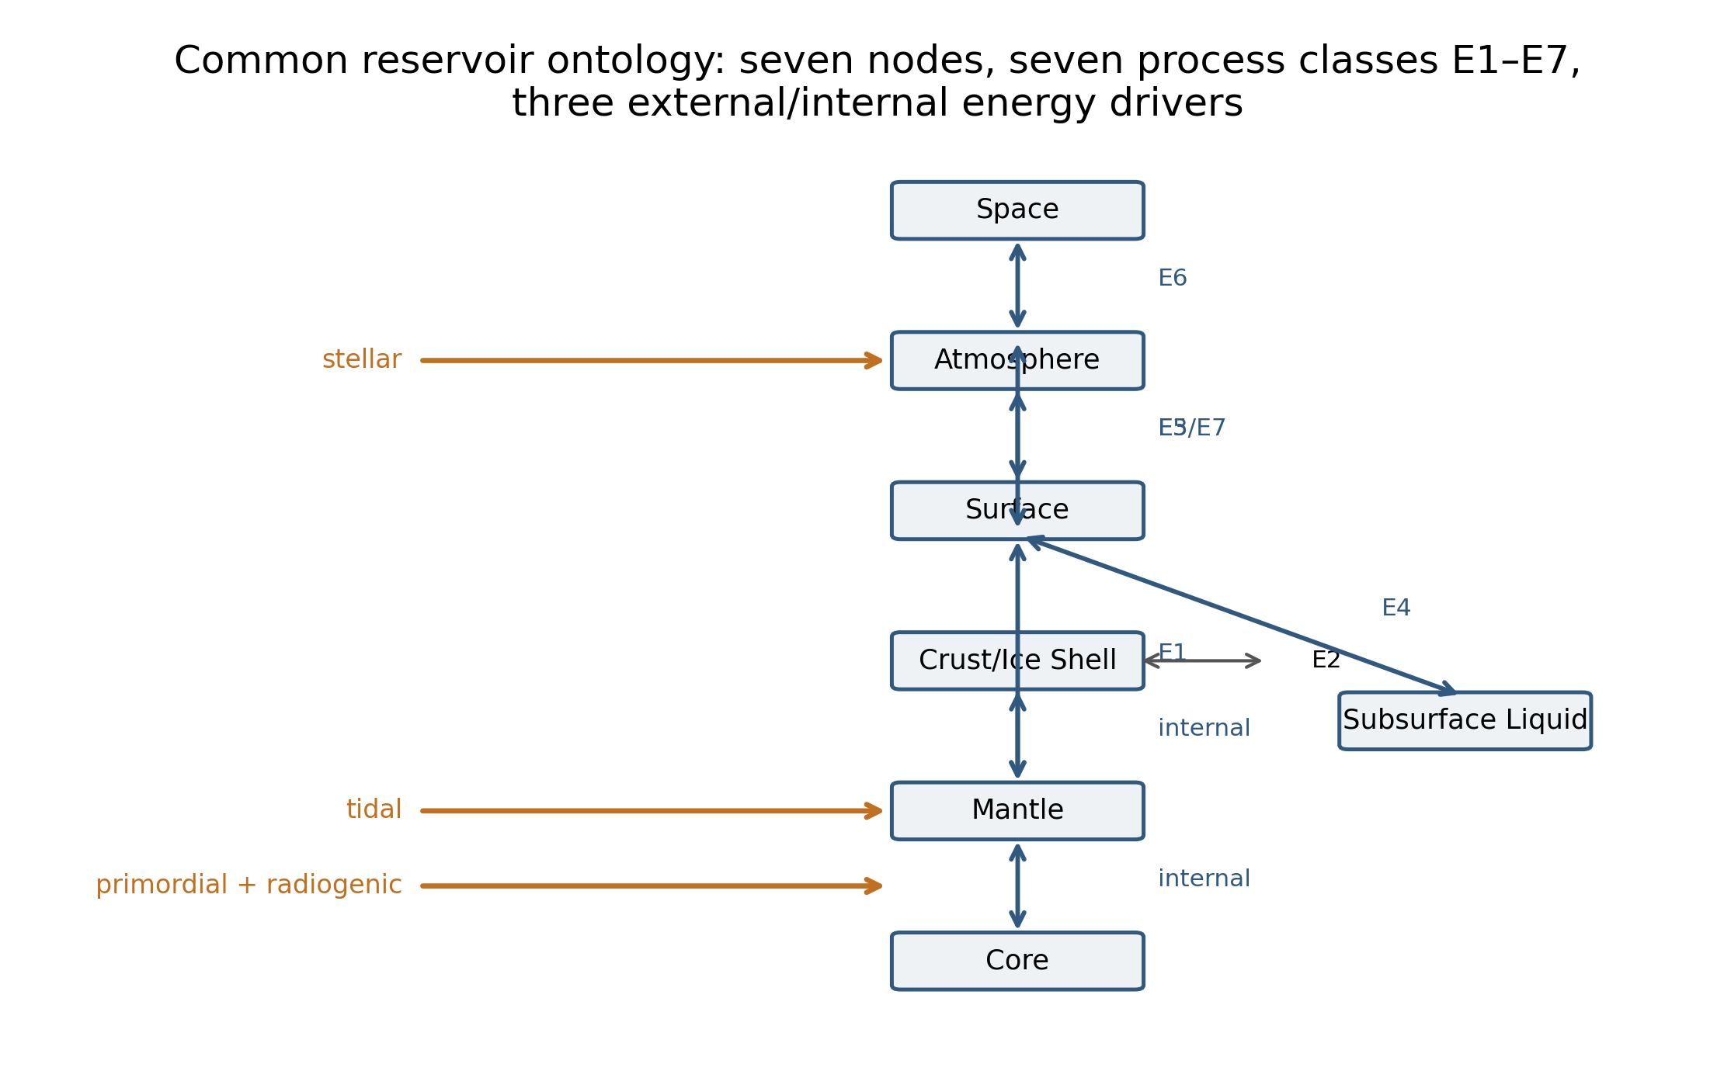
This framing is related to, but distinct from, habitability assessments (which ask whether conditions support life), interior/thermal-evolution models (which ask what drives activity in one body), and Earth-system 'planetary metabolism' or 'vitality' language (which we use here only as a loose umbrella term, never as a composite index). Our questions are comparative and falsifiable: (H1) is the dynamical state adequately represented by one latent activity axis? (H2) do circulation processes within one body persist for heterogeneous fractions of planetary history, beyond dating uncertainty? (H3) do bodies differ in network connectivity, not only in the presence of individual processes? (H4) is circulation architecture irreducible to age or internal heat?

2. Methods
We froze a priori a pilot set of eight bodies chosen for architectural diversity — Earth (strongly coupled reference), Venus (atmosphere-rich, hydrology-poor), Mars (intermediate), the Moon (low current circulation), Mercury (small body retaining an intrinsic dynamo), Io (tidal-magmatic extreme), Europa (tidal/subsurface-ocean), and Titan (atmosphere–surface condensable-fluid) — together with a fixed ontology of seven reservoir nodes (core, mantle, crust/ice shell, subsurface liquid, surface, atmosphere, space) and seven transfer-process classes E1–E7: interior→surface transport, crust/ice deformation and recycling, surface↔atmosphere exchange of any working fluid, subsurface-liquid↔surface exchange, atmosphere→surface deposition, planet→space loss, and chemical/redox recycling (Fig. 1). Body-specific processes map into these classes; magnetic dynamo is deliberately not an edge but an internal-state observable, and Europa's induced magnetic response is not counted as intrinsic-dynamo evidence.
Each of the 56 body × process cells carries three independent attributes: an evidence-state for current activity (directly observed / probable / residual / none detected / structurally absent), a measurement tier (A: direct quantitative; B: defensible proxy; C: state only; D: unconstrained), and an observability class (O0–O3). Quantitative values are included only where published, physically comparable measurements exist; otherwise the cell records state and evidence rather than an invented number — 32 of 56 cells carry quantitative estimates or measured zeros. Sources prioritize mission archives and primary literature (full provenance in the Supplement). Persistence is expressed as the fraction of body age over which each process is known to have operated; processes active today are right-censored rather than assigned arbitrary end dates, and cessation ages carry geological intervals (e.g., lunar mare volcanism 1.2–2.0 Ga; Martian dynamo ~4.1 Ga).
Analysis is descriptive throughout: at n = 8 we do not fit predictive models. We ordinate the evidence-state matrix (PCA on standardized ordinal states) with leave-one-body-out sensitivity for Earth, Io, Europa, and Titan; quantify within-body persistence spread as the range of persistence fractions including censored cells, with Monte Carlo sampling over cessation-date intervals; construct binary reservoir networks per body from supported process edges; and compare activity counts against the null predictors age, mass, and dominant energy source.

3. Results

3.1 Coverage and the activity matrix
The predefined coverage gate is exceeded: 53/56 cells (94.6%) are evaluable at tiers A–C and all eight bodies have ≥4 evaluable process classes. Fig. 2 shows the evidence-state matrix with measurement tiers. Directly observed activity is concentrated where expected (Earth throughout; Io's interior–surface, resurfacing, and plasma-loss channels; the CO2 cycle on Mars; escape everywhere it has been measured). The informative cells are the intermediate ones: probable-but-unobserved volcanism on Venus and Titan, contested plumes on Europa, residual contractional tectonics on the Moon and Mercury — and the three structural absences that eliminate the subsurface-liquid branch on Venus, the Moon, and Mercury.
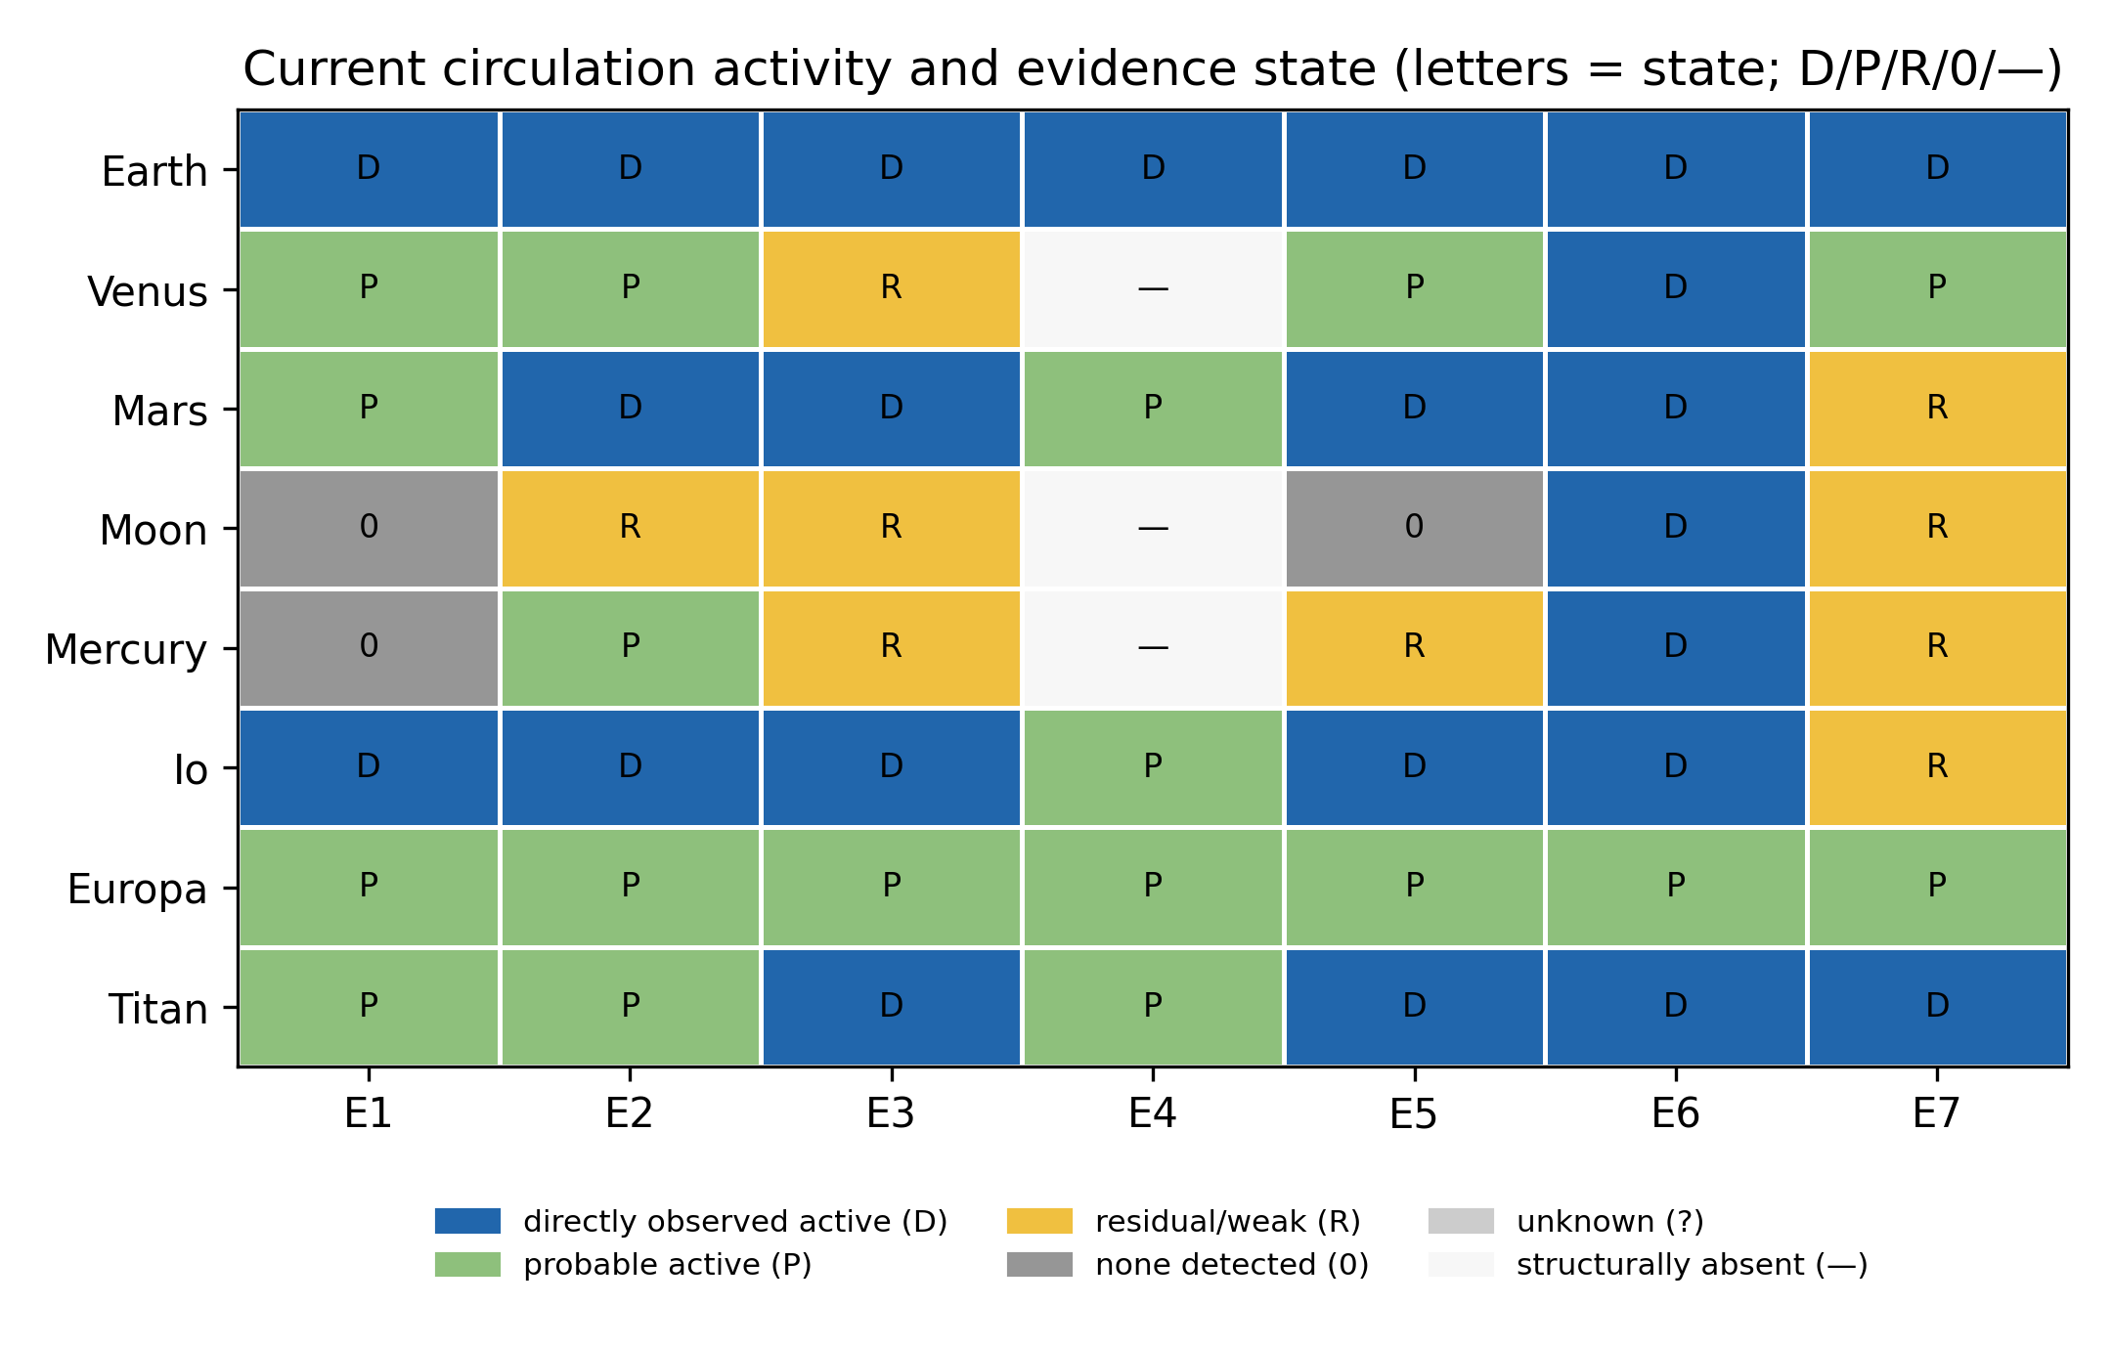

3.2 Dimensionality
On the evidence-state matrix, the first ordination axis explains 56% of variance and separates bodies by overall activity level; the next two axes carry 17% and ~15% (Fig. 3). Leave-one-body-out analysis gives a stable range (PC1 = 46–66%): no single flagship body determines the structure. H1 is therefore answered in the middle: a dominant activity gradient exists and a single axis provides a useful first-order summary, but a substantial share of variance lies outside it. The second axis carries physically interpretable signal: Europa (uniformly probable evidence states with weak observability) and Titan (atmosphere-dominated) separate from the terrestrial cluster.
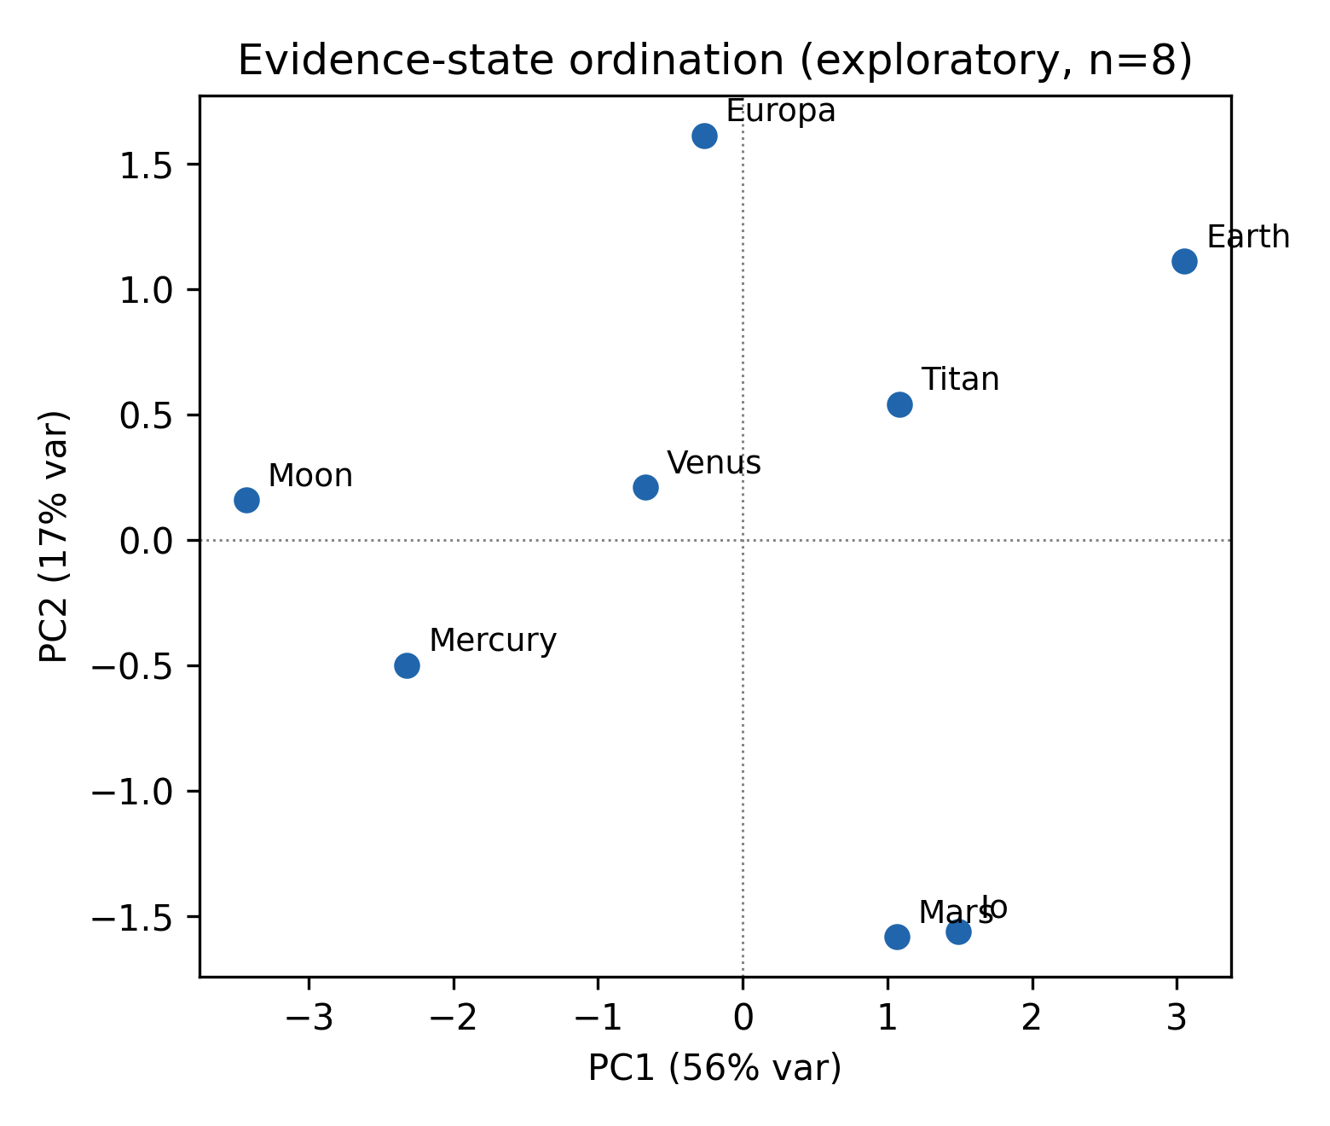

3.3 Asynchronous persistence
Where processes have ceased, they have ceased asynchronously (Fig. 4). Mars lost its core dynamo at ~4.1 Ga (Lillis et al., 2008; Vervelidou et al., 2017) — a persistence fraction of ~0.09 — while all seven edge classes persist at least residually to the present; Mercury's effusive volcanism ceased ~3.5 Ga (persistence fraction ~0.22; Byrne et al., 2016) while contractional tectonism and the internal dynamo continue (Watters et al., 2016; Anderson et al., 2011); the Moon's mare volcanism ended 1.2–2.0 Ga while weak contraction persists (Li et al., 2021; Watters et al., 2019). The persistence spread — the range of per-process persistence fractions within a body — is 0.91 of body age on Mars, 0.78 on Mercury, and 0.44 on the Moon, versus ~0 on Earth, Io, Europa, and Titan, whose surviving processes are all right-censored. H2 is supported for the three differentiated terrestrial bodies that show any cessation: bodies do not shut down as a unit.
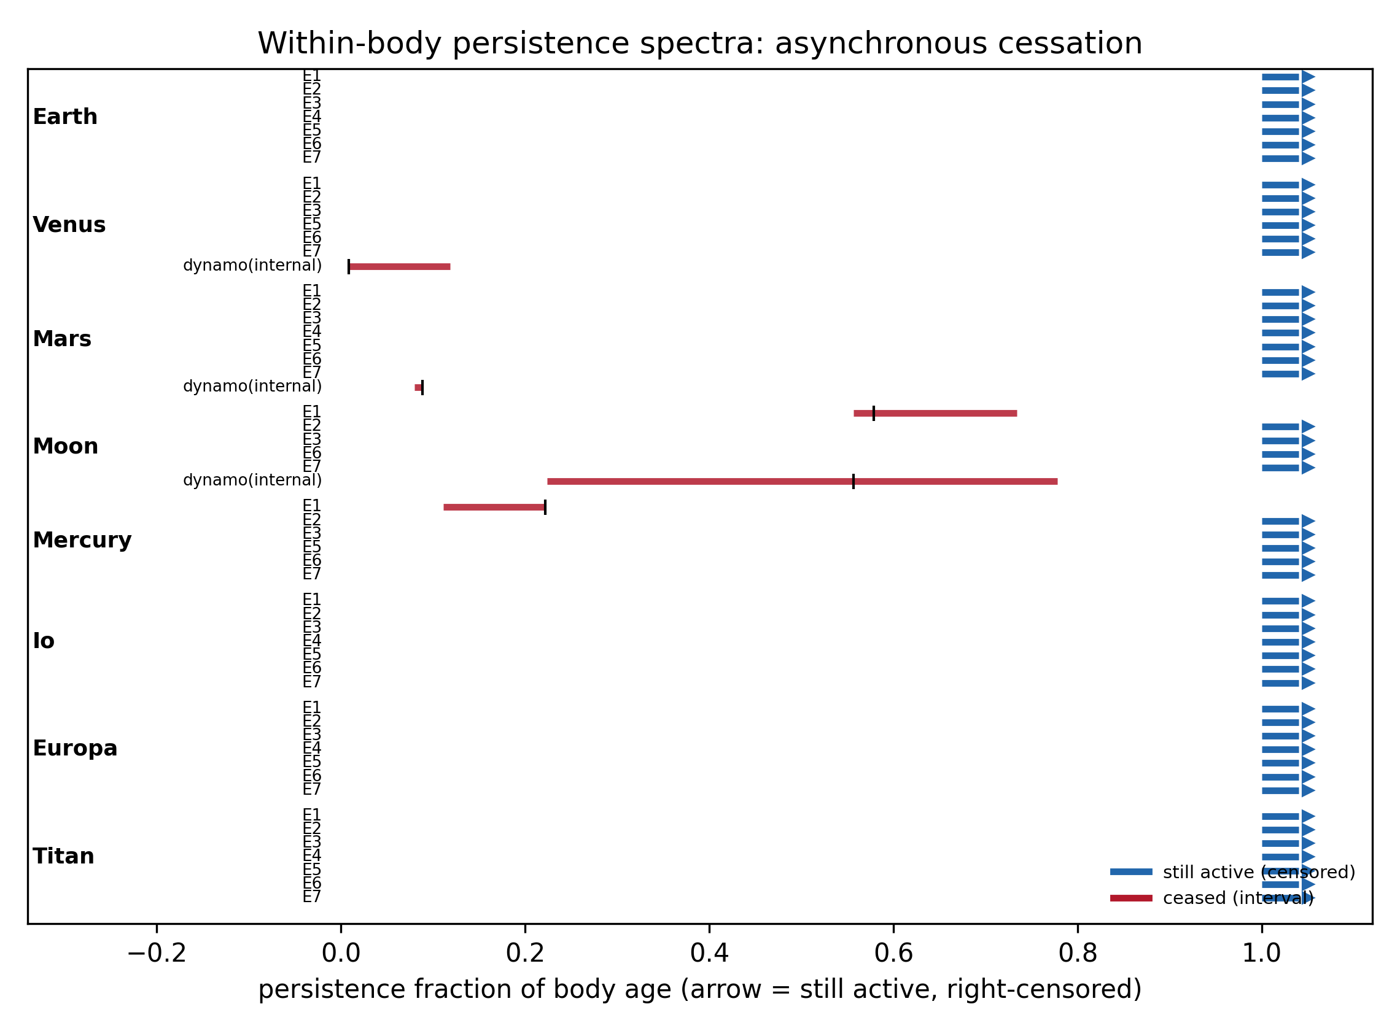

3.4 Network architecture
Supported process classes per body range from 4 (Moon) to 7 (Earth, Mars, Io, Europa, Titan), with Mercury intermediate at 5 (Fig. 5). Because subsurface-liquid exchange (E4) is structurally absent on three bodies, their reservoir graphs differ in connectivity: the Moon and Mercury have the most disconnected networks (4 components), despite Mercury's retention of an internal dynamo. Present-day bodies therefore differ not only in which processes run but in which reservoir couplings exist at all — consistent with H3 as a statement about current architecture (these architectures may arise through progressive loss, persistence, or reconfiguration of couplings, which the present data do not reconstruct).
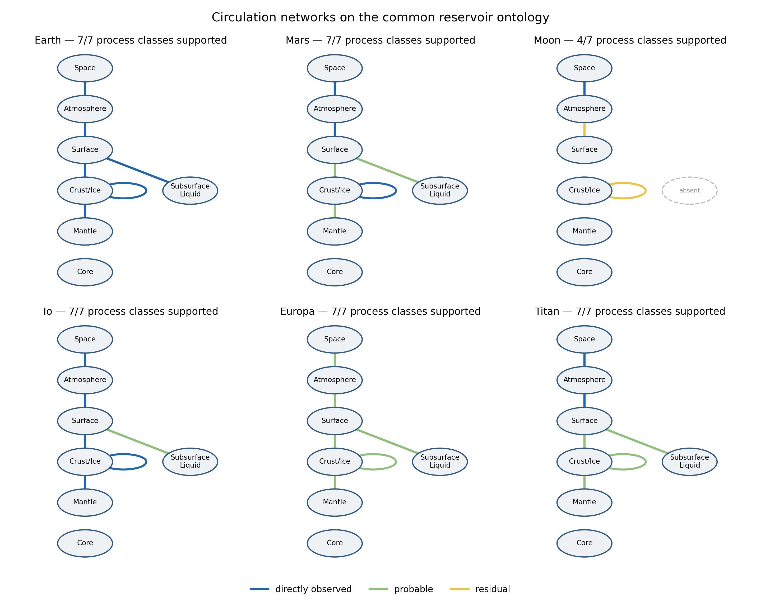

3.5 Quantitative anchors
Where physically comparable measurements exist, the quantitative subset reinforces the state-level picture rather than replacing it. Interior→surface heat transport spans three orders of magnitude — Io's global volcanic heat flow (~10^14 W; Veeder et al., 2012; Davies, 2007) exceeds Earth's total (~47 TW; Davies and Davies, 2010) per unit area by more than an order of magnitude — yet Io and Earth occupy different ordination regions because their other circulation branches differ. Measured escape fluxes span a similarly wide range: Io supplies ~1 t s^-1 to its plasma torus, Earth's hydrogen escape is ~3 kg s^-1 (Catling and Kasting, 2017), and Mars's present-day escape rates are measured by MAVEN (Jakosky et al., 2017). Reservoir turnover is computable only where a defensible reservoir size and flux coexist — Earth's hydrological turnover (~4.96×10^5 km3 yr^-1 evaporation against ~1.34×10^9 km3 of ocean; Trenberth et al., 2007) — and cannot be defined for most other bodies without invented numbers. That asymmetry is itself the point: comparative state must be expressed partly in evidence structure, not only in fluxes.

3.6 Comparison with simple descriptors
The supported-process count is not ordered by age (Spearman ρ = -0.33, p = 0.42) or mass (ρ = 0.08, p = 0.85; n = 8, descriptive only). Energy-source architecture organizes the sample better than either (Fig. 6): tidally dominated bodies (Io, Europa) sustain full process complements without an intrinsic dynamo; stellar-atmospheric processing sustains Titan's circulation; and the radiogenic–primordial terrestrials diverge depending on size and retained heat. A monotonic older→weaker trajectory is incompatible with the observed architectures: Mercury and Titan are both ancient Solar-System bodies yet retain radically different circulation architectures — Mercury keeps an internal dynamo that Titan lacks, while Titan supports a far richer surface–atmosphere circulation. H4 is supported within the pilot sample.
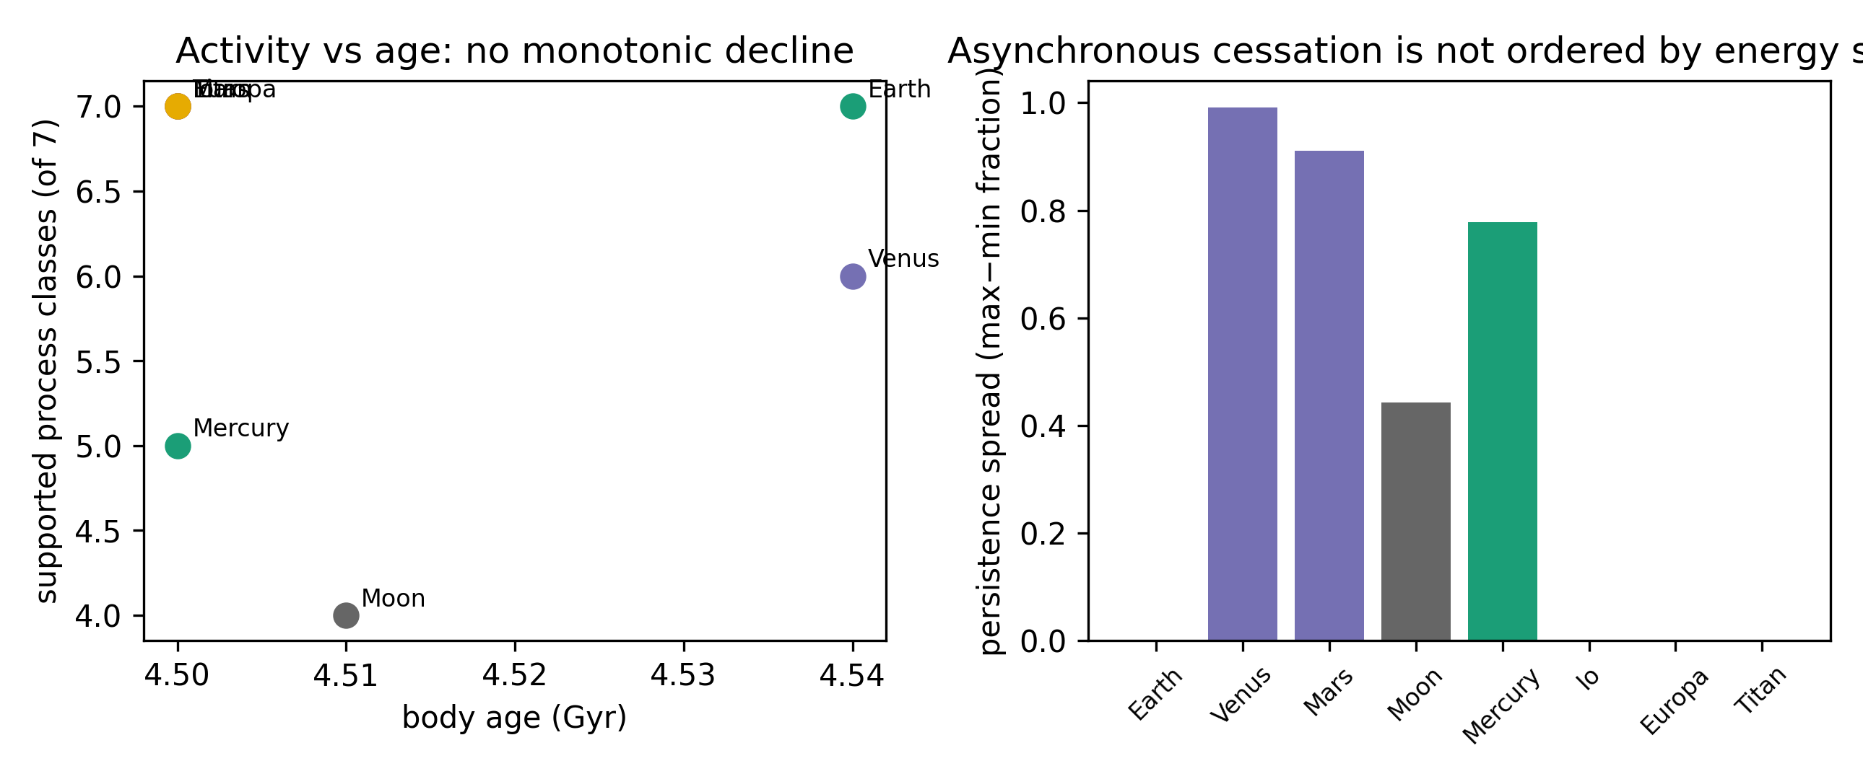

4. Discussion
Two of our three main findings are substantive rather than definitional. First, cessation is a per-subsystem event, not a whole-body event. On Mars, dynamo shutdown preceded the latest volcanism by ~4 Gyr; the architecture lost an internal driver but retained its surface–atmosphere–space circulation. Whole-planet 'activity' is therefore a poor state variable: what differs between Mars and Earth is less the amount of activity than which subsystem failed first. Second, circulation architecture tracks energy-source geometry more than bulk properties: tidal heating sustains Io and Europa's circulation without an internal dynamo, while stellar processing sustains Titan's methane cycle — two 'active' bodies with almost no overlap in which reservoirs are coupled.
The framework is falsifiable, and the pilot shows where it nearly fails. Had one latent dimension explained essentially all variance, the network representation would add little — PC1 alone carries ~56%, so a scalar summary is serviceable as a first approximation but discards almost half the structure. Had cessation been synchronous — all subsystems of a body expiring together — the persistence spectra of Mars and Mercury would be flat; instead they are the most spread in the sample. And had age or mass organized the activity counts, the network language would be redundant; the near-zero correlations show it is not, at least in this sample. None of these tests can exclude that the same patterns emerge from a deeper single variable — for instance total integrated energy throughput — but no such scalar is currently measurable across all eight bodies, which is an argument for the representation, not against it.
A circulation-architecture representation may also provide a physical basis for future extensions of habitability assessment beyond the conventional question of whether a body is naturally habitable (Cockell et al., 2016). For engineered or augmented habitability, an additional question is which planetary functions already operate and which would have to be supplied artificially. Two bodies that are similarly inhospitable under present conditions may therefore differ substantially in intervention requirements if one retains connected atmospheric, volatile, subsurface-liquid, chemical, or energetic circulation pathways whereas the other does not. The classifications developed here could thus provide a starting state for defining an 'augmentation gap' — the set of missing or insufficient circulation functions needed to establish a target material–energy cycle. Quantifying such intervention requirements lies beyond the scope of this Letter, but circulation architecture offers a framework in which natural and engineered habitability could eventually be considered on a common physical basis.
These conclusions carry explicit limits. Observability is uneven: Europa's probable activity rests on induction and morphology pending JUICE/Europa Clipper, and our evidence-state ordination uses ordinal data — the ~44% of ordination variance outside the first axis should be read as indicating further structure, not as a measurement of dimensionality. The pilot covers eight bodies; Enceladus, Ganymede, and Triton would test whether the asynchronous-cessation pattern generalizes to the outer Solar System, and exoplanet demography makes a common comparative state-space representation more valuable, not less. Extensions to cumulative geochemical recycling, metal concentration, and habitability timescales are natural but deliberately outside this Letter.

5. Conclusions
A common reservoir/process ontology can be operationalized across eight diverse planetary bodies at 95% cell coverage. Within that representation: circulation states have a dominant activity axis that is nonetheless incomplete, with ~44% of ordination variance on other axes; subsystem cessation is asynchronous where it occurs (Mars, Mercury, Moon) rather than whole-body; and supported process counts and network connectivity are not predictable from age or mass but are organized by energy-source architecture. A planetary body's dynamical state is a heterogeneous architecture of coupled circulation processes — including which couplings remain — and is not fully captured by a scalar description.

Declaration of competing interests
The authors declare no competing interests. [VERIFY]

Data and code availability
All processed tables, the measurement dictionary, analysis and figure scripts, and provenance records are available at https://github.com/bougtoir/planetary_circulation (public repository synced from the working tree). Source data are published mission and literature products cited per cell in the Supplement.

Acknowledgements
[TO COMPLETE]

Author contributions
[TO COMPLETE — CRediT]

References
Anderson, B.J., Johnson, C.L., Korth, H., Purucker, M.E., Winslow, R.M., Slavin, J.A., Solomon, S.C., McNutt, R.L., Raines, J.M., Zurbuchen, T.H., 2011. The global magnetic field of Mercury from MESSENGER orbital observations. Science 333, 1859–1862. doi:10.1126/science.1211001
Banerdt, W.B., Smrekar, S.E., Banfield, D., Giardini, D., Golombek, M., et al., 2020. Initial results from the InSight mission on Mars. Nat. Geosci. 13, 183–189. doi:10.1038/s41561-020-0544-y
Bierhaus, E.B., Zahnle, K., Chapman, C.R., 2009. Europa's crater distributions and surface ages, in: Pappalardo, R.T. et al. (Eds.), Europa. Univ. Arizona Press, pp. 161–180.
Blewett, D.T., Chabot, N.L., Denevi, B.W., Ernst, C.M., Head, J.W., et al., 2013. Mercury's hollows: constraints on formation and composition from analysis of geological setting and physical characteristics. Science 341, 1082–1085. doi:10.1126/science.1243054
Braden, S.E., Stopar, J.D., Robinson, M.S., Lawrence, S.J., van der Bogert, C.H., Hiesinger, H., 2014. Evidence for basaltic volcanism on the Moon within the past 100 million years. Nat. Geosci. 7, 787–791. doi:10.1038/ngeo2252
Sohl, F., Breuer, D., et al., 2022. Interiors of Earth-like planets and satellites of the Solar System. Surv. Geophys. 43. doi:10.1007/s10712-021-09677-x
Byrne, P.K., Ostrach, L.R., Fassett, C.I., Chapman, C.R., Denevi, B.W., Evans, A.J., Klimczak, C., Banks, M.E., Head, J.W., Solomon, S.C., 2016. Widespread effusive volcanism on Mercury likely ended by about 3.5 Ga. Geophys. Res. Lett. 43, 7408–7416. doi:10.1002/2016GL069412
Carlson, R.W., Johnson, R.E., Anderson, M.S., 1999. Sulfuric acid on Europa and the radiolytic sulfur cycle. Science 286, 97–99. doi:10.1126/science.286.5437.97
Catling, D.C., Kasting, J.F., 2017. Atmospheric Evolution on Inhabited and Lifeless Worlds. Cambridge Univ. Press.
Cockell, C.S., Bush, T., Bryce, C., Direito, S., Fox-Powell, M., Harrison, J.P., Lammer, H., Landenmark, H., Martin-Torres, J., Nicholson, N., Noack, L., O'Malley-James, J., Payler, S.J., Rushby, A., Samuels, T., Schwendner, P., Wadsworth, J., Zorzano, M.P., 2016. Habitability: a review. Astrobiology 16, 89–117. doi:10.1089/ast.2015.1295
Clinton, J., Ceylan, S., van Driel, M., Giardini, D., Stähler, S.C., et al., 2021. The Marsquake catalogue from InSight, sols 0–478. Phys. Earth Planet. Inter. 310, 106595. doi:10.1016/j.pepi.2020.106595
Crisp, J.A., 1984. Rates of magma emplacement and volcanic output. J. Volcanol. Geotherm. Res. 20, 177–211. doi:10.1016/0377-0273(84)90039-8
Davies, A.G., 2007. Volcanism on Io: A Comparison with Earth. Cambridge Univ. Press.
Davies, J.H., Davies, D.R., 2010. Earth's surface heat flux. Solid Earth 1, 5–24. doi:10.5194/se-1-5-2010
de Pater, I., Goldstein, D.B., Lellouch, E., et al., 2020. Io's optical aurora in Jupiter's shadow. Planet. Sci. J. 1, 29. doi:10.3847/PSJ/ab959f
DeMets, C., Gordon, R.G., Argus, D.F., Stein, S., 1990. Current plate motions. Geophys. J. Int. 101, 425–478. doi:10.1111/j.1365-246X.1990.tb06579.x
Elderfield, H., Schultz, A., 1996. Mid-ocean ridge hydrothermal fluxes and the chemical composition of the ocean. Annu. Rev. Earth Planet. Sci. 24, 191–224. doi:10.1146/annurev.earth.24.1.191
Hand, K.P., Carlson, R.W., Chyba, C.F., 2007. Energy, chemical disequilibrium, and geological constraints on Europa. Astrobiology 7, 1006–1022. doi:10.1089/ast.2007.0156
Herrick, R.R., Hensley, S., 2023. Surface changes observed on a Venusian volcano during the Magellan mission. Science 379, 1205–1208. doi:10.1126/science.abm7735
Horst, S.M., 2017. Titan's atmosphere and climate. J. Geophys. Res. Planets 122, 432–482. doi:10.1002/2016JE005240
Iess, L., Jacobson, R.A., Ducci, M., Stevenson, D.J., Lunine, J.I., et al., 2012. The tides of Titan. Science 337, 457–459. doi:10.1126/science.1219631
Jaeger, W.L., Turtle, E.P., Keszthelyi, L.P., Radebaugh, J., McEwen, A.S., Pappalardo, R.T., 2003. Orogenic tectonism on Io. J. Geophys. Res. 108, 5093. doi:10.1029/2002JE001946
Jakosky, B.M., Slipski, M., Benna, M., Mahaffy, P., Elrod, M., et al., 2017. Mars' atmospheric history derived from upper-atmosphere measurements of 38Ar/36Ar. Science 355, 1408–1410. doi:10.1126/science.aai7721
Jakosky, B.M., Brain, D., Chaffin, M., Curry, S., Deighan, J., et al., 2018. Loss of the Martian atmosphere to space: present-day loss rates determined from MAVEN observations and integrated loss through time. Icarus 315, 146–157. doi:10.1016/j.icarus.2018.05.030
Johnson, T.V., Cook, A.F., Sagan, C., Soderblom, L.A., 1979. Volcanic resurfacing rates and implications for volatiles on Io. Nature 280, 746–750. doi:10.1038/280746a0
Khurana, K.K., Jia, X., Kivelson, M.G., Nimmo, F., Schubert, G., Russell, C.T., 2011. Evidence of a global magma ocean in Io's interior. Science 332, 1186–1189. doi:10.1126/science.1201425
Kivelson, M.G., Khurana, K.K., Russell, C.T., Volwerk, M., Walker, R.J., Zimmer, C., 2000. Galileo magnetometer measurements: a stronger case for a subsurface ocean at Europa. Science 289, 1340–1343. doi:10.1126/science.289.5483.1340
Langseth, M.G., Keihm, S.J., Peters, K., 1976. Revised lunar heat-flow values. Proc. Lunar Sci. Conf. 7, 3143–3171.
Lawrence, D.J., Feldman, W.C., Goldsten, J.O., Maurice, S., Peplowski, P.N., et al., 2013. Evidence for water ice near Mercury's north pole from MESSENGER neutron spectrometer measurements. Science 339, 292–296. doi:10.1126/science.1229953
Li, Q.-L., Li, Q., Liu, Y., Tang, G., Li, J., et al., 2021. Two-billion-year-old volcanism on the Moon from Chang'e-5 basalts. Nature 600, 54–58. doi:10.1038/s41586-021-04100-2
Lillis, R.J., Frey, H.V., Manga, M., 2008. Rapid decrease in Martian crustal magnetization in the Noachian era: implications for the dynamo and climate of early Mars. Geophys. Res. Lett. 35, L14203. doi:10.1029/2008GL034338
Lopes, R.M.C., Kirk, R.L., Mitchell, K.L., LeGall, A., Barnes, J.W., et al., 2020. A global geomorphologic map of Titan. Nat. Astron. 4, 228–233. doi:10.1038/s41550-019-0917-3
Lorenz, R.D., Wall, S., Radebaugh, J., Boubin, G., Reffet, E., et al., 2006. The sand seas of Titan: Cassini RADAR observations of longitudinal dunes. Science 312, 724–727. doi:10.1126/science.1123257
Marcq, E., Bertaux, J.-L., Montmessin, F., Belyaev, D., 2013. Variations of sulphur dioxide at the cloud top of Venus's dynamic atmosphere. Nat. Geosci. 6, 25–28. doi:10.1038/ngeo1650
Mighani, S., Wang, H., Shuster, D.L., Borlina, C.S., Nichols, C.I.O., Weiss, B.P., 2020. The end of the lunar dynamo. Nat. Astron. 4, 366–367. doi:10.1038/s41550-020-1046-7
Munk, W., Wunsch, C., 1998. Abyssal recipes II: energetics of tidal and wind mixing. Deep-Sea Res. I 45, 1977–2010. doi:10.1016/S0967-0637(98)00070-3
O'Rourke, J.G., Korenaga, J., 2015. Thermal evolution of Venus with argon degassing. Icarus 260, 56–72. doi:10.1016/j.icarus.2015.07.009
Peale, S.J., Cassen, P., Reynolds, R.T., 1979. Melting of Io by tidal dissipation. Science 203, 892–894. doi:10.1126/science.203.4383.892
Persson, M., Futaana, Y., Nilsson, H., Stenberg Wieser, G., et al., 2018. The Venusian atmospheric oxygen ion escape: extrapolation to the early Solar System. Earth Planet. Sci. Lett. 504, 96–103. doi:10.1016/j.epsl.2018.09.021
Phillips, R.J., Raubertas, R.F., Arvidson, R.E., Sarkar, I.C., Herrick, R.R., Izenberg, N., Grimm, R.E., 1992. Impact craters and Venus resurfacing history. J. Geophys. Res. 97, 15923–15948. doi:10.1029/92JE01696
Phillips, R.J., Russell, C.T., 1987. Upper limit on the intrinsic magnetic field of Venus. J. Geophys. Res. 92, 2253–2263. doi:10.1029/JB092iB03p02253
Roth, L., Saur, J., Retherford, K.D., Strobel, D.F., Feldman, P.D., McGrath, M.A., Nimmo, F., 2014. Transient water vapor at Europa's south pole. Science 343, 171–174. doi:10.1126/science.1247051
Schmidt, B.E., Blankenship, D.D., Patterson, G.W., Schenk, P.M., 2011. Active formation of 'chaos terrain' over shallow subsurface water on Europa. Nature 479, 502–505. doi:10.1038/nature10608
Shao, Y., Wyrwoll, K.-H., Chappell, A., Huang, J., Lin, Z., et al., 2011. Dust cycle: an emerging core theme in Earth system science. Aeolian Res. 2, 181–204. doi:10.1016/j.aeolia.2011.02.001
Sotin, C., Head, J.W., Tobie, G., 2002. Europa: tidal heating of upwelling thermal plumes and the origin of lenticulae and chaos melting. Geophys. Res. Lett. 29, 74. doi:10.1029/2001GL013844
Sotin, C., Jaumann, R., Buratti, B.J., Brown, R.H., Clark, R.N., et al., 2005. Release of volatiles from a possible cryovolcano from near-infrared imaging of Titan. Nature 435, 786–789. doi:10.1038/nature03596
Mitri, G., Meriggiola, R., Hayes, A., Lefevre, A., Tobie, G., Genova, A., Lunine, J.I., Zebker, H., 2014. Shape, topography, gravity anomalies and tidal deformation of Titan. Icarus 236, 169–177. doi:10.1016/j.icarus.2014.03.018
Stofan, E.R., Elachi, C., Lunine, J.I., Lorenz, R.D., Stiles, B., et al., 2007. The lakes of Titan. Nature 445, 61–64. doi:10.1038/nature05438
Tarduno, J.A., Cottrell, R.D., Watkeys, M.K., Hofmann, A., Doubrovine, P.V., et al., 2010. Geodynamo, solar wind, and magnetopause 3.4 to 3.45 billion years ago. Science 327, 1238–1240. doi:10.1126/science.1183445
Trenberth, K.E., Smith, L., Qian, T., Dai, A., Fasullo, J., 2007. Estimates of the global water budget and its annual cycle using observational and model data. J. Hydrometeorol. 8, 758–769. doi:10.1175/JHM600.1
Trumbo, S.K., Brown, M.E., Hand, K.P., 2017. Evidence for an exchange of surface and subsurface oxidants on Europa. Sci. Rep. 7, 10686.
Turtle, E.P., Perry, J.E., Hayes, A.G., Lorenz, R.D., Barnes, J.W., et al., 2011. Rapid and extensive surface changes near Titan's equator: evidence of April showers. Science 331, 1414–1417. doi:10.1126/science.1201063
Vaucher, J., Baratoux, D., Mangold, N., Pinet, P., Kurita, K., Grégoire, M., 2009. The volcanic history of central Elysium Planitia: implications for Martian magmatism. Icarus 204, 418–442. doi:10.1016/j.icarus.2009.06.032
Veeder, G.J., Davies, A.G., Matson, D.L., Johnson, T.V., Williams, D.A., Radebaugh, J., 2012. Io: volcanic thermal sources and global heat flow. Icarus 219, 701–722. doi:10.1016/j.icarus.2012.04.004
Vervelidou, F., Lesur, V., Grott, M., Morschhauser, A., Lillis, R.J., 2017. Constraining the date of the Martian dynamo shutdown by means of crater magnetization signatures. J. Geophys. Res. Planets 122. doi:10.1002/2017JE005410
Watters, T.R., Selvans, M.M., Banks, M.E., Hauck, S.A., Becker, K.J., Robinson, M.S., 2016. Recent tectonic activity on Mercury: evidence for the presence of active thrust faults and faults. Nat. Geosci. 9, 743–747. doi:10.1038/ngeo2814
Watters, T.R., Weber, R.C., Collins, G.C., Howley, I.J., Schmerr, N.C., Johnson, C.L., 2019. Shallow seismic activity and young thrust faults on the Moon. Nat. Geosci. 12, 411–417. doi:10.1038/s41561-019-0362-2
Way, M.J., Del Genio, A.D., 2020. Venusian habitable climate scenarios: modeling Venus through time and applications to slowly rotating Venus-like exoplanets. J. Geophys. Res. Planets 125, e2019JE006276. doi:10.1029/2019JE006276
Weiss, B.P., Tikoo, S.M., 2014. The lunar dynamo. Science 346, 1246753. doi:10.1126/science.1246753
Wright, V., et al., 2024. Liquid water in the Martian mid-crust. Proc. Natl. Acad. Sci. 121, e2409983121. doi:10.1073/pnas.2409983121

Figure captions
Fig. 1. Common reservoir ontology: seven reservoirs and seven transfer-process classes (E1–E7) driven by primordial/radiogenic, tidal, and stellar energy.
Fig. 2. Current circulation activity and evidence state for the eight pilot bodies across process classes E1–E7. D = directly observed, P = probable, R = residual, 0 = none detected, — = structurally absent. Color encodes state; structural absence is distinguished from missing data.
Fig. 3. Ordination (PCA) of standardized evidence states, n = 8. PC1 is a dominant activity gradient; PC2 carries architecture information. Exploratory; see text for leave-one-body-out stability.
Fig. 4. Within-body persistence spectra: fraction of body age over which each process has operated. Arrows = still active (right-censored); red intervals = cessation-age uncertainty. Dynamo cessation is shown as an internal-state indicator, not a circulation edge.
Fig. 5. Current circulation-network connectivity for six representative bodies on the common ontology. Edge color = evidence strength; dashed node = structurally absent reservoir.
Fig. 6. Activity and energy architecture: supported process count vs body age (left), and persistence spread by dominant energy source (right).

