A network framework for comparing circulation architectures
across planetary bodies

Author: [AUTHOR NAME(S) — TO COMPLETE]
Affiliation(s): [TO COMPLETE]
Corresponding author: [email / postal address — TO COMPLETE]
Article type: Letter (Earth and Planetary Science Letters)
Keywords: comparative planetology; planetary evolution; tectonics; volcanism; atmospheric escape; network analysis

Abstract
Whether a planetary body is dynamically active is usually judged process by process — volcanism, tectonics, magnetic dynamo, hydrological cycling — yet the planetary state is the joint architecture of these coupled circulations, not any one of them. We build a common reservoir-and-process ontology (seven reservoirs, seven transfer-process classes) and apply it to a frozen set of eight bodies: Earth, Venus, Mars, the Moon, Mercury, Io, Europa, and Titan. Of 56 body × process cells, 92.9% carry defensible evidence states (tiers A–C). Three findings emerge. First, an ordination of evidence states has a dominant first axis (56% of variance), while ~44% of ordination variance lies outside that axis and carries architecture-specific information: a single activity axis is a useful first-order summary but does not capture the full comparative structure. Second, circulation shutdown within a body is asynchronous where it occurs at all — Mars lost its core dynamo ~4.1 Ga ago while volcanic, atmospheric, escape, and depositional processes persist to the present — a pattern of subsystem-level cessation, not whole-body decay. Third, the number of supported circulation processes per body (4–7) and the connectivity of reservoir networks are not ordered by body age (Spearman ρ ≈ -0.18) or mass (ρ ≈ 0.22); tidal, radiogenic–primordial, and stellar-atmospheric energy architectures produce qualitatively different circulation networks at comparable ages. Planetary dynamical state is thus better represented as a heterogeneous architecture of coupled processes — including which subsystems have shut down and when — than by a single active/inactive axis alone.

1. Introduction
How should the dynamical state of a planetary body be described? Comparative planetology is organized process by process. One literature reconstructs thermal evolution and heat flow — the engines that drive everything else (Langseth et al., 1976; Davies and Davies, 2010; Sohl et al., 2022). Another dates the presence and cessation of internal dynamos, from the early terrestrial paleofield (Tarduno et al., 2010) to the shutdowns of Mars (Lillis et al., 2008; Vervelidou et al., 2017), the Moon (Weiss and Tikoo, 2014; Mighani et al., 2020), and the never-measured Venusian dynamo (Phillips and Russell, 1987; O'Rourke and Korenaga, 2015). Volcanic and tectonic histories form a third strand (Johnson et al., 1979; Phillips et al., 1992; Byrne et al., 2016; Jaeger et al., 2003), atmospheric evolution and escape a fourth (Jakosky et al., 2017, 2018; Persson et al., 2018; Catling and Kasting, 2017), and hydrological or condensable-fluid cycles a fifth (Stofan et al., 2007; Trenberth et al., 2007; Wright et al., 2024), with chemical and redox cycling a sixth (Carlson et al., 1999; Marcq et al., 2013; Horst, 2017; Hand et al., 2007). Each of these literatures is deep and mature, and each answers a well-posed question about one subsystem on one body.
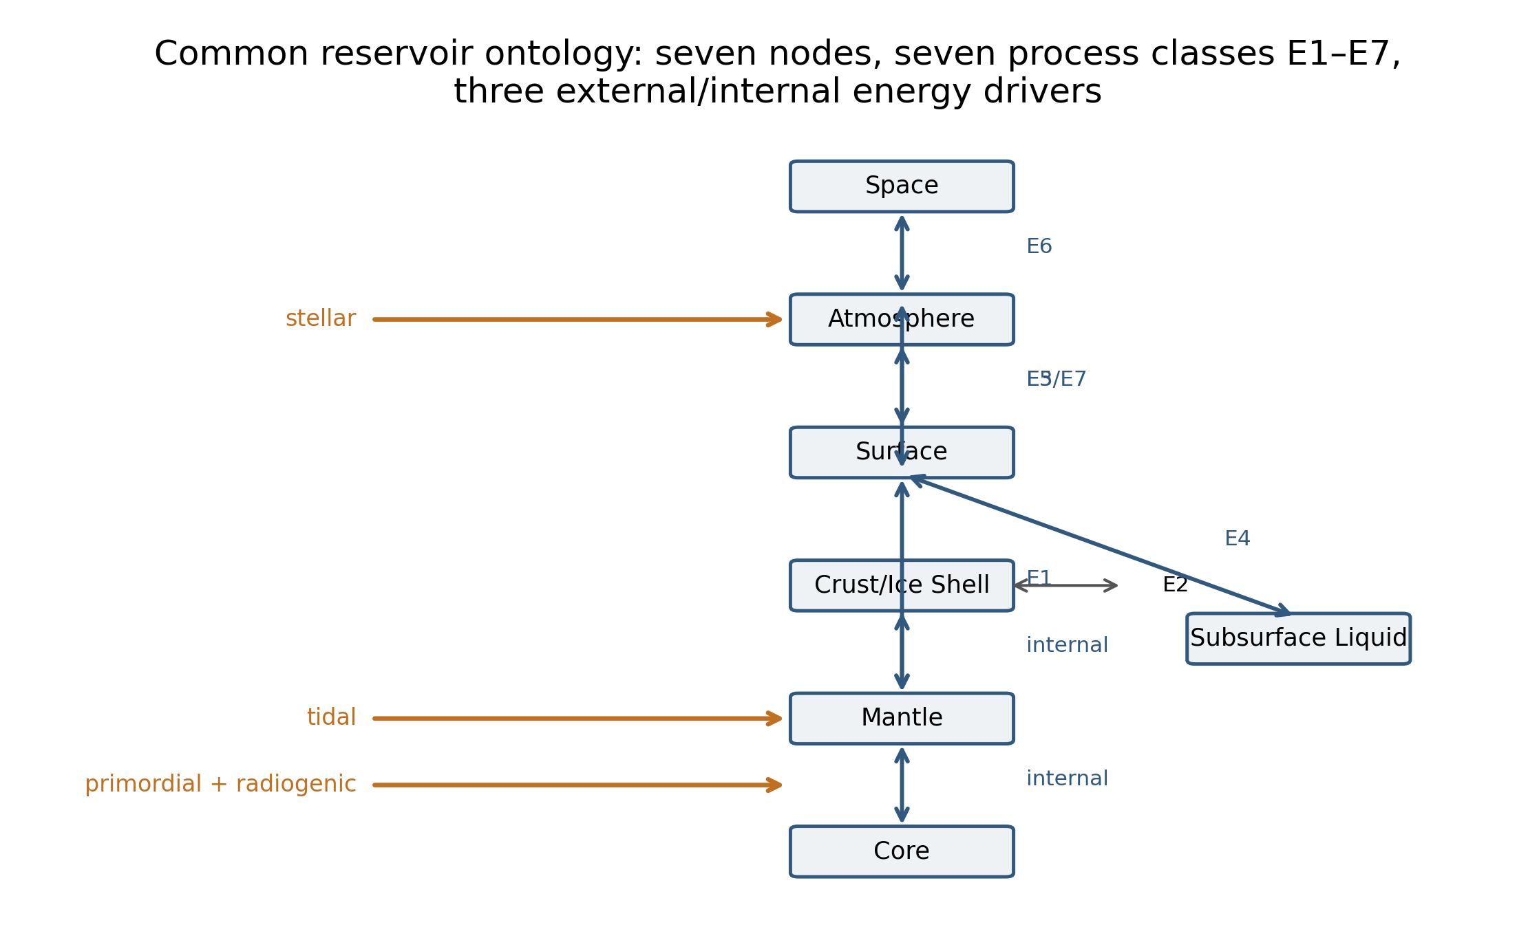
What they do not provide is a common comparative representation of whole-body dynamical state. In practice, the synthesis is made informally: a body is said to be 'more' or 'less' active, on an implicit scalar that nobody has operationalized. Several conceptual frames sit adjacent to that gap without filling it. Thermal-evolution and geodynamic models ask what drives activity within one body, not how architectures compare across bodies (Sohl et al., 2022; O'Rourke and Korenaga, 2015). Rocky planets are routinely described as heat engines run on radiogenic and primordial stores, with tidal dissipation as a second engine where resonances permit (Peale et al., 1979; Sotin et al., 2002). Interior–surface–atmosphere co-evolution frameworks connect the subsystems conceptually but stop at narrative coupling. Habitability assessments ask a different question — whether conditions can support life — and score environments, not architectures (Cockell et al., 2016). 'Planetary metabolism', 'geochemical metabolism', non-equilibrium-thermodynamic and entropy-production framings, and Gaia-adjacent whole-system language supply vocabulary but no measurement object: they name the phenomenon without operationalizing it (Munk and Wunsch, 1998; Elderfield and Schultz, 1996; Shao et al., 2011). We use such terms here only as loose umbrella language, never as a composite index.
This paper supplies the missing measurement object. We represent a planetary body as a network of coupled transfers of energy and matter among a common set of reservoirs (Fig. 1) and we operationalize the comparison by tracking five things separately: which inter-reservoir transfer processes operate now (current activity); how long each has persisted (persistence); how well each is constrained (observability); how the reservoir graph is connected (network architecture); and which energy source drives the architecture (energy-driver context). The claim is not that energy and matter cycle — that is obvious — nor that planets evolve, nor that subsystems shut down. It is that these five axes, measured on a shared ontology, expose comparative structure that the informal activity scalar hides. Two of the separations matter methodically: observability is not activity, because a poorly explored body must not appear inactive merely because less is known about it; and structural absence is not missingness, because a body that simply lacks a subsurface volatile reservoir encodes architecture, not a data gap.
We test the representation against four pre-registered questions on a frozen pilot set of eight bodies spanning terrestrial planets and satellites: Earth, Venus, Mars, the Moon, Mercury, Io, Europa, and Titan. (H1) Is dynamical state adequately represented by one latent activity axis? (H2) Do circulation processes within one body persist for heterogeneous fractions of planetary history, beyond dating uncertainty — i.e., is cessation a per-subsystem event? (H3) Do bodies differ in network connectivity, not only in the presence of individual processes? (H4) Is circulation architecture irreducible to the bulk descriptors age and mass? The questions are comparative and falsifiable, and the pilot is small enough that every cell-level judgment remains auditable. Nothing in what follows requires the reader to accept the ontology as the only possible one — only that whatever it measures, it measures identically on eight very different bodies.

2. Methods
We froze a priori a pilot set of eight bodies chosen to cover the architecturally distinct regimes found among large Solar-System bodies, not to be a representative sample: Earth (the strongly coupled reference with plate-scale interior–surface transport; DeMets et al., 1990), Venus (atmosphere-rich, hydrology-poor), Mars (intermediate, with a preserved sedimentary and magnetization record), the Moon (low current circulation with a well-dated igneous history), Mercury (a small body retaining an intrinsic dynamo; Anderson et al., 2011), Io (the tidal-magmatic extreme; Peale et al., 1979), Europa (tidal heating with a probable subsurface ocean; Kivelson et al., 2000), and Titan (an atmosphere–surface condensable-fluid cycle driven externally; Stofan et al., 2007; Horst, 2017). The set deliberately mixes planets and satellites: the ontology is defined at the body level, and parentage enters only through the energy-driver context. Enceladus, Ganymede, and Triton were reserved as out-of-sample tests rather than pilot members.
Each body is mapped onto a fixed reservoir ontology of seven nodes: core (the deep interior source of metallic dynamo action and primordial heat), mantle (silicate or ice-rock interior through which buoyant transport occurs), crust or ice shell (the mechanically coherent outer layer), subsurface liquid (a persistent volatile reservoir — water ocean, groundwater, brines, or methane/ethane liquid — isolated from the atmosphere), surface, atmosphere, and space (the terminal sink for loss processes). A reservoir is asserted only where one physically exists: Venus, the Moon, Mercury, and Io have no persistent subsurface volatile reservoir as far as is known, and Mars's putative mid-crustal liquid water remains a contested single-study inference rather than established architecture (Wright et al., 2024). These are structural absences recorded in the master table, not missing data points.
Transfers between reservoirs are classified into seven process classes (Fig. 1). E1, interior→surface transport, covers volcanism, plumes, cryovolcanism, and heat-driven buoyant delivery — on Earth spanning magma emplacement and extrusion (Crisp, 1984) and the mid-ocean-ridge circulation that couples it to the hydrosphere (Elderfield and Schultz, 1996), on Io expressed through permanent silicate volcanism (Johnson et al., 1979; Veeder et al., 2012) and associated orogenic tectonism (Jaeger et al., 2003). E2, crust/ice deformation and recycling, covers tectonics, resurfacing, lithospheric recycling, and planetary contraction. E3, surface↔atmosphere exchange, covers cycles of any working fluid — Earth's hydrological cycle (Trenberth et al., 2007), the CO2 cycle of Mars, Titan's methane cycle (Turtle et al., 2011; Lopes et al., 2020), and exogenic mobilization such as lunar dust transport or Titan's aeolian dune fields (Lorenz et al., 2006; Shao et al., 2011). E4, subsurface-liquid↔surface exchange, is restricted to persistent subsurface volatile reservoirs: Europa's chaos-forming exchange (Schmidt et al., 2011; Sotin et al., 2002) and Titan's postulated cryovolcanic recharge (Sotin et al., 2005; Mitri et al., 2014; Iess et al., 2012), set on a young cratered surface (Bierhaus et al., 2009), qualify, whereas Io's inferred global magma ocean (Khurana et al., 2011) is silicate partial melt — interior-state evidence under E1, not a volatile reservoir — and is deliberately not coded as E4. E5, atmosphere→surface deposition, covers condensation, precipitation, and fallout. E6, planet→space loss, covers thermal and non-thermal escape (Jakosky et al., 2018; Persson et al., 2018) and supply to external tori (de Pater et al., 2020). E7, chemical/redox recycling, is deliberately broad: it covers disequilibrium-maintaining coupled cycles such as Europa's sulfur cycle (Carlson et al., 1999; Trumbo et al., 2017), Venus's cloud-top SO2 variability (Marcq et al., 2013), Titan's atmospheric photochemistry (Horst, 2017), and volatile sublimation sculpting Mercury's hollows (Blewett et al., 2013). Three borderline conventions are stated explicitly. First, E1 versus E4 separates silicate magmatism from volatile-subsurface exchange. Second, E3 versus E5 distinguishes bidirectional exchange (evaporation–precipitation cycling) from net deposition. Third, an internal magnetic dynamo is not a circulation edge: it is an internal-state observable recorded as body-level metadata, so Europa's induced magnetic response (Kivelson et al., 2000) evidences a subsurface ocean but is never counted as an intrinsic dynamo, and Mercury's dynamo contributes to the persistence record without adding an edge.
Each of the 8 × 7 = 56 body × process cells carries three independent attributes. The evidence-state for current activity is coded directly observed (an instrument measurement exists — e.g., ion-escape flux at Venus, Persson et al., 2018; marsquake seismicity, Banerdt et al., 2020; Clinton et al., 2021), probable (strong indirect evidence — volcanic surface change on Venus, Herrick and Hensley, 2023; Europa plume detections, Roth et al., 2014; Titan seasonal surface change, Turtle et al., 2011), residual (the process continues at a much reduced level — lunar and Mercurian contractional faulting, Watters et al., 2016, 2019), none detected (searched for and absent), or structurally absent (the reservoir does not exist on that body). The measurement tier grades the basis of each cell (A: direct quantitative measurement; B: defensible proxy; C: state-level judgment only; D: unconstrained). The observability class (O0–O3) grades how difficult the cell is to observe at all — a discipline for keeping 'unobserved' separate from 'inactive'. Quantitative values are attached only where published, physically comparable measurements exist; 10 of 56 cells carry quantitative estimates or measured zeros, and the remaining cells record state and evidence rather than an invented number.
Persistence is expressed per process as the fraction of the body's age over which that process is known to have operated. Processes active today are right-censored (their persistence fraction approaches 1.0) rather than assigned arbitrary end dates; dated cessations carry geological intervals rather than point ages — lunar mare volcanism 1.2–2.0 Ga (Li et al., 2021; Braden et al., 2014), Mercurian effusive volcanism ~3.5 Ga (Byrne et al., 2016), the lunar dynamo (Mighani et al., 2020; Weiss and Tikoo, 2014), and the Martian dynamo ~4.1 Ga (Lillis et al., 2008; Vervelidou et al., 2017). Within-body persistence spread is defined as max − min of the per-process persistence fractions over dated cessations and right-censored cells. A process enters the statistic only if its cessation is empirically dated: Venus's dynamo shutdown, inferred from the absence of a detected field rather than from dated remanence (Phillips and Russell, 1987), is drawn in the persistence figure but excluded from the statistic. Monte Carlo sampling (4,000 draws) over the cessation-date intervals propagates dating uncertainty on this same statistic.
Analysis is descriptive throughout: at n = 8 we fit no predictive models and report no significance claims beyond the two deliberate null comparisons. The evidence-state matrix is ordinated with PCA on standardized ordinal states (structurally absent cells are imputed by column medians for ordination only, so that absence cannot manufacture activity signal), with leave-one-body-out sensitivity for each of the eight bodies. Binary reservoir networks are built per body from supported process edges (evidence-state direct, probable, or residual), and connectivity is summarized by supported-edge count and component count. Supported-process counts are compared against the null predictors age and mass (Spearman rank) and against the dominant circulation-driving energy source (radiogenic–primordial, tidal, or stellar) assigned per body. All cell-level judgments, measurement tiers, and source references are recorded in the master evidence table and provenance files in the public repository, so every number in this text can be traced to a row and a cited source.

3. Results

3.1 Coverage and the activity matrix
The predefined coverage gate is exceeded: 52/56 cells (92.9%) are evaluable at tiers A–C and all eight bodies have ≥4 evaluable process classes. Fig. 2 shows the evidence-state matrix with measurement tiers overlaid, so that the confidence structure can be read cell by cell. Directly observed activity is concentrated where expected — Earth throughout, where plate motions (DeMets et al., 1990), magma output (Crisp, 1984), the hydrological cycle (Trenberth et al., 2007), and ridge-axis hydrothermal circulation (Elderfield and Schultz, 1996) are all instrumented; Io's interior–surface, resurfacing, and plasma-loss channels, where volcanism is persistent and global (Johnson et al., 1979; Veeder et al., 2012) and supply to the torus is measured (de Pater et al., 2020); the CO2 cycle on Mars; and escape everywhere it has been measured, from MAVEN's present-day rates at Mars (Jakosky et al., 2017, 2018) to Venus's ion escape (Persson et al., 2018). The informative cells are the intermediate ones: probable-but-unobserved volcanism on Venus (Herrick and Hensley, 2023) and Titan (Sotin et al., 2005), contested plume evidence on Europa (Roth et al., 2014), residual contractional tectonics on the Moon and Mercury (Watters et al., 2016, 2019), and Mercury's polar volatile trapping as a probable cold-trapping channel (Lawrence et al., 2013) — and the four structural absences that eliminate the subsurface-volatile branch on Venus, the Moon, Mercury, and Io. The matrix thus reads as three populations at once: a core of instrumented circulation, a shell of probable and residual processes carrying most of the comparative signal, and a set of architectural voids that are not data gaps. No cell required inventing a measurement: wherever the evidence base could not support a state call, the tier records the gap honestly.
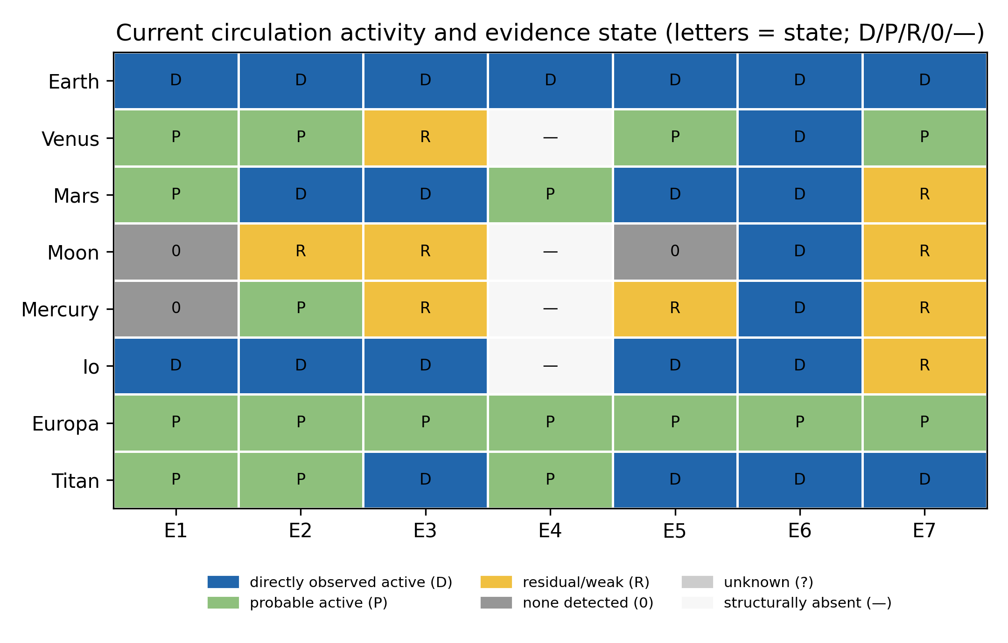

3.2 Dimensionality
On the evidence-state matrix, the first ordination axis explains 56% of variance and separates bodies by overall activity level; the next two axes carry 17% and 15% (Fig. 3). Leave-one-body-out analysis gives a stable range (PC1 = 46–66%): no single flagship body determines the structure, so the gradient is a property of the sample rather than of one dominant body. The second axis carries physically interpretable signal: Europa (uniformly probable evidence states with weak observability — the induction-inferred ocean, Kivelson et al., 2000; chaos-forming exchange, Schmidt et al., 2011) and Titan (atmosphere-dominated, with its methane–surface cycle, Horst, 2017; Lopes et al., 2020) separate from the terrestrial cluster, while the terrestrials themselves order along the gradient in a way no bulk descriptor predicts. H1 is therefore answered in the middle: a dominant activity gradient exists and a single axis provides a useful first-order summary, but a substantial share of variance lies outside it. The comparative state-space is real but not one-dimensional; bodies that coincide on the first axis can still differ architecturally on the second — which is exactly the structure the informal activity scalar would erase.
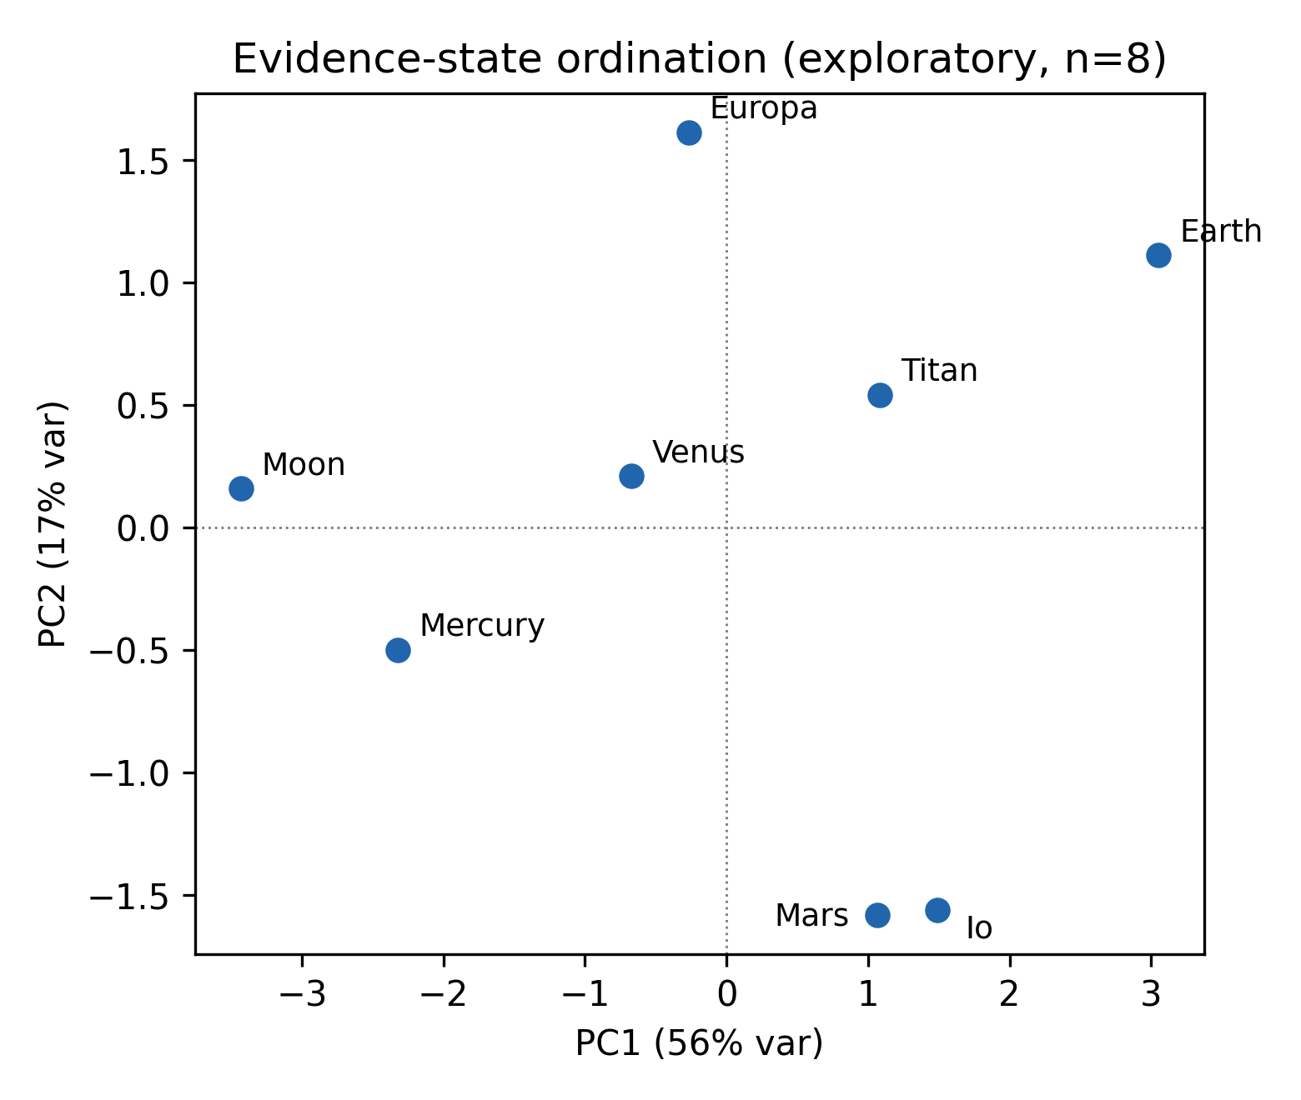

3.3 Asynchronous persistence
Where processes have ceased, they have ceased asynchronously (Fig. 4). Mars lost its core dynamo at ~4.1 Ga (Lillis et al., 2008; Vervelidou et al., 2017) — a persistence fraction of ~0.09 — while volcanism (extended into the Amazonian at Elysium, Vaucher et al., 2009) and all seven edge classes persist at least residually to the present; Mercury's effusive volcanism ceased ~3.5 Ga (persistence fraction ~0.22; Byrne et al., 2016) while contractional tectonism and the internal dynamo continue (Watters et al., 2016; Anderson et al., 2011); the Moon's dynamo died early (Weiss and Tikoo, 2014; Mighani et al., 2020) and its mare volcanism ended 1.2–2.0 Ga with a tail of young flows (Li et al., 2021; Braden et al., 2014) while weak contraction persists (Watters et al., 2019). The persistence spread — the range of per-process persistence fractions within a body — is 0.91 of body age on Mars, 0.78 on Mercury, and 0.44 on the Moon (Monte Carlo 5–95% bands 0.91–0.92, 0.78–0.88, and 0.32–0.75 respectively), versus ~0 on Earth, Venus, Io, Europa, and Titan, whose surviving dated processes are all right-censored. The spreads are robust to where each cessation sits inside its geological interval — dating uncertainty cannot manufacture the asynchrony. Venus's dynamo shutdown is drawn in Fig. 4 but excluded from the statistic because no paleofield — and hence no dated cessation — has ever been measured on Venus (Phillips and Russell, 1987); including it would smuggle an inference into an empirical count. H2 is supported for the three differentiated terrestrial bodies that show any dated cessation: bodies do not shut down as a unit, and 'a planet turned off' is not a state these data ever exhibit.
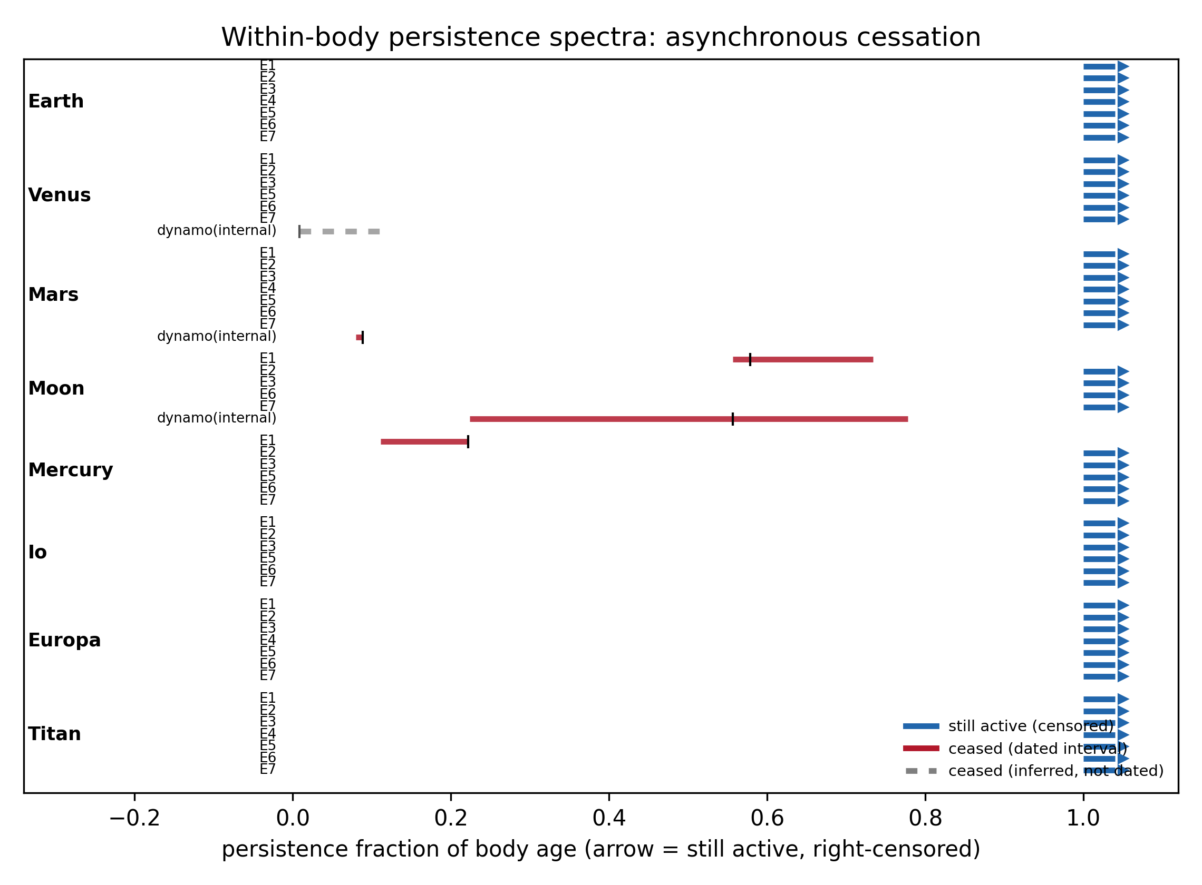

3.4 Network architecture
Supported process classes per body range from 4 (the Moon) to 7 (Earth, Mars, Europa, Titan), with Venus, Io at 6 and Mercury at 5 (Fig. 5). Because subsurface-volatile exchange (E4) is structurally absent on 4 bodies, their reservoir graphs differ in connectivity: the Moon and Mercury have the most disconnected networks (4 components), despite Mercury's retention of an internal dynamo. Earth's graph is the densest reference case — its crust-recycling edge closes a loop no other pilot body completes — while the satellites diverge by which branch dominates: Io is deep-interior and plasma dominated, Europa is subsurface dominated, Titan is atmosphere–surface dominated. Present-day bodies therefore differ not only in which processes run but in which reservoir couplings exist at all — consistent with H3 as a statement about current architecture (these architectures may arise through progressive loss, persistence, or reconfiguration of couplings, which the present data do not reconstruct).
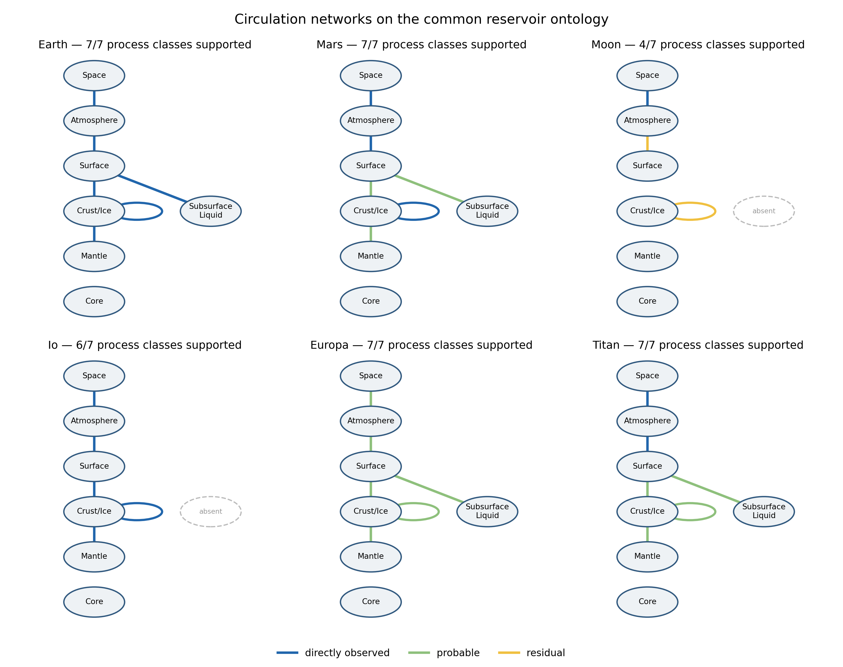

3.5 Quantitative anchors
Where physically comparable measurements exist, the quantitative subset reinforces the state-level picture rather than replacing it. Interior→surface heat transport spans three orders of magnitude — Io's global volcanic heat flow (~10^14 W; Veeder et al., 2012; Davies, 2007) exceeds Earth's total (~47 TW; Davies and Davies, 2010) per unit area by more than an order of magnitude — yet Io and Earth occupy different ordination regions because their other circulation branches differ: flux magnitude alone does not set architecture. Measured escape fluxes span a similarly wide range: Io supplies ~1 t s^-1 to its plasma torus (de Pater et al., 2020), Earth's hydrogen escape is ~3 kg s^-1 (Catling and Kasting, 2017), and Mars's present-day escape rates are measured by MAVEN (Jakosky et al., 2017, 2018). Reservoir turnover is computable only where a defensible reservoir size and flux coexist — Earth's hydrological turnover (~4.96×10^5 km3 yr^-1 evaporation against ~1.34×10^9 km3 of ocean; Trenberth et al., 2007) — and cannot be defined for most other bodies without invented numbers. That asymmetry is itself the point: comparative state must be expressed partly in evidence structure, not only in fluxes. Where the quantitative anchors do exist they confirm that ordination position tracks architecture, not output magnitude — Io's extreme heat throughput and Earth's moderate one are different solutions to different reservoirs, not steps on one scale.

3.6 Comparison with simple descriptors
The supported-process count is not ordered by age (Spearman ρ = -0.18, p = 0.68) or mass (ρ = 0.22, p = 0.61; n = 8, descriptive only). In this pilot, the dominant circulation-driving energy source is more informative about the architecture than either bulk property (Fig. 6): tidally driven bodies (Io, Europa) sustain near-full process complements without an intrinsic dynamo; stellar-atmospheric processing sustains Titan's circulation; and the radiogenic–primordial terrestrials diverge depending on size and retained heat. A monotonic older→weaker trajectory is incompatible with the observed architectures: Mercury and Titan are both ancient Solar-System bodies yet retain radically different circulation architectures — Mercury keeps an internal dynamo that Titan lacks, while Titan supports a far richer surface–atmosphere circulation. The bulk descriptors fail for opposite reasons on different bodies: age fails because cessation is asynchronous, mass fails because external drivers (tides at Io and Europa, stellar flux at Titan) decouple the architecture from the body's own heat budget. H4 is supported within the pilot sample.
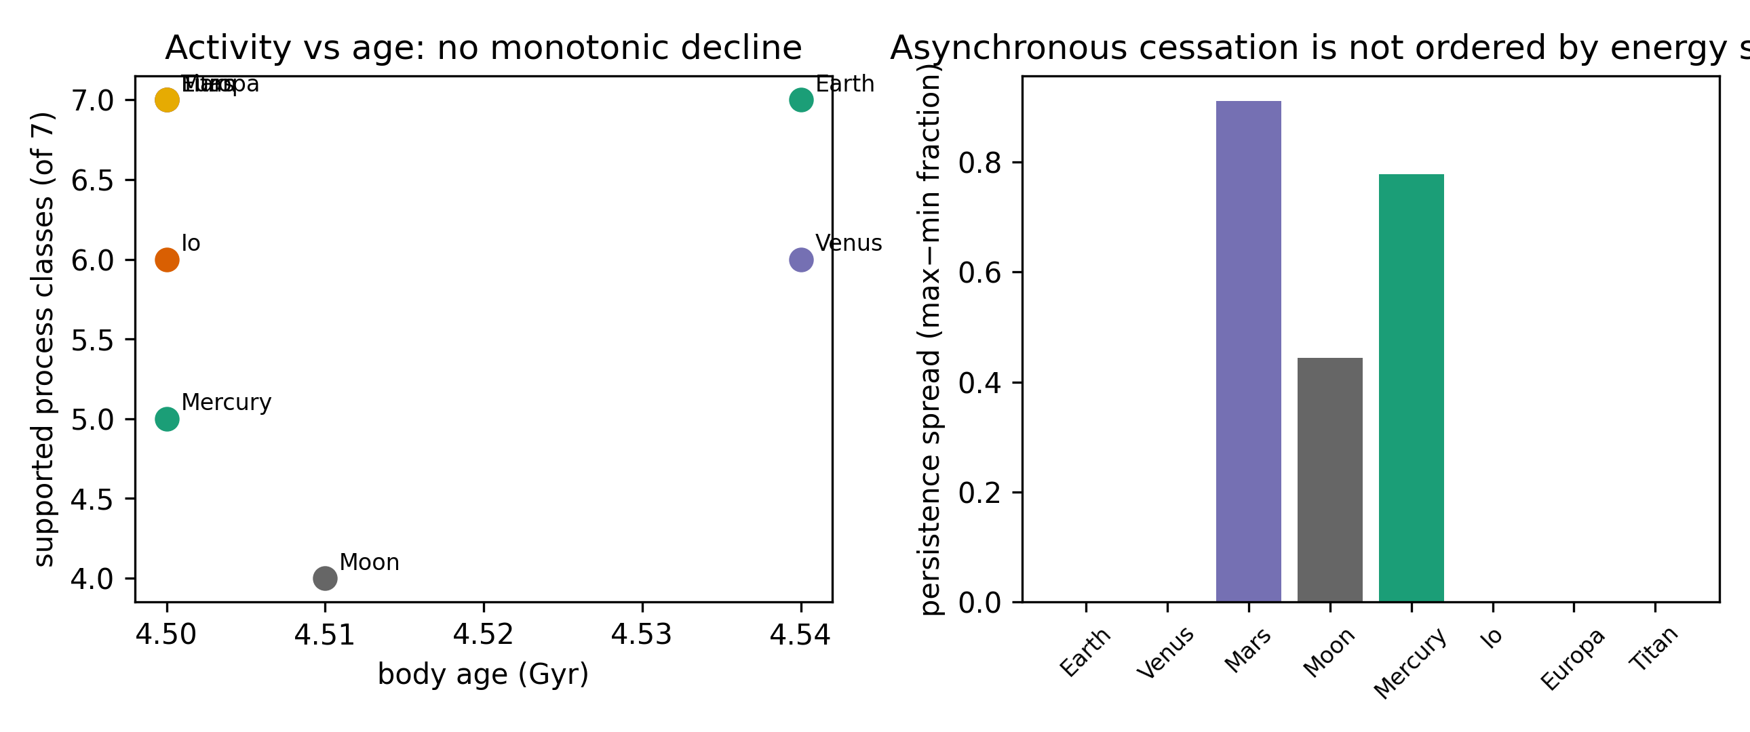

4. Discussion
The contribution of this Letter is a measurement object, not a model: a frozen, auditable representation in which the comparative dynamical state of a planetary body is a tuple of activity, persistence, observability, connectivity, and energy-driver context rather than an informal scalar. Two of our three main findings are substantive rather than definitional. First, cessation is a per-subsystem event, not a whole-body event. On Mars, dynamo shutdown preceded the latest volcanism by ~4 Gyr; the architecture lost an internal driver but retained its surface–atmosphere–space circulation. Whole-planet 'activity' is therefore a poor state variable: what differs between Mars and Earth is less the amount of activity than which subsystem failed first — Mars reads as a body that lost one coupling and kept the rest, not as a dimmer version of Earth. Second, circulation architecture tracks energy-source geometry more than bulk properties: tidal heating sustains Io and Europa's circulation without an internal dynamo, while stellar processing sustains Titan's methane cycle — two 'active' bodies with almost no overlap in which reservoirs are coupled.
Read against the literatures it joins, the representation adds four things that the process-by-process account cannot carry. It makes the scalar testable: the informal activity axis turns out to be a defensible first-order summary (PC1 = ~56%) rather than a complete one — an answer to H1 that neither the 'planets as heat engines' framing nor narrative comparisons could produce. It separates senescence from fragmentation: the persistence spectra show that terrestrial bodies lose couplings one at a time and in body-specific order, so 'dying' is an architectural reconfiguration, not a monotonic fade. It gives the energy-source contrast a common metric: the tidally driven bodies and the radiogenic terrestrials differ in which reservoirs are connected, not merely in how much heat flows. And it keeps ignorance visible as a separate axis — the observability structure of the matrix shows where 'less active' may still be 'less explored', which no scalar could distinguish.
The framework is falsifiable, and the pilot shows where it nearly fails. Had one latent dimension explained essentially all variance, the network representation would add little — PC1 alone carries ~56%, so a scalar summary is serviceable as a first approximation but discards almost half the structure. Had cessation been synchronous — all subsystems of a body expiring together — the persistence spectra of Mars and Mercury would be flat; instead they are the most spread in the sample. And had age or mass organized the activity counts, the network language would be redundant; the near-zero correlations show it is not, at least in this sample. None of these tests can exclude that the same patterns emerge from a deeper single variable — for instance total integrated energy throughput — but no such scalar is currently measurable across all eight bodies, which is an argument for the representation, not against it.
The natural comparison is to interior thermal-evolution and geodynamic histories, which explain per-body activity trajectories mechanistically (Sohl et al., 2022; O'Rourke and Korenaga, 2015). The two objects are complements, not rivals: thermal histories explain why a body sustains heat-driven circulation at all, while the architecture records which couplings survive and where they sit. A thermal model can say that Mercury's small core should have frozen; only an architectural description records that Mercury nevertheless retains a dynamo, lost its volcanism, kept its contraction, and voided its volatile branch — four asymmetric facts that no cooling curve carries by itself. The same distinction frames the observability axis as an epistemic finding in its own right: Europa's cell pattern (probable states with weak observability) is a claim about the measurement program, and it is what JUICE and Europa Clipper will test, not the ontology.
A circulation-architecture representation may also provide a physical basis for future extensions of habitability assessment beyond the conventional question of whether a body is naturally habitable (Cockell et al., 2016; cf. the climate-history scenarios of Way and Del Genio, 2020). For engineered or augmented habitability, an additional question is which planetary functions already operate and which would have to be supplied artificially. Two bodies that are similarly inhospitable under present conditions may therefore differ substantially in intervention requirements if one retains connected atmospheric, volatile, subsurface-liquid, chemical, or energetic circulation pathways whereas the other does not. The classifications developed here could thus provide a starting state for defining an 'augmentation gap' — the set of missing or insufficient circulation functions needed to establish a target material–energy cycle. Quantifying such intervention requirements lies beyond the scope of this Letter, but circulation architecture offers a framework in which natural and engineered habitability could eventually be considered on a common physical basis.
The same representation points toward cumulative geochemical applications that this Letter deliberately leaves open: an architecture with surviving surface–interior couplings is, formally, a body on which crustal material can be recycled and metals concentrated over geological time, whereas an architecture whose recycling edges have ceased preserves a frozen geochemical inventory. Extending the persistence record backward — from whether a process operates to how much material it has moved — is a natural extension of the framework, not a claim made here.
These conclusions carry explicit limits. The pilot is n = 8 chosen for architectural diversity, so every correlation reported here is a description of this sample, not an estimate of a Solar-System population: the null results against age and mass bound what this sample supports, they do not disprove bulk-descriptor influence everywhere. The ordination runs on ordinal evidence states rather than measured quantities — it ranks how well-evidenced activity is, and conflates, by design, process strength with observation depth wherever a quantitative anchor is absent — so the ~44% of ordination variance outside the first axis should be read as indicating further structure, not as a measurement of dimensionality. Observability is uneven: Europa's probable activity rests on induction and morphology pending JUICE/Europa Clipper, and Venus's current magmatism rests on surface-change detection from a single mission era. Cell judgments are literature-based and conservative: a disputed detection is coded probable, never direct, so the matrix understates rather than overstates activity where the evidence base is contested. These limits mark exactly where the framework is weakest and therefore where the next observations — JUICE, Europa Clipper, and any future Venus radar — decide between refinement and revision. The pilot covers eight bodies; Enceladus, Ganymede, and Triton would test whether the asynchronous-cessation pattern generalizes to the outer Solar System, and exoplanet demography makes a common comparative state-space representation more valuable, not less. Extensions to cumulative geochemical recycling, metal concentration, and habitability timescales are natural but deliberately outside this Letter.

5. Conclusions
A common reservoir/process ontology can be operationalized across eight diverse planetary bodies at 93% cell coverage. Within that representation: circulation states have a dominant activity axis that is nonetheless incomplete, with ~44% of ordination variance on other axes; subsystem cessation is asynchronous where it occurs (Mars, Mercury, Moon) rather than whole-body; and supported process counts and network connectivity are not predictable from age or mass but covary with the dominant circulation-driving energy source. The contribution is a measurement object — a frozen, auditable state representation that makes long-standing comparative intuitions testable — together with the first falsification of the informal activity scalar it was meant to replace. A planetary body's dynamical state is a heterogeneous architecture of coupled circulation processes — including which couplings remain — and is not fully captured by a scalar description. Whether the architecture perspective survives contact with the outer Solar System is a question the framework is now shaped to answer: the same frozen ontology applied to Enceladus, Ganymede, and Triton will either extend the asynchronous-cessation pattern or bound its reach, and either outcome is informative.

Declaration of competing interests
The authors declare no competing interests. [VERIFY]

Data and code availability
All processed tables, the measurement dictionary, analysis and figure scripts, and provenance records are available at https://github.com/bougtoir/planetary_circulation (public repository synced from the working tree). Source data are published mission and literature products cited per cell in the repository's master evidence table.

Acknowledgements
[TO COMPLETE]

Author contributions
[TO COMPLETE — CRediT]

References
Anderson, B.J., Johnson, C.L., Korth, H., Purucker, M.E., Winslow, R.M., Slavin, J.A., Solomon, S.C., McNutt, R.L., Raines, J.M., Zurbuchen, T.H., 2011. The global magnetic field of Mercury from MESSENGER orbital observations. Science 333, 1859–1862. doi:10.1126/science.1211001
Banerdt, W.B., Smrekar, S.E., Banfield, D., Giardini, D., Golombek, M., et al., 2020. Initial results from the InSight mission on Mars. Nat. Geosci. 13, 183–189. doi:10.1038/s41561-020-0544-y
Bierhaus, E.B., Zahnle, K., Chapman, C.R., 2009. Europa's crater distributions and surface ages, in: Pappalardo, R.T. et al. (Eds.), Europa. Univ. Arizona Press, pp. 161–180.
Blewett, D.T., Chabot, N.L., Denevi, B.W., Ernst, C.M., Head, J.W., et al., 2013. Mercury's hollows: constraints on formation and composition from analysis of geological setting and physical characteristics. Science 341, 1082–1085. doi:10.1126/science.1243054
Braden, S.E., Stopar, J.D., Robinson, M.S., Lawrence, S.J., van der Bogert, C.H., Hiesinger, H., 2014. Evidence for basaltic volcanism on the Moon within the past 100 million years. Nat. Geosci. 7, 787–791. doi:10.1038/ngeo2252
Sohl, F., Breuer, D., et al., 2022. Interiors of Earth-like planets and satellites of the Solar System. Surv. Geophys. 43. doi:10.1007/s10712-021-09677-x
Byrne, P.K., Ostrach, L.R., Fassett, C.I., Chapman, C.R., Denevi, B.W., Evans, A.J., Klimczak, C., Banks, M.E., Head, J.W., Solomon, S.C., 2016. Widespread effusive volcanism on Mercury likely ended by about 3.5 Ga. Geophys. Res. Lett. 43, 7408–7416. doi:10.1002/2016GL069412
Carlson, R.W., Johnson, R.E., Anderson, M.S., 1999. Sulfuric acid on Europa and the radiolytic sulfur cycle. Science 286, 97–99. doi:10.1126/science.286.5437.97
Catling, D.C., Kasting, J.F., 2017. Atmospheric Evolution on Inhabited and Lifeless Worlds. Cambridge Univ. Press.
Cockell, C.S., Bush, T., Bryce, C., Direito, S., Fox-Powell, M., Harrison, J.P., Lammer, H., Landenmark, H., Martin-Torres, J., Nicholson, N., Noack, L., O'Malley-James, J., Payler, S.J., Rushby, A., Samuels, T., Schwendner, P., Wadsworth, J., Zorzano, M.P., 2016. Habitability: a review. Astrobiology 16, 89–117. doi:10.1089/ast.2015.1295
Clinton, J., Ceylan, S., van Driel, M., Giardini, D., Stähler, S.C., et al., 2021. The Marsquake catalogue from InSight, sols 0–478. Phys. Earth Planet. Inter. 310, 106595. doi:10.1016/j.pepi.2020.106595
Crisp, J.A., 1984. Rates of magma emplacement and volcanic output. J. Volcanol. Geotherm. Res. 20, 177–211. doi:10.1016/0377-0273(84)90039-8
Davies, A.G., 2007. Volcanism on Io: A Comparison with Earth. Cambridge Univ. Press.
Davies, J.H., Davies, D.R., 2010. Earth's surface heat flux. Solid Earth 1, 5–24. doi:10.5194/se-1-5-2010
de Pater, I., Goldstein, D.B., Lellouch, E., et al., 2020. Io's optical aurora in Jupiter's shadow. Planet. Sci. J. 1, 29. doi:10.3847/PSJ/ab959f
DeMets, C., Gordon, R.G., Argus, D.F., Stein, S., 1990. Current plate motions. Geophys. J. Int. 101, 425–478. doi:10.1111/j.1365-246X.1990.tb06579.x
Elderfield, H., Schultz, A., 1996. Mid-ocean ridge hydrothermal fluxes and the chemical composition of the ocean. Annu. Rev. Earth Planet. Sci. 24, 191–224. doi:10.1146/annurev.earth.24.1.191
Hand, K.P., Carlson, R.W., Chyba, C.F., 2007. Energy, chemical disequilibrium, and geological constraints on Europa. Astrobiology 7, 1006–1022. doi:10.1089/ast.2007.0156
Herrick, R.R., Hensley, S., 2023. Surface changes observed on a Venusian volcano during the Magellan mission. Science 379, 1205–1208. doi:10.1126/science.abm7735
Horst, S.M., 2017. Titan's atmosphere and climate. J. Geophys. Res. Planets 122, 432–482. doi:10.1002/2016JE005240
Iess, L., Jacobson, R.A., Ducci, M., Stevenson, D.J., Lunine, J.I., et al., 2012. The tides of Titan. Science 337, 457–459. doi:10.1126/science.1219631
Jaeger, W.L., Turtle, E.P., Keszthelyi, L.P., Radebaugh, J., McEwen, A.S., Pappalardo, R.T., 2003. Orogenic tectonism on Io. J. Geophys. Res. 108, 5093. doi:10.1029/2002JE001946
Jakosky, B.M., Slipski, M., Benna, M., Mahaffy, P., Elrod, M., et al., 2017. Mars' atmospheric history derived from upper-atmosphere measurements of 38Ar/36Ar. Science 355, 1408–1410. doi:10.1126/science.aai7721
Jakosky, B.M., Brain, D., Chaffin, M., Curry, S., Deighan, J., et al., 2018. Loss of the Martian atmosphere to space: present-day loss rates determined from MAVEN observations and integrated loss through time. Icarus 315, 146–157. doi:10.1016/j.icarus.2018.05.030
Johnson, T.V., Cook, A.F., Sagan, C., Soderblom, L.A., 1979. Volcanic resurfacing rates and implications for volatiles on Io. Nature 280, 746–750. doi:10.1038/280746a0
Khurana, K.K., Jia, X., Kivelson, M.G., Nimmo, F., Schubert, G., Russell, C.T., 2011. Evidence of a global magma ocean in Io's interior. Science 332, 1186–1189. doi:10.1126/science.1201425
Kivelson, M.G., Khurana, K.K., Russell, C.T., Volwerk, M., Walker, R.J., Zimmer, C., 2000. Galileo magnetometer measurements: a stronger case for a subsurface ocean at Europa. Science 289, 1340–1343. doi:10.1126/science.289.5483.1340
Langseth, M.G., Keihm, S.J., Peters, K., 1976. Revised lunar heat-flow values. Proc. Lunar Sci. Conf. 7, 3143–3171.
Lawrence, D.J., Feldman, W.C., Goldsten, J.O., Maurice, S., Peplowski, P.N., et al., 2013. Evidence for water ice near Mercury's north pole from MESSENGER neutron spectrometer measurements. Science 339, 292–296. doi:10.1126/science.1229953
Li, Q.-L., Li, Q., Liu, Y., Tang, G., Li, J., et al., 2021. Two-billion-year-old volcanism on the Moon from Chang'e-5 basalts. Nature 600, 54–58. doi:10.1038/s41586-021-04100-2
Lillis, R.J., Frey, H.V., Manga, M., 2008. Rapid decrease in Martian crustal magnetization in the Noachian era: implications for the dynamo and climate of early Mars. Geophys. Res. Lett. 35, L14203. doi:10.1029/2008GL034338
Lopes, R.M.C., Kirk, R.L., Mitchell, K.L., LeGall, A., Barnes, J.W., et al., 2020. A global geomorphologic map of Titan. Nat. Astron. 4, 228–233. doi:10.1038/s41550-019-0917-3
Lorenz, R.D., Wall, S., Radebaugh, J., Boubin, G., Reffet, E., et al., 2006. The sand seas of Titan: Cassini RADAR observations of longitudinal dunes. Science 312, 724–727. doi:10.1126/science.1123257
Marcq, E., Bertaux, J.-L., Montmessin, F., Belyaev, D., 2013. Variations of sulphur dioxide at the cloud top of Venus's dynamic atmosphere. Nat. Geosci. 6, 25–28. doi:10.1038/ngeo1650
Mighani, S., Wang, H., Shuster, D.L., Borlina, C.S., Nichols, C.I.O., Weiss, B.P., 2020. The end of the lunar dynamo. Nat. Astron. 4, 366–367. doi:10.1038/s41550-020-1046-7
Munk, W., Wunsch, C., 1998. Abyssal recipes II: energetics of tidal and wind mixing. Deep-Sea Res. I 45, 1977–2010. doi:10.1016/S0967-0637(98)00070-3
O'Rourke, J.G., Korenaga, J., 2015. Thermal evolution of Venus with argon degassing. Icarus 260, 56–72. doi:10.1016/j.icarus.2015.07.009
Peale, S.J., Cassen, P., Reynolds, R.T., 1979. Melting of Io by tidal dissipation. Science 203, 892–894. doi:10.1126/science.203.4383.892
Persson, M., Futaana, Y., Nilsson, H., Stenberg Wieser, G., et al., 2018. The Venusian atmospheric oxygen ion escape: extrapolation to the early Solar System. Earth Planet. Sci. Lett. 504, 96–103. doi:10.1016/j.epsl.2018.09.021
Phillips, R.J., Raubertas, R.F., Arvidson, R.E., Sarkar, I.C., Herrick, R.R., Izenberg, N., Grimm, R.E., 1992. Impact craters and Venus resurfacing history. J. Geophys. Res. 97, 15923–15948. doi:10.1029/92JE01696
Phillips, R.J., Russell, C.T., 1987. Upper limit on the intrinsic magnetic field of Venus. J. Geophys. Res. 92, 2253–2263. doi:10.1029/JB092iB03p02253
Roth, L., Saur, J., Retherford, K.D., Strobel, D.F., Feldman, P.D., McGrath, M.A., Nimmo, F., 2014. Transient water vapor at Europa's south pole. Science 343, 171–174. doi:10.1126/science.1247051
Schmidt, B.E., Blankenship, D.D., Patterson, G.W., Schenk, P.M., 2011. Active formation of 'chaos terrain' over shallow subsurface water on Europa. Nature 479, 502–505. doi:10.1038/nature10608
Shao, Y., Wyrwoll, K.-H., Chappell, A., Huang, J., Lin, Z., et al., 2011. Dust cycle: an emerging core theme in Earth system science. Aeolian Res. 2, 181–204. doi:10.1016/j.aeolia.2011.02.001
Sotin, C., Head, J.W., Tobie, G., 2002. Europa: tidal heating of upwelling thermal plumes and the origin of lenticulae and chaos melting. Geophys. Res. Lett. 29, 74. doi:10.1029/2001GL013844
Sotin, C., Jaumann, R., Buratti, B.J., Brown, R.H., Clark, R.N., et al., 2005. Release of volatiles from a possible cryovolcano from near-infrared imaging of Titan. Nature 435, 786–789. doi:10.1038/nature03596
Mitri, G., Meriggiola, R., Hayes, A., Lefevre, A., Tobie, G., Genova, A., Lunine, J.I., Zebker, H., 2014. Shape, topography, gravity anomalies and tidal deformation of Titan. Icarus 236, 169–177. doi:10.1016/j.icarus.2014.03.018
Stofan, E.R., Elachi, C., Lunine, J.I., Lorenz, R.D., Stiles, B., et al., 2007. The lakes of Titan. Nature 445, 61–64. doi:10.1038/nature05438
Tarduno, J.A., Cottrell, R.D., Watkeys, M.K., Hofmann, A., Doubrovine, P.V., et al., 2010. Geodynamo, solar wind, and magnetopause 3.4 to 3.45 billion years ago. Science 327, 1238–1240. doi:10.1126/science.1183445
Trenberth, K.E., Smith, L., Qian, T., Dai, A., Fasullo, J., 2007. Estimates of the global water budget and its annual cycle using observational and model data. J. Hydrometeorol. 8, 758–769. doi:10.1175/JHM600.1
Trumbo, S.K., Brown, M.E., Hand, K.P., 2017. Evidence for an exchange of surface and subsurface oxidants on Europa. Sci. Rep. 7, 10686.
Turtle, E.P., Perry, J.E., Hayes, A.G., Lorenz, R.D., Barnes, J.W., et al., 2011. Rapid and extensive surface changes near Titan's equator: evidence of April showers. Science 331, 1414–1417. doi:10.1126/science.1201063
Vaucher, J., Baratoux, D., Mangold, N., Pinet, P., Kurita, K., Grégoire, M., 2009. The volcanic history of central Elysium Planitia: implications for Martian magmatism. Icarus 204, 418–442. doi:10.1016/j.icarus.2009.06.032
Veeder, G.J., Davies, A.G., Matson, D.L., Johnson, T.V., Williams, D.A., Radebaugh, J., 2012. Io: volcanic thermal sources and global heat flow. Icarus 219, 701–722. doi:10.1016/j.icarus.2012.04.004
Vervelidou, F., Lesur, V., Grott, M., Morschhauser, A., Lillis, R.J., 2017. Constraining the date of the Martian dynamo shutdown by means of crater magnetization signatures. J. Geophys. Res. Planets 122. doi:10.1002/2017JE005410
Watters, T.R., Selvans, M.M., Banks, M.E., Hauck, S.A., Becker, K.J., Robinson, M.S., 2016. Recent tectonic activity on Mercury: evidence for the presence of active thrust faults and faults. Nat. Geosci. 9, 743–747. doi:10.1038/ngeo2814
Watters, T.R., Weber, R.C., Collins, G.C., Howley, I.J., Schmerr, N.C., Johnson, C.L., 2019. Shallow seismic activity and young thrust faults on the Moon. Nat. Geosci. 12, 411–417. doi:10.1038/s41561-019-0362-2
Way, M.J., Del Genio, A.D., 2020. Venusian habitable climate scenarios: modeling Venus through time and applications to slowly rotating Venus-like exoplanets. J. Geophys. Res. Planets 125, e2019JE006276. doi:10.1029/2019JE006276
Weiss, B.P., Tikoo, S.M., 2014. The lunar dynamo. Science 346, 1246753. doi:10.1126/science.1246753
Wright, V., et al., 2024. Liquid water in the Martian mid-crust. Proc. Natl. Acad. Sci. 121, e2409983121. doi:10.1073/pnas.2409983121

Figure captions
Fig. 1. Common reservoir ontology: seven reservoirs and seven transfer-process classes (E1–E7) driven by primordial/radiogenic, tidal, and stellar energy.
Fig. 2. Current circulation activity and evidence state for the eight pilot bodies across process classes E1–E7. D = directly observed, P = probable, R = residual, 0 = none detected, — = structurally absent. Color encodes state; structural absence is distinguished from missing data.
Fig. 3. Ordination (PCA) of standardized evidence states, n = 8. PC1 is a dominant activity gradient; PC2 carries architecture information. Exploratory; see text for leave-one-body-out stability.
Fig. 4. Within-body persistence spectra: fraction of body age over which each process has operated. Arrows = still active (right-censored); red intervals = cessation-age uncertainty. Dynamo cessation is shown as an internal-state indicator, not a circulation edge.
Fig. 5. Current circulation-network connectivity for six representative bodies on the common ontology. Edge color = evidence strength; dashed node = structurally absent reservoir.
Fig. 6. Activity and energy architecture: supported process count vs body age (left), and persistence spread by dominant circulation-driving energy source (right).

