Pricing Apparent Environmental Performance: Strategic Selection and Reputation under a Zero-Effect Rainfall Null

Abstract
Environmental providers may be evaluated when natural hazards vary, providers select requests, and untreated counterfactuals are hidden. We impose an exact zero-effect null, R(1)=R(0), and use daily ERA5 precipitation for eight pre-specified climate stress tests to estimate prospective hazards and construct fictional observed-weather pseudo-events. A separate calibrated Monte Carlo model adds drought-driven demand, strategic acceptance, scenario willingness to pay (WTP), Bayesian reputation, and selective memory. Among 2595 pseudo-events, seven-day apparent success is 0.593 under random drought timing and 0.853 under high prospective hazard. Strategic acceptance changes accepted-event composition and raises mean simulated apparent success from 0.493 to 0.676 without changing rainfall. Reputation models generate mean scenario prices of 3.568 and 4.610, above the fixed 3.000 baseline, yet mean contemporaneous price-success differences are -2.447 and -3.037. The cluster-robust scenario-WTP interval includes zero, and an exploratory within-stratum permutation diagnostic is negative. WTP and prices are calibrated or simulated, not historical estimates. The ecological-economic contribution is a stock-flow result: past attributed outcomes support reputation and price, while current apparent performance remains a natural-rainfall flow governed by current ecological hazard.
Keywords: attribution; ecological-economic modelling; environmental uncertainty; rainfall hazard; reputation; strategic selection; valuation

1. Introduction
Environmental decisions are frequently made under uncertainty about both natural processes and causal counterfactuals. A drought intensifies demand for action at the same time that seasonal rainfall probabilities change. Providers may select when and where to act. Communities observe what happened after an intervention but not what would have happened without it. Prices, beliefs, and reputations can therefore respond to an outcome process that the intervention never changed.
Rainmaking offers a sharp stress test. Espín-Sánchez, Gil-Guirado, and Ryan develop an instrumental-belief account in which leaders cannot produce rain, drought timing and changing rainfall hazards make prayer persuasive, untreated outcomes are hidden, and persuasive practices can persist [1]. Their evidence includes long-run Murcia records and a large cross-cultural classification, and their theory discusses tangible benefits, support costs, and a strategic-timing alternative. Historical evidence also places rain-prayer institutions within broader problems of scarcity, resilience, and social stability [2]. Comparative ethnography describes rainmaking responses to rainfall scarcity or unreliability and their socio-psychological implications [3], while other accounts document specialized roles and stated payments [4]. These sources support institutional plausibility, not a universal law that providers screened requests or raised fees with drought. Prices and acceptance strategies below are therefore calibrated scenarios rather than reconstructed history.
The attribution problem is broader than rainmaking. Interventions are often initiated after unusually adverse conditions, creating regression-to-the-mean risk [5]. Observers use heuristics under uncertainty [6], and reinforcement can sustain beliefs when outcomes occur intermittently [7]. In environmental governance, a narrow monetary metric can additionally obscure cultural ecosystem services [8], shared and social values [9], and political choices embedded in valuation [10]. Nature's contributions are plural [11]; integrated valuation should preserve diverse value domains [12], and relational values need not be reducible to instrumental willingness to pay (WTP) [13].
We develop a qualified extension rather than another timing explanation. Requests and accepted events are separated; multiple providers differ in selectivity; past attributed outcomes create provider-specific reputation stocks; those stocks interact with current hazard in simulated WTP and price; and transfers, resource costs, profit, surplus, and non-monetary value are separately accounted. The principal boundary result is unfavorable to a simple performance-pricing story: reputation-mediated price premia coexist with zero or negative mean contemporaneous price-success differences.
Four distinctions organize the analysis. First, causal efficacy is a potential-outcome contrast, whereas apparent success is rainfall inside an attribution window. Second, baseline rainfall hazard is an ecological probability, not evidence of treatment response. Third, mean scenario price, provider-price heterogeneity, a reputation-mediated premium, and the contemporaneous price-success association are different objects. Fourth, the economic value of rainfall, intervention-created rainfall value, scenario WTP, a theoretical revenue-maximizing price, expenditure transfers, resource costs, and social or relational value are not interchangeable.
We examine eight declared analytic propositions: natural rainfall can generate apparent success; drought-driven demand increases intervention frequency; drought can increase scenario WTP; strategic acceptance increases apparent success; higher prices are positively associated with apparent success; learning creates persistent provider differentiation; selective memory raises price premia; and zero meteorological efficacy does not logically imply zero social value.

2. Conceptual framework
Figure 1 represents the data-generating system. Natural rainfall generates environmental scarcity. Scarcity affects requests and valuation; providers may accept requests using prospective hazard information; observed rainfall becomes apparent success; and apparent success updates belief and reputation. The dashed separation is the central exclusion: there is no causal arrow from the pseudo-event to rainfall.
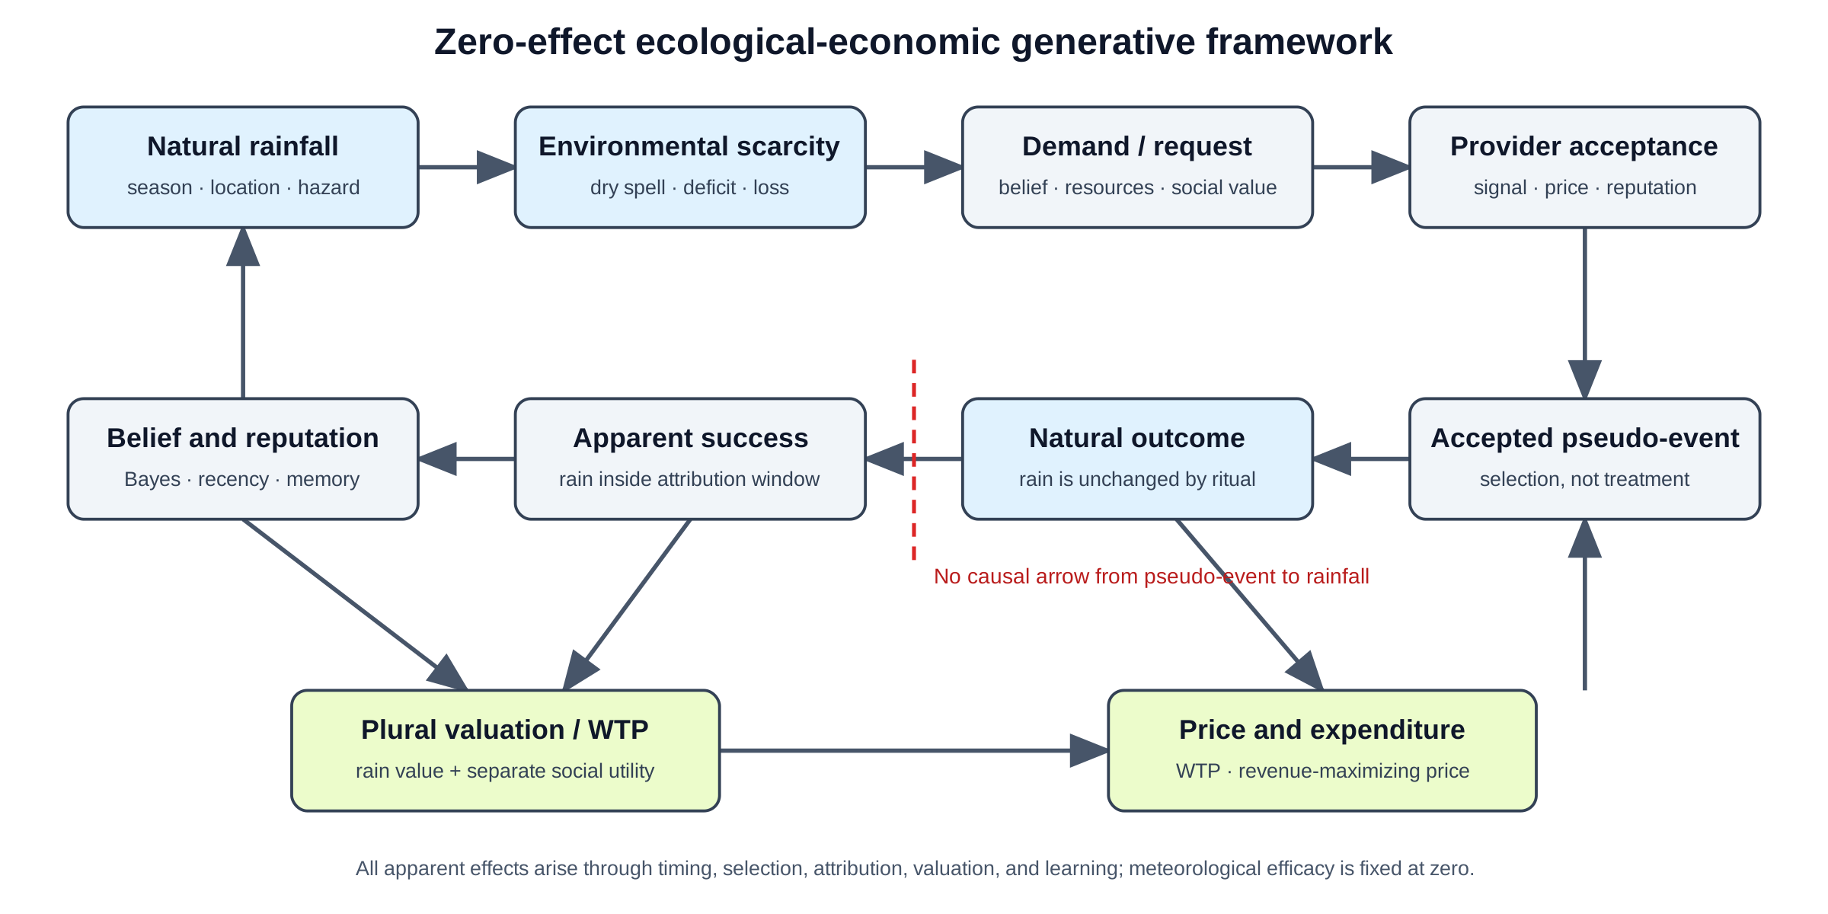
Figure 1. Conceptual framework. Environmental hazard enters demand, provider selection, valuation, attribution, and reputation, while ritual never changes rainfall.

2.1 Exact zero-effect null
For location r, day t, and pseudo-intervention indicator A_rt, let R_rt(a) denote potential rainfall under a ∈ {0,1}. The simulation enforces
R_rt(1)=R_rt(0)=R_rt.
No request, acceptance, provider, price, belief, or reputation variable changes this array. Apparent success for window w and rainfall threshold c is
S_rt(w,c)=1{max_j=1,…,wR_r,t+j≥ c}.
The event day is excluded. This definition captures a plausible retrospective attribution rule but is not an estimator of a treatment effect.

2.2 Environmental hazard, demand, and selection
Let H_rt(w,c) be the prospective probability of apparent success conditional on location, calendar month, and the preceding dry spell. We estimate this hazard from a training period rather than assume it rises with drought duration. Provider k observes a signal of H_rt and accepts a request with a probability increasing in that signal. Selection can therefore raise the success rate among accepted events even though it cannot change rainfall.
Drought affects demand separately from selection. A community is more likely to request action when the preceding dry spell is long or the rolling rainfall deficit is large. This changes the timing and frequency of observed events. It does not imply that rain is more likely merely because the dry spell is longer.

2.3 Valuation, price, and reputation
Scenario WTP combines an instrumental component related to expected avoided drought loss with a separate social-utility component. This construction is motivated by empirical evidence that people value drought-risk adaptation and supply security [14–16], but its numerical scale is not estimated from historical rainmaking payments. Payments are transfers from communities to providers; provider costs are resource costs; profit is revenue minus those costs. Because the pseudo-intervention creates no rainfall, its actuarially fair causal rainfall price is zero. The theoretical revenue-maximizing price is also distinct from the implemented quote, which is a fixed share of calibrated WTP.
Observers update provider beliefs only after accepted events. A Bayesian observer applies a Beta-Binomial update. A selective-memory observer gives greater weight to apparent successes than failures and discounts older observations. In M4–M5, the reputation stock \rho_jt is determined by outcomes before t, while current hazard H_rt enters the simulated quote:
\operatorname{WTP}_jrt=B(D_rt)[ U^S+V^R(D_rt)max(0,\rho_jt-H_rt)], \qquad p_jrt=0.8\operatorname{WTP}_jrt.
Current apparent success remains natural rainfall after the event. Past attributed outcomes can therefore create a reputation-mediated price premium and provider-price heterogeneity without making current price positively associated with current success. Informational cascades [17] and reputation under imperfect information [18] provide familiar economic analogues, but the mechanisms remain calibrated and stylized.

3. Methods

3.1 Design and rainfall data
The study uses daily precipitation from 1 January 1991 through 31 December 2020 at eight pre-specified point locations spanning contrasting rainfall regimes. The points are mechanism stress tests, not identified ritual communities or a representative global sample. Table 1 reports coordinates, regimes, observations, and missingness. The analyzed panel contains 87664 region-days.
Table 1. Study locations and rainfall observations.
Location | Latitude | Longitude | Rainfall regime | Region-days | Missing precipitation
Tucson, United States | 32.223 | -110.975 | hot semi-arid / monsoonal | 10958 | 0
Cape Town, South Africa | -33.925 | 18.424 | Mediterranean winter-rainfall | 10958 | 0
London, United Kingdom | 51.507 | -0.128 | temperate maritime | 10958 | 0
Mumbai, India | 19.076 | 72.878 | tropical monsoon | 10958 | 0
Nairobi, Kenya | -1.292 | 36.822 | subtropical highland / bimodal rainfall | 10958 | 0
Darwin, Australia | -12.463 | 130.846 | tropical savanna / monsoon | 10958 | 0
Tokyo, Japan | 35.676 | 139.650 | humid subtropical | 10958 | 0
Brasília, Brazil | -15.794 | -47.883 | tropical savanna | 10958 | 0
Rainfall was acquired through the Open-Meteo historical archive with the ERA5 model. ERA5 is a global atmospheric reanalysis [19]. Raw JSON responses are preserved with URLs, UTC retrieval times, byte sizes, and SHA-256 checksums. An initial ERA5-Land request returned complete date arrays but all precipitation values were null; those snapshots are retained as invalid audit material and excluded.

3.2 Prospective rainfall hazard
The years 1991–2010 form the training period and 2011–2020 the evaluation period. The primary rain-day threshold is 1 mm, with 0.1 and 5 mm sensitivity thresholds. Apparent success windows are 1, 3, 7, and 14 days. Preceding dry-spell duration and 30-day rainfall totals use only days before a candidate event. Candidate dates in both periods are truncated 14 days before the period boundary so every outcome window has complete follow-up. Training hazards condition on location, month, and dry-spell bins. This flexible stratification is used instead of a monotonic duration assumption. Cells with fewer than 20 training days use the corresponding location-month mean. The high-hazard threshold is the training-cell 75th percentile within location and never uses evaluation-period rainfall. Duration-based hazards are a descriptive survival object rather than a treatment response [20].

3.3 Observed-weather pseudo-events
Five fictional event rules are constructed from evaluation-period days without using event-day or future rainfall:
1. a dry-spell threshold;
2. a 30-day rainfall-deficit threshold;
3. a random drought day;
4. a high prospective-hazard threshold; and
5. a season-matched placebo.
Event-day rainfall is unavailable to every rule. Outcomes are always future observed rainfall, never generated or modified by an event. Rule-specific apparent success is reported across all thresholds and windows.

3.4 Scenario WTP and descriptive association
Scenario WTP increases with drought loss, social utility, and perceived probability of success. Rainfall and pseudo-event dates in this component are observed; WTP is constructed from calibrated quantities. We estimate a naive logit of seven-day apparent success on scenario WTP and a hazard-adjusted model including prospective hazard, drought severity, location, calendar month, and timing-rule effects. Standard errors are two-way clustered by region-year and region-rule, allowing arbitrary dependence within the weather-year and timing-rule series. Because rules can select the same or nearby dates, attribution windows can overlap, WTP is constructed from calibrated quantities, and the event is fictional, these regressions are exploratory model-consistent associations rather than estimates of demand, historical prices, or causal efficacy.

3.5 Staged Monte Carlo model comparison
The simulation samples one observed evaluation-year rainfall sequence per replication and uses the same sampled region-year across M0–M5. M0–M1 independently permute outcomes within that year to remove calendar structure; M2–M5 retain the observed local and seasonal ordering. The sequence is a mechanism decomposition or sequential generative enrichment, not a clean one-factor causal decomposition: restoring ordering between M1 and M2 changes multiple properties of the weather process. Each model has 10,000 replications and four providers:
- M0 Random timing: exogenous requests and shuffled outcomes.
- M1 Drought demand: requests respond to drought, with shuffled outcomes.
- M2 Realistic hazard: drought demand operates on local seasonal rainfall.
- M3 Strategic selection: providers condition acceptance on prospective hazard.
- M4 Bayesian reputation: outcomes update provider beliefs and belief-mediated WTP.
- M5 Selective/recency memory: successes and failures receive unequal, discounted weights.
Primary outputs are event frequency, apparent success, mean scenario price, provider-mean-price dispersion, event-level price–success difference, reputation dispersion, provider revenue, community expenditure, provider resource cost, provider profit, community material-plus-social utility, total social surplus, and provider-revenue dispersion. Event-level price–success differences are defined only for replications containing both successes and failures; event-based quantities are undefined when no event is accepted, and summaries omit only those undefined cells.

3.6 Robustness and falsification
Robustness analysis varies rainfall thresholds and attribution windows, provider selection slopes, Bayesian prior means, and memory weights. A 1,000-permutation falsification demeans outcomes and WTP within region–calendar-month–timing-rule strata, adjusts for hazard and drought severity, and shuffles WTP within the same strata. Exchangeability is assumed only within those strata. Monte Carlo precision is evaluated at 500, 1,000, 2,500, 5,000, and 10,000 replications. All propositions retain unfavorable or mixed results; no parameter was retuned to manufacture the anticipated sign. P-values are descriptive and exploratory: no multiplicity adjustment is used, and classifications rely on the full pattern across observed-weather, falsification, and simulation results rather than a 0.05 threshold. Detailed models, sensitivities, convergence, falsification, and accounting results are reported in the Supplementary material (Tables S1–S6).

4. Results

4.1 Estimated hazards are not mechanically increasing in dry-spell duration
Figure 2 shows substantial seasonal and geographic variation in seven-day rainfall hazards. The ordering of dry-spell bins is not uniformly increasing: a longer preceding dry spell can coincide with higher, lower, or similar prospective rainfall probability depending on location and month. The empirical hazard therefore rejects the shortcut that rain must become mechanically more likely as a dry spell lengthens.
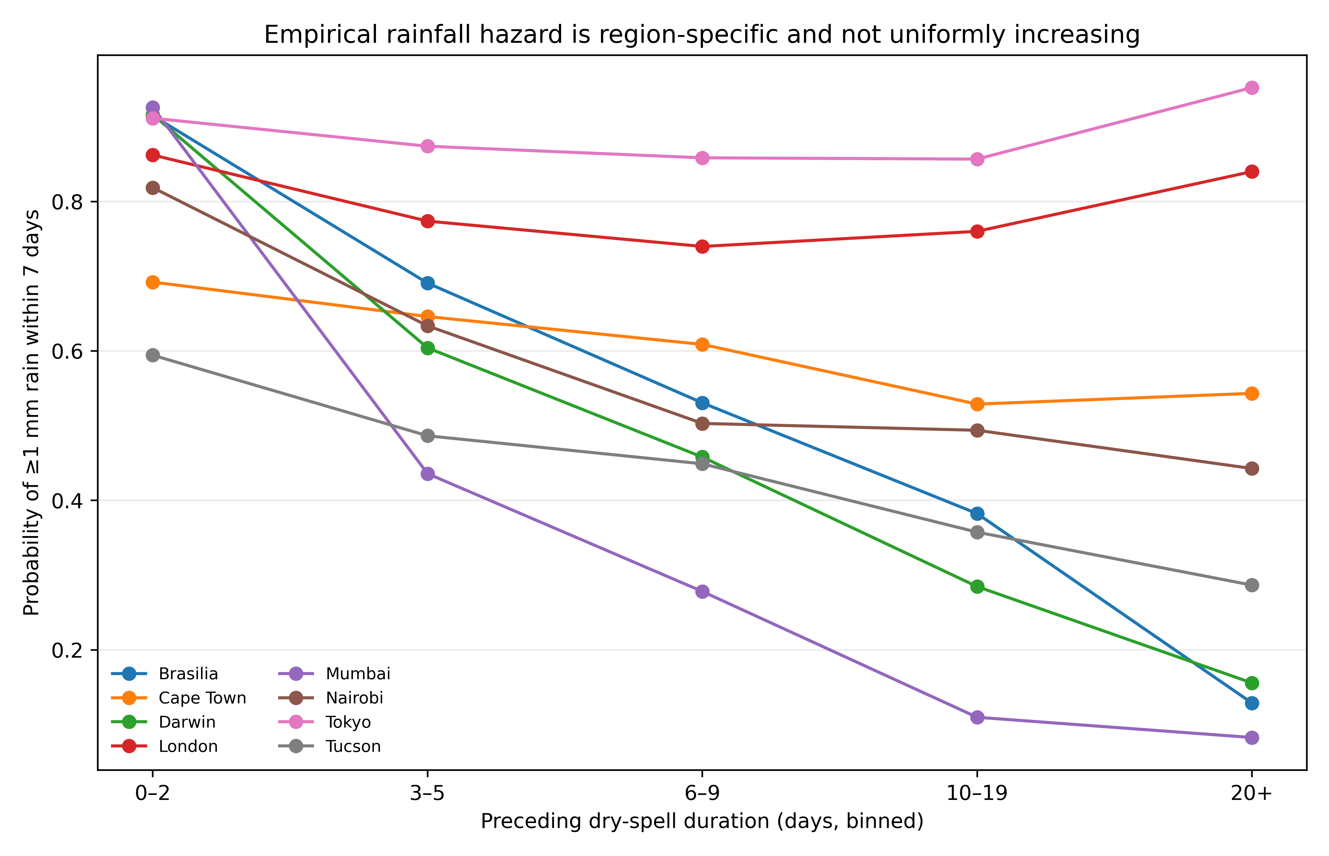
Figure 2. Estimated seven-day rainfall hazards by preceding dry-spell duration and location in the 1991–2010 training period. The eight locations are pre-specified mechanism stress tests, not a representative global sample.

4.2 Natural rainfall generates apparent success
The five event rules produce 2595 fictional events. Table 2 reports counts and success across attribution windows. At the primary seven-day, 1-mm outcome, apparent success is 0.823 for the rainfall-deficit rule, 0.601 for the dry-spell rule, 0.853 for high prospective hazard, 0.593 for a random drought day, and 0.600 for the season-matched placebo.
Table 2. Observed-weather pseudo-event results.
Selection rule | Events | Apparent success 1d | Apparent success 3d | Apparent success 7d | Apparent success 14d | Mean scenario WTP
30-day deficit threshold | 294 | 0.374 | 0.592 | 0.823 | 0.922 | 6.276
dry-spell threshold | 727 | 0.209 | 0.402 | 0.601 | 0.765 | 3.267
high prospective hazard | 395 | 0.461 | 0.671 | 0.853 | 0.947 | 6.815
random drought day | 509 | 0.191 | 0.381 | 0.593 | 0.745 | 3.073
season-matched placebo | 670 | 0.245 | 0.407 | 0.600 | 0.793 | 3.550
Figure 3 emphasizes the mechanism: prospective-hazard selection has the highest apparent success, whereas drought timing alone does not guarantee a favorable counterfactual comparison. Every bar is generated by natural rainfall under the exact zero-effect null.
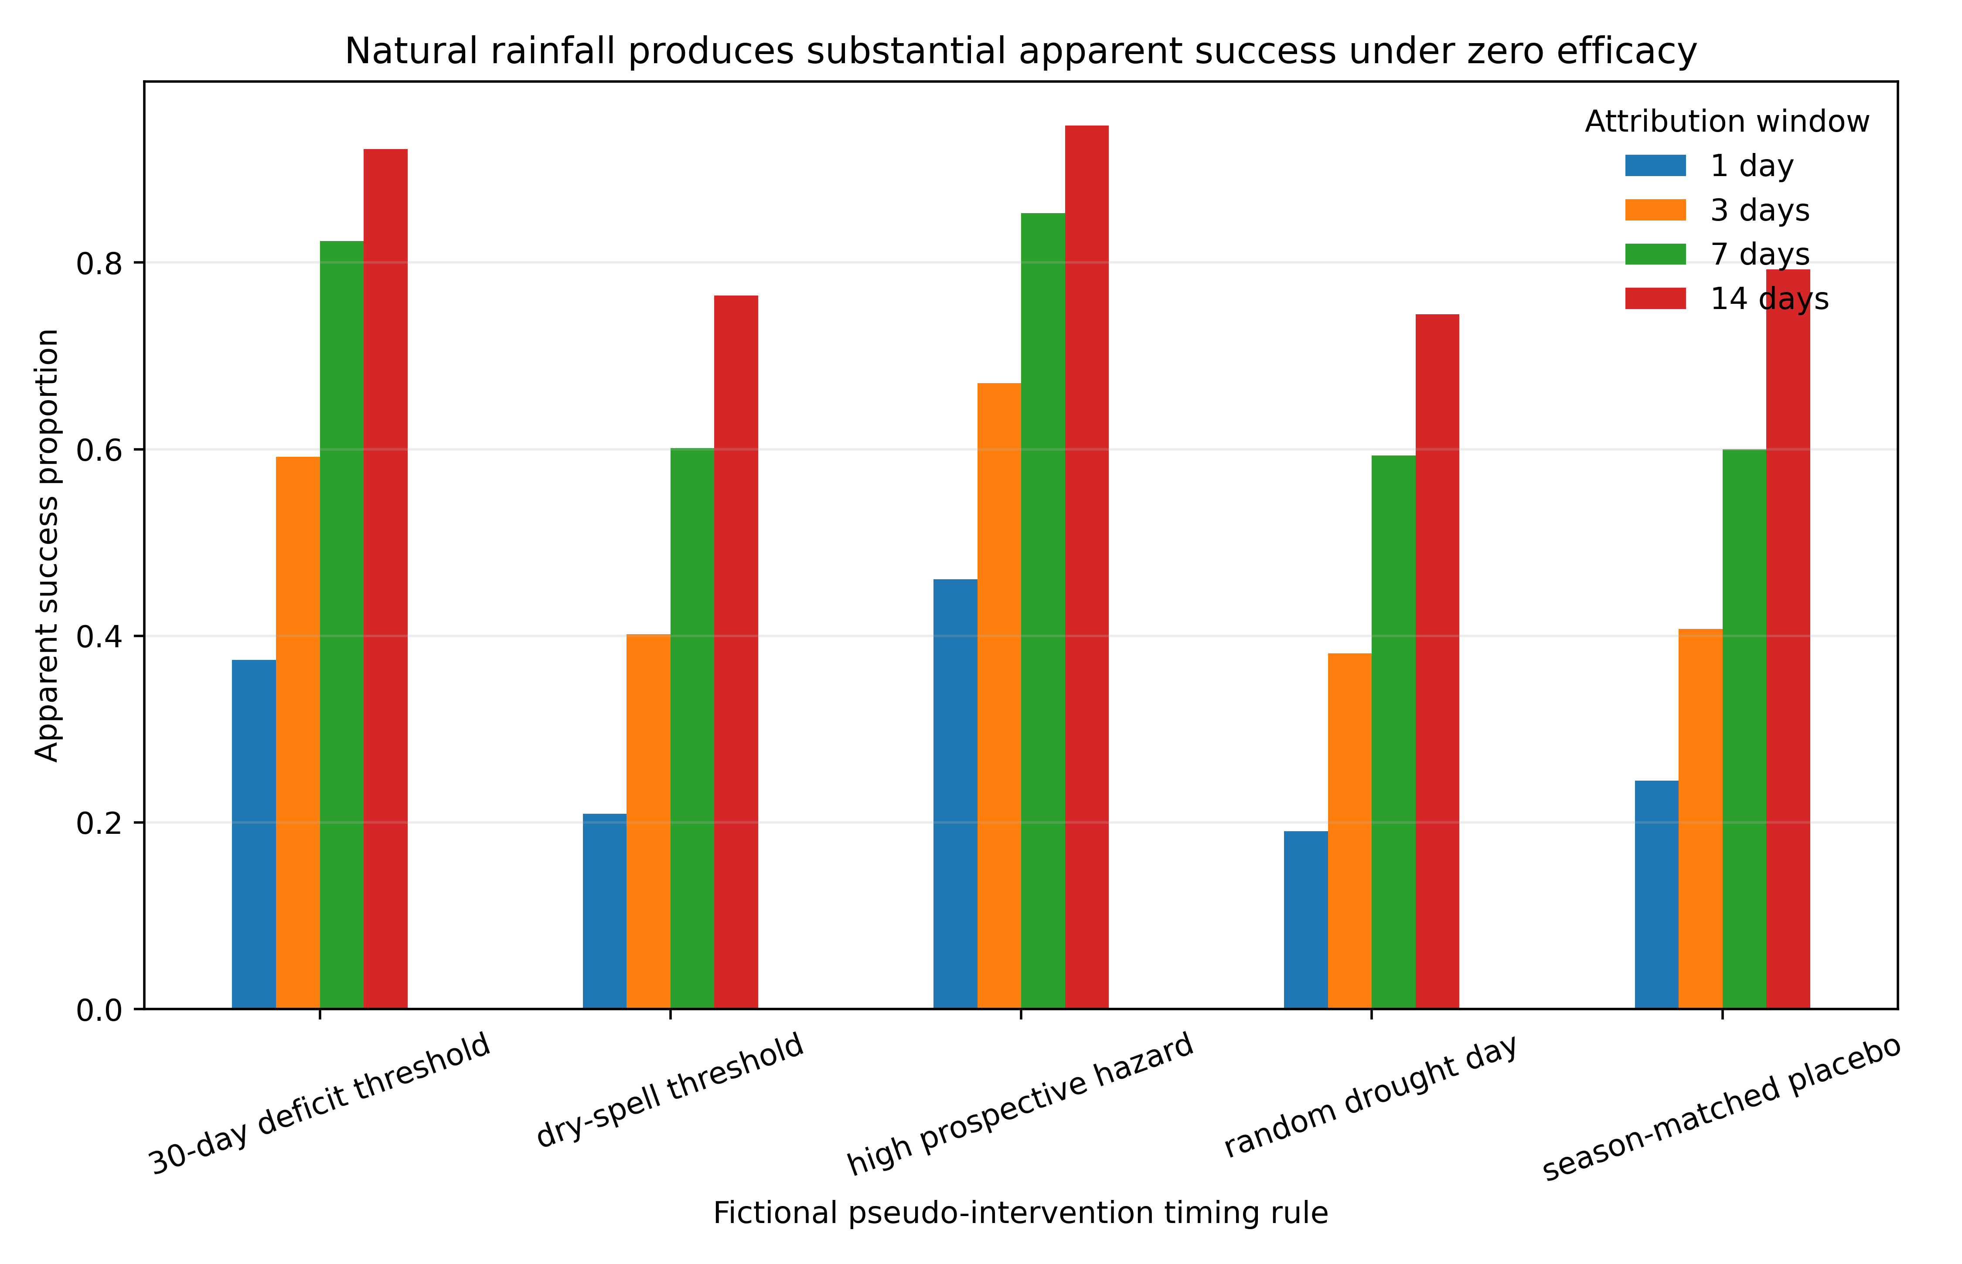
Figure 3. Natural rainfall following fictional zero-effect pseudo-events in 2011–2020, shown as apparent success by prospective event-selection rule.

4.3 Scenario WTP varies with drought, but positive price evidence fails
The naive scenario-WTP coefficient is 0.124 (95% model-based interval 0.086–0.162). Adjustment for prospective hazard and drought covariates reduces it to 0.036 (-0.028– 0.100). Two-way clustering gives a 95% interval of -0.039–0.111 across 80 clusters by region-year and 40 by region-rule (n=2595).
The adjusted linear-probability coefficient is -0.0319, compared with a permutation mean of -0.0002 and two-sided p=0.002. The permutation diagnostic has a negative within-stratum association rather than the declared positive one. Because it assumes exchangeability within the defined strata, uses a constructed scenario-WTP regressor, and retains overlapping outcome windows, it is exploratory rather than confirmatory historical evidence. Together with the negative mean M4–M5 event-level price–success differences, it does not support the general positive price-success proposition.

4.4 Demand, selection, and learning have distinct effects
Table 3 reports the staged model comparison. Moving from M0 to M1 increases mean event frequency from 24.36 to 68.95 while apparent success remains near 0.635 and 0.634. Restoring realistic local and seasonal rainfall in M2 changes apparent success to 0.493. Strategic acceptance in M3 reduces the number of accepted events to 16.92 and raises apparent success to 0.676, with rainfall still unchanged. This M2–M3 contrast shows how the acceptance rule changes accepted-event composition; it is not an estimate of historical provider behavior.
Table 3. Monte Carlo model decomposition.
Model | apparent success | events | mean price | price success difference | provider price dispersion | reputation dispersion
M0 Random timing | 0.635 | 24.362 | 3.000 | 0.000 | 0.000 | 0.000
M1 Drought demand | 0.634 | 68.952 | 3.000 | 0.000 | 0.000 | 0.000
M2 Realistic hazard | 0.493 | 68.978 | 3.000 | 0.000 | 0.000 | 0.000
M3 Strategic selection | 0.676 | 16.917 | 3.000 | 0.000 | 0.000 | 0.000
M4 Bayesian reputation | 0.674 | 16.946 | 3.568 | -2.447 | 0.887 | 0.117
M5 Selective/recency memory | 0.673 | 16.882 | 4.610 | -3.037 | 1.373 | 0.138
M0–M3 use a fixed scenario price of 3.000. Bayesian reputation in M4 generates mean scenario price 3.568, a mean premium of 0.568, reputation dispersion 0.117, and provider-mean-price dispersion 0.887. Selective/recency memory in M5 produces 4.610, 1.610, 0.138, and 1.373, respectively. These are calibrated simulation quantities, not historical currencies or estimates.
Contrary to a simple performance-pricing story, the mean event-level price(success)-price(failure) difference is -2.447 in M4 and -3.037 in M5. Thus mean price relative to baseline, provider price heterogeneity, and a reputation-mediated premium can all be positive while the contemporaneous price-success difference is negative. Past attributed outcomes enter the reputation stock, whereas current apparent success remains a flow from current natural hazard.
Figure 4 visualizes these margins. Drought demand expands event frequency; provider selection changes accepted-event composition and current success; learning creates reputation and provider-price dispersion; and price premia coexist with negative mean contemporaneous price-success differences.
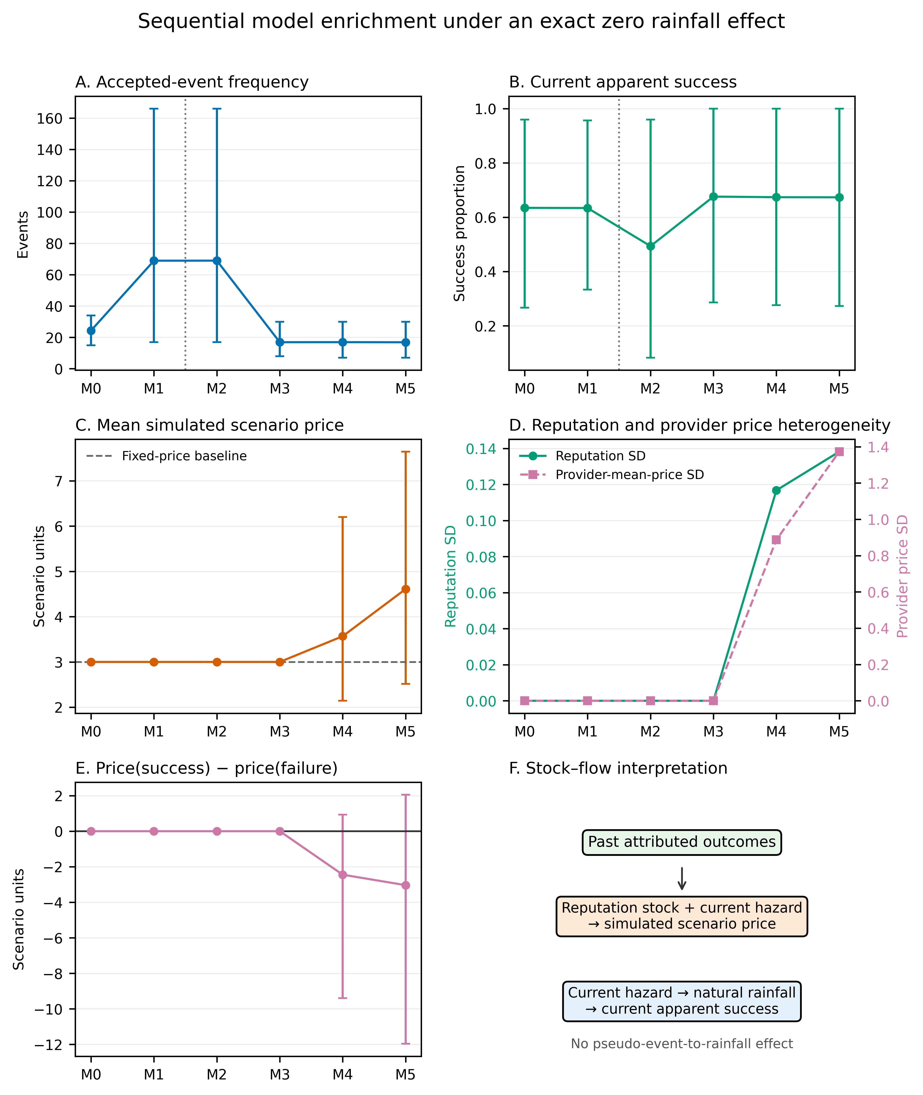
Figure 4. Sequential Monte Carlo model enrichment under M0–M5. M0–M1 shuffle rainfall outcomes within sampled years; M2–M5 retain observed local and seasonal ordering. Strategic selection changes accepted-event composition and current apparent success. In M4–M5, past attributed outcomes accumulate in reputation stocks that create price premia and provider-price heterogeneity, while current success remains a natural-rainfall flow governed by current hazard. Mean price(success) minus price(failure) is negative in M4–M5. Error bars are 2.5th and 97.5th Monte Carlo percentiles, not confidence intervals for historical parameters.

4.5 Findings are stable across thresholds, parameters, and replication counts
Figure 5A shows that apparent success increases with the attribution window and falls with the rainfall threshold, as expected from the definition. Figure 5B shows monotonic increases in M3 apparent success as the selection slope rises from 2 to 8. M4 prices increase with the Bayesian prior mean, and M5 prices increase with stronger selective memory. Figure 5C shows falling Monte Carlo standard errors; at 10,000 replications, apparent-success standard errors are at most 0.0028 among the six main models.
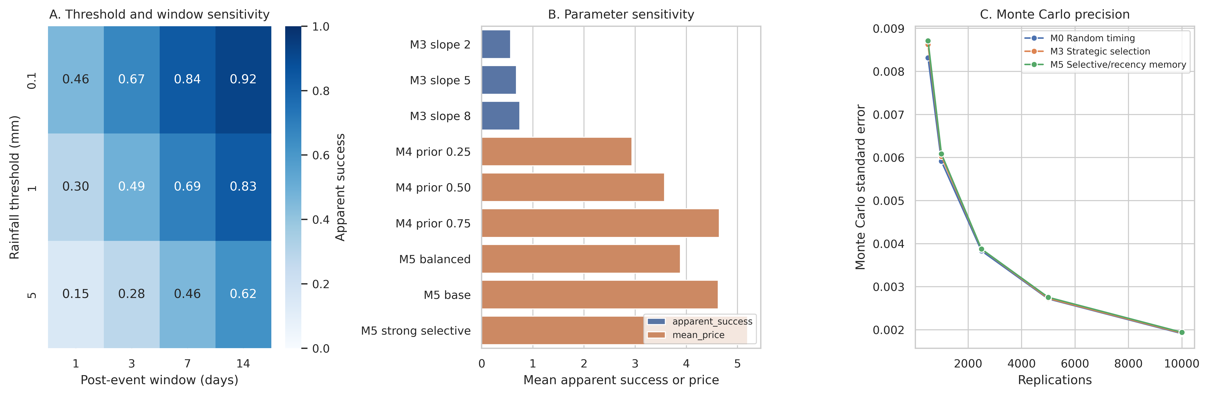
Figure 5. Robustness. Apparent success across rainfall thresholds and windows, selected parameter sensitivity, and Monte Carlo precision.
Table 4 classifies the analytic propositions by evidence domain. Natural-rainfall apparent success is demonstrated with observed weather, whereas strategic selection is demonstrated in the model using observed weather. Demand, WTP, learning, and memory results are model- or calibration-contingent; the price–success proposition is not supported; and the separation of meteorological from social value is a logical distinction rather than an empirical finding.
Table 4. Analytic proposition classification.
Hypothesis | Classification | Basis
Natural rainfall can generate substantial apparent success under zero efficacy | demonstrated with observed weather | Observed-weather pseudo-events and all simulation models
Drought-driven demand increases intervention frequency | demonstrated in model | M1 versus M0 under the specified demand function
Drought can increase scenario WTP | demonstrated in calibrated scenario | Calibrated rainfall-loss term raises WTP over intermediate drought severity but is offset at extremes by ability to pay
Strategic provider selection increases apparent success | demonstrated in model using observed weather | M3 versus M2 and selection-slope sensitivity
Higher prices are positively associated with apparent success | not supported | Two-way clustered logit interval includes zero; within-stratum permutation estimate and M4-M5 differences are negative
Reputation learning creates persistent provider differentiation | demonstrated in model | M4-M5 reputation dispersion under specified update rules
Selective and recency-weighted memory raises price premia | demonstrated in model | M5 versus M4 and memory sensitivity
Zero meteorological efficacy implies zero social value | logical distinction; not empirically tested | Positive social utility is modeled separately from causal rainfall benefit

5. Discussion

5.1 Selection and stock-flow feedback extend the timing account
The QJE comparator already establishes that endogenous prayer timing, changing rainfall hazards, hidden counterfactuals, and strategic leader timing can make an ineffective practice persuasive [1]. Our narrower extension separates requests from acceptance and adds multiple provider identities, provider-specific reputation stocks, simulated provider prices, and explicit economic accounting.
Scarcity changes who requests action and when; the calibrated provider rule changes which requests become accepted events; attribution maps natural rainfall into apparent success; and learning maps past outcomes into reputation. Demand can increase without success changing. Selection can increase current success without treatment. Reputation can persist without provider-specific efficacy. Price premia can arise without positive contemporaneous price-success associations.

5.2 Ecological-economic interpretation
The ecological component is not background noise. Seasonal and local rainfall hazards determine the opportunity set in which economic and institutional behavior operates. In the model, a provider who selectively accepts high-hazard requests can monetize information about nature without producing rainfall. A community that pays more during scarcity expresses a value of relief, coordination, or hope, but the transfer does not establish that the intervention created the environmental service.
This distinction matters for environmental valuation. The economic value of rainfall can be high, while the causal rainfall value of a zero-effect intervention is zero. Scenario WTP can be positive because it incorporates perceived efficacy or separate social utility. The theoretical revenue-maximizing price is distinct from the implemented quote, and neither is a historical estimate. Community expenditure and provider revenue are the two sides of a transfer; provider cost is a resource cost; profit and social surplus apply different accounting boundaries. Collapsing these objects into a single “value” would obscure both welfare and causality.
Plural valuation further limits what can be concluded from the null. Cultural, relational, psychological, coordination, and solidarity values may be real without meteorological efficacy [8–13]. Our model includes a separate social-utility term to prevent an invalid inference from “no rain effect” to “no social value.” We do not estimate that term or claim that it represents any particular community.

5.3 Why price premia do not imply positive price–success associations
The unfavorable price result is substantively informative. In the observed-weather scenario, the adjusted logit point estimate is positive, but the two-way clustered interval includes zero; the exploratory within-stratum permutation diagnostic is negative. In M4 and M5, mean event-level price-success differences are also negative, although their Monte Carlo percentile intervals include positive values. Reputation is a stock formed from earlier attributed outcomes, whereas current apparent success is a flow generated by current hazard. A high-reputation provider can charge more when the reputation-hazard gap is large and still encounter unfavorable natural rainfall.
This is a boundary condition, not a defect to be removed by retuning. Mean prices, provider-price heterogeneity, and reputation premia can reflect accumulated belief without identifying current causal performance. Evaluators should compare provider outcomes with prospective risk-adjusted benchmarks rather than raw success.

5.4 Limitations
First, the eight locations are point-based stress tests. They span major rainfall regimes but do not establish global representativeness and are not matched to historical ritual communities. Spatially distributed precipitation, forecast information, and measurement error could alter hazards.
Second, the WTP, prices, costs, provider count, acceptance function, and observer rules are calibrated scenarios. They are not estimates of historical beliefs or payment schedules. Historical sources support the institutional relevance of rainmaking but not a universal claim of drought-contingent fee escalation [2–4].
Third, the hazard estimator conditions on a limited state vector. A provider could use richer forecasts, cloud observations, or local ecological knowledge. Such information would likely strengthen selection possibilities, but its effect is not estimated here.
Fourth, apparent success is defined by fixed rainfall thresholds and windows. The robustness grid demonstrates sensitivity expected from that definition, not a uniquely correct cultural attribution rule.
Fifth, pseudo-event rules can select identical or nearby dates, observer states persist over time, and attribution windows overlap. Two-way clustered covariance addresses dependence within region-years and region-rule series, but the scenario-WTP regressions remain exploratory and no multiplicity-adjusted confirmatory test is claimed.
Sixth, social utility is separated conceptually but not empirically measured. The analysis rejects the logical equivalence between meteorological and social value; it does not demonstrate that every ritual creates positive welfare.
Finally, a zero-effect design is intentionally a limiting case. It establishes what timing, selection, and learning can generate without efficacy. It cannot show that all real-world environmental interventions are ineffective.

5.5 Implications
For empirical research, event studies of environmental interventions should estimate prospective natural hazards, exclude event-day information from timing rules, model selection into observed events, and distinguish apparent outcomes from causal effects. Negative controls and within-season permutations can reveal residual structure but do not replace a credible counterfactual.
For policy and market design, provider performance measures should be risk-adjusted. Reputation systems based on raw success can reward selective acceptance and favorable ecological exposure. Transparent disclosure of baseline hazard and rejected requests would reduce this distortion.
For ecological economics, the framework illustrates why environmental valuation needs both causal accounting and value pluralism. Monetary demand can be behaviorally real yet causally misattributed; non-monetary value can be meaningful yet absent from market prices. Keeping these dimensions separate permits a more respectful and analytically coherent evaluation.

6. Conclusion
Under an exact zero-effect null, natural rainfall still produces apparent success. Drought-driven demand determines when communities seek action; strategic providers can select favorable ecological states; attribution turns subsequent rain into perceived performance; and learning turns perceived performance into persistent reputation and price premia. None of these processes requires the intervention to change rainfall.
The strongest conclusion is therefore not that price proves efficacy or that zero meteorological efficacy erases social value. The positive contemporaneous price-success proposition is not supported: reputation-mediated mean prices and provider-price heterogeneity coexist with negative mean event-level price-success differences. Ecological hazard, endogenous behavior, valuation, and institutions jointly determine what observers see and pay for, but credible evaluation must keep natural performance, causal performance, scenario price, transfers, costs, and plural values distinct.

Acknowledgements
[AUTHOR INPUT REQUIRED: provide acknowledgements or confirm that none are required.]

Declarations

Data and code availability
Code, legally redistributable inputs, frozen analytical outputs, and manuscript-generation files are publicly available at https://github.com/bougtoir/pricing-the-rain. The repository preserves raw rainfall snapshots with machine-readable acquisition ledgers and checksums. Sources whose redistribution rights are unclear are not redistributed; the ledgers provide URLs, checksums, status notes, and retrieval instructions instead. Fictional pseudo-events and all simulation outputs are reproducible from the archived rainfall snapshots.

Funding
[AUTHOR INPUT REQUIRED: identify funding sources or state that no specific funding was received.]

Competing interests
[AUTHOR INPUT REQUIRED: declare competing interests or state that none exist.]

Author contributions
[AUTHOR INPUT REQUIRED: provide CRediT roles for each author.]

Ethics
The study uses public environmental data, bibliographic metadata, and simulated fictional events. It includes no human participants, personal data, or animal research.

Generative AI declaration
During preparation of this work, the authors used Devin (Cognition AI) to assist with code development, manuscript drafting, and language organization. [AUTHOR CONFIRMATION REQUIRED: after using this tool, the authors reviewed and edited the content as needed and take full responsibility for the content of the publication.] No generative-AI image tool was used to create or alter the scientific figures, and no generative AI was used to fabricate data or references.

References
1. Espín-Sánchez JA, Gil-Guirado S, Ryan N. Praying for Rain. The Quarterly Journal of Economics. 2026;141(3):2363-2422. doi:10.1093/qje/qjag026.
2. Espín-Sánchez JA, Gil-Guirado S. Praying for rain, resilience, and social stability in Murcia (southeast Spain). Ecology and Society. 2022;27(2). doi:10.5751/es-12875-270209.
3. Akong'a J. Rainmaking rituals: a comparative study of two Kenyan societies. African Study Monographs. 1987;8(2):71–85. doi:10.14989/68028.
4. Semenya DK. The making and prevention of rain amongst the Pedi tribe of South Africa: A pastoral response. HTS Teologiese Studies / Theological Studies. 2013;69(1). doi:10.4102/hts.v69i1.1175.
5. Barnett AG. Regression to the mean: what it is and how to deal with it. International Journal of Epidemiology. 2004;34(1):215-220. doi:10.1093/ije/dyh299.
6. Tversky A, Kahneman D. Judgment under Uncertainty: Heuristics and Biases. Science. 1974;185(4157):1124-1131. doi:10.1126/science.185.4157.1124.
7. Skinner BF. 'Superstition' in the pigeon. Journal of Experimental Psychology. 1948;38(2):168-172. doi:10.1037/h0055873.
8. Chan KMA, Satterfield T, Goldstein J. Rethinking ecosystem services to better address and navigate cultural values. Ecological Economics. 2012;74:8-18. doi:10.1016/j.ecolecon.2011.11.011.
9. Kenter JO, O'Brien L, Hockley N, Ravenscroft N, Fazey I, Irvine KN, et al. What are shared and social values of ecosystems?. Ecological Economics. 2015;111:86-99. doi:10.1016/j.ecolecon.2015.01.006.
10. Kallis G, Gómez-Baggethun E, Zografos C. To value or not to value? That is not the question. Ecological Economics. 2013;94:97-105. doi:10.1016/j.ecolecon.2013.07.002.
11. Pascual U, Balvanera P, Díaz S, Pataki G, Roth E, Stenseke M, et al. Valuing nature’s contributions to people: the IPBES approach. Current Opinion in Environmental Sustainability. 2017;26-27:7-16. doi:10.1016/j.cosust.2016.12.006.
12. Jacobs S, Dendoncker N, Martín-López B, Barton DN, Gomez-Baggethun E, Boeraeve F, et al. A new valuation school: Integrating diverse values of nature in resource and land use decisions. Ecosystem Services. 2016;22:213-220. doi:10.1016/j.ecoser.2016.11.007.
13. Himes A, Muraca B. Relational values: the key to pluralistic valuation of ecosystem services. Current Opinion in Environmental Sustainability. 2018;35:1-7. doi:10.1016/j.cosust.2018.09.005.
14. Schrieks T, Botzen WJW, Haer T, Aerts JCJH. Preferences for drought risk adaptation support in Kenya: Evidence from a discrete choice experiment and three decision-making theories. Ecological Economics. 2025;227:108425. doi:10.1016/j.ecolecon.2024.108425.
15. Pattanayak SK, Kramer RA. Pricing ecological services: Willingness to pay for drought mitigation from watershed protection in eastern Indonesia. Water Resources Research. 2001;37(3):771-778. doi:10.1029/2000wr900320.
16. Hensher D, Shore N, Train K. Water Supply Security and Willingness to Pay to Avoid Drought Restrictions*. Economic Record. 2006;82(256):56-66. doi:10.1111/j.1475-4932.2006.00293.x.
17. Bikhchandani S, Hirshleifer D, Welch I. A Theory of Fads, Fashion, Custom, and Cultural Change as Informational Cascades. Journal of Political Economy. 1992;100(5):992-1026. doi:10.1086/261849.
18. Kreps DM, Wilson R. Reputation and imperfect information. Journal of Economic Theory. 1982;27(2):253-279. doi:10.1016/0022-0531(82)90030-8.
19. Hersbach H, Bell B, Berrisford P, Hirahara S, Horányi A, Muñoz‐Sabater J, et al. The ERA5 global reanalysis. Quarterly Journal of the Royal Meteorological Society. 2020;146(730):1999-2049. doi:10.1002/qj.3803.
20. Cox DR. Regression Models and Life-Tables. Journal of the Royal Statistical Society Series B: Statistical Methodology. 1972;34(2):187-202. doi:10.1111/j.2517-6161.1972.tb00899.x.

