Empirical Study Report: Commercial Software Dependency
in Published Research (2020–2025)
PubMed Stratified Random Sampling — Full Study (N=10,000)
Report Date: March 2026

1. Executive Summary
This report presents the results of an empirical study examining commercial software dependency in published scientific research. We analyzed 10,000 papers published between 2020 and 2025, sampled from PubMed using stratified random sampling across 7 research fields.
Key Findings:
- Software was detected in 2,922 papers (29.2%)
- Commercial software was used in 1,853 papers (18.5%)
- Version numbers were reported in only 2,015 papers (20.2%)
- Mean estimated replication cost: $340 per paper ($0 median)
- Code availability was stated in only 529 papers (5.3%)
- Data availability was stated in only 367 papers (3.7%)

2. Methodology

2.1 Sampling Strategy
We employed stratified random sampling using the PubMed E-utilities API. Papers published from January 2020 onward, written in English, classified as journal articles (excluding reviews and case reports), and containing abstracts were eligible. The sample was stratified across 7 research fields based on MeSH (Medical Subject Headings) categories to ensure representative coverage.
Strata and Sample Sizes:
Research Field | N | Software Detection Rate | Commercial SW Rate
Biomedical Basic | 1429 | 40.3% | 20.6%
Clinical Medicine | 1429 | 32.1% | 26.2%
Chemistry Materials | 1429 | 23.7% | 17.3%
Physics Engineering | 1429 | 22.0% | 16.7%
Social Behavioral | 1429 | 30.3% | 25.1%
Computational Science | 1429 | 37.4% | 15.3%
Environmental Earth | 1426 | 18.7% | 8.6%

2.2 Data Extraction
For each paper, we extracted: (1) bibliographic metadata (PMID, title, journal, DOI, publication date, MeSH terms, affiliations, funding); (2) software mentions from abstracts and PMC full-text Methods sections using 95+ regex patterns; (3) version numbers; (4) code and data availability statements; and (5) estimated replication costs based on commercial software license prices.
PMC full-text was available for 4,816 papers (48.2%), enabling deeper extraction from Methods sections.

2.3 Year-Split Sampling
To work within PubMed's retstart limitation (maximum offset of 9,999), we implemented a year-split sampling strategy. For each stratum, queries were split by publication year (2020–2025), with up to 9,999 PMIDs fetched per year. The final sample was drawn randomly from the combined candidate pool, ensuring temporal representativeness.

3. Results

3.1 Software Mention Rates
Of the 10,000 papers analyzed, 2,922 (29.2%) mentioned at least one software tool. The mean number of software mentions per paper was 0.51. Commercial software was found in 1,853 papers (18.5%), while open-source software was found in 1,653 papers (16.5%).
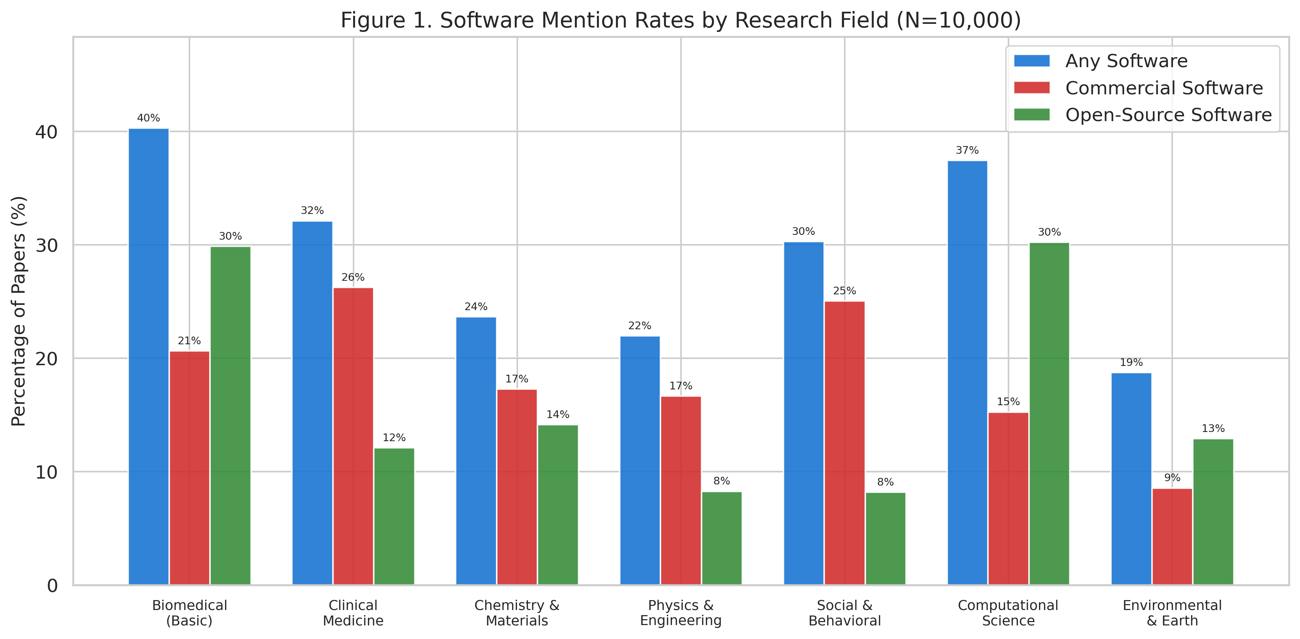
Figure 1. Software mention rates vary substantially across research fields, with Computational Science and Biomedical Basic showing the highest rates.

3.2 Most Frequently Used Software
The most frequently cited commercial software tools were SPSS (n=807), GraphPad Prism (n=410), MATLAB (n=170), Microsoft Excel (n=152), and Stata (n=101). Among open-source tools, the most prevalent were R (n=890), ImageJ (n=232), Python (n=167), ggplot2 (n=165), Cytoscape (n=140).
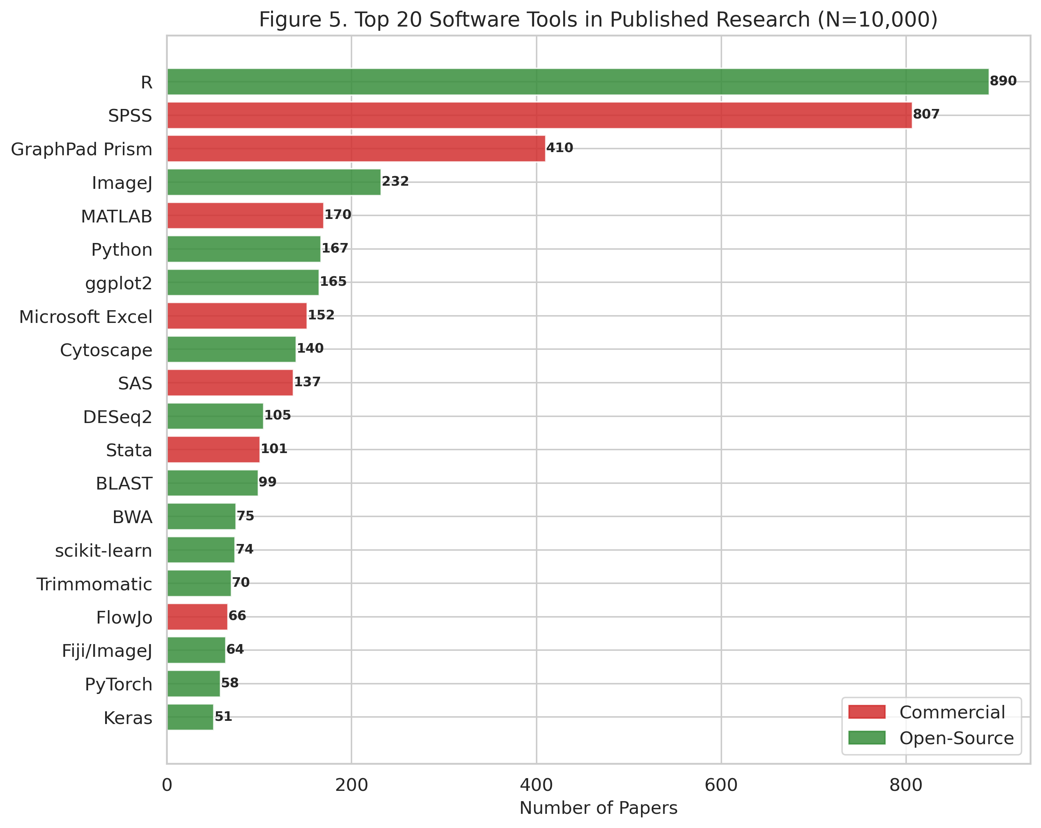
Figure 2. The top 20 software tools in published research, colored by license type (red=commercial, green=open-source).
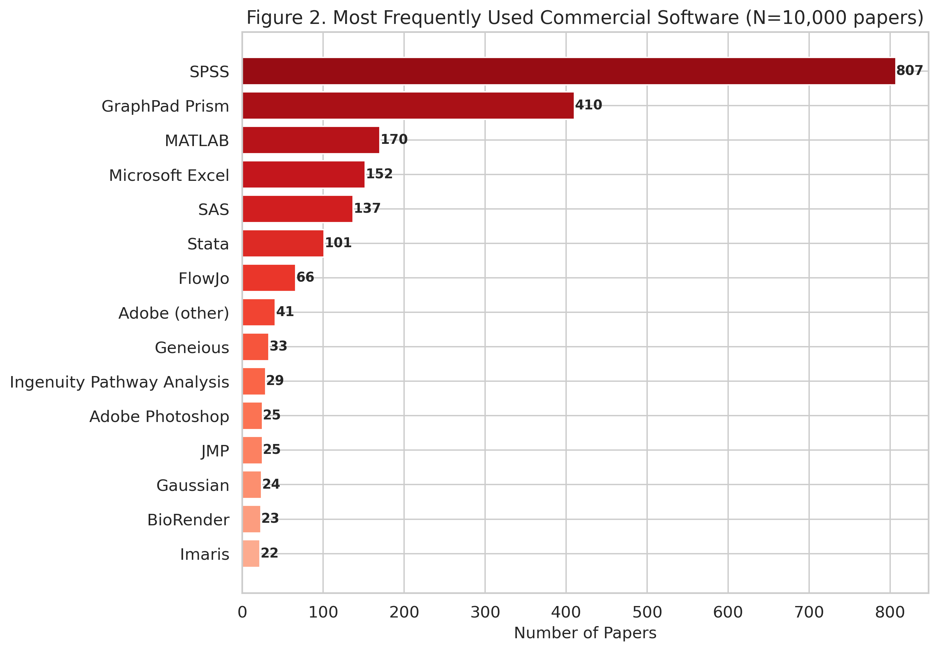
Figure 3. The 15 most frequently used commercial software tools. SPSS and GraphPad Prism together account for over half of all commercial software mentions.

3.3 Software Usage Across Fields
Software usage patterns differ markedly by research field. SPSS dominates in Clinical Medicine and Social/Behavioral sciences, while R is more prevalent in Computational Science and Biomedical Basic research.
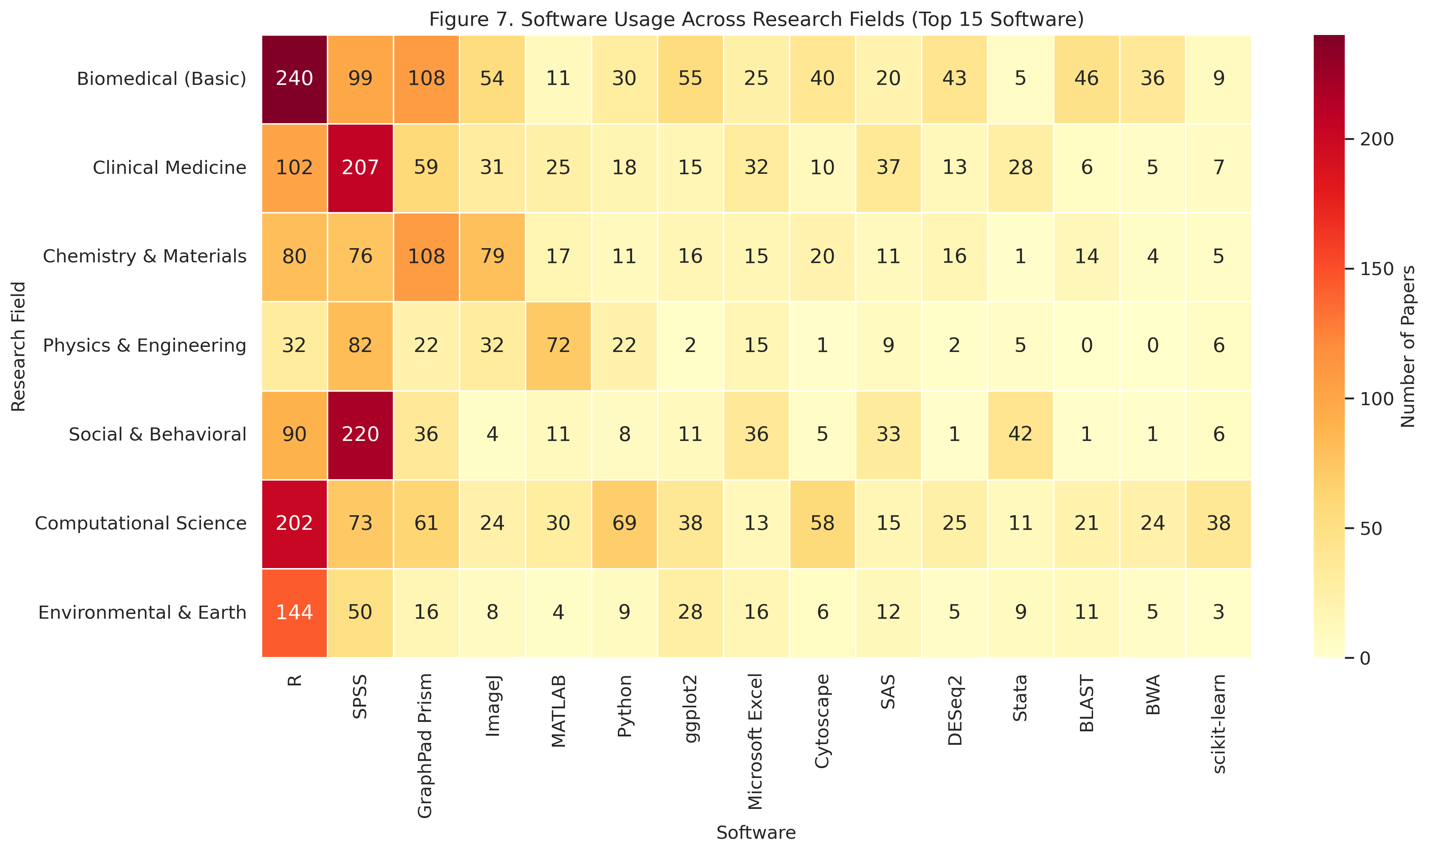
Figure 4. Heatmap showing the distribution of top 15 software tools across 7 research fields.

3.4 Version Reporting
Version numbers were reported for at least one software tool in 2,015 papers (20.2%). The mean version mention rate (proportion of detected software with an associated version number) was 17.0%. Social & Behavioral sciences showed the highest version reporting rate (81.9% among papers with software), while Physics & Engineering had the lowest (32.9%).
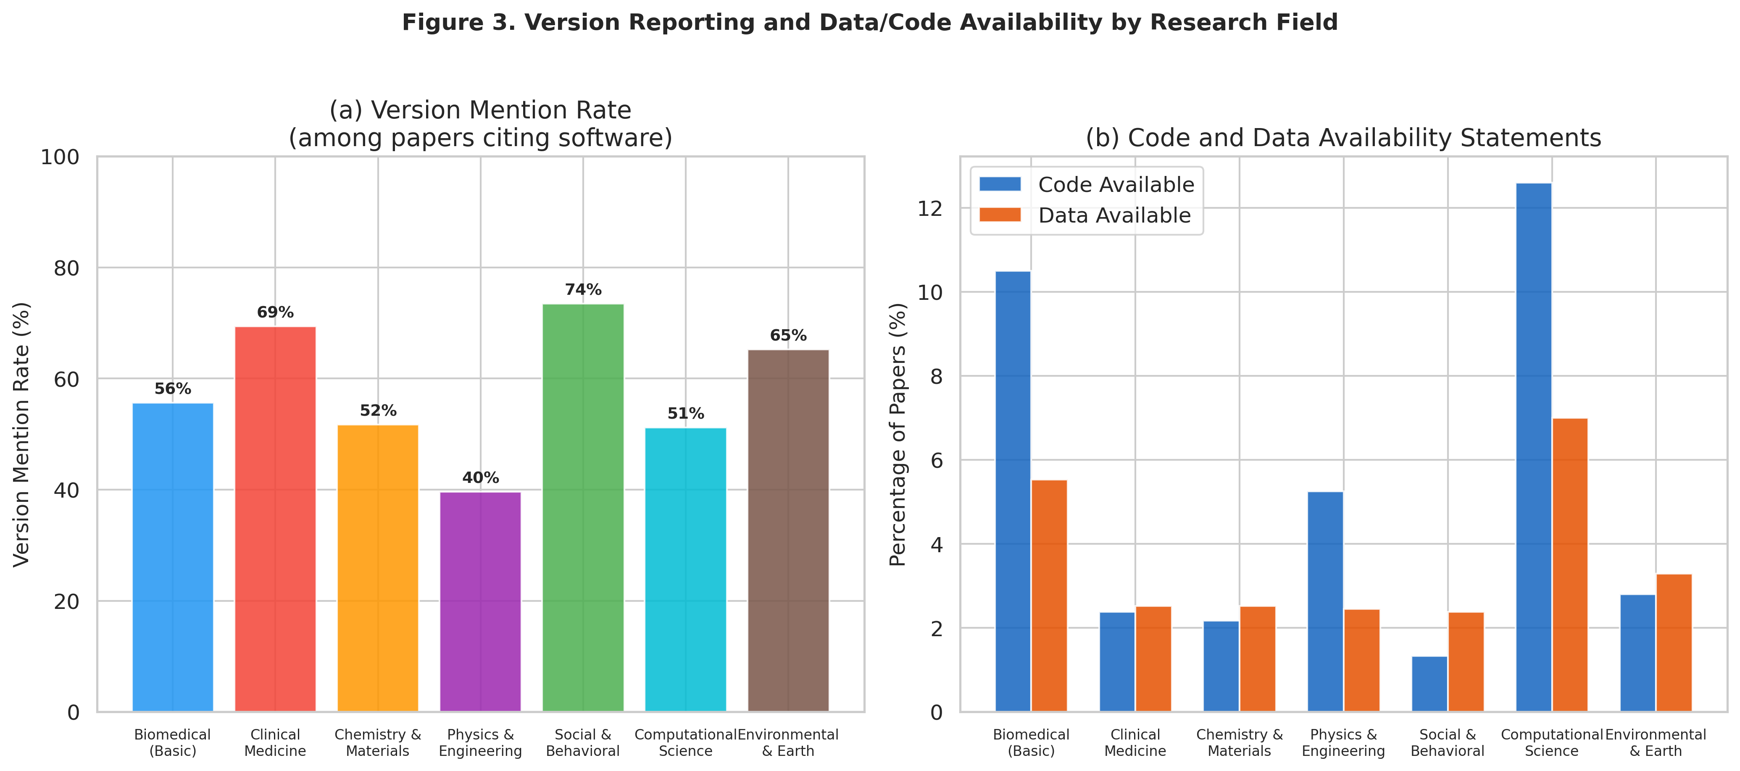
Figure 5. (a) Version mention rates and (b) code/data availability statements by research field.

3.5 Version Availability
For commercial software with version numbers reported, we assessed whether those specific versions are currently obtainable. The majority of commercial software versions used in published papers are classified as "likely unavailable" — meaning the vendor does not provide access to legacy versions, and only the current version is available for purchase.
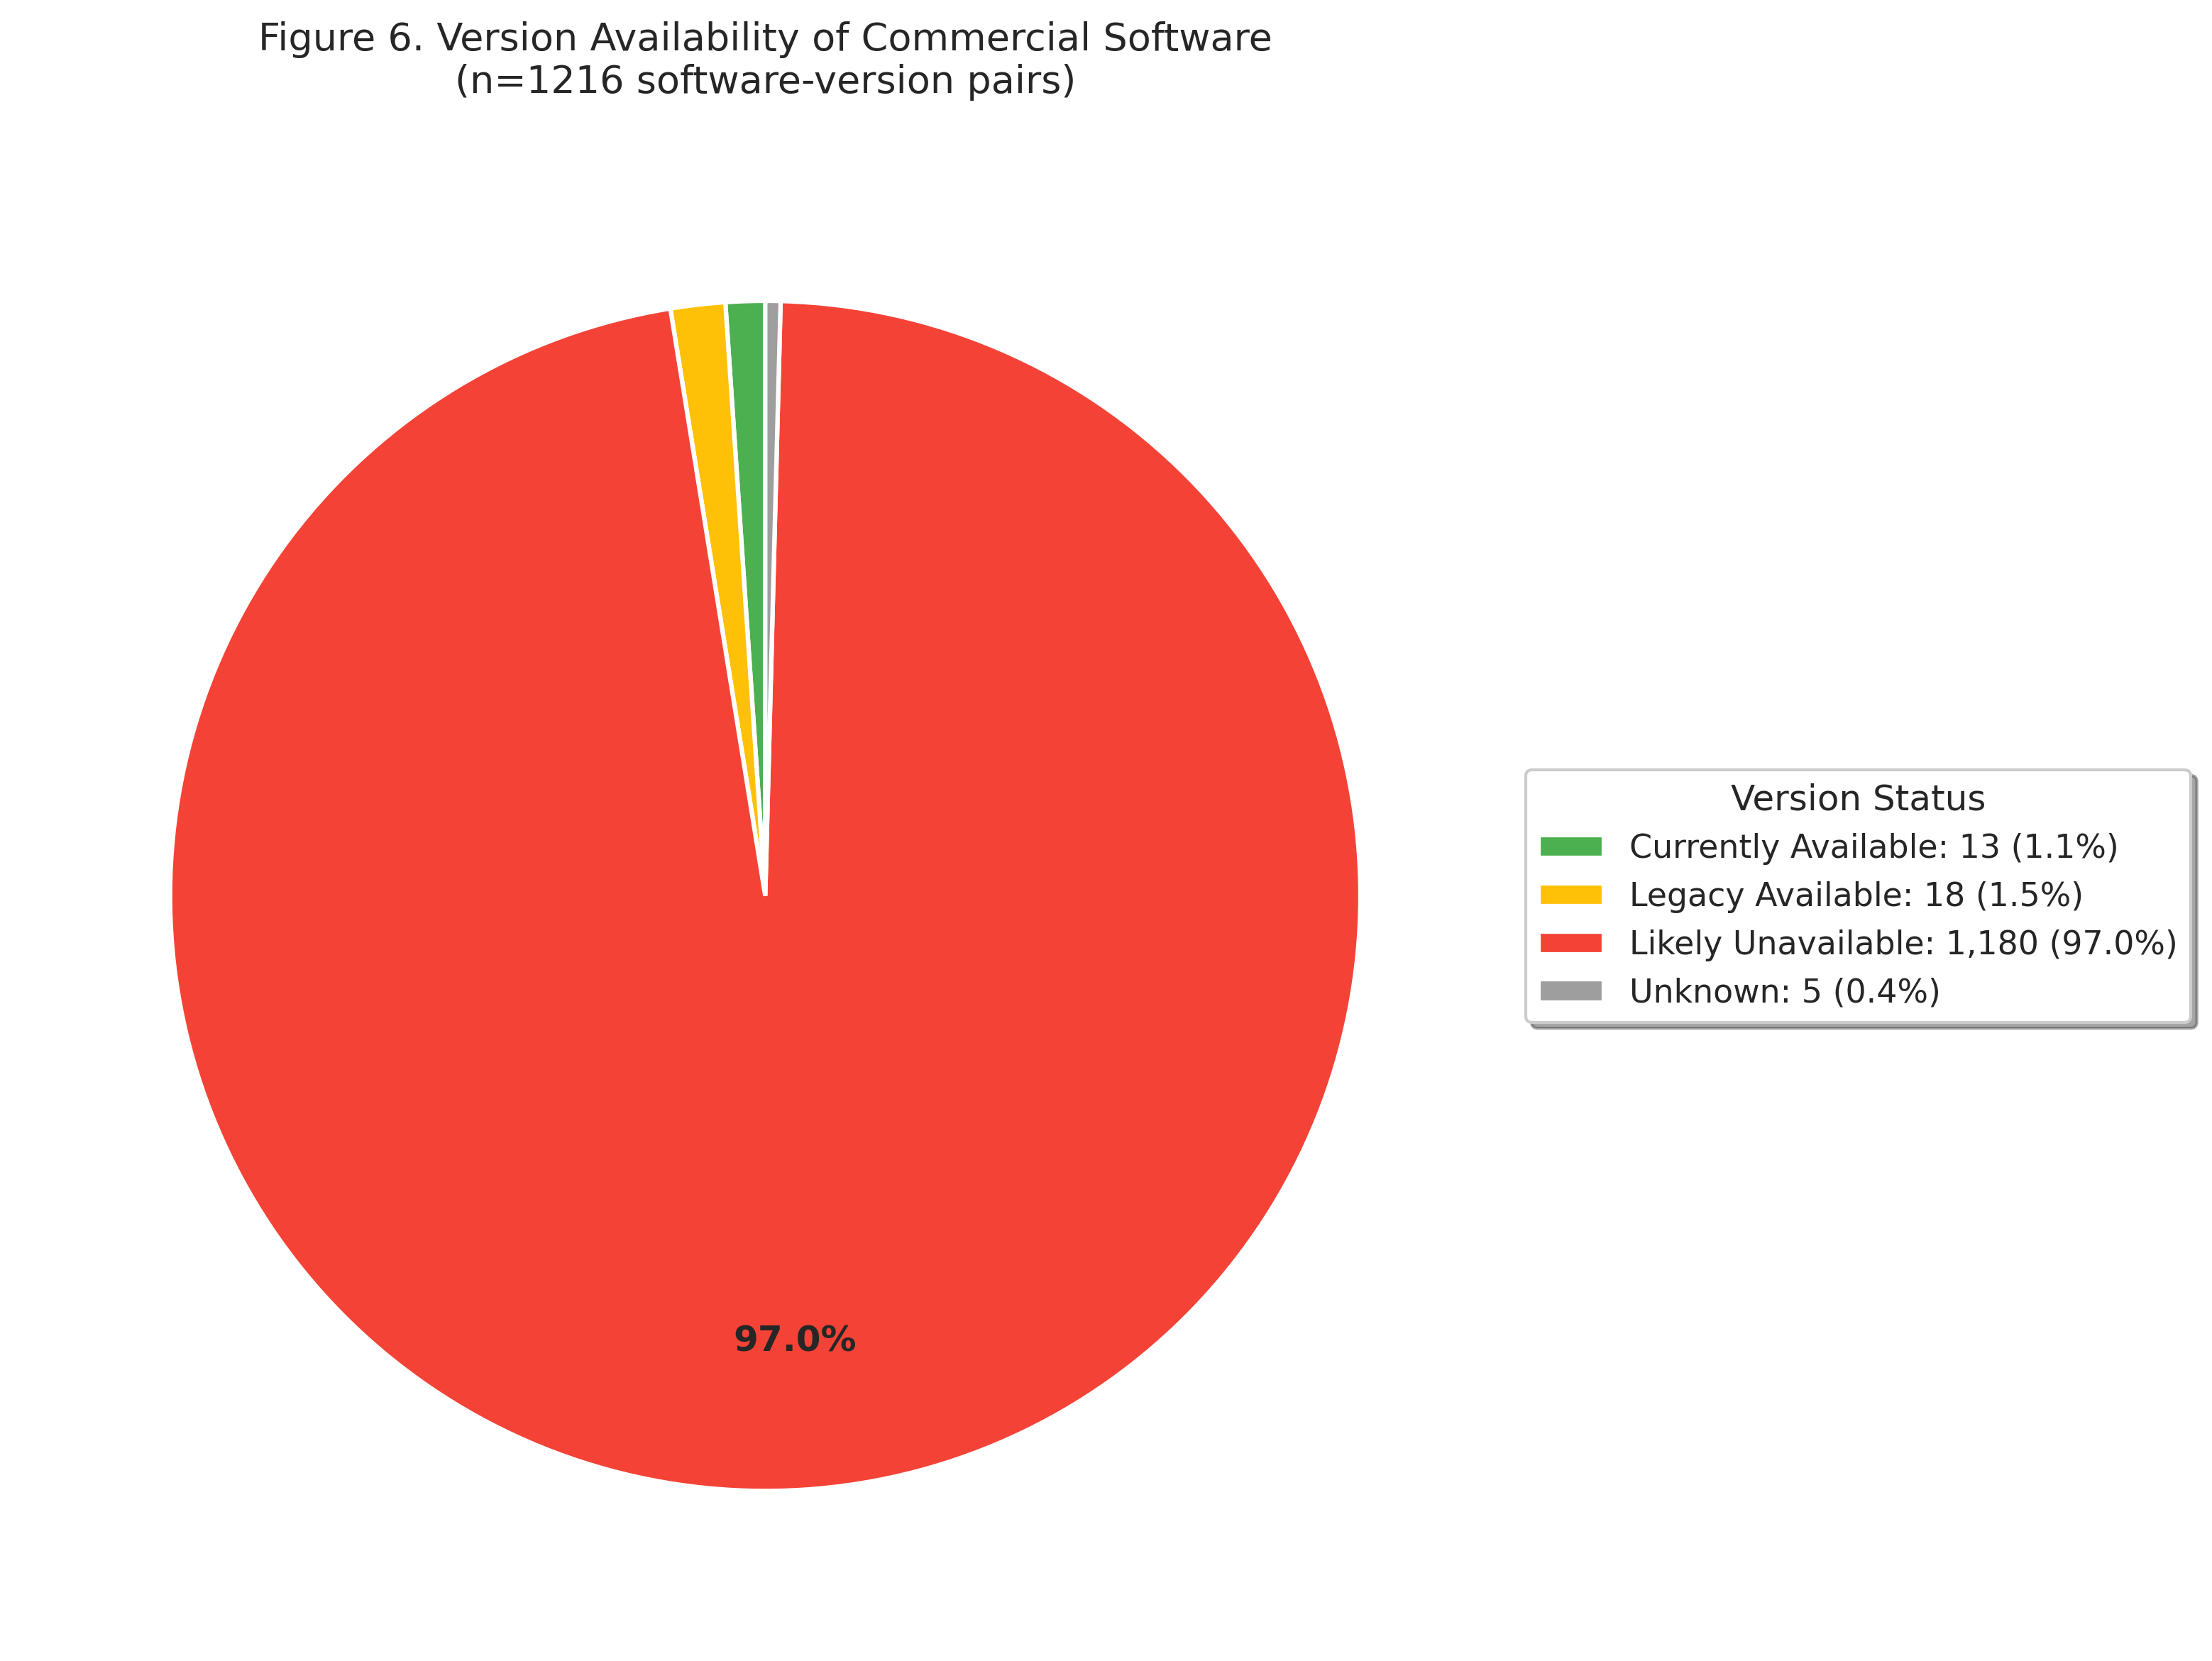
Figure 6. Availability assessment of commercial software versions cited in published papers.

3.6 Replication Cost Estimates
Among papers using commercial software (n=1791), the mean estimated replication cost was $1,900 (median: $1,188). The maximum estimated cost for a single paper was $13,500. These costs represent annual license fees for the commercial software mentioned in each paper and constitute a significant financial barrier to replication.
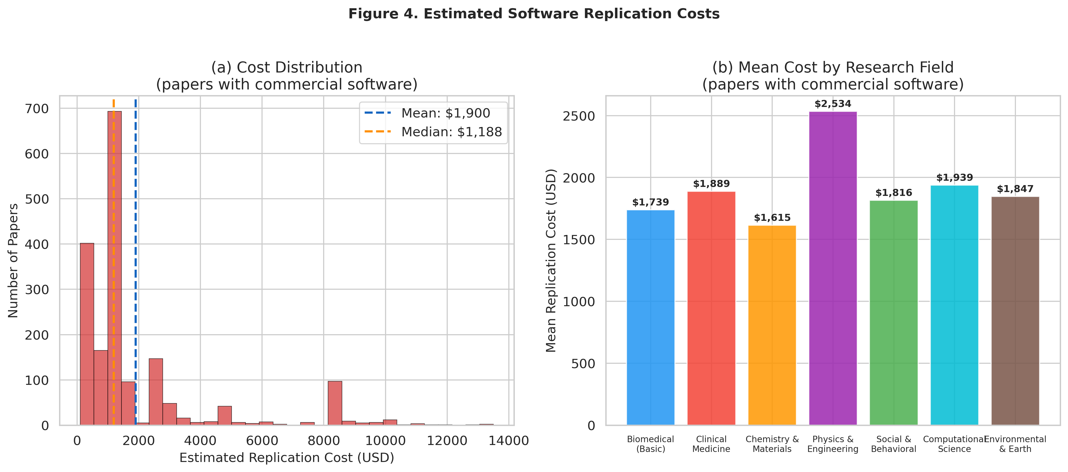
Figure 7. (a) Distribution of estimated replication costs and (b) mean cost by research field.

3.7 Impact of Full-Text Access
PMC full-text was available for 4,816 of 10,000 papers (48.2%). Software detection rates were substantially higher when full-text Methods sections were available compared to abstract-only analysis, confirming that abstract-based analysis alone significantly underestimates software usage.
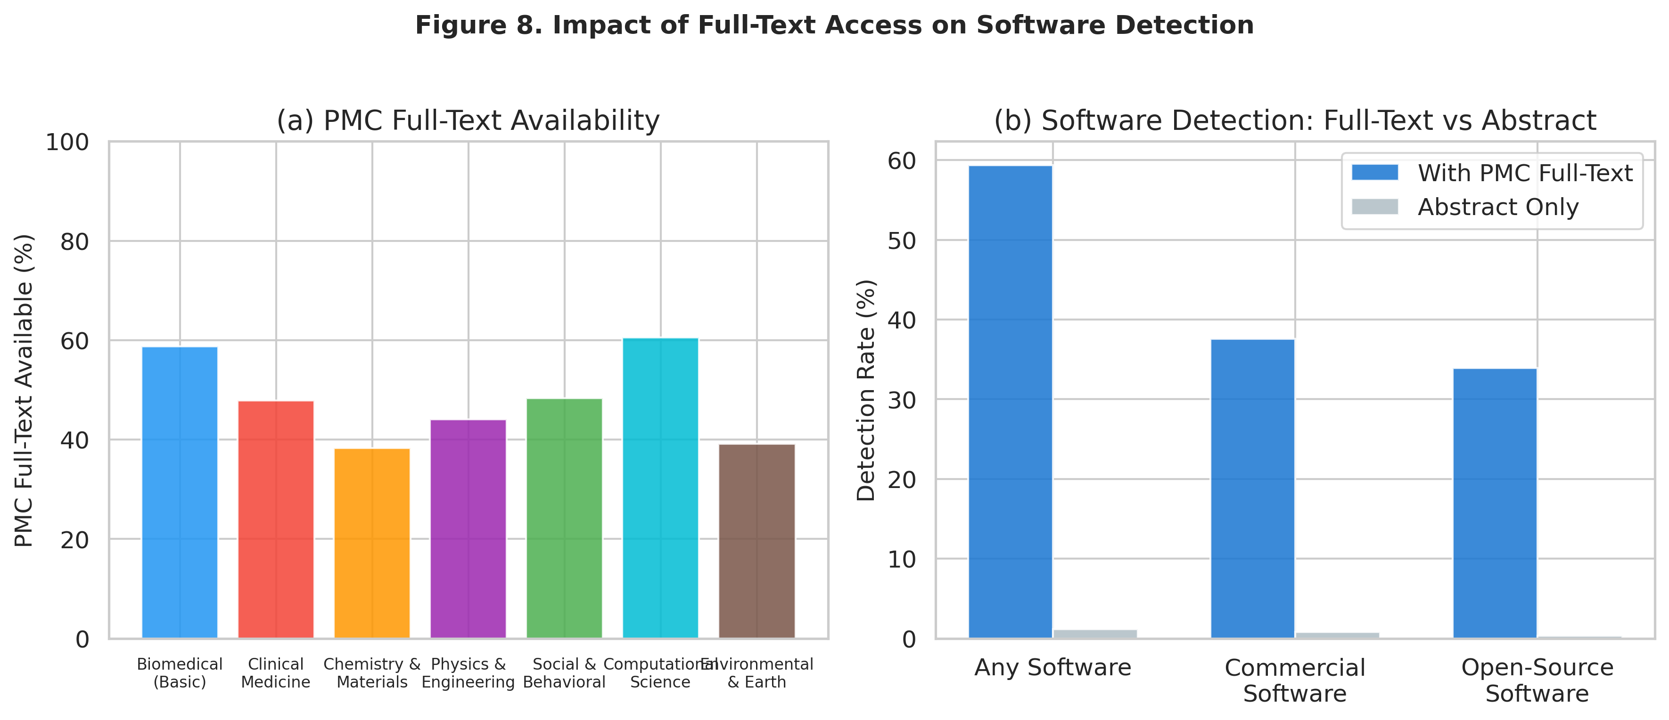
Figure 8. Software detection rates with and without PMC full-text access.

4. Discussion

4.1 Commercial Software as a Barrier to Reproducibility
Our findings reveal that 18.5% of papers in our sample rely on commercial software, with an average replication cost of $1,900 for those papers. This represents a substantial and often overlooked barrier to research reproducibility. Unlike code availability or data sharing, the financial cost of proprietary software licenses is rarely discussed in reproducibility frameworks.

4.2 The Version Accessibility Gap
Most commercial software vendors do not provide access to legacy versions. When a paper reports using "SPSS version 26" or "MATLAB R2021a," a researcher attempting to replicate the study may be unable to obtain those exact versions. Even with identical input data and analysis code, different software versions may produce different results due to changes in algorithms, default parameters, or numerical precision. This "version accessibility gap" is a critical but underappreciated dimension of the reproducibility crisis.

4.3 Version Reporting Practices
Only 17.0% of detected software had associated version numbers. This low rate of version reporting further compounds the reproducibility problem, as it prevents even the identification of which version was used, let alone its acquisition. Fields with strong computational traditions (Social & Behavioral, Environmental & Earth) showed higher version reporting rates, suggesting that community norms play an important role.

4.4 Limitations
- Software detection relies on regex pattern matching, which may miss some mentions or produce false positives.
- PubMed covers biomedical and life sciences more comprehensively than other fields.
- Only 48.2% of papers had PMC full-text available; abstract-only analysis underestimates true software usage.
- Cost estimates are based on standard license prices and may not reflect actual costs (e.g., institutional site licenses, academic discounts).
- Automated regex-based extraction may not capture all software mentions, particularly those using non-standard naming conventions.

5. Conclusions
This study provides empirical evidence that commercial software dependency constitutes a significant, quantifiable barrier to research reproducibility. The combination of (1) widespread commercial software use, (2) poor version reporting practices, (3) vendor policies that restrict access to legacy versions, and (4) substantial license costs creates a multi-layered obstacle to replication. We recommend that funding agencies, publishers, and software vendors collaborate to establish "Reproducibility Licenses" that enable free access to specific software versions cited in published research for the purpose of replication and verification.

