From scientific description to independent computational reconstruction
Prospective Paper II study linked to the EPJ commercial-software corpus
PREPARATION DRAFT — NOT SUBMISSION READY
Authors, affiliations and corresponding author: NOT FINALIZED.
Working journal: EPJ Research Infrastructures.

Preparation abstract
Access to research artifacts does not establish whether the published scientific description supports an independent implementation. This prospective study will estimate publication-grounded computational reconstructability under a specified agent, information boundary and resource budget, without consulting the original implementation or purchasing study-specific commercial software. The source audit identified 10,000 deposited records representing 9,935 distinct PMIDs. The author approved the unique-PMID frame while preserving every deposited row. Existing variables remain historical text detections rather than validated access assessments. The proposed design separates eligibility, input and resource access, specification, implementation, execution, numerical agreement and target-linked conclusion preservation. Three fixed independent run slots per sampled paper will support majority, strict and permissive outcome definitions while retaining missing or contaminated slots as unresolved. Targets, tolerances and resource ceilings must be frozen prospectively. This document contains only preparation findings and proposed methods. No pilot, reconstruction experiment, human validation or descriptive original-code reveal has been completed. No reconstructability rate or empirical conclusion is available. A qualified information firewall, verified study inputs and real validation remain necessary before this work can support a completed-study submission.
Keywords: computational reconstruction; reproducibility; scientific specification; research infrastructure; software accessibility; research agents

1 Introduction
Computational reproducibility terminology varies across communities (Goodman et al., 2016; National Academies of Sciences, Engineering, and Medicine, 2019). ACM's post-2020 terminology distinguishes execution of authors' artifacts from results obtained using independently developed artifacts (ACM Publications Board, 2020). We therefore use publication-grounded independent computational reconstruction as an operational description rather than proposing a universal definition.
The EPJ antecedent examines commercial software and version accessibility (Onishi and Ikenoue, 2026). Those conditions motivate, but do not answer, whether the scientific description contains enough operational detail to implement the reported method independently. The Wet antecedent concerns environmental confounding in clonal systems (Onishi, 2026). Its extension here is a conceptual analogy: nominal materials or data may be available while operational specification remains incomplete. The Wet full text was not accessible in the preparation audit; no detailed empirical claim is imported from it.
Independent paper-to-code reconstruction already has substantial precedent. PaperBench restricts original implementations but supplies author clarifications (Starace et al., 2025); ReplicationBench uses curated astrophysics tasks and supplied execution information (Ye et al., 2025). Paper2Code studies repository generation (Seo et al., 2026), while ScienceAgentBench evaluates curated scientific programming tasks (Chen et al., 2025). CORE-Bench instead supplies original code and data (Siegel et al., 2024; revised 2026). Their endpoints and information packages differ and must not be pooled as a publication-level reconstructability rate.
The proposed contribution is a finite-corpus estimation study with an explicit publication-only information boundary and zero study-specific software expenditure. It makes no first-study or terminological novelty claim. Figure 1 shows the proposed framework and the exclusion of robustness experiments.
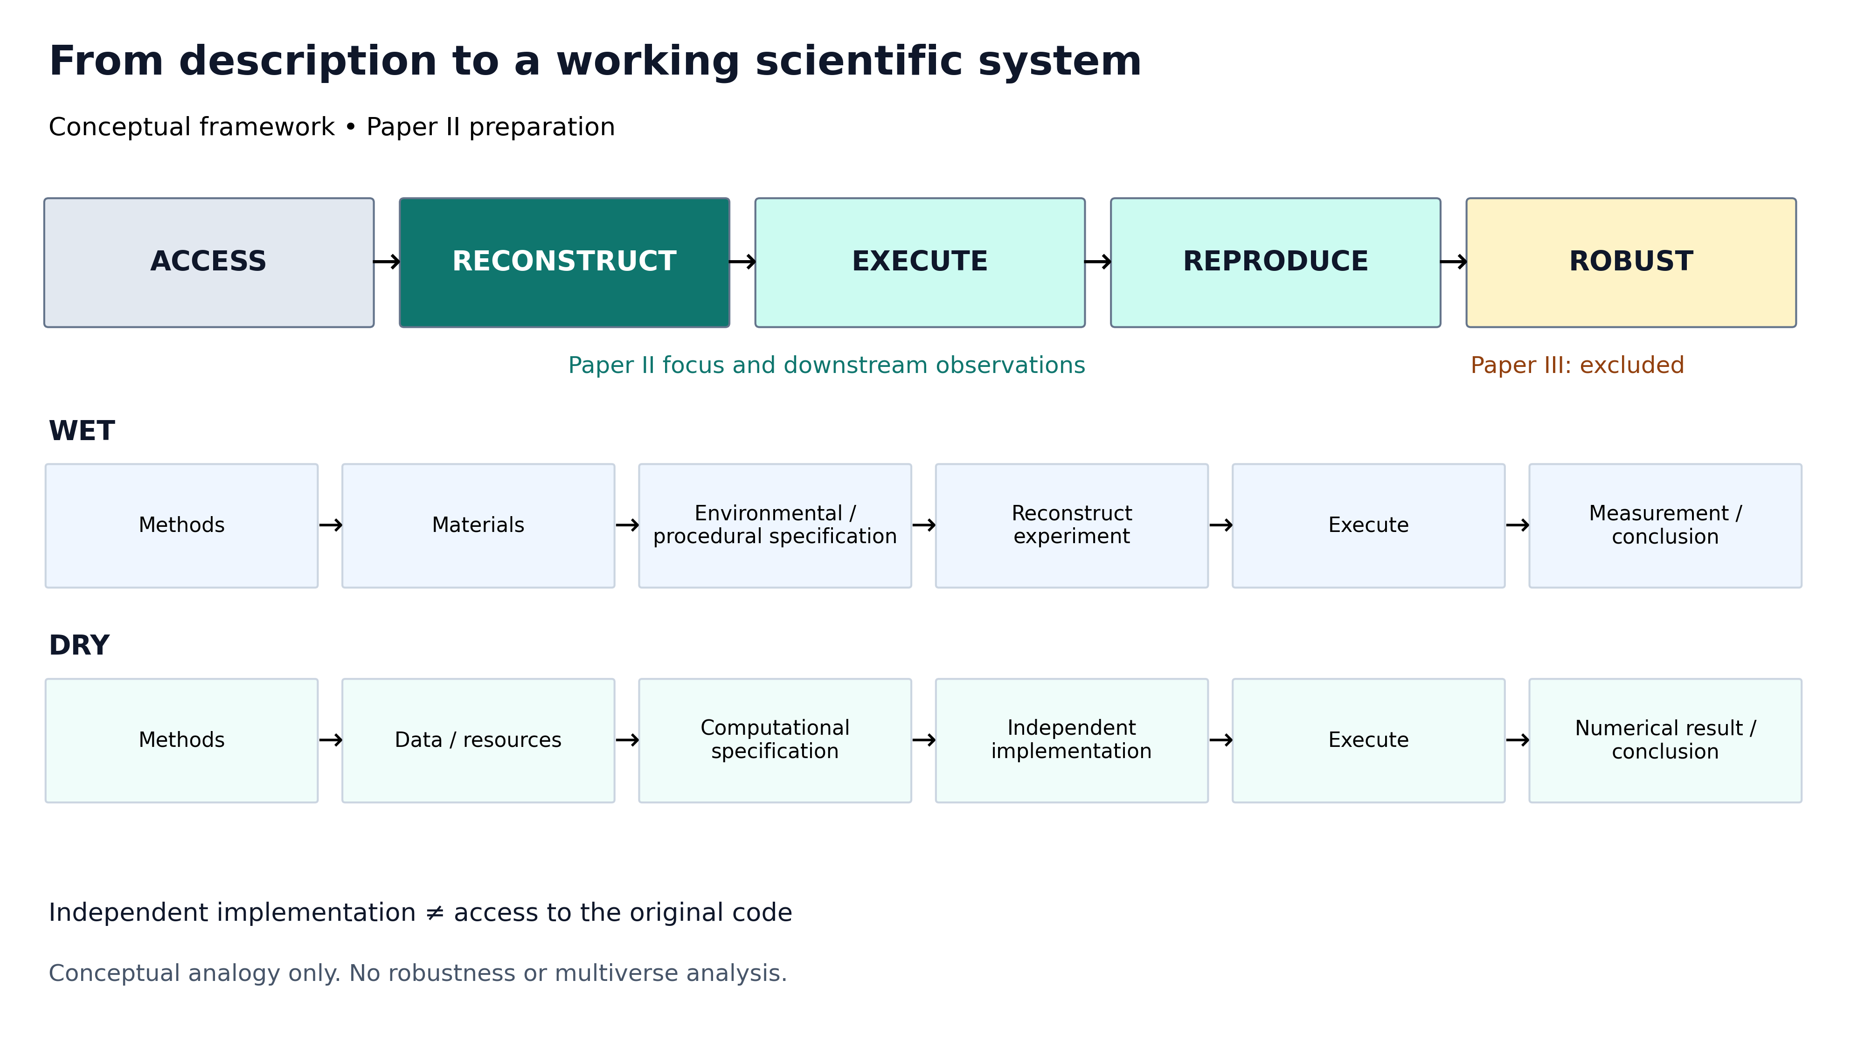
Figure 1. Conceptual Wet/Dry framework. Paper II focuses on RECONSTRUCT and observes EXECUTE and REPRODUCE. ROBUST belongs to future Paper III and is excluded. The two pathways are an analogy, not a literal equivalence or an empirical result.

2 Prospective methods — not yet performed

2.1 Source frame and eligibility
Preserve deposited source records and derive paper identity separately. G1 assesses whether a central claim depends on a computational procedure with a potentially objective output. G2 identifies the principal target; G3/G4 assess lawful input and zero-purchase resource access; G5 describes specification sufficiency. Neither access nor specification failures exclude otherwise eligible papers from the all-eligible policy estimand. Historical code/data flags cannot replace these assessments.

2.2 Sampling and target selection
Using the approved frame, a diverse pilot will finalize operational rules. The main sample is approximately 100 papers, stratified using a deterministic disjoint assignment of the seven overlapping EPJ fields. Save within-field sampling probabilities and weights. Before each run, select one central target by the frozen hierarchy and encode its associated claim. No outcome-informed target replacement is permitted. Planning precision in the supplement is not empirical evidence.

2.3 Independent reconstruction intervention
Use three clean, fixed slots per paper with the same target, package and permissions and equivalent model and resource settings. Permitted materials are the publication, methodological supplement, vetted inputs and general documentation. Original implementations and other runs are prohibited. The broker must restrict model-side tools and execution networking. Separate VMs alone are insufficient. Prior model training exposure cannot be certified absent. No qualified harness currently exists.

2.4 Outcomes and comparison
L1 specification, L2 implementation, L3 execution, L4 numerical reproduction and L5 conclusion preservation remain separate. A run succeeds only when an independent implementation executes and meets the frozen target-specific numerical rule. Majority paper success requires two clean successes among three fixed slots. Missing or contaminated slots remain unresolved, with bounds rather than reduced denominators. Exact counts, displayed-precision scalar comparisons and target-specific stochastic rules avoid arbitrary universal tolerances. Matching numbers do not by themselves prove implementation fidelity.

2.5 Statistical analysis and failure attribution
Use design-weighted finite-corpus estimates and separately reported uncertainty and unknown-status bounds. Fixed-frame census counts do not have paper-sampling error. Report complete-triple consistency, hierarchical outcomes, failures and burden. Do not fit unjustified multivariable models or interpret code-sharing associations causally. Distinguish observed reconstruction failure from demonstrated publication inadequacy. The proposed weighted interval is not yet implemented; details and prespecified sensitivities are in the draft SAP.

2.6 Freeze, reveal and human validation
Seal targets before runs and all outcomes before any original-code reveal. Reveal is descriptive only; no perturbation or revised score is allowed. Prepare approximately 15 outcome-balanced human cases after agent freeze, with validators masked to agent and reveal results. Actual human work, institutional determination and participation records are indispensable. No human outcome is simulated. No robustness or multiverse analysis is part of Paper II.

3 Observed preparation findings
The two pinned source CSVs contain 10,000 rows and 9,935 unique PMIDs, with 65 excess records over a unique-paper count. There are 64 repeated identifiers: 63 occur twice and 1 occurs three times. The deposit has 9,996 distinct PMID-field memberships, including 4 within-field excess records and 60 PMIDs spanning fields. Non-field extracted values agree across repeated records. Table 1 presents source-row and within-field identity counts; it is not an eligibility or reconstruction-results table.
Table 1. Observed deposited corpus structure.
Recorded EPJ field | Source rows | Unique PMIDs within field
Biomedical Basic | 1429 | 1429
Clinical Medicine | 1429 | 1429
Chemistry Materials | 1429 | 1429
Physics Engineering | 1429 | 1428
Social Behavioral | 1429 | 1429
Computational Science | 1429 | 1429
Environmental Earth | 1426 | 1423
The original sampling code caps annual candidate retrieval and its nominal random-offset expression is always zero. Historical candidate/API snapshots and validation annotations were not recovered. Consequently original population-wide selection probabilities and extraction accuracy are not established by this audit. Main-study outcomes below are delegated mechanical adjudications that await human adjudication; no human-validated reconstruction rate exists.

4 Main-study execution and delegated mechanical results
Status: every number in this section is a delegated mechanical adjudication of sealed blind outcomes under frozen rules (AMEND-2026-09-25-07). Human adjudication and investigator verification are pending, and the seven prospective pilot papers and seven ACCESSIBILITY_GATE_FAILED papers are outside every denominator below.
Exhaustive route screening of the unique-PMID frame left 461 route-eligible papers, from which 100 were sampled in seven frozen strata. 10 sampled papers completed three blind slots (30 runs); 90 were not run and retain machine-readable states (Table 2): external public reference resource required, delegated G1–G5 negative, required inputs absent from the public listing, specification rejected by the quote/leakage validator, target value not located verbatim, every candidate input leaking the target, or no input retained.
Among attempted papers the majority endpoint was met by 0 of 10 (secondary conditional rate; Wilson reference 0.00–0.28). Prespecified thresholds — strict: failure 10; majority: failure 10; permissive: failure 9, success 1. Run-level L1–L5 frequencies are in Table 3. Stop reasons: wall_limit 1, tool_limit 16, final_report 10, token_reserve_limit 2, malformed_action_limit 1. Failure codes by run (Table 4): F01 5, F03 2, F13 19, F15 3, F20 2. F13 denotes the frozen resource ceiling, not demonstrated publication inadequacy.
Under the frozen SAP the headline policy estimand retains non-attempted papers as policy non-success. Taking the delegated states as recorded, the simultaneous hypergeometric upper bound on the eligible-population success rate is 0.262 (weighted point estimate 0.000). Because gate verification is pending, an identification envelope that treats every non-attempted paper as unresolved reaches 0.974; it is a bound, not an estimate. No random-intercept model, perturbation, multiverse or alternative-implementation analysis was performed.
Descriptive original-code reveal (Table 5) was recorded only after the seal: 3 attempted papers named public code routes or shipped scripts inside the data deposit (withheld from the solver) and are described; 7 named none and receive a missing reveal assessment. Nothing was executed and no blind score was revisited.

5 Discussion boundary and submission hold
The source audit supports identity and denominator statements only. It cannot establish that publications are reconstructable or unreconstructable. A completed study must separate infrastructure barriers, scientific specification and agent limitations; agent failure is not human impossibility. Original-code availability may correlate with reporting practice but cannot be interpreted causally here. Methods-linter development and robustness analysis remain future work.
Submission is on hold for qualification of an enforced information firewall, pilot and prospective freeze, actual classification and reconstruction evidence, and human-validation status. This document must not be submitted as a completed empirical study or presented as a frozen protocol.

Statements and declarations — pending author completion
Funding, competing interests, author contributions, affiliations and correspondence: not provided. Human-validation ethics/consent determination: not completed. Data/code: the public EPJ-linked repository contains the source and preparation pipeline; no Paper II reconstruction dataset exists. Third-party full text is retained internally under its applicable rights and is not redistributed.
AI assistance: Devin performed source, literature and design audits and generated preparation code and draft materials. These preparation sessions are not blind reconstruction replicates. Human investigators must validate the design, factual claims, interpretation and final manuscript, and retain scientific responsibility.

References used in this preparation draft
Antecedent author names follow the supplied author specification. Publisher/Crossref metadata reverse the first author's name components; verify the final bibliographic form before submission. Preprints and version-specific claims are identified in the reference ledger.
ACM Publications Board (2020). New Changes to Badging Terminology. Official ACM policy explanation; badge version 1.1 effective after 2020-05-15. https://www.acm.org/publications/badging-terms
Chen, Ziru; Chen, Shijie; Ning, Yuting; Zhang, Qianheng; Wang, Boshi; Yu, Botao; Li, Yifei; Liao, Zeyi; Wei, Chen; Lu, Zitong; Dey, Vishal; Xue, Mingyi; Baker, Frazier N.; Burns, Benjamin; Adu-Ampratwum, Daniel; Huang, Xuhui; Ning, Xia; Gao, Song; Su, Yu; Sun, Huan (2025). ScienceAgentBench: Toward Rigorous Assessment of Language Agents for Data-Driven Scientific Discovery. Published ICLR 2025; first arXiv posting 2024; v3 2025. https://arxiv.org/abs/2410.05080
Goodman, Steven N.; Fanelli, Daniele; Ioannidis, John P. A. (2016). What does research reproducibility mean?. Published Perspective, Science Translational Medicine 8(341):341ps12, 2016. https://doi.org/10.1126/scitranslmed.aaf5027
National Academies of Sciences, Engineering, and Medicine (2019). Reproducibility and Replicability in Science. Published National Academies consensus report, 2019. https://doi.org/10.17226/25303
Onishi T [name order follows supplied author specification] (2026). The Invisible Variables: Why Clonal Systems are not Immune to Environmental Confounding. Published Comment, Stem Cell Reviews and Reports, 2026-09-10. https://doi.org/10.1007/s12015-026-11239-w
Onishi T; Ikenoue T [name order follows supplied author specification] (2026). The Hidden Cost of Reproducibility: Commercial Software Dependency in Published Research and the Version Accessibility Gap. Published EPJ Research Infrastructures 10, article 26, 2026-09-01. https://doi.org/10.1007/s41781-026-00180-9
Seo, Minju; Baek, Jinheon; Lee, Seongyun; Hwang, Sung Ju (2026). Paper2Code: Automating Code Generation from Scientific Papers in Machine Learning. Published ICLR 2026; arXiv first posted 2025, v5 2026. https://arxiv.org/abs/2504.17192
Siegel, Zachary S.; Kapoor, Sayash; Nadgir, Nitya; Stroebl, Benedikt; Narayanan, Arvind (2024). CORE-Bench: Fostering the Credibility of Published Research Through a Computational Reproducibility Agent Benchmark. arXiv preprint; v2 revised 2026-06-22; separate peer-reviewed venue not verified. https://arxiv.org/abs/2409.11363
Starace, Giulio; Jaffe, Oliver; Sherburn, Dane; Aung, James; Chan, Jun Shern; Maksin, Leon; Dias, Rachel; Mays, Evan; Kinsella, Benjamin; Thompson, Wyatt; Heidecke, Johannes; Glaese, Amelia; Patwardhan, Tejal (2025). PaperBench: Evaluating AI's Ability to Replicate AI Research. Published ICML 2025, PMLR 267; arXiv v3. https://arxiv.org/abs/2504.01848
Ye, Christine; Yuan, Sihan; Cooray, Suchetha; Dillmann, Steven; Roque, Ian L. V.; Baron, Dalya; Frank, Philipp; Martin-Alvarez, Sergio; Koblischke, Nolan; Qu, Frank J; Yang, Diyi; Wechsler, Risa; Ciuca, Ioana (2025). ReplicationBench: Can AI Agents Replicate Astrophysics Research Papers?. arXiv preprint v2, 2025-11-23; separate peer-reviewed venue not verified. https://arxiv.org/abs/2510.24591

