AI researchers as the next coal: transition rates, minimum viable research communities and the preservation of variety in global AI/ML
Article type: Full Length Article
Approximate word count (main text incl. tables, excl. references): 9051
Corresponding author: [To be completed at submission]

Abstract
Researcher mobility is measured as stocks and net flows, but those quantities do not say whether a research system can still reproduce its own workforce. We build a reproducible measurement pipeline that turns open bibliometric records into cohort career-transition rates, a six-compartment dynamical model, and a monitoring indicator pair: the equilibrium active pool relative to a minimum viable coauthor scale ($T/M$) and the proximity of that equilibrium to a model-implied viability boundary. The two are linked by construction and form one diagnostic scale, not two independent tests. Applied to an OpenAlex AI/ML cohort (2000-2023) across 9 research macro-regions, all systems exceed their minimum scale, but distance to the boundary is governed by relative scale rather than size: the lowest $T/M$ is 215.76 (Anglosphere ex-US), and the closest boundary is in Anglosphere ex-US, where exogenous entry rate ($I_{0}$) reduced to 0.5% of its current value-a 99.5% reduction-would drive the active pool to its threshold. Dropout, which drains every compartment, is the most elastic lever in every macro-region. Transition rates estimated from the 2011-2016 career-start window imply a smaller equilibrium pool than 2000-2010 rates in 1 of 9 macro-regions. Seven origin specifications never reverse a macro-region's mobility direction, and six PI definitions leave the $T$-side rankings structurally invariant while the P-side varies. The pipeline is field-agnostic; AI/ML is the case study. The indicators give a recomputable monitoring diagnostic; its ranking is conditional on the operational $M$ and we claim no validated predictive power.
Keywords: researcher mobility; research evaluation; science of science; minimum viable scale; compartment model; bibliometric indicators; artificial intelligence

Highlights
- A reproducible pipeline from bibliometric records to research-system viability
- Distance to the boundary follows relative scale $T/M$, not system size
- Closest boundary: Anglosphere ex-US, $I_{0}$ at 0.5% of baseline
- Dropout, which drains every career stage, is the most elastic lever everywhere
- Seven origin rules and six PI definitions audited in the main results

Data and Code Availability
All bibliometric data used in this study come from OpenAlex (https://openalex.org), an open scholarly database released under a CC0 licence; works were retrieved through the OpenAlex API for the Artificial Intelligence subfield (subfield 1702) and publication years 2000 to 2023. The country-to-macro-region mapping with its documented overrides, the estimated transition rates for every macro-region, and every aggregate result table underlying the figures and numbers reported here are available in the public GitHub repository https://github.com/bougtoir/researcher-mobility-ode. The same repository contains the Python code for cohort extraction, rate estimation, the ODE model and its endogenous-inflow variant, the bootstrap, the sensitivity and robustness analyses, the coupled nine-region simulation, and the script that regenerates this manuscript, its figures, tables and Supplementary Material. The author-level cohort and the underlying work and authorship records are derivatives of OpenAlex data and are not redistributed; the single reproduction command (reproduce.sh) re-extracts them from the OpenAlex API with the scripts provided, using the same subfield, year window and inclusion rules, and then rebuilds all results from that extraction. OpenAlex is updated continuously, so a fresh extraction reproduces the reported rates, rankings and thresholds up to small snapshot differences of the kind reported in Section 3.6. No proprietary or restricted data were used.

Declarations
Funding: [To be completed by the authors at submission.]
Competing interests: [To be completed by the authors at submission.]
Author contributions: [To be completed by the authors at submission.]
Declaration of generative AI in scientific writing: During the preparation of this work the authors used AI-assisted tools to draft, code, and revise the manuscript. All claims, data, and interpretations were reviewed and approved by the authors.
Acknowledgments: This study was motivated by a note.com essay by Yamada Y (momentumyy) that framed researcher mobility in terms of transition rates rather than net flows (Yamada Y (momentumyy). Kaigai de ateta kenkyusha wa sonogo dou naru no ka [What happens to researchers who make their name abroad?]. note.com, 2026. https://note.com/momentumyy/n/n86df5d34282d (accessed 2026-08-09).).

1. Introduction
The science of science measures researcher mobility as stocks and net flows: how many scientists a country has, how many leave and how many arrive [1,2,3]. Those quantities describe redistribution, but they do not tell an evaluator whether a research system can still reproduce its own workforce. What is missing is a community-level state variable-an observable quantity that tracks, in model terms, whether a system retains the capacity to reproduce its workforce before the headcount shows it. This paper builds that measurement pipeline end to end and applies it to one field where the question is urgent.
Artificial intelligence (AI) and machine learning (ML) research is an informative case. Its methods are a general-purpose technology being embedded across science, industry and public administration [4,5]; its senior researchers are unusually mobile internationally; and its talent, compute and data are concentrating in a small number of systems [5,6,7]. Governments compete for this population through visas, fellowships and salaries [3,8,9]. The question echoes Jevons's coal question—extended from an exhaustible input to a reproducible but concentrating human one [10,11]. A measurement framework that converts individual career-transition rates into system-level viability indicators is therefore of direct interest to research evaluation and science-of-science research, and AI/ML is the field where we calibrate and illustrate it; the framework itself is field-agnostic.
The mechanism behind the indicators has four steps. (i) Career-transition rates-entry ($I_{0}$), early-career moves abroad ($α$), return ($β$), high-impact production ($h_{D}$, $h_{A}$), promotion to independent authorship ($p_{D}$, $p_{A}$) and dropout ($d$)-determine the equilibrium domestic active pool $T$. (ii) Recruitment exhibits a network externality: principal investigators (PIs) train students and attract post-doctoral researchers, so inflow rises with the PI stock [12], making the pool self-reinforcing. (iii) From the field's observed coauthor structure we construct an operational benchmark, the minimum viable coauthor scale $M$ (the median number of independent last-author groups times the mean number of coauthors per work) [13], against which each system's equilibrium scale can be normalised. (iv) In the model, an equilibrium active pool below $M$ classifies the system as sub-scale relative to the field's observed coauthor intensity. Whether a real community that crosses such a benchmark stops reproducing its PI stock, loses research programmes, or fails irreversibly is an empirical question this paper does not claim to have answered; the path-dependent intuition behind such losses is Arthur's [14,15,16]. The research question is: for each research system, how far is the active pool from its minimum viable scale, which transition governs that distance, and has the distance been shrinking?
Four propositions are derived from the mechanism before seeing the results. P1 (relative scale): distance to the viability boundary is governed by $T/M$ rather than absolute $T$; because the entry lever rescales the whole equilibrium, this is a structural implication used diagnostically, not a falsifiable hypothesis. P2 (asymmetric leakage): dropout, which removes researchers from every compartment, is more elastic than early-career outflow, which preserves return. P3 (endogenous recruitment): the transition closest to the defined boundary is the one feeding the reproduction loop from outside ($I_{0}$), and the proximity ranking is robust to the form of the recruitment feedback. P4 (historical drift): later-window rates imply different equilibria from earlier-window rates, so proximity to the threshold is not stationary. P2-P4 are falsifiable by the fitted model; P1 is checked for consistency.
The contribution is primarily methodological. We assemble a fully reproducible measurement pipeline-from OpenAlex extraction through researcher identification, geographic attribution, mobility transitions, PI operationalisation and community aggregation to a calibrated six-compartment dynamical model-for a cohort of 623,176 AI/ML authors across 9 research macro-regions [17]. Each measurement choice is stress-tested: origin assignment under seven specifications, mobility direction under each, PI status under six alternative definitions propagated through the model, and a missingness and censoring audit; the sensitivity results are reported in the Results section alongside the model results, not relegated to footnotes. Empirically, we provide comparative estimates of career-transition rates, minimum viable scale and proximity to a model-implied viability boundary (MVB) for the macro-regions. For research evaluation, the output is a recomputable monitoring diagnostic ($T/M$ and its closest-lever reading, MVB proximity) that can be recomputed with each OpenAlex release. AI/ML serves as the case study; we make no claim that the specific findings generalise to other fields, only that the pipeline transfers.
Section 2 specifies data and measurement, Section 3 reports observed, model and sensitivity results in that order, Section 4 discusses implications and limitations, and Section 5 concludes.

2. Data and measurement

2.1 Data source and cohort
We extracted AI/ML works and author histories from the OpenAlex API for subfield 1702 (Artificial Intelligence), 2000-2023 [17]. OpenAlex provides open, CC0 metadata on authors, affiliations, countries, publication dates and citations. Author histories were built by following each author's sequence of works and affiliations, assigning a country per work and an origin macro-region by the modal group of recorded affiliations.
Authors enter the cohort if their first observed AI/ML publication is in 2000-2016 and they have at least two AI/ML works in 2000-2023; authors with only unknown affiliations are excluded, giving 623,176 authors. An author is active if they have at least one AI/ML work in 2020-2023 and has dropped out otherwise. A hit is a paper in the top 10% of AI/ML citations for its publication year, observed within the first eight career years. A PI is an author whose first last-author paper (single-authored papers are treated as last-author) appears in the window [18]. Both are deliberately broad operational definitions: a PI in this sense is any author with at least one independent last-author paper, not a tenured group leader, and a hit author is any author with at least one top-decile paper. Because the cohort is restricted to authors with at least two works, PIs account for 55-71% and hit authors for 31-62% of each macro-region's cohort (Table 1). The PI compartment therefore represents an operational proxy for the population able to lead work and recruit-last authorship stands in for group leadership rather than demonstrating it-and the minimum viable scale in Section 2.9 counts distinct last-author groups per year under the same definition, so the two are consistent. The abroad flag is set if the author is affiliated in a non-origin macro-region within the first six career years. OpenAlex coverage is incomplete for non-English venues and author disambiguation is imperfect, so absolute counts are model-implied stocks rather than a census; relative comparisons are preserved because the same rules are applied to every macro-region. Table 1 reports the cohort by macro-region. The China-centred, Continental Europe and United States macro-regions contribute the largest author counts. A smaller cohort with low coauthor intensity can be more resilient than a larger one with high coauthor intensity, which is why $T$ and $M$ must be compared jointly (P1).
Group | Authors | Works | Active 2020-2023 | Hit authors | PIs | Mean career start | Abroad early-career
Anglosphere ex-US | 54017 | 701927 | 23366 | 32061 | 36149 | 2007.4 | 12564
China-centred | 163971 | 1556825 | 91523 | 56710 | 116531 | 2009.1 | 15962
Continental Europe | 147366 | 1853004 | 63639 | 83782 | 97387 | 2008.0 | 17174
Islamic world | 45983 | 381930 | 25466 | 18556 | 31215 | 2011.2 | 6363
Japan | 28681 | 309340 | 10165 | 9390 | 15905 | 2006.8 | 2695
Other Western (Israel) | 3685 | 52066 | 1661 | 2303 | 2284 | 2007.4 | 1008
Other regions | 46189 | 383971 | 21030 | 14511 | 29822 | 2009.9 | 4471
South Asia | 26869 | 243272 | 16064 | 11657 | 18214 | 2011.5 | 3117
United States | 106415 | 1224020 | 45631 | 65018 | 70141 | 2007.4 | 15733
Table 1. Descriptive statistics for the extracted AI/ML cohort by research macro-region. Labels are operational aggregations of OpenAlex country-affiliation patterns.

2.2 Researcher identification
Each researcher is an OpenAlex author identifier, linked across works by OpenAlex's own disambiguation. Author disambiguation is imperfect: careers can be split across duplicate identifiers or merged across namesakes, and we do not re-disambiguate. Because every macro-region is subjected to the same extraction rules, we read the cohort sizes and the estimated rates as operational quantities that are comparable across systems rather than as exact headcounts, and we carry the disambiguation uncertainty into the measurement audit in Section 3.7.

2.3 Geographic attribution and origin
Each work carries the affiliation countries recorded for the author on that work; a work with several affiliations contributes all of its countries. An author's origin is an operational construct, not birthplace or nationality: it is the modal research macro-region of the author's affiliations over their first three observed career years (ties broken toward the earliest year). This window rule is one specification among several; Section 3.7 reports results under seven origin rules (the three-year mode, first observed affiliation, two- and five-year window modes, fractional assignment of multi-group years, exclusion of multi-group years, and seeded probabilistic assignment), so that no conclusion rests on this single choice. Two consequences of the operational definition are measured rather than assumed: multi-affiliated authors, for whom a single 'location' in a year is unobserved, and authors whose origin changes under an alternative rule. The aggregate mobility statistics are regional aggregates, and 'zero direction reversals' in Section 3.7 refers to those aggregates, not to individual trajectories.

2.4 Mobility transitions
From each author's origin and yearly affiliations we define the career transitions the model uses: the abroad flag records affiliation in a non-origin macro-region within the first six career years; return is recorded when a subsequent affiliation again includes the origin macro-region; hit and PI years are defined in Section 2.1 and 2.5; and dropout is inferred when no further AI/ML work is observed. Affiliation changes are a proxy for mobility: they do not observe physical moves, remote collaboration or short visits, and a researcher can hold affiliations in several systems at once. These limitations are quantified in Section 3.7.

2.5 PI operationalisation
The baseline PI proxy follows AI/ML authorship conventions: the senior or group-lead author is listed last or flagged corresponding. Because the concept 'principal investigator' has no direct bibliometric field, we define six operationalisations and propagate each through the full model (Section 3.7): ever-last-author (baseline), ever-corresponding-author, at least two last-author papers, at least eight observed career years, coauthor-network centrality in the top decile of the author's macro-region, and a combined union of the three career-stage definitions. The absolute PI share is proxy-dependent and we report the full range; the model's $T$-side equilibria are structurally invariant to the proxy because the inflow calibration anchors total entry to observed entry (Section 2.8), so only P-side quantities vary-an asymmetry we report rather than hide.

2.6 Community aggregation
The unit of analysis is the research macro-region: a set of countries treated as one recruitment pool under the modelling assumption that their AI/ML researchers share funding systems, labour markets, languages and mobility corridors closely enough for aggregate rates to be meaningful. For reproducibility, the initial partition of countries was taken from Huntington's taxonomy [19], which predicts the structure of global communication networks [20] and of scientific mobility and collaboration [21]; it serves only as a documented starting heuristic and the resulting groups are operational research systems, not civilisations. The partition was adjusted to the size and mobility structure of AI/ML: the United States is separated from the rest of the Anglosphere as the dominant destination with a distinct funding system; Continental Europe is kept distinct because intra-European mobility and EU funding form a separate bloc; Latin American, Orthodox and sub-Saharan African countries are merged into Other regions because their author counts are too small to estimate stable rates. The final 9 macro-regions are: United States, Anglosphere ex-US, Continental Europe, China-centred, Japan, South Asia, Islamic world, Other Western (Israel), Other regions. Anglosphere ex-US is in practice a single national system: United Kingdom of Great Britain and Northern Ireland accounts for 45% of its 2022-2023 AI/ML works, so results for this macro-region should be read as results for a small, high-impact national system. Figure 1 maps the partition and overlays the largest observed inter-region early-career flows, which are the cross-region moves the model tracks through the abroad compartments. The full country mapping is in Supplementary Material.
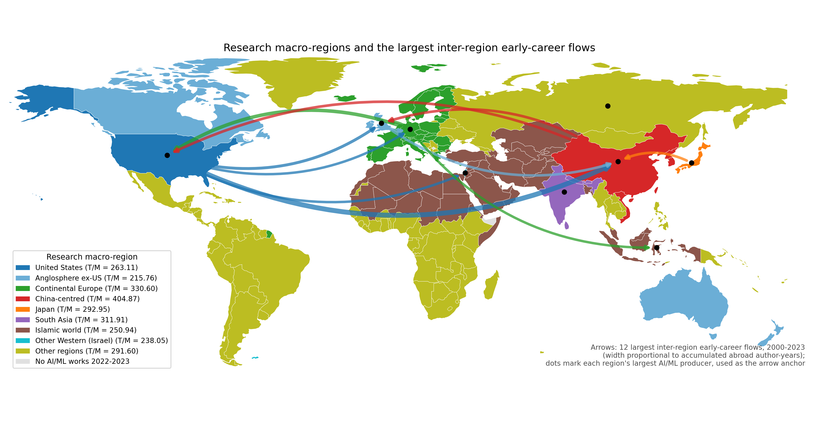
Figure 1. Research macro-regions and the largest inter-region early-career flows, 2000-2023. Country outlines from Natural Earth (public domain); arrow width is proportional to accumulated abroad author-years by origin and destination; the legend gives each region's equilibrium $T/M$ ratio.

2.7 Dynamical model
Each macro-region is represented by six compartments: domestic early-career ($D$), abroad early-career ($A$), domestic hit ($H_{D}$), abroad hit ($H_{A}$), domestic PI ($P_{D}$) and abroad PI ($P_{A}$) researchers. Transition rates are early-career outflow ($α$), return ($β$), hit generation ($h_{D}$, $h_{A}$), PI promotion ($p_{D}$, $p_{A}$) and dropout from all compartments ($d$). Figure 2 shows the structure; the equations are:
$$\frac{dD}{dt}=I{P_{D}} + βA - (α + h_{D} + d)D \\ \frac{dA}{dt}=αD - (β + h_{A} + d)A \\ \frac{dH_{D}}{dt}=h_{D}D + βH_{A} - (p_{D} + d)H_{D} \\ \frac{dH_{A}}{dt}=h_{A}A - (β + p_{A} + d)H_{A} \\ \frac{dP_{D}}{dt}=p_{D}H_{D} + βP_{A} - dP_{D} \\ \frac{dP_{A}}{dt}=p_{A}H_{A} - (β + d)P_{A}$$
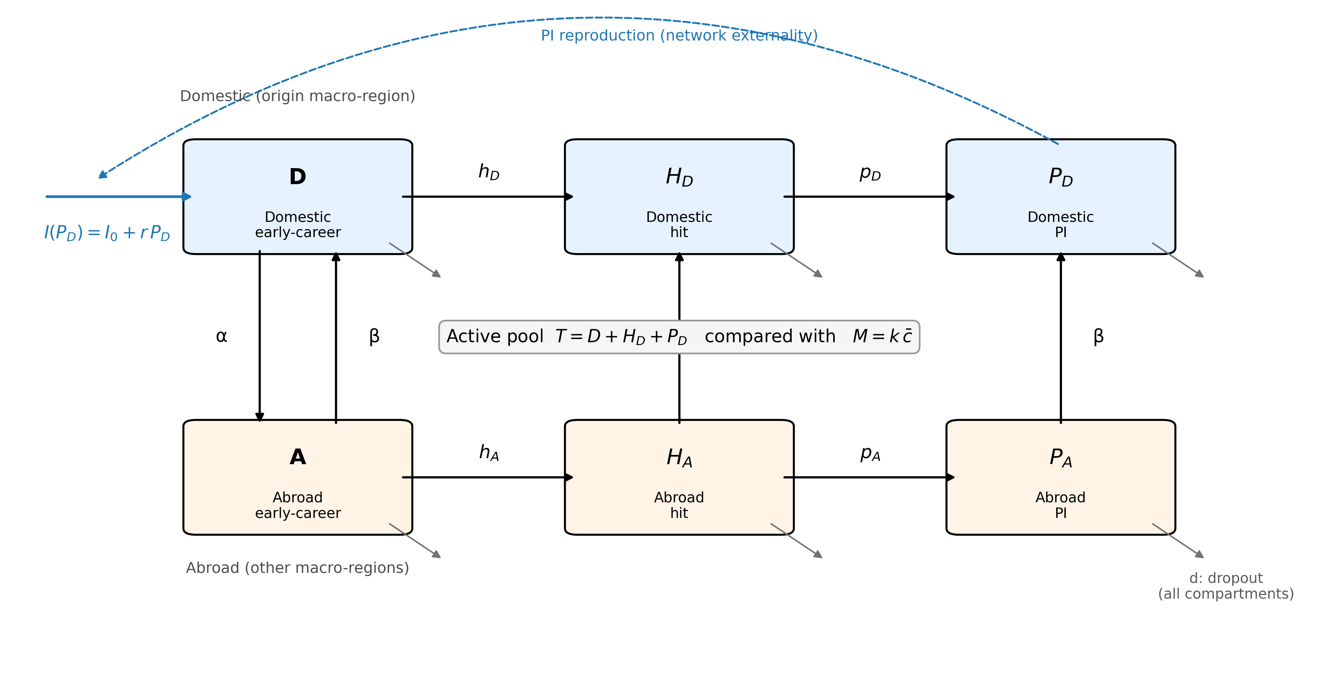
Figure 2. Compartment structure of the model for one research macro-region. Solid arrows are per-year transition rates; the dashed arrow is the endogenous recruitment feedback from the domestic PI stock; grey arrows are dropout from every compartment. The active pool $T$ is compared with the minimum viable coauthor scale $M$.
The model treats each macro-region as one aggregate with constant per-year rates and collapses careers into three observed layers. These simplifications keep the model estimable from OpenAlex and the threshold calculation transparent; the model is a diagnostic monitoring device, not a demographic projection, and we do not claim validated predictive performance.
Step (ii) of the mechanism is implemented by making entry depend on the domestic PI stock. The linear form is $I{P_{D}}=I_{0}+rP_{D}$, where $I_{0}$ is exogenous entry and $r$ is the PI reproduction rate, capped at 0.50× the stability-critical value (the most constrained fitted macro-region realises 0.40×). A saturating alternative, $I{P_{D}}=I_{0}+\frac{rP_{D}}{1 + ε×P_{D}}$, is used as a robustness check for P3. The cap prevents runaway growth when observed $r$ exceeds the critical value, a common finding because observed recruitment is bounded by the data window. Given $r$, $I_{0}$ is calibrated so that total equilibrium entry $I_{0} + r × P_{D}$ equals the observed annual entry of each macro-region; the equilibrium size of the active pool is therefore anchored to observed entry, and the PI feedback redistributes rather than rescales it.

2.8 Calibration and estimation
Rates are estimated as constant per-year hazards from observed transitions over exposure time, with a Laplace pseudocount of 1 per outcome. Because the data are right-censored, rates are lower bounds and equilibria conservative. Steady states are solved with a trust-region Newton method. The equilibrium $T$ is the asymptotic pool of an open system with continuing entry and is therefore larger than the 2020-2023 active count of the closed 2000-2016 cohort in Table 1 (by a factor of 2.5-3.1); the two are not comparable, and all claims rest on relative quantities ($T/M$, elasticities, proximity and rankings), not on absolute $T$. Elasticities perturb each rate by 1% and record the percentage change in $T$ (P2). Historical drift (P4) compares equilibria under rates estimated from the 2000-2010 and 2011-2016 career windows. Policy counterfactuals perturb single rates by ±10% and rank levers by margin gain; bootstrap resampling of authors (200 draws) gives 95% intervals. All counterfactuals are mechanical perturbations of fitted rates: they identify sensitive transitions, not causal effects of programmes. An annual layer re-estimates rates year by year (2000-2016), projects them to 2017-2026 and compares the projected compartment counts with observed 2017-2023 stocks; it is an exploratory extension whose estimation, regularisation, figures and accuracy metrics are reported in Supplementary Material Section S2 (Supplementary Figures S1-S3, Supplementary Tables S2-S5).

2.9 The boundary
Step (iii) is implemented as $M = k × c̄$, where $\overline{c}$ is the mean number of authors per work and $k$ the median number of distinct last-author groups per recent year. When the equilibrium active pool $T = D + H_{D} + P_{D}$ falls below $M$, the system is classified as sub-scale relative to the field's observed coauthor intensity-a model-implied, operational condition, not a demonstrated failure. Crossing $M$ does not by itself establish that research production stops, that the community collapses, or that any loss is irreversible: $M$ is a benchmark built from coauthor structure, not an empirically validated survival threshold, and it enters the model only as a comparison target, not as part of the fitted dynamics. For the boundary proximity measure we scale each rate until $T$ reaches $M$ and record the critical factor and its proximity |critical factor - 1|.
Terminology matters for interpretation. The boundary $M = k$ x $\overline{c}$ is a defined classification boundary: it is a function of observed coauthor structure and is not an object inside the ODE dynamics; the ODE solutions do not 'feel' $M$. Approaching the boundary (a falling margin) is a statement about fitted equilibria, not about time. A model crossing is what we compute when we perturb a rate until the equilibrium $T$ reaches $M$-it is an algebraic property of the fitted system, not a simulated or observed event in time. Empirical collapse of a real system is something the data do not contain: no observed macro-region is below $M$. Irreversibility, finally, enters only through the collapse rule of the coupled scenario in Section 2.10, where crossing $M$ switches off a region's PI-driven recruitment; it is an assumption of that scenario, not an empirical finding, and we do not claim that a real system below $M$ could not rebuild. We therefore speak throughout of a boundary, and never of a point of no return.

2.10 Sensitivity design and the talent-concentration scenario
Sensitivity is assessed along three axes whose results appear in Sections 3.4-3.7: functional form (linear versus saturating recruitment feedback), the value of $M$ (multipliers around the fitted $k$ and $\overline{c}$), and the measurement layer (origin rules, mobility specifications, PI definitions and missing-data treatment). Bootstrap resampling of authors (200 draws) gives 95% intervals on the equilibrium quantities.
To examine what the mechanism implies when one research system deliberately concentrates talent, we couple the nine fitted single-region models through the observed inter-regional mobility matrix (Figure 1) and simulate a stylised talent-concentration strategy. In the baseline, each macro-region's abroad compartments are distributed over host regions in proportion to observed off-diagonal abroad author-years (Supplementary Figure S2), each host recruits into its early-career pool in proportion to the PIs it hosts, and exogenous entry is adjusted so that the coupled system reproduces the fitted equilibria exactly. The concentration strategy is a pull of intensity φ exerted by one focal region: early-career outflow from every other region rises from $α$ to $α$(1 + φ), the increment is directed to the focal region and tracked in separate compartments, researchers pulled this way return at $β$/(1 + φ), and the stock already abroad keeps its observed host distribution, so every scenario starts from the same state. Two further rules link the scenario to the mechanism. Once a region's active pool falls below $M$, its PI-driven recruitment stops permanently (Section 2.9). Hit generation in all regions is multiplied by the effective number of macro-regions (inverse Simpson index of domestic active pools) relative to its baseline value, raised to a variety elasticity γ; $γ = 0$ is the fitted model and $γ > 0$ encodes the hypothesis that a more concentrated field generates fewer independent contributions. We run φ ∈ {0.5, 1.0, 2.0, 4.0, 8.0} for the two largest observed host regions, report all quantities relative to a $φ = 0$ baseline, and search for the smallest γ at which the field's, and the focal region's own, hit stock falls below baseline. The clock of the model is set by the fitted transition rates, so we report time in units of the characteristic time $τ = 1/\overline{d}$, the mean career duration implied by the fitted dropout rates ($τ$ ≈ 24 years); the horizon is 4.2 $τ$, and calendar years appear only as an annotation because the same trajectory would unfold faster or slower in a field with faster or slower career turnover. Read in this way, the horizon spans about 4 researcher generations; in a field where careers last twice as long the same number of generations would take twice as many years, and the policy implication of a given $t/τ$ shifts accordingly. φ, γ, the retention and collapse rules and the horizon are stylised assumptions, listed with their status in Supplementary Table S8; the transition rates, equilibria, thresholds and host shares are fitted. The scenario is a model-consistent projection of the mechanism, not a forecast.

3. Results
Results are reported in three layers that are kept distinct throughout: observed quantities estimated directly from the cohort, model-implied quantities computed from the fitted ODE, and sensitivity results showing how both layers move under alternative measurement and modelling choices.

3.1 Observed cohort and transition rates
Table 1 (Section 2.1) describes the cohort. The observed transition rates vary widely across macro-regions: early-career outflow $α$ spans 0.016 (Japan) to 0.053 (Other Western (Israel)), the share affiliated abroad within six career years $p_{abroad}$ spans 0.094 to 0.274, return $β$ spans 0.023 to 0.069, and annual dropout $d$ spans 0.029 to 0.058. These are observed hazards with Laplace regularisation, not model outputs; every model quantity in Sections 3.2-3.8 is downstream of them.

3.2 Equilibrium pools and minimum viable scale (P1)
Table 2 reports the equilibrium domestic active pool $T$, the minimum viable scale $M$ and the inflow parameters for the 9 macro-regions. All exceed their threshold under the fitted model, but the ratio $T/M$ ranges from 215.76 (Anglosphere ex-US) to 404.87 (China-centred). The China-centred, Continental Europe and United States macro-regions have the largest absolute pools; Other Western (Israel) has both the smallest pool and the narrowest absolute margin. Figure 3 visualises the gap between $T$ and $M$.
Group | $T$ | $M$ | Margin | $I_{0}$ | $r$ (fitted) | $r$ (observed) | $r$ (critical) | $T/M$
Anglosphere ex-US | 57452 | 266 | 57185 | 1589 | 0.0616 | 0.0879 | 0.1231 | 215.76
Continental Europe | 172499 | 522 | 171977 | 4334 | 0.0573 | 0.0890 | 0.1146 | 330.60
South Asia | 50492 | 162 | 50330 | 790 | 0.0280 | 0.0868 | 0.0560 | 311.91
Islamic world | 73408 | 293 | 73116 | 1352 | 0.0367 | 0.0867 | 0.0734 | 250.94
Japan | 26399 | 90 | 26309 | 1005 | 0.1061 | 0.1061 | 0.2624 | 292.95
Other regions | 56523 | 194 | 56329 | 1359 | 0.0704 | 0.0911 | 0.1409 | 291.60
Other Western (Israel) | 4242 | 18 | 4225 | 108 | 0.0580 | 0.0949 | 0.1161 | 238.05
China-centred | 279915 | 691 | 279223 | 4823 | 0.0375 | 0.0828 | 0.0750 | 404.87
United States | 120369 | 457 | 119912 | 3130 | 0.0591 | 0.0892 | 0.1181 | 263.11
Table 2. Equilibrium domestic active pool, minimum viable coauthor scale and endogenous inflow parameters by research macro-region.
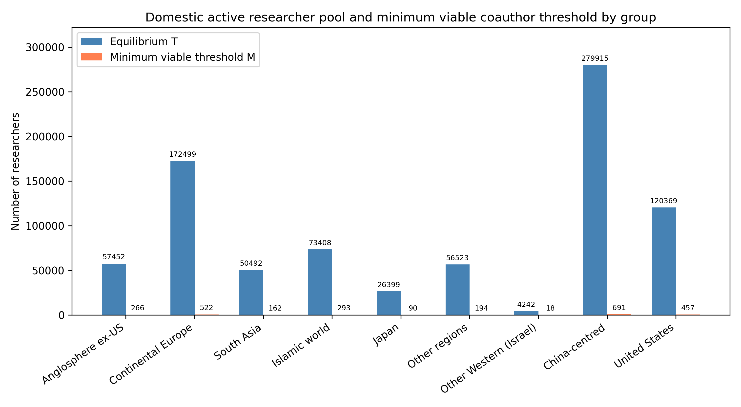
Figure 3. Equilibrium domestic active pool ($T$) and minimum viable coauthor scale ($M$) by research macro-region.

3.3 Which transitions govern the pool (P2)
Table 3 lists the three transition-rate elasticities with the largest absolute effect on $T$ in each macro-region. Dropout ($d$) is the largest negative lever everywhere, with elasticity from -2.79 to -2.31, whereas the largest absolute elasticity of early-career outflow ($α$) is 0.24; $|e_{d}|$ exceeds $|e_{α}|$ in 9 of 9 macro-regions, as P2 predicts. The largest positive transition lever is domestic hit generation ($h_{D}$), followed by principal-investigator promotion ($p_{D}$). The United States macro-region shows the strongest response to PI promotion ($p_{D}$). Attrition removes researchers from every compartment, whereas outflow moves them to compartments from which return and contribution remain possible.
Group | 1st rate | 1st elasticity | 2nd rate | 2nd elasticity | 3rd rate | 3rd elasticity
Anglosphere ex-US | $d$ | -2.66 | $h_{D}$ | 0.44 | $p_{D}$ | 0.35
China-centred | $d$ | -2.63 | $h_{D}$ | 0.37 | $p_{D}$ | 0.25
Continental Europe | $d$ | -2.65 | $h_{D}$ | 0.36 | $p_{D}$ | 0.36
Islamic world | $d$ | -2.60 | $h_{D}$ | 0.40 | $p_{D}$ | 0.24
Japan | $d$ | -2.31 | $h_{D}$ | 0.40 | $p_{D}$ | 0.30
Other Western (Israel) | $d$ | -2.73 | $p_{D}$ | 0.37 | $h_{D}$ | 0.33
Other regions | $d$ | -2.79 | $h_{D}$ | 0.49 | $p_{D}$ | 0.32
South Asia | $d$ | -2.52 | $h_{D}$ | 0.35 | $p_{D}$ | 0.21
United States | $d$ | -2.64 | $h_{D}$ | 0.38 | $p_{D}$ | 0.37
Table 3. Top transition-rate elasticities of the domestic active pool $T$ by research macro-region.

3.4 Viability-boundary proximity and endogenous recruitment (P1, P3)
Table 4 reports, for each macro-region, the single rate that reaches the active-pool threshold with the smallest proportional change, and Figure 4 ranks macro-regions by that proximity. $I_{0}$ is the closest viability-boundary lever for the active researcher pool in every group, consistent with P3: the transition that feeds the reproduction loop from outside is the binding one. The closest boundary is in Anglosphere ex-US, where $I_{0}$ multiplied by 0.0046-that is, the rate reduced to 0.5% of its current value, a 99.5% reduction-drives the active pool to $M$. Across macro-regions the Spearman correlation between boundary proximity and $T/M$ is 1.00, whereas that between proximity and absolute $T$ is 0.43. Because the $I_{0}$ lever scales the whole equilibrium, proximity is close to a deterministic function of $T/M$ in the linear model, so the first correlation is the consistency check that P1 calls for rather than an independent test; the diagnostic content of P1 is that the ranking by absolute size and the ranking by proximity diverge, which the second correlation shows (Section 3.8 returns to individual cases).
Group | Closest rate | Current value | Critical factor | Proximity
Anglosphere ex-US | $I_{0}$ | 1588.7 | 0.005 | 0.995
Other Western (Israel) | $I_{0}$ | 108.4 | 0.004 | 0.996
Islamic world | $I_{0}$ | 1352.4 | 0.004 | 0.996
United States | $I_{0}$ | 3129.9 | 0.004 | 0.996
Other regions | $I_{0}$ | 1358.5 | 0.003 | 0.997
Japan | $I_{0}$ | 1005.2 | 0.003 | 0.997
South Asia | $I_{0}$ | 790.3 | 0.003 | 0.997
Continental Europe | $I_{0}$ | 4334.3 | 0.003 | 0.997
China-centred | $I_{0}$ | 4822.7 | 0.002 | 0.998
Table 4. Closest boundary for the active researcher pool by research macro-region.
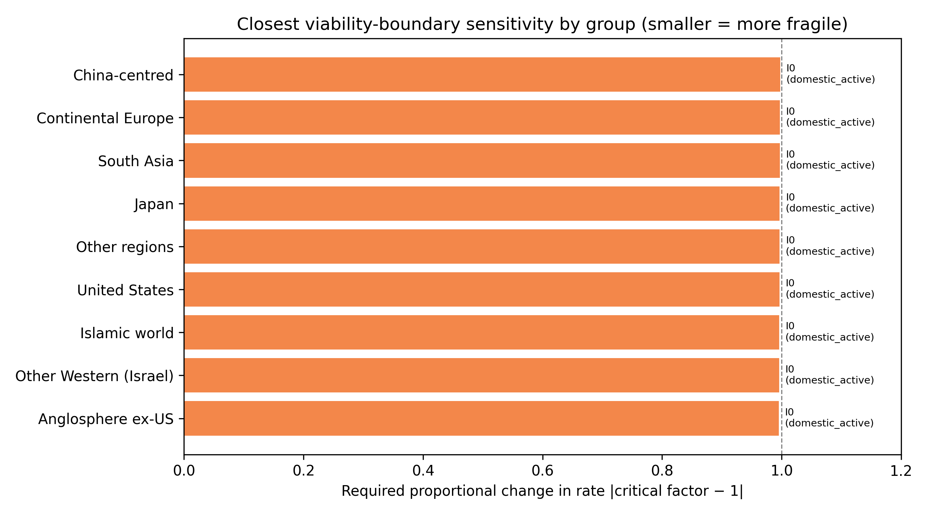
Figure 4. Closest viability-boundary proximity by research macro-region. Smaller values mean a smaller proportional change in the listed rate reaches the threshold.
Replacing the linear recruitment feedback with a saturating one changes the equilibrium pool by below 0.001% for every group (Table 5), and the closest lever is unchanged in every macro-region while the rank order of proximity has Spearman $ρ = 0.97$ between the two variants (Supplementary Table S7). The second part of P3 is therefore supported: the ranking of systems by fragility does not depend on the functional form of the network externality.
Group | Linear $T$ | Saturating $T$ | $ε$
Anglosphere ex-US | 57452 | 57452 | 0.00001
Continental Europe | 172499 | 172499 | 0.00000
South Asia | 50492 | 50492 | 0.00001
Islamic world | 73408 | 73408 | 0.00001
Japan | 26399 | 26399 | 0.00001
Other regions | 56523 | 56523 | 0.00001
Other Western (Israel) | 4242 | 4242 | 0.00009
China-centred | 279915 | 279915 | 0.00000
United States | 120369 | 120369 | 0.00000
Table 5. Equilibrium $T$ under linear and saturating PI-driven inflow.

3.5 Historical drift in transition rates (P4)
Table 6 compares the equilibrium that would emerge if rates estimated from the early (2000-2010) or late (2011-2016) career window persisted; Figure 5 plots the change in margin. All 9 macro-regions have dual-window support for both estimates. Under late-window rates the margin shrinks in Japan and grows in Islamic world, China-centred, South Asia, Other regions, Continental Europe, United States, Anglosphere ex-US, Other Western (Israel). The late window is shorter and its cohorts younger, so its promotion and hit rates are estimated from less exposure and its equilibria are less certain; the comparison is a sensitivity exercise rather than a forecast. It nevertheless supports P4 in its weak form: equilibria differ across windows, so the distance to the threshold is not stationary, and where margins shrink the mechanism implies ongoing drift toward the threshold.
Group | $T$ early | $T$ late | $ΔT$ (%) | Margin early | Margin late | $Δ$ margin
Anglosphere ex-US | 53748 | 67487 | 25.6 | 53481 | 67221 | 13739.3
Continental Europe | 156777 | 205006 | 30.8 | 156255 | 204484 | 48228.9
South Asia | 20498 | 107308 | 423.5 | 20336 | 107146 | 86810.5
Islamic world | 34790 | 147020 | 322.6 | 34498 | 146727 | 112229.8
Japan | 27891 | 24101 | -13.6 | 27801 | 24011 | -3790.5
Other regions | 37346 | 92916 | 148.8 | 37152 | 92722 | 55570.4
Other Western (Israel) | 3901 | 5097 | 30.7 | 3883 | 5080 | 1196.9
China-centred | 244735 | 350394 | 43.2 | 244043 | 349702 | 105659.0
United States | 108959 | 150719 | 38.3 | 108501 | 150262 | 41760.7
Table 6. Equilibrium active pool and safety margin under early (2000-2010) versus late (2011-2016) transition-rate regimes.
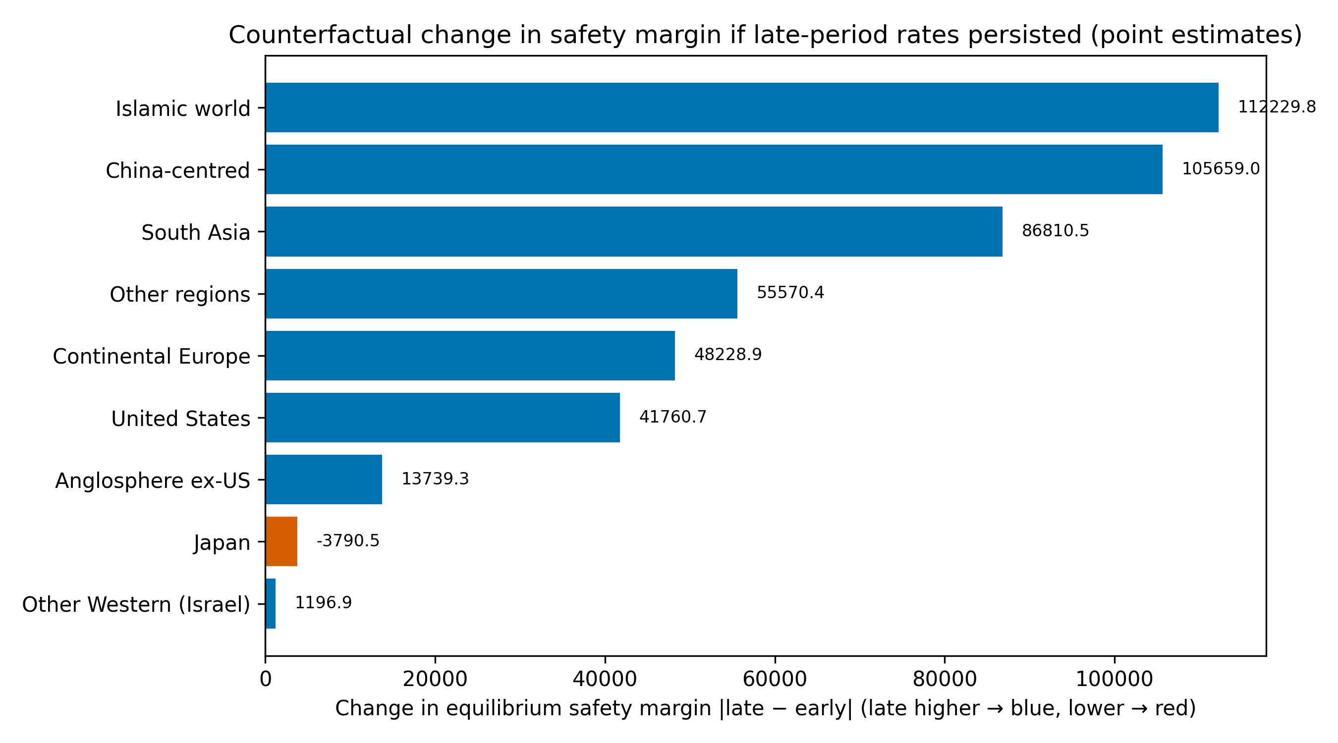
Figure 5. Change in safety margin between early and late transition-rate regimes. Negative values mean the late-window rates would shrink the margin if they persisted. Point estimates only; the two windows differ in cohort size.

3.6 Policy counterfactuals and uncertainty
Table 7 reports the mechanical counterfactual with the largest margin gain per 10% lever change in each macro-region. Reducing dropout is the dominant positive lever in every macro-region, consistent with P2. The gain from a 10% reduction in $d$ ranges from about 495 active researchers (Other Western (Israel)) to about 31,801 (China-centred). Blocking early-career outflow is not the efficient response: a researcher abroad remains in the global system and may return, whereas a researcher who leaves research is lost to every compartment.
Group | Lever | Direction | Change (%) | Gain per 10%
Anglosphere ex-US | $d$ | decrease | -10 | 6509
Continental Europe | $d$ | decrease | -10 | 19429
South Asia | $d$ | decrease | -10 | 5773
Islamic world | $d$ | decrease | -10 | 8400
Japan | $d$ | decrease | -10 | 2875
Other regions | $d$ | decrease | -10 | 6312
Other Western (Israel) | $d$ | decrease | -10 | 495
China-centred | $d$ | decrease | -10 | 31801
United States | $d$ | decrease | -10 | 13537
Table 7. Top positive mechanical counterfactual per research macro-region (margin gain per 10% proportional lever change).
We also evaluated multi-lever policy packages for the three smallest-margin groups. The package with the largest margin gain in each group was: Other Western (Israel) (retention: +529 active researchers); Japan (retention: +2,973 active researchers); South Asia (return plus retention: +6,036 active researchers). These packages combine dropout reduction with return or PI-pipeline levers, showing that the framework can compare multi-lever interventions as well as single-rate perturbations.
Figure 6 shows bootstrap 95% intervals for $T$ (values in Supplementary Table S6). Intervals are wide, and for the smallest macro-regions the lower bound lies closer to $M$, so point estimates of proximity should be read as indicative. The lower bounds nevertheless remain above $M$ for every macro-region, which supports the qualitative conclusion that no system is below its threshold under the fitted model.
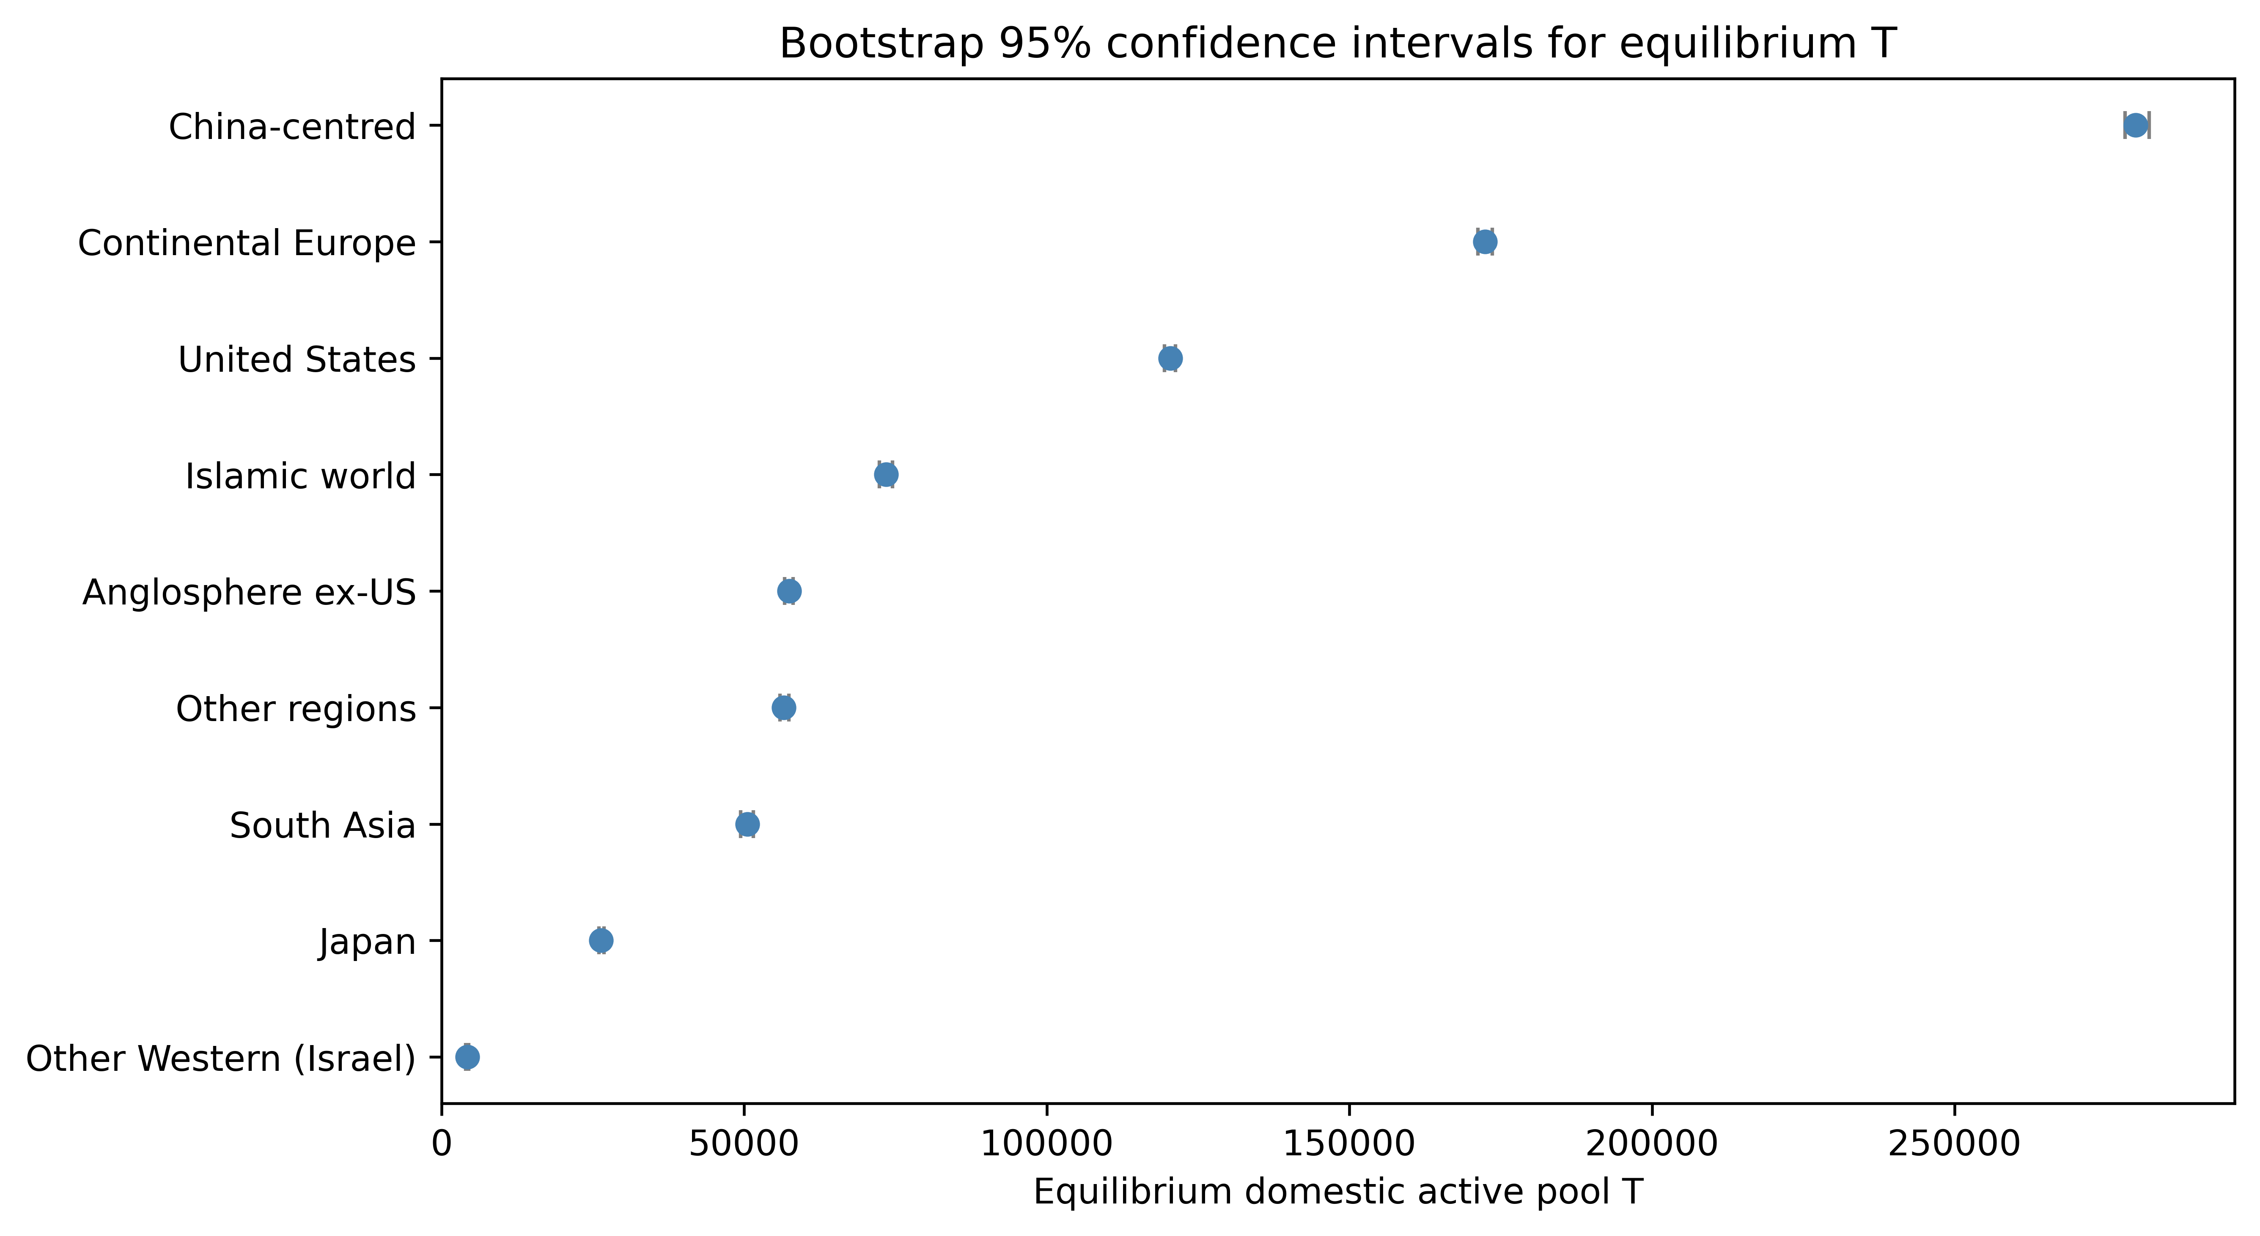
Figure 6. Bootstrap 95% confidence intervals for equilibrium $T$ by research macro-region.
Two further robustness checks address definitional choices in the mechanism. First, the PI proxy. Re-extracting the full cohort from a later OpenAlex snapshot (623,176 authors under the same inclusion rules; the difference from Table 1 reflects OpenAlex updates to author and affiliation records between the two extractions) and replacing the baseline definition (first last-author paper) with the first corresponding-author paper or with recurrence as last author (two or more last-author papers) changes the share of authors classified as PIs (mean across macro-regions 68.0%, 52.0% and 50.3% respectively), the promotion rates $p_{D}$ and $p_{A}$, the equilibrium PI pool $P_{D}$ and the split of recruitment between exogenous entry and PI-driven feedback. Because $I_{0}$ is calibrated so that total equilibrium entry equals observed entry (Section 2.8), the active pool $T$, $T/M$ and the proximity of the entry lever are invariant to the proxy by construction; the informative test is therefore whether the proxy-dependent quantities reorder the macro-regions. The ordering is largely preserved: Spearman rho with the baseline is at least 1.00 for the equilibrium PI pool and 1.00 for the proximity of the PI pool to its own threshold, the elasticity of $T$ to $p_{D}$ rises from 0.21-0.37 under the baseline to 0.30-0.54 under the stricter proxies (Spearman rho of the elasticity ranking with the baseline at least 0.68), and the closest lever for the PI pool is unchanged in every macro-region (Supplementary Tables S9-S10). Second, the threshold. Multiplying $M$ by 0.50-2.00 leaves no macro-region below its threshold (minimum $T/M$ 107.88 at the largest multiplier), preserves the ranking by $T/M$ and by proximity exactly (Spearman rho = 1.00 and 1.00), keeps |elasticity to $d$| > |elasticity to alpha| in every macro-region at every multiplier, and the closest lever is unchanged in every macro-region (Supplementary Table S11). Because $M$ enters the linear model only as the target, its level shifts distances without reordering systems under a common multiplier; that invariance is algebraic, not evidential. Perturbing each macro-region's $M$ independently over the same multiplicative range reverses the picture: all 36 of 36 region pairs can exchange order within their $T/M$ intervals, every macro-region can occupy every rank, and under independent uniform perturbations the baseline minimum (Anglosphere ex-US) is lowest in only 36% of draws (next: Other Western (Israel) 23%, Islamic world 16%). Japan spans ranks 1-9. The closest lever remains the exogenous entry rate at every multiplier, a structural property of the fitted model rather than a robustness result. The $T/M$ ranking is therefore conditional on the operational $M$: it is a monitoring diagnostic, not a determinate fragility ranking, and pinning down $M$ empirically is part of the validation agenda.
As an exploratory extension, the annual layer re-estimates the rates year by year and projects them to 2017-2026; rate-level projections have a skill ratio of 0.77 against a historical-mean baseline and the layer is a drift monitor rather than a forecast, so its figures and accuracy tables are reported in Supplementary Material Section S2 (Supplementary Figures S1-S3, Supplementary Tables S2-S5).

3.7 Measurement sensitivity: origin, PI definition, multi-affiliation and missingness
Origin specification. Re-estimating the cohort under 7 origin rules leaves the qualitative results intact: with $M$ held at its baseline value, the lowest-$T/M$ macro-region is Anglosphere ex-US under every rule, matching Table 2. (When $M$ is instead recomputed inside each rule's re-estimated coauthor structure, Other Western (Israel) falls lowest because its small pool of independent groups shrinks its $M$; that variant conflates the origin question with threshold construction, so we report the fixed-$M$ reading here and flag the alternative in the repository tables.) Additionally, in 54 group-rule cells (6 alternative rules x 9 macro-regions) the share affiliated abroad never crosses the majority direction-that is, no macro-region's aggregate $p_{abroad}$ flips from below to above 50%, or vice versa (0 reversals). This statement is about group-level aggregates: individual authors do change assigned origin under the alternative rules (baseline agreement 94-99.8%), so the stability is at the level of the regional statistics the model consumes, not of individual trajectories, and it is not a full validation of origin estimation.
Multi-affiliation and missingness. 8.4% of cohort authors record affiliations in more than one macro-region in at least one year; fractional and exclusion specifications of those years change the outputs by at most a few percent, so multi-affiliation is a measurement ambiguity to disclose rather than a driver of results. Country is missing on 4.2% of cohort authorship rows, and the missingness is not random (it is concentrated in earlier years), 5.7% of authors have careers left-censored at the 2000 window edge, and 28% of observed spans are shorter than five years (24% are 15 years or more). The first two push the reported rates toward underestimates of mobility; the short spans widen the bootstrap intervals, which is one reason rankings are reported rather than precise margins.
PI proxy. Across the 6 PI operationalisations the cohort PI share ranges from 10% to 87%, so the absolute PI share is not robust to the proxy and is never reported as a fact about the field. The $T$-side equilibria, $T/M$, elasticities and boundary proximities are structurally invariant to the PI definition because the inflow calibration fixes total entry to observed entry (Section 2.8); this invariance is a property of the calibration, not evidence that the PI measurement is valid. What does vary is the P-side: the domestic-PI equilibrium $P_{D}$ relative to its PI-scale threshold $M_{P}$ spans 30–6,010x across definitions, and the closest P-side lever is exogenous entry rate ($I_{0}$), early-career outflow rate ($α$), return rate ($β$) in every definition, so the qualitative findings survive while the absolute PI-stock numbers move.
Choice varied | Quantity affected | Observed effect | Caveat
Origin rule (7 specs) | Lowest-$T/M$ region (fixed $M$); $p_{abroad}$ direction | Invariant (Anglosphere ex-US); 0/54 aggregate reversals | Regional aggregates, not individuals
Multi-affiliation (8.4% authors) | All model outputs | <2% change under fractional/exclusion | Same-year location unobserved
PI proxy (6 defs) | PI share | 10-87% | Absolute share proxy-dependent
PI proxy (6 defs) | $T/M$, elasticities, proximity rankings | Structurally invariant ($I_{0}$ calibration) | Calibration artefact, not validation
PI proxy (6 defs) | $P_{D}/M_{P}$, closest P-side lever | 30–6,010x; lever unchanged | P-side varies by construction
Missing country (4.2% rows) | Rates | Toward underestimation | Missingness non-random
Left censoring (5.7%) | Career windows | Rates are lower bounds | Pre-2000 careers unobserved
Short spans (27.8% <5y) | Bootstrap intervals | Wide intervals | Rankings descriptive
Table 8. Measurement-sensitivity summary. Every row is computed from the cohort under the stated specification; details and per-rule tables are in the public repository.

3.8 Worked example: Japan
Japan illustrates the mechanism in a large research system with an independent institutional lineage and comparatively low $T/M$. Its fitted equilibrium is $T = 26,399$ active researchers ($D = 14,519$, $H_{D} = 5,452$, $P_{D} = 6,428$) against $M = 90$, so $T/M = 292.95$. The closest boundary is $I_{0}$: a fall to 0.3% of its current level would bring $T$ to $M$. Figure 7 places Japan's six compartments and compares its rates with the other macro-regions: early-career outflow ($α = 0.016$) and domestic PI promotion ($p_{D} = 0.063$) are comparatively low, return ($β = 0.025$) and domestic hit generation ($h_{D} = 0.044$) moderate, and dropout $d = 0.058$. Low leakage but a thin internal promotion pipeline is the configuration P1 and P2 describe: the system does not lose many researchers abroad, so its distance to the threshold is governed by scale relative to $M$ and by attrition rather than by mobility. Figure 8 generalises the diagnostic by plotting $T/M$ against boundary proximity for all macro-regions; the lower-left corner combines a low buffer with a small proportional change needed to reach $M$. The same two-panel diagnostic applies to any macro-region with sufficient OpenAlex coverage; Japan is a worked example, not a special case.
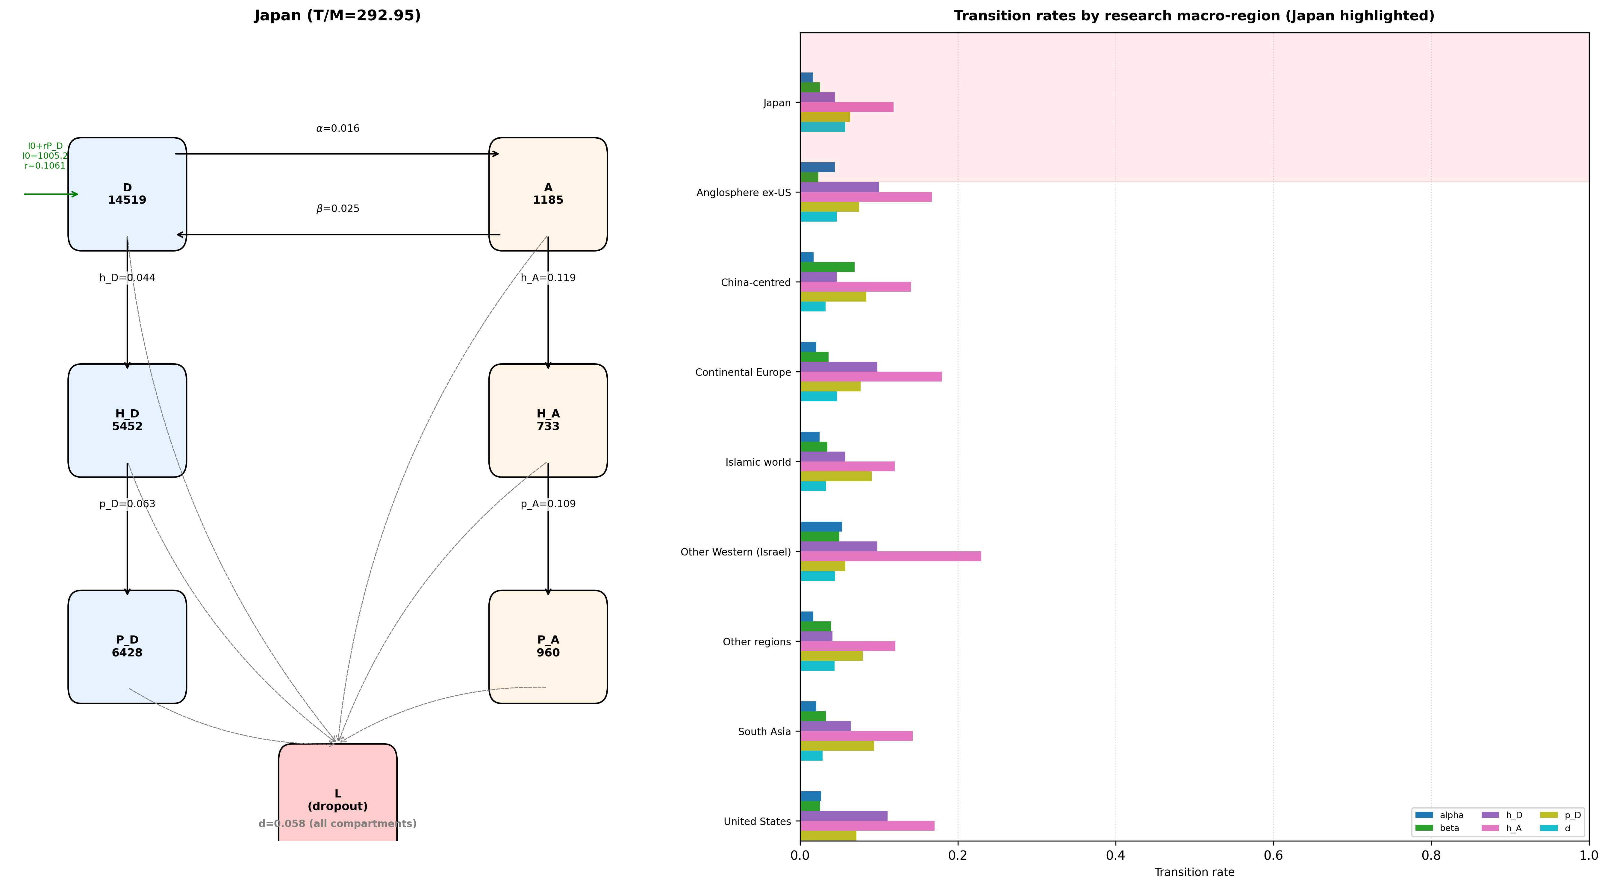
Figure 7. Japan in the six-compartment model, with a ladder of fitted transition rates across research macro-regions (Japan highlighted; longer bars are higher rates).
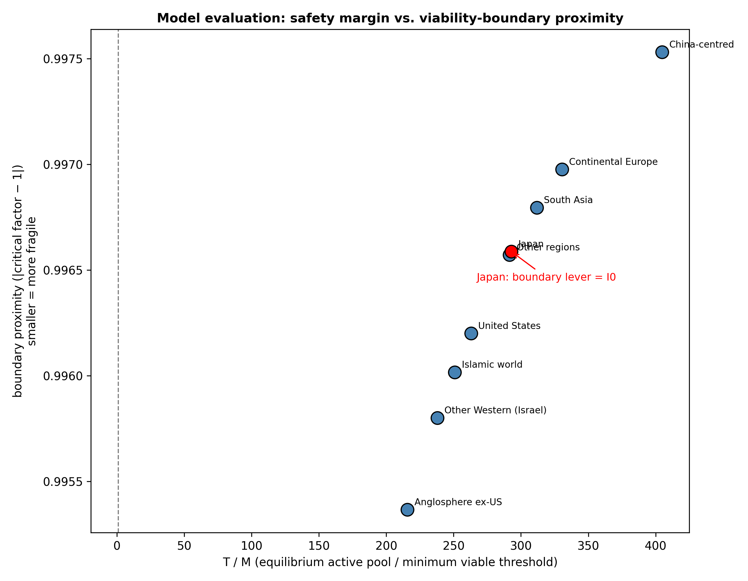
Figure 8. Equilibrium safety ratio ($T/M$) versus closest viability-boundary proximity for all research macro-regions. Japan is shown in red.

3.9 Talent concentration: short-run dominance, field-level loss
Under the coupled scenario of Section 2.10, the dominant region's hosted pool and share rise monotonically with the pull intensity φ, while the effective number of macro-regions falls: the strategy wins the short run it was designed for, at a direct variety cost to the field (Figure 9). Within the simulated horizon no region's active pool approaches $M$ (the collapse rule never activates in any run), so these outcomes do not depend on that scenario assumption. Whether the field's hit stock also falls depends on the variety elasticity γ: it declines even at $γ = 0$ for the United States, and only once γ exceeds a moderate value for the second-largest host. Whether the dominant region itself ends worse off requires a larger γ still (γ* = 3.9 at the strongest pull). γ is not identified by our data; the variety loss is the robust finding. Figure 10 shows the regional time paths at $φ = 8.0$: the dominant pool rises and source regions' margins narrow toward, but never reach, their thresholds within the horizon; were a crossing of $M$ to occur it would switch off that region's PI-driven recruitment under the scenario's collapse rule-a discrete model event that no run produces.
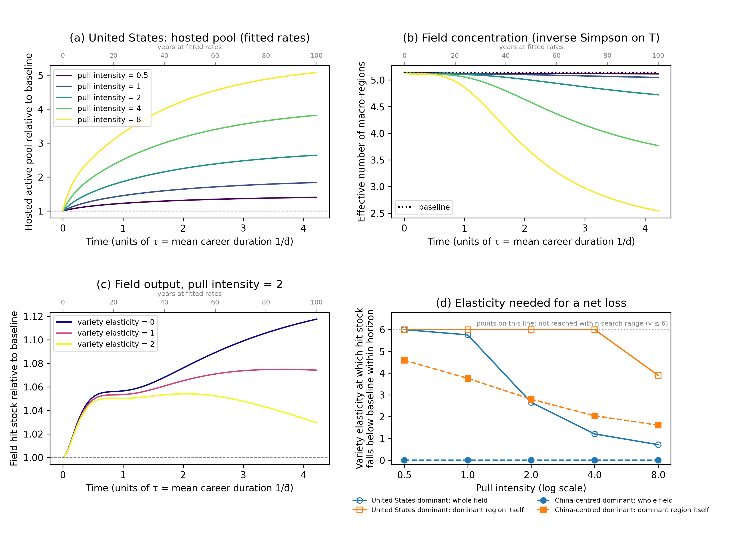
Figure 9. Talent-concentration scenario with the United States as the dominant region (coupled nine-region model, fitted rates unless stated). (a) Hosted active pool relative to the $φ = 0$ baseline; (b) effective number of macro-regions; (c) field hit stock relative to baseline at $φ = 2.0$ for three variety elasticities γ; ($d$) smallest γ at which the field's, and the dominant region's own, hit stock falls below baseline within the horizon, for the two largest host regions (points on the dotted line at the top of the panel: not reached within the search range). Time in (a)-(c) is in units of $τ = 1/\overline{d}$ (upper axis: years at fitted rates). φ and γ are stylised.
Dominant region | Pull intensity φ | Hosted pool at end of horizon (× baseline) | Share of hosted researchers at end of horizon (%) | Effective number of regions at end of horizon | Regions below $M$ | Field hit stock at end of horizon (× baseline) | γ* field | γ* dominant region
United States | 0.5 | 1.40 | 21 | 5.1 | 0 | 1.03 | not reached | not reached
United States | 1.0 | 1.84 | 27 | 5.0 | 0 | 1.06 | 5.76 | not reached
United States | 2.0 | 2.64 | 38 | 4.7 | 0 | 1.12 | 2.65 | not reached
United States | 4.0 | 3.81 | 53 | 3.8 | 0 | 1.20 | 1.20 | not reached
United States | 8.0 | 5.07 | 68 | 2.5 | 0 | 1.28 | 0.71 | 3.90
China-centred | 0.5 | 1.16 | 37 | 4.8 | 0 | 1.00 | 0 (fitted model) | 4.59
China-centred | 1.0 | 1.33 | 42 | 4.4 | 0 | 1.00 | 0 (fitted model) | 3.76
China-centred | 2.0 | 1.60 | 50 | 3.7 | 0 | 0.99 | 0 (fitted model) | 2.79
China-centred | 4.0 | 1.98 | 62 | 2.8 | 0 | 0.97 | 0 (fitted model) | 2.04
China-centred | 8.0 | 2.36 | 74 | 2.0 | 0 | 0.95 | 0 (fitted model) | 1.61
Table 9. Talent-concentration scenario at the end of the horizon (4.2 $τ$ ≈ 100 years at fitted rates) relative to the $φ = 0$ baseline, fitted rates ($γ = 0$), for the two largest observed host regions. γ* is the smallest variety elasticity at which the hit stock falls below baseline within the horizon.
Figure 10 shows the time paths behind these summaries for every macro-region at the strongest pull we simulate ($φ = 8.0$), one panel per γ. The timing scales with $τ$: a field with faster career turnover would reach the same crossings in proportionally fewer years, so the ordering of outcomes, not the calendar dates, is the result.
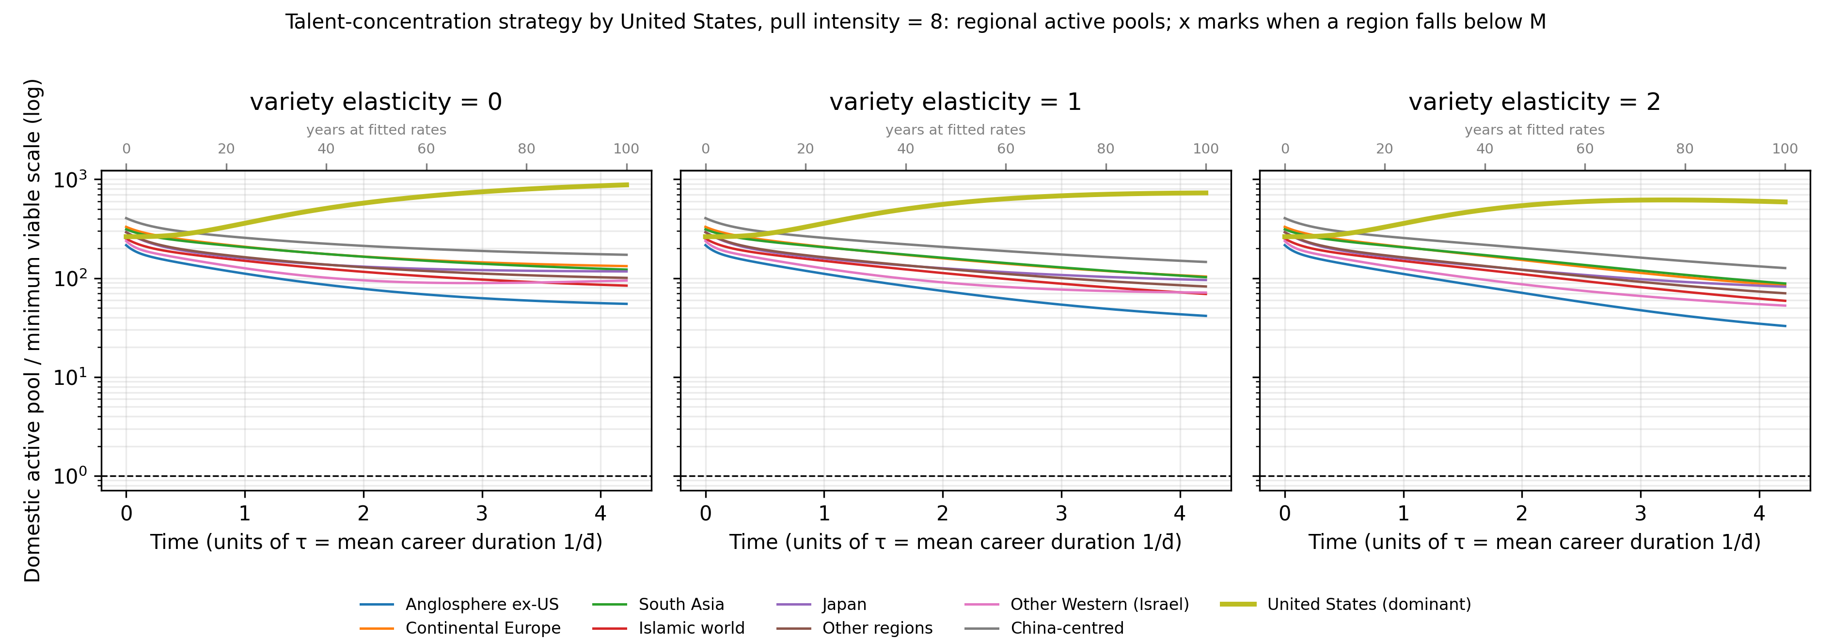
Figure 10. Regional time paths under the talent-concentration strategy exerted by the United States at pull intensity $φ = 8.0$, for three variety elasticities γ. Lines show each macro-region's domestic active pool as a multiple of its minimum viable coauthor scale $M$ (log scale; dashed line $M$); the thick line is the dominant region. Were a region to fall below $M$, a cross and dotted vertical would mark the crossing and its PI-driven recruitment would be switched off permanently under the scenario's collapse rule; in every simulated run no region crosses $M$ within the horizon (minimum trajectory value 20.7), so no crosses appear and the collapse rule is never activated. Time is in units of the characteristic time $τ = 1/\overline{d}$ (mean career duration; ≈24 years at fitted rates, upper axis). Fitted rates; φ, γ and the collapse rule are stylised.

4. Discussion

4.1 Principal findings
P1 is consistent with the results in the sense that matters for policy: rankings by absolute $T$ and by proximity to the threshold diverge ($ρ = 0.43$), the largest systems are not the safest, and proximity itself is governed by $T/M$ as the mechanism implies; this is a diagnostic reading rather than a test. P2 is supported in every macro-region: dropout is more elastic than early-career outflow, and reducing dropout is the most efficient single lever. P3 is supported: $I_{0}$ is the closest viability-boundary lever for the active researcher pool in every group, and the ranking is invariant to the form of the recruitment feedback. P4 is supported in its weak form: equilibria differ between the two career-start windows in all 9 macro-regions with dual-window support, and the margin shrinks in Japan. Together the results move the researcher-mobility debate from net flows to the transition rates that govern reproduction, and they give an empirically observable monitoring variable-one whose predictive value for real community failure is a separate, unvalidated question (Section 4.7).

4.2 Methodological contribution
For informetrics, the contribution is a measurement pipeline rather than a single indicator. Origin assignment, mobility transitions, PI status, community aggregation, calibration and the viability boundary are each specified operationally, and each is accompanied by a sensitivity result reported in the main text: origin under seven rules, mobility direction under each, PI under six definitions propagated through the model, multi-affiliation and missingness quantified. This is the level of measurement audit that secondary-data mobility studies often leave implicit, and it is what makes the resulting indicators-$T/M$ and viability-boundary proximity-usable as monitoring quantities. The pipeline is field-agnostic in design: every step is parameterised on a subfield, a year window and an authorship convention, and AI/ML is the case study on which it is calibrated and illustrated. We do not claim the findings generalise to other fields; we claim the machinery does, with authorship conventions redefined per field.

4.3 Related literature
Researcher mobility has been studied under the headings of brain drain, brain circulation and brain gain [1]. Outflows become a gain when return migration and diaspora networks are supported [1]; bilateral flows are driven by collaboration, economic convergence and visa restrictions [3]; and cross-country shares of foreign-born scientists vary widely [2]. In AI/ML, the United States is the dominant destination, mobile scientists keep ties to origin systems [5,22], and elite networks are highly clustered [23]. The economics of science supplies the microfoundation: individuals respond to career incentives [18]. What this literature measures is stocks and flows; it generally does not link observed career transitions to a community-level dynamical model and an explicitly defined operational scale benchmark. Evolutionary and innovation-systems economics supplies the threshold concepts-variety generation and selection, lock-in through increasing returns [14,15,16,24], and frameworks for analysing the diversity of a technological system [25,26,27]-but its unit of analysis is the firm, the technology or the sector. The present framework connects the two: the community-level state variable is the equilibrium active pool relative to a coauthor-scale threshold, estimated from the career transitions the mobility literature already measures. The AI-specific homogenisation concerns it connects to-algorithmic monoculture, benchmark and compute concentration, linguistic and data bias-are documented elsewhere [7,28,29,30,31,32,33], and the scale of the leading models intensifies the concentration [6,34,35]. Historical cases of fields that narrowed onto a dominant approach and stagnated are well documented-from the perceptrons controversy in AI itself, through Lysenkoist biology, pre-2008 macroeconomics and string theory, to agricultural monocultures [36,37,38,39,40,41,42,43,44]. Evidence that large fields slow canonical progress and that papers become less disruptive over time makes the variety question empirical rather than rhetorical [45,46]; diversity demonstrably aids problem solving [47], multi-site and internationally distributed teams retain high impact [48,49], innovation is highest at intermediate competition [50], and the processes are institutionally embedded in national and sectoral systems [51,52].

4.4 Implications for research evaluation
The indicators are designed for evaluators rather than for national accounting. $T/M$ and boundary proximity can be recomputed with each OpenAlex release; a declining margin in any macro-region is a signal for the field, not only for that region. Because the closest lever and the most elastic lever are identified separately, the indicators also distinguish where monitoring should focus: entry pipelines ($I_{0}$) bind first at the observed scale, while attrition ($d$) is the most elastic. The exploratory annual layer provides the machinery for tracking rates year by year, although its current direction-prediction skill is low and it should be read as a monitor rather than a forecast. For individual universities, the PI stock is the node of the network externality in the model: institutions that convert hit researchers into PIs and retain them would, on the fitted mechanism, regenerate their own inflow. The macro-regional ladder (Figure 7) could in principle give a benchmark against which an institution's own transition rates are read, but our estimates are at macro-region level and institutional-scale validity is unvalidated until an institutional calibration exercise is done. For early-career researchers, going abroad is a smaller threat to a home system than net-flow accounting implies; attrition is the larger one.

4.5 Policy implications
Concentrating talent is individually advantageous for the large systems pursuing it: it raises short-run output [6,8,9], but each round of concentration lowers $T/M$ in the systems that lose researchers; within the stylised scenario this is a model-dependent risk of reduced field-level diversity, not an unconditional forecast of field decline-whether research quality or novelty actually degrades depends on the unidentified variety elasticity γ (Section 3.9). No single actor captures the benefit of the variety it preserves, so the response has to be shared: jointly funded early-career fellowships and return grants aimed at low-$T/M$ systems, routine monitoring of the indicator pair, and shared compute and data infrastructure acting on the intra-regional levers $h_{D}$ and $p_{D}$ where mobility itself cannot or should not be steered [14,26]. Because endogenous inflow is capped at 0.50× the critical reproduction rate, the implied interventions are conservative: they aim to keep systems away from the threshold, not to maximise any one system's share. Lever rankings are model-conditional: they follow from the fitted rates and thresholds and are not causal effects of programmes.

Lever | Mechanism (in model) | Policy instrument | Principal actor | Empirical evidence | Unintended consequences | Uncertainty and model dependence
Dropout ($d$) | Lowers $d$; raises $T$ and margin directly; most elastic lever | Early-career fellowships, childcare and dual-career support, stable non-tenure tracks | Universities, department heads | Indirect: early-career support is linked to lower attrition in the fellowship/tenure literature; AI/ML magnitude unestablished | Lock-in of marginal researchers; subsidy capture by secure staff | Rate elasticity estimated; instrument-to-rate link not measured
Exogenous entry ($I_{0}$) | Raises $I_{0}$; linearly rescales all stocks; closest lever at observed scale | Research-master and undergraduate pipelines, doctoral fellowships, recruitment visas | National funders, ministries | Strong generic: doctoral expansion raises the research workforce; visa effects on inflow documented | Dilution of supervision quality; credential inflation | $I_{0}$ is calibrated to observed entry; pipeline vs migration not separable
Return from abroad ($β$) | Raises return inflow into early-career pool | Return grants, diaspora networks, dual appointments, overseas-experience recognition | Diaspora networks, funders, recruiters | Mixed: diaspora policies show small positive return rates | Return-then-leave-again churn; benefits concentrated on the already-mobile | Return measured from affiliations only; physical return unobserved
Domestic hit generation ($h_{D}$) | Raises hit generation; builds the H compartments feeding P | Independent-lab programmes, doctoral/postdoctoral training, compute access | National funders, universities | Moderate: compute/data access is the AI/ML-specific bottleneck | Concentration on incumbents; hardware lock-in | $h_{D}$ bundles output quantity and quality
PI promotion ($p_{D}$) | Raises promotion $D$ to $P_{D}$; feeds the reproduction loop | Tenure-track conversion, startup packages, project-based PI status | Universities, funders | Indirect: tenure-track expansion raises senior-author counts (descriptive) | Premature promotion dilutes the PI proxy (measurement, not reality) | Instrument-proxy mismatch possible; ranking robust to $M$ only at observed scale
Table 10. Levers, mechanisms, instruments, evidence and uncertainty. Lever rankings are model-conditional; the instrument-to-rate links are argued from the literature, not measured here.

Each instrument affects a model rate; the instrument-to-rate link is argued from the literature, not measured here, and estimated rate elasticities do not establish that any single instrument moves any single rate by the stated amount. Regional effects are two-sided: a pull that raises one region's inflow lowers another's, and the coupled scenario shows the sender regions, not only the receiver, pay the margin cost.

4.6 Limitations
OpenAlex affiliation and country assignments are noisy, especially for multi-affiliated authors, and coverage of non-English venues is incomplete. The $T/M$ ranking is sensitive to the operational $M$: under independent per-region multipliers in [0.5, 2.0] every region pair can exchange order, so the ranking conditions on the chosen threshold definition (Section 3.6). The macro-regional grouping is coarse; within-group heterogeneity is substantial, and the grouping of, for example, mainland China and Taiwan follows current OpenAlex country metadata rather than any resolution of their relationship. Geographic variety is a proxy for the cognitive and institutional variety the mechanism concerns, and the model does not observe research content directly; that macro-regions differ in institutions, languages and funding is documented, but that they carry distinct research programmes is assumed here, not measured, and claims about problem framings or benchmarks should be read with that qualification. Irreversibility is likewise a property of the collapse rule in the coupled scenario, not an empirical finding: a real system that fell below $M$ could in principle rebuild through return migration or new entry, which the model does not represent, and the viability boundary is an operational comparison benchmark derived from observed coauthor structure: it does not alter the fitted ODE dynamics, and crossing it does not establish that the endogenous recruitment mechanism ceases to operate or that the community becomes unable to recover. The model omits cross-region spillovers, firm-level mobility and within-year dynamics; rates are assumed constant within windows; the cohort over-weights prolific authors; and bootstrap intervals are wide, so rankings are descriptive. The endogenous inflow cap (0.50) is a modelling choice whose alternatives should be mapped. Falling below $M$ is a sufficient condition only for classification as sub-scale under the operational definition; it is neither an established necessary nor sufficient condition for empirical community collapse. The historical comparison rests on two point estimates. The talent-concentration scenario couples the regions only through observed host shares and stylised pull, retention and collapse rules, holds fitted rates constant over a long horizon, and treats the variety elasticity γ as a free parameter; its results are model-consistent projections that rank strategies, not predictions of when any region's advantage ends. The PI and hit proxies follow AI/ML authorship conventions (group leader listed last or corresponding; hits scored within the AI/ML subfield); the sensitivity battery shows the absolute PI share varies widely across definitions while rankings survive, and transfer of the pipeline to fields with alphabetical author order or consortium authorship requires redefining these proxies. Measurement limits quantified in Section 3.7-multi-affiliated authors, non-random missing country, left-censored careers at the 2000 window edge, and short observed spans-mean the reported rates are best read as comparable lower bounds. Finally, the propositions are tested on nine macro-regions, so correlational support for P1 is indicative; the strongest support is for P2 and P3, which hold system by system.

4.7 Future validation agenda
Three extensions would test rather than extend the framework. First, external validation of the viability boundary: back-testing the indicator against historical cases of systems that contracted or lost a research programme would show whether proximity predicts outcomes rather than merely describing fitted equilibria. Second, identifying the variety elasticity γ from disruption or novelty measures would determine whether the talent-concentration scenario's field-level output loss is a real possibility or a parameter artefact. Third, applying the pipeline to a field with different authorship conventions-and to a deliberately mis-specified macro-regional partition-would test which results are measurement artefacts and which are structural. Each is executable on open data with the released code.

5. Conclusion
We asked how far each AI/ML research system is from an operational benchmark scale derived from observed coauthor structure-below which, in model terms, it would be classified as sub-scale-which career transition governs that distance, and whether the distance is shrinking. The answer is delivered by a measurement pipeline that turns open bibliometric records into cohort career-transition rates, a calibrated compartment model, and a monitoring diagnostic pair ($T/M$ and its closest-lever reading, viability-boundary proximity), with every measurement choice stress-tested in the main results. All systems currently exceed their minimum viable coauthor scale, but in the fitted model distance to the threshold is governed by relative scale and by attrition rather than by size or outflow; exogenous entry is the binding lever everywhere at the observed scale; the boundary-proximity ranking is robust to the form of the recruitment feedback; and rates have drifted between career windows, shrinking the margin in Japan. For research evaluation the contribution is a reproducible, field-agnostic measurement framework for research-system viability; for AI/ML it locates the systems whose margins are thin and the levers that matter. Extensions include external validation of the boundary against historical contractions, identification of the variety elasticity, finer partitions with inter-regional spillovers, and application to other general-purpose research fields.

References
1. Thorn K, Holm-Nielsen L B. International Mobility of Researchers and Scientists: Policy Options for Turning a Drain into a Gain. UNU-WIDER Research Paper No. 2006/83, 2006. https://www.wider.unu.edu/publication/international-mobility-researchers-and-scientists
2. Franzoni C, Scellato G, Stephan P E. Foreign-born scientists: mobility patterns for 16 countries. Nat Biotechnol. 2012;30(12):1250-1253. https://doi.org/10.1038/nbt.2449
3. Appelt S, van Beuzekom B, Galindo-Rueda F, de Pinho R. Which factors influence the international mobility of research scientists? OECD Science, Technology and Industry Working Papers 2015/02, 2015. https://doi.org/10.1787/5js1tmrr2233-en
4. Bresnahan T F, Trajtenberg M. General purpose technologies 'Engines of growth'? J Econom. 1995;65(1):83-108. https://doi.org/10.1016/0304-4076(94)01598-T
5. MacroPolo. The Global AI Talent Tracker 2.0. Paulson Institute, 2023. https://macropolo.org/digital-projects/the-global-ai-talent-tracker/
6. Sevilla J, Heim L, Ho A, Besiroglu T, Hobbhahn M, Villalobos P. Compute trends across three eras of machine learning. In: 2022 International Joint Conference on Neural Networks (IJCNN). IEEE; 2022. p. 1-8. https://doi.org/10.1109/IJCNN55064.2022.9891914
7. Ahmed N, Wahed M. The de-democratization of AI: deep learning and the compute divide in artificial intelligence research. arXiv:2010.15581, 2020. https://doi.org/10.48550/arXiv.2010.15581
8. Shachar A. The Race for Talent: Highly Skilled Migrants and Competitive Immigration Regimes. NYU Law Rev. 2006;81(1):148-206.
9. Kerr W R. Global Talent and U.S. Immigration Policy. Harvard Business School Working Paper No. 20-107, 2020. https://www.hbs.edu/ris/Publication%20Files/20-107_0967f1ab-1d23-4d54-b5a1-c884234d9b31.pdf
10. Jevons W S. The Coal Question: An Inquiry Concerning the Progress of the Nation, and the Probable Exhaustion of Our Coal-Mines. London: Macmillan, 1865.
11. Alcott B. Jevons' paradox. Ecol Econ. 2005;54(1):9-21. https://doi.org/10.1016/j.ecolecon.2005.03.020
12. Katz M L, Shapiro C. Network externalities, competition, and compatibility. Am Econ Rev. 1985;75(3):424-440.
13. Shaffer M L. Minimum Population Sizes for Species Conservation. BioScience. 1981;31(2):131-134. https://doi.org/10.2307/1308256
14. Arthur W B. Competing technologies, increasing returns, and lock-in by historical events. Econ J. 1989;99(394):116-131. https://doi.org/10.2307/2234208
15. Nelson R R, Winter S G. An Evolutionary Theory of Economic Change. Cambridge, MA: Harvard University Press, 1982.
16. Dosi G. Technological paradigms and technological trajectories: a suggested interpretation of the determinants and directions of technical change. Res Policy. 1982;11(3):147-162. https://doi.org/10.1016/0048-7333(82)90016-6
17. Priem J, Piwowar H, Orr R. OpenAlex: A fully-open index of scholarly works, authors, venues, institutions, and concepts. arXiv:2205.01833, 2022. https://doi.org/10.48550/arXiv.2205.01833
18. Stephan P E. The Economics of Science. J Econ Lit. 1996;34(3):1199-1235.
19. Huntington S P. The Clash of Civilizations and the Remaking of World Order. New York: Simon & Schuster, 1996.
20. State B, Park P, Weber I, Macy M. The mesh of civilizations in the global network of digital communication. PLoS ONE. 2015;10(5):e0122543. https://doi.org/10.1371/journal.pone.0122543
21. Chinchilla-Rodríguez Z, Miao L, Murray D, Robinson-García N, Costas R, Sugimoto C R. A global comparison of scientific mobility and collaboration according to national scientific capacities. Front Res Metr Anal. 2018;3:17. https://doi.org/10.3389/frma.2018.00017
22. AlShebli B, Memon S A, Evans J A, Rahwan T. China and the U.S. produce more impactful AI research when collaborating together. Sci Rep. 2024;14:28576. https://doi.org/10.1038/s41598-024-79863-5
23. Yuan S, Shao Z, Wei X, Tang J, Hall W, Wang Y, et al. Science behind AI: the evolution of trend, mobility, and collaboration. Scientometrics. 2020;124(2):993-1013. https://doi.org/10.1007/s11192-020-03423-7
24. David P A. Clio and the economics of QWERTY. Am Econ Rev. 1985;75(2):332-337.
25. Stirling A. A general framework for analysing diversity in science, technology and society. J R Soc Interface. 2007;4(15):707-719. https://doi.org/10.1098/rsif.2007.0213
26. Saviotti P P. Technological Evolution, Variety and the Economy. Cheltenham: Edward Elgar, 1996. https://doi.org/10.4337/9781035334858
27. Metcalfe J S. Evolutionary Economics and Creative Destruction. London: Routledge, 1998. https://doi.org/10.4324/9780203275146
28. Kleinberg J, Raghavan M. Algorithmic monoculture and social welfare. Proc Natl Acad Sci USA. 2021;118(22):e2018340118. https://doi.org/10.1073/pnas.2018340118
29. Hooker S. The hardware lottery. Commun ACM. 2021;64(12):58-65. https://doi.org/10.1145/3467017
30. Koch B, Denton E, Hanna A, Foster J G. Reduced, reused and recycled: the life of a dataset in machine learning research. arXiv:2112.01716, 2021. https://doi.org/10.48550/arXiv.2112.01716
31. Joshi P, Santy S, Budhiraja A, Bali K, Choudhury M. The state and fate of linguistic diversity and inclusion in the NLP world. In: Proceedings of the 58th Annual Meeting of the Association for Computational Linguistics. ACL; 2020. p. 6282-6293. https://doi.org/10.18653/v1/2020.acl-main.560
32. Bender E M, Gebru T, McMillan-Major A, Shmitchell S. On the dangers of stochastic parrots: can language models be too big? In: Proceedings of the 2021 ACM Conference on Fairness, Accountability, and Transparency (FAccT '21). ACM; 2021. p. 610-623. https://doi.org/10.1145/3442188.3445922
33. Raji I D, Bender E M, Paullada A, Denton E, Hanna A. AI and the everything in the whole wide world benchmark. arXiv:2111.15366, 2021. https://doi.org/10.48550/arXiv.2111.15366
34. Kaplan J, McCandlish S, Henighan T, Brown T B, Chess B, Child R, et al. Scaling laws for neural language models. arXiv:2001.08361, 2020. https://doi.org/10.48550/arXiv.2001.08361
35. Bommasani R, Hudson D A, Adeli E, Altman R, Arora S, von Arx S, et al. On the opportunities and risks of foundation models. arXiv:2108.07258, 2021. https://doi.org/10.48550/arXiv.2108.07258
36. Olazaran M. A sociological study of the official history of the perceptrons controversy. Soc Stud Sci. 1996;26(3):611-659. https://doi.org/10.1177/030631296026003005
37. Rumelhart D E, Hinton G E, Williams R J. Learning representations by back-propagating errors. Nature. 1986;323(6088):533-536. https://doi.org/10.1038/323533a0
38. Joravsky D. The Lysenko Affair. Cambridge, MA: Harvard University Press, 1970.
39. Colander D, Goldberg M, Haas A, Juselius K, Kirman A, Lux T, et al. The financial crisis and the systemic failure of the economics profession. Crit Rev. 2009;21(2-3):249-267. https://doi.org/10.1080/08913810902934109
40. Smolin L. The Trouble with Physics: The Rise of String Theory, the Fall of a Science, and What Comes Next. Boston: Houghton Mifflin, 2006.
41. Ullstrup A J. The impacts of the southern corn leaf blight epidemics of 1970-1971. Annu Rev Phytopathol. 1972;10:37-50. https://doi.org/10.1146/annurev.py.10.090172.000345
42. McCook S. Global rust belt: Hemileia vastatrix and the ecological integration of world coffee production since 1850. J Glob Hist. 2006;1(2):177-195. https://doi.org/10.1017/S174002280600012X
43. Avelino J, Cristancho M, Georgiou S, Imbach P, Aguilar L, Bornemann G, et al. The coffee rust crises in Colombia and Central America (2008-2013): impacts, plausible causes and proposed solutions. Food Secur. 2015;7(2):303-321. https://doi.org/10.1007/s12571-015-0446-9
44. Ploetz R C. Management of Fusarium wilt of banana: a review with special reference to tropical race 4. Crop Prot. 2015;73:7-15. https://doi.org/10.1016/j.cropro.2015.01.007
45. Chu J S G, Evans J A. Slowed canonical progress in large fields of science. Proc Natl Acad Sci USA. 2021;118(41):e2021636118. https://doi.org/10.1073/pnas.2021636118
46. Park M, Leahey E, Funk R J. Papers and patents are becoming less disruptive over time. Nature. 2023;613(7942):138-144. https://doi.org/10.1038/s41586-022-05543-x
47. Hong L, Page S E. Groups of diverse problem solvers can outperform groups of high-ability problem solvers. Proc Natl Acad Sci USA. 2004;101(46):16385-16389. https://doi.org/10.1073/pnas.0403723101
48. Jones B F, Wuchty S, Uzzi B. Multi-University Research Teams: Shifting Impact, Geography, and Stratification in Science. Science. 2008;322(5905):1259-1262. https://doi.org/10.1126/science.1158357
49. Freeman R B, Huang W. Collaboration: Strength in diversity. Nature. 2014;513(7518):305. https://doi.org/10.1038/513305a
50. Aghion P, Bloom N, Blundell R, Griffith R, Howitt P. Competition and innovation: an inverted-U relationship. Q J Econ. 2005;120(2):701-728. https://doi.org/10.1162/0033553053970214
51. Lundvall B-Å. National Systems of Innovation: Toward a Theory of Innovation and Interactive Learning. London: Anthem Press, 1992.
52. Malerba F. Sectoral systems of innovation and production. Res Policy. 2002;31(2):247-264. https://doi.org/10.1016/S0048-7333(01)00139-1

