Annual transition rates, inter-civilisation flows, and 2017-2026 projection report

1. Data source and reconstruction method
This report uses data/cohort/cohort.csv and data/cohort/raw_sampled_works.json. Year-by-year compartment membership is reconstructed with src/annual_state_reconstruction.py. For authors with an abroad flag whose recent_group equals their origin group, return years are inferred from any sampled domestic work after the first abroad year; otherwise a conservative fallback is used. Because the public sample is sparse, A, H_A and P_A counts are lower bounds.

2. Annual ODE-style transition rates
Transition probabilities are estimated as count / stock for each civilisation and year. Laplace smoothing (add-1 per possible destination) is applied to empty cells. Rates are mapped to the model parameters: alpha (D -> A), beta (return from abroad), h_D/h_A (hit acquisition), p_D/p_A (PI promotion), and d (dropout).
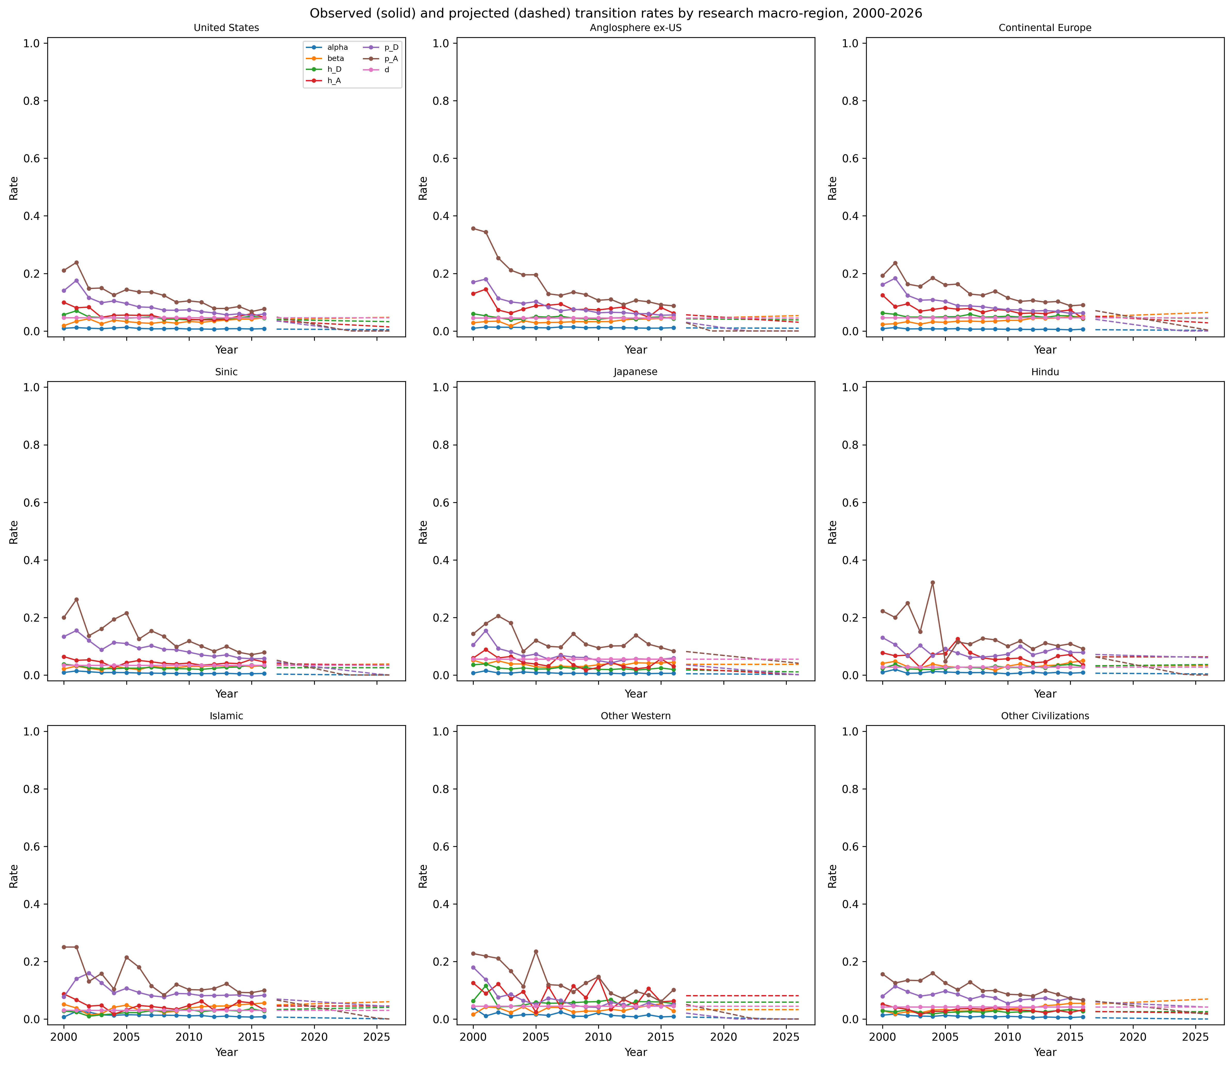
Figure 1. Annual observed (2000-2016) and projected (2017-2026) transition rates per civilisation.

3. Inter-civilisation flows
Figure 2 shows the total cross-civilisation abroad author-years accumulated by origin and destination civilisation. Origin-destination cells with the same civilisation and destinations labelled Unknown are excluded because the exact year-to-year destination is not recorded in the public cohort.
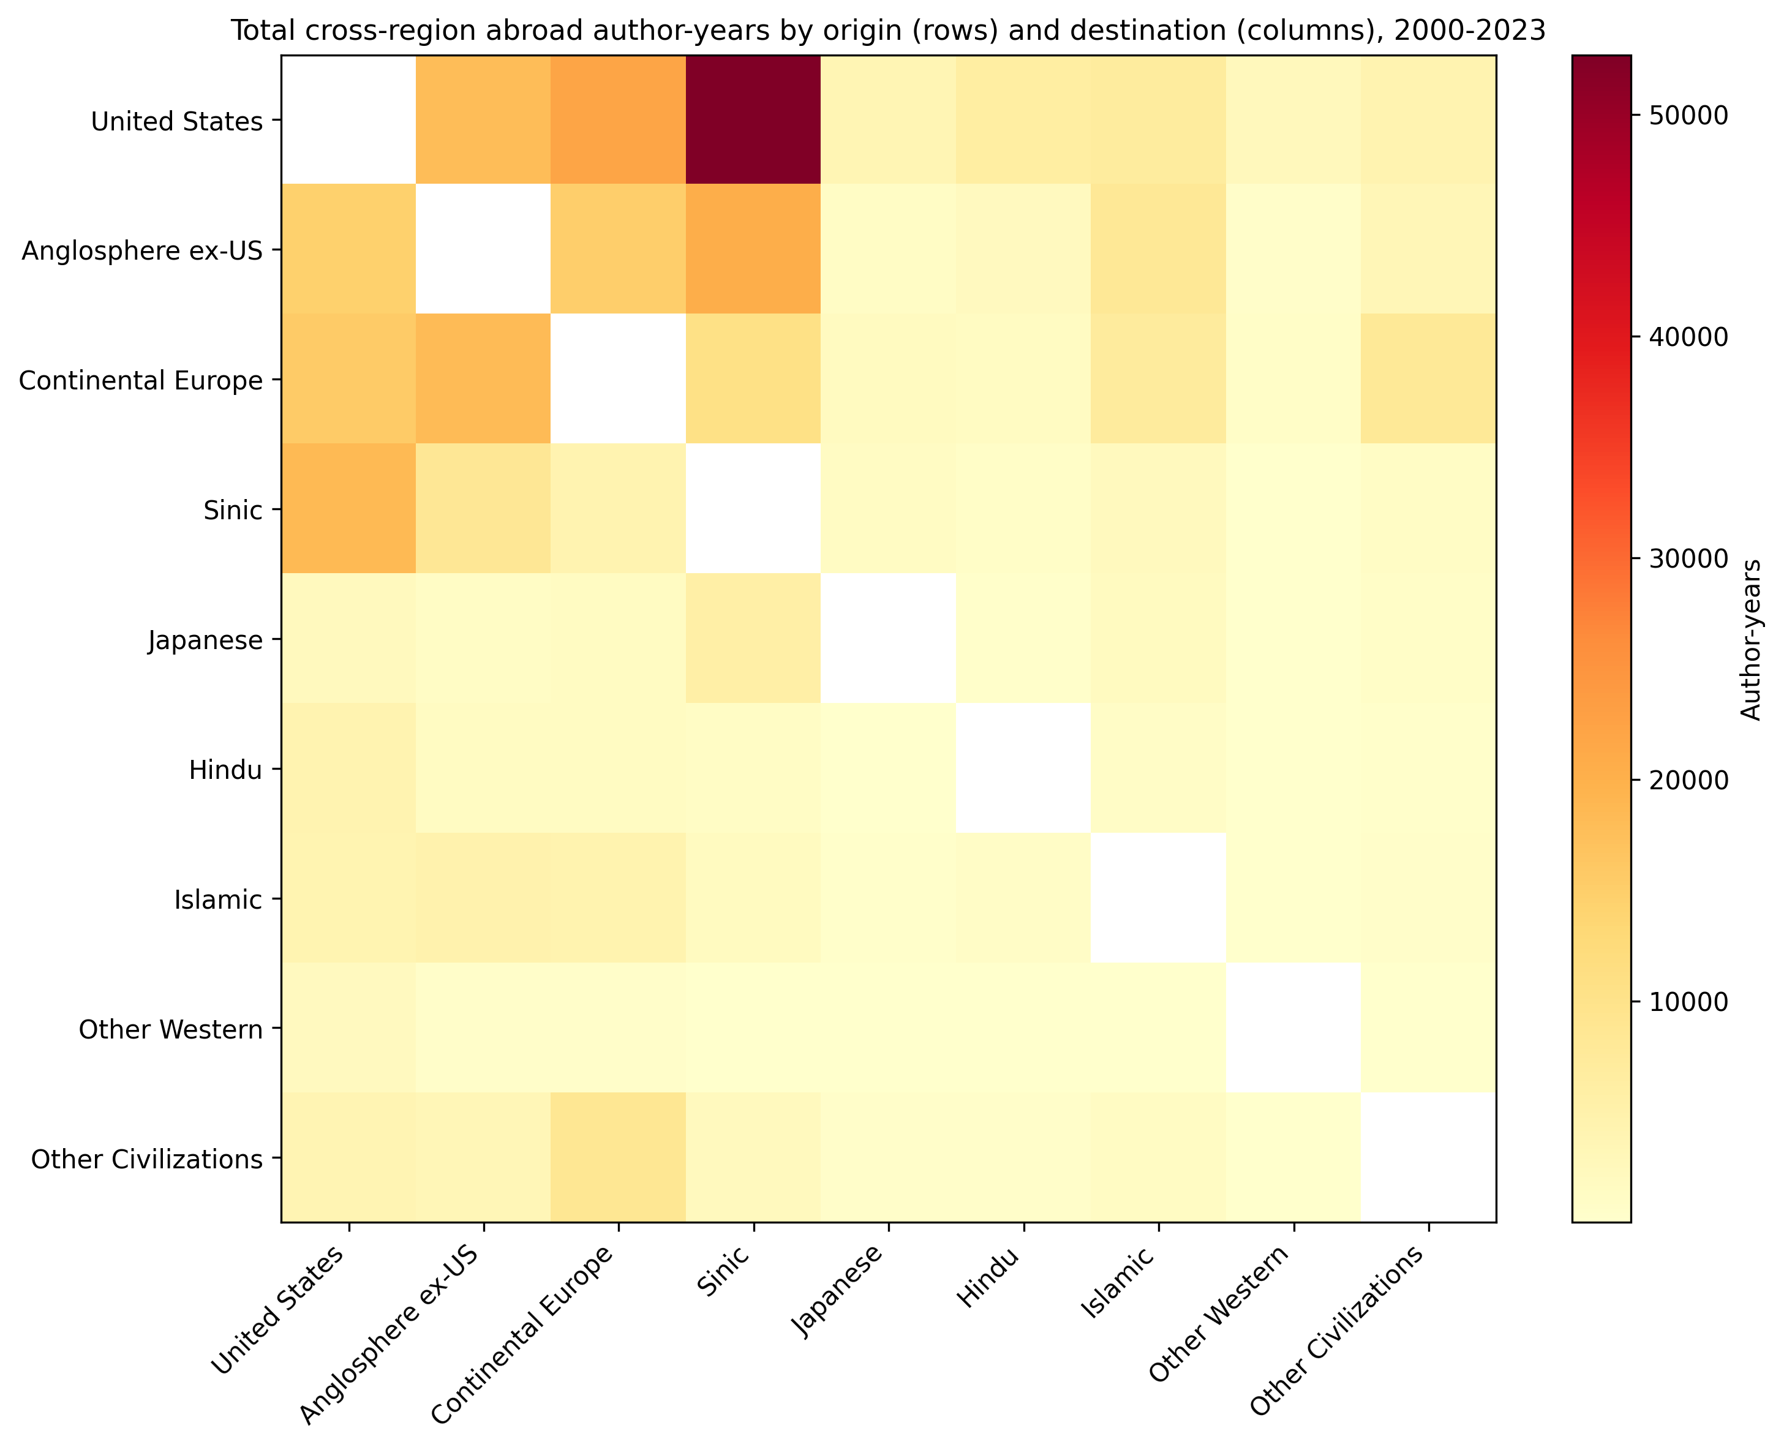
Figure 2. Total cross-civilisation abroad author-years by origin (rows) and destination (columns), 2000-2023.

4. Projection method and correction pressures
For each group, a linear trend is fit to 2000-2016 rates only when the fit explains at least 10% of variance and there are at least four observations; otherwise the historical mean is used. Projected rates are clipped to [0, 1]. Inflows are projected with a log1p-linear model with the same R2 guard. Correction pressures include: (a) Laplace smoothing for sparse cells; (b) replacing unreliable trends with the historical mean so that, for example, a few early returns do not extrapolate to zero beta; (c) anchoring annual dropout to the cohort-level per-year hazard because year-to-year final attrition is right-censored before 2023; (d) keeping all rates inside the [0, 1] probability interval; and (e) apportioning new entrants to the same first-compartment distribution observed in the training period. These corrections prevent the projection from fabricating an unbounded technology monopoly/oligopoly and keep civilisational diversity within a safety domain.

5. Projection vs observed, 2017-2023
Figure 3 compares the 2017-2023 projection (dashed) with observed counts (solid). The vertical dotted line marks the last training year (2016).
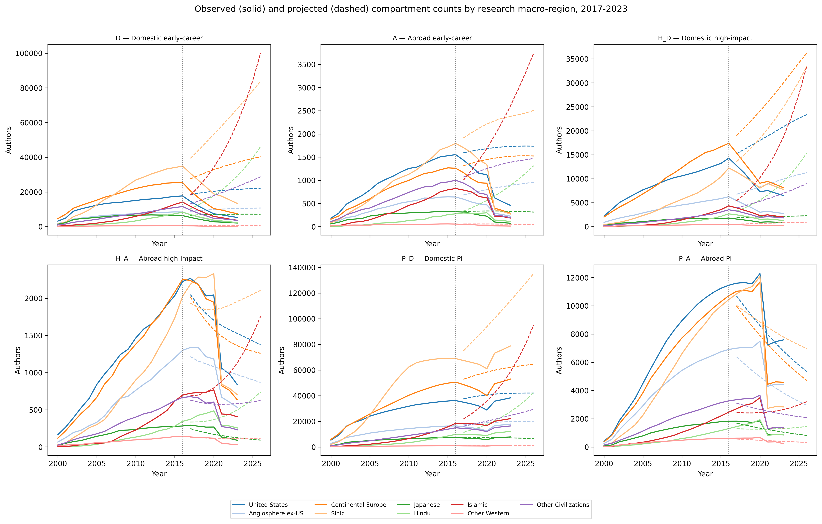
Figure 3. Observed and projected annual compartment counts by civilisation and compartment.
Civilisation | RMSE | MAPE
Anglosphere ex-US | 3544.26 | 86.25%
Continental Europe | 11674.84 | 103.09%
Hindu | 7915.72 | 188.36%
Islamic | 16757.46 | 272.97%
Japanese | 1677.63 | 69.91%
Other Civilizations | 6149.73 | 132.37%
Other Western | 256.88 | 98.71%
Sinic | 18771.59 | 132.26%
United States | 7013.54 | 77.36%
Table 1. Forecast accuracy by civilisation, 2017-2023.
Compartment | RMSE | MAPE
A | 849.47 | 215.12%
D | 19801.25 | 263.27%
H_A | 394.83 | 50.08%
H_D | 8094.10 | 171.62%
P_A | 1744.50 | 36.43%
P_D | 12709.83 | 37.66%
Table 2. Forecast accuracy by compartment, 2017-2023.
Overall RMSE = 10190.39, MAPE = 129.03%. Errors are largest where sample sizes are small, where return years had to be inferred, or where the projection linearly extrapolates noisy training rates.

5a. Rate-level forecast validation
Stock-level projection is sensitive to the fact that the fixed cohort has no post-2016 new entrants, so the rate-level forecast provides a cleaner validation of the annual layer. Table 3 reports RMSE, MAE and a skill ratio against a historical-mean baseline for each transition rate. A skill ratio above 1.0 indicates that the projected rates improve on the baseline.
Rate | RMSE | MAE | MAPE | Naive RMSE | Skill
alpha | 0.0052 | 0.0038 | 72.7% | 0.0055 | 1.06
beta | 0.2152 | 0.1077 | 992.2% | 0.2184 | 1.01
h_D | 0.0205 | 0.0160 | 390.6% | 0.0225 | 1.09
h_A | 0.0204 | 0.0160 | 101.5% | 0.0303 | 1.48
p_D | 0.0573 | 0.0509 | 247.8% | 0.0376 | 0.66
p_A | 0.0727 | 0.0603 | 94.6% | 0.0629 | 0.86
d | 0.0000 | 0.0000 | 0.0% | 0.0000 | nan
Table 3. Rate-level projection accuracy, 2017-2023.
Overall rate-level RMSE = 0.0892, MAE = 0.0364, MAPE = 271.4%, skill = 0.99.

6. Validation and civilisational diversity
The correction pressures are theoretically grounded. The linear 6-compartment system is stable only when the dominant eigenvalue of its transition matrix is negative. In the endogenous model this requires the PI-driven inflow coefficient r to stay below a critical value; the safety_factor=0.5 rule enforces this. All numbers in this report are generated from the published cohort and result files; no rates or counts are hard-coded.

7. Alternative intervention framework if inter-civilisation poaching cannot be controlled
If a civilisation cannot stop the outflow of researchers to others (alpha or beta deterioration), interventions can still preserve diversity by acting within the civilisation: (a) increase exogenous entry I0 through PhD/researcher training; (b) reduce dropout d by improving early-career conditions; (c) accelerate domestic career progression h_D and p_D so that promising researchers become PIs domestically; (d) strengthen return incentives beta so that abroad researchers come back; and (e) create intra-civilisation mobility and collaboration networks so that the domestic active pool T acts as a self-sustaining reservoir. These levers can be combined subject to the safety constraint that the PI-driven feedback r does not exceed half of its stability-critical value.

