AI researchers as the next coal: transition rates, minimum viable research communities and the preservation of variety in global AI/ML
Article type: Research Article
Approximate word count (main text incl. tables, excl. references): 10524
Corresponding author: [To be completed at submission]

Abstract
Artificial intelligence (AI) research talent is a general-purpose infrastructural input, comparable to coal in Jevons's analysis of industrial Britain. Its rapid concentration in a few centres raises a question that neither researcher-mobility nor evolutionary innovation studies answer: at what point does the loss of researchers from a smaller research system become a lasting loss of variety for the field as a whole? We derive a mechanism linking career-transition rates to a minimum viable coauthor scale and to variety loss, and examine four propositions with a six-compartment ordinary-differential-equation model fitted to OpenAlex AI/ML records (2000-2023) for 9 research macro-regions. All equilibrium active pools exceed their minimum viable scale, but proximity to the point of no return depends on the ratio of pool to threshold, not absolute size: the lowest ratio is 3.01 (Other Western (Israel)), and the closest point of no return is in Other Western (Israel), where a 67% reduction in the exogenous entry rate ($I_{0}$) would drive the active pool to its threshold. Dropout, which drains every compartment, is the most elastic lever in every macro-region. Transition rates estimated from the 2011-2016 career-start window imply a smaller equilibrium pool than 2000-2010 rates in 1 of 9 macro-regions. Treating AI research capacity as a sociotechnical infrastructure rather than a national asset, the analysis is mechanistic and reproducible from open data, and gives governments, funders and universities a common early-warning metric. Preserving variety across research macro-regions is argued to benefit the whole field and society, not only the systems at risk.
Keywords: researcher mobility; artificial intelligence; research variety; minimum viable population; path dependence; compartment model; technology policy

Highlights
- AI research talent is framed as a general-purpose input, after Jevons's coal question
- Career transition rates linked to minimum viable scale and lasting variety loss
- Closest PNR: Other Western (Israel), via 67% change in $I_{0}$
- Dropout, which drains every career stage, is the most elastic lever everywhere
- Preserving macro-regional variety benefits the whole AI field, not only small systems

Data and Code Availability
All bibliometric data used in this study come from OpenAlex (https://openalex.org), an open scholarly database released under a CC0 licence; works were retrieved through the OpenAlex API for the Artificial Intelligence subfield (subfield 1702) and publication years 2000 to 2023. The country-to-macro-region mapping with its documented overrides, the estimated transition rates for every macro-region, and every aggregate result table underlying the figures and numbers reported here are available in the public GitHub repository https://github.com/bougtoir/researcher-mobility-ode. The same repository contains the Python code for cohort extraction, rate estimation, the ODE model and its endogenous-inflow variant, the bootstrap, the sensitivity and robustness analyses, the coupled nine-region simulation, and the script that regenerates this manuscript, its figures, tables and Supplementary Material. The author-level cohort and the underlying work and authorship records are derivatives of OpenAlex data and are not redistributed; the single reproduction command (reproduce.sh) re-extracts them from the OpenAlex API with the scripts provided, using the same subfield, year window and inclusion rules, and then rebuilds all results from that extraction. OpenAlex is updated continuously, so a fresh extraction reproduces the reported rates, rankings and thresholds up to small snapshot differences of the kind reported in Section 5.5. No proprietary or restricted data were used.

Declarations
Funding: [To be completed by the authors at submission.]
Competing interests: [To be completed by the authors at submission.]
Author contributions: [To be completed by the authors at submission.]
Declaration of generative AI in scientific writing: During the preparation of this work the authors used AI-assisted tools to draft, code, and revise the manuscript. All claims, data, and interpretations were reviewed and approved by the authors.
Acknowledgments: This study was motivated by a note.com essay by Yamada Y (momentumyy) that framed researcher mobility in terms of transition rates rather than net flows (Yamada Y (momentumyy). Kaigai de ateta kenkyusha wa sonogo dou naru no ka [What happens to researchers who make their name abroad?]. note.com, 2026. https://note.com/momentumyy/n/n86df5d34282d (accessed 2026-08-09).).

1. Introduction
In 1865 William Stanley Jevons asked whether Britain's industrial expansion could outlast the coal on which it ran [1]. His question was not about a commodity but about a general-purpose input whose availability conditioned every downstream industry. Artificial intelligence (AI) and machine learning (ML) research talent occupies a comparable position today: methods developed by a small, highly mobile population of doctoral researchers, post-doctoral researchers and principal investigators (PIs) are being embedded in science, industry and public administration as a general-purpose technology [2,3]. Governments in the United States, China, Europe, Japan and India now treat this population as a strategic input and compete for it through visas, fellowships and salaries [4,5]. Unlike coal, however, research talent is reproducible, mobile and subject to positive feedback: researchers train researchers, and they cluster where other researchers already are. The policy-relevant question is therefore not whether the global stock of AI researchers will be exhausted, but whether the distribution of that stock across research systems can pass a point beyond which some systems can no longer reproduce themselves.
Two literatures speak to that question without answering it. Research on scientist mobility describes brain drain, brain circulation and brain gain in terms of stocks and net flows [6,7], and the economics of science explains the individual career decisions behind those flows [8]. Evolutionary and innovation-systems economics explains why variety among research programmes matters for long-run technological change and how positive feedback produces lock-in [9,10,11]. Neither literature specifies the mechanism by which individual career-transition rates in one research system translate into a lasting loss of variety for the field as a whole. Without that mechanism, arguments for sustaining smaller research systems remain either national (protect our researchers) or purely normative (diversity is good), and they cannot say how close a system is to a threshold or which transition would move it there.
This paper supplies that mechanism and tests it. Section 2 reviews the two literatures and the AI-specific evidence on concentration and homogenisation, identifies the gap, and derives a four-step mechanism: career-transition rates determine the active researcher pool; network externalities in recruitment make the pool self-reinforcing; the pool must exceed a minimum viable coauthor scale to keep producing work; and falling below that scale removes a distinct research programme from the global menu of variety. From this mechanism we derive one research question and four propositions (P1-P4) about which research systems are closest to their point of no return (PNR), which transitions govern the distance, how endogenous recruitment shapes it, and whether historical changes in transition rates have moved systems toward or away from the threshold. Section 3 describes the OpenAlex cohort of 723,647 AI/ML authors and the grouping of countries into 9 research macro-regions [12]. Section 4 specifies a six-compartment ordinary-differential-equation (ODE) model whose rates are estimated from those data. Section 5 reports the propositions' tests, and Section 6 discusses who benefits from preserving variety across research macro-regions.
The contribution is threefold. Theoretically, it links researcher-mobility research to evolutionary innovation studies through an explicit threshold mechanism, and it extends Jevons's question from an exhaustible resource to a reproducible but concentrating human input. Empirically, it provides what are, to our knowledge, the first comparative estimates of career-transition rates, minimum viable coauthor scale and PNR proximity for AI/ML research macro-regions from open bibliometric data. For technology and society, it reframes the case for sustaining smaller research systems: the beneficiaries are not only those systems but the field and the societies that depend on the variety of problems, methods and evaluation norms it can generate.

2. Theoretical framework

2.1 Researcher mobility: from net flows to career transitions
Researcher mobility has been studied under the headings of brain drain, brain circulation and brain gain [6]. Thorn and Holm-Nielsen argue that outflows from smaller systems become a gain only when return migration and diaspora networks are supported, and a drain when local environments cannot retain or reproduce talent [6]. Appelt et al., using a gravity model for 1996-2011, find that collaboration, economic convergence and visa restrictions are the strongest correlates of bilateral flows, and that much movement is circulation rather than one-way migration [4]. Franzoni et al. document large cross-country differences in the share of foreign-born scientists [7]. In AI/ML specifically, the United States remains the dominant destination while China and India expand domestic retention [3]; mobile AI scientists retain collaboration ties with their origin systems [13]; and elite AI networks are highly clustered, with brain drain from developing systems intensifying [14]. The economics of science provides the microfoundation: individuals decide where to train, whether to go abroad, when to return and when to leave research in response to career incentives and institutional quality [8]. What this literature measures, however, is stocks and flows. It does not specify a community-level state variable whose crossing would make the loss of researchers self-reinforcing rather than recoverable.

2.2 Variety, selection and lock-in in evolutionary innovation studies
Evolutionary economics treats technological change as a process of variety generation and selection [9]. Research programmes are carried by organisations with routines, and technological paradigms channel search along trajectories that exclude alternatives [10]. Metcalfe formalises selection as a replicator process in which the rate of change of the population depends on the variety present in it [15], and Saviotti shows that variety is both an output of and an input to long-run development: without new variety, selection eventually exhausts the options on which it operates [16]. Arthur and David show how increasing returns and positive feedback lock a system into a historically contingent trajectory that may be inferior to foregone alternatives [11,17]. The national and sectoral innovation-systems literature adds that these processes are institutionally embedded: funding systems, labour markets and universities co-evolve with the research they sustain [18,19]. Stirling's general framework distinguishes variety (number of categories), balance (their relative size) and disparity (how different they are), and argues that all three matter for the resilience of a technological system [20]. Aghion et al. provide complementary evidence that innovation is highest at intermediate degrees of competition [21]. This literature explains why the loss of a distinct research programme is costly and hard to reverse, but its unit of analysis is the firm, the technology or the sector. It does not connect variety to the career-transition rates of the researchers who carry research programmes.
The danger is not hypothetical; several fields have narrowed onto a dominant approach, lost the communities that carried alternatives, and then stagnated until variety was rebuilt from outside or from marginal survivors. AI itself provides the clearest case: after the perceptrons controversy of the late 1960s, funding and students moved almost entirely to symbolic approaches, connectionist research survived only in a few peripheral groups, and the field waited nearly two decades for the back-propagation revival [22,23]. Hooker's hardware lottery, discussed below, reads the subsequent history in the same terms. In Soviet biology, the state-enforced dominance of Lysenkoism removed genetics as a research programme and left the country decades behind in the life sciences once the programme was abandoned [24]. In economics, the convergence of macroeconomics on a single class of equilibrium models before 2008 is widely cited by economists themselves as a reason the profession failed to see the financial crisis coming [25], and in theoretical physics the concentration of positions and students on string theory has been criticised from within the field for crowding out alternatives without delivering testable progress [26]. Agricultural monocultures show the same structure with a biological rather than intellectual selection pressure: the 1970 southern corn leaf blight spread through a maize crop in which most hybrids shared one cytoplasm [27]; coffee leaf rust destroyed the Ceylon coffee industry in the 1870s-1880s once plantations of a single, genetically narrow Coffea arabica stock were connected by trade, and the same pathogen caused the 2008-2013 crises in Colombia and Central America after resistance in the dominant cultivars broke down [28,29]; and the Gros Michel banana was eliminated commercially by Fusarium wilt, with its Cavendish successor now facing the same fate [30]. At the level of science as a whole, large fields have been shown to ossify around canonical work and disruptive contributions have declined across disciplines [31,32]. These cases differ in mechanism and in how contested the diagnosis is, and we do not claim that AI/ML is already in such a state; they establish that a field can select its way into a position from which recovery is slow and depends on the survival of communities outside the dominant programme.

2.3 Why AI/ML is a special case: concentration and homogenisation
Several features of contemporary AI/ML research make the variety-selection argument more than a general worry. First, Kleinberg and Raghavan show formally that when many decision-makers converge on the same algorithm, an algorithmic monoculture can lower social welfare even if each adopter individually improves, because correlated errors are no longer averaged out [33]. Second, Hooker's hardware lottery argues that which research ideas succeed depends on their compatibility with the dominant hardware and software stack, so that concentration of compute concentrates the ideas that can be tested [34]. Third, benchmark and dataset use has become increasingly concentrated on a small number of datasets originating from a few institutions [35], and the pursuit of general benchmarks embeds particular framings of what counts as progress [36]. Fourth, the empirical success of scaling laws [37] and foundation models [38] has produced a single dominant paradigm whose compute requirements have grown by orders of magnitude [39], shifting participation from universities toward a few large firms and their partners [40]. Fifth, the data on which models are trained are dominated by a few languages and by cultural framings embedded in them [41,42]. Each of these is a channel through which the geography of the research population shapes the variety of problems, methods and evaluation norms in the field.
There are serious counterarguments. Compute and data exhibit economies of scale, so concentration may be the efficient way to reach the frontier, and open-source and open-weight releases diffuse frontier methods to researchers everywhere at low cost [38]. Geographic or macro-regional diversity is, moreover, only a coarse proxy for the cognitive diversity that matters for problem-solving [43]; two research systems in different regions may work on the same problems with the same methods. We accept these points. The argument developed below is not that concentration is inefficient in the short run, nor that every region carries a distinct research programme. It is that when a research system falls below the scale needed to reproduce itself, whatever distinct problem framings, data, languages and institutional experiments it carried are removed from the menu on which future selection can operate, and that this loss is difficult to reverse because the same positive feedbacks that produced it work against recovery. Open diffusion of methods lowers the cost of using the frontier; it does not by itself sustain the local PIs, students and institutions needed to define problems differently.

2.4 The gap: an infrastructural input with a threshold
Bringing the literatures together exposes the gap. Mobility research has the microdata on career transitions but no community-level threshold; evolutionary innovation studies have the threshold concepts (lock-in, loss of variety) but no link to career transitions. Jevons's coal question is useful precisely because it framed a general-purpose input in terms of a system-level constraint rather than individual mines, and because it was refined by later work showing that efficiency gains can increase rather than reduce demand [1,44]. The analogy has strict limits. Researchers are human capital that reproduces through training; they move across systems; and AI tools may raise rather than lower the demand for researchers. We therefore do not claim that AI talent is exhaustible. We claim that, like coal for Jevons, it is an input whose distribution across systems determines what the whole can do, and that for each system there is a scale below which the input is no longer reproduced locally. Identifying that scale and the transitions that govern distance to it is the missing mechanism.

2.5 Mechanism: transition rates, network externalities, minimum viable scale, variety loss
The mechanism has four steps. (i) Career-transition rates determine the active pool. Within a research system, researchers enter (exogenous entry $I_{0}$), move abroad early in their career ($α$), return ($β$), produce high-impact work ($h_{D}$, $h_{A}$), become PIs ($p_{D}$, $p_{A}$) or leave research ($d$). Given these rates, the domestic active pool $T = D + H_{D} + P_{D}$ has a well-defined equilibrium. (ii) Network externalities make the pool self-reinforcing. Recruitment is not exogenous: PIs train students and attract post-doctoral researchers, so inflow rises with the PI stock. This is a network externality in the sense of Katz and Shapiro—the value of joining a research system rises with the number already in it [45]. It implies that a decline in $T$ reduces future inflow, which reduces $T$ further. (iii) The pool must exceed a minimum viable scale. Following the minimum-viable-population concept in conservation biology [46], we define an operational minimum viable coauthor scale $M = k × \overline{c}$ as the number of active researchers needed to staff the field's observed number of distinct PI groups ($k$) at its observed coauthor intensity ($\overline{c}$); hereafter $M$. It is operational in that it is computed from observed publication structure rather than derived from a demographic extinction model. Below $M$ the system cannot produce work at the field's norms, mentorship chains break and the feedback in step (ii) runs in reverse. (iv) Falling below $M$ removes variety. Because research programmes are carried by PIs and the institutions around them [9,10], a system that can no longer reproduce its PI stock loses the programme, not just the headcount. The loss is path-dependent in Arthur's sense [11]: recovery requires rebuilding the feedback loop against competitors that have grown stronger in the meantime. In the AI-specific channels of Section 2.3, this means fewer independent sources of problems, benchmarks, data and evaluation norms for the field as a whole.

2.6 Research question and propositions
The research question follows: for each AI/ML research macro-region, how far is the active researcher pool from its minimum viable scale, which career transition governs that distance, and has the distance been shrinking? Four propositions are derived from the mechanism rather than from the data.
P1 (relative scale; structural implication). Under network externalities in recruitment, distance to the PNR is governed by the ratio $T/M$ rather than by absolute $T$. Systems with lower $T/M$ require a smaller proportional change in a transition rate to reach $M$, so proximity should track $T/M$ more closely than it tracks $T$. Because the entry lever rescales the whole equilibrium, this is a structural implication of the model rather than a hypothesis the data could reject; its diagnostic content is that the ranking by absolute size and the ranking by proximity diverge.
P2 (asymmetric leakage). A transition that removes researchers from every compartment (dropout, $d$) has a larger equilibrium elasticity than a transition that moves researchers between compartments within the global system (early-career outflow, $α$), because the latter preserves the possibility of return ($β$) and of contribution from abroad. Hence |elasticity of $T$ with respect to $d$| > |elasticity with respect to $α$| in every system.
P3 (endogenous recruitment). Because inflow depends on the PI stock, the transition closest to the threshold should be the one that feeds the reproduction loop from outside—exogenous entry $I_{0}$—rather than a mobility rate; and the ranking of systems by proximity should be robust to the functional form of the recruitment feedback (linear versus saturating).
P4 (historical drift). If transition rates estimated from the later career window (2011-2016) differ from those of the earlier window (2000-2010), the equilibrium implied by the later rates should differ from that implied by the earlier rates; where the later equilibrium is smaller, the system has been drifting toward its threshold and the mechanism predicts ongoing variety loss unless rates change.
These propositions are mechanistic in the sense that each follows from a specific step of Section 2.5. P2-P4 could be falsified by the fitted model: P2 by any system in which $α$ is more elastic than $d$, P3 by a mobility rate being the closest lever or by rank reversals under saturation, and P4 by identical early- and late-window equilibria. P1 is a diagnostic proposition: it is checked for consistency and used to read the results, not tested.

3. Data and macro-regional grouping
We extracted AI/ML works and author histories from the OpenAlex API for subfield 1702 (Artificial Intelligence), 2000-2023 [12]. OpenAlex provides open, CC0 metadata on authors, affiliations, countries, publication dates and citations. Author histories were built by following each author's sequence of works and affiliations, assigning a country per work and an origin macro-region by the modal country of recorded affiliations.

3.1 Research macro-regions
The unit of analysis is the research macro-region: a set of countries whose AI/ML researchers share funding systems, labour markets, languages and mobility corridors closely enough to be treated as one recruitment pool. For reproducibility, the initial partition of countries was taken from Huntington's taxonomy [47], which predicts the structure of global communication networks [48] and of scientific mobility and collaboration [49]; it serves only as a documented starting heuristic and the resulting groups are operational research systems, not civilisations. The partition was adjusted to the size and mobility structure of AI/ML: the United States is separated from the rest of the Anglosphere as the dominant destination with a distinct funding system; Continental Europe is kept distinct because intra-European mobility and EU funding form a separate bloc; Latin American, Orthodox and sub-Saharan African countries are merged into Other regions because their author counts are too small to estimate stable rates. The final 9 macro-regions are: United States, Anglosphere ex-US, Continental Europe, China-centred, Japan, South Asia, Islamic world, Other Western (Israel), Other regions. Other Western (Israel) is in practice a single national system: Israel accounts for 100% of its 2022-2023 AI/ML works, so results for this macro-region should be read as results for a small, high-impact national system. Figure 1 maps the partition and overlays the largest observed inter-region early-career flows, which are the cross-region moves the model tracks through the abroad compartments. The full country mapping is in Supplementary Material.
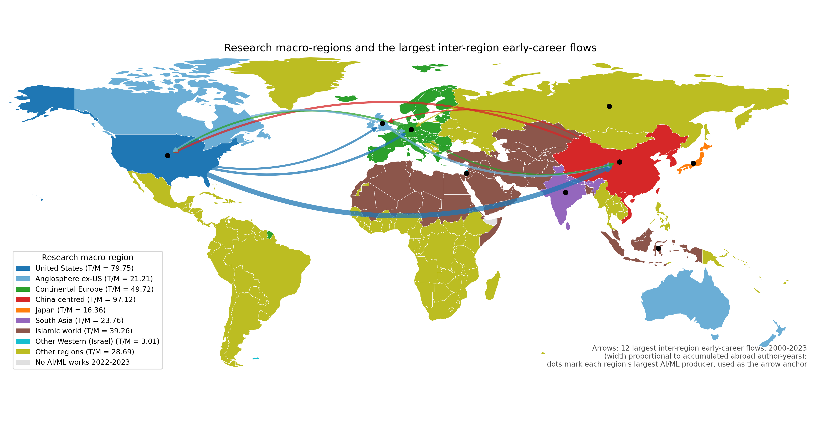
Figure 1. Research macro-regions and the largest inter-region early-career flows, 2000-2023. Country outlines from Natural Earth (public domain); arrow width is proportional to accumulated abroad author-years by origin and destination; the legend gives each region's equilibrium $T/M$ ratio.

3.2 Cohort and variable definitions
Authors enter the cohort if their first observed AI/ML publication is in 2000-2016 and they have at least two AI/ML works in 2000-2023; authors with only unknown affiliations are excluded, giving 723,647 authors. An author is active if they have at least one AI/ML work in 2020-2023 and has dropped out otherwise. A hit is a paper in the top 10% of AI/ML citations for its publication year, observed within the first eight career years. A PI is an author whose first last-author paper (single-authored papers are treated as last-author) appears in the window [8]. Both are deliberately broad operational definitions: a PI in this sense is any author with at least one independent last-author paper, not a tenured group leader, and a hit author is any author with at least one top-decile paper. Because the cohort is restricted to authors with at least two works, PIs account for 58-74% and hit authors for 31-60% of each macro-region's cohort (Table 1). The PI compartment therefore represents the population able to lead work and recruit, and the minimum viable scale in Section 4.3 counts distinct last-author groups per year under the same definition, so the two are consistent. The abroad flag is set if the author is affiliated in a non-origin macro-region within the first six career years. OpenAlex coverage is incomplete for non-English venues and author disambiguation is imperfect, so absolute counts are model-implied stocks rather than a census; relative comparisons are preserved because the same rules are applied to every macro-region. Table 1 reports the cohort by macro-region. The China-centred, Continental Europe and United States macro-regions contribute the largest author counts. A smaller cohort with low coauthor intensity can be more resilient than a larger one with high coauthor intensity, which is why $T$ and $M$ must be compared jointly (P1).
Group | Authors | Works | Active 2020-2023 | Hit authors | PIs | Mean career start | Abroad early-career
Anglosphere ex-US | 64122 | 700342 | 28218 | 35822 | 43628 | 2007.3 | 16233
China-centred | 190051 | 1589023 | 103673 | 61738 | 140701 | 2008.7 | 23956
Continental Europe | 168911 | 1766329 | 74004 | 90322 | 111466 | 2008.0 | 26060
Islamic world | 51043 | 387001 | 29703 | 20435 | 35558 | 2011.4 | 8131
Japan | 32007 | 293437 | 11846 | 9915 | 18543 | 2006.7 | 4417
Other Western (Israel) | 4397 | 49748 | 1981 | 2646 | 2848 | 2007.4 | 1414
Other regions | 50240 | 371952 | 23671 | 17128 | 32449 | 2009.2 | 9136
South Asia | 28069 | 225684 | 17047 | 12043 | 19185 | 2011.3 | 4289
United States | 134807 | 1298250 | 58969 | 74972 | 91029 | 2007.3 | 27420
Table 1. Descriptive statistics for the extracted AI/ML cohort by research macro-region. Labels are operational aggregations of OpenAlex country-affiliation patterns.

4. Methods

4.1 Compartment model
Each macro-region is represented by six compartments: domestic early-career ($D$), abroad early-career ($A$), domestic hit ($H_{D}$), abroad hit ($H_{A}$), domestic PI ($P_{D}$) and abroad PI ($P_{A}$) researchers. Transition rates are early-career outflow ($α$), return ($β$), hit generation ($h_{D}$, $h_{A}$), PI promotion ($p_{D}$, $p_{A}$) and dropout from all compartments ($d$). Figure 2 shows the structure; the equations are:
$$\frac{dD}{dt}=I{P_{D}} + βA - (α + h_{D} + d)D \\ \frac{dA}{dt}=αD - (β + h_{A} + d)A \\ \frac{dH_{D}}{dt}=h_{D}D + βH_{A} - (p_{D} + d)H_{D} \\ \frac{dH_{A}}{dt}=h_{A}A - (β + p_{A} + d)H_{A} \\ \frac{dP_{D}}{dt}=p_{D}H_{D} + βP_{A} - dP_{D} \\ \frac{dP_{A}}{dt}=p_{A}H_{A} - (β + d)P_{A}$$
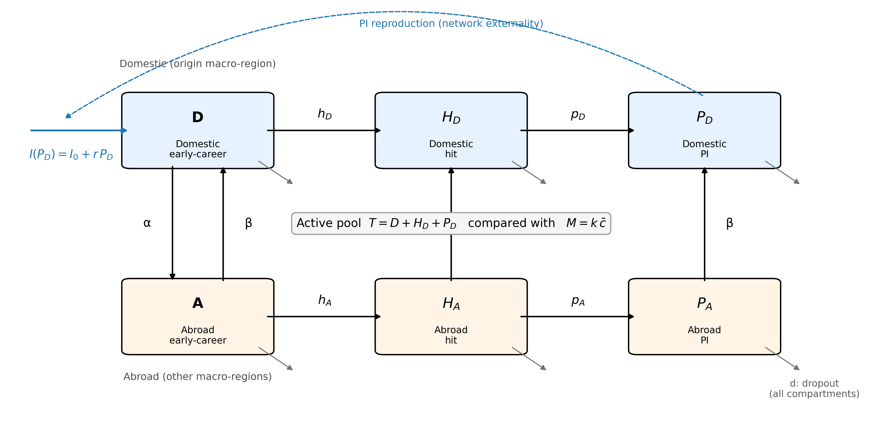
Figure 2. Compartment structure of the model for one research macro-region. Solid arrows are per-year transition rates; the dashed arrow is the endogenous recruitment feedback from the domestic PI stock; grey arrows are dropout from every compartment. The active pool $T$ is compared with the minimum viable coauthor scale $M$.
The model treats each macro-region as one aggregate with constant per-year rates and collapses careers into three observed layers. These simplifications keep the model estimable from OpenAlex and the threshold calculation transparent; the model is an early-warning device, not a demographic projection.

4.2 Endogenous inflow (network externality)
Step (ii) of the mechanism is implemented by making entry depend on the domestic PI stock. The linear form is $I{P_{D}}=I_{0}+rP_{D}$, where $I_{0}$ is exogenous entry and $r$ is the PI reproduction rate, capped at 0.50× the stability-critical value (the most constrained fitted macro-region realises 0.40×). A saturating alternative, $I{P_{D}}=I_{0}+\frac{rP_{D}}{1 + ε×P_{D}}$, is used as a robustness check for P3. The cap prevents runaway growth when observed $r$ exceeds the critical value, a common finding because observed recruitment is bounded by the data window. Given $r$, $I_{0}$ is calibrated so that total equilibrium entry $I_{0} + r × P_{D}$ equals the observed annual entry of each macro-region; the equilibrium size of the active pool is therefore anchored to observed entry, and the PI feedback redistributes rather than rescales it.

4.3 Minimum viable coauthor scale
Step (iii) is implemented as $M = k × c̄$, where $\overline{c}$ is the mean number of authors per work and $k$ the median number of distinct last-author groups per recent year. When the equilibrium active pool $T = D + H_{D} + P_{D}$ falls below $M$, the system cannot produce work at the field's coauthor intensity. Falling below $M$ is a sufficient, not a necessary, condition for collapse; $M$ is a soft lower bound, so observed margins are probably smaller than they appear.

4.4 Estimation, elasticities, PNR and counterfactuals
Rates are estimated as constant per-year hazards from observed transitions over exposure time, with a Laplace pseudocount of 1 per outcome. Because the data are right-censored, rates are lower bounds and equilibria conservative. Steady states are solved with a trust-region Newton method. The equilibrium $T$ is the asymptotic pool of an open system with continuing entry and is therefore larger than the 2020-2023 active count of the closed 2000-2016 cohort in Table 1 (by a factor of 2.4-3.1); the two are not comparable, and all claims rest on relative quantities ($T/M$, elasticities, proximity and rankings), not on absolute $T$. Elasticities perturb each rate by 1% and record the percentage change in $T$ (P2). For the PNR we scale each rate until $T$ reaches $M$ and record the critical factor and its proximity |critical factor − 1| (P1, P3). Historical drift (P4) compares equilibria under rates estimated from the 2000-2010 and 2011-2016 career windows. Policy counterfactuals perturb single rates by ±10% and rank levers by margin gain; bootstrap resampling of authors (200 draws) gives 95% intervals. All counterfactuals are mechanical perturbations of fitted rates: they identify sensitive transitions, not causal effects of programmes. An annual layer re-estimates rates year by year (2000-2016), projects them to 2017-2026 and compares the projected compartment counts with observed 2017-2023 stocks; it is an exploratory extension whose estimation, regularisation, figures and accuracy metrics are reported in Supplementary Material Section S2 (Supplementary Figures S1-S3, Supplementary Tables S2-S5).

4.5 Talent-concentration scenario
To examine what the mechanism implies when one research system deliberately concentrates talent, we couple the nine fitted single-region models through the observed inter-regional mobility matrix (Figure 1) and simulate a stylised talent-concentration strategy. In the baseline, each macro-region's abroad compartments are distributed over host regions in proportion to observed off-diagonal abroad author-years (Supplementary Figure S2), each host recruits into its early-career pool in proportion to the PIs it hosts, and exogenous entry is adjusted so that the coupled system reproduces the fitted equilibria exactly. The concentration strategy is a pull of intensity φ exerted by one focal region: early-career outflow from every other region rises from $α$ to $α$(1 + φ), the increment is directed to the focal region and tracked in separate compartments, researchers pulled this way return at $β$/(1 + φ), and the stock already abroad keeps its observed host distribution, so every scenario starts from the same state. Two further rules link the scenario to the mechanism. Once a region's active pool falls below $M$, its PI-driven recruitment stops permanently (Section 4.3). Hit generation in all regions is multiplied by the effective number of macro-regions (inverse Simpson index of domestic active pools) relative to its baseline value, raised to a variety elasticity γ; $γ = 0$ is the fitted model and $γ > 0$ encodes the hypothesis that a more concentrated field generates fewer independent contributions. We run φ ∈ {0.5, 1.0, 2.0, 4.0, 8.0} for the two largest observed host regions, report all quantities relative to a $φ = 0$ baseline, and search for the smallest γ at which the field's, and the focal region's own, hit stock falls below baseline. The clock of the model is set by the fitted transition rates, so we report time in units of the characteristic time $τ = 1/\overline{d}$, the mean career duration implied by the fitted dropout rates ($τ$ ≈ 24 years); the horizon is 4.1 $τ$, and calendar years appear only as an annotation because the same trajectory would unfold faster or slower in a field with faster or slower career turnover. Read in this way, the horizon spans about 4 researcher generations; in a field where careers last twice as long the same number of generations would take twice as many years, and the policy implication of a given $t/τ$ shifts accordingly. φ, γ, the retention and collapse rules and the horizon are stylised assumptions, listed with their status in Supplementary Table S8; the transition rates, equilibria, thresholds and host shares are fitted. The scenario is a model-consistent projection of the mechanism, not a forecast.

5. Results

5.1 Equilibrium pools and minimum viable scale (P1)
Table 2 reports the equilibrium domestic active pool $T$, the minimum viable scale $M$ and the inflow parameters for the 9 macro-regions. All exceed their threshold under the fitted model, but the ratio $T/M$ ranges from 3.01 (Other Western (Israel)) to 97.12 (China-centred). The China-centred, Continental Europe and United States macro-regions have the largest absolute pools; Other Western (Israel) has both the smallest pool and the narrowest absolute margin. Figure 3 visualises the gap between $T$ and $M$.
Group | $T$ | $M$ | Margin | $I_{0}$ | $r$ | $r$ (observed) | $r$ (critical) | $T/M$
Anglosphere ex-US | 67532 | 3183 | 64348 | 1886 | 0.0633 | 0.0865 | 0.1265 | 21.21
Continental Europe | 195095 | 3923 | 191172 | 4968 | 0.0595 | 0.0891 | 0.1190 | 49.72
South Asia | 53434 | 2249 | 51185 | 826 | 0.0273 | 0.0861 | 0.0546 | 23.76
Islamic world | 88522 | 2255 | 86267 | 1501 | 0.0318 | 0.0844 | 0.0635 | 39.26
Japan | 29332 | 1793 | 27539 | 1134 | 0.1015 | 0.1015 | 0.2554 | 16.36
Other regions | 59355 | 2069 | 57286 | 1478 | 0.0662 | 0.0911 | 0.1324 | 28.69
Other Western (Israel) | 4824 | 1601 | 3223 | 129 | 0.0599 | 0.0908 | 0.1198 | 3.01
China-centred | 303935 | 3129 | 300805 | 5590 | 0.0420 | 0.0795 | 0.0840 | 97.12
United States | 147067 | 1844 | 145223 | 3965 | 0.0620 | 0.0871 | 0.1240 | 79.75
Table 2. Equilibrium domestic active pool, minimum viable coauthor scale and endogenous inflow parameters by research macro-region.
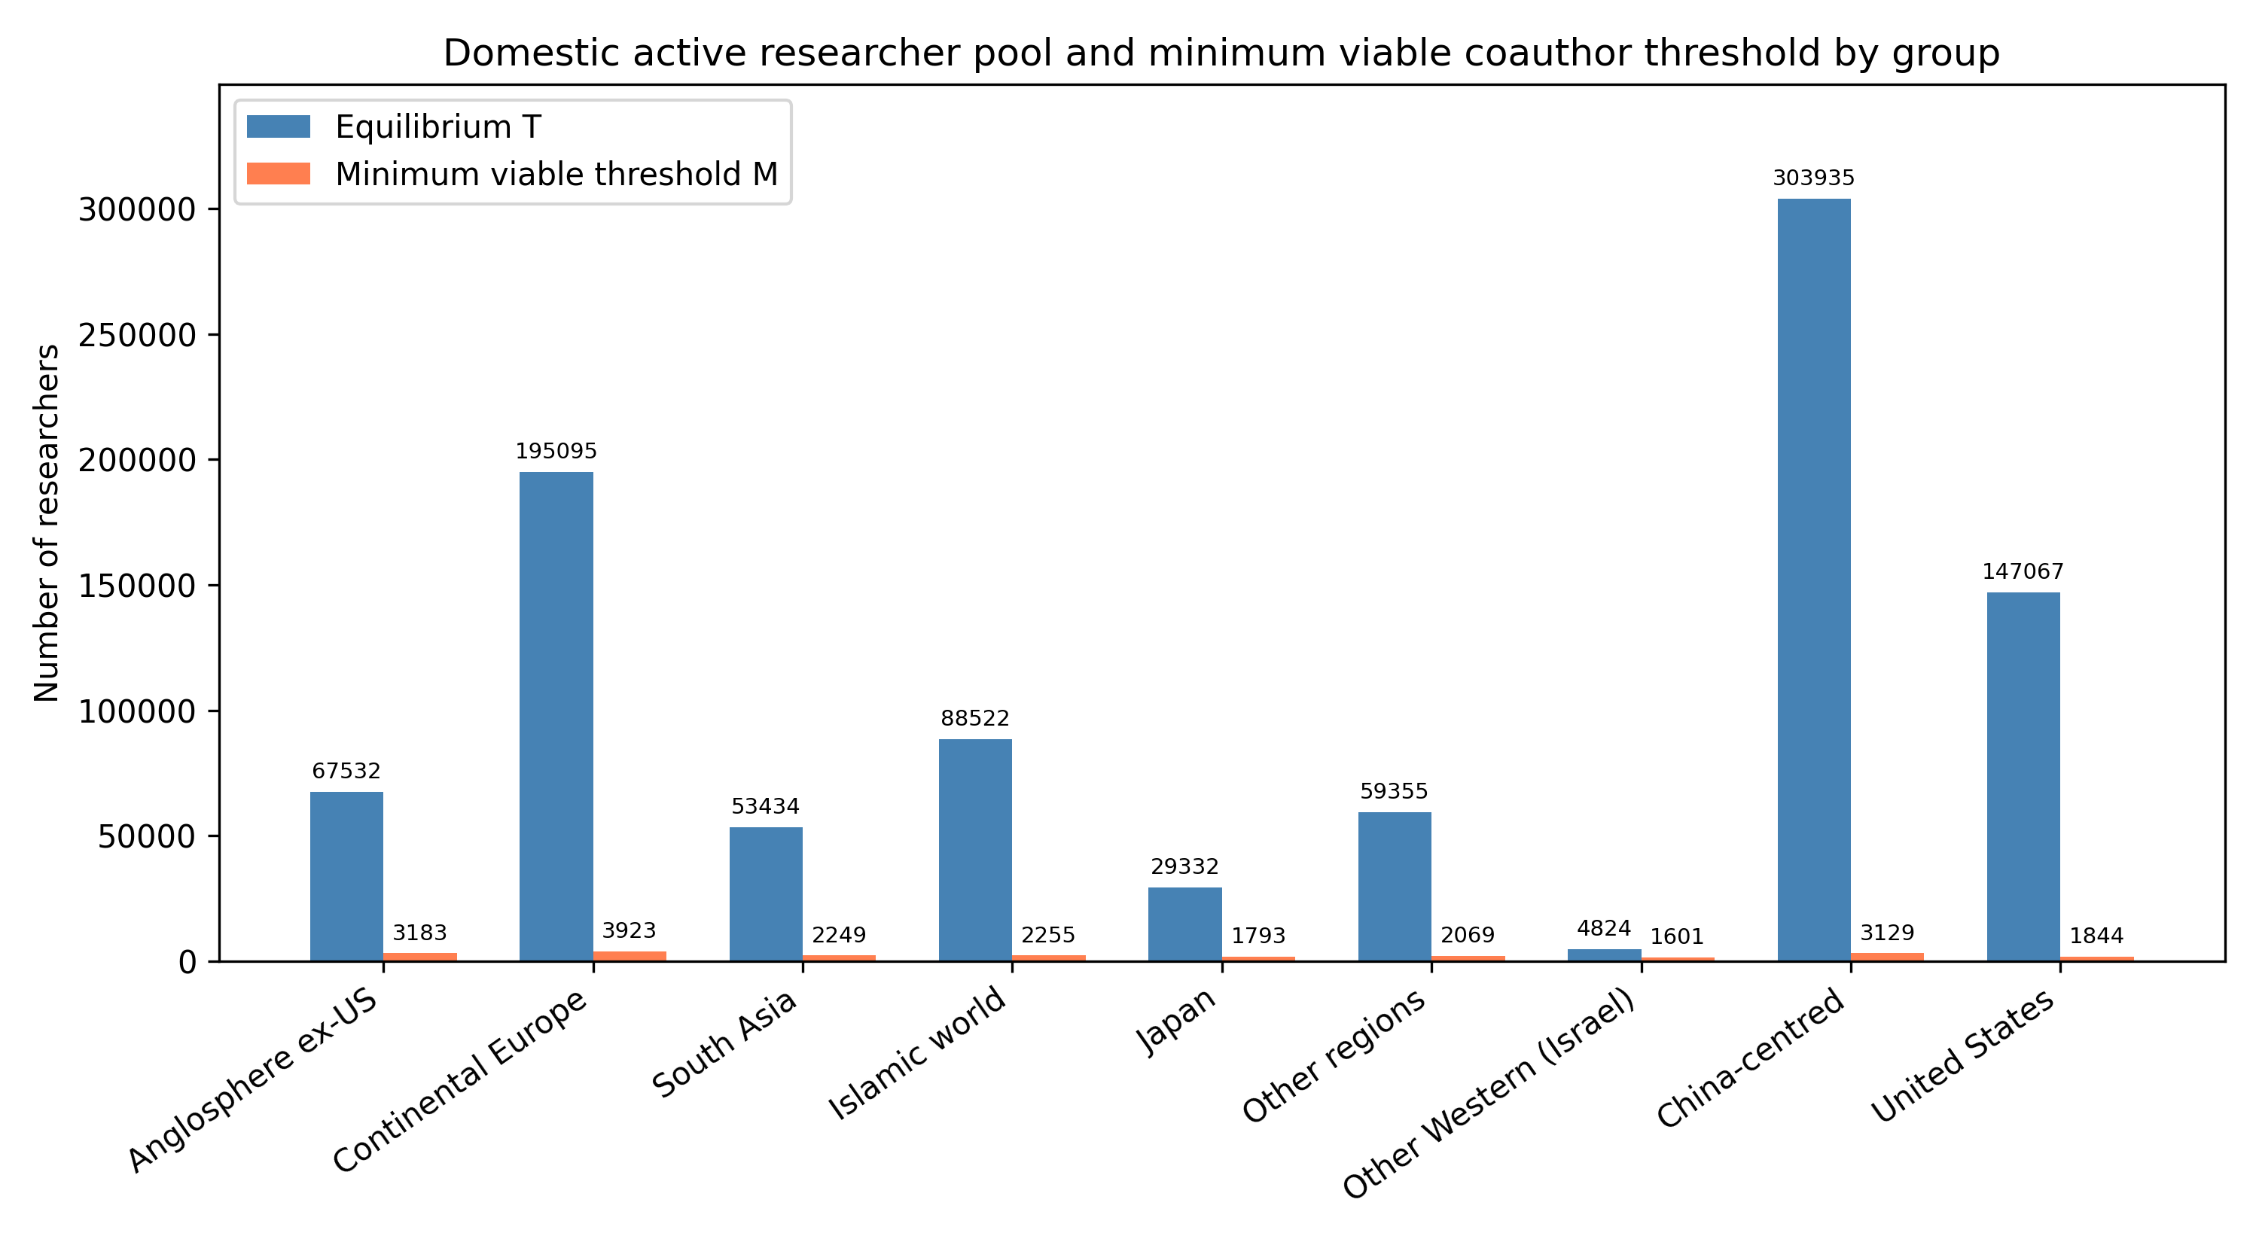
Figure 3. Equilibrium domestic active pool ($T$) and minimum viable coauthor scale ($M$) by research macro-region.

5.2 Which transitions govern the pool (P2)
Table 3 lists the three transition-rate elasticities with the largest absolute effect on $T$ in each macro-region. Dropout ($d$) is the largest negative lever everywhere, with elasticity from -2.79 to -2.27, whereas the largest absolute elasticity of early-career outflow ($α$) is 0.27; $|e_{d}|$ exceeds $|e_{α}|$ in 9 of 9 macro-regions, as P2 predicts. The largest positive transition lever is domestic hit generation ($h_{D}$), followed by principal-investigator promotion ($p_{D}$). The United States macro-region shows the strongest response to PI promotion ($p_{D}$). Attrition removes researchers from every compartment, whereas outflow moves them to compartments from which return and contribution remain possible.
Group | 1st rate | 1st elasticity | 2nd rate | 2nd elasticity | 3rd rate | 3rd elasticity
Anglosphere ex-US | $d$ | -2.68 | $h_{D}$ | 0.47 | $p_{D}$ | 0.34
China-centred | $d$ | -2.69 | $h_{D}$ | 0.40 | $p_{D}$ | 0.26
Continental Europe | $d$ | -2.68 | $h_{D}$ | 0.39 | $p_{D}$ | 0.35
Islamic world | $d$ | -2.58 | $h_{D}$ | 0.37 | $p_{D}$ | 0.22
Japan | $d$ | -2.27 | $h_{D}$ | 0.39 | $p_{D}$ | 0.27
Other Western (Israel) | $d$ | -2.74 | $h_{D}$ | 0.37 | $p_{D}$ | 0.35
Other regions | $d$ | -2.79 | $h_{D}$ | 0.49 | $p_{D}$ | 0.31
South Asia | $d$ | -2.54 | $h_{D}$ | 0.34 | $p_{D}$ | 0.21
United States | $d$ | -2.67 | $h_{D}$ | 0.45 | $p_{D}$ | 0.36
Table 3. Top transition-rate elasticities of the domestic active pool $T$ by research macro-region.

5.3 PNR and endogenous recruitment (P1, P3)
Table 4 reports, for each macro-region, the single rate that reaches the active-pool threshold with the smallest proportional change, and Figure 4 ranks macro-regions by that proximity. $I_{0}$ is the closest point-of-no-return lever for the active researcher pool in every group, consistent with P3: the transition that feeds the reproduction loop from outside is the binding one. The closest PNR is in Other Western (Israel), where $I_{0}$ multiplied by 0.332 (a 67% reduction) drives the active pool to $M$. Across macro-regions the Spearman correlation between PNR proximity and $T/M$ is 1.00, whereas that between proximity and absolute $T$ is 0.93. Because the $I_{0}$ lever scales the whole equilibrium, proximity is close to a deterministic function of $T/M$ in the linear model, so the first correlation is the consistency check that P1 calls for rather than an independent test; the diagnostic content of P1 is that the ranking by absolute size and the ranking by proximity diverge, which the second correlation shows (Section 5.6 returns to individual cases).
Group | Closest rate | Current value | Critical factor | Proximity
Other Western (Israel) | $I_{0}$ | 129.3 | 0.332 | 0.668
Japan | $I_{0}$ | 1134.4 | 0.061 | 0.939
Anglosphere ex-US | $I_{0}$ | 1885.9 | 0.047 | 0.953
South Asia | $I_{0}$ | 825.6 | 0.042 | 0.958
Other regions | $I_{0}$ | 1477.6 | 0.035 | 0.965
Islamic world | $I_{0}$ | 1501.3 | 0.025 | 0.975
Continental Europe | $I_{0}$ | 4968.0 | 0.020 | 0.980
United States | $I_{0}$ | 3964.9 | 0.013 | 0.987
China-centred | $I_{0}$ | 5589.7 | 0.010 | 0.990
Table 4. Closest PNR for the active researcher pool by research macro-region.
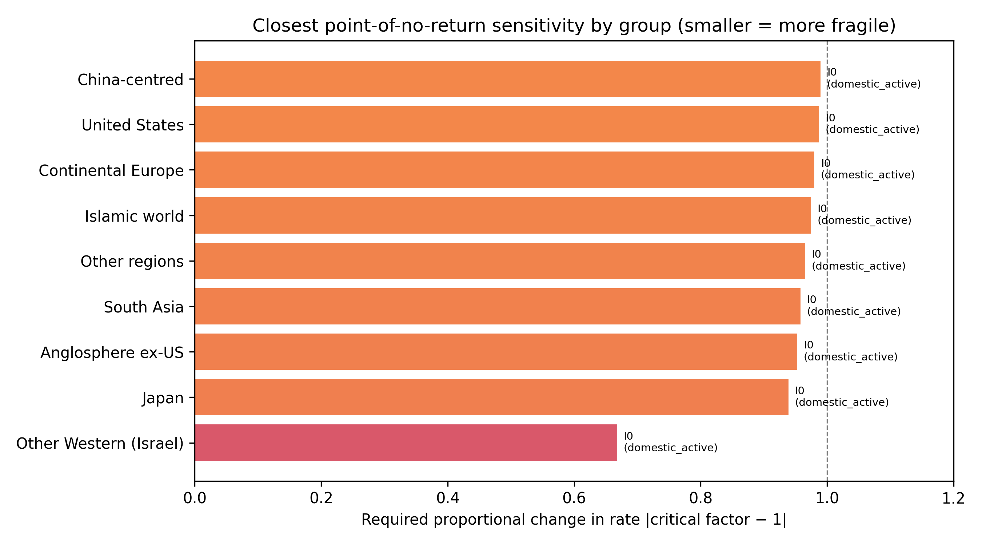
Figure 4. Closest point-of-no-return proximity by research macro-region. Smaller values mean a smaller proportional change in the listed rate reaches the threshold.
Replacing the linear recruitment feedback with a saturating one changes the equilibrium pool by below 0.001% for every group (Table 5), and the closest lever is unchanged in every macro-region while the rank order of proximity has Spearman $ρ = 1.00$ between the two variants (Supplementary Table S7). The second part of P3 is therefore supported: the ranking of systems by fragility does not depend on the functional form of the network externality.
Group | Linear $T$ | Saturating $T$ | $ε$
Anglosphere ex-US | 67532 | 67532 | 0.00000
Continental Europe | 195095 | 195095 | 0.00000
South Asia | 53434 | 53434 | 0.00001
Islamic world | 88522 | 88522 | 0.00001
Japan | 29332 | 29332 | 0.00001
Other regions | 59355 | 59355 | 0.00001
Other Western (Israel) | 4824 | 4824 | 0.00007
China-centred | 303935 | 303935 | 0.00000
United States | 147067 | 147067 | 0.00000
Table 5. Equilibrium $T$ under linear and saturating PI-driven inflow.

5.4 Historical drift in transition rates (P4)
Table 6 compares the equilibrium that would emerge if rates estimated from the early (2000-2010) or late (2011-2016) career window persisted; Figure 5 plots the change in margin. All 9 macro-regions have dual-window support for both estimates. Under late-window rates the margin shrinks in Japan and grows in Islamic world, South Asia, China-centred, Continental Europe, Other regions, United States, Anglosphere ex-US, Other Western (Israel). The late window is shorter and its cohorts younger, so its promotion and hit rates are estimated from less exposure and its equilibria are less certain; the comparison is a sensitivity exercise rather than a forecast. It nevertheless supports P4 in its weak form: equilibria differ across windows, so the distance to the threshold is not stationary, and where margins shrink the mechanism implies ongoing drift toward the threshold.
Group | $T$ early | $T$ late | $ΔT$ (%) | Margin early | Margin late | $Δ$ margin
Anglosphere ex-US | 64779 | 75245 | 16.2 | 61596 | 72062 | 10466.2
Continental Europe | 177460 | 231958 | 30.7 | 173536 | 228035 | 54498.4
South Asia | 23397 | 110377 | 371.8 | 21148 | 108128 | 86979.8
Islamic world | 37899 | 186245 | 391.4 | 35644 | 183990 | 148346.1
Japan | 31781 | 25052 | -21.2 | 29989 | 23259 | -6729.5
Other regions | 42881 | 91930 | 114.4 | 40812 | 89861 | 49049.3
Other Western (Israel) | 4450 | 5731 | 28.8 | 2849 | 4129 | 1280.2
China-centred | 278159 | 360991 | 29.8 | 275030 | 357861 | 82831.4
United States | 139401 | 169788 | 21.8 | 137557 | 167943 | 30386.5
Table 6. Equilibrium active pool and safety margin under early (2000-2010) versus late (2011-2016) transition-rate regimes.
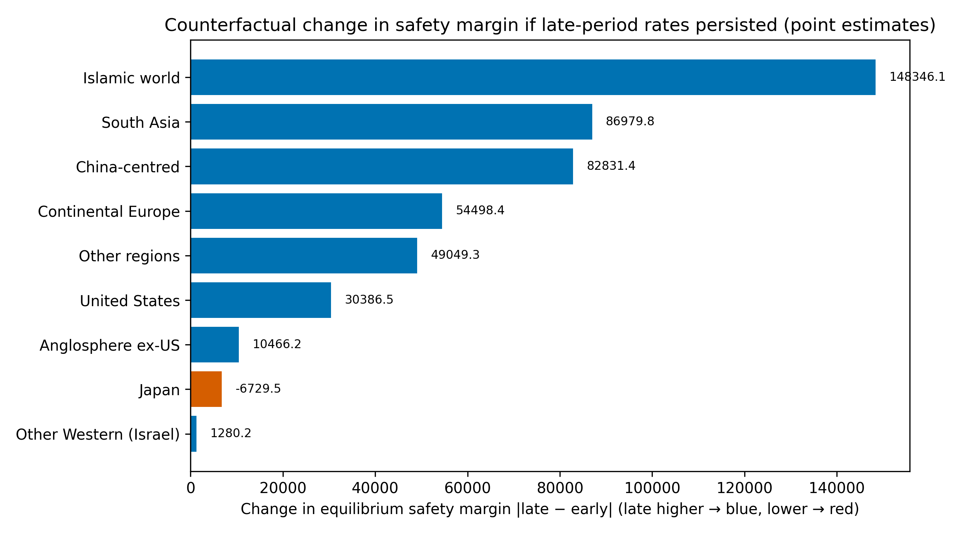
Figure 5. Change in safety margin between early and late transition-rate regimes. Negative values mean the late-window rates would shrink the margin if they persisted. Point estimates only; the two windows differ in cohort size.

5.5 Policy counterfactuals and uncertainty
Table 7 reports the mechanical counterfactual with the largest margin gain per 10% lever change in each macro-region. Reducing dropout is the dominant positive lever in every macro-region, consistent with P2. The gain from a 10% reduction in $d$ ranges from about 567 active researchers (Other Western (Israel)) to about 34,739 (China-centred). Blocking early-career outflow is not the efficient response: a researcher abroad remains in the global system and may return, whereas a researcher who leaves research is lost to every compartment.
Group | Lever | Direction | Change (%) | Gain per 10%
Anglosphere ex-US | $d$ | decrease | -10 | 7660
Continental Europe | $d$ | decrease | -10 | 22093
South Asia | $d$ | decrease | -10 | 6184
Islamic world | $d$ | decrease | -10 | 10239
Japan | $d$ | decrease | -10 | 3194
Other regions | $d$ | decrease | -10 | 6723
Other Western (Israel) | $d$ | decrease | -10 | 567
China-centred | $d$ | decrease | -10 | 34739
United States | $d$ | decrease | -10 | 16560
Table 7. Top positive mechanical counterfactual per research macro-region (margin gain per 10% proportional lever change).
We also evaluated multi-lever policy packages for the three smallest-margin groups. The package with the largest margin gain in each group was: Other Western (Israel) (retention: +616 active researchers); Japan (return plus retention: +3,369 active researchers); South Asia (retention: +6,536 active researchers). These packages combine dropout reduction with return or PI-pipeline levers, showing that the framework can compare multi-lever interventions as well as single-rate perturbations.
Figure 6 shows bootstrap 95% intervals for $T$ (values in Supplementary Table S6). Intervals are wide, and for the smallest macro-regions the lower bound lies closer to $M$, so point estimates of proximity should be read as indicative. The lower bounds nevertheless remain above $M$ for every macro-region, which supports the qualitative conclusion that no system is below its threshold under the fitted model.
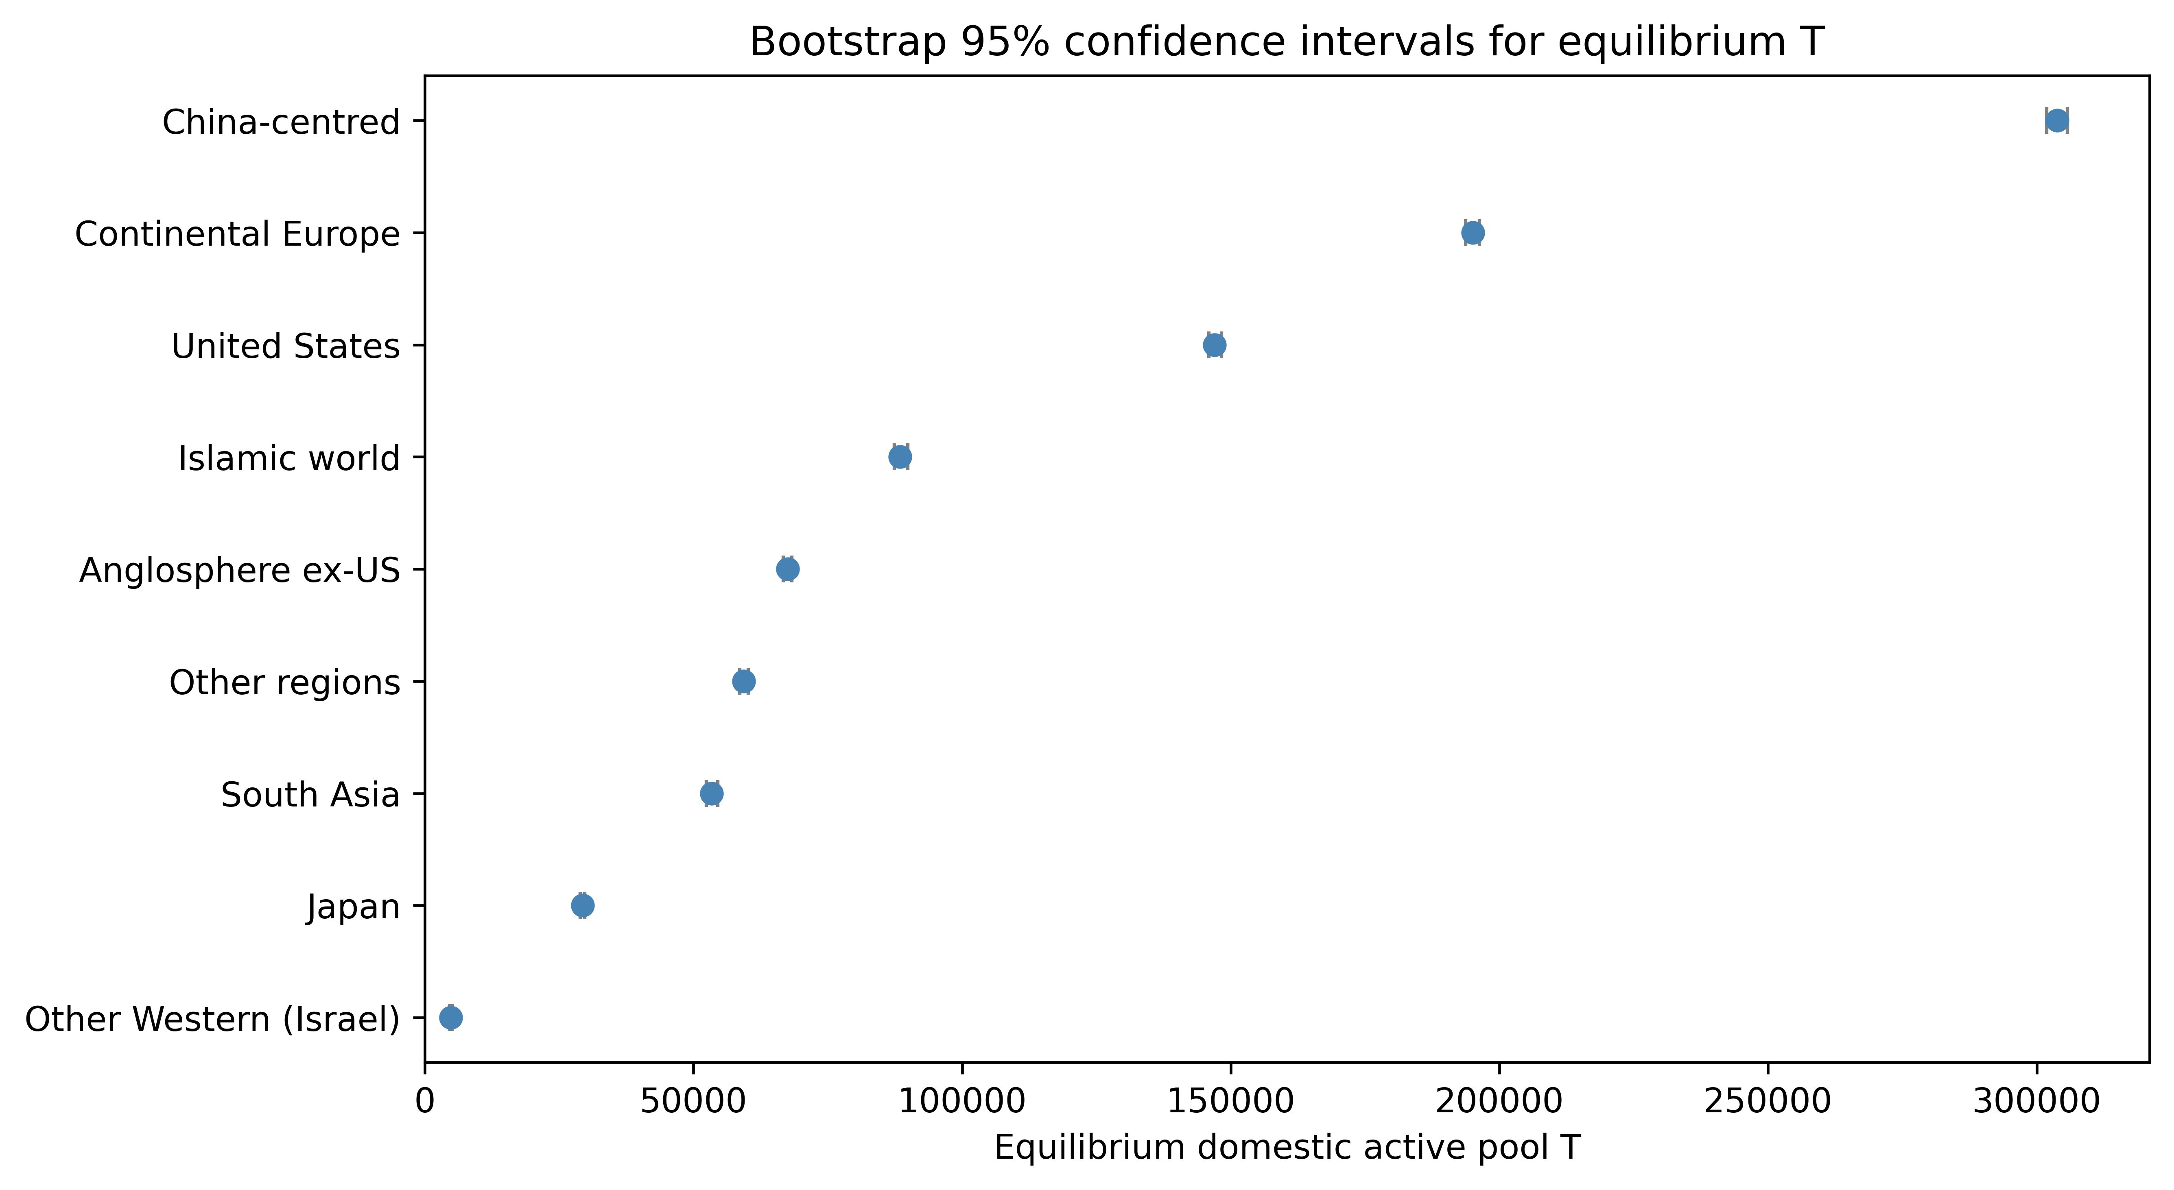
Figure 6. Bootstrap 95% confidence intervals for equilibrium $T$ by research macro-region.
Two further robustness checks address definitional choices in the mechanism. First, the PI proxy. Re-extracting the full cohort from a later OpenAlex snapshot (719,173 authors under the same inclusion rules; the difference from Table 1 reflects OpenAlex updates to author and affiliation records between the two extractions) and replacing the baseline definition (first last-author paper) with the first corresponding-author paper or with recurrence as last author (two or more last-author papers) changes the share of authors classified as PIs (mean across macro-regions 67.4%, 51.3% and 48.2% respectively), the promotion rates $p_{D}$ and $p_{A}$, the equilibrium PI pool $P_{D}$ and the split of recruitment between exogenous entry and PI-driven feedback. Because $I_{0}$ is calibrated so that total equilibrium entry equals observed entry (Section 4.2), the active pool $T$, $T/M$ and the proximity of the entry lever are invariant to the proxy by construction; the informative test is therefore whether the proxy-dependent quantities reorder the macro-regions. The ordering is largely preserved: Spearman rho with the baseline is at least 0.98 for the equilibrium PI pool and 1.00 for the proximity of the PI pool to its own threshold, the elasticity of $T$ to $p_{D}$ rises from 0.21-0.36 under the baseline to 0.30-0.51 under the stricter proxies (Spearman rho of the elasticity ranking with the baseline at least 0.73), and the closest lever for the PI pool changes only in Other Western (Israel), where it becomes dropout rate ($d$) under the stricter proxies (Supplementary Tables S9-S10). Second, the threshold. Multiplying $M$ by 0.50-2.00 leaves no macro-region below its threshold (minimum $T/M$ 1.51 at the largest multiplier), preserves the ranking by $T/M$ and by proximity exactly (Spearman rho = 1.00 and 1.00), keeps |elasticity to $d$| > |elasticity to alpha| in every macro-region at every multiplier, and the closest lever changes only for Other Western (Israel) at multipliers 1.25, 1.50, 2.00, where the closest lever becomes the dropout rate ($d$) (Supplementary Table S11). Because $M$ enters the linear model only as the target, its level shifts distances without reordering systems; the substantive results are relative.
As an exploratory extension, the annual layer re-estimates the rates year by year and projects them to 2017-2026; rate-level projections have a skill ratio of 0.99 against a historical-mean baseline and the layer is a drift monitor rather than a forecast, so its figures and accuracy tables are reported in Supplementary Material Section S2 (Supplementary Figures S1-S3, Supplementary Tables S2-S5).

5.6 Worked example: Japan
Japan illustrates the mechanism in a large research system with an independent institutional lineage and comparatively low $T/M$. Its fitted equilibrium is $T = 29,332$ active researchers ($D = 16,248$, $H_{D} = 5,714$, $P_{D} = 7,370$) against $M = 1,793$, so $T/M = 16.36$. The closest PNR is $I_{0}$: a fall to 6.1% of its current level would bring $T$ to $M$. Figure 7 places Japan's six compartments and compares its rates with the other macro-regions: early-career outflow ($α = 0.025$) and domestic PI promotion ($p_{D} = 0.064$) are comparatively low, return ($β = 0.029$) and domestic hit generation ($h_{D} = 0.040$) moderate, and dropout $d = 0.055$. Low leakage but a thin internal promotion pipeline is the configuration P1 and P2 describe: the system does not lose many researchers abroad, so its distance to the threshold is governed by scale relative to $M$ and by attrition rather than by mobility. Figure 8 generalises the diagnostic by plotting $T/M$ against PNR proximity for all macro-regions; the lower-left corner combines a low buffer with a small proportional change needed to reach $M$. The same two-panel diagnostic applies to any macro-region with sufficient OpenAlex coverage; Japan is a worked example, not a special case.
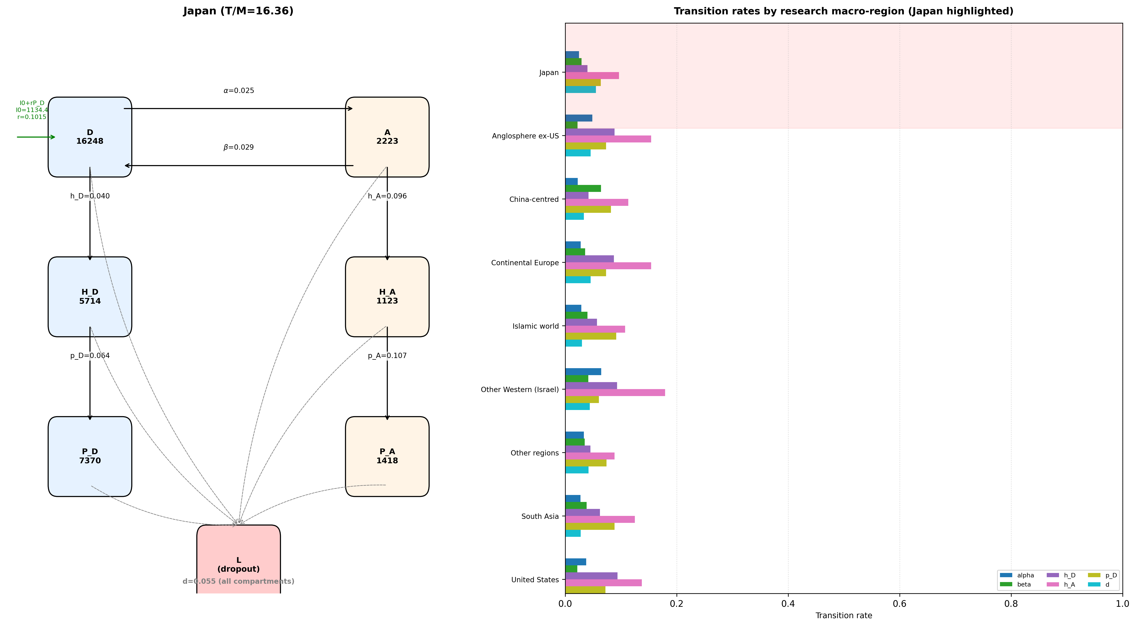
Figure 7. Japan in the six-compartment model, with a ladder of fitted transition rates across research macro-regions (Japan highlighted; longer bars are higher rates).
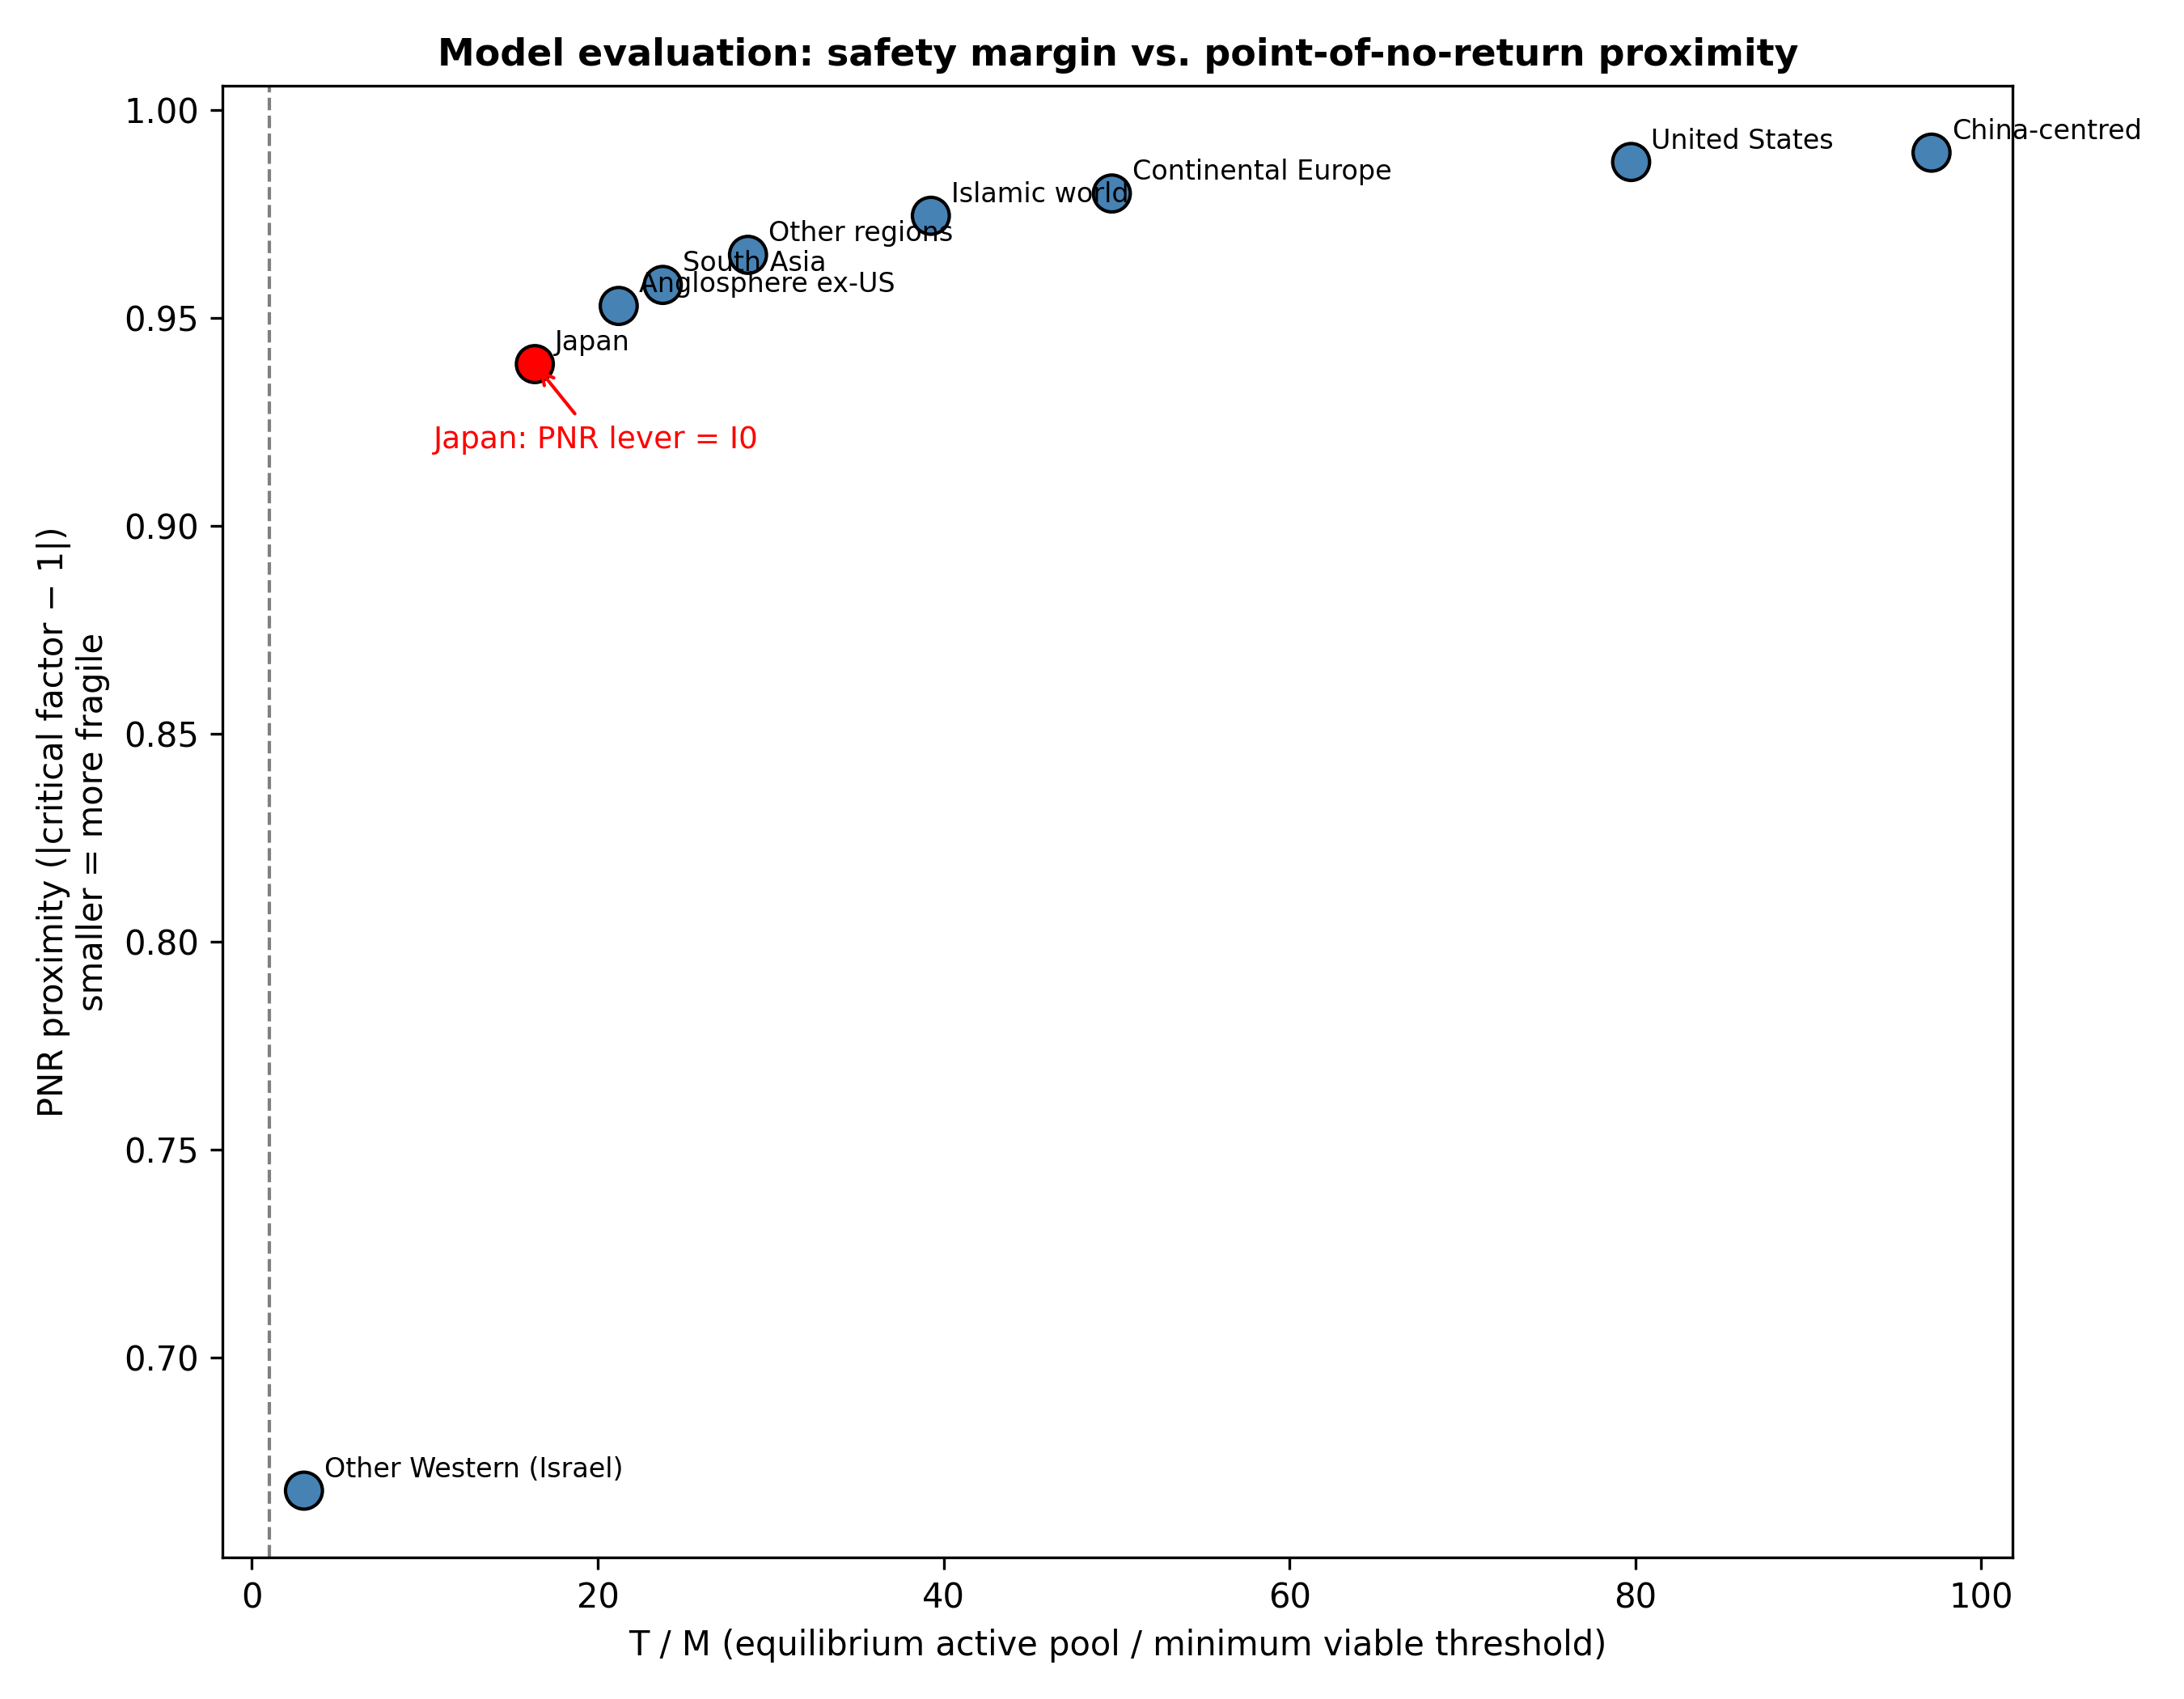
Figure 8. Equilibrium safety ratio ($T/M$) versus closest point-of-no-return proximity for all research macro-regions. Japan is shown in red.

5.7 Talent concentration: short-run dominance, field-level loss
Figure 9 and Table 8 summarise the scenario with China-centred as the dominant region; it is the largest observed host of abroad researchers. With the fitted rates ($γ = 0$) the pull works for the region that exerts it: for φ from 0.5 to 8.0, its hosted active pool ends 22-155% above baseline and its share of all researchers hosted abroad rises from 31% to as much as 77% (upper-left panel). The field pays in concentration: the effective number of macro-regions falls from 5.2 to 4.8-1.8 (upper-right panel), and the lowest $T/M$ among source regions ends at 0.50, with 1 source region below $M$ at the strongest pull. For this host the field's total hit stock falls even without a variety effect: it rises by at most 7.1% (peaking at t ≈ 0.4-0.5 $τ$ (≈9-12 years at fitted rates)), drops below baseline from t ≈ 1.1-1.7 $τ$ (≈28-41 years at fitted rates), and ends 0.3-5.5% below it (lower-left panel), because the researchers it attracts, and the early-career researchers they recruit, generate hits at the host's fitted domestic rate, which ranks 2nd lowest of the nine (Figure 10), while PI-driven recruitment in the source regions weakens. With the United States as the dominant region the field's hit stock rises at $γ = 0$ (Table 8), because its fitted domestic rates are higher, and falls below baseline once γ exceeds 0.5-4.9 at the pull intensities where the threshold is reached within the search range. In both cases the dominant region keeps a larger share of a more concentrated field; whether the field is also smaller depends on the host's own reproduction rates and on how much output owes to variety.
Whether the dominant region itself ends worse off depends on γ (lower-right panel). With China-centred at $φ = 2.0$, its own hit stock at the end of the horizon (4.1 $τ$) is 98% above baseline with $γ = 0$ and 18% above it with $γ = 2$, while the field's is 45% below. The elasticity at which its own output falls below baseline within the horizon is γ* = 4.5 at $φ = 0.5$ and 1.5 at $φ = 8.0$: the harder it pulls, the less variety dependence is needed for the strategy to turn against it. For the United States the same threshold is reached within $γ ≤ 6$ only at the strongest pull. The field-level loss of variety is therefore the robust finding; the field-level loss of output holds at $γ = 0$ for one host and above a moderate γ for the other; and the dominant region's own loss requires the largest γ. γ is not identified by our data, and it is the empirical quantity on which the difference between a lasting relative advantage for the dominant region and a dead end for it turns.
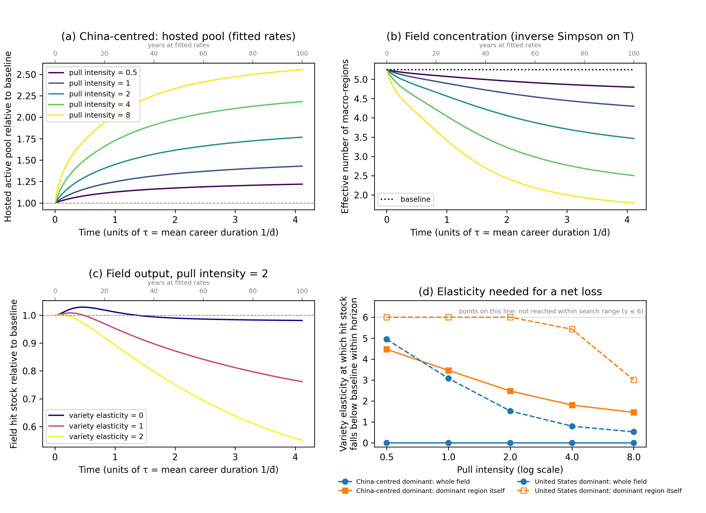
Figure 9. Talent-concentration scenario with China-centred as the dominant region (coupled nine-region model, fitted rates unless stated). (a) Hosted active pool relative to the $φ = 0$ baseline; (b) effective number of macro-regions; (c) field hit stock relative to baseline at $φ = 2.0$ for three variety elasticities γ; ($d$) smallest γ at which the field's, and the dominant region's own, hit stock falls below baseline within the horizon, for the two largest host regions (points on the dotted line at the top of the panel: not reached within the search range). Time in (a)-(c) is in units of $τ = 1/\overline{d}$ (upper axis: years at fitted rates). φ and γ are stylised.
Dominant region | Pull intensity φ | Hosted pool at end of horizon (× baseline) | Share of hosted researchers at end of horizon (%) | Effective number of regions at end of horizon | Regions below $M$ | Field hit stock at end of horizon (× baseline) | γ* field | γ* dominant region
China-centred | 0.5 | 1.22 | 37 | 4.8 | 0 | 1.00 | 0 (fitted model) | 4.47
China-centred | 1.0 | 1.43 | 43 | 4.3 | 0 | 0.99 | 0 (fitted model) | 3.46
China-centred | 2.0 | 1.77 | 53 | 3.5 | 0 | 0.98 | 0 (fitted model) | 2.48
China-centred | 4.0 | 2.18 | 66 | 2.5 | 0 | 0.96 | 0 (fitted model) | 1.80
China-centred | 8.0 | 2.55 | 77 | 1.8 | 1 | 0.94 | 0 (fitted model) | 1.45
United States | 0.5 | 1.46 | 24 | 5.2 | 0 | 1.03 | 4.95 | not reached
United States | 1.0 | 1.93 | 31 | 5.0 | 0 | 1.07 | 3.08 | not reached
United States | 2.0 | 2.76 | 43 | 4.5 | 0 | 1.13 | 1.52 | not reached
United States | 4.0 | 3.87 | 57 | 3.3 | 0 | 1.20 | 0.79 | 5.42
United States | 8.0 | 4.92 | 71 | 2.2 | 1 | 1.27 | 0.52 | 3.01
Table 8. Talent-concentration scenario at the end of the horizon (4.1 $τ$ ≈ 100 years at fitted rates) relative to the $φ = 0$ baseline, fitted rates ($γ = 0$), for the two largest observed host regions. γ* is the smallest variety elasticity at which the hit stock falls below baseline within the horizon.
Figure 10 shows the time paths behind these summaries for every macro-region at the strongest pull we simulate ($φ = 8.0$), one panel per γ. The dominant region's active pool rises and stays high, the source regions decline towards their thresholds at rates set by their fitted transition rates, and each crossing of $M$ switches off a region's PI-driven recruitment under the collapse rule, so that within the simulation each crossing is a discrete loss for the field rather than one more step in a smooth contraction. Other Western (Israel) falls below $M$ at t ≈ 2.1, 1.7, 1.5 $τ$ (≈50, 41, 37 years at fitted rates) for γ of 0, 1 and 2 respectively; no other region crosses within the horizon. Larger γ brings the crossing forward, because the loss of variety lowers hit generation everywhere, including in the dominant region. The other source regions end the horizon above $M$ but on declining paths, so the horizon, not the mechanism, bounds how many crossings the figure shows; the geographical extent of the field (Figure 1) is traded for a shorter temporal one. The timing scales with $τ$: a field with faster career turnover would reach the same crossings in proportionally fewer years, so the ordering of outcomes, not the calendar dates, is the result.
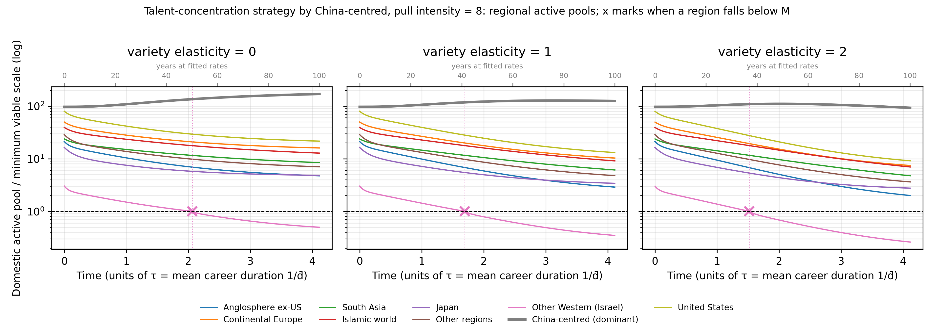
Figure 10. Regional time paths under the talent-concentration strategy exerted by China-centred at pull intensity $φ = 8.0$, for three variety elasticities γ. Lines show each macro-region's domestic active pool as a multiple of its minimum viable coauthor scale $M$ (log scale; dashed line $M$); the thick line is the dominant region. Crosses and dotted verticals mark when a region falls below $M$, after which its PI-driven recruitment is switched off permanently. Time is in units of the characteristic time $τ = 1/\overline{d}$ (mean career duration; ≈24 years at fitted rates, upper axis). Fitted rates; φ, γ and the collapse rule are stylised.

6. Discussion

6.1 What the propositions show
P1 is consistent with the results in the sense that matters for policy: rankings by absolute $T$ and by proximity to the threshold diverge ($ρ = 0.93$), the largest systems are not the safest, and proximity itself is governed by $T/M$ as the mechanism implies; as Section 2.6 notes, this is a diagnostic reading rather than a test. P2 is supported in every macro-region: dropout is more elastic than early-career outflow, and reducing dropout is the most efficient single lever. P3 is supported: $I_{0}$ is the closest point-of-no-return lever for the active researcher pool in every group, and the ranking is invariant to the form of the recruitment feedback. The primacy of the entry lever is a property of the fitted thresholds rather than of the mechanism: when $M$ is raised to 1.25× its fitted value or more, dropout becomes the closest lever in Other Western (Israel) (Section 5.5), which is why we read P3 as support for the entry lever being binding at the observed scale, not as a general law. P4 is supported in its weak form: equilibria differ between the two career-start windows in all 9 macro-regions with dual-window support, and the margin shrinks in Japan. Together the results move the researcher-mobility debate from net flows to the transition rates that govern reproduction, and they give the evolutionary argument about variety an empirically observable early-warning variable.

6.2 Variety loss as an evolutionary dead end
The mechanism implies that concentration in AI/ML research is not merely distributional. Short-run efficiency from scale in compute and data is real [39], but the same feedbacks that produce it narrow the population on which selection operates. If a macro-region's active pool falls below $M$, the PIs who framed problems from that system's languages, data and institutional context stop being replaced [41,42]; the benchmarks and hardware paths they might have championed are not tried [34,35]; and the field loses an independent check on correlated errors of the kind Kleinberg and Raghavan describe [33]. In Saviotti's terms, variety that is not regenerated is eventually exhausted by selection [16]; in Arthur's, the outcome is locked in [11]. Open-source diffusion widens access to methods but does not regenerate the local PI stock, which in the fitted model feeds the binding entry lever. This is the sense in which a research system's PNR is an evolutionary dead end for the field rather than a loss for one country.

6.3 Who benefits from preserving variety?
Because the argument is mechanistic rather than national, its beneficiaries can be stated by actor.
Governments and funders of smaller research systems. The model tells them which transition is binding and how large a proportional change would reach the threshold. Because $I_{0}$ is the closest lever, doctoral pipelines and early-career entry are first-order defences, while dropout reduction is the most elastic single lever; blocking outflow is not. Table 9 maps levers to instruments.
Universities and research institutes. The PI stock is the node of the network externality: institutions that convert hit researchers into PIs ($p_{D}$) and retain them ($d$) regenerate their own inflow. The framework lets a university read its own transition rates against the macro-regional ladder in Figure 7.
Early-career researchers. In the fitted model, going abroad is a smaller threat to a home system than net-flow accounting implies; attrition is the larger one. Policies that support return and dual affiliation rather than penalising mobility serve both the individual and the system. Researchers in systems near their threshold face shrinking prospects of independent PI positions, and the equilibrium diagnostic gives an early indication of that risk.
The field as a whole. Multi-site and internationally distributed teams retain high impact [50,51], and collaboration between the largest systems is more impactful than either alone [13]. Sustaining the systems that supply those collaborators keeps the field's menu of problems, benchmarks and evaluation norms wide, which is what allows it to correct errors and change paradigms.
Society. AI systems are deployed in health, education, administration and language across societies whose data and languages are under-represented in the dominant paradigm [41,42]. A field with more independent research systems is more likely to build, test and contest systems for those contexts. The competition for talent among jurisdictions [5,52] is therefore not zero-sum at the level of society: the losers of a round of concentration include the users of the technology, not only the systems that lost researchers.

6.4 Policy levers and early warning
Table 9 maps the sensitive levers to instruments and to the actors who control them. $I_{0}$ and $h_{D}$ are mainly set by national funders and ministries; $p_{D}$ and $d$ by universities and department heads; $β$ by diaspora networks, return grants and recruiters. The framework can be rerun with each OpenAlex release to update rates, margins and proximity; the exploratory annual layer in Supplementary Material Section S2 provides the machinery for tracking rates year by year, although its current direction-prediction skill is low and it should be read as a monitor rather than a forecast. Because endogenous inflow is capped at 0.50× the critical reproduction rate, the implied interventions are conservative: they aim to keep systems away from the threshold, not to maximise any one system's share. Where inter-regional mobility cannot be regulated, intra-regional levers—$d$, $h_{D}$ and $p_{D}$—remain available and, in the fitted model, are the more elastic ones. All counterfactuals are mechanical; turning them into policy priorities requires programme costs, lags and behavioural responses that are outside this paper.
Lever | Policy instrument | Principal actor
Dropout ($d$) | Early-career fellowships, childcare and dual-career support, stable non-tenure tracks | Universities, department heads
Exogenous entry ($I_{0}$) | Research-master and undergraduate pipelines, doctoral fellowships, recruitment visas | National funders, ministries
Return from abroad ($β$) | Return grants, diaspora networks, dual appointments, overseas-experience recognition | Diaspora networks, funders, recruiters
Domestic hit generation ($h_{D}$) | Independent-lab programmes, doctoral/postdoctoral training, compute access | National funders, universities
PI promotion ($p_{D}$) | Tenure-track conversion, startup packages, project-based PI status | Universities, funders
Table 9. Transition levers, policy instruments and principal actors.

6.5 Implications for policy and for the field's future
The results also bear on the strategy that large research systems are currently pursuing. Concentrating talent, compute and data is individually advantageous for each of them taken alone: it raises short-run output, and a system that stands aside loses ground to those that do not [5,39,52]. The mechanism shows why the collective outcome of that strategy can be an evolutionary dead end. Each round of concentration lowers $T/M$ in the systems that lose researchers, and once one of them falls below $M$ its PI stock stops reproducing and whatever distinct problem framings, benchmarks and data it carried leave the field's menu, with no route back in the model [11,16,17]. The efficiency gains accrue to the concentrating systems immediately; the loss of error-correcting capacity is borne later by the whole field, including those systems, and by the societies that use the technology [33,34]. This is a coordination problem of the kind that talent competition between jurisdictions cannot solve on its own, because no single actor captures the benefit of the variety it preserves. Current debates about pacing AI development are usually framed around safety; the present results suggest a second reason for restraint in the race for talent, which is that the race narrows the population on which the field's own future selection depends.
The scenario in Section 5.7 puts numbers on this argument within the fitted model. A region that pulls early-career researchers from everywhere else gains a larger hosted pool and a larger share for as long as we simulate, and the field ends more concentrated in every setting we examined. Whether the field also ends smaller depends on the host's own reproduction rates and on the variety elasticity γ: for the largest observed host it does so with the fitted rates alone, for the second-largest once γ exceeds a moderate value. Whether the dominant region itself eventually falls below its own baseline requires a larger γ still. Our data do not identify γ, so the model does not say how long the advantage lasts or whether it ends within a national time horizon. The evaluation does not depend on that question. The mechanism in Section 2 holds that variety is what lets the field correct correlated errors and change paradigms; if that premise carries any weight, γ is positive, and at the scale of the field, of society and of humanity the strategy trades error-correcting capacity that everyone uses for a share advantage that one system holds inside a more concentrated and, in the long run, smaller field. A relative advantage sustained inside a shrinking field is exactly the outcome the mechanism identifies as a dead end. Enclosure of AI/ML talent can therefore be individually rational and remain collectively a poor strategy, and the case for coordination does not rest on showing that the enclosing region will lose.
For a system that is weighing whether to recruit aggressively from others, the same scenario gives the conditions under which the strategy turns against the recruiter. In the simulation, the dominant region's own hosted hit stock falls below its no-pull baseline within the horizon once γ exceeds a threshold that decreases as the pull intensifies: from 4.5 at $φ = 0.5$ to 1.5 at $φ = 8.0$ with China-centred as host, and only at the two strongest pull intensities ($γ = 5.4$ and 3.0) with the United States as host, whose higher fitted domestic reproduction rates absorb more of the variety loss. The field's PI stock, its capacity to reproduce the next generation, ends below baseline once γ exceeds 0.17-0.45 for China-centred and 0.75-4.97 for the United States, in each case well below the γ at which the host's own output reverts. Three qualifications bound this reading. The thresholds are outputs of a stylised simulation under the assumptions in Supplementary Table S8, not empirical estimates; γ is not identified by our data; and the values depend on which region pulls, how hard, whether hosts recruit, and which outcome is scored, so no single number applies across settings. The result is therefore not that international recruitment is harmful as such. It is that a recruiter cannot assume its gain is permanent: the harder it pulls, and the more the field's output owes to variety, the smaller the γ at which its own advantage in absolute output reverts, while the field-level losses in variety and in PI reproduction arrive earlier and at smaller γ still. For a system deciding whether to draw on smaller systems, that is the case for restraint the fitted model supports; for a system deciding how to respond to being drawn on, it points back to the levers in Table 9 rather than to barriers on mobility.
Three practical steps follow from the fitted model rather than from national interest. First, multilateral early-career fellowships aimed at systems with low $T/M$, funded jointly by the largest systems, act on the two levers the model identifies as most consequential: $I_{0}$ as the closest lever to the threshold and dropout as the most elastic one. Return grants and dual appointments that keep researchers attached to their origin system ($β$) complement them without penalising mobility, which the fitted model finds to be a weak lever. Second, funders, leading venues and research institutions can monitor regional variety directly, using $T/M$ and point-of-no-return proximity as indicators that can be recomputed with each OpenAlex release alongside author-affiliation statistics, and treat a declining margin in any macro-region as a signal for the field rather than for that region alone. Third, shared compute and data infrastructure open to researchers in smaller systems acts on $h_{D}$ and $p_{D}$, the intra-regional levers that remain available where mobility itself cannot or should not be steered.
On the field's trajectory, the comparison of career windows in Section 5.4 shows the margin shrinking in Japan while it widened in the other macro-regions, so the macro-regions are not drifting in the same direction. If those drifts persist, a system can move from a comfortable $T/M$ to the threshold without any single year looking alarming, and the field would come to depend on fewer independent sources of problems and evaluation norms. This is a projection of current rates, not a forecast, and rates can change with policy; the exploratory annual layer in Supplementary Material exists to detect whether they do. The point of the framework is to make that drift visible while the levers that reverse it are still inexpensive, before proximity to $M$ turns a distributional question into one that the model treats as irreversible.

6.6 Limitations
OpenAlex affiliation and country assignments are noisy, especially for multi-affiliated authors, and coverage of non-English venues is incomplete. The macro-regional grouping is coarse; within-group heterogeneity is substantial, and the grouping of, for example, mainland China and Taiwan follows current OpenAlex country metadata rather than any resolution of their relationship. Geographic variety is a proxy for the cognitive and institutional variety the mechanism concerns, and the model does not observe research content directly; that macro-regions differ in institutions, languages and funding is documented, but that they carry distinct research programmes is assumed here, not measured, and claims about problem framings or benchmarks should be read with that qualification. Irreversibility is likewise a property of the collapse rule, not an empirical finding: a real system that fell below $M$ could in principle rebuild through return migration or new entry, which the model does not represent, so 'PNR' denotes the threshold at which the fitted feedback loop stops sustaining the pool, not a prediction that recovery is impossible. The model omits cross-region spillovers, firm-level mobility and within-year dynamics; rates are assumed constant within windows; the cohort over-weights prolific authors; and bootstrap intervals are wide, so rankings are descriptive. The endogenous inflow cap (0.50) is a modelling choice whose alternatives should be mapped. Falling below $M$ is a sufficient rather than necessary condition for collapse, and the historical comparison rests on two point estimates. The talent-concentration scenario couples the regions only through observed host shares and stylised pull, retention and collapse rules, holds fitted rates constant over a long horizon, and treats the variety elasticity γ as a free parameter; its results are model-consistent projections that rank strategies, not predictions of when any region's advantage ends. The PI and hit proxies follow AI/ML authorship conventions (group leader listed last or corresponding; hits scored within the AI/ML subfield); the Supplementary robustness check varies the PI proxy, but transfer of the pipeline to fields with alphabetical author order or consortium authorship requires redefining these proxies, as documented in the public code. Finally, the propositions are tested on nine macro-regions, so correlational support for P1 is indicative; the strongest support is for P2 and P3, which hold system by system.

7. Conclusion
Jevons asked how long a general-purpose input would sustain a system that depended on it. For AI/ML research talent the analogous question is not exhaustion but distribution: at what point does the concentration of a reproducible input leave some research systems unable to reproduce it? We derived a mechanism from career-transition rates through network externalities and minimum viable scale to variety loss, and examined four propositions with a compartment model fitted to open bibliometric data for nine research macro-regions. All systems currently exceed their minimum viable coauthor scale, but distance to the threshold is governed by relative scale and by attrition rather than by size or outflow; exogenous entry is the binding lever everywhere; the ranking is robust to the form of the recruitment feedback; and rates have drifted between career windows, shrinking the margin in Japan. The case for preserving variety across research macro-regions rests on these mechanics rather than on national interest: the beneficiaries are the governments and institutions that can act on specific levers, the early-career researchers whose prospects depend on them, the field whose capacity for error correction depends on independent systems, and the societies whose problems, data and languages those systems represent. A coupled simulation of an aggressive concentration strategy shows why: the region that concentrates talent gains a larger share for as long as we simulate, while the field loses macro-regional variety at once and concentration can reduce total output after a transient gain, so concentrating talent is individually rational for each large system and can become, at the scale of the field, of society and of humanity, an evolutionary dead end; how long the individual advantage lasts depends on how much research output owes to variety, which is the open empirical question. This is why the practical response has to be shared: jointly funded early-career fellowships and return grants for low-$T/M$ systems, routine monitoring of $T/M$ across macro-regions, and open compute and data infrastructure. Extensions include finer partitions with explicit inter-regional spillovers, dynamic solution of the ODE to estimate time to threshold, endogenous coauthor thresholds, application to other general-purpose research fields, and integration with programme cost data.

References
1. Jevons W S. The Coal Question: An Inquiry Concerning the Progress of the Nation, and the Probable Exhaustion of Our Coal-Mines. London: Macmillan, 1865.
2. Bresnahan T F, Trajtenberg M. General purpose technologies 'Engines of growth'? J Econom. 1995;65(1):83-108. https://doi.org/10.1016/0304-4076(94)01598-T
3. MacroPolo. The Global AI Talent Tracker 2.0. Paulson Institute, 2023. https://macropolo.org/digital-projects/the-global-ai-talent-tracker/
4. Appelt S, van Beuzekom B, Galindo-Rueda F, de Pinho R. Which factors influence the international mobility of research scientists? OECD Science, Technology and Industry Working Papers 2015/02, 2015. https://doi.org/10.1787/5js1tmrr2233-en
5. Shachar A. The Race for Talent: Highly Skilled Migrants and Competitive Immigration Regimes. NYU Law Rev. 2006;81(1):148-206.
6. Thorn K, Holm-Nielsen L B. International Mobility of Researchers and Scientists: Policy Options for Turning a Drain into a Gain. UNU-WIDER Research Paper No. 2006/83, 2006. https://www.wider.unu.edu/publication/international-mobility-researchers-and-scientists
7. Franzoni C, Scellato G, Stephan P E. Foreign-born scientists: mobility patterns for 16 countries. Nat Biotechnol. 2012;30(12):1250-1253. https://doi.org/10.1038/nbt.2449
8. Stephan P E. The Economics of Science. J Econ Lit. 1996;34(3):1199-1235.
9. Nelson R R, Winter S G. An Evolutionary Theory of Economic Change. Cambridge, MA: Harvard University Press, 1982.
10. Dosi G. Technological paradigms and technological trajectories: a suggested interpretation of the determinants and directions of technical change. Res Policy. 1982;11(3):147-162. https://doi.org/10.1016/0048-7333(82)90016-6
11. Arthur W B. Competing technologies, increasing returns, and lock-in by historical events. Econ J. 1989;99(394):116-131. https://doi.org/10.2307/2234208
12. Priem J, Piwowar H, Orr R. OpenAlex: A fully-open index of scholarly works, authors, venues, institutions, and concepts. arXiv:2205.01833, 2022. https://doi.org/10.48550/arXiv.2205.01833
13. AlShebli B, Memon S A, Evans J A, Rahwan T. China and the U.S. produce more impactful AI research when collaborating together. Sci Rep. 2024;14:28576. https://doi.org/10.1038/s41598-024-79863-5
14. Yuan S, Shao Z, Wei X, Tang J, Hall W, Wang Y, et al. Science behind AI: the evolution of trend, mobility, and collaboration. Scientometrics. 2020;124(2):993-1013. https://doi.org/10.1007/s11192-020-03423-7
15. Metcalfe J S. Evolutionary Economics and Creative Destruction. London: Routledge, 1998. https://doi.org/10.4324/9780203275146
16. Saviotti P P. Technological Evolution, Variety and the Economy. Cheltenham: Edward Elgar, 1996. https://doi.org/10.4337/9781035334858
17. David P A. Clio and the economics of QWERTY. Am Econ Rev. 1985;75(2):332-337.
18. Lundvall B-Å. National Systems of Innovation: Toward a Theory of Innovation and Interactive Learning. London: Anthem Press, 1992.
19. Malerba F. Sectoral systems of innovation and production. Res Policy. 2002;31(2):247-264. https://doi.org/10.1016/S0048-7333(01)00139-1
20. Stirling A. A general framework for analysing diversity in science, technology and society. J R Soc Interface. 2007;4(15):707-719. https://doi.org/10.1098/rsif.2007.0213
21. Aghion P, Bloom N, Blundell R, Griffith R, Howitt P. Competition and innovation: an inverted-U relationship. Q J Econ. 2005;120(2):701-728. https://doi.org/10.1162/0033553053970214
22. Olazaran M. A sociological study of the official history of the perceptrons controversy. Soc Stud Sci. 1996;26(3):611-659. https://doi.org/10.1177/030631296026003005
23. Rumelhart D E, Hinton G E, Williams R J. Learning representations by back-propagating errors. Nature. 1986;323(6088):533-536. https://doi.org/10.1038/323533a0
24. Joravsky D. The Lysenko Affair. Cambridge, MA: Harvard University Press, 1970.
25. Colander D, Goldberg M, Haas A, Juselius K, Kirman A, Lux T, et al. The financial crisis and the systemic failure of the economics profession. Crit Rev. 2009;21(2-3):249-267. https://doi.org/10.1080/08913810902934109
26. Smolin L. The Trouble with Physics: The Rise of String Theory, the Fall of a Science, and What Comes Next. Boston: Houghton Mifflin, 2006.
27. Ullstrup A J. The impacts of the southern corn leaf blight epidemics of 1970-1971. Annu Rev Phytopathol. 1972;10:37-50. https://doi.org/10.1146/annurev.py.10.090172.000345
28. McCook S. Global rust belt: Hemileia vastatrix and the ecological integration of world coffee production since 1850. J Glob Hist. 2006;1(2):177-195. https://doi.org/10.1017/S174002280600012X
29. Avelino J, Cristancho M, Georgiou S, Imbach P, Aguilar L, Bornemann G, et al. The coffee rust crises in Colombia and Central America (2008-2013): impacts, plausible causes and proposed solutions. Food Secur. 2015;7(2):303-321. https://doi.org/10.1007/s12571-015-0446-9
30. Ploetz R C. Management of Fusarium wilt of banana: a review with special reference to tropical race 4. Crop Prot. 2015;73:7-15. https://doi.org/10.1016/j.cropro.2015.01.007
31. Chu J S G, Evans J A. Slowed canonical progress in large fields of science. Proc Natl Acad Sci USA. 2021;118(41):e2021636118. https://doi.org/10.1073/pnas.2021636118
32. Park M, Leahey E, Funk R J. Papers and patents are becoming less disruptive over time. Nature. 2023;613(7942):138-144. https://doi.org/10.1038/s41586-022-05543-x
33. Kleinberg J, Raghavan M. Algorithmic monoculture and social welfare. Proc Natl Acad Sci USA. 2021;118(22):e2018340118. https://doi.org/10.1073/pnas.2018340118
34. Hooker S. The hardware lottery. Commun ACM. 2021;64(12):58-65. https://doi.org/10.1145/3467017
35. Koch B, Denton E, Hanna A, Foster J G. Reduced, reused and recycled: the life of a dataset in machine learning research. arXiv:2112.01716, 2021. https://doi.org/10.48550/arXiv.2112.01716
36. Raji I D, Bender E M, Paullada A, Denton E, Hanna A. AI and the everything in the whole wide world benchmark. arXiv:2111.15366, 2021. https://doi.org/10.48550/arXiv.2111.15366
37. Kaplan J, McCandlish S, Henighan T, Brown T B, Chess B, Child R, et al. Scaling laws for neural language models. arXiv:2001.08361, 2020. https://doi.org/10.48550/arXiv.2001.08361
38. Bommasani R, Hudson D A, Adeli E, Altman R, Arora S, von Arx S, et al. On the opportunities and risks of foundation models. arXiv:2108.07258, 2021. https://doi.org/10.48550/arXiv.2108.07258
39. Sevilla J, Heim L, Ho A, Besiroglu T, Hobbhahn M, Villalobos P. Compute trends across three eras of machine learning. In: 2022 International Joint Conference on Neural Networks (IJCNN). IEEE; 2022. p. 1-8. https://doi.org/10.1109/IJCNN55064.2022.9891914
40. Ahmed N, Wahed M. The de-democratization of AI: deep learning and the compute divide in artificial intelligence research. arXiv:2010.15581, 2020. https://doi.org/10.48550/arXiv.2010.15581
41. Joshi P, Santy S, Budhiraja A, Bali K, Choudhury M. The state and fate of linguistic diversity and inclusion in the NLP world. In: Proceedings of the 58th Annual Meeting of the Association for Computational Linguistics. ACL; 2020. p. 6282-6293. https://doi.org/10.18653/v1/2020.acl-main.560
42. Bender E M, Gebru T, McMillan-Major A, Shmitchell S. On the dangers of stochastic parrots: can language models be too big? In: Proceedings of the 2021 ACM Conference on Fairness, Accountability, and Transparency (FAccT '21). ACM; 2021. p. 610-623. https://doi.org/10.1145/3442188.3445922
43. Hong L, Page S E. Groups of diverse problem solvers can outperform groups of high-ability problem solvers. Proc Natl Acad Sci USA. 2004;101(46):16385-16389. https://doi.org/10.1073/pnas.0403723101
44. Alcott B. Jevons' paradox. Ecol Econ. 2005;54(1):9-21. https://doi.org/10.1016/j.ecolecon.2005.03.020
45. Katz M L, Shapiro C. Network externalities, competition, and compatibility. Am Econ Rev. 1985;75(3):424-440.
46. Shaffer M L. Minimum Population Sizes for Species Conservation. BioScience. 1981;31(2):131-134. https://doi.org/10.2307/1308256
47. Huntington S P. The Clash of Civilizations and the Remaking of World Order. New York: Simon & Schuster, 1996.
48. State B, Park P, Weber I, Macy M. The mesh of civilizations in the global network of digital communication. PLoS ONE. 2015;10(5):e0122543. https://doi.org/10.1371/journal.pone.0122543
49. Chinchilla-Rodríguez Z, Miao L, Murray D, Robinson-García N, Costas R, Sugimoto C R. A global comparison of scientific mobility and collaboration according to national scientific capacities. Front Res Metr Anal. 2018;3:17. https://doi.org/10.3389/frma.2018.00017
50. Jones B F, Wuchty S, Uzzi B. Multi-University Research Teams: Shifting Impact, Geography, and Stratification in Science. Science. 2008;322(5905):1259-1262. https://doi.org/10.1126/science.1158357
51. Freeman R B, Huang W. Collaboration: Strength in diversity. Nature. 2014;513(7518):305. https://doi.org/10.1038/513305a
52. Kerr W R. Global Talent and U.S. Immigration Policy. Harvard Business School Working Paper No. 20-107, 2020. https://www.hbs.edu/ris/Publication%20Files/20-107_0967f1ab-1d23-4d54-b5a1-c884234d9b31.pdf

