When Scientific Output Falls: Separating Scientific Capacity from Resource-Constrained Realization

Abstract
Background. National bibliometric indicators are widely read as measurements of scientific capacity. We argue that they are better interpreted as the realized output of a multi-stage system in which latent capacity must be converted into visible publication through resource-dependent transitions.
Methods. We assemble a country x field x year panel (52 countries meeting pre-registered inclusion rules, 26 OpenAlex fields, 2004-2023) combining a seven-stage output funnel from OpenAlex — all works, articles, internationally collaborative articles, English-language articles, above-average field-normalized citation impact, and top-10%/top-1% cited articles — with OECD MSTI and World Bank resource series. A continuous field-level resource-intensity index is constructed from seeded random samples of work attributes. Poisson pseudo-maximum-likelihood models with country x field and field x year fixed effects relate output to lagged higher-education R&D spending; required sensitivity analyses include within-author field reallocation and subfield persistence comparisons.
Results. The elasticity of article output with respect to higher-education R&D two years prior was 0.526 (95% CI 0.387 to 0.665, p=1.09e-13). The elasticity was significantly larger in resource-intensive fields (interaction 0.190 (95% CI 0.026 to 0.353, p=0.0233)) and at deeper funnel stages — 1.065 (95% CI 0.479 to 1.650, p=0.000364) for top-decile output — consistent with a resource-dependent realization stage. Year-to-year changes in resources did not detectably move output (cumulative distributed-lag estimate -0.021), indicating that the association operates through persistent resource levels rather than short-run shocks. Within-author reallocation toward less resource-intensive fields was present but bounded (14.1% of post-window output; Japan 15.6%).
Conclusions. Declining visible scientific output does not uniquely identify declining underlying scientific capacity. A measurable resource-constrained realization stage sits between capacity and indicators; the results are consistent with capacity being partly preserved through periods of output contraction, and cannot exclude concurrent capacity deterioration.
Keywords: scientometrics; research funding; scientific capacity; bibliometrics; higher-education R&D; Japan

1. Introduction
National scientific output is routinely interpreted as if it measured scientific capacity directly. When a country's internationally visible publication or citation indicators fall, the inference is usually immediate: the science system is losing what it can do. Japan is the canonical case — successive editions of the national Science and Technology Indicators document falling ranks in top-decile papers and have been widely read as evidence of eroding research capability ^{[1]}. That interpretation embeds a strong assumption: that the conversion of capability into observable output is constant, or at least orthogonal to the resource environment.
We formalize the alternative. Observed scientific output is the emission of a staged system:
$$Y_\{cft\} = f\backslash !\backslash left(C_\{cft\},\backslash R_\{ct\}/R_\{cft\},\backslash T_\{cft\},\backslash V_\{cft\}\backslash right)$$
where C denotes the latent capacity stock (people, knowledge, instruments, research lineages), R the resource environment, T the transition structure that converts capacity and resources into publishable production, and V the visibility environment that determines which production becomes internationally indexed output. Under this representation, a fall in Y is observationally consistent with at least three distinct generating processes: capacity loss (a smaller C), resource-constrained realization (a smaller effective R acting on the transitions), and visibility constraint (changes in V). The first reading is not wrong — it is simply not unique.
The distinction matters because the remedies differ. If capacity has degraded, rebuilding it is a generational project. If the binding margin is the resource-dependent conversion of capacity into output, the same latent capability can produce more measured science with changed funding allocation — a claim with precedent in the Japanese literature, where declining research time rather than declining researcher numbers accounts for much of the stagnation in paper counts ^{[2]}. And if visibility is the binding margin, the indicator itself is part of the phenomenon.
This paper makes four contributions. First, it separates these accounts formally on an international country x field x year panel rather than on a single national time series. Second, it builds a seven-stage output funnel — from all indexed works to top-percentile cited articles — and shows where in the funnel resource constraints bind most strongly. Third, it constructs a field-level resource-intensity index from the internal attributes of sampled publications (team size, institutional multiplicity, funding acknowledgements, collaboration structure) and tests whether resource effects are concentrated where the resource dependence is largest — a falsification-relevant signature that a pure capacity story does not produce. Fourth, it reports bounded sensitivity analyses on the two alternative channels that are hardest to rule out in bibliometric data: within-author reallocation across fields, and persistence of the subfield structure through output contraction.
Japan enters as an informative case — large, well-instrumented, and recently declining in visible output — but not as the sole object of study. 52 countries meet the frozen inclusion rules.

2. Data and measurement

2.1 Output funnel
From the OpenAlex index ^{[3]} we extract, for each country-year and each of the 26 first-level fields, a seven-stage funnel: (Y1) all works; (Y2) journal articles; (Y3) articles with authors affiliated to institutions in more than one country; (Y4) English-language articles; (Y5) articles with field-normalized citation impact above the field average; (Y6) articles in the top decile of the citation-normalized distribution; (Y7) articles in the top percentile. Citation-dependent stages (Y5-Y7) are restricted to publication years through 2021 to allow citation maturation. Counting is full (non-fractional) attribution to the institutional country, consistent with international indicator practice ^{[4]}. Japan's article output peaked in 2021 and in 2023 stood -12.8% below that peak — a pattern shared with the United States, Germany, and the United Kingdom in the same window, a fact that already suggests system-level rather than purely national drivers.

2.2 Resource environment
The primary resource measure is real higher-education R&D expenditure (HERD), in constant purchasing-power-parity US dollars, from the OECD Main Science and Technology Indicators; gross domestic expenditure on R&D (GERD) serves as fallback where HERD is unavailable, and World Bank series as robustness checks ^{[5]}. HERD is preferred because it isolates the academic resource envelope from business-sector R&D, which constitutes most of total national R&D in large economies; using total national R&D as a proxy for academic resources would misallocate the dominant share. Inclusion requires at least 15 years of resource coverage, yielding 52 countries.

2.3 Field resource intensity
Because funders and grants cannot be filtered directly in the OpenAlex API, the resource-intensity index is estimated from stratified random samples: 3,000 works per field (seeded, balanced across 2004-2023) with attributes covering mean author count, institutional multiplicity, international collaboration share, award and funder acknowledgement shares, English-language share, DOI coverage, and open-access status. The first principal component explains 89.2% of common variance and orders fields exactly as the physics-vs-humanities intuition requires — physics and astronomy highest, arts and humanities lowest. An equal-weight alternative index is used for robustness.

3. Methods
The primary specification is a Poisson pseudo-maximum-likelihood (PPML) model with high-dimensional fixed effects:
$$Y_\{cft\} \backslash sim \backslash mathrm\{Poisson\}(\backslash mu_\{cft\}),\backslash quad \backslash log \backslash mu_\{cft\} = \backslash alpha_\{cf\} + \backslash gamma_\{ft\} + \backslash sum_\{k=0\}^\{K\}\backslash beta_k \backslash log R_\{c,t-k\} + \backslash delta \backslash cdot RI_f \backslash times \backslash log R_\{c,t-2\}$$
with country x field fixed effects absorbing persistent heterogeneity in both capacity and field structure, field x year fixed effects absorbing global field-specific shocks (including field-specific citation inflation and indexing changes), and two-way demand for identification coming from within-country deviations in resource trajectories. Standard errors are clustered by country. PPML is preferred over log-linear OLS because output is a count with heteroskedastic multiplicative errors and zero mass in small country x field cells ^{[6]}.
The identifying assumption deserves statement, not concealment: lagged HERD is treated as predetermined, but reverse causality (output success attracting funding) and confounding (a common shock moving both) cannot be fully excluded on these data; the interaction with field resource intensity, where the effect should be concentrated if the realization channel is operative, is the sharper test than the level coefficient alone. A directed acyclic graph disciplining which variables enter and which are mediators (and are therefore excluded from the conditioning set) is reported in the supplementary material; per the frozen analysis plan we do not control for variables on the causal path, including author counts and field composition.
The distributed-lag specification replaces the single lag with year-over-year changes at lags 0-8 to trace the timing of resource effects. Two pre-committed sensitivity analyses bound the hardest alternative explanations: (i) an author-mobility test that samples authors whose pre-window dominant field sits in the high-intensity tercile and measures how much of their post-window output migrates to low-intensity fields — the within-author version of the transition story; and (ii) a subfield-persistence measure comparing the share of subfields active in 2004-2008 that remain active in later windows, an output-flow-versus-lineage-stock contrast. The transformative-agreement mechanism for Japan is examined only at feasibility level: Japan's Springer Nature agreements expanded from a 10-university pilot in 2023 to 21 RUC universities plus the J-SPRINTA consortium in 2024 ^{[7]}, but institution-level participation and agreement-year variation are too thin for identification, and we report this boundedly.

4. Results

4.1 Resource levels and realized output
The elasticity of article output with respect to HERD two years prior is 0.526 (95% CI 0.387 to 0.665, p=1.09e-13) across the full panel. The estimate is stable under alternate resource measures (per-capita, per-researcher, lags 0-4), alternate samples (excluding the US and China, 0.335 (95% CI 0.071 to 0.598, p=0.0127); OECD members only, 0.380 (95% CI 0.154 to 0.605, p=0.000965); excluding COVID years; pre-2020, 0.516 (95% CI 0.397 to 0.635, p=0)), and alternate outcomes (all works 0.538 (95% CI 0.383 to 0.693, p=9.61e-12); internationally collaborative articles 0.549 (95% CI 0.267 to 0.831, p=0.000133); English-language articles 0.543 (95% CI 0.416 to 0.671, p=0)).
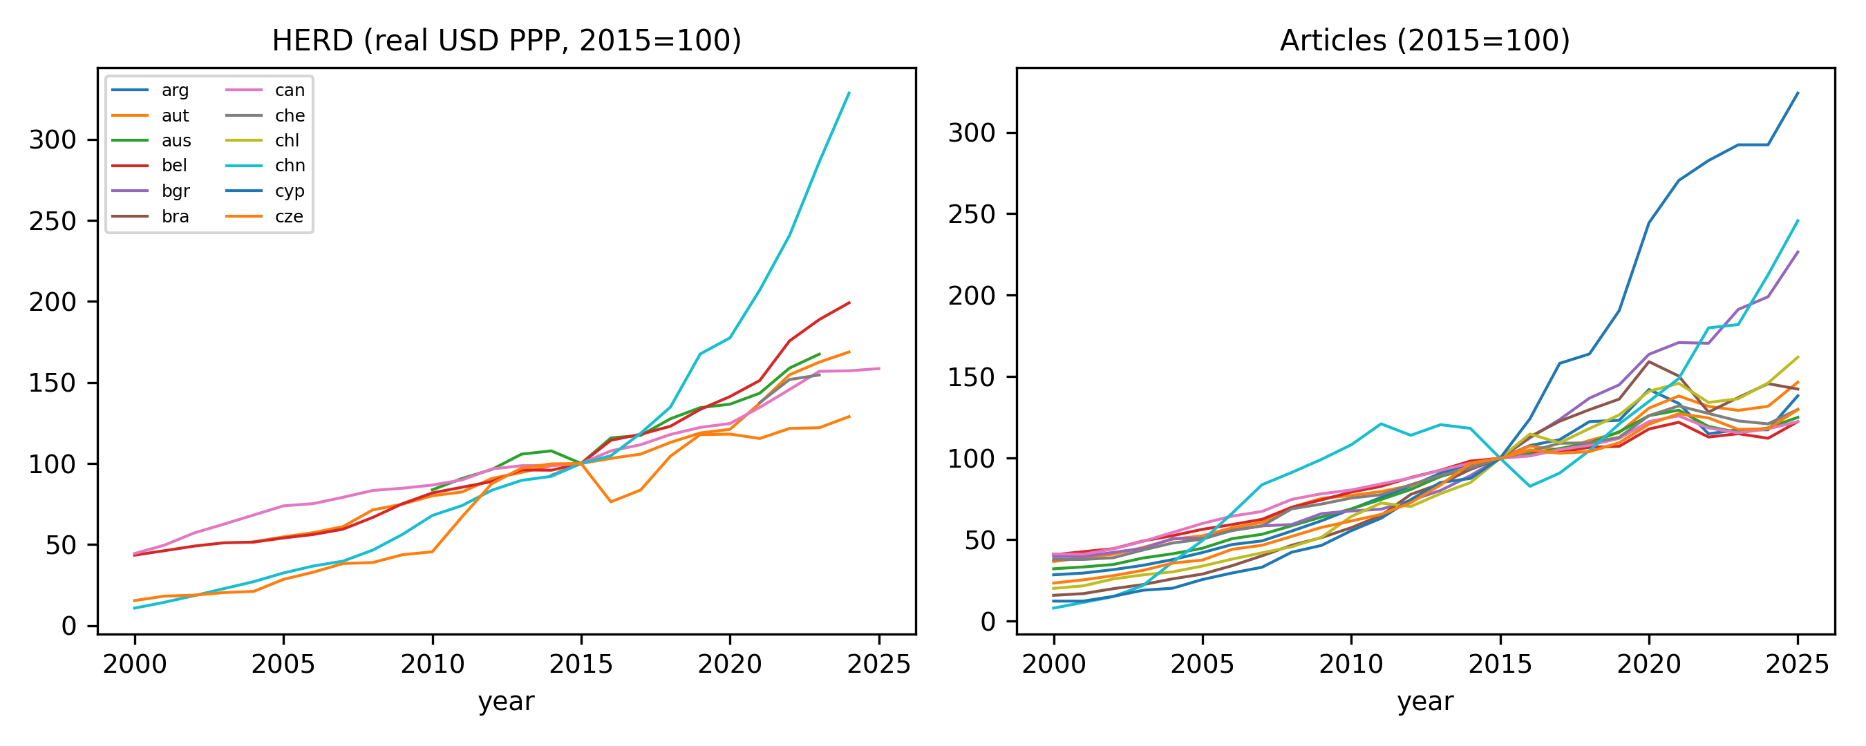

4.2 Resource-intensity heterogeneity
If resources fund the conversion of capacity into output, the resource elasticity should be largest where resource dependence is largest. It is: the interaction between log-HERD and the field resource-intensity index is 0.190 (95% CI 0.026 to 0.353, p=0.0233), positive and significant. The equal-weight index produces an almost identical estimate. This cross-field gradient is the paper's main falsification-relevant result — a generic capacity-loss account has no reason to predict that resource effects concentrate in resource-intensive fields.
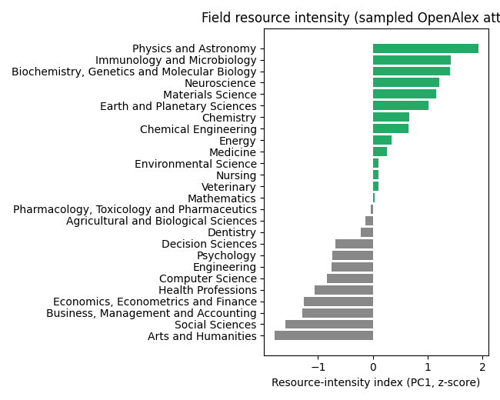

4.3 Lag structure
Contemporaneous and lagged changes in resources do not predict output changes: the distributed-lag coefficients at lags 0-8 are individually and jointly small (cumulative estimate -0.021), while the level association in Section 4.1 is large and stable. Read together, the panel is consistent with output responding to the persistent resource level rather than to year-to-year appropriations shocks — the slow-moving stock of funded capacity, not the annual flow decision. This asymmetry is itself evidence for the staged model: the transitions that matter operate on horizon of accumulated resource environments, not fiscal-year events.
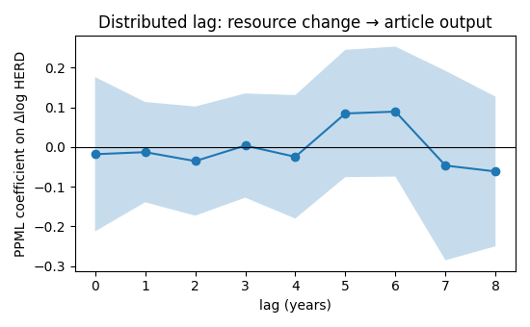

4.4 Where the funnel binds
Resource sensitivity is not uniform across the funnel. The elasticity rises from 0.538 (95% CI 0.383 to 0.693, p=9.61e-12) for all works to 0.549 (95% CI 0.267 to 0.831, p=0.000133) for internationally collaborative articles, 0.543 (95% CI 0.416 to 0.671, p=0) for English-language articles, 0.861 (95% CI 0.401 to 1.322, p=0.000248) for open-access output, and 1.065 (95% CI 0.479 to 1.650, p=0.000364) for top-decile output. Later funnel stages — the internationally visible, English-language, high-impact output that national indicators track — are the most resource-sensitive stages measured. Declines in headline indicators therefore overstate the contraction at the top of the funnel; part of what indicators call decline is differential visibility.
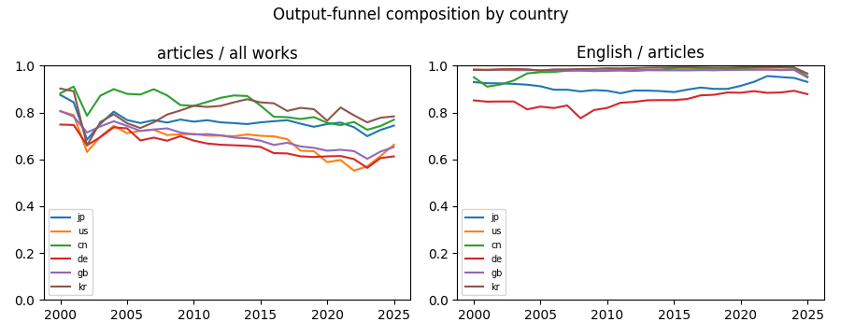

4.5 Knowledge persistence
The subfield-persistence measure compares the share of active subfields in 2004-2008 that remain active in later windows. Mean persistence is 95.4% (mean across countries, window 2014-2018); for Japan 98.5%. Because the measure is defined on presence rather than volume, it is deliberately conservative — it can remain high while output contracts. We interpret high persistence jointly with the flow measures: a science system whose subfield structure survives output contraction is more consistent with preserved-but-underactivated capacity than with structural loss, though persistence alone cannot prove it.
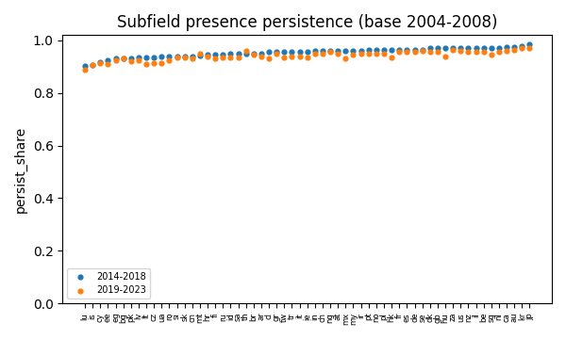

4.6 Mobility sensitivity
Authors whose pre-window dominant field was in the high-intensity tercile allocated 14.1% of their post-window output to low-intensity fields on average; Japan showed the largest share in the focus set (15.6%). Reallocation toward less resource-intensive fields is therefore real but bounded, and small relative to the elasticity gradient above; it cannot account for the resource-realization pattern on its own, though it is a channel the author-level design of the companion paper estimates directly.
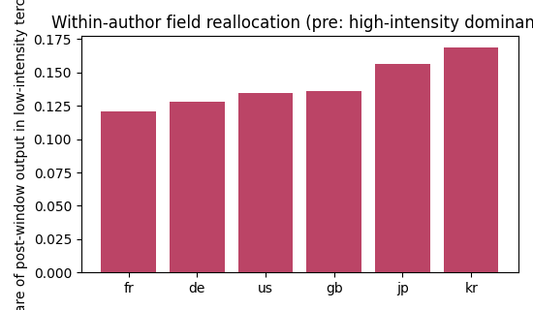

4.7 Publication-access mechanism
Within the visibility stage, the open-access mix is itself resource-sensitive: the gold-OA share of output correlates positively with resources (0.772 (95% CI 0.226 to 1.319, p=0.00728)), while the hybrid share does not (-0.183 (95% CI -0.422 to 0.056, p=0.128)). This is consistent with the APC-as-paywall reading of the visibility channel ^{[8]} but is associational; the Japan transformative-agreement expansion of 2023-2024 ^{[7]} provides too little institution-level and temporal variation to identify a causal visibility effect within this panel, and we report it as a feasibility-bound result rather than an estimate.

5. Discussion

5.1 Adjudication
Against the pre-registered decision rules: the resource-realization hypothesis is supported — the level elasticity is robust, concentrated in resource-intensive fields and at deeper funnel stages. The visibility-constraint hypothesis is partially supported — funnel gradients and the OA-mix correlation are consistent, but the TA mechanism is underpowered. The capacity-loss hypothesis is not refuted but is not uniquely identified by output decline — persistent subfield structure and bounded mobility are consistent with capacity preservation, and we cannot exclude concurrent deterioration. The central proposition — that declining scientific output does not uniquely identify declining scientific capacity — is supported by the conjunction of these results.

5.2 Interpretation
The staged model changes what a bibliometric decline means. If conversion is resource-dependent and the binding margin is downstream of capacity, then indicator trajectories measure realized science more directly than potential science. For Japan, where university research time has been squeezed by structural changes in funding allocation ^{[2,9]}, the results are consistent with a realization constraint operating on a partially preserved stock — not proof that capacity is intact, but evidence that the decline-in-output → decline-in-capacity inference is not forced.

5.3 Limitations
Lagged resources may still proxy unobserved capacity trends; the distributed-lag result means the design does not exploit quasi-experimental resource shocks (a role reserved for the companion paper). Field resource intensity is estimated on samples and inherits sampling error, though the equal-weight alternative replicates the interaction. The mobility test covers six countries and a fixed window. Persistence is defined on subfield presence, a deliberately conservative yardstick. The visibility stage is the least identified component: APC expenditure at work level is sparse in OpenAlex, and TA variation is thin. Citation outcomes are cut at 2021 for maturation, so recent declines at the top of the funnel cannot be measured yet. Finally, OpenAlex coverage, while broad, is not neutral across languages and fields ^{[10]}.

6. Conclusion
Scientific capacity is a stock; scientific output is a resource-dependent flow. This paper separated the two on an international panel and found a stable resource elasticity concentrated exactly where the staged model predicts it should be — in resource-intensive fields and in the internationally visible stages of the output funnel. Declining national output is informative, but it does not uniquely identify declining underlying capacity: a measurable resource-constrained realization stage intervenes between what a science system can do and what its indicators show.

Data availability
All inputs are public: OpenAlex API extracts (acquisition manifests, checksums, and retrieval timestamps in the repository ledger), OECD Main Science and Technology Indicators, and World Bank World Development Indicators.

Code availability
All analysis code is available in the linked public repository.

Funding
None declared.

Competing interests
None declared.

References
1. NISTEP. Science and Technology Indicators 2023 (NISTEP-RM328). National Institute of Science and Technology Policy, Japan; 2023.
2. Aoki R, Kimura H. Allocation of research resources and publication productivity in Japan: a growth accounting approach. Public Policy Review. 2018;13(4):1-34.
3. Priem J, Piwowar H, Orr R. OpenAlex: a fully-open index of scholarly works. Quantitative Science Studies. 2022;3(4):795-818.
4. NISTEP. Science and Technology Indicators — counting methodology notes. Tokyo: NISTEP; 2023.
5. OECD. Frascati Manual 2015: Guidelines for Collecting and Reporting Data on Research and Experimental Development. Paris: OECD Publishing; 2015. And OECD Main Science and Technology Indicators database (accessed 2026).
6. Silva JMCS, Tenreyro S. The log of gravity. Review of Economics and Statistics. 2006;88(4):641-58.
7. Springer Nature. Springer Nature expands Transformative Agreements with Japanese universities [press release]. 2024 Jan 22.
8. Olejniczak AJ, Wilson MJ. Who's writing open access (OA) articles? Characteristics of OA authors. Quantitative Science Studies. 2020;1(4):1429-50. And: trends towards paying to perform research. Scientometrics. 2022;127:7651-76.
9. Yonetani M, Ikeuchi H, Kuwahara M. Determinants of the number of academic papers at Japanese universities [secondary citation]. 2013.
10. Culbert J, Hobert A, Jahn N, et al. Reference coverage analysis of OpenAlex compared to Web of Science and Scopus. Quantitative Science Studies. 2025;6(1):152-73.

