Global Weibull Analysis of Sovereign Reign Durations:
A Reliability Engineering Approach to Quantifying Historical Political Stability

[Author Name(s)]
[Affiliation(s)]
[Name, Email]
\

Abstract
The Weibull distribution, a cornerstone of reliability engineering for modelling failure times in mechanical and electronic components, has recently been applied to political history through Saleh's (2019) landmark study of Roman emperors. We extend this approach to a global scale, fitting the Weibull distribution to sovereign reign durations across 31 distinct polities spanning six continents and over 3,000 years of recorded history. The Weibull shape parameter k serves as a quantitative 'political stability index': k < 1 indicates decreasing hazard (coup-prone regimes where early overthrow is common), k approximately equal to 1 suggests constant hazard (memoryless, random replacement), and k > 1 implies increasing hazard (stable systems where longer reigns become progressively more likely to end, analogous to wear-out failure in engineering). Our main analysis reveals substantial variation across polities (k range: 0.851-2.721; median 1.240). Sub-analyses stratified by succession mechanism demonstrate that elective systems (pooled k = 1.019) exhibit significantly lower stability than hereditary monarchies (pooled k = 1.298; two-sample Kolmogorov-Smirnov p < 0.0001). Era-based stratification shows a monotonic increase in k from antiquity (k = 0.890) through the modern period (k = 1.200), with a reversal in the contemporary era (k = 0.996). Historical validation demonstrates a significant negative correlation between k and violent succession rates (Spearman rho = -0.638, p = 0.0002), confirming that the parameter captures empirically grounded patterns of political violence. These findings establish the Weibull shape parameter as a robust, cross-culturally applicable metric for historical political stability.
Keywords: Weibull distribution; reliability engineering; political stability; reign duration; comparative history; survival analysis; bathtub curve; violent succession

Introduction
The application of reliability engineering methods to historical and social phenomena represents an emerging frontier in quantitative historiography. Reliability engineering, developed primarily for analysing the failure times of mechanical components, electronic devices, and complex systems, provides a mathematically rigorous framework for understanding time-to-event data (Lawless, 2003). At the centre of this framework lies the Weibull distribution, introduced by Waloddi Weibull in 1951, which has become the standard tool for modelling failure-time distributions in engineering (Weibull, 1951; Abernethy, 2004). The distribution's versatility stems from its shape parameter k, which captures qualitatively different failure regimes: k < 1 corresponds to infant mortality (early failures that decrease over time), k = 1 to random failures (constant hazard, equivalent to the exponential distribution), and k > 1 to wear-out failures (increasing hazard with age). These three regimes form the well-known 'bathtub curve' of reliability engineering (O'Connor and Kleyner, 2012).
The conceptual leap from mechanical failure to political succession was pioneered by Saleh (2019), who fitted the Weibull distribution to the reign durations of 69 Roman emperors in a study published in Palgrave Communications. Saleh demonstrated that the distribution of Roman imperial reign lengths followed a Weibull distribution with k = 0.93, indicating a slightly decreasing hazard rate - a pattern consistent with a 'coup-prone' regime where the risk of violent removal was highest in the early years of rule. This groundbreaking work established that the statistical tools developed for engineering reliability could yield meaningful insights when applied to political history.
The theoretical justification for treating sovereign reign durations as analogous to component lifetimes finds unexpected support in constitutional theory. The 'Emperor Organ Theory' (Tenno Kikan-setsu), articulated by the prominent Japanese constitutional scholar Minobe Tatsukichi in the early twentieth century, explicitly conceived of the emperor as an organ (kikan) of the state rather than a transcendent sovereign (Minobe, 1912, 1923). Under this framework, the monarch functions as a component within the larger machinery of governance - a conceptualisation that directly parallels the reliability engineering perspective in which individual components serve defined roles within complex systems. Although Minobe's theory was developed in the specific context of Japanese constitutional law and was controversially suppressed in the 1935 Emperor Organ Theory Incident (Tenno Kikan-setsu Jiken), its core insight - that rulers are functional elements of state apparatus rather than sui generis entities - provides a principled rationale for applying engineering failure models to political succession (Miller, 1965; Banno, 2001).
Despite the promise of Saleh's approach, the existing literature remains limited to a single polity. Whether the Weibull distribution generalises beyond the Roman Empire, and whether the shape parameter k can serve as a meaningful cross-cultural index of political stability, remain open questions. Previous quantitative approaches to political dynamics have examined the growth and decline of empires (Taagepera, 1979), secular cycles in state formation (Turchin, 2003; Turchin and Nefedov, 2009), power-law scaling in conflict severity (Clauset, 2018), and cross-cultural variation in political organisation (Murdock, 1967; Olsson and Paik, 2016), but none have applied parametric survival analysis to sovereign tenure as a systematic metric of political stability. The present study addresses this gap by conducting a systematic Weibull analysis of sovereign reign durations across 31 polities drawn from Europe, Asia, the Middle East, Africa, and the Americas, encompassing over 1,000 individual reigns spanning more than three millennia. We further stratify our analysis by succession mechanism (elective vs. hereditary) and by historical era (Ancient, Medieval, Early Modern, Modern, and Contemporary) to explore structural and temporal determinants of political stability. Critically, we validate our statistical findings against the historical record of violent successions, civil wars, and usurpations to demonstrate that the Weibull shape parameter captures empirically meaningful patterns of political violence.
Our central hypothesis is that the Weibull shape parameter k provides a robust, interpretable, and cross-culturally comparable metric for political stability - a 'peacefulness index' grounded in the mathematics of survival analysis. We test this hypothesis through comprehensive goodness-of-fit testing, bootstrap confidence interval estimation, stratified sub-analyses, and historical validation.

Methods

Data collection and scope
Reign duration data were compiled from established historical sources and verified against multiple references for each polity. A total of 31 distinct polities were included, comprising 1,071 individual reigns. The polities span six geographic-cultural categories: Europe (13 polities: Roman Empire, England/Britain, France, Holy Roman Empire, Denmark, Sweden, Scotland, Spain, Portugal, Poland, Russia, Byzantine Empire, Papacy post-1000 CE); Asia (9 polities: Japan Emperors, China Tang, China Ming, China Qing, Korea Joseon, Korea Goryeo, Mughal Empire, Khmer Empire, Thailand Chakri); Middle East (4 polities: Ottoman Empire, Islamic Caliphate, Mamluk Sultanate, Persia/Iran); Africa (2 polities: Ethiopia, Egypt New Kingdom); and Americas (1 polity: USA Presidents). Reign durations were measured in years from accession to end of reign (abdication, death, or deposition). Reigns of less than 0.25 years were included at their recorded duration. Interregna and regencies were excluded.

Temporal scope and exclusion criteria
Not all polities were analysed across their full historical span. Temporal scope was determined for each polity based on three criteria: (1) reliability of succession records, (2) institutional continuity of the political system, and (3) minimum sample size requirements. Where a polity underwent fundamental institutional transformation (e.g., the transition from Anglo-Saxon heptarchy to the unified English monarchy), only the period of institutional continuity was included. Table A1 (Appendix) provides the complete scope rationale for each polity. Key scope decisions are summarised here.
The Papacy was restricted to the post-1000 CE period for three reasons: (1) the College of Cardinals was established by the papal bull In Nomine Domini (1059), creating the modern conclave electoral system - prior papal selection was dominated by Roman aristocratic factions and imperial appointment, representing a fundamentally different institutional mechanism; (2) pre-1000 CE records contain disputed dates for many early popes; and (3) over 30 anti-popes existed before 1000 CE, making it difficult to define 'legitimate' reign durations consistently. England/Britain was analysed from the Norman Conquest (1066), as pre-Conquest Anglo-Saxon succession operated under a fundamentally different political structure (multiple competing kingdoms). France was analysed from the Capetian dynasty (987), excluding Merovingian and Carolingian periods due to fragmented political structures and unreliable reign records. Sweden was analysed from Gustav I Vasa (1523) due to complications arising from the Kalmar Union period. Persia/Iran was analysed from the Safavid dynasty (1501), as pre-Safavid entities represent fundamentally different political structures with fragmentary succession records.
Japan's Emperors were analysed from Emperor Kinmei (539 CE), excluding the legendary emperors (Jimmu through Ingyo) whose historicity and reign dates are based on mythological tradition rather than verifiable historical records. The Islamic Caliphate encompasses the Rashidun, Umayyad, and Abbasid caliphates (632-1258 CE), excluding post-Mongol shadow caliphates in Cairo, which held no substantive political authority. Egypt was limited to the New Kingdom (1550-1077 BCE), which has the best-documented succession records among Egyptian periods. The Khmer Empire was restricted to the Angkor period (802-1431), as post-Angkor records are too fragmentary for reliable analysis. Ethiopia was analysed from the Solomonic restoration (1270), excluding the earlier Zagwe dynasty due to unreliable chronology. Several polities (China Tang, China Ming, China Qing, Korea Joseon, Korea Goryeo, Mamluk Sultanate, Ottoman Empire, Roman Empire, Byzantine Empire, and USA Presidents) were analysed across their full historical spans.

Classification of succession mechanisms
Each polity was classified as either 'elective' or 'hereditary' based on the predominant succession mechanism. Elective polities (N = 8) include systems where the sovereign was chosen through election, selection by a council, or military acclamation: Roman Empire, Byzantine Empire, Holy Roman Empire, Poland (elected kings period), Papacy, Islamic Caliphate, Mamluk Sultanate, and USA Presidents. Hereditary polities (N = 23) include systems where succession followed dynastic lineage as the primary mechanism, even where occasional irregularities occurred.

Era classification
For the era-based sub-analysis, individual reign durations were assigned to five standard historical periods based on the chronological position of each reign within the polity's temporal range: Ancient (to 476 CE, fall of the Western Roman Empire), Medieval (476-1453 CE, fall of Constantinople), Early Modern (1453-1789, French Revolution), Modern (1789-1945, end of World War II), and Contemporary (1945-present). Assignment was performed proportionally: each reign was placed in the era corresponding to its estimated start date within the polity's total timespan.

Weibull distribution fitting
The two-parameter Weibull distribution with probability density function f(t) = (k/lambda)(t/lambda)^(k-1) exp(-(t/lambda)^k) was fitted to each dataset using maximum likelihood estimation (MLE). The shape parameter k and scale parameter lambda were estimated using Newton-Raphson iteration with initial values obtained from linearised regression on Weibull probability plots. Goodness of fit was assessed using the Kolmogorov-Smirnov (KS) test and the coefficient of determination (R-squared) from the Weibull probability plot. A minimum sample size of N >= 5 was required for fitting.

Bootstrap confidence intervals
Ninety-five percent confidence intervals for the shape parameter k were estimated using nonparametric bootstrap resampling with 500 iterations. For each iteration, a bootstrap sample of size N was drawn with replacement from the observed reign durations, and the Weibull shape parameter was re-estimated. The 2.5th and 97.5th percentiles of the bootstrap distribution defined the confidence interval.

Statistical comparisons
Differences between sub-groups (elective vs. hereditary; between eras) were assessed using the two-sample Kolmogorov-Smirnov test and the Mann-Whitney U test. A bootstrap test for the difference in shape parameters was conducted with 1,000 resamples, computing the probability that k_hereditary > k_elective and the 95% confidence interval for the difference. Kaplan-Meier survival curves (Kaplan and Meier, 1958) were computed for visual comparison of pooled sub-groups. Proportional hazards assumptions were assessed following the framework of Cox (1972). All analyses were conducted in Python 3 using NumPy, SciPy, and Matplotlib.

Historical validation
To validate that the Weibull shape parameter captures empirically meaningful patterns of political stability rather than merely statistical artefacts, we compiled an independent dataset of violent succession events for each polity, drawing on the Archigos dataset of political leaders (Goemans et al., 2009) where available and supplementing with primary historical sources. For each polity, the total number of successions and the number of violent successions (defined as transitions involving assassination, deposition by force, military coup, civil war, or execution of the predecessor) were tallied from historical sources. The number of major civil wars and internal armed conflicts during each polity's analysed period was also recorded. The violent succession rate (violent successions / total successions) and civil war count were then correlated with the Weibull shape parameter k using Pearson and Spearman rank correlation coefficients.

Results

Main analysis: global comparison of 31 polities
The Weibull distribution provided an adequate fit (KS test p > 0.05) for the majority of the 31 polities analysed. Table 1 presents the complete results, ranked by shape parameter k. The shape parameter ranged from k = 0.851 (Mamluk Sultanate) to k = 2.721 (USA Presidents), with a median of 1.240 and a mean of 1.330. Figure 1 displays these results on a world map, where bubble colour indicates the k value (red = low/chaotic, green = high/stable) and bubble size reflects sample size N.
Three distinct stability regimes emerged. First, a 'coup-prone' cluster (k < 1) comprising the Mamluk Sultanate (k = 0.851, 95% CI [0.73, 1.13]), the Roman Empire (k = 0.880, CI [0.78, 1.04]), and the Mughal Empire (k = 0.936, CI [0.72, 1.50]), characterised by decreasing hazard rates where early overthrow was most common. Second, a 'random replacement' cluster (k approximately 1.0-1.3) encompassing the majority of polities, including the Islamic Caliphate (k = 1.004), Russia (k = 1.015), the Byzantine Empire (k = 1.113), and most European and Asian monarchies. Third, a 'stable/aging' cluster (k > 1.5) including Japan's Emperors (k = 1.648), Denmark (k = 1.788), Sweden (k = 1.897), Scotland (k = 1.937), and the USA Presidents (k = 2.721), where reign durations exhibited strong wear-out patterns analogous to component aging in engineering.

Table 1. Weibull shape parameter k for 31 polities
Polity | k | 95% CI | N | Succession | Region
Mamluk Sultanate | 0.851 | [0.73, 1.13] | 27 | Elective | Middle East
Roman Empire | 0.880 | [0.78, 1.04] | 55 | Elective | Europe
Mughal Empire | 0.936 | [0.72, 1.50] | 15 | Hereditary | Asia
Islamic Caliphate | 1.004 | [0.87, 1.25] | 55 | Elective | Middle East
Russia | 1.015 | [0.80, 1.45] | 25 | Hereditary | Europe
Persia/Iran | 1.079 | [0.80, 1.59] | 22 | Hereditary | Middle East
Byzantine Empire | 1.113 | [0.99, 1.27] | 71 | Elective | Europe
Egypt (New Kingdom) | 1.132 | [0.93, 1.44] | 31 | Hereditary | Africa/M.East
China (Qing) | 1.140 | [0.88, 2.09] | 11 | Hereditary | Asia
China (Tang) | 1.140 | [0.90, 1.69] | 22 | Hereditary | Asia
Ethiopia | 1.150 | [0.94, 1.53] | 27 | Hereditary | Africa
Papacy (post-1000) | 1.163 | [1.04, 1.33] | 121 | Elective | Europe
Holy Roman Empire | 1.171 | [0.98, 1.50] | 43 | Elective | Europe
France | 1.235 | [1.02, 1.59] | 38 | Hereditary | Europe
Ottoman Empire | 1.240 | [1.02, 1.60] | 39 | Hereditary | Middle East
Korea (Joseon) | 1.262 | [1.02, 1.77] | 28 | Hereditary | Asia
Portugal | 1.285 | [1.05, 1.74] | 31 | Hereditary | Europe
England/Britain | 1.308 | [1.08, 1.62] | 40 | Hereditary | Europe
Korea (Goryeo) | 1.324 | [1.08, 1.80] | 33 | Hereditary | Asia
China (Ming) | 1.338 | [1.03, 2.14] | 17 | Hereditary | Asia
Khmer Empire | 1.381 | [1.11, 1.91] | 20 | Hereditary | Asia
Thailand (Chakri) | 1.492 | [1.22, 3.66] | 10 | Hereditary | Asia
Poland | 1.552 | [1.24, 2.17] | 32 | Elective | Europe
Japan (Emperors) | 1.648 | [1.43, 1.94] | 86 | Hereditary | Asia
Denmark | 1.788 | [1.54, 2.29] | 49 | Hereditary | Europe
Spain | 1.791 | [1.24, 3.27] | 18 | Hereditary | Europe
Sweden | 1.897 | [1.41, 2.99] | 23 | Hereditary | Europe
Scotland | 1.937 | [1.63, 2.59] | 40 | Hereditary | Europe
USA (Presidents) | 2.721 | [2.36, 3.30] | 42 | Elective | Americas

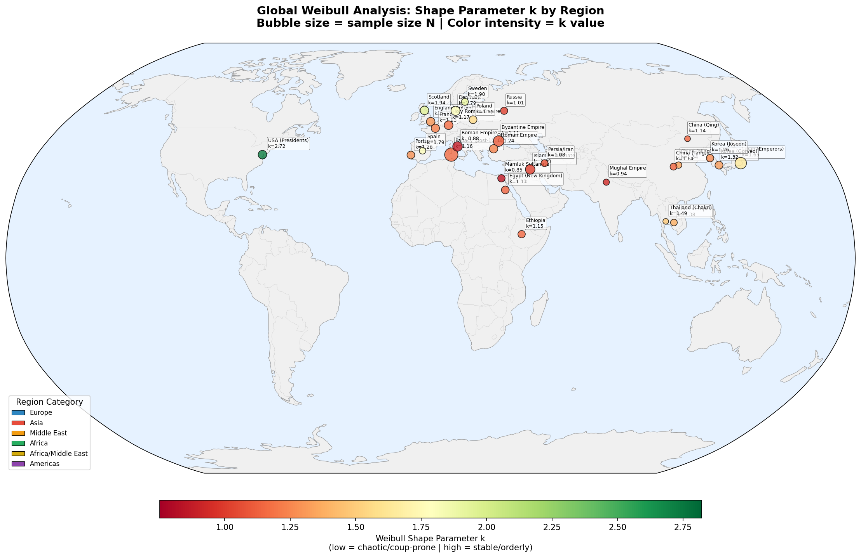
Figure 1. World map of Weibull shape parameter k for 31 polities. Bubble colour indicates k value (red = chaotic/coup-prone, green = stable/orderly). Bubble size reflects sample size N.

Historical validation: violent successions and civil wars
Table 3 presents the violent succession rates and civil war counts for all 29 polities with available data, alongside their Weibull shape parameters. The violent succession rate varied from 3.3% (Papacy post-1000) to 66.7% (Mamluk Sultanate). A strong and statistically significant negative correlation was observed between the shape parameter k and the violent succession rate (Pearson r = -0.551, p = 0.002; Spearman rho = -0.638, p = 0.0002). Similarly, k was significantly negatively correlated with the number of civil wars (Spearman rho = -0.528, p = 0.003). Figure 6 displays these relationships graphically.
The correlation between k and historical violence provides important empirical validation of the 'peacefulness index' interpretation. Polities with k < 1 - the Mamluk Sultanate, Roman Empire, and Mughal Empire - all exhibited violent succession rates exceeding 45%, consistent with regimes characterised by chronic political violence. The Mamluk Sultanate, with the lowest k (0.851), had a violent succession rate of 66.7% (18 of 27 successions) and experienced 8 major internal conflicts, reflecting the system's inherent basis in military slave-soldier factionalism. The Roman Empire (k = 0.880) recorded 36 violent successions out of 55 (65.5%), including 15 civil wars - a figure that encompasses notorious episodes such as the Year of the Four Emperors (69 CE), the Crisis of the Third Century (235-284 CE), and the Year of the Six Emperors (238 CE). The Islamic Caliphate (k = 1.004) experienced the First, Second, and Third Fitna civil wars, the Abbasid Revolution, and the Anarchy at Samarra, with an overall violent rate of 50.9%.
At the opposite extreme, polities with high k values generally exhibited low violent succession rates. The Papacy post-1000 (k = 1.163) had only 4 violent successions out of 121 (3.3%), reflecting the stabilising influence of the conclave electoral system established in 1059. Japan's Emperors (k = 1.648) recorded only 3 violent incidents (the Jinshin War of 672 and indirect effects of the Hogen and Heiji Rebellions) out of 86 successions (3.5%). The USA Presidents (k = 2.721) experienced 4 assassinations (Lincoln, Garfield, McKinley, Kennedy) out of 42 transitions (9.5%), but notably, none of these resulted in extra-constitutional succession - the presidential line of succession operated as designed in each case.
Several polities present informative exceptions to the general pattern. Scotland (k = 1.937) has a relatively high violent succession rate (27.5%, 11 of 40) despite its high k value. This apparent contradiction is explained by the concentration of violence in early Scottish history (Wars of Independence, 1296-1357) followed by long periods of stable succession, producing an overall increasing-hazard pattern. Conversely, the Ottoman Empire (k = 1.240) exhibited a moderate violent succession rate (30.8%) that was partially institutionalised through the practice of fratricide (Fatih Kanunnamesi), whereby new sultans eliminated potential rival claimants - a form of violence that paradoxically contributed to regime stability by preventing prolonged succession crises.

Table 3. Violent succession rates and civil wars by polity
Polity | k | Total | Violent | Rate | Civil Wars
Mamluk Sultanate | 0.851 | 27 | 18 | 66.7% | 8
Roman Empire | 0.880 | 55 | 36 | 65.5% | 15
Islamic Caliphate | 1.004 | 55 | 28 | 50.9% | 6
Mughal Empire | 0.936 | 15 | 7 | 46.7% | 5
Byzantine Empire | 1.113 | 71 | 33 | 46.5% | 12
Persia/Iran | 1.079 | 22 | 9 | 40.9% | 4
Khmer Empire | 1.381 | 20 | 8 | 40.0% | 4
Ethiopia | 1.150 | 27 | 10 | 37.0% | 5
Russia | 1.015 | 25 | 8 | 32.0% | 2
China (Tang) | 1.140 | 22 | 7 | 31.8% | 3
Ottoman Empire | 1.240 | 39 | 12 | 30.8% | 4
Scotland | 1.937 | 40 | 11 | 27.5% | 4
Korea (Goryeo) | 1.324 | 33 | 8 | 24.2% | 3
Egypt (New Kingdom) | 1.132 | 31 | 6 | 19.4% | 2
Holy Roman Empire | 1.171 | 43 | 8 | 18.6% | 5
Spain | 1.791 | 18 | 3 | 16.7% | 2
Portugal | 1.285 | 31 | 5 | 16.1% | 3
Poland | 1.552 | 32 | 5 | 15.6% | 3
England/Britain | 1.308 | 40 | 6 | 15.0% | 3
Korea (Joseon) | 1.262 | 28 | 4 | 14.3% | 2
Sweden | 1.897 | 23 | 3 | 13.0% | 1
China (Ming) | 1.338 | 17 | 2 | 11.8% | 1
France | 1.235 | 38 | 4 | 10.5% | 2
Denmark | 1.788 | 49 | 5 | 10.2% | 2
Thailand (Chakri) | 1.492 | 10 | 1 | 10.0% | 0
USA (Presidents) | 2.721 | 42 | 4 | 9.5% | 1
China (Qing) | 1.140 | 11 | 1 | 9.1% | 2
Japan (Emperors) | 1.648 | 86 | 3 | 3.5% | 3
Papacy (post-1000) | 1.163 | 121 | 4 | 3.3% | 0
Note: 'Violent' counts include assassinations, depositions by force, military coups, executions, and outcomes of civil wars. 'Civil Wars' counts major internal armed conflicts during the analysed period.

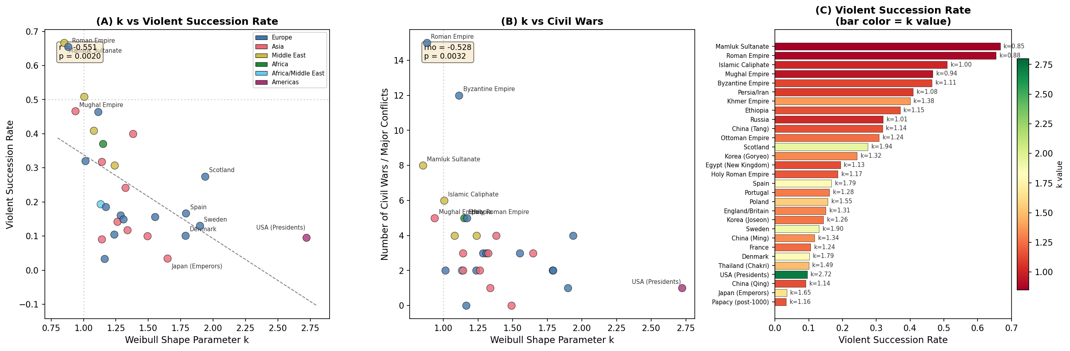
Figure 6. Historical validation of Weibull shape parameter k. (A) Scatter plot of k versus violent succession rate with linear regression (r = -0.551, p = 0.002). (B) k versus number of civil wars/major conflicts (rho = -0.528, p = 0.003). (C) Horizontal bar chart of violent succession rates for all polities, coloured by k value (red = low k, green = high k).

Accession age distributions
To assess the potential influence of child and puppet rulers on the analysis, accession ages were compiled for all 29 polities with available data. Table 4 presents summary statistics. Substantial variation existed across polities: median accession age ranged from 13.0 years (China Qing) to 56.5 years (Papacy post-1000), with the proportion of accessions under age 18 ranging from 0% (USA Presidents, Papacy) to 59.3% (Mamluk Sultanate). Figure 7 displays these distributions graphically.
Japan's Emperors exhibited a particularly striking pattern: 22 of 96 accessions (22.9%) occurred before age 10, and 49 of 96 (51.0%) before age 18, yielding a median accession age of only 17.0 years. This reflects the prevalence of child emperors installed as figureheads during the Fujiwara regency, insei (cloistered emperor), and shogunate periods. China's Qing dynasty showed an even higher proportion of child accessions (50.0% under age 10, N = 10), with emperors Puyi (age 2), Guangxu (3), Shunzhi (5), and Tongzhi (5) all installed as children under regent control. Scotland (38.1% under age 10) also exhibited frequent child accessions, including Mary Queen of Scots (6 days old), James V (1 year), and James VI (1 year). The Mamluk Sultanate, despite being a military slave-soldier system, had 59.3% of accessions under age 18, reflecting the practice of installing child sultans as puppets of powerful amirs.
Critically, no statistically significant correlation was found between the Weibull shape parameter k and any accession age metric across polities: k versus median accession age (Pearson r = +0.236, p = 0.217; Spearman rho = -0.029, p = 0.881), k versus proportion of accessions under age 18 (r = -0.074, p = 0.704), and k versus proportion under age 10 (r = +0.103, p = 0.595). This absence of systematic correlation suggests that while individual polities (Japan, China Qing, Scotland) may have k values influenced by puppet ruler dynamics, young accession does not systematically bias the shape parameter in one direction across all polities. The relationship between accession age and k is mediated by polity-specific institutional arrangements rather than a universal confound.

Table 4. Accession age summary statistics by polity
Polity | k | N | Median Age | Mean Age | % <10y | % <18y
USA (Presidents) | 2.721 | 46 | 55.0 | 55.5 | 0.0% | 0.0%
Papacy (post-1000) | 1.163 | 68 | 56.5 | 56.2 | 0.0% | 0.0%
Roman Empire | 0.880 | 50 | 40.5 | 39.8 | 0.0% | 14.0%
Islamic Caliphate | 1.004 | 54 | 30.0 | 31.9 | 0.0% | 7.4%
Denmark | 1.788 | 23 | 31.0 | 33.5 | 0.0% | 13.0%
Ottoman Empire | 1.240 | 37 | 30.0 | 32.3 | 2.7% | 18.9%
England/Britain | 1.308 | 42 | 31.0 | 31.8 | 7.1% | 16.7%
France | 1.235 | 38 | 23.5 | 25.1 | 13.2% | 34.2%
Japan (Emperors) | 1.648 | 96 | 17.0 | 21.0 | 22.9% | 51.0%
Scotland | 1.937 | 21 | 15.0 | 20.3 | 38.1% | 57.1%
China (Qing) | 1.140 | 10 | 13.0 | 18.2 | 50.0% | 50.0%
Mamluk Sultanate | 0.851 | 27 | 14.0 | 20.0 | 14.8% | 59.3%
Note: Table shows selected polities illustrating the range of accession age patterns. Full data for all 29 polities are available in the Appendix.

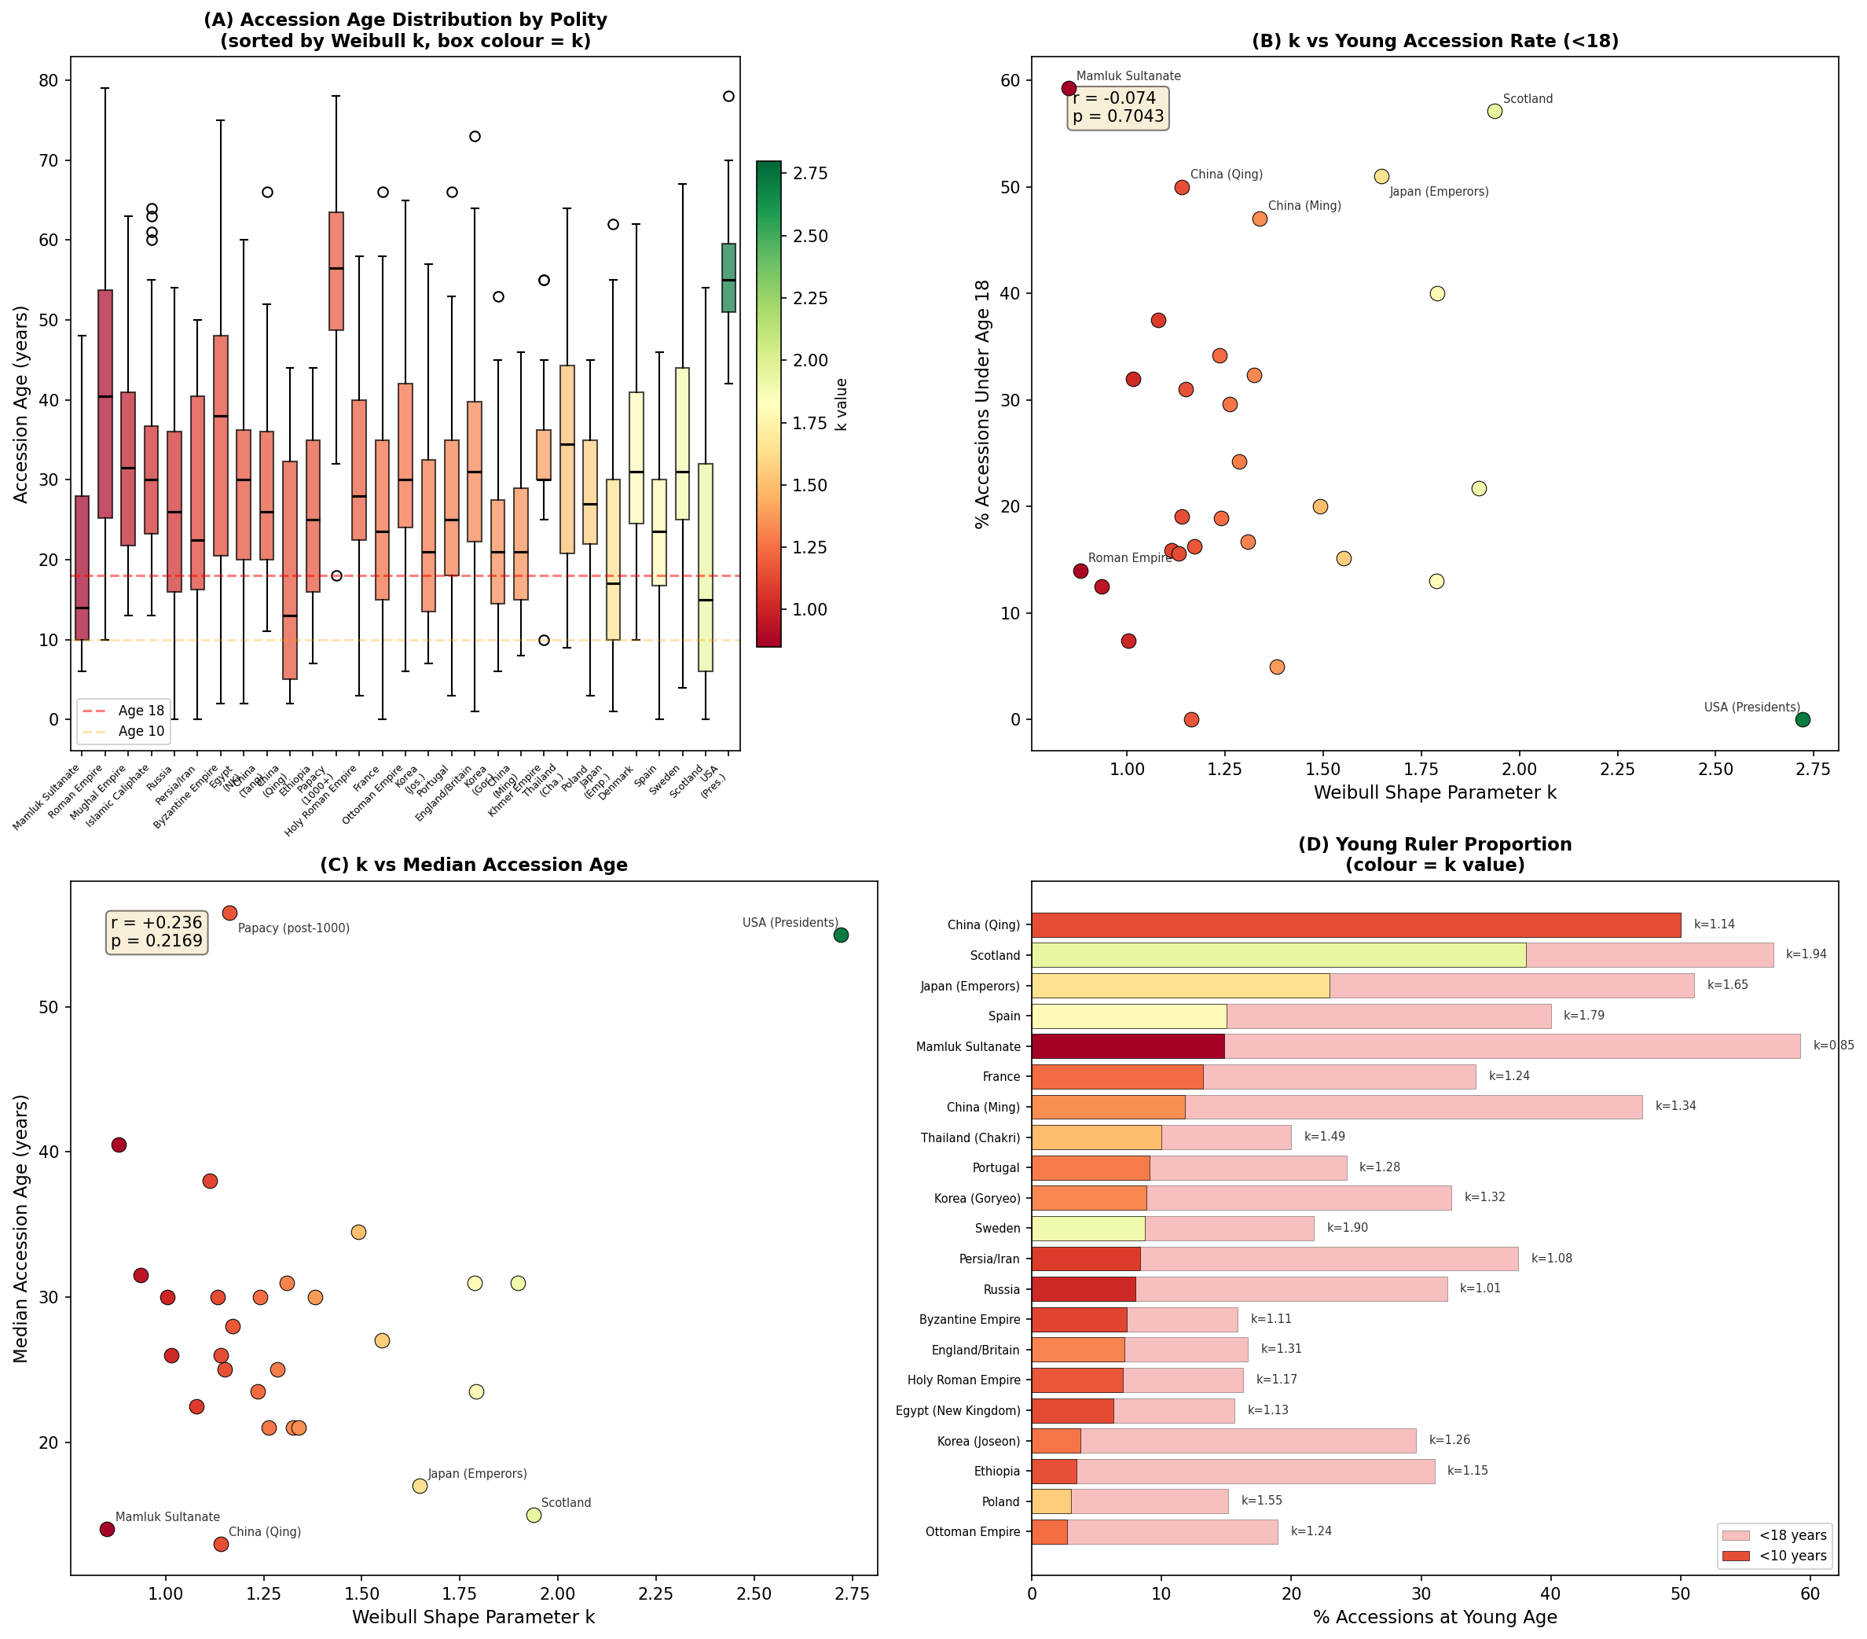
Figure 7. Accession age analysis. (A) Box plots of accession age by polity, sorted by k (box colour indicates k value). Dashed lines mark ages 10 and 18. (B) k versus percentage of accessions under age 18 (r = -0.074, p = 0.704, n.s.). (C) k versus median accession age (r = +0.236, p = 0.217, n.s.). (D) Horizontal bar chart of young ruler proportions (red = under 10, pink = under 18).

Sensitivity analysis: excluding child rulers
To quantify the impact of child rulers on the Weibull shape parameter, the analysis was re-run for each polity after excluding reigns where the ruler acceded before age 10 (primary analysis) and before age 18 (secondary analysis). Table 5 presents the results for key affected polities, and Figure 8 displays the sensitivity results graphically.
The sensitivity analysis revealed a striking bidirectional pattern. In some polities, excluding child rulers decreased k substantially: Japan's Emperors dropped from k = 1.648 to 1.346 (excluding accession < 10, delta k = -0.302) and to 1.208 (excluding < 18, delta k = -0.440); Scotland fell from 1.937 to 1.485 (delta k = -0.452 excluding < 10); and Sweden from 1.897 to 1.415 (delta k = -0.482). In these polities, child rulers had been installed as figureheads with managed successions, inflating k by introducing artificially regular (non-random) reign durations.
Conversely, in other polities, excluding child rulers increased k: France rose from 1.235 to 1.606 (delta k = +0.371 excluding < 10) and to 1.830 (excluding < 18); the Holy Roman Empire from 1.171 to 1.473 (delta k = +0.302); and the Mamluk Sultanate from 0.851 to 0.951 (delta k = +0.100). In these systems, child rulers were targets of political instability - their short, chaotic reigns introduced additional variance that depressed k. The Mamluk Sultanate is instructive: despite 59.3% of accessions occurring before age 18, its k remained below 1 even after excluding all child accessions, confirming that the system's instability was structural rather than an artefact of child sultans.
Critically, Japan's k remained above 1.0 even after excluding all accessions under age 18 (k = 1.208), indicating that the increasing-hazard (wear-out) pattern is genuine and not solely an artefact of managed figurehead transitions. The magnitude of the change (delta k = -0.440) is, however, substantial, confirming that puppet emperor dynamics materially influence the estimated shape parameter.

Table 5. Sensitivity analysis: Weibull k excluding child rulers
Polity | k (all) | N | k (no<10) | N | delta k | k (no<18) | N | delta k
Japan (Emperors) | 1.648 | 96 | 1.346 | 74 | -0.302 | 1.208 | 47 | -0.440
Scotland | 1.937 | 20 | 1.485 | 13 | -0.452 | 1.269 | 9 | -0.668
Sweden | 1.897 | 23 | 1.415 | 21 | -0.482 | 1.419 | 18 | -0.478
France | 1.235 | 37 | 1.606 | 33 | +0.371 | 1.830 | 25 | +0.595
Holy Roman Empire | 1.171 | 43 | 1.473 | 40 | +0.302 | 1.585 | 36 | +0.414
Mamluk Sultanate | 0.851 | 27 | 0.951 | 23 | +0.100 | 1.072 | 11 | +0.221
China (Qing) | 1.140 | 10 | 1.703 | 5 | +0.563 | 1.703 | 5 | +0.563
China (Ming) | 1.338 | 17 | 1.102 | 15 | -0.236 | 0.938 | 9 | -0.400
Poland | 1.552 | 33 | 1.239 | 32 | -0.313 | 1.267 | 28 | -0.285
Note: 'no<10' excludes reigns where accession age was below 10 years; 'no<18' excludes accession age below 18 years. Delta k = k(excluded) - k(all). Negative delta k indicates that child rulers inflated the original k (managed figurehead transitions); positive delta k indicates that child rulers depressed the original k (targets of instability).

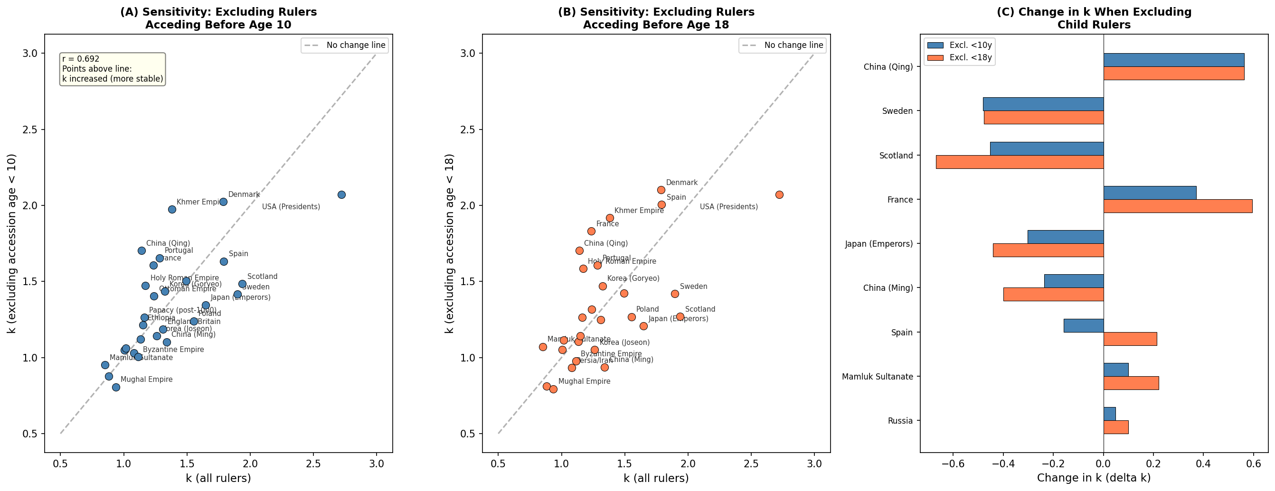
Figure 8. Sensitivity analysis of Weibull k when excluding child rulers. (A) k with all rulers versus k excluding accession age < 10 (dashed line = no change). (B) k with all rulers versus k excluding accession age < 18. (C) Change in k (delta k) for key polities; blue = excluding < 10, orange = excluding < 18. Negative delta indicates child rulers inflated k; positive indicates they depressed k.

Sub-analysis 1: Elective versus hereditary succession
The 31 polities were stratified into elective (N = 8 polities, 446 pooled reigns) and hereditary (N = 23 polities, 625 pooled reigns) groups based on predominant succession mechanism. Pooled Weibull fitting revealed a striking difference: elective systems yielded k = 1.019 (95% CI [0.96, 1.09]), indicating near-constant hazard (approximately memoryless replacement), while hereditary systems yielded k = 1.298 (95% CI [1.24, 1.37]), indicating moderately increasing hazard (wear-out pattern). The difference was highly significant by both the two-sample Kolmogorov-Smirnov test (D = 0.286, p < 0.0001) and the Mann-Whitney U test (U = 90,176, p < 0.0001). Bootstrap testing (1,000 resamples) confirmed that P(k_hereditary > k_elective) = 1.000, with a 95% CI for the difference of [0.176, 0.370].
Mean reign duration also differed substantially: 11.2 years for elective systems versus 18.6 years for hereditary systems. However, the shape parameter comparison is more informative than the mean, as it captures the distributional pattern rather than merely the central tendency. The near-unity k for elective systems implies that the probability of a ruler being replaced is approximately constant over time - consistent with political mechanisms (term limits, competitive elections, palace coups) that operate independently of tenure length. In contrast, the k > 1 for hereditary systems indicates that longer-reigning monarchs become progressively more likely to end their reign, consistent with biological aging and the accumulation of political pressures over extended periods. A notable outlier is the USA Presidents (k = 2.721), classified as elective but exhibiting the highest k of all polities, reflecting the highly regularised term structure of the American presidency. Figure 2 illustrates the geographic distribution of these comparisons, and Figure 3 displays the detailed statistical comparison.
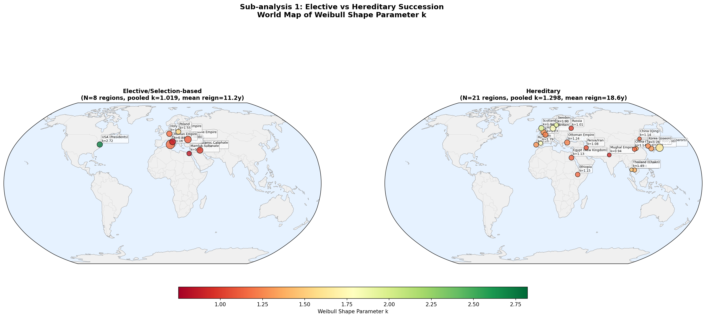
Figure 2. World map comparison of elective (left) and hereditary (right) polities. Elective systems cluster around k ~ 1 (red-orange), while hereditary systems show greater variation and higher median k values.

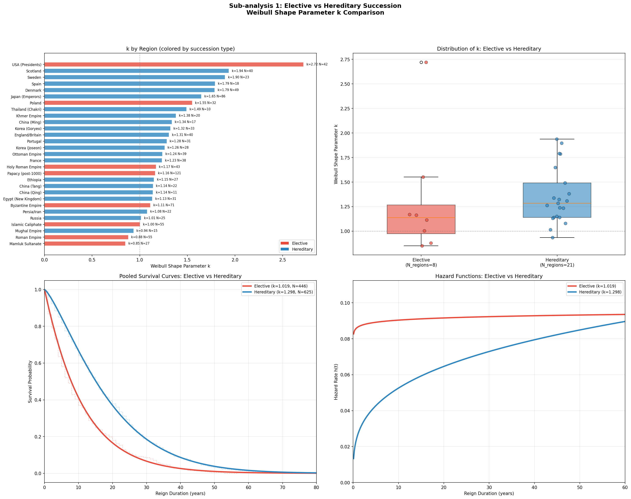
Figure 3. Sub-analysis 1: Elective vs. hereditary succession. Top left: k by polity (coloured by succession type). Top right: box plot comparison. Bottom left: pooled survival curves. Bottom right: hazard functions.

Sub-analysis 2: Era-based stratification
Table 2 presents the era-stratified results. A clear temporal trend emerged: the pooled shape parameter increased monotonically from the Ancient period (k = 0.890, N = 93) through the Medieval (k = 1.163, N = 531), Early Modern (k = 1.182, N = 289), and Modern (k = 1.200, N = 131) periods, before reversing in the Contemporary era (k = 0.996, N = 27). This pattern suggests a long-term trend toward greater political stability (increasing k) that was partially reversed in the post-1945 period, possibly reflecting decolonisation, democratisation, and the decline of traditional monarchy.
The Ancient period, dominated by the Roman Empire (k = 0.880, N = 55), exhibited a decreasing hazard characteristic of coup-prone regimes. The Medieval period, with the largest sample (N = 531 from 19 polities), showed the beginnings of increasing hazard. The Early Modern and Modern periods continued this trend, with notably high individual k values for Japan's Emperors in the Early Modern period (k = 2.864) and France in the Modern period (k = 3.066). The Contemporary period's reversion to k ~ 1 is based on a small sample (N = 27 from 8 polities) and should be interpreted cautiously; a sensitivity analysis combining the Modern and Contemporary periods yielded k = 1.147 (95% CI [1.06, 1.25]), consistent with the overall upward trend. Figure 4 displays the era-based stratification results graphically, and Figure 5 provides box plot comparisons of k across geographic region, succession type, and historical era.

Table 2. Weibull shape parameter k by historical era
Era | Period | k | 95% CI | N | Mean reign (y) | KS p
Ancient | ~476 CE | 0.890 | [0.80, 1.05] | 93 | 12.4 | 0.392
Medieval | 476-1453 | 1.163 | [1.10, 1.24] | 531 | 14.5 | 0.071
Early Modern | 1453-1789 | 1.182 | [1.09, 1.29] | 289 | 17.8 | 0.242
Modern | 1789-1945 | 1.200 | [1.10, 1.34] | 131 | 15.9 | 0.158
Contemporary | 1945~ | 0.996 | [0.89, 1.23] | 27 | 18.6 | 0.072

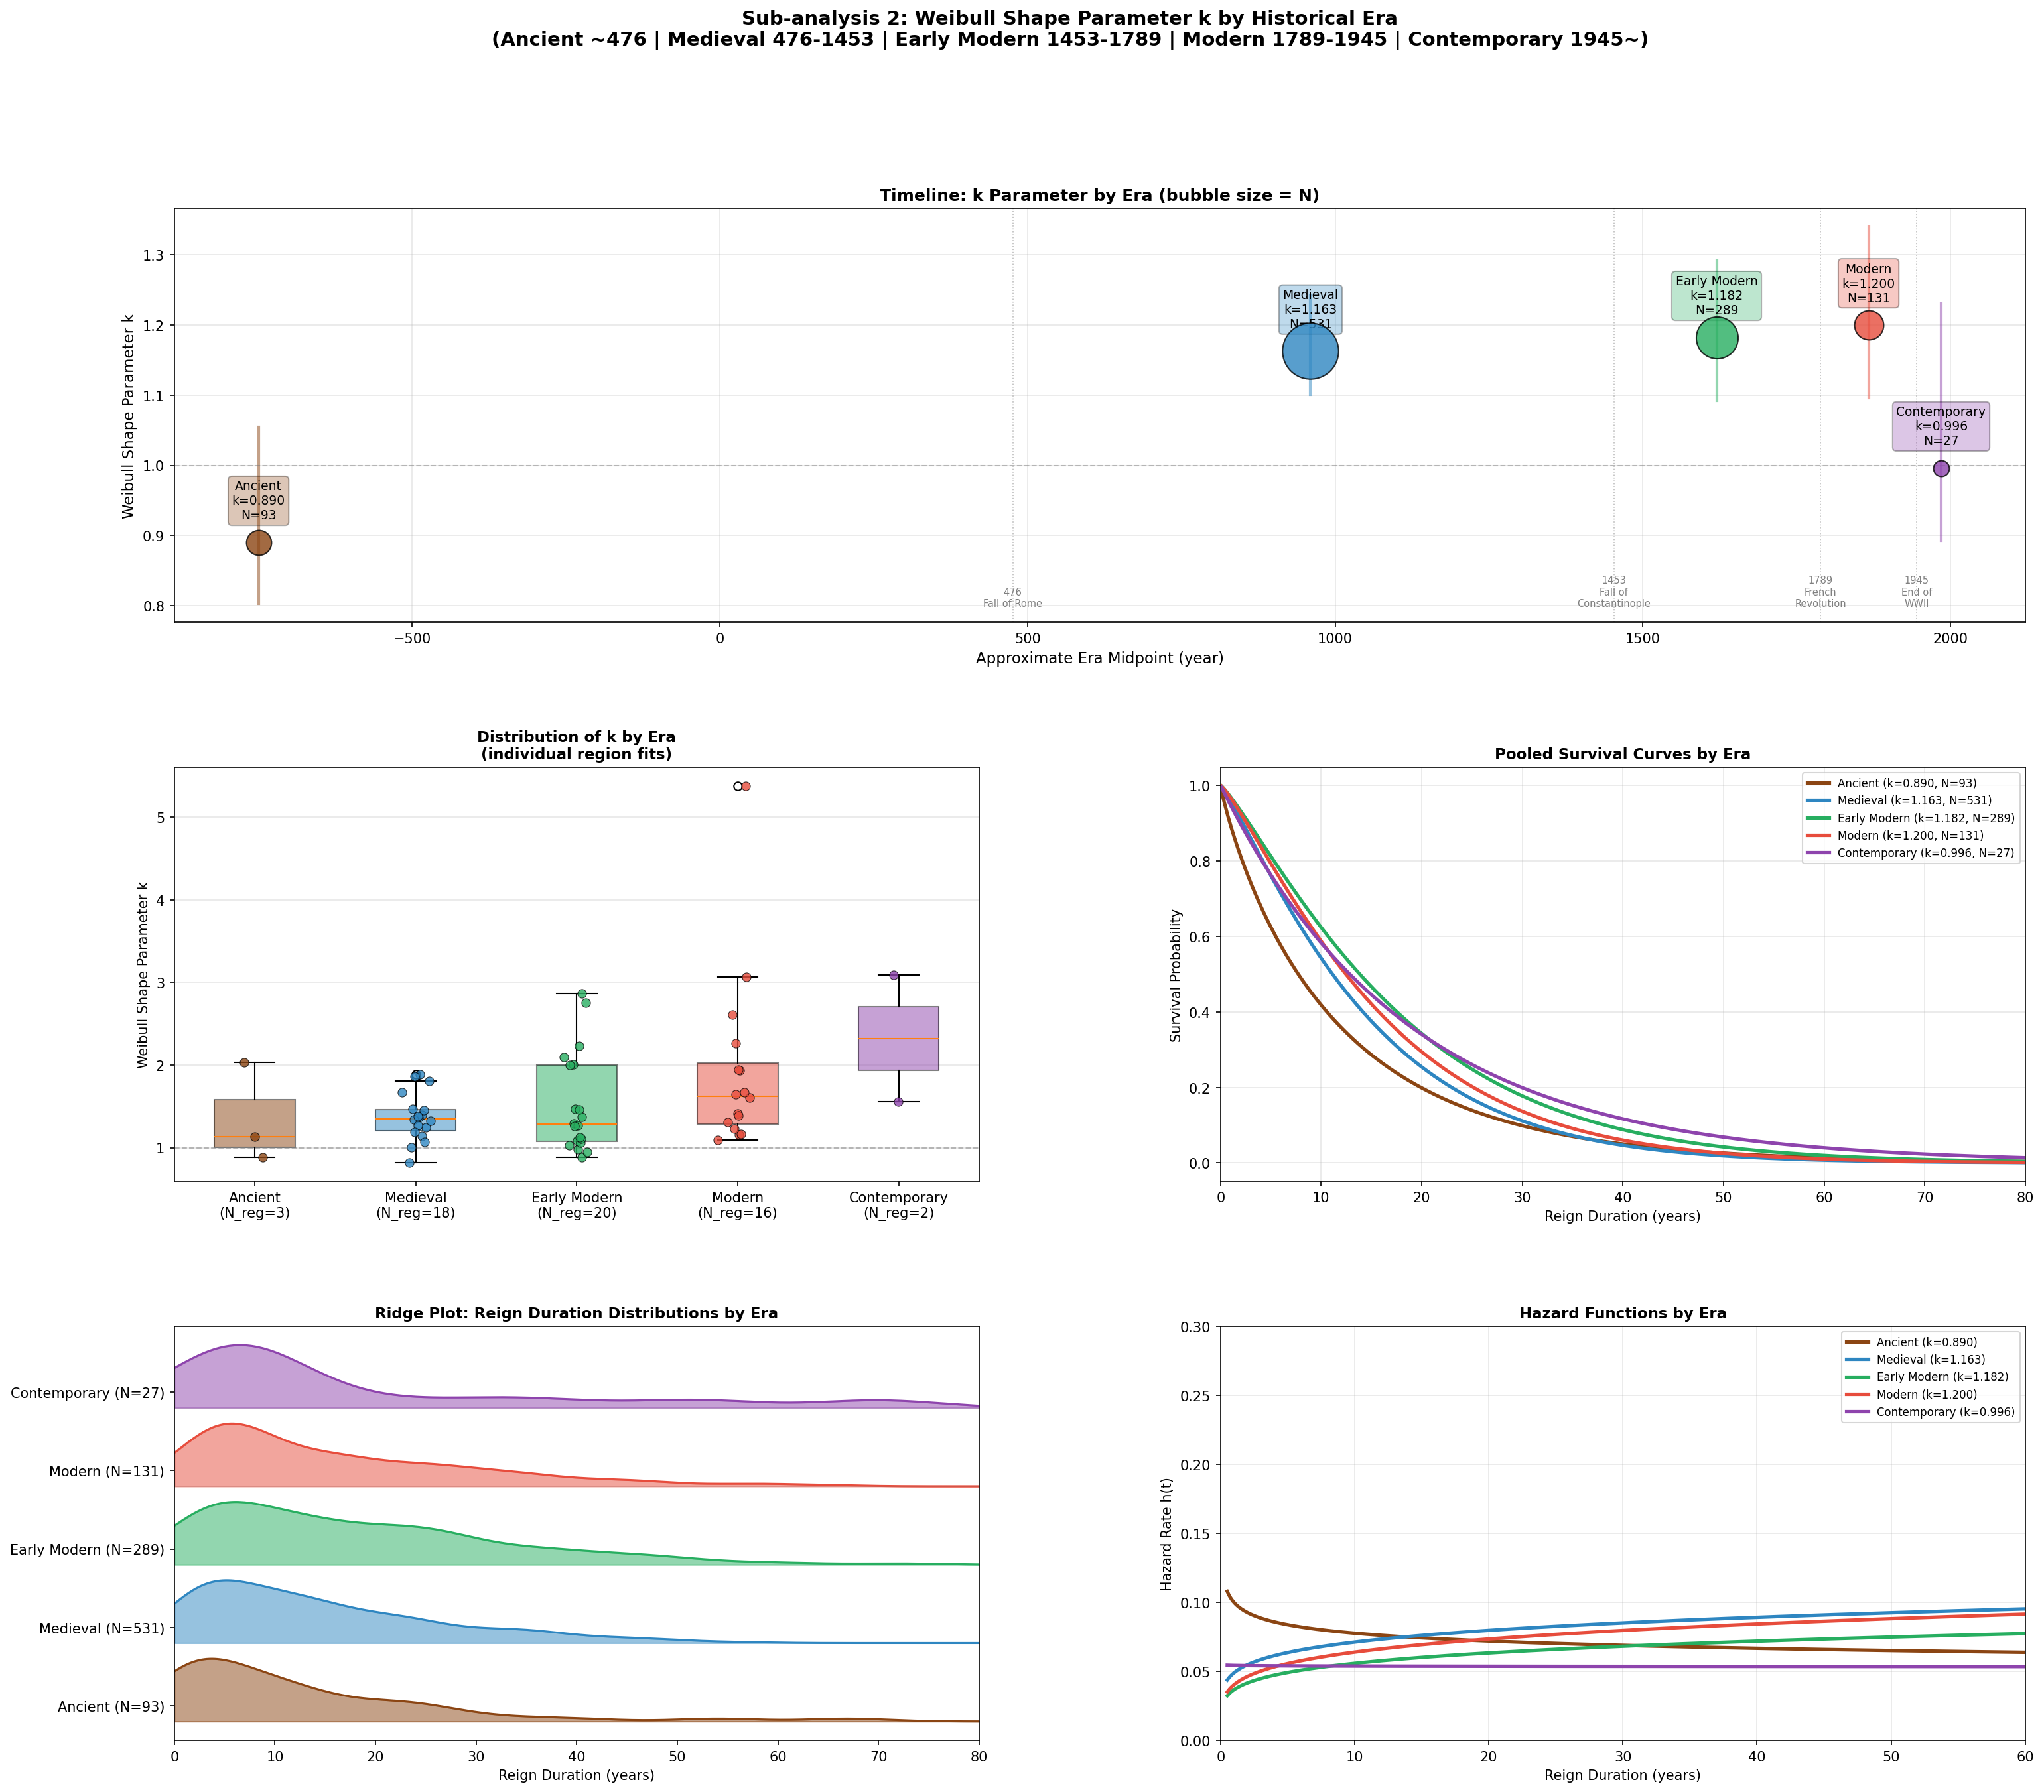
Figure 4. Sub-analysis 2: Era-based stratification. Top: timeline bubble chart (bubble size = N). Middle left: box plot of individual region k values by era. Middle right: pooled survival curves. Bottom left: ridge plot of reign duration distributions. Bottom right: hazard functions by era.

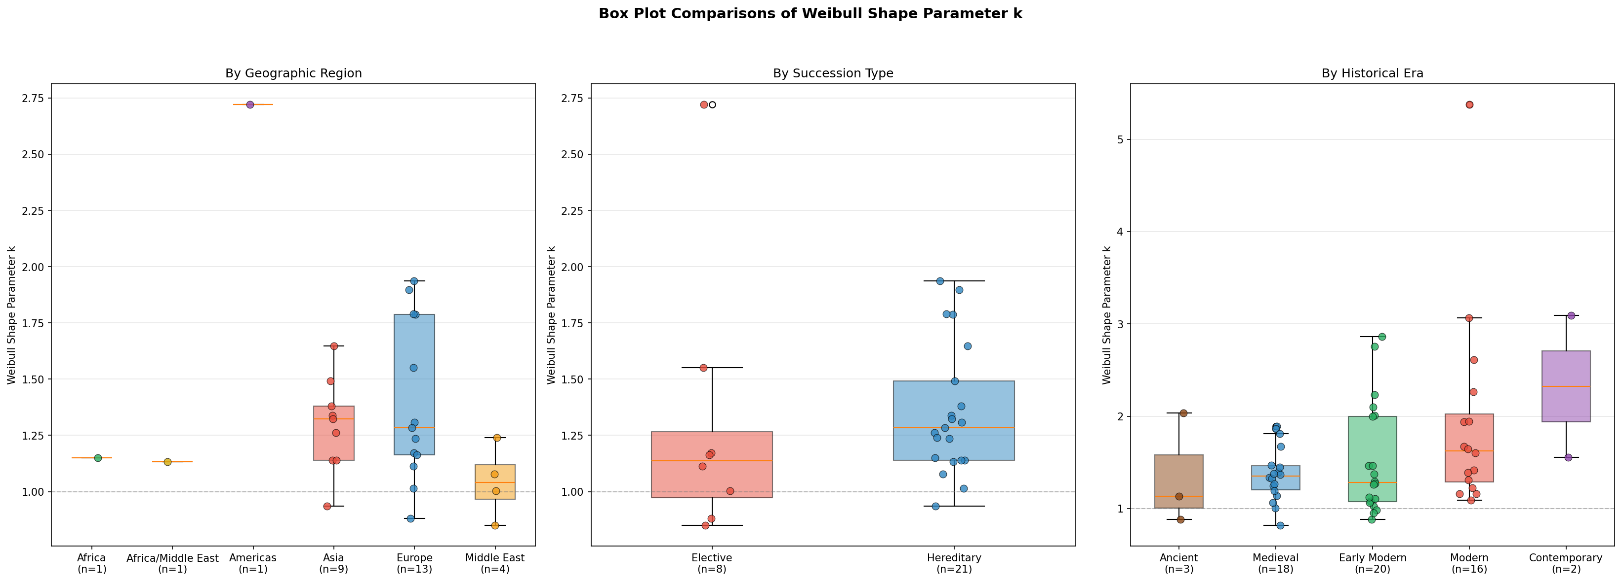
Figure 5. Box plot comparisons of the Weibull shape parameter k across three dimensions: geographic region (left), succession type (centre), and historical era (right). Individual polity values are overlaid as scatter points.

Discussion
This study represents the first systematic global application of Weibull reliability analysis to sovereign reign durations, extending Saleh's (2019) pioneering single-polity study to 31 polities across six continents. Our findings demonstrate that the Weibull distribution provides a robust fit across diverse political systems and historical periods, and that the shape parameter k captures meaningful variation in political stability patterns.
The conceptual framework underlying this analysis draws on two intellectual traditions. The first is reliability engineering, where the Weibull distribution has been the standard tool for modelling component failure times since Weibull's (1951) original formulation. The second is constitutional theory, specifically Minobe Tatsukichi's Emperor Organ Theory (Tenno Kikan-setsu), which conceptualised the sovereign as a functional organ of the state apparatus (Minobe, 1912, 1923). This 'ruler-as-component' perspective provides the theoretical bridge between reliability engineering and political history: just as a bearing or transistor serves a defined function within a machine and eventually fails through predictable mechanisms, a sovereign serves a defined constitutional role and eventually leaves office through mechanisms that follow characteristic statistical patterns.
Our main finding - that the Weibull shape parameter varies substantially across polities (range: 0.851-2.721) and tracks intuitive notions of political stability - supports the use of k as a quantitative 'peacefulness index'. The three polities with k < 1 (Mamluk Sultanate, Roman Empire, Mughal Empire) are precisely those known for chronic political violence and frequent usurpation. Conversely, the polities with k > 1.5 - the 'stable/aging' cluster - include USA Presidents (k = 2.721), Scotland (k = 1.937), Sweden (k = 1.897), Spain (k = 1.791), Denmark (k = 1.788), Japan's Emperors (k = 1.648), and Poland (k = 1.552). These polities share traditions of orderly succession, whether through regularised electoral mechanisms (USA), strong hereditary norms (Scandinavia, Spain), or institutionalised figurehead systems (Japan). Japan's position is particularly noteworthy, consistent with the imperial institution's remarkable longevity and the relative rarity of violent succession in the imperial line.
The accession age analysis and sensitivity analysis provide important nuance to these findings. The bidirectional effect of child rulers - inflating k in figurehead systems (Japan, Scotland) while depressing it in instability-prone systems (France, Mamluk Sultanate) - demonstrates that young accession is not a simple confound but interacts with institutional context. Japan's k decreased from 1.648 to 1.208 when excluding all accessions under age 18, but remained above 1.0, indicating a genuine wear-out pattern even among adult-accession emperors. This raises a deeper interpretive question: does an orderly figurehead succession, maintained by a principle of 'reigning but not ruling' (rex regnat et non gubernat, a maxim attributed to the 16th-century Polish Grand Chancellor Jan Zamoyski in the context of the Polish-Lithuanian Commonwealth's Golden Liberty, and later adopted to describe constitutional monarchies including Britain and Japan), constitute genuine political stability? We argue that it does, in the sense that the regularity of nominal succession reflects the stability of the underlying institutional arrangement - whether that arrangement concentrates real power in the emperor, a regent, or a shogun. The Weibull k parameter thus captures institutional stability at the level of the nominal sovereign, which is itself a meaningful social fact even when power is exercised elsewhere.
The historical validation analysis provides strong empirical support for interpreting k as a stability metric. The significant negative correlation between k and violent succession rates (Spearman rho = -0.638, p = 0.0002) demonstrates that the Weibull shape parameter is not merely a statistical abstraction but reflects concrete patterns of political violence. Polities with k < 1 averaged a violent succession rate of 59.6%, compared to 20.5% for polities with k > 1.3. The correlation with civil war frequency (rho = -0.528, p = 0.003) further validates this interpretation: regimes that experienced more frequent internal armed conflicts tended to exhibit lower k values, confirming that the 'infant mortality' failure pattern in reliability engineering maps onto the political phenomenon of early-reign coups and violent overthrows. Notable exceptions such as Scotland (high k despite moderate violence) and the Ottoman Empire (moderate k despite institutionalised violence) highlight the importance of considering the temporal distribution of violence, not merely its frequency, when interpreting the shape parameter.
The sub-analysis by succession mechanism reveals a fundamental structural difference between elective and hereditary systems. The near-unity pooled k for elective systems (k = 1.019) implies an approximately memoryless (exponential) distribution of reign durations - that is, the probability of succession in any given year is roughly constant regardless of how long the ruler has been in power. This is consistent with the operation of institutional mechanisms (elections, conclaves, military acclamation) that are triggered by political opportunity rather than biological aging (Svolik, 2012). The higher k for hereditary systems (k = 1.298) reflects the greater influence of biological aging and the 'survivorship advantage' of established monarchs who have successfully navigated the early years of their reign.
The era-based sub-analysis reveals a striking temporal pattern: a monotonic increase in k from antiquity through the modern period, followed by a reversal in the contemporary era. The increasing trend (Ancient k = 0.890 to Modern k = 1.200) may reflect the gradual development of institutional constraints on succession - from the unconstrained violence of Roman imperial politics (Scheidel, 2017) to the increasingly regularised succession norms of early modern and modern monarchies. This trajectory is consistent with broader arguments about the decline of political violence over historical time (Pinker, 2011; Goldstein, 2011) and the role of institutional frameworks in constraining violence (North et al., 2009). The rise and fall of great powers (Kennedy, 1987) may also have shaped the temporal trend, as hegemonic stability in certain periods reduced the frequency of violent succession. The contemporary reversal (k = 0.996) likely reflects the fundamentally different nature of post-1945 governance, including democratisation, decolonisation, and the replacement of hereditary monarchy with elected leadership in many polities.

Limitations
Several limitations warrant discussion. First, the quality and completeness of historical data vary substantially across polities, with ancient and non-European polities generally having less reliable records. The temporal scope of each polity was carefully chosen to balance data reliability against comprehensiveness, but these scope decisions inevitably involve judgement. For example, restricting the Papacy to post-1000 CE excludes approximately 150 popes, and restricting England/Britain to post-1066 excludes the Anglo-Saxon period. Sensitivity analyses with alternative scope boundaries would strengthen confidence in the results.
Second, the classification of succession mechanisms as binary (elective vs. hereditary) oversimplifies the rich variety of historical succession practices. Many polities exhibited mixed systems (e.g., Poland transitioned from hereditary to elective monarchy in 1572; the Ottoman Empire practised hereditary succession with institutionalised fratricide). A more nuanced classification might yield additional insights.
Third, the presence of puppet rulers and figurehead monarchs represents a systematic source of potential bias. In several polities, the nominal sovereign held little or no real political power for extended periods: Japan's emperors were ceremonial figureheads during the Fujiwara regency (~858-1068), the insei (cloistered emperor) system, and the Kamakura, Muromachi, and Tokugawa shogunates (~1185-1868); late Abbasid caliphs (after ~940s) were puppets of Buyid and Seljuk warlords; Goryeo kings were controlled by the Choe military dictatorship (1196-1258) and subsequently by Mongol overlords; late Tang emperors (after 820) were dominated by eunuch factions; and Ethiopian emperors during the Zemene Mesafint (1769-1855) were figureheads under regional warlords. In these cases, the Weibull shape parameter reflects the stability of figurehead succession rather than genuine political stability. Japan's high k (1.648) is particularly affected: for most of the analysed period, imperial succession was managed by non-imperial power-holders (regents, shoguns) who had strong incentives to maintain orderly figurehead transitions. Future work should consider stratifying by periods of substantive versus nominal rule where the historical record permits such distinction.
Fourth, the accession age analysis (Table 4, Figure 7) reveals that young rulers installed as puppets or figureheads are concentrated in specific polities. Japan's Emperors had 51.0% of accessions before age 18 (median accession age 17.0 years), China's Qing dynasty had 50.0% under age 10, and Scotland had 38.1% under age 10. These child rulers introduce reign durations that reflect the preferences of power-brokers rather than organic political dynamics. However, the absence of a significant correlation between k and any accession age metric across all polities (all p > 0.2) indicates that young accession does not constitute a systematic confound at the global level. Rather, its effects are polity-specific: Japan's high k may be inflated by managed figurehead transitions, while the Mamluk Sultanate's low k persists despite similarly frequent young accessions (59.3% under 18), because in that system child sultans were rapidly overthrown by rival factions.
Fifth, the assignment of reigns to historical eras involves simplifying assumptions about the temporal distribution of reigns within each polity. The analysis treats each reign as independent, whereas in reality, succession events may be clustered during periods of political crisis or civil war. Finally, the Contemporary era sample is small (N = 27), limiting the reliability of conclusions about post-1945 patterns.
Future work could extend this analysis in several directions: incorporating additional polities and non-sovereign leadership positions (e.g., prime ministers, corporate CEOs), developing mixed Weibull models to capture polities with multiple failure modes, exploring time-varying hazard models that allow k to change within a polity's history, and - critically - stratifying by the degree of actual political power held by the nominal sovereign. The intersection of reliability engineering and political history opened by Saleh (2019) and extended here offers rich possibilities for quantitative comparative historiography.

Conclusion
We have demonstrated that the Weibull distribution, the workhorse of reliability engineering, provides a robust and interpretable framework for quantifying political stability across 31 polities spanning three millennia. The shape parameter k serves as a meaningful 'peacefulness index' that distinguishes coup-prone regimes (k < 1) from stable, aging-dominated systems (k > 1.5), and this interpretation is validated by a significant negative correlation with historical violent succession rates (rho = -0.638, p = 0.0002) and civil war frequency (rho = -0.528, p = 0.003). Elective systems exhibit near-constant hazard (k ~ 1), while hereditary systems show moderately increasing hazard (k ~ 1.3). Historical era analysis reveals a long-term trend toward greater stability that partially reverses in the post-1945 period. These findings establish the Weibull shape parameter as a powerful tool for quantitative comparative historiography and invite further application of reliability engineering methods to social and political phenomena.

Data availability
All reign duration data used in this study were compiled from publicly available historical sources. The complete dataset (reign durations for 31 polities, N = 1,148), violent succession counts, variable definitions, and all analysis code (Python) are publicly available at: https://github.com/bougtoir/sovereign-weibull-analysis. The repository contains: (1) full raw datasets in CSV format, (2) variable definitions and coding schemes, (3) all statistical scripts used for Weibull fitting, sub-analyses, historical validation, accession age analysis, and sensitivity analysis.

References
- Abernethy, R.B. (2004). The New Weibull Handbook (5th ed.). Robert B. Abernethy.
- Banno, J. (2001). Democracy in Pre-War Japan: Concepts of Government, 1871-1937. Routledge.
- Clauset, A. (2018). Trends and fluctuations in the severity of interstate wars. Science Advances, 4(2), eaao3580.
- Davies, N. (2005). God's Playground: A History of Poland (Revised ed., Vol. 1). Oxford University Press. [For Jan Zamoyski's maxim rex regnat et non gubernat and the Golden Liberty system.]
- Cox, D.R. (1972). Regression models and life-tables. Journal of the Royal Statistical Society: Series B, 34(2), 187-220.
- Goemans, H.E., Gleditsch, K.S., and Chiozza, G. (2009). Introducing Archigos: A dataset of political leaders. Journal of Peace Research, 46(2), 269-283.
- Goldstein, J.S. (2011). Winning the War on War: The Decline of Armed Conflict Worldwide. Dutton.
- Kaplan, E.L. and Meier, P. (1958). Nonparametric estimation from incomplete observations. Journal of the American Statistical Association, 53(282), 457-481.
- Kennedy, P. (1987). The Rise and Fall of the Great Powers. Random House.
- Lawless, J.F. (2003). Statistical Models and Methods for Lifetime Data (2nd ed.). Wiley.
- Miller, F.O. (1965). Minobe Tatsukichi: Interpreter of Constitutionalism in Japan. University of California Press.
- Minobe, T. (1912). Kempo Kowa [Lectures on the Constitution]. Yuhikaku.
- Minobe, T. (1923). Kempo Satsuyo [Outline of the Constitution]. Yuhikaku.
- Murdock, G.P. (1967). Ethnographic Atlas. University of Pittsburgh Press.
- North, D.C., Wallis, J.J., and Weingast, B.R. (2009). Violence and Social Orders: A Conceptual Framework for Interpreting Recorded Human History. Cambridge University Press.
- O'Connor, P.D.T. and Kleyner, A. (2012). Practical Reliability Engineering (5th ed.). Wiley.
- Olsson, O. and Paik, C. (2016). Long-run cultural divergence: Evidence from the Neolithic Revolution. Journal of Development Economics, 122, 197-213.
- Pinker, S. (2011). The Better Angels of Our Nature: Why Violence Has Declined. Viking.
- Saleh, J.H. (2019). Statistical reliability analysis for a most dangerous occupation: Roman emperor. Palgrave Communications, 5(1), 155.
- Scheidel, W. (2017). The Great Leveler: Violence and the History of Inequality from the Stone Age to the Twenty-First Century. Princeton University Press.
- Svolik, M.W. (2012). The Politics of Authoritarian Rule. Cambridge University Press.
- Taagepera, R. (1979). Size and duration of empires: Growth-decline curves, 600 B.C. to 600 A.D. Social Science History, 3(3/4), 115-138.
- Turchin, P. (2003). Historical Dynamics: Why States Rise and Fall. Princeton University Press.
- Turchin, P. and Nefedov, S.A. (2009). Secular Cycles. Princeton University Press.
- Weibull, W. (1951). A statistical distribution function of wide applicability. Journal of Applied Mechanics, 18(3), 293-297.

Ethical Approval
This article does not contain any studies with human participants performed by any of the authors.

Informed Consent
This article does not contain any studies with human participants performed by any of the authors.

Appendix

Table A1. Temporal scope and rationale for each polity
Polity | Period analysed | Rationale for scope
Roman Empire | 27 BCE - 476 CE | Full period. Excludes the Republic (fundamentally different political structure: consuls, not emperors).
England/Britain | 1066 - present | From Norman Conquest. Pre-1066 Anglo-Saxon kings excluded due to fragmented record-keeping and multiple competing kingdoms.
France | 987 - 1870 | Capetian dynasty onward. Merovingian and Carolingian periods excluded due to fragmented political structure and unreliable reign records.
Holy Roman Empire | 962 - 1806 | Full period from Otto I to dissolution.
Denmark | 936 - present | From Gorm the Old. Full documented monarchical period.
Sweden | 1523 - present | From Gustav I Vasa. Pre-Vasa period excluded due to Kalmar Union complications and fragmented records.
Scotland | 843 - 1603 | Kenneth MacAlpin to Union of Crowns. Full independent Scottish monarchy.
Spain | 1479 - present | From Ferdinand and Isabella. Unified Spanish monarchy only.
Portugal | 1139 - 1910 | From Afonso Henriques to end of monarchy. Full Portuguese monarchical period.
Poland | 960 - 1795 | From Mieszko I to Third Partition. Includes both Piast dynasty and elective monarchy period.
Russia | 1462 - 1917 | From Ivan III to Nicholas II. Muscovite and Imperial Russia.
Byzantine Empire | 395 - 1453 | From east-west division to Fall of Constantinople. Full period.
Papacy (post-1000) | 1000 - present | Pre-1000 excluded: (1) College of Cardinals established 1059 (In Nomine Domini) - prior selection by Roman factions/imperial appointment; (2) unreliable pre-1000 dates; (3) >30 anti-popes before 1000 CE.
Ottoman Empire | 1299 - 1922 | Full Ottoman period from Osman I to abolition of sultanate.
Islamic Caliphate | 632 - 1258 | Rashidun, Umayyad, Abbasid. Excludes post-Mongol shadow caliphates in Cairo (no real political power).
Mamluk Sultanate | 1250 - 1517 | Full Mamluk period.
Persia/Iran | 1501 - 1979 | Safavid dynasty onward. Pre-Safavid dynasties excluded as fundamentally different entities with fragmentary records.
Japan (Emperors) | 539 - 2019 | From Emperor Kinmei to Emperor Akihito. Legendary emperors (Jimmu through Ingyo) excluded due to uncertain historicity.
China (Tang) | 618 - 907 | Full Tang dynasty.
China (Ming) | 1368 - 1644 | Full Ming dynasty.
China (Qing) | 1644 - 1912 | Full Qing dynasty. Small N (11) reflects the dynasty's relatively few rulers.
Korea (Joseon) | 1392 - 1910 | Full Joseon dynasty plus Korean Empire.
Korea (Goryeo) | 918 - 1392 | Full Goryeo dynasty.
Mughal Empire | 1526 - 1857 | Full Mughal period. Small N (15) reflects the empire's relatively brief span.
Khmer Empire | 802 - 1431 | Angkor period only. Post-Angkor records too fragmentary for reliable analysis.
Thailand (Chakri) | 1782 - present | Chakri dynasty only. Previous dynasties analysed separately would yield too few reigns per dynasty.
Ethiopia | 1270 - 1974 | Solomonic dynasty restoration to end of monarchy. Earlier Zagwe dynasty excluded due to unreliable chronology.
Egypt (New Kingdom) | 1550 - 1077 BCE | New Kingdom only. Other periods would yield too few reigns per period with reliable chronology; New Kingdom has best-documented succession records.
USA (Presidents) | 1789 - present | Complete record from Washington to present.

