PERSPECTIVE
The Invisible Variables: Why Clonal Systems Are Not Immune to Environmental Confounding
[Author names]
[Affiliations]
Correspondence: [Corresponding author email]
Keywords: pluripotent stem cells; cell culture environment; reproducibility; environmental monitoring; differentiation variability
Classification: Embryonic Stem Cells/Induced Pluripotent Stem (iPS) Cells

Abstract
Pluripotent stem cell (PSC) differentiation protocols suffer from persistent batch-to-batch variability that impedes both basic research and clinical manufacturing. We argue that this variability has a methodological blind spot: environmental variables—humidity, volatile organic compounds, ambient light, electromagnetic fields, and barometric pressure—remain unmonitored in most laboratories. The clonal nature of PSC research creates a false sense of experimental control; genetic homogeneity does not eliminate environmental confounding. We term this the 'clonal complacency trap'—the assumption that genetic uniformity guarantees experimental uniformity. Drawing on the in vitro fertilization field's experience, where volatile organic compound control increased blastocyst rates by 18%, we illustrate how environmental optimization transformed outcomes. A natural experiment using 6,101 Gene Expression Omnibus (GEO) datasets demonstrates that apparent seasonality in public databases is an institutional artifact driven by Japan's fiscal year-end, not a biological signal—highlighting the need for prospective measurement rather than retrospective inference. We propose IoT-based multi-parameter environmental monitoring as a systematic, low-cost method to identify which invisible variables matter for PSC culture.

Significance Statement
Stem cell therapies are entering clinical trials, but batch-to-batch variability in differentiation remains a major barrier. We identify an overlooked source: the laboratory environment. Air quality, humidity, light, and barometric pressure fluctuate seasonally and differ between buildings, yet go unmeasured in stem cell experiments. Clonal cell lines create a false sense of control, masking these environmental influences. Fertility medicine solved a similar problem by controlling air quality, dramatically improving outcomes. We propose continuous environmental monitoring to reveal correctable sources of variability, improving research reproducibility and cell therapy manufacturing.

Introduction
Pluripotent stem cell (PSC)-derived therapies are advancing rapidly, with over 115 trials and 1,200 patients dosed as of 2024.¹ Yet differentiation protocols remain notoriously variable across laboratories and even between batches within a single group.²⁻⁴ Multi-site reproducibility studies consistently report that laboratory-of-origin is the dominant source of variance in iPSC-derived neuron transcriptomes, exceeding the effect of genetic background or differentiation batch.³ The field has invested enormously in optimizing controllable recipe variables—growth factors, small molecules, extracellular matrices, timing—while largely ignoring the environment in which these recipes are executed.
A deeper methodological issue compounds the problem. Research using clonal systems—isogenic iPSC lines, genetically identical clones—operates under the implicit assumption that genetic homogeneity renders confounding adjustment unnecessary. Because the genetic background is 'controlled,' investigators rarely apply the stratification or sensitivity analyses that epidemiologists consider mandatory for observational data. Non-genetic confounders (environmental, temporal, institutional) are neither measured nor adjusted for. We term this the 'clonal complacency trap'—the assumption that genetic uniformity guarantees experimental uniformity.
Consider an analogy. Artisanal bread quality varied unpredictably between batches until industrial bakeries recognized that controlling oven temperature alone was insufficient; ambient humidity, dough temperature during proofing, and air quality were equally critical. We argue that today's PSC laboratory resembles the pre-industrial bakery: we control incubator temperature and CO₂ but leave humidity, volatile organic compounds (VOCs), ambient light, electromagnetic fields, and barometric pressure entirely unmonitored.
In this Perspective, we draw on evidence from the in vitro fertilization (IVF) field, molecular sensitivity data for PSCs, and a natural experiment in public databases to argue that environmental variables constitute an overlooked, correctable source of differentiation variability. We propose IoT-based environmental monitoring as a practical path forward.

The IVF Precedent: Environmental Control Transforms Outcomes
The IVF field provides a compelling precedent. Before systematic environmental control, unexplained clinic-to-clinic variation was attributed to operator skill and patient selection. After implementing VOC filtration and positive-pressure air handling,⁵ many laboratories saw 10–20% improvements in blastocyst rates.⁶ Cai et al demonstrated through real-time monitoring that even low VOC concentrations linearly predicted decreased blastocyst quality, and that the effect was specific to fresh embryos—frozen embryos were unaffected—indicating that early-stage cells are selectively vulnerable to environmental perturbation.⁷
Seasonal patterns reinforce the environmental link. Leathersich et al analyzed 3,659 frozen embryo transfer cycles in Perth, Australia, finding that oocytes collected in summer had 30% higher live birth rates than autumn-collected oocytes.⁸ Crucially, only the season at oocyte collection mattered—not the season of transfer—establishing that the effect acts during a specific developmental window (oocyte maturation and early cleavage) rather than through a general mechanism. Northern Hemisphere studies report concordant summer advantages,⁹ and direct experimental evidence in mice shows that embryos cultured during summer exhibit the 'two-cell block' phenomenon absent in winter.¹⁰
The IVF evidence provides a causal structure directly relevant to PSC biology. PSC differentiation protocols recapitulate aspects of early embryonic lineage commitment over 7–30 days and traverse epigenetic states homologous to preimplantation development—exit from naive pluripotency, lineage priming, specification—each potentially gated by the same environmental sensitivities that affect early embryos.

Why PSCs Are Uniquely Vulnerable
Several lines of evidence support the premise that environmental factors affect PSCs while being negligible for established cell lines. First, PSCs display markedly greater chemical sensitivity: human iPS cells are approximately 1.5-fold more sensitive to drug exposure than ES cells, and both are several-fold less resistant than differentiated cell types; critically, naive-state induction further increases sensitivity, establishing a gradient from differentiated (resistant) to naive-pluripotent (most vulnerable).¹¹
Second, osmotic perturbations of surprisingly small magnitude gate cell fate transitions. McCreery et al showed that compaction-triggered changes in nuclear shape and volume in human iPSCs remodel chromatin architecture and prime ectodermal differentiation.¹² During biosafety cabinet work, culture medium evaporates at rates determined by ambient humidity, producing osmolarity increases that could cross these thresholds. Chui et al confirmed that hyperosmotic culture drives NF-κB and WNT signaling-dependent cell cycle exit and maturation¹³—meaning osmolarity changes of physiological magnitude are not merely stress events but active differentiation signals.
Third, PSCs depend on circadian clock components in a non-canonical manner. CRY1 is dramatically upregulated in iPSCs and ESCs compared to somatic cells, and its deletion impairs self-renewal and disrupts differentiation.¹⁴ BMAL1 coordinates energy metabolism and differentiation independently of circadian oscillation, which is suppressed in pluripotent cells.¹⁵ This architecture—dependence on clock molecules without functional clock oscillation—may render PSCs vulnerable to external zeitgeber inputs (eg, ambient light leaking into incubators or biosafety cabinets) that would not perturb differentiated cells with intact circadian buffering. Fourth, fine particulate matter downregulates pluripotency markers (NANOG, OCT4) in human ESCs through ROS-mediated AKT/ERK signaling¹⁶ at concentrations harmless to somatic cells.
Together, these findings establish that PSCs sit at an energetically shallow decision landscape where subtle environmental shifts can tip the balance between self-renewal and lineage commitment. Each mechanism operates through a different signal transduction pathway (osmolarity via nuclear mechanics, light via clock gene regulation, VOCs via ROS signaling), yet all converge on pluripotency gene networks. The key point is not that any single perturbation is catastrophic, but that the magnitude of real-world effects remains unknown because the relevant variables have not been systematically measured alongside differentiation outcomes.

A Natural Experiment Reveals Institutional Confounding
To test whether institutional rhythms confound clonal research data, we analyzed submission dates for 6,101 PSC differentiation datasets deposited in NCBI GEO¹⁷ between 2001 and 2026 (search: 'iPSC OR ESC differentiation'; inclusion: all dataset types with valid submission dates). The overall monthly distribution was significantly non-uniform (χ²=32.3, df=11, P=.0007) with a pronounced March peak—superficially consistent with a spring photoperiod advantage.
We exploited a natural experiment: geographic variation in academic/fiscal year calendars. Countries were grouped by academic year start: Japan/South Korea (March/April, n=250), USA/Europe/China (September/October, n=2,825), and Southern Hemisphere (n=83). Using Pearson χ² and circular Rayleigh tests,¹⁸ only the Japan/Korea group showed significant seasonality (χ²=32.8, P=.0006, Rayleigh R=0.172) with a March peak perfectly aligned with Japan's fiscal year-end. The much larger September-start group showed no significant seasonal pattern (χ²=15.0, P=.13). Japan—just 3.3% of total datasets—drove the overall signal entirely: excluding Japan eliminated statistical significance (Figure 1).
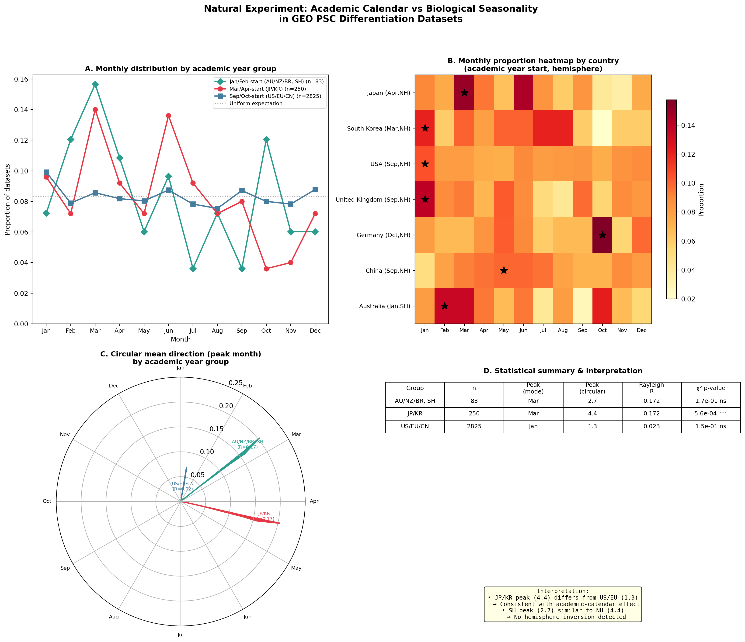
Figure 1. Institutional calendar confounding in GEO PSC datasets. (A) Monthly submission distributions for 6,101 GEO PSC differentiation datasets grouped by country academic-year start. (B) Country-level heatmap. (C) Circular Rayleigh vectors showing mean submission direction. (D) Statistical summary: only Japan/Korea shows significant seasonality, aligned with Japan's March 31 fiscal year-end.
This result carries a critical methodological lesson: what appeared to be evidence of seasonal biological influence on stem cell research was an artifact of Japan's March 31 fiscal year-end, which creates a rush to deposit data before annual reporting deadlines. The broader implication is that any field relying on publication or deposition timing as a proxy for experimental timing risks confounding institutional rhythms with biological ones. Prospective environmental measurement, not retrospective database mining, is required to detect real environmental effects on PSC differentiation.

The Path Forward: Environmental Monitoring as Method
Our analysis demonstrates that retrospective database mining cannot detect or rule out environmental effects on PSC differentiation. The IVF evidence suggests such effects exist in early-stage cells,^{8,10} and the vulnerability evidence suggests PSCs are plausible targets.^{11,12} What is needed is a systematic method: prospective, controlled environmental monitoring paired with differentiation outcome tracking.¹⁹
We propose a three-phase approach (Figure 2). Phase I: equip PSC facilities with continuous multi-parameter sensors (humidity, illuminance, ELF-EMF, barometric pressure, VOCs, vibration) at 1-minute resolution alongside routine differentiation outcomes for 12 or more months. Modern IoT sensor packages achieve this at modest cost (<$5,000 per laboratory). Phase II: analyze existing IVF registry data (HFEA in the UK, ANZARD in Australia) containing date-stamped cycle outcomes with latitude information to directly test hemisphere-inversion predictions for photoperiod-driven effects. Phase III: for variables identified as significantly correlated with outcomes, conduct controlled interventions (eg, humidity-controlled vs uncontrolled incubators, light-tight hoods vs standard biosafety cabinets).
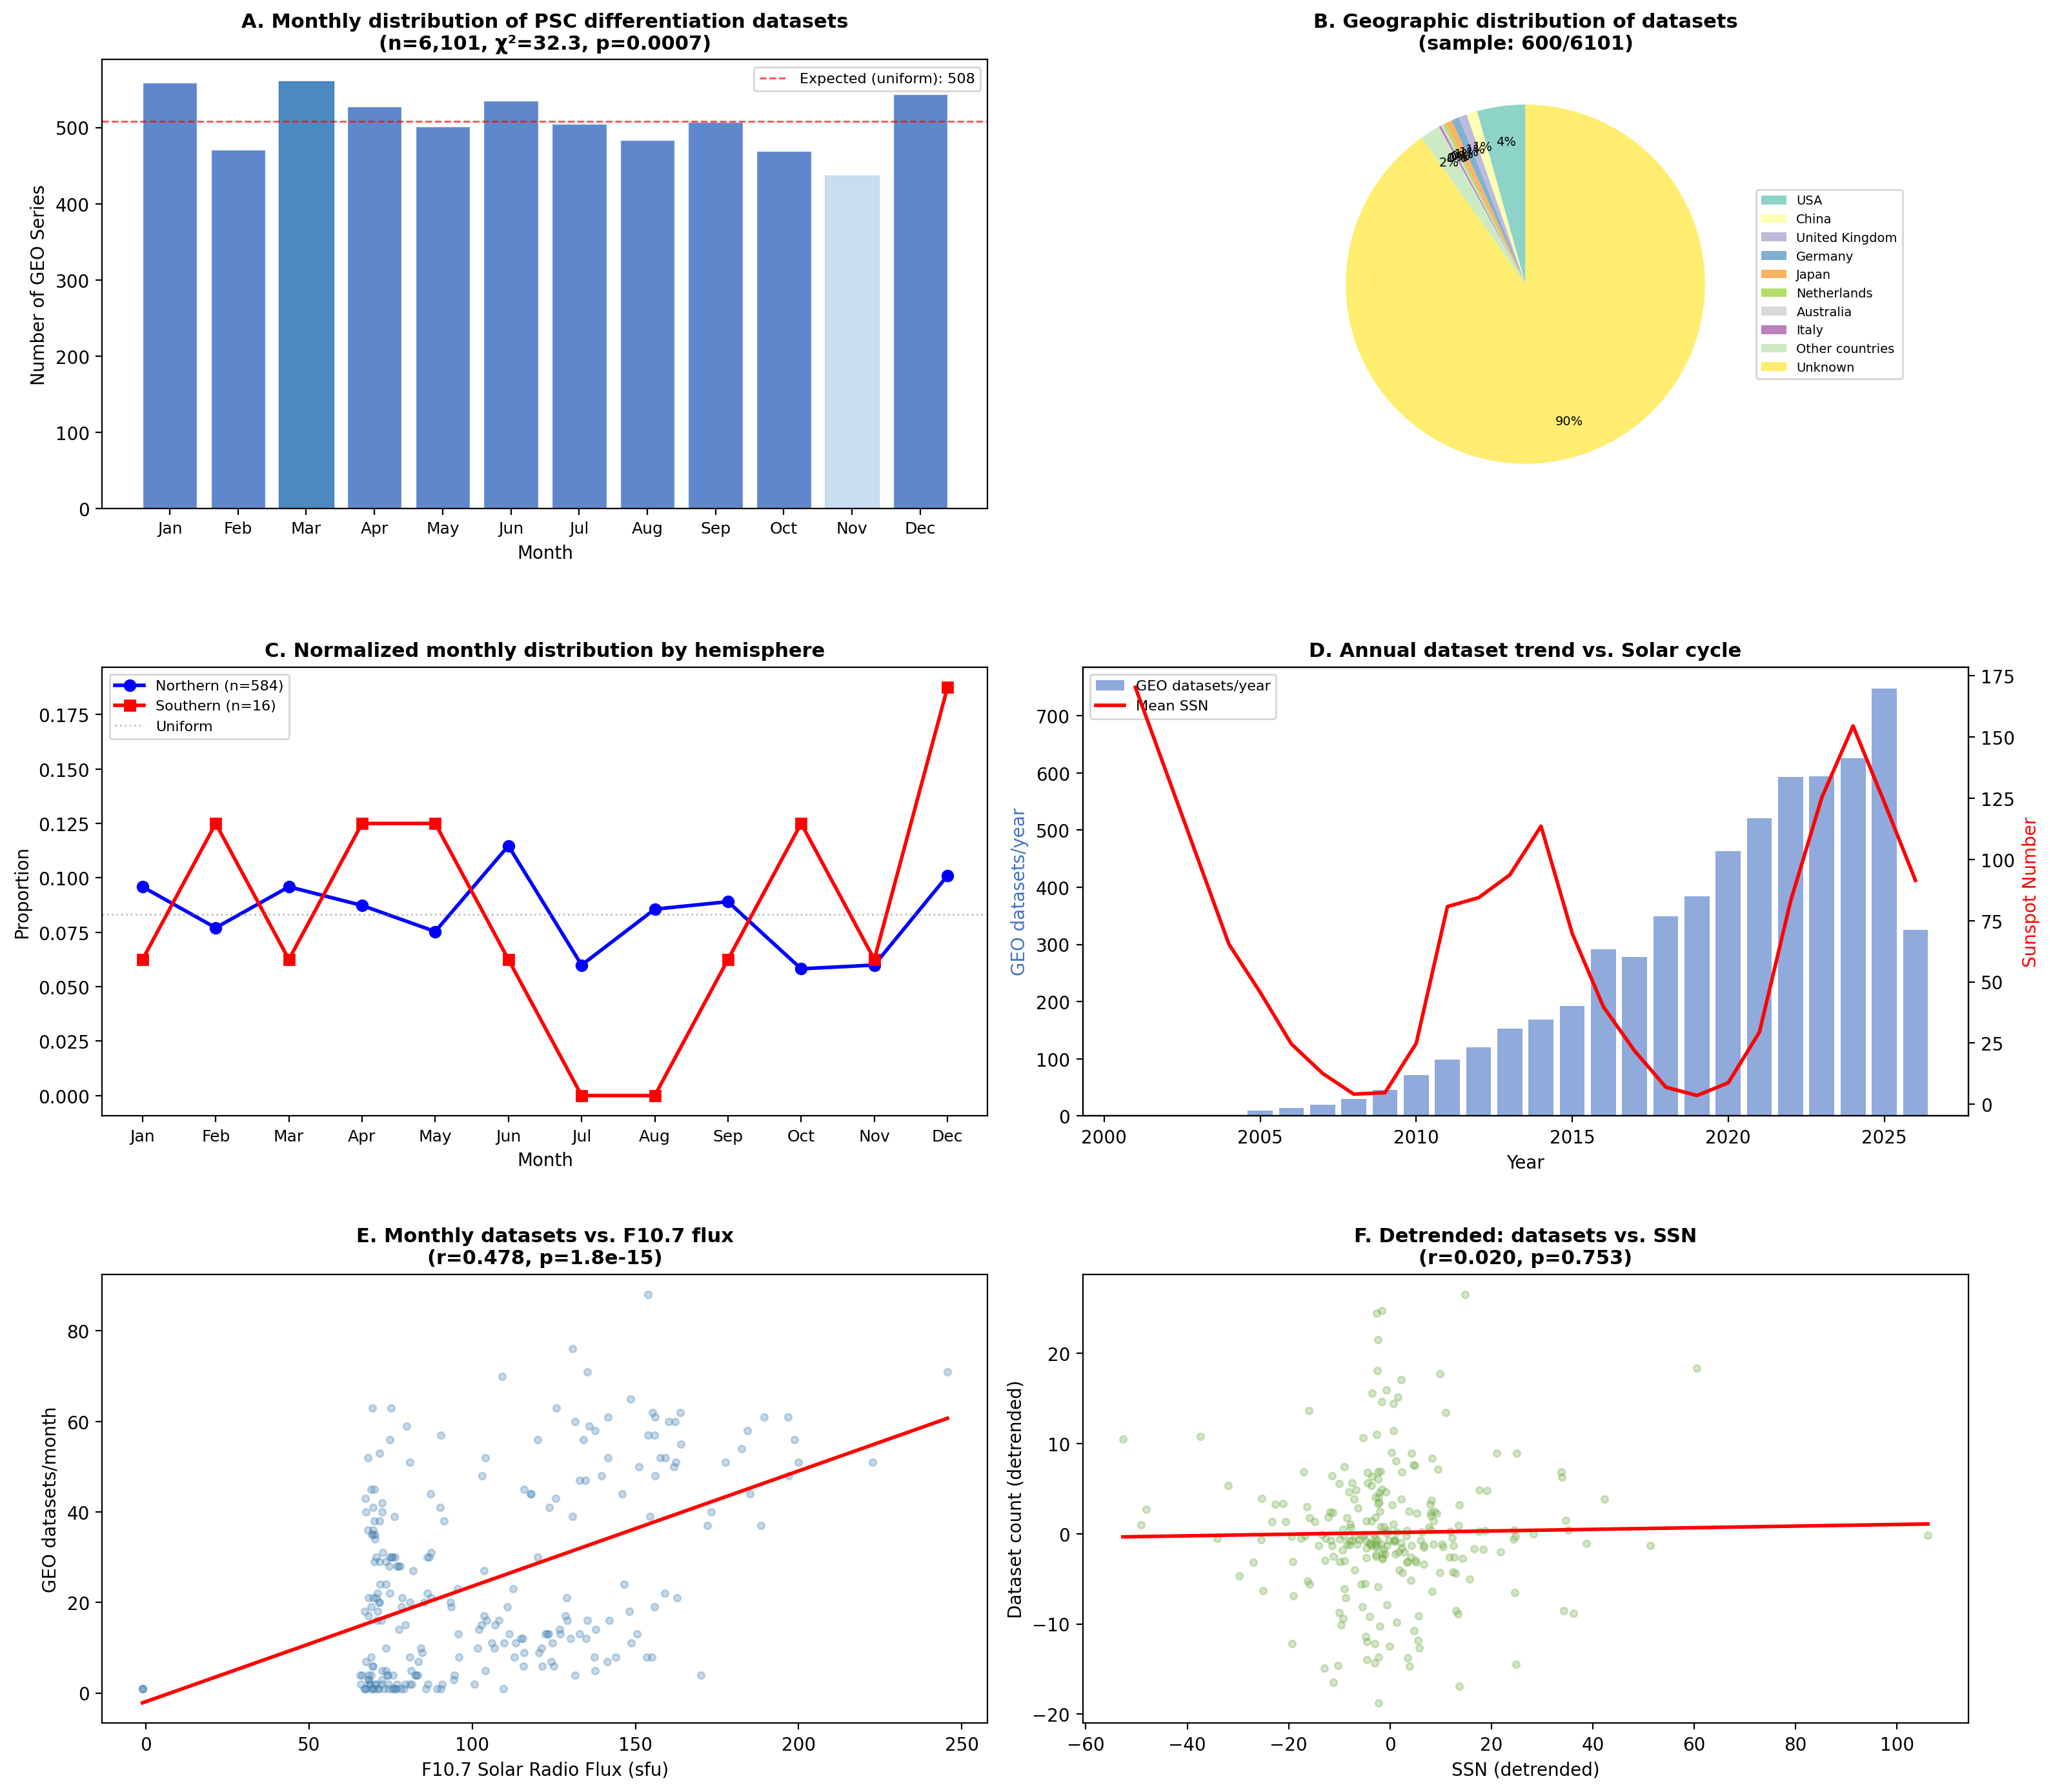
Figure 2. Proposed research roadmap for environmental profiling of PSC culture. (A) Evidence matrix classifying uncontrolled environmental variables by hemisphere-dependence and strength of existing evidence. (B) Three-phase investigation strategy: Phase I (passive IoT monitoring), Phase II (IVF registry analysis), Phase III (controlled intervention).
The hemisphere-inversion test provides a powerful diagnostic criterion. Variables whose effects are phase-inverted between Northern and Southern Hemisphere laboratories implicate solar-driven mechanisms—photoperiod, temperature, UV flux—while hemisphere-synchronous effects implicate geomagnetic or cosmic ray pathways. A coordinated multi-center study spanning both hemispheres could decompose seasonal variation into these mechanistic categories.
A critical advantage of this approach is that it does not require investigators to alter their existing protocols. Environmental sensors operate passively in the background, producing time-series data that can be retrospectively correlated with differentiation outcomes already being collected. This dramatically lowers the barrier to participation and enables meta-analysis across laboratories using different protocols, cell lines, and differentiation targets.

Implications for Reproducibility and Manufacturing
As PSC-derived therapies advance toward clinical application,¹ manufacturing consistency becomes a regulatory imperative. Current Good Manufacturing Practice (cGMP) facilities control temperature and particulates, but do not routinely monitor illuminance, electromagnetic fields, VOCs, or barometric pressure. If any of these variables meaningfully affect differentiation efficiency—as the IVF precedent suggests they affect embryo development—current manufacturing harbors a hidden source of batch failure attributed to 'biological stochasticity' but potentially environmental in origin and therefore correctable.²⁰
The economic argument is compelling. A single failed GMP differentiation batch can cost $50,000–$500,000 in reagents and labor; environmental monitoring systems cost <$5,000 per facility to install. If monitoring identifies even one correctable environmental variable that reduces batch failure rates by 5–10%, the return on investment is immediate. Recent proposals for 'cytocentric' quality principles independently converge on this conclusion, arguing that environmental sensing must become a foundational element of cell manufacturing quality systems.^{21,22}
The monitoring approach imposes no change on existing workflows—it simply makes the invisible visible. Unlike prospective intervention studies requiring protocol changes and ethics approval, passive environmental monitoring can be implemented immediately in any laboratory or manufacturing facility. The resulting time-stamped, multi-parameter datasets, combined across sites and latitudes, would constitute a resource analogous to weather station networks that transformed meteorology from anecdote to predictive science. Even a null result would be informative: demonstrating that environmental variables do not meaningfully affect differentiation would definitively close this gap in our understanding and redirect attention to other sources of variability.

Conclusion
The history of experimental biology is punctuated by discoveries that 'noise' was signal from an unmeasured variable—stomach ulcers attributed to stress were caused by Helicobacter pylori; sudden infant death syndrome attributed to fate was linked to sleeping position. We argue that inter-batch variability in PSC differentiation may represent a comparable situation: outcomes attributed to inherent biological stochasticity may partly reflect unmeasured environmental inputs.
We have spent two decades optimizing recipes while ignoring the kitchen. The convergence of IVF environmental control evidence,^{6,7} seasonal effects on early embryos,^{8,10} molecular vulnerability of pluripotent cells,¹¹⁻¹⁶ and the methodological lessons from GEO analysis^{17,18} suggest that the invisible variables are neither negligible nor intractable. They merely need to be measured. The cost of doing so is negligible compared to the cost of failed differentiation batches in clinical manufacturing. If even one invisible variable proves consequential—as VOCs proved consequential in IVF⁶—the return on investment will be transformative for both basic research reproducibility and clinical manufacturing.

Acknowledgments
[To be added]

Author Contributions
[To be added upon submission]

Disclosure of Potential Conflicts of Interest
The authors declare no potential conflicts of interest.

Data Availability Statement
GEO dataset metadata and analysis code are available at [repository URL to be added upon acceptance].

Figure Legends
Figure 1. Academic calendar variation as a natural experiment. (A) Normalized monthly distributions of GEO PSC dataset submissions by academic year group. The March/April-start group (Japan/Korea) shows a pronounced March peak absent in the September-start group (USA/Europe/China). (B) Country-level heatmap showing that the pattern is driven predominantly by Japan. (C) Circular mean directions (Rayleigh vectors) for each group. (D) Statistical summary: only Japan/Korea achieves significance (P<.001). n=6,101 total datasets; 3,195 with country affiliation.
Figure 2. Research roadmap for environmental profiling of PSC culture. (A) Evidence matrix: uncontrolled environmental variables classified by hemisphere-dependence (inverted = solar-driven; synchronous = geomagnetic) and current evidence level. (B) Three-phase investigation strategy from passive monitoring through retrospective registry analysis to controlled intervention.

References
1. Kirkeby A, Main H, Carpenter M. Pluripotent stem-cell-derived therapies in clinical trial: a 2025 update. Cell Stem Cell. 2025;32(1):10-37.
2. Yamanaka S. Pluripotent stem cell-based cell therapy—promise and challenges. Cell Stem Cell. 2020;27(4):523-531.
3. Volpato V, Smith J, Sandor C, et al. Reproducibility of molecular phenotypes after long-term differentiation to human iPSC-derived neurons: a multi-site omics study. Stem Cell Reports. 2018;11(4):897-911.
4. Volpato V, Webber C. Addressing variability in iPSC-derived models of human disease: guidelines to promote reproducibility. Dis Model Mech. 2020;13(1):dmm042317.
5. Mortimer D, Cohen J, Mortimer ST, et al. Cairo consensus on the IVF laboratory environment and air quality: report of an expert meeting. Reprod Biomed Online. 2018;36(6):658-674.
6. Agarwal N, Chattopadhyay R, Chakravarty B. Volatile organic compounds and good laboratory practices in the in vitro fertilization laboratory: the important parameters for successful outcome in extended culture. J Assist Reprod Genet. 2017;34(8):999-1006.
7. Cai J, Zhou H, Wang M, et al. Real-time monitoring reveals the effects of low concentrations of volatile organic compounds in the embryology laboratory. Hum Reprod. 2025;40(3):deaf008.
8. Leathersich SJ, Roche CS, Walls M, Nathan E, Hart RJ. Season at the time of oocyte collection and frozen embryo transfer outcomes. Hum Reprod. 2023;38(9):1714-1722.
9. Wang C, Chen J, Lin Z, et al. The impact of season, temperature, and direct normal irradiance on IVF pregnancy outcomes: a retrospective cohort study. Int J Biometeorol. 2025;69(10):2053-2065.
10. Wang JP, Her WY, Meir YJ, Liu TS, Chang HL, Haung FL. Seasonal variation in cell cycle during early development of the mouse embryo. Reproduction. 1992;94(2):431-436.
11. Panina Y, Yamane J, Kobayashi K, Sone H, Fujibuchi W. Human ES and iPS cells display less drug resistance than differentiated cells, and naive-state induction further decreases drug resistance. J Toxicol Sci. 2021;46(3):131-142.
12. McCreery KP, Stubb A, Stephens R, et al. Mechano-osmotic signals control chromatin state and fate transitions in pluripotent stem cells. Nat Cell Biol. 2025;27(10):1757-1770.
13. Chui JSH, Izuel-Idoype T, Qualizza A, et al. Osmolar modulation drives reversible cell cycle exit and human pluripotent cell differentiation via NF-κB and WNT signaling. Adv Sci. 2024;11(7):2307554.
14. Sato S, Hishida T, Kinouchi K, et al. The circadian clock CRY1 regulates pluripotent stem cell identity and somatic cell reprogramming. Cell Rep. 2023;42(6):112590.
15. Ameneiro C, Moreira T, Fuentes-Iglesias A, et al. BMAL1 coordinates energy metabolism and differentiation of pluripotent stem cells. Life Sci Alliance. 2020;3(5):e201900534.
16. Bi S, Liang W, Qi R, et al. Fine particulate matter reduces the pluripotency and proliferation of human embryonic stem cells through ROS induced AKT and ERK signaling pathway. Reprod Toxicol. 2020;96:231-240.
17. Barrett T, Wilhite SE, Ledoux P, et al. NCBI GEO: archive for functional genomics data sets—update. Nucleic Acids Res. 2013;41(D1):D991-D995.
18. Mardia KV, Jupp PE. Directional Statistics. Wiley; 2000.
19. Klein SG, Alsolami SM, Steckbauer A, et al. Toward best practices for controlling mammalian cell culture environments. Front Cell Dev Biol. 2022;10:788808.
20. Karagiannis P, Takahashi K, Saito M, et al. Induced pluripotent stem cells and their use in human models of disease and development. Physiol Rev. 2019;99(1):79-114.
21. Henn AD, Mitra K, Hunsberger J, et al. Applying the cytocentric principles to regenerative medicine for reproducibility. Curr Stem Cell Rep. 2022;8(4):197-202.
22. Henn AD, Pereira T, Hunsberger J, et al. Cytocentric measurement for regenerative medicine. Front Med Technol. 2023;5:1154653.

