Stress-testing public-data urban accessibility proxies: street-hail taxi relocation without fleet telemetry

Abstract
Constructed spatial proxies — accessibility indices, amenity scores, availability surfaces — are widely optimized in urban-computing research wherever direct operational ground truth is unavailable. Because a heterogeneous surface contains local maxima, optimizing a proxy under its own score mechanically produces apparent gains, and self-optimization is not external validation. Using street-hail taxi relocation as a motivating case study, we construct four public-data-derived opportunity surfaces on the directed road network of Tokyo's five central wards (27,887 segments) and audit relocation optimization over 2,000 origins at 100-500 m walking radii through component ablation, cross-specification transfer, a simple road-hierarchy heuristic, and 500-permutation spatial nulls with origin-clustered inference. Apparent gains are large (98% of origins improved, mean 1.50 SD at 300 m) and exceed the nearest-major-road heuristic in 81% of origins, but cross-specification transfer between conceptually distinct component families is weak (53% and 43% of origins positive), and spatially permuted surfaces reproduced improvement prevalence almost fully, with only a small observed advantage at some walking radii (empirical p=0.03-0.09 for the weekday-17 null, below 0.05 only at 200 m), while producing larger mean gain magnitudes than the observed surface. Large within-score optimization gains therefore did not translate into equally strong cross-specification evidence and were partly reproducible under spatial nulls: self-optimization alone is insufficient validation of a constructed urban spatial proxy. We therefore propose cross-specification transfer, component ablation, spatial-null comparison, and simple heuristic benchmarking as complementary internal stress tests when external outcome labels are unavailable.
Keywords: urban accessibility; geocomputation; spatial optimization; mobility proxy; permutation test; public urban data

1. Introduction
Urban planning and mobility research increasingly relies on constructed spatial proxies: accessibility indices that summarize the spatial distribution of opportunities [1,2], cumulative-opportunity and gravity-type measures [3], amenity and composite urban scores [4,5], and availability or demand surfaces built from open spatial data. These constructions sit at the core of the geocomputational research programme that Computers, Environment and Urban Systems has long housed: spatial decision support built on assembled geodata rather than on measured outcomes [6]. Such constructions are not conveniences of last resort: they exist because the outcomes planners care about — realized access, successful encounters, used services — are routinely proprietary, expensive, or not yet observable. Accessibility itself has a long theoretical lineage as a determinant of land use and travel behaviour [1,7], and its measurement has been shown to depend materially on specification choices [2,8].
A first methodological difficulty is therefore that accessibility and opportunity surfaces are not uniquely defined. The measure chosen (cumulative opportunity, gravity, space-time, place-rank), the distance decay assumed, the scale of aggregation, the weighting of components, and the spatial representation all change the resulting surface and, with it, any downstream conclusion [2,3,9]. Composite indicators inherit a parallel sensitivity: weighting, normalization, and aggregation choices are consequential and partly arbitrary, which is why construction handbooks recommend robustness checks over single headline values [4,10,5]. Spatial representation adds a further, well-documented layer of fragility: results depend on the zoning system and scale of analysis — the modifiable areal unit problem [11,12] — and on how networks and boundaries are operationalized [6,13].
Optimization adds a second, less often examined inferential problem. If the same constructed score is used both to select the optimum and to judge it, a positive gain is partly structural: a heterogeneous surface contains local maxima, and choosing the best candidate in a neighbourhood mechanically outperforms the baseline. This is a circular-validation risk — the instrument that proposes the answer also grades it. Sensitivity analysis in the specification sense [14] asks whether answers change when assumptions change, but it does not ask the harder questions: does the selected location remain preferable under another plausible proxy, does the gain exceed what a spatially unstructured surface of identical marginals would yield, and does a simple domain heuristic recover most of the apparent benefit? Recent methodological work on multiverse and specification-curve analysis [15,16] and on undisclosed analytic flexibility [17,18] has made a similar point in statistical settings; the spatial-optimization analogue is less developed.
Robustness practice in the applied spatial literatures has largely converged on parameter sensitivity: vary the distance decay, vary the weights, vary the scale, and check that rankings survive [14,5]. This is necessary but addresses a different question than the one optimization raises. Specification-curve and multiverse analyses have shown, in statistical settings, that conclusions robust to perturbation can still be artefacts of analytic choice when the selection criterion is correlated with the outcome [15,16,17]. The spatial-proxy analogue is sharper: the 'perturbations' are alternative plausible surfaces, and the 'selection' is literal argmax over a spatial neighbourhood. What is missing in the accessibility and geocomputation literature is a habit of asking whether a proxy-optimized location still looks good under another defensible surface, and whether the gain exceeds what a spatially meaningless surface would deliver.
Street-hail taxi relocation is an instructive case study for this problem. The operational data that could measure vacant-taxi opportunity are proprietary — recommender systems like T-Finder [19] and trajectory-based demand models [20,21,22,23] all presuppose fleet telemetry. The passenger's problem is concretely spatial: where to stand or walk in order to encounter a cruising taxi, a question the bilateral search-and-meeting literature has formalized [24,25,26]. Street-hail remains a substantial market in dense cities [27], public spatial data are tempting substitutes for the missing telemetry, and taxi-stand and dispatch siting work shows the practical appetite for such proxies [28]. The strand of work on demand prediction and recommendation [20,21,22] and on equilibrium analysis of the hail market [25,26] presumes exactly the kind of observed demand or trajectories that are unavailable here — which is what makes the case clean: it isolates the proxy-validity question from any claim of operational improvement. Prior taxi work has pursued operational effectiveness given demand data; the contribution here is not a recommendation system but a methodological audit of what proxy optimization can and cannot establish when those data are absent.
Two points of scope follow. First, the passenger-side relocation question — where to stand to maximize encounter probability — is well motivated practically [24,22], but this paper deliberately does not deliver a relocation system; it uses the problem to examine what public-data optimization can establish. Second, the methodological gap identified above is not hypothetical: optimization of constructed surfaces is standard practice in accessibility-based planning, facility siting, and mobility availability analysis, and the validation habits carried over from descriptive index work (sensitivity of the measure) do not cover the inferential step from measure to optimum.
The street-hail instance is deliberately simple — one city, one decision type, one family of public data — because the inferential point is easier to see without operational machinery around it, and the same construction applies wherever a planner- or analyst-built surface is optimized against itself.
The contribution is methodological. The paper (1) formalizes the distinction between within-proxy optimization gain and evidence of transferable spatial structure — a location selected under score A may score higher under A (apparent gain), may or may not improve a distinct plausible score B (transferable internal structure), and neither is evidence of a real-world outcome (external validity); (2) operationalizes cross-specification transfer as an internal validity stress test; (3) uses spatial permutation nulls [29,30] to quantify how much apparent gain can arise from a heterogeneous surface without meaningful observed spatial organization, in the spirit of spatial-pattern inference under autocorrelation [31,32,33]; (4) combines ablation, transfer, null comparison, and simple heuristic benchmarking into a practical falsification-oriented stress-test framework; and (5) demonstrates the framework on street-hail taxi relocation, where no proprietary fleet telemetry exists (Figure 1). These tests are internal checks, not universally sufficient validation criteria. They complement, rather than replace, conventional sensitivity analysis and conventional validation — they exist for the regime where external labels cannot be obtained at all; their role is analogous to robustness and falsification practices in the specification-uncertainty literature [15,16].
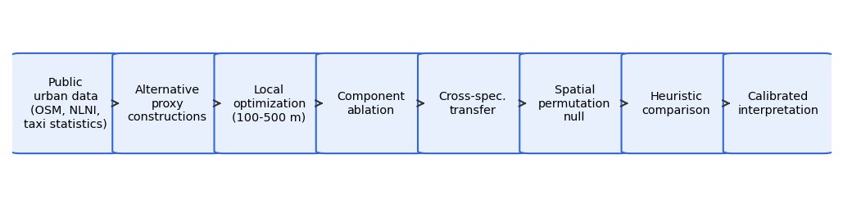
Figure 1. Internal stress-test workflow: public urban data, alternative proxy constructions, local optimization, component ablation, cross-specification transfer, spatial permutation null, heuristic comparison, and calibrated interpretation.

1.1 Research questions
RQ1: How large are apparent relocation gains under self-optimization? RQ2: Do gains persist across alternative component specifications? RQ3: Do locations selected under one specification improve another specification's score? RQ4: Do observed gains exceed those of spatially permuted surfaces with identical marginals? RQ5: How much of the gain does the nearest-major-road heuristic explain?

2. Materials and Methods

2.1 Study area and case-study rationale
Five contiguous central wards of Tokyo (Chiyoda, Chuo, Minato, Shinjuku, Shibuya) form the study area — a canonical high-density street-hail environment [27] where fleet telemetry is inaccessible but public spatial data are rich. The area contains the city's principal nightlife and business districts, so the constructed proxies face a genuinely hard test.

2.2 Public urban data
OpenStreetMap road network and points of interest via the Overpass API [34]; FY2023 railway-station locations from the MLIT National Land Numerical Information N02 dataset [35]; and the hourly taxi-use distribution from the Tokyo Taxi Center monitor survey [36] (Table 1). The restricted CSIS Pseudo-PFLOW product was inaccessible and substituted with the monitor profile. The FY2023 N02 schema contains no passenger-count field, so the station term is an unweighted location kernel — a documented simplification whose effect is bounded by the ablation and transfer tests. Each source is also a proxy-construction choice: station presence is not station usage, monitor-period profiles are not vacant-supply profiles, and OSM hierarchy is not cruising demand — the audit's job is to make those gaps visible rather than to close them by assumption.

2.3 Directed road-network representation
The street-hail decision is made on streets, not in zones: direction matters because a passenger can hail only the travelling side of a divided road, and one-way structure changes which segments carry cruising flow. A directed segment graph (27,887 hail-feasible segments) therefore replaces areal cells, avoiding the aggregation ambiguity of zonal representations [12]; a {NWE}-edge pedestrian walk graph underlies the equirectangular walking distances. The choice matters for the audit itself: a zonal accessibility grid would smooth the very local maxima that self-optimization exploits, so the network representation keeps the inferential problem visible rather than averaged away.

2.4 Alternative opportunity proxies
The four specifications are deliberately alternative plausible readings of 'opportunity', not competing predictive models. A circulation-potential proxy combines road-class weight, a Gaussian attractor kernel field $D(e)$ (kernel bandwidth $σ = 300 m$), and a period multiplier from the monitor profile blended toward nightlife contexts:
$P_{circ}(e,t) = w_{road}(e)·(0.3 + D(e))·P(h;ctx(e))$
Four z-standardized specifications follow: road-only (hierarchy, degree, lanes); attractor-only (station, nightlife, hotel/hospital, transit, taxi-stand kernels); the circulation proxy; and the combined score
$S_{COMB} = z(z log(1+P_{circ}) + 0.5 S_{road} + 0.4 C_{ctx})$
Each construction encodes a different theory of where a cruising taxi is likely to pass: the road-only specification treats hierarchy, connectivity, and capacity as sufficient information — the 'knowledgeable local' reading; the attractor-only specification treats origins and destinations — stations, nightlife, hotels and hospitals, transit nodes, existing stands — as sufficient; the circulation proxy couples the two through the kernel field and a period-weighted profile; and the combined score averages the three readings after z-standardization. None is privileged a priori, which is the point: they are alternative plausible readings of opportunity rather than competing predictive models, and the audit asks whether the locations they privilege agree. All are modeled public-data proxies — none is observed taxi availability — and their construction inherits the composite-index sensitivities documented elsewhere [4,10].

2.5 Local pedestrian relocation optimization
2,000 origins (seed 42); candidates are segments reachable within 100/200/300/500 m walking distance; the selected location maximizes the score over candidates, mirroring the marginal repositioning a passenger would actually perform. The 100-500 m radius range brackets the walk a hail passenger plausibly makes — short enough that most origins have many candidates, long enough that the candidate set grows superlinearly in dense networks. Because every radius re-optimizes, the radius sweep also functions as a dose-response check: a genuine structural advantage should grow smoothly with candidate-set size, whereas generic maximum-selection grows mechanically as well — which is why radii alone cannot separate the two.

2.6 The self-optimization problem
If $S_{A}(x)$ is the opportunity score and $x_{A}^{*} = argmax x_{c}∈N(x_{0}) S_{A}(x_{c})$, then
$S_{A}(x_{A}^{*}) − S_{A}(x_{0}) ≥ 0$
holds by construction whenever a better-scoring candidate exists in $N(x_{0})$. Positive self-gain is therefore partly structural — an order-statistical property of optimizing a heterogeneous surface — and cannot alone validate the proxy. This is the central premise of the audit.

2.7 Component ablation
Each specification is optimized separately. Ablation addresses whether apparent gains hinge on one particular construction choice (weights, kernels, components) — the same question specification-sensitivity work poses for composite indices [5], here asked of spatial scores. If apparent gains appeared only under the combined score, the composite weighting would be the suspect; if they appear under every construction, the phenomenon lies in optimization on heterogeneous surfaces itself rather than in any single design decision. The four specifications deliberately span two different information families — network hierarchy and destination kernels — so the ablation also feeds the transfer test of §2.8.

2.8 Cross-specification transfer
The transfer gain $TG(A→B) = S_{B}(x_{A}^{*}) − S_{B}(x_{0})$ evaluates locations selected under specification A (selector) under a distinct specification B (evaluator). Off-diagonal transfer — especially between the road-only and attractor-only component families, which encode different information structures — is stronger internal evidence than self-gain, because it cannot be manufactured by the selection rule itself. Diagonal entries remain self-optimization. The distinction mirrors the difference between re-fitting under perturbed assumptions and transporting a conclusion to a different reasonable analysis pipeline [15]: a gain that exists only inside the family that produced it is evidence about that family, not about the city.

2.9 Spatial permutation null
Scores are permuted across all hail-feasible segments (500 repetitions). The null preserves the marginal score distribution, the network geometry, the origin distribution, and the candidate counts, while destroying the observed spatial arrangement [29,30]. Because optimization rewards local variance, a scrambled surface with the same value distribution is not a straw man but a sharp benchmark: anything optimization does to it is attributable to generic heterogeneity plus selection, not to urban structure. It answers a specific question: how much improvement would optimization deliver on a surface with identical values but random placement? Observed improvement fractions and gain magnitudes are compared against the null with empirical $p = (1 + \#\{null ≥ obs\})/(1 + N)$.
Three outcomes are distinguishable. If observed statistics exceed the null on both prevalence and magnitude, the spatial arrangement carries exploitable information; if prevalence but not magnitude exceeds it, the arrangement adds a reliability edge but not larger wins; and if neither exceeds the null, the apparent gain is generic maximum-selection on a heterogeneous surface. The comparison is run per period and per radius because the answer need not be uniform across either.

2.10 Constrained permutation sensitivity
A within-ward permutation preserves coarse geographic structure — the district-level organization a sceptic might credit with the gains — and tests whether the remaining fine-scale arrangement is still distinguishable from random. It is the more conservative of the two nulls.

2.11 Heuristic comparators
Stay; random relocation (10 seeded draws); and the nearest major-class road, a meaningful domain heuristic because cruising taxis concentrate on arterials and a literate local needs no model to walk to one [24]. Heuristics serve two audit roles: they bound how much added value the constructed score plausibly contributes beyond common knowledge, and they guard against the 'complexity premium' — the tendency to credit elaborate constructions for gains a trivial rule would have delivered.

2.12 Cluster-aware statistical inference
Origin-period rows are repeated measurements, so naive independence would overstate precision. Period-invariant specifications use unique origins (n = 1,961-1,999); period-varying specifications use an origin-clustered bootstrap (5,000 replicates) and paired tests on origin-mean differences. Effects, confidence intervals, and p-values are reported together rather than p alone. The clustering matters practically: origins that start near high-opportunity areas improve less under any specification, so treating each origin-period row as independent would inflate effective sample size by roughly an order of magnitude.

2.13 Reproducibility
Fixed seeds, raw-data snapshots with a SHA-256 ledger, public code, a canonical numerical registry that generates every printed analysis value, and machine-readable tables.

3. Results

3.1 Opportunity surfaces and local heterogeneity
All four surfaces are strongly heterogeneous, with ridges along arterials and station fronts (Figure 2). Heterogeneity is expected — and is precisely what makes local maxima easy to find.
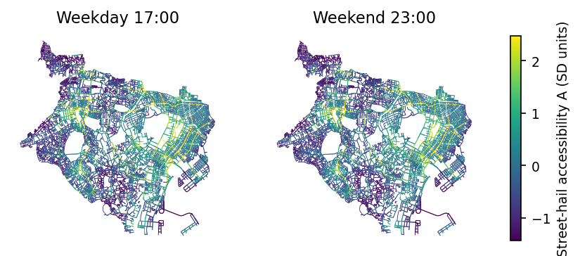
Figure 2. Modeled street-hail opportunity surface (combined specification, SD units), weekday 17:00 and weekend 23:00.

3.2 Apparent gains under self-optimization
Self-optimization produces large apparent gains (RQ1): 84%-100% of origins have a higher-scoring segment within reach, mean gain 0.69-1.93 SD (Figure 3, Table 2; a worked example in Figure 4). These gains are partly structural by construction (§2.6).
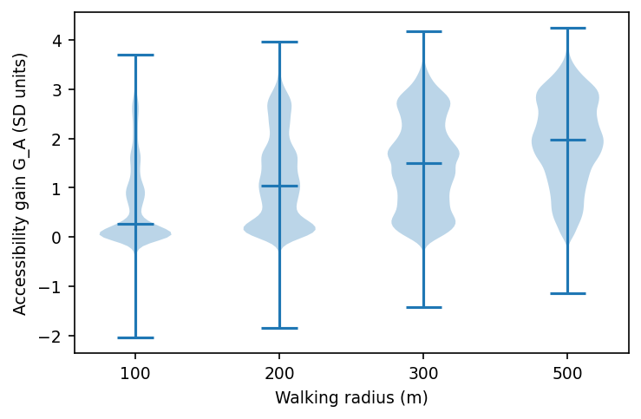
Figure 3. Apparent self-optimization gains (SD units) by walking radius, combined specification.
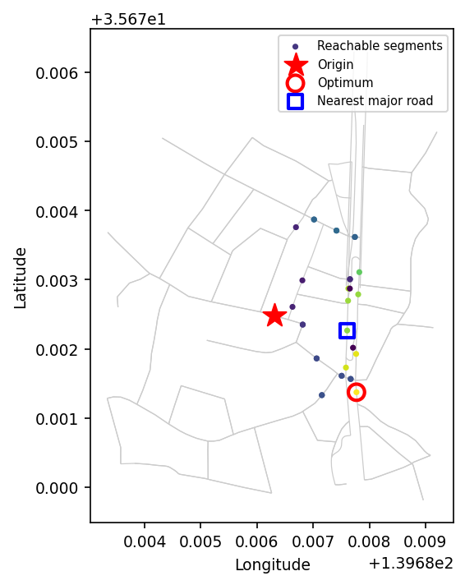
Figure 4. Local optimization example (200 m, weekday 17:00): apparent gain under the combined score.

3.3 Comparison with simple heuristics
Large self-gains invite a sceptical first question: would any trivial spatial rule do the same? The heuristic comparison answers it. Against heuristics (RQ5): the combined optimum beats random relocation in 100% of origins at 300 m, and beats the nearest major road in 81% of origins (paired surplus 0.22 SD, clustered 95% CI [0.211, 0.235], Wilcoxon p<0.001; Figure 5). The constructed score therefore contains spatial information beyond road hierarchy alone — an internal result that says nothing yet about real taxi encounters.
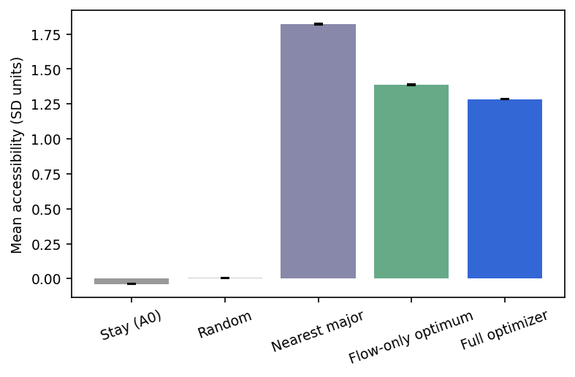
Figure 5. Mean modeled score by strategy (combined specification, radii pooled). Error bars = SEM.

3.4 Component ablation
Apparent gains persist under every construction (RQ2): at 300 m, road-only 95%, attractor-only 99%, proxy 98%, combined 98% improved (Figure 6, Table 3). Segment rankings agree only moderately to strongly (Spearman 0.55-0.97): the constructions are alternative readings with varying degrees of agreement, and persistence is not proof of external validity.
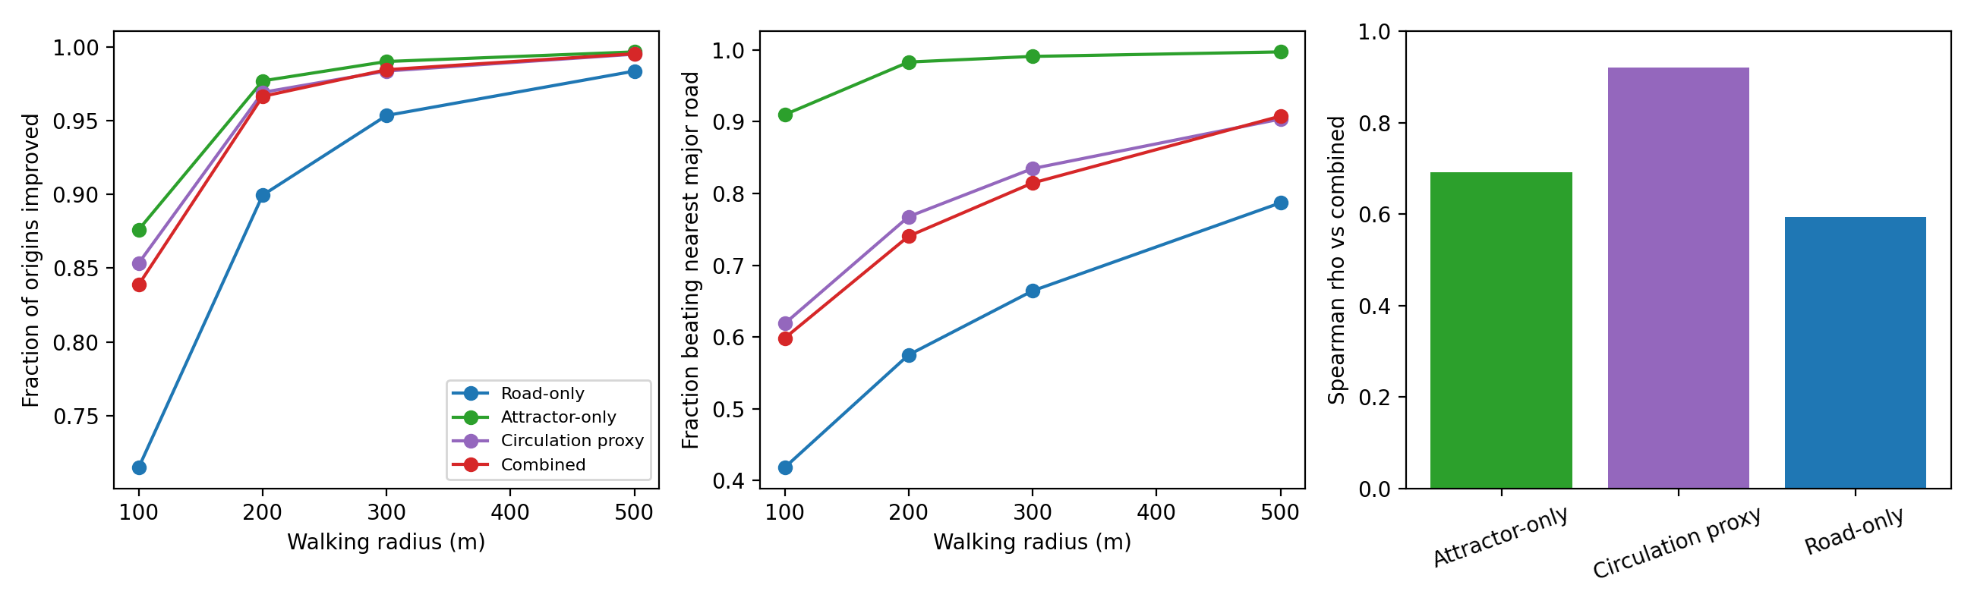
Figure 6. Component ablation across walking radii.

3.5 Cross-specification transfer
The ablation establishes that apparent gains are not an artefact of one construction; the transfer test asks the harder question of whether different constructions identify the same places. Transfer between conceptually distinct component families is weak (RQ3): road-selected locations improve the attractor score for 53% of origins (mean 0.04 SD) and attractor-selected locations improve the road score for 43% of origins (0.08 SD) — showing weak directional consistency. Transfer into the proxy is stronger (attr→proxy 69%; road→proxy 90%) because the proxy embeds road hierarchy (Figure 7, Table 4). Weak off-diagonal transfer is itself a key finding: the constructions partly identify different, non-transferable structure.
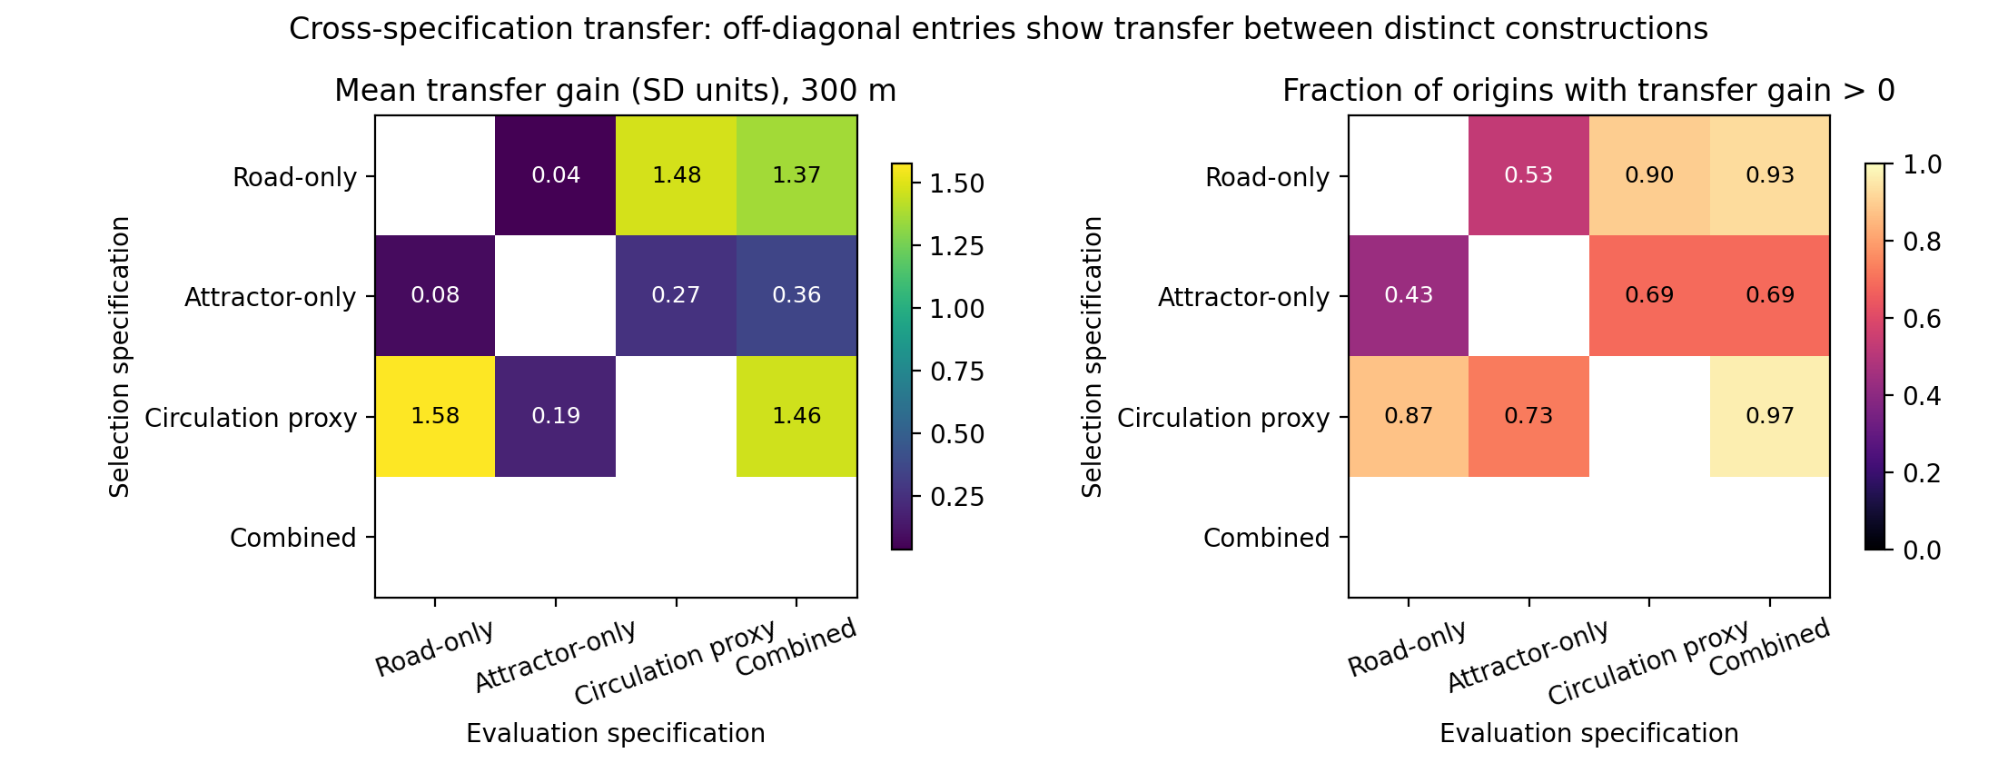
Figure 7. Transfer matrix at 300 m. Diagonal would be self-optimization; off-diagonal entries are internal transfer evidence.

3.6 Spatial permutation null
The decisive test is whether the observed surface's spatial arrangement adds anything beyond generic heterogeneity. Against the unrestricted null (RQ4): improvement prevalence marginally exceeds permutation at 200-500 m (observed 0.983 vs null 0.979 at 300 m; empirical p=0.03-0.09 for the weekday-17 null) but not at 100 m (p=1.0). Mean gain magnitude does not exceed the null at any radius (observed 1.50 vs null 2.61 SD at 300 m; Figure 8, Table 5). A spatially unstructured surface with identical marginals produces larger local contrasts: most of the apparent gain is generic maximum-selection, while the observed surface's spatial autocorrelation [31] actually compresses local maxima.
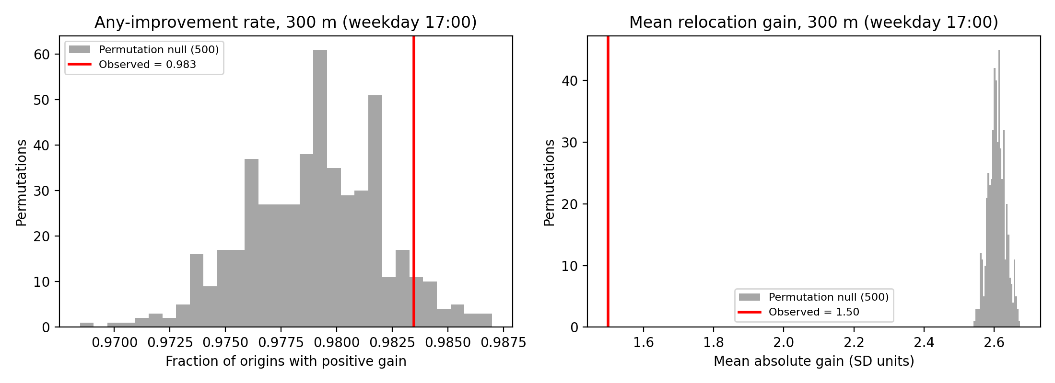
Figure 8. Observed statistics (red) vs 500-permutation null (gray), 300 m, weekday 17:00.

3.7 Constrained-null sensitivity
One possible rescue is that the important organization lives at district rather than segment scale. The within-ward and weekend-23 nulls reproduce the same pattern (marginal prevalence advantage at 200-500 m; observed magnitude below the null), so coarse district structure does not rescue the gain-magnitude claim.

3.8 Temporal and district secondary analyses
Under the modeled temporal specifications, gains are largest in the weekday-morning period; the weekend specification shifts modeled opportunity toward nightlife contexts — input-profile consequences (Figure 9). Kernel bandwidth 150/500 m leaves gains nearly unchanged (rho 0.98/0.99).
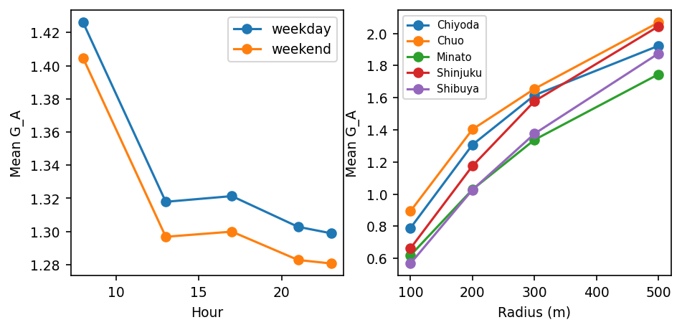
Figure 9. Modeled gain by hour/day-type and ward/radius — model behavior, not observed patterns.

3.9 Summary of evidence levels
Level 1 (self-optimization): large apparent gains — achieved. Level 2 (internal stress tests): ablation passed; transfer weak; heuristic contrast retained; permutation shows prevalence marginally above but magnitude below null. Level 3 (external empirical validation): not available in this study.

4. Discussion

4.1 Apparent optimization gain is not validation
The self-optimization inequality is structural: with ~hundreds of reachable candidates, a local maximum almost surely exceeds the origin. This is the spatial analogue of the statistical observation that selecting on the measured outcome inflates it [17,18]. Composite-index research long ago documented that constructed scores encode their constructors' choices [10,4,5]; the results here show the corresponding trap on the optimization side: large gains persist under every alternative construction we tested, yet persistence across constructions is not evidence that any of them describes the world. The practical lesson is not that gains exist — it is that their size carries almost no validating information. The same logic explains why optimization results are so persuasive in practice: the numbers are real, correctly computed, and often large — what they lack is a baseline of what optimization delivers by construction. A useful analogy is the distinction between internal and external validity in the causal-inference literature: a pipeline can be internally consistent — correctly optimized, correctly measured — while telling us nothing about the target domain, because the criterion by which success is judged is a construction, not an observation.

4.2 Cross-specification transfer as a stronger internal test
The road-only and attractor-only specifications encode different information structures — network hierarchy versus destination kernels — so transfer between them tests whether a selected location is preferable under a genuinely different plausible reading of opportunity. Positive but limited transfer means the two families partly identify different places: an improvement under one public-data reading of 'opportunity' shows weak cross-specification consistency under the other. This is distinct from parameter sensitivity [14]: a spec curve perturbs coefficients within one family, whereas transfer asks whether the answer generalizes across families — closer in spirit to the multiverse question of whether conclusions survive reasonable analyst variation [15,16]. Transfer alone does not prove validity; weak transfer does, however, falsify the strong claim that the proxy identifies structure all reasonable constructions share.

4.3 Spatial nulls and generic heterogeneity
The decisive result is comparative: a shuffled surface reproduces ≈101% of the observed improvement prevalence on average across the examined radii (null/observed ratio 0.99-1.04) and produced larger mean gain magnitudes. The mechanism is order-statistical: optimizing over many candidates rewards variance, and the real surface's positive spatial autocorrelation [31,32] suppresses the local contrast a scrambled one enjoys. Monte-Carlo nulls have a long history in spatial-pattern inference [29,30,33]; using them here reframes 'how much did optimization gain?' into 'how much gain would any heterogeneous surface deliver?'. What the real urban surface contributes is a marginal reliability edge — not bigger wins — so its fine-scale arrangement adds little for relocation purposes. It is worth stressing what this is not: the null does not 'beat' the model in any operational sense, because neither surface is validated against encounters; the comparison instead locates where the apparent gain comes from. A prevalence edge of a few percentage points at mid-range radii is the entire observed margin — a finding that would be invisible if only the headline self-gain had been reported.
The autocorrelation direction deserves emphasis because it cuts against intuition. Readers schooled on Moran's I or LISA [31,33] might expect spatial clustering to help local optimization — clusters mean predictable hot spots. For relocation the opposite holds locally: autocorrelation means an origin already sits on values similar to its neighbours, so the local maximum is only modestly higher; a scrambled surface places extreme values arbitrarily close. Optimization gain is therefore anti-correlated with the surface's own organization — an interpretation that could not have been made without the permutation comparison.

4.4 Why heuristic superiority is insufficient
The combined optimum's surplus over the nearest major road shows the score encodes information beyond hierarchy — a real, if narrow, computational finding, since road-hierarchy knowledge is what an unaided user can deploy for free [24]. But benchmark-beating is still internal evidence: decision-support evaluation normally requires comparison against realized outcomes, which do not exist here. The honest statement is that the model earns its complexity relative to the free heuristic without any demonstration that either achieves real encounters. The benchmark does set a useful calibration anchor: if a proposed proxy cannot beat the free heuristic, the case for its complexity collapses immediately — a cheap test that many index-optimization pipelines skip.

4.5 From sensitivity analysis to falsification-oriented proxy auditing
Sensitivity analysis asks whether the answer changes when assumptions change [14]; the framework here asks whether the apparent benefit survives tests designed to undermine the naive interpretation — a falsification orientation closer to the multiverse/specification-curve programme [15,16] and to randomization inference [30] than to classical sensitivity analysis. The resulting workflow is compact (Figure 1): CONSTRUCT one or more plausible proxy surfaces; OPTIMIZE candidate locations; ABLATE components to test specification dependence; TRANSFER selected locations across alternative specifications; NULL-TEST against spatially permuted or otherwise structured nulls; BENCHMARK against simple domain heuristics; CALIBRATE claims to the evidence level that survives. It is an internal, falsification-oriented audit — a practical workflow, not a universal standard. Two design principles underlie it. First, tests should be destructive by intent: each stage is built to break the naive reading (that optimization gain implies spatial knowledge), not to corroborate it. Second, calibration is explicit: claims are stated at the level of evidence that survives (§3.9), so a pipeline that passes ablation but fails transfer and null tests licenses exactly the modest claim the residual evidence supports. Applied here, the workflow converted a superficially strong result — near-universal improvement with large effect sizes — into the accurate statement that the surface's fine-scale arrangement contributes little beyond generic heterogeneity.

4.6 Implications for urban accessibility research
The problem class is broad: accessibility indices [1,2,3], cumulative-opportunity and space-time measures [8,7], composite urban scores [4,5], transit and destination accessibility surfaces [37,9], and mobility-availability proxies all share the same inferential structure — a constructed score optimized where outcome labels are sparse. Nothing here invalidates proxy-based planning; the narrower claim is that proxy optimization requires stronger validation than within-score improvement, and that the three internal tests used here are cheap to add to such pipelines. For accessibility measurement in particular — where debates about metric and scale choice are long-running [2,8] — the transfer and null tests offer a way to ask whether a metric choice changes not just the estimated accessibility but the locations optimization would actually select.
There is also a constructive implication. The tests are ordinal and comparative rather than calibrated, so they compose naturally with the existing accessibility toolkit: a cumulative-opportunity surface or a transit accessibility index [3,37] can be carried through the same audit, and a siting recommendation that survives transfer and null tests is materially stronger than one that only reports its own score improvement. Where the audit fails, the honest remedy is external data or explicitly discounted claims — not a more elaborate proxy.

4.7 Prospective infrastructure siting under no-label conditions
The same constraint appears, sharper, when infrastructure is prospective and historical outcome labels cannot exist. Alternative-fuel station planning formalized this as flow-based siting on networks [38,39]; public charging-station deployment is optimized under demand uncertainty [40]; and hydrogen-refueling planning has long proceeded from modeled demand surfaces in the absence of any realized demand [41]. In each case planners must optimize a constructed proxy for an outcome that has not yet been observed — precisely the setting in which internal stress tests of the kind demonstrated here can reduce overinterpretation until external outcomes become available. The present framework does not solve siting; it disciplines the claims a proxy-optimization pipeline can honestly make.

4.8 Street-hail taxis as a motivating case
The taxi case is scientifically useful because it combines three features: a genuinely spatial passenger decision [24,26], proprietary operational data — the telemetry behind T-Finder and trajectory-demand systems [19,20,23,22] — and a strong temptation to substitute public proxies for the missing observations [28,27]. The paper is therefore not an operational validation of a recommendation system; the case makes the proxy-optimization problem concrete.
The bilateral-search tradition offers a complementary reading of the null result: search equilibrium models make encounter probability depend on both cruising supply and searching demand on the same network [25,26], and no static public-data surface can capture that two-sided dynamic. The stress tests here do not assume such a model; they ask only whether the static proxy's own structure does any work, and answer 'very little'.

4.9 Limitations
No observed vacant-taxi ground truth; no actual waiting-time outcomes; scores are uncalibrated public-data proxies; temporal structure is partly modeled from the monitor profile; Tokyo specificity limits generalization; roadside hail feasibility is imperfectly represented; the station term is unweighted (FY2023 N02 lacks passenger counts); the proxy constructions share inputs and are not fully independent; cross-specification transfer is internal evidence only; and permutation conclusions depend on the null definition — the within-ward variant mitigates but does not eliminate this dependence. Two limitations cut deeper than the rest. First, all four specifications are built from the same underlying data universe — the same OSM network and POIs — so even 'distinct' constructions share errors the audit cannot see; cross-specification transfer tests construction-family dependence, not data-universe dependence. Second, the audit's nulls are value-permutations on a fixed network; richer constrained nulls (e.g. autocorrelation-preserving surrogates) could sharpen the prevalence comparison, and the choice of null remains a specification decision of its own — the same caveat the MAUP literature raises for representation choice [12,13].

4.10 Requirements for external empirical validation
Before any operational interpretation, external evidence would require observed vacant-taxi passage, actual waiting times, or prospective passenger outcomes.

5. Conclusion
Optimization performance and proxy validity are not equivalent. A constructed surface's susceptibility to optimization is a property of its heterogeneity and representation, not of its correspondence to the world. In a street-hail relocation audit built entirely on public data, large within-score optimization gains did not translate into equally strong cross-specification evidence and were partly reproducible under spatially permuted null surfaces: self-optimization alone is insufficient validation of a constructed urban opportunity proxy. Component ablation, cross-specification transfer, spatial-null comparison, and simple heuristic benchmarking together form a practical falsification-oriented stress-test framework for such studies — a checklist for what an apparent gain must survive before it is interpreted as structure rather than as selection. The caution applies beyond taxis: accessibility indices, amenity scores, and mobility proxies are routinely optimized wherever outcome labels are absent, and it becomes acute for prospective infrastructure whose outcomes cannot yet be observed. What remains unresolved — as it must be, here — is external validation against realized outcomes: observed encounters, waiting times, or prospective passenger results. Until then, the disciplined claim is the narrow but useful one — the audit framework exposes the distinction between apparent optimization gain and transferable spatial structure, and on this case it reports that apparent success can coexist with weak evidence of transferable spatial structure. For studies that build, rather than observe, their surfaces, that combination of ambition and restraint is the defensible default.

Declarations
Data availability: all inputs are public datasets (Table 1); preprocessing and analysis code, the canonical numerical registry, and machine-readable result tables are openly available at https://github.com/bougtoir/street-hail-taxi-accessibility. Competing interests: none declared. Funding: none.

References
1. Hansen WG. How accessibility shapes land use. J Am Inst Plann. 1959;25(2):73-76. doi:10.1080/01944365908978307.
2. Handy SL, Niemeier DA. Measuring accessibility: an exploration of issues and alternatives. Environ Plann A. 1997;29(7):1175-1194. doi:10.1068/a291175.
3. Geurs KT, van Wee B. Accessibility evaluation of land-use and transport strategies: review and research directions. J Transp Geogr. 2004;12(2):127-140. doi:10.1016/j.jtrangeo.2003.10.005.
4. OECD/JRC. Handbook on Constructing Composite Indicators: Methodology and User Guide. OECD Publishing. 2008. doi:10.1787/9789264043466-en.
5. Greco S, Ishizaka A, Tasiou M, Torrisi G. On the methodological framework of composite indices: a review of the issues of weighting, aggregation, and robustness. Soc Indic Res. 2019;141(1):61-94. doi:10.1007/s11205-017-1832-9.
6. Longley PA, Goodchild MF, Maguire DJ, Rhind DW. Geographic Information Science and Systems. 4th ed. Wiley. 2015.
7. Miller HJ. Measuring space-time accessibility benefits within transportation networks: basic theory and computational procedures. Geogr Anal. 1999;31(1):1-26. doi:10.1111/j.1538-4632.1999.tb00976.x.
8. Kwan MP. Space-time and integral measures of individual accessibility: a comparative analysis using a point-based framework. Geogr Anal. 1998;30(3):191-216. doi:10.1111/j.1538-4632.1998.tb00396.x.
9. Shen Q. Location characteristics of inner-city neighborhoods and employment accessibility of low-wage workers. Environ Plann B. 1998;25(3):345-365. doi:10.1068/b250345.
10. Freudenberg M. Composite indicators of country performance: a critical assessment. OECD STI Working Paper 2003/16. OECD Publishing. doi:10.1787/405566708255.
11. Openshaw S. The Modifiable Areal Unit Problem. Geo Books, Norwich. 1984.
12. Fotheringham AS, Wong DWS. The modifiable areal unit problem in multivariate statistical analysis. Environ Plann A. 1991;23(7):1025-1044. doi:10.1068/a231025.
13. Jelinski DE, Wu J. The modifiable areal unit problem and implications for landscape ecology. Landsc Ecol. 1996;11(3):129-140. doi:10.1007/BF02447512.
14. Saltelli A, Ratto M, Andres T, Campolongo F, Cariboni J, Gatelli D, Saisana M, Tarantola S. Global Sensitivity Analysis: The Primer. Wiley. 2008. doi:10.1002/9780470725184.
15. Steegen S, Tuerlinckx F, Gelman A, Vanpaemel W. Increasing transparency through a multiverse analysis. Perspect Psychol Sci. 2016;11(5):702-712. doi:10.1177/1745691616658637.
16. Simonsohn U, Simmons JP, Nelson LD. Specification curve analysis. Nat Hum Behav. 2020;4(11):1208-1214. doi:10.1038/s41562-020-0912-z.
17. Simmons JP, Nelson LD, Simonsohn U. False-positive psychology: undisclosed flexibility in data collection and analysis allows presenting anything as significant. Psychol Sci. 2011;22(11):1359-1366. doi:10.1177/0956797611417632.
18. Gelman A, Loken E. The garden of forking paths: why multiple comparisons can be a problem, even when there is no 'fishing expedition' or 'p-hacking' and the research hypothesis was posited ahead of time. Department of Statistics, Columbia University. 2014.
19. Yuan NJ, Zheng Y, Zhang L, Xie X. T-Finder: a recommender system for finding passengers and vacant taxis. IEEE Trans Knowl Data Eng. 2013;25(10):2390-2403. doi:10.1109/TKDE.2012.153.
20. Moreira-Matias L, Gama J, Ferreira M, Mendes-Moreira J, Damas L. Predicting taxi-passenger demand using streaming data. IEEE Trans Intell Transp Syst. 2013;14(3):1393-1402. doi:10.1109/TITS.2013.2262376.
21. Hwang RH, Hsueh YL, Chen YT. An effective taxi recommender system based on a spatio-temporal factor analysis model. Inf Sci. 2015;314:28-40. doi:10.1016/j.ins.2015.03.047.
22. Yuan NJ, Zheng Y, Zhang L, Xie X. Where to find my next passenger? In: Proc 13th ACM Int Conf Ubiquitous Computing. 2011:329-338. doi:10.1145/2030112.2030135.
23. Zheng Y, Liu Y, Yuan J, Xie X. Urban computing with taxicabs. In: Proc 13th ACM Int Conf Ubiquitous Computing (UbiComp). 2011:99-108. doi:10.1145/2030112.2030126.
24. Yang H, Leung CWY, Wong SC, Bell MGH. Equilibria of bilateral taxi-customer searching and meeting on networks. Transp Res Part B. 2010;44(8-9):1067-1083. doi:10.1016/j.trb.2010.03.003.
25. Yang H, Wong SC. Demand-supply equilibrium of taxi services in a network under competition and regulation. Transp Res Part B. 2002;36(9):799-819. doi:10.1016/S0191-2615(01)00031-5.
26. Wong KI, Wong SC, Bell MGH, Yang H. Modeling the bilateral micro-searching behavior for urban taxi services using the absorbing Markov chain approach. J Adv Transp. 2008. doi:10.1002/atr.5670390107.
27. Tokyo Hire-Taxi Association. Tokyo no Taxi 2025. https://taxi-tokyo.or.jp/ (accessed 2026-09-29).
28. Ocalir EV, Ercoskun OY, Tur R. An integrated model of GIS and fuzzy logic (FMOTS) for location decisions of taxicab stands. Expert Syst Appl. 2010;37(7):4892-4901. doi:10.1016/j.eswa.2009.12.073.
29. Besag J, Diggle PJ. Simple Monte Carlo tests for spatial pattern. Appl Stat. 1977;26(3):327-333. doi:10.2307/2346974.
30. Manly BFJ. Randomization, Bootstrap and Monte Carlo Methods in Biology. 3rd ed. Chapman & Hall/CRC. 2007. doi:10.1201/9781315273075.
31. Moran PAP. Notes on continuous stochastic phenomena. Biometrika. 1950;37(1-2):17-23. doi:10.2307/2332142.
32. Getis A, Ord JK. The analysis of spatial association by use of distance statistics. Geogr Anal. 1992;24(3):189-206. doi:10.1111/j.1538-4632.1992.tb00261.x.
33. Anselin L. Local indicators of spatial association - LISA. Geogr Anal. 1995;27(2):93-115. doi:10.1111/j.1538-4632.1995.tb00338.x.
34. OpenStreetMap contributors. Planet dump and Overpass API. https://www.openstreetmap.org (ODbL; accessed 2026-09-29 via OSMnx 2.0.7).
35. Ministry of Land, Infrastructure, Transport and Tourism (Japan). National Land Numerical Information, N02 railway dataset (FY2023). https://nlftp.mlit.go.jp/ksj/ (accessed 2026-09-29).
36. Tokyo Taxi Center. Taxi user monitor survey, FY2023 tabulation report. https://www.tokyo-tc.or.jp/center/uploads/monitor_2024.pdf (accessed 2026-09-29).
37. Mavoa S, Witten K, McCreanor T, O'Sullivan D. GIS based destination accessibility via public transit and walking in Auckland, New Zealand. J Transp Geogr. 2012;20(1):15-22. doi:10.1016/j.jtrangeo.2011.10.001.
38. Kuby M, Lim S. The flow-refueling location problem for alternative-fuel vehicles. Socioecon Plann Sci. 2005;39(2):125-145. doi:10.1016/j.socsc.2004.03.001.
39. Kuby M, Lim S. Location of alternative-fuel stations using the flow-refueling location model and dispersion of candidate sites on arcs. Netw Spat Econ. 2007;7(2):129-152. doi:10.1007/s11067-006-9003-0.
40. He F, Wu D, Yin Y, Guan Y. Optimal deployment of public charging stations for plug-in hybrid electric vehicles. Transp Res Part B. 2013;47:87-101. doi:10.1016/j.trb.2012.09.007.
41. Nicholas M, Ogden J. Regional consumer hydrogen demand and optimal hydrogen refueling station siting. UC Davis ITS Report. 2004. doi:10.2172/928253.

Table 1. Public data sources
Source | Provider/License | Scope | Role
OSM road network + POIs | OSM contributors / ODbL | 5 central wards | segments, context, walk network
NLNI N02 station locations | MLIT / NLNI terms | FY2023 | station-presence attractor
Tokyo Taxi Center monitor survey | Tokyo Taxi Center | FY2023, n=2,662 | temporal profile
THTA yearbook 2025 | THTA | FY2024 | background

Table 2. Self-optimization outcomes by radius (combined specification)
Radius m | origins | improved | >0.1 SD | mean gain (SD) | beats nearest major | gain CI
100 | 1961 | 84% | 67% | 0.69 | 60% | [0.649, 0.722]
200 | 1989 | 97% | 90% | 1.16 | 74% | [1.124, 1.204]
300 | 1997 | 98% | 96% | 1.50 | 81% | [1.462, 1.539]
500 | 1999 | 100% | 99% | 1.93 | 91% | [1.894, 1.968]

Table 3. Ablation summary (300 m)
Specification | improved | >0.1 SD | beats nearest major | beats random | best is major road
Road-only | 95% | 95% | 66% | 100% | 55%
Attractor-only | 99% | 92% | 99% | 100% | 12%
Circulation proxy | 98% | 93% | 83% | 100% | 56%
Combined | 98% | 96% | 81% | 100% | 56%

Table 4. Cross-specification transfer at 300 m (mean TG SD / % positive)
Selector \ Evaluator | Road-only | Attractor-only | Circulation proxy | Combined
Road-only | (self) | 0.04 / 53% | 1.48 / 90% | 1.37 / 93%
Attractor-only | 0.08 / 43% | (self) | 0.27 / 69% | 0.36 / 69%
Circulation proxy | 1.58 / 87% | 0.19 / 73% | (self) | 1.46 / 97%

Table 5. Spatial permutation null (combined specification, weekday 17:00)
Radius m | obs frac>0 | null frac>0 | empirical p | obs mean G | null mean G
100 | 0.839 | 0.874 | 1.000 | 0.69 | 1.67
200 | 0.966 | 0.957 | 0.030 | 1.17 | 2.30
300 | 0.983 | 0.979 | 0.074 | 1.50 | 2.61
500 | 0.995 | 0.992 | 0.086 | 1.92 | 2.90

