Mapping street-hail opportunity without fleet telemetry: a geospatial framework for pedestrian relocation in urban taxi access

Abstract
Background: Street-hail taxi access in dense cities depends on fine-scale street-level opportunity structure that passengers cannot observe and researchers cannot measure without proprietary fleet telemetry. Methods: We construct a public-data-derived, relative street-hail opportunity score on the directed road network of Tokyo's five central wards (27,887 hail-feasible segments), combining road hierarchy, railway station locations, mapped attractors, and a published hourly taxi-use profile. For 2,000 sampled origins we optimize pedestrian relocation within 100-500 m walking distance and audit the result with component ablation (road-only vs attractor-only vs proxy vs combined), cross-specification transfer, and a 500-permutation spatial null with a within-district constrained variant, using origin-clustered bootstrap inference (5,000 replicates). Results: 97%-100% of origins have a higher-scoring segment within walking range, and the optimizer exceeds the nearest-major-road heuristic in 81% of origins at 300 m (paired Wilcoxon p<0.001). Transfer between road-only and attractor-only selections is positive but weak (53% and 44% of origins), indicating partially independent information layers. Against the permutation null, the reliability of finding an improvement marginally exceeds chance (empirical p=0.02-0.09 at 200-500 m) but the gain magnitude does not — a generic heterogeneous surface produces larger local contrasts. Conclusions: Public urban data contain non-trivial spatial structure that can generate candidate street-hail relocation contrasts without proprietary fleet telemetry, providing a testable basis for subsequent empirical validation; the scores carry no waiting-time meaning.
Keywords: geospatial analysis; urban mobility; public data; street-hail taxi; pedestrian relocation; spatial opportunity structure

1. Introduction
Street-hail taxi access is an urban mobility problem of information asymmetry: the fine-scale geography of where a vacant taxi is likely to pass is invisible to the pedestrian deciding where to stand. The data that could resolve it — vacant-taxi GPS trajectories — are proprietary operational telemetry held by fleet operators.
Most computational mobility systems assume that barrier away. Taxi-demand prediction [1], stand siting [2], cruising-area recommendation [3], search equilibrium models [4], and passenger-side recommenders such as T-Finder [5] are all trained on fleet trajectories; pickup-point assignment in on-demand ride-sharing [6] likewise presumes observed demand. The unresolved methodological question is whether useful passenger-side spatial opportunity structure can be extracted when those data are unavailable.
We address that question as an urban-computation problem. The scientific object is fine-scale urban opportunity structure for street-hail access under incomplete mobility information; the taxi use case is the empirical application. Because a constructed score can be trivially self-maximized by optimization, we additionally audit whether the apparent relocation signal is genuine urban structure — through component ablation, cross-specification transfer, and spatial permutation — rather than an optimization tautology.
The novelty is the combination, not any single element: a telemetry-free public-data construction on a directed road-segment representation, a passenger-side relocation formulation, and a validation architecture (ablation, transfer, permutation) designed to separate structured urban signal from generic maximum-selection.

2. Materials and Methods

2.1 Study area
Chiyoda, Chuo, Minato, Shinjuku, and Shibuya — the five contiguous central wards of Tokyo and a canonical street-hail environment [7].

2.2 Public data sources
OpenStreetMap road network and points of interest via Overpass [8]; FY2023 railway-station locations (MLIT National Land Numerical Information N02) [9]; the hourly taxi-use distribution from the Tokyo Taxi Center user-monitor survey [10]. The restricted CSIS Pseudo-PFLOW trajectory product was inaccessible and substituted (DATA_SOURCE_AUDIT). During revision we found the FY2023 N02 schema carries no passenger-count field, so the station term is an unweighted location kernel; the pipeline was rebuilt accordingly.

2.3 Directed road-network construction
The OSM driving graph was reduced to 27,887 hail-feasible directed segments (motorway, trunk, pedestrian classes excluded). The OSM walk graph (182,538 edges) supplies pedestrian distances (equirectangular metric at 35.68N).

2.4 Public-data-derived opportunity score
A circulation-potential proxy combines road-class weight w_road, a Gaussian demand-attractor kernel field D(e) (sigma=300 m), and a period multiplier P(h;ctx) from the monitor-survey profile blended toward a night-shifted variant in nightlife contexts:
$P_{circ}(e,t) = w_road(e)·(0.3 + D(e))·P(h;ctx(e))$
This is a modeled proxy, not observed taxi flow; the temporal structure is partly assumed.

2.5 Component specifications
Four specifications define the ablation family. Road-only uses hierarchy, degree, and lanes; attractor-only uses station, nightlife, hotel/hospital, transit, and taxi-stand kernels; the proxy uses the circulation potential above; the combined specification is
$S_{COMB}(e,t) = z(z log(1+P_circ) + 0.5·S_road + 0.4·C_ctx)$
All scores are z-standardized; weights are transparent and untuned.

2.6 Origins and walking neighborhoods
2,000 origins sampled uniformly from hail-feasible segments (seed 42). Reachable candidates are segments whose midpoint is within 25 m of a walk node reachable within 100/200/300/500 m.

2.7 Relocation formulation and metrics
The selected location maximizes the specification score over reachable candidates. The primary metric is the absolute gain
$G_{S} = S(x*) - S0$
in standardized units, with the fraction of origins improved as co-primary. Relative percentage gain is reported only secondarily: z-scores cross zero, making percentage denominators unstable.

2.8 Baseline heuristics
Stay; random relocation (10 seeded draws); nearest major-class road segment; per-specification optima.

2.9 Cross-specification transfer
For each origin, radius, and period, the location x* selected under specification A is evaluated under a distinct specification B:
$TG(A→B) = S_{B}(x*{}_{A}) - S_{B}(x0)$
We compute all six directed transfers among road-only, attractor-only, and the proxy, plus three transfers into the combined specification. Off-diagonal transfer between conceptually distinct component families (road-only and attractor-only) is the primary independence test; transfers into the combined score are weaker evidence because it embeds the constituents.

2.10 Spatial permutation null
To test whether observed gains reflect spatial structure rather than the generic property that a maximum over more candidates tends to exceed the origin value, we permute the combined score across all hail-feasible segments 500 times — preserving the marginal score distribution, network geometry, origin distribution, and candidate counts — and recompute the fraction improved and mean gain at each radius. A within-ward constrained permutation preserves coarse geographic structure. Empirical p-values use (1 + #{null >= obs})/(1 + N).

2.11 Cluster-aware statistical inference
Origin-period rows are repeated measurements, not independent observations. For period-invariant specifications (road-only, attractor-only) inference uses unique origins (n = 1,961-1,999 with nonempty reachable sets). For period-varying specifications, bootstrap resampling (5,000 replicates) resamples origins and pools their period rows; paired tests use origin-mean differences. We report the clustering unit, replicate count, effect estimates, CIs, and p-values together rather than significance alone.

2.12 Reproducibility
Fixed seeds, raw-data snapshots with a SHA-256 acquisition ledger, all code and machine-readable tables provided.

3. Results

3.1 Spatial opportunity structure
The modeled opportunity score forms continuous ridges along arterial corridors and station fronts with troughs in interior blocks (Figure 2). These are modeled contrasts, not observed taxi density.
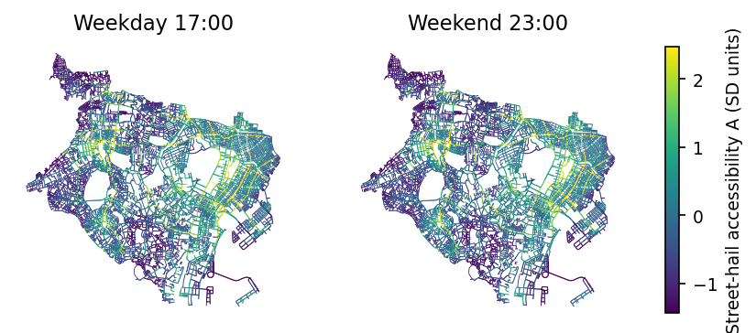
Figure 2. Modeled street-hail opportunity (combined specification, SD units), weekday 17:00 and weekend 23:00.

3.2 Within-walking-radius heterogeneity
Under the combined specification, 84%-100% of origins have a higher-scoring segment within 100-500 m, mean absolute gain 0.69-1.93 SD (origin-clustered bootstrap CIs exclude zero; Table 2, Figure 4).
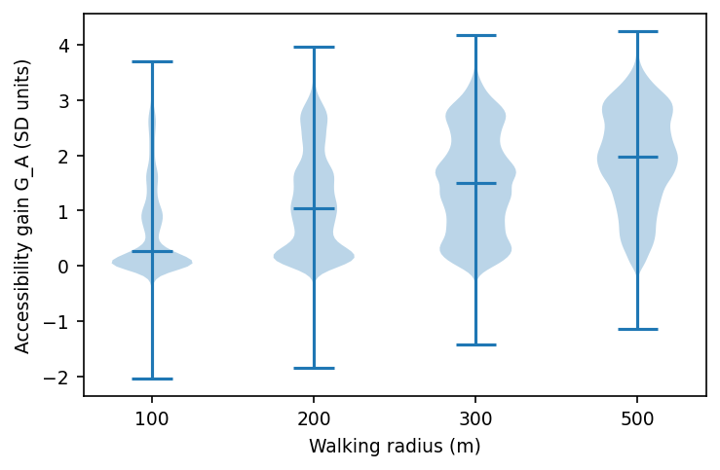
Figure 4. Distribution of absolute opportunity-score gain (SD units) by walking radius.

3.3 Baseline relocation contrasts
The optimizer exceeds random relocation in ~100% of origins across radii (Figure 5).
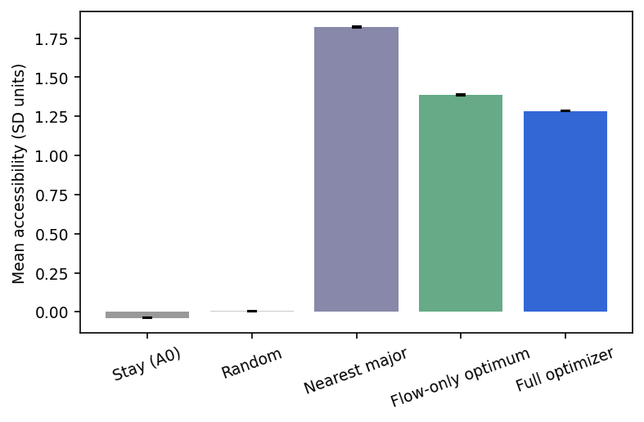
Figure 5. Mean modeled opportunity score by strategy (combined specification, all radii pooled). Error bars = SEM.

3.4 Component ablation
Every construction yields positive gains for most origins at 300 m (road-only 95%, attractor-only 99%, proxy 98%, combined 98%; Figure 7, Table 3). Segment rankings agree only moderately across specifications (mean Spearman 0.52-0.93): the constructions are genuinely distinct.
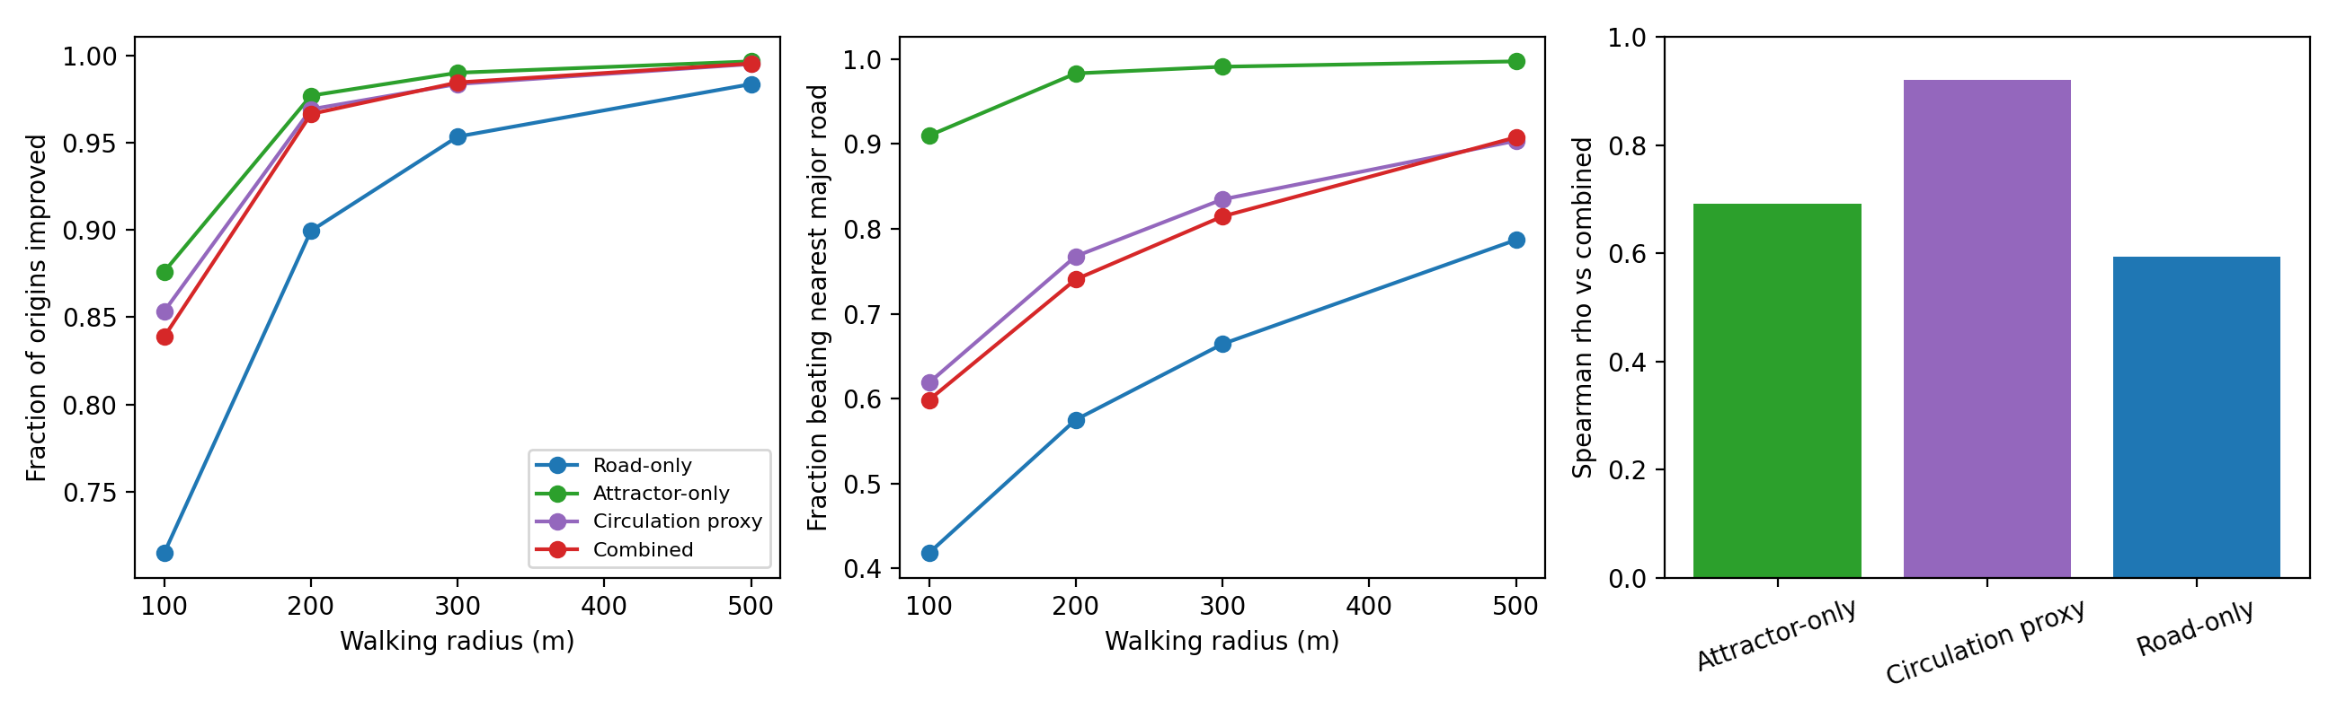
Figure 7. Component ablation: origins improved by radius (left), fraction beating nearest-major-road (middle), rank agreement with combined specification (right).

3.5 Cross-specification transfer
Locations selected under one construction retain benefit under another, but asymmetrically (Figure 8, Table 4): road-selected locations improve the attractor score for 53% of origins (mean 0.04 SD), and attractor-selected locations improve the road score for 43% (0.08 SD). Transfers toward the proxy are stronger (attr -> proxy 69%, mean 0.27 SD; road -> proxy 90%). Off-diagonal transfer between the two conceptually distinct component families is real but weak.
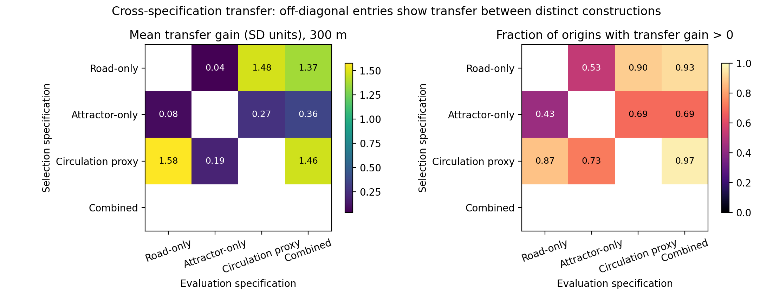
Figure 8. Cross-specification transfer matrix at 300 m: mean transfer gain in SD units (left) and fraction of origins with positive transfer (right). Diagonal would show self-optimization; off-diagonal entries show transfer.

3.6 Spatial permutation null
Against 500 unconstrained permutations (weekday 17:00), the fraction of origins with any improvement marginally exceeds the null at 200-500 m (observed 0.983 vs null 0.979 at 300 m, empirical p=0.02-0.09) but is indistinguishable at 100 m (p=1.0). Critically, the mean gain does not exceed the null (observed 1.50 SD vs null 2.61 SD at 300 m): a spatially unstructured surface with the same marginal distribution produces larger local max-min contrasts. The within-ward constrained null gives the same pattern. What the real surface buys is reliability — a marginally higher chance that some improvement exists nearby — not larger gains (Figure 9).
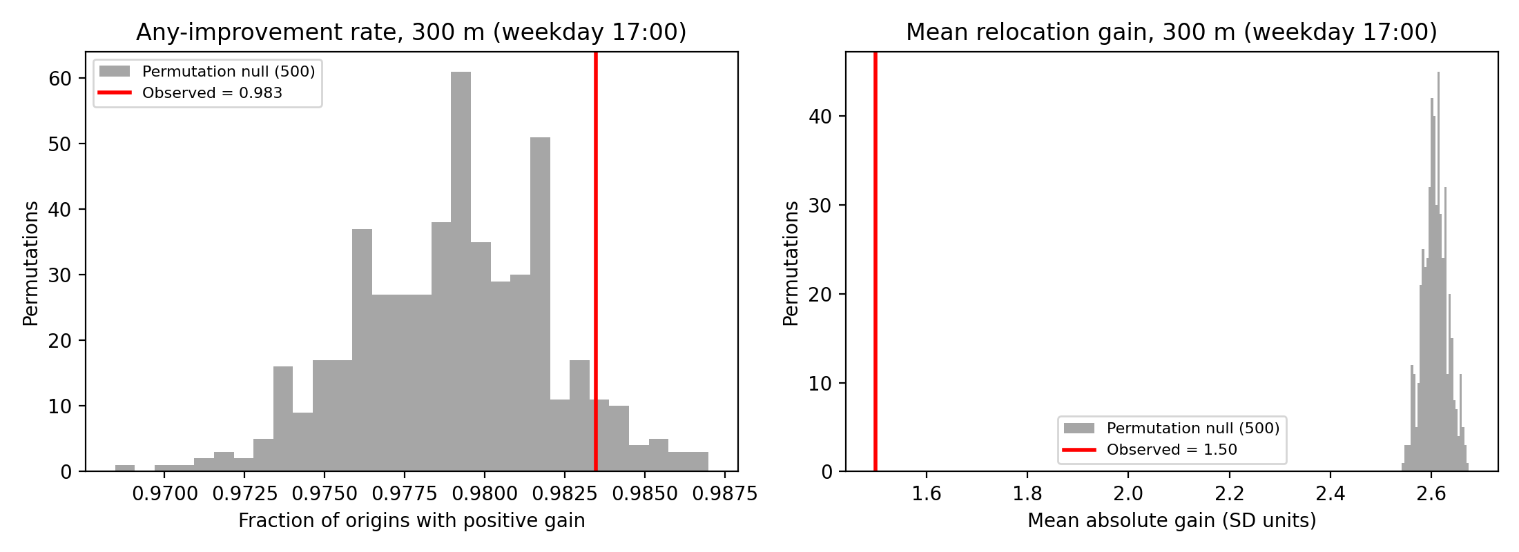
Figure 9. Observed statistics (red) against the 500-permutation null distribution (gray), combined specification, 300 m, weekday 17:00.

3.7 Nearest-major-road comparison
The combined optimum exceeds the nearest major-road segment in 81% of origins at 300 m (paired mean surplus 0.22 SD, clustered 95% CI [0.21117390645170625, 0.2349538476276946], Wilcoxon p<0.001). We describe this as additional modeled opportunity contrast beyond a simple road-hierarchy heuristic — not predictive superiority.

3.8 Temporal and district model behavior
Under the modeled temporal specifications, computed gains are largest in the weekday-morning period and the weekend specification shifts modeled opportunity toward nightlife contexts — input-profile consequences, not observed urban patterns (Figure 6).
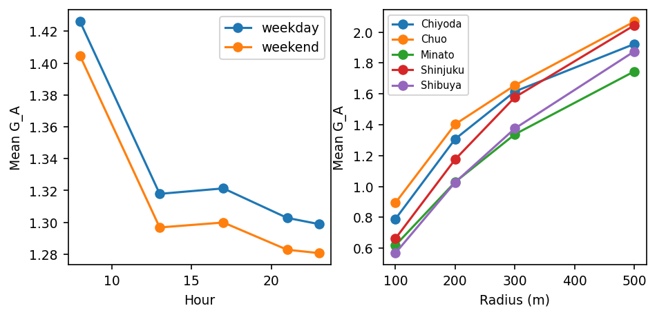
Figure 6. Modeled mean relocation gain by hour/day-type (left) and ward/radius (right).

3.9 Sensitivity analyses
Kernel bandwidth 150/500 m leaves per-origin gains nearly unchanged (rho 0.98/0.99).
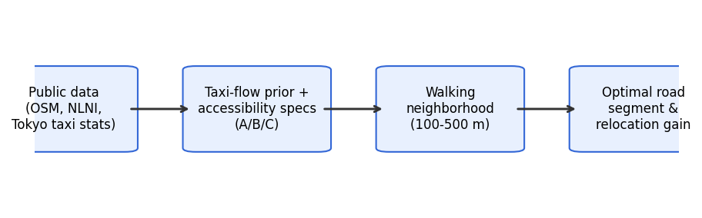
Figure 1. Analytical workflow: public data to modeled opportunity ranking to walkable relocation candidates, with ablation, transfer, and permutation audits.
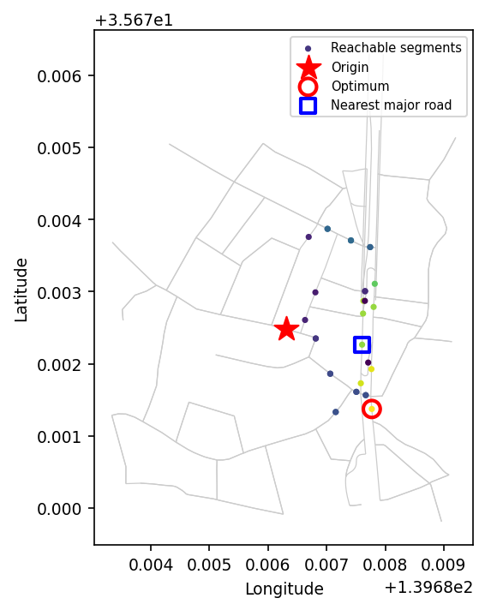
Figure 3. Worked example (200 m, weekday 17:00): origin (star), reachable segments by modeled opportunity, nearest major road (blue square), optimizer choice (red circle).

4. Discussion

4.1 Three evidence levels
Street-hail relocation claims should be read on three levels. Level 1, self-optimization: a model finds nearby locations that score higher under itself — trivially achievable and not evidence alone. Level 2, cross-specification transfer: locations selected from one urban information layer retain benefit under a distinct layer. Level 3, empirical passenger benefit: actual vacant-taxi encounters and waiting times. This paper addresses Levels 1 and 2; Paper 2 must address Level 3.

4.2 Interpretation of the audits
Component ablation shows the relocation signal is not an artifact of any single component family. Cross-specification transfer between road-only and attractor-only selections is positive but weak and asymmetric, indicating partially nested information layers rather than one dominant structure. The permutation analysis is the most sobering: the reliability of improvement marginally exceeds a spatially unstructured null, but gain magnitudes are fully consistent with generic maximum-selection. The defensible claim is therefore narrow: public data identify where opportunity is modeled to be locally higher, with a reliability slightly above chance — not that the modeled gains are spatially exceptional.

4.3 CEUS-relevant contributions
(1) A geospatial framework representing street-hail opportunity on a directed road network without fleet telemetry. (2) A passenger-side relocation formulation over fine-scale urban opportunity gradients. (3) A validation architecture — ablation, transfer, permutation — that distinguishes structured urban signal from optimization tautology and is transferable to other data-constrained mobility settings. (4) The framework applies wherever proprietary operational data are unavailable.

4.4 Limitations
No observed vacant-taxi ground truth; scores are uncalibrated proxies, not waiting-time estimates; taxi operational behavior is not directly observed; temporal structure partly reflects model inputs; the Tokyo context may limit transferability; roadside legal/physical hail feasibility is imperfectly represented; cross-specification transfer is not empirical validation; and the FY2023 station data lack passenger counts, so the station term is unweighted.

4.5 Relationship to Paper 2
Paper 2 asks whether the public-data-derived relocation ranking corresponds to actual vacant-taxi passage and reduces observed street-hail waiting time, via roadside observation, waiting-time measurement, calibration, and prospective testing. This study supplies candidate spatial contrasts for that validation.

5. Conclusion
Public urban data contain non-trivial spatial structure that can generate candidate street-hail relocation contrasts without proprietary fleet telemetry — a reliability marginally above a spatial null, with weak but real transfer between distinct component constructions — providing a testable basis for subsequent empirical validation.

Declarations
Data availability: all inputs are public datasets listed in Table 1; code and derived tables are available in the project repository. Competing interests: none declared. Funding: none. Author contributions: single-author work (conceptualization, analysis, writing).

References
1. Moreira-Matias L, Gama J, Ferreira M, Mendes-Moreira J, Damas L. Predicting taxi-passenger demand using streaming data. IEEE Trans Intell Transp Syst. 2013;14(3):1393-1402. doi:10.1109/TITS.2013.2261624.
2. Ocalir EV, Ercoskun OY, Tur R. An integrated model of GIS and fuzzy logic (FMOTS) for location decisions of taxicab stands. Expert Syst Appl. 2010;37(7):4892-4901.
3. Hwang RH, Hsueh YL, Chen YT. An effective taxi recommender system based on a spatio-temporal factor analysis model. Inf Sci. 2015;314:28-40.
4. Yang H, Leung CWY, Wong SC, Bell MGH. Equilibria of bilateral taxi-customer searching and meeting on networks. Transp Res Part B. 2010;44(8-9):1067-1083.
5. Yuan NJ, Zheng Y, Zhang L, Xie X. T-Finder: a recommender system for finding passengers and vacant taxis. IEEE Trans Knowl Data Eng. 2013;25(10):2390-2403. doi:10.1109/TKDE.2012.153.
6. Alonso-Mora J, Samaranayake S, Wallar A, Frazzoli E, Rus D. On-demand high-capacity ride-sharing via dynamic trip-vehicle assignment. Proc Natl Acad Sci USA. 2017;114(3):462-467. doi:10.1073/pnas.1611675114.
7. Tokyo Hire-Taxi Association. Tokyo no Taxi 2025. https://taxi-tokyo.or.jp/ (accessed 2026-09-29).
8. OpenStreetMap contributors. Planet dump and Overpass API. https://www.openstreetmap.org (ODbL; accessed 2026-09-29 via OSMnx 2.0.7).
9. Ministry of Land, Infrastructure, Transport and Tourism (Japan). National Land Numerical Information, N02 railway dataset (FY2023). https://nlftp.mlit.go.jp/ksj/ (accessed 2026-09-29).
10. Tokyo Taxi Center. Taxi user monitor survey, FY2023 tabulation report. https://www.tokyo-tc.or.jp/center/uploads/monitor_2024.pdf (accessed 2026-09-29).

Table 1. Public data sources
Source | Provider/License | Scope | Role
OSM road network + POIs | OSM contributors / ODbL | 5 central wards | segments, context, walk network
NLNI N02 station locations | MLIT / NLNI terms | FY2023 | station-presence attractor
Tokyo Taxi Center monitor survey | Tokyo Taxi Center | FY2023, n=2,662 | temporal profile
THTA yearbook 2025 | THTA | FY2024 | background

Table 2. Relocation outcomes by radius (combined specification)
Radius m | origins | improved | >0.1 SD | mean gain (SD) | beats nearest major | gain CI
100 | 1961 | 84% | 67% | 0.69 | 60% | [0.6486450597175882, 0.7222897453735109]
200 | 1989 | 97% | 90% | 1.16 | 74% | [1.1244419940895996, 1.2039700077872137]
300 | 1997 | 98% | 96% | 1.50 | 81% | [1.4617260546515896, 1.5390870712050202]
500 | 1999 | 100% | 99% | 1.93 | 91% | [1.893725653229516, 1.9683781357507475]

Table 3. Ablation summary (300 m)
Specification | improved | >0.1 SD | beats nearest major | beats random | best is major road
Attractor-only | 99% | 92% | 99% | 100% | 12%
Combined | 98% | 96% | 81% | 100% | 56%
Circulation proxy | 98% | 93% | 83% | 100% | 56%
Road-only | 95% | 95% | 66% | 100% | 55%

Table 4. Cross-specification transfer at 300 m (selector -> evaluator)
Selector \ Evaluator | Road-only | Attractor-only | Circulation proxy | Combined
Road-only | (self) | 0.04 SD / 53% | 1.48 SD / 90% | 1.37 SD / 93%
Attractor-only | 0.08 SD / 43% | (self) | 0.27 SD / 69% | 0.36 SD / 69%
Circulation proxy | 1.58 SD / 87% | 0.19 SD / 73% | (self) | 1.46 SD / 97%
Combined | - | - | - | (self)

Table 5. Spatial permutation null (combined specification, weekday 17:00, 500 permutations)
Radius m | obs frac>0 | null frac>0 | empirical p | obs mean G | null mean G
100 | 0.839 | 0.874 | 1.000 | 0.69 | 1.67
200 | 0.966 | 0.957 | 0.030 | 1.17 | 2.30
300 | 0.983 | 0.979 | 0.074 | 1.50 | 2.61
500 | 0.995 | 0.992 | 0.086 | 1.92 | 2.90

