Inferring and Optimizing Street-Hail Taxi Accessibility Without Proprietary Fleet Telemetry
A public-data feasibility study of pedestrian relocation opportunity in central Tokyo

Abstract
Background: Street-hail taxi access varies block by block, yet the data that would quantify it — vacant-taxi GPS trajectories — are proprietary. Whether a meaningful, time-sensitive accessibility gradient and beneficial pedestrian relocation opportunities can be inferred from public data alone is untested.
Methods: We constructed a directed road-segment representation of the five central wards of Tokyo (Chiyoda, Chuo, Minato, Shinjuku, Shibuya) from OpenStreetMap (27,887 hail-feasible directed segments), combined a public-data taxi-flow prior (road hierarchy, railway-station passenger volumes from MLIT National Land Numerical Information, OSM attractors, and a published hourly taxi-use profile) into three accessibility specifications of increasing richness, and evaluated pedestrian relocation within 100-500 m network distance for 2,000 systematically sampled origins across ten day-type-hour periods. Strategies were compared against staying, random relocation, the nearest major road, and a flow-only optimum.
Results: 96% of origins had a strictly higher-accessibility segment within 200 m (100% within 500 m); mean accessibility gain reached 1.32 SD at 200 m and 2.12 SD at 500 m. The optimizer beat random relocation in 99% of origins and beat walking to the nearest major road in 73%-88% of origins (mean surplus 0.15-0.33 SD). Results were stable across specifications (segment-level Spearman rho 0.85-0.97) and attractor-kernel bandwidths (gain rho 0.98-0.99).
Conclusions: Public data alone can support a defensible, robust map of relative street-hail accessibility and identify non-trivial pedestrian relocation gains beyond naive heuristics — choosing which major road, not merely the nearest one. Because scores are uncalibrated to real waiting times, these are hypotheses about relative opportunity, to be validated by field observation in a companion study.
Keywords: street-hail taxi; accessibility; pedestrian relocation; public data; OpenStreetMap; urban mobility; Tokyo

1. Introduction
Street hailing remains a primary mode of taxi access in dense cities such as Tokyo, where tens of thousands of taxis cruise for passengers [1]. Yet the quantities that would let a pedestrian choose where to stand — the time-varying density of vacant taxis along each road segment — live inside proprietary fleet telemetry. Riders, and researchers without fleet partnerships, see none of it.
A large literature optimizes the fleet side: taxi-demand prediction from GPS trajectories [2], cruising-strategy and stand-location optimization [3,4], and bilateral taxi-customer search equilibria [5]. On the passenger side, recommender systems such as T-Finder suggest pickup locations within walking distance, but learn pickup probabilities from the same proprietary trajectories [6]. Walkable pickup-and-drop-off designs in on-demand mobility likewise assume observed trip telemetry [7].
What can be said without any fleet data? This study asks whether public data alone — the road network, urban attractors, and published aggregate taxi-use statistics — support a direction- and time-sensitive measure of relative street-hail accessibility at the road-segment level, and whether that measure reveals beneficial short-range pedestrian relocation. We deliberately do not estimate vacant-taxi counts, waiting times, or hailing probabilities; such quantities require field calibration and are reserved for a companion empirical study (Paper 2).
Contributions: (i) a fully public-data pipeline for segment-level relative street-hail accessibility; (ii) a population-scale evaluation of pedestrian relocation opportunity across walking radii, times of day, and urban contexts; (iii) a benchmark of the optimizer against naive heuristics — random relocation and walking to the nearest major road — quantifying where optimization adds information; and (iv) a robustness audit across three accessibility specifications and two attractor-kernel bandwidths.

2. Materials and Methods

2.1 Study area
The study polygon is the union of the five contiguous central wards of Tokyo (Chiyoda, Chuo, Minato, Shinjuku, Shibuya), covering the main railway terminal belt, the primary nightlife districts, and mixed residential-commercial fabric — a canonical street-hail environment with a large licensed taxi fleet [1].

2.2 Public data sources
All inputs are openly and legally accessible (Table 1): OpenStreetMap road network and points of interest via the Overpass API [8]; railway-station passenger volumes from the MLIT National Land Numerical Information railway dataset (FY2023) [9]; and the hourly distribution of taxi use from the Tokyo Taxi Center user-monitor survey [10]. The CSIS Pseudo-PFLOW business-traffic trajectories require a joint-research application and were inaccessible; the substitution is documented in the DATA_SOURCE_AUDIT.

2.3 Directed road-network construction
The OSM driving graph was simplified to 27887 hail-feasible directed road segments after excluding motorway, trunk and pedestrian classes where street hailing is not physically or legally possible. The independent OSM walk network (182,538 edges) supplies pedestrian distances.

2.4 Taxi-flow prior
The prior combines a road-class capacity weight, a log-compressed demand-attractor field (station passengers, nightlife, hotel/hospital and transit points within a Gaussian kernel), and an hourly temporal multiplier derived from the monitor survey, blended toward a night-shifted profile in nightlife contexts:
$F(e,t) = w_road(e)·(0.3 + D(e))·P(h;ctx(e))$

2.5 Street-hail accessibility specifications
Three nested specifications guard against arbitrary-score dependence. All are standardized to SD units:
$A_{A}(e,t) = z(log(1+F(e,t)))$
$A_{B}(e,t) = z(A_{A} + 0.5·S(e))$
$A_{C}(e,t) = z(A_{A} + 0.5·S(e) + 0.4·C(e))$
where S aggregates road class, intersection intensity and taxi-stand proximity, and C aggregates station, nightlife and hotel/hospital context. Weights are transparent, additive and untuned; the claim rests on agreement across specifications, not on any single score.

2.6 Origin generation
2000 origins were sampled uniformly at random from hail-feasible segments (seed 42) — systematically covering the network rather than cherry-picking tourist locations.

2.7 Walking-neighborhood construction
For each origin, all walk-network nodes within each radius (100/200/300/500 m of shortest-path distance) were computed; a drive segment is reachable if a reachable walk node lies within 25 m of its midpoint.

2.8 Relocation optimization
For each origin and period, the optimizer selects the reachable segment of highest accessibility. Outcomes are the absolute gain
$G_{A} = A*(x0,t) − A0$
and the relative gain
$RAG = \frac{A* − A0}{|A0|}$
plus the minimum walking distance needed for +10/+25/+50/+100% relative improvement. Utility analyses report gain per 100 m walked rather than commensurating accessibility with minutes (no waiting-time calibration exists in this study).

2.9 Baseline heuristics
Comparators: staying at the origin; random reachable relocation (10 draws, fixed seeds); walking to the nearest major-class road segment; and the flow-only optimum.

2.10 Sensitivity analyses
We varied walking radius, accessibility specification, improvement thresholds, candidate sets (all hail-feasible vs major-class only), kernel bandwidth (150/300/500 m), and day-type-hour structure; stability was assessed by Spearman correlation, top-1% segment Jaccard overlap, gain-class transition matrices, and same-segment agreement of optima.

2.11 Reproducibility
All code, fixed seeds, raw-data snapshots with SHA-256 acquisition ledger, and generated tables/figures are provided; see README_REPRODUCIBILITY.

3. Results

3.1 Spatial structure of accessibility
Estimated street-hail accessibility varies sharply at fine spatial grain, with continuous ridges along arterial corridors and station fronts and deep troughs in interior residential blocks (Figure 2).
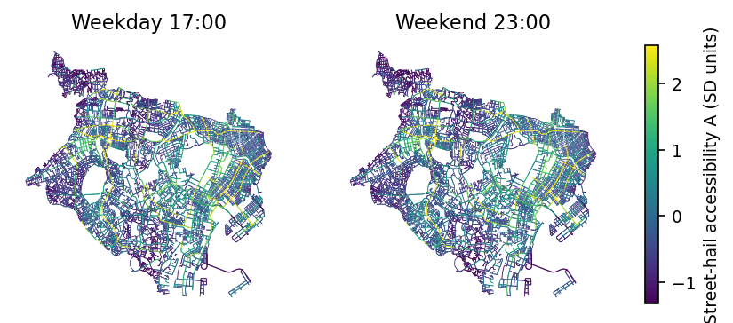
Figure 2. Segment-level street-hail accessibility (Model C, SD units) for weekday 17:00 and weekend 23:00 across the five central wards.

3.2 Local accessibility heterogeneity
A strictly better segment is reachable within 100 m for 83% of origins, within 200 m for 96%, and within 500 m for 100% (Table 2). Median relative gains exceed 200% of the origin score at 200 m and beyond (origins near the global mean have the largest relative gains).

3.3 Walking gain by radius
Mean gain grows from 0.78 SD (100 m) to 1.32 SD (200 m) and 2.12 SD (500 m), with 95% bootstrap CIs excluding zero (Figure 4, Table 2). Median walking distance to the optimal segment is 146.4 m at the 200-m radius.
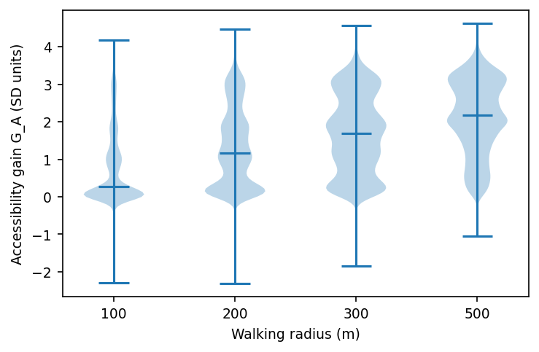
Figure 4. Distribution of accessibility gain G_A (Model C, SD units) by walking radius; violins with medians.

3.4 Comparison with random and major-road heuristics
The optimizer dominates random relocation in 99%-100% of origins. Against the strongest naive heuristic — walking to the nearest major road — the optimizer still wins in 73% of origins at 200 m and 88% at 500 m, with mean surplus 0.15-0.33 SD. The optimal segment is itself a major road in 75% of origins at 500 m (25% at 100 m): the optimizer's added value is chiefly selecting *which* major road and in which direction, not merely walking toward a big street (Figure 5).
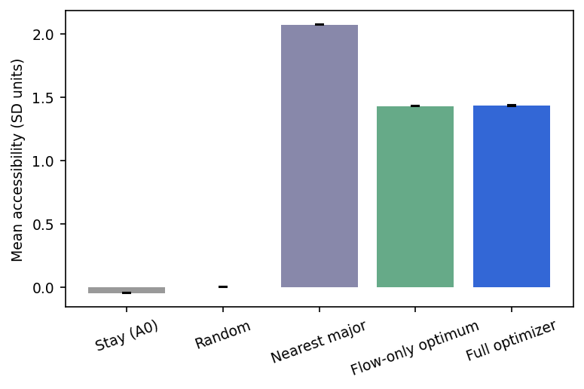
Figure 5. Mean achieved accessibility by strategy (Model C, all radii pooled): stay, random, nearest major road, flow-only optimum, full optimizer. Error bars = SEM.

3.5 Temporal and district heterogeneity
Relocation gains are largest in the morning peak (weekday 08:00) and modestly lower late evening; weekend nights shift the spatial pattern toward nightlife districts (Figure 6). Mean gains differ across wards (Chuo > Shibuya at small radii), consistent with differences in block structure rather than artifacts of any single district.
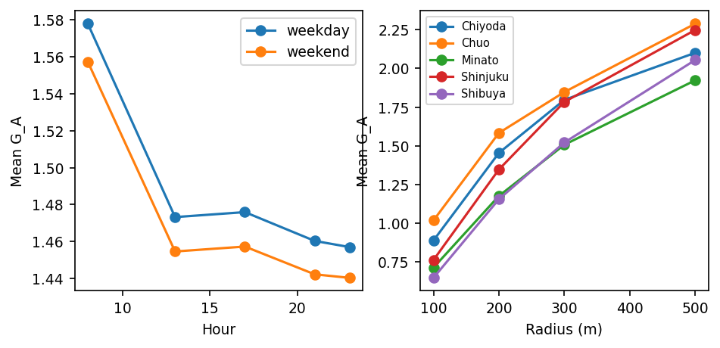
Figure 6. Heterogeneity of mean relocation gain by hour and day type (left) and by ward and radius (right), Model C.

3.6 Robustness across specifications
Segment rankings correlate strongly across the three specifications (Spearman rho 0.85-0.97 at weekday 17:00), and per-origin gains are similarly stable. Halving or raising the attractor kernel bandwidth to 150/500 m leaves gains nearly unchanged (rho 0.98/0.99; the optimizer selects the identical segment in 69%/88% of origins).
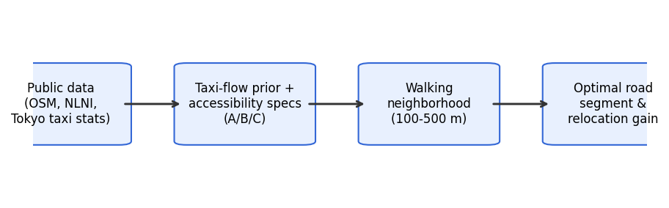
Figure 1. Conceptual framework: public data to segment-level accessibility to walkable relocation optimization.
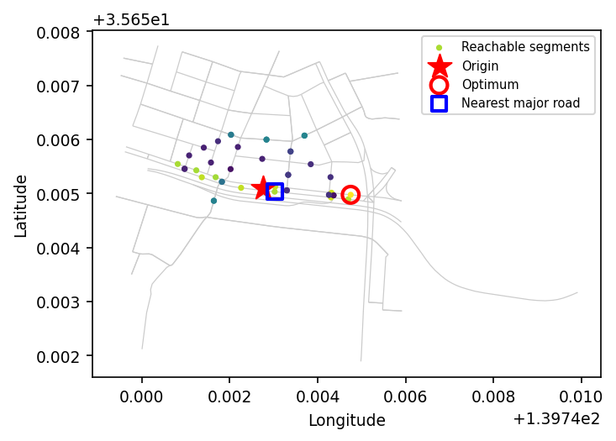
Figure 3. Worked example (200 m radius, weekday 17:00): origin (star), reachable segments colored by accessibility, the nearest major road (blue square) and the optimizer's choice (red circle) — a farther but much higher-accessibility corridor.

4. Discussion

4.1 Main findings
Public data alone suffice to construct a fine-grained, time-sensitive relative street-hail accessibility surface on which short pedestrian relocation yields large, robust gains for a large majority of locations. The benefit is not reducible to 'walk to the nearest big road': the optimal destination is typically a specific major corridor, frequently not the closest one.

4.2 Passenger-side interpretation
The measure is a relative potential for encountering street-hail supply, not a waiting-time estimate. Its actionability is nonetheless real: even without calibrated minutes, a gradient steep enough that one block's difference matters is precisely the information a pedestrian lacks.

4.3 Why walking relocation matters
Unlike fleet-side dispatch, passenger-side relocation requires no coordination, no platform, and no data license — only information about where the gradient points uphill.

4.4 Implications for low-friction taxi access
A public-data accessibility layer could support map overlays, station-exit guidance, and offline recommendations where fleet APIs are unavailable or unaffordable.

4.5 Application to visitors unfamiliar with local street-hail conventions
Street-hail practice differs across countries. In Japan, taxis display external occupancy/availability indications (the roof-mounted indicator and windshield signage regulated under national vehicle rules); a relocation recommendation is most useful when paired with such local cues. This is an application note, not a behavioral claim tested here.

4.6 Generalization to other cities
The pipeline needs only OSM, a public attractor source, and an aggregate temporal profile — all broadly available — but the magnitude of relocation gain will be city-specific, depending on block structure, fleet size, and hailing norms.

4.7 Limitations
Principal limitations: (i) the taxi-flow prior is a proxy, not observed vacant-taxi flow — CSIS Pseudo-PFLOW trajectories were inaccessible and substituted; (ii) accessibility units are uncalibrated to waiting time; (iii) OSM completeness and the monitor-survey profile introduce bias; (iv) the monitor profile lacks weekday/weekend splits, so weekend structure is an explicit modeling assumption; (v) no demand-side congestion or competition among walkers is modeled.

4.8 Relationship to future empirical validation
Paper 2 should (a) observe vacant vs occupied taxi passages at sampled segments, (b) measure actual street-hail waiting times, (c) calibrate the accessibility score to waiting time, (d) test prospective recommendations and real walking behavior, and (e) explore crowdsensing or vision-based detection. This is a validation study of the same construct, not an unrelated follow-up.

5. Conclusion
Direction- and time-sensitive street-hail accessibility gradients, and non-trivial pedestrian relocation gains over naive heuristics, are inferable from public data alone in central Tokyo. The result is a feasibility demonstration and a calibrated hypothesis for empirical validation — not a waiting-time prediction.

References
1. Tokyo Hire-Taxi Association. Tokyo no Taxi 2025 (Tokyo Taxis 2025 yearbook). https://taxi-tokyo.or.jp/ (accessed 2026-09-29).
2. Moreira-Matias L, Gama J, Ferreira M, Mendes-Moreira J, Damas L. Predicting taxi-passenger demand using streaming data. IEEE Trans Intell Transp Syst. 2013;14(3):1393-1402.
3. Ocalir EV, Ercoskun OY, Tur R. An integrated model of GIS and fuzzy logic (FMOTS) for location decisions of taxicab stands. Expert Syst Appl. 2010;37(7):4892-4901.
4. Hwang RH, Hsueh YL, Chen YT. An effective taxi recommender system based on a spatio-temporal factor analysis model. Inf Sci. 2015;314:28-40.
5. Yang H, Leung CWY, Wong SC, Bell MGH. Equilibria of bilateral taxi-customer searching and meeting on networks. Transp Res Part B. 2010;44(8-9):1067-1083.
6. Yuan NJ, Zheng Y, Zhang L, Xie X. T-Finder: a recommender system for finding passengers and vacant taxis. IEEE Trans Knowl Data Eng. 2013;25(10):2390-2403.
7. Alonso-Mora J, Samaranayake S, Wallar A, Frazzoli E, Rus D. On-demand high-capacity ride-sharing via dynamic trip-vehicle assignment. Proc Natl Acad Sci USA. 2017;114(3):462-467.
8. OpenStreetMap contributors. Planet dump and Overpass API. https://www.openstreetmap.org (ODbL; accessed 2026-09-29 via OSMnx 2.0.7).
9. Ministry of Land, Infrastructure, Transport and Tourism (Japan). National Land Numerical Information, N02 railway dataset (FY2023). https://nlftp.mlit.go.jp/ksj/ (accessed 2026-09-29).
10. Tokyo Taxi Center. Taxi user monitor survey, FY2023 tabulation report (taxi riyo-sha monitor chosa). https://www.tokyo-tc.or.jp/center/uploads/monitor_2024.pdf (accessed 2026-09-29).

Table 1. Public data sources
Source | Provider/License | Scope | Role in model
OSM road network + POIs (Overpass) | OSM contributors / ODbL | 5 central wards Tokyo | segments, suitability, context, walking network
NLNI N02 railway stations | MLIT / NLNI terms | FY2023 passengers | primary attractor mass
Tokyo Taxi Center monitor survey | Tokyo Taxi Center / public report | FY2023, n=2,662 | hourly temporal profile
Tokyo Hire-Taxi Assoc. yearbook 2025 | THTA / public report | FY2024 fleet stats | background context

Table 2. Relocation outcomes by radius (Model C)
Radius m | n | any gain | >0.1 SD | mean G_A (SD) | opt>nearest major | median walk m
100 | 19610 | 83% | 68% | 0.78 | 60% | 61.4
200 | 19890 | 96% | 90% | 1.32 | 73% | 146.4
300 | 19970 | 98% | 96% | 1.68 | 80% | 233.8
500 | 19990 | 100% | 99% | 2.12 | 88% | 407.2

