Public-Data Ranking of Street-Hail Taxi Opportunity and Pedestrian Relocation Candidates Without Fleet Telemetry
A computational feasibility study in central Tokyo

Abstract
Background: Street-hail taxi opportunity varies block by block, but the data that would measure it — vacant-taxi telemetry — are proprietary. This study asks whether public urban data alone can generate a defensible relative ranking of modeled street-hail opportunity and non-trivial pedestrian relocation candidates. No proprietary fleet data, roadside observation, or waiting-time measurements are used; all scores are proxy-based and uncalibrated.
Methods: A directed road-segment map of the five central wards of Tokyo (27,887 hail-feasible segments) was combined with a public-data-derived circulation-potential proxy (road hierarchy, FY2023 railway-station passenger volumes, mapped attractors, and a published hourly taxi-use profile). Four opportunity specifications — road-only, attractor-only, circulation proxy, and combined — were evaluated ablatively. For 2,000 sampled origins across ten day-type-hour periods, relocation within 100-500 m network distance was compared against staying, random relocation, and the nearest major road.
Results: 96%-100% of origins had a higher-scoring reachable segment at 200-500 m. The combined optimizer exceeded random relocation in ~100% of origins and the nearest-major-road heuristic in 73%-88% of origins (paired Wilcoxon p<0.001). Relocation opportunity persisted under every ablation: road-only and attractor-only constructions yielded 95% and 99% improved origins at 300 m, with segment rank correlations to the combined model of 0.52-0.93.
Conclusions: Public urban data can generate robust relative rankings of modeled street-hail opportunity and identify candidate pedestrian relocation contrasts without proprietary fleet telemetry. The scores carry no calibrated waiting-time meaning; they define candidate spatial contrasts for the field-validation study that must follow.
Keywords: street-hail taxi; public data; pedestrian relocation; accessibility proxy; OpenStreetMap; Tokyo; feasibility study

1. Introduction
Street hailing remains a primary taxi-access mode in dense cities such as Tokyo [1], but the data needed to quantify street-level opportunity — vacant-taxi trajectories — are proprietary. Passengers, and researchers without fleet access, cannot observe them.
Prior work optimizes the fleet side: GPS-based taxi-demand prediction [2], stand siting [3], cruising-area recommendation [4], and bilateral search equilibrium models [5]. Passenger-side relocation toward better pickup spots is precedented (T-Finder [6], walkable pickup-and-drop-off designs [7]) but every such system is trained on telemetry. The open question is what survives when telemetry is removed entirely.
This study is deliberately a dry, public-data feasibility analysis. It constructs a public-data-derived proxy for relative street-hail opportunity — not a measurement of vacant-taxi supply — and tests whether the resulting spatial rankings reveal meaningful pedestrian relocation contrasts. A component ablation asks whether the signal survives when the construct is decomposed into road-structure-only and attractor-only families, guarding against a tautological composite score.
The intended contribution is the measurement/data architecture: telemetry-free, segment-level, passenger-side, and robustness-audited. Claims are restricted to modeled opportunity rankings; waiting times and vacant-taxi probabilities are reserved for empirical validation.

2. Materials and Methods

2.1 Study area
The five contiguous central wards of Tokyo (Chiyoda, Chuo, Minato, Shinjuku, Shibuya) — a canonical street-hail environment [1].

2.2 Public data sources
OpenStreetMap road network and POIs via Overpass [8]; FY2023 railway-station passenger volumes (MLIT National Land Numerical Information) [9]; the hourly taxi-use distribution from the Tokyo Taxi Center user-monitor survey [10]. The restricted CSIS Pseudo-PFLOW business-traffic trajectories were inaccessible and substituted; see DATA_SOURCE_AUDIT.

2.3 Directed road-network construction
The OSM driving graph was reduced to 27,887 hail-feasible directed segments (motorway, trunk and pedestrian classes excluded). The OSM walk graph (182,538 edges) supplies pedestrian distances.

2.4 Circulation-potential proxy
The modeled proxy combines a road-class capacity weight, a Gaussian demand-attractor kernel field, and the monitor-survey hourly profile blended toward a night-shifted variant in nightlife contexts:
$P{circ}_{}(e,t) = w_road(e)·(0.3 + D(e))·P(h;ctx(e))$
This is a modeled proxy, not observed taxi flow; the temporal structure is partly assumed (weekend/night behavior is a modeling input).

2.5 Opportunity specifications and ablation
Four specifications define the ablation family: road-only (hierarchy, degree, lanes), attractor-only (station, nightlife, hotel/hospital, transit, taxi-stand kernels), the circulation-potential proxy, and a combined score:
$S_{COMB}(e,t) = z(z log(1+P_circ) + 0.5·S_road + 0.4·C_ctx)$
All scores are z-standardized; weights are transparent and untuned. The ablation tests whether relocation signal persists under substantially different constructions rather than relying on the composite.

2.6 Origin generation
2,000 origins sampled uniformly from hail-feasible segments (seed 42).

2.7 Walking neighborhoods
Reachable drive segments = hail-feasible edges with midpoint within 25 m of a walk node reachable within radius 100/200/300/500 m.

2.8 Relocation optimization and metrics
Primary metric: absolute gain in standardized score
$G_{S} = S*(x0,t) − S0$
Fraction of origins improved and distance to prespecified score improvement are co-primary. Relative percentage gain is secondary only: z-scores cross zero, making percentage gains near the mean denominator-unstable; no headline result uses them.

2.9 Baseline heuristics
Stay; random relocation (10 seeded draws); nearest major-class road segment; per-specification optima in the ablation.

2.10 Sensitivity analyses
Radii, specification family, improvement thresholds, candidate sets, kernel bandwidth (150/300/500 m), and day-type-hour structure; stability via Spearman correlation, top-1% Jaccard, gain-class transitions, and same-segment optimum agreement.

2.11 Reproducibility
Fixed seeds, raw-data snapshots with SHA-256 ledger, all code and result tables provided.

3. Results

3.1 Spatial structure of modeled opportunity
The modeled opportunity score shows continuous ridges along arterial corridors and station fronts and troughs in interior blocks (Figure 2). These are modeled contrasts, not observed taxi density.
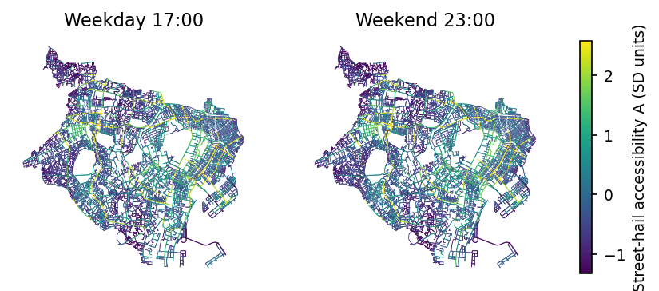
Figure 2. Modeled street-hail opportunity (combined specification, SD units), weekday 17:00 and weekend 23:00. Values are proxy-based modeled scores, not observed taxi flow.

3.2 Local heterogeneity and relocation gain
Under the combined specification, 83%-100% of origins have a higher-scoring segment within 100-500 m; mean absolute gain ranges 0.78 to 2.12 SD (bootstrap CIs exclude zero; Table 2, Figure 4).
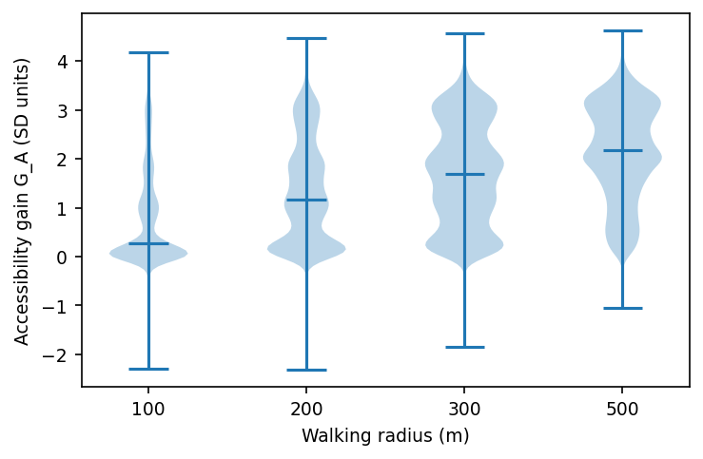
Figure 4. Distribution of absolute opportunity-score gain (SD units) by walking radius; violins with medians.

3.3 Comparison with random and major-road heuristics
The optimizer exceeds random relocation in ~100% of origins and the nearest major road in 60%-88%, mean paired surplus 0.10-0.33 SD (Wilcoxon p<0.001). The optimal segment is itself major-class in 75% of origins at 500 m: the added value is selecting which corridor, not walking toward any major street (Figure 5).
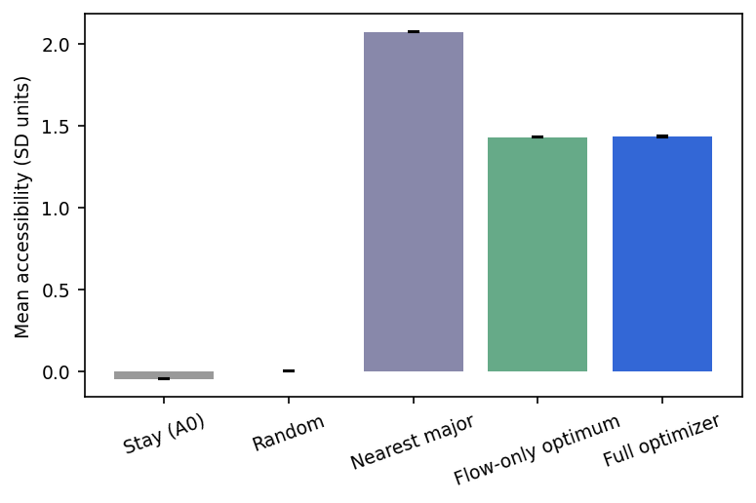
Figure 5. Mean modeled opportunity score by strategy (combined specification, all radii pooled). Error bars = SEM.

3.4 Ablation: does the signal survive decomposition?
Relocation opportunity persists under every construction (Figure 7, Table 3): at 300 m, road-only improves 95% of origins and attractor-only 99%. Against the nearest major road, the road-only optimum wins 66% of origins (its own input is hierarchy), while attractor-only wins 99% — the spatial contrast is not an artifact of any single component family. Segment rank correlations with the combined model are 0.93 (proxy), 0.73 (road-only), 0.52 (attractor-only): moderate agreement, meaning the constructions are genuinely different yet consistently identify local gradients.
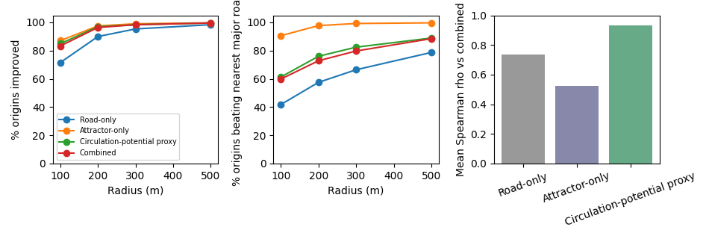
Figure 7. Ablation summary. Left: fraction of origins improved by radius. Middle: fraction beating the nearest-major-road heuristic. Right: mean Spearman rank correlation of each specification against the combined model.

3.5 Temporal and district model behavior
Under the modeled temporal specifications, computed relocation gains are largest in the weekday-morning period, and the weekend specification shifts modeled opportunity toward nightlife contexts. These are input-profile consequences — descriptive model behavior, not observed urban patterns (Figure 6). Ward-level differences in mean gain are consistent with block-structure differences.
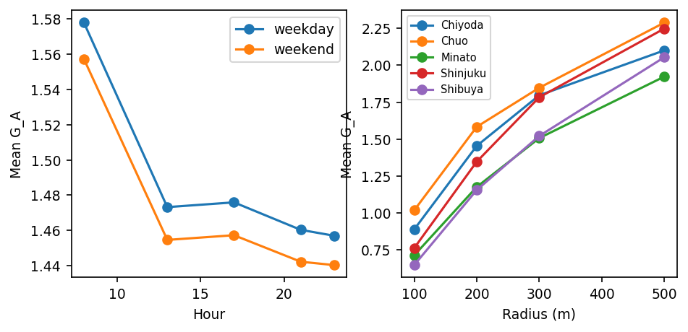
Figure 6. Modeled mean relocation gain by hour/day-type (left) and ward/radius (right) under the assumed temporal profile — model behavior, not observed patterns.

3.6 Robustness
Halving/raising the attractor kernel bandwidth (150/500 m) leaves per-origin gains nearly unchanged (rho 0.98/0.99; identical optimum in 69%/88% of origins).
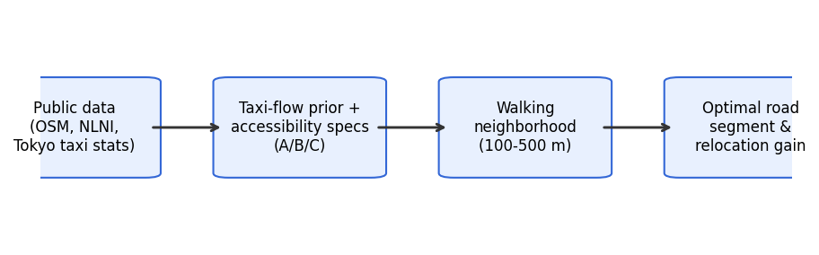
Figure 1. Conceptual framework: public data to modeled opportunity ranking to walkable relocation candidates.
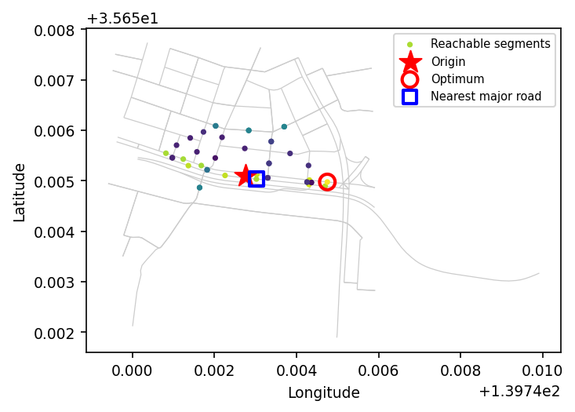
Figure 3. Worked example (200 m, weekday 17:00): origin (star), reachable segments colored by modeled opportunity, nearest major road (blue square), optimizer's choice (red circle).

4. Discussion

4.1 Main findings
Public urban data generate spatially structured candidate rankings of modeled street-hail opportunity in which short pedestrian relocation yields non-trivial score gains for a large majority of origins — and the contrast persists under independent ablation constructions. Consistency across substantially different public-data constructions, not any single score, is the main result.

4.2 Passenger-side interpretation
The score is a relative modeled opportunity, not waiting time. The resulting spatial contrasts are sufficiently large and structured to motivate prospective empirical validation — whether they translate into shorter waits is exactly what Paper 2 must measure.

4.3 Why walking relocation matters
Passenger-side relocation needs no fleet coordination or data license. That the optimizer's added value is 'which corridor' rather than 'walk toward a major street' is itself a useful finding for downstream study design.

4.4 Implications for low-friction taxi access
A public-data opportunity layer could support map overlays and station-exit guidance where fleet APIs are unavailable — contingent on empirical calibration.

4.5 Visitors unfamiliar with local conventions
Street-hail conventions differ internationally; Japanese taxis display external occupancy/availability indications. A relocation recommendation is most useful paired with such cues — an application note, not a tested claim.

4.6 Generalization
The pipeline needs only OSM, public attractor data, and an aggregate temporal profile; magnitudes are city-specific.

4.7 What this study does not establish
By design, Paper 1 establishes none of: actual vacant-taxi passage rates, real waiting-time reduction, probability of a successful street hail, or behavioral compliance with walking recommendations. These require Paper 2 field observation and calibration.

4.8 Limitations
(i) The circulation-potential proxy is modeled, not observed — the Pseudo-PFLOW trajectories were access-restricted and substituted. (ii) Scores are uncalibrated to waiting time. (iii) Weekend and night temporal structure is assumed, not measured. (iv) OSM completeness and monitor-survey sampling introduce bias. (v) No demand-side competition is modeled.

4.9 Relationship to Paper 2
Paper 2 provides empirical validation: roadside observation of vacant/occupied passage, waiting-time measurement, score-to-waiting-time calibration, and prospective recommendation testing. Paper 1 supplies candidate spatial contrasts for that validation.

5. Conclusion
Multiple independent public-data constructions identify consistent local gradients in modeled street-hail opportunity, and optimized pedestrian relocation over those rankings adds information beyond the nearest-major-road heuristic. The result is a validated computational precondition, not a validated passenger benefit.

References
1. Tokyo Hire-Taxi Association. Tokyo no Taxi 2025. https://taxi-tokyo.or.jp/ (accessed 2026-09-29).
2. Moreira-Matias L, Gama J, Ferreira M, Mendes-Moreira J, Damas L. Predicting taxi-passenger demand using streaming data. IEEE Trans Intell Transp Syst. 2013;14(3):1393-1402.
3. Ocalir EV, Ercoskun OY, Tur R. An integrated model of GIS and fuzzy logic (FMOTS) for location decisions of taxicab stands. Expert Syst Appl. 2010;37(7):4892-4901.
4. Hwang RH, Hsueh YL, Chen YT. An effective taxi recommender system based on a spatio-temporal factor analysis model. Inf Sci. 2015;314:28-40.
5. Yang H, Leung CWY, Wong SC, Bell MGH. Equilibria of bilateral taxi-customer searching and meeting on networks. Transp Res Part B. 2010;44(8-9):1067-1083.
6. Yuan NJ, Zheng Y, Zhang L, Xie X. T-Finder: a recommender system for finding passengers and vacant taxis. IEEE Trans Knowl Data Eng. 2013;25(10):2390-2403.
7. Alonso-Mora J, Samaranayake S, Wallar A, Frazzoli E, Rus D. On-demand high-capacity ride-sharing via dynamic trip-vehicle assignment. Proc Natl Acad Sci USA. 2017;114(3):462-467.
8. OpenStreetMap contributors. Planet dump and Overpass API. https://www.openstreetmap.org (ODbL; accessed 2026-09-29 via OSMnx 2.0.7).
9. Ministry of Land, Infrastructure, Transport and Tourism (Japan). National Land Numerical Information, N02 railway dataset (FY2023). https://nlftp.mlit.go.jp/ksj/ (accessed 2026-09-29).
10. Tokyo Taxi Center. Taxi user monitor survey, FY2023 tabulation report. https://www.tokyo-tc.or.jp/center/uploads/monitor_2024.pdf (accessed 2026-09-29).

Table 1. Public data sources
Source | Provider/License | Scope | Role
OSM road network + POIs | OSM contributors / ODbL | 5 central wards | segments, context, walk network
NLNI N02 stations | MLIT / NLNI terms | FY2023 | attractor mass
Tokyo Taxi Center monitor survey | Tokyo Taxi Center | FY2023, n=2,662 | temporal profile
THTA yearbook 2025 | THTA | FY2024 | background

Table 2. Relocation outcomes by radius (combined specification)
Radius m | n | improved | >0.1 SD | mean gain (SD) | beats nearest major | median walk m
100 | 19610 | 83% | 68% | 0.78 | 60% | 61.4
200 | 19890 | 96% | 90% | 1.32 | 73% | 146.4
300 | 19970 | 98% | 96% | 1.68 | 80% | 233.8
500 | 19990 | 100% | 99% | 2.12 | 88% | 407.2

Table 3. Ablation summary (300 m radius)
Specification | improved | >0.1 SD | beats nearest major | beats random | best is major road
Attractor-only | 99% | 91% | 99% | 100% | 11%
Combined | 98% | 96% | 80% | 100% | 56%
Circulation proxy | 98% | 92% | 82% | 100% | 56%
Road-only | 95% | 95% | 66% | 100% | 55%

