Stress-testing public-data urban accessibility proxies: street-hail taxi relocation without fleet telemetry

Abstract
Many urban-computing studies optimize constructed spatial proxies — accessibility indices, amenity scores, availability surfaces — where direct operational ground truth is unavailable. Because a heterogeneous surface contains local maxima, optimizing a proxy under its own score mechanically produces apparent gains, and self-optimization is not external validation. Using street-hail taxi relocation as a motivating case study, we construct four public-data-derived opportunity surfaces on the directed road network of Tokyo's five central wards (27,887 segments) and audit relocation optimization over 2,000 origins at 100-500 m walking radii through component ablation, cross-specification transfer, a simple road-hierarchy heuristic, and 500-permutation spatial nulls with origin-clustered inference. Apparent gains are large (98% of origins improved, mean 1.50 SD at 300 m) and exceed the nearest-major-road heuristic in 81% of origins, but cross-specification transfer between conceptually distinct component families is weak (53% and 43% of origins positive), and spatially permuted surfaces reproduced improvement prevalence almost fully, with only a small observed advantage at some walking radii (empirical p=0.03-0.09 for the weekday-17 null, below 0.05 only at 200 m), while producing larger mean gain magnitudes than the observed surface. Large within-score optimization gains therefore did not translate into equally strong cross-specification evidence and were partly reproducible under spatial nulls: self-optimization alone is insufficient validation of a constructed urban spatial proxy. We therefore propose cross-specification transfer, component ablation, spatial-null comparison, and simple heuristic benchmarking as complementary internal stress tests when external outcome labels are unavailable.
Keywords: urban accessibility; geocomputation; spatial optimization; mobility proxy; permutation test; public urban data

1. Introduction
Urban planning and mobility research increasingly relies on constructed spatial proxies — accessibility indices, amenity opportunity scores, pedestrian safety surfaces, micromobility availability proxies, EV-charging and service-location maps — because direct operational measurements are proprietary, expensive, or unavailable. These surfaces are then optimized: choose the best location, the highest-accessibility node, the highest-opportunity zone.
A methodological problem follows. The same score defines both what 'better' means and which candidate is selected, so a large apparent gain can arise mechanically from score heterogeneity, candidate-set size, and order statistics rather than from meaningful urban structure. Studies often report the internal gain without testing whether the selected location transfers to an alternative plausible specification, whether the gain exceeds what a spatially permuted surface would yield, or whether a simple heuristic explains most of it.
Street-hail taxi relocation is an ideal case study: the operational telemetry that could measure vacant-taxi opportunity is proprietary (systems like T-Finder [1] require fleet trajectories), the passenger decision is spatial, public-data proxies are tempting, and walking defines a natural local optimization problem [2]. Prior taxi-demand [3] and recommendation work [4,5] likewise presumes observed demand; pickup-point assignment in ride-sharing [6] assumes known trip requests.
The contribution is methodological. The paper makes five related contributions: (1) it formalizes the distinction between within-proxy optimization gain and evidence of transferable spatial structure — a location selected under score A may have a higher value under score A (apparent optimization gain), may or may not improve a distinct plausible score B (transferable internal structure), and neither is evidence of a real-world outcome (external validity); (2) it operationalizes cross-specification transfer as an internal validity stress test; (3) it uses spatial permutation nulls to quantify how much apparent gain can arise from a heterogeneous surface without meaningful observed spatial organization; (4) it combines ablation, transfer, null comparison, and simple heuristic benchmarking into a practical stress-test framework; and (5) it demonstrates the framework on street-hail taxi relocation where no proprietary fleet telemetry exists. The workflow is falsification-oriented: construct a proxy, optimize it, observe the apparent gain, then attempt to falsify the naive interpretation — optimization success is treated as a hypothesis to be challenged, not as validation by itself (Figure 1). These tests are internal checks, not universally sufficient validation criteria.
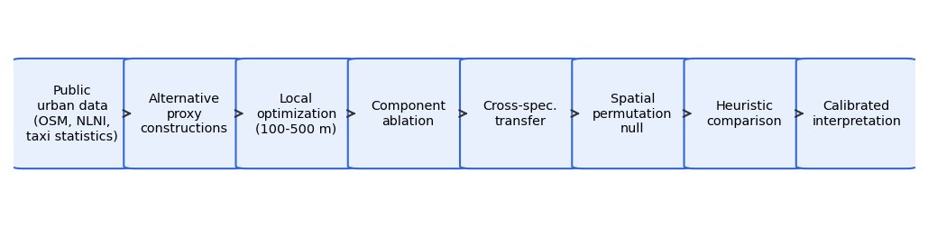
Figure 1. Internal stress-test workflow: public urban data, alternative proxy constructions, local optimization, component ablation, cross-specification transfer, spatial permutation null, heuristic comparison, and calibrated interpretation.

1.1 Research questions
RQ1: How large are apparent relocation gains under self-optimization? RQ2: Do gains persist across alternative component specifications? RQ3: Do locations selected under one specification improve another specification's score? RQ4: Do observed gains exceed those of spatially permuted surfaces with identical marginals? RQ5: How much of the gain does the nearest-major-road heuristic explain?

2. Materials and Methods

2.1 Study area and case-study rationale
Five contiguous central wards of Tokyo (Chiyoda, Chuo, Minato, Shinjuku, Shibuya) — a canonical street-hail environment [7] where fleet telemetry is inaccessible.

2.2 Public urban data
OpenStreetMap road network and POIs via Overpass [8]; FY2023 railway-station locations (MLIT NLNI N02) [9]; hourly taxi-use distribution from the Tokyo Taxi Center monitor survey [10] (Table 1). The restricted CSIS Pseudo-PFLOW product was inaccessible and substituted. The FY2023 N02 schema contains no passenger-count field, so the station term is an unweighted location kernel (documented correction).

2.3 Directed road-network representation
27,887 hail-feasible directed segments from the OSM drive graph; 182,538-edge walk graph for pedestrian distances (equirectangular metric).

2.4 Alternative opportunity proxies
A circulation-potential proxy combines road-class weight, a Gaussian attractor kernel field $D(e)$ (kernel bandwidth $σ = 300 m$), and a period multiplier from the monitor profile blended toward nightlife contexts:
$P_{circ}(e,t) = w_{road}(e)·(0.3 + D(e))·P(h;ctx(e))$
Four z-standardized specifications: road-only (hierarchy, degree, lanes); attractor-only (station, nightlife, hotel/hospital, transit, taxi-stand kernels); the circulation proxy; and the combined score
$S_{COMB} = z(z log(1+P_{circ}) + 0.5 S_{road} + 0.4 C_{ctx})$
All are modeled public-data proxies — none is observed taxi availability.

2.5 Local pedestrian relocation optimization
2,000 origins (seed 42); candidates are segments reachable within 100/200/300/500 m walking distance; the selected location maximizes the score over candidates.

2.6 The self-optimization problem
If $S_{A}(x)$ is the opportunity score and $x_{A}^{*} = argmax x_{c}∈N(x_{0}) S_{A}(x_{c})$, then
$S_{A}(x_{A}^{*}) − S_{A}(x_{0}) ≥ 0$
holds by construction whenever a better-scoring candidate exists in $N(x_{0})$. Positive self-gain is therefore partly structural and cannot alone validate the proxy — the central premise of this audit.

2.7 Component ablation
Each specification is optimized separately to test whether apparent gains depend on one construction.

2.8 Cross-specification transfer
Transfer gain $TG(A→B) = S_{B}(x_{A}^{*}) − S_{B}(x_{0})$ evaluates locations selected under specification A under a distinct specification B. Off-diagonal transfer — especially between the road-only and attractor-only component families — is the internal validity test; diagonal terms are self-optimization.

2.9 Spatial permutation null
Scores are permuted across all hail-feasible segments (500 repetitions), preserving the marginal distribution, network geometry, origin distribution, and candidate counts. Observed improvement fractions and gain magnitudes are compared against the null; empirical $p = (1 + \#\{null ≥ obs\})/(1 + N)$.

2.10 Constrained permutation sensitivity
A within-ward permutation preserves coarse geographic structure and tests whether fine-scale organization remains non-random.

2.11 Heuristic comparators
Stay; random relocation (10 seeded draws); nearest major-class road.

2.12 Cluster-aware statistical inference
Origin-period rows are repeated measurements. Period-invariant specifications use unique origins (n = 1,961-1,999); period-varying specifications use an origin-clustered bootstrap (5,000 replicates) and paired tests on origin-mean differences. Effects, CIs, and p-values are reported together.

2.13 Reproducibility
Fixed seeds, raw-data snapshots with a SHA-256 ledger, public code, a canonical numerical registry, and machine-readable tables.

3. Results

3.1 Opportunity surfaces and local heterogeneity
All four surfaces are strongly heterogeneous, with ridges along arterials and station fronts (Figure 2).
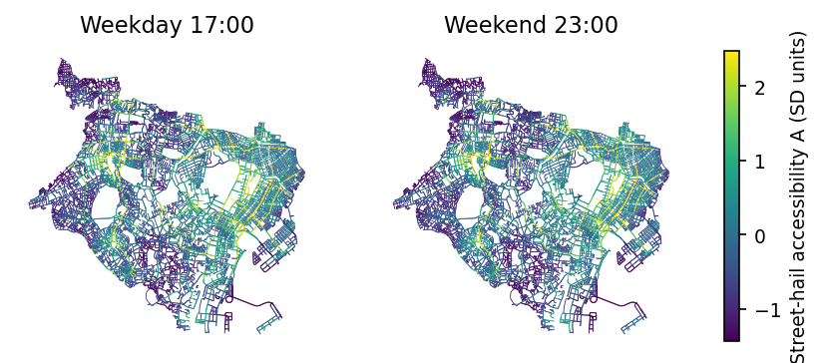
Figure 2. Modeled street-hail opportunity surface (combined specification, SD units), weekday 17:00 and weekend 23:00.

3.2 Apparent gains under self-optimization
Self-optimization produces large apparent gains (RQ1): 84%-100% of origins have a higher-scoring segment within reach, mean gain 0.69-1.93 SD (Figure 3, Table 2; a worked example in Figure 4). These gains are partly structural by construction.
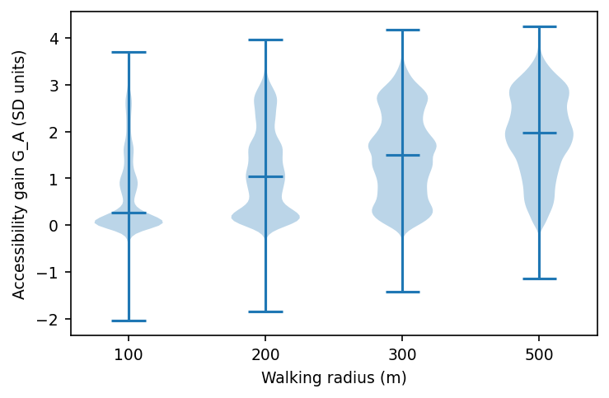
Figure 3. Apparent self-optimization gains (SD units) by walking radius, combined specification.
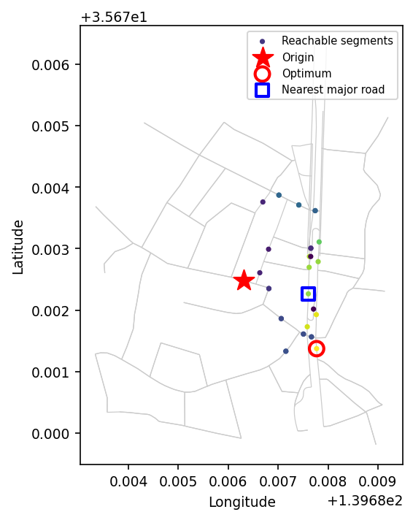
Figure 4. Local optimization example (200 m, weekday 17:00): apparent gain under the combined score.

3.3 Comparison with simple heuristics
Against heuristics (RQ5): the combined optimum beats random relocation in 100% of origins at 300 m, and beats the nearest major road in 81% of origins (paired surplus 0.22 SD, clustered 95% CI [0.211, 0.235], Wilcoxon p<0.001; Figure 5). These values establish the magnitude of apparent within-score gain, not external validity: the constructed score contains spatial information beyond road hierarchy alone, but that does not show the selected location is better for obtaining a real taxi.
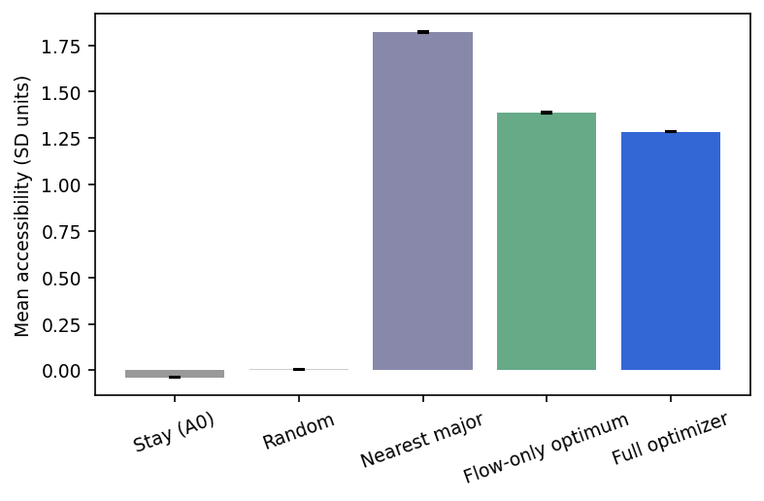
Figure 5. Mean modeled score by strategy (combined specification, radii pooled). Error bars = SEM.

3.4 Component ablation
Apparent gains persist under every construction (RQ2): at 300 m, road-only 95%, attractor-only 99%, proxy 98%, combined 98% improved (Figure 6, Table 3). Segment rankings agree only moderately to strongly (Spearman 0.55-0.97): the constructions are alternative readings with varying degrees of agreement, and persistence is not proof of external validity.
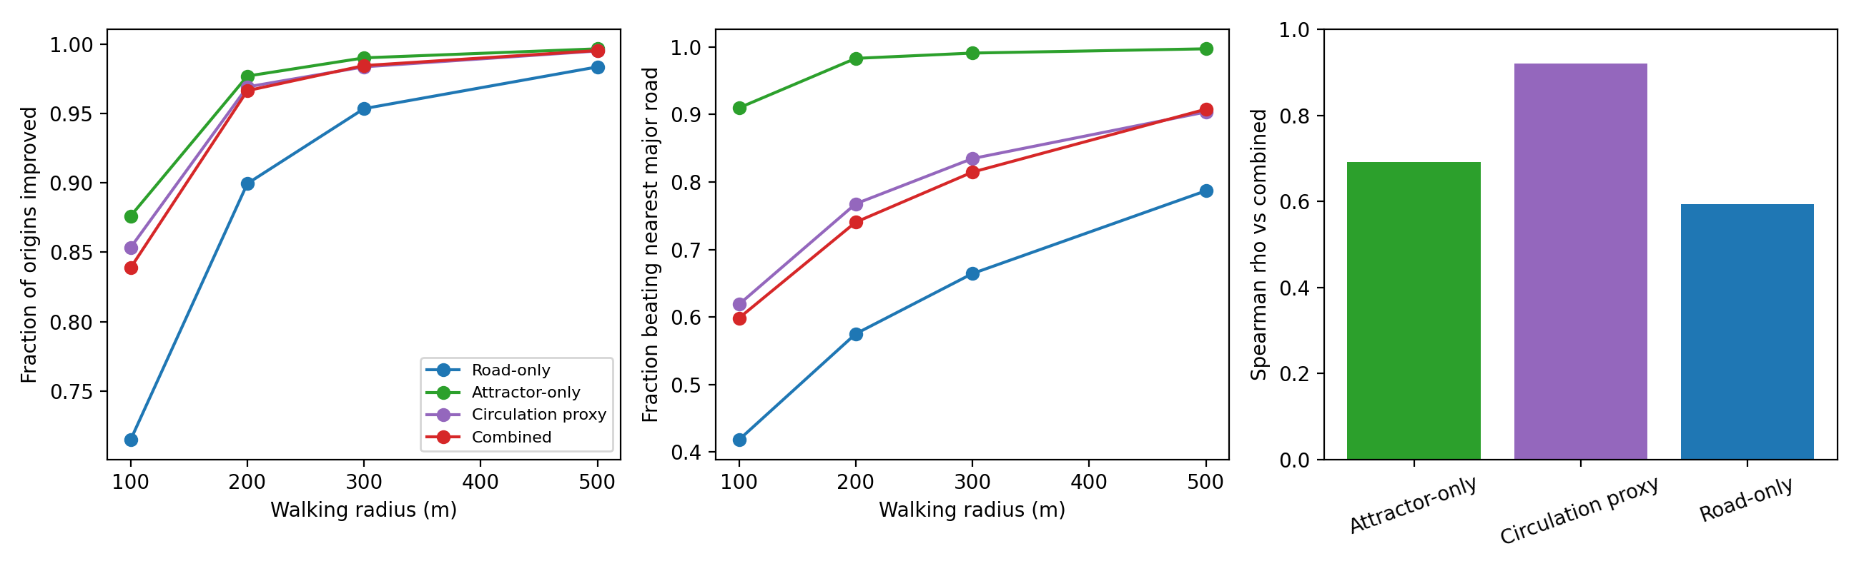
Figure 6. Component ablation across walking radii.

3.5 Cross-specification transfer
Transfer between conceptually distinct component families is weak (RQ3): road-selected locations improve the attractor score for 53% of origins (mean 0.04 SD) and attractor-selected locations improve the road score for 43% of origins (0.08 SD) — near-chance fractions. Transfer into the proxy is stronger (attr→proxy 69%; road→proxy 90%) because the proxy embeds road hierarchy (Figure 7, Table 4). Weak off-diagonal transfer is itself a key finding: the constructions partly identify different, non-transferable structure.
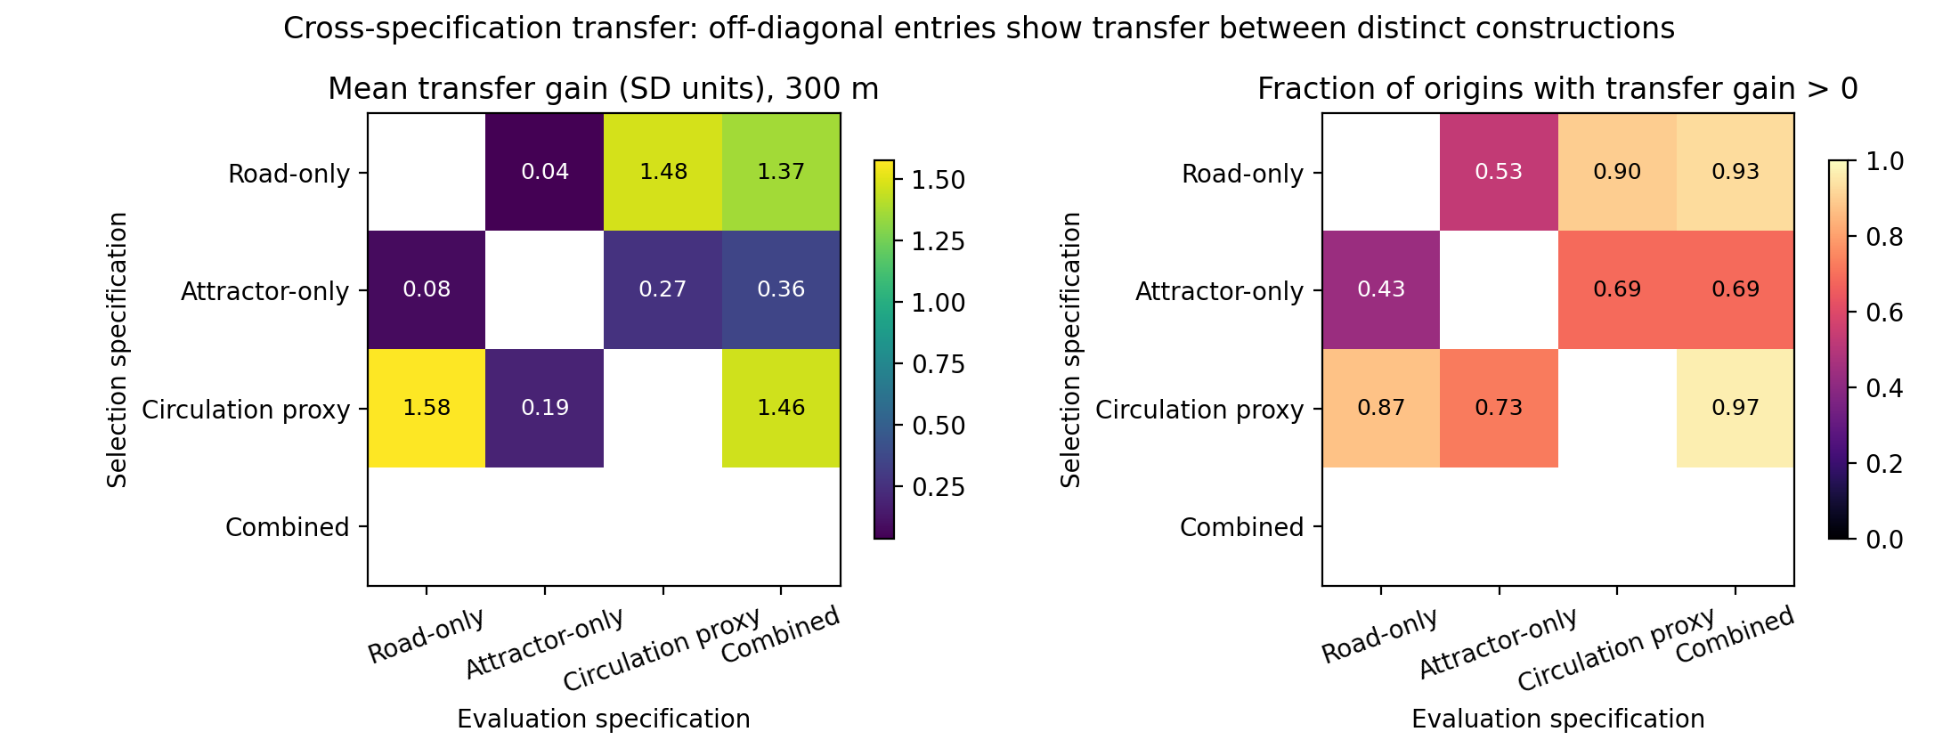
Figure 7. Transfer matrix at 300 m. Diagonal would be self-optimization; off-diagonal entries are internal transfer evidence.

3.6 Spatial permutation null
Against the unrestricted null (RQ4): improvement prevalence marginally exceeds permutation at 200-500 m (observed 0.983 vs null 0.979 at 300 m; empirical p=0.03-0.09 for the weekday-17 null) but not at 100 m (p=1.0). Mean gain magnitude does not exceed the null at any radius (observed 1.50 vs null 2.61 SD at 300 m; Figure 8, Table 5). A spatially unstructured surface with identical marginals produces larger local contrasts: most of the apparent gain is generic maximum-selection, while the observed surface's spatial autocorrelation actually compresses local maxima.
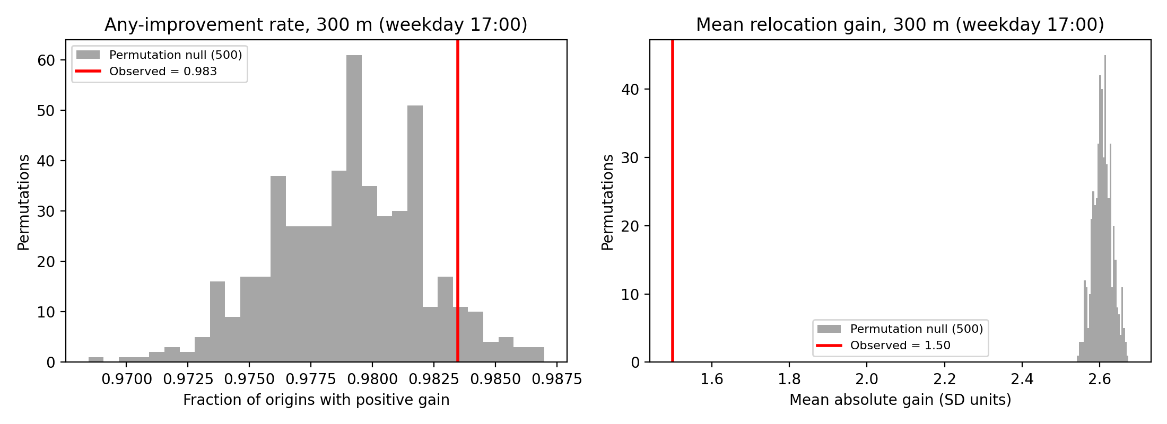
Figure 8. Observed statistics (red) vs 500-permutation null (gray), 300 m, weekday 17:00.

3.7 Constrained-null sensitivity
The within-ward and weekend-23 nulls reproduce the same pattern (marginal prevalence advantage at 200-500 m; observed magnitude below the null), so coarse district structure does not rescue the gain-magnitude claim.

3.8 Temporal and district secondary analyses
Under the modeled temporal specifications, gains are largest in the weekday-morning period; the weekend specification shifts modeled opportunity toward nightlife contexts — input-profile consequences (Figure 9). Kernel bandwidth 150/500 m leaves gains nearly unchanged (rho 0.98/0.99).
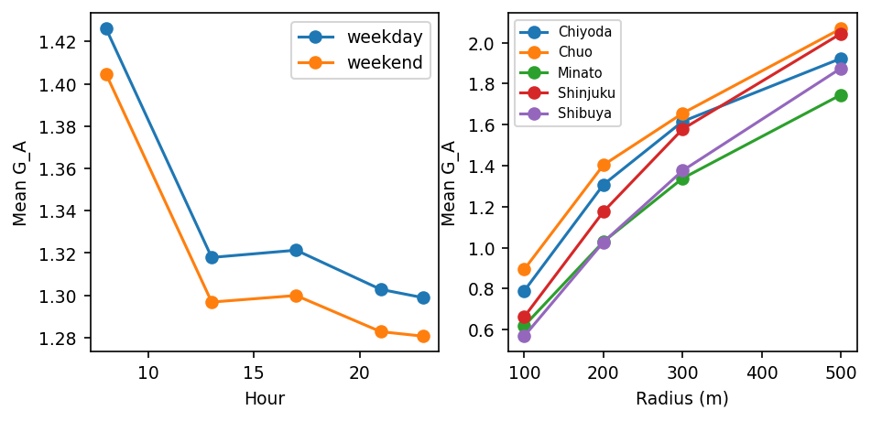
Figure 9. Modeled gain by hour/day-type and ward/radius — model behavior, not observed patterns.

3.9 Summary of evidence levels
Level 1 (self-optimization): large apparent gains — achieved. Level 2 (internal stress tests): ablation passed; transfer weak; heuristic contrast retained; permutation shows prevalence marginally above but magnitude below null. Level 3 (external empirical validation): not available in this study.

4. Discussion

4.1 Large apparent gains do not establish proxy validity
The self-optimization inequality is structural: with ~hundreds of reachable candidates, a local maximum almost surely exceeds the origin. The practical lesson is not that gains exist — it is that their size carries almost no validating information.

4.2 Cross-specification transfer reveals limited robustness
Positive but near-chance transfer between road-only and attractor-only selections means the two component families partly identify different places: an improvement under one plausible public-data reading of 'opportunity' is roughly a coin flip under the other. Any deployed proxy would inherit this specification dependence.

4.3 Spatial permutation shows the role of generic heterogeneity
The decisive result: a shuffled surface reproduces ≈101% of the observed improvement prevalence on average across the examined radii (null/observed ratio 0.99-1.04) and produced larger mean gain magnitudes. What the real urban surface contributes is a marginal reliability edge — not bigger wins. Interpreted honestly, this means the constructed proxy's fine-scale spatial arrangement adds little beyond generic heterogeneity for relocation purposes.

4.4 What the nearest-major-road comparison does and does not show
The combined optimum's surplus over the nearest major road shows the score encodes information beyond hierarchy — a real, if narrow, computational finding. It says nothing about real taxi encounters.

4.5 From optimization gain to proxy validity
Optimization of a heterogeneous spatial score will tend to locate a nearby value higher than the starting location: within-score gain is partly an order-statistical property of the constructed surface, not evidence about the world. Cross-specification transfer asks a stronger question — does the selected location remain preferable under another plausible information structure? Spatial permutation asks another — does the observed spatial organization yield gains beyond those of heterogeneous values arranged under a null spatial structure? Here, weak and asymmetric transfer plus strong null performance show why the large self-gains should not be interpreted naively: the main scientific result is not that the taxi relocation proxy succeeded operationally, but that apparently persuasive optimization gains can survive despite limited evidence of transferable spatial structure. This circular validation risk — the score used to select an optimum is also the score used to declare it successful — applies to a class of constructed surfaces (accessibility indices, opportunity and amenity scores, mobility-availability and service-location indices) that share the same inferential structure; these are problem classes, not empirically tested applications.

4.6 A practical proxy-auditing framework
A compact internal stress-test workflow follows from the results (Figure 1): (1) CONSTRUCT one or more plausible proxy surfaces; (2) OPTIMIZE candidate locations; (3) ABLATE components to test specification dependence; (4) TRANSFER selected locations across alternative specifications; (5) NULL-TEST against spatially permuted or otherwise structured nulls; (6) BENCHMARK against simple domain heuristics; (7) CALIBRATE claims to the evidence level that survives. This is an internal, falsification-oriented audit — not a universal standard.

4.7 Implications for prospective infrastructure siting
The problem examined here extends beyond mobility settings in which operational data are proprietary. Similar inferential constraints arise when infrastructure is prospective and historical outcome labels do not yet exist — for example, early-stage hydrogen-refueling or emerging charging-network siting. Planners may then optimize constructed demand or accessibility proxies with no observations of realized use. Our results caution that large within-proxy optimization gains should not by themselves be interpreted as evidence of meaningful siting advantage; ablation, transfer, spatial-null comparison, and simple heuristic benchmarks provide practical internal stress tests until external validation becomes possible.

4.8 Street-hail taxis as motivating case
The paper is not an operational validation of a taxi recommendation system. The street-hail case was chosen because it makes the proxy-optimization problem concrete: no ground truth, a spatial passenger decision, and tempting public data. Low-friction street-hail information could also matter for visitors unfamiliar with local hailing conventions — a motivation, not a tested claim.

4.9 Limitations
No observed vacant-taxi ground truth; scores are uncalibrated public-data proxies; temporal structure is partly assumed; Tokyo specificity; roadside hail feasibility imperfectly represented; station term is unweighted (FY2023 N02 lacks passenger counts); transfer and null tests are internal checks, not empirical validation.

4.10 Requirements for external empirical validation
Before any operational interpretation, external evidence would require observed vacant-taxi passage, actual waiting times, or prospective passenger outcomes.

5. Conclusion
Optimization performance and proxy validity are not equivalent. Large within-score optimization gains did not translate into equally strong cross-specification evidence and were partly reproducible under spatially permuted null surfaces. Self-optimization alone is insufficient validation of a constructed urban opportunity proxy; ablation, transfer, and spatial-null tests form a minimal internal stress-test framework for such studies. The same caution applies to prospective urban-infrastructure siting in which historical outcome labels do not yet exist: optimization of a constructed proxy should be stress-tested against alternative specifications and spatial nulls before being interpreted as evidence of real-world advantage.

Declarations
Data availability: all inputs are public datasets (Table 1); preprocessing and analysis code, the canonical numerical registry, and machine-readable result tables are openly available at https://github.com/bougtoir/street-hail-taxi-accessibility. Competing interests: none declared. Funding: none.

References
1. Yuan NJ, Zheng Y, Zhang L, Xie X. T-Finder: a recommender system for finding passengers and vacant taxis. IEEE Trans Knowl Data Eng. 2013;25(10):2390-2403. doi:10.1109/TKDE.2012.153.
2. Yang H, Leung CWY, Wong SC, Bell MGH. Equilibria of bilateral taxi-customer searching and meeting on networks. Transp Res Part B. 2010;44(8-9):1067-1083.
3. Moreira-Matias L, Gama J, Ferreira M, Mendes-Moreira J, Damas L. Predicting taxi-passenger demand using streaming data. IEEE Trans Intell Transp Syst. 2013;14(3):1393-1402.
4. Hwang RH, Hsueh YL, Chen YT. An effective taxi recommender system based on a spatio-temporal factor analysis model. Inf Sci. 2015;314:28-40.
5. Ocalir EV, Ercoskun OY, Tur R. An integrated model of GIS and fuzzy logic (FMOTS) for location decisions of taxicab stands. Expert Syst Appl. 2010;37(7):4892-4901.
6. Alonso-Mora J, Samaranayake S, Wallar A, Frazzoli E, Rus D. On-demand high-capacity ride-sharing via dynamic trip-vehicle assignment. Proc Natl Acad Sci USA. 2017;114(3):462-467. doi:10.1073/pnas.1611675114.
7. Tokyo Hire-Taxi Association. Tokyo no Taxi 2025. https://taxi-tokyo.or.jp/ (accessed 2026-09-29).
8. OpenStreetMap contributors. Planet dump and Overpass API. https://www.openstreetmap.org (ODbL; accessed 2026-09-29 via OSMnx 2.0.7).
9. Ministry of Land, Infrastructure, Transport and Tourism (Japan). National Land Numerical Information, N02 railway dataset (FY2023). https://nlftp.mlit.go.jp/ksj/ (accessed 2026-09-29).
10. Tokyo Taxi Center. Taxi user monitor survey, FY2023 tabulation report. https://www.tokyo-tc.or.jp/center/uploads/monitor_2024.pdf (accessed 2026-09-29).

Table 1. Public data sources
Source | Provider/License | Scope | Role
OSM road network + POIs | OSM contributors / ODbL | 5 central wards | segments, context, walk network
NLNI N02 station locations | MLIT / NLNI terms | FY2023 | station-presence attractor
Tokyo Taxi Center monitor survey | Tokyo Taxi Center | FY2023, n=2,662 | temporal profile
THTA yearbook 2025 | THTA | FY2024 | background

Table 2. Self-optimization outcomes by radius (combined specification)
Radius m | origins | improved | >0.1 SD | mean gain (SD) | beats nearest major | gain CI
100 | 1961 | 84% | 67% | 0.69 | 60% | [0.649, 0.722]
200 | 1989 | 97% | 90% | 1.16 | 74% | [1.124, 1.204]
300 | 1997 | 98% | 96% | 1.50 | 81% | [1.462, 1.539]
500 | 1999 | 100% | 99% | 1.93 | 91% | [1.894, 1.968]

Table 3. Ablation summary (300 m)
Specification | improved | >0.1 SD | beats nearest major | beats random | best is major road
Road-only | 95% | 95% | 66% | 100% | 55%
Attractor-only | 99% | 92% | 99% | 100% | 12%
Circulation proxy | 98% | 93% | 83% | 100% | 56%
Combined | 98% | 96% | 81% | 100% | 56%

Table 4. Cross-specification transfer at 300 m (mean TG SD / % positive)
Selector \ Evaluator | Road-only | Attractor-only | Circulation proxy | Combined
Road-only | (self) | 0.04 / 53% | 1.48 / 90% | 1.37 / 93%
Attractor-only | 0.08 / 43% | (self) | 0.27 / 69% | 0.36 / 69%
Circulation proxy | 1.58 / 87% | 0.19 / 73% | (self) | 1.46 / 97%

Table 5. Spatial permutation null (combined specification, weekday 17:00)
Radius m | obs frac>0 | null frac>0 | empirical p | obs mean G | null mean G
100 | 0.839 | 0.874 | 1.000 | 0.69 | 1.67
200 | 0.966 | 0.957 | 0.030 | 1.17 | 2.30
300 | 0.983 | 0.979 | 0.074 | 1.50 | 2.61
500 | 0.995 | 0.992 | 0.086 | 1.92 | 2.90

