Supplementary Material
Supplement to: When Do Fixed Appointment Slots Fail? Service-Time Tail Risk, Scheduling Regret, and Robust Outpatient Operations

S1. Full performance table
policy_performance.csv contains 82 rows: 10 service-time specs x 9 policies, evaluated on 100,000 sessions each (fresh draws).

S2. Delay cascade
A single 45-min consultation injected at successive positions; cascade length = downstream appointments with >1 min added waiting.
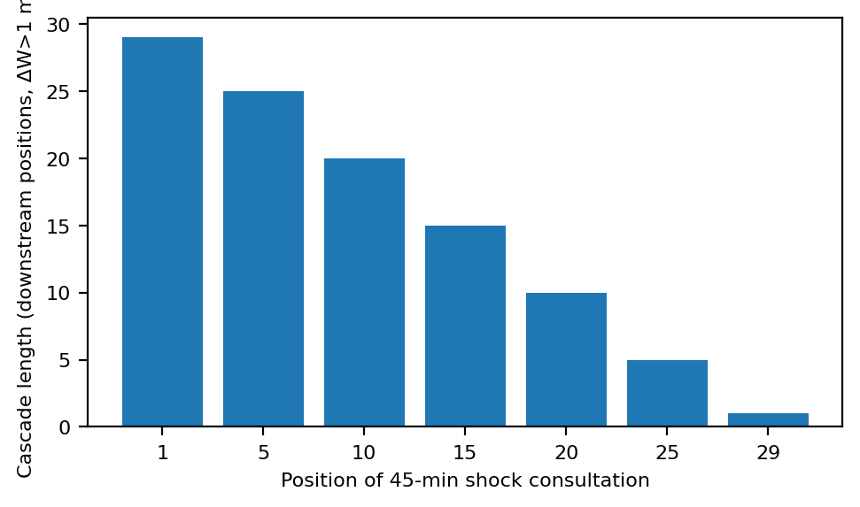

S3. Estimation uncertainty
Moment-fitted gamma design vs historical sample size n; Q90 regret over 400 replications per cell.
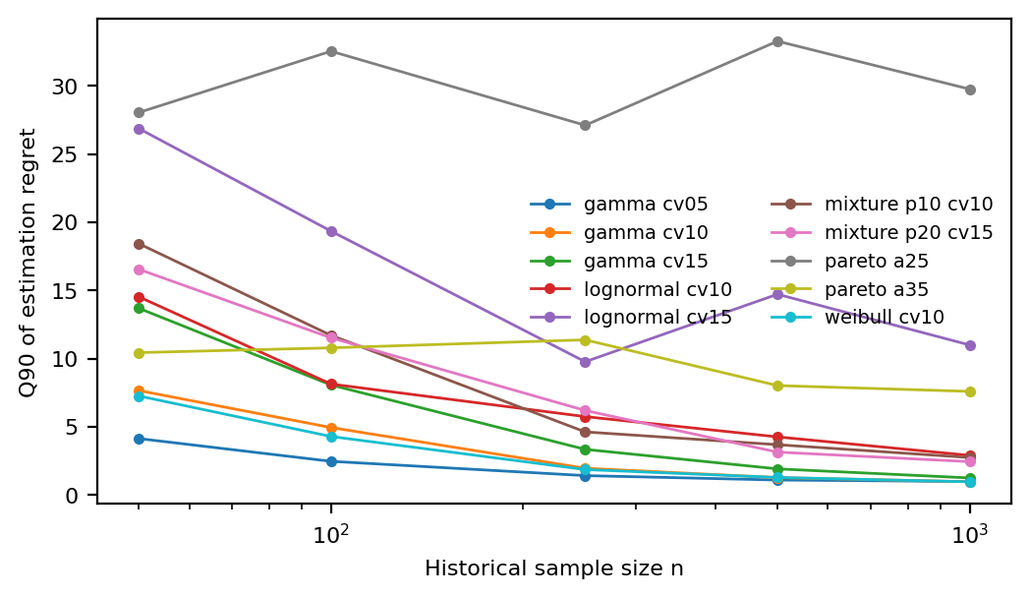

S4. Operational robustness
Fixed vs tail-aware designs under no-shows (p in {0,.05,.10,.20}) and arrival jitter (sd 0 or 2 min). See operational_robustness.csv.

