Supplementary Material
Supplement to: Service-Time Distributional Uncertainty in Outpatient Scheduling: When Simple Interval Optimization Is Enough

S1. Full performance table
policy_performance.csv contains 82 rows: 10 service-time specs x 9 policies, evaluated on 100,000 sessions each (fresh draws).

S2. Delay cascade
A single 45-min consultation injected at successive positions; cascade length = downstream appointments with $>1$ min added waiting (Figure 6).
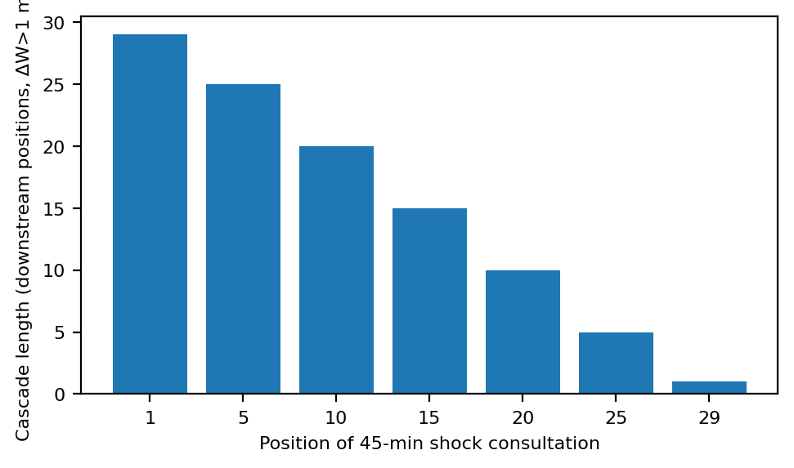
Figure 6. Delay cascade from a single injected 45-min consultation.

S3. Estimation uncertainty
Moment-fitted gamma design vs historical sample size $n$; $Q_{90}$ regret over 400 replications per cell (Figure S1).
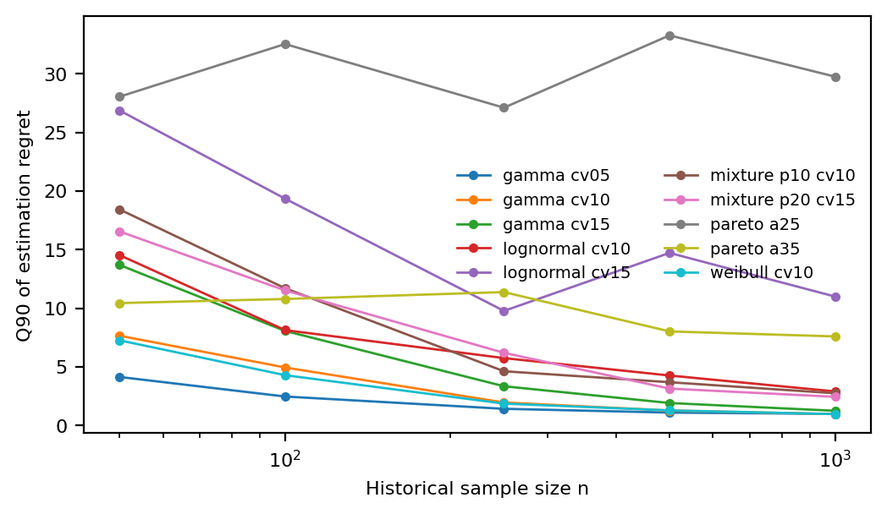
Figure S1. Moment-fitted gamma design regret vs historical sample size $n$.

S4. Operational robustness
Fixed vs tail-aware designs under no-shows ($p∈\{0,.05,.10,.20\}$) and arrival jitter (sd 0 or 2 min). See operational_robustness.csv.

