Service-Time Distributional Uncertainty in Outpatient Scheduling: When Simple Interval Optimization Is Enough

Abstract
Outpatient appointment systems are typically designed around mean consultation
time, yet consultation durations are strongly right-skewed and their upper tails
vary across clinics and specialties. We study when and why fixed, mean-based
appointment slots fail under distributional uncertainty in service times, using
a finite-horizon Lindley-type delay recursion evaluated by large-scale Monte
Carlo simulation. Holding the mean service time fixed, we vary only the
distributional family and tail shape across gamma, Weibull, lognormal,
two-component mixture, and Pareto-type designs. Fixed mean-based slots incur
relative scheduling regret of 36.7%–71.3% versus an
optimized benchmark across the ten specifications at session size N = 30
(scenario-mean regret rises from 25.5% at N = 20 to 49.3% at
N = 50); absolute regret grows roughly linearly in the coefficient of
variation. The central result is one of simplicity: a single SAA-optimized
uniform interval recovers nearly all attainable benefit (maximum relative
regret 1.4% versus oracle), while nonuniform, CVaR-aware and
distributionally robust designs add little incremental value in the studied
domain. Misspecifying the service-time family can erase the gains of careful
optimization — under-designing the interval costs about three times as much
as over-designing on average — and when the true family is genuinely
heavy-tailed, moment-fitted designs remain unreliable even at 1,000
historical observations. We translate the results into a
value-of-optimization map over CV, tail ratio, and session size showing
where the benefit of interval optimization is largest.
Keywords: appointment scheduling; healthcare operations; stochastic
service times; scheduling regret; distributionally robust optimization;
decision rules

Highlights
- Fixed mean-based slots incur 36.7%–71.3% relative regret at N=30
- A single optimized uniform interval caps regret at 1.4% vs oracle
- Tail shape, not the mean, drives finite-session delay propagation
- Wrong-family intervals can cost more than no optimization at all
- Light-tailed designs stabilize by ~250 observations; Pareto a=2.5 does not

1. Introduction
Outpatient clinics commit to appointment intervals before demand is observed.
The dominant design heuristic — divide session length by a target number of
patients, i.e., set each interval equal to the mean consultation time — is
attractive because it requires only a single, easily measured statistic. Yet
consultation durations are right-skewed: occasional long consultations are
common in primary care, and their frequency varies with specialty, case mix,
and documentation burden. When an unusually long consultation occurs mid-
session, the accumulated delay propagates to every subsequent patient; a
mean-based schedule has no slack to absorb it.
This paper asks a narrower but more actionable question than "are heavy-tailed
service times bad?": *when and why does the fixed mean-based slot design fail,
even when the mean consultation time is correctly specified?* We isolate the
mechanism by holding the service-time mean fixed and varying only tail
structure, quantify the resulting finite-session delay propagation and
scheduling regret, and ask which simple, measurable policy classes recover
most of the attainable benefit.
Outpatient appointment scheduling dates to Bailey (1952) and Welch and
Bailey (1952), with the stochastic core traceable to Lindley (1952) and
early policy comparisons by Soriano (1966); modern reviews include Cayirli
and Veral (2003), Cayirli et al. (2006), Gupta and Denton (2008), and
Ahmadi-Javid et al. (2017). Optimal interval design under known stochastic
service times is well studied (Denton and Gupta 2003; Kaandorp and Koole
2007; Begen and Queyranne 2011; Berg et al. 2014; Chen and Robinson 2014;
Pan et al. 2021),
as are heuristic rules (Robinson and Chen 2003), unpunctuality and
interruptions (Klassen and Yoogalingam 2013; Deceuninck et al. 2018),
no-shows and overbooking (Hassin and Mendel 2008; Muthuraman and Lawley
2008; Zacharias and Pinedo 2014; Wang and Fung 2015), and service-time
variability (Salzarulo et al. 2011). Distributionally robust and conic
designs hedge against limited distributional information (Kong et al. 2013;
Mak et al. 2015; van Eekelen et al. 2024; Bauerhenne et al. 2026),
resting on CVaR and robust-optimization machinery
(Rockafellar and Uryasev 2000; Bertsimas and Sim 2004; Rahimian and
Mehrotra 2022), with general scheduling foundations in Pinedo (2011).
What is less developed is an interpretable mapping from distributional
shape — and distributional *misspecification* — to the value of scheduling
complexity: most studies propose a specific policy and compare it against
the status quo rather than asking how much a clinic gains per unit of added
policy complexity, and the cost of misspecifying the service-time family
itself is rarely isolated.
Our contributions are:
1. Distributional-shape effect. Identical service-time means produce
markedly different finite-session delay propagation and cost when the
distributional family and upper tail differ.
2. Value of optimization. Against a common-random-number oracle we show
that mean-based slots leave a large fraction of attainable savings
unrealized across the studied design space.
3. A simplicity result. A single scalar, SAA-optimized uniform interval
captures nearly all attainable benefit; nonuniform, CVaR-aware and
distributionally robust policies add little incremental value.
4. Distributional model risk. A wrongly assumed service-time family can
erase optimization gains, and under-designing the interval is about three
times as costly as over-designing it on average.
5. Implementation guidance. Measurable descriptors (CV, Q95/mean,
session size) locate where the value of optimization concentrates;
estimation effort on the service-time distribution precedes scheduling
sophistication.

2. Model
A session contains N patients scheduled by N - 1 inter-appointment
intervals x_1,...,x_(N-1) (patient N's scheduled start is the last lattice
point; session-end accounting is handled by overtime, not an interval).
Patient i's consultation takes S_i >= 0; arrivals are on time in the base
model. Let D_i denote the delay at the scheduled start of patient i, equal
to patient i's waiting time W_i. Then
D_1 = 0, D_(i+1) = max(0, D_i + S_i - x_i), i = 1,...,N-1,
the finite-horizon Lindley recursion on the lattice of scheduled starts.
Physician idle time is I = sum_(i=1)^(N-1) max(0, x_i - D_i - S_i) and
session overtime is O = D_N + S_N, the residual work after the scheduled
end. The social cost
of a session is
C(pi) = c_w * sum_i W_i + c_i * I + c_o * O,
with baseline weights (c_w, c_i, c_o) = (1, 2, 2) reflecting that physician
idle and overtime minutes are costlier than patient waiting minutes; all
conclusions are rechecked under alternative weightings. A policy pi maps
available information to the interval vector x. The oracle pi* optimizes a
piecewise-constant interval vector under the true distribution by sample
average approximation (SAA); regret is R(pi) = C(pi) - C(pi*) and relative
regret R(pi)/C(pi*).
Policies evaluated (Table 2) span: fixed mean-based slots; a conservative
Table 2 Scheduling policies and information requirements.
policy_id | Policy | Information required | complexity
fixed_mean | Fixed mean-based | E[S] only | 1
fixed_conservative | Fixed conservative | E[S] | 1
quantile | Quantile-based | E[S], Q85[S] | 2
class_based | Class-based | per-class means, class labels | 3
opt_uniform | Optimized uniform | full distribution (SAA) | 3
opt_nonuniform | Optimized nonuniform | full distribution (SAA) | 4
tail_aware | Tail-aware CVaR | full distribution (SAA) | 4
dro | DRO uniform | ambiguity set (4 families) | 5
oracle | Oracle nonuniform | true distribution (SAA, large) | 6
fixed slot (mean plus slack); a quantile-based slot; a class-based rule using
mixture-component labels where such classes are observable; SAA-optimized
uniform and nonuniform intervals; a CVaR-penalized tail-aware uniform
interval; a distributionally robust (DRO) uniform interval hedging across a
four-family ambiguity set; and the oracle.
Service-time families are parameterized so that E[S] = 10 min for every spec
(Table 1, Fig. 1): gamma, Weibull, and lognormal at CV = 0.5–2.0, gamma-gamma
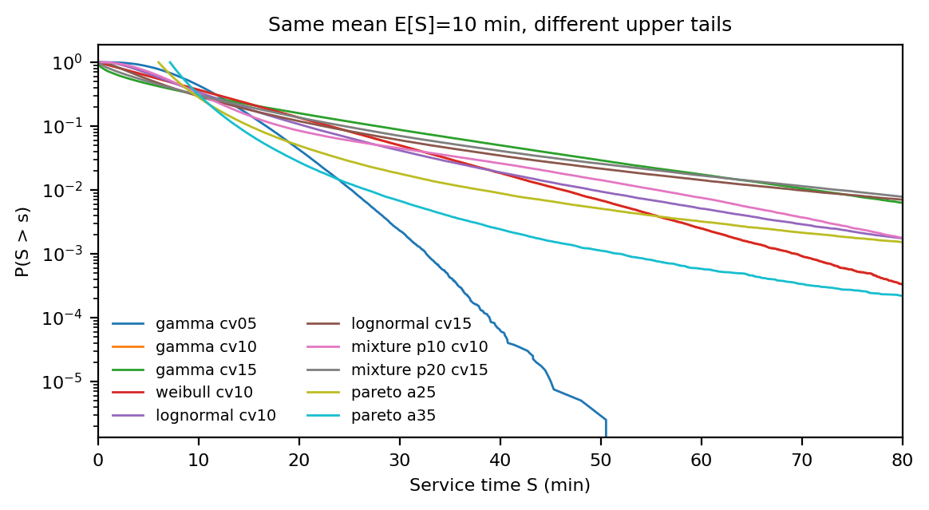
Figure 1. Same-mean (E[S]=10 min) service-time distributions with different upper tails (survival functions).
Table 1 Model and simulation design.
Component | Specification
Recursion | D1=0; D_{i+1}=max(0, D_i + S_i - x_i)
Session size N | 20, 30, 50 (focal 30)
Reference mean E[S] | 10 min
Distribution families | Gamma, Weibull, Lognormal, two-component mixture, Pareto-I (alpha=2.5,3.5)
CV grid | 0.25-2.0
Evaluation sessions M | 60,000-100,000 per condition
SAA samples for policy design | 4,000-12,000
Cost weights (c_w, c_i, c_o) | (1,2,2) baseline; sensitivity (1,1,1)-(1,2,6)
Randomization | fixed seeds per experiment; fresh evaluation draws
mixtures with a long-consultation component, and Pareto type I with tail
index alpha in {2.5, 3.5} — the only genuinely heavy-tailed cases here
(infinite fourth moment for alpha = 2.5). We use "heavy-tailed" only for the
Pareto cases; the skewed finite-moment families are described as right-skewed
or long-tailed throughout.

3. Computational design
For each condition we evaluate policies on M = 60,000–100,000 independently
sampled sessions (evaluation draws are fresh and disjoint from SAA design
draws), reporting Monte Carlo standard errors. Designs span N in
{20, 30, 50} and CV in [0.25, 2.0] with boundary refinement where regret
surfaces curve. In the misspecification study the designing distribution
differs from the generating distribution in family, parameters, or both. For
estimation uncertainty we draw n in {50,...,1000} historical service times,
fit a gamma by moments, and evaluate the implied optimal uniform interval;
the fitted-CV-to-interval map is itself a precomputed SAA table kept in the
reproducibility package. We report effect sizes and MC uncertainty rather
than significance tests, which are uninformative at these sample sizes.

4. Results

4.1 Tail structure matters beyond the mean
With identical E[S], mean waiting under fixed slots differs sharply across
families (Fig. 1; Fig. 2): for lognormal service at CV = 1.5, mean waiting per
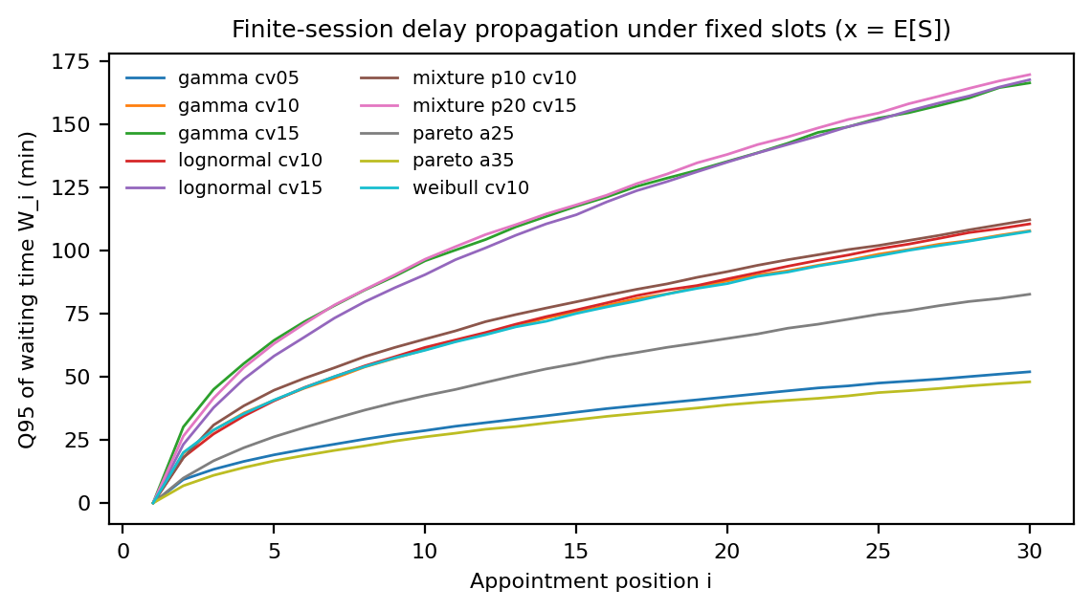
Figure 2. Finite-session delay propagation under fixed mean-based slots (x = E[S]).
patient is 29.2 min and 31.2% of patients wait over
30 min, versus a fraction of that for gamma at the same CV and identical mean.
Fixed mean-based slots incur 36.7%–71.3% relative regret
versus the oracle across the ten service-time specs at N = 30 (the
specification range, not a scenario mean); absolute regret rises
roughly linearly in CV (gamma at N = 30: 96 cost units at
CV = 0.25, 521 at CV = 2.0), while relative regret is nearly
flat in CV but steeply increasing in session size (scenario-mean relative
regret 25.5% at N = 20, 36.3% at N = 30, 49.3% at N = 50). The finding is not that fixed
slots fail only beyond a variance threshold: they leave a quarter to a half
of attainable savings unclaimed across the whole design grid, and the loss is
largest where sessions are longest and upper quantiles are fat relative to
the mean.

4.2 When fixed scheduling becomes most costly
Two descriptors drive the penalty map (Fig. 3): the coefficient of variation
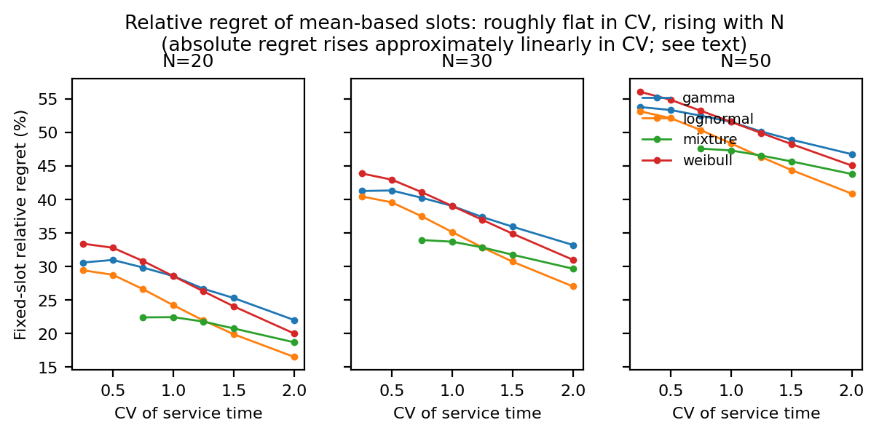
Figure 3. Fixed mean-based slot relative regret across families and CV, by session size N.
sets the absolute stakes — the unrecovered cost of mean-based slots rises
approximately linearly in CV within each family — while family identity at
fixed CV ranks by the Q95/mean ratio, so that gamma CV = 1.5 and lognormal
CV = 1.5 with identical mean and CV still differ materially in regret.
Session size amplifies the relative burden because a longer session gives
delay cascades more positions over which to accumulate.

4.3 Misspecification cost
Optimizing the interval under a wrongly assumed family is not free insurance
(Fig. 4): the worst off-diagonal cell adds 446 cost units relative
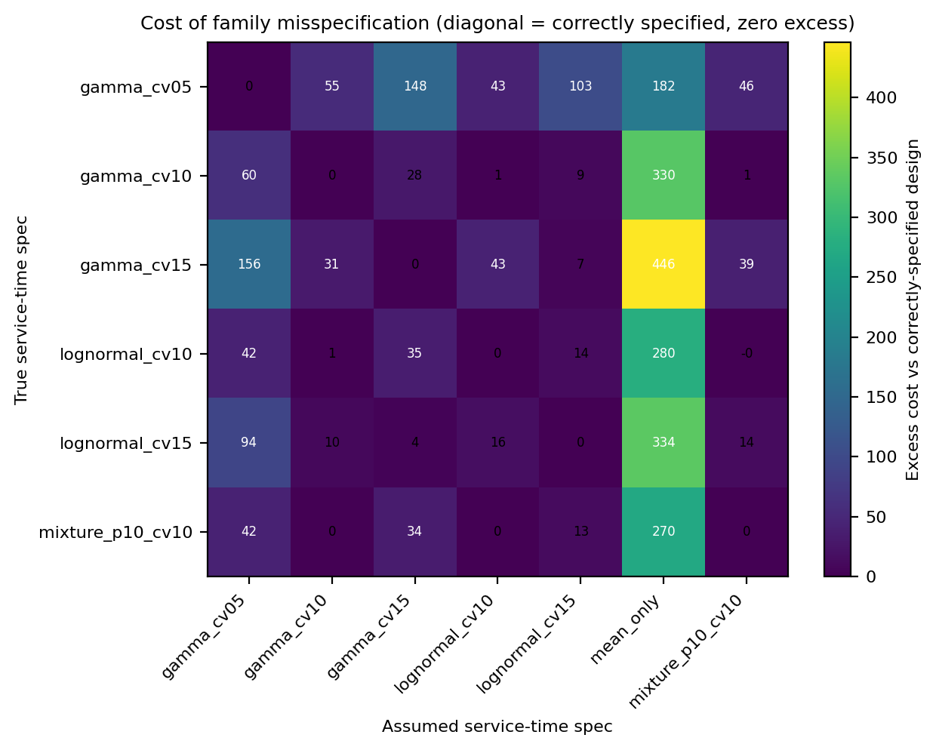
Figure 4. True x assumed distribution matrix: excess cost of misspecification.
to the correctly specified design — more than the gap between fixed slots
and the oracle for several true distributions. Under-designing (assuming a
lower-CV family than the truth) is consistently worse than over-designing.
With moment-fitted gamma designs, median estimation regret is already small
at n = 250 (1.14 cost units; Q90 5.18) versus n = 50
(14.11); the gains from n beyond ~500 are minor for light-tailed
families. The exception is the genuinely heavy-tailed Pareto alpha = 2.5
case, where the Q90 estimation regret stays flat around 30
cost units even at n = 1,000 — tail-aware design remains unreliable there no
matter how much history is available, because the sampling variability of
the fitted CV does not decay in the usual way.

4.4 A simplicity result: one optimized interval suffices
The SAA-optimized uniform interval is the workhorse: mean relative regret
1.2% and maximum 1.4% across all ten service-time specs
versus oracle, and within 5% of oracle in every studied scenario
(Table 4). Nonuniform position-dependent intervals recover essentially the
Table 4 Policy complexity vs benefit summary.
Policy | Information required | Implementation | Mean regret (%) | Max regret (%)
Oracle | true distribution (SAA, large) | full distribution, N-1 intervals | 0 | 0
Optimized nonuniform | full distribution (SAA) | N-1 intervals, SAA-optimized | 0 | 0
Optimized uniform | full distribution (SAA) | one scalar, SAA-optimized | 1.2 | 1.4
DRO uniform | ambiguity set (4 families) | one scalar, ambiguity-set worst case | 5.3 | 34.6
Fixed conservative | E[S] | one scalar (E[S]+slack) | 8.9 | 18.5
Quantile-based | E[S], Q85[S] | one scalar (quantile) | 12.1 | 33.3
Tail-aware (CVaR) | full distribution (SAA) | one scalar, E+CVaR objective | 20.3 | 40.8
Class-based | per-class means, class labels | scalar per class | 51.6 | 64
Fixed mean-based | E[S] only | one scalar (E[S]) | 55 | 71.3
remaining gap — the incremental saving over the optimized uniform interval
is only 0.6–1.4% of session cost — while
the DRO uniform interval and the CVaR-penalized tail-aware design are farther
from the oracle in expected cost (the CVaR design optimizes a different
objective, trading expected cost for worst-quantile protection; it is not a
failure of the method). Class-based rules help only where observable classes
exist (mixture specs). We stress that near-oracle performance of the uniform
interval reflects the value of scalar optimization under a known or
estimated family, not distributionally robust behavior per se; the
misspecification study in Section 4.3 is what measures model risk.
Conservative fixed slots (mean + 25%) recover much of the gap but at
materially higher idle time. The interval sweep traces the
waiting–idle/overtime frontier (Fig. 5); all optimized policies sit on or
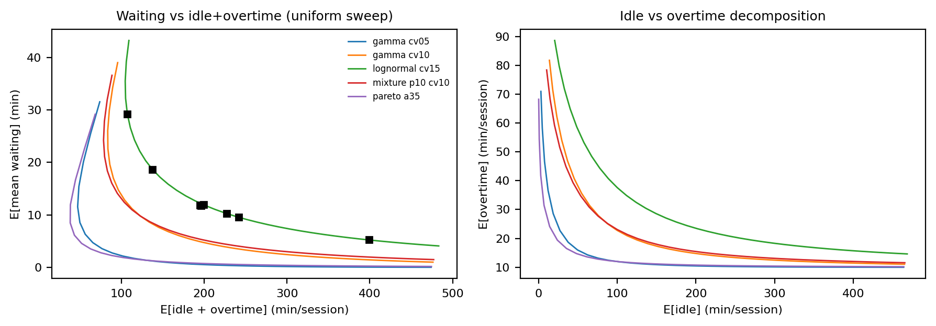
Figure 5. Waiting vs idle+overtime trade-off under the uniform-interval sweep.
near that frontier, so the choice reduces to where on the frontier the cost
weights place the clinic.
The pattern is stable under cost weights ranging (1,1,1) to (1,2,6): the
optimized uniform interval's maximum regret stays at or below 2.5%
across the weight grid. Under no-shows up to 20% and arrival jitter, policy
orderings weaken as expected — the CVaR tail-aware design beats the
mean-based rule in 33.3% of disrupted conditions at 10% no-shows and
in none at 20% — because disruptions themselves add service-time noise and
lower effective load, narrowing the gap between policies.

4.5 Delay cascades and sequencing
A single 45-min consultation injected mid-session produces a delay cascade
lasting 15 subsequent appointments and 422 min of
extra cumulative waiting (Fig. S1). Early-session shocks are costlier in
aggregate waiting; end-of-session shocks convert to overtime instead.

4.6 Value-of-optimization map
Plotting fixed-slot regret over (CV, Q95/mean) for each family yields a
compact map of where optimization value concentrates (Fig. 6): there is no
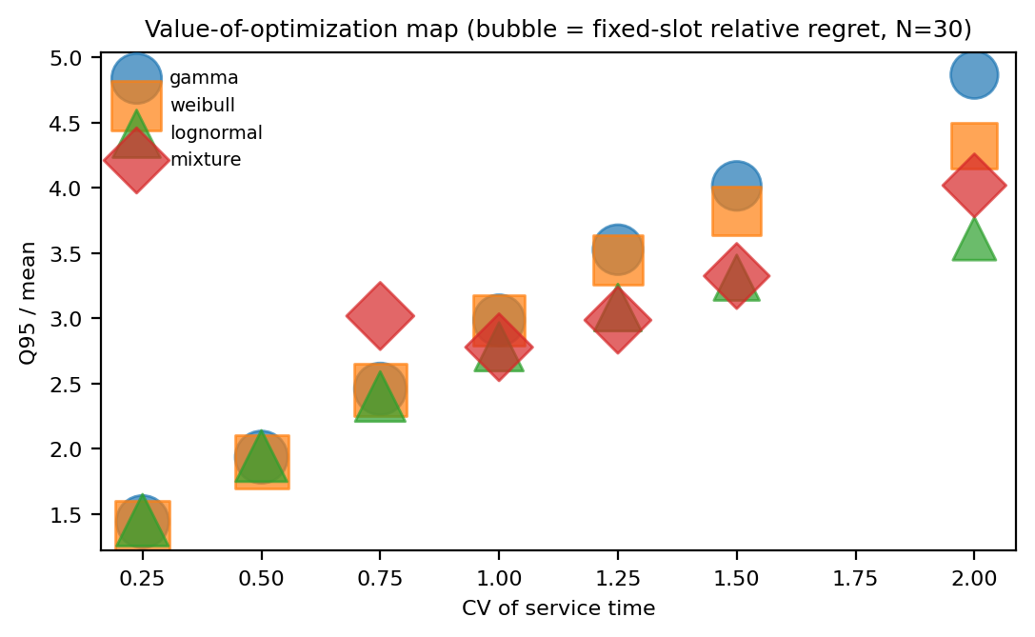
Figure 6. Managerial decision map (bubble size = fixed-slot relative regret, N=30).
corner of the explored space where mean-based slots are competitive, and
the benefit of optimization rises sharply with session size and tail ratio
— exactly where a clinic should adopt the one-parameter optimized uniform
interval. Because the optimized uniform interval already sits at the oracle
boundary across the map, the map prescribes where to optimize, not which
of several complex policies to choose.

5. Discussion
The central finding is a management-science simplicity result: in the
studied domain, essentially all attainable improvement over fixed
mean-based slots is captured by optimizing a single scalar — the uniform
appointment interval — so the operational priority is calibrating that one
interval against a well-estimated service-time distribution rather than
deploying individualized, CVaR-aware, or distributionally robust machinery.
This separates the value of optimization (large: fixed slots leave
36.3% of attainable savings unrealized at N = 30) from the value of
information (upper-tail descriptors determine how large the stakes are) and
from scheduling complexity (nearly worthless beyond the scalar interval).
Second, distributional model risk is real and asymmetric. Designs optimized
under a wrongly assumed family can exceed the cost of no optimization at
all (the mean-only column of Fig. 4 is the worst), and under-designing the
interval is on average about three times as costly as over-designing it
(mean excess 86 vs 38 cost units). The estimation
study quantifies how much history is needed: for the finite-moment and
light-tailed families studied, moment-based designs are already stable at
~250 observations, while the genuinely heavy-tailed Pareto stress case
never stabilizes — there, family diagnosis matters more than sample size.
Third, implementability: the recommended design needs only (i) an empirical
CV and upper quantile of consultation duration and (ii) a one-time scalar
SAA optimization — no per-patient prediction or sequencing engine.
We deliberately do not claim that fixed-slot failure is "a tail rather
than utilization phenomenon": utilization was not independently
manipulated in this design, and the attenuation of policy gaps as no-shows
rise is consistent with a load channel we did not isolate. The
identification statement we support is narrower and stronger: at fixed
mean and fixed load, distributional family and upper-tail shape alone move
waiting and regret substantially.
Limitations: synthetic service times calibrated in mean and CV; a
single-provider, single-session model; punctual arrivals in the base case;
specific cost weights and a bounded weight grid; SAA policy optimization
that is itself subject to the misspecification we document; a nonexhaustive
set of families; and no empirical external validation on measured
consultation times. The mechanisms (finite-horizon delay accumulation,
scalar-interval sufficiency) plausibly extend to analogous finite-horizon
scheduled services — procedure blocks, imaging sessions, service counters —
but that generalization is a conjecture, not a result. Validation on
measured consultation-time data and multi-provider extensions are natural
next steps.

6. Conclusion
Mean-based fixed appointment slots underperform across the explored design
space: specification-level relative regret is 36.7%–71.3%
at N = 30 and the scenario mean grows with session length (25.5% to
49.3%) and tail ratio. A single optimized uniform interval —
requiring only moment-level information — recovers nearly all regret
(maximum 1.4%); CVaR and DRO machinery adds little for the
families studied. When the assumed family is wrong, under-designing the
interval is on average about three times as costly as over-designing it,
and under genuinely heavy-tailed service times moment-fitted designs do
not stabilize even at 1,000 historical observations. Effective scheduling
need not be complicated — but the distribution feeding the one optimized
interval must be right.

Declaration of competing interest
[TO BE COMPLETED BY AUTHORS — generated placeholder; no competing interests
invented.]

Declaration of generative AI and AI-assisted technologies
[DRAFT FOR AUTHOR REVIEW] During the preparation of this work the authors used
an AI coding assistant (Devin, Cognition AI) to draft simulation code, run
computational analyses, generate figures, and prepare manuscript text. The
authors reviewed and edited all content and take full responsibility for the
integrity of this publication. [Confirm against the current Elsevier policy at
submission.]

Data availability
All results are generated by the reproducible simulation pipeline; code and
configuration are available at [PUBLIC REPO URL — insert at submission].

References
Ahmadi-Javid, Amir; Jalali, Zahra; Klassen, Kenneth J (2017). Outpatient appointment systems in healthcare: A review of optimization studies. European Journal of Operational Research. doi:10.1016/j.ejor.2016.06.064
Bailey, Norman T. J. (1952). A Study of Queues and Appointment Systems in Hospital Out-Patient Departments, with Special Reference to Waiting-Times. Journal of the Royal Statistical Society Series B: Statistical Methodology. doi:10.1111/j.2517-6161.1952.tb00112.x
Bauerhenne, Carolin; Kolisch, Rainer; Schulz, Andreas S. (2026). Robust Appointment Scheduling with Waiting Time Guarantees. Manufacturing &amp; Service Operations Management. doi:10.1287/msom.2024.0852
Begen, Mehmet A.; Queyranne, Maurice (2011). Appointment Scheduling with Discrete Random Durations. Mathematics of Operations Research. doi:10.1287/moor.1110.0489
Berg, Bjorn P.; Denton, Brian T.; Ayca Erdogan, S.; Rohleder, Thomas (2014). Optimal booking and scheduling in outpatient procedure centers. Computers &amp; Operations Research. doi:10.1016/j.cor.2014.04.007
Bertsimas, Dimitris; Sim, Melvyn (2004). The Price of Robustness. Operations Research. doi:10.1287/opre.1030.0065
CAYIRLI, TUGBA; VERAL, EMRE (2003). OUTPATIENT SCHEDULING IN HEALTH CARE: A REVIEW OF LITERATURE. Production and Operations Management. doi:10.1111/j.1937-5956.2003.tb00218.x
Cayirli, Tugba; Veral, Emre; Rosen, Harry (2006). Designing appointment scheduling systems for ambulatory care services. Health Care Management Science. doi:10.1007/s10729-006-6279-5
Chen, Rachel R.; Robinson, Lawrence W. (2014). Sequencing and Scheduling Appointments with Potential Call‐In Patients. Production and Operations Management. doi:10.1111/poms.12168
Deceuninck, Matthias; Fiems, Dieter; De Vuyst, Stijn (2018). Outpatient scheduling with unpunctual patients and no-shows. European Journal of Operational Research. doi:10.1016/j.ejor.2017.07.006
Denton, Brian; Gupta, Diwakar (2003). A Sequential Bounding Approach for Optimal Appointment Scheduling. IIE Transactions. doi:10.1080/07408170304395
Gupta, Diwakar; Denton, Brian (2008). Appointment scheduling in health care: Challenges and opportunities. IIE Transactions. doi:10.1080/07408170802165880
Hassin, Refael; Mendel, Sharon (2008). Scheduling Arrivals to Queues: A Single-Server Model with No-Shows. Management Science. doi:10.1287/mnsc.1070.0802
Kaandorp, Guido C.; Koole, Ger (2007). Optimal outpatient appointment scheduling. Health Care Management Science. doi:10.1007/s10729-007-9015-x
Klassen, Kenneth J.; Yoogalingam, Reena (2013). Appointment system design with interruptions and physician lateness. International Journal of Operations &amp; Production Management. doi:10.1108/01443571311307253
Kong, Qingxia; Lee, Chung-Yee; Teo, Chung-Piaw; Zheng, Zhichao (2013). Scheduling Arrivals to a Stochastic Service Delivery System Using Copositive Cones. Operations Research. doi:10.1287/opre.2013.1158
Lindley, D. V. (1952). The theory of queues with a single server. Mathematical Proceedings of the Cambridge Philosophical Society. doi:10.1017/s0305004100027638
Mak, Ho-Yin; Rong, Ying; Zhang, Jiawei (2015). Appointment Scheduling with Limited Distributional Information. Management Science. doi:10.1287/mnsc.2013.1881
Muthuraman, Kumar; Lawley, Mark (2008). A stochastic overbooking model for outpatient clinical scheduling with no-shows. IIE Transactions. doi:10.1080/07408170802165823
Pan, Xingwei; Geng, Na; Xie, Xiaolan (2021). Appointment scheduling and real-time sequencing strategies for patient unpunctuality. European Journal of Operational Research. doi:10.1016/j.ejor.2021.02.055
Pinedo, Michael L. (2011). Selected Scheduling Systems. Scheduling. doi:10.1007/978-1-4614-2361-4_27
ROBINSON, LAWRENCE W.; CHEN, RACHEL R. (2003). Scheduling doctors' appointments: optimal and empirically-based heuristic policies. IIE Transactions. doi:10.1080/07408170304367
Rahimian, Hamed; Mehrotra, Sanjay (2022). Frameworks and Results in Distributionally Robust Optimization. Open Journal of Mathematical Optimization. doi:10.5802/ojmo.15
Rockafellar, R. Tyrrell; Uryasev, Stanislav (2000). Optimization of conditional value-at-risk. The Journal of Risk. doi:10.21314/jor.2000.038
Salzarulo, Peter A.; Bretthauer, Kurt M.; Côté, Murray J.; Schultz, Kenneth L. (2011). The Impact of Variability and Patient Information on Health Care System Performance. Production and Operations Management. doi:10.1111/j.1937-5956.2010.01210.x
Soriano, A. (1966). Comparison of Two Scheduling Systems. Operations Research. doi:10.1287/opre.14.3.388
Wang, Jin; Fung, Richard Y.K. (2015). Dynamic appointment scheduling with patient preferences and choices. Industrial Management &amp; Data Systems. doi:10.1108/imds-12-2014-0372
Welch, J.D.; Bailey, NormanT.J. (1952). APPOINTMENT SYSTEMS IN HOSPITAL OUTPATIENT DEPARTMENTS. The Lancet. doi:10.1016/s0140-6736(52)90763-0
Zacharias, Christos; Pinedo, Michael (2014). Appointment Scheduling with No‐Shows and Overbooking. Production and Operations Management. doi:10.1111/poms.12065
van Eekelen, Wouter; den Hertog, Dick; van Leeuwaarden, Johan (2024). Distributionally robust appointment scheduling that can deal with independent service times. nan. doi:10.2139/ssrn.4892477

Table 3 Representative policy performance and regret (focal specs).
Table 3 Representative policy performance and regret (focal specs).
Policy | E[wait] (min) | P(wait>30 min) (%) | E[idle] (min) | E[overtime] (min) | E[cost] | Regret vs oracle (%)
Fixed mean-based | 29.2 | 31.2 | 48.6 | 58.6 | 1092 | 46.4
Fixed conservative | 18.6 | 19.8 | 100 | 37.6 | 834 | 11.9
Quantile-based | 9.6 | 9.9 | 219.8 | 22.2 | 770 | 3.3
Optimized uniform | 11.9 | 12.4 | 173.7 | 25.9 | 757 | 1.4
Optimized nonuniform | 11.8 | 12.3 | 170.4 | 25.7 | 746 | -0
Tail-aware (CVaR) | 5.3 | 5.3 | 382.8 | 16.2 | 956 | 28.1
DRO uniform | 10.3 | 10.7 | 203.8 | 23.3 | 762 | 2.2
Oracle | 11.9 | 12.4 | 169.2 | 25.5 | 746 | 0

