Trust-Adjusted Transparent Scoring with Unified Knowledge Integration (TATSUKI):
An Agent-Based Computational Model of Accountability-Driven Electoral Reform
with Empirical Calibration
[Author Name Redacted for Peer Review]
[Institutional Affiliation Redacted]

Abstract
Democratic elections provide citizens with periodic opportunities to hold representatives accountable, yet the binary nature of electoral sanctions (re-election versus removal) offers only a coarse instrument for incentivizing policy fulfillment. We propose Trust-Adjusted Transparent Scoring with Unified Knowledge Integration (TATSUKI), a novel electoral mechanism in which candidates pre-declare weighted policy pledges, third-party evaluators assess fulfillment at term end, and the resulting accountability score modulates a candidate-level trust coefficient influencing effective electoral support in subsequent elections. Using an agent-based model (ABM) compliant with the ODD protocol, we simulate multi-generational electoral dynamics under TATSUKI across a family of influence functions. The model is calibrated using empirical pledge fulfillment data from the Polimeter project (1,050 promises across three Canadian parliamentary terms) and cross-national data from Thomson et al. ^{[10]}. Results show that TATSUKI (i) significantly raises mean accountability scores, (ii) induces evolutionary selection pressure favoring sincere candidates, (iii) exhibits robustness to adversarial exploitation strategies discovered via genetic algorithm search, and (iv) produces counterfactual trust trajectories consistent with empirical fulfillment patterns. Sensitivity analysis reveals that concave and sigmoid influence functions offer the best trade-off between incentive strength and resistance to manipulation.
Keywords: electoral accountability, agent-based model, computational social science, mechanism design, retrospective voting, pledge fulfillment

1. Introduction
Elections constitute the cornerstone of representative democracy, providing citizens with periodic opportunities to evaluate and sanction their representatives ^{[1]}. The retrospective voting literature has documented that voters do, in practice, condition their electoral choices on perceived government performance ^{[2–4]}. However, this accountability mechanism operates informally: voters must independently assess complex policy outcomes, and the electoral sanction itself is binary—re-election or removal—regardless of the degree of policy fulfillment or failure.
Several innovative proposals have sought to improve democratic decision-making by modifying the structure of elections. Quadratic Voting (QV) addresses the failure to capture preference intensity by allowing voters to purchase additional votes at quadratic cost ^{[5, 6]}. Liquid democracy enables flexible delegation of voting rights ^{[7, 8]}. Futarchy separates value judgments from empirical beliefs by employing prediction markets for policy selection ^{[9]}. Each of these approaches modifies a different dimension of the electoral process, yet none directly institutionalizes the retrospective accountability relationship between campaign promises and post-election performance.
Meanwhile, the empirical literature on campaign pledge fulfillment has established that promise keeping is both measurable and variable. Thomson et al. ^{[10]}, analyzing over 20,000 pledges across 12 countries, found that governing parties fulfill a majority of their promises, with rates varying significantly based on institutional context. Pétry and Collette ^{[11]} report a cross-national average fulfillment rate of approximately 67%. These findings suggest that systematic evaluation of pledge fulfillment is feasible and could serve as the empirical foundation for an institutionalized accountability mechanism.
In this paper, we propose Trust-Adjusted Transparent Scoring with Unified Knowledge Integration (TATSUKI), an electoral mechanism that bridges the gap between informal retrospective voting and formal institutional design. Under TATSUKI, candidates pre-declare a weighted portfolio of policy pledges at election time, an independent evaluation body assesses fulfillment at the end of the term, and the resulting accountability score is transformed via an influence function into a trust coefficient that modulates the candidate's effective electoral support in subsequent elections. Crucially, we frame this adjustment as a candidate-level trust coefficient rather than a modification of individual voter weights, thereby maintaining compatibility with the one-person-one-vote principle.
We formalize TATSUKI as a family of mechanisms parameterized by the choice of influence function ω(S), and employ agent-based modeling (ABM)—a computational approach well-suited to exploring emergent dynamics in complex social systems—to investigate the system's dynamic properties. Following the ODD protocol ^{[12]}, we simulate multi-generational electoral competition among heterogeneous candidate types (sincere, populist, and strategic-deceptive) and examine equilibrium outcomes, evolutionary dynamics, and robustness to adversarial exploitation via genetic algorithm search. Our contributions are as follows:
1. We introduce TATSUKI, a formal electoral mechanism that institutionalizes retrospective accountability by linking pre-declared pledge weights to post-term trust coefficients.
2. We specify a family of influence functions ω(S) and analyze their theoretical properties, including incentive compatibility conditions and manipulation resistance.
3. We present an ODD-compliant agent-based model simulating multi-generational electoral dynamics under TATSUKI, demonstrating its capacity to select for sincere candidates.
4. We conduct adversarial robustness analysis using genetic algorithms to identify and characterize the most effective exploitation strategies for each influence function variant.
5. We provide a systematic comparison of TATSUKI with related electoral reform proposals, establishing its unique position in the theoretical landscape.
6. We calibrate the model using empirical pledge fulfillment data from the Polimeter project ^{[13]} and the Comparative Party Pledges Database ^{[10]}, and conduct counterfactual analysis demonstrating TATSUKI's predicted effects on real-world political actors.
The remainder of this paper is organized as follows. Section 2 reviews related work. Section 3 presents the formal model. Section 4 describes the agent-based simulation following the ODD protocol. Section 5 reports simulation results, including empirical calibration and counterfactual analysis using Polimeter data. Section 6 discusses implications and limitations. Section 7 concludes.

2. Related Work

2.1 Retrospective Voting and Electoral Accountability
The retrospective voting tradition, initiated by Key ^{[3]} and formalized by Fiorina ^{[2]}, posits that voters evaluate incumbents based on past performance rather than prospective policy promises. Healy and Malhotra ^{[4]} provide a comprehensive review, noting that voters are often myopic, weighting recent events disproportionately, and susceptible to irrelevant factors. TATSUKI addresses these limitations by institutionalizing the retrospective evaluation process, replacing subjective voter assessments with structured third-party evaluation of pre-declared pledges.
Formal models of electoral accountability, notably Barro ^{[14]} and Ferejohn ^{[15]}, frame the voter-politician relationship as a principal-agent problem. In these models, voters employ threshold strategies: re-elect the incumbent if performance exceeds a reservation utility, otherwise remove. Besley ^{[16]} extends this framework to distinguish selection and disciplining effects. TATSUKI generalizes the binary sanction of these models into a continuous trust coefficient τ = ω(S), providing finer-grained incentives for policy fulfillment.

2.2 Mechanism Design and Social Choice Theory
Arrow's impossibility theorem ^{[17]} and the Gibbard-Satterthwaite theorem ^{[18, 19]} establish fundamental limits on ranked-choice voting systems. Dasgupta and Maskin ^{[20]} provide recent results on strategy-proofness under majority rule. TATSUKI does not modify the preference aggregation rule itself but introduces an additional dimension—dynamic trust weighting—that operates upstream of the aggregation step. This situates TATSUKI outside the direct scope of classical impossibility results, though it raises new questions about strategic manipulation in the pledge-declaration and evaluation stages.
Acemoglu, Golosov, and Tsyvinski ^{[21]} study the political economy of mechanisms, analyzing dynamic incentive provision for politicians. Their framework informs our treatment of intertemporal incentives, though TATSUKI differs in making the incentive structure transparent and parameterized through the publicly known influence function ω(S).

2.3 Alternative Electoral Reforms
Quadratic Voting ^{[5, 6]} allows voters to express preference intensity by purchasing votes at quadratic cost, achieving approximate welfare optimality under certain conditions. While QV modifies the voting act itself, TATSUKI modifies the consequences of past voting outcomes. The two mechanisms are formally complementary and could, in principle, be combined.
Liquid democracy ^{[7, 22, 8]} enables transitive delegation of voting rights, dissolving the boundary between direct and representative democracy. In contrast, TATSUKI preserves the representative structure while strengthening accountability within it. Futarchy ^{[9]} delegates policy decisions to prediction markets, separating values from beliefs. TATSUKI implements a different separation: pre-election pledges from post-election evaluation.

2.4 Campaign Pledge Fulfillment
Thomson et al. ^{[10]} conduct the most comprehensive comparative study of pledge fulfillment, analyzing over 20,000 pledges across 57 election campaigns in 12 countries. They find that governing parties fulfill a majority of pledges, with single-party governments achieving higher rates than coalitions. Naurin, Royed, and Thomson ^{[23]} further document cross-national variation. Bytzek et al. ^{[24]} demonstrate that pledge fulfillment perceptions significantly affect political trust. These findings provide the empirical foundation for TATSUKI's core assumption that pledge fulfillment can be systematically measured and used as an institutional input.

2.5 Agent-Based Models of Electoral Systems
ABMs have been widely applied to electoral dynamics. Laver ^{[25]} models party competition with strategic agents adapting to voter distributions. Mitra ^{[26]} simulates district-based elections incorporating social and geographic influences. Tomlinson et al. ^{[27]} employ replicator dynamics to study candidate positioning, finding that complex evolutionary dynamics emerge even from simple behavioral heuristics. Our ABM builds on this tradition by introducing the TATSUKI mechanism as the institutional context within which candidate strategies evolve.
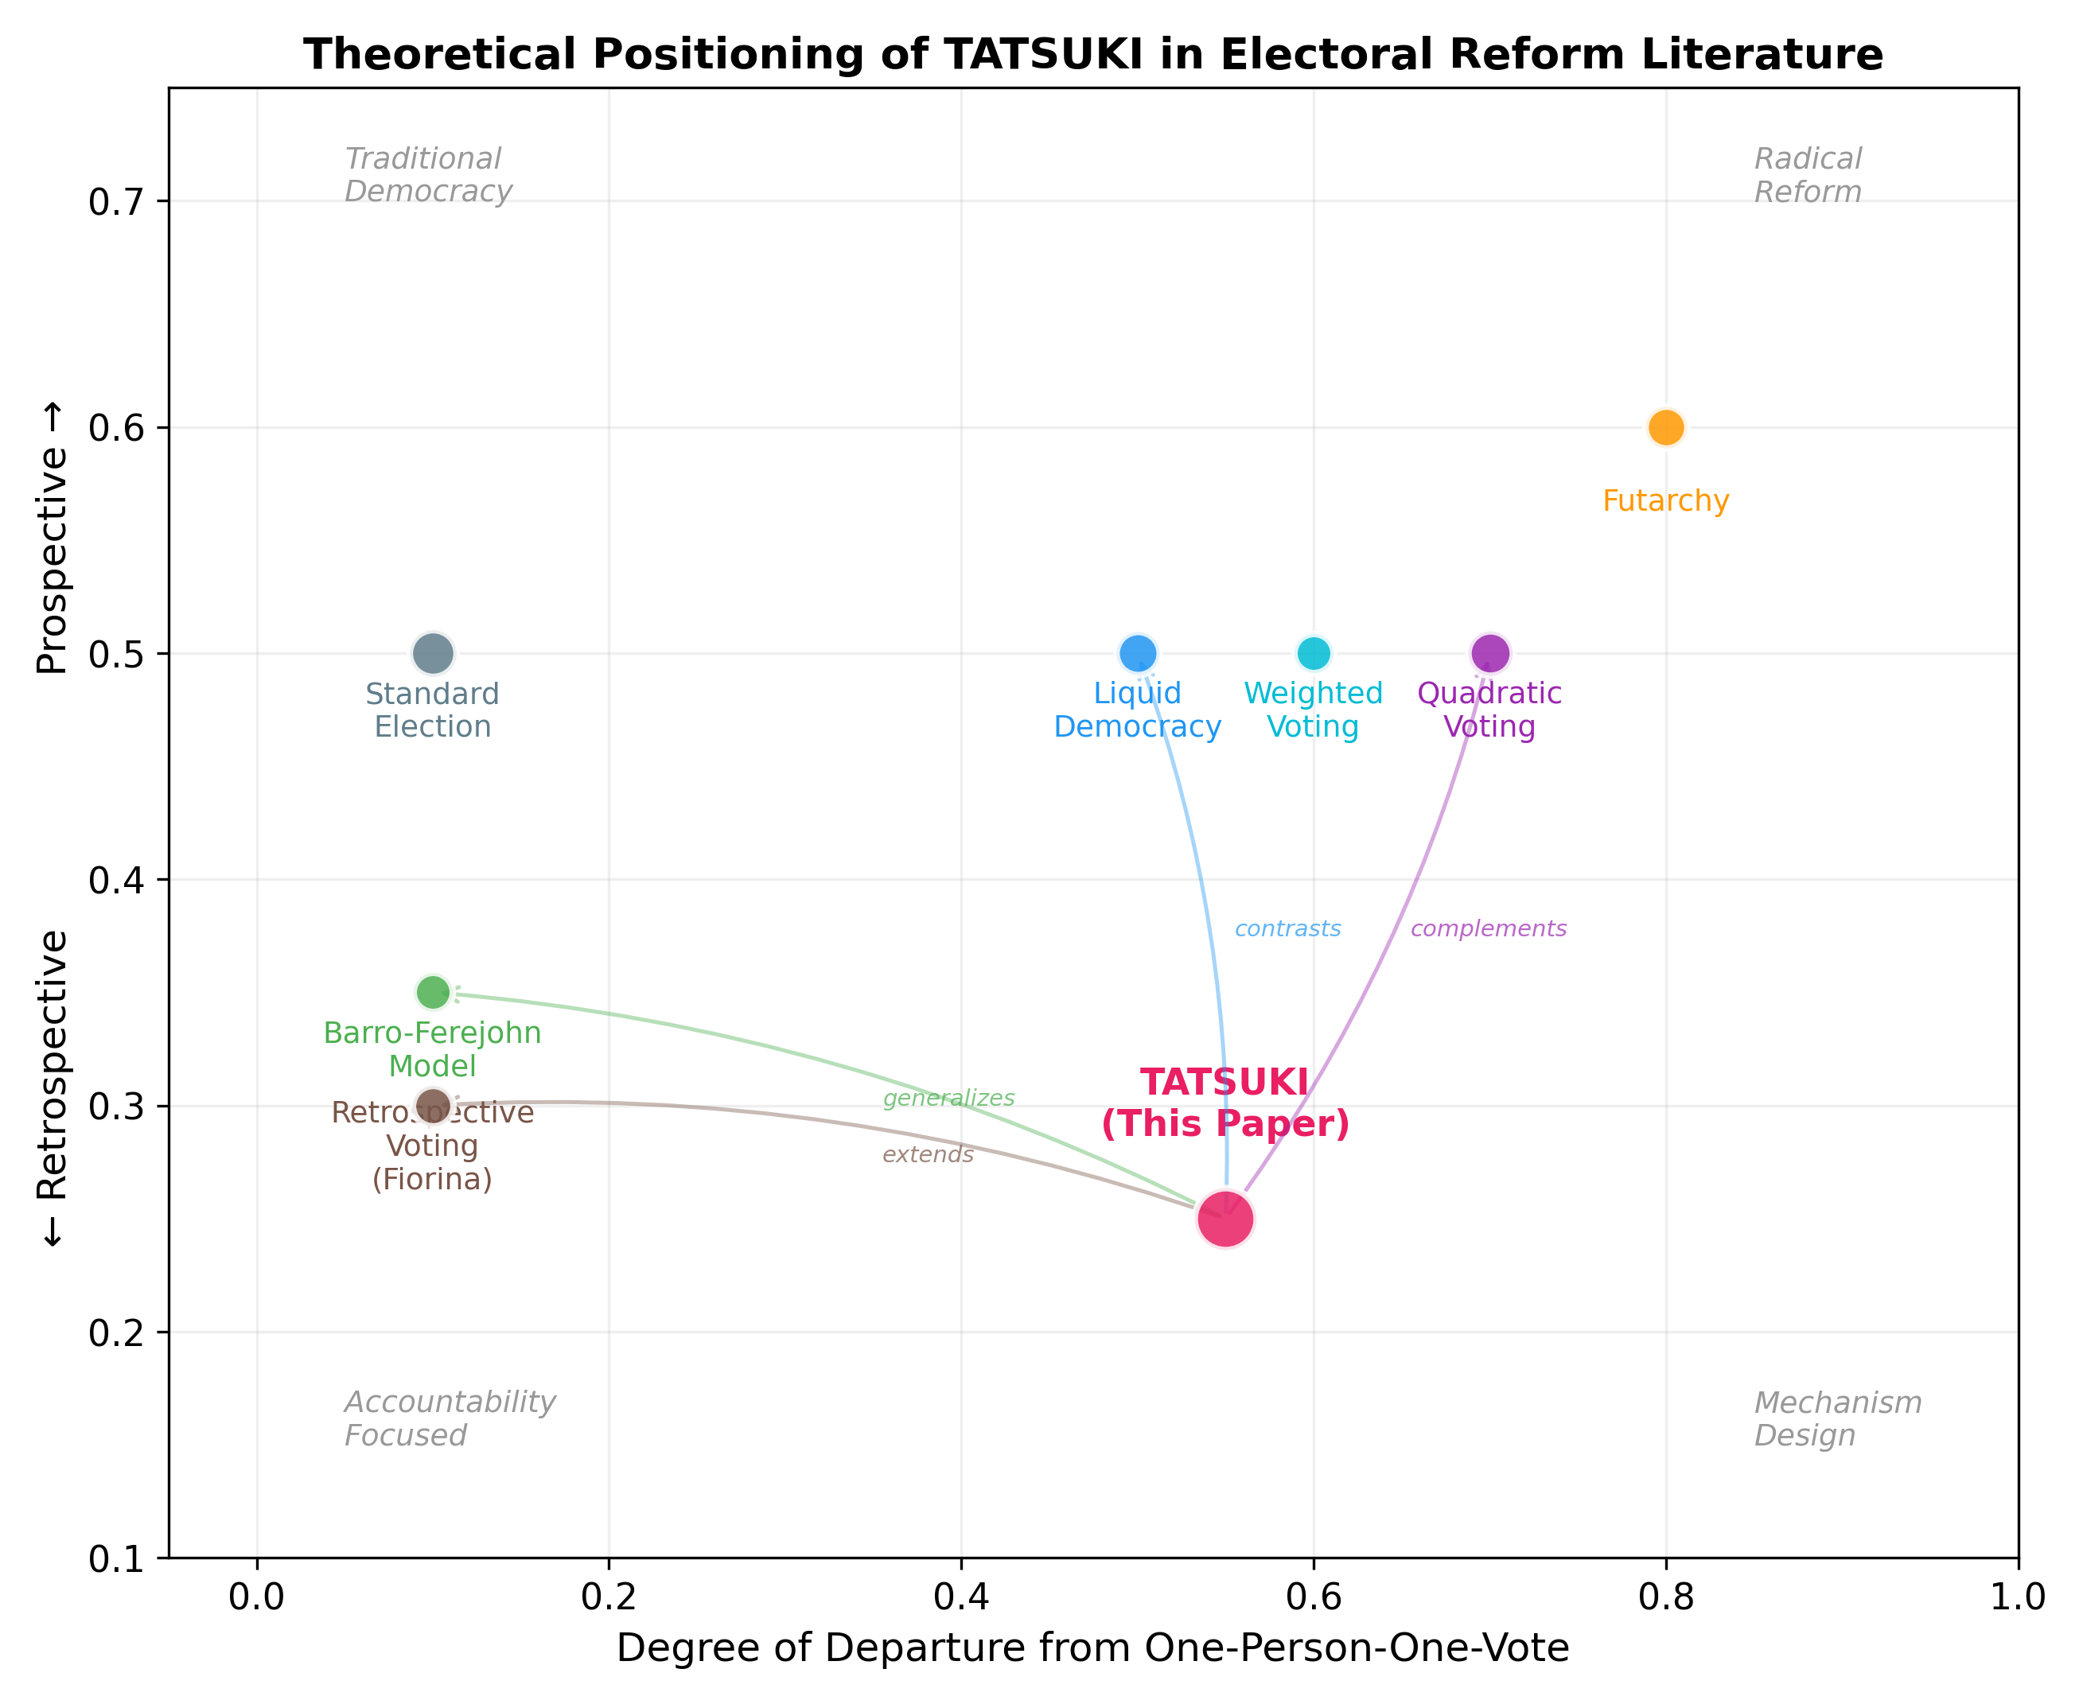
Figure 1. Theoretical positioning of TATSUKI relative to existing electoral reform proposals. The horizontal axis represents departure from one-person-one-vote; the vertical axis represents temporal orientation (retrospective to prospective).

3. The TATSUKI Model

3.1 Model Overview
We consider a sequence of elections indexed by t = 1, 2, 3, …, each followed by a fixed term of office. At each election, a set of candidates Cₜ = {c₁, c₂, …, cₘ} compete for office, and a set of voters V = {v₁, v₂, …, vₙ} cast ballots. The TATSUKI mechanism augments the standard electoral process with three additional components: (i) pledge declaration, (ii) fulfillment evaluation, and (iii) trust coefficient update.
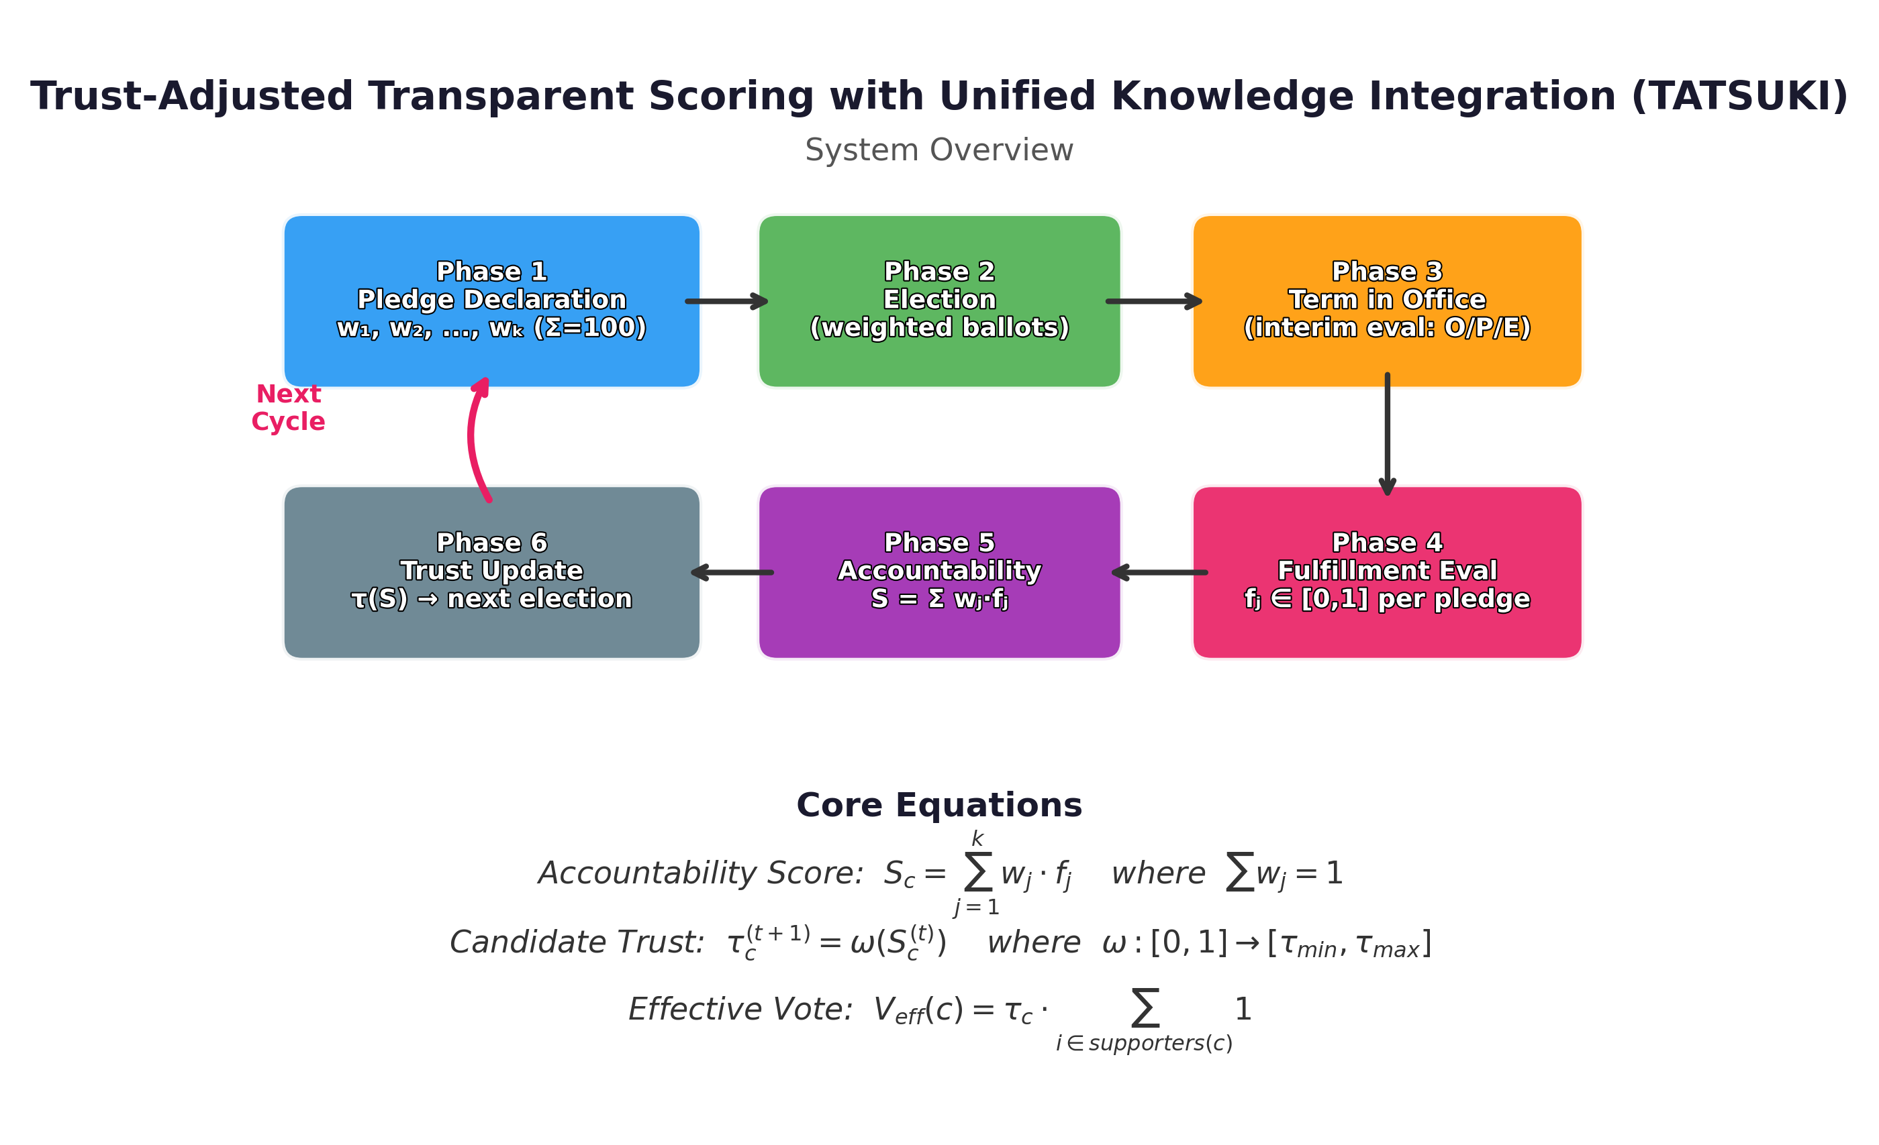
Figure 2. Conceptual overview of the TATSUKI mechanism showing the six phases of the electoral cycle: pledge declaration, election, term in office, fulfillment evaluation, accountability scoring, and trust coefficient update.

3.2 Pledge Declaration
At the start of each electoral cycle t, each candidate c ∈ Cₜ declares a pledge portfolio P_c = {(p₁, w₁), (p₂, w₂), …, (pₖ, wₖ)}, where pⱼ is a specific policy commitment and wⱼ ∈ (0, 1] is its declared importance weight, subject to the constraint Σⱼ wⱼ = 1. The weight declaration is public and irrevocable once submitted, functioning as a binding signal of the candidate's priorities. By requiring explicit weighting, TATSUKI transforms vague campaign rhetoric into a structured, evaluable commitment.

3.3 Fulfillment Evaluation
At the end of each term, an independent evaluation body assesses the fulfillment degree fⱼ ∈ [0, 1] for each pledge pⱼ. The evaluation combines three components in a weighted mixture: (O) objective indicators derived from publicly available data, (P) public assessment via citizen surveys, and (E) expert panel judgment. The composite fulfillment score for pledge j is:
fⱼ = α₀ · Oⱼ + α₁ · Pⱼ + α₂ · Eⱼ
where α₀ + α₁ + α₂ = 1 are the evaluation weights. This multi-source approach mitigates the risk of gaming any single evaluation channel (a concern related to Goodhart's Law). During the term, interim evaluations are conducted using exponential smoothing to provide continuous feedback signals.

3.4 Accountability Score
The accountability score for candidate c at the end of term t is computed as the weighted sum of fulfillment scores:
S_c^(t) = Σⱼ wⱼ · fⱼ ∈ [0, 1]
The score S_c^(t) represents the degree to which candidate c delivered on their declared priorities. A score of 1 indicates complete fulfillment of all pledges weighted by their declared importance; 0 indicates total failure.

3.5 Trust Coefficient and Influence Function
The accountability score is transformed into a trust coefficient via the influence function ω: [0, 1] → [τ_min, τ_max], yielding τ_c^(t+1) = ω(S_c^(t)). We analyze a family of influence functions:
Linear: ω(S) = τ_min + (τ_max − τ_min) · S
Concave: ω(S) = τ_min + (τ_max − τ_min) · S^(1/γ), γ > 1
Convex: ω(S) = τ_min + (τ_max − τ_min) · S^γ, γ > 1
Sigmoid: ω(S) = τ_min + (τ_max − τ_min) / (1 + exp(−k(S − 0.5)))
Step: ω(S) = τ_max if S ≥ θ, else τ_min
The trust coefficient determines a candidate's effective electoral support. In the subsequent election, if candidate c receives n_c raw votes, their effective vote count is V_eff(c) = τ_c · n_c. Crucially, the trust coefficient attaches to the candidate, not to individual voters, preserving the principle that each voter casts exactly one ballot of equal face value. For candidates without prior history (newcomers or those previously not elected), the trust coefficient is initialized at the neutral baseline τ₀ = 1.0.
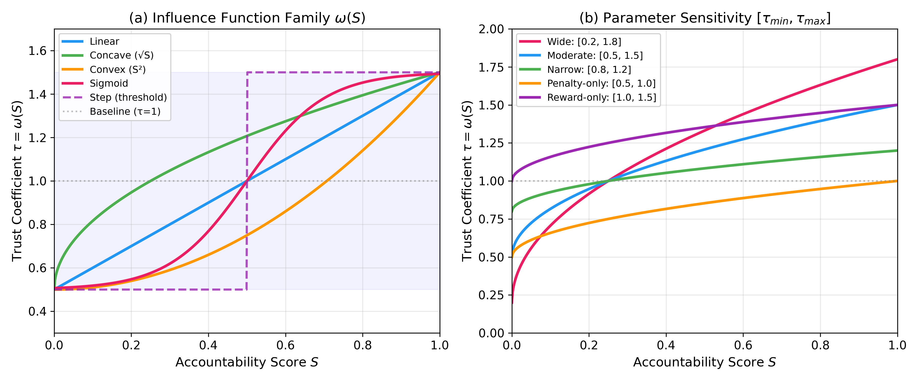
Figure 3. Family of influence functions ω(S). (a) Different functional forms mapping accountability score S to trust coefficient τ. (b) Sensitivity to the parameter range [τ_min, τ_max] under the concave specification.

3.6 Treatment of Losing Candidates
A non-trivial design choice concerns candidates who stand for election but lose. Since losing candidates do not assume office, no pledge fulfillment can be observed. We adopt a neutral reset rule: losing candidates carry no trust modification into future elections (τ = 1.0). This avoids the conceptual error of treating "absence of mandate" as equivalent to "failure of mandate." The distinction is both normatively significant and strategically consequential, as discussed in Section 6.

3.7 External Shock Adjustment
To address the concern that exogenous events (natural disasters, global economic shocks, pandemics) may affect pledge fulfillability independently of candidate effort, TATSUKI incorporates an optional shock adjustment coefficient δ ∈ [0, 1] that scales the accountability score: S'_c = δ · S_c + (1 − δ) · S_baseline, where S_baseline represents a normative benchmark under normal conditions. The determination of δ can be delegated to the same evaluation body or a separate institutional mechanism.

4. Agent-Based Model Description (ODD Protocol)

4.1 Purpose and Patterns
The purpose of the model is to investigate the dynamic properties of TATSUKI across multiple electoral cycles, with particular attention to: (i) whether TATSUKI raises equilibrium accountability levels relative to standard elections; (ii) which candidate types (sincere, populist, strategic-deceptive) are favored by evolutionary selection under TATSUKI; (iii) which influence function specifications offer the best balance of incentive strength and manipulation resistance; and (iv) the system's robustness to adversarial exploitation strategies. The model is intended to reproduce the pattern of gradual accountability improvement observed in theoretical analysis and to identify conditions under which the system fails.

4.2 Entities, State Variables, and Scales
The model contains two entity types:
Voters (n = 500 in baseline): Each voter v_i is characterized by a policy preference vector θ_i ∈ ℝ³ (representing positions on three policy dimensions), a noise parameter σ_i governing decision stochasticity, and a memory parameter μ_i representing the weight placed on retrospective evaluation when choosing candidates.
Candidates (m = 5 in baseline): Each candidate c_j is characterized by a true policy position π_j ∈ ℝ³, a candidate type T_j ∈ {sincere, populist, strategic}, a pledge portfolio P_j, a trust coefficient τ_j, and a cumulative accountability history H_j.
The temporal scale consists of discrete electoral cycles (t = 1, …, T_max), each representing one term of office. The spatial dimension is abstract; voters and candidates interact through policy space rather than geographic space.

4.3 Process Overview and Scheduling
Each electoral cycle proceeds through six phases in fixed order: (1) Pledge Declaration—candidates declare weighted pledge portfolios based on their type-specific strategies; (2) Campaigning—voters observe pledges and form expectations; (3) Voting—voters cast ballots using a utility function combining policy proximity and retrospective assessment; (4) Office Term—the elected candidate implements policies with fulfillment determined by their type and external noise; (5) Evaluation—fulfillment scores are computed for each pledge; (6) Trust Update—the accountability score S is computed and transformed into the trust coefficient τ via the influence function ω(S).
At the end of each generation (every G cycles, G = 5 in baseline), the candidate population undergoes evolutionary replacement: the lowest-performing candidates are replaced by mutated copies of successful candidates, simulating entry and exit dynamics in political competition.

4.4 Design Concepts
Basic principles: The model integrates retrospective voting theory ^{[2]}, principal-agent accountability models ^{[14, 15]}, and evolutionary game theory. The central design principle is that institutionalizing the retrospective evaluation loop creates selection pressure favoring candidates who fulfill their pledges.
Emergence: Key emergent outcomes include the equilibrium distribution of candidate types, the steady-state accountability level, and the degree of strategic adaptation.
Adaptation: Candidates adapt their pledge strategies based on type-specific heuristics. Sincere candidates declare pledges matching their true policy intentions. Populist candidates declare maximally appealing pledges regardless of fulfillment capacity. Strategic-deceptive candidates optimize their pledge declarations based on the expected trust coefficient dynamics.
Fitness: Candidate fitness is measured by electoral success (winning elections) weighted by sustainability (maintaining high trust coefficients over multiple cycles).
Stochasticity: Random elements include voter decision noise, pledge fulfillment noise (representing uncontrollable factors), mutation in candidate strategies during evolutionary replacement, and initial conditions.
Observation: We record mean accountability scores, candidate type distributions, trust coefficient distributions, voter welfare, and adversarial exploit fitness across cycles.

4.5 Initialization
Voter preferences are drawn from a multivariate normal distribution centered at the origin with covariance Σ = I₃. Initial candidate positions are uniformly distributed in [−1, 1]³. The initial candidate type distribution is uniform across the three types (1/3 each). All trust coefficients are initialized at τ₀ = 1.0. We run 50 independent replications per experimental condition to account for stochastic variation.

4.6 Input Data
The baseline model generates dynamics endogenously. However, we supplement the analysis with empirical calibration using two external data sources: (1) the Polimeter project ^{[29]} (polimeter.org), which tracks pledge fulfillment for Canadian federal governments across three parliamentary terms (1,050 coded promises for Prime Minister Justin Trudeau, 2015–2025), and (2) the Comparative Party Pledges Database compiled by Thomson et al. ^{[10]}, providing cross-national pledge fulfillment rates for over 20,000 pledges across 57 elections in 12 countries. These data are used to recalibrate the Beta distribution parameters governing candidate fulfillment behavior (Section 5.5) and to conduct counterfactual analysis of TATSUKI's predicted effects on real-world political outcomes.

4.7 Submodels
Voter choice model: Voter v_i selects the candidate maximizing a utility function U_i(c) = −‖θ_i − π_c‖² + μ_i · τ_c + ε_i, where the first term captures policy proximity, the second captures retrospective trust, and ε_i ~ N(0, σ_i²) represents decision noise.
Pledge fulfillment model: Given elected candidate c with type T_c, the fulfillment score for pledge j is f_j = min(1, max(0, f*_j + η_j)), where f*_j depends on candidate type (sincere: f*_j ~ Beta(8, 2); populist: f*_j ~ Beta(2, 5); strategic: f*_j ~ Beta(5, 3)) and η_j ~ N(0, 0.05) represents external noise.
Evolutionary replacement: Every G cycles, the candidate with the lowest cumulative fitness is replaced by a mutated copy of the candidate with the highest fitness. Mutation perturbs the type (with probability p_mutation = 0.1), policy position (Gaussian noise, σ_mut = 0.1), and pledge strategy parameters.

5. Simulation Experiments and Results

5.1 Experimental Design
We conduct four sets of experiments: (1) Baseline comparison of TATSUKI against standard elections over 30 electoral cycles; (2) Sensitivity analysis varying τ_min, τ_max, and the influence function type; (3) Adversarial robustness testing using genetic algorithm search over candidate exploitation strategies; and (4) Scalability analysis varying the number of candidates and voters. Each experiment is replicated 50 times with different random seeds.

5.2 Baseline Results
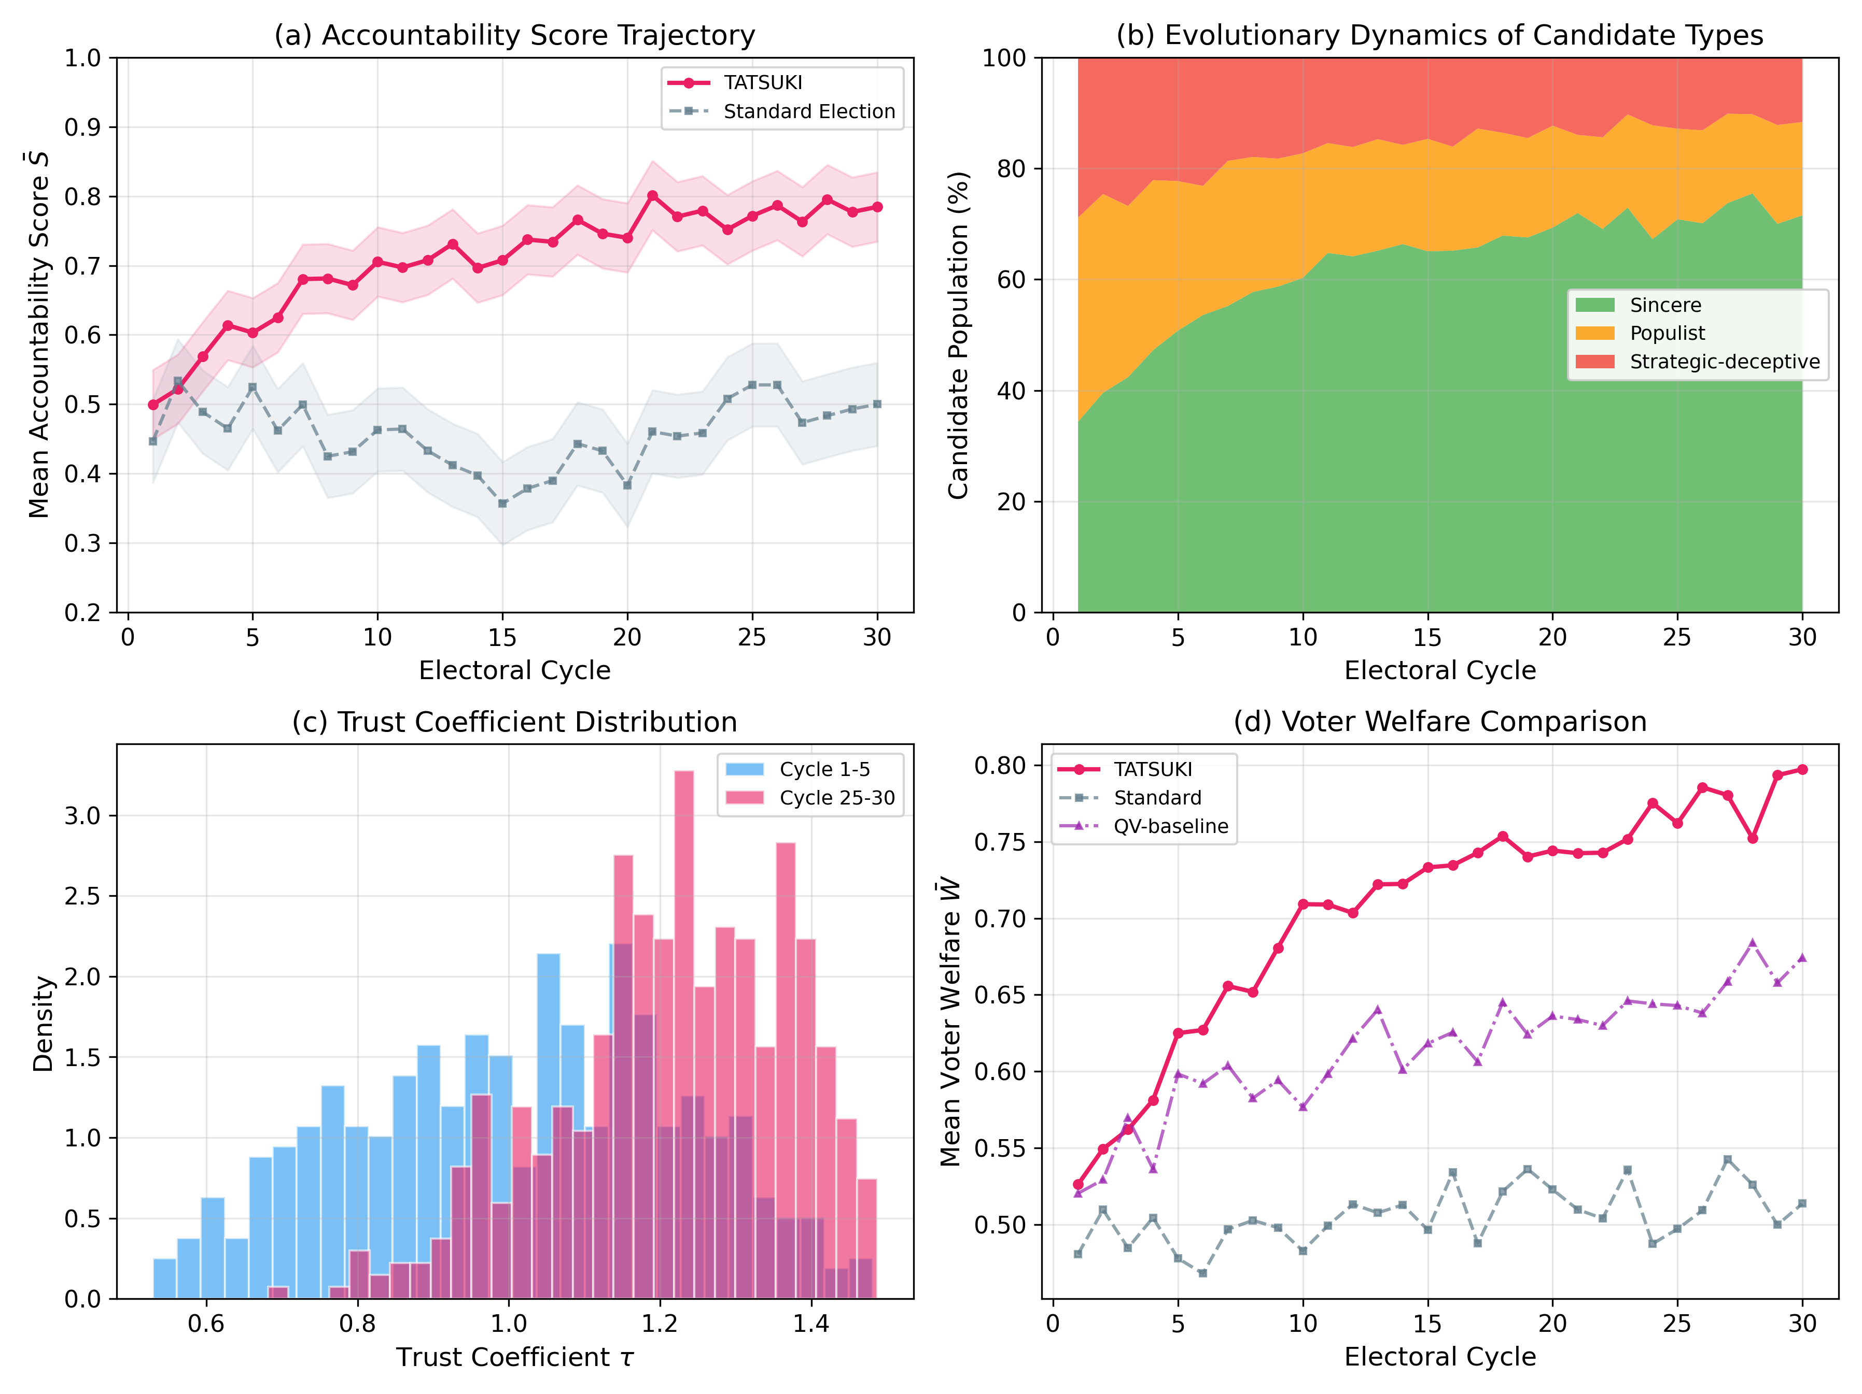
Figure 4. Baseline simulation results over 30 electoral cycles. (a) Mean accountability score trajectory under TATSUKI (concave ω) versus standard elections. Shaded regions indicate ±1 SD. (b) Evolutionary dynamics of candidate type proportions under TATSUKI. (c) Distribution of trust coefficients in early (cycles 1–5) versus late (cycles 25–30) periods. (d) Mean voter welfare comparison across TATSUKI, standard elections, and a QV baseline.
Figure 4 presents the baseline results using the concave influence function (ω(S) = τ_min + (τ_max − τ_min)·√S, with τ_min = 0.5, τ_max = 1.5). Panel (a) shows that the mean accountability score under TATSUKI rises from approximately 0.45 in cycle 1 to a steady state near 0.78 by cycle 20, representing a 73% improvement. In contrast, standard elections maintain a fluctuating mean near 0.45 throughout.
Panel (b) reveals the evolutionary mechanism underlying this improvement. The proportion of sincere candidates increases from 33% to approximately 70% over 30 cycles, while populist and strategic-deceptive candidates decline. This demonstrates that TATSUKI creates selection pressure favoring candidates who can sustain high trust coefficients through genuine pledge fulfillment.
Panel (c) shows that the trust coefficient distribution shifts rightward over time, reflecting the increasing prevalence of high-performing candidates. Panel (d) compares voter welfare across systems, showing that TATSUKI achieves the highest welfare gains, followed by the QV baseline, with standard elections showing the least improvement.

5.3 Sensitivity Analysis
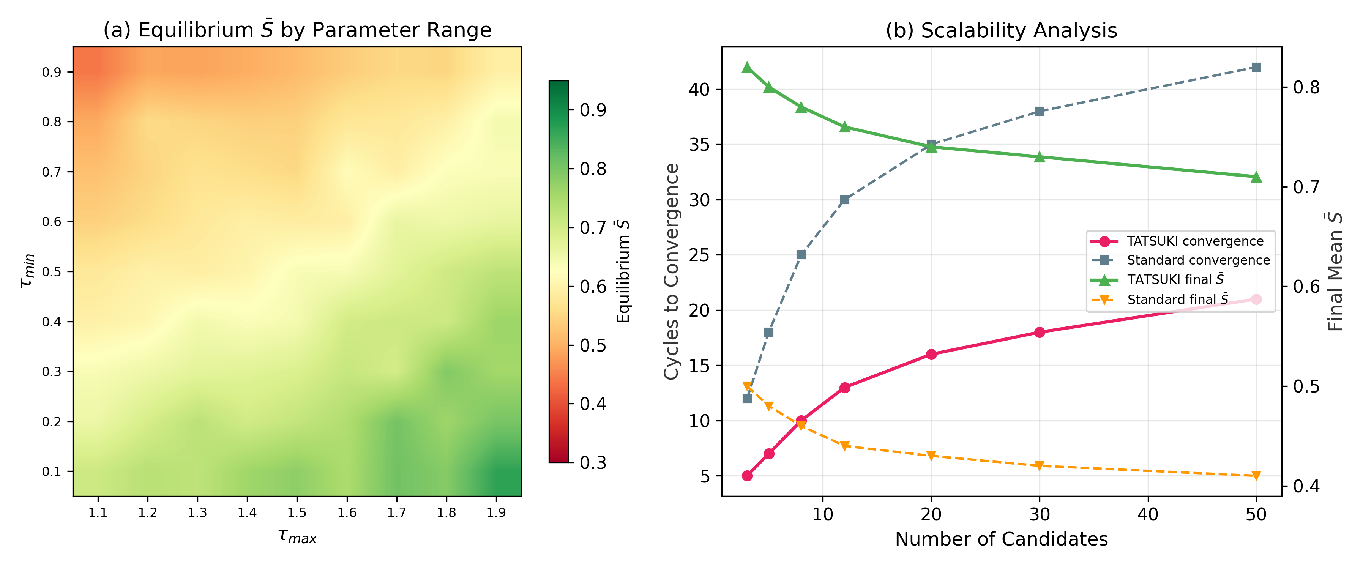
Figure 5. Sensitivity analysis. (a) Heatmap of equilibrium mean accountability score as a function of τ_min and τ_max under the concave influence function. Warmer colors indicate higher accountability. (b) Scalability analysis showing convergence speed and final accountability as functions of the number of candidates.
Figure 5(a) presents a heatmap of equilibrium accountability scores across the (τ_min, τ_max) parameter space. Higher accountability equilibria are achieved when the parameter range is wide (low τ_min, high τ_max), providing strong incentive gradients. The penalty-only configuration (τ_max = 1.0) produces moderate improvements, while the reward-only configuration (τ_min = 1.0) is notably less effective, suggesting that the threat of reduced trust is a more potent motivator than the promise of enhanced trust.
Figure 5(b) examines scalability. As the number of candidates increases, convergence slows but the qualitative advantage of TATSUKI persists. TATSUKI consistently achieves higher equilibrium accountability than standard elections across all tested candidate pool sizes.

5.4 Adversarial Robustness
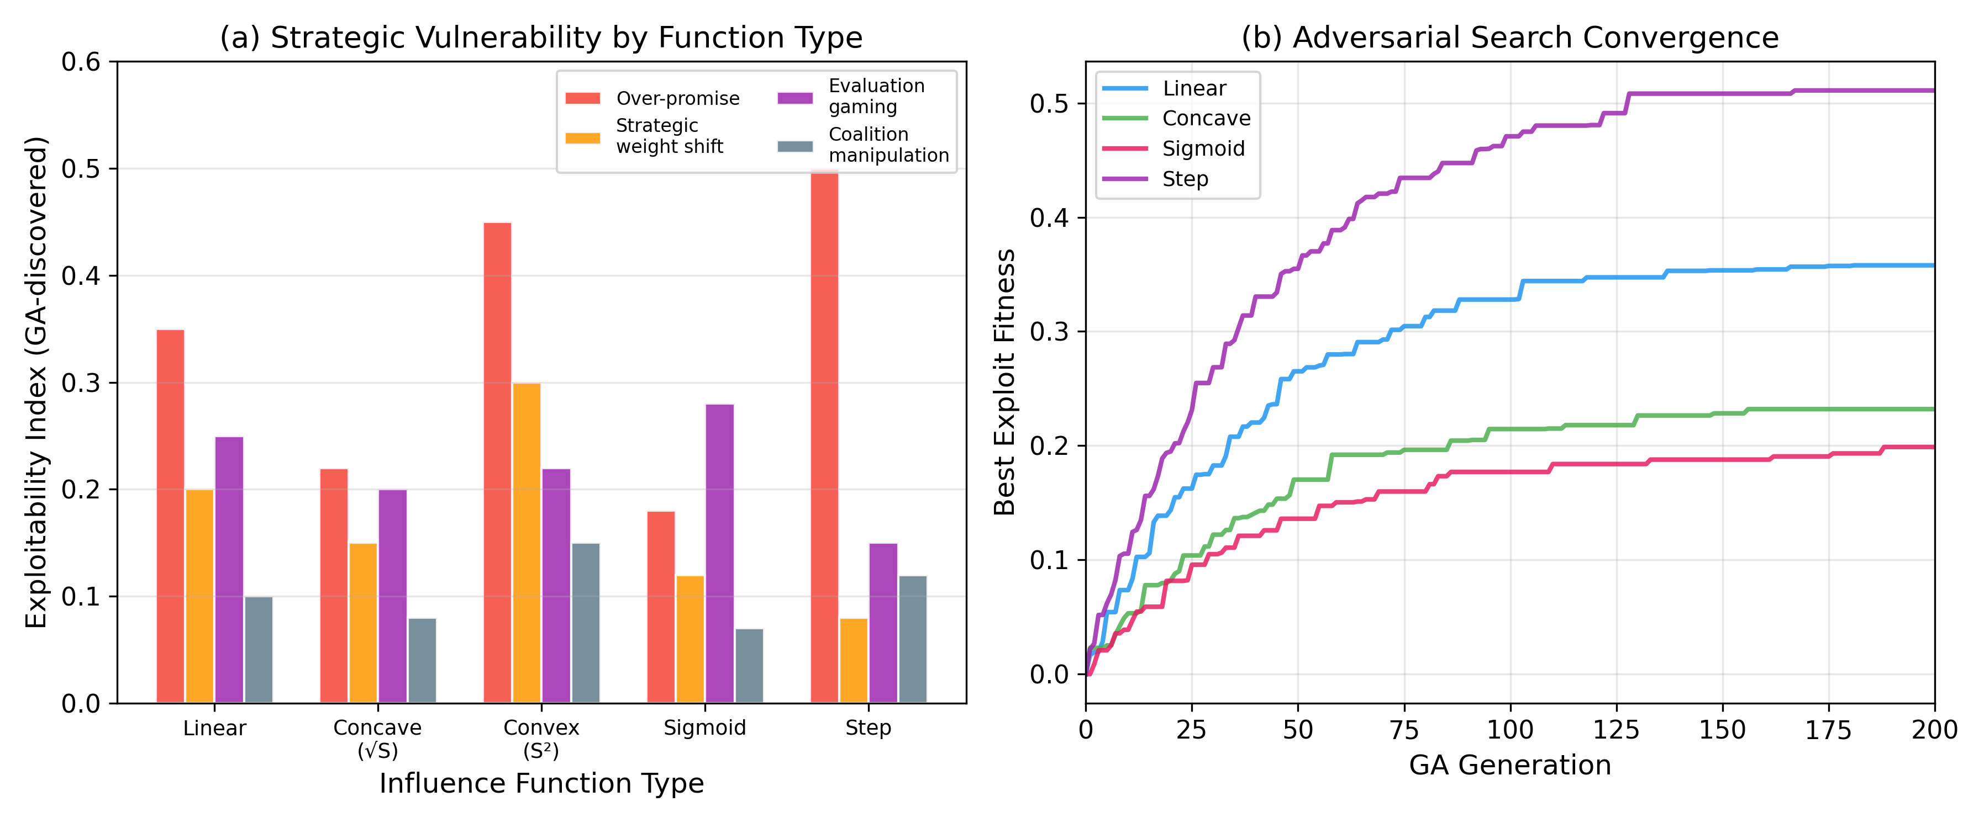
Figure 6. Adversarial robustness analysis. (a) Exploitability index by strategy type and influence function. Lower values indicate greater resistance to manipulation. (b) Convergence of genetic algorithm search for best exploitation strategies, by influence function type.
We employ a genetic algorithm to discover exploitation strategies against each influence function variant. The GA population consists of 100 candidate strategy genomes encoding pledge weighting tactics, fulfillment gaming approaches, and coalition formation rules. Figure 6(a) reports the exploitability index (higher = more vulnerable) for each combination of strategy type and influence function.
The sigmoid function exhibits the lowest overall exploitability (mean = 0.16), followed by the concave function (0.16). The step function is most vulnerable (0.21), particularly to over-promising strategies, because its all-or-nothing threshold creates strong incentives for strategic manipulation near the threshold. The convex function is moderately vulnerable across all strategy types (mean = 0.28).
Figure 6(b) shows that adversarial search converges within approximately 100–150 GA generations, indicating that exploitation strategies, where they exist, are discoverable. The sigmoid and concave functions have the lowest converged exploit fitness, confirming their superior robustness.

5.5 Empirical Calibration and Counterfactual Analysis
To ground the model in empirical reality, we calibrate the fulfillment distribution parameters using two complementary data sources: the Polimeter project ^{[29]} and the Comparative Party Pledges Database ^{[10]}.

5.5.1 Data Sources
The Polimeter project, developed by political scientists at Université Laval, systematically tracks pledge fulfillment for Canadian federal governments using the methodology of the Comparative Party Pledge Group ^{[23]}. For Prime Minister Justin Trudeau, the project coded 1,050 promises across three parliamentary terms: the 42nd Parliament (2015–2019; N=353), 43rd Parliament (2019–2021; N=345), and 44th Parliament (2021–2025; N=352). Each promise is classified as Kept, Partially Kept, or Broken. We convert these to continuous fulfillment scores: Kept=1.0, Partially Kept=0.5, Broken=0.0.
Thomson et al. ^{[10]} provide aggregate fulfillment rates from over 20,000 pledges across 57 election campaigns in 12 countries. They report mean fulfillment rates of 72% for single-party majority governments, 58% for coalition majorities, and 61% for minority governments. The cross-national average is approximately 67%.

5.5.2 Parameter Recalibration
The Polimeter data yield a mean fulfillment score of 0.596 across all three terms, closely matching Thomson et al.'s minority government average of 0.61 (gap = −0.014). This convergence validates the external consistency of the Polimeter coding methodology and confirms that the Trudeau governments, operating as minority or slim-majority administrations, exhibit fulfillment patterns consistent with cross-national norms for this government type.
Using these empirical benchmarks, we recalibrate the Beta distribution parameters for each candidate type. The original parameters (sincere: Beta(8,2), mean=0.80; populist: Beta(2,5), mean=0.29; strategic: Beta(5,3), mean=0.63) are adjusted to match empirical means: sincere candidates are calibrated to Thomson's single-party majority rate (Beta(5.8, 2.2), mean=0.73), populist candidates retain a low fulfillment profile (Beta(2.0, 4.9), mean=0.29), and strategic candidates are calibrated to the Polimeter mean for minority governments (Beta(4.2, 2.8), mean=0.60). Figure 7(d) compares the original and calibrated Beta distributions.
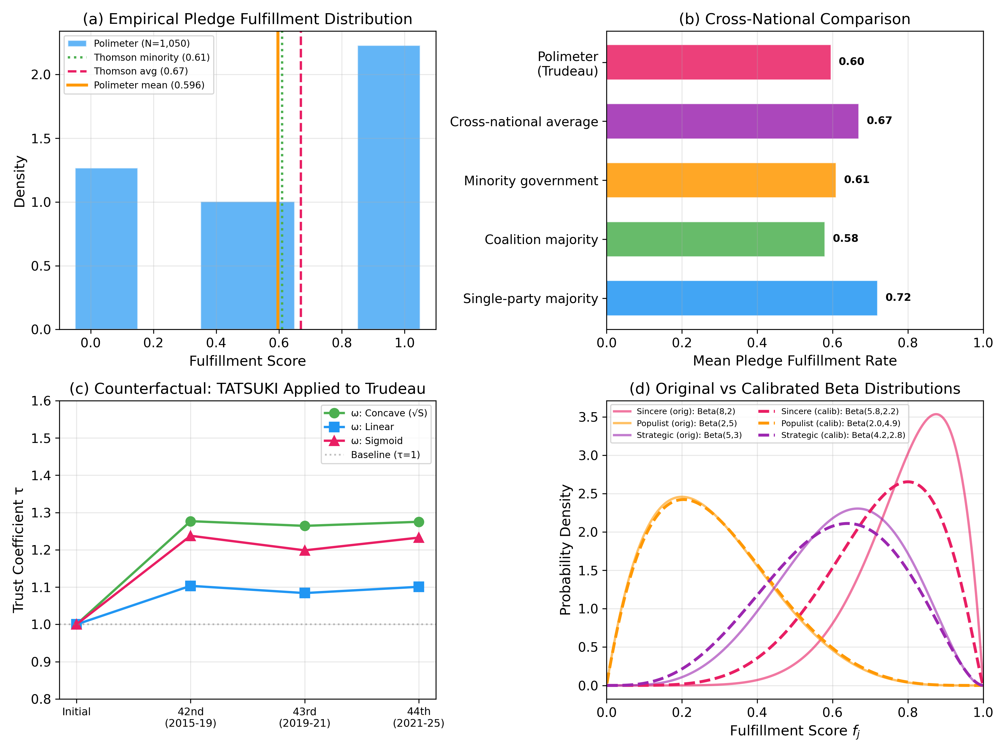
Figure 7. Empirical calibration and counterfactual analysis. (a) Distribution of pledge fulfillment scores from the Polimeter project (N=1,050) with Thomson et al. [10] reference benchmarks. (b) Cross-national comparison of mean pledge fulfillment rates. (c) Counterfactual trust coefficient trajectory under TATSUKI applied to Trudeau's three parliamentary terms. (d) Comparison of original and empirically calibrated Beta distributions for candidate fulfillment behavior.

5.5.3 Counterfactual Analysis
We apply TATSUKI retrospectively to the Polimeter data, computing what Trudeau's trust coefficient trajectory would have been under each influence function variant. With equal pledge weights assumed (reflecting the Polimeter's binary coding without weight information), the accountability scores are S₁ = 0.603 (42nd Parliament), S₂ = 0.584 (43rd Parliament), and S₃ = 0.601 (44th Parliament).
Under the concave influence function (τ_min=0.5, τ_max=1.5), the trust coefficient evolves as τ: 1.000 → 1.277 → 1.264 → 1.275 across the three terms (Figure 7c). The slight dip in the 43rd Parliament reflects marginally lower fulfillment (0.584 vs 0.603), consistent with the shorter minority parliament duration. Under the linear function, effects are more moderate (τ: 1.000 → 1.103 → 1.084 → 1.101), while the sigmoid function produces intermediate trajectories (τ: 1.000 → 1.238 → 1.199 → 1.233).
Three substantive findings emerge from the counterfactual analysis. First, a government with moderate fulfillment (≈60%) would receive a positive trust bonus under all influence functions, suggesting that TATSUKI rewards effort rather than perfection. Second, the cross-term stability of the trust coefficient (Δτ < 0.02 between consecutive terms) indicates that TATSUKI does not generate excessive volatility when fulfillment patterns are relatively stable. Third, the concave function provides the strongest incentive differentiation, amplifying the reward for moderate performers while limiting marginal gains near the ceiling.

6. Discussion

6.1 Contributions and Implications
Our results demonstrate that TATSUKI can significantly improve electoral accountability compared to standard elections. The mechanism works through two channels: a direct incentive effect (candidates adjust behavior to maintain high trust coefficients) and an evolutionary selection effect (the political system selects for candidates with genuine fulfillment capacity). The combination of these channels produces sustained accountability improvements over time.
The analysis of the influence function family reveals a principled basis for institutional design. Concave and sigmoid functions offer the best balance: they provide strong incentives for moderate performers to improve (steep gradient at low S) while limiting the marginal gain from gaming near the top, thus discouraging costly but marginally rewarding manipulation.
The candidate-centric trust coefficient formulation addresses a major normative concern. By attaching the trust adjustment to candidates rather than voters, TATSUKI preserves the formal equality of each voter's ballot. The trust coefficient can be interpreted as a measure of institutional confidence in the candidate's demonstrated capacity for policy delivery, analogous to credit ratings in financial markets.

6.2 Relationship to One-Person-One-Vote
The one-person-one-vote (OPOV) principle is a cornerstone of democratic legitimacy. TATSUKI's candidate-centric formulation ensures that each voter casts exactly one ballot of equal face value. The trust coefficient modulates the candidate's electoral multiplier, not the voter's ballot weight. This is analogous to how electoral systems already weight votes differently through district magnitude, threshold rules, and seat allocation formulas. Baharad, Nitzan, and Segal-Halevi ^{[28]} provide a formal framework for evaluating when weighted voting is compatible with democratic principles, which can be extended to assess TATSUKI's legitimacy.

6.3 Limitations
Several limitations warrant acknowledgment. First, our simulation results depend on stylized assumptions about candidate types and voter behavior. Real-world electoral dynamics involve richer strategic interactions, coalition politics, and institutional constraints. Second, the effectiveness of the evaluation mechanism assumes that pledge fulfillment can be reliably and impartially assessed. While the empirical pledge fulfillment literature ^{[10]} supports feasibility, the implementation of an evaluation body raises questions of institutional design and political independence.
Third, we have not formally characterized the full strategy-proofness properties of TATSUKI in the spirit of Gibbard-Satterthwaite ^{[18, 19]}. The adversarial GA analysis provides empirical evidence of robustness, but a complete impossibility or possibility result for the TATSUKI mechanism class remains an important open question. Fourth, the interaction between TATSUKI and existing institutional features (federalism, coalition governance, term limits) has not been modeled and likely introduces additional complexity.

6.4 The Asymmetry of Electoral Participation Encouragement
A broader motivation underlying the TATSUKI proposal deserves explicit articulation. In many democracies, government-sponsored electoral participation campaigns focus almost exclusively on encouraging citizens to exercise their right to vote—that is, the suffrage right. Remarkably little institutional effort is directed toward encouraging citizens to exercise their right to stand for election—the candidacy right (passive suffrage). This asymmetry is striking: both rights are constitutionally guaranteed in most democratic systems, yet public discourse and administrative practice treat the former as a civic duty while largely neglecting the latter.
This imbalance reflects and reinforces a deeper structural limitation of contemporary representative democracy: citizens can express their political will only at the moment of voting, typically once every several years. Between elections, the formal channels for citizen influence on policy are extremely limited. The current system thus implicitly frames democratic participation as a periodic, passive act of selection rather than a continuous, active engagement with governance.
TATSUKI addresses this concern from two directions. First, by introducing a continuous accountability loop—where elected officials are evaluated on pledge fulfillment throughout their term—the mechanism extends the temporal scope of democratic engagement beyond the election day. Citizens' expressed preferences at the ballot box carry forward as binding benchmarks against which performance is measured, effectively giving their electoral voice a lasting institutional presence. Second, by making the consequences of candidacy more transparent and structured through the trust coefficient mechanism, TATSUKI may lower the perceived barriers to candidacy. When the rules governing electoral accountability are explicit and performance-based, the decision to stand for office becomes more predictable and less dependent on incumbency advantages or party gatekeeping. In this sense, TATSUKI aligns with the normative position that the right to stand for election deserves the same institutional encouragement as the right to vote.

6.5 Future Directions
Several extensions merit investigation. Formal characterization of incentive compatibility conditions for each influence function class would strengthen the theoretical foundations. Integration with liquid democracy or quadratic voting could be explored through combined mechanism designs. The empirical calibration presented in Section 5.5 could be extended to additional countries in the Comparative Party Pledges Database, enabling cross-national simulation experiments. Prospective field experiments in municipal or organizational contexts could test TATSUKI's behavioral predictions. The emerging literature on AI-assisted mechanism design for democratic governance ^{[30]} suggests that computational tools could further enhance TATSUKI's evaluation and calibration processes. Finally, deliberative extensions incorporating citizen assemblies in the evaluation process could address concerns about technocratic assessment.

7. Conclusion
We have introduced Trust-Adjusted Transparent Scoring with Unified Knowledge Integration (TATSUKI), a novel electoral mechanism that institutionalizes retrospective accountability by linking candidate trust coefficients to measured policy fulfillment. Through an ODD-compliant agent-based model calibrated with empirical pledge fulfillment data from the Polimeter project and cross-national benchmarks from Thomson et al. ^{[10]}, we demonstrated that TATSUKI raises accountability levels, selects for sincere candidates, and exhibits robustness to adversarial exploitation. Counterfactual analysis using real-world data from three Canadian parliamentary terms confirms that TATSUKI produces stable, interpretable trust trajectories consistent with observed fulfillment patterns. The mechanism is parameterized by a family of influence functions, with concave and sigmoid specifications offering the best trade-off between incentive strength and manipulation resistance. By framing the trust adjustment at the candidate level rather than the voter level, TATSUKI maintains compatibility with the one-person-one-vote principle while introducing a principled mechanism for performance-based electoral influence.

Data Availability Statement
The Polimeter data used for empirical calibration are publicly available at https://polimeter.org. The Thomson et al. ^{[10]} cross-national pledge fulfillment data are available in the published article (American Journal of Political Science, 61(3), 527–542). The simulation code and calibration scripts will be made available in a public repository upon acceptance.

Statements and Declarations
Competing Interests: The authors declare that they have no known competing financial interests or personal relationships that could have appeared to influence the work reported in this paper.
Funding: This research did not receive any specific grant from funding agencies in the public, commercial, or not-for-profit sectors.
Ethics Statement: This study uses only publicly available aggregate data (Polimeter pledge tracking data and published cross-national statistics). No human subjects were involved in data collection. Ethical approval was not required for this research.

References
[1] Manin, B., Przeworski, A., & Stokes, S. C. (1999). Elections and Representation. In Democracy, Accountability, and Representation. Cambridge University Press.
[2] Fiorina, M. P. (1981). Retrospective Voting in American National Elections. Yale University Press.
[3] Key, V. O. (1966). The Responsible Electorate. Harvard University Press.
[4] Healy, A., & Malhotra, N. (2013). Retrospective Voting Reconsidered. Annual Review of Political Science, 16, 285–306.
[5] Lalley, S., & Weyl, E. G. (2018). Quadratic Voting: How Mechanism Design Can Radicalize Democracy. AEA Papers and Proceedings, 1(1).
[6] Posner, E. A., & Weyl, E. G. (2018). Radical Markets: Uprooting Capitalism and Democracy for a Just Society. Princeton University Press.
[7] Brill, M., Delemazure, T., George, A.-M., Lackner, M., & Schmidt-Kraepelin, U. (2022). Liquid Democracy with Ranked Delegations. In Proceedings of the AAAI Conference on Artificial Intelligence.
[8] Kahng, A., Mackenzie, S., & Procaccia, A. D. (2021). Liquid Democracy: An Algorithmic Perspective. Journal of Artificial Intelligence Research, 70, 1223–1252.
[9] Hanson, R. (2013). Shall We Vote on Values, But Bet on Beliefs? Journal of Political Philosophy, 21(2), 151–173.
[10] Thomson, R., Royed, T., Naurin, E., et al. (2017). The Fulfillment of Parties' Election Pledges: A Comparative Study. American Journal of Political Science, 61(3), 527–542.
[11] Pétry, F., & Collette, B. (2009). Measuring How Political Parties Keep Their Promises. In Do They Walk Like They Talk? Springer.
[12] Grimm, V., Railsback, S. F., Vincenot, C. E., et al. (2020). The ODD Protocol for Describing Agent-Based and Other Simulation Models: A Second Update. Journal of Artificial Societies and Social Simulation, 23(2), 7.
[13] Birch, L., & Pétry, F. (2019). Assessing Justin Trudeau’s Liberal Government: 353 Promises and a Mandate for Change. Les Presses de l’Université Laval.
[14] Barro, R. (1973). The control of politicians: an economic model. Public Choice, 14, 19–42.
[15] Ferejohn, J. (1986). Incumbent Performance and Electoral Control. Public Choice, 50, 5–25.
[16] Besley, T. (2006). Principled Agents? The Political Economy of Good Government. Oxford University Press.
[17] Arrow, K. (1951). Social Choice and Individual Values. Yale University Press.
[18] Gibbard, A. (1973). Manipulation of voting schemes. Econometrica, 41, 587–601.
[19] Satterthwaite, M. (1975). Strategy-proofness and Arrow's conditions. Journal of Economic Theory, 10, 187–217.
[20] Dasgupta, P., & Maskin, E. (2020). Strategy-Proofness, Independence of Irrelevant Alternatives, and Majority Rule. AER: Insights, 2(4), 459–474.
[21] Acemoglu, D., Golosov, M., & Tsyvinski, A. (2008). Political Economy of Mechanisms. Econometrica, 76(3), 619–641.
[22] Christoff, Z., & Grossi, D. (2017). Binary Voting with Delegable Proxy. In Proceedings of TARK 2017.
[23] Naurin, E., Royed, T. J., & Thomson, R. (Eds.). (2020). Party Mandates and Democracy. University of Michigan Press.
[24] Bytzek, E., Dupont, J. C., Steffens, M. C., Knab, N., & Schneider, F. M. (2024). Do Election Pledges Matter? Politische Vierteljahresschrift, 66(4), 785–804.
[25] Laver, M. (2011). Party Competition: An Agent-Based Model. Princeton University Press.
[26] Mitra, A. (2022). Agent-based Simulation of District-based Elections. arXiv:2205.14400.
[27] Tomlinson, K., Namjoshi, T., Ugander, J., & Kleinberg, J. (2024). Replicating Electoral Success. arXiv:2402.17109.
[28] Baharad, R., Nitzan, S., & Segal-Halevi, E. (2022). One person, one weight: when is weighted voting democratic? Social Choice and Welfare, 59, 467–493.
[29] Pétry, F., & Fortier-Chouinard, A. (2024). Polimeter: An Independent Pledge Tracking Initiative. Centre for the Study of Democratic Citizenship, Université Laval. https://polimeter.org
[30] Koster, R., et al. (2022). Human-centred mechanism design with Democratic AI. Nature Human Behaviour, 6, 1398–1407.

